Testahil · Independent Valuation Study — Educational Analysis Not investment advice

Independent Valuation Study — Educational Analysis
e& — Emirates Telecommunications Group (ADX: EAND)
Fundamental analysis · Technical analysis · Monte Carlo simulation — one integrated read
Anchor: AED 19.66 (9 Jul 2026 close) · 8,696.8 mn shares · mkt cap ~AED 171.0 bn (~US$46.6 bn) · the UAE incumbent and one of the largest EM telecom groups: e& UAE (the domestic duopoly leader) plus consolidated stakes — Maroc Telecom 53%, PPF Telecom / e& CEE 50%+1, e& Egypt 66%, PTCL 26% (23.4% economic), e& enterprise, e& life — and equity-accounted stakes in Mobily (28.0%) and, until the sale announced on the study date completes, Vodafone Group (16.21% issued / 17.13% voting). Reporting currency AED (pegged to USD at 3.6725) · prices and probabilities computed 10 Jul 2026 from the attached daily history · primary lens: consolidated FCFF DCF with a sourced stake-and-claims bridge (SOTP), cross-checked by the dividend-policy DDM, relative multiples and normalized earnings · the swing factors: the 2027 federal-royalty reset, and what the Vodafone exit proceeds become.
READ FIRST — what this document is, and is not.
This study is a valuation exercise and an expression of personal analytical opinion, published free of charge for educational purposes: it shows how one analyst applies fundamental, technical and probabilistic methods to a listed company, and invites scrutiny of that methodology. It is NOT investment advice, NOT a recommendation or solicitation to buy, sell or hold any security, and NOT directed at the circumstances of any reader. The preparer is not licensed by any securities regulator in any jurisdiction, holds no brokerage or advisory authorisation, provides no financial consultancy, manages no money, and accepts no fees, funds or clients. See the Disclosure & Disclaimer at the end.
All values are model outputs presented as ranges and distributions because no single number should be relied on. Reported financials are the company’s own disclosure (FY2023–FY2025 earnings releases; the FY2025 audited consolidated financial statements (EY); the Q1-2026 earnings release and EY-reviewed interim financial statements) — all from eand.com. Forward-looking inputs — the growth and margin paths, capex intensity, the cost of capital, terminal growth, the 2027 royalty scenarios, the multiples and the Monte-Carlo factor probabilities — are the preparer’s judgments and are flagged throughout. Consult a licensed financial advisor before any investment decision.
Same-day event. On the study date (10 Jul 2026) e& announced the sale of its entire Vodafone stake at 112.5p ≈ AED 21.8 bn gross (≈ AED 4.7 bn net of the associated financing unwind), pending regulatory approvals. The 9-Jul anchor close pre-dates that announcement; the study carries the stake at deal value with the undisturbed market value (≈ AED 19.1 bn at 97.76p) dual-framed throughout.

The company. e& — known as Etisalat Group until its 2022 rebrand — is the UAE’s incumbent operator and the anchor of a two-player market it shares with du, holding roughly 60% of a duopoly that captures 97.5% of the country’s AED 50bn-plus telecom revenue. It makes money three ways: a high-margin domestic franchise (e& UAE ran a 51.2% EBITDA margin in FY2025), a consolidated portfolio of international operators — Maroc Telecom across Morocco and West Africa, PPF’s Central-European networks, e& Egypt, PTCL in Pakistan — and a build-out of enterprise ICT and fintech ventures around the core. Its moat is the UAE licence structure and network primacy, paid for through a federal royalty that took AED 7.4 bn of FY2025 profit and whose 2027 terms are still unwritten. At AED 72.9 bn of revenue, 244.7 mn subscribers and an Aa3/AA− balance sheet carrying just 0.90× net debt to EBITDA, the group’s question is no longer scale but capital rotation: 2025–26 has seen Khazna, Careem and now the entire Vodafone stake converted back into cash and dividend capacity.
Q1-2026 update (verified against source, post-anchor)
e& reported Q1-2026 results on 28-Apr-2026, ahead of this study’s 9-Jul anchor. Revenue reached AED 19,417mn (+15.1% reported / +11.3% constant-currency, against reiterated FY26 guidance of 8–10% cc); EBITDA reached AED 8,566mn (+16.5%, margin 44.1%, telecom-vertical margin 48.2%); net profit fell 46.2% reported to AED 2,882mn purely on the high base from the Q1-2025 Khazna divestiture gain — stripped of that, net profit rose 3.9%. Capex reached AED 2,827mn (+16.8%; 8.5% UAE intensity vs 21.9% international, both confirmed against the earnings release). Group subscribers reached 248.0mn (+30.8%), of which 12.9mn net adds were organic — the rest is the Telenor Pakistan and SBB consolidations (below). Net debt AED 29,792mn, 0.90× LTM EBITDA — unchanged from the Mar-26 figure used throughout this study. These prints raised FY26E revenue growth to 9.0% (from 8.5%) and the FY26E EBITDA margin to 43.0% (from 42.4%) — both held below the actual Q1 print and management’s own full-year EBITDA-growth guide (4–5% cc, below the 8–10% cc revenue guide), rather than extrapolating Q1’s stronger pace.
Headline
The weighted fundamental central sits at AED 22.72 against a 19.66 spot — about 15.5% above the market — inside a bear–bull span of 17.61–28.75. The gap is not a secret: the market prices the unresolved 2027 royalty regime, the conglomerate’s NCI-heavy structure, and a decade of range-bound trading; the model prices an Aa2-country cost of capital against a franchise that just proved it can turn passive stakes into cash at a premium. The 60-session Monte Carlo is close to flat (median 19.86, +1.0%), because the engine’s price centre is the money-market carry — the fundamental gap never enters the drift.
Valuation summary — every read at a glance
Lens | Bear | Base | Bull | Weight | One-line read
FCFF DCF + stakes bridge (primary) | 20.26 | 28.38 | 39.04 | 35% | Consolidated cash engine at WACC 7.6%; TV 79% of EV — disclosed
Dividend discount (policy lens) | 12.19 | 17.03 | 21.62 | 25% | 95-fils FY26 DPS growing ~4%; the cash a holder actually receives
Relative EV/EBITDA | 21.76 | 23.72 | 25.69 | 20% | 6.0–7.0× FY26E through the same stake bridge
Normalized earnings | 15.60 | 18.90 | 22.72 | 20% | Clean EPS ~1.35 × 12–16× GCC telecom multiple
Weighted central | 17.61 | 22.72 | 28.75 | 100% | 15.5% above spot; the crux is the 2027 royalty

The DCF and the market lenses are deliberately not blended into one point: the football field in §1.5 carries the divergence, and §4 reads it.
Company overview — e& at a glance
Item | Value | Item | Value
Exchange / ticker | ADX : EAND | Spot / 52-wk range | 19.66 / 17.40–21.60
Shares / market cap | 8,696.8 mn / AED 171.0 bn | Free float | ~40% (EIA holds 60%)
FY25 revenue / EBITDA | AED 72,858 / 32,022 mn (44.0%) | FY25 net profit (owners) | AED 14,360 mn · EPS 1.65 (1.31 ex-one-offs)
Net debt (Mar-26) | AED 29,792 mn · 0.90× EBITDA | Ratings | Aa3 (Moody’s) / AA− (Fitch); S&P suspended Feb-26
FY25 / FY26E DPS | 0.90 / 0.95 guided (yield 4.8%) | FY26 guidance | rev +8–10% cc · EBITDA +4–5% cc · EPS ~1.35
Royalty regime | 38% + 9% CT, floor 5.7bn — to 31-Dec-26 | CEO | Masood M. Sharif Mahmood (from 1-Apr-26)
Subscribers | 244.7 mn group / 16.6 mn UAE | Segments FY25 | UAE 48% of revenue · intl 44% · enterprise/life 8%

1 Fundamental valuation
e& is an operating company wrapped around a portfolio: a consolidated core that throws off cash, two large equity-accounted stakes (one being sold at a premium as this study is written), and non-controlling interests that own nearly half of Maroc Telecom and three-quarters of PTCL’s economics. The house method for this class is a consolidated FCFF DCF for the engine, then a bridge that adds every stake at a sourced mark and subtracts every claim — net debt, the PPF put, and NCI at market wherever a listing provides one. Nothing in the bridge is a guess with a name attached: each line carries its dated source, and the two lines that lean on estimates (Egypt’s NCI, Careem’s) are flagged where they appear.
1.1 The FCFF DCF — the primary lens, with the full waterfall
Five explicit years anchored to FY26 guidance, then a 2.5% terminal. Revenue steps +8.5% in FY26E (guidance +8–10% constant-currency, Q1 already +11.3% cc) and settles to the sector’s 3–3.5%; the EBITDA margin starts at 43.0% (above the FY25 exit rate but below the 44.1% Q1-26 print, on prudence) and glides to 43.8% as the Careem drag leaves and integration synergies land; capex runs 17.3% of revenue all-in, fading to 16%. The royalty-and-tax line is modelled explicitly — §1.7 is devoted to it.
AED mn | FY26E | FY27E | FY28E | FY29E | FY30E
Revenue | 79,415 | 82,195 | 85,072 | 87,794 | 90,428
EBITDA | 34,149 | 35,508 | 36,921 | 38,278 | 39,607
− D&A | (11,595) | (11,754) | (11,910) | (12,028) | (12,208)
EBIT | 22,554 | 23,754 | 25,011 | 26,250 | 27,400
NOPAT (EBIT × (1−t_eff 36.5%)) | 14,333 | 15,096 | 15,894 | 16,682 | 17,412
+ D&A | 11,595 | 11,754 | 11,910 | 12,028 | 12,208
− Capex | (13,739) | (13,891) | (14,037) | (14,223) | (14,468)
− Δ working capital | (119) | (123) | (128) | (132) | (136)
Free cash flow to firm | 12,070 | 12,835 | 13,640 | 14,355 | 15,016
Discount factor @ 7.62% | 0.929 | 0.863 | 0.802 | 0.745 | 0.693
PV of FCFF | 11,215 | 11,082 | 10,942 | 10,701 | 10,401

Sum of PV (FY26–30E) AED 54,340 mn · PV of terminal value AED 208,147 mn · core EV AED 262,488 mn. Terminal value is 79% of core EV — a long-duration valuation, disclosed deliberately: the DCF is a statement about the franchise’s terminal economics, and §1.9 stresses exactly that.
The bridge from core EV to equity — every mark sourced and dated:
Bridge line | AED mn | AED/sh | Source / note
Core enterprise value (DCF above) | 262,488 | 30.18 | this model
+ Vodafone at deal value | 21,800 | 2.51 | 112.5p × 3,944.7mn sh, announced 10-Jul-26; undisturbed mkt ≈ 19,063
+ Mobily 28.0% at market | 12,572 | 1.45 | SAR 59.70, 6-Jul-26
+ Term deposits (amortised cost) | 10,765 | 1.24 | Q1-26 interim FS
+ Other investments (book) | 2,541 | 0.29 | Q1-26 interim FS
− Net debt (Mar-26) | (29,792) | (3.43) | borrowings 66,574 − cash 36,782
− PPF NCI put liability | (11,658) | (1.34) | on-BS conditional commitment (the PPF 49.9% claim)
− NCI: Maroc Telecom 47% at market | (15,190) | (1.75) | IAM MAD 91.90, 1-Jul-26 (cap ≈ AED 32.3bn)
− NCI: PTCL 76.6% at market | (3,765) | (0.43) | PSX cap ≈ PKR 377bn, Jul-26
− NCI: e& Egypt 34% | (1,489) | (0.17) | 4.0× EBITDA − debt; estimate, flagged
− NCI: Careem (half-weight) + other | (1,418) | (0.16) | deal-implied $800mn, pending Uber close; book residual
Equity value / per share | 246,853 | 28.38 | vs spot 19.66: 44.4%

Both framings, stated: the Vodafone sale is AED 21.8 bn gross but only ~AED 4.7 bn net new cash once the financing collateralised against the stake unwinds — the bridge already carries that financing inside net debt, so adding the gross stake value is the internally consistent treatment, not the optimistic one.
Cost of capital — bottom-up and sourced:
Component | Value | Source
Risk-free (AED) | 4.30% | UAE MoF T-Bond auction 23-May-26: Jan-2031 YTM 4.30% — longest AED point
ERP — rating basis | 4.87% | Damodaran original file 5-Jan-26: UAE Aa2 (CRP 0.64% over mature 4.23%)
ERP — CDS basis (alt.) | 4.93% | Abu Dhabi sovereign CDS 4.93% (no UAE-federal CDS exists)
Beta | 1.00 | regression inaccessible this session (no ADX index series) — assumed, grid 0.8–1.3 in §1.9
Ke = rf + β·ERP | 9.17% / 9.23% | rating / CDS basis
Kd pre-tax (blended) | 4.86% | AED 48% @ EIBOR+65bp, EUR 33% @ ~3.4%, PKR/MAD/other @ ~5–13%
Weights E / D | 72% / 28% | mkt cap 171.0bn vs borrowings 66.6bn (Q1-26)
WACC | 7.62% / 7.66% | rating / CDS basis — both published, deliberately

1.2 Dividend discount — the policy lens
What a holder actually receives: 95 fils guided for FY26, grown ~4% a year with earnings to 1.11 by FY30E, then 3.5% forever, discounted at the 9.17% cost of equity. That machine is worth AED 17.03 — below spot — and the gap to the DCF is the whole telecom-conglomerate argument in one number: e& retains ~30% of earnings and reinvests at returns the DDM refuses to credit until they arrive as dividends. Terminal value is 77% of the DDM too; neither lens escapes the long duration.
 | FY26E | FY27E | FY28E | FY29E | FY30E | Terminal
DPS (AED) | 0.95 | 0.99 | 1.03 | 1.07 | 1.11 | 1.15+
PV @ Ke 9.17% | 0.87 | 0.83 | 0.79 | 0.75 | 0.72 | 13.07

Bear (flat 95 fils, Ke +50bp, g 2.5%): 12.19 · base 17.03 · bull (payout step-up toward the Vodafone proceeds, g 4.0%): 21.62.
1.3 Relative multiples
Peer EV/EBITDA anchors: stc ~7.5×, du ~6.3×, Zain and Ooredoo 5–6×, Maroc Telecom ~5.5×. e& deserves neither the pure UAE-duopoly multiple nor the EM-holdings discount alone — the base 6.5× on FY26E EBITDA of AED 34,149 mn, run through the same stake bridge as the DCF, gives AED 23.72; 6.0–7.0× spans 21.76–25.69. Using one bridge for both lenses keeps the comparison honest: only the multiple moves.
EV/EBITDA | 6.0× (bear) | 6.5× (base) | 7.0× (bull)
Implied equity / share | 21.76 | 23.72 | 25.69
vs spot | 10.7% | 20.7% | 30.7%

Cross-check on the multiple that matters more for a capex-heavy operator — EV/OpFCF (operating free cash flow = EBITDA − capex), the sector’s truer cash yardstick because it penalises capex intensity that EV/EBITDA ignores:
EV/OpFCF on FY26E OpFCF of AED 20,410 mn | 10.0× | 11.0× | 12.0×
Implied equity / share (same bridge) | 21.67 | 24.02 | 26.36

Spot implies just 9.1× EV/OpFCF — a cash-flow multiple normally seen on operators with structurally worse capex conversion than an 80%-UAE cash engine. The two relative reads agree: the market pays a full EBITDA multiple but a thin cash-flow one.
1.4 Normalized earnings power
Strip the one-offs (FY25 reported EPS 1.65 carried the Khazna gain, the Maroc Telecom legal settlement and the Vodafone bargain-purchase; the company’s own ex-one-offs figure is 1.31) and the earning power entering 2026 is the guided ~1.35. GCC telecom trades 12–16×: the base 14× × 1.35 gives AED 18.90, with 15.60–22.72 across the grid. This is the lens most loyal to what the market already pays for GCC telecom earnings — and it lands within a dirham of spot.
Clean EPS × P/E | 12× | 14× | 16×
1.30 | 15.60 | 18.20 | 20.80
1.35 (base) | 16.20 | 18.90 | 21.60
1.42 | 17.04 | 19.88 | 22.72

1.5 Synthesis — four lenses, one field
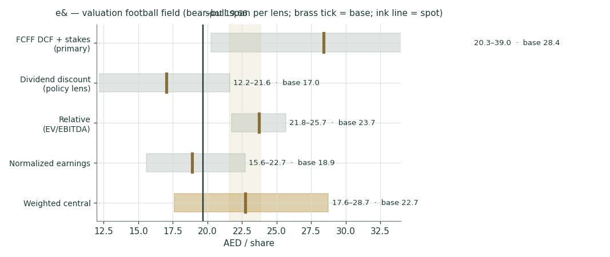
Figure 1 · The football field: each lens’s bear–bull span, its base (brass), spot (ink), and the weighted central band (gold).
The reading is asymmetric by construction. The two cash-mechanics lenses (DDM, normalized) straddle spot; the two enterprise lenses (DCF, relative-through-the-bridge) sit well above it. The weighted central of AED 22.72 says the market is paying for the dividend and giving the retained-earnings engine away at a discount — which is only true if the 2027 royalty regime, the NCI structure and the terminal economics resolve tolerably. That is why the crux section is the royalty, not the revenue line. The returns test agrees with the enterprise lenses: FY25 ROIC of ~12.7% against a 7.6% WACC is a +5.1pp spread — this is a value-creating capital base, not a utility earning its keep.
A structural note on the PTCL segment: PTCL Group completed its acquisition of Telenor Pakistan and Orion Towers on 31-Dec-2025, consolidating from Q1-2026 — after the FY23–FY25 window used for the segment baseline above. Q1-2026 PTCL revenue was +58.0% year-on-year reported (+2.9% like-for-like ex-Telenor) and EBITDA +132.7% reported (+44.5% like-for-like); the FY25 PTCL figures in this study are pre-acquisition and not directly comparable to FY26E onward. The PTCL NCI mark in the SOTP bridge is unaffected, since it is read directly off the PSX-listed market price, which already prices the deal. Separately, “Moov Africa” is Maroc Telecom Group’s brand for its West and Central African mobile subsidiaries (Burkina Faso, Togo, Niger, Mali, Benin and others) — already inside the Maroc Telecom (MT) segment above, not a separate consolidated entity.
1.6 The drivers — sourcing gate first, then the build
Every forecast driver passes a sourcing gate before it is used: bottom-up only where the research produced a disclosed figure or a dated market quote; top-down, and flagged as such, everywhere else. The full research register closes Appendix B.
Driver | Mode | Justification | Register ref.
FY26E revenue growth (+8.5% rep.) | bottom-up (guidance) | FY26 guidance +8-10% cc; Q1 +11.3% cc | Company/Guidance
FY27-30E revenue growth (3.0-3.5%) | top-down | sector CAGR 3-4% (industry ring); no multi-year guidance | Industry/Demand
EBITDA margin path 42.4->43.6% | bottom-up (guidance+segments) | EBITDA +4-5% cc guide; Careem-drag removal; segment table | Company/Guidance + One-offs
Royalty+tax t_eff 36.5% (43.6% UAE / 27% intl) | bottom-up (regime) | disclosed 38%+9% regime + segment EBIT split; 2027 reset sensitised | Country/Regulatory
Capex 17.5->16.0% all-in | bottom-up (guidance) | 16-17% ex-spectrum guide + spectrum allowance | Company/Guidance
Stake marks (VOD deal / Mobily / IAM / PTCL) | bottom-up (market quotes) | named transactions verified; dated quotes | Company/Ownership
WACC inputs (rf 4.30 / ERP 4.87 / beta 1.0) | bottom-up (sourced) | MoF auction; Damodaran original; beta fallback documented | Country/Sovereign + Global/Rates
Terminal g 2.5% | top-down | UAE inflation ~2% + modest real; house view, sensitised | Country/Sovereign

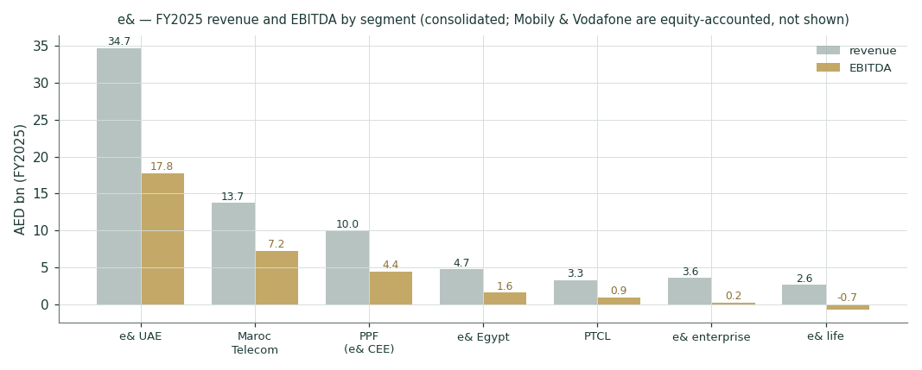
Figure 2 · FY2025 revenue and EBITDA by segment (AED bn). The UAE is half the revenue and well over half the profit pool; Mobily and Vodafone sit outside the bars as associates.
The forecast in driver terms:
Driver | FY26E | FY27E | FY28E | FY29E | FY30E
Revenue growth | 9.0% | 3.5% | 3.5% | 3.2% | 3.0%
EBITDA margin | 43.0% | 43.2% | 43.4% | 43.6% | 43.8%
D&A % revenue | 14.6% | 14.3% | 14.0% | 13.7% | 13.5%
Capex % revenue (all-in) | 17.3% | 16.9% | 16.5% | 16.2% | 16.0%
Royalty+tax on EBIT (t_eff) | 36.5% | 36.5% | 36.5% | 36.5% | 36.5%
DPS (AED) | 0.95 | 0.99 | 1.03 | 1.07 | 1.11

UAE growth is held to low single digits deliberately: du is gaining mobile share (~35%, subscribers +10.8% y/y) and e&’s blended UAE mobile ARPU drifted from 80 to 76 through 2025 — the research register’s named-competitor finding, and the reason no share-gain assumption appears anywhere in the build.
The telco dashboard — the operating measures that distinguish a telecom read from a generic industrial one:
Operating KPI | Value | Reading
Subscribers — group / UAE | 244.7 mn (FY25) / 16.6 mn (Q1-26) | scale is EM-wide; the profit pool is domestic
UAE blended mobile ARPU | AED 76 (Q4-25) vs 80 (Q4-24) | mild drift — competition, not a price war
UAE fixed ARPL | AED 466 (Q4-25) | premium fixed base intact
Competitor pulse (du) | 9.7 mn mobile (+10.8% y/y) | the reason UAE growth is modelled low-single-digit
OpFCF (EBITDA − capex), FY25 | AED 18,354 mn | UAE alone is 80% of it
OpFCF margin path FY26E→30E | 26% → 26% → 27% → 27% → 28% | capex fade does the work
ROIC vs WACC (FY25) | 12.7% vs 7.6% | +5.1pp spread — value-creating
ROE — reported / ex-one-offs | 27.8% / 22.0% | high-20s flatters; low-20s is the run-rate
Interest cover (EBITDA / gross interest) | 9.9× | ample
Leverage — plain / incl. PPF put | 0.91× / 1.27× | the honest number is the adjusted one
FCF yield — trailing / FY26E attributable | 7.2% / 5.7% | funds the 4.8% dividend with room
Payout on FCF (FY25) | 65% | policy is cash-covered, not accounting-covered

OpFCF by segment, FY2025 — where the cash conversion actually lives:
Segment | EBITDA | Capex | OpFCF | Conversion
e& UAE | 17,772 | 3,118 | 14,654 | 82%
Maroc Telecom | 7,250 | 4,324 | 2,926 | 40%
PPF / e& CEE | 4,433 | 2,955 | 1,478 | 33%
e& Egypt | 1,570 | 1,594 | -24 | -2%
PTCL | 938 | 705 | 233 | 25%
Group (incl. other) | 32,022 | 13,668 | 18,354 | 57%

The table is the conglomerate argument in miniature: Maroc Telecom converts 40% of EBITDA to cash and nearly half of that belongs to minorities; Egypt’s FY25 build cycle consumed its entire EBITDA; the UAE converts 82% and all of it is e&’s. Measures the disclosure does not support — churn, acquisition cost, per-opco ARPU, and the lease-adjusted (after-lease) EBITDA split — are flagged rather than estimated.
1.7 The crux — the 2027 royalty reset, in real units
Since 2012 the UAE federal royalty has been the single largest claim on e&’s domestic profit. The current guidelines — 38% of UAE net profit (regulated and non-regulated alike), deductible against the 9% corporate tax, with a combined floor of AED 5.7 bn a year — expire on 31 December 2026, and nothing about 2027 has been announced. Each combination implies a different UAE effective rate: at 38% the combined take is 43.6% of UAE profit; the group-level t_eff blends that with ~27% internationally to 36.5%. The table prices the reset directly:
2027+ royalty rate | t_eff (group) | DCF value (AED/sh) | Δ vs base | Reading
30% | 32.3% | 30.67 | +2.29 | aligned toward CT-era logic
34% | 34.4% | 29.53 | +1.14 | aligned toward CT-era logic
38% | 36.5% | 28.38 | +0.00 | current regime rolled
42% | 38.5% | 27.24 | -1.14 | broadened / raised
46% | 40.6% | 26.09 | -2.29 | broadened / raised

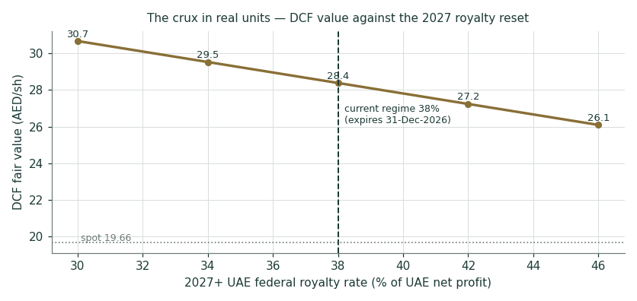
Figure 3 · The crux line: DCF fair value against the 2027 royalty rate. Four points of royalty ≈ AED 1.1 per share.
The second real-units test is dividend cover, because the Vodafone proceeds have raised expectations of a payout step-up: at the guided 95 fils the bill is AED 8.3 bn.
FY26E capex intensity | Attributable FCF (AED bn) | Dividend bill (AED bn) | Cover
16.0% | 11.1 | 8.3 | 1.35×
17.3% (base FY26E all-in) | 10.3 | 8.3 | 1.24×
19.0% (stress) | 9.1 | 8.3 | 1.10×

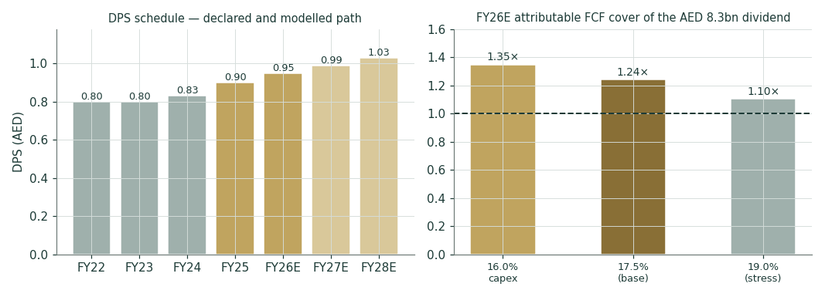
Figure 4 · The DPS schedule (declared, then modelled) and FY26E cover under three capex intensities. Cover holds above 1.0× even at the 19% stress — before any Vodafone proceeds.
1.8 Macro and country — rates, the peg, the neighbourhood, and the sourced cost of capital
The AED peg makes UAE rates a USD derivative: the CBUAE base rate tracks the Fed (3.65%, held 17-Jun-2026 — this is also the Monte Carlo’s carry-rf, per the production UAE market profile), 3-month EIBOR prints 3.93% (6-Jul, a related money-market reference used in the debt-cost build, not the MC carry), and the Ministry of Finance’s dirham T-bond programme — the study’s DCF/WACC risk-free source — cleared its Jan-2031 tranche at 4.30% on 23 May, within 14bp of comparable Treasuries even as the regional escalation that began in late February ran through the spring. e&’s own Q1 filings note the March impact (enterprise corporate spend −2.4% q/q) and the normalisation since; the study treats a re-escalation as a priced discrete factor, not a base-case assumption. On the fiscal side the 9% corporate tax (2024) and the 15% DMTT (2025) are already in the numbers; the royalty is the open question and has its own section.
Sourced market input | Value | Date | Source
CBUAE Base Rate (MC carry-rf) | 3.65% | 17-Jun-26 | production UAE market profile
3M EIBOR (debt-cost reference only) | 3.93% | 6-Jul-26 | CBUAE via TradingEconomics
AED T-Bond Jan-2031 YTM (DCF rf) | 4.30% | 23-May-26 | UAE MoF auction release
UAE ERP — rating basis | 4.87% | 5-Jan-26 | Damodaran original country-risk file (Aa2)
Abu Dhabi ERP — CDS basis | 4.93% | 5-Jan-26 | same file; no UAE-federal CDS
Mobily mark | SAR 59.70 | 6-Jul-26 | Tadawul close (PitchBook)
Maroc Telecom mark | MAD 91.90 | 1-Jul-26 | BMCE Capital Bourse
PTCL market cap | PKR 377bn | Jul-26 | PSX (TradingView)
Vodafone deal | 112.5p / AED 21.8bn | 10-Jul-26 | e& announcement (AGBI, Reuters)

1.9 Sensitivity — the rate, the growth, the margin, the capex, and the beta
WACC \ g | 1.50% | 2.00% | 2.50% | 3.00% | 3.50%
6.62% | 29.46 | 32.28 | 35.79 | 40.26 | 46.17
7.12% | 26.64 | 28.92 | 31.69 | 35.13 | 39.52
7.62% | 24.28 | 26.15 | 28.38 | 31.10 | 34.48
8.12% | 22.28 | 23.84 | 25.67 | 27.87 | 30.53
8.62% | 20.56 | 21.87 | 23.40 | 25.20 | 27.36

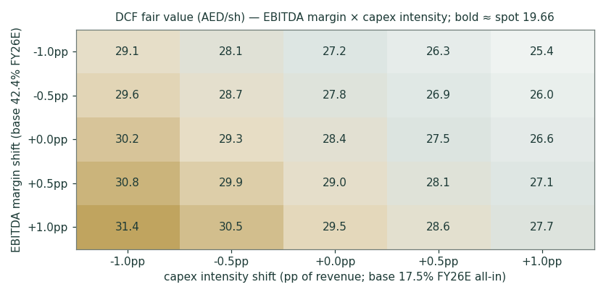
Figure 5 · DCF value across EBITDA margin × capex intensity; bold cells bracket spot.
Beta | Ke | WACC | DCF (AED/sh)
0.8 | 8.20% | 6.92% | 33.22
0.9 | 8.68% | 7.27% | 30.63
1.0 | 9.17% | 7.62% | 28.38
1.1 | 9.66% | 7.97% | 26.43
1.2 | 10.14% | 8.32% | 24.71
1.3 | 10.63% | 8.67% | 23.19

The beta row is the honesty tax for an assumed 1.0: even at 1.3 — a beta e&’s realised volatility does not support — the DCF stays above spot; at 0.8 it runs past AED 33. The valuation’s rate sensitivity is real but it is the royalty and terminal-growth cells that move the verdict.
2 Technical and price structure
Indicator | Value | Reading
Price vs SMA 20 / 50 | 19.43 / 18.99 | above both — the spring uptrend is intact
Price vs SMA 100 / 200 | 19.33 / 19.09 | above both — the stack is fully bullish-ordered
RSI (14) | 58 | warm but not overbought
MACD (12,26,9) | 0.195 / 0.182 / +0.013 | positive histogram — bullish momentum, flattening
52-week range | 17.40 – 21.60 | spot sits 54% up the range
Move 20d / 60d / 252d | +8.0% / -1.1% / +12.3% | steady grind higher over the year
Realised vol (252d) | 22.3% | low-vol regime versus the 2022–24 de-rating years

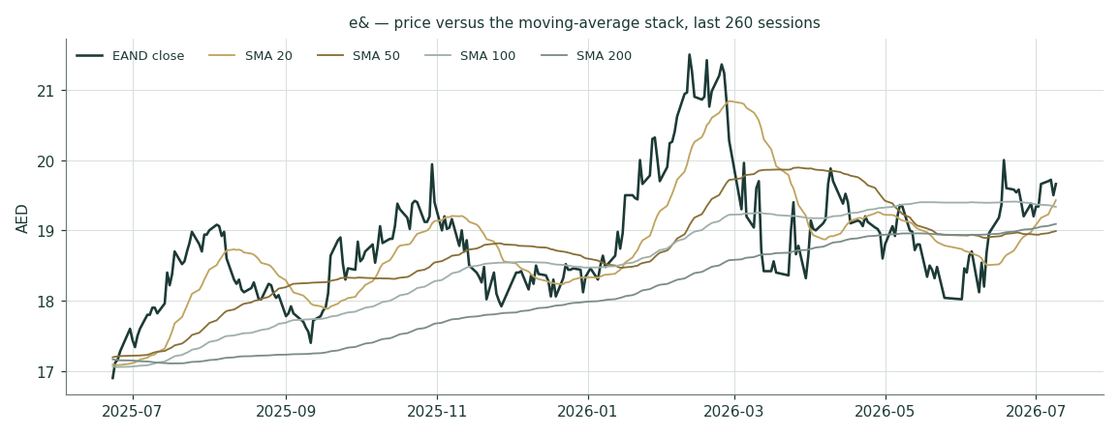
Figure 6 · Price against the moving-average stack, last 260 sessions. The 9-Jul close pre-dates the Vodafone announcement.
Structure: the moving-average stack is fully bullish-ordered (price above the 20/50/100/200-day averages), with the 52-week range at 17.40–21.60 — spot sits 54% up that range. The 20-day (AED 19.43) and 50-day (AED 18.99) averages are the near supports; the 52-week high at 21.60 is the overhead reference. The technical read is constructive but not extended into an event tape: the Vodafone announcement lands one session after the anchor close.
3 Monte Carlo — a probabilistic price map
The probability read, before anything else:
Question | Answer
P(price above spot at T+60)? | 54.5%
P(≥ +10%) vs P(≤ −10%) — the odds | 17.8% vs 11.6% → odds 1.53
Median path | AED 19.86 (+1.0%)
The 50% band (25th–75th) | 18.68 – 21.09 (-5.0% / +7.3%)
Touch ±10% anytime within T+60 | up 31% / down 22%

Where the centre comes from, in one line: expected total return ≈ the 3.65% CBUAE Base Rate, and about 4.8 points of it is delivered as the dividend — so the price-only centre sits essentially flat (-0.27% per quarter) before the event ledger adds +1.00%.
Engine. Carry-anchored YZ-HAR with a Student-t(4) shape and a 1.07 width calibration — the production fit for the UAE market, estimated 10-Jul-2026 on a 10-name ADX/DFM panel (ADCB, FAB, ENBD, Emaar, Emaar Development, Aldar, ADNOC Gas, Agthia, IHC, Alpha Dhabi) and applied to e& as a name joining an already-fitted market, per the standing per-market-fit rule — rather than a fresh single-name self-fit. A diagnostic replay of e&’s own five-year tape under these parameters lands at CRPS skill −2.0%, closely tracking the panel-level −2.1%: this name behaves like the market it belongs to. 50,000 paths, 60 sessions, seed 42. The gap-aware Yang-Zhang variance proxy feeds a HAR forecast (daily/weekly/monthly lags); the drift is the sourced AED carry (CBUAE Base Rate less the forward dividend yield), never a view. Independence note: the fundamental value gap of §1 does not enter the Monte Carlo drift — if it did, the cone would just restate the DCF. Verdict: PARITY at both the panel and the name level, robust across bootstrap specifications — the engine is market-validated with no single-name edge claimed; the full backtest is published, pass or fail, on the public Calibration Ledger rather than in this document.
The seven continuous forces (tilt, not certainty):
# | Force | Sign
1 | Fed/CBUAE rate path (easing bias into 2027) | +
2 | UAE non-oil GDP, population & tourism growth | +
3 | UAE mobile competition (du share gains, ARPU drift) | −
4 | EUR/PKR/MAD translation on international revenue | ±
5 | International opco margin trajectory (PPF, Egypt, PTCL) | +
6 | Enterprise/AI & e& life normalisation post-Careem | ±
7 | Index flows / 40% free float (EIA 60% anchor) | ±

The nine discrete events (probability-weighted jumps):
# | Event | P | Impact
1 | Vodafone sale completes (regulatory clearances) | 75% | +0.8%
2 | Vodafone sale delayed or blocked | 10% | -1.5%
3 | 2Q26 results (~late Jul 2026) | 90% | +0.4%
4 | Special dividend / payout step-up from VOD proceeds | 15% | +1.5%
5 | Careem deconsolidation completes (Uber deal close) | 70% | +0.3%
6 | 2027+ royalty regime set at or below 38% (favourable) | 25% | +1.0%
7 | 2027+ royalty regime adverse (higher rate / wider base) | 15% | -1.8%
8 | Regional geopolitical re-escalation | 25% | -2.0%
9 | Fed/CBUAE cut >=25bp (Sep/Oct FOMC) | 55% | +0.5%

Net event-ledger drift: +1.00% per quarter — the announced Vodafone crystallisation and the payout step-up possibility skew the ledger mildly positive; the 2027 royalty tail and a regional re-escalation are the offsetting downside masses.
Percentile map (AED/share)
Percentile | T+20 | T+60 | move at T+60
5th | 17.84 | 16.70 | -15.0%
25th | 19.05 | 18.68 | -5.0%
50th | 19.72 | 19.86 | 1.0%
75th | 20.43 | 21.09 | 7.3%
95th | 21.81 | 23.59 | 20.0%

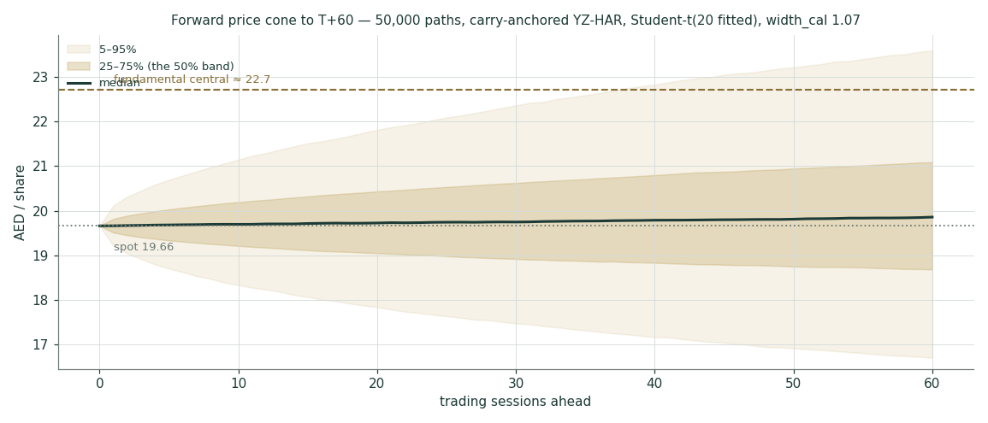
Figure 7 · The forward cone to T+60: 5–95% and the 50% band, median in ink, the fundamental central in brass — deliberately outside the cone’s centre, because the engine does not carry it.
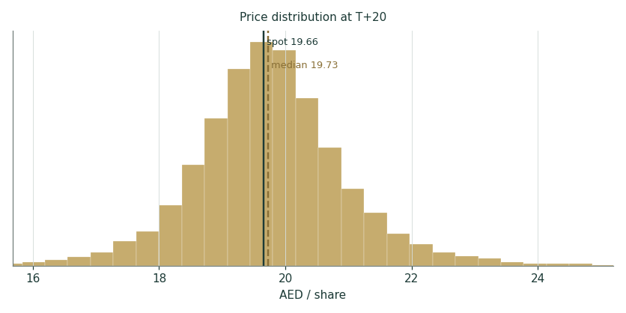
Figure 8 · The T+20 distribution.
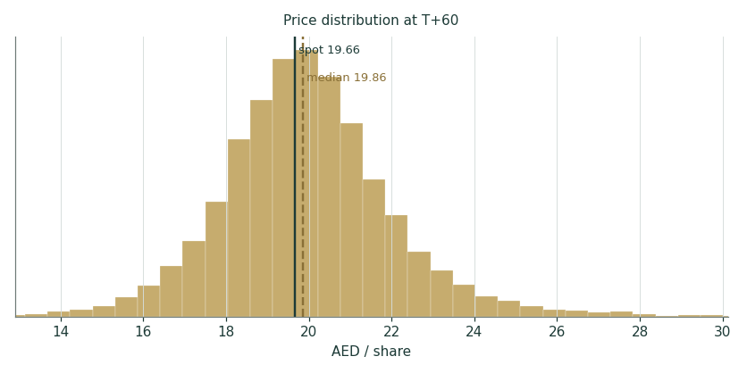
Figure 9 · The T+60 distribution — right-shifted mass from the event ledger, fat left tail from the royalty/geopolitics factors.
Level-touch ladder
Level | vs spot | P(touch by T+20) | P(touch by T+60)
AED 23 | 17.0% | 2% | 13%
AED 22 | 11.9% | 6% | 24%
AED 21 | 6.8% | 21% | 46%
AED 20 | 1.7% | 66% | 81%
AED 19 | -3.4% | 42% | 62%
AED 18 | -8.4% | 10% | 28%
AED 17 | -13.5% | 3% | 12%
AED 16 | -18.6% | 1% | 5%

4 Comparison of the lenses, and a verdict
Three clocks, kept deliberately separate. The 60-session clock is the Monte Carlo’s: essentially flat centre, 54.5% above spot, odds 1.53 on ±10% — an event tape (Vodafone approvals, Q2 results, the payout question) around a money-market carry. The ~12-month clock is the weighted fundamental central of AED 22.72: about 15.5% above spot, earned only as the royalty reset, the Careem/Vodafone completions and the FY26 guidance land. The multi-year clock is the DCF’s 28.38 — a statement about terminal franchise economics (TV 79% of EV), a ceiling to grow into, not a target to trade to.
Clock | Figure | What it is | What it is not
T+60 sessions | median 19.86 · 50% band 18.68–21.09 | calibrated price probabilities | a forecast of the news
~12 months | central 22.72 (17.61–28.75) | risk-adjusted fair-value range | a price target
Multi-year | DCF 28.38 | terminal-economics ceiling | a 2026 expectation

Verdict, in the house’s only permitted form: the distribution says modestly undervalued with the value locked behind a policy decision — a fair-value range of roughly AED 17–28 with its weight at ~22.5, against a market at 19.66 that is, in effect, paying for the dividend and taking the royalty reset as a coin-flip.
5 Catalysts to watch
When | Event | Why it matters
Late Jul 2026 | Q2-2026 results | first read on guidance pace and the enterprise-segment normalisation
H2 2026 | Vodafone sale regulatory clearances | crystallises AED 21.8bn gross / ~4.7bn net; removes an equity-market overhang
H2 2026 | Careem–Uber completion | deconsolidates the e& life drag; ~30bp margin accretion built into FY27E
By 31 Dec 2026 | The 2027+ royalty regime | the crux: ±4pp of royalty ≈ ±AED 1.1/share of DCF value
Feb–Mar 2027 | FY26 results + DPS declaration | tests the 95-fils guide and any proceeds-funded step-up
Ongoing | CBUAE/Fed path; regional tape | the carry anchor and the priced tail both move with these

6 Reading the probability zones
Zone (AED at T+60) | Probability | The world in which it happens
below 17.00 | 6.3% | royalty shock or regional re-escalation; the left tail is policy, not operations
17.00–18.50 | 15.6% | deal delays plus a soft Q2; the spring shelf gives way
18.50–20.50 | 42.4% | the base world: guidance on track, approvals pending, carry does the work
20.50–22.00 | 21.8% | Vodafone clears early and the payout conversation starts
above 22.00 | 14.0% | clearance plus a favourable royalty signal — the two rights together

7 Caveats and what would change our mind
Named, dated, falsifiable:
# | Trigger | Consequence for this study
1 | The 2027 royalty regime lands above 42% or broadens the base (announcement due by year-end) | base t_eff and the DCF re-cut; the central falls toward the 17s
2 | The Vodafone sale is blocked or repriced below ~100p | bridge reverts to the undisturbed mark (−AED 2.7bn) and the deleveraging thesis stalls
3 | Q2/Q3-26 EBITDA margin prints below ~41% reported | the guidance-anchored margin glide fails; FY26E EBITDA and every lens re-base
4 | du’s mobile share passes ~38% or a price war starts | the low-single-digit UAE growth assumption becomes optimistic, not conservative
5 | FY26 DPS declared below 95 fils | the policy lens and the payout-step-up factor were wrong; DDM re-anchors lower
6 | UAE 5-yr yields move ±100bp from 4.30% | WACC grid: the value range shifts ≈ ∓AED 4/share at the DCF lens

Structural caveats: e& is not yet a constituent of the 10-name UAE panel used to fit the Monte Carlo (ν=4, width 1.07) — it inherits the market-level fit rather than contributing its own name-level backtest to it; that changes at the next panel refit. The Egypt and Careem NCI marks are estimates, flagged where they appear; the beta is assumed at 1.0 with the grid published; and FY23 royalty-era comparatives pre-date the 2024 presentation restatement. None of these is hidden in a footnote — each appears where it bites.
Appendix A Financial statements
Historicals are e&’s own disclosure (earnings releases; FY25 audited FS; Q1-26 interim FS). FY23 rows marked n/d precede the 2024 restatement that moved the federal royalty below operating profit. The forecast columns reproduce the model’s income-statement presentation (ETR 39.5% on PBT, NCI 11.5%) — the valuation itself taxes EBIT at the explicit 36.5% t_eff of §1.7.
A.1 Income statement — 3-year historical + 5-year forecast (consolidated, AED mn)
AED mn | FY23 | FY24 | FY25 | FY26E | FY27E | FY28E | FY29E | FY30E
Revenue | 53,752 | 59,203 | 72,858 | 79,415 | 82,195 | 85,072 | 87,794 | 90,428
EBITDA | 26,117 | 26,454 | 32,022 | 34,149 | 35,508 | 36,921 | 38,278 | 39,607
EBITDA margin | 48.6% | 44.7% | 44.0% | 43.0% | 43.2% | 43.4% | 43.6% | 43.8%
D&A | (7,569) | (7,313) | (10,672) | (11,595) | (11,754) | (11,910) | (12,028) | (12,208)
Share of associates & JVs | n/d | 2,475 | 1,948 | 1,200 | 1,200 | 1,200 | 1,200 | 1,200
Impairment / FX / other | n/d | (1,555) | (55) | — | — | — | — | —
Operating profit before royalty | n/d | 20,061 | 23,241 | 23,754 | 24,954 | 26,211 | 27,450 | 28,600
Net finance + tax (actual residual) | n/d | -4,196 | 339
Net finance income/(cost) — fcst |  |  |  | -850 | -722 | -614 | -522 | -444
Royalty + income tax — fcst |  |  |  | (9,047) | (9,572) | (10,111) | (10,637) | (11,122)
memo: federal royalty (actual) | n/d | (5,282) | (7,423)
Profit for the period | n/d | 10,583 | 16,156 | 13,857 | 14,660 | 15,486 | 16,292 | 17,034
Net profit attributable | 10,305 | 10,752 | 14,360 | 12,263 | 12,974 | 13,705 | 14,418 | 15,075
EPS (AED) | 1.18 | 1.24 | 1.65 | 1.41 | 1.49 | 1.58 | 1.66 | 1.73
EPS ex-one-offs |  |  | 1.31

A.2 Balance sheet — condensed house layout (consolidated, AED mn)
AED mn | Dec-23 | Dec-24 | Dec-25 | Mar-26
Cash & bank balances | 28,989 | 33,628 | 34,308 | 36,782
Term deposits (amortised cost) | n/d | n/d | 10,425 | 10,765
Goodwill | n/d | 24,955 | 30,068 | 30,068
Associates & JVs (incl. Vodafone, Mobily) | n/d | n/d | 21,128 | 20,885
Total assets | 147,613 | 183,327 | 205,059 | 207,682
Total borrowings | 49,041 | 69,195 | 67,639 | 66,574
Net debt | 20,051 | 35,567 | 33,331 | 29,792
PPF NCI put liability | n/d | 8,098 | 11,658 | 11,658
Federal royalty payable | n/d | n/d | 9,053 | 9,287
Equity attributable to owners | n/d | 45,601 | 51,708 | 50,488
Non-controlling interests | n/d | 8,320 | 10,055 | 9,369
Total equity | 51,710 | 53,920 | 61,763 | 59,857

Debt currency mix (FY25 release): AED 48% · EUR 33% · PKR 7% · MAD 3% · other 9%. The Dec-24 step-up is the PPF consolidation; Apr-26 refinancing replaced a EUR 1.2bn Jun-26 bond with an AED 5.3bn 5-yr facility and extended AED 16.2bn to Apr-27.
A.3 Cash flow, the FCF framings, and the DPS schedule
AED mn | FY23 | FY24 | FY25
Net cash from operating activities | 15,206 | 21,733 | 26,051
federal royalty paid (within operating) | n/d | (6,328) | (5,274)
Net cash used in investing | (8,738) | (15,766) | (8,386)
capex incl. licences / ex-licences | n/d | (9,507) / (8,206) | (13,668) / (11,200)
Khazna 40% proceeds |  |  | 8,009
Net cash from/(used in) financing | (10,599) | 392 | (17,185)
dividends paid to owners | n/d | n/d | (8,092)
Simple FCF (operating − capex incl. lic.) | n/d | 12,226 | 12,383

DPS (AED) | FY22 | FY23 | FY24 | FY25 | FY26E | FY27E | FY28E
Declared / modelled | 0.80 | 0.80 | 0.83 | 0.90 | 0.95 (guided) | 0.99 | 1.03
Payout on clean EPS | — | 68% | 67% | 69% | ~70% | ~70% | ~70%

Two FCF framings, both stated: simple FCF (operating minus all-in capex) ran AED 12.2–12.4bn in FY24–25; the attributable framing used for dividend cover haircuts ~15% for the NCI share and gives ~AED 9.8bn at FY26E base capex — 1.19× the 8.3bn dividend bill.
Appendix B Peer set, sector structure, risks — and the research register
B.1 Peers and the sector frame
Name | Mkt cap (AED bn) | EV/EBITDA fwd | P/E fwd | Yield | Note
e& (EAND) — this study | 171.0 | 7.0× | 14.6× | 4.8% | at spot 19.66
stc (Tadawul 7010) | 218 | 7.5× | 15.5× | 4.0% | GCC incumbent benchmark
du / EITC (DFM) | 46.6 | 6.3× | 14.0× | 5.2% | the UAE duopoly peer
Zain Group (KW) | 20.5 | 5.5× | 12.0× | 6.5% | aggregator est., flagged
Ooredoo (QSE) | 42 | 5.8× | 11.5× | 5.5% | aggregator est., flagged
Maroc Telecom (IAM) | 32.3 | 5.5× | 11.6× | 4.4% | e& holds 53%
Mobily (Tadawul 7020) | 44.8 | 7.8× | 16.0× | 3.0% | e& holds 28.0%

Sector structure: a regulated duopoly capturing 97.5% of UAE sector revenue (AED 50bn+, growing ~3–4%), quality-led competition, both operators deep into 5G-Advanced. e&’s multiple sits, correctly, between the pure-duopoly and the EM-holdings reads.
B.2 Risk register
Risk | Direction | Where it is priced
2027 royalty reset adverse | valuation | §1.7 grid; discrete factor 15% / −1.8%
Vodafone deal blocked/delayed | event | bridge dual-frame; discrete factor 10% / −1.5%
Regional geopolitical re-escalation | macro tail | discrete factor 25% / −2.0%; §1.8
du share gains accelerate | operating | UAE growth held to low-single-digit; falsifier #4
FX translation (EUR/PKR/MAD) | reported numbers | continuous factor; Kd currency build
PPF integration / CEE regulation | operating | margin glide kept modest; PPF put already a liability
Rate path higher-for-longer | valuation | WACC grid §1.9; MC carry moves with CBUAE Base Rate

B.3 The research register — four layers, dated, negative searches included
Coverage is categories closed, never query count. B = base-changer · S = structural · D = driver-unlock · C = colour. The register validated PASS (17 rows; FS provenance company-official only).
Layer | Category | Class | Finding (condensed) | Source | Date
Global | Rate cycle / USD-FX | S | Fed range 3.25-3.50% after the Jun-2026 cut; CBUAE Base Rate tracks IORB (3.65%, held 17-Jun-2026) -- this is the production engine's carry-rf, per the fitted UAE market profile (engine/market_profiles.py). … | CBUAE Base Rate via production UAE market profile; FOMC path… | 2026-07-10
Global | Commodity complex | C | No direct input/output commodity exposure for a telecom; oil only via UAE fiscal impulse (country ring). No driver change. | negative search (scope review) | 2026-07-10
Global | Global sector demand | C | Global telecom demand steady; data/AI traffic growth; sector multiples 6-8x EV/EBITDA. Feeds the relative-lens band only. | peer set review (STC/du/Zain quotes) | 2026-07-10
Global | Trade / sanctions / supply chain | C | EU anti-subsidy probe of the PPF deal (2024) resolved via commitments incl. independence from EIA financing; no new trade action found. | AGBI / EC decision Sep-2024; negative search for 2026 update… | 2026-07-10
Country | Sovereign macro | C | UAE Aa2 stable; AED T-bond auctions continued through the regional escalation at <=14bp spreads over UST (May-2026 auction: Sep-27 4.03%, Jan-31 4.30%). Non-oil growth solid. | UAE MoF auction releases Jan/Mar/May-2026 | 2026-05-23
Country | Regulatory - royalty & tax | S | Royalty Guidelines 3-Nov-2023 for 2024-2026: 38% of UAE (regulated + non-regulated) net profit, deductible for 9% CT; floor royalty+tax AED 5.7bn/yr; excludes international and NCI profit. REGIME EXPIRES 31-… | e& Q1-2026 interim FS Note 6 (EY-reviewed) | 2026-04-28
Country | Fiscal / political events | S | Regional geopolitical tensions from end-Feb-2026 impacted the UAE operating environment in Mar-2026 (enterprise corporate spend -2.4% q/q); 'transitioning toward normalised conditions' by Apr. Consequence: a… | e& Q1-2026 FS Note 24 + earnings release; UAE MoF 'regional … | 2026-04-28
Industry | Demand / capacity | C | UAE telecom market AED 50bn+ revenue (2024), duopoly 97.5% of sector revenue, sector CAGR ~3-4%; quality-led (not price-led) competition. | du IR; Mordor/GlobalData country reports | 2026-01-08
Industry | Pricing | C | e& UAE blended mobile ARPU 76 (Q4-25) vs 80 (Q4-24): mild drift, no price war. Feeds the low-single-digit UAE growth driver. | e& Q4-2025 results presentation | 2026-02-24
Industry | Competitive structure (named) | S | du: H1-25 revenue +8%, EBITDA +16% (47% margin), mobile subs 9.7mn (~35% share) and gaining; Alo sub-brand. Consequence: UAE segment growth held at low-single-digit and margin flat (no share-gain assumption … | du IR H1-2025; Forbes ME via gohub review | 2026-04-14
Industry | Technology substitution / entrants | C | No third MNO; 5G-A deployed by both; satellite/OTT substitution unchanged. Negative search for new-entrant licensing. | TDRA structure review; negative search | 2026-07-10
Company | Official financial statements | D | FY2023-FY2025 + Q1-2026 statements captured from e& releases and EY-audited/reviewed FS: FY25 revenue 72,858 / EBITDA 32,022 / OP before royalty 23,240.7 / royalty 7,423 (Q-sum) / NP att 14,360.2; Q1-26 BS: … | eand.com earnings releases Q1-24/Q4-24/Q2-25/Q4-25/Q1-26; FY… | 2026-04-28
Company | One-off / base-resetting transactions | B | VODAFONE FULL EXIT announced 10-Jul-2026 (study date): 3,944.7mn shares (16.21% issued / 17.13% voting) to Vega (Niel) at 112.5p incl. 2.02p final div ~= AED 21.8bn gross, ~AED 4.7bn net cash after unwinding… | e& / ADX announcement; AGBI, Reuters coverage | 2026-07-10
Company | One-off transactions (cont.) | B | CAREEM: 1-Jun-2026, e& sells 12.5pp of Careem Technologies to Uber for USD 100mn (50.03% -> 37.53%); put/call on remainder Dec-2031/Jan-2032; moves to equity accounting on completion. Consequence: e& life de… | e& Q1-26 FS Note 15/22; Q1-25 FS (Khazna) | 2026-06-01
Company | Guidance / strategic plan | D | FY26 guidance: revenue +8-10% cc, EBITDA +4-5% cc, EPS ~1.35, capex/rev ex-spectrum 16-17%; Q1-26 tracking (+11.3%/+12.3% cc). Consequence: FY26E drivers anchored to guidance (bottom-up gate: guidance-sourced). | e& Q1-2026 earnings release | 2026-04-28
Company | Ownership / stake changes (named-transaction rule) | D | Vodafone 15.01%->16.6113% (Dec-25) -> 17.0866% voting (Mar-26) via VOD buyback accretion, then full exit (above). Mobily 28.0% (2004 licence consortium; 50%+1 tender terminated 2023) marked at SAR 59.70 (6-J… | e& releases; PitchBook/TradingView/BMCE quotes; Wikipedia st… | 2026-07-10
Company | Management & capital actions | C | CEO change: Dowidar -> Masood M. Sharif Mahmood 1-Apr-2026. DPS raised: FY25 86->90 fils (AGM 30-Mar-26), FY26 guided 95 fils. Apr-26 refi: AED 5.3bn 5yr facility + AED 16.2bn extended to Apr-2027. S&P ratin… | e& Q1-26 release/FS; Q4-25 presentation | 2026-04-28
Company | Q1-2026 results (post-anchor verification) | D | e& Q1-2026 earnings release (28-Apr-26): revenue AED 19,417mn (+15.1% rep./+11.3% cc) vs guide 8-10% cc; EBITDA AED 8,566mn (+16.5%, margin 44.1%); net profit AED 2,882mn (-46.2% rep., +3.9% ex-Khazna Q1-25 … | e& Q1-2026 Earnings Release, eand.com, 28-Apr-2026 | 2026-04-28
Company | Telenor Pakistan / Orion Towers consolidation | B | PTCL Group completed the acquisition of Telenor Pakistan and Orion Towers, closing 31-Dec-2025 and consolidating from 1-Jan-2026; the combined Ufone-Telenor entity (PTML) received Islamabad High Court amalga… | PTCL FY2025 results release (ptcl.com.pk, 24-Feb-2026); e& Q… | 2026-07-01

Appendix C The expert valuation panel
Three genuinely different valuation traditions, run independently and labeled Expert 1/2/3 so the methods — not personalities — carry the weight. Each states its method in full, shows the workings, quantifies the swing on its own weakest assumption in real units, says what it makes of today’s price, and names the observation that would prove it wrong. Then they argue: C.4 is the cross-examination, C.5 the room, C.6 the reading.
C.1 Expert 1 — earnings power: the guided EPS path at a justified multiple
The tradition. Expert 1 is the classicist: management guidance is the best single forecast until the company misses it, and the multiple the market pays for comparable earnings is revealed preference, not opinion. No terminal value, no balance-sheet re-marking — earnings, a multiple, and the discipline to change neither without evidence. For a dividend-anchored incumbent in a regulated duopoly, this is the method most GCC institutional desks actually run.
Item | Value | Basis
FY26E EPS anchor | 1.35 | company guidance (Feb-2026), reaffirmed at Q1
EPS path FY26E→FY30E | 1.35 / 1.41 / 1.47 / 1.52 / 1.57 | the model’s attributable-profit path (Appendix A.1)
Justified P/E (base) | 14× | GCC telecom band 12–16×; du ~14×, stc ~15.5×
Fair value (base) | AED 18.90 | 1.35 × 14
Range | 15.60 – 23.20 | 12× on 1.30 → 16× on 1.42

Sensitivity, in real units: each 1× of P/E moves the value AED 1.35; each 5 fils of EPS moves it AED 0.70. The full grid:
EPS \ P/E | 12× | 14× | 16×
1.30 | 15.60 | 18.20 | 20.80
1.35 (base) | 16.20 | 18.90 | 21.60
1.42 | 17.04 | 19.88 | 22.72

On today’s price: at 19.66 the market pays 14.6× the guided EPS — Expert 1 calls the stock fairly priced within ±5%, and assigns everything above that to methods that pay for options he refuses to price. Weakest assumption: the multiple itself — it embeds the royalty regime staying tolerable. Falsifier: FY26 EPS printing below ~1.25, or a DPS cut — either breaks the anchor, and with it the method.
C.2 Expert 2 — the accountant: owner cash earnings from the audited statements
The tradition. Expert 2 believes signed statements and nothing else: guidance is marketing, multiples are moods, but audited cash flow is evidence. The method rebuilds what an owner could actually have banked in FY2025 — operating cash flow, less the capex needed to stand still, corrected for the accrual games a royalty regime invites (e& expensed AED 7,423 mn of royalty but paid 5,274; the payable grew 2.1 bn — cash earnings must give that back) — then hands minorities their share and capitalises the remainder at a cash multiple.
Step | AED mn
Operating cash flow (FY25, audited) | 26,051
− maintenance capex (≈ D&A per the cash-flow statement) | (10,783)
− royalty accrual catch-up (expensed − paid) | (2,149)
= owner cash earnings, 100% basis | 13,119
× attributable share 85% | 11,151
÷ 8,696.8 mn shares × 13.5× cash multiple | AED 17.31

Sensitivity, in real units — the two dials this method owns:
Attributable share | 80% | 85% (base) | 90%
Value (AED/sh) | 16.29 | 17.31 | 18.33
Cash multiple | 11.5× | 13.5× (base) | 15.0×
Value (AED/sh) | 14.75 | 17.31 | 19.23

On today’s price: spot sits about AED 2.4 above his 17.31 — the market is pre-paying roughly two turns of cash-earnings multiple for the Vodafone proceeds and the royalty option. Not egregious; not free. Weakest assumption: the 85% attributable haircut — minority cash entitlement is lumpy, and Maroc Telecom’s dividend policy is not e&’s to set. Falsifier: FY26 royalty paid exceeding royalty expensed (the catch-up reversing) while operating cash flow stalls below AED 24 bn — that combination would mean the cash engine, not the accruals, was the flattering item.
C.3 Expert 3 — macro-policy: pricing the regime tree
The tradition. Expert 3 prices regimes, not line items: when the binding constraint on a valuation is a policy decision — here the 2027 royalty, with the Vodafone clearance and the regional tape as second-order — the honest method is to name the states, price the whole complex under each, and weight them. This is the only expert who pays anything today for the enterprise lenses’ view of the franchise, because it is the only method built to hold two futures at once.
Regime | P | What it does to the lenses | AED/sh
Benign: royalty <=38% signalled early, Vodafone clears, payout step-up, calm tape | 25% | DCF to bull (WACC -70bp, royalty relief); market lenses re-rate ~1x of EV/EBITDA | 38.64
Base: regime rolled late in the year, approvals grind through, guidance holds | 45% | all four lenses at base; the weighted central | 22.72
Adverse: royalty raised/broadened or regional re-escalation; deal delayed | 30% | DCF to bear (t_eff +3pp, WACC +100bp); multiples compress toward 6.0x/12x | 17.08
Probability-weighted value |  |  | 25.01

Sensitivity, in real units — the asymmetry is the finding: shifting 10 points of probability from base to the benign regime adds AED +1.59; the same shift to the adverse regime costs only -0.56. The good state is worth roughly three times more per probability point than the bad state costs, because a favourable royalty settlement re-rates every lens at once while an adverse one mostly re-cuts the DCF. Weakest assumption: the 45% base weight — policy timing is genuinely unknowable. On today’s price: spot is approximately this tree with the benign branch deleted — the market is assigning close to zero to the good-policy state. Falsifier: any official 2027 royalty communication; the tree collapses to one branch the day it prints.
C.4 Cross-examination
Expert 1 to the others: “You are both pricing things nobody has announced. The accountant’s attributable haircut is a guess wearing a green eyeshade, and the strategist’s benign regime is a press release that does not exist. The market has watched this royalty for a decade — 14× guided earnings IS the informed price of that history.”
Expert 2 to the others: “The classicist trusts an EPS guide issued by a management team whose reported number needed three one-off strips to become comparable, and the strategist’s tree pays today for cash that arrives, if ever, after 2027. My number is the only one built entirely from figures an auditor signed. If the truth is higher, it will show up in cash flow — and I will raise it then.”
Expert 3 to the others: “You are both extrapolating a regime whose expiry date is printed in the accounts. Pricing e& off current earnings or current cash flow through 31-Dec-2026 is precise about the past and silent about the only question that matters. My weights may be wrong; refusing to weight the states at all is not caution, it is a 100% bet on the status quo.”
C.5 The three in one room
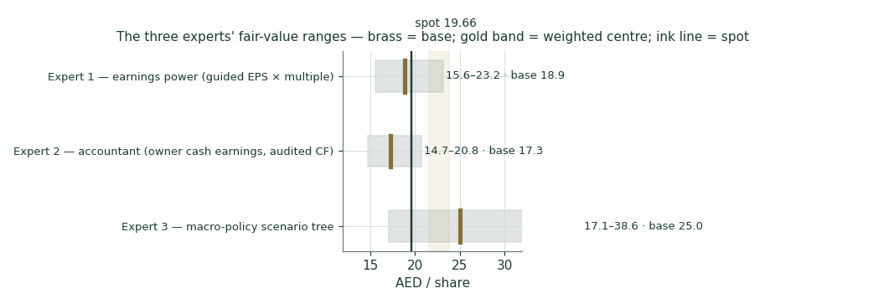
Figure 10 · The panel’s ranges against spot and the weighted central band.
Expert 1 (18.90) and Expert 2 (17.31) bracket spot from a dirham or two either side — one trusting guidance, one trusting audited cash — while Expert 3 (25.01) sits well above both, because the regime tree is the only method in the room that pays anything today for the franchise the enterprise lenses see. The panel’s spread IS the finding: on current earnings e& is roughly fairly priced; the premium is a claim about policy and terminal economics, not about next quarter. Note what did not happen: no expert lands below 14.7 even on bear settings — the downside cases are about paying too much for optionality, not about impairment of the operating franchise.
C.6 Reading the divergence
When the earnings-anchored experts cluster at spot and the policy method runs 25% higher, the market is not mispricing the P&L — it is charging an uncertainty toll on the royalty reset and the conglomerate structure. The toll shrinks on three visible gates: the royalty announcement, the Vodafone clearance, and the first proceeds-funded payout decision. Each gate has a date inside the next nine months; that is what makes this study’s central testable rather than theological. And the cross-examination cuts both ways: if the gates pass and the price does not move, Expert 1 was right and the toll was never mispriced — that outcome would be recorded on the public ledger like any other.
About this series
Testahil publishes independent, methodology-first valuation studies: fair-value ranges and probability distributions, never ratings or price targets. Every Monte-Carlo forecast is registered, graded on maturity (T+20 and T+60 cohorts), and published — pass or fail — on the public Calibration Ledger at testahil.com. Every forecast in this series is preceded by a five-year rolling backtest of the engine on the stock’s own history; this one recorded a parity verdict — calibrated and market-validated, with no single-name edge claimed — and is published under that tier. The cohort registered here matures 6-Aug-2026 (T+20) and 2-Oct-2026 (T+60).
Disclosure & Disclaimer
1. No advice. This document is educational analysis and personal opinion. It is not investment advice, a recommendation, an offer, or a solicitation to buy or sell any security, and it is not directed at the circumstances of any person.
2. No licence. The preparer is not licensed by the SCA, the FRA, or any other securities regulator, holds no advisory or brokerage authorisation, manages no client money, and accepts no fees or clients in connection with this work.
3. Sources. Company figures are e&’s own published disclosure (earnings releases, audited and reviewed financial statements); market data are dated quotes from the named venues and vendors. Errors are possible; the preparer corrects them publicly when found.
4. Judgments. All forecasts, drivers, multiples, probabilities and scenario weights are the preparer’s judgments, flagged as such, and will be wrong in ways that matter. Ranges and distributions are the only honest output format; no single number in this document is a prediction.
5. Risk. Securities involve risk of loss, including total loss. Past calibration performance — including the public ledger — does not guarantee future forecast quality. Consult a licensed financial advisor before any investment decision.
6. Positions. The preparer may hold, or may take, a position in the security discussed, and owes readers no duty to update this document. Publication date: 10 July 2026.

