Testahil · Independent Valuation Study — Educational Analysis | Not investment advice

Independent Valuation Study — Educational Analysis
Edita Food Industries S.A.E. (EGX: EFID)
Fundamental analysis · Technical analysis · Monte Carlo simulation — one integrated read
Anchor: EGP 27.34 (01 Jul 2026 close) · 1,400.04m shares · mkt cap ~EGP 38.3bn · EV ~EGP 37.4bn (net cash EGP 853m, 31-Mar-26) · Egypt’s leading packaged-snacks franchise — cakes, croissants, rusks, wafers, candy and biscuits under Molto, Todo, Bake Rolz, MiMix, Freska and the HoHos/Twinkies/Tiger Tail (HTT) brands, now owned across all of Africa · prices and probabilities computed 03 Jul 2026 from the attached daily history · primary lens: going-concern FCFF DCF with a segment gross-profit build · gross-margin durability through the next EGP move is the swing factor.
READ FIRST — what this document is, and is not. This study is a valuation exercise and an expression of personal analytical opinion, published free of charge for educational purposes: it shows how one analyst applies fundamental, technical and probabilistic methods to a listed company, and invites scrutiny of that methodology. It is NOT investment advice, NOT a recommendation or solicitation to buy, sell or hold any security, and NOT directed at the circumstances of any reader. The preparer is not licensed by the Egyptian Financial Regulatory Authority (FRA) or any other securities regulator in any jurisdiction, holds no brokerage authorisation, provides no financial consultancy, manages no money, and accepts no fees, funds or clients. See the Disclosure & Disclaimer at the end. All values are model outputs presented as ranges and distributions because no single number should be relied on. Reported financials are the company’s own disclosure (FY2025 earnings release, 11 Mar 2026; 1Q2026 release, 17 May 2026); forward-looking inputs — the growth and margin path, the multiples, the DCF and the Monte-Carlo factor probabilities — are the preparer’s judgments and are flagged throughout. A note on the share count: shareholders approved a capital action in September 2025 that doubled the share count to 1,400.04m; the attached price history is split-adjusted and all per-share figures in this study use the current count. Consult a licensed financial advisor before any investment decision.

Headline
The model’s read: fairly valued, with the distribution tilted slightly to the upside. At EGP 27.34 the shares sit essentially on top of our weighted central estimate of EGP 27.68 — a 1% gap that is noise, not signal. Beneath that flat surface the lenses genuinely disagree: the FCFF DCF (EGP 29.7) and the segment gross-profit build (EGP 30.1) see modest upside from a business compounding revenue at ~30% with ~19% EBITDA margins and a newly net-cash balance sheet, while the normalized-earnings read (EGP 26.7) and especially the dividend-discount sanity check (EGP 16.5) remind you how expensive equity duration is at a 21% cost of capital in Egyptian pounds. The bear-to-bull FCFF span is EGP 16.4 to EGP 42.8 — the honest width of a single-country consumer franchise priced in a high-inflation currency.
Three years of context matter more than the point estimate. Edita has already delivered the devaluation trade: revenue rose from EGP 7.7bn in 2022 to EGP 20.9bn in 2025, net profit from EGP 1.0bn to EGP 2.4bn, and the split-adjusted share price roughly six-folded from its 2022 low. What remains is a different, slower question — whether a branded snacks franchise can keep converting Egyptian price-point migration into volume growth (1Q2026 tons +36.7% y-o-y) and hold the 34–35% gross margin it printed once input-cost tailwinds and a stable pound flattered the ledger. Our Monte Carlo, which deliberately excludes the fundamental view from its drift, puts the three-month 50% band at EGP 24.40–31.65 with a 53.6% probability of closing above spot at T+60.

Valuation summary — every read at a glance
Lens / read | Value (EGP/sh) | Vs spot | One-line basis
FCFF DCF (primary) | 29.74 | +8.8% | 5-yr explicit FCFF, WACC 20.7%, terminal g 13.5% nominal
Segment gross-profit build | 30.09 | +10.1% | FY26E segment GP × 4.4x EV/GP + net cash
Relative multiples | 29.09 | +6.4% | 11.5x FY26E EPS blended with 7.0x FY26E EV/EBITDA
Normalized earnings power | 26.70 | −2.3% | 11% mid-cycle net margin × 12.5x justified P/E
DDM (sanity) | 16.51 | −39.6% | 45% payout discounted at a 21.4% cost of equity
Weighted fair value | 27.68 | +1.3% | 35/25/20/10/10 weights across the five lenses
FCFF bear / bull | 16.41 / 42.78 | −40% / +56% | margin 18% & WACC 22.5% vs margin 20.5% & WACC 20.5%
Monte Carlo T+60 median | 27.82 | +1.8% | 50,000 paths from spot; value gap kept out of the drift
MC 50% band (T+60) | 24.40 – 31.65 | −11% / +16% | the instrument’s genuine quarter-ahead uncertainty
Spot (01-Jul-2026) | 27.34 | — | EGX close, split-adjusted series

Company overview — Edita at a glance
Item | Value
Listing | EGX: EFID (GDR history on LSE); founded 1996, HQ 6th of October City
Business | Packaged snack foods: cakes, croissants/bakery, rusks, wafers, candy, biscuits, frozen bakery
Brands | Molto, Todo, Bake Rolz, Bake Stix, MiMix, Freska, Oniro, Molto Forni; HoHos/Twinkies/Tiger Tail owned across Africa since Jan-2026
Footprint | ~7,000 employees; plants in 6th of October, 10th of Ramadan and Beni Suef; subsidiary in Morocco; 49% of TJA (Iraq) since Jan-2025
FY2025 revenue / EBITDA / net profit | EGP 20,915m / 4,011m (19.2%) / 2,442m (11.7%) — IFRS management accounts
1Q2026 | Revenue EGP 5,770m (+34.7%), EBITDA 18.3%, net profit EGP 793m (+108%)
Volumes | FY2025: 3.79bn packs, 154.7k tons (+19.3%); 1Q2026 tons +36.7% y-o-y
Exports | FY2025 EGP 1.96bn (9.5% of sales); 1Q2026 +73% y-o-y; Morocco EGP 572m FY2025
Balance sheet | Net cash EGP 853m at 31-Mar-2026 (net debt EGP 2,144m a year earlier); FY2025 capex EGP 1,393m
Shareholders (1Q2026) | Quantum Invest BV 49% · RIMCO 10% · Kingsway Fund 6% · free float/others 35%
Shares / market cap | 1,400.04m shares (post Sep-2025 capital action) · ~EGP 38.3bn at spot
Dividends | EGP 400m for 2022 and 2023 (plus EGP 300m interim); EGP 800m for 2024 (paid Apr-2025)
At spot | ~10.0x FY2026E P/E · ~6.9x FY2026E EV/EBITDA · ~13.4x trailing P/E
Sources | Company earnings releases FY2023–FY2025 and 1Q2026; EGX disclosures via Mubasher; african-markets.com share data

1 Fundamental valuation
Edita is a going concern with one dominant economic engine — branded, price-point-led snacks sold tens of millions of times a day — so the primary lens is a consolidated FCFF DCF, cross-checked by a segment gross-profit build, relative multiples, a normalized-earnings read and a dividend-discount sanity test. Every input sits on the Assumptions sheet of the companion model; nothing below is asserted without a visible calculation.

1.1 FCFF DCF — the primary lens
The forecast runs five years in nominal Egyptian pounds. Revenue growth starts at 30% for FY2026 — 1Q2026 printed +34.7% and management guides to continued price-point migration plus the ~15% capacity added by the October-2025 asset purchase — then fades to 13% by FY2030 as inflation normalizes. EBITDA margin is held at 19.2–19.5%, between the 19.2% of FY2025 and the 18.3% of a seasonally lighter 1Q2026, deliberately below the 21.5% peak of 4Q2025. Capex fades from 6.5% of sales to 5.0%; working capital consumes 2% of incremental revenue; tax is 26.5%, the 1Q2026 effective rate.
WACC build | Input
Risk-free (EGP 10-yr, mid-2026) | 16.5%
Equity risk premium | 7.0%
Beta | 0.70
Cost of equity | 21.4%
Pre-tax cost of debt | 19.0% (largely subsidized industrial facilities in practice)
Debt weight / tax | 10% / 26.5%
WACC | 20.7%
Terminal growth (nominal) | 13.5%

DCF (EGP m) | FY26E | FY27E | FY28E | FY29E | FY30E
Revenue | 27,190 | 33,171 | 39,142 | 45,014 | 50,865
EBITDA | 5,220 | 6,435 | 7,633 | 8,778 | 9,919
EBIT | 4,514 | 5,573 | 6,615 | 7,562 | 8,545
NOPAT | 3,318 | 4,096 | 4,862 | 5,558 | 6,281
− Capex | (1,767) | (1,990) | (2,153) | (2,251) | (2,543)
− Δ NWC | (125) | (120) | (119) | (117) | (117)
+ D&A | 707 | 862 | 1,018 | 1,215 | 1,373
FCFF | 2,132 | 2,849 | 3,608 | 4,406 | 4,994
Discount factor @ 20.66% WACC | 0.829 | 0.687 | 0.569 | 0.472 | 0.391
PV of FCFF | 1,767 | 1,957 | 2,054 | 2,079 | 1,953

DCF valuation bridge | EGP m | Working
Sum of PV, explicit FCFF FY26E–FY30E | 9,809 | the five PV cells above
Terminal value at end-FY2030E | 79,202 | FCFF₅ 4,994 × (1 + g 13.5%) / (WACC 20.66% − g 13.5%)
PV of terminal value | 30,973 | 79,202 × 0.391 (year-5 discount factor)
Enterprise value | 40,782 | 9,809 + 30,973
+ Net cash (31-Mar-2026) | 853 | 1Q2026 earnings release
Equity value | 41,635 | —
÷ Shares outstanding | 1,400.04m | post Sep-2025 capital action
DCF fair value per share | EGP 29.74 | +8.8% vs spot 27.34
Terminal value share of EV | 75.9% | the honest cost of a 7.2-point WACC−g spread

Every step of the build is shown above: five explicit years of free cash flow, each discounted at the 20.66% WACC; a Gordon terminal value on FY2030E FCFF; the year-5 discount back; net cash on top; a per-share answer of EGP 29.74, 8.8% above spot. The terminal value carries 75.9% of enterprise value — stated plainly rather than hidden, because that is what a 7.2-point WACC-minus-g spread leaves in any high-nominal-rate DCF. At fair value the implied FY2026E P/E is 10.9x and EV/EBITDA 7.6x — hardly heroic for a franchise earning a ~50% return on tangible capital.

1.2 Cash flow — the cross-check
The same forecast, run through the three statements, shows why the DCF is not a leap of faith: free cash flow after all capex runs EGP 2.7–5.6bn a year, dividends at a 45% payout consume EGP 1.7–3.0bn, and the cash balance still compounds from EGP 5.8bn (31-Mar-2026) to ~EGP 13.5bn by FY2030 with debt held flat. The FY2026E free-cash-flow yield on the current market cap is ~7.6%, rising to ~14% by FY2030 — in a currency whose deposits yield more, which is precisely why the pound-denominated cost of capital, not the business, is the valuation’s binding constraint.
Cash flow (EGP m) | FY26E | FY27E | FY28E | FY29E | FY30E
Cash from operations | 4,690 | 5,509 | 6,461 | 7,332 | 8,251
Capex | (1,767) | (1,990) | (2,153) | (2,251) | (2,543)
Free cash flow | 2,923 | 3,519 | 4,308 | 5,081 | 5,708
Dividends (45% payout) | (1,724) | (2,058) | (2,386) | (2,700) | (3,042)
Closing cash | 5,762 | 7,117 | 8,848 | 11,041 | 13,494

1.3 Relative multiples
The EGX consumer set trades cheap in absolute terms — a median ~7.8x forward earnings — because every name carries the same currency and purchasing-power risk. Edita has always commanded a premium for category leadership, brand depth and execution, and at spot it costs ~10.0x FY2026E earnings and ~6.9x EV/EBITDA. We set the target multiples at 11.5x P/E and 7.0x EV/EBITDA: a visible but not extravagant premium to peers, and a deep discount to regional quality (Almarai at ~21x) that acknowledges the pound. Applied to FY2026E EPS of EGP 2.74 and EBITDA of EGP 5,220m, the two reads average EGP 29.09.
Peer (Testahil estimates, Jul-2026) | Market | P/E fwd | EV/EBITDA fwd
Juhayna (JUFO) | EGX | 10.5x | 6.0x
Obour Land (OLFI) | EGX | 8.0x | 4.5x
Domty (DOMT) | EGX | 7.5x | 5.0x
Eastern Company (EAST) | EGX | 7.0x | 5.5x
EGX median | — | 7.8x | 5.3x
Almarai (2280.SE) | Tadawul | 21.0x | 12.0x
Edita at spot | EGX | 10.0x | 6.9x
Edita target | — | 11.5x | 7.0x

1.4 Normalized earnings power
Strip the year: FY2024 net margin was 8.8% (devaluation squeeze), FY2025 11.7% (pricing catch-up plus soft commodities), 1Q2026 13.7% (operating leverage plus a large interest-income line). We take 11.0% as the honest mid-cycle margin — above the squeeze, below the sugar-and-cocoa-blessed present — on FY2026E revenue of EGP 27.2bn. That is EGP 2,991m of normalized profit, EGP 2.14 a share, worth EGP 26.70 at a 12.5x justified multiple. The lens deliberately refuses to capitalize the current interest windfall or the current commodity tailwind, which is why it lands below spot.

1.5 Synthesis — five lenses
Lens | Value (EGP/sh) | Weight | Contribution
FCFF DCF | 29.74 | 35% | 10.41
Relative multiples | 29.09 | 25% | 7.27
Normalized earnings power | 26.70 | 20% | 5.34
Segment GP build | 30.09 | 10% | 3.01
DDM | 16.51 | 10% | 1.65
Weighted fair value |  |  | 27.68
Spot / implied upside | 27.34 |  | +1.3%

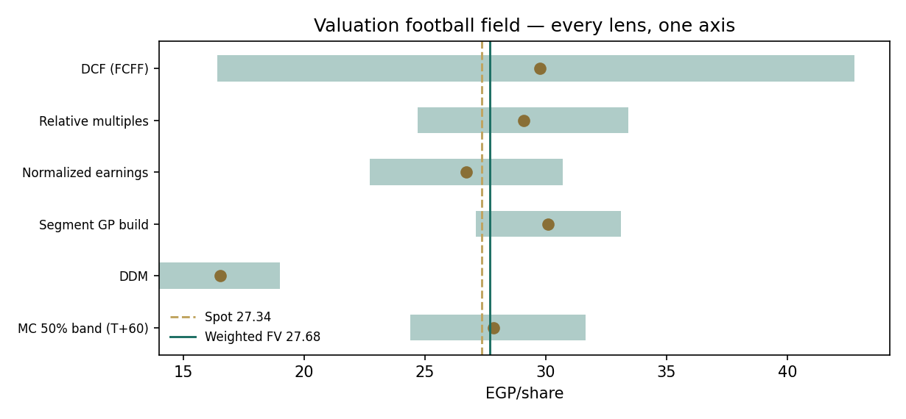
Figure 1 — the football field: five fundamental lenses plus the Monte-Carlo 50% band, one axis.
The DDM is kept at a 10% weight and shown without apology: at a 21.4% cost of equity, cash actually distributed is worth far less than cash retained and compounded at a ~50% ROIC, and the EGP 16.5 read quantifies that gap rather than invalidating the other lenses. The three business-value lenses cluster at 26.7–30.1; the weighted EGP 27.68 sits inside that cluster and on top of the market.

1.6 The segments — a deeper look
Cakes remain the engine — 52% of FY2025 revenue at a 36.6% gross margin — but the past two years’ growth has been broad. Bakery (croissants and the new paté/Molto King lines) grew 26% in FY2025 and 68% in 1Q2026 on capacity additions; rusks +49%; wafers +16% with a toll-manufacturing agreement (MIFAD, Freska Square) signed in 1Q2026 to double capacity; biscuits +75% from a small base under Oniro. Frozen bakery is the one loss-maker (EGP −50m gross in FY2025) — a deliberate option on at-home consumption, small enough to carry. The FY2026E build below applies per-segment growth and margin assumptions and sums to EGP 27.3bn of revenue and EGP 9.36bn of gross profit; at 4.4x EV/gross-profit (what the peer set’s EV/EBITDA implies once SG&A intensity is equalized) plus net cash, the segment lens reads EGP 30.09.
Segment | FY23 rev | FY24 rev | FY25 rev | FY25 GPM | FY26E growth | FY26E rev | FY26E GP
Cakes | 6,033 | 8,272 | 10,856 | 36.6% | +27% | 13,787 | 5,101
Bakery | 4,067 | 4,657 | 5,885 | 33.4% | +38% | 8,122 | 2,721
Wafers | 1,079 | 1,735 | 2,019 | 31.0% | +22% | 2,463 | 776
Rusks | 545 | 727 | 1,085 | 29.9% | +40% | 1,519 | 471
Candy | 308 | 485 | 558 | 27.1% | +18% | 658 | 188
Biscuits | 80 | 196 | 344 | 21.8% | +45% | 498 | 122
Frozen | 15 | 72 | 62 | neg. | +30% | 81 | (24)
Raw chips & other | 0 | 2 | 107 | 15.1% | +60% | 172 | 26
Total | 12,126 | 16,146 | 20,915 | 33.9% | +30.5% | 27,299 | 9,381

Segment scorecard | Market position | Growth | Margin | Capital need | Grade
Cakes | ~half the market, HTT brands owned | volume-led, mature | best in house | moderate | A
Bakery / croissants | dominant, new formats scaling | fastest large segment | rebuilt to 33%+ | new lines added | A−
Wafers | top-tier, tolling doubles capacity | steady | stable ~31% | asset-light via MIFAD | B+
Rusks | leader (Bake Rolz/Stix) | strong | recovering | low | B+
Candy & biscuits | challenger under MiMix/Oniro | high % off small base | thin but improving | tolling + own lines | B
Frozen | optionality | experimental | negative | contained | C

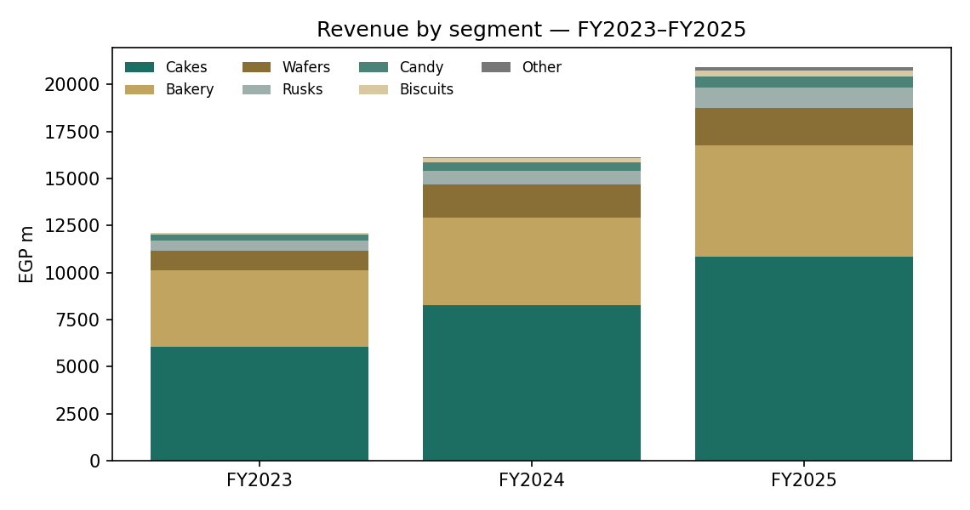
Figure 2 — revenue by segment, FY2023–FY2025 (EGP m).

1.7 Gross-margin durability — the crux
Everything in this valuation swings on one line: can Edita hold a 34–35% gross margin through the next currency event? Roughly four-fifths of direct materials are imported or FX-linked — flour blends, sugar, cocoa, oils, packaging films — so a step-devaluation resets the cost base overnight while retail price points move in discrete jumps (EGP 5 → 10) that take quarters to execute without volume damage. The 2023–24 sequence showed both halves: gross margin fell from 32.4% to 30.4% as the pound broke, then rebuilt to 33.9% in FY2025 and 34.9% in 1Q2026 as price-point migration completed, volumes recovered (+19% tons FY2025, +37% 1Q2026) and soft-commodity costs eased. Each point of FY2026E gross margin is ~EGP 272m of gross profit; flowed through at the marginal tax rate it moves the DCF by roughly EGP 1.4/share and the earnings-power lens similarly — a two-point margin miss erases the entire headline upside, a two-point beat funds the bull case. That asymmetry, not the growth rate, is why the weighted value sits so close to spot.
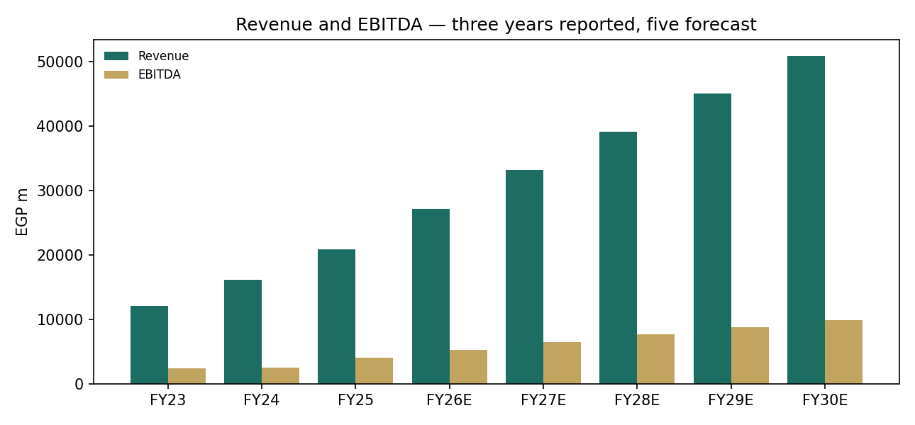
Figure 3 — revenue and EBITDA, three reported years and the five-year forecast (EGP m; forecast bars lighter).

1.8 Macro and country — the pound, rates, and the consumer
The study is priced in nominal EGP, so Egypt’s macro is inside every number. The disinflation path — CPI down from the 2023–24 peaks, the CBE easing through 2025–26, T-bond yields near 16–17% at mid-2026 — sets the 16.5% risk-free and the 13.5% terminal growth (roughly long-run inflation plus modest real growth). Household purchasing power is the demand-side risk: Edita’s answer is the price-point ladder, which converts inflation into pack-size and price-tier migration rather than outright volume loss, and the 1Q2026 print (+18% packs, +37% tons) says it is working. The balance sheet is a quiet macro asset — EGP 5.8bn of cash earning high nominal deposit rates against largely subsidized industrial borrowings produced EGP 189m of net finance income in 1Q2026 alone — and exports (9.5% of sales, +73% y-o-y in 1Q2026) plus Morocco and the Iraq associate give the first genuine hard-currency hedge in the P&L. A fresh EGP step-change would compress margins for two to four quarters, lift the discount rate, and simultaneously raise the EGP value of the export line: net negative, survivable, and exactly the scenario Expert 3 prices in the appendix.

1.9 DCF sensitivity — WACC × terminal growth
WACC \ g | 11.5% | 12.5% | 13.5% | 14.5% | 15.5%
18.7% | 31.4 | 34.6 | 39.0 | 45.3 | 55.2
19.7% | 28.2 | 30.6 | 33.9 | 38.3 | 44.7
20.7% | 25.7 | 27.6 | 29.7 | 33.0 | 37.6
21.7% | 23.7 | 25.1 | 26.9 | 29.3 | 32.7
22.7% | 22.0 | 23.2 | 24.6 | 26.4 | 28.9

Read the grid as Egypt in miniature: a two-point fall in the discount rate — the disinflation-completes world — is worth ~EGP 9 a share on its own, while even the harshest cell (22.7% WACC, 11.5% g) still prices the equity at EGP 22, because the cash generation is real. The base cell is bolded in the model: 20.7% × 13.5% → EGP 29.7.

2 Technical and price structure
The tape is a pause inside a completed re-rating. From the March-2022 low (split-adjusted EGP 3.28) the shares six-folded to an all-time high of EGP 32.50 on 9 February 2026, then spent five months consolidating; at EGP 27.34 the price is 16% off that high, essentially flat year-to-date (−1.6%), and still +106% over twelve months. Spot sits below the 50-day (28.55) and 100-day (28.31) averages but comfortably above a rising 200-day (25.86) — a short-term stall on a long-term uptrend. RSI-14 at 46 is neutral; MACD (-0.41) is below its signal (-0.31) with a small negative histogram (-0.10), i.e. mildly bearish momentum without acceleration. The June swing low at ~25.5–25.9 coincides with the 200-day — that is the level the structure defends; above, the February high at 32.50 is the obvious supply.
Indicator | Reading | Interpretation
Spot (01-Jul-2026) | 27.34 | —
SMA 50 / 100 / 200 | 28.55 / 28.31 / 25.86 | below short MAs, above rising 200-day
RSI (14) | 46.4 | neutral
MACD / signal / histogram | −0.41 / −0.31 / −0.10 | mildly bearish, decelerating
52-week range | 12.80 – 32.50 | upper third of the range
All-time high | 32.50 (09-Feb-2026) | −15.9% from ATH
3-month / 1-year change | +8.3% / +106% | consolidation inside an uptrend
Structure | support ~25.5–25.9 (200-day + June low); supply 32.50 | range 26–32 until broken

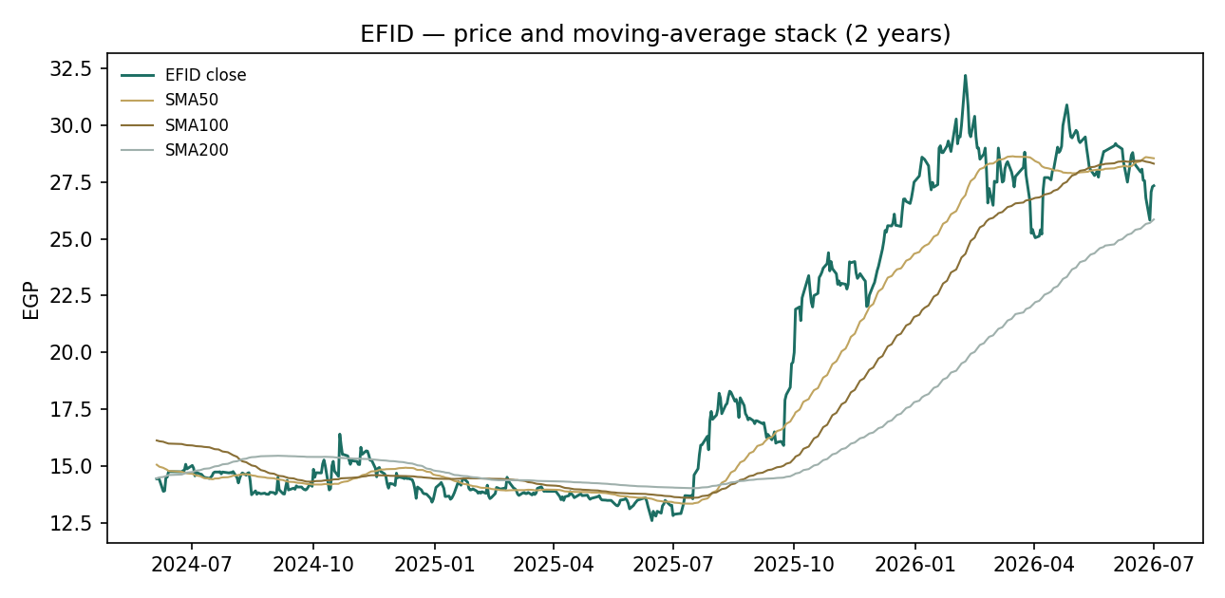
Figure 4 — price and the 50/100/200-day moving-average stack, two years.

3 Monte Carlo — a probabilistic price map
We simulate 50,000 three-month price paths (seed 42) from the 01-Jul-2026 close. Width is sized by the house YZ-HAR engine: a pooled log-HAR cascade (variance lags 1/5/22) on a gap-aware Yang-Zhang variance proxy projects the average daily variance over the next 60 sessions — regime-conditional by construction — giving a daily σ of 2.60% (41.3% annualized). Innovations are unit-variance Student-t(5), implemented as a per-path chi-square variance mixture so the 60-day aggregate is exactly t5: a tighter interquartile body with honest tails. Drift is asset-class-conditional and for an EGX consumer staple it is OFF — Step 0 (Appendix B) showed the secular-drift variant fails the CRPS gate here — with only the small net drift of the 16-factor overlay (7 continuous + 9 discrete events from the egx_staples factor set, flagged uncalibrated pending sign-off) layered on top. These paths diffuse from spot and deliberately do not embed the fundamental view — the value gap of Section 1 is kept out of the drift.
Horizon | P5 | P25 | Median | P75 | P95
T+20 (~29 Jul) | 22.35 | 25.48 | 27.48 | 29.62 | 33.56
T+60 (~24 Sep) | 19.40 | 24.40 | 27.82 | 31.65 | 38.98

Lead with the 50% band, not the tails: one quarter out the middle half of outcomes spans EGP 24.40–31.65 — about 27% of spot, the irreducible quarter-ahead uncertainty of an EGX single name — and at one month it is EGP 25.48–29.62. The distribution closes above spot on 53.6% of paths; the mean (EGP 28.39) sits above the median, the signature of the t5 right tail plus the small positive factor drift.
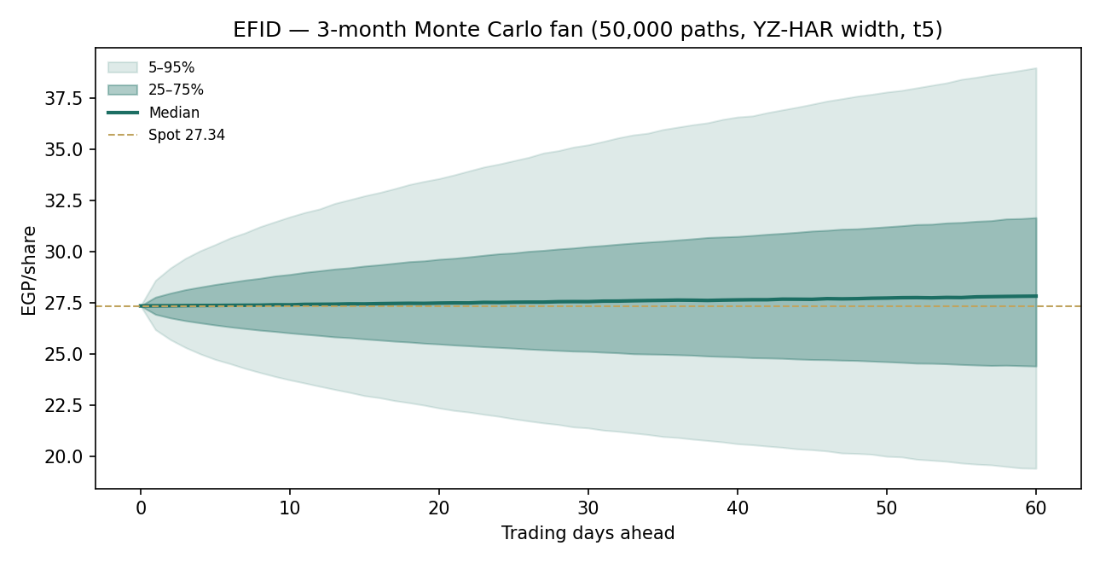
Figure 5 — the fan: 50,000 paths, 25–75% and 5–95% bands, median, spot reference.
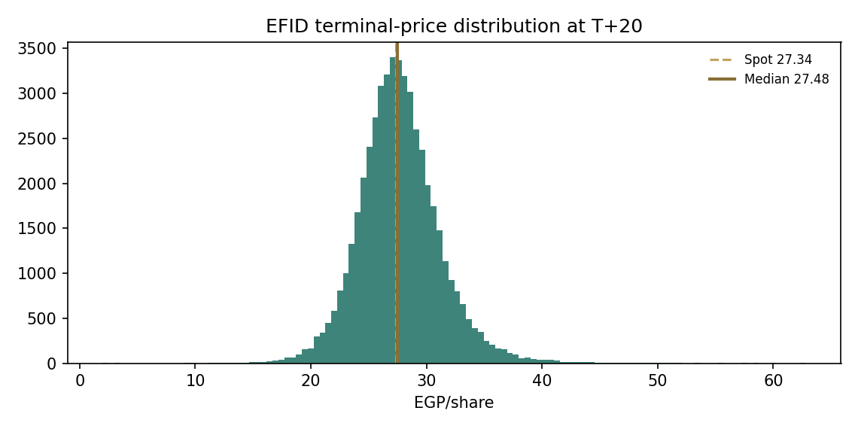
Figure 6 — terminal-price distribution at T+20.
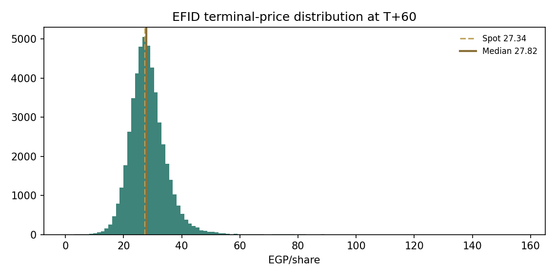
Figure 7 — terminal-price distribution at T+60.
Touch by T+60 — upside | P(touch) |  | Touch by T+60 — downside | P(touch)
28.00 | 85.3% |  | 27.00 | 87.1%
29.00 | 72.4% |  | 26.00 | 70.9%
30.00 | 60.6% |  | 25.00 | 55.9%
31.00 | 49.9% |  | 24.00 | 42.7%
32.00 | 40.7% |  | 23.00 | 31.6%
33.00 | 32.9% |  | 22.00 | 22.8%
35.00 | 21.3% |  | 20.00 | 10.9%

The ladders read like the tape: both 28 and 27 are touched on ~85% of paths (the range is alive on both sides), the February high at 32–33 is reached on a third to two-fifths of paths, and the 200-day zone at ~25 is visited on more than half. A close below 22 — the level that would break the 2024 base structure — occurs on fewer than a quarter of paths.

4 Comparison of the lenses, and a verdict
Read | Says | Weight in the verdict
Fundamental (weighted) | EGP 27.68 — fair value on top of spot; business quality high, currency cost of capital high | anchor
FCFF DCF / segment build | EGP 29.7–30.1 — modest upside if margins and growth hold | tilt up
Normalized / DDM | EGP 26.7 / 16.5 — the price of capitalizing a windfall, and of EGP duration | tilt down
Technical | uptrend intact above a rising 200-day; short-term momentum soft; 26–32 range | neutral-to-constructive
Monte Carlo (T+60) | median 27.82; 50% band 24.40–31.65; P(above spot) 53.6% | the distribution

Verdict: a quality compounder at a full-ish price — the re-rating is done, the compounding is not. The market has already paid for the devaluation-recovery story it once refused to price; at ~10x forward earnings with a net-cash balance sheet, a ~50% ROIC and a working price-point machine, the shares are neither cheap enough to pound the table nor expensive enough to fade. The fundamental case from here is earned quarter by quarter — volume growth, margin retention, export scaling — and the distribution says exactly that: a coin-flip-plus (53.6%) of finishing the quarter higher, a middle half of outcomes spanning −11% to +16%, and tails owned by the pound in one direction and by operating leverage in the other. In house language: hold the distribution in your head, not a target.

5 Catalysts to watch
When | What | Why it moves the value
Aug 2026 | 2Q2026 results | first full quarter of the new cake line at full utilization; watch gross margin vs 34.9%
2H 2026 | MIFAD wafer tolling ramp (Freska Square) | asset-light capacity doubling in wafers; mix and GPM read-through
2H 2026 | HTT-Africa rollout economics | license-free HoHos/Twinkies/Tiger Tail across 45+ markets; export margin uplift
Ongoing | CBE rate path & EGP regime | every 100bp off the discount rate is worth roughly EGP 1.5–2/share in the DCF
Q4 2026 – 2027 | Edita Iraq (TJA) consolidation & Morocco scaling | second and third P&L legs outside the pound
Mar–Apr 2027 | FY2026 dividend proposal | payout policy on a net-cash balance sheet; the DDM lens re-rates on payout
Anytime | Soft-commodity cycle (sugar, cocoa, wheat, packaging) | four-fifths of direct materials are FX-linked; the crux of §1.7
Anytime | A new EGP step-devaluation | the named bear scenario: margin squeeze + higher WACC, partly offset by exports

6 Reading the probability zones
Zone at T+60 (EGP) | Probability | Reading
Below 20 | 6.2% | tail: devaluation shock or a market-wide EGX break
20 – 22 | 6.2% | base-structure test; 2024 acceptance area
22 – 24 | 10.2% | below the 200-day; margin-miss pricing
24 – 26 | 13.3% | the 200-day / June-low battleground
26 – 28 | 15.4% | the modal zone — spot and the weighted fair value both live here
28 – 30 | 14.1% | reclaiming the 50/100-day stack
30 – 32 | 11.2% | approach to the February supply shelf
32 – 34 | 7.8% | ATH breakout territory
Above 34 | 15.4% | t5 right tail: margin beat + rate-cut acceleration + flows

Two-thirds of the probability mass sits between EGP 22 and EGP 32 — the consolidation writ forward. The fat 15.4% above EGP 34 is not a forecast of a breakout; it is what honest t5 tails look like on a 41%-vol instrument, and it is symmetric in spirit with the 12.4% below EGP 22.

7 Caveats and what would change our mind
What would move the fair value up: two consecutive quarters of gross margin at or above 35% (we would lift the mid-cycle margin and the multiple); a CBE easing cycle that takes the 10-year below 15% (each WACC point is ~EGP 1.5–2); exports sustaining >12% of sales with Morocco profitable (a genuine FX hedge deserves a lower risk premium); a formal payout policy above 55% (the DDM lens closes toward the others).
What would move it down: a step-devaluation of the pound (the modeled bear: 18% EBITDA margin and a 22.5% WACC → EGP 16.4); volume declining while price/mix carries growth (the 2024 pattern returning); cocoa/sugar spikes unhedged; capex overshooting 7% of sales without matching volume; governance surprises around the 49% controlling holder or related-party brand transactions.
Known model weaknesses, stated plainly: the historical balance sheet is reconstructed around disclosed items (equity and PP&E are flagged Testahil estimates — the earnings releases do not publish full statements); FY2023 D&A and finance lines are estimated; the segment EV/GP multiple is a derived, not observed, market quantity; the 16-factor overlay for egx_staples carries Appendix-A default probabilities, flagged uncalibrated pending sign-off; and every EGP figure embeds an inflation forecast that will be wrong in one direction or the other. The Monte Carlo models price, not value.

Appendix A Financial statements
Three reported years (IFRS management accounts from the company’s earnings releases) and the five-year model forecast. Yellow-flag convention from the companion Excel: FY2023 D&A/finance lines and all historical equity/PP&E figures are Testahil estimates where the releases do not publish the line; each carries its method in a cell comment in the model.

A.1 Income statement (EGP m)
 | FY23A | FY24A | FY25A | FY26E | FY27E | FY28E | FY29E | FY30E
Revenue | 12,126 | 16,146 | 20,915 | 27,190 | 33,171 | 39,142 | 45,014 | 50,865
Growth | +58% | +33.2% | +29.5% | +30.0% | +22.0% | +18.0% | +15.0% | +13.0%
Gross profit | 3,925 | 4,906 | 7,086 | 9,244 | 11,345 | 13,426 | 15,440 | 17,447
Gross margin | 32.4% | 30.4% | 33.9% | 34.0% | 34.2% | 34.3% | 34.3% | 34.3%
EBITDA | 2,366 | 2,538 | 4,011 | 5,220 | 6,435 | 7,633 | 8,778 | 9,919
EBITDA margin | 19.5% | 15.7% | 19.2% | 19.2% | 19.4% | 19.5% | 19.5% | 19.5%
D&A | 330e | 380 | 469 | 707 | 862 | 1,018 | 1,215 | 1,373
EBIT | 2,036 | 2,157 | 3,542 | 4,514 | 5,573 | 6,615 | 7,562 | 8,545
Net finance | (80)e | (186) | (91) | 700 | 650 | 600 | 600 | 650
Profit before tax | 1,956 | 1,972 | 3,451 | 5,214 | 6,223 | 7,215 | 8,162 | 9,195
Income tax | (449) | (556) | (1,009) | (1,382) | (1,649) | (1,912) | (2,163) | (2,437)
Net profit (IFRS) | 1,507 | 1,415 | 2,442 | 3,832 | 4,574 | 5,303 | 5,999 | 6,759
Net margin | 12.4% | 8.8% | 11.7% | 14.1% | 13.8% | 13.5% | 13.3% | 13.3%
EPS (EGP, current shares) | 1.08 | 1.01 | 1.74 | 2.74 | 3.27 | 3.79 | 4.28 | 4.83

A.2 Balance sheet (EGP m)
 | FY23A | FY24A | FY25A | FY26E | FY27E | FY28E | FY29E | FY30E
Net PP&E & intangibles | 4,540e | 5,400e | 6,324e | 7,384 | 8,512 | 9,647 | 10,683 | 11,853
Inventories | 1,867 | 3,034 | 2,315 | 3,018 | 3,682 | 4,345 | 4,997 | 5,646
Trade & notes receivable | 160 | 175 | 244 | 326 | 398 | 470 | 540 | 610
Other assets (est.) | 1,000e | 1,300e | 1,600e | 1,760 | 1,936 | 2,130 | 2,343 | 2,577
Cash & equivalents | 1,356 | 1,324 | 4,741 | 5,762 | 7,117 | 8,848 | 11,041 | 13,494
Total assets | 8,923 | 11,233 | 15,224 | 18,250 | 21,645 | 25,439 | 29,603 | 34,180
Loans & borrowings | 2,031 | 3,468 | 4,475 | 4,475 | 4,475 | 4,475 | 4,475 | 4,475
Bank overdrafts | 597 | 808 | 771 | 771 | 771 | 771 | 771 | 771
Payables & other liabilities | 2,496 | 1,956 | 3,078 | 3,997 | 4,876 | 5,754 | 6,617 | 7,477
Total liabilities | 5,123 | 6,233 | 8,324 | 9,243 | 10,122 | 11,000 | 11,863 | 12,723
Shareholders’ equity | 3,800e | 5,000e | 6,900e | 9,008 | 11,523 | 14,439 | 17,739 | 21,457
Balance check | 0 | 0 | 0 | 0 | 0 | 0 | 0 | 0
Net debt / (net cash) | 1,271 | 2,952 | 504 | (517) | (1,872) | (3,603) | (5,795) | (8,249)
memo: co-disclosed net debt | 674 | 2,144 | (267) | — | — | — | — | —

The memo line shows the company’s own net-debt disclosure, which nets certain deposits/notes differently from our simple loans-plus-overdrafts-minus-cash definition; the trajectory — leveraged into the 2024 squeeze, net cash by end-2025 — is identical.

A.3 Cash flow (EGP m)
 | FY25A* | FY26E | FY27E | FY28E | FY29E | FY30E
Net profit | 2,442 | 3,832 | 4,574 | 5,303 | 5,999 | 6,759
+ D&A | 469 | 707 | 862 | 1,018 | 1,215 | 1,373
Δ Working capital & other | 1,729 | (151) | (43) | (59) | (76) | (94)
Cash from operations | 4,640 | 4,690 | 5,509 | 6,461 | 7,332 | 8,251
Capex | (1,393) | (1,767) | (1,990) | (2,153) | (2,251) | (2,543)
Free cash flow | 3,248 | 2,923 | 3,519 | 4,308 | 5,081 | 5,708
Dividends paid | (800) | (1,724) | (2,058) | (2,386) | (2,700) | (3,042)
Δ Debt & overdrafts | 969 | 0 | 0 | 0 | 0 | 0
Net change in cash | 3,417 | 1,021 | 1,354 | 1,731 | 2,193 | 2,453
Closing cash | 4,741 | 5,762 | 7,117 | 8,848 | 11,041 | 13,494

*FY2025A is a Testahil derivation from disclosed period-end balances (the net-debt walk); the company’s releases do not restate a full historical cash-flow statement.

Appendix B Step 0 — calibration backtest
Before any valuation was written, the Monte-Carlo engine was made to earn its keep on this ticker: a five-year rolling backtest, horizon 60 trading days, 20 non-overlapping origins across the full 2021–2026 history, each forecast built only from data available at its origin. The grade is skill versus a naïve zero-drift random-walk lognormal cone sized by trailing realized volatility — measured by CRPS skill (must exceed zero) and the Winkler interval score. Coverage and PIT are diagnostics only, because band-containment rewards width.
Configuration | CRPS skill | Winkler-90 skill | Cov 50/80/90 | PIT mean | Gate
YZ-HAR, t5, drift OFF | +1.6% | +10.1% | 65% / 85% / 90% | 0.61 | PASS
YZ-HAR, t5, drift ON (expanding secular) | −0.9% | +18.8% | 60% / 80% / 90% | 0.55 | FAIL (CRPS ≤ 0)

The drift finding matters beyond this study: Edita’s own history contains a genuine six-fold uptrend, yet feeding that trend into the drift destroys CRPS skill — the expanding-window mean overshoots exactly at regime turns (the 2023 squeeze, the 2025 consolidation), the same failure that killed trend drift for Samsung and Tata. EGX consumer staples therefore join international names, metals and EGX holdcos in the drift-OFF class; only EGX developers retain the secular drift. The passing configuration beats the benchmark on both the CRPS and the interval score, with 50% coverage a touch generous (13 of 20 cohorts inside) and a PIT mean of 0.61 — right-shifted but within sampling noise at n = 20 (1.75 standard errors), the visible footprint of a secular re-rating the zero-drift cone deliberately refuses to predict.
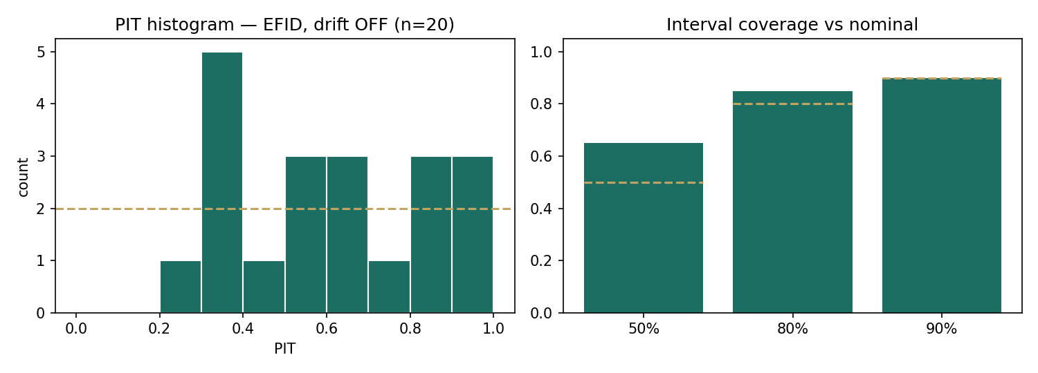
Figure 8 — Step 0 diagnostics: PIT histogram (left) and 50/80/90% interval coverage vs nominal (right), drift-OFF configuration, 20 non-overlapping cohorts.
Artifacts (per-cohort CRPS/Winkler/PIT tables for both configurations, coverage table, skill table) ship in the study’s files/ directory, not the project library. Forward cohorts for this study — T+20 and T+60 from 01-Jul-2026, with anchor_vol 41.3% and horizon_days logged — will be scored by ledger_scorer v2 against the same benchmark when they mature.

Appendix C Peer set, sector structure, and risks
Peer set. The listed EGX consumer universe is thin and imperfect: Juhayna (dairy and juice — the closest branded-FMCG analogue), Obour Land and Domty (white cheese, with Domty a direct bakery entrant), and Eastern Company (tobacco — no product overlap, but the exchange’s reference consumer cash machine). Almarai on Tadawul anchors what regional quality costs in a hard-ish currency. Edita’s ~10x forward P/E premium to the ~7.8x EGX median has persisted for a decade and is earned: leadership across five snack categories, the exchange’s deepest route-to-market in traditional trade, and now outright HTT brand ownership across Africa.
Sector structure. Egyptian packaged snacks is a price-point business: the consumer buys a ladder of EGP 5/10/15 packs, not grammage, so inflation is passed through by migrating the ladder and re-engineering pack economics — which favors the scale player with the brand permission to move first. Barriers are distribution density (hundreds of thousands of traditional-trade outlets), brand memory, and increasingly capital: a modern cake or croissant line is an FX-denominated purchase that sub-scale competitors defer. Competition is Mondelez and regional importers at the premium end, Corona/Bisco Misr in biscuits, and the informal bakery sector at the bottom — the true volume competitor when purchasing power breaks.
Risk | Mechanism | Mitigant / monitor
EGP step-devaluation | ~80% of direct materials imported or FX-linked; instant COGS reset | price-point ladder; exports 9.5% of sales and rising; watch GPM quarterly
Purchasing-power shock | volume down-trading to informal substitutes | 1Q26 packs +18%, tons +37% — monitor pack growth turning negative
Soft commodities | sugar, cocoa, wheat, oils, films cycles | partial hedging/inventory cover (FY24 inventory build was deliberate)
Concentration of control | Quantum 49% + related-party brand history (HTT bought from an affiliate) | disclosed transactions; board process; minority-alignment record is long
Execution on new capacity | FY25–26 lines must fill to hold margin | utilization disclosures; first new cake line full by end-1Q26
Regional expansion losses | Morocco/Iraq scale-up costs | Morocco revenue +21% 1Q26; segment losses contained (frozen −EGP 50m)
Rate normalization cuts interest income | 1Q26 net finance +EGP 189m flatters PBT | normalized-earnings lens already excludes it
EGX liquidity & flows | single-market listing; EM flow beta | ADV healthy post-split; GDR line dormant

Appendix D The expert valuation panel
Three experts from the house persona library, cast for an industrial/consumer going concern: an earnings-power capitalizer, a quality-of-earnings accountant, and a macro-policy scenario builder. Each runs a genuinely different method on the same disclosed numbers; each states what would falsify them. Per house rule they are labelled Expert 1/2/3. Point values are logged (03-Jul-2026, spot 27.34) in the per-expert calibration layer, separate from the core ledger.
Method discipline, stated up front. The panel is not three flavors of the same DCF: Expert 1 never builds a forecast, Expert 2 never trusts one, and Expert 3 builds three and refuses to choose. Each fair value below is derived on the page from disclosed figures — the FY2025 and 1Q2026 releases and the reconstructed statements of Appendix A — and each expert signs a falsification condition tied to observable prints, so the panel can be graded, not merely admired. Where an input is a judgment (a multiple, a probability, a sustainable growth rate) it is named as the swing input and stress-tested in its own sensitivity row. A quarterly update re-runs these same three personas on fresh data; it does not recast them.

D.1 Expert 1 — steady-state earnings power, capitalized
Worldview and tradition. Expert 1 descends from the Graham-and-Dodd earnings-power line as modernized by the value-driver formula: a franchise is worth its sustainable owner earnings, capitalized at the cost of equity less the growth those earnings can self-fund. No terminal-value theater, no five-year hockey sticks — one representative year, one reinvestment rate, one return on incremental capital, and the arithmetic does the rest. When it works: stable-demand franchises with visible unit economics and long reinvestment runways — exactly a branded staples company. When it fails: at regime changes (a devaluation resets the "representative year" overnight), and whenever the Ke-minus-g denominator gets thin, where a one-point wobble swings the answer violently — a real hazard at Egyptian discount rates.
Standard workings. (1) Fix a representative-year revenue and EBIT margin, deliberately mid-cycle. (2) NOPAT = EBIT × (1 − t). (3) Estimate the reinvestment rate RR (capex above depreciation plus working capital, over NOPAT) and the return on that incremental capital (ROIIC); sustainable g = RR × ROIIC, capped by nominal GDP logic. (4) Value of operations = NOPAT × (1 − RR) / (Ke − g). (5) Add net cash, divide by shares.
Expert 1 — workings | Value | Note
Representative revenue (FY26E) | EGP 27,190m | 1Q26 run-rate, mid-cycle margin applied below
Mid-cycle EBIT margin | 16.6% | FY25 16.9%, FY24 13.4%, 1Q26 15.5% — takes the middle
NOPAT (t = 26.5%) | EGP 3,318m | operating only; interest income excluded on principle
Reinvestment rate (RR) | 35% | capex 6% of sales less D&A, plus NWC, over NOPAT
ROIIC | 46% | incremental EBIT FY23→FY25 over incremental invested capital
Sustainable g = min(RR×ROIIC, cap) | 16.0% | raw 16.1%; capped at nominal-GDP-plus
Cost of equity | 21.4% | 16.5% rf + 0.70 × 7.0%
Value of operations | EGP 39,913m | 3,318 × 0.65 / (0.214 − 0.160)
+ Net cash | EGP 853m | 31-Mar-2026
Fair value per share | EGP 29.12 | 40,766 / 1,400.04m

Worked example, read aloud. Of every pound of after-tax operating profit, thirty-five piastres are ploughed back at a 46% incremental return — that reinvestment is the growth, 16% a year, sustainably self-funded. The remaining sixty-five piastres are the owner’s coupon: EGP 2,157m, growing at 16%, discounted at 21.4%, is worth EGP 2,157m/5.4% = EGP 39.9bn of operations. The company hands you the cash pile on top. EGP 29.1 a share — and note the method needed no forecast beyond one representative year.
Expert 1 — sensitivity on the swing input (sustainable g) | 14.0% | 15.0% | 16.0% | 17.0% | 18.0%
Value of operations (EGP m) | 29,149 | 33,703 | 39,913 | 49,023 | 63,441
Fair value per share (EGP) | 21.4 | 24.7 | 29.1 | 35.6 | 45.9

Cross-examination. To Expert 2: your quality haircuts are yesterday’s news — the FX inventory gain and the subsidy spread are real cash that funded real capacity; punishing the margin twice is not conservatism, it is double-counting. To Expert 3: your devaluation scenario is inside my ROIIC already — 2023–24 happened, and incremental returns still printed 46%; pricing the same shock again in the probability tree and in the discount rate is belt, braces and a second belt. Verdict: EGP 29.1, modest upside. Falsification: two consecutive quarters with EBIT margin below 14% or tons declining y-o-y — either breaks the "representative year." What the market implies: at 27.34 the market is paying for g ≈ 15.3% on my machinery — it believes the franchise, just half a growth-point less than I do.

D.2 Expert 2 — the accountant: quality of earnings, then a multiple
Worldview and tradition. Expert 2 comes from the forensic-accounting school: before any earnings number is capitalized it must be cleaned — of accounting-regime quirks, one-off tailwinds, and income that belongs to the balance sheet rather than the business. The method is deliberately boring: reconcile the accounting bases, normalize the P&L line by line, apply a through-cycle multiple that a private buyer of the whole company would pay, and let the balance sheet speak for itself. When it works: whenever a headline year flatters — which is precisely the FY2025/1Q2026 setup. When it fails: on genuine step-changes, where yesterday’s "normal" is the wrong base and the haircuts become a systematic pessimism machine.
Standard workings. (1) Reconcile EAS to IFRS (employee profit-share is a distribution under EAS, an expense under IFRS — the honest earnings base is IFRS). (2) Normalize: strip super-normal net interest income; haircut the gross margin for the identifiable commodity/FX tailwind; expense the subsidy benefit embedded in below-market industrial loans. (3) Apply a through-cycle earnings multiple from the private-transaction and EGX record. (4) Add net cash at face — cash needs no multiple.
Expert 2 — quality bridge (FY26E basis) | EGP m | EPS (EGP)
Reported-path FY26E net profit (IFRS, model) | 3,832 | 2.74
− Super-normal net interest (keep a normal +150) | (404) | (0.29)
− Commodity/FX gross-margin tailwind (0.8pt of GPM, after tax) | (160) | (0.11)
− Subsidized-debt benefit (≈600bp on EGP 4.5bn, after tax) | (197) | (0.14)
− EAS profit-share framing (already in IFRS; no add-back allowed) | 0 | 0.00
Clean, ownerly FY26E earnings | 3,071 | 2.19
Through-cycle multiple (EGX quality staples) | 10.5x | —
Value of the business | 32,246 | 23.03
+ Net cash at face | 853 | 0.61
Fair value per share | — | EGP 23.64 ≈ 24.5 with 1H26 cash build

Worked example, read aloud. The 13.7% net margin of 1Q2026 is three margins stacked: an operating business earning perhaps 11%, a treasury desk clipping a 189-million-pound quarterly coupon off high rates, and a procurement window where sugar and cocoa behaved. Pay a multiple for the first, face value for the second’s balance, and nothing for the third. Clean EPS is EGP 2.19; ten-and-a-half times — what control transactions in Egyptian consumer have actually cleared through cycles — is EGP 23.0, plus the cash. Call it EGP 24.5 allowing the first-half cash build. The other forty piastres of reported margin are weather, not climate.
Expert 2 — sensitivity on the swing input (clean multiple) | 9.0x | 10.0x | 10.5x | 11.5x | 12.5x
Fair value per share (EGP) | 20.3 | 22.5 | 23.6 | 25.8 | 28.0

Cross-examination. To Expert 1: your 46% ROIIC is measured across the single greatest nominal repricing in the company’s history — incremental "returns" earned by selling the same tonnage at devalued-pound prices are inflation, not genius; a clean ROIIC is closer to 30%, and your g collapses with it. To Expert 3: at least you price the shock — but your upside scenario capitalizes the same interest income I just removed; disinflation cuts the treasury coupon exactly as it lowers the discount rate, and your tree nets those against each other too generously. Verdict: EGP 24.5 — the market is paying about three pounds a share for weather. Falsification: gross margin held at ≥ 34% through a full commodity cycle and a ≥ 10% EGP move — that would prove the margin is structural and my haircut wrong. What the market implies: 27.34 backs out ~12.1x my clean EPS — the market is paying a quality premium I reserve for proven through-cycle margins.

D.3 Expert 3 — macro-policy: the pound decides, so price the pound
Worldview and tradition. Expert 3 is a country-risk economist in the emerging-markets tradition: for a single-currency consumer franchise, the sovereign macro path is not context, it is the valuation. The method is a probability-weighted scenario tree over the policy variables that actually bind — the exchange-rate regime, the disinflation path, and the real income of the median household — with the equity valued inside each state and the states weighted by odds stated in advance, so they can be marked right or wrong later. When it works: economies mid-transition, where the distribution of outcomes is wide and visibly state-dependent — Egypt in 2026 to a tee. When it fails: when the scenarios are theater (probabilities reverse-engineered from a desired answer) or the company-level execution differences inside each state are hand-waved.
Standard workings. (1) Define three policy states over the 12-month horizon. (2) Inside each, set the FX/rate/CPI vector, translate to Edita’s revenue growth, gross margin and discount rate, and value with the house DCF machinery. (3) Assign probabilities from the external accounts, the IMF-program arithmetic and the CBE’s revealed function. (4) The fair value is the weighted sum; the tails are reported, not hidden.
Expert 3 — the tree | Disinflation completes | Muddle-through | Step-devaluation
Probability | 55% | 30% | 15%
EGP path / policy | stable-to-firmer; CBE cuts continue; 10-yr → 14–15% | pound drifts; cuts stall; 10-yr ~17% | one-off 15–20% reset; emergency hikes
Edita revenue growth (12m) | +28% (volume-led) | +22% (price-led) | +34% nominal, volume −5%
Gross margin | 34.5% | 33.0% | 30.0% trough, recovering
WACC applied | 19.2% | 21.0% | 23.5%
Equity value per share | EGP 33.0 | EGP 25.5 | EGP 17.5
Weighted contribution | 18.15 | 7.65 | 2.63

Worked example, read aloud. In the majority world — the IMF program holds, remittances and Suez normalize, the CBE keeps cutting — Edita is a volume compounder discounted two points cheaper than today and is worth EGP 33. In the muddle, it grinds: pricing does the work, the multiple stays pinned, EGP 25.5. In the shock — the state every Egyptian portfolio must carry — margins take the 2024 round-trip again and the discount rate spikes before the export line and the price ladder claw it back: EGP 17.5, not zero, because the franchise has now demonstrated the recovery mechanism once. Weighted: EGP 28.4; I shade to EGP 28.2 for the transition costs the tree averages away.
Expert 3 — sensitivity on the swing input (P of step-devaluation) | 5% | 10% | 15% | 25% | 35%
Weighted fair value (EGP) | 29.7 | 29.0 | 28.4 | 26.8 | 25.3

Cross-examination. To Expert 1: a single Ke-minus-g spread is a scenario tree in denial — your 5.4-point denominator silently assumes my 55% state with certainty; put 15% odds on the shock and your perpetuity machinery snaps. To Expert 2: your haircuts are my muddle-through state wearing a green eyeshade — legitimate, but you apply them unconditionally; in the disinflation state the "windfall" interest income becomes a lower discount rate pound-for-pound, and you capture neither. Verdict: EGP 28.2. Falsification: the pound moving more than 10% in either direction within six months against my state weights, or CPI re-accelerating above 20% — either re-draws the tree. What the market implies: 27.34 solves to roughly a 19–20% shock probability on my tree — the market is a touch more worried about the pound than I am, and that spread is the whole trade.

D.5 The three in one room
Put them at one table and the argument lands on a single line item: the 34.9% gross margin of 1Q2026. Expert 1 opens: "That margin is the franchise showing its true shape now that pricing caught up — capitalize it." Expert 2, dryly: "That margin is sugar futures and a treasury coupon in a trench coat. Show me one commodity cycle and one currency event with the margin intact and I will pay your multiple myself — until then it is weather." Expert 3 leans back: "You are both describing states and calling them the world. In my majority state Expert 1 is right and the stock is worth 33; in my shock state Expert 2 is an optimist. The only honest number is the weighted one — and notice that the market’s 27.34 sits almost exactly on my tree, which should worry all three of us about how much edge is left." Expert 1: "Your tree double-charges the shock — it is in your margins AND your WACC." Expert 3: "Because it hits both. Ask 2024." Expert 2, closing: "Then we agree on the falsifier: hold 34% gross margin through the next pound move, and the bull case writes itself."

D.6 Reading the divergence
Expert | Method | Fair value (EGP) | Vs spot | Bear / bull | The one assumption doing the work
Expert 1 | Earnings power capitalized | 29.12 | +6.5% | 21.4 / 45.9 | sustainable g = RR × ROIIC = 16%
Expert 2 | Quality-of-earnings × through-cycle multiple | 24.50 | −10.4% | 20.3 / 28.0 | a 10.5x clean multiple; margin tailwinds are weather
Expert 3 | Probability-weighted policy tree | 28.20 | +3.1% | 17.5 / 33.0 | 15% odds on an EGP step-devaluation
House (§1.5) | Five-lens weighted | 27.68 | +1.3% | 16.4 / 42.8 | 35% weight on the FCFF DCF
Market | — | 27.34 | — | — | implies g ≈ 15.3% (E1), 12.1x clean (E2), P(shock) ≈ 19% (E3)

What the spread measures. The EGP 24.5–29.1 expert range is only ±9% around spot — unusually tight for this panel — because all three agree the business is excellent and disagree only about which year is normal. Expert 1 capitalizes the machine’s demonstrated incremental returns; Expert 2 refuses to pay for anything the 2026 weather delivered; Expert 3 prices the referee — the pound — directly. The market price sits a pound above the accountant and a pound below the earnings-power read, which is another way of saying the exchange has internalized both arguments and is charging roughly a one-in-five devaluation premium. The divergence is therefore not a mispricing signal; it is a live measurement of how much of Edita’s printed margin the market believes is climate. Watch the falsifiers, not the fair values: a 34%+ gross margin through the next commodity-and-currency cycle collapses the panel toward Expert 1; the next step-devaluation collapses it toward Expert 3’s left tail.
A second reading of the table: the bear columns disagree more than the base columns. Expert 2’s floor (EGP 20.3) assumes the business keeps earning and only the multiple compresses; Expert 3’s floor (EGP 17.5) is a genuine macro event; Expert 1’s (EGP 21.4) is a growth fade with the franchise intact. That the three floors cluster at 17–21 — roughly 25% below spot — while the ceilings scatter from 28 to 46 tells you where the risk is asymmetric: the downside is bounded by demonstrated cash generation, the upside is a function of how long Egyptian nominal conditions stay kind. It is the mirror image of 2022, when the ceilings clustered and the floors scattered.

About this series
Testahil publishes independent, educational valuation studies. Each is an attempt to reason transparently about what a security is worth, with every assumption shown and a companion model so readers can disagree productively. The house style is distributions, not tips: we describe ranges and probabilities, not targets, and we do not tell anyone what to do. Studies are framed as educational analysis, the preparer is not licensed by any securities regulator, and holdings are disclosed.

Disclosure & Disclaimer
Not investment advice. This document is educational and informational only. It is not, and must not be relied upon as, investment, financial, legal, accounting or tax advice, nor an offer, solicitation or recommendation to buy, sell or hold any security. It contains no price target and no rating.
No licence; no advisory relationship. The preparer is not registered or licensed with the Egyptian Financial Regulatory Authority (FRA) or any other securities or financial regulator in any jurisdiction, holds no brokerage or investment-advisory authorisation, and is not acting as your adviser or fiduciary. Nothing here is personalised to your circumstances.
Holdings disclosure. The preparer may hold, and may in the future take or dispose of, a position in the security discussed in this report, and may transact at any time without notice. This is a potential conflict of interest you should weigh.
Sources & accuracy. Reported financial and operating figures are drawn from the company’s public disclosure (earnings releases FY2023–FY2025 and 1Q2026, EGX filings via public aggregators) and other public sources believed reliable but not independently verified; they may contain errors or be superseded. Forward-looking inputs — the growth and margin path, the multiples, the DCF, the scenario probabilities and the Monte-Carlo factor probabilities — are the preparer’s own judgments and are inherently uncertain. Historical balance-sheet lines not published in the releases (equity, PP&E, other assets) are Testahil estimates and are flagged as such.
Forward-looking statements. Any statements about the future are estimates subject to risks and uncertainties; actual results may differ materially. The Monte Carlo models price, not value, and encodes subjective probabilities for events that have not occurred.
No reliance; your responsibility. Do your own research and consult a licensed professional before making any decision. You are solely responsible for your investment decisions and their outcomes. To the maximum extent permitted by law, the preparer accepts no liability for any loss arising from use of this document.
Currency & figures. All figures are in Egyptian pounds (EGP); m denotes million and bn billion. Indicative FX at the study date: USD/EGP ~48. Per-share figures use the post-September-2025 share count of 1,400.04m throughout; the price series is split-adjusted. Rounding may cause totals to differ slightly. Spot price and market data are as of 01 July 2026 and change continuously.
TESTAHIL · Independent Valuation Study · Educational Analysis · Edita Food Industries S.A.E. (EGX: EFID) · edition 03-07-2026 · reporting currency EGP

