Testahil · Independent Valuation Study — Educational Analysis · Not investment advice
Independent Valuation Study — Educational Analysis
e-finance for Digital and Financial Investments S.A.E. (EGX: EFIH)
Fundamental analysis · Technical analysis · Monte Carlo simulation — one integrated read
Anchor: EGP 20.74 (01 Jul 2026 close) · 3,466.67 mn shares (par EGP 0.50) · market cap ~EGP 71.9 bn · Egypt’s state-linked digital-payments and government-cloud infrastructure group (Transaction · Cloud · Build & Operate · consumer/embedded-finance ventures) · prices and probabilities computed 01 Jul 2026 from the attached daily history · primary lens: a going-concern free-cash-flow-to-firm DCF on EGP-appropriate parameters, cross-checked by a segment sum-of-the-parts, relative multiples and normalized earnings · the swing factors are the multiple placed on Cloud/Transaction and the EGP discount rate.
READ FIRST — what this document is, and is not. This study is a valuation exercise and an expression of personal analytical opinion, published free of charge for educational purposes: it shows how one analyst applies fundamental, technical and probabilistic methods to a listed company, and invites scrutiny of that methodology. It is NOT investment advice, NOT a recommendation or solicitation to buy, sell or hold any security, and NOT directed at the circumstances of any reader. The preparer is not licensed by any securities regulator in any jurisdiction, holds no Egyptian (FRA) or other authorisation, provides no financial consultancy, manages no money, and accepts no fees, funds or clients. See the Disclosure & Disclaimer at the end. All values are model outputs presented as ranges and distributions because no single number should be relied on. Reported financials are the company’s own disclosure (FY2025 earnings release, 04 Mar 2026, and 1Q2026 release, 13 May 2026); forward-looking inputs — the segment marks, the multiples, the DCF and the Monte-Carlo factor probabilities — are the preparer’s judgments and are flagged throughout. FY2023 figures are reconstructed from disclosed 9M2024 year-on-year growth and are shown for scale, not for precision. Consult a licensed financial advisor before any investment decision.
Headline
The model’s read: excellent business, full price — the tape is discounting continued exceptional execution and a benign, falling EGP rate path. At EGP 20.74 the shares sit about 46% above our blended central fair value of EGP 14.2. The tension is not about the business, which is first-rate: e-finance grew revenue 30% in FY2025 to EGP 6,773 mn at a 49% EBITDA margin, earned a ~28% return on equity, and carries net cash — an asset-light monopoly-like position in Egypt’s payment rails plus the country’s licensed government cloud. The tension is arithmetic. On EGP-appropriate parameters (a 21% WACC, an 11% nominal terminal growth), an intrinsic going-concern DCF lands at EGP 10.8 and a segment sum-of-the-parts at EGP 12.3, while the two market-multiple lenses — relative EV/EBITDA and normalized earnings — land near EGP 18. Spot is above all four base cases. High nominal growth and a high nominal discount rate are pulling against each other, and the market is siding with growth. Technically the stock is consolidating just under its 20/50/100-day averages but well above the 200-day, with RSI a neutral 46 and momentum mildly negative — a pause in an uptrend, not a breakdown. Over three months the Monte Carlo places the 5th–95th percentile band at roughly EGP 14.1–30.6, with the median at spot.
Valuation summary — every read at a glance
One table for the four reads that follow — what the business is worth (fundamental), what the tape is doing (technical), where price could travel over three months (Monte Carlo), and how three independent expert methods land. Every row is developed in the sections and appendices below.
Lens / read | What it measures | Output | Takeaway
FUNDAMENTAL — what the business is worth (the anchor)
Going-concern DCF (heaviest weight) | Discounted 5-yr FCFF, EGP params | EGP 10.8 | −48% vs spot
Sum-of-the-parts (segment) | Marked segments less discount | EGP 12.3 | −41% · segment view
Relative multiples | Normalized EV/EBITDA + net cash | EGP 18.2 | −12% · nearer market
Normalized earnings | Mid-cycle NP after NCI × P/E | EGP 18.4 | −11% · the ceiling
Weighted central | Blend 35 / 25 / 20 / 20 | EGP 14.2 | spot +46%
TECHNICAL — what the tape is doing (timing, not value)
Trend & momentum | Price vs 20/50/100/200-day averages | Below 20/50/100; above 200 | Pause in uptrend
Momentum / range | RSI · MACD · 52-week range | RSI 46 · MACD −0.09 hist · 11.2–23.3 | Neutral, mild fade
MONTE CARLO — where price could go in 3 months (paths from spot)
T+20 sessions | 50,000 paths · YZ-HAR · t(5) | p5 16.6 · p50 20.7 · p95 25.9 | Median ≈ spot
T+60 sessions | same engine, longer horizon | p5 14.1 · p50 20.7 · p95 30.6 | Wide, right-skewed
EXPERT PANEL — three independent methods (Appendix D)
Expert 1 — earnings power | Mid-cycle earnings × justified P/E | EGP 18.4 | Most bullish
Expert 2 — earnings quality / cash | Durable core FCFF vs treasury income | EGP 12.5 | Cautious
Expert 3 — macro-policy / EGP discount | EGP cost of capital + country risk | EGP 11.5 | Most conservative
Panel range | Spread = growth vs discount | 11.5–18.4 | Centres ~14.1
Bottom line. Every fundamental read sits below spot; they disagree only on how far. The blended central is near EGP 14.2 — about 32% below the EGP 20.74 spot — the three experts span EGP 11.5–18.4, and each one turns on the same pair of questions: the multiple the market should place on a 30%-plus grower with a government-linked moat, and the discount rate appropriate to Egyptian pounds while rates are still falling. The technical tape is the lone neutral, consolidating rather than confirming either case, which is why the three-month distribution centres on spot with a wide right tail rather than on the lower fundamental cluster.
Company overview — e-finance at a glance
Item | Value
Listed entity | e-finance for Digital and Financial Investments S.A.E. (EGX: EFIH)
What it owns | Payment-rails/transaction processing · government cloud hosting · build-&-operate projects · consumer & embedded-finance ventures (eKhales, eAswaaq, card production, BPO)
Spot / date | EGP 20.74 · 01 Jul 2026 close
Shares · market cap | 3,466.67 mn (par EGP 0.50) · ~EGP 71.9 bn
Balance sheet | Net cash EGP 1,379 mn (31 Dec 2025); ~0.4x EBITDA; near debt-free
FY2025 revenue / EBITDA margin | EGP 6,773 mn (+30.0% YoY) · 49.2% (rising)
FY2025 net profit after NCI | EGP 2,405 mn (+35.4% YoY); ROE ~28%
Segment mix (FY2025) | Transaction 40% · Cloud 35% · Build & Operate 17% · Other 8%
52-week range | EGP 11.20 – 23.28
Ownership | Saudi Egyptian Investment Co 25.8% · National Investment Bank 21.8% · Banque Misr 7.0% · NBE 6.7% · Egyptian Banks Co 6.7% · ECIP 6.7% · float ~25%
IPO | Listed Oct 2021 at EGP 13.98
Source: e-finance FY2025 earnings release (04 Mar 2026) and 1Q2026 release (13 May 2026); EGX disclosures. Values rounded.
1 Fundamental valuation
We value e-finance as a going concern: an asset-light, cash-generative infrastructure operator whose worth is dominated by the stream of cash its rails and cloud throw off, not by a break-up of its balance sheet. The primary and heaviest-weighted lens is therefore a consolidated free-cash-flow-to-firm DCF, struck on parameters appropriate to Egyptian pounds. Because the group does run several distinct businesses on different economics, we cross-check with a segment sum-of-the-parts, a relative-multiple read and a normalized-earnings-power read. The weights and the football field are in §1.5; the swing factors — the Cloud/Transaction multiple and the discount rate — are dissected in §1.7, the macro backdrop in §1.8, and the sensitivity grid in §1.9. Unlike a holding company, there is no conglomerate break-up story here; the debate is entirely about growth, margins and the price of EGP capital.
1.1 Going-concern DCF — the primary lens
We project five years (FY2026E–FY2030E) off the FY2025 base, fading revenue growth from ~32% toward the low-teens as the law of large numbers bites, holding the EBITDA margin near 50% (it was 49.2% in FY2025 and 54.0% in 1Q2026), and treating the group as it is — light on capex (~4–5% of revenue for the cloud build-out) and rich in cash conversion. Free cash flow to the firm is NOPAT plus D&A, less capex and the increase in working capital, plus the after-tax investment-and-interest income that is a recurring feature of e-finance’s treasury and associate book. We discount at a 21% WACC — a normalized, forward EGP cost of equity for a low-beta, government-linked name as the central bank eases (spot cost of equity is nearer 22–24%, and we flag this choice) — and grow the terminal at 11% nominal, consistent with Egypt’s long-run inflation-plus-real-growth. A ~20% economic haircut for minority interests is applied to enterprise value.
The base-case projection builds free cash flow to the firm explicitly for five years and discounts it, with a Gordon terminal beyond FY2030E:
DCF base case (EGP mn) | FY26E | FY27E | FY28E | FY29E | FY30E
EBIT | 4,119 | 5,179 | 6,170 | 7,091 | 7,918
NOPAT = EBIT × (1 − tax) | 3,192 | 4,014 | 4,782 | 5,495 | 6,136
+ D&A | 358 | 475 | 617 | 770 | 910
− Capex | (492) | (622) | (686) | (722) | (728)
− Increase in net working capital | (153) | (165) | (168) | (163) | (151)
+ After-tax net investment income | 698 | 740 | 790 | 841 | 891
FCFF | 3,603 | 4,442 | 5,336 | 6,221 | 7,059
Discount factor @ 21% WACC | 0.826 | 0.683 | 0.564 | 0.467 | 0.386
PV of FCFF | 2,977 | 3,034 | 3,012 | 2,902 | 2,721

DCF valuation bridge | EGP mn
Σ PV of explicit FCFF (FY2026–30E) | 14,647
+ Terminal value (Gordon, g = 11%) | 78,350
PV of terminal value | 30,207
Enterprise value | 44,854
EV attributable to controlling (× (1 − NCI 20%)) | 35,883
+ Net cash | 1,379
Equity value | 37,262
Fair value per share (EGP) | 10.75
Terminal value as % of enterprise value | 67.3%

The scenario range flexes the two inputs that dominate the answer — the discount rate and the terminal growth — with the operating fade and margin varied alongside:
DCF input | Bear | Base | Bull
WACC (EGP) | 23.0% | 21.0% | 18.5%
Terminal growth | 10.0% | 11.0% | 12.0%
FY2026–30 revenue CAGR | ~18% | ~24% | ~30%
Through-cycle EBITDA margin | 46% | 49% | 52%
Fair value (EGP/share) | 7.5 | 10.8 | 22.0
DCF base ≈ EGP 10.8/share. The enterprise value is ~EGP 44.9 bn (about 13x FY2025 EBITDA and 10x FY2026E), with the terminal ~67% of EV — high, as it always is for a grower, and the reason the WACC/terminal pair dominates the answer. The result is well below spot: a 21% discount rate is unforgiving of cash flows that arrive years out, however fast they compound. This is the crux of the whole study, and §1.9 re-prices it across the discount rate and the multiple.
1.2 Segment sum-of-the-parts — the cross-check
Because the parts trade on different economics — a mature, high-margin payment-rails business; a hyper-growth government cloud; a lumpy build-and-operate arm; and a spread of early consumer/embedded-finance ventures — a segment sum can sanity-check the group DCF. We mark each on its FY2025 segment EBITDA and an EV/EBITDA multiple that fits it, deduct nothing for net debt (the group is net cash), apply a small complexity discount, and haircut for minorities.
Segment (base) | Basis | Multiple | EV (EGP mn)
Transaction (payment rails) | EBITDA 1,554 × mult | 16.0x | 24,859
Cloud (gov hosting) | EBITDA 1,265 × mult | 20.0x | 25,297
Build & Operate | EBITDA 349 × mult | 7.0x | 2,442
Other (card/BPO/embedded) | EBITDA 153 × mult | 12.0x | 1,831
Σ Enterprise value |  |  | 54,429
less: complexity discount (5%) |  |  | (2,721)
× (1 − NCI 20%) + net cash 1,379 | = EGP 12.3/share |  | 42,745
SOTP base ≈ EGP 12.3/share, with a bear–bull span of EGP 9.5–22.0 driven mostly by the Cloud and Transaction multiples. Note the tension already visible: the market pays ~21x FY2025 EV/EBITDA for the whole group, while our part-by-part marks — generous by absolute standards (16x for the rails, 20x for cloud) — sum to ~16x. The gap between 16x and 21x is what the growth optimist is paying for.
1.3 Relative multiples
On its own forward numbers e-finance is expensive and reasonable at once: ~16x forward (FY2026E) EV/EBITDA and ~24x forward P/E for a business compounding revenue ~30% with a 50% margin is a PEG comfortably below one — not obviously rich for the growth. We mark the relative lens on a normalized EBITDA (~EGP 4,400 mn, near FY2026E) and a target multiple that a disciplined buyer of Egyptian growth infrastructure would pay, adding net cash.
Relative basis | Bear | Base | Bull
Normalized EBITDA (EGP mn) | 3,900 | 4,400 | 4,800
EV/EBITDA multiple | 12.0x | 14.0x | 16.0x
Fair value (EGP/share) | 13.0 | 18.2 | 26.0
Relative base ≈ EGP 18.2 — nearer spot than the intrinsic lenses, because it anchors to a market multiple rather than a discount rate. It is, in effect, the read of a buyer who accepts today’s growth-multiple regime rather than one who discounts every future pound at Egypt’s cost of capital.
1.4 Normalized earnings power
e-finance’s earnings are already near a normalized run-rate — this is not a trough or peak story — so the normalized lens is close to a forward P/E on mid-cycle profit. We take mid-cycle net profit after minorities of ~EGP 2,900 mn (roughly FY2026E) and apply a justified through-cycle P/E for a high-ROE, net-cash, government-linked grower.
Normalized-earnings basis | Bear | Base | Bull
Mid-cycle NP after NCI (EGP mn) | 2,600 | 2,900 | 3,200
Justified P/E | 18.0x | 22.0x | 26.0x
Fair value (EGP/share) | 13.0 | 18.4 | 26.0
Normalized-earnings base ≈ EGP 18.4 — the ceiling of the central case, and the read most sympathetic to the market. It credits the franchise with a premium multiple but does not, unlike the tape, extrapolate 30%-plus growth indefinitely.
1.5 Synthesis — four lenses
We weight the going-concern DCF most heavily because it is the honest test of an asset-light cash compounder; the SOTP checks it against the parts; the relative and normalized lenses carry the market’s multiple regime. The blend deliberately keeps meaningful weight on the intrinsic lenses so the answer is not simply a restatement of the current multiple.
Lens | Weight | Bear | Base | Bull
Going-concern DCF | 35% | 7.5 | 10.8 | 22.0
Sum-of-the-parts | 25% | 9.5 | 12.3 | 22.0
Relative multiples | 20% | 13.0 | 18.2 | 26.0
Normalized earnings | 20% | 13.0 | 18.4 | 26.0
Weighted central |  | 10.2 | 14.2 | 23.6
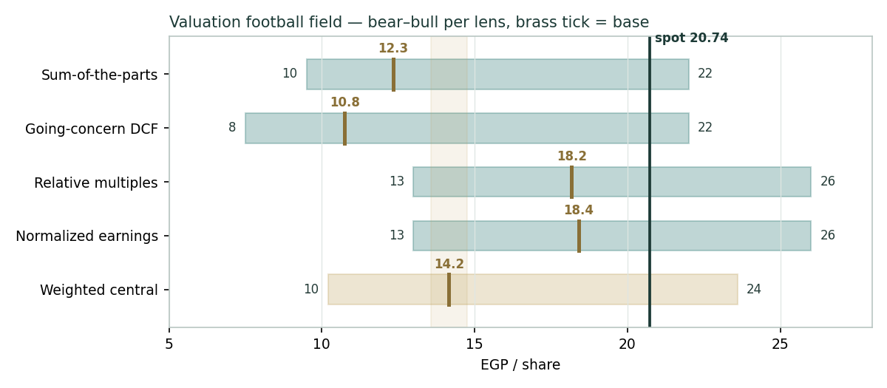
Figure 1 — Valuation football field. Bars span bear–bull per lens; the brass tick is each base case; the gold band is the blended central range; the dark line is spot.
Central fair value ≈ EGP 14.2/share, about 32% below spot. The spread of the base lenses (EGP 10.8 to 18.4) is itself the message: this is not a cheap stock on any intrinsic measure, but neither is it absurd on the market’s own multiple — it is a high-quality franchise whose price already embeds years of continued outperformance. Notably, spot (EGP 20.74) sits above every base lens and only inside the blended bull scenario (EGP 23.6): the tape is trading near the optimistic edge of our fundamental range.
1.6 The operating segments — a deeper look
Transaction (FY2025 revenue EGP 2,679 mn, +30%) is the cash engine and the moat: e-finance operates the rails for government collections and disbursements, card management and payment processing on a mix of fixed and variable fees, and it benefits mechanically from the digitisation of tax, customs and subsidy flows — national tax collections rose ~38% and a Q4 tourism surge (the Grand Egyptian Museum opening) added throughput. Cloud (EGP 2,387 mn, +51%) is the growth and scarcity story: the licensed government cloud, expanding capacity to meet rising demand, at a high margin. Build & Operate (EGP 1,163 mn, −5%) is the lumpy, lower-margin project arm. Other (EGP 545 mn, +58%) bundles card production, BPO and the consumer/embedded-finance ventures (eKhales, eAswaaq). The table scores each part on the axes that matter for value.
Segment | Growth | Margin | Capital intensity | Swing role
Transaction | High (+30%) | Very high | Low | Cash moat
Cloud | Hyper (+51%) | High | Moderate (build-out) | Value engine
Build & Operate | Lumpy (−5%) | Low | Low | Ballast
Other | High (+58%) | Mixed / early | Low | Optionality
1.7 The multiple and the discount rate — the crux
Two judgments drive this valuation more than any other, and neither concerns the business’s quality, which is not in doubt. First, the multiple e-finance deserves: at ~16x forward EV/EBITDA and ~24x forward earnings the market treats it as a durable 30%-grower with a government moat. If Egyptian digitisation sustains 25%-plus growth for longer than our fade assumes, today’s multiple is defensible and our intrinsic lenses are too conservative. Second, the EGP discount rate: a going-concern DCF in Egyptian pounds must discount at Egypt’s cost of capital. We use 21% (normalized, forward), but the spot EGP cost of equity is nearer 22–24%. Every point of WACC is worth roughly EGP 1.0–1.5/share here, and the entire gap between our EGP 10.8 DCF and the EGP 18 market-multiple lenses is, at root, a disagreement about whether one should discount at today’s high nominal rate or a lower normalized one as the central bank eases. The bull case is that rates fall faster than assumed and growth persists longer; the bear case is that neither happens and the multiple compresses toward the intrinsic value.
1.8 Macro and country — Egypt, rates, the pound and concentration
e-finance is a leveraged play on the Egyptian state and the Egyptian macro cycle. Interest rates cut both ways: high EGP rates depress the DCF (the discount-rate problem above) but also lift the group’s own interest income on its cash and treasury-bill book — and a falling-rate path, which the market appears to expect, would re-rate the equity while trimming that income. Inflation is the tailwind under the revenue line: much of the transaction business scales with nominal flows (tax, customs, subsidies), so high nominal GDP growth feeds the top line. Government concentration is the structural risk: a large share of revenue and receivables is tied to state entities and state-linked shareholders (the National Investment Bank, Banque Misr, NBE and the Saudi Egyptian Investment Company together dominate the register), which supports the moat but caps independence and adds policy/tariff-setting risk. The pound matters less directly than for an exporter, but EGP devaluation episodes compress the dollar value of the equity and can spike the discount rate. These levers sit behind the bear and bull cases in §1.5 and the catalysts in §5.
1.9 Relative-lens sensitivity — the multiple the market pays
Holding the balance sheet fixed, the grid re-prices the relative lens across the normalized EBITDA and the EV/EBITDA multiple. The cells near spot (EGP 20.74) are highlighted; the value runs from EGP 12.5 (12x on EGP 3,800 mn) to EGP 22.6 (18x on EGP 4,800 mn). Read it as a map of how much forward growth the market has already capitalised: spot corresponds to ~15–16x on a normalized ~EGP 4,400 mn — i.e. the market is paying a mid-teens multiple on next year’s EBITDA, not on a distant normalized figure.
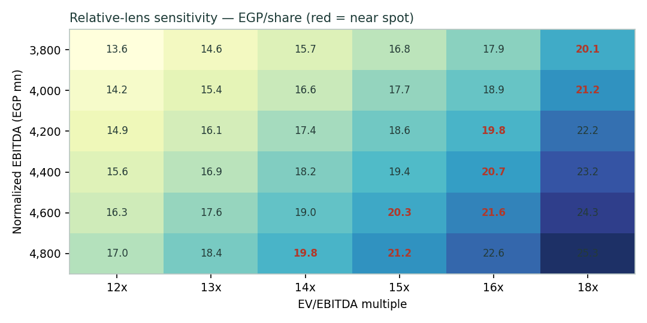
Figure 2 — Relative-lens sensitivity to normalized EBITDA and the EV/EBITDA multiple (EGP/share). Red cells sit near spot.
2 Technical and price structure
The tape is consolidating, not breaking. e-finance trades just below its 20-, 50- and 100-day moving averages but comfortably above the 200-day, the MACD histogram is mildly negative, and RSI sits at a neutral 46 — neither overbought nor oversold. The structure reads as a pause after a strong recovery that carried price from the EGP 11 area (the 52-week low) to the low-EGP-20s, with the longer-term trend still up. This is the mirror image of TMPV-style oversold weakness: here the fundamentals argue the stock is rich while the tape is merely resting.
Indicator | Reading | Signal
Spot | EGP 20.74 | —
SMA 20 / 50 | EGP 21.06 / 21.31 | Just below — short-term soft
SMA 100 / 200 | EGP 20.86 / 18.32 | Below 100, above 200 — trend intact
RSI (14) | 46.2 | Neutral
MACD (12,26,9) | −0.25 line / −0.16 signal / −0.09 hist | Mildly negative
52-week range | EGP 11.20 – 23.28 | Upper third of range
Realized vol (252d) | 34.4% | Elevated (typical for the name)
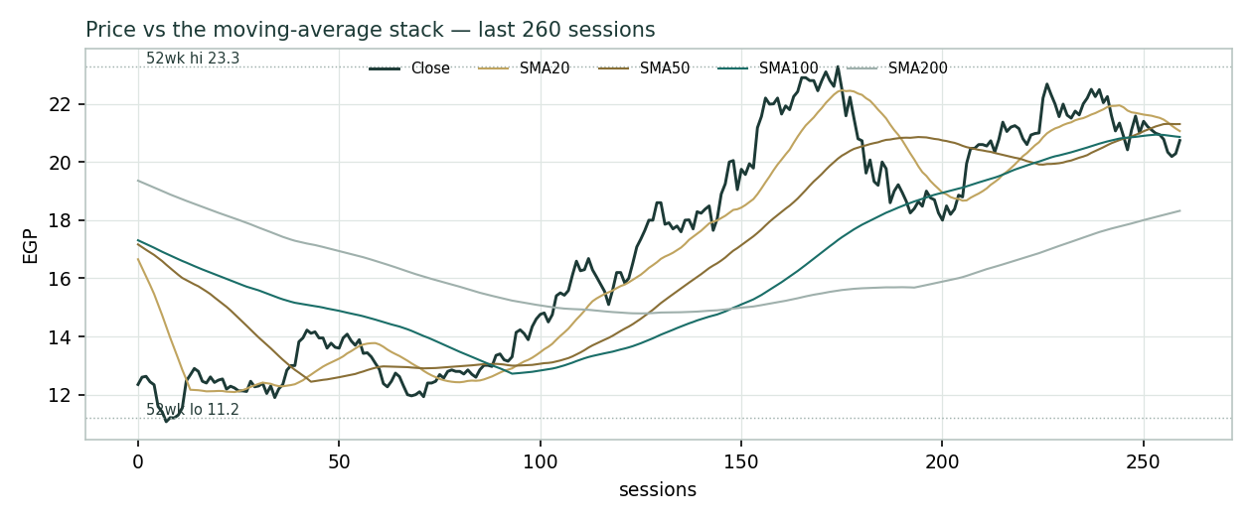
Figure 3 — Price versus the moving-average stack, last 260 sessions.
For the probabilistic work this matters in one way: a neutral, mid-trend tape neither widens the downside tail (as an oversold tape would) nor confirms the fundamental caution. Price and value genuinely disagree — the tape near its highs, the intrinsic lenses well below — and §6 reads the resulting probability zones without forcing a reconciliation.
3 Monte Carlo — a probabilistic price map
We simulate 50,000 three-month price paths (seed 42) with the house YZ-HAR engine: volatility width is set by a pooled log-HAR cascade on a gap-aware Yang–Zhang variance proxy (not trailing close-to-close vol), innovations are unit-variance Student-t(5) for honest tails, and — critically for this name — drift is switched OFF. Step 0 (Appendix B) showed that a secular-drift assumption fails e-finance’s calibration: like the international names in the house library, its post-IPO history contains a de-rating and a recovery that break a confident trend at the regime turn, so the zero-drift configuration is the one that beats the benchmark. By design the paths diffuse from spot, and the §1 value gap is kept out of the drift — the fundamental picture lives in §1, not here; §3 maps where price could go from today, not where value sits. The live forward volatility is ~50.9% annualized (e-finance is a high-vol name); a sixteen-factor stack (seven continuous drivers, nine discrete events) layers on top of the diffusion.
Continuous factor (7) | Dir. | Discrete event (9) | Prob. | Impact
Digitisation / tax-flow throughput | + | 2Q2026 results (Aug) | 85% | +0.4%
Cloud demand / capacity ramp | + | CBE rate decision | 55% | ±1.5%
EGP interest-rate path (income vs discount) | ± | Dividend / capital-return news | 30% | +1.0%
Tourism / consumer transaction volumes | + | New government mandate / contract | 25% | +2.0%
Competitive pressure (Fawry, banks, fintechs) | − | Regulatory / fee-cap change | 20% | −2.5%
EGP devaluation / FX shock | − | Shareholder placement / lock-up | 20% | −1.5%
Cost inflation / margin drag | − | Index / flow rebalancing | 25% | +1.0%
 |  | Associate / investment-income surprise | 25% | +1.2%
 |  | Macro / risk-off (EM) | 20% | −2.0%
Percentile map (EGP/share):
Horizon | p5 | p25 | p50 | p75 | p95
T+20 sessions | 16.58 | 19.13 | 20.74 | 22.48 | 25.94
T+60 sessions | 14.08 | 18.04 | 20.74 | 23.85 | 30.56
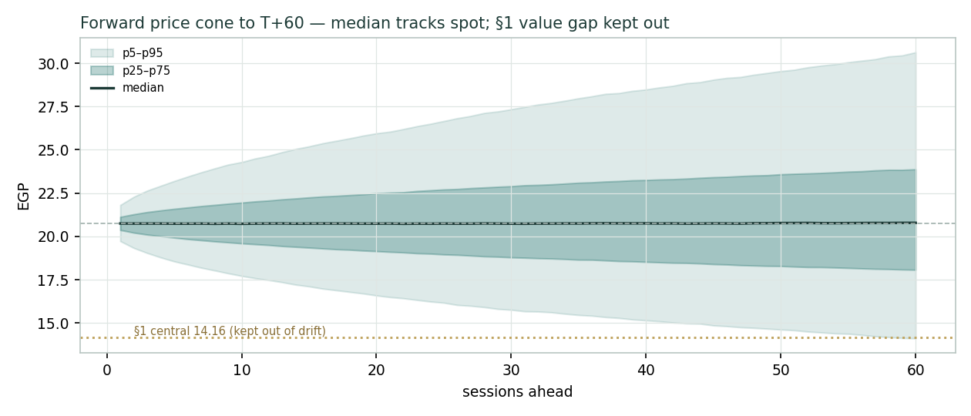
Figure 4 — Forward price cone to T+60. Median tracks spot; the gold dotted line marks the EGP 14.2 fundamental central value, deliberately kept out of the drift.
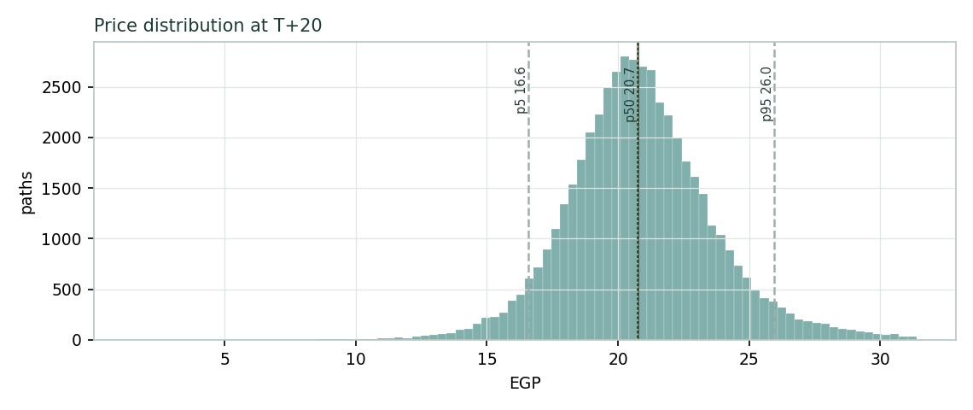
Figure 5 — Price distribution at T+20.
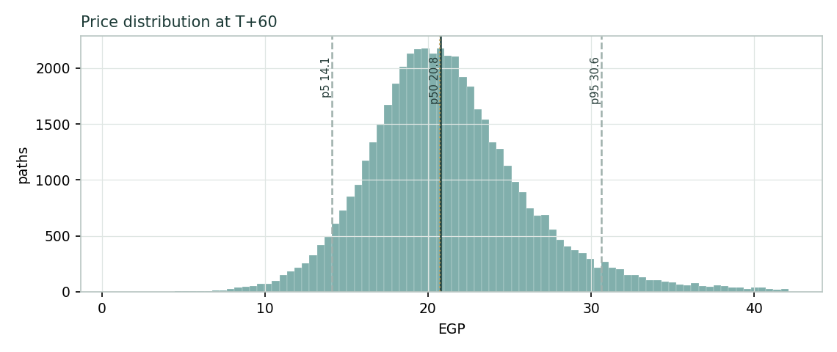
Figure 6 — Price distribution at T+60.
Lead with the body, not the tail. The 50% interquartile band is EGP 19.1–22.5 at T+20 and EGP 18.0–23.9 at T+60 — the latter about 28% of spot, which is the instrument’s genuine quarter-ahead uncertainty, not padding. The band is right-skewed: e-finance’s own volatility plus the discrete upside events (a rate cut, a new mandate, a capital return) produce a heavier upper tail.
Level-touch ladder — the probability that price touches a level at any point by the horizon (running max for upside, running min for downside):
Level | T+20 touch | T+60 touch | Note
EGP 26 | 8% | 26% | Toward 52-wk-high zone / bull scenarios
EGP 24 | 20% | 44% | Above the range high
EGP 23 | 33% | 56% | Near 52-week high
EGP 22 | 53% | 72% | Just above spot
EGP 21 | 81% | 89% | At spot
EGP 20 | 67% | 80% | Just below spot
EGP 19 | 40% | 62% | Mild downside
EGP 18 | 21% | 45% | Toward the market-multiple fair value
4 Comparison of the lenses, and a verdict
Three readings sit side by side. The fundamental lenses cluster at EGP 10.8–18.4 with a central EGP 14.2 — meaningfully below spot, the gap being a growth-versus-discount disagreement rather than a quality doubt. The technical picture is neutral: consolidating below the short-term averages, above the 200-day, momentum mildly soft. The probabilistic map says that over three months price is roughly symmetric-to-right-skewed around spot — the median is EGP 20.7, not EGP 14.2, because the simulation does not assume the value gap closes inside the quarter.
Lens | Reads | Central / implication
Fundamental (4-lens) | Full / rich | EGP 14.2 (~−32% vs spot)
Technical | Neutral / consolidating | Support ~EGP 18–19; resistance ~EGP 23
Monte Carlo (3-month) | Wide, right-skewed | Median EGP 20.7; p5–p95 14.1–30.6
Verdict (a fair-value read, not a recommendation). e-finance is a genuinely excellent business trading at a full price. On intrinsic, EGP-appropriate parameters the shares look rich — the market is capitalising continued 30%-class growth and, implicitly, a falling discount rate. The bull case is coherent (Egypt’s digitisation runway is long, margins are still expanding, and the group is net cash with an optionality-rich venture book), and it is what would have to be true to justify spot. The bear case is equally clean: growth fades faster, rates stay higher for longer, and the multiple compresses toward the intrinsic EGP 12–14. The honest summary is a value below price, a near-term distribution centred on price, and an outcome that hinges on two judgments — the durable growth rate and the price of EGP capital — which is why the bear–bull span (EGP 10.2–23.6) is wide. Readers should weigh the lenses themselves; we publish the distribution, not a target.
5 Catalysts to watch
- 2Q2026 results (≈Aug 2026). First read after the strong 1Q2026 (+38.8% revenue, 54.0% EBITDA margin) on whether the growth and margin momentum hold.
- CBE rate path. Each cut lowers the equity discount rate (supportive of the multiple) while trimming e-finance’s own interest income — a two-sided catalyst.
- New government mandates. Fresh collection/disbursement, cloud or digital-ID contracts extend the moat and the growth runway.
- Cloud capacity & margin. Evidence that the cloud build-out sustains its ~50%-plus segment margin as it scales.
- Dividend & capital return. Payout policy on a net-cash balance sheet; any buyback or special distribution.
- Consumer/embedded-finance ventures. Traction (or losses) at eKhales, eAswaaq and card production — the optionality bucket.
- Shareholder register. Any placement, lock-up expiry or change among the state-linked and Saudi holders that alters float and overhang.
- EGP & inflation. A devaluation episode or an inflation surprise re-prices both the top line and the discount rate.
6 Reading the probability zones
Translating the three-month distribution into plain zones, anchored on spot EGP 20.74 and the fair-value cluster:
Zone (T+60) | Range | Approx. probability | What it would mean
Deep downside | < EGP 16 | ~14% | Growth scare / EM risk-off; toward the intrinsic cluster
Lower band | EGP 16–19 | ~25% | De-rating toward market-multiple fair value
Around spot | EGP 19–22 | ~30% | Status quo; growth-multiple regime holds
Upper band | EGP 22–26 | ~20% | Momentum + rate-cut optimism extend the run
Strong upside | > EGP 26 | ~11% | New mandate / capital return / rate cuts together
The distribution is close to symmetric with a slightly heavier upper tail from the discrete upside events. It is not a forecast; it is the spread of outcomes consistent with the stock’s own volatility and the factor stack.
7 Caveats and what would change our mind
- The discount rate is the model. Most of the gap to spot is the 21% EGP WACC. If a normalized cost of capital of 18% is the right lens as rates fall, the DCF rises toward EGP 15–16 and the gap narrows sharply.
- Growth could outrun the fade. We fade revenue to the low-teens by FY2030; Egypt’s digitisation is early and 1Q2026 ran +38.8%. Sustained 25%-plus growth would validate the market’s multiple.
- Government concentration. The moat and the risk are the same fact: revenue and receivables lean on state entities. A change in fee-setting, mandate allocation or political priorities would hit hard.
- The NCI haircut is a simplification. We apply a flat 20% economic minority share to enterprise value; if minorities are concentrated in smaller, lower-value subsidiaries, both intrinsic lenses are too low.
- Treasury/associate income is real but rate-sensitive. ~EGP 0.9 bn of investment-and-interest income flows through profit; a sharp rate decline trims it even as it lifts the equity multiple.
- Technical reminder. A neutral RSI and a mid-trend tape say nothing about value; the technical read is context, not a trigger.
Appendix A Financial statements
Selected consolidated figures in EGP million. FY2024 and FY2025 are company disclosure (FY2025 earnings release, 04 Mar 2026); FY2023 is reconstructed from disclosed 9M2024 year-on-year growth and segment trends and is shown for scale. FY2026E–FY2030E are the model’s forecast, driven off the Assumptions sheet in the companion workbook.
A.1 Income statement (consolidated, EGP mn)
Line | FY23 | FY24 | FY25 | FY26E | FY27E | FY28E | FY29E | FY30E
Revenue | 3,916 | 5,209 | 6,773 | 8,954 | 11,308 | 13,711 | 16,043 | 18,202
Gross profit | 2,036 | 2,787 | 3,819 | 5,059 | 6,389 | 7,678 | 8,904 | 10,011
EBITDA | 1,801 | 2,450 | 3,332 | 4,477 | 5,654 | 6,787 | 7,861 | 8,828
EBITDA margin | 46.0% | 47.0% | 49.2% | 50.0% | 50.0% | 49.5% | 49.0% | 48.5%
D&A | (180) | (230) | (252) | (358) | (475) | (617) | (770) | (910)
EBIT | 1,621 | 2,220 | 3,080 | 4,119 | 5,179 | 6,170 | 7,091 | 7,918
Investment & interest income | 500 | 785 | 893 | 960 | 1,020 | 1,090 | 1,160 | 1,230
Finance cost | (40) | (50) | (50) | (60) | (65) | (70) | (75) | (80)
PBT | 2,081 | 2,956 | 3,923 | 5,019 | 6,134 | 7,190 | 8,176 | 9,068
Tax | (468) | (665) | (895) | (1,129) | (1,380) | (1,618) | (1,840) | (2,040)
less: minorities | (323) | (515) | (623) | (778) | (951) | (1,114) | (1,267) | (1,406)
Net profit after NCI | 1,290 | 1,776 | 2,405 | 3,112 | 3,803 | 4,458 | 5,069 | 5,622
FY2023 reconstructed; FY2024–FY2025 disclosed (FY2025 earnings release, 04 Mar 2026); FY2026E–FY2030E model forecast, driven off the Assumptions sheet.
A.2 Balance sheet (consolidated, EGP mn)
Line | FY23 | FY24 | FY25 | FY26E | FY27E | FY28E | FY29E | FY30E
PP&E + intangibles | 2,100 | 2,400 | 2,600 | 2,734 | 2,881 | 2,950 | 2,902 | 2,720
Financial investments | 2,899 | 3,746 | 5,823 | 5,823 | 5,823 | 5,823 | 5,823 | 5,823
Receivables | 862 | 1,146 | 1,490 | 1,970 | 2,488 | 3,016 | 3,529 | 4,005
Cash & equivalents | 1,140 | 1,306 | 1,491 | 4,614 | 8,496 | 13,181 | 18,642 | 24,821
Other assets | 400 | 450 | 500 | 500 | 500 | 500 | 500 | 500
Total assets | 7,400 | 9,048 | 11,904 | 15,641 | 20,188 | 25,470 | 31,396 | 37,868
Controlling equity | 5,300 | 6,680 | 8,626 | 11,258 | 14,501 | 18,309 | 22,618 | 27,360
Minority interests | 1,100 | 1,300 | 1,500 | 2,278 | 3,229 | 4,343 | 5,610 | 7,016
Borrowings | 90 | 100 | 112 | 112 | 112 | 112 | 112 | 112
Payables | 587 | 781 | 1,016 | 1,343 | 1,696 | 2,057 | 2,406 | 2,730
Provisions & other | 323 | 187 | 650 | 650 | 650 | 650 | 650 | 650
Net cash (cash − debt) | 1,050 | 1,206 | 1,379 | 4,502 | 8,384 | 13,069 | 18,530 | 24,709
Balance check | 0 | 0 | 0 | 0 | 0 | 0 | 0 | 0
A.3 Cash flow (forecast, EGP mn)
Line | FY26E | FY27E | FY28E | FY29E | FY30E
Operating cash flow | 4,095 | 5,064 | 6,021 | 6,943 | 7,787
− Capex | (492) | (622) | (686) | (722) | (728)
Free cash flow | 3,603 | 4,442 | 5,336 | 6,221 | 7,059
− Dividend | (480) | (560) | (650) | (760) | (880)
Net change in cash | 3,123 | 3,882 | 4,686 | 5,461 | 6,179
Appendix B Step 0 — calibration backtest
Before any forecast we test the Monte Carlo lens on e-finance’s own history: at each origin, using only data to that date, we generate a 60-session-ahead distribution and score the realized close against it. The grade is skill versus a zero-drift random-walk benchmark, measured by CRPS skill (must be > 0) and the interval (Winkler) score; the PIT histogram and 50/80/90% coverage are diagnostics only. Two configurations were tested. Drift-off passes (CRPS skill +0.023 at the fortnightly step, +0.017 non-overlapping, with a roughly uniform PIT); drift-on fails (CRPS skill −0.023), because e-finance’s post-IPO history contains a de-rating then a recovery that break a confident trend at the regime turn — the same failure seen on the international names in the house library. The zero-drift configuration is therefore carried into the §3 forward run. Coverage runs slightly wide (94% at the nominal 90% band): an honestly-wide cone, not a tuned-narrow one.
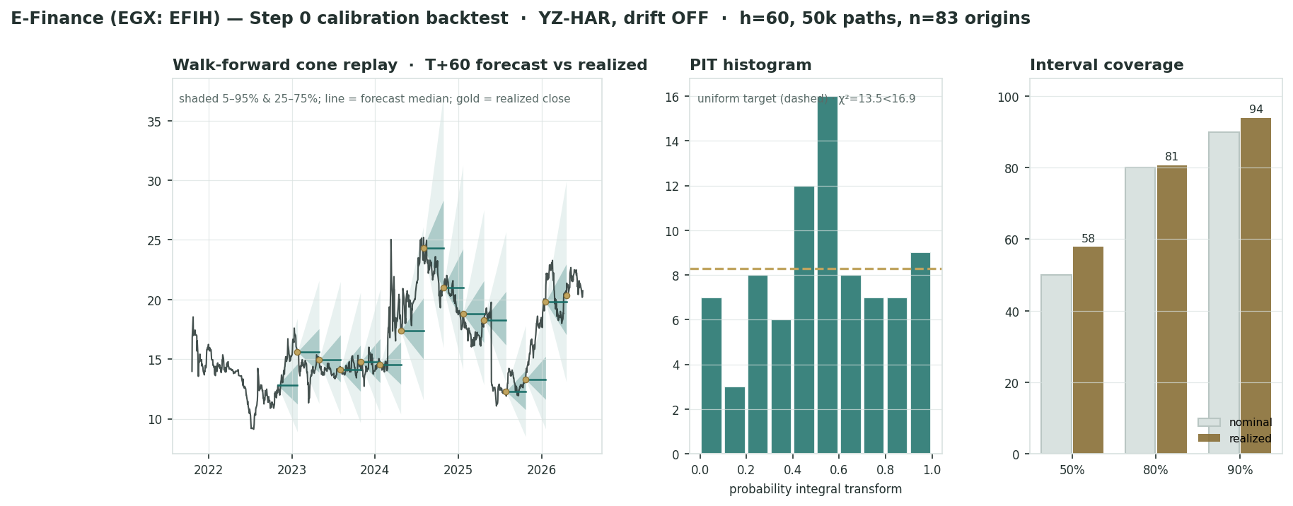
Figure B-1 — Calibration backtest (drift-off, accepted): quarterly cone replay, PIT histogram, and interval coverage versus target.
Config | n | CRPS skill | Winkler skill | PIT mean (χ²)
Drift OFF (step 10d) ✓ | 83 | +0.023 | +0.077 | 0.53 (13.5 < 16.9)
Drift OFF (non-overlap) | 14 | +0.017 | +0.041 | —
Drift ON (step 10d) ✗ | 83 | −0.023 | +0.054 | 0.52
Benchmark | — | 0 (by def.) | 0 | 0.50 target
The grade is skill, not band-containment: the drift-off lens beats the naïve cone on CRPS and interval score with a near-uniform PIT, and is accepted. This is a genuine, if modest, edge over the random walk — consistent with the house finding that for names without a clean secular trend, honest width plus a fat-tailed shape beats a confident drift.
Appendix C Peer set, sector structure, and risks
e-finance has no single clean comparable — it is a payment-rails processor, a government cloud host and an embedded-finance venture book in one wrapper. The peer set is therefore split by part.
Part | Closest peers | Typical valuation
Payment rails / processing | Fawry (EGX), Network International, Geidea | EV/EBITDA ~10–18x; growth-linked
Government cloud / IT | regional cloud & IT-services names | EV/Revenue ~3–7x; scarcity premium
Card & embedded finance | Paymob, MNT-Halan, Marqeta | early-stage / strategic marks
Sector structure. Egyptian digital payments are structurally growing — driven by financial inclusion, the digitisation of government collections and disbursements, and a young, mobile-first population — and e-finance sits at the infrastructure layer with a government-anchored moat. Competition comes from Fawry (consumer-facing), the banks (in-house processing) and a growing fintech field (Paymob, MNT-Halan) at the edges. Principal risks: a higher-for-longer EGP discount rate; a faster-than-expected growth fade; government/regulatory concentration (fee-setting, mandate allocation); EGP devaluation; competitive fee pressure; and execution/losses in the consumer-venture bucket.
Appendix D The expert valuation panel
Every Testahil study closes with a panel of standing expert personas — drawn from the house Expert Persona Library, not invented for the occasion, so that each accumulates a track record across studies and a quarterly update is a re-run, not a re-training. For an asset-light, cash-generative growth franchise the library’s casting map points to the earnings-power, accountant/cash-returns and macro-policy personas; the capital-heavy “cash-returns” persona that a factory or a developer would attract is not cast here, because e-finance spends only ~4–5% of revenue on capex. We therefore seat the three whose methods both fit the instrument and genuinely disagree: Expert 1 (earnings power and relative multiples), Expert 2 (earnings quality and cash returns), and Expert 3 (macro-policy — the EGP discount rate and country/concentration risk). Each runs a genuinely different method — a multiple on normalized profit, a discounted stream of durable core cash, and a discount-rate-first read of Egyptian pounds — derives its fair value from shown workings rather than assertion, and states a falsification condition that would prove it wrong. The three land, respectively, at the top, middle and bottom of the fundamental range, and their spread is a clean, single-axis measure of the study’s only real question: whether to pay a growth multiple on Egyptian cash flows or to discount them at Egypt’s cost of capital. None of the three doubts the quality of the business; they disagree only about its price.
D.1 Expert 1 — earnings power and relative multiples
Worldview. A high-quality operating business is worth a fair multiple of its sustainable, mid-cycle earnings; peaks and troughs are noise to be stripped out, and durable growth and high returns on capital earn a premium multiple, not a penalty. e-finance, to her, is exactly the kind of franchise the method was built for: a near-monopoly on Egypt’s government payment rails, the country’s licensed government cloud growing 51%, a 49–54% EBITDA margin, a ~28% return on equity, and a net-cash balance sheet with an optionality-rich venture book on top. She does not accept that such a business should be discounted to a low intrinsic value simply because Egyptian nominal rates are temporarily high; a durable compounder, in her view, is re-rated as those rates normalise, and the patient owner is paid for waiting. Her anchor is the multiple, benchmarked to the growth-and-returns profile and to what disciplined buyers pay for comparable payment and cloud infrastructure across emerging markets.
When it works / fails. The method is at its best for franchises with a demonstrable, repeatable growth-and-returns record and a defensible moat — precisely e-finance’s profile through its listed history. It fails at a structural break: if the digitisation runway shortens, if the government re-sets processing fees or re-allocates mandates, or if competition from Fawry, the banks or the fintech field compresses the take rate, then her “mid-cycle” earnings are mis-specified and the premium multiple she pays is simply wrong. She is also, by construction, exposed to the criticism that a P/E capitalises whatever sits in reported profit — including the rate-sensitive treasury and associate income that Expert 2 wants to strip out.
Standard workings & worked example. She normalises net profit after minorities to a mid-cycle figure (here ~EGP 2,900 mn, close to FY2026E, since e-finance is neither at a trough nor an obvious peak), divides by the 3,466.67 mn shares to get normalised EPS of ~EGP 0.84, and applies a justified P/E benchmarked to the growth rate and to regional payment peers — 22x, a premium to a mature utility but a discount to the ~24x the market itself pays and well below a pure-growth fintech. The arithmetic is deliberately simple; the judgment is entirely in the multiple.
Expert 1's normalization | Value
Mid-cycle net profit after NCI (EGP mn) | 2,900
Shares (mn) → normalized EPS | 3,466.67 → EGP 0.84
Justified P/E (premium grower, net cash) | 22.0x
Fair value | → EGP 18.4 / share
Sensitivity (swing = the multiple). The whole answer is the multiple: at 18x she is at EGP 15.1, at 22x EGP 18.4, at 26x EGP 21.7. A one-turn move in the justified P/E is worth ~EGP 0.84/share. She would defend anything from the high-teens to the mid-twenties given the growth, which is precisely why the intrinsic experts regard her lens as the least disciplined — it imports the market’s regime rather than testing it.
Cross-examination. She tells Expert 2 that stripping out treasury and associate income double-penalises a business that genuinely earns it — the cash and T-bill book is a permanent, well-managed feature, not a one-off, and refusing to capitalise it understates the franchise. She tells Expert 3 that discounting a durable 30%-grower at a spot EGP rate mistakes a temporary rate cycle for a permanent structural cost; the low beta already embeds Egyptian risk, and the government anchor is a moat that reduces cash-flow volatility, not merely a concentration hazard. On her telling, both colleagues are valuing e-finance as if today’s rate environment and today’s growth are frozen in place, when the base case is that rates fall and the runway persists.
Verdict, falsification, market-implied. Fair EGP 18.4 (range EGP 13.0–26.0). Falsified by a durable growth slowdown below ~15% a year, a structural margin reset, or a government-driven cut to processing economics that a premium multiple cannot survive. The market price (EGP 20.74) implies a multiple ~13% above her justified 22x — so even the most bullish of the three experts is more cautious than the tape, which is itself a useful signal about how much optimism is already in the price.
D.2 Expert 2 — earnings quality and cash returns
Worldview. Cash, not booked profit, is the test, and in e-finance’s accounts not all profit is equal. He looks past the income statement to the economic substance and separates two very different streams: the durable operating core — the transaction rails and the cloud, which throw off high-margin, self-funding cash — from the rate-sensitive treasury-and-associate income (roughly EGP 0.9 bn of interest on the cash and T-bill book plus the share of associates’ results), which a falling-rate path will shrink and which he refuses to capitalise at a full equity multiple. He charges the cloud build-out its true capital cost, insists that reported growth be reconciled to free cash, and values only what he judges repeatable and independent of the interest-rate cycle. His is the most conservative construction of the three because it credits the least to anything that is not core, recurring operating cash.
When it works / fails. The lens is at its best where reported earnings flatter the underlying cash picture — where non-operating income, aggressive capitalisation or working-capital timing inflate the headline. It fails in the opposite case: if e-finance’s “non-core” treasury and associate income proves as durable and well-managed as the operating core (a plausible reading, given the group’s consistent net-cash discipline), then he systematically under-credits a genuine, repeatable earnings stream and his fair value is too low. He is also exposed to the charge that he under-weights a long, visible growth runway by discounting only what is provable today.
Standard workings & worked example. He rebuilds free cash flow to the firm from operating EBIT alone — excluding investment income — nets out the full cloud capex, discounts the resulting stream at the EGP cost of capital, and then adds back only the disclosed net cash (EGP 1,379 mn) rather than capitalising the income it generates. On FY2026E core operating cash of ~EGP 2,900 mn discounted at 21% with a modest terminal, plus net cash, he arrives at ~EGP 12.5/share — deliberately below the group DCF, which does credit the investment income.
Expert 2's cash-returns test | Value
Core FCFF (FY2026E, ex-investment income) | ~2,900
EGP discount rate | 21%
Treasury/associate income | credited at book, not capitalized
Net cash added | 1,379
Fair value | → EGP 12.5 / share
Sensitivity (swing = how much treasury income is durable). His answer hinges on one judgment. Crediting the full investment-and-associate income stream as durable lifts him to ~EGP 15; excluding it entirely, and charging the cloud its harshest capital cost, drops him to ~EGP 10. The ~EGP 5 range around his EGP 12.5 base is a direct measure of how much of e-finance’s reported profit one believes is repeatable, rate-independent operating cash.
Cross-examination. He tells Expert 1 that a P/E struck on headline profit capitalises interest income that a CBE cut will visibly shrink — the very rate decline her bull case relies on to re-rate the multiple would, at the same time, reduce the earnings she is multiplying, so she cannot have the re-rating and the earnings both. He tells Expert 3 that the discount rate is right but too blunt: applying a single high EGP WACC to the whole business ignores that the operating core is far more predictable than a cyclical, and that a long, visible digitisation runway is a real asset that a discount-rate-only read discards. His position is the fulcrum of the panel — more cautious than the market, but unwilling to write the business down as far as a pure rate lens would.
Verdict, falsification, market-implied. Fair EGP 12.5 (range EGP 9.0–17.0). Falsified if core cash conversion proves as strong and durable as the headline profit through a full rate cycle — i.e. if the treasury and associate income turns out to be a permanent structural feature rather than a rate-cycle windfall. The market price implies core, durable cash flows roughly 40% above his estimate: the tape does not distinguish core operating cash from treasury income, and pays for both at the same premium multiple.
D.3 Expert 3 — macro-policy: the EGP discount and country risk
Worldview. For a company that earns and reports in Egyptian pounds, the discount rate is the valuation. He starts not from the business but from the price of EGP capital — a spot cost of equity near 22–24%, built from a high local risk-free rate and a modest equity premium against a low beta — and from the specific risk that a large share of e-finance’s revenue and receivables is owed by, or intermediated for, the Egyptian state and state-linked shareholders. He treats the multiple as an output of those inputs, not as a thing to be chosen, and he is sceptical of any valuation that quietly assumes the rate cut it needs. His discipline is to make the cost of capital explicit and let it set the price; his blind spot, which he concedes, is that he can be too anchored to today’s rate when the whole market is looking through it.
When it works / fails. The method earns its keep in exactly this setting — a high-nominal-rate emerging market where the discount rate, not the operating story, drives the answer, and where investors who ignore the local cost of capital repeatedly overpay. It fails if rates fall faster and further than his cautious path assumes: if Egyptian inflation and policy rates converge toward single digits with growth intact, his high WACC is stale and his fair value is too low. That is the bull case he is most exposed to, and he does not pretend otherwise — he simply refuses to underwrite it before it happens.
Standard workings & worked example. He takes the group’s cash flows, discounts them at a spot-to-normalised EGP WACC (he uses ~23% at the spot end), embeds a government-revenue-concentration adjustment as an addition to the discount rather than a separate haircut, grows the terminal at 11% nominal, and reads off the implied price — ~EGP 11.5/share. The number is close to Expert 2’s and well below Expert 1’s, and the difference is entirely the rate at which Egyptian pounds are discounted.
Expert 3's discount-rate test | Value
Spot EGP cost of equity | ~23%
Government-concentration adjustment | embedded in a higher discount
Terminal growth (nominal) | 11%
Implied fair value at spot rates | → EGP 11.5 / share
Sensitivity (swing = the EGP WACC). The discount rate is the entire disagreement, and his sensitivity makes it legible: at a normalised 18% WACC he rises to ~EGP 16, essentially closing the gap to the market-multiple lenses; at the spot 24% he falls to ~EGP 10. Every point of WACC is worth roughly EGP 1.0–1.5/share. His base EGP 11.5 is simply the spot rate applied honestly.
Cross-examination. He tells Expert 1 that a premium multiple on Egyptian cash flows is a category error — those pounds are discounted at 22–24% whatever multiple one writes on the earnings, and a P/E that ignores the local cost of capital is a foreign-investor illusion. He tells Expert 2 that even the durable operating core is worth less than it looks once charged the true cost of EGP capital: quality does not exempt a cash flow from being discounted at Egypt’s rate. His retort to both is the same — the argument is not about the business, it is about the currency it earns, and the day the central bank delivers the cuts the market expects, he will raise his number alongside theirs.
Verdict, falsification, market-implied. Fair EGP 11.5 (range EGP 8.0–18.0) — the most cautious of the three. Falsified by a durable fall in Egyptian rates toward single digits with growth intact, which would make his high WACC obsolete. The market price implies an EGP discount rate well below spot — on his reading, the tape has already priced the rate cut he has not yet been willing to assume, which is either foresight or complacency depending on the central bank.
D.5 The three in one room
The single question they most disagree on is not the business but the price of Egyptian capital and how long its growth lasts.
Expert 1: “This is a 30%-grower with 50% margins, net cash and a government moat. That is a premium franchise; you pay a premium multiple. Twenty-two times mid-cycle earnings is EGP 18, and the runway argues it lasts.”
Expert 2: “Half your ‘earnings’ growth leans on interest and associate income that a rate cut will shrink. Charge the cloud its capital cost, count only the durable core cash, add the net cash — that is EGP 12, not EGP 18.”
Expert 3: “You are both arguing about the multiple. In Egyptian pounds the discount rate is the argument. Discount those cash flows at 22–24% and add a concentration haircut and the number is EGP 11 — the day rates fall, we can all raise it together.”
Expert 1: “But the market is not waiting for the cut to happen; it is discounting that it will. If policy rates fall three or four points over two years, your EGP 11 becomes EGP 16 and my EGP 18 barely moves. You are underwriting the past rate, not the forward one.”
Expert 2: “And when that cut arrives, roughly a third of the profit you are both multiplying — the interest income on the cash and the T-bills — comes down with it. The re-rating and the earnings pull in opposite directions. Pay for the core, which is real either way, and treat the rest as a bonus, not a base case.”
Expert 3: “Then we agree on the mechanism and differ only on the odds. Name the rate path and the growth fade, and the three numbers collapse into one. Until the central bank acts, I will hold the spot rate; you two are already spending the cut.”
D.6 Reading the divergence
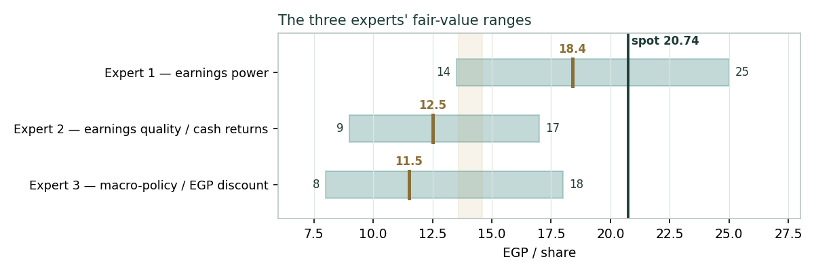
Figure D-1 — The three experts' fair-value ranges. Brass ticks are base cases; the gold band is the central; the dark line is spot. The spread is almost entirely a growth-versus-discount disagreement.
Expert | Method | Single swing assumption | Base
Expert 1 | Earnings power / multiples | Justified P/E on mid-cycle EPS | EGP 18.4
Expert 2 | Earnings quality / cash | Durable core FCFF vs treasury income | EGP 12.5
Expert 3 | Macro-policy / EGP discount | The EGP cost of capital | EGP 11.5
The spread — EGP 11.5 to 18.4 at base — is wide, and it is almost entirely a growth-versus-discount disagreement: none of the three contests the quality of the rails, the scale of the cloud, or the net-cash balance sheet. What separates them is whether to pay a premium multiple on Egyptian growth (Expert 1), to trust only the durable, self-funding core (Expert 2), or to let the EGP discount rate set the price (Expert 3). The EGP 6.9 spread is therefore a clean measure of one uncertainty — the appropriate price of Egyptian capital while rates are falling. Resolve that, and the three converge. Spot (EGP 20.74) sits above all three base cases, nearest Expert 1’s bull: the market is pricing the most optimistic combination of durable growth and imminent rate relief.
Each expert's point fair value (and bull/base/bear) is logged with the study date (01 Jul 2026) and spot (EGP 20.74) as an internal per-expert track record, kept separate from the core Calibration Ledger.
About this series
Testahil publishes independent, educational valuation studies. Each is an attempt to reason transparently about what a security is worth, with every assumption shown and a companion model so readers can disagree productively. The house style is distributions, not tips: we describe ranges and probabilities, not targets, and we do not tell anyone what to do. Studies are framed as educational analysis, the preparer is not licensed by any securities regulator, and holdings are disclosed.
Disclosure & Disclaimer
Not investment advice. This document is educational and informational only. It is not, and must not be relied upon as, investment, financial, legal, accounting or tax advice, nor an offer, solicitation or recommendation to buy, sell or hold any security. It contains no price target and no rating.
No licence; no advisory relationship. The preparer is not registered or licensed with any securities or financial regulator in any jurisdiction, including the Egyptian Financial Regulatory Authority (FRA), holds no brokerage or investment-advisory authorisation, and is not acting as your adviser or fiduciary. Nothing here is personalised to your circumstances.
Holdings disclosure. The preparer may hold, and may in the future take or dispose of, a position in the security discussed in this report, and may transact at any time without notice. This is a potential conflict of interest you should weigh.
Sources & accuracy. Reported financial and operating figures are drawn from the company’s public disclosure and other public sources believed reliable but not independently verified; they may contain errors or be superseded. Forward-looking inputs — the segment marks, the multiples, the DCF and Monte-Carlo factor probabilities — are the preparer’s own judgments and are inherently uncertain. FY2023 figures are reconstructed from disclosed interim growth.
Forward-looking statements. Any statements about the future are estimates subject to risks and uncertainties; actual results may differ materially. The Monte Carlo models price, not value, and encodes subjective probabilities for events that have not occurred.
No reliance; your responsibility. Do your own research and consult a licensed professional before making any decision. You are solely responsible for your investment decisions and their outcomes. To the maximum extent permitted by law, the preparer accepts no liability for any loss arising from use of this document.
Currency & figures. Figures are in Egyptian pounds (EGP); mn denotes million and bn billion. Rounding may cause totals to differ slightly. Spot price and market data are as of 01 July 2026 and change continuously.
TESTAHIL · Independent Valuation Study · Educational Analysis · e-finance for Digital and Financial Investments (EGX: EFIH) · edition 03-07-2026 · reporting currency EGP

