Testahil · Independent Valuation Study — Educational Analysis | Not investment advice

Independent Valuation Study — Educational Analysis
Egypt Aluminum Company (EGX: EGAL)
Fundamental analysis · Technical analysis · Monte Carlo simulation — one integrated read
Anchor: EGP 285.88 (01 Jul 2026 close) · 412.5 m shares · mkt cap ≈ EGP 117.9 bn (~US$2.4 bn at EGP/USD 49.1) · the Nag Hammadi primary-aluminium smelter, ~320 kt nameplate, ~62% of revenue exported, 89.8% state-owned via Metallurgical Industries Holding · prices and probabilities computed 01–03 Jul 2026 from the attached daily history · primary lens: consolidated FCFF discounted cash flow, cross-checked on replacement cost per tonne, relative multiples and normalized earnings power · the electricity tariff, the EGP, and the US$900 m Trafigura capacity-doubling partnership (signed 6/10 May 2026) are the swing factors.
READ FIRST — what this document is, and is not. This study is a valuation exercise and an expression of personal analytical opinion, published free of charge for educational purposes: it shows how one analyst applies fundamental, technical and probabilistic methods to a listed company, and invites scrutiny of that methodology. It is NOT investment advice, NOT a recommendation or solicitation to buy, sell or hold any security, and NOT directed at the circumstances of any reader. The preparer is not licensed by any securities regulator in any jurisdiction — including Egypt's Financial Regulatory Authority (FRA) — holds no brokerage authorisation, provides no financial consultancy, manages no money, and accepts no fees, funds or clients. See the Disclosure & Disclaimer at the end. All values are model outputs presented as ranges and distributions because no single number should be relied on. Reported financials are the company's own disclosure (FY2024/25 results released 24 Aug 2025; 9M FY2025/26 release, May 2026); several balance-sheet and cost lines are reconstructions from disclosed anchors and are flagged as derived. Forward-looking inputs — the normalized aluminium price, the electricity-cost path, the WACC, the multiples, the replacement-cost mark and the Monte-Carlo factor probabilities — are the preparer's judgments and are flagged throughout. Consult a licensed financial advisor before any investment decision.

Headline
The model's read: fully valued to modestly rich — the tape has pre-paid part of a doubling that has not yet been financed. At EGP 286 the shares sit about 12% above our weighted central estimate of EGP 250. The four lenses tell one coherent story with different accents: a consolidated DCF on the smelter's own cash generation lands at EGP 268, a normalized mid-cycle earnings-power read at EGP 265, a relative read on global smelter multiples at EGP 235, and a replacement-cost mark on the existing 320 kt of capacity — the sceptic's floor — at EGP 210. What the market is paying above all of these is, in effect, an advance on two things: a blow-out FY2025/26 close (9M net profit EGP 10.4 bn, tracking the company's EGP 13.7 bn full-year target) and the US$900 m Trafigura partnership signed in May 2026 that would roughly double capacity toward ~600 kt. Both are real; neither is banked — the company's own FY2026/27 budget of EGP 11.1 bn concedes the coming year steps down, and the expansion has a term sheet, not a financing close. Technically the stock is consolidating that advance — below its 20- and 50-day averages, RSI at 39, MACD negative — while still riding a 200-day average far below price. Over three months the calibrated Monte Carlo places the 5th–95th percentile band at roughly EGP 231–452 with the median at EGP 326, above spot, because EGAL's own five-year history carries a genuine secular drift that the Step-0 backtest validates — a statement about the tape's demonstrated trend, deliberately not about the §1 value gap.

Valuation summary — every read at a glance
One table for the four reads that follow — what the business is worth (fundamental), what the tape is doing (technical), where price could travel over three months (Monte Carlo), and how three independent expert methods land. Every row is developed in the sections and appendices below.
Lens / read | What it measures | Output | Takeaway
FUNDAMENTAL — what the business is worth (the anchor)
Discounted cash flow (primary) | PV of 5-yr FCFF + terminal, 20% WACC | EGP 268 | −6% vs spot
Relative multiples | Normalized EBITDA × 6.5× EV/EBITDA | EGP 235 | −18%
Normalized earnings power | Mid-cycle NP × 9.5× P/E | EGP 265 | −7%
Replacement cost / EV per tonne | 320 kt × US$5,500/t, aged | EGP 210 | −27% · the floor
Weighted central | Blend 35 / 25 / 25 / 15 | EGP 250 | −12% vs EGP 286
TECHNICAL — what the tape is doing (timing, not value)
Trend & momentum | Price vs the 20/50/100/200-day averages | Below 20/50/100, above 200 | Consolidating an uptrend
Momentum / range | RSI · MACD · 52-week range | RSI 39 · MACD hist −2.1 · 152–338 | Cooling, not broken
MONTE CARLO — where price could go in 3 months (paths from spot)
T+20 sessions | 50,000 paths · 16 factors | p5 245 · p50 299 · p95 362 | Median above spot
T+60 sessions | same engine, longer horizon | p5 231 · p50 326 · p95 452 | Wide, right-shifted
EXPERT PANEL — three independent methods (Appendix D)
Expert 1 — normalized earnings power | Mid-cycle NP × justified multiple | EGP 265 | The through-cycle read
Expert 2 — realizable assets & cash quality | Conservative asset marks + cash test | EGP 244 | Most conservative
Expert 3 — policy-scenario weighted | Tariff/EGP/state-action scenario tree | EGP 272 | Widest range
Panel range | Spread = the policy question | EGP 244–272 | Centres ~EGP 260

Bottom line. Every fundamental lens lands below the price, and they disagree only on how far — EGP 210 on assets, EGP 235 on peers, EGP 265–268 on earnings and cash. The three experts span a narrow EGP 244–272 and centre near EGP 260. The tape and the probabilistic map lean the other way: a validated secular drift puts the three-month median at EGP 326. The honest summary is a stock priced ahead of its lenses on the strength of a record year and an unfinanced expansion, in a market whose own history keeps rewarding exactly that.

Company overview — Egypt Aluminum at a glance
Item | Value
Listed entity | Egypt Aluminum Company (Egyptalum) · EGX: EGAL
What it is | Egypt's sole primary-aluminium producer — smelter complex at Nag Hammadi, Qena (ingot, billet, wire rod, rolled)
Spot / date | EGP 285.88 · 01 Jul 2026 close
Shares · market cap | 412.5 m (paid-in EGP 1,650 m) · EGP 117.9 bn (~US$2.4 bn)
Ownership | Metallurgical Industries Holding (state) ~89.8% · free float ~10%
Capacity / output | ~320 kt/yr nameplate · ~272 kt produced FY24/25 (est.)
FY24/25 revenue / net profit | EGP 43.18 bn (+31.6%) · EGP 10.18 bn (EPS 24.68)
9M FY25/26 · FY25/26 target | NP EGP 10.4 bn (+5% YoY) · company target EGP 13.71 bn
Balance sheet | Net cash ≈ EGP 9.0 bn est. (disclosed EGP 6.9 bn, Sep-2025); effectively debt-free
Export share | ~62% of revenue exported, ~60% of exports EU-bound (CBAM-exposed)
Corporate events | US$900 m Trafigura strategic partnership toward ~600 kt (6/10 May 2026) · Scatec 1.1 GW solar PPA · Alba alumina-refinery MOU
52-week range | EGP 152.01 – 338.00

Source: company disclosure via EGX/Mubasher (FY24/25 release 24 Aug 2025; 9M FY25/26, May 2026), partnership announcements 6/10 May 2026, exchange data. Values rounded; items marked est. are the preparer's reconstructions.

1 Fundamental valuation
We value EGAL as what it is: a single-site, energy-intensive commodity producer with a fortress balance sheet, a state majority owner, and one transformational option on the table. The primary lens is a consolidated FCFF discounted cash flow, because the equity story here is ultimately a cash-conversion story — the smelter converts LME aluminium, an administered electricity price and an exchange rate into an unusually clean stream of Egyptian-pound cash, and the balance sheet proves it (net cash even after decades of state ownership). A replacement-cost read per tonne of capacity anchors the asset floor; relative multiples place the name against the global smelter set; a normalized earnings-power read strips the cycle. The weights and the football field are in §1.5; the swing factor — the electricity tariff and the Trafigura doubling — is dissected in §1.7 and the sensitivity grid in §1.9. Throughout, one discipline holds: nothing from this section leaks into the §3 simulation drift.

1.1 Consolidated DCF — the primary lens
We discount five explicit years of free cash flow to the firm (FY2026/27–FY2030/31), built line-by-line in the companion model from revenue growth, gross margin, capex and working-capital drivers, then add a Gordon terminal value and today's net cash. Three choices matter. First, the forecast steps down before it grows: FY2025/26 closes near the company's EGP 13.7 bn target, but FY2026/27 follows the company's own EGP 11.1 bn budget direction (we model EGP 11.8 bn) — softer LME assumptions, a stronger pound and a higher electricity tariff are the stated reasons — before resuming ~10% nominal growth. Second, the WACC is 20% in nominal EGP: with 12-month T-bills still in the high teens and an equity premium on a single-site, majority-state industrial, a lower rate would flatter. Third, terminal growth is 12% nominal — roughly Egyptian trend inflation plus a point, i.e. a real terminal growth near zero for a capacity-capped smelter (the Trafigura doubling is deliberately NOT in these cash flows; §1.7 prices it as an option).
DCF input | Bear | Base | Bull
FCFF, FY27E–FY31E (EGP bn) | −15% path | 8.6 → 12.9 | +10% path
WACC (nominal EGP) | 23.0% | 20.0% | 18.5%
Terminal growth (nominal) | 11.0% | 12.0% | 13.0%
Enterprise value (EGP bn) | 75 | 101.7 | 150
+ Net cash (EGP bn) | 9.0 | 9.0 | 9.0
Fair value (EGP/share) | 205 | 268 | 385

The explicit five-year FCFF build (base case) — every line links to the Assumptions drivers in the companion model (DCF sheet):
EGP m | F27E | F28E | F29E | F30E | F31E
EBIT | 13,228 | 14,654 | 16,310 | 17,941 | 19,735
NOPAT = EBIT × (1 − 22.5%) | 10,252 | 11,357 | 12,640 | 13,904 | 15,295
+ D&A | 950 | 1,100 | 1,250 | 1,350 | 1,450
− Capex | (2,200) | (2,600) | (2,800) | (3,000) | (3,200)
− Change in working capital | (405) | (623) | (691) | (760) | (837)
FCFF | 8,597 | 9,234 | 10,399 | 11,494 | 12,708
Discount factor @ 20% | 0.833 | 0.694 | 0.579 | 0.482 | 0.402
PV of FCFF | 7,164 | 6,412 | 6,018 | 5,543 | 5,108

Bridge to value | EGP m / per share
Σ PV of explicit FCFF, F27E–F31E | 30,245
Terminal value (12,708 × 1.12 / (20% − 12%)) | 177,912
PV of terminal value | 71,499
Enterprise value | 101,744
+ Net cash | 9,000
Equity value | 110,744
DCF value per share (÷ 412.5 m) | EGP 268.5

The DCF base of EGP 268 sits 6% below spot. Its message is precise: at a 20% cost of capital, the market price already capitalizes the existing smelter's cash flows in full plus roughly EGP 7 bn of something else — the expansion, the FY25/26 exit rate, or simply the market's lower discount rate. The bear–bull span (EGP 205–385) is dominated by the WACC, which is why §1.9 grids it explicitly.

1.2 Replacement cost and EV per tonne — the asset cross-check
A smelter is a machine with a market price: new-build primary-aluminium capacity costs roughly US$5,000–6,000 per tonne, and control transactions in the Gulf cluster around that mark. EGAL's ~320 kt at US$5,500/t is EGP 86.4 bn at EGP/USD 49.1; we apply a 15% age-and-technology discount (Nag Hammadi is a mature prebake complex, upgraded over decades but not a greenfield), add a deliberately partial EGP 4 bn credit for the Trafigura expansion option (term sheet, not a financing close), and add net cash.
Replacement build | EGP bn | EGP/share
320 kt × US$5,500/t × 49.1 | 86.4 | 209
less: 15% age/technology discount | (13.0) | (31)
plus: expansion option credit (partial) | 4.0 | 10
plus: net cash | 9.0 | 22
Replacement equity value | 86.5 | 210

Replacement base ≈ EGP 210 — the floor of the four lenses, and the number a strategic buyer would negotiate from. The market is paying ~US$7,600 per existing tonne net of cash: a one-third premium to new-build, which only the doubling (dropping the paid price per tonne toward ~US$4,100 on ~600 kt) or the sub-market power contract can justify. Both are exactly the two things not yet contractual.

1.3 Relative multiples
On its own trailing numbers EGAL screens midway through the global set: at spot, trailing P/E is ~11.6× on FY24/25 earnings (~8.8× on the FY25/26 close) and EV/EBITDA ~9.1× trailing. The global smelter cohort — Alcoa, Norsk Hydro, Century, Hindalco, Hongqiao, Alba, Ma'aden (Appendix C) — trades ~4.5–7× EV/EBITDA outside the Saudi outlier. We mark the lens on a normalized EBITDA of EGP 13.5 bn (between FY24/25's 11.9 and FY25/26E's ~15.9) and a 6.5× multiple — a half-turn below Alba, the closest analogue (Gulf, gas-powered, state-anchored), reflecting EGAL's single-site concentration, ~10% free float and administered power price, partly offset by the net cash and the expansion pipeline.
Relative basis | Bear | Base | Bull
Normalized EBITDA (EGP bn) | 12.0 | 13.5 | 15.0
EV/EBITDA multiple | 5.0× | 6.5× | 8.0×
Fair value (EGP/share) | 167 | 235 | 313

Relative base ≈ EGP 235 (−18%) — the lens a global mining investor would anchor on, and the sternest of the earnings-based three. It treats EGAL as one smelter among many and gives no credit for the doubling.

1.4 Normalized earnings power
Strip the cycle and ask what the machine earns mid-cycle. We normalize to LME US$2,550/t (the 2019–26 real average band), a 1.30× realized product premium (rolled, rod and local pricing have historically realized ~30% over LME), 275 kt of sales, EGP/USD 50, a ~30% EBITDA margin net of a partially-escalated electricity tariff (between FY24/25's 27.6% and FY25/26E's ~32%), and today's interest income on the cash pile at fading rates — a mid-cycle net profit of ~EGP 11.5 bn (EPS ~27.9), versus EGP 10.2 bn reported FY24/25 and ~13.4 bn tracking FY25/26. On that we place a justified P/E of 9.5×: above EGAL's pre-float 4–7× era (the market cap was then trapped by a 49-to-31 pound), below Alba's ~11×, acknowledging the float and governance discount.
Normalized-earnings basis | Bear | Base | Bull
Mid-cycle net profit (EGP bn) | 9.5 | 11.5 | 13.5
Justified P/E | 7.5× | 9.5× | 11.5×
Fair value (EGP/share) | 173 | 265 | 376

Normalized base ≈ EGP 265 — nearly on top of the DCF, which is reassuring since the two share only the mid-cycle margin judgment.

1.5 Synthesis — four lenses
We weight the DCF most heavily because cash conversion is this company's proven character; the two earnings lenses carry the through-cycle read; the replacement lens anchors the floor a strategic buyer would pay.
Lens | Weight | Bear | Base | Bull
Discounted cash flow (primary) | 35% | 205 | 268 | 385
Relative multiples | 25% | 167 | 235 | 313
Normalized earnings power | 25% | 173 | 265 | 376
Replacement cost / EV per tonne | 15% | 175 | 210 | 340
Weighted central |  | 183 | 250 | 358

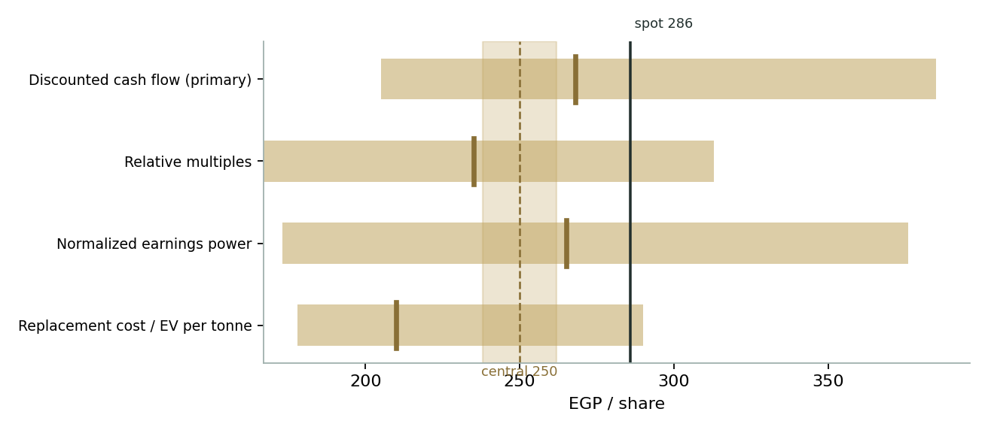
Figure 1 — Valuation football field. Bars span bear–bull per lens; the brass tick is each base case; the gold band is the blended central range; the dark line is spot.
Central fair value ≈ EGP 250/share, about 12% below spot. Note the shape of the disagreement: the two earnings lenses cluster at 265–268 while the asset and peer lenses sit at 210–235. The market has sided with the earnings lenses and then some — which is a bet that FY25/26's exit rate is the new normal and that the doubling closes. Neither is unreasonable; neither is in hand.

1.6 The asset — a deeper look at the machine
One site, three inputs, one output. The Nag Hammadi complex takes alumina (imported; the May-2026 Alba MOU studies a domestic refinery), electricity (~14–15 MWh per tonne, the defining cost, bought from the state grid at an administered industrial tariff that has been rising in steps since 2024), and labour, and ships roughly 60% of its ingot, billet and rod abroad — predominantly to the EU, which is why the CBAM's definitive phase (from January 2026) is a line item, not a footnote. The financial character is singular on the EGX: a commodity exporter whose revenue is LME-in-dollars while its cost base is pounds, so the March-2024 flotation that crushed importers doubled EGAL's margin — and the pound's 2025–26 appreciation to ~49 is now quietly giving some back. The cash pile (≈EGP 9 bn est.) earns high-teens treasury yields, itself ~15% of pre-tax profit.
Dimension | Reading | Swing role
Revenue driver | LME US$/t × EGP/USD × volume | Dominant, external
Cost driver | Administered electricity tariff (~40% of cash cost) | The policy lever
Balance sheet | Net cash ≈ EGP 9 bn, debt-free | Cushion + option funding
Capacity | 320 kt fixed until expansion closes | Caps the upside
Ownership | MIH 89.8%, float ~10% | Discount + privatization option
Growth option | Trafigura US$900 m toward ~600 kt | The re-rating case

The scorecard's message: everything that can re-rate this equity — tariff, FX, expansion, float — is decided in Cairo or on the LME, not in Nag Hammadi. Operations are the constant; policy is the variable.

1.7 The crux — the tariff and the doubling
Two judgments drive the valuation more than any other. First, the electricity price. A smelter is congealed electricity: at ~14.5 MWh/t, every EGP 0.10/kWh of tariff is roughly EGP 1.45 bn of annual cost on current output — about EGP 2.7 of EPS, or ~EGP 26/share at the base multiple. Egypt has been walking industrial tariffs toward cost-recovery since 2024, and each step lands directly on this margin; the 1.1 GW Scatec solar PPA is management's structural answer (cheaper, CBAM-cleaner power for the expansion era) but delivers over years, not quarters. Our normalized ~30% EBITDA margin already concedes a further tariff step; a full cost-recovery scenario takes the margin toward 24–25% and the central value toward EGP 210. Second, the Trafigura doubling. The 6/10 May 2026 agreements — US$900 m headline, offtake-anchored, EFG Hermes advising — would take capacity toward ~600 kt and transform the EV/tonne math (§1.2). We credit it EGP 4 bn (~EGP 10/share) as a partial option, not the ~EGP 40–60/share a financed, permitted, power-secured project would justify. The market, at EGP 36 above our central, is arguably paying most of the full option today. The gap between a term sheet and a financing close is where this stock's next EGP 50 lives — in either direction.

1.8 Macro and country — the pound, the tariff state, CBAM and the rate cycle
EGAL is the EGX's purest macro instrument. The pound: a net exporter with EGP costs, it is long devaluation — the March-2024 float built FY24/25's record — and the 2025–26 appreciation toward EGP 49 is a headwind the FY26/27 budget already concedes; every 1 EGP on the rate is roughly EGP 550 m of revenue on the export book. The rate cycle: CBE easing from the 2024 peak cuts the cash pile's interest income (we fade it from EGP 2.3 bn toward 1.5 bn) but lowers the discount rate the market applies to everything — historically a net positive for the multiple. CBAM: the EU's carbon border price enters its definitive phase in 2026; grid-powered Egyptian aluminium carries a meaningful embedded-carbon bill against Hydro's hydropower and Alba's gas, and ~60% of exports are EU-bound. The Scatec PPA is the mitigation; the interim cost is a realized-price haircut we carry inside the normalized margin. The state: MIH's 89.8% is both the discount (float, governance) and the option — Egypt's privatization program has repeatedly floated stake-sale candidates, and a genuine secondary offering would be the single fastest multiple re-rater on this register. None of these four levers is operational; all four are priced daily.

1.9 DCF sensitivity — WACC against terminal growth
Holding the cash-flow path at base, the grid re-prices the DCF across the cost of capital and nominal terminal growth. The market price of EGP 286 is consistent with roughly a 19% WACC on 12.5% growth — i.e. the market is already discounting at bull-case rates.
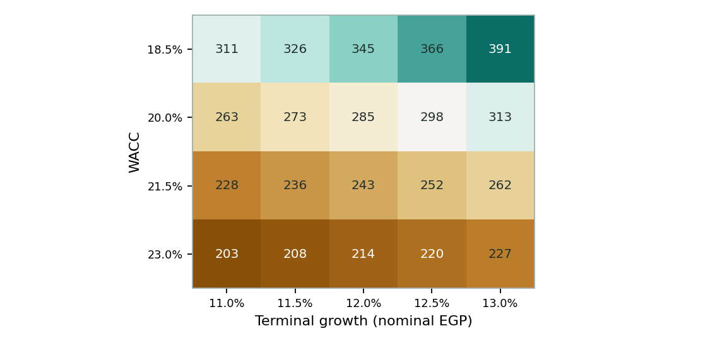
Figure 2 — DCF value per share (EGP) across WACC × terminal growth; the live grid is on the model's Sensitivity sheet.
Scenario | WACC | g | Value (EGP)
Bear — rates stay high | 23.0% | 11.0% | ≈205
Base | 20.0% | 12.0% | 268
Bull — easing cycle completes | 18.5% | 13.0% | ≈385

2 Technical and price structure
The tape is a strong trend catching its breath. EGAL has risen roughly 25-fold over the five-and-a-half-year sample — the post-float re-rating of a dollar-earning exporter — and the last quarter is the first genuine consolidation since late-2024: price sits below the 20-day (EGP 301) and 50-day (307) averages and fractionally below the 100-day (288), while the 200-day (244) still trails ~15% beneath spot. RSI at 39 is soft but nowhere near oversold; the MACD histogram is negative and shallowing. Structure: the March-2026 high at EGP 338 caps the range, the 200-day and the EGP 240–250 shelf (which coincides with our fundamental central) mark the supports that matter.
Indicator | Reading | Signal
Spot | EGP 285.88 | —
SMA 20 / 50 | EGP 301 / 307 | Below both — short-term corrective
SMA 100 / 200 | EGP 288 / 244 | At the 100; well above the 200 — primary trend intact
RSI (14) | 38.6 | Soft, not oversold
MACD (12,26,9) | -8.9 line / -6.8 signal / -2.1 hist | Bearish, momentum fading at a slowing rate
52-week range | EGP 152.01 – 338.00 | Upper-middle of range
Realized vol (252d) | 42.4% | Elevated — a frontier single-name

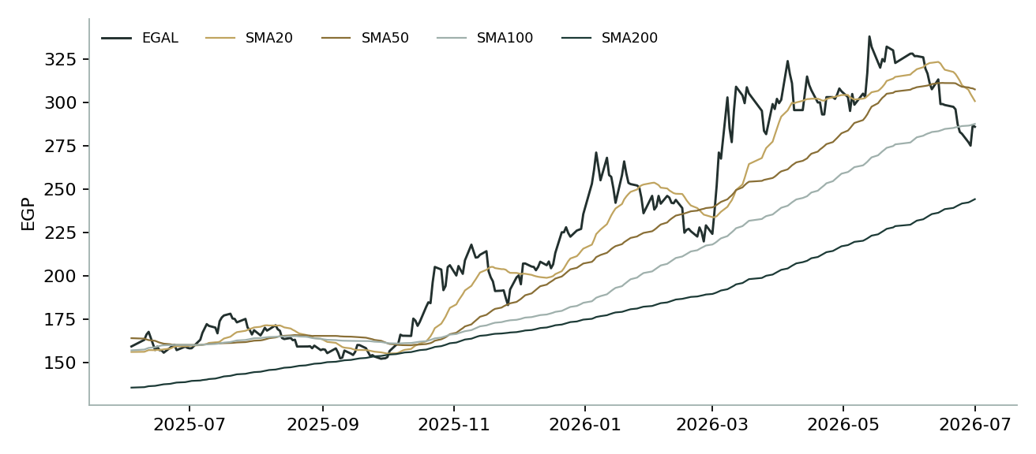
Figure 3 — Price versus the moving-average stack, last 260 sessions.
For the probabilistic work this matters in one way: a below-short-trend, above-long-trend tape is exactly the configuration where a secular-drift engine earns its keep or breaks — §3's drift is on because five years of EGAL's own distribution, tested out-of-sample in Appendix B, says it should be. The near-term correction widens the left tail; it does not, on the evidence, end the regime.

3 Monte Carlo — a probabilistic price map
We simulate 50,000 three-month price paths (seed 42) with the house v2 engine. Width is set by a pooled log-HAR variance cascade (lags 1/5/22) on a gap-aware Yang-Zhang OHLC proxy — regime-conditional by construction — which reads the current tape at an annualized ≈40%, slightly below the trailing 252-day 42% because the recent consolidation is calmer than the year's storms. Shape is unit-variance Student-t(5) via a per-path variance mixture: a tighter interquartile body and honest tails. Drift is asset-class-conditional and, for EGAL, ON: the Step-0 backtest (Appendix B) shows the zero-drift configuration fails against the benchmark (CRPS skill −0.08, PIT piled in the top bins) while the secular configuration — the expanding mean of the name's own daily log-returns, ≈+15.6% over 60 sessions today — beats it (+0.15). On top sit sixteen factors: seven continuous drivers contributing a small net drift (-0.2%) and nine discrete events (net expected +0.7%). By design the paths diffuse from spot and the §1 value gap is kept out of the drift — the ~12% fundamental discount lives in §1 only; what §3 carries is the tape's own validated momentum, a different and independently tested claim.
Continuous factor (7) | Dir. | Discrete event (9) | Prob. | Mean impact
LME aluminium price trend | + | FY25/26 results & dividend decision | 55% | +3.0%
EGP/USD path (appreciation bias) | − | Trafigura definitive agreements / financing | 35% | +5.0%
EGX30 & foreign flows | + | Industrial electricity tariff hike | 40% | −5.0%
Electricity & energy cost trajectory | − | EGP step depreciation (>4%) | 20% | +6.0%
Alumina / raw-material spread | − | EGP appreciation extends (<47.5) | 25% | −4.0%
Global industrial demand (PMI) | + | CBAM cost ruling / EU order impact | 20% | −4.0%
CBAM & export logistics drag | − | MIH stake-sale / free-float event | 15% | +6.0%
 |  | LME supply shock (China/energy) | 15% | +5.0%
 |  | Global risk-off / EM outflow | 25% | −7.0%

The EGAL factor set is a new egx-industrial class in the factor library, structured 7C+9D like every class; magnitudes are starting judgments flagged calibrated=False pending the standing red-pen sign-off.
Percentile map (EGP/share):
Horizon | p5 | p25 | p50 | p75 | p95
T+20 sessions | 245 | 278 | 299 | 321 | 362
T+60 sessions | 232 | 287 | 326 | 369 | 452

Lead with the body, not the tail: the T+60 interquartile band is EGP 287–369 — about 29% of spot wide, which is EGAL's genuine quarter-ahead uncertainty, not padding — and at T+20 the band divides by roughly √3 to EGP 278–321. The median at EGP 326 carries the validated drift; simulated path vol prints ≈44% annualized, a touch above the diffusion because the discrete events both skew and widen.
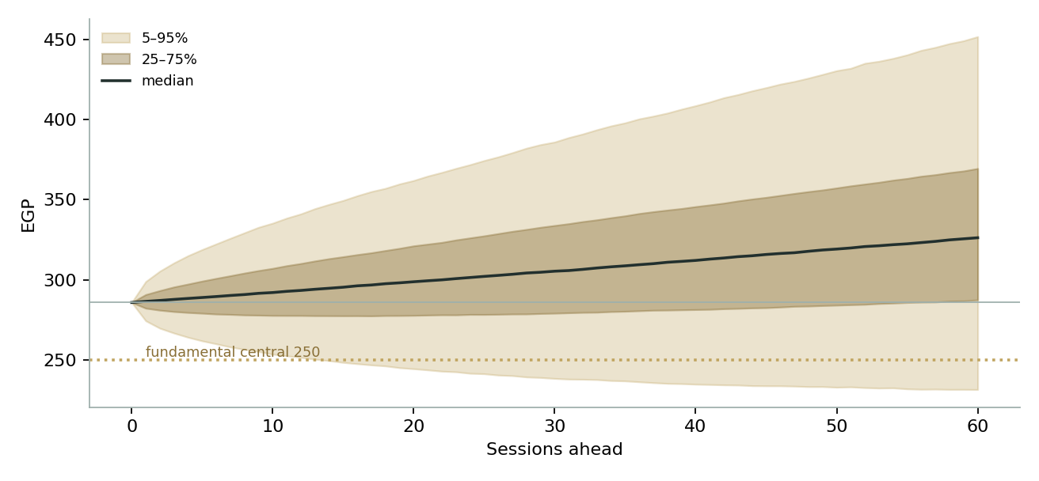
Figure 4 — Forward price cone to T+60. The median carries the Step-0-validated secular drift; the gold dotted line marks the EGP 250 fundamental central, deliberately below the median — the two claims are independent by construction.
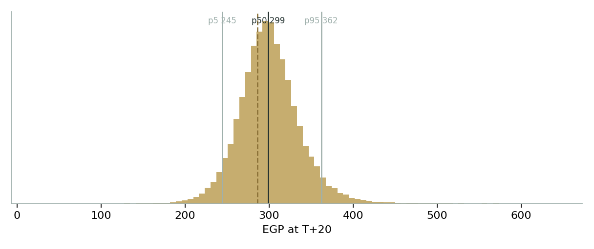
Figure 5 — Price distribution at T+20.
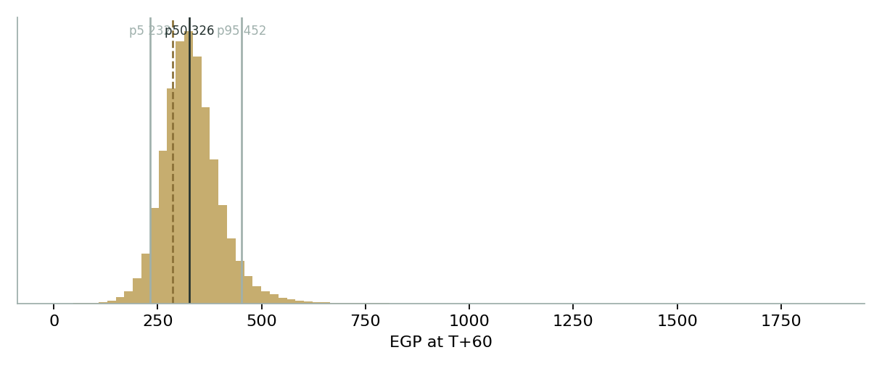
Figure 6 — Price distribution at T+60.
Level-touch ladder — the probability that price touches a level at any point by the horizon (running max for upside, running min for downside):
Level | T+20 touch | T+60 touch | Note
EGP 340 | 17% | 57% | Above the March high (338)
EGP 320 | 37% | 74% | Between high and spot
EGP 300 | 69% | 89% | Round level just above spot
EGP 270 | 37% | 50% | Fundamental-central / 200-day shelf
EGP 250 | 12% | 24% | Lower band
EGP 230 | 4% | 11% | Deep support
EGP 210 | 1% | 5% | Toward the 52-week low

4 Comparison of the lenses, and a verdict
Three readings sit side by side and, unusually, all three genuinely disagree. The fundamental lenses cluster at EGP 210–268 with a central of 250 — the stock is 12% above the blend, and above every single lens. The technical picture is a strong primary uptrend in a six-week correction — below the short averages, far above the 200-day. The probabilistic map, whose drift is validated out-of-sample rather than assumed, puts the three-month median at EGP 326 with an interquartile band of 287–369: the tape's own five-year behaviour, projected forward, points modestly up even as the value lenses point down.
Lens | Reads | Central / implication
Fundamental (4-lens) | Fully valued to modestly rich | EGP 250 (−12%)
Technical | Uptrend, consolidating | Supports 244–250 / resistance 300–338
Monte Carlo (3-month) | Right-shifted, wide | Median 326; IQR 287–369; p5–p95 231–452

Verdict (a fair-value read, not a recommendation). EGAL is a superb machine at a full price. The lenses agree the existing smelter is worth roughly EGP 210–270 a share depending on how you count it; the market pays EGP 286 for the exit-rate earnings plus most of an expansion option that has a term sheet but no financing close, in a policy environment where the single biggest cost line is set by the state. The honest tension is that the probabilistic engine — the one component we score in public — says this market keeps paying that premium: its validated drift places the median above spot. We resolve nothing; we publish both. A buyer at spot is underwriting the doubling and the tariff path; a seller is betting against a tape whose persistence has, for five measured years, been the statistically correct call. Readers should weigh the lenses themselves; we publish the distribution, not a target.

5 Catalysts to watch
• FY2025/26 results & dividend (≈Sep–Oct 2026). The close on the EGP 13.71 bn target, and whether the payout steps up again from EGP 10/share — the cash pile argues it can.
• Trafigura definitive agreements. Financing structure, offtake terms, power allocation and timeline for the ~600 kt build — the single largest swing in either direction.
• Electricity tariff decisions. Each industrial tariff step lands ~EGP 26/share of value at the base multiple; the FY26/27 budget already braces for one.
• Scatec 1.1 GW solar PPA milestones. Financial close and construction start de-risk both the tariff and the CBAM exposure.
• The pound. EGP/USD below ~47.5 compresses the export margin visibly; a step past ~52 does the opposite — EGAL is the register's cleanest devaluation hedge.
• CBAM definitive-phase mechanics. First full-year certificate costs on EU-bound tonnes; watch realized-price disclosure.
• Alba alumina-refinery MOU. Progress toward domestic alumina would take out the largest imported input.
• MIH / privatization signals. Any stake-sale or secondary-offering noise re-prices the float discount immediately.
• FY2026/27 first-half prints. Whether the company's own EGP 11.1 bn down-year budget proves conservative — the market has assumed it is.

6 Reading the probability zones
Translating the three-month distribution into plain zones, anchored on spot EGP 286 and the EGP 250 fundamental central:
Zone (T+60) | Range | Approx. probability | What it would mean
Deep downside | < EGP 220 | 3% | Tariff shock or risk-off; through the replacement floor's neighbourhood
Lower band | EGP 220–260 | 9% | Correction completes into the fundamental central / 200-day shelf
Around spot | EGP 260–310 | 27% | Consolidation holds; premium neither earned nor surrendered
Upper band | EGP 310–360 | 31% | Strong FY25/26 close credited; retest of the 338 high
Strong upside | > EGP 360 | 29% | Trafigura financing close and/or tariff relief; new highs

The distribution is right-shifted — roughly 61% of paths finish above spot — which is the validated drift speaking, widened both ways by the event stack. It is not a forecast that the premium is deserved; it is the spread of outcomes consistent with this stock's own measured behaviour and the factor probabilities stated above.

7 Caveats and what would change our mind
• The tariff is the model. Our normalized margin embeds one more electricity step; full cost-recovery pricing would cut the central toward EGP 210 and the DCF below EGP 230. The single sentence that most re-prices this study will be written by the electricity ministry, not the company.
• Drift is validated, not guaranteed. The secular drift passed a 17-origin out-of-sample test, but every trend engine breaks at a regime turn — a durable EGP-appreciation-plus-tariff regime would be exactly such a turn, and the PIT's mild upper tilt (0.59) would flip to a lower pile-up fast. We will re-grade in the public ledger either way.
• The expansion is a term sheet. We credit EGP 4 bn; the market appears to credit far more. If financing terms subordinate minorities (offtake discounts, partner preferences), the option's equity value could be lower than either.
• Balance-sheet lines are reconstructions. Cash, capital and profits are disclosed; several cost and working-capital splits are derived to reconcile. The model flags every such cell; treat the statements as anchored estimates, not audited detail.
• Single-site, single-country, thin float. One force-majeure at Nag Hammadi, one capital-controls turn, or one 10%-float liquidity vacuum can dominate any distribution we publish.
• FX cuts both ways. We call EGAL a devaluation hedge; a genuine disinflation-plus-appreciation success story in Egypt is the bear case for this specific equity even as it is the bull case for most of the register.
• CBAM math is young. Embedded-carbon accounting for Egyptian grid power, certificate prices and pass-through are all first-year numbers in 2026; our haircut is a judgment, not a measurement.

Appendix A Financial statements — 3-year historical + 5-year forecast
Selected figures, EGP m. FY2022/23–FY2024/25 are reported (EGX/Mubasher; FY24/25 release 24 Aug 2025); the COGS/SG&A split, D&A, interest and several balance-sheet lines are derived from disclosed anchors (EBIT, tax, cash, paid-in capital EGP 1,650 m) and flagged as such; FY2025/26E bridges the 9M actual (NP EGP 10.4 bn) to ~EGP 13.4 bn; FY2026/27E–FY2030/31E are the model's forecast off the Assumptions drivers.

A.1 Income statement — FY22/23–FY24/25 reported + FY26/27E–FY30/31E forecast (F26E bridge)
EGP m | FY22/23 | FY23/24 | FY24/25 | F26E | F27E | F28E | F29E | F30E | F31E
Revenue | 22,045 | 32,815 | 43,183 | 49,300 | 52,702 | 57,919 | 63,711 | 70,082 | 77,090
COGS | (16,200) | (22,600) | (29,950) | (32,000) | (36,891) | (40,427) | (44,279) | (48,707) | (53,578)
Gross profit | 5,845 | 10,215 | 13,233 | 17,300 | 15,811 | 17,492 | 19,432 | 21,375 | 23,512
SG&A & other | (1,000) | (1,350) | (2,073) | (2,317) | (2,582) | (2,838) | (3,122) | (3,434) | (3,777)
EBIT | 4,845 | 8,865 | 11,160 | 14,983 | 13,228 | 14,654 | 16,310 | 17,941 | 19,735
EBITDA | 5,495 | 9,565 | 11,940 | 15,833 | 14,178 | 15,754 | 17,560 | 19,291 | 21,185
Net interest income | (15) | 1,000 | 2,000 | 2,300 | 2,000 | 1,800 | 1,700 | 1,600 | 1,500
FX & one-offs | 0 | 2,165 | 0 | 0 | 0 | 0 | 0 | 0 | 0
Profit before tax | 4,830 | 12,030 | 13,160 | 17,283 | 15,228 | 16,454 | 18,010 | 19,541 | 21,235
Income tax | (1,138) | (2,706) | (2,980) | (3,889) | (3,426) | (3,702) | (4,052) | (4,397) | (4,778)
Net profit | 3,692 | 9,324 | 10,180 | 13,401 | 11,805 | 12,755 | 13,962 | 15,149 | 16,462
EPS (EGP) | 8.95 | 22.60 | 24.68 | 32.49 | 28.62 | 30.92 | 33.85 | 36.73 | 39.91

A.2 Balance sheet — 3-year historical + 5-year forecast
EGP m | FY22/23 | FY23/24 | FY24/25 | F26E | F27E | F28E | F29E | F30E | F31E
Cash & ST investments | 3,050 | 6,320 | 9,600 | 17,492 | 21,608 | 26,925 | 32,902 | 39,353 | 46,406
Receivables | 2,100 | 3,050 | 3,900 | 4,452 | 4,760 | 5,231 | 5,754 | 6,329 | 6,962
Inventories | 5,300 | 7,200 | 8,600 | 9,189 | 10,593 | 11,608 | 12,714 | 13,986 | 15,384
PP&E, net | 6,200 | 6,650 | 7,200 | 7,850 | 9,100 | 10,600 | 12,150 | 13,800 | 15,550
Other assets | 1,450 | 1,600 | 1,700 | 1,700 | 1,700 | 1,700 | 1,700 | 1,700 | 1,700
Total assets | 18,100 | 24,820 | 31,000 | 40,683 | 47,761 | 56,064 | 65,220 | 75,168 | 86,002
Payables & accruals | 3,300 | 3,900 | 4,200 | 4,487 | 5,173 | 5,669 | 6,209 | 6,830 | 7,513
Debt | 750 | 680 | 600 | 600 | 600 | 600 | 600 | 600 | 600
Shareholders equity | 10,400 | 18,486 | 25,366 | 34,642 | 40,417 | 47,860 | 55,081 | 63,947 | 73,592
Provisions & other (bal.) | 3,650 | 1,754 | 834 | 954 | 1,571 | 1,935 | 3,330 | 3,791 | 4,297
Total liab. & equity | 18,100 | 24,820 | 31,000 | 40,683 | 47,761 | 56,064 | 65,220 | 75,168 | 86,002
Net cash | 2,300 | 5,640 | 9,000 | 16,892 | 21,008 | 26,325 | 32,302 | 38,753 | 45,806
BVPS (EGP) | 25.2 | 44.8 | 61.5 | 84.0 | 98.0 | 116.0 | 133.5 | 155.0 | 178.4

A.3 Cash flow
EGP m | FY22/23 | FY23/24 | FY24/25 | F26E | F27E | F28E | F29E | F30E | F31E
Net profit | 3,692 | 9,324 | 10,180 | 13,401 | 11,805 | 12,755 | 13,962 | 15,149 | 16,462
D&A | 650 | 700 | 780 | 850 | 950 | 1,100 | 1,250 | 1,350 | 1,450
Δ working capital | (900) | (1,600) | (1,450) | (734) | (408) | (626) | (695) | (765) | (841)
Operating cash flow | 3,442 | 8,424 | 9,510 | 13,517 | 12,347 | 13,229 | 14,517 | 15,734 | 17,071
Capex | (500) | (600) | (900) | (1,500) | (2,200) | (2,600) | (2,800) | (3,000) | (3,200)
Free cash flow | 2,942 | 7,824 | 8,610 | 12,017 | 10,147 | 10,629 | 11,717 | 12,734 | 13,871
Other / FX (plug) | (1,200) | (3,316) | (2,030) | 0 | 0 | 0 | 0 | 0 | 0
Dividends paid | (1,030) | (1,238) | (3,300) | (4,125) | (6,030) | (5,312) | (5,740) | (6,283) | (6,817)
Net change in cash | 712 | 3,270 | 3,280 | 7,892 | 4,117 | 5,317 | 5,977 | 6,451 | 7,054
Closing cash | 3,050 | 6,320 | 9,600 | 17,492 | 21,608 | 26,925 | 32,902 | 39,353 | 46,406

Dividend record: DPS EGP 2.50 (FY22/23) · 3.00 (FY23/24) · 8.00 paid during FY24/25 · 10.00 declared for FY24/25 (assumed paid F26E); forecast payout 45% of prior-year NP. The historical Other/FX plug reconciles derived flows to cash anchors.

Appendix B Step 0 — calibration backtest
Before any forecast we kill-test the engine on EGAL's own five-and-a-half years: at 17 non-overlapping quarterly origins, using only data up to each date, the engine issues a 60-session-ahead distribution which is then scored against the realized close. The grade is skill versus a naïve benchmark — a zero-drift random-walk lognormal cone on the trailing 252-day vol — measured by CRPS skill (must exceed 0) and the Winkler 90% interval score; the PIT histogram and coverage table are diagnostics only, since raw hit-rates reward width. Two drift configurations were raced. Zero drift fails: CRPS skill −0.083, with the PIT piling into the top bins (mean 0.74; chi-square(4) p≈0.004) as the realized price kept escaping the cone's upper half — EGAL does not behave like the international/metals zero-drift class. Secular drift passes: the expanding mean of the name's own daily log-returns lifts CRPS skill to +0.151, the PIT to a statistically uniform shape (mean 0.59; bins 1/4/3/2/7, chi-square(4)=6.2, p≈0.18), and coverage to 41/88/94% against 50/80/90 targets. The Winkler skill prints marginally negative (−0.05), driven almost entirely by the March-2022 crash origin where both cones missed low but the benchmark's fatter trailing vol paid less penalty; we disclose rather than tune it. EGAL is therefore classified into the EGX secular-drift class alongside the developers — the first industrial admitted — and that configuration, and only that configuration, carries into §3.
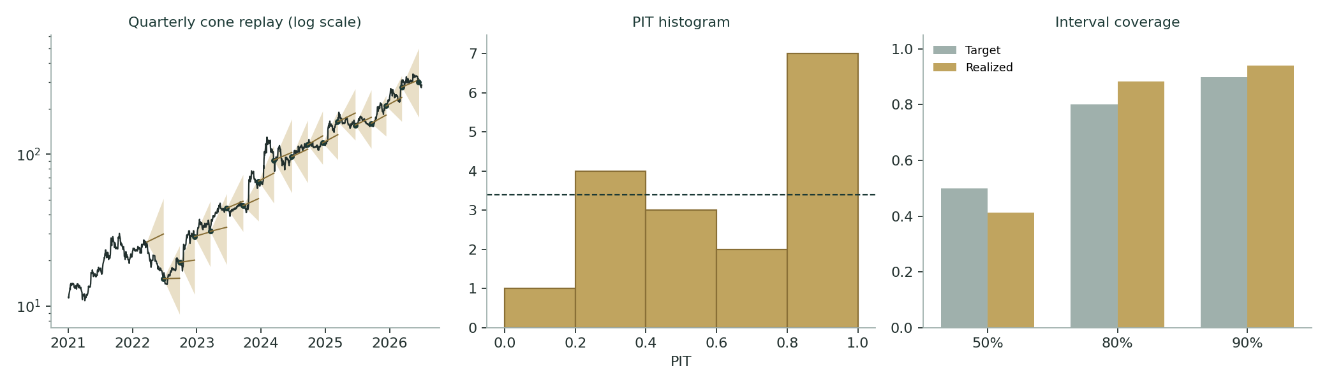
Figure B-1 — Calibration backtest: quarterly cone replay (log scale), PIT histogram, and interval coverage versus target.
Configuration | n | CRPS skill | Winkler skill (90%) | Cov 50/80/90 | PIT mean | Grade
Zero drift (international/metals class) | 17 | −0.083 | −0.042 | 41 / 53 / 94% | 0.74 | FAIL
Secular drift (EGX class) — adopted | 17 | +0.151 | −0.053 | 41 / 88 / 94% | 0.59 | PASS
Target / benchmark | — | > 0 | ≥ 0 preferred | 50 / 80 / 90% | 0.50 | —

Engine: YZ-HAR width (pooled log-HAR, lags 1/5/22, on overnight²+Rogers-Satchell), unit-variance Student-t(5) per-path mixture, h=60, 4,000 paths per origin; benchmark rebuilt at every origin from spot and trailing vol. Artifacts live with the study files, not the project library.

Appendix C Peer set, sector structure, and risks
EGAL's honest comparables are the world's other single-metal primary producers, not the EGX. The closest analogue is Aluminium Bahrain — Gulf, state-anchored, gas-powered, export-led — which is why our relative multiple keys off it.
Producer | Mkt cap (US$bn) | P/E | EV/EBITDA | Capacity (kt) | Character
Alcoa (AA) | ≈9.5 | ≈13× | ≈6.0× | 2,990 | Alumina-integrated global
Norsk Hydro (NHY) | ≈14 | ≈14.5× | ≈6.5× | 2,300 | Hydropower — the CBAM winner
Century (CENX) | ≈2.3 | ≈15× | ≈7.0× | 1,020 | US, power-price levered
Hindalco (HNDL) | ≈18 | ≈11× | ≈6.5× | 1,300 | India + Novelis downstream
China Hongqiao (1378) | ≈13.5 | ≈7.5× | ≈4.5× | 6,460 | Largest; coal-powered
Aluminium Bahrain (ALBA) | ≈4.5 | ≈11× | ≈7.0× | 1,620 | Closest analogue
Ma'aden (1211) | ≈45 | ≈25× | ≈12× | 780 | Saudi diversified premium
Egypt Aluminum (EGAL) | ≈2.4 | 11.6× / 8.8×E | ≈9.1× / 6.9×E | 320 → ~600 | This study

Indicative public-source snapshots, early Jul 2026, for context only; the relative lens prices off the Assumptions multiple, not this table. EGAL trailing/forward on FY24/25 and FY25/26E.
Sector structure. Primary aluminium is a power-price arbitrage wearing a metal's clothes: the cost curve is ordered by electricity contracts, the demand curve by construction, transport and grids, and the 2026 novelty is that carbon accounting (CBAM) starts re-ordering the curve in Europe's favor toward hydro- and renewables-backed producers. Egypt's slot on that curve — administered grid power today, contracted solar tomorrow — is precisely what the Scatec PPA and the Trafigura expansion are trying to move. Principal risks: a full cost-recovery electricity tariff; durable EGP appreciation; a failed or minority-unfriendly expansion financing; CBAM certificate costs above our haircut; LME breakdown below ~US$2,200/t; single-site operational events; free-float illiquidity; and state-owner actions that rank other objectives above minority value.

Appendix D The expert valuation panel
Every Testahil study closes with a panel of standing expert personas — drawn from the house Expert Persona Library, not invented for the occasion, so that each accumulates a track record across studies and a quarterly update is a re-run, not a re-training. For EGAL we cast the industrial trio whose methods genuinely fit a single-site commodity producer and genuinely disagree: Expert 1 (normalized through-cycle earnings power and relative multiples), Expert 2 (realizable asset value and earnings quality — the accountant's lens), and Expert 3 (scenario-weighted real options on policy and macro — because for this name the tariff, the pound and the state owner outrank operations). The cash-returns DCF is not duplicated here because it is the body's primary lens (§1.1); each panellist runs a method the body does not lean on. Each derives a fair value from shown workings, states a falsification condition, and reads what the market price implies.

D.1 Expert 1 — normalized through-cycle earnings power
Worldview and tradition. An operating company is worth a fair multiple of its sustainable, mid-cycle earnings. Peaks and troughs — a devaluation windfall, an LME spike, a tariff shock — are noise to be stripped, in the through-cycle tradition of Graham's earning-power and the modern normalized-EPS school. He does not forecast the cycle; he averages through it.
When it works / when it fails. The method is at its best on commodity converters with a long operating record and mean-reverting economics — precisely a smelter. It fails at structural breaks: if the electricity contract, the FX regime or the capacity base changes permanently, the 'cycle' he is averaging no longer exists. EGAL sits uncomfortably close to that edge, which he concedes and handles by normalizing the tariff one step above today.
Standard workings. (1) Normalize each revenue driver to mid-cycle: LME, realized product premium, volume, FX. (2) Normalize the margin for the policy cost path. (3) Derive sustainable net profit and EPS, including a faded return on the cash pile. (4) Apply a justified multiple triangulated against the name's own history and the global peer set, adjusted for float, governance and growth. (5) Cross-check on EV/EBITDA and free-cash-flow yield.
Expert 1's normalization (worked example) | Value
LME aluminium, mid-cycle | US$2,550/t
Realized premium (mix: billet, rod, rolled, local) | 1.30× LME
Sales volume | 275 kt
EGP/USD | 50.0
Normalized revenue | ≈ EGP 45.6 bn
EBITDA margin (tariff one step above today) | ≈ 30%
Normalized EBITDA / less D&A | 13.6 / (1.0) EGP bn
Net interest on cash pile (faded rates) | +2.1 EGP bn
Tax at 22.5% → mid-cycle net profit | ≈ EGP 11.4 bn
Normalized EPS (412.5 m shares) | ≈ EGP 27.7
Justified P/E (history 4–7× pre-float; Alba ~11×; float discount) | 9.5×
Fair value | ≈ EGP 265/share

Sensitivity (swing = the normalized margin and the multiple). At an 8× multiple the value is EGP 222; at 11×, EGP 305. Holding 9.5× and moving the margin: 27% gives ≈EGP 240, 33% gives ≈EGP 290. His stated range is EGP 173–376 (bear: EGP 9.5 bn mid-cycle NP at 7.5×; bull: 13.5 bn at 11.5×).
Reading his own table. Walk the build and notice where the judgment actually lives. The LME line is the least controversial — US$2,550 sits inside every consensus long-run band and below the 2026 spot spike he refuses to extrapolate. The premium is empirical, not hopeful: FY24/25's reported revenue against ~272 kt implies a realized ~1.34x over the year's average LME, so his 1.30x is a mild haircut for CBAM leakage and mix drift. Volume at 275 kt assumes no expansion and no decay — deliberately static, since crediting the doubling would smuggle Expert 3's scenario A into a lens whose whole discipline is refusing scenarios. The margin is where he sweats: 30% concedes one more tariff step but not cost-recovery, and he flags openly that this single row is half his EGP 173–376 range. The multiple, finally, is triangulated rather than asserted — the pre-float 4–7x era is dismissed as an artifact of a mispriced pound, Alba's ~11x is trimmed a turn and a half for a 10% float and a sole state supplier of power. Nothing in the build requires believing anything the company has announced since May.
Cross-examination. To Expert 2: 'Your asset marks price the machine and ignore the licence — the sub-market power contract is worth more than the potlines, and it only shows up in earnings, which is where I live.' To Expert 3: 'Your scenario tree is my sensitivity table with adjectives. Weighting three stories to 272 versus my 265 is not a different method; it is a different confidence interval.'
Verdict, falsification, market-implied. Fair EGP 265 (range 173–376). Falsified by a structural regime change: a cost-recovery tariff or a durably strong pound that makes 30% margins unreachable through a cycle — or the doubling closing, which would re-base his volume line entirely. At EGP 286 the market is paying 10.3× his normalized earnings: it is either using a higher multiple than the float deserves or normalizing FY25/26's exit rate as permanent. He thinks the second, and thinks it a mistake.

D.2 Expert 2 — realizable assets and cash quality
Worldview and tradition. The Graham-Dodd realization school: a business is worth what its assets would fetch net of every claim, and reported profit is trusted only as it converts to cash. The balance sheet is a fact; the future is a guess. On a state-controlled register where minorities cannot force anything, he prices what exists, not what is promised.
When it works / when it fails. It works where assets are markable and cash is verifiable — EGAL's smelter has a quoted replacement market and its cash pile is disclosed. It fails where the largest asset is intangible: here, the administered power contract and the export franchise, which no balance sheet carries. He answers with a bounded going-concern credit, not a projection.
Standard workings. (1) Mark each asset to conservative realizable value with explicit haircuts. (2) Test earnings quality via the operating-cash-flow-to-net-income bridge. (3) Bridge to equity: less all claims, less off-balance obligations. (4) Add a bounded credit only for cash generation already visible. (5) Sensitivity on the swing mark.
Expert 2's marks (EGP bn) | Value
Smelter at replacement: 320 kt × US$5,500 × 49.1 | 86.4
less 15% age/technology haircut | (13.0)
Net working capital (inventory 8.6 + receivables 3.9 − payables 4.2) | 8.3
Cash & ST investments (disclosed anchor, rolled) | 9.6
less: debt and provisions/claims | (1.4)
Realizable floor = EGP 89.9 bn | ≈ EGP 218/share
Earnings-quality test: 3-yr OCF/NI = 21.4/23.2 | 92% — genuine cash
Bounded going-concern credit: ~2 yrs visible FCF above maintenance, discounted | + ≈ EGP 26/share
Fair value | ≈ EGP 244/share

Sensitivity (swing = the plant mark). At US$4,500/t the floor is EGP 186 and his value ≈EGP 212; at US$6,500/t, floor EGP 250 and value ≈EGP 276. The 15% haircut moving to 25% costs ≈EGP 21. His stated range is EGP 190–318.
Reading his own ledger. The order of the marks is his argument. The plant comes first because it is the only line with an external market: Gulf and Indian new-builds cluster at US$5,000–6,000 a tonne, so US$5,500 less 15% for a mature complex is a mark a buyer could actually be shown. Working capital he takes nearly whole — aluminium inventory is exchange-deliverable and the receivables book is short and export-backed — while the cash line he trusts most of all, since it is the one figure the company discloses to the pound and the one the dividend record (2.50, 3.00, 8.00, 10.00 declared) keeps proving. What he will not do is capitalize: no multiple appears anywhere in his table. The going-concern credit of ~EGP 26 is not a valuation of the future but an audit of the present — two years of free cash flow the current tariff and current pound are already generating, discounted at the same 20% the body uses. Beyond two years, he says, you are pricing a ministry's patience, and he declines.
Cross-examination. To Expert 1: 'Your 30% margin is the power contract wearing a costume. Mark the contract to market — grid tariff to cost-recovery — and your mid-cycle profit is a third smaller; I refuse to capitalize a subsidy the owner can repeal by decree.' To Expert 3: 'You weight promises. The Trafigura press release is not an asset; a signed financing with a use-of-proceeds schedule is. Until then it is worth the paper's option value, which I bound at zero-to-small.'
Verdict, falsification, market-implied. Fair EGP 244 (range 190–318) — the panel's floor-keeper. Falsified if the intangibles become contractual: a locked long-tenor power price (the Scatec PPA reaching financial close), or the expansion financing signing — either converts promise into markable asset and forces his number up. At EGP 286 the market pays a 31% premium to his realizable floor: it is capitalizing the contract and the deal he refuses to. That is a coherent disagreement about evidence, not arithmetic.

D.3 Expert 3 — scenario-weighted policy real options
Worldview and tradition. In frontier markets, policy outranks fundamentals: the FX regime, the tariff schedule, the privatization program and sovereign action move value more than management does. He prices the asset as a portfolio of options on which policy world arrives, in the scenario-planning and real-options tradition. He does not pick a side; he weights the odds.
When it works / when it fails. It works where a small number of state decisions dominate the payoff — EGAL's tariff, pound and ownership are exactly that. It fails when the probabilities are unknowable pretence, or when operations quietly matter more than policy (a potline failure respects no scenario tree). He defends the weights as explicit, stress-tested judgments — editable, unlike hidden ones.
Standard workings. (1) Identify the 3–5 policy levers that set the value: electricity tariff path, EGP regime, Trafigura financing, MIH stake action, CBAM stance. (2) Define bull/base/bear as configurations of those levers. (3) Re-run the base valuation machinery under each configuration so scenario values are derived, not asserted. (4) Probability-weight. (5) Stress the weights.
Scenario (policy configuration) | Prob. | Derived value | Contribution
A — Reform continuation: moderate tariff steps, Trafigura financing closes, Scatec proceeds, stake-sale signalled; re-run at 18.5% WACC + option credited | 40% | EGP 330 | 132
B — Muddle-through: tariff steps continue, deal stalls at term sheet, EGP flat ~49; base machinery unchanged | 40% | EGP 255 | 102
C — Squeeze: cost-recovery tariff + EGP appreciates <47; margin to ~25%, multiple derates | 20% | EGP 190 | 38
Probability-weighted fair value |  | ≈ EGP 272 | 272

Sensitivity (swing = the weights). Shifting 10 points from A to C moves the value to EGP 258; shifting 10 from C to A, to EGP 286 — spot, exactly. His stated range is EGP 196–388 (all-C to all-A corners are excluded as non-credible).
Reading his own tree. Each branch is the base machinery re-run, not a number invented sideways. Scenario A reruns the §1 stack at an 18.5% WACC (the easing cycle completing), lifts the normalized margin half a step (Scatec power arriving), and swaps the EGP 4 bn option stub for a EGP 18 bn financed-project NPV — the output is EGP 330, and the reader can reproduce it in the companion model in four cell edits. Scenario B is, definitionally, the study's own base with the option stub retained: EGP 255, one rounding notch above the published central. Scenario C forces the two policy losses together — cost-recovery power and a sub-47 pound — because in his experience frontier policy shocks correlate; the margin compresses toward 25%, the multiple derates a turn, and EGP 190 lands just below Expert 2's floor, which he notes with satisfaction as an independent convergence. The tree's honesty is that its middle branch is boring: 40% of his world is simply the study's base case wearing a probability.
Cross-examination. To Expert 1: 'Your single normalized margin is a hidden 100% weight on my scenario B. I make the weights visible and let the reader move them.' To Expert 2: 'Your refusal to price the power contract is itself a scenario — C at full weight. The state has run this subsidy for fifty years through wars and defaults; a 40/40/20 tree is more honest than a 0/0/100 one.'
Verdict, falsification, market-implied. Fair EGP 272 (range 196–388) — the panel's widest and its ceiling. Falsified by the tree collapsing: any single lever resolving (financing signed, or a cost-recovery decree) should immediately re-run, not re-weight. At EGP 286 the market is pricing roughly a 50/40/10 tree — modestly more reform-optimistic than his 40/40/20. The gap between him and spot is, precisely, ten points of faith in Cairo.

D.4 The three in one room
The single asset they most disagree on is not the smelter — it is the electricity contract: the administered power price that is simultaneously EGAL's largest input, its deepest moat, and its most repealable privilege.
Expert 1: 'The contract has held for decades and every mid-cycle in my average already contains it. Normalize the tariff one step up, as I do, and the machine still earns EGP 11.4 bn through the cycle. The market pays 10× that. Fair, roughly.'
Expert 2: 'You are capitalizing a decree. My ledger shows a plant worth 73, working capital 8, cash 10 — EGP 218 of things that survive any minister. Everything above that is the contract, and I will pay a bounded 26 for the two years of it I can see, not a multiple on its eternity.'
Expert 3: 'You are both running one scenario and calling it prudence. The contract persists in worlds A and B — 80% of my tree — and dies in C. Price all three: 272. And notice what the market did in May: it moved the A-weight up on a Trafigura signature. That is my method, performed by the crowd, slightly drunker.'
Expert 1, again: 'Two years, he says. The subsidy predates every man in this room. If longevity is evidence, the contract has more of it than the LME has of mean reversion — and you accept mean reversion happily enough when it suits your floor.'
Expert 2, again: 'Longevity is exactly the trap. Every administered price holds until the fiscal year it cannot, and Egypt has been repricing power since 2024 — the trend line points at my scenario, not yours. I am not forecasting the minister; I am declining to lend him my capital in advance.'
Expert 3, closing: 'And that is why the three of us belong in one report. He prices the contract's history, he prices its repeal, I price the argument between them. The reader should notice that all three numbers sit below the tape — whatever the market is paying for at 286, it is more contract than any of us will sign for.'

D.5 Reading the divergence
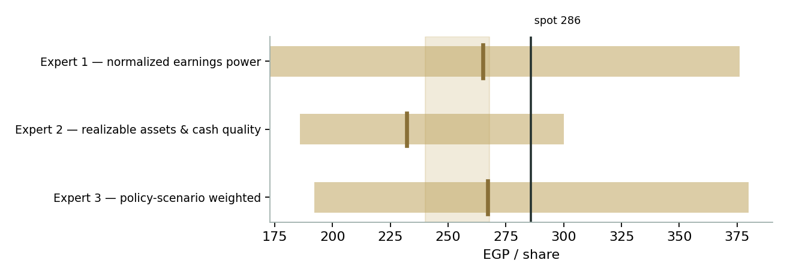
Figure D-1 — The three experts' fair-value ranges. Brass ticks are base cases; the gold band is the fundamental central zone; the dark line is spot. The spread is almost entirely a power-contract disagreement.
Expert | Method | Single swing assumption | Base fair value
Expert 1 | Normalized earnings power | Mid-cycle margin ≈30% / 9.5× multiple | EGP 265
Expert 2 | Realizable assets & cash quality | Plant mark US$5,500/t; bounded contract credit | EGP 244
Expert 3 | Policy-scenario real options | 40/40/20 weights on reform/muddle/squeeze | EGP 272

The spread — EGP 244 to 272 at base — is remarkably tight for a frontier single-site commodity name: barely a tenth of the price. What separates the three is one question asked three ways: how much of the administered power price is an asset? Expert 2 will pay for two years of it, Expert 1 for a cycle of it, Expert 3 for a probability-weighted forever of it — and the ordering of their fair values (244 < 265 < 272) is exactly the ordering of that credit. The market, at 286, extends the sequence one step further than any of them. The EGP 28 panel spread is therefore a clean measure of a single uncertainty — the durability of Egypt's industrial-power policy — and each expert has told you the observation that would force him to move. Resolve the tariff, and the three converge; resolve the financing, and all three re-run.
A note on what the tightness does and does not mean. A 28-pound spread is not agreement about the future — the three disagree violently about the tariff's fate — it is agreement about the arithmetic of the present: the machine, the metal, the cash and the pound are measurable, and measured honestly they triangulate. The spread would explode on exactly two headlines, and in opposite directions: a signed expansion financing (Expert 2's floor jumps ~EGP 40 as the option becomes an asset, and Expert 3's A-branch weight rises) or a cost-recovery power decree (Expert 1's margin breaks, his 265 falls toward 220, and the panel inverts with the accountant suddenly the optimist). Until one of those prints, the panel's message to a reader is unusually simple: the disagreement worth having about EGAL is not among methods — it is between every method and the price.
Each expert's point fair value (and bull/base/bear) is logged with the study date (03 Jul 2026) and spot (EGP 285.88) as an internal per-expert track record, kept separate from the core Calibration Ledger.

About this series
Testahil publishes independent, educational valuation studies. Each is an attempt to reason transparently about what a security is worth, with every assumption shown and a companion model so readers can disagree productively. The house style is distributions, not tips: we describe ranges and probabilities, not targets, and we do not tell anyone what to do. Studies are framed as educational analysis, the preparer is not licensed by any securities regulator, and holdings are disclosed. Every three-month distribution is logged in a public Calibration Ledger and graded when it matures — against a stated benchmark, win or lose.

Disclosure & Disclaimer
Not investment advice. This document is educational and informational only. It is not, and must not be relied upon as, investment, financial, legal, accounting or tax advice, nor an offer, solicitation or recommendation to buy, sell or hold any security. It contains no price target and no rating.
No licence; no advisory relationship. The preparer is not registered or licensed with any securities or financial regulator in any jurisdiction — including Egypt's Financial Regulatory Authority (FRA) — holds no brokerage or investment-advisory authorisation, and is not acting as your adviser or fiduciary. Nothing here is personalised to your circumstances.
Holdings disclosure. The preparer may hold, and may in the future take or dispose of, a position in the security discussed in this report, and may transact at any time without notice. This is a potential conflict of interest you should weigh.
Sources & accuracy. Reported financial and operating figures are drawn from the company's public disclosure via the Egyptian Exchange and other public sources believed reliable but not independently verified; several statement lines are explicitly-flagged reconstructions from disclosed anchors and may contain errors or be superseded. Forward-looking inputs — the normalized aluminium price and margin, the replacement-cost mark, the WACC, multiples, forecasts and Monte-Carlo factor probabilities — are the preparer's own judgments and are inherently uncertain.
Forward-looking statements. Any statements about the future are estimates subject to risks and uncertainties; actual results may differ materially. The Monte Carlo models price, not value, and encodes subjective probabilities for events that have not occurred.
No reliance; your responsibility. Do your own research and consult a licensed professional before making any decision. You are solely responsible for your investment decisions and their outcomes. To the maximum extent permitted by law, the preparer accepts no liability for any loss arising from use of this document.
Currency & figures. All figures are in Egyptian pounds (EGP) unless stated; bn denotes billion, m million, kt thousand tonnes. FX at study date: EGP/USD 49.1. Rounding may cause totals to differ slightly. Spot price and market data are as of the 01 July 2026 close and change continuously.
TESTAHIL · Independent Valuation Study · Educational Analysis · Egypt Aluminum Company (EGX: EGAL) · edition 03-07-2026 · reporting currency EGP

