Testahil · Independent Valuation Study — Educational Analysis Not investment advice

Independent Valuation Study — Educational Analysis
Electro Cable Egypt Co. S.A.E. (EGX: ELEC)
Fundamental analysis · Technical analysis · Monte Carlo simulation — one integrated read
Anchor: EGP 2.19 (5 Aug 2026 close) · 3,313.5 mn shares · mkt cap ~EGP 7.3 bn · Egypt's oldest cable maker (founded 1954; parent Mostorod plant ~25,000 t/yr, plus Giza Power Industry's 81,745 sqm Abu Rawash plant, capacity undisclosed), listed on the EGX since 1995, majority-held by the Gadwa-led related-party group (66.72% as of 5-Jul-2026, down from 81.2% in Mar-2025 through sustained block sales; free float ~33%), consolidating Giza Power Industry and two smaller subsidiaries · products: low/medium/high-voltage power cables, enameled wire, overhead conductors, telephone cable · prices and probabilities computed 5 Aug 2026 from the attached daily history · primary lens: a free-cash-flow DCF on a forward discount-rate schedule that follows the Egyptian easing cycle down · the two swing factors are working-capital collection and where cable margins settle after the devaluation-era windfall.
READ FIRST — what this document is, and is not.
This study is a valuation exercise and an expression of personal analytical opinion, published free of charge for educational purposes: it shows how one analyst applies fundamental, technical and probabilistic methods to a listed company, and invites scrutiny of that methodology. It is NOT investment advice, NOT a recommendation or solicitation to buy, sell or hold any security, and NOT directed at the circumstances of any reader. The preparer is not licensed by any securities regulator in any jurisdiction, holds no Egyptian (FRA) or other brokerage or advisory authorisation, provides no financial consultancy, manages no money, and accepts no fees, funds or clients. See the Disclosure & Disclaimer at the end.
A sourcing note specific to this company, stated up front rather than buried: Electro Cable Egypt’s full audited statements were not reachable through the channels available for this study — headline revenue, profit and total assets are multiply-sourced from bourse-disclosure reporting services, but several line items (interest expense, capex, the working-capital split, facility-level debt) are DERIVED and are labelled as such wherever they appear. What the FY2024 closure check (reported net profit reproduced within 0.8% from disclosed EBIT, interest coverage and the statutory tax rate) validates is the finance-cost and tax chain — no more; the capex and working-capital derivations rest on their own stated constructions and carry their own stated ranges. Where a fair value per share appears in this study it is an intrinsic-value estimate under stated assumptions, not a broker price target (a forecast of where the market price goes); the study carries no rating and no trade recommendation. The companion Source Register document lists every input, its source and its date. Consult a licensed financial advisor before any investment decision.

Headline
The model's read: meaningfully overvalued — the price still pays for devaluation-era earnings the company itself is no longer printing. At EGP 2.19, our weighted central estimate sits roughly 85% below the price of EGP 0.34 (range 0.18–0.95). The arithmetic of the last three years explains why. FY2023–24 were windfall years: revenue rose 52% then 59% and net profit reached EGP 1.25–1.33 bn as devaluation repriced copper-linked cable prices through a pound-denominated cost base and inventory. FY2025 took the windfall back — revenue −21.5%, net profit −62% to EGP 500 mn — and 1Q2026 swung to a consolidated net LOSS of EGP 242 mn on sales down 44%. The disclosed 1Q26 lines are blunt: gross margin 5.7% (vs 33.1% a year earlier) and operating profit of EGP 1.4 mn — effectively zero. Meanwhile the balance sheet carries ~EGP 10.5 bn of bank debt (triangulated from the disclosed FY25 totals; facilities disclosed at 10.9 bn, up from 8.96 bn a year earlier) against EGP ~4 bn of equity, working capital has swollen to ~113% of annual revenue (receivables and copper-inflated inventory), and operating cash flow has been negative — at ~22% funding costs, finance expense alone consumes the entire operating line in a soft year. The valuation is built bottom-up from tonnage: implied volumes fell from ~24,000 t (96% of capacity, FY23–24) to ~9,300 t annualized in 1Q26 (~37%), and conversion EBITDA went ~146,000 → ~182,000 (FY25, inflated by copper inventory gains) → ~11,000 EGP per tonne. On that build, discounted at a rate schedule following the central bank's own easing path (21.5% gliding to 15.0% terminal, normalized capital structure), the enterprise is worth LESS than its ~EGP 9.8 bn net debt — the intrinsic equity is negative and is floored at zero only by limited liability. The normalized-earnings and book lenses (0.70 and 0.91) assume the balance sheet gets fixed first; even the bull scenario (0.95 central) sits 57% below today's price. Technically the tape is neutral-to-firm — above the short averages, below the falling 200-day, RSI mid-50s — and the three-month simulation, which prices the stock's own path rather than its value, puts the 5th–95th percentile band at EGP 1.71–3.07 with a median near 2.29. The gap between that tape-anchored map and the fundamental work is the study's central tension, examined in §4.
Valuation summary — every read at a glance
One table for the four reads that follow — what the business is worth (fundamental), what the tape is doing (technical), where price could travel over three months (Monte Carlo), and how three independent expert methods land. Every row is developed in the sections and appendices below.
Lens / read | What it measures | Output | Takeaway
FUNDAMENTAL — what the business is worth (the anchor)
FCFF DCF (primary) | Cash flow on the easing-cycle discount schedule — 82% of the EV comes from the terminal value (§1.1, §1.9) | EGP 0.01 | -100% vs spot
Relative (EV/EBITDA) | Mid-cycle EBITDA × peer-anchored multiple | EGP 0.05 | -98%
Normalized earnings | Mid-cycle EPS × through-cycle P/E | EGP 0.70 | -68%
Book / replacement | Justified P/B on sustainable ROE | EGP 0.91 | -58%
Weighted central | Blend 40 / 20 / 20 / 20 | EGP 0.34 | -85% vs EGP 2.19
TECHNICAL — what the tape is doing (timing, not value)
Trend & momentum | Price vs the 20/50/100/200-day averages | Above 20/50/100 · below 200 | Neutral, basing
Momentum / range | RSI · MACD · 52-week range | RSI 54 · MACD flat · 1.90–3.36 | No strong signal
MONTE CARLO — where price could go in 3 months (paths from spot)
1 month | 50,000 calibrated paths | p5 1.91 · p50 2.22 · p95 2.59 | Carry-tilted drift
3 months | same engine, longer horizon | p5 1.71 · p50 2.29 · p95 3.07 | Wide, right-skewed
EXPERT PANEL — three independent methods (Appendix C)
Expert 1 — earnings power | Normalized EPS × justified multiple | EGP 0.70 | Most generous
Expert 2 — owner cash earnings | What the statements actually convert to cash | EGP 0.11 | Most severe
Expert 3 — cash returns vs capital cost | Economic profit through the rate cycle | EGP 0.10 | —
Panel range | Spread = the collection-and-margin question | EGP 0.10–0.70 | All below spot

Bottom line. Every fundamental lens, and every one of the three expert methods, lands below the market price — the most generous read (0.70, normalized earnings power) still sits 68% under spot, and the cash-flow-based reads sit far lower. On the bottom-up tonnage build there is NO fundamental path to EGP 2.19 inside the modelled scenario space: even the bull case — conversion economics recovering to ~175,000 EGP/tonne, volumes near 70% utilization, full collection, an easing overshoot — centres at 0.95, still 57% below the market. Reaching spot requires the devaluation windfall itself to return. The market may also simply be pricing ELEC as a small-cap trading vehicle — the stock trades actively on the EGX70 rotation, and the controlling group has been a steady seller into that liquidity (block sales at EGP 2.00–2.21 through 2026). The probabilistic map's median (2.29) is above spot only because it prices the stock's own path — the carry on Egyptian money is 19.5% a year and the simulation is anchored on it; it is not a statement about value.
Company overview — Electro Cable Egypt at a glance
Item | Value
Listed entity | Electro Cable Egypt Co. S.A.E. (EGX: ELEC; ISIN EGS3G231C011)
What it does | Egypt’s oldest diversified cable maker (est. 1954, nationalised 1960s, Pioneers group since 2013): LV/MV/HV power cables, enameled copper wire, overhead conductors, telephone cables; Mostorod (Shubra El-Kheima) plant, ~25,000 t/yr; consolidates Giza Power Industry + 2 smaller units
Spot / date | EGP 2.19 · 5 Aug 2026 close
Shares · market cap | 3,313.5 mn (par EGP 0.20) · ~EGP 7.3 bn
FY25 revenue / net profit | EGP 10,819 mn (−21.5% YoY) · EGP 500.3 mn (−62%; 4.6% margin)
1Q26 revenue / net profit | EGP 2,094 mn (−43.8%) · gross margin 5.7% (vs 33.1%) · net LOSS EGP 241.6 mn (vs +451.7 mn)
Balance sheet | FY25: assets EGP 16.5 bn · bank debt ~EGP 10.5 bn triangulated (facilities disclosed 10.9 bn; 8.96 bn FY24) · equity ~EGP 4.1 bn · ND/E ~240%
52-week range | EGP 1.90 – 3.36 (all-time high 4.84, 31-Jan-2024)
Ownership | Gadwa-led related-party group 66.72% (5-Jul-26 disclosure: Gadwa 25.31% · Sumu 21.05% · Alhsn 19.86% · two minors) — down from 81.2% Mar-25 via block sales; free float ~33%
Dividends | None in the disclosed record (FY23–FY25 confirmed carried forward; no earlier distribution found)
Corporate events | Alhsn block sale 88 mn sh @ EGP 2.00 (1-Jul-26) · Mashareq partial reductions @ 2.21–2.33 (Feb-26, still holds ~0.8%) · H1-2026 results due ~mid-Aug-2026

Source: bourse-disclosure reporting of the company’s EGX filings (FY23/FY24/FY25 and 1Q26), Mubasher company profile, ownership disclosures. Values rounded. Full sourcing in the companion Source Register.
1 Fundamental valuation
We value ELEC as a single operating company — a working-capital-intensive cable assembler whose economics are set by three things it does not control (copper, the pound, the interest-rate cycle) and two it partly does (collection of its receivables, and the margin it can defend once devaluation windfalls wash out). The primary lens is a free-cash-flow DCF built on a forward discount-rate schedule that follows the Egyptian easing cycle down — discounting every year at one flat crisis-era rate would assert that Egypt never normalises, which the central bank’s own published path contradicts. A relative read, a normalized mid-cycle read and a book-value read complete the set; the synthesis and football field are in §1.5, the drivers in §1.6, the crux in §1.7 and the sensitivity grids in §1.9.
1.1 The FCFF DCF — the primary lens, with the full waterfall
The build below shows every step from revenue to present value: EBITDA → D&A → EBIT → NOPAT (EBIT × (1 − 22.5%)) → + D&A → − capex → − Δ working capital → free cash flow to firm → that year’s own forward discount rate → PV. Note the discount-factor row: each year is discounted at its own forward WACC, gliding from 21.5% (this year’s money) to 15.0% (terminal money), with the glide shape taken from the same forward cost-of-debt path used in the interest forecast — one assumed easing calendar, used everywhere, never two. The terminal value is capitalised at the terminal WACC and discounted at the same year-5 cumulative factor as the year-5 cash flow: one date, one price of time.
EGP mn | FY26E | FY27E | FY28E | FY29E | FY30E
Revenue | 10,178 | 12,016 | 13,921 | 15,806 | 17,554
EBITDA | 416 | 1,071 | 1,541 | 1,894 | 2,160
− D&A | (132) | (156) | (181) | (205) | (228)
EBIT | 284 | 915 | 1,360 | 1,689 | 1,932
NOPAT (EBIT × (1−t 22.5%)) | 220 | 709 | 1,054 | 1,309 | 1,497
+ D&A | 132 | 156 | 181 | 205 | 228
− Capex | (225) | (243) | (262) | (283) | (306)
− Δ working capital | 845 | (1,337) | (1,184) | (937) | (590)
Free cash flow to firm | 973 | -715 | -211 | 294 | 830
Forward WACC (that year) | 21.5% | 19.5% | 18.0% | 16.3% | 15.0%
Discount factor (cumulative) | 0.823 | 0.688 | 0.583 | 0.502 | 0.436
PV of FCFF | 800 | -492 | -123 | 148 | 362

Δ working capital shown as (build) / release. FY26E’s large positive cash flow is a one-off working-capital release as revenue contracts — it is collection of the past, not earning power.
DCF bridge | EGP mn
Σ PV of explicit FCFF (FY26–30E) | 695
Terminal value (g = 5.0%, ROIC-consistent: 9.2% ROIC × 55% reinvestment) | 7,150
PV of terminal value (at the year-5 factor) | 3,119
Enterprise value | 3,813
Terminal value as % of EV | 82%
less: net debt (FY25: triangulated — see §1.6 roll-forward) | (9,805)
less: non-controlling interests | (0)
Equity value — INTRINSIC (EV does not cover the debt) | (5,992)
Equity value — floored at zero (limited liability) | 0
per share (3,313.5 mn shares) — nominal option-value placeholder | EGP 0.01

Four honesty notes, and they carry the study. First, the base-case DCF says the enterprise is worth EGP 6.0 bn LESS than its net debt: at record copper (which inflates the working capital the business must carry) and pre-windfall conversion economics, the discounted cash flows do not cover the ~EGP 9.8 bn triangulated net debt. A share cannot be worth less than zero — limited liability floors the equity — so what a holder owns at the base case is an option on the bull scenario, not a claim on current cash flows. Second, 82% of the EV sits in the terminal value, which is why §1.9 grids the terminal rate and the this-year rate independently. Third, the terminal is ROIC-consistent and the arithmetic cuts AGAINST the company: at a terminal return on capital of 9.2% versus a 15.0% terminal cost of capital, growth SUBTRACTS value — funding 5% growth absorbs 55% of NOPAT to earn less than the capital costs, so the g-sensitivity gradient runs the unusual way (more growth, less value) by construction, not by error. Fourth, every 1 bn of EV is worth ~EGP 0.30/share, which is why the bear–bull span (0.01–1.01) is so wide: the bull case is not a tweak — it requires windfall conversion economics to partially return.
1.2 Book value and replacement — the asset lens
ELEC has no dividend in its disclosed record (none FY23–FY25; no earlier distribution found), so a dividend lens is unavailable; the asset lens takes its place. Book equity is ~EGP 4.1 bn (FY24 disclosed ~3.6 bn plus FY25 profit, nothing paid out), i.e. book value per share ≈ EGP 1.24. What justifies a premium or discount to book is the return the book earns: at a sustainable ~14% ROE (normalized profit ~EGP 600–750 mn on a growing book — well below the 35%+ devaluation-era prints) against a ~17.3% normalised cost of equity and 5% growth, the justified multiple is (ROE−g)/(Ke−g) ≈ 0.73× book → EGP 0.91/share. The market pays ~1.8× book today — a multiple that needs ROE near 27% to justify, a level the company only ever reached with devaluation at its back.
Book-lens build | Bear | Base | Bull
Sustainable ROE | 11% | 14% | 18%
Justified P/B = (ROE−g)/(Ke−g) | 0.49× | 0.73× | 1.16×
Fair value (× BVPS 1.24) | 0.61 | 0.91 | 1.31

1.3 Relative multiples
The closest listed comparable is El Sewedy Electric — a diversified cables-plus-EPC group (wires & cables ~55% of FY25 revenue, engineering & construction ~31%), twenty-six times ELEC’s revenue, export-hedged, moderately levered. Computed from its own FY25 filing at the latest dated market print, SWDY trades at ~11.3× trailing earnings and ~7.1× EV/EBITDA (the 10.4×/6.0× aggregator prints previously carried here did not reproduce from the filing and have been replaced). Riyadh Cables (Tadawul) trades richer (~14.3× at SAR 102.70, 30-Jul-26) in a different market. ELEC merits a clear discount to Elsewedy’s multiple — 2.5× levered, domestically concentrated, no dividend record, currently loss-making, and Elsewedy’s multiple is partly an EPC multiple, not a pure cable read. We mark the lens on FY27E EBITDA (the first recovery year — deliberately below the build’s FY28E mid-cycle) at 4.5–6.5× EV/EBITDA, a 8–36% discount to the computed peer 7.1×, net of the debt remaining after the FY26E working-capital release.
Relative basis | Bear | Base | Bull
FY27E EBITDA (EGP mn) | 1,071 | 1,071 | 1,071
EV/EBITDA multiple | 4.5× | 5.5× | 6.5×
less net debt (end-FY26E) | (10,926) | (10,926) | (10,926)
Fair value (EGP/share) | 0.05 | 0.05 | 0.05

Relative base ≈ EGP 0.05 — the bluntest lens in the study: at ANY peer-anchored multiple (4.5–6.5×) on realistic mid-cycle EBITDA, the disclosed debt exceeds the entire enterprise value and the equity is worth nothing; the lens is shown floored at EGP 0.05. For the equity to be worth spot on this lens, the market must apply Elsewedy’s own multiple to EBITDA that has not been printed since the windfall years.
1.4 Normalized earnings power — where this sits in the cycle
Cycle position first: FY2023–24 were the top — devaluation repriced the finished-goods book faster than the cost base, and net margin hit 14.4% then 9.6%. FY2025–26 is the washout: revenue −21.5% then −44% in 1Q26, a net loss, and margin compression as stable-pound competition returned. Mid-cycle is neither: we take FY28E-scale operations from the tonnage build — the build's mid-cycle year — (13.4 kt at 54% utilization, revenue ~EGP 13.9 bn, EBITDA margin 11.1% as the build outputs it) with a normalised funding cost (15% on net debt CONDITIONALLY reduced to ~EGP 6 bn — i.e. this lens assumes the balance sheet has already been fixed, which the base-case cash flows do not achieve) → normalized net profit ≈ EGP 357 mn, EPS ≈ 0.11. At a justified through-cycle 6.5× — a ~42% discount to Elsewedy’s computed 11.3× trailing, held deliberately deep for leverage, concentration and the uncovered float — the lens lands at EGP 0.70. (Rebasing to the same relative discount the prior aggregator print implied, ~7–8×, would lift this lens toward 0.8–0.9 and the weighted central by ~0.01–0.04 — inside the stated range; we keep 6.5× as the conservative documented judgment.)
Normalized-earnings basis | Bear | Base | Bull
Mid-cycle net profit (EGP mn) | 143 | 357 | 563
Justified P/E | 5.5× | 6.5× | 8.0×
Fair value (EGP/share) | 0.24 | 0.70 | 1.36

1.5 Synthesis — four lenses, one field
The DCF carries the heaviest weight because it is the only lens that prices the working-capital problem explicitly; the relative lens anchors what a buyer pays for comparable cash flow; normalized earnings carries the recovery thesis; the book lens anchors the downside.
Lens | Weight | Bear | Base | Bull
FCFF DCF (glide schedule) | 40% | 0.01 | 0.01 | 1.01
Relative (EV/EBITDA) | 20% | 0.05 | 0.05 | 0.05
Normalized earnings | 20% | 0.24 | 0.70 | 1.36
Book / replacement | 20% | 0.61 | 0.91 | 1.31
Weighted central |  | 0.18 | 0.34 | 0.95

What the DCF scenario columns actually assume, and their full bridges — every knob and every output shown, so the bear and bull are checkable the same way the base is:
 | Bear | Base | Bull
Conversion EBITDA/t shift | −30% | 0% | +30% (≈175 k EGP/t)
Volume shift | −10% | 0% | +15%
LME copper shift | 0% | 0% | −10% (softer copper eases the WC burden)
Terminal NWC intensity | 105% of revenue | 88% | 76% (back to FY24)
Terminal WACC | 17.0% | 15.0% | 13.5%
Terminal growth g | 4% | 5% | 6%
Net debt anchor | 10,805 | 9,805 | 8,805
Terminal ROIC (recomputed under the shifts) | 5.2% | 9.2% | 15.8%
PV of explicit FCFF (EGP mn) | -643 | 695 | 2,989
PV of terminal value | 668 | 3,119 | 9,167
Enterprise value | 26 | 3,813 | 12,155
Equity (EV − net debt), intrinsic | -10,779 | -5,992 | 3,350
Per share (floored at zero where negative) | 0.01 | 0.01 | 1.01

The bull is not the base grid’s corner: it moves volumes, copper, the collection glide, the terminal rate, growth and the debt anchor together, and the terminal return on capital is recomputed under the shifted margins (15.8% bull vs 9.2% base) — which is why its terminal value is a multiple of the base’s. That is the scenario’s construction, disclosed here in full; whether that much goes right at once is exactly what the bear–bull span prices.
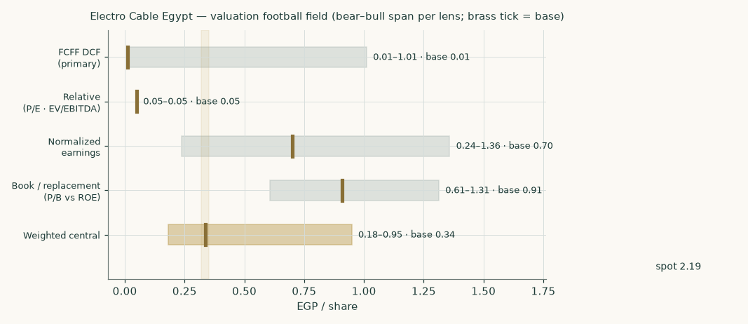
Figure 1 — Valuation football field. Bars span bear–bull per lens; the brass tick is each base case; the gold band is the blended central range; the dark line is spot.
Central fair value ≈ EGP 0.34/share, 85% below spot. Note what the field is saying: the four base cases span 0.01 (DCF, floored) to 0.91 (book) — a wide span in ratio terms, but every lens lands far below the price, and spot sits outside the whole cluster at the far edge of the bull span. The agreement is on direction: the disagreement in this study is not between the lenses; it is between all of them and the price.
1.6 The drivers — a bottom-up tonnage build, calibrated on disclosed anchors
The forecast is built from physical volumes and unit economics, not top-line growth rates. Revenue = tonnes shipped × price per tonne, where price per tonne = LME copper × EGP/USD × a fabrication uplift of 1.387× (copper is ~72% of a power-cable price — industry norm, LME moves passed through quotations). EBITDA = tonnes × conversion EBITDA per tonne. Margins are OUTPUTS of this build, not assumptions. The company discloses no volumes, so the build is calibrated on what IS disclosed — revenue, copper, the currency — and validated against the stated ~25,000 t/yr capacity:
Implied history | LME avg ($/t) | EGP avg | Price/t (k EGP) | Implied volume (kt) | Utilization | Conv. EBITDA/t (k)
FY23 | 8,478 | 30.7 | 361 | 24.0 | 96% | 111
FY23 at the parallel rate (~38) | 8,478 | 38.0 | 447 | 19.4 | 78% | —
FY24 (the validation year) | 9,147 | 45.3 | 575 | 24.0 | 96% | 146
FY25 | 10,000 | 49.5 | 687 | 15.8 | 63% | 182
Q1-2026, annualized | 12,852 | 50.4 | 898 | 9.3 | 37% | 11

The fabrication uplift (1.387×) is set from the industry copper-share norm, NOT fitted to this table — that FY24 then back-solves to 24.0 kt, 96% of the stated capacity in the boom year, is the validation. The decomposition’s central finding: the revenue collapse is a VOLUME collapse (utilization ~96% → ~38%), partly masked by record copper; and conversion EBITDA per tonne collapsed with it (146 → 11 k EGP/t) as fixed costs lost their absorption. FY25’s 182 k/t is inflated by copper inventory gains. Capacity figure is single-sourced and possibly parent-only — utilization is indicative.
The forecast drivers, on the same axes:
Driver | FY26E | FY27E | FY28E | FY29E | FY30E
Volume (kt) | 10.4 | 11.9 | 13.4 | 14.8 | 16.0
Utilization | 42% | 48% | 54% | 59% | 64%
LME copper ($/t) — flat at the current market level | 14,000 | 14,000 | 14,000 | 14,000 | 14,000
EGP/USD (~3%/yr crawl) | 50.4 | 52.0 | 53.5 | 55.0 | 56.5
Price per tonne (k EGP) | 979 | 1,010 | 1,039 | 1,068 | 1,097
Revenue (EGP mn) | 10,178 | 12,016 | 13,921 | 15,806 | 17,554
Conversion EBITDA/t (k EGP) | 40 | 90 | 115 | 128 | 135
EBITDA (EGP mn) — output | 416 | 1,071 | 1,541 | 1,894 | 2,160
EBITDA margin — output | 4.1% | 8.9% | 11.1% | 12.0% | 12.3%

Volume recovery to 64% utilization by FY30E (EETC’s EGP 45 bn plan, the EU €690 mn package, interconnector follow-on) — still below the FY23–24 near-full prints. Conversion EBITDA/t recovers to 135 k by FY30E: nominally below FY24’s 146 k despite five years of EGP inflation, and, as a share of realized price at the $14k copper anchor (12.3%), matching the PRE-windfall 2022 norm (~12%) rather than the devaluation-era 25%. Copper is anchored FLAT AT THE CURRENT MARKET (~$14,000/t, 3–4 Aug LME cash) — a “no view” forecast must anchor on the tape, and the −10% sensitivity column (=$12.6k, the consensus print this study previously anchored on) carries the mean-reversion case. Working capital stays on its intensity glide (112% → 88% of revenue) — copper strength therefore inflates the working capital the model must fund, which is exactly the mechanism the tonnage build exists to price. Note the FY26E within-year ramp this implies: Q1 ran ~11k EGP/t conversion at 37% utilization, so the FY26E average of 40k requires Q2–Q4 near ~50k as utilization recovers — the H1-2026 statements (due ~mid-Aug) are the first checkpoint on that ramp. One capacity caveat: the 25 kt denominator is the PARENT’s Mostorod plant; the consolidated Giza Power Industry plant at Abu Rawash (81,745 sqm, range up to 220 kV per the company) adds undisclosed tonnage, so every utilization percentage here is an upper bound — volumes themselves are revenue-implied and unaffected. Every driver above is a stated, sensitized house judgment (§1.9).
The net-debt anchor — triangulated, not read off one sentence. The FY25 filing coverage says the company “obtained credit facilities of EGP 10.9 bn during 2025” — ambiguous between the drawn balance and limits granted. Rather than lean on that sentence, the anchor is rolled forward from the FY24 audited comparatives (assets 14,970 · debt 8,960 · cash 828 · equity 3,600) through the four hard disclosed FY25 points: total assets 16,460, net profit 500.3, revenue 10,819, and no dividend.
Step | EGP mn
FY25 equity, rolled (3,600 + 500.3, no dividend, no revaluation history) | ≈ 4,100
FY25 total liabilities (disclosed assets 16,460 − equity) | 12,360
less non-debt liabilities (FY24’s 2,410 scaled with purchase value, −21.5%) | (≈ 1,890)
= drawn debt, balance-sheet residual | ≈ 10,465
less cash (estimated: 500 stress floor – 830 FY24-flat, midpoint) | (≈ 665)
= net debt, method A | ≈ 9,800
Cross-check B — cash-flow roll-forward: FY24 net debt 8,132 + interest 2,150 + tax 145 + capex 210 + working-capital build ~2,036 − EBITDA 2,871 | ≈ 9,800
Cross-check C — the facilities sentence read as fully drawn, less cash | ≈ 10,235
Anchor carried in the model (A/B central; range 9,120–10,360 in sensitivity) | 9,805

Methods A and B share the balance-sheet decomposition of the working-capital build, so their agreement is consistency, not full independence; C is the upper cross-check — the triangulated drawn debt sits at 96% of the disclosed facilities, consistent with the 10.9 bn being near-fully-drawn limits. The reverse test rejects holding debt at the FY24 level (net debt ~8.2 bn): that would force non-debt liabilities up 41% in a year when purchase value fell 21%. The range is worth ~±EGP 0.19/share; the audited FY2025 borrowings note is the named falsifier.
1.7 The crux — working capital first, margins second, rates third
Three judgments drive this valuation, in order of size. FIRST, collection. Working capital stands near ~EGP 12.2 bn — 113% of a full year’s revenue — against ~76% a year earlier: copper-inflated inventory plus receivables that grew as revenue shrank, funded by ~EGP 10.5 bn of bank debt (facilities disclosed at 10.9 bn). The DCF’s FY26E cash flow is dominated by a ~EGP 845 mn assumed release as sales contract; if those receivables do not collect (state-linked customers, dealer credit), the release never happens, debt stays ~EGP 11 bn at 22% money, and the equity rounds to nothing — that is the bear case’s mechanism, not rhetoric. Each 5 points of terminal working-capital intensity is worth roughly EGP 0.15–0.20/share. SECOND, the margin. FY24–25 EBITDA margins near 25% carried devaluation inventory gains; the DISCLOSED 1Q26 lines put the trough on the table — gross margin 5.7%, operating profit zero. The model’s mid-cycle EBITDA margin is an OUTPUT of the tonnage build: 11.1% by FY28E, 12.3% terminal — a judgment between the proven trough and the windfall ceiling — and each 15% shift on conversion EBITDA/t is worth roughly EGP 0.48/share on the unfloored DCF (§1.9 grid). THIRD, the rate path: at 22% money, finance expense consumes the operating line; at the terminal 15%, the same business supports a meaningful EPS again. The easing calendar is therefore load-bearing — which is exactly why it is built into the discount schedule rather than averaged away.
1.8 Macro and country — rates, the pound, copper, and the sourced cost of capital
Egypt held its policy corridor at 19.00/20.00% in July 2026 (third consecutive hold, after 825bp of cuts Apr-25→Feb-26) with inflation at 14.3% and a 7%±2pp target for late-2026, 5%±2pp for 2028. The pound has round-tripped since the March-2024 float — 46.8 at the strong side (Feb-26) to ~54.7 at the war spike (Apr-26), back to ~49.8 today. The path was NOT placid, but the destination is: two years of roughly flat nominal EGP against 14–28% cumulative inflation is a large REAL appreciation, which is precisely what un-winds windfall cable margins: copper is fully imported and USD-priced (up ~51% y/y), sales are domestic and EGP-priced. The demand side is genuinely strong — EETC’s EGP 45 bn transmission plan, the EU’s €690 mn grid package, the Egypt–Saudi interconnector (tested; commercial operation now targeted end-2026) — but pass-through pricing means volume recovers before margin does. Every cost-of-capital input below is sourced (full provenance in the Source Register):
Component | Value | Source / note
Egypt 10Y local yield (observed) | 22.31% | investing.com print, 21-Jul-2026; May-26 window avg 21.3% corroborates
less sovereign default spread (CDS) | −3.40% | The local yield already prices default risk; charging it again in the ERP would double-count
= risk-free for the equity build | 18.91% | CDS basis (rating basis: 22.31 − 6.37 = 15.94%)
Equity risk premium — Egypt (CDS-based, primary) | 9.41% | Damodaran original country-risk file, Jan-2026 (rating-based 13.94% shown in sensitivity)
Beta (own regression, weekly, 5yr) | 0.964 | vs 30-name equal-weight EGX composite: R² 0.222, n=257, SE 0.113, CI90 [0.78, 1.15] — passes the usability gate; not weak-flagged
Cost of equity Ke | 27.98% | = 18.91 + 0.964 × 9.41
Cost of debt Kd (pre-tax, marginal EGP) | 22.0% | Corridor + credit margin; checked against effective rates 23.5% (FY24) and 22.1% (FY25, on the triangulated debt path) — inside 150bp
Debt currency | ~100% EGP (presumption, flagged) | No facility disclosure reachable; no USD facility found in any search — the gap is stated, not assumed away
Weights E / D — explicit window | 41% / 59% | Market cap 7.26 bn vs triangulated FY25 drawn debt 10.5 bn
WACC — explicit window (this year) | 21.53% | CDS-primary (rating alternative 23.20%)
Terminal rf (norm-built) | 10.5% | CBE’s own Q4-2028 inflation target 5% + 5.5pp real-rate convention
Terminal ERP · terminal Kd | 7.0% · 15.0% | Normalised below crisis level · Egyptian long-run corporate norm 14–16%
Weights E / D — terminal (normalized) | 60% / 40% | The steady state presupposes deleveraging; today’s ~60% distress weight into perpetuity would be circular (the equity weight depends on the DCF’s own output). Conservative direction: more weight on the dearer equity leg
WACC — terminal | 15.00% | Capitalises the terminal value; reached via the glide below

The forward schedule, year by year — the glide shape is the forward cost-of-debt path’s own cumulative progress, so the discount rate and the interest forecast normalise on one easing calendar:
 | FY26E | FY27E | FY28E | FY29E | FY30E
Forward Kd path (pre-tax) | 22.0% | 20.0% | 18.5% | 16.8% | 15.5%
Forward Ke (same easing calendar) | 28.0% | 24.7% | 22.2% | 19.4% | 17.2%
Glide fraction | 0% | 31% | 54% | 80% | 100%
Forward WACC | 21.5% | 19.5% | 18.0% | 16.3% | 15.0%
Cumulative discount factor | 0.823 | 0.688 | 0.583 | 0.502 | 0.436

A pound arriving 31-Dec-2030 carries the same 0.436 discount factor whether it arrives as a forecast cash flow or inside the terminal value — the common sell-side construction that discounts the terminal alone at a lower rate manufactures value by relabelling, and is not used here.
1.9 Sensitivity — the rate, the growth, the margin, the collection, and the beta
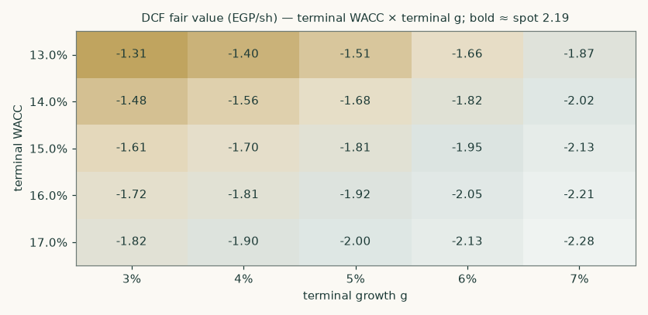
Figure 2 — DCF fair value (EGP/share) across terminal WACC × terminal growth. Bold cells sit nearest spot.
Terminal WACC \ g | 3% | 4% | 5% | 6% | 7%
13.0% | -1.31 | -1.40 | -1.51 | -1.66 | -1.87
14.0% | -1.48 | -1.56 | -1.68 | -1.82 | -2.02
15.0% | -1.61 | -1.70 | -1.81 | -1.95 | -2.13
16.0% | -1.72 | -1.81 | -1.92 | -2.05 | -2.21
17.0% | -1.82 | -1.90 | -2.00 | -2.13 | -2.28

DCF fair value (EGP/share) across terminal WACC × terminal growth. Base cell 15.0% × 5% = 0.01 (equity floored at zero — the base EV does not cover the net debt). Note the g-gradient runs the UNUSUAL way — more growth, less value — because the terminal return on capital (10.3%) sits below the terminal cost of capital (15.0%): growth that earns less than it costs subtracts value. This is the construction working correctly, not an error.
Explicit \ terminal WACC | 13.0% | 14.0% | 15.0% | 16.0% | 17.0%
19.5% | -1.46 | -1.63 | -1.77 | -1.88 | -1.97
20.5% | -1.49 | -1.65 | -1.79 | -1.90 | -1.99
21.5% | -1.51 | -1.68 | -1.81 | -1.92 | -2.00
22.5% | -1.54 | -1.70 | -1.83 | -1.93 | -2.02
23.5% | -1.56 | -1.72 | -1.85 | -1.95 | -2.04

Explicit-window WACC × terminal WACC, each varied independently around its own base — what the valuation needs the ECONOMY to do, separate from what it needs the company to do.
Conversion-EBITDA/t shift \ terminal NWC % | 100% | 94% | 88% | 82% | 76%
-30% | -3.26 | -3.02 | -2.77 | -2.53 | -2.29
-15% | -2.77 | -2.53 | -2.29 | -2.05 | -1.81
+0% | -2.29 | -2.05 | -1.81 | -1.57 | -1.33
+15% | -1.81 | -1.57 | -1.33 | -1.08 | -0.84
+30% | -1.33 | -1.08 | -0.84 | -0.60 | -0.36

The company grid: conversion economics × working-capital collection. Terminal ROIC is RECOMPUTED in every cell (shifted NOPAT over shifted invested capital), so margin shifts carry through to the terminal economics — the grid’s stated specification. +30% on conversion EBITDA/t (≈175 k EGP/t — a partial return of the windfall) AND collection back toward FY24’s ~76% intensity still does not reach spot on this lens alone; the market price needs the bull case on every axis at once, including the cost of capital.
Terminal ROIC | Reinvestment needed for g = 5% | Terminal value (EGP mn) | DCF (EGP/sh, unfloored)
7.7% | 65% | 5,513 | -2.02
8.5% | 59% | 6,474 | -1.90
9.2% ← used | 55% | 7,150 | -1.81
12.0% | 42% | 9,171 | -1.54
15.0% ← = terminal WACC | 33% | 10,481 | -1.37

Terminal return on capital, varied alone. This is the input that sets the reinvestment burden (RR = g ÷ ROIC) and drives the inverted growth gradient; its swing across this range (~±EGP 0.3/share unfloored) is larger than the entire beta grid’s — which is why it is gridded here alongside the rates. Even at ROIC equal to the terminal cost of capital, the enterprise still does not cover the net debt.
Beta | Ke | WACC (explicit) | WACC (terminal) | DCF (EGP/sh)
0.60 | 24.6% | 20.1% | 13.5% | -1.59
0.78 ← CI low | 26.2% | 20.8% | 14.2% | -1.71
0.80 | 26.4% | 20.9% | 14.3% | -1.72
0.96 ← used | 28.0% | 21.5% | 15.0% | -1.81
1.00 | 28.3% | 21.7% | 15.2% | -1.83
1.15 ← CI high | 29.7% | 22.2% | 15.8% | -1.89
1.30 | 31.1% | 22.8% | 16.4% | -1.95

Beta sensitivity spanning the regression’s own 90% confidence interval plus the fixed house anchors. The valuation conclusion does not turn on the beta.
2 Technical and price structure
The tape is neutral: a stock that de-rated hard (−28% year-to-date, −21% over twelve months) and is now basing. Price sits above the 20/50/100-day averages but below a still-falling 200-day near 2.40 — the signature of a countertrend rally inside a larger downtrend, powered by the July-2026 EGX small-cap rotation rather than company news. RSI in the mid-50s and a flat MACD confirm: no strong signal either way. The deep floor is the 52-week low at 1.90; the ceiling that matters is the 200-day / 2.40–2.50 shelf, then the February-2026 block-trade zone near 2.80.
Indicator | Reading | Signal
Spot | EGP 2.19 | —
SMA 20 / 50 | EGP 2.18 / 2.14 | Above both — short-term stabilising
SMA 100 / 200 | EGP 2.14 / 2.40 | Above 100 · below a falling 200 — larger trend still down
RSI (14) | 53.9 | Neutral
MACD (12,26,9) | +0.011 line / +0.015 signal / -0.004 hist | Flat, momentum fading
52-week range | EGP 1.90 – 3.36 | Lower third of the range
Realized vol (252d) | 27.8% | Moderate for an EGX small-cap
12-month / YTD return | -21% / -28% | De-rating year

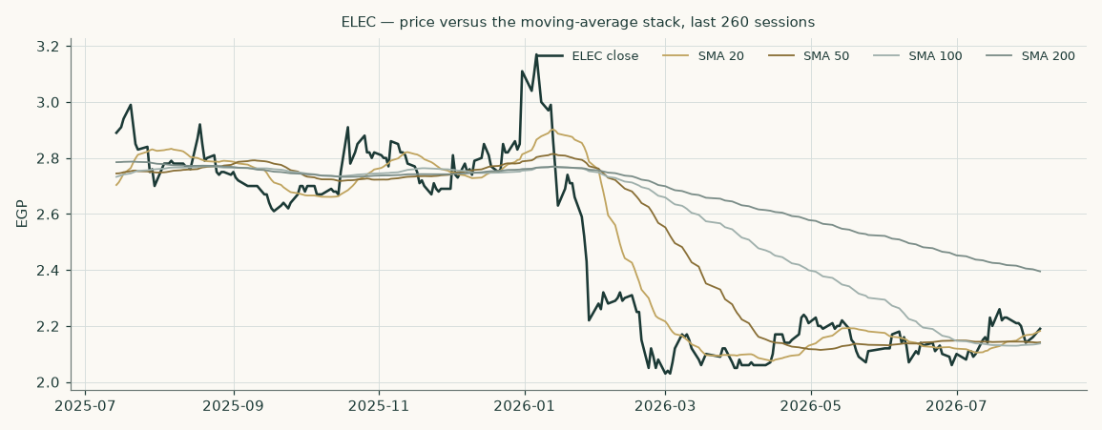
Figure 3 — Price versus the moving-average stack, last 260 sessions.
For the probabilistic work this matters one way: a basing, high-carry tape thickens the near-term upside tail even where the fundamental work says value sits far lower. The technical and fundamental pictures disagree here, and §6 reads the resulting probability zones without forcing a reconciliation.
3 Monte Carlo — a probabilistic price map
The probability read below opens the section, per house presentation: computed from the same 50,000 paths as everything that follows, it is a summary of the distribution, not an input to it.
The probability read (3 months)
P(price above spot) | 61%
P(+10%) vs P(−10%) — the odds | 37% vs 18% · 2.1 : 1
Median level, and its move | EGP 2.29 (+4.7%)
The 50% band (25th–75th) | EGP 2.06 – 2.55
Touch(+10%) / touch(−10%) at any point | 60% / 39%

We simulate 50,000 three-month price paths with the house engine, exactly as fitted on the 30-name Egyptian panel: width from a gap-aware Yang–Zhang variance forecast (annualised ≈ 40% at this anchor; the panel's width-calibration factor 0.951 scales the applied cone to ≈37% effective — both numbers stated so the cone reconciles to its label), Student-t(6) tails calibrated on the panel, and drift anchored on the cost of carrying Egyptian money (the 19.50% policy-corridor rate) — deliberately nothing else. No margin view, no fair-value gap, no analyst judgment enters the drift: the same configuration was walk-forward tested on this stock's own history at seventeen non-overlapping quarterly origins (the full valid span after Egypt's March-2022 structural break), where it beat a carry-anchored random-walk benchmark by a scale-normalized skill of +0.09 with statistically uniform interval coverage (χ² p ≈ 0.4) — which is the only reason it is published. The upward median is the price of time in a 19.5% currency, not a view that the stock should rise.
By design the paths diffuse from spot as near-term price and deliberately do not embed the fundamental value gap of §1. §3 maps where price could go from today; §1 says what the business is worth. When they disagree — as they do here — that disagreement is information, and §4 reads it.
Forces and events on the watch list — context for reading the distribution, not drift inputs (the engine is deliberately carry-only):
Continuous force | Dir. | Discrete event (next 3 months) | When / note
EGX70 small-cap rotation / retail flows | ± | H1-2026 results publication | ~mid-Aug-2026 — the single largest scheduled event
CBE easing resumption (finance-cost relief) | + | CBE MPC meetings | 20-Aug / 01-Oct / 12-Nov-2026
Copper at records (input cost, WC strain) | − | Egypt–Saudi interconnector commissioning | Final testing since Feb-2026
EGP stability (real appreciation vs margins) | − | EETC tender awards (EGP 45bn plan) | Through FY26/27
Grid-capex demand cycle | + | Further controlling-group block sales | Pattern: Jan/Feb/Apr/Jul-2026
Receivables collection cycle | ± | EGP step-move (either direction) | Range-bound 47–52 since the float

Percentile map (EGP/share)
Horizon | p5 | p25 | p50 | p75 | p95
1 month | 1.91 | 2.10 | 2.22 | 2.35 | 2.59
3 months | 1.71 | 2.06 | 2.29 | 2.55 | 3.07

Lead with the 50% band, not the tails: a quarter ahead, half of all paths finish between roughly EGP 2.06 and 2.55; at one month the band is EGP 2.10–2.35. The 5–95% cone is context, not a forecast.
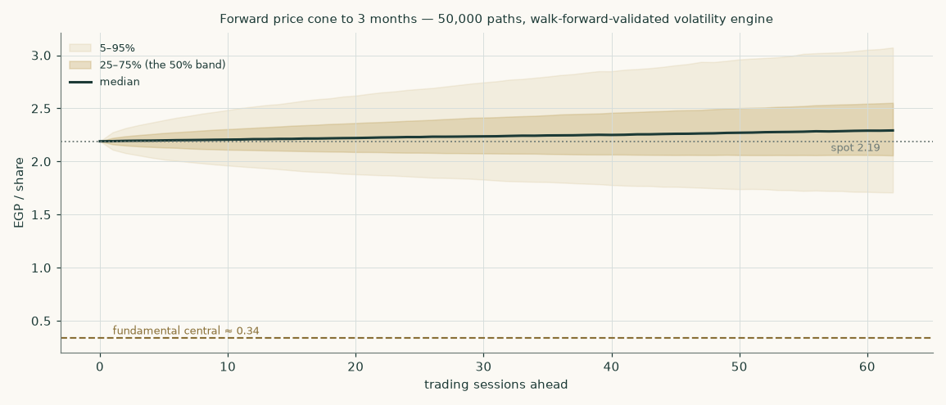
Figure 4 — Forward price cone to 3 months. The brass dashed line marks the fundamental central — far below the whole cone: the tape would have to fall out of its own distribution to reach it within a quarter.
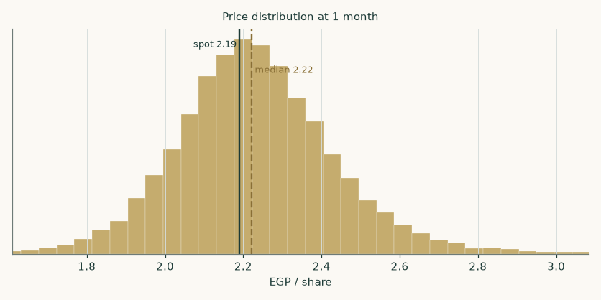
Figure 5 — Price distribution at 1 month.
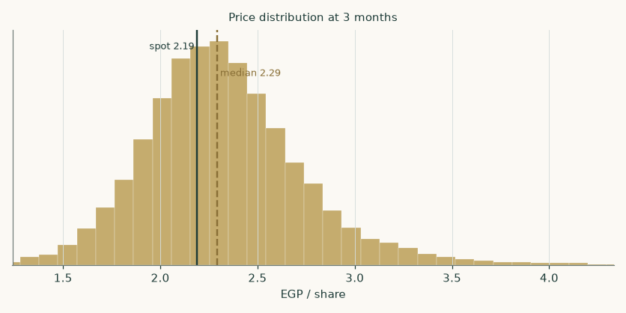
Figure 6 — Price distribution at 3 months.
Level-touch ladder
The probability that price touches a level at any point by the horizon (running max for upside, running min for downside):
Level (EGP) | 1-month touch | 3-month touch | Note
3.00 | 1% | 10% | Post-results re-rating zone
2.75 | 3% | 22% | Feb-26 block-trade zone
2.50 | 14% | 47% | The 200-day shelf
2.35 | 40% | 70% | SMA-200 first test
2.05 | 31% | 54% | July base / SMA-50 zone
1.90 | 8% | 27% | 52-week low
1.70 | 1% | 9% | Below the low — bear-case zone

4 Comparison of the lenses, and a verdict
Three readings sit side by side, and they genuinely disagree. The fundamental lenses cluster at EGP 0.05–0.70 with a central of 0.34 — roughly 85% below the market. The technical picture is neutral: a basing chart inside a larger downtrend, no strong signal. The probabilistic map's median (2.29) sits slightly ABOVE spot — but read it for what it is: the engine anchors drift on the 19.5% cost of Egyptian money and prices the stock's own path; it does not know what the business is worth. The fundamental work says the price needs the bull scenario to be right; the tape says the market is not currently walking away from that bet; the simulation says a quarter is too short for the gap to close by drift alone.
Lens | Reads | Central / implication
Fundamental (4-lens) | Meaningfully overvalued | EGP 0.34 (-85%)
Technical | Neutral — basing inside a downtrend | Support 2.05 / 1.90; resistance 2.40 (200d) / 2.80
Monte Carlo (3-month) | Carry-tilted, wide | Median 2.29; p5–p95 1.71–3.07

Verdict (a fair-value read, not a recommendation). ELEC reads severely overvalued on fundamentals (-85% to the central estimate), and the bottom-up build sharpens the statement: at record copper and pre-windfall conversion economics, the enterprise is worth less than its ~EGP 9.8 bn net debt — the base-case equity is an option, not a claim — and the modelled equity P&L path breaches book solvency by FY29E unless margins or volumes outrun the base case. Three checkable legs carry the read: the earnings the market capitalises were devaluation-era windfalls the company has stopped printing (1Q26: gross margin 5.7%, operating profit zero); implied volumes have fallen to ~38% of capacity while working capital of ~113% of revenue is funded at 22% money; and the controlling group has been selling at EGP 2.00–2.21 throughout 2026. What would change the read is equally specific: an H1-2026 print showing conversion EBITDA per tonne back above ~100,000 EGP without currency help, receivables actually collecting (operating cash flow positive, debt falling), or a step-devaluation — the one event that genuinely reruns the windfall. Even then, note the ceiling: the modelled bull central is 0.95. The bear–bull span (EGP 0.18–0.95) is wide, humility is warranted on the derived lines, and the tonnage build rests on a single-sourced capacity figure — but no reading of the disclosed numbers we can construct supports the current price. We publish the distribution, not a target.
5 Catalysts to watch
- H1-2026 results (~mid-August 2026). The single most important print of the year: whether the 1Q26 loss was the trough. Watch three lines — gross margin (the ~14% implied trough vs any recovery), receivables (collection or further build), and finance cost (the first read on easing pass-through).
- CBE MPC meetings (20-Aug, 01-Oct, 12-Nov 2026). Each 100bp off the corridor cuts ~EGP 110 mn from annual finance cost at the disclosed debt load and compresses the discount schedule — the most mechanical catalyst.
- EETC tender awards under the EGP 45 bn FY25/26 plan. Direct order-book demand; ELEC’s ~2/3 revenue exposure to the power sector makes tender flow the volume driver.
- Egypt–Saudi interconnector commissioning. Entered final testing Feb-2026; commercial operation was postponed in June to end-2026 (summer peak loads). Commissioning validates the HV build-out cycle and pulls forward follow-on grid spending.
- Copper. AT records — LME cash ~$14,000/t (3–4 Aug-26; all-time high $14.5k Jan-26), and the model now anchors its flat forecast there: every leg higher inflates ELEC’s working capital and funding need; a copper break lower (the −10% grid column = $12.6k) would be a quiet balance-sheet relief.
- The pound. A step-devaluation would reflate cable margins and inventory (the FY23–24 mechanism) at the cost of the funding base; continued stability keeps the margin squeeze on. This stock is, in effect, a devaluation call option the market keeps partly priced.
- Controlling-group block sales. Gadwa/Alhsn/Mashareq sold through Jan/Feb/Apr/Jul-2026 at EGP 2.00–2.21. Further distribution caps rallies; a cessation — or a strategic buyer — changes the flow picture.
- Any audited-statement access. Publication of the full FY25/H1-26 statements (receivables ageing, facility schedule, capex) would resolve the derived lines in this model — in either direction.
6 Reading the probability zones
Translating the three-month distribution into plain zones, anchored on spot EGP 2.19 and the fair-value cluster:
Zone (3 months) | Range | Approx. probability | What it would mean
Deep downside | < EGP 1.80 | ~8% | Collection fails / H1 loss deepens; breaks the 52-week low toward the fundamental reads
Lower band | EGP 1.80–2.05 | ~16% | De-rating resumes; the July base gives way
Around spot | EGP 2.05–2.35 | ~32% | Status quo: small-cap rotation holds the price, fundamentals unresolved
Upper band | EGP 2.35–2.70 | ~28% | H1 relief + easing resumption; 200-day reclaimed
Strong upside | > EGP 2.70 | ~16% | Margin-recovery evidence or devaluation trade returns; block-trade zone retested

Note what the zone table cannot say: nothing in a three-month price map adjudicates the fundamental question. Even the deep-downside zone stops far above the DCF’s base value — if the fundamental work is right, the reckoning is slower than a quarter. The map describes the tape’s physics; the thesis lives in §1.
7 Caveats and what would change our mind
- The statements gap is narrower than at first build, but still real. The Q1-2026 income-statement lines, the FY25 totals (assets, profit, no dividend) and the FY25/FY24 facilities figures ARE disclosed (recovered from press coverage of the EGX filings); interest expense, capex, the working-capital split and facility-level terms remain DERIVED. The FY24 triangulation closing within 0.8% earns the derivations a place in the model, and the net-debt anchor is now triangulated three ways off the FY24 audited comparatives rather than read from the ambiguous facilities sentence (§1.6) — but the honest range is still EGP 9.1–10.4 bn, worth ~±EGP 0.19/share, and the residual risk is SKEWED ADVERSE: the two readings the triangulation could not use both sit at or above the top of the range (facilities-as-drawn 10.2 bn; an unverifiable aggregator debt/equity print implying ~10.4 bn net). At that challenged 10.4 bn reading the unfloored DCF moves to -1.98/share — deeper underwater, same floored conclusion. The audited FY2025 borrowings note is the one document that would settle it. Every derived line is flagged in §1.6 and the Source Register.
- The base-case equity P&L path raises a genuine solvency question. Charging 22%-gliding-to-15% money on the triangulated debt against recovering-but-thin conversion economics, the modelled book equity erodes from ~EGP 4.1 bn to below zero by FY29E, with net debt rising toward EGP 17 bn. This is a modelled path on derived lines, not an audit opinion — but it is what the disclosed numbers imply if nothing improves, and it explains why the DCF equity is an option rather than a claim. The exits are named in §4: collection, conversion recovery above ~100k EGP/t, a step-devaluation, or a controlling-group recapitalisation.
- The working-capital release is an assumption, not a fact. FY26E’s cash flow leans on ~EGP 845 mn of collection as revenue contracts (smaller than in earlier drafts because copper is now anchored at the $14k market level, which keeps more capital trapped). Receivables from state-linked customers can age for years; if intensity stays above ~100% of revenue, the bear case is the base case.
- Margin normalisation is a judgment between poles. Nobody outside the company knows whether 25% EBITDA margins were entirely windfall; the build’s ~11–12% mid-cycle-to-terminal output is argued, sensitized, and could be wrong in either direction. The §1.9 company grid is the honest statement of how much this matters.
- Terminal-value dependency. 82% of the EV is terminal value at a 5.8-pt negative terminal spread — HIGH, and stated prominently per house rule: the explicit years are working-capital-suppressed, so most of the modelled worth arrives after them; the study is partly a bet on Egyptian normalisation arriving on the central bank’s own schedule.
- A devaluation would rescue the bull case. The FY23–24 windfall mechanism — EGP falls, copper-linked prices reprice, inventory gains — is repeatable. This study’s base case assumes the pound holds; readers who expect another step-move should weight the bull column, and note that the same event punishes the funding side and the country risk premium.
- The market may be pricing flow, not value. A ~33%-float EGX70 name in a retail rotation can stay away from fundamental value for a long time; overvaluation is a statement about the destination, never the timetable.
- Concentrated ownership cuts both ways. The related-party group has sold down hard — 81.2% (Mar-25) to 66.72% (Jul-26) — which both widens the float and underlines the insider read; but the group could equally take the company private, restructure the debt, or inject assets; control events are not in the model.
- The simulation prices the path, not the thesis. Its median sits above spot because Egyptian carry is 19.5%; do not read that as the model disagreeing with itself — the two clocks measure different things.
Appendix A Financial statements
Consolidated figures as available through bourse-disclosure reporting of the company’s EGX filings; derived lines are marked (d) and their construction is stated in §1.6 and the Source Register. The five-year forecast is the model build (companion Excel, formula-linked to its Assumptions sheet). EGP million.
A.1 Income statement — 3-year historical + 5-year forecast (consolidated, EGP mn)
Line | FY23 | FY24 | FY25 | FY26E | FY27E | FY28E | FY29E | FY30E
Revenue | 8,673 | 13,778 | 10,819 | 10,178 | 12,016 | 13,921 | 15,806 | 17,554
EBITDA | 2,661 (d) | 3,490 (a) | 2,871 (d) | 416 | 1,071 | 1,541 | 1,894 | 2,160
EBITDA margin | 30.7% | 25.3% | 26.5% | 4.1% | 8.9% | 11.1% | 12.0% | 12.3%
D&A | (61) (d) | (90) | (76) (d) | (132) | (156) | (181) | (205) | (228)
EBIT | 2,600 (d) | 3,400 | 2,796 (d) | 284 | 915 | 1,360 | 1,689 | 1,932
Net finance cost | (990) (d) | (1,700) (d) | (2,150) (d) | (2,157) | (2,185) | (2,520) | (2,696) | (2,800)
Earnings before tax | 1,610 | 1,700 | 646 | (1,873) | (1,270) | (1,160) | (1,007) | (868)
Income tax (effective; statutory 22.5%) | (362) | (372) | (145) | — | — | — | — | —
Net profit (attributable) | 1,248 | 1,328 | 500 | (1,873) | (1,270) | (1,160) | (1,007) | (868)
EPS (EGP) | 0.38 | 0.40 | 0.15 | (0.57) | (0.38) | (0.35) | (0.30) | (0.26)

Historical revenue/NP/EBT/tax: bourse-reported. (d) = derived; (a) = single-aggregator figure (Investing.com), flagged. The FY24 closure (reported NP reproduced within 0.8% from disclosed EBIT, coverage and the statutory rate) validates the finance-cost and tax chain specifically — the capex and working-capital derivations carry their own constructions and ranges. The FY24 tax cell is the effective plug (21.9%) to the reported NP; the statutory rate is 22.5%. Forecast net-finance-cost line uses the forward Kd path on the modelled debt schedule; the equity P&L pays zero cash tax in loss years and uses the 5-year Egyptian loss carryforward, while the FCFF valuation taxes EBIT at the full 22.5% every year (the standard unlevered convention — conservative, since it forgoes the NOL shield worth ~0.1–0.2/share unfloored). That tax-convention difference is also why the net-debt schedule in A.2 runs slightly below net debt rolled from the FCFF line (~66 mn in FY26E): the schedule pays the equity P&L’s actual (zero) tax, the FCFF line pays notional full tax. The valuation runs on FCFF, which is independent of the financing line.
A.2 Balance sheet — condensed house layout (consolidated, EGP mn)
Line | FY22 | FY23e | FY24 | FY25e | FY27E | FY30E
Total assets (model basis fwd) | 4,960 | 10,000 (e) | 14,970 | 16,460 | 15,117 | 17,827
of which net working capital | n/d | ~7,000 (e) | ~10,500 (d) | 12,245 (d) | 12,737 | 15,447
Net debt | n/d | n/d | 8,132 | 9,805 (d) | 13,620 | 19,602
Equity attributable | n/d | n/d | 3,600 | 4,100 (d) | 956 | -2,078
Net debt / equity | n/d | n/d | 226% | 239% (d) | 1424% | -943%

(e) = estimate bounded by disclosed prints; (d) = derived from disclosed totals (construction in §1.6). FY22/FY24/FY25 total assets, the FY24 debt/cash/equity set and the FY25 facilities are sourced; the FY25 debt/cash/net-debt set is triangulated from them (roll-forward table, §1.6); the FY23 year-end balance sheet was never found (flagged gap). Forecast columns are the model’s clean-surplus roll-forward — and they are the honest bad news: on the base case, book equity erodes toward zero by FY29–30E while net debt compounds. See §7, first two caveats.
A.3 Cash flow markers and the working-capital story
Marker | FY23 | FY24 | FY25 | FY26E
Operating cash flow | negative (agg.) | negative (agg.) | ~+690 pre-finance / ~−1,460 after finance (d) | +1,198 (release)
NWC as % of revenue | ~81% (e) | ~76% (d) | ~113% (d) | 112%
Capex (derived: maintenance norm ~EGP 8–9k/t of capacity) | ~104 (d) | ~165 (d) | ~210 (d) | 225
Dividends paid | 0 | 0 | 0 | 0 — none in the disclosed record

The aggregator flag “operating cash flow is negative; debt is not well covered” (FY24 vintage) is the single most important sentence in ELEC’s public record: three years of reported profits never became cash — they became receivables and inventory, funded by debt at 20%+ money.
Appendix B Peer frame, risk register — and the research register
B.1 Peers and the sector frame
Name | Mkt cap | P/E | EV/EBITDA | D/E | Note
El Sewedy Electric (EGX: SWDY) | EGP 196 bn (21-Jul print; ~205 bn at 27-Jul) | 11.3× (computed) | ~7.1× (computed) | moderate | FY25 revenue EGP 281 bn, NP 17.3 bn, EBITDA 30.7 bn, net bank debt 19.8 bn (filed); W&C grew low-teens FY25 — the widely quoted +66% is FY2024
Riyadh Cables (Tadawul: 4142) | SAR 15.4 bn (30-Jul) | 14.3× | ~12.5× (derived) | ~0.5× | What the market pays for the same industry with a clean balance sheet; balance-sheet inputs unverified
Electro Cable Egypt (ELEC) | EGP 7.3 bn | 14.5× trailing | ~5.9× on FY25e | ~2.5× | On depressed, now loss-making earnings; ~5.5× on FY24 windfall EPS
Giza Cables (private; unrelated to ELEC’s subsidiary Giza Power Industry) | — | — | — | — | The other mid-tier player; no public financials

Sector structure: one giant (Elsewedy, with scale, exports and funding access) above a tier of mid-caps competing on price and local content in government tenders. Demand is the strongest it has been in a decade (grid capex, interconnection, renewables hookups) — but pass-through pricing means the demand cycle rescues volumes before it rescues margins, and funding cost decides who banks the difference.
B.2 Risk register
Risk | Direction | Where it is priced
Receivables fail to collect / further WC build | Severe negative | Bear DCF (0.05); the central weight on the DCF
Margins never recover past ~14% | Negative | Company grid, bear column
Copper spikes further (WC funding strain) | Negative | Qualitative; enters through the NWC glide
EGP step-devaluation | Positive for margins, negative for funding/CRP | Bull margin column; not in the base case
Easing cycle stalls (inflation re-accelerates) | Negative | Explicit × terminal WACC grid
Controlling-group distribution continues | Negative (flow) | Not in the model — a market-structure risk
Control event (buy-out, restructuring, asset injection) | Either | Not in the model
Statement access resolves derived lines adversely | Either | §7 first caveat; ~±EGP 0.19/share on the triangulated ND range

B.3 The research register — four layers, dated, negative searches included
Research for this study ran outward-in — world, country, industry, company — before any forecast driver was set. The register below condenses what was found and where; the companion Source Register document carries the full input-by-input listing.
Layer | Class | Finding (condensed) | Source | Date
Global | D | Copper +51.6% y/y: LME cash ~$14.0k (3-4 Aug-26; ATH $14.5k Jan-26), COMEX $6.63/lb; US refined-copper tariff 15% (Jan-27)/30% (Jan-28) AUTHORIZED but determination pending — 50% duty on semi-finished in force since Aug-25 | TradingEconomics; INN; Federal Register | 05-Aug-26
Global | S | Grid renewal + data centers drive global W&C demand (~6.5% CAGR to $409bn by 2034) | Fortune BI; Mordor; CRU | 2026
Global | B | Fed held 3.50–3.75% on 29-Jul-26 (fifth straight hold) | Federal Reserve | 29-Jul-26
Country | B/D | CBE held 19.00/20.00% on 09-Jul-26, third straight hold; 825bp cut Apr-25→Feb-26; next MPC 20-Aug | CBE via FocusEconomics | 09-Jul-26
Country | B | Inflation 14.3% (Jun-26); target 7±2pp Q4-26, 5±2pp Q4-28 | CBE CPI release | 09-Jul-26
Country | B | Egypt 10Y 22.31% print 21-Jul-26 (May-26 avg 21.3; Jul-26 3Y auction 23.3 — early-Aug band ~22.3–23.0); 5Y CDS 270 (Jan) → ~330 (late-May, war) → ~296 (Jun, retightening) | investing.com; MoF; MacroMicro | May–Aug-26
Country | S/D | EETC EGP 45bn FY25/26 plan; EGP 26.5bn spent FY24/25; EU €690mn package 15-Jun-26 (22GW hookups by 2030) | DNE; EEAS | Nov-25–Jun-26
Country | B | EGP ~49.8 spot; 52-week path 46.8 (Feb-26) → ~54.7 (Apr-26 war spike) → 49.8 — a nominal round-trip that is still a large REAL appreciation given the inflation differential | Xe; exchangerates.org.uk; Bloomberg | Aug-26
Country | B | Corporate tax confirmed 22.5%, unchanged | PwC Tax Summaries | 2026
Industry | S | Egypt power-cable market ~6.7% CAGR 2026-32; Elsewedy W&C grew low-teens in FY25 (H1 +12.3%; the widely quoted +66% is FY2024) — demand support, not proof | 6Wresearch; Elsewedy releases | 2026
Industry | S | LME-linked pass-through pricing with raw-material clauses; margins structurally thin; scale + funding decide winners | IndexBox | 2025-26
Industry | D | Egypt–Saudi $1.8bn/3,000MW interconnector: 95% complete (Oct-25), final testing entered Feb-26, commercial operation POSTPONED to end-2026 (Jun-26 announcement) | DNE; Zawya; Shorouk | Oct-25–Jun-26
Company | C | FY25 NP −62% to 500.3mn; 1Q26 net LOSS 241.6mn on sales −44% — the windfall is over | Zawya; Arab Finance | Mar/May-26
Company | C | FY24-vintage: debt ~9bn, equity ~3.6bn, D/E 248% (was 36%), OCF negative, coverage 2.0× | Simply Wall St | May-25
Company | C/D | Related-party group 81.2% (Mar-25) → 66.72% (05-Jul-26): Alhsn 88mn sh @2.00 (01-Jul-26); Mashareq partial cuts @2.21–2.33 (Feb-26, holds ~0.8%) | Hapi Journal; Arab Finance; Forbes ME | 2025-26
Company | C | No published estimates or targets located (one aggregator claims nominal coverage, zero estimates submitted); no dividend in the disclosed record; no capital increase 2024-26 | sweep + aggregators | 05-Aug-26
Company | C | Audited FS PDFs unreachable (company site & disclosure hosts blocked) — derived lines flagged throughout | access log | 05-Aug-26

Class: B = backdrop · S = structural · D = discrete/event · C = company-specific.
Appendix C The expert valuation panel
Every study closes with a panel of standing expert methods — each expert runs a genuinely different method, derives a fair value from shown workings, and states the evidence that would falsify it. For ELEC we cast the earnings-power lens, the accountant’s owner-cash-earnings lens, and the cash-returns lens — the three methods that disagree most productively on a levered cyclical.
C.1 Expert 1 — earnings power: normalized EPS at a justified multiple
Worldview. A cyclical is worth a fair multiple of its mid-cycle earnings; both the windfall peak and the washout trough are noise to be stripped.
When it works / fails. Best with a long through-cycle record; vulnerable when “mid-cycle” itself is contested — exactly the ELEC problem: is normal 14% EBITDA margin or 25%?
Expert 1’s build | Value
Mid-cycle revenue (FY28E-scale) | 13,921
Mid-cycle EBITDA margin (the FY28E tonnage-build output) | 11.1%
Normalized net profit (after 15% money on ~6bn net debt) | 357
Normalized EPS | 0.11
Justified through-cycle P/E | 6.5×
Fair value | → EGP 0.70

Sensitivity (swing = the margin and the multiple): at 8× on the same earnings, 1.36; at 5.5× on bear-margin earnings, 0.24. Falsified by two consecutive halves of EBITDA margin above ~20% without currency help — that would prove the windfall margins were partly structural.
C.2 Expert 2 — the accountant: owner cash earnings from the statements
Worldview. Profit is an opinion; cash is a fact. Value only the earnings that historically became cash the owner could take out.
When it works / fails. Devastating on names whose profits pile up as receivables — ELEC precisely; unfair to genuine growth if the working-capital build eventually monetises.
Expert 2’s ledger | Value
Reported cumulative NP FY23–FY25 | 3,076
Of which converted to operating cash | ≈ nil (OCF negative in FY23/24; FY25 ~+690 pre-finance, ~−1,460 after finance costs)
Where it went | Receivables + inventory, funded by ~EGP 10.5bn of bank debt at 20%+ money
Cash-earnings basis (FY27E EBIT less actual funding cost, after tax) | -985/yr — negative
plus 35% credit toward the normalized-earnings figure | +469
= creditable cash earnings before floor | -515 — still negative
FLOOR applied: nominal residual cash-earnings base (option value, disclosed) | 60 mn/yr
Multiple on floored cash earnings | 6× → equity 360 mn
Fair value | → EGP 0.11

Sensitivity: his range (0.07–0.16) turns almost entirely on how much credit to give unproven collection. Falsified by a published cash-flow statement showing sustained positive operating cash flow with receivables actually falling — he would re-run on the proven number.
C.3 Expert 3 — cash returns: ROIC against the cost of capital, through the rate cycle
Worldview. A business is worth its invested capital plus the present value of its spread over the cost of that capital. In a disinflating economy, both legs move — measure them on one calendar.
When it works / fails. The right frame for capital-heavy compounders and the honest frame for capital-heavy value traps; weakest when invested capital itself is mismeasured (his caveat: ELEC’s IC is mostly working capital of contestable quality).
Expert 3’s economic-profit test | Value
Invested capital (terminal-year basis) | 16,325
Terminal ROIC | 9.2%
Cost of capital: 21.5% today → 15.0% terminal | the spread is NEGATIVE for the whole explicit window
His EV (economic-profit build ≈ the DCF with a 5% haircut on the spread years) | 3,623
less net debt | (9,805)
= intrinsic equity per share — negative | -1.87
FLOOR applied: limited-liability option value (same logic as the DCF lens, disclosed) | 0.10
Fair value | → EGP 0.10

Sensitivity: ±EGP 500 mn on the EV or the debt anchor moves him ±0.15/share — his range (0.05–0.20) is the leverage talking, not the method. Falsified by ROIC printing above the falling WACC earlier than modelled — collection would do it, since it shrinks the denominator and the debt at once.
C.4 Cross-examination
Expert 1 to Expert 2: “You are punishing them twice — once for the working-capital build and again with a 6× multiple on the earnings that survive it. Collection is not impossible; it is just unproven.”
Expert 2 to Expert 1: “Your normalized EPS pays out of profits that have never once turned into cash. Show me one year of positive operating cash flow and I will move; until then a multiple on paper earnings is a multiple on paper.”
Expert 3 to both: “You are arguing about the numerator. The economics are simpler: this business earns ~10% on its capital at the terminal and pays 22% for money today, 15% even in the normalized state. A negative spread at this leverage is value destruction on a schedule — the only question is whether the easing cycle arrives before the balance sheet does.”
C.5 The three in one room
Where they agree is more striking than where they differ: all three land below EGP 0.70 — the most generous number in the room is still ~68% under the market. They disagree on mechanism, not direction: Expert 1 prices a recovery that has not printed, Expert 2 refuses to pay for cash that has not appeared, Expert 3 counts the cost of waiting for either. Each names the same two exhibits as decisive: the H1-2026 statements (margin and receivables) and any audited cash-flow disclosure.
C.6 Reading the divergence
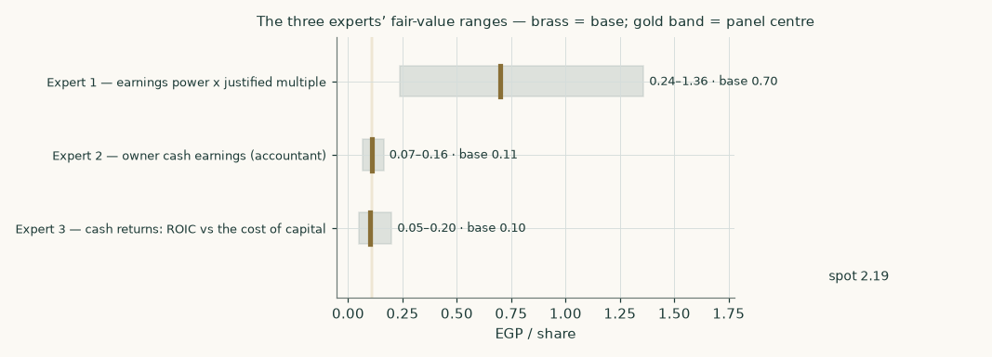
Figure 7 — The three experts’ fair-value ranges. Brass ticks are base cases; the gold band is the panel centre; the dark line is spot — above every range shown.
Expert | Method | Single swing assumption | Base fair value
Expert 1 | Earnings power × justified multiple | Mid-cycle EBITDA margin 11.1% (the FY28E build) | EGP 0.70
Expert 2 | Owner cash earnings | Credit given to unproven collection | EGP 0.11
Expert 3 | Cash returns (ROIC vs WACC) | The net-debt anchor ±1 bn | EGP 0.10

The spread — 0.10 to 0.70 at base — is wide in ratio terms but narrow in message: no method that starts from the company’s own disclosed numbers reaches the market price without assuming the best corner of the scenario space. The panel’s centre sits close to the study’s weighted central (EGP 0.34), which is the reassuring kind of agreement: three different roads, one neighbourhood.
Each expert’s point fair value (and range) is logged with the study date (5 Aug 2026) and spot (EGP 2.19) as an internal per-expert track record.
About this series
Testahil publishes independent, educational valuation studies. Each is an attempt to reason transparently about what a security is worth, with every assumption shown and a companion model so readers can disagree productively. The house style is distributions, not tips: we describe ranges and probabilities, not targets, and we do not tell anyone what to do. Studies are framed as educational analysis, the preparer is not licensed by any securities regulator, and holdings are disclosed.
Disclosure & Disclaimer
Not investment advice. This document is educational and informational only. It is not, and must not be relied upon as, investment, financial, legal, accounting or tax advice, nor an offer, solicitation or recommendation to buy, sell or hold any security. It contains no price target and no rating.
No licence; no advisory relationship. The preparer is not registered or licensed with any securities or financial regulator in any jurisdiction — including Egypt’s Financial Regulatory Authority (FRA) — holds no brokerage or investment-advisory authorisation, and is not acting as your adviser or fiduciary. Nothing here is personalised to your circumstances.
Holdings disclosure. The preparer may hold, and may in the future take or dispose of, a position in the security discussed in this report, and may transact at any time without notice. This is a potential conflict of interest you should weigh.
Sources & accuracy. Reported financial and operating figures are drawn from public disclosure-reporting services believed reliable but not independently verified; the company’s audited statements were not directly accessible, and lines derived from disclosed totals are flagged as such throughout. Forward-looking inputs — margins, the working-capital path, multiples, the discount-rate schedule and simulation settings — are the preparer’s own judgments and are inherently uncertain.
Forward-looking statements. Any statements about the future are estimates subject to risks and uncertainties; actual results may differ materially. The Monte Carlo models price, not value.
No reliance; your responsibility. Do your own research and consult a licensed professional before making any decision. You are solely responsible for your investment decisions and their outcomes. To the maximum extent permitted by law, the preparer accepts no liability for any loss arising from use of this document.
Currency & figures. Figures are in Egyptian pounds (EGP), millions unless stated; bn denotes billion. FX at study date: USD/EGP ≈ 50.3. Rounding may cause totals to differ slightly. Spot price and market data are as of 5 August 2026 and change continuously.
TESTAHIL · Independent Valuation Study · Educational Analysis · Electro Cable Egypt Co. S.A.E. (EGX: ELEC) · edition 05-08-2026 · reporting currency EGP

