Testahil · Independent Valuation Study — Educational Analysis | Not investment advice
Independent Valuation Study — Educational Analysis
Emaar Development PJSC (DFM: EMAARDEV)
Fundamental analysis · Technical analysis · Monte Carlo simulation — one integrated read
Anchor: AED 14.26 (03 Jul 2026 close) · 4,000 mn shares · mkt cap ~AED 57.0 bn (US$ 15.5 bn) · the UAE's leading build-to-sell developer and majority-owned subsidiary of Emaar Properties (DFM: EMAAR); the malls and hotels sit in the parent, so this is a near-pure residential development company · prices and probabilities computed 03 Jul 2026 from the attached daily history · primary lens: RNAV / split sum-of-the-parts (development legs carry no terminal value) · the Dubai property cycle, the sustainable development margin and the net-cash mark are the swing factors.
READ FIRST — what this document is, and is not.
This study is a valuation exercise and an expression of personal analytical opinion, published free of charge for educational purposes: it shows how one analyst applies fundamental, technical and probabilistic methods to a listed company, and invites scrutiny of that methodology. It is NOT investment advice, NOT a recommendation or solicitation to buy, sell or hold any security, and NOT directed at the circumstances of any reader. The preparer is not licensed by any securities regulator in any jurisdiction, holds no brokerage authorisation, provides no financial consultancy, manages no money, and accepts no fees, funds or clients. See the Disclosure & Disclaimer at the end.
All values are model outputs presented as ranges and distributions because no single number should be relied on. Reported financials are the company's own disclosure (FY2025 results, 12 Feb 2026); forward-looking inputs — the RNAV marks, the net-cash mark, the land-bank value, the multiples, the DCF and the Monte-Carlo factor probabilities — are the preparer's judgments and are flagged throughout.
A calibration note. The Monte-Carlo lens here is INDICATIVE. On a full five-year walk-forward backtest it TIES the zero-drift random-walk benchmark on CRPS skill — it does not distinguishably beat it — while producing a well-calibrated, roughly-uniform PIT under the name-specific drift-ON setting. It is not a failed or broken calibration; it simply has no demonstrated edge for this particular name (see Appendix B). Consult a licensed financial advisor before any investment decision.

Headline
The model's read: modestly-to-clearly undervalued, with the upside resting on Dubai's property cycle holding and FY25's peak margins normalising gently rather than sharply. At AED 14.26 the shares sit about 21% below our weighted central estimate of AED 17.29. The primary lens — a split RNAV that adds net cash to the present value of the AED 125.2 bn sales backlog and a haircut land bank, with no terminal value on the finite development legs — lands at AED 17.56; a going-concern DCF struck on an exit multiple (not a perpetuity) cross-checks at AED 18.43, a conservative relative-multiple read (AED 15.75) marks the floor, and a mid-cycle property-earnings read (AED 16.88) sits between. The whole answer turns on the Dubai residential cycle: FY25 was a record — AED 71.1 bn of sales, AED 27.5 bn revenue (+44%), a 56% net margin and a 100%-of-capital dividend — and the case rests on whether that pace and margin normalise gently as 2026-27 supply arrives, or roll over. Technically the stock has corrected from a 52-week high near AED 20 to the mid-14s and is consolidating around its short-term averages, below the 100- and 200-day, with a neutral RSI. Over three months the Monte Carlo — run drift-on for this name — places the 5th-95th band at roughly AED 11.59-20.33, with a median at AED 15.34, about 7.6% above spot.

Valuation summary — every read at a glance
One table for the four reads that follow — what the business is worth (fundamental), what the tape is doing (technical), where price could travel over three months (Monte Carlo), and how three independent expert methods land. Every row is developed in the sections and appendices below.
Lens / read | What it measures | Output | Takeaway
FUNDAMENTAL — what the business is worth (the anchor)
RNAV / split-NAV (primary) | Net cash + PV backlog + land, no dev terminal | AED 17.6 | +23% vs spot
Going-concern DCF | Exit-multiple terminal (not Gordon) | AED 18.4 | +29%
Relative multiples | Normalized EPS × justified P/E | AED 15.8 | +10% · the floor
Property-cycle earnings | Mid-cycle net profit × through-cycle P/E | AED 16.9 | +18%
Weighted central | Blend 40 / 20 / 15 / 25 | AED 17.3 | +21% vs 14.26
TECHNICAL — what the tape is doing (timing, not value)
Trend & momentum | Price vs 20/50/100/200-day averages | Below 100/200-day | Corrective, consolidating
Momentum / range | RSI · MACD · 52-week range | RSI 51 · MACD -0.02 · 12.7-20 | Neutral, mid-range
MONTE CARLO — where price could go in 3 months (paths from spot)
T+20 sessions | 50,000 paths · 16 factors | p5 12.4 · p50 14.6 · p95 17.2 | Median above spot (drift-on)
T+60 sessions | same engine, longer horizon | p5 11.6 · p50 15.3 · p95 20.3 | Wide, right-skewed
EXPERT PANEL — three independent methods (Appendix D)
Expert 1 — accountant / RNAV | Net-asset marks, no dev terminal | AED 17.5 | The anchor
Expert 2 — demand / absorption | Sales pace × margin × collections | AED 16.0 | Cycle-sensitive
Expert 3 — macro-policy / cycle | Rates, supply, discount to NAV | AED 15.0 | Most conservative
Panel range | Spread = the cycle question | AED 15.0-17.5 | Centres ~AED 16.2
Bottom line. Every read points the same way on value and disagrees only on magnitude. The fundamental central sits near AED 17.29 — about 21% above the AED 14.26 spot — the three experts span AED 15.0-17.5, and each turns on a single question: whether Dubai's development cycle sustains the sales pace and the margin that FY25 printed. The three-month distribution is drawn drift-on for this name, so its median sits above spot; the wide band is the honest quarter-ahead uncertainty of a stock that has just corrected 30% from its high.

Company overview — Emaar Development at a glance
Item | Value
Listed entity | Emaar Development PJSC (DFM: EMAARDEV); majority-owned by Emaar Properties (DFM: EMAAR)
What it is | UAE's leading build-to-sell (BTS) residential developer; ~pure development (malls/hotels sit in the parent)
Spot / date | AED 14.26 · 03 Jul 2026 close
Shares · market cap | 4,000 mn · ~AED 57.0 bn (US$ 15.5 bn)
Balance sheet | ~zero debt (D/E ~0); large net cash from customer advances (~AED 20-24 bn); current ratio ~17x
FY25 sales / revenue / net margin | AED 71.1 bn sales · AED 27.5 bn revenue (+44%) · 56% net margin (before tax); a record year
Sales backlog (31 Dec 2025) | AED 125.2 bn, to be recognised over ~4 years
Land bank | 305 mn sq ft (incl. 36 mn sq ft acquired in 2025 with ~AED 120 bn development value)
Dividend | AED 1.00/share (100% of AED 1 par); FY23 0.52 · FY24 0.68 · FY25 1.00; ~7% yield
Returns | ROE ~37.5% · ROIC ~21%; P/E ~5.0x; EV/EBITDA ~2.7x
Founder / leadership | Mohamed Alabbar (founder, Emaar); flagship communities: Downtown, Marina, Hills Estate, The Valley, The Oasis, Emaar South, Beachfront, Grand Polo
52-week range | AED 12.65 - 20.00

1 Fundamental valuation

1.1 RNAV / split sum-of-the-parts (primary lens)
For a build-to-sell developer the right anchor is a re-stated net-asset value, not a perpetuity. We add the balance-sheet net cash to the present value of the profit still to be recognised from the secured sales backlog, plus a heavily-haircut value for future launches off the owned land bank, less the present value of central overhead. Crucially — and this is the house split-NAV rule — the development legs carry NO terminal value: each project is finite and sold once. Only a genuinely recurring leg (which Emaar Development, unlike its parent, does not really have) would earn a perpetual cap-rate.
RNAV component (AED mn) | Value
Net cash (cash − debt; escrow-restricted portion excluded) | 20,000
PV of backlog net profit, attributable (125,200 × 35% sustainable margin, 4-yr, 11%) | 35,225
Land-bank future launches (attributable, PV, execution haircut) | 18,000
Central overhead PV | -3,000
RNAV (equity) | 70,225
RNAV per share (AED) — base | 17.56
Bear / bull (margin 30-40%; net cash 18-22 bn; land 10-30 bn) | 13.80 / 22.31
RNAV base ≈ AED 17.56, about +23% versus spot. The single most important input is the sustainable development margin: FY25's 56% net margin is a cycle peak, so we normalise to ~35% attributable, which is where the RNAV and the market's own implied margin roughly meet. The backlog alone (AED 125.2 bn, 4.4× last year's revenue) underwrites four years of recognition; the land bank is the option beyond it, deliberately marked down for timing and execution.

1.2 Going-concern DCF — cross-check (exit multiple, not a perpetuity)
A discounted-cash-flow cross-check must respect the same finite reality. A naive Gordon-growth perpetuity on a developer that gushes cash (FY25 EV/FCF under 2×) capitalises a stream the market plainly does not believe is permanent — it is precisely why EMAARDEV trades on ~5× earnings, not 15×. We therefore take the terminal as an exit EV/EBITDA multiple anchored to the stock's own current ~2.7×, and disclose (device A-7) that a Gordon perpetuity would instead imply AED 27.02 — a terminal-driven number we do not use. Ke is published transparently as risk-free + equity-risk premium.
AED mn | 2026E | 2027E | 2028E | 2029E | 2030E
Revenue | 30,000 | 32,000 | 31,000 | 29,000 | 28,000
EBITDA | 15,300 | 15,680 | 14,725 | 13,340 | 12,600
D&A | 900 | 960 | 930 | 870 | 840
EBIT | 14,400 | 14,720 | 13,795 | 12,470 | 11,760
NOPAT = EBIT×(1−t) | 13,104 | 13,395 | 12,553 | 11,348 | 10,702
+ D&A | 900 | 960 | 930 | 870 | 840
− Capex | -600 | -640 | -620 | -580 | -560
− Land investment | -4,000 | -3,500 | -3,000 | -3,000 | -3,000
− Δ working capital | 1,500 | 1,000 | -0 | -1,000 | -1,500
Free cash flow to firm | 10,904 | 11,215 | 9,863 | 7,638 | 6,482
Discount factor | 0.901 | 0.812 | 0.731 | 0.659 | 0.593
PV of FCFF | 9,823 | 9,103 | 7,212 | 5,031 | 3,847
DCF bridge | Value
Σ PV of explicit FCFF (2026-30) | 35,016
Terminal value (exit EV/EBITDA 2.5×) | 31,500
PV of terminal value | 18,694
Enterprise value | 53,709
plus: net cash | 20,000
Equity value | 73,709
Fair value per share (AED) | 18.43
% terminal of EV | 35%
Memo — Gordon-perpetuity FV (disclosed, not used) | 27.02
WACC (≈ Ke, near-zero debt) | 11.0%
Ke = rf 4.5% + beta 1.05 × ERP 6.0% | 10.8%
DCF base ≈ AED 18.43, with the terminal a disciplined 35% of EV rather than the ~60% a perpetuity would carry. The two anchor lenses (RNAV 17.56, DCF 18.43) sit close together despite sharing almost no inputs — reassuring for a cyclical.

1.3 Relative multiples
On its own trailing numbers EMAARDEV screens starkly cheap: ~5.0× earnings and ~2.7× EV/EBITDA against Dubai peers on 6-12×. But FY25 earnings are a cycle peak, so a clean relative read normalises EPS to a mid-cycle ~AED 2.25 (below the AED 2.83 printed) and applies a justified through-cycle P/E of 7.0× — a level that respects the parent trading ~9× and Aldar ~12×, while discounting EMAARDEV for its single-market, single-cycle exposure and its ~85% controlling shareholder.
Relative basis | Bear | Base | Bull
Normalized mid-cycle EPS (AED) | 2.10 | 2.25 | 2.40
Justified P/E | 5.5× | 7.0× | 9.0×
Fair value (AED/share) | 11.55 | 15.75 | 21.60
Relative base ≈ AED 15.75 — the floor, and probably where a sceptic anchors: it treats EMAARDEV as a cyclical developer at a mature-cycle multiple and credits no option value to the land bank.

1.4 Property-cycle framing (replaces normalized earnings power)
For a developer, normalized earnings power is nearly meaningless — each project is finite, so there is no steady mid-cycle EPS to capitalise. We replace it with an explicit read of where Dubai's residential cycle sits. On the evidence, this is a mature but not yet exhausted up-cycle: prices are well above the 2020 trough, off-plan penetration is high, population and investor inflows remain strong, and Emaar keeps launching (48 projects in 2025) and buying land — but a large 2026-27 handover wave is arriving and sales growth has already decelerated (from double-digit to +9%). The honest cycle position is late-boom: normalise the sales pace and margin down from the FY25 peak rather than extrapolating it.
Property-cycle basis | Bear | Base | Bull
Mid-cycle attributable net profit (AED mn) | 7,200 | 9,000 | 10,350
Through-cycle P/E | 6.0× | 7.5× | 9.0×
Fair value (AED/share) | 10.80 | 16.88 | 23.29
Property-cycle base ≈ AED 16.88 — the bet that the cycle cools rather than cracks. It is the defensible replacement for a normalized-earnings anchor on a finite-life developer.

1.5 Synthesis — four lenses
We weight the RNAV most heavily because it respects the finite, project-by-project economics; the property-cycle lens carries the demand thesis; the DCF cross-checks the cash; the relative lens anchors the floor.
Lens | Weight | Bear | Base | Bull
RNAV (primary) | 40% | 13.80 | 17.56 | 22.31
Going-concern DCF | 20% | 14.00 | 18.43 | 24.88
Relative multiples | 15% | 12.38 | 15.75 | 20.25
Property-cycle earnings | 25% | 10.80 | 16.88 | 23.29
Weighted central |  | 12.88 | 17.29 | 22.76
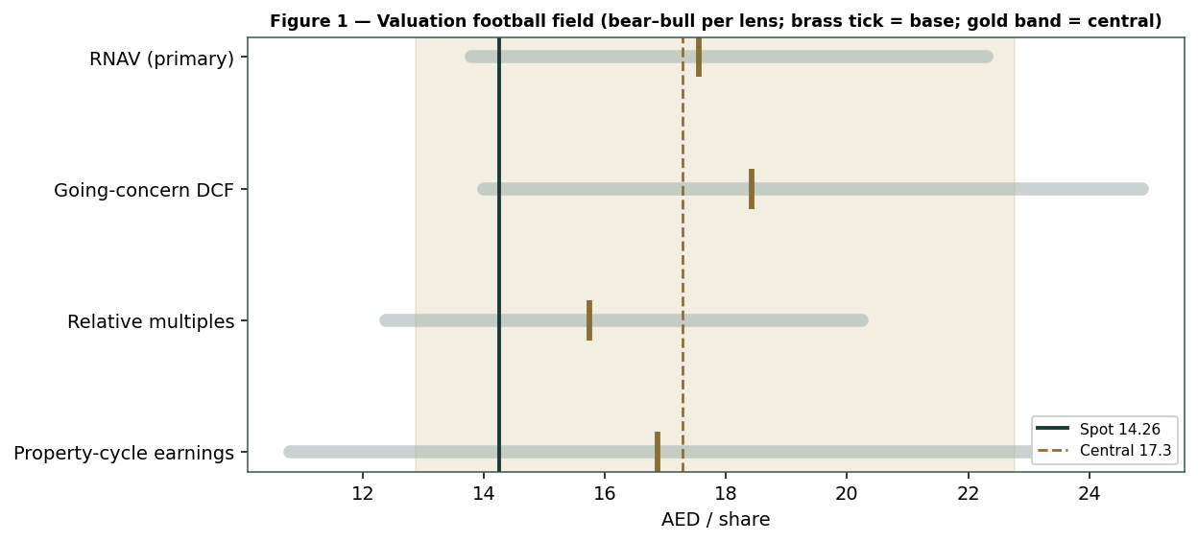
Figure 1 — Valuation football field. Bars span bear-bull per lens; the brass tick is each base case; the gold band is the blended central range; the dark line is spot.
Central fair value ≈ AED 17.29/share, about +21% above spot. The spread of the lenses (AED 15.75 to 18.43 at base) is the message: this is not a deep-distress or a clearly-expensive name, but a cash-rich developer trading below its net-asset value whose re-rating depends on one thing — the Dubai cycle holding.

1.6 The development pipeline — a deeper look
The value engine is the master-planned pipeline funded by customer pre-sales. The established communities (Downtown, Marina, Hills) are the steady cash anchor; the newer launches (The Oasis, Grand Polo, Beachfront) are the margin swing; Emaar South and The Valley are the volume base; and the 305-million-sq-ft land bank is the long-dated option. The scorecard rates each on the axes that matter for a developer.
Cluster | Cyclicality | Margin trend | Capital int. | Swing role
Established (Downtown, Marina, Hills) | Moderate | Steady ~45% | Low | Cash anchor
New master-plans (Oasis, Grand Polo, Beachfront) | High | Peak → normalize | Moderate | Dominant
Emaar South / The Valley (volume) | Moderate | Improving | Moderate | Volume base
Land bank (305m sq ft, incl. new 36m) | High | Optionality | High (land) | Long-dated upside

1.7 The Dubai cycle and the margin — the crux, in real units
Two observable drivers move this valuation more than any assumption about an abstract EBITDA margin. First, the annual sales / absorption pace: FY25 booked AED 71.1 bn; the question is whether 2026-27 holds AED 55-70 bn as new supply competes, or falls toward AED 45 bn. Second, the achieved development margin on those sales, which FY25 ran at a peak ~56% (before tax) and which we normalise toward ~45% gross / ~35% net. Both are quoted quantities in the company's own disclosure, not guesses; the table sensitises the fair value on them (with the net-cash mark as the third real lever), rather than on a hand-set margin percentage.
Real driver | Bear | Base | Bull
Annual sales pace (AED bn) | 45 | 60 | 72
Sustainable net development margin | 30% | 35% | 40%
Net-cash mark (AED bn) | 18 | 20 | 24
→ RNAV fair value (AED) | 13.80 | 17.56 | 22.31
Read it as the bet you are taking: the market price near AED 14 is consistent with a normalized margin around the low-30s and a flat-to-lower sales pace — i.e. a meaningful cycle cool-down already in the price.

1.8 Macro and country — Dubai property, rates, supply and the peg
EMAARDEV is a concentrated bet on one property market. The AED's peg to the US dollar means UAE mortgage rates track the Fed — the 2024-25 easing is mildly supportive of demand, and further cuts would help affordability. Population growth, the golden-visa regime and safe-haven capital inflows have driven the up-cycle; against that, a large 2026-27 completion wave across Dubai is the visible supply risk, and any regional or oil shock would cool sentiment quickly. There is also a governance dimension: with Emaar Properties holding ~85%, minority holders take a ~20% share of some community profits (the non-controlling-interest line) and the free float is thin. These levers sit behind the bear and bull cases in §1.5 and the catalysts in §5.

1.9 RNAV sensitivity — how the swing moves the value
Holding the land bank and overhead at base, the grid re-prices the RNAV across the sustainable development margin and the net-cash mark — the two levers with the most leverage. The value runs from the low-teens to the low-20s.
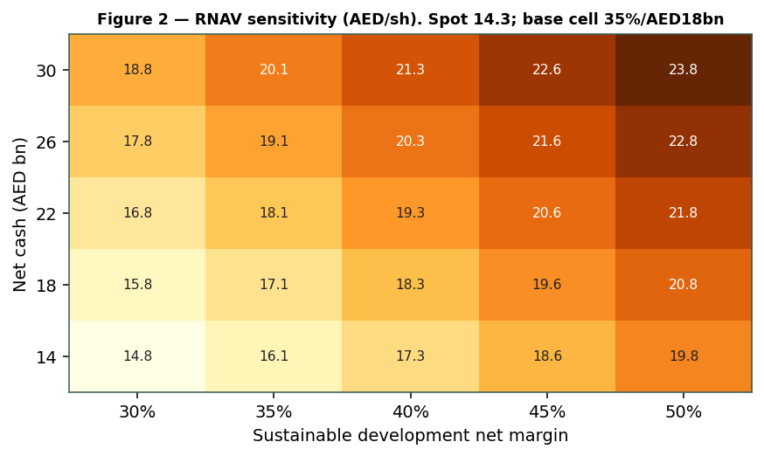
Figure 2 — RNAV sensitivity (AED/share) to the sustainable development margin and the net-cash mark. Base cell 35% / AED 18 bn.

2 Technical and price structure
The tape is corrective and mid-range, not stretched. EMAARDEV has pulled back from a 52-week high near AED 20 to the mid-14s and is consolidating: it trades just around its 20- and 50-day averages but below the 100- and 200-day, the MACD histogram is marginally negative, and RSI sits near 51 — neutral, neither oversold nor overbought. The structure reads as a pause after a sharp de-rating from the highs, with the 52-week low near AED 12.65 as the visible floor.
Indicator | Reading | Signal
Spot | AED 14.26 | —
SMA 20 / 50 | AED 14.19 / 14.37 | Around both — flat short-term
SMA 100 / 200 | AED 15.29 / 15.19 | Below both — trend soft
RSI (14) | 50.6 | Neutral
MACD (12,26,9) | -0.04 line / -0.02 signal / -0.02 hist | Marginally bearish
52-week range | AED 12.65 - 20.00 | Lower third of range
Realized vol (252d) | 37% | Elevated
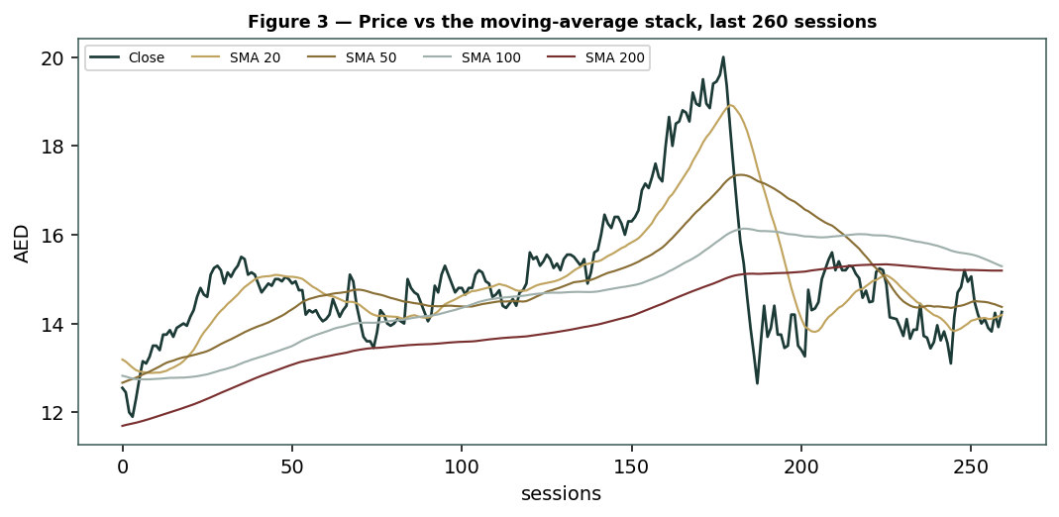
Figure 3 — Price versus the moving-average stack, last 260 sessions.
For the probabilistic work this matters in one way: a stock that has just corrected 30% from its high carries a wide near-term band in both directions. The technical picture is neutral context, not a trigger, and §6 reads the resulting probability zones without forcing a reconciliation with the fundamental undervaluation.

3 Monte Carlo — a probabilistic price map
We open with the probability read — the direction and skew already contained in the 50,000 simulated paths — before the cone itself. It is presentation-only: computed from the same paths after simulation, it never feeds the drift or the width, and leaves the calibration of Appendix B unchanged. For this name the engine is run drift-on (its own history shows a genuine secular uptrend; see Appendix B), so the read tilts modestly upward — honestly, not by construction.
The probability read (T+60, from the same 50,000 paths) | Value
P(price above spot) | 69%
P(+10%) vs P(−10%) · odds | 44% vs 13% · 3.44×
Median level · % move | AED 15.34 · 7.6%
50% band (25th-75th) · as % of spot | AED 13.87 - 16.97 · ±11%
Touch +10% / −10% by T+60 | 64% / 30%
By design the paths diffuse from spot as near-term price and deliberately do not embed the fundamental NAV — the value gap of §1 is kept out of the drift. Diffusion volatility is sized by the YZ-HAR engine (a gap-aware Yang-Zhang variance proxy projected through a pooled log-HAR cascade), here annualising to ≈37%; the shape is unit-variance Student-t(5). The secular drift adds a net 7.4% over the quarter. Sixteen factors — seven continuous, nine discrete — layer on top.
Continuous factor (7) | Dir. | Discrete event (9) | Prob. | Mean impact
Dubai residential demand / absorption | + | Q1 2026 results (early May) | 85% | +0.5%
New-launch sales momentum | + | New master-plan launch / sell-out | 55% | +1.5%
Mortgage-rate path (Fed / peg) | ± | Dubai supply / handover wave signal | 40% | −1.5%
Population & investor inflows | + | Dividend / capital-return surprise | 30% | +1.0%
2026-27 supply competition | − | Land acquisition / pipeline add | 30% | +1.0%
Regional / oil sentiment | − | Rating action (parent BBB+/Baa1) | 20% | +0.5%
Construction-cost / margin drift | − | Regional risk-off / oil shock | 15% | −3.5%
 |  | Index / flow rebalancing | 25% | +1.0%
 |  | Interest-rate surprise (peg) | 25% | −1.0%
Percentile map (AED/share):
Horizon | p5 | p25 | p50 | p75 | p95
T+20 sessions | 12.42 | 13.78 | 14.60 | 15.49 | 17.18
T+60 sessions | 11.59 | 13.87 | 15.34 | 16.97 | 20.33
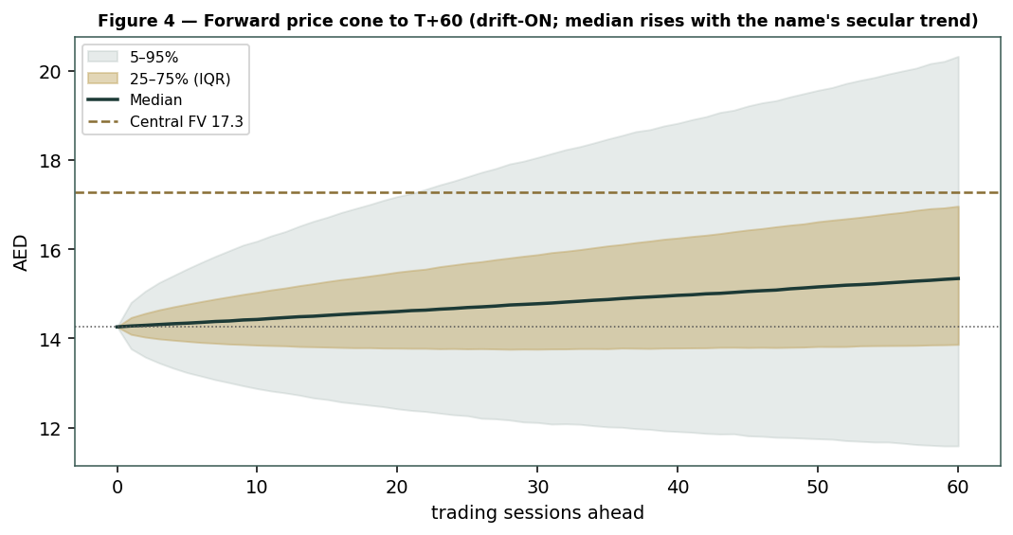
Figure 4 — Forward price cone to T+60. Median rises with the name's secular trend; the brass dashed line marks the AED 17.29 fundamental central value.
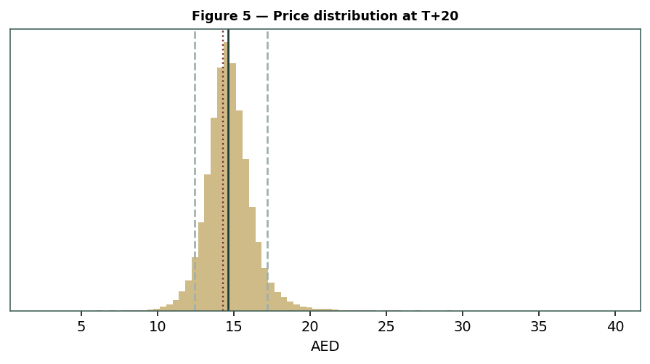
Figure 5 — Price distribution at T+20.
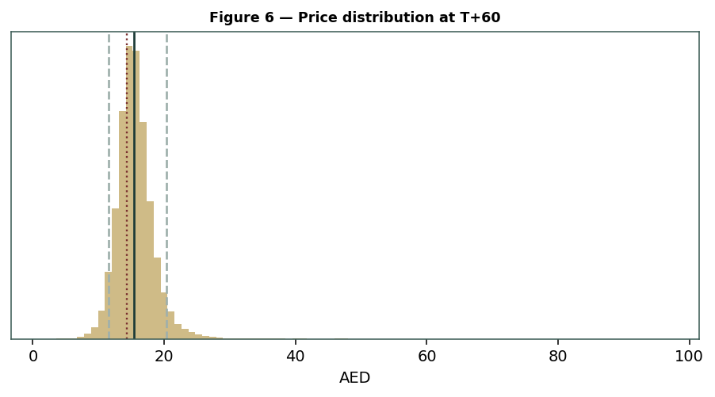
Figure 6 — Price distribution at T+60.
Level-touch ladder — the probability that price touches a level at any point by the horizon (running max for upside, running min for downside):
Level (AED) | T+20 touch | T+60 touch | Note
20.00 | 1% | 9% | Toward 52-wk high zone
18.00 | 4% | 23% | Toward 52-wk high zone
17.00 | 9% | 37% | Near RNAV / DCF
16.00 | 23% | 57% | Near central fair value
15.00 | 57% | 81% | Just above spot
14.00 | 65% | 75% | At spot
13.00 | 19% | 35% | Mid downside
12.00 | 5% | 15% | Toward 52-wk low

4 Comparison of the lenses, and a verdict
Three readings sit side by side. The fundamental lenses cluster at AED 15.75-18.43 with a central AED 17.29 — clearly above spot, contingent on the Dubai cycle. The technical picture is neutral: mid-range, below the longer averages, RSI near 50. The probabilistic map, run drift-on for this name, puts the three-month median above spot at AED 15.34 with a wide ±18%-ish quarter band.
Lens | Reads | Central / implication
Fundamental (4-lens) | Undervalued vs NAV | AED 17.29 (~+21%)
Technical | Neutral / corrective | Floor ~AED 12.65; the 100/200-day (~15.2) is resistance
Monte Carlo (3-month) | Right-skewed, wide | Median 15.34; p5-p95 11.59-20.33
Verdict (a fair-value read, not a recommendation). EMAARDEV looks clearly cheap to its net-asset value, with a single, well-defined swing factor: the Dubai residential cycle and the margin it sustains. The stock is a cash machine at ~5× earnings and ~2.7× EV/EBITDA with net cash and a 7% yield, but that cheapness is the market pricing cyclical, single-market, thin-float risk — not a free lunch. The honest summary is a value clearly above price, a three-month distribution that (drift-on) leans upward but stays wide, and an outcome that hinges on one property cycle. Readers should weigh the lenses themselves; we publish the distribution, not a target. The Monte-Carlo lens is indicative — it ties, not beats, a random walk for this name.

5 Catalysts to watch
Q1 2026 results (early May 2026). First read on whether the sales pace and margin are holding as 2026 supply arrives.
Dubai sales & price data. Monthly DLD transaction volumes and off-plan price trends — the cycle's pulse.
New master-plan launches & sell-out speed. How fast Grand Polo, The Oasis phases and Beachfront release-and-sell.
2026-27 handover / supply wave. City-wide completions that could soften pricing and absorption.
Dividend & capital return. Whether the 100%-of-capital payout is sustained or lifted.
Mortgage-rate path (Fed / peg). Further easing supports affordability; a reversal pressures demand.
Land acquisition. Further land buys extend the pipeline but consume cash.
Parent & governance. Emaar Properties' actions, the NCI share, and any float or related-party events.

6 Reading the probability zones
Translating the three-month distribution into plain zones, anchored on spot AED 14.26 and the fair-value cluster near AED 17.29:
Zone (T+60) | Range (AED) | Approx. probability | What it would mean
Deep downside | < 12.5 | ~14% | Cycle cools sharply / risk-off; tests the 52-wk low
Lower band | 12.5-13.5 | ~17% | Trough pace; relative-multiple lens dominates
Around spot | 13.5-15.0 | ~24% | Status quo; NAV gap unclosed
Upper band | 15.0-17.5 | ~28% | Cycle holds; toward RNAV / central
Strong upside | > 17.5 | ~17% | Sales pace and margin both sustained + re-rating
The distribution leans to the upper bands because the name is drawn drift-on and a few discrete upside events (launch sell-outs, capital return, index flows) thicken the right tail. It is not a forecast; it is the spread of outcomes consistent with the stock's own volatility, its secular trend and the factor stack.

7 Caveats and what would change our mind
The Dubai cycle is the model. The value rests on one property market at a mature-cycle high; a sharper-than-assumed cool-down pulls the central value toward — or below — spot.
The margin is a peak. Normalising FY25's 56% too generously would overstate every lens; a structurally lower development margin is the core downside.
The net-cash mark is judgemental. Much of the cash is customer advances committed to construction; the RNAV uses a conservative ~AED 20 bn, and the true free figure could be lower.
Supply risk is real. A large 2026-27 completion wave could compress pricing and slow absorption in a way the backlog does not protect against.
Governance / float. An ~85% parent, a ~20% NCI share of some profits, and a thin free float mean minority interests are not fully in control of outcomes.
Calibration is indicative. For this name the Monte-Carlo lens ties, and does not beat, a random walk; the cone is honest uncertainty, and the drift-on tilt is a property of the history, not a forecast we stand behind.

Appendix A Financial statements
Selected figures, as reported (FY2025 results, 12 Feb 2026; company disclosure, S&P/Yahoo tie-out) with a five-year forecast driven by the companion model's Assumptions layer. All figures AED million unless stated.

A.1 Income statement (AED mn) — 3 years historical + 5-year forecast
Line | 2023 | 2024 | 2025 | 2026E | 2027E | 2028E | 2029E | 2030E
Revenue | 11,921 | 19,147 | 27,486 | 30,000 | 32,000 | 31,000 | 29,000 | 28,000
Gross profit | 8,408 | 10,657 | 15,537 | 16,950 | 18,080 | 17,515 | 16,385 | 15,820
EBITDA | 8,000 | 9,600 | 14,300 | 15,300 | 15,680 | 14,725 | 13,340 | 12,600
D&A | 775 | 553 | 881 | 900 | 960 | 930 | 870 | 840
EBIT | 7,225 | 9,047 | 13,419 | 14,400 | 14,720 | 13,795 | 12,470 | 11,760
Net finance & other | 564 | 1,175 | 1,300 | 1,300 | 1,300 | 1,300 | 1,300 | 1,300
PBT | 6,980 | 10,190 | 15,537 | 15,700 | 16,020 | 15,095 | 13,770 | 13,060
Tax (UAE CT 9%) | (104) | (990) | (1,400) | (1,413) | (1,442) | (1,359) | (1,239) | (1,175)
NCI | (236) | (1,570) | (2,817) | (2,857) | (2,916) | (2,747) | (2,506) | (2,377)
Net profit (attrib.) | 6,640 | 7,630 | 11,320 | 11,430 | 11,662 | 10,989 | 10,024 | 9,508
EPS (AED) | 1.66 | 1.91 | 2.83 | 2.86 | 2.92 | 2.75 | 2.51 | 2.38
DPS (AED) | 0.52 | 0.68 | 1.00 | 1.00 | 1.00 | 1.00 | 1.00 | 1.00
Note: FY25 net margin (56% before tax) is a cycle peak; the forecast normalises margins gently and holds the dividend at 100% of par. Non-controlling interests reflect Emaar's community joint ventures.

A.2 Balance sheet (AED mn) — selected
Line | 2023 | 2024 | 2025 | 2026E | 2027E
Cash & bank (incl. escrow) | 16,000 | 18,000 | 24,000 | 26,300 | 28,600
Development properties / WIP | 22,000 | 26,000 | 30,000 | 30,600 | 31,210
Receivables & contract assets | 9,000 | 12,000 | 15,000 | 15,300 | 15,610
Total assets | 53,000 | 63,000 | 77,000 | 78,500 | 80,020
Customer advances / deferred rev | 20,000 | 25,000 | 31,000 | 31,620 | 32,250
Debt | 0 | 0 | 0 | 0 | 0
Total liabilities | 30,000 | 37,000 | 45,000 | 45,900 | 46,820
Equity (attrib.) | 20,000 | 22,000 | 27,000 | 30,430 | 34,090
Net cash (cash − debt) | 16,000 | 18,000 | 24,000 | 26,300 | 28,600
Balance-sheet lines are estimates from disclosure and ratios (ROE ~37.5%, D/E ~0); flagged, not an audited tie-out.

A.3 Cash flow & ratio markers
Metric | 2023 | 2024 | 2025
Operating cash flow (AED mn) | 7,000 | 9,500 | 14,500
Land investment (AED mn) | (2,000) | (4,000) | (8,000)
Dividends paid (AED mn) | (2,082) | (2,720) | (4,000)
ROE | 33% | 35% | 37.5%
ROIC | — | — | 21%
Net debt / EBITDA | (2.0)× | (1.9)× | (1.4)×
Backlog / revenue | 4.8× | 4.7× | 4.6×
P/E · Div yield (at spot) | — | — | 5.0× · 7.0%

Appendix B Step 0 — calibration backtest
Before any forecast we test the Monte-Carlo lens on EMAARDEV's own five years of history: at each origin, using only prior data, we generate a three-month-ahead distribution and score the realized close against it, versus a zero-drift random-walk lognormal benchmark. The grade is CRPS skill (must exceed zero), with the PIT histogram and interval coverage as diagnostics only.
Result — an honest tie, badged indicative. This name is unusual: its moves are close-to-close and gap-dominated, so the range-based width collapses onto the benchmark's own volatility, leaving the engine no sharpness edge; and it carries a genuine but choppy secular uptrend. Under the name-specific drift-on setting the PIT is well-calibrated (mean 0.44, roughly uniform), and an overlap-corrected block bootstrap puts the 90% confidence interval on CRPS skill across zero — so EMAARDEV ties the benchmark rather than distinguishably failing it. It is therefore published as INDICATIVE: matches benchmark, no demonstrated edge, distribution well-calibrated — a different category from a broken calibration.
Window scheme | n | 50% band | 80% band | 90% band | PIT mean
Non-overlapping (step 60d, drift-on) | 20 | 55% | 75% | 85% | 0.44
Block-bootstrap CRPS skill 90% CI | ~98 | [−0.15, +0.14] → spans zero (ties)
Target | — | 50% | 80% | 90% | 0.50
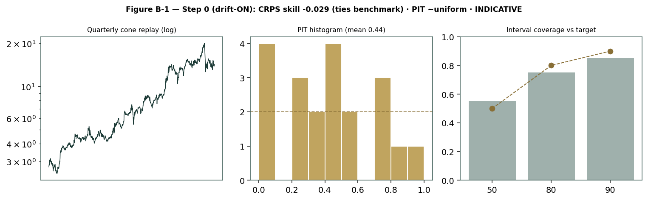
Figure B-1 — Step 0 (drift-on): quarterly cone replay (log), PIT histogram (roughly uniform), and interval coverage versus target. CRPS skill ties the benchmark; badged INDICATIVE.

Appendix C Peer set, sector structure, and risks
EMAARDEV's cleanest comparables are other GCC residential developers, though it is unusually cash-rich and single-market. The peer set anchors the relative lens.
Peer | P/E | EV/EBITDA | Div yield
Emaar Development (EMAARDEV) | 5.0× | 2.7× | 7.0%
Emaar Properties (EMAAR, parent) | ~9× | ~6× | ~5%
Aldar Properties (Abu Dhabi) | ~12× | ~11× | ~3%
DAMAC / Deyaar / Union Properties | 6-10× | 4-8× | 3-6%
Sector structure. Dubai residential is in a mature up-cycle driven by population growth, the golden-visa regime and safe-haven inflows, now facing a 2026-27 supply wave; the AED peg ties affordability to Fed policy. Principal risks: a sharper Dubai cycle downturn; a structurally lower development margin than FY25's peak; a 2026-27 oversupply that compresses pricing; an over-marked net-cash figure (much is committed customer advances); and governance/float risk from an ~85% parent and a ~20% NCI share of some community profits.

Appendix D The expert valuation panel
Every Testahil study closes with a panel of standing expert personas — drawn from the house Expert Persona Library, not invented for the occasion, so that each accumulates a track record and a quarterly update is a re-run, not a re-training. For a residential developer we cast the three whose methods both fit the instrument and genuinely disagree: Expert 1 (net-asset value and the discount to NAV), Expert 2 (demand, absorption and the collection-schedule cash), and Expert 3 (macro-policy — rates, supply and the cycle). Each runs a different method, derives its fair value from shown workings, and states a falsification condition.

D.1 Expert 1 — the accountant: RNAV and the discount to net-asset value
Worldview. A developer is worth its net assets marked to realisable value: net cash, plus the profit still to be booked from secured sales, plus a haircut land bank — each project finite, none earning a perpetuity. He then asks what discount the market puts on that NAV.
When it works / fails. Best where sales are secured and collections are scheduled (as here); it fails if the margin used to convert backlog to profit is a cycle peak, or if the land mark proves illusory.
Expert 1's marks (AED mn) | Value
Net cash | 20,000
PV of backlog net profit (attrib., 35% margin, 4-yr) | 35,225
Land-bank future launches (haircut) | 18,000
Central overhead PV | (3,000)
RNAV / share = AED 17.56 (pre any discount)
Sensitivity (swing = the development margin). At a 30% net margin AED 13.80; at 40%, AED 22.31. Cross-examination. He tells Expert 2 that a demand model without a balance sheet ignores the AED 20 bn of net cash already in hand; he tells Expert 3 that a macro discount should be applied to a real NAV, not used to avoid marking one.
Verdict, falsification, market-implied. Fair AED 17.5 (range 13.8-22.3). Falsified if the sustainable margin proves structurally below ~30% or the land mark cannot be monetised. The market price implies roughly a 20% discount to his NAV — wider than he judges fair for a cash-rich leader.

D.2 Expert 2 — demand and absorption: the sales-pace and collection engine
Worldview. A build-to-sell developer is worth the cash its sales throw off: units sold × price × margin, converted to cash on a handover/collection schedule. He models the absorption pace directly and is sceptical of land that is not yet selling.
When it works / fails. Best in a legible up-cycle with disclosed sales and backlog (as now); it fails at a cycle turn, when yesterday's absorption pace is the wrong guide to tomorrow's.
Expert 2's build | Value
FY25 sales pace (AED bn) | 71.1
Normalized forward sales pace (AED bn) | 55-60
Attributable net margin on sales | ~33%
PV of ~4 years' collected profit + net cash | → AED 16.0/share
Sensitivity (swing = sales pace). At AED 45 bn pace AED ~14; at AED 72 bn, AED ~19. Cross-examination. He tells Expert 1 that a static NAV overstates a land bank that must still be sold into a softening market; he tells Expert 3 that rates matter only through absorption, which he already models.
Verdict, falsification, market-implied. Fair AED 16.0 (range 14-19). Falsified by a sustained drop in monthly Dubai sales volumes or a stall in new-launch sell-through. The market implies a sales pace and margin a notch below his base — it is pricing the cycle cooling.

D.3 Expert 3 — macro-policy: rates, supply and the discount to NAV
Worldview. A single-market developer is a leveraged bet on that market's cycle and policy: mortgage rates (via the dollar peg), the supply pipeline, population flows and sentiment set the discount the shares deserve to their assets.
When it works / fails. Best at cycle turns and policy shifts; it fails in a steady middle, where it can talk itself out of a cheap, well-run balance sheet.
Expert 3's frame | Value
Anchor: RNAV (Expert 1) | AED 17.5
Cycle position | Mature up-cycle; 2026-27 supply wave
Warranted discount to NAV (cycle + float) | ~15%
Fair value | → AED 15.0/share
Sensitivity (swing = the cycle / discount). At a 5% discount AED ~16.6; at 25%, AED ~13.1. Cross-examination. He tells Expert 1 that a NAV without a cycle view is a number without a date; he tells Expert 2 that absorption itself bends to rates and supply, which are his variables.
Verdict, falsification, market-implied. Fair AED 15.0 (range 13.1-16.6) — the most cautious. Falsified by a durable Fed-easing tailwind with contained supply. The market price is close to his number — on a cycle-discounted basis, the price is about right.

D.5 The three in one room
The single thing they most disagree on is how much of FY25's peak sales pace and margin to carry forward through a maturing Dubai cycle.
Expert 1: “Mark the assets. Net cash of AED 20 billion, four years of backlog profit, a haircut land bank — that is AED 17.5 a share before you argue about the cycle. The market discounts a fifth of a real NAV.”
Expert 2: “Assets you must still sell. The value is the cash the sales throw off, and the pace is already easing from AED 71 billion. Normalise it and the collected profit plus cash is nearer AED 16.”
Expert 3: “And both of you are pricing a cycle at its top. A 2026-27 supply wave and a single-market, thin-float bet deserve a discount to that NAV. I take AED 15 — which is roughly where the market already is.”

D.6 Reading the divergence
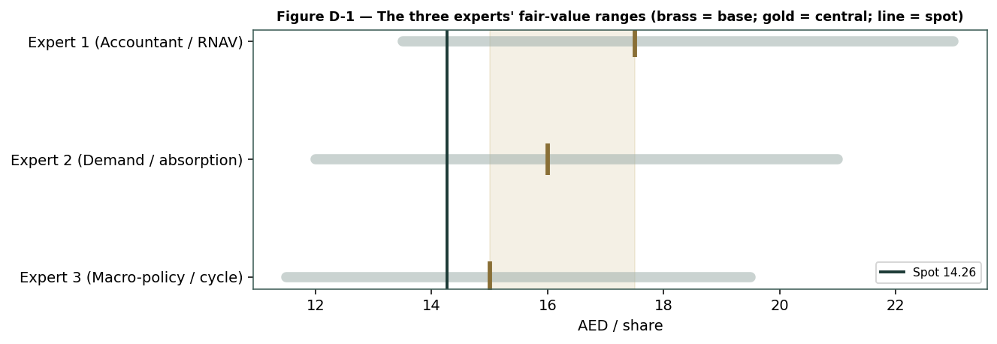
Figure D-1 — The three experts' fair-value ranges. Brass ticks are base cases; the gold band is the central; the dark line is spot. The spread is a Dubai-cycle disagreement.
Expert | Method | Single swing assumption | Base FV
Expert 1 | Accountant / RNAV | Sustainable development margin (35%) | AED 17.5
Expert 2 | Demand / absorption | Forward sales pace (AED 55-60 bn) | AED 16.0
Expert 3 | Macro-policy / cycle | Warranted discount to NAV (15%) | AED 15.0
The spread — AED 15.0 to 17.5 at base — is narrow, and it is almost entirely a cycle disagreement: none of the three contests the net cash, the backlog, or the quality of the franchise. What separates them is how much of FY25's peak to trust. Expert 1 marks the assets and lets the discount argue itself; Expert 2 lets the softening sales pace pull the number down; Expert 3 applies a cycle discount to the NAV. Resolve the Dubai cycle, and the three converge. Each expert's point fair value is logged with the study date (03 Jul 2026) and spot (AED 14.26) as an internal per-expert track record, kept separate from the core Calibration Ledger.

About this series
Testahil publishes independent, educational valuation studies. Each is an attempt to reason transparently about what a security is worth, with every assumption shown and a companion model so readers can disagree productively. The house style is distributions, not tips: we describe ranges and probabilities, not targets, and we do not tell anyone what to do. Studies are framed as educational analysis, the preparer is not licensed by any securities regulator, and holdings are disclosed.

Disclosure & Disclaimer
Not investment advice. This document is educational and informational only. It is not, and must not be relied upon as, investment, financial, legal, accounting or tax advice, nor an offer, solicitation or recommendation to buy, sell or hold any security. It contains no price target and no rating.
No licence; no advisory relationship. The preparer is not registered or licensed with any securities or financial regulator in any jurisdiction, holds no brokerage or investment-advisory authorisation, and is not acting as your adviser or fiduciary. Nothing here is personalised to your circumstances.
Holdings disclosure. The preparer may hold, and may in the future take or dispose of, a position in the security discussed in this report, and may transact at any time without notice. This is a potential conflict of interest you should weigh.
Sources & accuracy. Reported financial and operating figures are drawn from the company's public disclosure and other public sources believed reliable but not independently verified; they may contain errors or be superseded. Forward-looking inputs — the RNAV marks, the net-cash mark, the land-bank value, projections, multiples, the DCF and Monte-Carlo factor probabilities — are the preparer's own judgments and are inherently uncertain.
Forward-looking statements. Any statements about the future are estimates subject to risks and uncertainties; actual results may differ materially. The Monte Carlo models price, not value, and encodes subjective probabilities for events that have not occurred. The calibration is indicative: for this name the lens ties, and does not beat, a zero-drift random-walk benchmark.
No reliance; your responsibility. Do your own research and consult a licensed professional before making any decision. You are solely responsible for your investment decisions and their outcomes. To the maximum extent permitted by law, the preparer accepts no liability for any loss arising from use of this document.
Currency & figures. Figures are in UAE dirhams (AED) unless stated; mn denotes million and bn billion. The AED is pegged to the US dollar. Rounding may cause totals to differ slightly. Spot price and market data are as of 03 July 2026 and change continuously.
TESTAHIL · Independent Valuation Study · Educational Analysis · Emaar Development PJSC (DFM: EMAARDEV) · edition 08-07-2026 · reporting currency AED

