Independent Valuation Study — Educational Analysis
Emaar Misr for Development (EGX: EMFD)
Fundamental analysis · Technical analysis · Monte Carlo simulation — one integrated read
Anchor: EGP 12.44 (17 Jun 2026 close) · 5.447bn shares · mkt cap ~EGP 67.8bn · net cash ~EGP 34.7bn · free float ~11% (Emaar Properties PJSC owns ~88.7%) · prices & probabilities computed 17 Jun 2026 from the attached EMFD price history (19 Jun 2025 – 17 Jun 2026) · independent bottom-up valuation, derived project inputs
READ FIRST — what this document is, and is not. This study is a valuation exercise and an expression of personal analytical opinion, published free of charge for educational purposes: it shows how one analyst applies fundamental, technical and probabilistic methods to a listed company, and invites scrutiny of that methodology. It is NOT investment advice, NOT a recommendation or solicitation to buy, sell or hold any security, and NOT directed at the circumstances of any reader. The preparer is not licensed by the Egyptian Financial Regulatory Authority (FRA) or any other regulator, provides no financial consultancy, manages no money, and accepts no fees, funds or clients. See the Disclosure & Disclaimer at the end. All values are model outputs presented as ranges and distributions because no single number should be relied on. Project-level inputs are DERIVED estimates calibrated to disclosed totals and market comparables — Emaar Misr publishes no project-level economics — and are flagged throughout. Consult a licensed financial advisor before any investment decision.

Headline
The model’s read: the three-month distribution skews constructive, but the stock is extended near its 52-week high after a ~40% run. An independent, clean-sheet bottom-up build — every project valued from units × price/m² and m² × construction-cost/m², the Marassi hotels and the retail/commercial base valued as separate EBITDA-multiple segments, minority treated as negligible (Emaar Misr’s operating subsidiaries are effectively wholly owned; the Marassi Red Sea JV is carried at EMFD’s economic share), and the parent-attributable ~98% of net cash (~EGP 34.7bn) added, with no external price target embedded — puts risk-adjusted fair value at EGP 19.84, ~59% above the EGP 12.44 market; full execution of the modelled pipeline is worth EGP 23.43 (+88%). A consolidated whole-company DCF (EGP 21.98) corroborates the asset-based build, and a four-lens synthesis — SOTP/RNAV, DCF, relative multiples and a discount-to-NAV reading — centres on ~EGP 19.5. The defensible floor — net cash plus contracted backlog plus the two segments, all risk-weighted, with every unlaunched project at zero — is ~EGP 13.71, which sits about 10% ABOVE the current price: on these (derived) inputs the market is paying less than the net cash, backlog and operating segments alone, ascribing nothing to the unsold development pipeline. Technically the picture is the mirror image of a pullback: price closed 12.44 just below the 12.50 period high, riding above a rising stack of moving averages (SMA20 11.44, SMA50 10.62, SMA150 9.82), with RSI(14) elevated at ~64 (Wilder) — a strong, intact uptrend that is stretched but not yet at the classic 70 overbought line. A single 10-factor Monte Carlo (CBE rate, FX, inflation, EGX flows, Brent/Gulf liquidity, geopolitics, Marassi Red Sea / land monetization, launch execution, North-Coast season, credit; 50,000 paths, seed 42) puts the T+20 median at ~12.8 and the T+60 median at ~13.4, with a right tail to ~18.5. Net: the stock trades well below the model’s risk-adjusted value — indeed below its risk-weighted floor on these derived inputs — yet the tape is extended near the highs; the right tail of the distribution belongs to launch execution and the Red Sea / land story, the left tail to FX/geopolitical macro and a momentum reversal from these stretched levels. This study estimates values and probabilities — it does not recommend actions, and the project-level inputs that drive the upside are the author’s estimates, not company disclosure.

1. Fundamental analysis
How a developer is valued — and how this section is built. A property developer is not a single cash stream, and it is not valued like an industrial company. The standard practice among international research houses is to value a developer primarily on a sum-of-the-parts revalued net asset value (RNAV): each project, the landbank and the recurring assets are valued separately and summed to a gross asset value, then net cash is added and debt subtracted to reach net asset value, and a discount-to-NAV is applied to reflect how the market prices the sector. A consolidated discounted cash flow (DCF) and trading multiples serve as cross-checks. The key point — and the reason a developer’s accounts behave the way they do — is that the business is valued on the worth of its assets and the cash they generate, NOT by projecting a decades-long balance sheet: inventory, work-in-progress and customer advances are point-in-time stocks that net to zero as a project completes, not a forecast series to be rolled forward for twenty years. This study follows that practice. It presents four fundamental lenses — (1) SOTP / RNAV, (2) consolidated DCF, (3) relative multiples, and (4) a discount-to-NAV reading — and then synthesises them into a single representative figure and a range. Projected statements are shown only over a near-term five-year horizon, where a balance sheet is informative; the valuation itself rests on project cash flows and asset values.
The building blocks. Emaar Misr is a diversified developer: a development business spanning several large communities, an owned-hotel portfolio at Marassi (Address / Vida flags), and a recurring-income base (Marassi retail and marina, Uptown Cairo commercial). Each development is valued as its own DCF and summed (the SOTP); hotels and recurring income are valued on EBITDA multiples appropriate to those asset types. The contracted backlog and the mature selling phases are the existing business; the newer launches (Belle Vie, Soul) and the Marassi Red Sea JV are pipeline option value — worth a great deal if they execute, little if they don’t — so each is weighted by an execution probability. Minority is negligible (the operating subsidiaries are effectively wholly owned; Emaar Properties’ ~88.7% is the listed parent’s stake, not a subsidiary minority inside EMFD), and the Marassi Red Sea JV is carried at EMFD’s economic share. The parent-attributable ~98% of net cash is added to reach equity value.
Each project is built bottom-up from its unit mix priced per square metre, with construction and land costed per square metre, and only the unsold remainder is valued — already-sold units sit in the contracted backlog, so nothing is double-counted. Each cohort carries an EGP price escalator (~14%/yr) on a 10%-down-plus-instalment collection schedule; a 5% perpetual-growth (Gordon) terminal value captures development beyond the modelled pipeline. No project-level data is disclosed by the company: the unit mixes, sold-percentages, buildable ratios, per-project prices and construction costs, the segment EBITDA and the backlog split are the author’s estimates, calibrated so that the model reproduces Emaar Misr’s disclosed FY2025 totals (revenue EGP 19.8bn, inventory EGP 76.4bn, contract liabilities EGP 60.3bn, net cash EGP 34.7bn). They are flagged as blue inputs in the companion Excel and are illustrative, not authoritative.

1.1 Method 1 — Sum-of-the-parts / revalued net asset value (RNAV)
The primary lens for a developer. Each business is valued by the method that fits it and summed to an operating enterprise value, then net cash is added and minority subtracted. The column shows the risk-adjusted (execution-weighted) per-share contribution; full execution removes the execution haircut and is noted at the foot.
Component (bottom-up build) | Risk-adj EGP/sh | What it is
Contracted backlog | 4.54 | already sold (~EGP 110bn est.); collected over ~6 yrs
Uptown Cairo — Mokattam | 1.54 | 4.9m m² mixed-use; under development
Marassi — North Coast | 1.30 | 6.25m m² coastal flagship; mostly pre-sold, remainder here
Belle Vie — New Zayed | 0.99 | 2.1m m²; recent launch, deliveries from 2025
Mivida — New Cairo | 0.61 | 3.7m m²; largely delivered, remainder here
Cairo Gate + Soul | 0.83 | Sheikh Zayed gateway + Dabaa coastal (risk-weighted)
Marassi Red Sea (JV) + landbank + terminal | 0.86 | Red Sea JV at ~25% economic share + land + 5% g terminal
Development + backlog subtotal | 10.67 | the property engine
Hospitality (Marassi hotels) | 1.81 | Address, Vida, Al Alamein — EBITDA × 6.5×
Recurring income (retail / marina / commercial) | 1.11 | Marassi & Uptown annuity base — EBITDA × 7.5×
Operating EV / share | 13.60 | all three businesses, risk-weighted
Add: net cash (98% parent, ~EGP 34.7bn) | +6.24 | net cash × 98% parent-attributable
Less: minority | 0.00 | negligible — operating subsidiaries wholly owned
Base-case equity value | 19.84 | +59% vs 12.44; full execution EGP 23.43 (+88%)
Figures are rounded to two decimals; per-stream components may not sum exactly to the subtotals shown.
Full-execution variant. The bridge above is risk-adjusted (each line weighted by its execution probability). Setting every probability to 100% — all projects, the backlog, both segments and the terminal value delivering as modelled — lifts operating EV to EGP 17.18/share and equity value to EGP 23.43 (+88% vs 12.44). The distance between the two, EGP 19.84 versus 23.43, is the execution haircut the risk-adjusted case applies.

1.2 Method 2 — Consolidated discounted cash flow (FCFF)
A whole-company cross-check. Rather than summing project DCFs, the consolidated DCF treats Emaar Misr as one unlevered free-cash-flow stream — total collections less construction, land, SG&A, overhead and tax — discounted at the same 18% WACC with a 5% perpetual-growth terminal value, with the hotel and recurring segments and net cash then added. It returns EGP 21.98/share on full execution and EGP 18.77/share when the same blended execution haircut is applied to the development stream. That it lands within ~6% of the SOTP full-execution figure (23.43) is the point: two independent constructions of the same business corroborate each other — the test a single method cannot pass on its own.

1.3 Method 3 — Relative multiples and discount-to-NAV
Where the intrinsic methods ask what the assets are worth, relative multiples ask what the market pays for comparable developers. The EGX real-estate sector trades around 8–9× trailing earnings and ~1.9× sales, and developers characteristically trade at a discount to NAV. Each row pairs Emaar Misr’s current multiple with a fair range drawn from sector and peer levels, and the implied equity value per share.
Lens | EMFD now | Fair range | Implied EGP/sh
Price / book (BVPS EGP 12.17) | 1.02× | 1.0 – 1.4× | 12.2 – 17.0
Price / earnings (normalised EPS ~1.15) | 13.7× ttm | 8 – 11× | 9.2 – 12.6
EV / backlog (EGP 110bn) | 0.30× | 0.40 – 0.50× | 14.4 – 16.5
Discount to RNAV | 37 – 47% | 25 – 35% | 14.9 – 15.2
Relative blended midpoint | — | — | ≈14.0
The relative lenses cluster around EGP 14 — well below the intrinsic NAV/DCF of ≈20–23. That gap IS the structural discount-to-NAV the sector carries: on near-term earnings Emaar Misr is not obviously cheap, even as it looks deeply discounted against its asset base. The two families of method answer different questions and are deliberately not blended into one number without judgement.

1.4 Fundamental valuation — synthesis
Four lenses, one picture. For an asset-rich developer carrying net cash and a large, partly-contracted landbank, the intrinsic methods (SOTP/RNAV and consolidated DCF) carry the most weight; relative multiples enter as a market-reality cross-check. The weighted figure below is the study’s single representative fundamental value — but the range, not the point, is what matters.
Fundamental method | EGP/sh | vs spot | Weight
SOTP / RNAV — risk-adjusted | 19.84 | +59% | 35%
Consolidated DCF (FCFF) — full execution | 21.98 | +77% | 25%
SOTP / RNAV — full execution | 23.43 | +88% | 15%
Relative multiples — blended | 14.01 | +13% | 25%
Weighted central fundamental value | ≈19.5 | +56% | 100%
Figures are rounded; the weighted central value is EGP 19.46. Weights are judgemental, reflecting an asset-rich developer best anchored on intrinsic value.
Reading it. The fundamental range runs from a defensible floor of ~EGP 13.7 — net cash at 98% parent + the contracted backlog + the two segments, all risk-weighted, with every unlaunched project and the terminal value set to zero — to a full-execution ceiling of EGP 23.4, with a central estimate near EGP 19.5. At spot 12.44 the market prices a 37% discount to the risk-adjusted NAV and 47% to the gross NAV — wide even by emerging-market developer standards, which is the same as saying the market ascribes little or nothing to the unlaunched pipeline. Note the unusual ordering: the risk-weighted floor sits ABOVE the market price — a flag to scrutinise the derived backlog, segment and net-cash assumptions before drawing any conclusion.
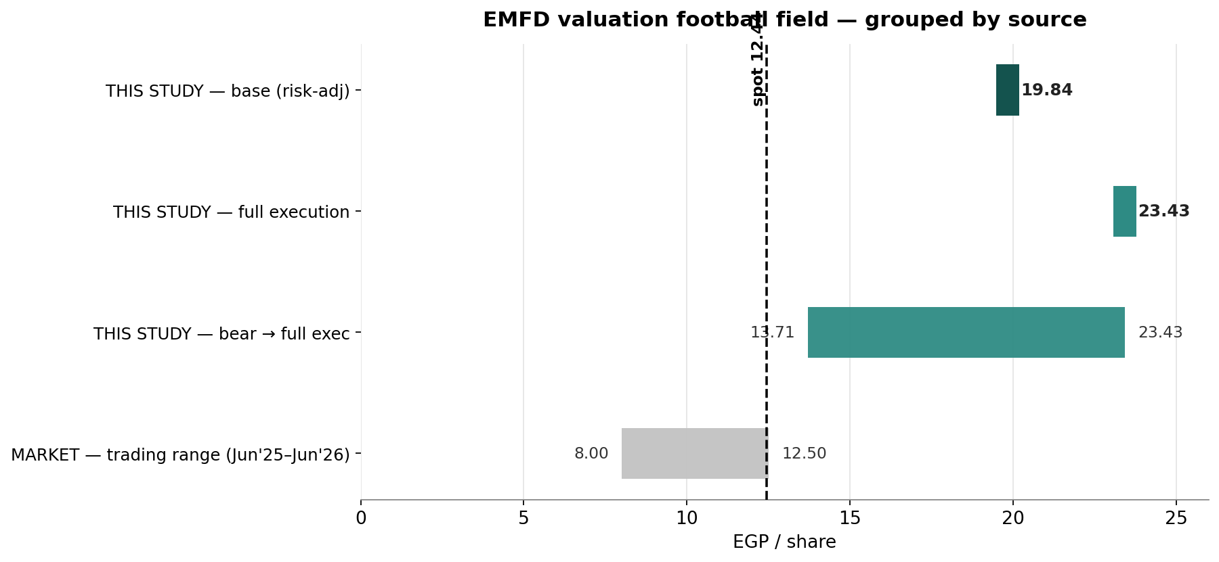
Figure 1. Fundamental range vs the market. THIS STUDY: the risk-adjusted SOTP/RNAV base of EGP 19.84 (dark) — effectively the synthesised central estimate of ~EGP 19.5 — sits inside a bear-to-full-execution range of 13.71–23.43; full execution 23.43; the consolidated DCF (21.98) anchors the same middle. MARKET: the trading range (Jun’25–Jun’26, 8.00–12.50) and spot 12.44 (dashed), from the attached price history. At spot the market pays for roughly the contracted business, segments and net cash, and little or nothing for the unlaunched pipeline.

1.5 The three operating streams — development, hospitality, recurring
The base value is the sum of three businesses valued by the method that fits each: development + backlog by discounted cash flow (10.67/sh risk-adjusted), and two operating segments capitalised on EBITDA multiples. Hospitality and recurring income are distinct — different revenue, different cyclicality, hence different multiples — and the model keeps them apart. The companion Excel carries a dedicated Segments sheet; the table below sets all three streams side by side.
Dimension | Development + backlog (DCF / SOTP) | Hospitality (Marassi hotels) | Recurring income (retail / commercial)
What it is | Egyptian communities sold as units — Marassi, Mivida, Uptown, Cairo Gate, Belle Vie, Soul, the Marassi Red Sea JV — plus the contracted backlog | Owned hotels at Marassi (Address, Address Beach Resort, Vida, Al Alamein) under Emaar Hospitality management | Marassi retail & marina (Mporium) and Uptown Cairo commercial (Emaar Square) inside the communities
Revenue driver | Units × price/m², collected over down-payment + instalments — mostly EGP | Room nights × ADR + F&B + events — partly USD | Rents + footfall + service fees — mostly EGP
Cyclicality | Cyclical — launch timing, mortgage availability, FX on build cost | High — tourism, FX, seasonal (North Coast) | Low — contractual, sticky
Revenue / EBITDA (FY est.) | Valued on project cash flows, not an EBITDA multiple | ~4.2 / 1.9 (≈45% owned-asset margin) | ~2.1 / 0.95 (≈45% blended)
Valuation | Discounted cash flow per project (SOTP), + backlog + terminal value | EBITDA × 6.5× (lower, for cyclicality) | EBITDA × 7.5× (higher — an annuity premium)
Risk-adj EV (EGP bn) | 58.1 | 9.9 | 6.1
Contribution / share | 10.67 | 1.81 | 1.11
Key fundamentals — Q1-2026: net profit EGP 7.77bn, up ~133% YoY, but the swing is dominated by foreign-exchange revaluation on the large USD-linked cash and receivable balances rather than operations — the reported bottom line is FX-distorted in both directions and should be read through. FY-2025: revenue EGP 19.81bn (+4% YoY); consolidated net profit EGP 5.55bn; attributable net profit EGP 4.97bn (EPS ~0.91) — FY2024’s EGP 15.4bn net profit was inflated by a large FX gain and is not a clean comparator. P/E ~13.7× trailing on attributable EPS; EV ~EGP 33bn (market cap less net cash) against an estimated ~EGP 110bn backlog → EV/backlog ~0.30×. The defining feature is the balance sheet: cash and investments ~EGP 42.6bn vs debt ~EGP 7.8bn → net cash ~EGP 34.7bn (≈51% of market cap) — the inverse of the leveraged developer, which removes the rate-shock vulnerability that constrains the sector. Inventory (development properties) is EGP 76.4bn and contract liabilities (customer advances) EGP 60.3bn, both consistent with a large, partly pre-sold pipeline. A structural caveat sits alongside the balance sheet: free float is only ~11% (Emaar Properties PJSC owns ~88.7%), so the shares are thin and the price can move sharply on modest flow. All figures are vendor-sourced (S&P Capital IQ / EGX filings) and should be verified against the audited accounts.

2. Technical analysis
All technical inputs below are computed directly from the attached EMFD daily price history (19 Jun 2025 – 17 Jun 2026, 242 sessions).
Timeframe | Trend | Read
Weekly / long | Strong up | Secular bull; +40% over the sample; price far above a rising SMA150 (9.82, +27%); successive higher highs into the 12.50 period high — trend firmly intact
Daily | Up, extended | Price 12.44 sits above SMA5 (12.10), SMA20 (11.44) and SMA50 (10.62), all rising; RSI(14) ~64 (Wilder) is elevated but below the 70 overbought line; the advance is mature and stretched rather than fresh
Hourly / short | At resistance | 12.44 is within a whisker of the 12.50 period high; a clean break opens blue-sky, while failure here risks a pullback toward the 11.4 (SMA20) / 10.6 (SMA50) supports given the stretched reading
Resistance | Pivot | Support
R3 blue-sky above 12.50 (no prior trades) | spot 12.44 | S1 11.44 (SMA20)
R2 round 13.0 | ATR(14) 0.53 (4.3%) | S2 10.62 (SMA50)
R1 12.50 (period high) | range 8.00–12.50 (Jun’25–Jun’26) | S3 9.82 (SMA150)
Daily ATR(14) is EGP 0.53 (4.3%); realized volatility is ~41% annualized on the trailing 60 sessions (full-sample ~32%), with pronounced positive skew (+1.13) and fat tails (excess kurtosis +4.1) — all measured from the attached history. The moving-average configuration is unambiguously constructive: price sits above a rising 50-day and well above the 150-day, the hallmark of an intact uptrend. The tension is that the same tape is stretched (RSI ~64 on Wilder's method, approaching but not at the 70 overbought line) right at the 12.50 ceiling, on a thin 11% float that amplifies both directions. A daily close that holds above 12.50 confirms continuation into blue-sky; a rejection here, with RSI rolling over, would be the textbook setup for a mean-reversion pullback toward the 11.4–10.6 moving-average supports.

3. Monte Carlo simulation — one model, ten external factors
Method. One simulation, not a model zoo: 50,000 daily paths to T+60 are driven by ten external factors. Five are continuous (compounding daily with drift and volatility): the CBE policy-rate path, the EGP/USD rate, inflation, EGX30/foreign-flow beta, and Brent/Gulf liquidity. Five are discrete events (each occurring with a stated probability on a random session, with a stated impact): a geopolitical/regional-security shock, the Marassi Red Sea / strategic-land monetization story, project-launch execution, the North-Coast coastal-demand season, and mortgage-credit conditions. Idiosyncratic company noise (calibrated to the attached history) tops the paths up to EMFD’s realized volatility. The factors are adapted to Emaar Misr’s nature — its net-cash balance sheet softens the rate channel, its Marassi hotels and North-Coast exposure make the coastal season a material lever, and the Red Sea JV / land bank replaces a cross-border driver. Every drift, probability and impact below is an explicit, editable judgment — the table IS the model.

3.1 The ten external factors — calibration
Factor (10 external drivers) | Type | 3M drift / prob. | 3M vol / impact | Channel
1 CBE policy rate path | continuous | +2.0% | 4% | discounting, softened by interest income on net cash
2 EGP/USD exchange rate | continuous | −1.5% | 6% | FX translation; USD hotel revenue + imported inputs
3 Inflation (CPI) | continuous | +1.5% | 4% | real-asset hedge bid, construction costs
4 EGX30 & foreign flows | continuous | +1.5% | 7% | market beta, liquidity (amplified by thin float)
5 Brent oil / Gulf liquidity | continuous | +0.5% | 5% | GCC buyer purchasing power; North Coast demand
6 Geopolitical / regional security | event | p = 30% | −10% (±5%) | risk-premium shock
7 Marassi Red Sea / land monetization | event | p = 30% | +5% (±4%) | JV progress, strategic land sales & sentiment
8 Project launch & sales execution | event | p = 55% | +7% (±4%) | Marassi / Mivida / Belle Vie — the catalyst
9 North-Coast / coastal-demand season | event | p = 45% | +5% (±5%) | Marassi hotels & resort sales — a material lever
10 Mortgage finance & credit | event | p = 35% | +2% (±5%) | affordability, velocity

3.2 Percentile estimates (anchor 12.44, 50,000 paths)
Horizon — 10-factor model | 5% | 25% | Median | 75% | 95%
T+20 (~1 month) | 10.50 | 11.80 | 12.75 | 13.78 | 15.46
T+60 (~3 months) | 9.64 | 11.71 | 13.39 | 15.29 | 18.47
The five continuous factors compound daily; the five event factors arrive as discrete jumps on a random session within the window. Net expected 3M factor contribution is ~+9% before idiosyncratic noise; annualized path volatility is ~42% (vs ~41% realized over the trailing window — kept deliberately wide given the stretched tape and thin float). The T+60 distribution is right-skewed: median 13.4, with the launch and Red Sea / land events carrying the upside shoulder and the geopolitical jump the left tail. Note these paths diffuse from spot and do not embed the fundamental NAV — they describe near-term price, not value.

3.3 Forward cone — percentile cone to T+60
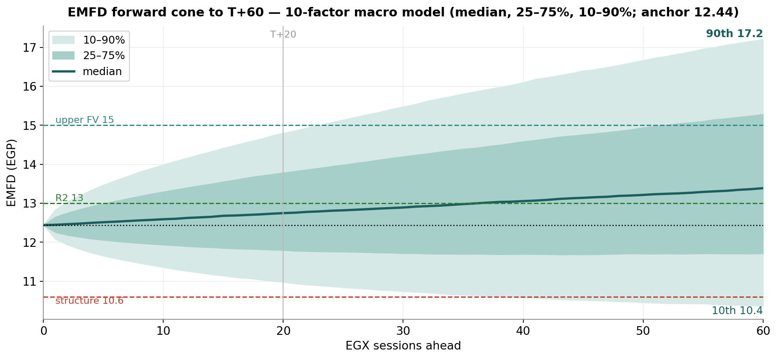
Figure 2. Forward cone (median, 25–75%, 10–90%) from the 10-factor macro model. The median drifts to ~12.8 by T+20 and ~13.4 by T+60; the 10–90% band spans ~10.5–15.5 at one month and ~9.6–18.5 at three. Dashed reference levels: 13.0 (round, green), 15.0 (upper fair-value zone, teal), 10.6 (structure-break / SMA50, red); dotted: spot 12.44; vertical mark at T+20.

3.4 Probability bell curves at T+20 and T+60
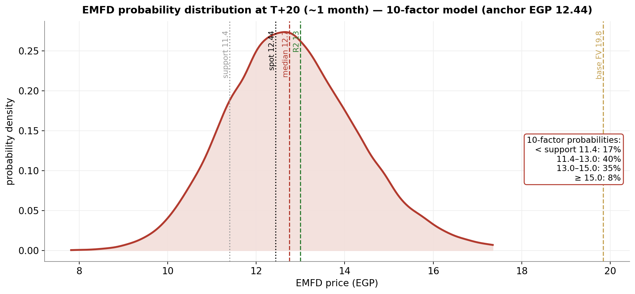
Figure 3. T+20 distribution (10-factor model): ~17% below the 11.4 support, ~40% in 11.4–13.0, ~35% in 13.0–15.0, and ~8% above 15.0. The body sits around spot; the upper-NAV zone is largely out of reach on a one-month horizon.
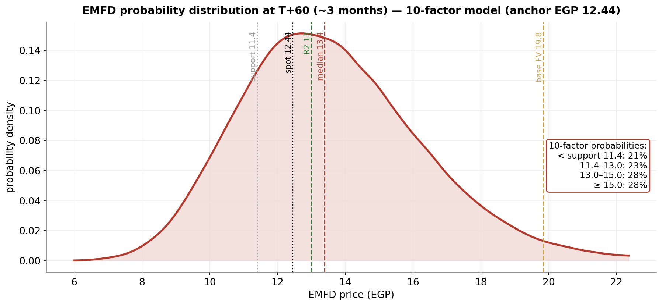
Figure 4. T+60 distribution (10-factor model). The three-month view fans out and skews right — median 13.4, with ~28% of paths above the 15.0 upper-FV level while ~21% still finish below the 11.4 support. This is where the catalyst factors pay; the geopolitical jump keeps the left tail honest. The risk-adjusted NAV (19.84) sits beyond the three-month cone.

3.5 Level-touch probabilities
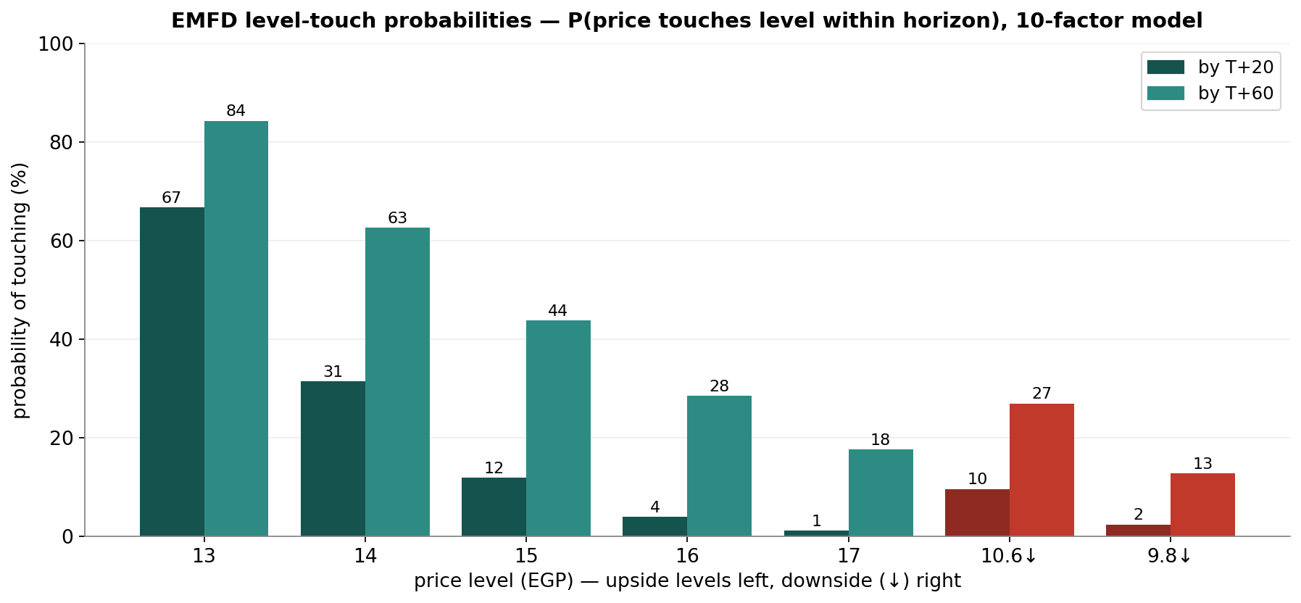
Figure 5. Level-touch probabilities (10-factor model) — probability of the price touching each level within each horizon (T+20 / T+60): upside 13 = 67%/84%, 14 = 31%/63%, 15 = 12%/44%, 16 = 4%/28%, 17 = 1%/18%; downside 10.6 = 10%/27%, 9.8 = 2%/13%. A descriptive output of the simulation: how often paths reach each level, nothing more.

4. Comparison — fundamental vs technical vs Monte Carlo
Lens | Core output | What it says | Analytical implication
Fundamental | Base EGP 19.84 risk-adjusted; 23.43 full execution; ~13.71 bear | Risk-adjusted value ~59% above market; even the risk-weighted floor (~13.71) sits ~10% above price on these derived inputs | Modelled value sits well above price — but the floor-above-market result is a flag to scrutinise the derived backlog, segment and net-cash inputs, not a signal
Technical | Strong uptrend, stretched; price at the 12.50 ceiling above a rising MA stack; RSI ~64 (Wilder) | A mature, intact advance that is stretched right at resistance on a thin float | Momentum favours continuation only on a clean break of 12.50; from these stretched levels, rejection risks a pullback to 11.4–10.6
Monte Carlo (10-factor) | T+20 median 12.75 (~17% finish below 11.4); T+60 median 13.39 (~28% finish ≥ 15.0) | One month is two-sided around spot; three months skew right as the launch and coastal events pay | Time favours the right tail, but the NAV is beyond the three-month cone — the value gap is a multi-quarter story
Verdict: the three lenses tell one story on different clocks — the fundamental value sits ~59% above price (with a risk-weighted floor that, on these derived inputs, is itself above the market), the tape is in a strong but stretched uptrend pinned at the 12.50 ceiling, and the three-month distribution skews right on launch execution and the coastal/Red Sea catalysts while leaving the full NAV beyond the quarter. The standout — and the thing to test first — is that the market appears to price Emaar Misr below its net cash, backlog and operating segments combined; if the derived backlog (~EGP 110bn), segment EBITDA and 98% net-cash attribution are even roughly right, that is a deep discount, but each of those is an estimate, not a disclosure. The fundamental case and the secular uptrend point the same way; the Monte Carlo simply says the next month is two-sided and stretched while the quarter can pay. What, if anything, follows for any individual depends on circumstances this study does not know and does not address.

5. Catalyst calendar
Catalyst | Date | In window | Read
CBE MPC | Jul 2026 | within T+20 | The CBE deposit rate has been held at 19% (lending 20%) since Feb 2026 — 825bps of cuts since Apr 2025, then paused amid regional-conflict inflation risk; further cuts aid sentiment, but net-cash EMFD is far less rate-sensitive than levered peers
North-Coast summer season | Jun–Aug 2026 | in window | Peak Marassi resort sales and hotel occupancy — the pivotal seasonal lever (event p = 45%)
Marassi Red Sea / land progress | 2026–2028 | partly | JV milestones and strategic land monetization; long-dated, heavily risk-weighted (event p = 30%)
Belle Vie / Soul launches & deliveries | 2026 | in window | New-community execution; the largest single upside factor in the simulation (launch p = 55%)
Q2 results (backlog→rev) | ~mid-Aug | T+60 | Revenue-recognition story as backlog converts; watch the FX line, which has whipsawed reported profit

6. Reading the probabilities — significant zones (analysis, not guidance)
This section translates the simulation into the price zones where the three lenses say something analytically distinct. It is a map of the distribution — not a plan, not guidance, and not calibrated to any reader’s circumstances.
- 12.44–12.50 — the ceiling test. Spot sits a whisker below the 12.50 period high; above it is blue-sky with no prior trading. 67% of simulated paths touch 13.0 within one month (84% within three), so the round-number break is well within reach — but the move is occurring from an elevated RSI of ~64 (just below the 70 overbought line).
- 13.0–15.0 — the re-rating zone. The event factors (launch p = 55%, coastal p = 45%) place most of the right tail here; 31%/63% of paths touch 14 and 12%/44% touch 15 (T+20/T+60). This band is where the discount to NAV begins to close if execution lands.
- 15.0–18.5 — the upper-distribution / partial-NAV zone. Only 4%/28% of paths touch 16 and 1%/18% touch 17 within the horizons — effectively the ceiling of the three-month cone. The risk-adjusted NAV (19.84) sits above this band entirely: the cone reaches it only beyond three months and only on strong execution.
- 11.4 / 10.6 / 9.8 — the structural-floor zone. Below the 11.4 support (SMA20) the extended advance is in question (downside touch of 10.6 ≈ 10% by T+20, 27% by T+60); below ~9.8 (SMA150) the secular uptrend itself would be challenged (touch of 9.8 ≈ 2%/13%). These are also the levels at which the market would price the company below even the model’s risk-weighted floor.

7. Caveats
- The project-level inputs are estimates, not disclosure — this is the assumption that moves the number most. Emaar Misr publishes no project-by-project economics. The unit mixes, sold-percentages, buildable ratios, prices and construction costs per m², the segment EBITDA (~EGP 1.9bn hospitality, ~EGP 0.95bn recurring) and the backlog (~EGP 110bn) are all the author’s estimates, calibrated only to reproduce disclosed company-level totals. They are illustrative; audited segment notes or a project disclosure would materially reshape the SOTP, and the floor-above-market result depends directly on them.
- The bear floor sitting above market is a result to interrogate, not to trust. It says net cash + backlog + segments (all risk-weighted) exceed the market cap. If the backlog or segment estimates are too high, or net cash is less parent-attributable than the 98% assumed, the floor falls back below price. Treat it as a prompt to verify the inputs.
- Net cash is credited at 98%, and the FX line distorts reported profit. EMFD carries large USD-linked balances; FX revaluation has swung net profit sharply (FY2024 and Q1-2026 were FX-inflated), so reported earnings are a poor guide to operating performance and the net-cash figure itself moves with the EGP.
- Bottom-up valuation is assumption-driven (WACC 18%, each project’s sold/unsold split, the JV economic share on Marassi Red Sea, ~14% escalation, the normalized terminal FCFF, and the hotel/recurring EBITDA and exit multiples) — calibrated to disclosed totals, not audited project-level data. Illustrative ranges, not precision.
- Thin free float amplifies everything. With ~88.7% held by Emaar Properties PJSC, only ~11% floats; liquidity is limited and the price can move sharply on modest flow, which also inflates realized volatility relative to the underlying business.
- Monte Carlo factors are independent (no cross-correlation matrix or volatility clustering — rate cuts and FX moves are in reality linked); each factor’s drift, probability and impact is judgment, not estimation; event timing within the window is uniform-random. Technical inputs are computed from the attached vendor price history and not reconciled to exchange tick data.
Momentum-reading note (educational). A standard divergence read: price rising while RSI stalls or falls under its moving average is the classic bearish-divergence configuration — momentum fading into strength. Price and RSI rising together marks a healthy trend; an elevated RSI (here ~64 on Wilder's method, below the classic 70 overbought line) in an uptrend is not itself a sell signal but flags a tape vulnerable to mean-reversion if price is rejected at resistance. On the downside, price falling while RSI rises flags seller exhaustion. These are descriptive patterns for reading momentum, not signals to act on.

Appendix — About this series: the standing format
Every instrument (equity or metal) analysed in this educational series follows the same standing format, in order:
- Headline — the analytical read, timeframe and key numbers, one paragraph.
- 1. Fundamental analysis — DCF + multiples + NAV/SOTP (per-project for developers; EBITDA-multiple segments where diversified) → football field → fair-value range.
- 2. Technical analysis — weekly/daily/hourly trend, levels table, ATR/vol, the volume tell.
- 3. Monte Carlo simulation — ONE model: ten external macro factors, 50,000 paths; factor table + percentile table + forward cone + bell curves (T+20/T+60) + level-touch probabilities.
- 4. Comparison — fundamental vs technical vs Monte Carlo — one table reconciling the three lenses + a verdict: where they agree, where they differ, and on what clock.
- 5. Catalyst calendar · 6. Probability map · 7. Caveats + momentum note · closing Disclosure & Disclaimer.

Disclosure & Disclaimer — read in full
Nature of this document. This study is an educational valuation exercise and an expression of the preparer’s personal analytical opinion, based exclusively on publicly available information and on assumptions stated in the text and the accompanying model. It is published free of charge, on a standing periodic schedule, to demonstrate methodology and to invite scrutiny and critique of that methodology. No advice, no recommendation, no solicitation. Nothing in this document constitutes investment advice, financial consultancy, securities analysis services, a research recommendation, a rating, a price target, an offer, or a solicitation or invitation to buy, sell, hold, subscribe for or otherwise deal in any security or financial instrument. No statement herein is directed at, or calibrated to, the investment objectives, financial situation, risk tolerance or particular needs of any person. No licensed activity. The preparer is not licensed or registered with the Egyptian Financial Regulatory Authority (FRA) or any other securities regulator; does not carry on financial consultancy, securities evaluation or analysis services, portfolio management, brokerage, promotion or any other regulated activity; does not manage money; and does not accept clients, fees, subscriptions or funds of any kind. Publication independence. This study was prepared and published independently, on a pre-set schedule, and is not intended to — and must not be used to — influence the market price of any security. Estimates and uncertainty. All valuations, scenarios, probabilities and levels are model outputs resting on explicit, subjective assumptions; they are illustrative, highly uncertain, and likely to prove wrong in material respects. In particular, the project-level inputs underlying the valuation are the preparer’s estimates, not company disclosure. They are deliberately presented as ranges and distributions because no single number should be relied on. Public and vendor-sourced data are believed reliable but are not guaranteed; vendor-derived figures are flagged as such where used. No liability. To the maximum extent permitted by applicable law, the preparer accepts no liability or responsibility whatsoever for any decision made or action taken or not taken, or for any loss or damage of any kind incurred, by any person in reliance on, or in connection with, any part of this document or the accompanying model. Reader’s responsibility. Any person considering an investment decision should conduct their own independent assessment and consult a financial advisor licensed in their jurisdiction. If the publication of material of this kind is restricted where you are reading it, do not rely on it. Holdings disclosure. The preparer may hold, and may in the future take or dispose of, a position in the security discussed in this report.
17 June 2026

