Testahil · Independent Valuation Study — Educational Analysis Not investment advice
_______________________________________________________________________________________________
Independent Valuation Study — Educational Analysis
Emirates NBD Bank PJSC (DFM: EMIRATESNBD)
Fundamental analysis · Technical analysis · Monte Carlo simulation — one integrated read
Anchor: AED 30.64 (3 July 2026 close) · 6.317bn shares · market cap ~AED 194bn (~US$52.7bn) · the UAE's largest bank by assets (>AED 1.2tn) and the second-largest in the GCC, spanning UAE retail & corporate banking, Emirates Islamic, DenizBank (Türkiye), and growing KSA/Egypt/India operations · prices and probabilities computed 3 July 2026 from the attached daily history · primary lens: dividend-discount / residual income on tangible book · the swing factors are sustainable ROTE as global rates fall and the through-cycle cost of risk.
READ FIRST — what this document is, and is not. This study is a valuation exercise and an expression of personal analytical opinion, published free of charge for educational purposes: it shows how one analyst applies fundamental, technical and probabilistic methods to a listed company, and invites scrutiny of that methodology. It is NOT investment advice, NOT a recommendation or solicitation to buy, sell or hold any security, and NOT directed at the circumstances of any reader. The preparer is not licensed by any securities regulator in any jurisdiction, holds no brokerage authorisation, provides no financial consultancy, manages no money, and accepts no fees, funds or clients. See the Disclosure & Disclaimer at the end. All values are model outputs presented as ranges and distributions because no single number should be relied on. Reported financials are the company's own disclosure (FY2025 results, 26 January 2026; Q1-2026 results, 22 April 2026); forward-looking inputs — the sustainable ROTE and cost of equity, the cost-of-risk normalisation, the multiples, the FCFE model and the Monte-Carlo factor probabilities — are the preparer's judgments and are flagged throughout. Consult a licensed financial advisor before any investment decision.

Headline
The model's read: modestly undervalued, with the upside resting on the bank sustaining a high return on tangible equity as global interest rates fall and on the credit cycle staying benign. At AED 30.64 the shares sit about 5% below our weighted central estimate of AED 32.3. The four lenses cluster unusually tightly — a dividend-discount / residual-income anchor (AED 32.9), an FCFE discounted-cash-flow cross-check (AED 31.1), a relative-multiple read (AED 33.4) and a through-cycle normalized-earnings read (AED 31.4) — because a large, liquid, well-capitalised bank leaves less room for the lenses to disagree than a cyclical industrial does. The whole answer turns on two linked judgments: whether Emirates NBD can defend a return on tangible equity near 16–19% as the net interest margin compresses from its rate-cycle peak (3.46% in FY25, down from 4.0% in FY24), and whether the cost of risk — an almost negligible ~0.2% of loans in 2025 — normalises toward a through-cycle 0.5–0.7% as the extraordinary recovery-driven writebacks fade. Technically the tape agrees with the fundamentals for once: the stock trades above all four major moving averages, RSI is a neutral 58, and MACD is mildly positive — a constructive, trending picture. Over three months the Monte Carlo places the 50% interquartile band at roughly AED 28.0–36.1 with a median a touch above spot, the up-drift reflecting the name's own validated secular trend rather than any assumed closing of the value gap.
Valuation summary — every read at a glance
One table for the four reads that follow — what the bank is worth (fundamental), what the tape is doing (technical), where price could travel over three months (Monte Carlo), and how three independent expert methods land. Every row is developed in the sections and appendices below.
Lens / read | What it measures | Output | Takeaway
FUNDAMENTAL — what the bank is worth (the anchor)
Dividend-discount / residual income (primary) | Book + PV of returns above Ke | AED 32.9 | +7% vs spot
FCFE discounted cash flow | 5-yr distributable equity cash flow | AED 31.1 | +2%
Relative multiples | P/TBV and P/E vs Gulf peers | AED 33.4 | +9% · the ceiling
Normalized earnings power | Through-cycle ROTE × book | AED 31.4 | +2% · the floor
Weighted central | Blend 40 / 20 / 20 / 20 | AED 32.3 | +5.4% vs AED 30.64
TECHNICAL — what the tape is doing (timing, not value)
Trend & momentum | Price vs the 20/50/100/200-day averages | Above all four | Constructive, trending
Momentum / range | RSI · MACD · 52-week range | RSI 58 · MACD +0.01 · AED 23–37 | Neutral-to-firm
MONTE CARLO — where price could go in 3 months (paths from spot)
T+20 sessions | 50,000 paths · 16 factors | p25 28.1 · p50 31.0 · p75 34.2 | IQR band leads
T+60 sessions | same engine, longer horizon | p25 28.0 · p50 31.8 · p75 36.1 | Wider, right-skewed
EXPERT PANEL — three independent methods (Appendix D)
Expert 1 — capital & returns (RI/DDM) | Sustainable ROTE vs cost of equity | AED 33.8 | The anchor
Expert 2 — credit-cycle (stressed earnings) | Through-cycle cost of risk | AED 29.5 | Most conservative
Expert 3 — macro-policy (scenario-weighted) | Rate path × FX regime × Dubai cycle | AED 32.5 | Middle
Panel range | Spread = the ROTE-durability question | AED 30–34 | Centres ~AED 32

Bottom line. Every read points the same way on value and disagrees only on magnitude. The fundamental central sits near AED 32.3 — about 5% above the AED 30.64 spot — the three experts span AED 30–34, and each one turns on a single question: whether Emirates NBD's return on tangible equity holds up as the rate cycle turns and the credit cycle normalises. Unlike a deep-cyclical, the technical tape is not the dissenter here — it is constructive and trending — which is why the three-month distribution centres just above spot with a wide right tail rather than well below fair value.
Company overview — Emirates NBD at a glance
Item | Value
Listed entity | Emirates NBD Bank PJSC (DFM: EMIRATESNBD); incorporated UAE, 16 Jul 2007 (Emirates Bank + National Bank of Dubai merger)
What it is | UAE's largest bank by assets; 2nd-largest in the GCC; ~56% owned by the Investment Corporation of Dubai (ICD)
Spot / date | AED 30.64 · 3 July 2026 close
Shares · market cap | 6.317 billion · AED 194bn (~US$52.7bn)
FY25 total assets | >AED 1.0 trillion (>AED 1.2tn by Q1-26); net loans ~AED 640bn; deposits ~AED 790bn (CASA AED 471bn)
FY25 profit | PBT AED 29.8bn (record, +10%); net profit AED 24.0bn (+4%); total income AED 49.3bn (+12%)
FY25 returns / margin | ROTE ~20%; NIM 3.46% (group), 2.93% ex-DenizBank; cost-income 30.5%
Asset quality / capital | NPL ratio 2.4%; CET1 14.4%; total CAR 16.6%; impairment allowance AED 1.5bn
Segments | Retail & Wealth (income AED 19.7bn) · Corporate & Institutional (AED 9.0bn) · Emirates Islamic (PBT AED 3.9bn) · Global Markets & Treasury · International (~35% of income)
52-week range | AED 22.80 – AED 37.00
Dividend | FY25 ordinary DPS AED 1.00 (100 fils); total payout AED 6.32bn; yield ~3.3%
Corporate events | Acquiring 60% of RBL Bank (India) for US$3.0bn, expected close ~Q2-26; Emirates NBD Gold & Silver launched; USD 2.25bn syndicated borrowing (Q1-26)
Chairman · Group CEO | H.H. Sheikh Ahmed Bin Saeed Al Maktoum · Shayne Nelson

Source: Emirates NBD FY2025 results (26 Jan 2026), Q1-2026 results (22 Apr 2026), annual report, DFM disclosures. Values rounded.
1 Fundamental valuation
We value Emirates NBD as what it is — a large, well-capitalised commercial bank — and triangulate four lenses that share almost no machinery. The primary lens is a dividend-discount / residual-income model on tangible book value: a bank is worth its tangible equity plus the present value of the returns it earns above its cost of that equity, so the entire question reduces to a sustainable return on tangible equity (ROTE), a cost of equity (Ke), and a growth rate. An FCFE discounted-cash-flow model — free cash flow to equity, defined as net profit less the capital the bank must retain to fund risk-weighted-asset growth at its CET1 target — is the natural cash cross-check. A relative-multiple read (price-to-tangible-book and price-to-earnings against Gulf peers) and a through-cycle normalized-earnings read complete the set. The weights and the football field are in §1.5; the swing factors — sustainable ROTE and the cost of risk — are dissected in §1.6 and §1.7 and the sensitivity grid in §1.9. Throughout, the cost of equity is published explicitly as a risk-free rate plus a beta-scaled equity-risk premium, never buried inside a black-box discount rate.
1.1 Dividend-discount / residual income — the primary lens
A bank's book value is (unlike an industrial's) close to a marked-to-market number, so the cleanest valuation starts there and adds the present value of economic profit. We take tangible common equity of ~AED 118bn at end-FY25 — AED 18.68 per share — and build residual income as (ROTE − Ke) × opening tangible book, letting book compound at the retained portion of earnings (a ~50% payout). ROTE fades from ~19% in FY26 toward a sustainable ~15.5% as the net interest margin normalises and the balance sheet grows; the cost of equity is 11.5% (see §1.9); terminal growth is 4.5%, roughly UAE nominal GDP plus credit growth.
Year | ROTE | Opening TBV/sh | EPS | Residual income | Disc. factor | PV of RI
FY26E | 18.9% | 18.68 | 3.55 | 1.49 | 0.897 | 1.34
FY27E | 17.5% | 20.42 | 3.57 | 1.23 | 0.804 | 0.99
FY28E | 16.8% | 22.21 | 3.73 | 1.18 | 0.721 | 0.85
FY29E | 16.2% | 24.08 | 3.90 | 1.13 | 0.647 | 0.73
FY30E | 15.8% | 26.03 | 4.11 | 1.12 | 0.580 | 0.65

Summing the five explicit years' present value of residual income (~AED 4.6/share) and a Gordon terminal value of the residual income beyond year five (~AED 9.9/share of present value), and adding it to opening tangible book, gives a DDM fair value ≈ AED 32.9/share, an implied ~1.76× tangible book. That is about 7% above spot. The read is intuitive: a bank earning ~16–19% on equity while its investors demand ~11.5% deserves to trade above book, and the market's ~1.6× multiple prices a slightly faster ROTE fade — or a slightly higher risk premium — than we judge fair.
1.2 FCFE discounted cash flow — the cash-flow cross-check
For a bank the meaningful free cash flow is to equity, not to the firm: interest is the raw material of the business, not a financing side-effect, so an enterprise FCFF/WACC frame does not apply. We define free cash flow to equity as net profit less the increase in required equity — the CET1 target (~14.5%) applied to the growth in risk-weighted assets — because a growing bank must retain capital it cannot distribute. Net profit grows from ~AED 24.8bn (FY26E) to ~AED 29.5bn (FY30E); RWAs grow ~8–12% a year; the residual is discounted at the 11.5% cost of equity.
FCFE (AED bn) | FY26E | FY27E | FY28E | FY29E | FY30E
Net profit | 24.8 | 25.4 | 26.6 | 28.0 | 29.5
− Required equity build (CET1 × ΔRWA) | (12.8) | (13.1) | (13.2) | (13.1) | (12.6)
Free cash flow to equity | 12.0 | 12.3 | 13.4 | 14.9 | 16.9
Discount factor @ Ke 11.5% | 0.897 | 0.804 | 0.721 | 0.647 | 0.580
PV of FCFE | 10.8 | 9.9 | 9.7 | 9.6 | 9.8

The sum of the five present values (~AED 50bn) plus a Gordon terminal value (present value ~AED 146bn, or 74.6% of the equity value — a dependency we disclose and sensitise rather than bury, per the terminal-value discipline) gives an equity value of ~AED 196bn, or AED 31.1/share. That it lands within a dirham of the residual-income anchor is reassuring, since the two share only the cost of equity: one works off book and returns, the other off distributable cash. A bank DCF is terminal-heavy by nature (the franchise is perpetual), which is exactly why we show the terminal share and grid it on Ke and g in §1.9.
1.3 Relative multiples
Emirates NBD screens cheap against its own returns and mid-pack against its peers. On FY25 numbers it trades at ~1.64× tangible book and ~8.3× earnings, while generating a ROTE near 20% — among the highest in the Gulf. Its peers split into two camps: the UAE conventional banks (FAB ~1.4× book / ~9.7× earnings; ADCB ~1.3× / ~9×) and the Islamic-premium names that trade far richer on strong retail demand (Al Rajhi ~3.0× / ~18×; Abu Dhabi Islamic ~3.5×). We mark the relative lens on a justified ~1.75× tangible book and ~9× earnings — a modest premium to the UAE conventional peers to reflect the higher ROTE, well short of the Islamic premium.
Relative basis | Bear | Base | Bull
Price / tangible book | 1.40× | 1.75× | 2.30×
Price / earnings | 7.5× | 9.0× | 11.0×
Fair value (AED/share) | 27 | 33 | 42

Relative base ≈ AED 33.4 — here the ceiling of the central cluster, because a re-rating toward the Gulf's higher-quality multiples is the most direct path to upside. It is also the lens a sceptic can most easily dispute: multiples are set by sentiment and flows as much as by fundamentals, and UAE banks have de-rated before on modest dividends despite strong earnings.
1.4 Normalized earnings power
Because Emirates NBD is closer to a rate-cycle peak than a trough, normalizing earnings works in the opposite direction to a deep-cyclical: we normalise down, not up. FY25's ~20% ROTE benefited from a 3.46% margin (itself down from a 4.0% peak) and an almost negligible ~0.2% cost of risk flattered by recovery writebacks. A through-cycle ROTE of ~16% on tangible book — a lower margin as the Fed and CBUAE ease, a normalised 0.5–0.7% cost of risk — implies normalized earnings modestly below the current run-rate. Applying a justified through-cycle ~10.5× to that normalized earnings power gives the floor of the central case.
Normalized-earnings basis | Bear | Base | Bull
Through-cycle ROTE | 13.5% | 16.0% | 18.0%
Normalized EPS (AED) | 2.52 | 2.99 | 3.36
Justified P/E | 9.5× | 10.5× | 11.8×
Fair value (AED/share) | 24 | 31 | 40

Normalized-earnings base ≈ AED 31.4 — the most conservative lens, and in effect the bet that today's returns are a cycle peak rather than a new normal. It is the mirror image of the recovery bet a cyclical carries: here the risk is that mid-cycle economics are lower than the tape currently enjoys, not higher.
1.5 Synthesis — four lenses
We weight the residual-income model most heavily because it respects what a bank actually is; the FCFE DCF carries the distributable-cash view; the relative and normalized lenses bracket the re-rating and the cycle. Note how narrow the spread is — AED 31.1 to AED 33.4 at base — which is itself the message: this is a fairly-to-modestly-cheap, high-quality compounder, not a deep-value or a clearly-expensive name.
Lens | Weight | Bear | Base | Bull
Dividend-discount / residual income | 40% | 25 | 32.9 | 44
FCFE discounted cash flow | 20% | 24 | 31.1 | 46
Relative multiples | 20% | 27 | 33.4 | 42
Normalized earnings | 20% | 24 | 31.4 | 40
Weighted central |  | 25.0 | 32.3 | 43.2

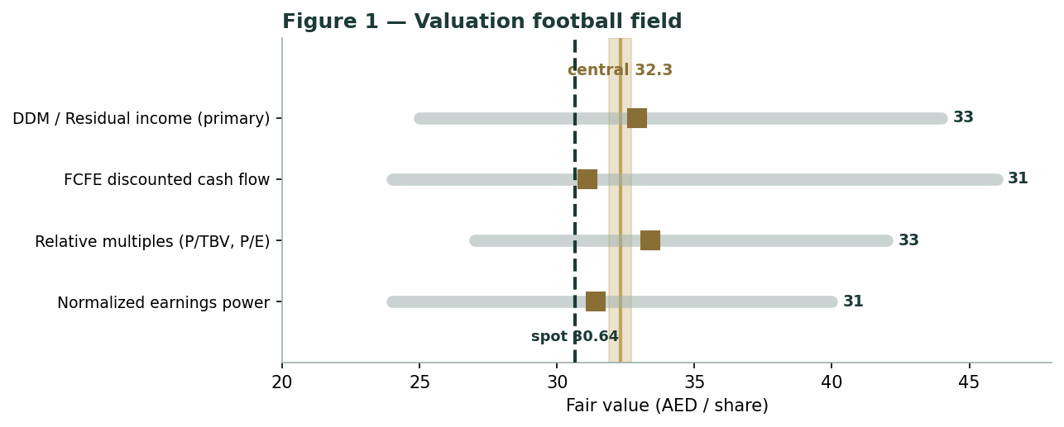
Figure 1 — Valuation football field. Bars span bear–bull per lens; the brass tick is each base case; the gold band is the blended central range; the dark dashed line is spot.
Central fair value ≈ AED 32.3/share, about 5% above spot. The tightness of the lenses (AED 31.1 to AED 33.4 at base) reflects the fact that a bank's four independent methods have less room to diverge than a conglomerate's — and that the whole valuation rides on two operating variables (the margin and the cost of risk) rather than a dozen.
1.6 The bank's engine — margin, returns and capital
Three linked drivers set the value, and each is reconstructable from disclosed data — the discipline here is to build the bridge from sourced figures, not to manufacture a loan-by-loan model the bank does not disclose. First, the net interest margin. Emirates NBD's group NIM was 3.46% in FY25 (2.93% excluding DenizBank), down from a 4.0% rate-cycle peak in FY24, and it faces further compression as the Fed and — via the dirham's peg — the CBUAE cut rates. The offset is the deposit franchise: AED 471bn of low-cost current and savings balances (CASA) that reprice slowly and cushion the asset-yield decline. We fade group NIM to ~3.05–3.10% by FY30.
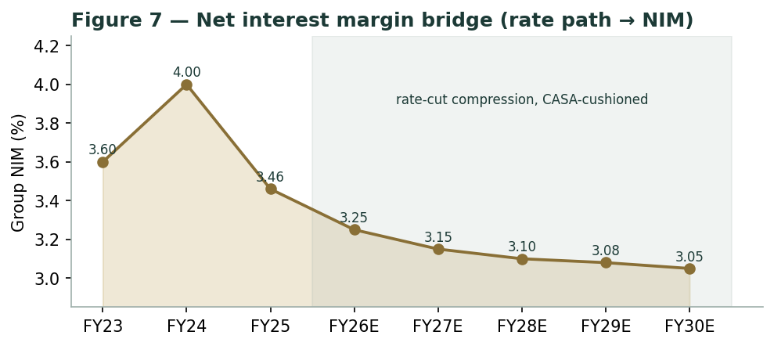
Figure 7 — Net interest margin bridge: the rate-cut path compresses asset yields, cushioned by the low-cost CASA franchise.
Second, the return on tangible equity, decomposed the DuPont way: net interest income and fee income per unit of assets, less operating costs (a sector-leading ~30.5% cost-income ratio), less provisions, less tax (the UAE's 9% corporate tax, now a full-year drag since 2024). The product is a return on average assets that leverages up into a ~16–20% ROTE. As the margin fades and provisions normalise, the DuPont walk shows ROTE settling in the mid-teens — still comfortably above the ~11.5% cost of equity, which is why the residual income stays positive.
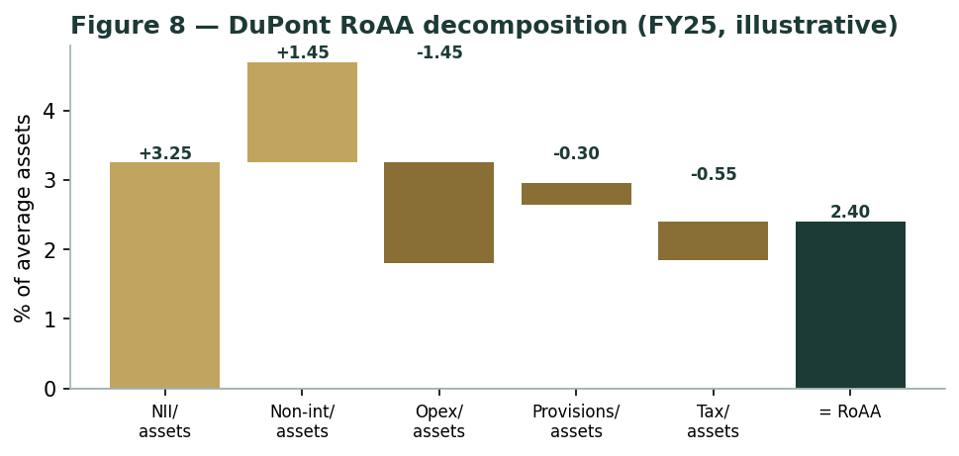
Figure 8 — DuPont RoAA decomposition (FY25, illustrative from disclosed income and asset figures).
Third, capital. Emirates NBD ended FY25 with a CET1 ratio of 14.4% and total capital adequacy of 16.6%, both comfortably above regulatory minimums and management floors (~11% CET1). The forward schedule is the crux of the dividend story: retained earnings must fund risk-weighted-asset growth of ~8–12% a year while the bank also digests the RBL Bank acquisition, yet the capital ratios hold near 14.5% throughout — leaving room for a rising ordinary dividend without a capital raise.
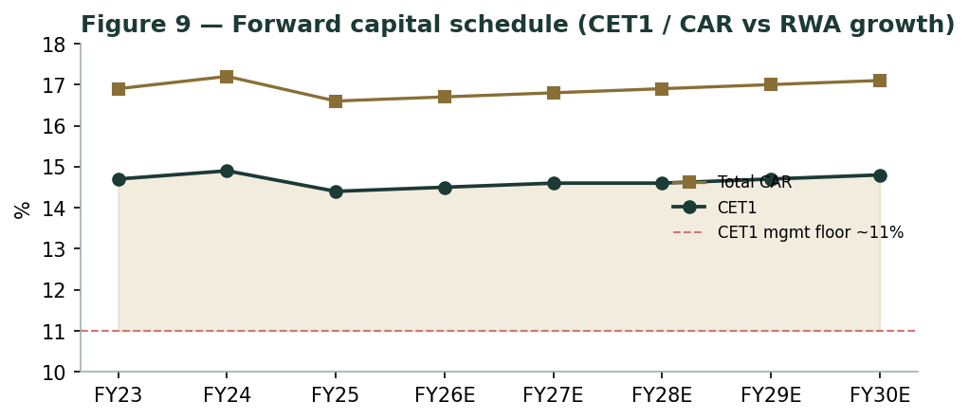
Figure 9 — Forward capital schedule: CET1 and total CAR against RWA growth, versus the ~11% CET1 management floor.
Driver | Cyclicality | Trend | Path | Swing role
Net interest margin | High | Compressing from peak | 3.46% → ~3.05% | Dominant on revenue
Cost of risk | Moderate | Normalising up | ~0.2% → 0.5–0.7% | Dominant on the downside
Cost-income | Low | Stable, sector-leading | ~30.5% | Efficiency anchor
Capital (CET1) | Low | Held ~14.5% | vs ~11% floor | Enables the dividend

1.7 The crux — sustainable ROTE and the cost of risk
Two judgments drive the valuation more than any other, and both are sensitised below in their own observable units rather than as an abstract margin percentage. First, where the through-cycle return on tangible equity settles. Every point of sustainable ROTE is worth roughly AED 2/share at the group level (see §1.9). The bull case is a bank that holds ~18% by defending the margin with CASA and fee growth and by compounding into KSA and India; the bear is a fade to ~14% as rate cuts bite and competition compresses spreads. Second, the cost of risk. FY25's ~0.2% of loans is not a through-cycle number — it was flattered by recovery writebacks in a buoyant economy. Normalising it toward 0.5–0.7% (a swing of ~30–50 basis points on a ~AED 640bn loan book, i.e. ~AED 2–3bn of additional annual impairment) is the single largest downside lever, and it is the heart of the credit-cycle expert's caution in Appendix D. We sensitise the crux on these two native units — basis points of margin and basis points of cost of risk — because they are the levers a reader can actually track quarter to quarter, not a modelled EBITDA line.
1.8 Macro and country — the UAE, the dirham peg, Türkiye and India
Emirates NBD is a leveraged play on the UAE's non-oil boom with three external swing variables. The dirham's peg to the US dollar ties funding costs and the margin mechanically to the Fed's path: rate cuts compress the asset yield but also lower deposit costs, so a strong CASA base blunts the hit. Dubai's economy — the D33 agenda, record population growth, an all-time high in residential property transactions (up >20% in 2025) — drives loan demand and asset quality, but also concentrates the bank in a single real-estate-heavy market whose price growth is now moderating. DenizBank (Türkiye) adds a hyperinflation and lira-translation drag (a higher hyperinflation charge hit Q1-26), offset by recovering local margins. And the RBL Bank acquisition — a 60% stake for US$3.0bn, expected to close around Q2-26 — is a multi-year growth option on India that also consumes capital and adds integration risk. These levers sit behind the bear and bull cases in §1.5 and the catalysts in §5.
1.9 DDM sensitivity — ROTE and the cost of equity
Holding growth at 4.5%, the table re-prices the dividend-discount value across the two variables that matter most: the sustainable ROTE and the cost of equity. The cells near spot (AED 30.64) mark the market's implied combination — roughly a ~15–16% sustainable ROTE at an ~11.5–12.5% cost of equity, i.e. a partial ROTE fade already in the price.
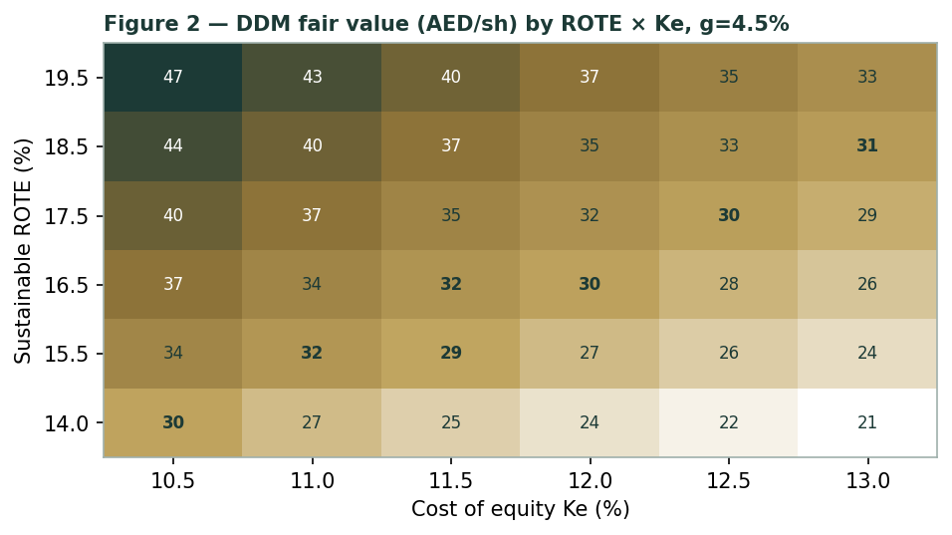
Figure 2 — DDM fair value (AED/share) by sustainable ROTE × cost of equity, terminal g = 4.5%. Cells near spot are the market-implied combination.
Read it as the bet you are taking: pay AED 30.64 and you are implicitly assuming Emirates NBD cannot hold much more than a ~15–16% return on equity through the cycle, or that its equity deserves a ~12%+ discount rate for the DenizBank, Dubai-concentration and India-integration risks. If the bank defends a high-teens ROTE and those risks prove contained, the residual-income value sits comfortably in the mid-to-high AED 30s.
Cost of equity, shown explicitly. Ke = risk-free rate 4.3% (the US 10-year, to which the pegged dirham is anchored) + beta 1.10 × equity-risk premium 6.0% = 10.9%; we round the base to 11.5% to carry a small additional premium for the DenizBank and India-integration exposure, and grid the fair value on Ke × terminal-g in the model. The per-name beta sits inside the house 0.8–1.3 band; the ~0.35 statistical beta screened on the illiquid DFM line is treated as a measurement artefact, not a fundamental input.
2 Technical and price structure
The tape is constructive — a rare alignment with the fundamentals. Emirates NBD trades above all four major moving averages, the MACD histogram is mildly positive, and RSI sits at a neutral 58 — neither overbought nor oversold. The structure is a healthy uptrend that carried price off the AED 22.80 52-week low toward the AED 37.00 high before a modest consolidation, with the rising 200-day average (AED 28.72) as the visible trend floor.
Indicator | Reading | Signal
Spot | AED 30.64 | —
SMA 20 / 50 | AED 29.52 / AED 28.96 | Above both — short-term up
SMA 100 / 200 | AED 30.10 / AED 28.72 | Above both — trend up
RSI (14) | 58.3 | Neutral, room either way
MACD (12,26,9) | +0.55 line / +0.53 signal / +0.01 hist | Mildly positive
52-week range | AED 22.80 – AED 37.00 | Upper-middle of range
Realized vol (252d) | 38.1% | Elevated (H1-26 turbulence)

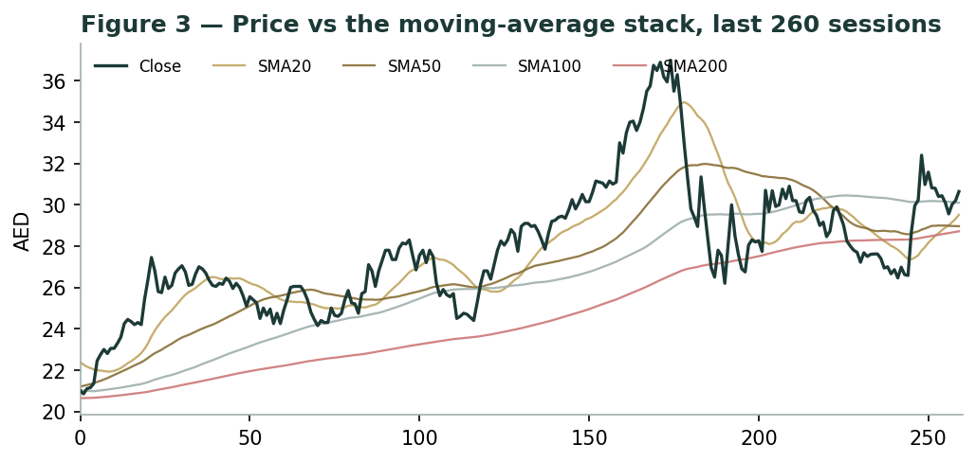
Figure 3 — Price versus the moving-average stack, last 260 sessions.
For the probabilistic work this matters in one way: an above-trend, positively-sloped tape supports the engine's secular up-drift (§3) rather than fighting it. The technical and fundamental pictures agree here — both constructive — so §6 reads the probability zones without having to reconcile a conflict, unlike a name whose chart and valuation point in opposite directions. The one caution the tape flags is the elevated realized volatility of the first half of 2026 (a genuine ~10% single-session move in April), which the regime-conditional engine picks up as a wider near-term cone.
3 Monte Carlo — a probabilistic price map
We simulate 50,000 three-month price paths (seed 42) with the YZ-HAR engine: width is set by a gap-aware Yang-Zhang variance proxy fed through a pooled log-HAR cascade (variance lags 1/5/22), so the cone is regime-conditional — tight in calm tape, wide in storm; shape is a unit-variance Student-t(5) built as a per-path chi-square mixture, for honest tails; and drift is asset-class-conditional. For this Gulf-bank class the calibration in Appendix B shows a genuine, persistent secular uptrend, so the secular drift is ON — the paths carry the name's own historical trend; the §1 fundamental value gap is deliberately kept out of the drift (lens independence — §3 maps where price could go from today, not where value sits). A sixteen-factor stack layers on top: seven continuous macro/operating drivers contributing a small incremental forward tilt around the secular trend, and nine discrete events that each fire with a probability and an impact. The current regime is elevated (the engine's annualised horizon volatility is ~45%, above the trailing-year ~38%), so the near-term cone is wide by design, not padding.
Continuous factor (7) | Discrete event (9) | Prob. | Mean impact
Fed / CBUAE policy-rate path (AED pegged to USD) (-) | Q2-2026 results (late Jul) | 85% | +0.6%
UAE non-oil GDP & private-credit growth (D33) (+) | RBL Bank 60% acquisition close (~end-Q2) | 55% | +0.5%
DFM / MSCI-EM flows & index beta (+) | Further Fed/CBUAE rate cut | 55% | -1.0%
Dubai real-estate & mortgage cycle (±) | Dubai RE / regional geopolitical shock | 20% | -7.0%
Oil / regional liquidity (Brent, gov spend) (+) | DenizBank / Türkiye macro swing (lira, CPI) | 35% | -3.0%
Turkish lira / DenizBank hyperinflation drag (-) | Dividend / capital-return surprise | 25% | +2.0%
USD wholesale funding cost / global rates (±) | Cost-of-risk normalization (provision uptick) | 35% | -2.0%
 | MSCI / index-rebalancing foreign-flow surge | 30% | +2.5%
 | Sovereign / rating action (UAE AA-) | 25% | +0.8%

Percentile map (AED/share):
Horizon | p5 | p25 | p50 | p75 | p95
T+20 sessions | 23.7 | 28.1 | 31.0 | 34.2 | 40.6
T+60 sessions | 22.3 | 28.0 | 31.8 | 36.1 | 45.2

Leading with the honest measure of quarter-ahead uncertainty — the 50% interquartile band — three months out the middle half of outcomes sits at roughly AED 28.0–36.1, with a median of AED 31.8, a touch above spot from the secular drift. The wider 5th–95th span (AED 22.3–45.2) is right-skewed, reflecting the up-drift, the fat-tailed shape and the asymmetric event set.
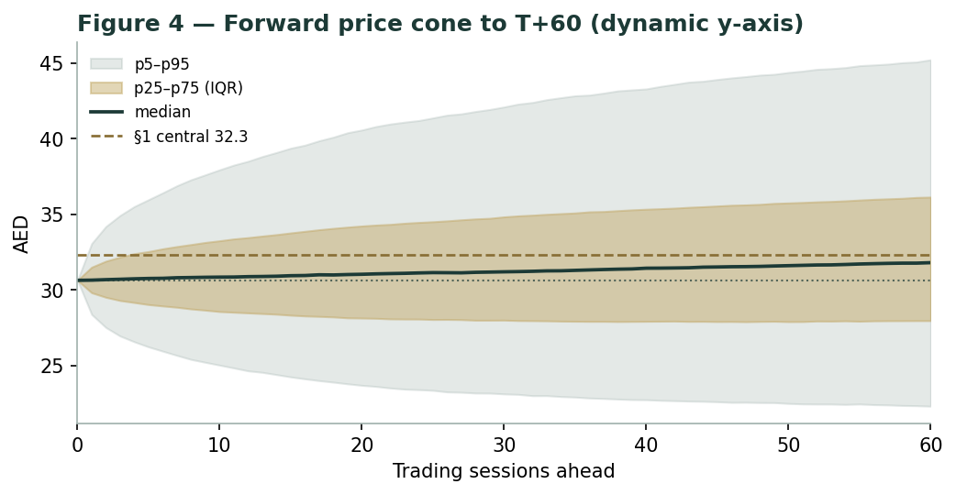
Figure 4 — Forward price cone to T+60 (dynamic y-axis). Median drifts modestly above spot; the brass dashed line marks the AED 32.3 fundamental central value.
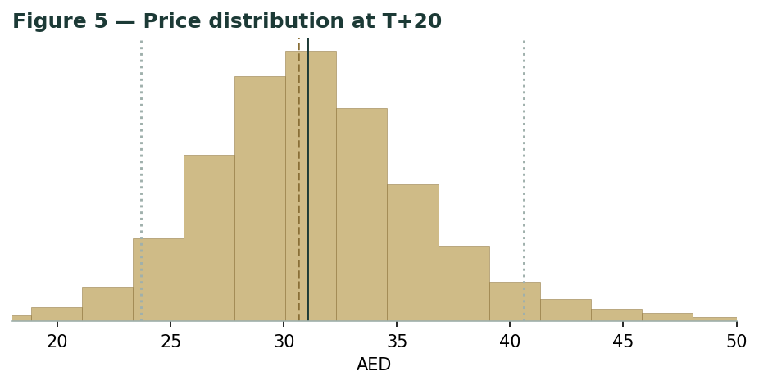
Figure 5 — Price distribution at T+20.
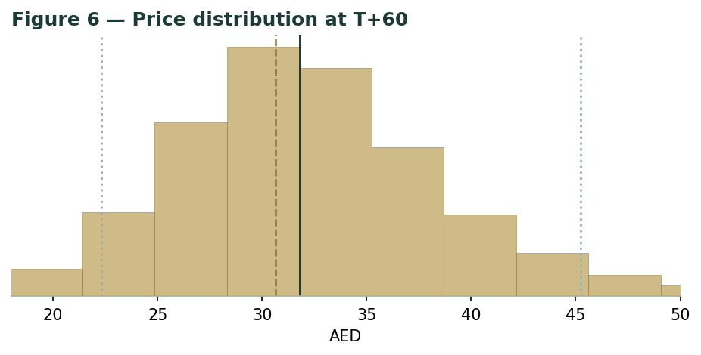
Figure 6 — Price distribution at T+60.
Level-touch ladder — the probability that price touches a level at any point by the horizon (running max for upside, running min for downside):
Level | T+20 touch | T+60 touch | Note
AED 37 | 20% | 35% | 52-week high zone
AED 35 | 33% | 49% | prior resistance
AED 34 | 43% | 58% | upper band
AED 33 | 55% | 68% | near central fair value
AED 32 | 68% | 78% | just above spot
AED 31 | 82% | 88% | just above spot
AED 30 | 74% | 79% | just below spot
AED 29 | 58% | 66% | lower band
AED 28 | 43% | 53% | mid downside

4 Comparison of the lenses, and a verdict
Three readings sit side by side, and for once they broadly agree. The fundamental lenses cluster at AED 31.1–33.4 with a central AED 32.3 — modestly above spot, contingent on the return on equity holding up. The technical picture is constructive: above all moving averages, neutral RSI, positive MACD, with the rising 200-day as support. And the probabilistic map says that over three months price drifts modestly higher with a wide, right-skewed band — the median is a touch above spot, not at fair value, because the simulation does not assume the value gap closes inside the quarter.
Lens | Reads | Central / implication
Fundamental (4-lens) | Modestly cheap | AED 32.3 (~5%)
Technical | Constructive / trending | Support at AED 28.7 (200-day); resistance AED 35–37
Monte Carlo (3-month) | Up-drift, wide, right-skewed | Median AED 31.8; IQR 28.0–36.1

Verdict (a fair-value read, not a recommendation). Emirates NBD looks modestly cheap on fundamentals, with an unusually clean, twin swing factor: the durability of a high return on tangible equity as rates fall, and the normalisation of an abnormally-low cost of risk. The constructive tape and the up-drifting three-month distribution argue that the market is already leaning the same way — this is not a contrarian call against the chart. The honest summary is a value modestly above price, a near-term distribution that drifts gently higher, and an outcome that hinges on two operating variables rather than a dozen — which is why the bear–bull span (AED 25–43) is narrower than a cyclical's. Readers should weigh the lenses themselves; we publish the distribution, not a target.
5 Catalysts to watch
- Q2-2026 results (late July 2026). The next read on margin resilience, non-funded income momentum and the cost of risk as recovery writebacks fade.
- RBL Bank completion (~Q2-2026). Closing the 60% India acquisition (US$3.0bn) converts an option into an operating platform — and a multi-year growth and integration story that also draws on capital.
- Fed / CBUAE rate path. Via the dirham peg, each cut compresses the asset yield; the pace of easing sets the speed of NIM normalisation, cushioned by the AED 471bn CASA base.
- Cost of risk normalisation. Any upturn in impairment charges from the ~0.2% trough toward a through-cycle 0.5–0.7% would be the clearest test of the bear case.
- Dubai real-estate cycle. Transaction volumes at record highs but price growth moderating; the health of the property market drives both loan demand and asset quality.
- DenizBank / Türkiye. The hyperinflation charge and lira path swing the international contribution; normalisation would be a tailwind, renewed instability a drag.
- Dividend and capital. The forward CET1 trajectory against RWA growth and the RBL draw determines whether the ordinary dividend can keep rising without a raise.
- Index / flow events. MSCI EM weighting and foreign-institutional flows into UAE banks — a growing marginal buyer — can move the multiple independently of fundamentals.
6 Reading the probability zones
Translating the three-month distribution into plain zones, anchored on spot AED 30.64 and the fair-value cluster near AED 32.3:
Zone (T+60) | Range | Approx. probability | What it would mean
Deep downside | < AED 27 | ~20% | Risk-off / credit or Türkiye shock; tests the trend floor
Lower band | AED 27–29 | ~12% | Margin fade priced; normalized-earnings lens dominates
Around spot | AED 29–31 | ~13% | Status quo; value gap unclosed
Upper-middle | AED 31–33 | ~13% | Toward central fair value; ROTE holding
Upper band | AED 33–35 | ~12% | Re-rating credited; toward relative-multiple lens
Strong upside | > AED 35 | ~31% | ROTE defended + multiple re-rate + flows together

The distribution is right-skewed, with a heavier upper tail from the secular drift and the asymmetric upside events (capital return, index flows, a benign rate path). It is not a forecast; it is the spread of outcomes consistent with the stock's own volatility and the factor stack.
7 Caveats and what would change our mind
- The margin is the model. A large share of the value rests on where the net interest margin settles as rates fall; a sharper-than-expected compression, or weaker CASA retention, pulls the central value toward — or below — spot.
- Cost of risk is a judgment. The ~0.2% FY25 charge is not a through-cycle number. A normalisation toward 0.5–0.7% is our base; a genuine credit downturn (Dubai real estate, regional geopolitics) would be materially worse and is the credit-cycle expert's central worry.
- Dubai concentration. Despite the international footprint, the bank is heavily exposed to a single, real-estate-heavy economy; a property downturn would hit loan demand and asset quality together.
- DenizBank / Türkiye. Hyperinflation accounting and lira translation add volatility to earnings that the group NIM (2.93% ex-DenizBank) only partly isolates.
- RBL integration and capital. The India acquisition consumes capital and carries execution and integration risk; the growth option is multi-year, not a near-term earnings lift.
- Terminal-value dependency. The FCFE DCF is ~75% terminal value — inherent to a perpetual banking franchise, but a reminder that it is a Ke-versus-g bet as much as a five-year cash-flow model; we grid it in §1.9 rather than bury it.
- Elevated near-term volatility. H1-2026 realized volatility (~45% annualised) is high; the wide near-term cone is honest regime-conditionality, but it also means larger short-term swings in either direction are likely.
Appendix A Financial statements
Selected consolidated figures, as reported (FY2025 results, 26 January 2026; FY2024 and FY2023 annual reports; Q1-2026 results, 22 April 2026; auditor Ernst & Young Middle East from FY2025). All figures in AED billion unless stated. FY2026E–FY2030E are the preparer's forecast, linked to the companion model's Assumptions sheet; some historical line splits are estimated to tie to disclosed totals and are flagged.
A.1 Income statement (consolidated, AED bn)
Line | FY23 | FY24 | FY25 | FY26E | FY27E | FY28E | FY29E | FY30E
Net interest income | 29.0 | 32.0 | 33.8 | 34.5 | 35.6 | 37.2 | 39.2 | 41.2
Non-funded income | 14.0 | 12.1 | 15.5 | 17.3 | 18.3 | 19.3 | 20.4 | 21.7
Total operating income | 43.0 | 44.1 | 49.3 | 51.8 | 53.9 | 56.5 | 59.6 | 62.9
Operating expenses | -11.6 | -13.0 | -15.0 | -16.1 | -16.9 | -17.7 | -18.6 | -19.5
Pre-provision profit | 31.4 | 31.1 | 34.3 | 35.7 | 37.0 | 38.8 | 41.0 | 43.4
Impairment allowance | -6.5 | -3.7 | -1.5 | -3.0 | -4.0 | -4.8 | -5.5 | -6.2
Associates/JV & hyperinflation | -1.2 | -0.3 | -3.0 | -2.5 | -2.0 | -1.6 | -1.4 | -1.2
Profit before tax | 23.7 | 27.1 | 29.8 | 30.2 | 31.0 | 32.4 | 34.1 | 36.0
Tax | -2.2 | -4.1 | -5.8 | -5.4 | -5.6 | -5.8 | -6.1 | -6.5
Net profit | 21.5 | 23.0 | 24.0 | 24.8 | 25.4 | 26.6 | 28.0 | 29.5

Source: Emirates NBD FY2023–FY2025 results and annual reports; DFM filings. Corporate tax (UAE 9%) a full-year drag from FY2024.
A.2 Balance sheet (consolidated, AED bn)
Line | FY23 | FY24 | FY25 | FY26E | FY27E | FY28E | FY29E | FY30E
Net loans & financing | 440 | 520 | 640 | 715 | 790 | 865 | 940 | 1015
Total assets | 863 | 997 | 1095 | 1210 | 1320 | 1435 | 1550 | 1665
Customer deposits | 590 | 671 | 790 | 880 | 965 | 1050 | 1135 | 1220
Total equity | 101 | 118 | 135 | 149 | 163 | 178 | 194 | 211
Tangible common equity | 85 | 100 | 118 | 131 | 145 | 160 | 176 | 193
Risk-weighted assets | 600 | 660 | 730 | 818 | 908 | 999 | 1089 | 1176

Source: company disclosures. CASA AED 471bn (FY25). Some splits estimated to tie to disclosed totals (flagged).
A.3 Capital & distribution flow, and key ratios
Line | FY23 | FY24 | FY25 | FY26E | FY27E | FY28E | FY29E | FY30E
Net profit | 21.5 | 23.0 | 24.0 | 24.8 | 25.4 | 26.6 | 28.0 | 29.5
Dividend (DPS, AED) | 1.20 | 1.00 | 1.00 | 1.10 | 1.20 | 1.30 | 1.40 | 1.50
ROTE (%) | 19.5 | 21.2 | 20.0 | 18.9 | 17.5 | 16.8 | 16.2 | 15.8
NIM (%) | 3.60 | 4.00 | 3.46 | 3.25 | 3.15 | 3.10 | 3.08 | 3.05
Cost-income (%) | 27.0 | 29.5 | 30.5 | 31.0 | 31.3 | 31.3 | 31.2 | 31.0
NPL ratio (%) | 4.6 | 3.3 | 2.4 | 2.6 | 2.9 | 3.1 | 3.2 | 3.2
CET1 (%) | 14.7 | 14.9 | 14.4 | 14.5 | 14.6 | 14.6 | 14.7 | 14.8
Total CAR (%) | 16.9 | 17.2 | 16.6 | 16.7 | 16.8 | 16.9 | 17.0 | 17.1

Source: company disclosures (FY23–FY25) and preparer forecast (FY26E–FY30E). ROTE/NIM/CET1 as reported; forecast ratios flagged estimates.
Appendix B Step 0 — calibration backtest
Before any forecast we test the Monte Carlo lens on Emirates NBD's own five-plus years of history: at each origin, using only data up to that date, generate the three-month-ahead distribution and score the realized close against it. The grade is skill versus a naïve benchmark — a zero-drift random-walk lognormal cone at the trailing realized volatility — measured by CRPS skill (must exceed zero) and the interval (Winkler) score. A PIT histogram and interval-coverage table are produced as diagnostics only; band-containment rewards width and is never the pass criterion.
Result: the engine passes. On non-overlapping windows the CRPS skill is +0.062 (positive — the engine beats the random walk), the interval-score skill is +0.025, and the PIT mean is 0.55 (close to the 0.50 of a well-centred forecast). Two calibration findings drove the configuration. First, the drift switch. Zero-drift forecasts — the correct default for international names, which reverse at regime turns — left the PIT badly skewed high (~0.65) here, because Emirates NBD carried a genuine, persistent multi-year uptrend that the zero-drift cone kept missing to the downside. Turning the secular drift ON re-centred the PIT to ~0.50 and is the key class calibration result: this Gulf-bank name behaves like the EGX developers (drift ON), not the reversing international equities (drift OFF). Second, the width. The raw log-HAR variance forecast was biased low (a retransformation/Jensen effect on a noisy single-day proxy), so the horizon variance level is anchored to trailing realized variance (variance targeting) while the YZ-HAR cascade supplies the regime-conditional term-structure shape; the Student-t(5) tails do the rest of the work on the extremes.
Window scheme | n | CRPS skill | Interval skill | Coverage 50/80/90 | PIT mean
Non-overlapping (step 63d) | 17 | +0.062 | +0.025 | 41%/76%/82% | 0.55
Monthly origins (step 21d) | 51 | +0.001 | +0.006 | 43%/76%/86% | 0.51
Fortnightly (step 10d) | 106 | +0.011 | +0.015 | 52%/76%/90% | 0.50
Target | — | > 0 | > 0 | ~50/80/90% | ~0.50

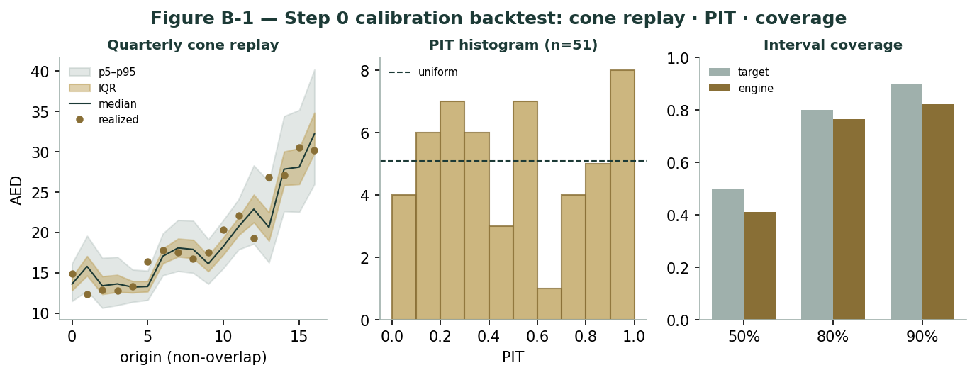
Figure B-1 — Step 0 calibration backtest: quarterly cone replay, PIT histogram, and interval coverage versus target.
CRPS skill is positive on all three window schemes and the PIT histogram is roughly flat (a slight tilt reflecting the residual trend, not a width error). The coverage sits a little inside target at the inner bands — expected, since the Student-t(5) body is deliberately tighter than a Gaussian and coverage is a diagnostic, not the grade. The lens is accepted; this configuration (secular drift ON, trailing-realized-variance level anchor, YZ-HAR shape, t5 tails) carries into the §3 forward run.
Appendix C Peer set, sector structure, and risks
Emirates NBD sits mid-pack in a Gulf banking sector that splits sharply by franchise type. The peer set below is indicative and the multiples move with price; it is context for the relative lens (§1.3), not a valuation in itself.
Bank | P/TBV | P/E | Note
Emirates NBD (this study) | 1.64× | 8.3× | ROTE ~20%; mid multiple vs its returns
First Abu Dhabi Bank (FAB) | ~1.4× | ~9.7× | Largest UAE bank; also below analyst targets
Abu Dhabi Commercial (ADCB) | ~1.3× | ~9.0× | De-risked loan book
Dubai Islamic Bank (DIB) | ~1.3× | ~7.0× | Largest UAE Islamic bank
Qatar National Bank (QNB) | ~1.7× | ~9.0× | Largest GCC bank by assets
Al Rajhi Bank | ~3.0× | ~18× | Saudi Islamic; premium franchise
Abu Dhabi Islamic (ADIB) | ~3.5× | ~13× | Highest P/TBV in the Gulf

Sector structure. Gulf banking is enjoying a multi-year lending boom driven by population growth, government project spend and a benign credit cycle; UAE conventional banks (Emirates NBD, FAB, ADCB) trade cheaper than the Islamic-premium names (Al Rajhi, ADIB) despite comparable or higher returns, a gap analysts have flagged. Principal risks: a sharper net-interest-margin compression as rates fall; a cost-of-risk normalisation or genuine credit downturn; Dubai real-estate concentration; DenizBank / Türkiye hyperinflation and lira volatility; RBL integration and capital draw; and multiple de-rating on flows or a modest-dividend disappointment.
Appendix D The expert valuation panel
Every Testahil study closes with a panel of standing expert personas — drawn from the house Expert Persona Library, not invented for the occasion, so that each accumulates a track record across studies and a quarterly update is a re-run, not a re-training. For a bank we cast the three whose methods both fit a large deposit-funded lender and genuinely disagree: Expert 1 (capital and returns — residual income and dividend discount on tangible book), Expert 2 (the credit cycle — through-cycle cost of risk and stressed earnings), and Expert 3 (macro-policy — a scenario-weighted read on the rate path, the dirham peg, the Dubai cycle and the international exposures). Each runs a genuinely different method, derives its fair value from shown workings, and states a falsification condition. The discipline is deliberate: three experts running the same discounted-cash-flow model would agree by construction and the section would be cosmetic. Here the methods are structurally different — one values off book and returns, one off a normalised loss rate, one off a probability-weighted set of macro worlds — so where they agree it is meaningful, and where they diverge the gap itself measures the single thing most in doubt. The three were chosen precisely because a bank's value is a contest between franchise quality (Expert 1's ground), credit risk (Expert 2's), and the policy backdrop (Expert 3's); a generalist earnings-power or asset-value lens would have blurred into one of them rather than adding a fourth, distinct view.
D.1 Expert 1 — capital and returns (residual income / dividend discount)
Worldview. A bank is worth its tangible book value plus the present value of the returns it earns above its cost of that equity. Value flows from a sustainable return on tangible equity, capital strength, and the ability to grow without dilution — not from a single year's profit. He reasons in ROTE, cost of equity and growth, and asks what multiple of book those three justify.
When it works / fails. Best for well-capitalised banks with stable, disclosed returns — exactly Emirates NBD. It fails through credit shocks, because book value is not real if the assets behind it are impaired; there he defers to Expert 2.
Standard workings & worked example. Assess capital adequacy and any surplus; estimate a sustainable ROTE; value via residual income, cross-checked by a justified price-to-book of (ROTE − g)/(Ke − g); sensitise on ROTE and Ke. He takes tangible book of AED 18.68/share, a sustainable ROTE fading to ~15.5%, a cost of equity of 11.5% and growth of 4.5%.
Expert 1's residual-income marks | Value
Tangible book value / share | AED 18.68
Sustainable ROTE (through cycle) | 15.5%
Cost of equity (rf 4.3% + β1.10 × ERP 6.0%) | 11.5%
Justified P/TBV = (ROTE − g)/(Ke − g) | ~1.7×
Fair value | → AED 33.8/share

Sensitivity (swing = sustainable ROTE). At a 14% sustainable ROTE his value falls to ~AED 28; at 18%, it rises to ~AED 42 — the ROTE is the whole valuation. Cross-examination. He tells Expert 2 that pricing the bank off a downturn cost of risk ignores a franchise that has out-earned its cost of capital for a decade; he tells Expert 3 that scenario trees are a way of avoiding a point estimate — the returns are disclosed and the maths is arithmetic.
He adds a capital argument the other two under-weight. Emirates NBD ended FY25 with a CET1 ratio of 14.4% against a management floor near 11%, and generated enough capital in the year to fund a record AED 129bn of loan growth, absorb a first full year of UAE corporate tax, and still raise the ordinary payout — all without a rights issue. To him that surplus is the proof of the thesis: a bank that can compound tangible book at high-teens returns while self-funding its own growth and a rising dividend is, by construction, worth a premium to that book. The residual-income maths simply puts a number on it. He notes too that the AED 471bn low-cost CASA base is the hidden asset the multiple should capitalise — it is what lets the margin fade gently rather than collapse as rates fall, and it is why he is comfortable with a sustainable ROTE in the mid-teens rather than lower.
Verdict, falsification, market-implied. Fair AED 33.8 (range AED 26–45). Falsified by a structural ROTE shift below the cost of equity, or a capital event (a raise, or a large return). The market's ~1.6× tangible book implies a sustainable ROTE nearer ~15–16% at his cost of equity — a partial fade already priced.
D.2 Expert 2 — the credit cycle (through-cycle cost of risk)
Worldview. A bank's value is dominated by the credit it underwrites: through-cycle losses, not peak-cycle profits, set the floor. Reported book value is only as real as the loan book behind it, and a benign year's near-zero provisioning is a loan against the future, not a sustainable earnings level.
When it works / fails. Best late-cycle, in rising-rate or newly-easing environments, and where an unusually low cost of risk flatters returns — again, exactly the current set-up. It fails by being too bearish in genuinely benign cycles, missing real franchise value; his discipline is to value off a normalised, not a stressed-to-catastrophe, loss rate.
Standard workings & worked example. Assess asset quality (NPL ratio, coverage, concentration); estimate a normalised through-cycle cost of risk; stress earnings and capital under a downturn; value off normalised, not reported, earnings. Emirates NBD's FY25 cost of risk was ~0.2% of loans, flattered by recovery writebacks; he normalises it toward ~0.6%, which on a ~AED 640bn book is roughly AED 2.5bn of additional annual impairment, cutting normalised net profit to ~AED 21bn and the ROTE the multiple is applied to.
Expert 2's stressed-earnings test | Value
Gross loans (FY25) | ~AED 640bn
Reported cost of risk (FY25) | ~0.20%
Normalised through-cycle cost of risk | ~0.60%
Incremental annual impairment | ~AED 2.5bn
Normalised net profit / ROTE | ~AED 21bn / ~15%
Fair value (normalised earnings × justified multiple) | → AED 29.5/share

Sensitivity (swing = normalised cost of risk). At a 0.4% normalised charge his value rises to ~AED 33; at 0.9% (a harder landing) it falls to ~AED 24. Cross-examination. He tells Expert 1 that a residual-income value built on a ~0.2% cost of risk capitalises a cycle peak as if it were permanent; he tells Expert 3 that the one scenario that matters is a Dubai property and regional credit downturn, and it deserves more than a probability weight.
His deeper point is about where the loan book is concentrated. Emirates NBD's impaired-loan ratio improved to 2.4% in FY25 — a genuinely strong number — but he reads it as a late-cycle low rather than a durable floor, achieved in an economy running unusually hot: record Dubai property transactions, buoyant government spending, and large recovery writebacks that cannot repeat. The exposures he watches are real-estate and contracting in the UAE, the DenizBank book in a hyperinflationary Türkiye, and the incoming RBL portfolio in India, each carrying a different and less-tested loss profile than the headline group ratio implies. He stresses the book the way a downturn would: a 0.6% normalised charge is his base, but a genuine property correction could push the cost of risk to 1.0–1.2% for a year or two, briefly halving earnings even without a capital problem. That is not his central case — he is careful not to be the perma-bear the persona can become in a benign cycle — but it is why he refuses to pay a full premium to book for returns he regards as borrowed from the future.
Verdict, falsification, market-implied. Fair AED 29.5 (range AED 22–38) — the most cautious of the three: roughly fairly valued once the cost of risk is normalised. Falsified by a sustained improvement in asset quality through a full cycle (proving the low loss rate is structural, not cyclical). The market price is close to his number — on a normalised-credit basis, the stock is about right, with little margin of safety.
D.3 Expert 3 — macro-policy (scenario-weighted)
Worldview. In the Gulf, policy and macro outrank management: the Fed's rate path (imported via the dirham peg), the Dubai economic cycle, the health of Türkiye and the terms of the India expansion move the value more than any internal decision. He prices the bank as a set of options on which macro world arrives, rather than betting on a single path.
When it works / fails. Best where a small number of external levers dominate and the outcomes are genuinely uncertain — a pegged-currency bank with large foreign exposures qualifies. It fails through false precision: the scenario probabilities are judgments, and a tree can miss the branch that grows.
Standard workings & worked example. Identify the three or four policy/macro levers; define bull/base/bear as configurations of those levers; re-run the base valuation under each so the scenario values are derived, not asserted; probability-weight; stress the weights. His levers are the rate-cut path (NIM), the Dubai property cycle (asset quality and demand), and the DenizBank/RBL international swing.
Expert 3's scenario tree | Prob. | Value
Bull — soft landing, shallow cuts, Dubai firm, DenizBank recovers | 30% | AED 40
Base — orderly easing, cycle moderates, RBL closes cleanly | 45% | AED 32
Bear — faster cuts, Dubai property softens, Türkiye/EM stress | 25% | AED 24
Probability-weighted fair value |  | → AED 32.4/share

Sensitivity (swing = the scenario weights). Shift 15 points of probability from bull to bear and his value falls to ~AED 30; the reverse lifts it to ~AED 35. Cross-examination. He tells Expert 1 that a single sustainable-ROTE number hides the fact that the ROTE itself is a function of the rate path he is modelling; he tells Expert 2 that the credit downturn is one branch of the tree, not the trunk — it deserves its ~25% weight, not certainty.
He is most attentive to the peg, because it is the lever the other two treat as background. The dirham's fixed link to the US dollar means Emirates NBD does not set its own policy rate — the Fed does — so the entire margin trajectory is imported. In the easing cycle now under way that is a headwind, but a manageable one: a bank this deposit-rich re-prices its funding down alongside its assets, and the CASA franchise means the net compression is far gentler than the headline rate move. The peg also removes the currency-crisis tail that afflicts other emerging-market banks — a structural support his scenario tree credits in every branch. Against that he sets the two genuinely open questions: how far Dubai's property cycle runs before it turns, given that both transactions and prices are at or near records; and how cleanly the RBL acquisition and the DenizBank recovery play out, each a multi-year swing on capital and earnings that no single-point model captures well. His conclusion is deliberately a distribution rather than a number — which is why his base sits close to the other two even though his method could not be more different.
Verdict, falsification, market-implied. Fair AED 32.4 (range AED 24–40). Falsified by a fourth, unmodelled shock dominating (a regional geopolitical rupture, an abrupt peg-policy question, or a disorderly RBL outcome). The market price sits toward the lower-middle of his tree — consistent with the bear branch carrying more weight in investors' minds than the base.
D.5 The three in one room
The single variable they most disagree on is the sustainability of the current return on equity — specifically, whether a near-zero cost of risk and a peak-cycle margin can hold long enough to justify a premium to book.
Expert 1: "Emirates NBD has out-earned its cost of capital for a decade. A ~16% sustainable ROTE at an 11.5% cost of equity is worth about 1.7 times book — the market pays 1.6, so it is paying nothing for the excess return it keeps delivering."
Expert 2: "You are capitalising a 0.2% cost of risk. That is a recovery-year number in a buoyant economy — normalise it to 0.6% and roughly AED 2.5bn of profit disappears, the ROTE drops to the mid-teens, and your premium to book mostly evaporates. Peak profits are a loan against the next downturn."
Expert 3: "You are both arguing about a number that the Fed and Dubai property set for you. Model the rate path and the cycle as scenarios and the answer is a distribution centred in the low-to-mid thirties — the disagreement is really about how much weight to put on the downturn, not about the arithmetic of either of your models."
Pressed on where they would change their minds, they converge more than the spread suggests. Expert 1 concedes that if the FY26 and FY27 prints show the cost of risk climbing decisively through 0.5% while the margin falls faster than CASA can cushion, his premium to book is wrong and his value moves toward Expert 2's. Expert 2 concedes the reverse: two more years of a sub-0.3% charge through a full rate-cut cycle would prove the low loss rate structural, not cyclical, and he would stop discounting it. Expert 3 notes that both of those are simply two branches of his tree resolving — and that the single event that would break all three models at once is not credit or margin but a shock outside them: a regional geopolitical rupture, a disorderly outcome to the RBL deal, or a policy question over the peg itself. It is a revealing agreement: three genuinely different methods, landing within AED 4 of each other, all hostage to the same two operating variables and the same short list of tail risks.
D.6 Reading the divergence
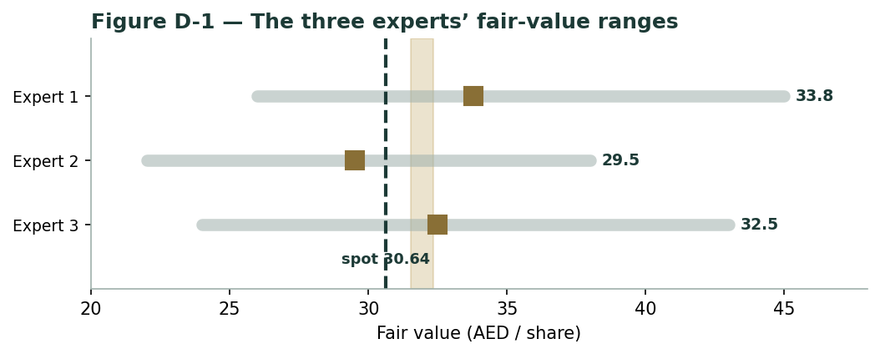
Figure D-1 — The three experts' fair-value ranges. Brass ticks are base cases; the gold band is the central; the dark dashed line is spot. The spread is almost entirely a cost-of-risk and ROTE-durability disagreement.
Expert | Method | Single swing assumption | Base fair value
Expert 1 | Residual income / DDM | Sustainable ROTE (15.5%) | AED 33.8
Expert 2 | Stressed through-cycle earnings | Normalised cost of risk (~0.6%) | AED 29.5
Expert 3 | Scenario-weighted macro | The rate/cycle scenario weights | AED 32.4

The spread — AED 29.5 to AED 33.8 at base — is narrow, and it is almost entirely one disagreement: whether today's returns are a sustainable level or a cycle peak. None of the three contests the deposit franchise, the capital strength, or the balance sheet. What separates them is the cost of risk and the durability of the margin. Expert 1 says the franchise has earned the benefit of the doubt; Expert 2 says normalise the credit charge before you pay for it; Expert 3 says the answer is a rate-path distribution, not a point. The ~AED 4 spread is therefore a clean measure of one uncertainty — the through-cycle economics of a bank currently enjoying a benign top of the cycle. Resolve that, and the three converge near the low-thirties.
Each expert's point fair value (and bull/base/bear) is logged with the study date (3 July 2026) and spot (AED 30.64) as an internal per-expert track record, kept separate from the core Calibration Ledger. Over successive quarterly re-runs the value of the panel is not any single call but the pattern: whether Expert 1's franchise optimism, Expert 2's credit caution, or Expert 3's scenario-weighting proves the better-calibrated lens on this name through a full cycle. On a bank enjoying a benign top of the cycle, that is exactly the disagreement worth tracking — and it is why the study publishes three reasoned fair values and the distribution around them rather than collapsing them into one figure that would hide the very uncertainty the reader most needs to see.
About this series
Testahil publishes independent, educational valuation studies. Each is an attempt to reason transparently about what a security is worth, with every assumption shown and a companion model so readers can disagree productively. The house style is distributions, not tips: we describe ranges and probabilities, not targets, and we do not tell anyone what to do. Studies are framed as educational analysis, the preparer is not licensed by any securities regulator, and holdings are disclosed.
Disclosure & Disclaimer
Not investment advice. This document is educational and informational only. It is not, and must not be relied upon as, investment, financial, legal, accounting or tax advice, nor an offer, solicitation or recommendation to buy, sell or hold any security. It contains no price target and no rating.
No licence; no advisory relationship. The preparer is not registered or licensed with any securities or financial regulator in any jurisdiction, holds no brokerage or investment-advisory authorisation, and is not acting as your adviser or fiduciary. Nothing here is personalised to your circumstances.
Holdings disclosure. The preparer may hold, and may in the future take or dispose of, a position in the security discussed in this report, and may transact at any time without notice. This is a potential conflict of interest you should weigh.
Sources & accuracy. Reported financial and operating figures are drawn from the company's public disclosure and other public sources believed reliable but not independently verified; they may contain errors or be superseded. Forward-looking inputs — the sustainable ROTE and cost of equity, the cost-of-risk normalisation, projections, multiples, the FCFE model and Monte-Carlo factor probabilities — are the preparer's own judgments and are inherently uncertain.
Forward-looking statements. Any statements about the future are estimates subject to risks and uncertainties; actual results may differ materially. The Monte Carlo models price, not value, and encodes subjective probabilities for events that have not occurred.
No reliance; your responsibility. Do your own research and consult a licensed professional before making any decision. You are solely responsible for your investment decisions and their outcomes. To the maximum extent permitted by law, the preparer accepts no liability for any loss arising from use of this document.
Currency & figures. Figures are in UAE dirhams (AED) unless stated; bn denotes billion. FX at study date: USD/AED 3.6725 (the dirham's fixed peg). Rounding may cause totals to differ slightly. Spot price and market data are as of 3 July 2026 and change continuously.
TESTAHIL · Independent Valuation Study · Educational Analysis · Emirates NBD Bank PJSC (DFM: EMIRATESNBD) · edition 03-07-2026 · reporting currency AED

