Testahil · Independent Valuation Study — Educational Analysis | Not investment advice

Independent Valuation Study — Educational Analysis
Telecom Egypt Company S.A.E. (EGX: ETEL)
Fundamental analysis · Technical analysis · Monte Carlo simulation — one integrated read
Anchor: EGP 92.6 (01 Jul 2026 close) · 1,707.1mn shares · mkt cap ~EGP 158.1bn (~US$3.2bn at 49.1) · Egypt's fixed-line and fibre incumbent, its fourth mobile operator (WE), the operator of the Suez subsea-cable corridor, and the holder of a 45% stake in Vodafone Egypt · prices and probabilities computed 01 Jul 2026 from the attached daily history · primary lens: sum-of-the-parts on the FY2025 audited numbers (core telecom on EV/EBITDA, the VFE stake on marked earnings) · the VFE mark and the state-control/complexity discount are the swing factors.
READ FIRST — what this document is, and is not. This study is a valuation exercise and an expression of personal analytical opinion, published free of charge for educational purposes: it shows how one analyst applies fundamental, technical and probabilistic methods to a listed company, and invites scrutiny of that methodology. It is NOT investment advice, NOT a recommendation or solicitation to buy, sell or hold any security, and NOT directed at the circumstances of any reader. The preparer is not licensed by any securities regulator in any jurisdiction — including Egypt's Financial Regulatory Authority — holds no brokerage authorisation, provides no financial consultancy, manages no money, and accepts no fees, funds or clients. See the Disclosure & Disclaimer at the end. All values are model outputs presented as ranges and distributions because no single number should be relied on. Reported financials are the company's own disclosure (FY2025 audited results, 26 Feb 2026; Q1 2026 release, May 2026); forward-looking inputs — the mark on the Vodafone Egypt stake, the complexity/state-control discount, the multiples, the DCF and the Monte-Carlo factor probabilities — are the preparer's judgments and are flagged throughout. A note on structure: Telecom Egypt is an operating company with a holding-company question inside it — nearly half of the marked value sits in a 45% associate stake that does not consolidate — which is why this study reads it partly through a holdco lens. Consult a licensed financial advisor before any investment decision.

Headline
The model's read: undervalued, with the upside resting on the market crediting the Vodafone Egypt stake and the discount on the wrapper narrowing. At EGP 92.6 the shares sit about 27% below our weighted central estimate of EGP 118. The two anchor lenses agree closely — a sum-of-the-parts lands at EGP 118 and a core-cash-flow DCF at EGP 107 — while a conservative relative-multiple read (EGP 103) marks the floor and a normalized-earnings read (EGP 134) marks the ceiling. The whole answer turns on two judgments: what the unlisted 45% of Vodafone Egypt is worth — its FY2025 profit attributable to Telecom Egypt was EGP 14.8bn, up 71% — and how large a discount a 70% state-owned wrapper deserves. At spot the market pays roughly a 33% discount to the marked parts; we assume 15% is fair. Operationally the company just printed its best year on record — revenue +31% to EGP 106.7bn, EBITDA margin 45%, FCFF swinging to +EGP 21.1bn, leverage down to 1.3× — and the regulator has since approved 13–15% price adjustments. Technically the tape is consolidating just under its 20/50-day averages after a 148% twelve-month run, with RSI neutral at 47.2. Over three months the Monte Carlo places the 5th–95th percentile band at roughly EGP 78–145, with the median at EGP 106 — above spot, because this name's calibrated engine carries the EGX secular drift.

Valuation summary — every read at a glance
One table for the four reads that follow — what the business is worth (fundamental), what the tape is doing (technical), where price could travel over three months (Monte Carlo), and how three independent expert methods land. Every row is developed in the sections and appendices below.
Lens / read | What it measures | Output | Takeaway
FUNDAMENTAL — what the business is worth (the anchor)
Sum-of-the-parts (primary) | Core telecom + 45% VFE, less debt & discount | EGP 118 | +27% vs spot
Core-FCFF DCF + stake | Discounted 5-yr core cash flows | EGP 107 | +16%
Relative multiples | Justified P/E on blended EPS | EGP 103 | +11% · the floor
Normalized earnings | Mid-cycle NPAT × P/E | EGP 134 | +45% · the ceiling
Weighted central | Blend 40 / 20 / 15 / 25 | EGP 118 | +27% vs 92.6
TECHNICAL — what the tape is doing (timing, not value)
Trend & momentum | Price vs the 20/50/100/200-day averages | Below 20/50; above 100/200 | Pausing inside an uptrend
Momentum / range | RSI · MACD · 252-session range | RSI 47.2 · MACD -0.19 · 36–113.0 | Neutral, post-run consolidation
MONTE CARLO — where price could go in 3 months (paths from spot)
T+20 sessions | 50,000 paths · 16 factors | p5 81 · p50 97 · p95 117 | Median above spot (class drift)
T+60 sessions | same engine, longer horizon | p5 78 · p50 106 · p95 145 | Wide, right-skewed
EXPERT PANEL — three independent methods (Appendix D)
Expert 1 — NAV & the discount | Marked parts less a fair wrapper discount | EGP 123 | The anchor
Expert 2 — normalized earnings power | Mid-cycle EPS × justified multiple | EGP 134 | Most bullish
Expert 3 — cash returns (ROIC vs WACC) | Economic profit on invested capital | EGP 98 | Most conservative
Panel range | Spread = the VFE-and-discount question | EGP 98–134 | Centres ~EGP 118

Bottom line. Every fundamental read points the same way and disagrees only on magnitude. The central sits near EGP 118 — about 27% above the EGP 92.6 spot — the three experts span EGP 98–134, and each one turns on the same pair of judgments: the mark on an unlisted associate and the discount on a state-controlled wrapper. Unusually, the probabilistic map leans the same way — the calibrated engine carries this class's secular drift, so the three-month median sits at EGP 106 rather than at spot. The dissent is quieter here than usual: it is the size of the ask, not its direction.

Company overview — Telecom Egypt at a glance
Item | Value
Listed entity | Telecom Egypt Company S.A.E. (EGX: ETEL; LSE GDR: TEEG)
What it owns | Fixed-line & fibre incumbent · WE mobile (4th MNO) · 45% of Vodafone Egypt · the Suez subsea-cable corridor (SEA-ME-WE, AAE, Coral Bridge) · data centres
Spot / date | EGP 92.6 · 01 Jul 2026 close
Shares · market cap | 1,707.1mn · EGP 158.1bn
Net debt (latest) | ~EGP 58bn (FY25 balance sheet 66.1; Q1-26: −EGP 8bn QoQ; ND/EBITDA 1.3×)
FY25 revenue / EBITDA margin | EGP 106.7bn (+31% YoY) · 45%
VFE stake share of value | ~40% of the pre-discount marked EV (EGP 118.4bn of 295.4bn)
252-session range | EGP 36.0 – 113.0 (all-time high 112.98 on 16 Feb 2026)
Ownership | Ministry of Finance ~70% · free float ~30% (post the May-2023 9.5%+0.5% sale at EGP 23.11)
MD & CEO · next results | Tamer El Mahdi (since late 2025) · Q2 2026 due 13 Aug 2026
Dividend | EGP 1.50/share for FY2025, paid 30 Apr 2026 (payout ~13%)

Source: company FY2025 audited results (26 Feb 2026), Q1 2026 release (May 2026), EGX/LSE disclosures, exchange data. Values rounded.

1 Fundamental valuation
We value Telecom Egypt as an operating incumbent with a holding-company question inside it, and triangulate four lenses. The primary lens is a sum-of-the-parts (SOTP) because the two value engines obey different economics — a capex-heavy, EGP-earning fixed/wholesale operator, and a 45% equity-method stake in the country's most profitable mobile operator, which contributes no revenue line and no EBITDA, only an income pick-up of EGP 14.8bn — and a single group multiple would price the stake at the core's multiple, which is exactly the mistake this structure invites. A core-cash-flow DCF, a relative-multiple cross-check and a normalized-earnings-power read complete the set. The weights and the football field are in §1.5; the swing factors — the VFE mark and the wrapper discount — are dissected in §1.7 and the sensitivity grid in §1.9.

1.1 Sum-of-the-parts — the primary lens
Each part is marked on the basis that best fits it. The core business — retail fixed voice and broadband, WE mobile, enterprise, domestic wholesale and the international/subsea franchise — is marked on 2026E EBITDA of EGP 52.6bn (FY25 printed 47.5; Q1-26 annualises above 50 before the NTRA's 13–15% tariff headroom flows through) at 3.25× EV/EBITDA, inside the 3–5.5× band where emerging-market incumbents trade and below the Gulf names, reflecting Egypt cost of capital and a cash-capex ratio still near 30% of sales. The Vodafone Egypt stake is marked on earnings: EGP 14.8bn of FY25 income to TE implies EGP 32.9bn for 100%, and at 8.0× — a discount to Vodacom's own ~10× — the 45% is worth EGP 118.4bn. The cross-check is the only transaction in the stock: Vodacom bought Vodafone Group's 55% in 2022 for ~US$2.7bn, which grosses to ~US$5.0bn — EGP ~245bn at today's 49.1 — putting the 45% at ~EGP 110bn before any growth since; the earnings mark is 8% above that, three record years later. A small residual captures the data-centre/regional-hub build and non-core land. From the summed enterprise value we deduct net debt and apply a complexity/state-control discount.
Part (base case) | Basis | Value (EGP bn)
Core Telecom Egypt | EGP 52.6bn 2026E EBITDA × 3.25× | 171.0
Vodafone Egypt, 45% | EGP 32.9bn × 8.0× P/E × 45% | 118.4
Other (data-hub JV, land, non-core) | Judgment residual | 6.0
Σ Enterprise value |  | 295.4
less: net debt | Q1-26 basis | (58.0)
Equity value (pre-discount) | = EGP 139.0 / share | 237.4
less: complexity / state-control discount | 15% | (35.7)
SOTP equity value | = EGP 118 / share | 201.7

SOTP base ≈ EGP 118/share, with a bear–bull span of EGP 83–158 driven mainly by the VFE mark and the discount (see §1.9). The pre-discount NAV of EGP 139.0 says the market is paying EGP 92.6 for EGP 139.0 of marked assets — a ~33% implied discount, more than double our assumed 15%, which is the crux of the bull case.

1.2 Core-FCFF DCF + the stake — the cash-flow cross-check
A discounted-cash-flow build on the core operations is the natural check on the asset sum, because it shares almost no inputs with the multiple-based marks. The free cash flow is derived, year by year, from the forecast statements in Appendix A — EBITDA less D&A gives EBIT; a 22.5% cash tax gives NOPAT; D&A is added back; in-service capex (the maintainable basis — the 5G licence is treated as a sunk one-off, a flagged judgment; the cash-flow statement still carries full cash capex) and working-capital build (5% of incremental revenue) are deducted. The resulting FCFF path of EGP 18.5bn rising to 27.9bn sits deliberately below the company's own FY25 print of 21.1bn on its broader definition, and squarely inside management's FY26 guide of FCFF/EBITDA in the mid-thirties. Cash flows are discounted at a 23% EGP-nominal WACC against 11% nominal terminal growth (roughly 8–10% long-run inflation plus ~2% real): a 12-point spread that keeps the terminal multiple honest at ~5.4× EBITDA. The full five-year build:
Core DCF build (EGP bn) | FY26E | FY27E | FY28E | FY29E | FY30E
Revenue | 119.5 | 131.4 | 143.3 | 154.7 | 165.6
EBITDA | 52.6 | 57.2 | 61.6 | 66.5 | 71.2
less: D&A | (15.7) | (17.2) | (18.6) | (19.8) | (21.0)
EBIT | 36.9 | 40.0 | 43.0 | 46.7 | 50.2
less: cash tax @ 22.5% | (8.3) | (9.0) | (9.7) | (10.5) | (11.3)
NOPAT | 28.6 | 31.0 | 33.3 | 36.2 | 38.9
add: D&A | 15.7 | 17.2 | 18.6 | 19.8 | 21.0
less: in-service capex (21%→19% of rev.) | (25.1) | (26.9) | (28.7) | (30.2) | (31.5)
less: ΔWC (5% of Δrevenue) | (0.6) | (0.6) | (0.6) | (0.6) | (0.5)
Core FCFF (built) | 18.5 | 20.6 | 22.7 | 25.3 | 27.9
Discount factor @ 23% WACC | 0.813 | 0.661 | 0.537 | 0.437 | 0.355
PV of FCFF | 15.1 | 13.6 | 12.2 | 11.0 | 9.9

Bridge to equity | EGP bn | EGP/share
Σ PV of FCFF, FY26E–FY30E | 61.9 | —
Terminal value: FY30E FCFF × 1.11 / (23% − 11%) = 258.1, discounted 5 years | 91.7 | —
Core enterprise value | 153.5 | —
+ VFE stake at the §1.1 mark | 118.4 | —
− Net debt | (58.0) | —
× (1 − 15% complexity discount) → equity | 181.8 | 107

DCF scenarios | Bear | Base | Bull
FCFF path (FY26E start, EGP bn) | 16.7 (−10%) | 18.5 | 20.4 (+10%)
WACC (EGP nominal) | 25.0% | 23.0% | 21.5%
Terminal growth (nominal) | 10.0% | 11.0% | 12.0%
Core enterprise value (EGP bn) | 113.6 | 153.5 | 207.1
Fair value (EGP/share) | 70 | 107 | 154

The DCF base of EGP 107 lands beside the SOTP's 118 — reassuring, since one prices assets and the other prices cash flows built line-by-line from the same statements. Its width is a fair warning: at Egyptian nominal rates a point of WACC or of terminal growth moves the answer by ten pounds a share, and the capex basis is a live judgment — on full cash capex (licences included) the FCFF path would start nearer EGP 12bn and the DCF nearer EGP 90.

1.3 Relative multiples
On its own reported numbers ETEL screens cheap against any incumbent set: EGP 11.93 of FY25 EPS puts the spot P/E at 7.8×, and the core trades near 1.2× trailing EV/EBITDA once the whole market cap is (wrongly) charged to the core alone. Emerging-market incumbents cluster at 6–10× earnings — Turk Telekom at the cheap end of that band is the closest macro analogue, the Gulf names the expensive end — and Vodafone Egypt inside the group deserves a mobile-leader multiple the blend obscures. We mark the relative lens on a blended EPS of EGP 12.9 (between FY25's 11.93 and the model's 2026E ~14.7, holding back some of the tariff-driven jump) and a justified 8.0×.
Relative basis | Bear | Base | Bull
EPS basis (EGP) | 11.93 (FY25 reported) | 12.9 (blended) | 15.0 (2026E model)
Justified P/E | 6.5× | 8.0× | 9.5×
Fair value (EGP/share) | 78 | 103 | 142

Relative base ≈ EGP 103 — the most conservative lens, and probably where a sceptic anchors. It treats the group as one blended EM utility, credits no separate value to the associate stake, and quietly assumes the 2025 earnings step is as good as it gets.

1.4 Normalized earnings power
If 2026 merely delivers what is already visible — a full year of the FY25 revenue base, the NTRA's 13–15% price adjustments from mid-year, interest expense falling 25% as the CBE eases, and VFE income compounding — the group's mid-cycle earnings power sits well above the FY25 print, which itself absorbed EGP-appreciation FX losses. We normalize NPAT to EGP 30bn (the 2026–27 run-rate with FX noise stripped; Q1-26 adjusted profit of EGP 5.9bn annualises near 24 before any tariff effect), giving a normalized EPS of EGP 15.8, and apply a justified through-cycle 8.5× — below every Gulf peer and level with the group's own five-year average.
Normalized-earnings basis | Bear | Base | Bull
Mid-cycle NPAT (EGP bn) | 25.0 | 30.0 | 34.0
Normalized EPS (EGP) | 13.2 | 15.8 | 17.9
Justified P/E | 7.0× | 8.5× | 10.0×
Fair value (EGP/share) | 92 | 134 | 179

Normalized-earnings base ≈ EGP 134 — the recovery-of-purchasing-power lens and the ceiling of the central case. It is, in effect, the bet that the 2024–25 repricing of Egyptian telecom services is a level shift, not a spike.

1.5 Synthesis — four lenses
We weight the SOTP most heavily because it is the only lens that respects the associate structure; the DCF carries the cash discipline; the normalized lens carries the earnings momentum; the relative lens anchors the floor.
Lens | Weight | Bear | Base | Bull
Sum-of-the-parts | 40% | 83 | 118 | 158
Core-FCFF DCF + stake | 20% | 70 | 107 | 154
Relative multiples | 15% | 78 | 103 | 142
Normalized earnings | 25% | 92 | 134 | 179
Weighted central |  | 82 | 118 | 160

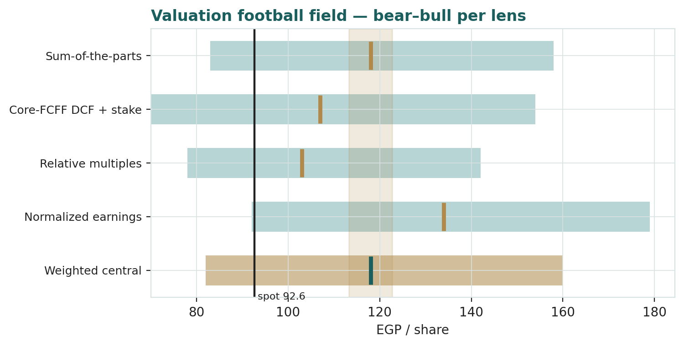
Figure 1 — Valuation football field. Bars span bear–bull per lens; the brass tick is each base case; the gold band is the blended central range; the dark line is spot.
Central fair value ≈ EGP 118/share, about 27% above spot. The spread of the lenses (EGP 103 to 134 at base) is itself the message: even the floor lens sits above price, so the question the market is asking is not whether the parts are worth more than EGP 92.6, but whether a 70% state-owned wrapper around an unlisted associate ever gets paid for them.

1.6 The two value engines — a deeper look
The core (FY25: revenue EGP 106.7bn, EBITDA 45%, cash capex 28% of sales, ~14.1mn fixed-voice, 11.1mn fixed-broadband and 15.5mn WE mobile customers) is really two businesses. Retail — Home & Consumer plus Enterprise, EGP 61.9bn — is the EGP-denominated engine: data revenue grew 46% in FY25 and the NTRA's mid-2026 tariff round adds 13–15% of headroom on top. Wholesale and international — EGP 44.8bn across domestic infrastructure, International Carrier Affairs and IC&N — is the hard-currency engine: international incoming calls printed EGP 13.1bn (+30%), subsea-cable projects +31%, and the October-2024 EGP 30bn infrastructure agreements with Vodafone Egypt run to 2034. The third engine never touches the P&L above the investment-income line: the 45% of Vodafone Egypt, whose contribution rose 71% to EGP 14.8bn and whose dividends (EGP 3.1bn net in 2024) are becoming a real cash stream. The table scores each on the axes that matter.
Part | Growth | FX sensitivity | Capital intensity | Swing role
Core retail (H&C + Enterprise) | High — data +46%, tariff round ahead | Low (EGP-priced) | High (fibre, 5G rollout) | Cash engine
Core wholesale & int’l | High — IIC +30%, cables +31% | High (USD-linked) | Moderate | Growth + natural FX hedge
Vodafone Egypt, 45% | High — income +71% FY25 | Moderate | Nil to TE (associate) | Dominant value swing

1.7 The VFE mark and the wrapper discount — the crux
Two judgments drive the valuation more than any other. First, what the unlisted 45% of Vodafone Egypt is worth. There is one hard data point — Vodacom's 2022 purchase of the 55% at ~US$2.7bn, grossing to ~US$5.0bn — and one soft series: the income line ETEL books, which has compounded from EGP 5.3bn (FY23) to 8.7bn (FY24) to 14.8bn (FY25). Our 8.0× mark values the whole of VFE at EGP 263bn, about 7% above the FX-translated deal price despite profits having roughly tripled since; every 1.0× on that multiple moves the SOTP by roughly EGP 7.4/share post-discount. Second, the discount on the wrapper: a 70% Ministry-of-Finance holding, an associate stake with no control and no listing, a divestment programme that periodically hangs supply over the float, and a payout ratio of only ~13% all argue for one; the question is size. We apply 15%; the market at spot implies ~33%. Every five points of discount is worth about EGP 7.0/share. The two obvious narrowing mechanisms are both live: a VFE monetization or listing would turn the soft mark into a hard one, and a rising dividend (payout guided upward as leverage falls through 1.3×) shrinks the penalty for minority status. The symmetric risk is that a state placement is done at a discount and resets the anchor lower — 2023's 9.5% sale cleared at EGP 23.11.

1.8 Macro and country — the pound, the CBE, the regulator and the canal
ETEL is a rare EGX name that is hedged on both sides of the Egyptian macro question. The pound cuts both ways: the 2022–24 devaluations that took USD/EGP from 15.7 to ~50 repriced its USD-linked wholesale revenue upward (and its USD debt with it — gross debt rose 64% in FY24 on revaluation alone), while 2026's appreciation to 49.1 (from a February peak near 54.9) has done the reverse, generating EGP 5.3bn of non-cash FX losses in Q1 alone even as it deflates the dollar debt. The CBE's easing cycle is a clean tailwind: interest expense fell 25% YoY in Q1-26 and every further cut flows almost directly to the pre-tax line of a company carrying ~EGP 74bn of gross debt. The regulator turned from headwind to tailwind in May 2026, approving 13–15% adjustments on fixed broadband and mobile prices — management now expects to exceed its own FY26 guidance — and the 2026–2030 National Spectrum Strategy frames the next network cycle. The geography is the quiet fourth factor: the Suez corridor carries a dominant share of Europe–Asia data traffic, Red Sea security incidents cut both ways (repair risk against scarcity pricing of intact capacity), and Egypt's IMF-anchored programme keeps the sovereign backdrop — and the divestment pipeline that may include more ETEL paper — in play. These levers set the bear and bull cases in §1.5 and the catalysts in §5.

1.9 SOTP sensitivity — how much the two swing inputs move the value
Holding the core and other parts at base, the grid re-prices the SOTP across the VFE earnings multiple and the wrapper discount. The value runs from EGP 95 (6.5× / 25%) to EGP 144 (9.5× / 5%).
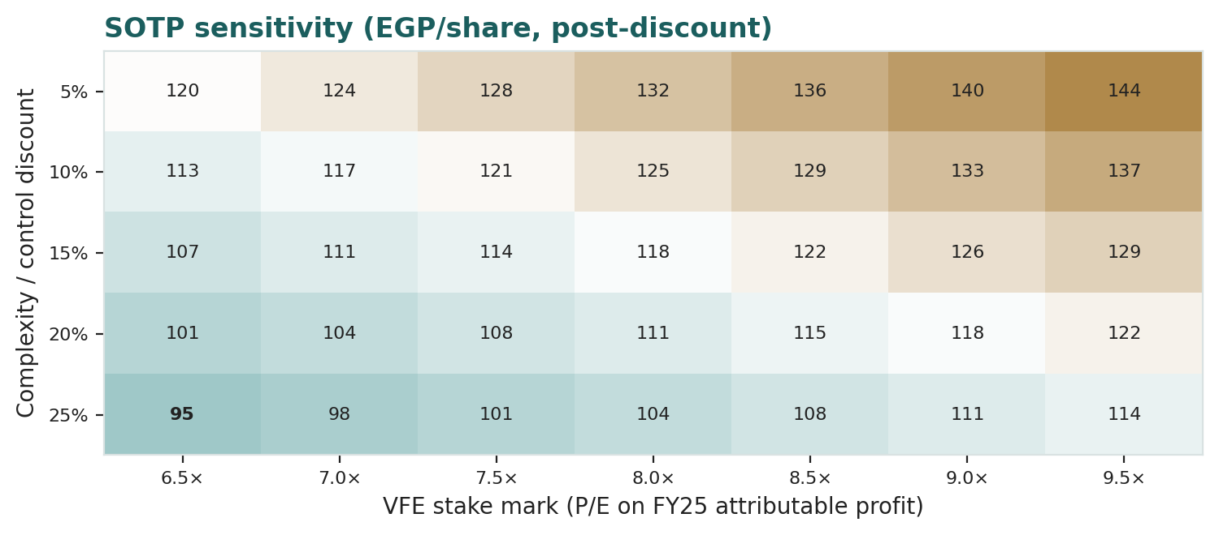
Figure 2 — SOTP sensitivity to the VFE mark and the complexity/state-control discount (EGP/share, post-discount).
Read it as the bet you are taking: the market price of EGP 92.6 is consistent with roughly a 6.5× VFE mark on a ~20–25% discount — i.e. the deal-price stake with no growth since, inside a heavily penalised wrapper. Anything better than that on either axis is unpaid-for.

2 Technical and price structure
The tape is a pause inside a powerful uptrend. ETEL has returned ~148% over twelve months, printed its all-time high of EGP 112.98 on 16 February 2026, corrected ~18% into April, and has since built a range in the low-90s to mid-90s. Price sits a fraction below the 20- and 50-day averages, above the 100-day, and far above a still-rising 200-day at EGP 74.7 — the classic geometry of consolidation, not reversal. RSI is dead neutral and the MACD histogram is fractionally negative: momentum has cooled without breaking.
Indicator | Reading | Signal
Spot | EGP 92.6 | —
SMA 20 / 50 | EGP 93.3 / 94.6 | Just below both — short-term pause
SMA 100 / 200 | EGP 91.3 / 74.7 | Above both — primary trend up
RSI (14) | 47.2 | Neutral
MACD (12,26,9) | -0.61 line / -0.43 signal / -0.19 hist | Mildly bearish, flattening
252-session range | EGP 36.0 – 113.0 | Upper-middle of range
Realized vol (252d) | 41.3% | Elevated — a hot tape

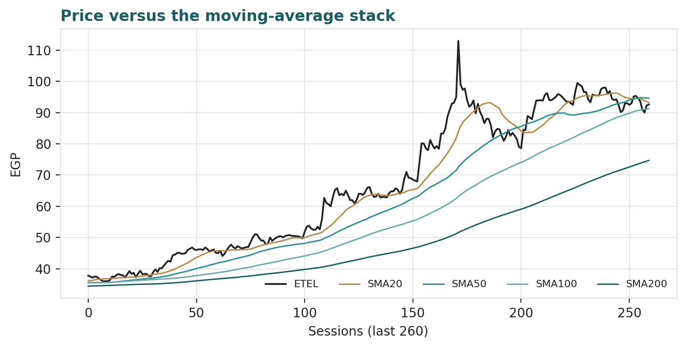
Figure 3 — Price versus the moving-average stack, last 260 sessions.
For the probabilistic work this matters in one way: a consolidating, high-volatility tape after a vertical run widens both tails — the up-tail because the primary trend is intact, the down-tail because 41% realized volatility gives back ground quickly. §6 reads the resulting probability zones without forcing a reconciliation.

3 Monte Carlo — a probabilistic price map
We simulate 50,000 three-month price paths (seed 42) using a sixteen-factor stack: seven continuous macro/operating drivers contributing a small net forward drift, and nine discrete events that each fire with a probability and an impact. By design the paths diffuse from spot, and the §1 value gap is kept out of the drift — the fundamental NAV gap lives in §1, not here; §3 maps where price could go from today, not where value sits. Width is sized by the YZ-HAR engine calibrated in Appendix B (log-HAR variance cascade on a gap-aware Yang-Zhang proxy; forward path volatility ≈ 38.3% annualized), the shape is a unit-variance Student-t(5) per-path mixture, and — per the Appendix-B result — the EGX secular drift is ON for this name (+9.7% over the quarter, the expanding-window mean of its own history), with the factor stack adding a net +2.3% continuous and +2.2% of expected event skew on top.
Continuous factor (7) | Dir. | Discrete event (9) | Prob. | Mean impact
CBE policy-rate path (easing) | + | Q2 2026 results (13 Aug) | 85% | +0.5%
EGP/USD path (appreciation) | mixed | NTRA tariff implementation read-through | 45% | +2.0%
Inflation / NTRA tariff pass-through | + | Government sell-down / placement (overhang) | 25% | -4.0%
EGX30 & foreign flows | + | VFE monetization / stake headline | 15% | +6.0%
Data demand / broadband ARPU | + | New EGP step-move (either direction) | 20% | +1.0%
VFE earnings momentum | + | Dividend-policy / payout surprise | 15% | +1.5%
Capex intensity / FCF drag | - | Red Sea / subsea disruption | 25% | -2.5%
 |  | New cable / IRU / data-hub deal (Helios close) | 45% | +2.0%
 |  | Index / MSCI flow event | 25% | +1.2%

All factor magnitudes and probabilities are the preparer’s judgments (a first-pass egx_telecom set, flagged calibrated=false pending sign-off); the diffusion width and drift are the calibrated engine.
Percentile map (EGP/share):
Horizon | p5 | p25 | p50 | p75 | p95
T+20 sessions | 81 | 91 | 97 | 104 | 117
T+60 sessions | 78 | 94 | 106 | 119 | 145

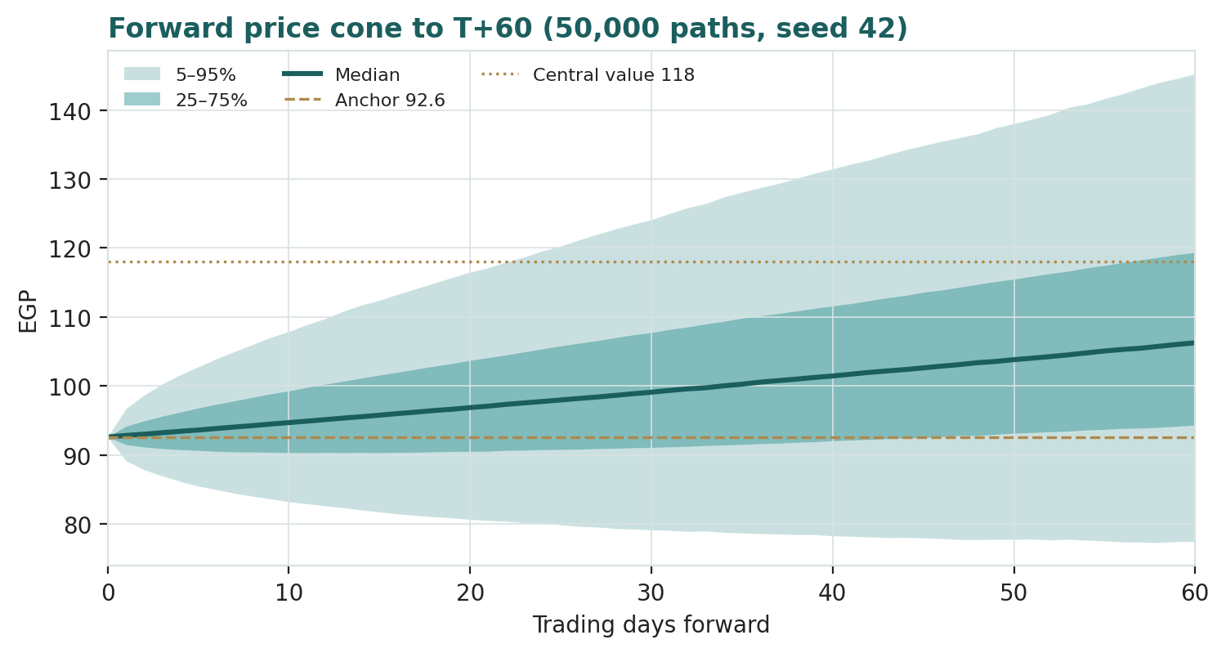
Figure 4 — Forward price cone to T+60. The median carries the calibrated class drift; the gold dotted line marks the EGP 118 fundamental central value, still above the cone's middle.
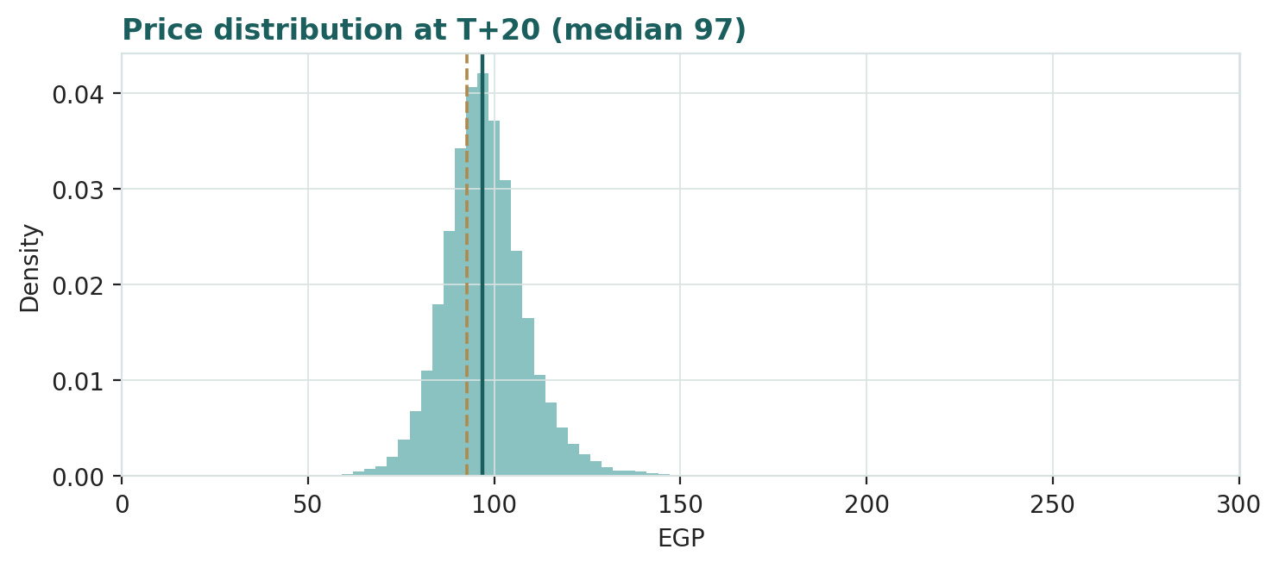
Figure 5 — Price distribution at T+20.
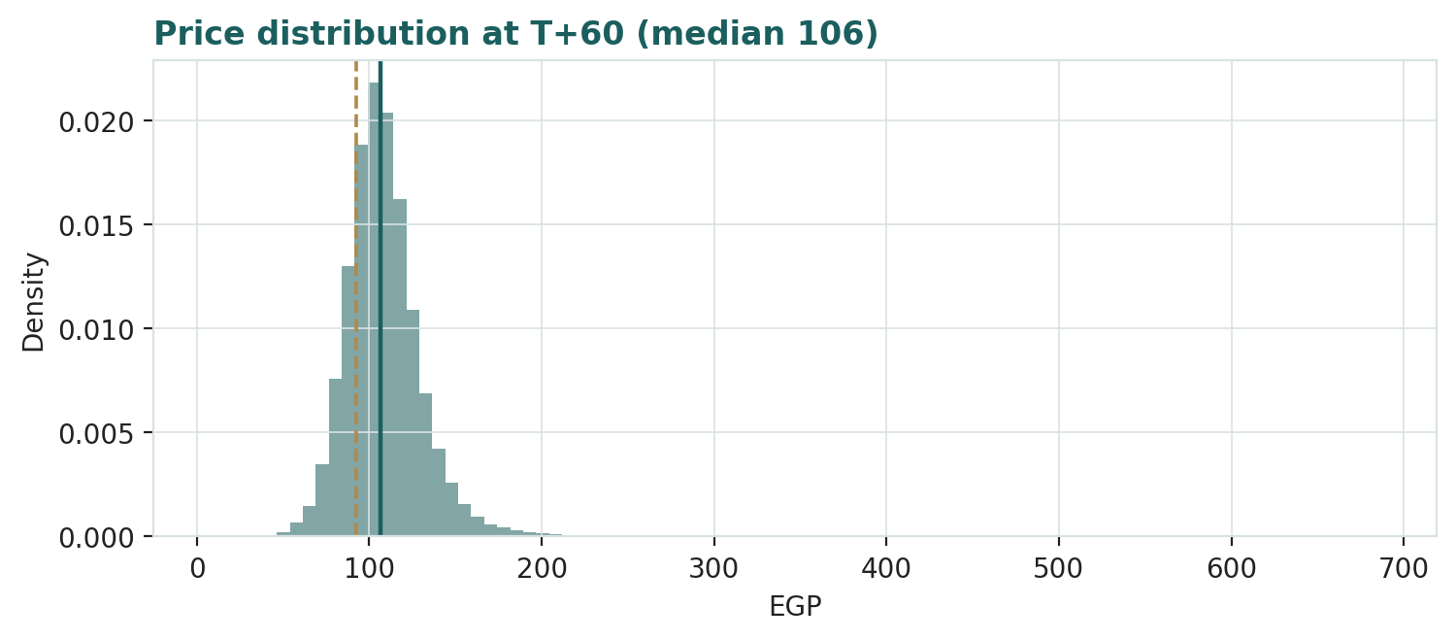
Figure 6 — Price distribution at T+60.
Level-touch ladder — the probability that price touches a level at any point by the horizon (running max for upside, running min for downside):
Level | T+20 touch | T+60 touch | Note
EGP 120 | 5% | 33% | Above the central fair value
EGP 113 | 11% | 49% | The all-time high
EGP 105 | 30% | 70% | Mid up-band
EGP 100 | 53% | 83% | Round number, p50 zone
EGP 95 | 81% | 94% | Just above spot
EGP 90 | 53% | 62% | Just below spot
EGP 85 | 22% | 34% | April consolidation floor
EGP 80 | 8% | 18% | Near the p5
EGP 75 | 3% | 10% | Deep-retrace zone

4 Comparison of the lenses, and a verdict
Three readings sit side by side. The fundamental lenses cluster at EGP 103–134 with a central of 118 — well above spot, contingent on the market paying for an associate stake it can see but not touch. The technical picture is constructive-neutral: a pause under the short averages inside a primary uptrend, with 41% realized volatility. The probabilistic map leans up rather than sitting flat: because this name's calibrated engine carries the EGX secular drift, the three-month median is EGP 106, with an interquartile band of 94–119 and a 5–95 band of 78–145.
Lens | Reads | Central / implication
Fundamental (4-lens) | Clearly cheap on marked parts | EGP 118 (~+27%)
Technical | Consolidating inside an uptrend | Support 91 (SMA100) and 85; resistance 93–95 then 105/113
Monte Carlo (3-month) | Right-leaning, wide | Median 106; IQR 94–119; p5–p95 78–145

Verdict (a fair-value read, not a recommendation). ETEL looks genuinely undervalued on fundamentals, with an unusually legible pair of swing factors: the mark on 45% of Vodafone Egypt, and the discount a state wrapper deserves. Unlike most value cases, the operating story needs no recovery — FY25 was a record and FY26 guidance is already being raised — so the gap is a pricing question, not an earnings one. The honest summary is a value near EGP 118, a three-month distribution whose median (106) covers only part of that gap, and a fat left tail (p5 78) that prices exactly the two hazards the discount exists for: a state placement into the float and an FX-loss-heavy print. Readers should weigh the lenses themselves; we publish the distribution, not a target.

5 Catalysts to watch
- Q2 2026 results (13 Aug 2026). First quarter carrying the NTRA tariff adjustments; watch whether management formally raises the “exceed high-single-digit” FY26 guide.
- NTRA tariff implementation. The pace at which the approved 13–15% fixed-broadband and mobile adjustments reach the bill — the cleanest EPS lever of 2026–27.
- VFE monetization or listing signals. Any revival of the 2023 QIA/PIF interest, or an IPO of Vodafone Egypt, converts the study’s soft mark into a market one.
- State sell-down / placement. The MoF’s 70% sits inside the divestment programme; a placement adds float and an overhang print in the same event.
- Dividend policy. Payout is ~13% on a 1.3× levered balance sheet generating EGP 21bn of FCFF; any step toward a formal payout ratio narrows the wrapper discount directly.
- CBE rate path. Each cut flows to a gross-debt-heavy P&L (interest already −25% YoY) and lowers the 23% WACC every lens leans on.
- EGP regime. Appreciation keeps generating non-cash FX losses (EGP 5.3bn in Q1) while flattering the debt; a new step-devaluation reverses both signs.
- Subsea milestones. New cable landings, IRU sales and the Red Sea security situation reprice the hard-currency wholesale engine in both directions.

6 Reading the probability zones
Translating the three-month distribution into plain zones, anchored on spot EGP 92.6 and the fair-value cluster:
Zone (T+60) | Range | Approx. probability | What it would mean
Deep downside | < EGP 75 | ~4% | Placement into the float + FX losses; retests the April base
Lower band | EGP 75–87 | ~10% | Tariff delay or a soft Q2; consolidation extends
Around spot | EGP 87–100 | ~23% | Status quo; value gap unclosed
Upper band | EGP 100–115 | ~31% | Tariff flow-through credited; toward the relative lens
Strong upside | > EGP 115 | ~32% | Discount narrows / VFE headline; toward the central and the high

The distribution leans right — roughly 63% of paths finish above EGP 100 — because the calibrated engine carries the class's secular drift and the event stack is mildly positive; the left tail is fattened by the placement-overhang and Red-Sea events. It is not a forecast; it is the spread of outcomes consistent with the stock's own volatility, its calibrated drift class, and the factor stack.

7 Caveats and what would change our mind
- The VFE mark is the model. Nearly half the pre-discount value rests on an unlisted associate marked off one 2022 transaction and an income line; a monetization at a materially lower price would pull the central value toward — or below — spot.
- The discount can widen, not just narrow. A discounted state placement, governance friction, or a payout that stays token could push the market’s ~33% implied discount wider still, and our 15% would then be the error.
- FX cuts both ways. The wholesale engine and the debt stack are both USD-linked; the study is struck at 49.1. Appreciation keeps hitting reported profit (non-cash), while a new devaluation would reflate revenue and debt together.
- Capex history. Cash capex ran 43% of sales as recently as FY24; the FCFF path assumes the 2025 discipline holds through a 5G and fibre cycle. It might not.
- The secular drift is a class property, not a promise. The +9.7%/quarter drift is the five-year mean of a period containing two devaluations; a genuine FX-regime change would break it — the same failure that killed drift for international names in our backtests. Appendix B’s PIT is the tripwire to watch at re-run.
- Technical reminder. A neutral-RSI consolidation after a 148% year says nothing about value; ranges resolve both ways. The technical read is context, not a trigger.

Appendix A Financial statements
Selected consolidated figures: FY23–FY25 as reported (FY2025 audited results, 26 Feb 2026, Egyptian Accounting Standards; FY2024 and FY2023 company releases), FY26E–FY30E per the model — every forecast cell below mirrors the companion workbook, whose Assumptions sheet drives it. FY23 balance-sheet lines not disclosed in the summary format are derived from stated anchors (cash per the FY25 cash-flow statement; gross debt per the FY24 release’s “+64%”; ND/EBITDA 1.7×) and flagged. EBIT here = EBITDA − D&A (model definition; the EAS summary line differs).

A.1 Income statement (consolidated, EGP bn)
Line | FY23 | FY24 | FY25 | FY26E | FY27E | FY28E | FY29E | FY30E
Revenue | 56.7 | 81.7 | 106.7 | 119.5 | 131.4 | 143.2 | 154.7 | 165.5
growth % | +28% | +45% | +31% | +12% | +10% | +9% | +8% | +7%
EBITDA | 22.5 (d) | 32.6 | 47.5 | 52.6 | 57.2 | 61.6 | 66.5 | 71.2
margin | 40% | 40% | 45% | 44% | 44% | 43% | 43% | 43%
D&A | 7.9 (d) | 11.7 (d) | 13.6 (d) | 15.7 | 17.2 | 18.6 | 19.8 | 21.0
VFE investment income | 5.3 (d) | 8.7 (d) | 14.8 | 17.8 | 20.4 | 22.9 | 25.2 | 27.4
Net finance cost & other | (4.8) (b) | (15.6) (b) | (16.3) (b) | (14.5) | (12.5) | (11.0) | (10.0) | (9.0)
NPAT | 11.5 | 10.1 | 22.6 | 27.9 | 33.3 | 38.1 | 43.0 | 47.7
EPS, reported (EGP) | ~5.4 | 4.79 | 11.93 | 14.72 | 17.54 | 20.10 | 22.68 | 25.13
Dividend per share (EGP) | n/d | 1.50 | 1.50 | 2.00 | 2.60 | 3.30 | 4.00 | 4.70

(d) derived by chaining the releases’ stated growth rates (EBITDA +45% FY24, +46% FY25; D&A +48% FY24, +16% FY25; VFE +64% FY24, +71% FY25). (b) balancing to reported NPAT at the stated effective rates; forecast net finance cost is an Assumptions input. FY24 NPAT includes EGP 4.9bn non-recurring FX losses (normalized 14.3bn). Forecast at 30.5% effective tax + minorities; DPS path is the model’s payout assumption (13% → ~19%).

A.2 Balance sheet (consolidated, EGP bn)
Line | FY23 | FY24 | FY25 | FY26E | FY27E | FY28E | FY29E | FY30E
Cash & equivalents | 10.4 | 7.6 | 7.7 | 7.7 | 7.7 | 7.7 | 7.7 | 7.7
Current assets | 32.4 (e) | 42.9 | 46.8 | 51.9 | 56.3 | 60.7 | 64.9 | 68.9
Net fixed assets | 72.0 (e) | 104.1 | 119.8 | 135.2 | 149.6 | 163.9 | 178.1 | 191.9
Investments (VFE, equity method) | 12.0 (e) | 18.8 | 30.9 | 44.1 | 59.0 | 75.4 | 93.1 | 112.0
Total assets | 128 (e) | 198.0 | 225.9 | 254 | 283 | 311 | 340 | 370
Gross debt | 49.7 (d) | 81.5 | 73.8 | 72.7 | 67.6 | 59.2 | 48.1 | 34.1
Total liabilities | 90.7 (e) | 152.0 | 162.2 | 166 | 166 | 162 | 155 | 144
Equity | 37.5 (e) | 45.9 | 63.7 | 88.2 | 117.0 | 149.5 | 185.7 | 225.3
Net debt | 39.3 (d) | 73.9 | 66.1 | 65.0 | 59.9 | 51.6 | 40.4 | 26.4
Net debt / EBITDA | 1.7× | 2.2× | 1.3× | 1.2× | 1.0× | 0.8× | 0.6× | 0.4×

FY24/FY25 per the FY2025 earnings release balance-sheet summary. (d) derived from stated anchors; (e) estimated to complete the FY23 column — the FY23 summary balance sheet is not restated in the FY25 release. Forecast is the workbook’s roll-forward: fixed assets grow with cash capex less D&A, the VFE book compounds income less dividends received, net debt amortizes with FCFF after finance costs and dividends, equity accretes retained earnings. Company ND/EBITDA uses its own cash definition (1.3× FY25 vs the 1.39× raw calculation); forecast ratio is the raw calculation.

A.3 Cash flow (consolidated, EGP bn)
Line | FY23 | FY24 | FY25 | FY26E | FY27E | FY28E | FY29E | FY30E
Operating cash flow | n/d | 21.5 | 37.6 | 29.7 | 35.0 | 39.8 | 44.6 | 49.2
Investing cash flow | n/d | (31.5) | (29.2) | (31.1) | (31.5) | (32.9) | (34.0) | (34.8)
Financing cash flow | n/d | 6.9 | (8.3) | 1.3 | (3.4) | (6.8) | (10.5) | (14.4)
Cash, end of period | 10.4 | 7.6 | 7.7 | 7.7 | 7.7 | 7.7 | 7.7 | 7.7
Cash capex (incl. licences), memo | 26.4 | 35.1 | 29.6 | 31.1 | 31.5 | 32.9 | 34.0 | 34.8
In-service capex, memo | 20.3 | 19.8 | 20.4 | — | — | — | — | —
FCFF (company definition), memo | n/d | (1.6) | 21.1 | 18.5 | 20.6 | 22.7 | 25.3 | 27.9

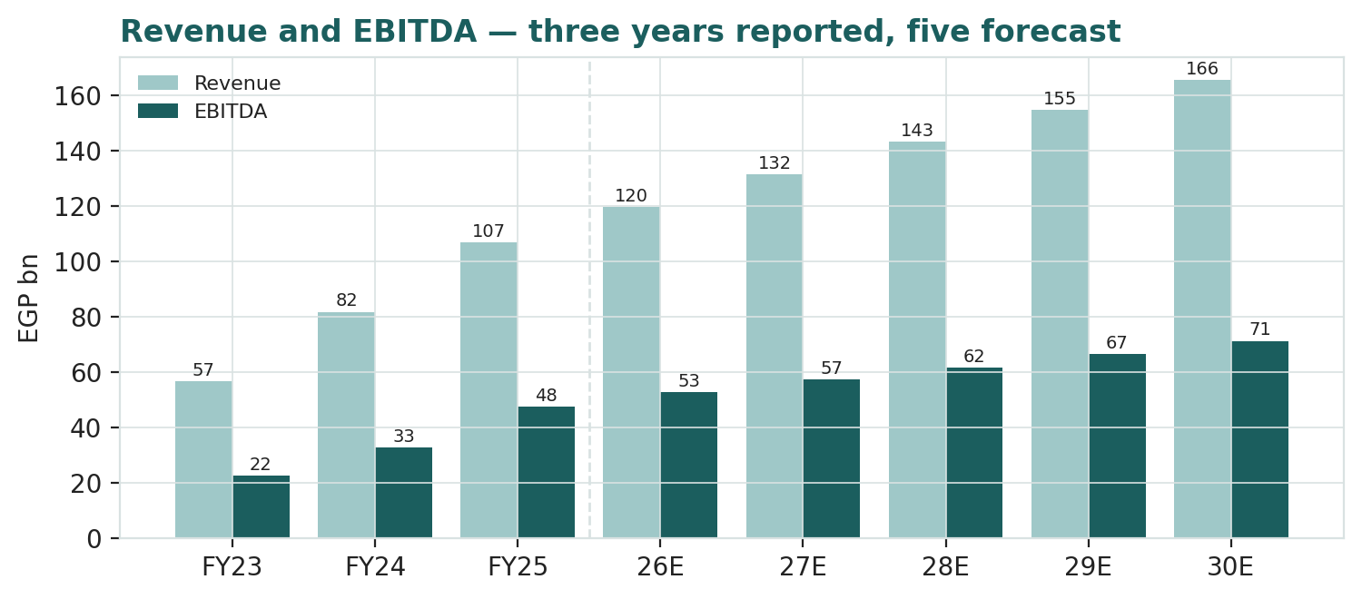
Figure 7 — Revenue and EBITDA: three years reported, five forecast (model; FY26E–FY30E drivers on the Assumptions sheet of the companion workbook).

Appendix B Step 0 — calibration backtest
Before any forecast we test the Monte Carlo lens on ETEL's own five-and-a-half years of history: at 17 non-overlapping quarterly origins (h = 60 sessions), using only data up to each origin, the YZ-HAR engine generates the three-month-ahead distribution and the realized close is scored against it. The grade is skill versus a naïve benchmark — a zero-drift random-walk lognormal cone on trailing realized vol — measured by CRPS skill and the 80% Winkler interval score; the PIT histogram and the coverage table are diagnostics only, because hit-rates reward width. Two drift configurations were run. Drift-OFF (the default for a first-pass asset class) beat the benchmark on CRPS (+4.5%) but produced a materially right-skewed PIT (mean 0.66, KS p = 0.03): realized prices sat persistently in the upper half of the forecast — the signature of this name's genuine secular uptrend. Per protocol we recalibrated the asset-class drift and re-ran: with the EGX secular drift ON, CRPS skill rises to +13.0%, Winkler skill to +20.3%, and the PIT is statistically uniform (KS p = 0.54). EGX-telecom therefore joins the EGX secular-drift class, and drift-ON is the configuration carried into §3.
Configuration | n | CRPS skill | Winkler skill (80%) | 50% band | 80% band | 90% band | PIT mean | KS p
Drift OFF (rejected) | 17 | +4.5% | +16.9% | 47% | 71% | 94% | 0.66 | 0.03
Drift ON (adopted) | 17 | +13.0% | +20.3% | 41% | 71% | 88% | 0.55 | 0.54
Target / pass rule | — | > 0 | > 0 | 50% | 80% | 90% | 0.50 | uniform

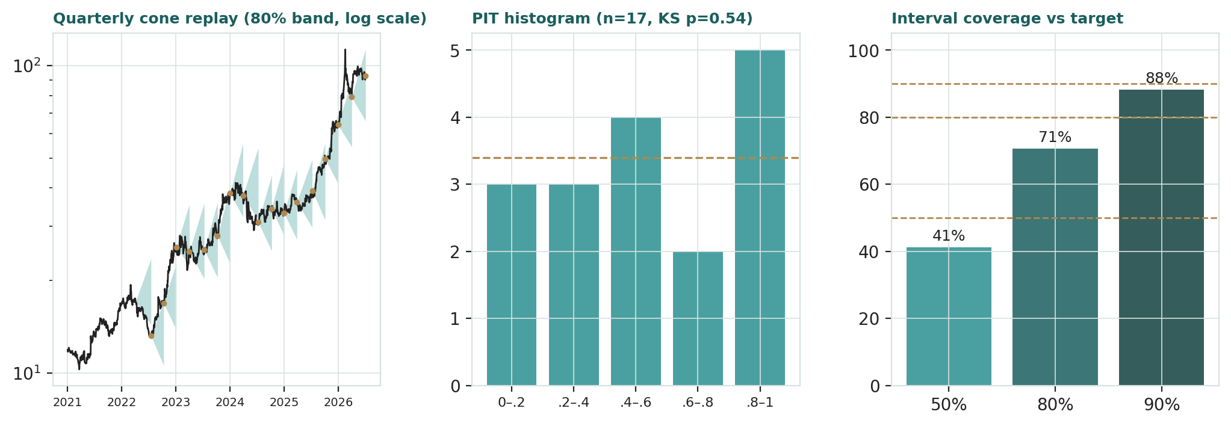
Figure B-1 — Calibration backtest (drift-ON): quarterly cone replay (80% band, log scale), PIT histogram, and interval coverage versus target.
Coverage sits within small-sample tolerance of target at all three bands (with n = 17, one window is ±6 points) and the point coverage below target is the correct direction for a CRPS-graded engine — sharp, not padded. The per-origin scores are archived in files/step0_drift_on.csv; anchor_vol and horizon_days accompany any ledger row so the benchmark can be rebuilt at maturity.

Appendix C Peer set, sector structure, and risks
ETEL has no clean comparable — a fixed-line monopoly, a subsea-corridor operator and a 45% mobile associate in one wrapper. The peer set is therefore split by part, with typical bands rather than a single screen.
Peer | Market | Typical EV/EBITDA | Typical P/E | Why it matters
Vodacom Group | JSE | 4.0–5.0× | 9–11× | Owns the other 55% of VFE — the natural read-across for the stake
stc (Saudi Telecom) | Tadawul | 7–8× | 15–17× | The GCC quality ceiling
e& (Etisalat) | ADX | 5.5–6.5× | 10–12× | Regional incumbent benchmark
Ooredoo | QSE | 4.5–5.5× | 10–12× | MENA multi-market operator
Turk Telekom | BIST | 3–4× | 5–8× | High-inflation EM incumbent — the closest macro analogue
Mobily | Tadawul | 6–7× | 13–15× | Mobile pure-play reference for VFE

Sector structure. Egyptian mobile is a four-operator market led by Vodafone Egypt (~42–43% share) ahead of Orange, e& Egypt and ETEL’s own WE (~10–13%); fixed-line and fibre are an ETEL monopoly that wholesales to all of them, so the incumbent is paid on both sides of its own competition. Internationally, the Suez corridor gives Egypt a dominant share of Europe–Asia traffic and ETEL the landing-station franchise. Principal risks: a state placement into the float and the broader divestment overhang; the VFE mark proving optimistic at monetization; EGP regime shifts in either direction; NTRA pricing risk (the 2026 round was favourable — the next may not be); a capex cycle that re-inflates past 30% of sales; and Red Sea security disrupting the cable franchise.

Appendix D The expert valuation panel
Every Testahil study closes with a panel of standing expert personas — drawn from the house Expert Persona Library, not invented for the occasion, so that each accumulates a track record across studies and a quarterly update is a re-run, not a re-training. For ETEL we cast the three whose methods both fit an operating incumbent wrapped around a large unlisted associate and genuinely disagree: Expert 1 (net asset value and the wrapper discount), Expert 2 (normalized earnings power and justified multiples), and Expert 3 (cash returns — return on invested capital versus its cost). Each runs a different method, derives its fair value from shown workings, and states a falsification condition. The macro-policy lens — the pound, the CBE, the regulator, the sovereign — runs through the body (§1.8, §5) rather than as a separate persona, because in this name it is an input to all three methods rather than a method of its own.

D.1 Expert 1 — net asset value and the wrapper discount
Worldview and tradition. A company that is partly a container of assets is worth the sum of those assets at realizable value, less a discount for the container. He descends from the closed-end-fund and holding-company literature: mark each part to what a willing buyer would pay for it alone, deduct the debt, and then argue about one number — the discount — which he treats as an observable market object with its own history and its own catalysts, not a fudge factor.
When it works / when it fails. The method is at its best exactly here: the parts are separable (a core operator and a 45% associate that never consolidates), one part has a real transaction mark, and a discount is plainly observable at spot. It fails when a mark is stale or illusory — an unlisted stake is worth its mark only if someone will eventually pay it — and when the container itself destroys value faster than the discount admits (forced placements, trapped cash, minority abuse).
Standard workings. (1) Mark the core on a going-concern multiple of forward EBITDA. (2) Mark the associate on earnings, triangulated against the last transaction. (3) Add residuals, deduct net debt. (4) Choose a fair discount from the wrapper’s specific defects — control, float, payout, monetization path — and compare it to the implied discount at spot.
Expert 1’s marks (EGP bn) | Value
Core Telecom Egypt (52.6 × 3.25×) | 171.0
Vodafone Egypt 45% (32.9 × 8.0× × 45%) | 118.4
Other (data-hub JV, land, non-core) | 6.0
Σ EV − net debt 58 = EGP 139.0/sh pre-discount | 237.4
Fair wrapper discount 12% (payout rising, monetization path live) | → EGP 123/sh

Worked example — pricing the discount itself. He decomposes his 12% as: ~5 points for the 70% state holding and its placement overhang (2023’s 9.5% cleared at EGP 23.11 — supply happens, and at a price); ~4 points for the associate’s minority-no-listing status (income you book but cannot direct); ~3 points for a 13% payout that keeps cash inside the wrapper. Each defect has a live cure: a formal payout policy, a VFE listing, a placement that raises float. That is why his fair discount (12%) sits under the study’s 15% and far under the ~33% the market implies.
The discount’s own history. He also reads the implied discount as a time series, because a discount that has already travelled tells you it can travel again. At the May-2023 placement price of EGP 23.11 the market was paying roughly a 55–60% discount to a then-NAV built on the freshly-struck Vodacom deal mark and a pre-repricing core — the deepest print in the series, made at the bottom of the devaluation panic. Through the 2024–25 record years the implied discount compressed steadily as the income line tripled and leverage halved, reaching the low-30s at the February-2026 all-time high before settling at today’s ~33%. Two mechanical observations follow. First, the compression so far has come entirely from the numerator (value grew into the price); the discount itself has never actually re-rated — which is his opportunity. Second, every prior EGX wrapper that installed a formal payout policy or listed a crown-jewel subsidiary saw its discount close by double digits within four quarters; ETEL has both levers loaded and unpulled. His 12% is therefore not a hope — it is where comparable cured wrappers already trade.
Sensitivity (swing = the discount). On his marks, EGP 139.0/sh pre-discount: at a 5% discount EGP 132; at 15%, 118; at 25%, 104; at the market-implied ~33%, 93 — which is spot. The entire debate between him and the market is that one number.
Cross-examination. He tells Expert 2 that capitalizing a normalized EPS silently re-marks the associate at the group multiple — the blend launders the stake’s value into an earnings line and then discounts it twice. He tells Expert 3 that charging the group a 23% WACC on invested capital penalises the associate for capital ETEL never invested and does not control — the stake is a claim, not a project.
Verdict, falsification, market-implied. Fair EGP 123 (range 105–140). Falsified if the marks prove unrealizable — above all if a VFE monetization or listing clears materially below an 8× earnings mark — or if the state demonstrates that the wrapper’s defects are permanent (placements at deep discounts, payout frozen). The market price implies a ~33% discount to his NAV: nearly three times what he judges fair.

D.2 Expert 2 — normalized earnings power and justified multiples
Worldview and tradition. An operating business is worth a fair multiple of its sustainable mid-cycle earnings; peaks, troughs and translation noise are to be stripped out, not capitalized. She works in the Graham-and-Dodd normalization line: find the earnings level the franchise defends through a cycle, justify a multiple from growth, payout and risk, and refuse to pay for arithmetic that depends on a single hot year.
When it works / when it fails. Best for franchises with pricing power and a repeating demand base — an incumbent selling connectivity in a 105-million-person market qualifies. It fails at structural breaks: if the 2024–25 earnings step is a devaluation artefact that real-terms competition claws back, her “mid-cycle” is an illusion; and it is blind to balance-sheet and wrapper questions by construction.
Standard workings. (1) Rebuild NPAT ex-FX noise and one-offs. (2) Test the level against bottom-up drivers (tariffs, subscribers, VFE income, interest path). (3) Set a justified P/E off peers and the name’s own history. (4) Multiply, and state what growth the market is refusing to pay for.
Expert 2’s normalization | Value
FY25 reported NPAT (EGP bn) | 22.6
+ FX-noise strip (Q1-26 alone: 5.3 non-cash) and full-year tariff effect | → 30.0 mid-cycle
Shares (mn) → normalized EPS (post profit-share) | 1,707 → EGP 15.8
Justified P/E (EM incumbent; below every Gulf peer) | 8.5×
Fair value | → EGP 134/sh

Worked example — is 30 defensible? Take Q1-26’s adjusted EGP 5.9bn (+27% YoY), annualise to ~24, add a half-year of the 13–15% tariff round on the ~EGP 62bn retail base at incumbent drop-through (~3–4bn), a year of CBE easing on ~EGP 74bn of gross debt (~2bn), and VFE income compounding in the teens (~2bn): the bridge reaches 30–32 without heroics. Her 30 takes the bottom of it.
Justifying the 8.5×. The multiple is built, not borrowed. On the standard identity — justified P/E ≈ payout ÷ (r − g) — an EGP investor demanding ~23% against ~12% nominal mid-cycle growth needs only a ~35% payout to justify 3.2× as a floor with zero growth credit beyond the terminal, and ~8× once the double-digit near-term ramp is present-valued explicitly; her two-stage build (five years at the model path fading to the terminal) lands at 8.3–8.9× across reasonable fade speeds, and she rounds to 8.5×. Triangulation says the same thing from outside: Turk Telekom — the one peer living in comparable inflation — trades 5–8× on stagnant real earnings, and ETEL’s real earnings are not stagnant; the Gulf incumbents trade 10–17× on lower growth and lower rates. 8.5× is therefore the humble middle: above a broken-macro comp, far below the petro-premium set, and precisely what the dividend-discount arithmetic supports if the payout merely rises toward the level the balance sheet already permits.
Sensitivity (swing = the multiple, then the level). At 7.0× her EPS gives EGP 111; at 10.0×, 158. If normalization is only 25bn, base drops to EGP 112; at 34bn it is 152.
Cross-examination. She tells Expert 1 that a NAV table is static — his 8× mark on VFE is itself an earnings judgment wearing an asset costume, so he should stop pretending the methods differ on the stake and argue the multiple openly. She tells Expert 3 that charging a 23% nominal WACC against returns earned in the same 25%-inflation era double-counts the macro: deflate both sides or neither.
Verdict, falsification, market-implied. Fair EGP 134 (range 111–158). Falsified if the tariff round is competed or regulated away and 2027 EPS stalls below ~EGP 12 — i.e., if 2025 was the peak, not the base. The market pays 5.9× her normalized EPS: it is refusing to pay even a no-growth multiple for a franchise growing earnings at double digits.

D.3 Expert 3 — cash returns: ROIC versus the cost of capital
Worldview and tradition. A business creates value only when each pound of capital earns more than it costs; everything else is redistribution. He is the economic-profit discipline — NOPAT over invested capital against WACC — and he is professionally allergic to Egyptian nominal arithmetic, where 30% revenue growth can coexist with real value destruction if the capital base inflates faster still.
When it works / when it fails. Best for capital-heavy operators, which is precisely what a fibre-and-subsea incumbent spending 28–31% of sales in cash capex is. It fails when the capital base misstates the economics — an associate carried at EGP 30.9bn book that earns 14.8bn for its owner makes group ROIC meaningless unless the stake is carved out, which he does — and at genuine inflection points, where trailing returns understate a repriced future.
Standard workings. (1) Carve the associate out of both NOPAT and invested capital. (2) Compute core ROIC on the operating base. (3) Value the core as invested capital × ROIC/WACC (the no-growth economic-profit identity). (4) Add the stake at a conservative mark, deduct debt.
Expert 3’s economic-profit test | Value
Core NOPAT 2026E (EBIT 36.9 × (1−22.5%)) (EGP bn) | ~28.6
Core invested capital (net fixed 119.8 + WC & licences, ex-VFE book) | ~160
Core ROIC vs WACC | ~17.9% vs ~23% → negative spread
Core value = IC × ROIC/WACC | ~125
+ VFE stake at deal-anchored mark (no growth credit) | +100
− Net debt 58 → equity | 167
Fair value | → EGP 98/sh

Worked example — why below book economics. The core earns roughly 18 pounds per hundred invested while its capital costs 23: on the identity, a pound inside this operator is worth ~78 piastres until the spread closes. He allows two honest outs — the tariff round lifts NOPAT without new capital (pure spread repair), and the CBE cycle is cutting the 23% itself — but he prices what is, not what is promised, and marks VFE at the FX-translated 2022 deal (~EGP 100bn for the 45%) with zero growth credit, because an unlisted minority claim earns no premium in his book until cash proves it.
The incremental-capital ledger. His second table is the one management never publishes: what the last pound of capex earned. Across FY23–FY25 the company put EGP 91bn of cash capex to work (26.4 + 35.1 + 29.6) while core EBITDA rose EGP 25bn and his core NOPAT roughly EGP 13bn — an incremental pre-tax cash return in the mid-teens on money spent at the top of a 25%-rate cycle, some of it forced (the 5G licence, FX-hedging prepayments to vendors) rather than chosen. That is the honest indictment and the honest hope in one number: trailing incremental returns sit below the hurdle, but the 2026 vintage is different in kind — cash capex is guided down toward the low-20s of sales just as the tariff round lifts NOPAT on the existing base, so the marginal spread turns positive even while the average spread still reads negative. He credits none of that until it prints, which is exactly why his number is the floor of the panel and why his falsification condition is the first one likely to trigger.
Sensitivity (swing = WACC, then the spread). At a 21% WACC his core is worth ~136 and the total ~EGP 104/sh; at 25%, ~EGP 92/sh. If the tariff round lifts core ROIC to 21%, base rises to ~EGP 110/sh.
Cross-examination. He tells Expert 1 that a discount debate is premature until the parts themselves earn their keep — a NAV built on a core with a negative economic spread is a sum of optimistic marks. He tells Expert 2 that mid-cycle earnings without the capital consumed to produce them is a half-truth: this franchise spent EGP 91bn of cash capex in three years to deliver her earnings step, and someone must be charged for it.
Verdict, falsification, market-implied. Fair EGP 98 (range 82–115) — the most cautious of the three: modest upside, no margin of safety. Falsified by a durable core ROIC above WACC — two consecutive years of spread — or by VFE cash (dividends or a monetization) exceeding his deal-anchored mark. The market price is a few pounds below his number: on a cash-returns basis, the price is roughly right and everything above it is a bet on the spread closing.

D.4 The three in one room
The single asset they most disagree on is the 45% of Vodafone Egypt — specifically, whether an unlisted minority claim earns its growth in a valuation before cash proves it.
Expert 2: “The income line tripled in two years — 5.3, 8.7, 14.8. Normalize the group and you are paying under six times earnings for the country’s connectivity incumbent. The stake is not a hope; it reports every quarter.”
Expert 3: “It reports; it does not pay. Three point one billion of dividends against fourteen point eight of income — the rest is a bigger book entry inside a wrapper you don’t control. I’ll pay the 2022 deal price, translated. Growth is credited on receipt.”
Expert 1: “You are both pricing the engine and ignoring the container. Mark the parts any way you like — my table says 139 a share before the discount, his sceptical marks still say near 120. The market pays 93. The argument that matters is not eight times versus deal price; it is why a wrapper with a live monetization path and a rising dividend deserves a thirty-three per cent discount. That number, not the multiple, is where the money is.”
Expert 2: “Then we agree more than we admit. His trigger is cash received; mine is earnings sustained; yours is the discount repriced — and all three fire on the same two events: a payout policy and a VFE liquidity event. The disagreement is sequencing, not destination.” Expert 3: “Sequencing is the whole job. Paid first, believed second.”

D.5 Reading the divergence
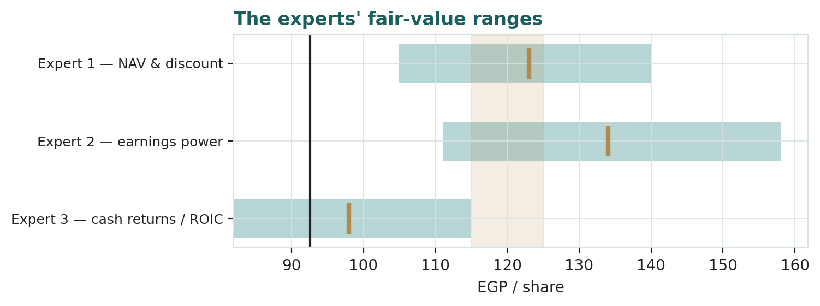
Figure D-1 — The three experts’ fair-value ranges. Brass ticks are base cases; the gold band is the study central; the dark line is spot. The spread is almost entirely a VFE-and-discount disagreement.
Expert | Method | Single swing assumption | Base fair value
Expert 1 | NAV & wrapper discount | Fair discount (12%) | EGP 123
Expert 2 | Normalized earnings power | Mid-cycle NPAT EGP 30bn / 8.5× | EGP 134
Expert 3 | Cash returns / ROIC | Core ROIC ~18% vs ~23% WACC | EGP 98

The spread — EGP 98 to 134 at base — is narrow for an EGX name, and it is almost entirely one disagreement: how much of the Vodafone Egypt earnings stream, and of the tariff-led earnings step, gets credited before cash confirms it. None of the three contests the operating record, the balance-sheet repair, or the existence of the subsea franchise. Expert 2 credits growth as reported; Expert 3 credits it on receipt; Expert 1 says the credit question is really a discount question on the wrapper that stands between shareholders and the cash. The EGP 36 spread is therefore a clean measure of a single uncertainty — the conversion of booked associate income and regulated price rises into distributable cash. Resolve that, and the three converge from both sides onto the study’s central.
Each expert’s point fair value (and bull/base/bear) is logged with the study date (03 Jul 2026) and spot (EGP 92.6) as an internal per-expert track record, kept separate from the core Calibration Ledger.

About this series
Testahil publishes independent, educational valuation studies. Each is an attempt to reason transparently about what a security is worth, with every assumption shown and a companion model so readers can disagree productively. The house style is distributions, not tips: we describe ranges and probabilities, not targets, and we do not tell anyone what to do. Studies are framed as educational analysis, the preparer is not licensed by any securities regulator, and holdings are disclosed.

Disclosure & Disclaimer
Not investment advice. This document is educational and informational only. It is not, and must not be relied upon as, investment, financial, legal, accounting or tax advice, nor an offer, solicitation or recommendation to buy, sell or hold any security. It contains no price target and no rating
No licence; no advisory relationship. The preparer is not registered or licensed with any securities or financial regulator in any jurisdiction — including the Financial Regulatory Authority (FRA) of Egypt — holds no brokerage or investment-advisory authorisation, and is not acting as your adviser or fiduciary. Nothing here is personalised to your circumstances
Holdings disclosure. The preparer may hold, and may in the future take or dispose of, a position in the security discussed in this report, and may transact at any time without notice. This is a potential conflict of interest you should weigh
Sources & accuracy. Reported financial and operating figures are drawn from the company’s public disclosure (FY2025 audited results, 26 Feb 2026; the Q1 2026, FY2024 and FY2023 releases), EGX/LSE filings and other public sources believed reliable but not independently verified; they may contain errors or be superseded. Forward-looking inputs — the SOTP marks, the Vodafone Egypt stake mark, the complexity/state-control discount, projections, multiples, the DCF and Monte-Carlo factor probabilities — are the preparer’s own judgments and are inherently uncertain
Forward-looking statements. Any statements about the future are estimates subject to risks and uncertainties; actual results may differ materially. The Monte Carlo models price, not value, and encodes subjective probabilities for events that have not occurred
No reliance; your responsibility. Do your own research and consult a licensed professional before making any decision. You are solely responsible for your investment decisions and their outcomes. To the maximum extent permitted by law, the preparer accepts no liability for any loss arising from use of this document
Currency & figures. All figures are in Egyptian pounds (EGP); bn denotes billions. FX at study date: USD/EGP 49.1. Rounding may cause totals to differ slightly. Spot price and market data are as of 01 July 2026 and change continuously
TESTAHIL · Independent Valuation Study · Educational Analysis · Telecom Egypt Company S.A.E. (EGX: ETEL) · edition 03-07-2026 · reporting currency EGP

