Testahil · Independent Valuation Study — Educational Analysis Not investment advice

Elm Company
Valuation Study — Tadawul: 7203 · reporting currency SAR
Fundamental analysis · Technical analysis · Monte Carlo simulation — one integrated read
Spot SAR 658.50 · close 2026-07-07 · shares 80m · market cap SAR 52.7bn · div yield 1.3%
One-line thesis: a monopolistic government-digital-platform compounder that has de-rated ~49% from its Jan-2025 peak; after the crash it trades roughly around a neutral-beta fair value, and the swing factor is now the discount rate the market assigns it.
READ FIRST. This is an educational valuation study, not investment advice, and contains no recommendation, rating, or price target. It presents a range of fair value and a probability distribution of the three-month price path — descriptive, never directive. Elm has a short (~4.4-year) listed history dominated by one boom-bust cycle; several forecast inputs are the preparer’s own flagged views, and the discount rate — the single largest swing factor — is deliberately shown across a wide sensitivity band rather than as a point. The preparer may hold, and may in future take or dispose of, a position in the security discussed.

The company
Elm Company is Saudi Arabia’s leading provider of digital-government services and business-process outsourcing. Founded in Riyadh in 1988 and majority-owned by the state through the Public Investment Fund, Elm builds and operates the digital platforms through which Saudi citizens, residents and businesses transact with the government — among them Absher (national identity, visa and traffic services), Muqeem (residency and work permits) and Nusuk (pilgrimage planning) — alongside a business-enablement and outsourcing arm and a professional-services and consulting practice. Its competitive moat rests on privileged, largely exclusive access to the Kingdom’s national data registry, which the company turns into high-margin, transaction- and subscription-based products; roughly 70% of revenue is recurring and about 38% is earned from the public sector. Since listing on the Tadawul in February 2022, Elm has compounded revenue at about 25% a year to SAR 7.4bn in 2024 while earning exceptional returns on capital (ROIC ~88%) from an asset-light, net-cash balance sheet — making it one of the most direct listed proxies for Vision 2030’s drive to digitise the Saudi economy.
At a glance
Item | Value
Listing | Tadawul: 7203 (IPO 9 Feb 2022 at SAR 128; capital SAR 800mn, 80.0m shares @ par 10)
Business | Saudi Arabia’s leading digital-services & business-process-outsourcing group (founded 1988)
Segments | Digital Business (73.8% of 2024 revenue), Business Process Outsourcing, Professional Services
Flagship platforms | Absher (e-visa/permits), Muqeem (work permits), Nusuk (pilgrimage), Tabadul, Thiqah — national-registry access
FY2024 revenue / net profit | SAR 7,407mn (+25.6%) / SAR 1,824mn (+35%); EPS SAR 23.51
Profitability | Gross margin 40.9%, EBIT margin 23.0%, ROE ~39% (avg equity; ~47% trailing), ROIC ~88%; ~70% recurring revenue
Balance sheet | Net cash (~SAR 4.2bn cash & Murabaha; ~SAR 1.9bn net of leases/income-sharing); negligible financial debt
Ownership / customer mix | ~38.5% of 2024 revenue from the public sector; strategic government relationships
Spot / range | SAR 658.5; 52-week SAR 509–983; all-time high SAR 1,289 (Jan 2025)

Headline
Elm listed in February 2022 at SAR 128, ran ~10× to an all-time high of SAR 1,289 (P/E ~56×) in January 2025, and has since de-rated to SAR 658 (P/E ~24×) — down ~49% from the peak and ~10% below its 200-day average. The crash has done most of the work of correcting the euphoria. On a neutral-beta base case (β 1.0, WACC 10.5%) the discounted-cash-flow value is ~SAR 576, the relative lenses bracket spot (EV/EBITDA ~SAR 590–660, forward P/E ~SAR 690), and a weighted central fair value sits near SAR 620 (range ~530–720). Spot at SAR 658 is therefore ~6% above that central estimate — roughly fairly valued, a slight premium. The whole valuation, though, hinges on one number: the discount rate a de-rated hyper-grower deserves. At Elm’s unusually low historical beta (~0.37 → WACC ~8%) the DCF says ~SAR 750–900; at a neutral beta ~SAR 576; and if the market now re-rates Elm as a high-beta name post-crash (β ~1.6–2.0 → WACC ~13.5–15.7%) the DCF falls to ~SAR 370–430. That fork is the study’s crux.
Valuation summary — every read at a glance
Lens | Method | Fair-value read (SAR) | Weight
FUNDAMENTAL
1.1 Primary — DCF | 5-yr FCFF, β 1.0, WACC 10.5% (rating) / 11.2% (CDS), g 4% | 576 (range 396–750 on β 0.7–1.6) | 40%
1.2 Cash-flow cross-check | FCFF yield & ROIC-vs-WACC spread | directional — supports mid-600s
1.3 Relative — EV/EBITDA | 16–22× 2025e EBITDA of SAR 2,529mn | 529–719 (18–20× ≈ 593–656) | 25%
1.3 Relative — forward P/E | 20–28× 2025e EPS of SAR 28.6 | 572–800 (24× ≈ 686) | 30%
1.4 Version/recurring cycle | ~70% recurring, platform-launch cadence | qualitative — durability check
TECHNICAL
2 Price structure | Below MA20/50/100/200; RSI ~37 (oversold); MACD negative | downtrend, oversold near support
MONTE CARLO
3 Path distribution (T+60) | Saudi-fitted ν=5, carry-anchored, 50k paths | median 662 (+0.6%); 50% band 589–746
EXPERT PANEL
Expert 1 — growth durability | discount-rate-anchored DCF | ~560–680
Expert 2 — quality & moat | ROIC-vs-WACC / normalized power | ~600–720
Expert 3 — macro / Vision 2030 | TAM penetration | ~560–700
WEIGHTED CENTRAL FAIR VALUE |  | ≈ 620 (range ~530–720) | 100%

Fair-value ranges and a probability distribution — never a rating or target. Spot SAR 658.5 sits ~6% above the weighted central estimate: roughly fairly valued, a slight premium, with the discount rate the dominant swing factor.
1 · Fundamental valuation
Elm is a digital-government-platform and services company: asset-light, cash-generative, and structurally levered to Saudi Arabia’s digitisation. It is not a bank, a developer, or a holding company, so the instrument-appropriate primary lens is a discounted-cash-flow model on the operating business, cross-checked with relative multiples and a recurring-revenue durability read. The value gap identified here is a ~12-month fundamental anchor and is kept entirely separate from the three-month Monte Carlo path in §3.
1.1 Primary lens — discounted cash flow (FCFF)
We forecast five explicit years of free cash flow to the firm off the operating business (EBIT, excluding the Murabaha/investment income the cash pile throws off — that cash is added back separately as net cash, so it is not double-counted). Revenue is modelled to compound at ~16% and moderate toward the terminal rate; the EBIT margin expands modestly from 23.0% as the higher-margin Digital Business gains share, partly offset by rising lease depreciation and outsourcing mix. Zakat is applied at the ~7% effective rate Elm actually pays (it pays zakat, not the 20% corporate tax).
SAR mn | 2025e | 2026e | 2027e | 2028e | 2029e
Revenue | 9,651 | 11,302 | 12,907 | 14,455 | 15,901
growth % | 30.3% | 17.1% | 14.2% | 12.0% | 10.0%
EBITDA | 2,529 | 2,995 | 3,446 | 3,903 | 4,293
− Depreciation & amortisation | (290) | (339) | (387) | (434) | (477)
EBIT | 2,239 | 2,656 | 3,059 | 3,469 | 3,816
EBIT margin | 23.2% | 23.5% | 23.7% | 24.0% | 24.0%
NOPAT (EBIT×(1−z)) | 2,082 | 2,470 | 2,845 | 3,226 | 3,549
+ Depreciation & amortisation | 290 | 339 | 387 | 434 | 477
− Capex | (309) | (350) | (387) | (434) | (477)
− Δ working capital | (56) | (41) | (40) | (39) | (36)
Free cash flow to firm | 2,007 | 2,417 | 2,805 | 3,188 | 3,513
Discount factor | 1.105 | 1.221 | 1.350 | 1.491 | 1.648
PV of FCFF | 1,816 | 1,980 | 2,078 | 2,137 | 2,131

Free cash flow to the firm, five-year explicit forecast. Every input links to the model’s Assumptions sheet. Capex and ΔWC shown in parentheses.
DCF bridge to value | SAR mn / per share
Sum of PV of explicit FCFF (2025e–29e) | 10,142
Terminal value (Gordon, g 4%, WACC 10.5%) | 56,121
PV of terminal value | 34,050 (77% of EV)
Enterprise value | 44,192
+ Net cash (net of leases & income-sharing) | 1,900
Equity value | 46,092
÷ shares (m) | 80
Fair value per share (base case) | SAR 576

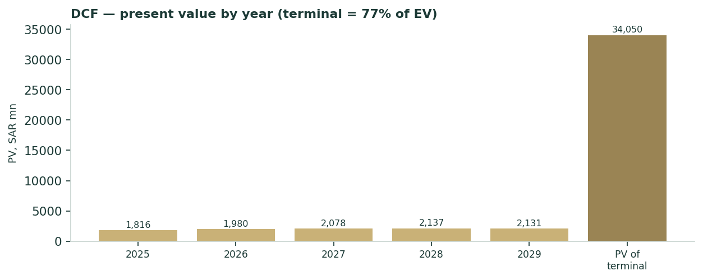
Present value by year. The terminal block dominates — the signature of any high-growth DCF — which is why the discount rate, not the near-term forecast, drives the answer.
Terminal value is 77% of enterprise value — high, as it must be for any fast-grower, and disclosed rather than buried. That dependency is exactly why the discount rate is the crux and is sensitized so widely in §1.9. The base case rests on a neutral beta of 1.0; the derivation of the cost of capital, and the beta question, are in §1.8.
1.2 Cash-flow cross-check — returns on capital
Elm converts roughly 90% of net profit into operating cash and earns a return on invested capital near 88% — a function of the asset-light, national-registry-access model where incremental platform transactions carry almost no incremental cost beyond income-sharing. With a cost of capital near 10.5%, the ROIC-vs-WACC spread is enormous, which is the economic case for a premium multiple and for value that is heavily terminal. The cross-check does not produce an independent point estimate; it confirms that the mid-600s implied by the other lenses is consistent with the quality of the franchise, provided the moat holds.
1.3 Relative multiples
Elm has historically traded at ~42× earnings and briefly 56× at the peak, a ~114% average premium to the TASI (currently ~24× vs TASI ~17.5×). Applying a defensible forward range to 2025e metrics:
Multiple applied | 16× | 18× | 20× | 22×
EV/EBITDA → EV (SAR mn) | 40,464 | 45,522 | 50,580 | 55,638
→ per share (SAR) | 529 | 593 | 656 | 719

Multiple applied | 20× | 24× | 28× | 32×
Forward P/E → per share (SAR) | 572 | 686 | 800 | 915

On 2025e EBITDA of SAR 2,529mn and 2025e EPS of SAR 28.6. The relative lenses bracket spot: EV/EBITDA at a still-premium 18–20× implies SAR 593–656; forward P/E at 24× (well below Elm’s history, roughly the current multiple) implies SAR 686.
1.4 Recurring-revenue and platform-cycle framing
For a software/platform name, “normalised earnings power” is replaced by a recurring-revenue and platform-cadence read. About 70% of Elm’s revenue is recurring (transactions and subscriptions on established platforms), and the backlog is ~SAR 3.8bn. Growth arrives in steps as new platforms mature and cross-sell compounds; margins on existing products improve with usage. The durability question is not whether Elm grows, but whether its exclusivity — access to the national data registry that underpins the highest-margin Digital Business line — persists. That is the moat, and its potential erosion is the bear case (see §1.7 and Appendix B).
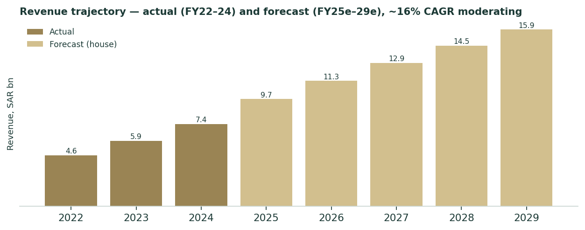
Revenue: three actual years (FY22–24) and the five-year forecast (FY25e–29e), compounding ~16% and moderating — broadly in line with sell-side ranges but built from the preparer’s own drivers.
1.5 Synthesis — five lenses and the football field
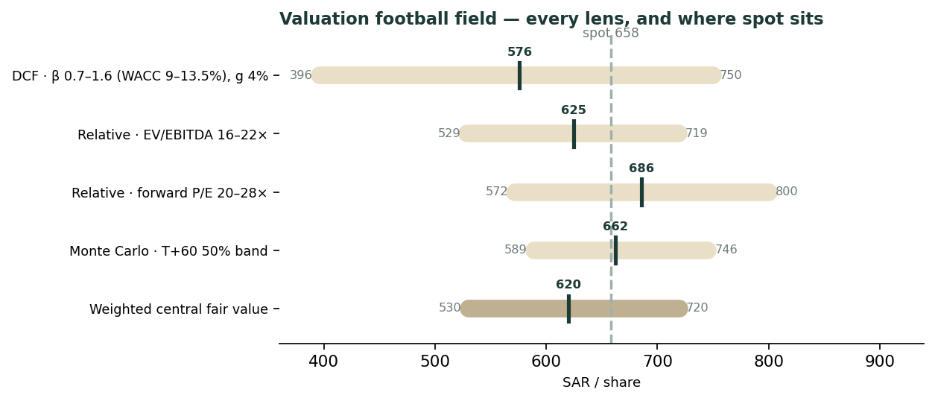
Every lens on one axis. The DCF spans a wide band because 77% of its value is terminal and therefore discount-rate-driven; the relative lenses and the weighted central (~SAR 620) bracket spot, which sits at the upper edge of the fair-value range.
The lenses converge on a central fair value near SAR 620 with a range of roughly SAR 530–720. Spot at SAR 658 is inside that range, ~6% above the centre — the de-rate has removed the euphoria and left Elm trading around intrinsic value on a neutral-beta base case. The dispersion is dominated not by disagreement about the business but by the discount rate.
1.6 Segment scorecard
Segment (FY2024) | Revenue SAR mn | % of total | Growth | Gross margin | Role
Digital Business | 5,469 | 73.8% | +28.5% | ~46% | Highest-margin engine; national-registry platforms
Business Process Outsourcing | ~1,300 | ~18% | +20.7% | ~25% | Scaling; lower margin, large TAM as firms in-source
Professional Services | ~640 | ~9% | −6.7% | declining | Project-based; lumpy, lowest priority
Total | 7,407 | 100% | +25.6% | 40.9% | —

Segment splits for BPO and Professional Services are estimated from disclosed growth rates and the Digital Business figure; the mix is shifting toward the higher-margin Digital Business line (68.9% of revenue in 2017 → 73.8% in 2024).
1.7 The crux — what discount rate does a de-rated hyper-grower deserve?
Because ~77% of DCF value is terminal, the fair value is almost entirely a function of the cost of capital, and Elm’s beta is genuinely ambiguous. Over its full listed life it has behaved like a low-correlation, government-linked defensive (published beta ~0.37); over the last three months it has crashed hard alongside — and amplified relative to — the market (a 40-day regression gives beta ~2.0, but that window is the crash itself). The honest base case takes a neutral beta of 1.0; the sensitivity below shows why this single choice moves fair value from ~SAR 370 to ~SAR 900.
If the market prices Elm as… | implied beta | WACC | DCF fair value (g 4%)
a low-beta government defensive | ~0.7 | 9.0% | ~SAR 750
a neutral equity (base case) | 1.0 | 10.5% | ~SAR 576
a volatile growth name | ~1.3 | 12.0% | ~SAR 469
a high-beta, post-crash re-rate | ~1.6 | 13.5% | ~SAR 396

The crux in one table. The second driver, terminal growth, moves value far less (±SAR ~40 per 50bp). The full grid is §1.9.
1.8 Macro and cost of capital
Elm is a leveraged play on Saudi Arabia’s Vision 2030 digitisation: the government targets the digital economy at 19% of GDP by 2030 (from ~15% in 2024), and Elm sits at the centre of e-government service delivery. The cost of capital is built bottom-up for the Saudi market rather than shortcut to a US rate (the currency peg does not make the SAR and USD curves equivalent):
Cost-of-capital input | Value | Source / note
Risk-free rate (SAR) | 5.5% | Derived SAR 10-year sovereign (KSA USD 10Y UST+95bp + documented SAR-over-USD pickup); short-end anchor 4.6% (1yr Sah sukuk)
Equity risk premium — rating | 5.01% | Damodaran original file, Saudi row (Moody’s Aa3: CRP 0.78% + mature 4.23%)
Equity risk premium — CDS | 5.72% | Same file, Saudi CDS 0.98% (the more conservative of the two)
Beta | 1.0 (anchor) | 40-day TASI regression β 2.03 (R² 21%) is crash-contaminated; long-run published β ~0.37; neutral 1.0 used, sensitized 0.7–1.6
Cost of equity | 10.5% / 11.2% | rf + β×ERP, on the rating and CDS premia respectively
Capital structure | ~100% equity | net cash, negligible financial debt (lease liabilities only) → WACC ≈ Ke
WACC (used) | 10.5% / 11.2% | rating-based primary; CDS-based published alongside per house rule

Both equity-risk-premium bases are published. The beta question is the crux (§1.7); the wide WACC sensitivity in §1.9 is the honest response to it.
1.9 Sensitivity — WACC × terminal growth
WACC ＼ terminal g | 3.0% | 3.5% | 4.0% | 4.5% | 5.0%
7.50% | 862 | 953 | 1071 | 1227 | 1447
9.00% | 646 | 693 | 750 | 819 | 905
10.51% | 516 | 544 | 576 | 614 | 658
12.00% | 431 | 449 | 469 | 493 | 519
13.50% | 369 | 382 | 396 | 411 | 429

Fair value per share (SAR). The base case is WACC 10.51% × g 4.0% = SAR 576. The table makes the discount-rate dependency explicit rather than resolving it: a reasonable person could defend anything from the high-500s to the mid-700s depending on how Elm’s post-crash risk is judged.
2 · Technical and price structure
Indicator | Reading | Interpretation
Spot vs 200-day MA | SAR 658 vs 730 (-10%) | below — established downtrend
MA stack (20/50/100/200) | 695 / 670 / 634 / 730 | price under all four; bearish alignment
RSI (14) | 37 | oversold-leaning; momentum washed out
MACD histogram | -7.2 | below signal — negative but flattening
52-week range | SAR 510 – 982 | spot in the lower third, near recent support

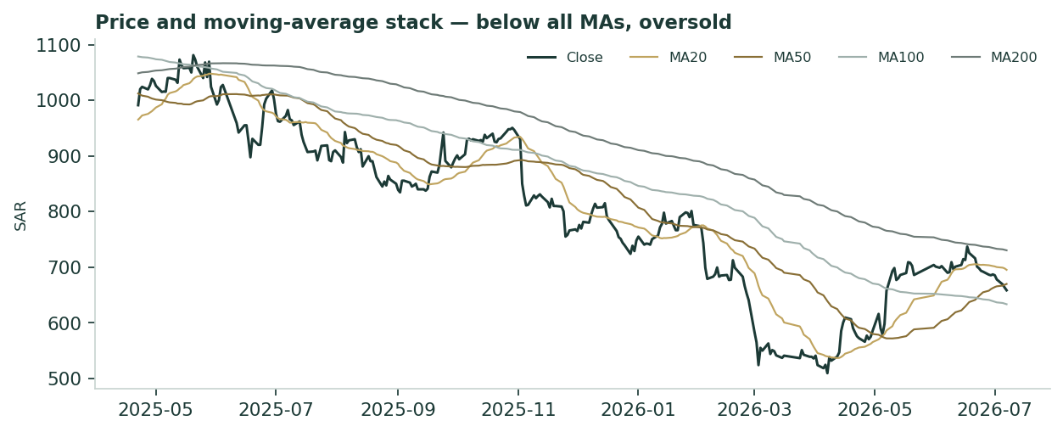
Price below all major moving averages after the de-rate; the tape is a clean downtrend that has become oversold, with spot near the lower band of its 52-week range.
The technical picture corroborates the fundamental one: a stock that has crashed from euphoria to around fair value, now oversold and near support. Technical structure is a description of positioning, not a forecast; the probabilistic view is in §3.
3 · Monte Carlo — the three-month distribution
These paths diffuse from spot as near-term price and deliberately do not embed the §1 fundamental value gap — the value gap is kept out of the drift, so the fundamental and probabilistic lenses stay independent. Width is set by the gap-aware Yang-Zhang / HAR volatility engine calibrated on Saudi’s own panel (Student-t ν=5, width_cal 1.28); the centre is the market-level carry (risk-free minus dividend yield), with no signal (Saudi runs carry-only). 50,000 paths, seed 42.
The probability read
Question (T+60, ≈3 months) | Answer
P(price above spot) | 51%
P(+10%) vs P(−10%) | 30% vs 26% (odds ~1.17:1)
Median level and move | SAR 662 (+0.6%)
50% band (25th–75th) | SAR 589 – 746 (24% of spot)
Touch +10% / touch −10% | 55% / 48%

The median move is +0.6% — a near-flat centre. That is the honest read for Elm: with the SAR risk-free (~4.25%) modestly above the ~1.3% dividend yield, the carry tilts the median very slightly up, and no market signal is added. The direction shown is only the carry; it is an explained flat, not a manufactured view. The width, not the drift, is the story.
Percentile map
Percentile | 5th | 10th | 25th | 50th | 75th | 90th | 95th
T+20 (≈1m) | 547 | 575 | 616 | 660 | 706 | 758 | 798
T+60 (≈3m) | 480 | 522 | 589 | 662 | 746 | 843 | 920
T+60 vs spot | -27% | -21% | -11% | +1% | +13% | +28% | +40%

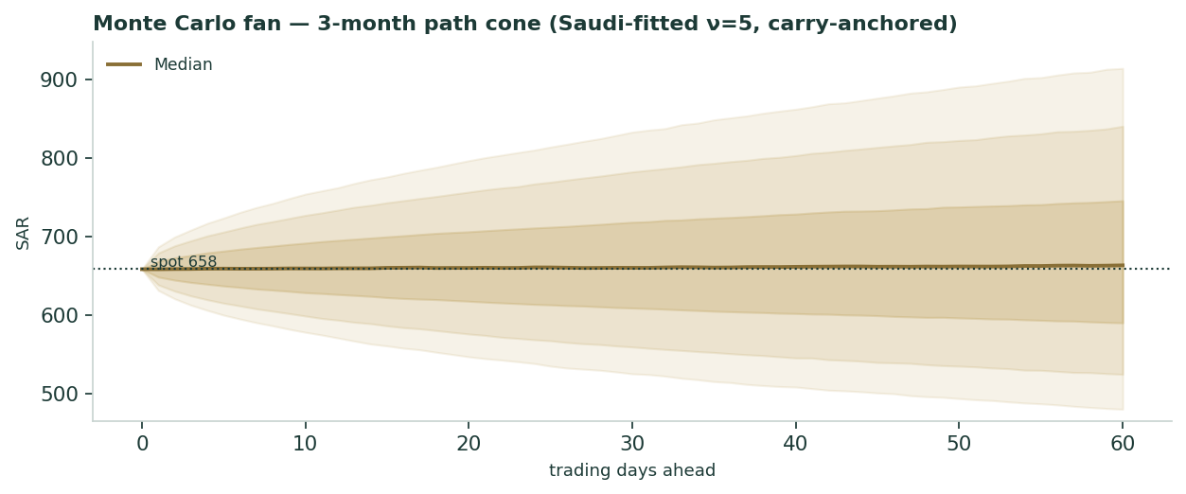
The three-month path cone. The band widens roughly with the square root of time; at T+20 the 50% band is about SAR 617–706, at T+60 about SAR 589–746.
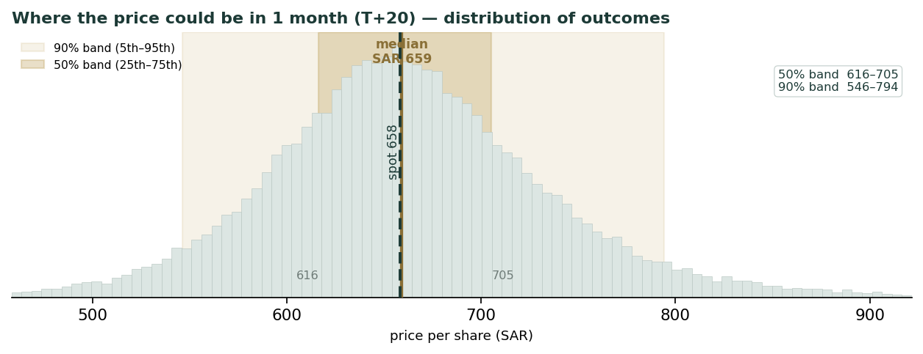
Where the price could be in ~1 month. Bars are the frequency of the 50,000 simulated outcomes; the darker band is the 50% range (25th–75th percentile), the lighter band the 90% range, the brass line the median, and the dark dashed line today’s price. The fitted Student-t (ν=5) has a long, thin upper tail — a handful of extreme paths are cut off the right of the view for readability; the median and bands are computed on all paths and are unaffected.
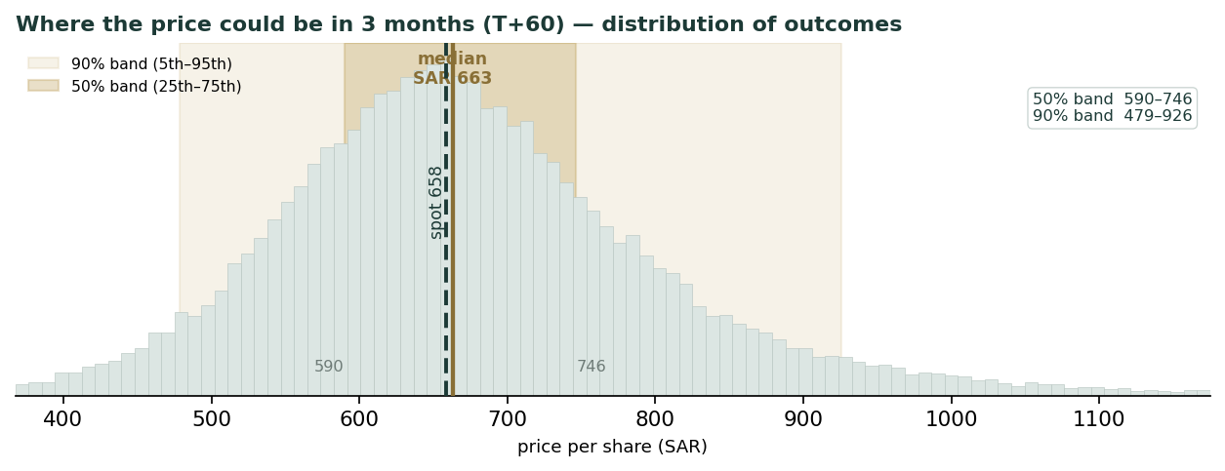
The same read at ~3 months. Half of the simulated outcomes fall between SAR 590 and 746 (the 50% band); nine in ten between SAR 479 and 926. The centre is near flat — a slight upward tilt from the carry — so the width, not the direction, is the message.
Touch-probability ladder
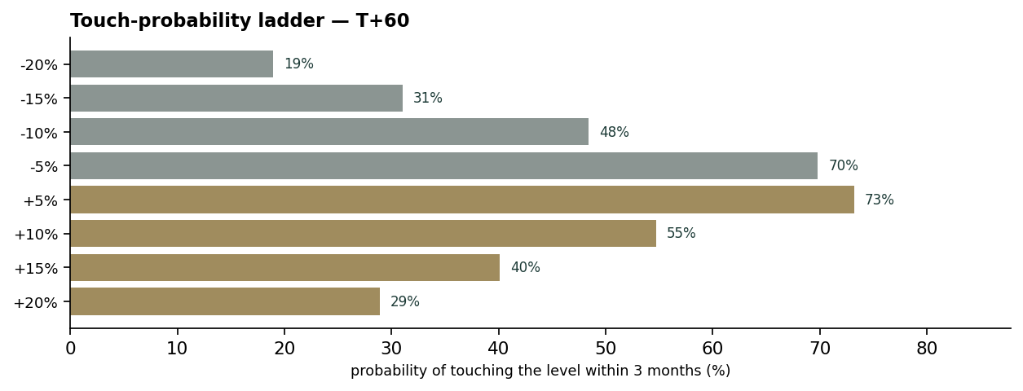
Probability of touching each level at any point within three months. Touching +10% (SAR ~724) and −10% (SAR ~593) are roughly balanced, tilted marginally to the upside by the carry.
4 · Comparison of the lenses, and a verdict
The three lenses agree on the shape of the situation. Fundamentally, Elm has de-rated from euphoria (P/E 56×) to around fair value (P/E ~24×), with a weighted central estimate near SAR 620 and spot ~6% above it. Technically, the tape is a washed-out, oversold downtrend near support. Probabilistically, the three-month distribution is centred near flat with a symmetric ~±12% interquartile band. The honest synthesis: Elm is roughly fairly valued after the crash, trading at a slight premium to a neutral-beta central estimate, with genuine two-sided risk. The single question that decides whether it is cheap or dear from here is the discount rate — i.e. whether the market treats Elm as the low-beta government compounder it has historically been, or re-rates it as a higher-beta growth name after the crash. This study quantifies that fork rather than resolving it.
5 · Catalysts to watch
- Earnings & guidance: full-year 2025 results (revenue tracking ~SAR 9.5–10bn) and 2026 guidance — confirmation or deceleration of the ~16% growth path.
- Exclusivity / data access: any change to Elm’s exclusive access to the national data registry, or to income-sharing terms on flagship platforms — the core moat variable.
- Government pipeline: Vision-2030 project awards, tourism/Hajj digital mandates (Nusuk), giga-project and smart-city work, and the digital-economy GDP target.
- M&A: further platform/Digital-Business acquisitions (following Tabadul/Thiqah) deploying the net-cash balance sheet.
- Cost of capital: the Saudi risk-free path and, above all, how the market re-prices Elm’s beta as the post-crash trading history lengthens.
6 · Reading the probability zones
Zone (T+60) | Range (SAR) | Probability | What it would mean
Upper tail | > 746 | ~25% | moat-durability re-rating / low-beta view reasserts
Upper-mid | 658 – 746 | ~26% | drift back toward the mid-fair-value estimate
Lower-mid | 589 – 658 | ~24% | continued de-rate toward neutral-beta DCF (~576)
Lower tail | < 589 | ~25% | high-beta re-rate / growth or exclusivity scare

Probabilities read off the same 50,000-path T+60 distribution. Zones are descriptive, not targets.
7 · Caveats and what would change our mind
- Discount-rate dependence: the whole DCF pivots on the discount rate (77% terminal value); we anchor a neutral beta but a defensible case exists from ~SAR 370 to ~SAR 900.
- Short, regime-dominated history: Elm’s ~4.4-year listed life is one boom-bust cycle, which makes both its historical beta and its volatility estimates unstable; the 40-day regression beta is crash-contaminated and not used as a point.
- Moat / exclusivity: loss of national-registry exclusivity, adverse income-sharing renegotiation, or a competitor gaining data access would break the highest-margin line and the terminal thesis — the central bear case.
- Government concentration: ~38.5% of revenue is public-sector; a sustained fiscal retrenchment or reallocation of digital mandates would slow the growth path.
- Forecast inputs: several forecast inputs (revenue path, margin trajectory, capex/WC ratios) are the preparer’s flagged views; full-year 2025 audited results would revise the base.
Our mind changes if: Digital Business growth falls below ~10% for two consecutive years; any flagship platform loses exclusivity or is re-tendered; or the market’s pricing of Elm’s beta settles durably away from the neutral anchor — in which case the fair-value range re-centres materially.
Appendix A · Financial statements
A.1 Income statement (SAR mn) — three actual, five forecast
 | 2022a | 2023a | 2024a | 2025e | 2026e | 2027e | 2028e | 2029e
Revenue | 4,606 | 5,898 | 7,407 | 9,651 | 11,302 | 12,907 | 14,455 | 15,901
Cost of revenue | (2,736) | (3,563) | (4,378) | (5,704) | (6,634) | (7,525) | (8,369) | (9,143)
Gross profit | 1,870 | 2,335 | 3,029 | 3,947 | 4,668 | 5,382 | 6,086 | 6,758
Operating expenses | (894) | (981) | (1,326) | (1,708) | (2,012) | (2,323) | (2,617) | (2,942)
Operating income (EBIT) | 976 | 1,354 | 1,703 | 2,239 | 2,656 | 3,059 | 3,469 | 3,816
Other income (net) | + 37 | + 119 | + 251 | + 220 | + 228 | + 236 | + 244 | + 252
Profit before zakat | 1,013 | 1,473 | 1,954 | 2,459 | 2,884 | 3,295 | 3,713 | 4,068
Zakat | (83) | (124) | (130) | (172) | (202) | (231) | (260) | (285)
Net profit | 930 | 1,349 | 1,824 | 2,287 | 2,682 | 3,064 | 3,453 | 3,783
EPS (SAR) | 11.99 | 17.46 | 23.51 | 28.6 | 33.5 | 38.3 | 43.2 | 47.3

Actuals from Elm IR earnings releases and Argaam; forecast columns are the preparer’s model, driven off the Assumptions sheet.
A.2 Balance sheet (SAR mn) — summary
 | 2022a | 2023a | 2024a | 2025e | 2026e | 2027e | 2028e | 2029e
Cash & short-term investments | ~2,900 | ~3,500 | 4,200 | ~5,000 | ~5,900 | ~6,900 | ~8,000 | ~9,200
Other assets | ~3,126 | ~4,597 | 5,354 | ~6,300 | ~7,300 | ~8,300 | ~9,300 | ~10,300
Total assets | 6,026 | 8,097 | 9,554 | — | — | — | — | —
Total liabilities | 2,979 | 4,102 | 4,261 | ~4,500 | ~4,800 | ~5,100 | ~5,400 | ~5,700
Total equity | 3,047 | 3,994 | 5,293 | 6,802 | 8,573 | 10,595 | 12,874 | 15,371

Balance sheet is presented in summary form; forecast is a coherent roll-forward (equity = prior + retained profit at ~66% retention; cash builds with free cash flow). Elm carries no meaningful financial debt — “liabilities” are chiefly lease liabilities, income-sharing payables and zakat. Dashes denote lines not individually forecast.
A.3 Cash flow (SAR mn) — summary
 | 2022a | 2023a | 2024a | 2025e | 2026e | 2027e | 2028e | 2029e
Operating cash flow | 1,706 | 1,559 | 1,662 | 2,521 | 2,980 | 3,411 | 3,848 | 4,224
Capex | — | — | (228) | (309) | (350) | (387) | (434) | (477)
Free cash flow | — | ~1,027 | ~1,434 | 2,212 | 2,630 | 3,024 | 3,414 | 3,747
Dividends paid | (441) | (532) | (583) | ~(620) | ~(700) | ~(800) | ~(910) | ~(1,030)

Operating cash flow and free cash flow; Elm’s FCF conversion is high given the asset-light model (cash capex ~3% of revenue). Historical dividends from the equity-bridge disclosures; forecast at ~33% payout.
A.4 Per-share and ratio dashboard
Per-share / ratio | 2022a | 2023a | 2024a | 2025e
EPS (SAR) | 11.99 | 17.46 | 23.51 | 28.6
DPS (SAR) | 5.50 | 6.65 | 7.29 | 7.75
BVPS (SAR) | 38.1 | 49.9 | 66.2 | 85.0
Revenue growth | — | +28.1% | +25.6% | +30.3%
Gross margin | 40.6% | 39.6% | 40.9% | ~41.3%
EBIT margin | 21.2% | 23.0% | 23.0% | 23.2%
Net margin | 20.2% | 22.9% | 24.6% | ~23.7%
ROE (avg equity) | — | 38% | 39% | 38%
ROIC | ~80% | ~85% | ~88% | ~85%
Free cash flow (SAR mn) | — | 1,027 | 1,434 | 2,212

Valuation at spot SAR 658 | Trailing (2024a) | Forward (2025e)
P/E | 28.0× | 23.0×
P/B | 10.0× | —
EV/EBITDA | 26.7× | 20.1×
Dividend yield | 1.3% | —
FCF yield (on market cap) | 2.7% | 4.2%

The standardised ratio panel, identical in shape across Testahil studies. Elm now trades at ~24× trailing / ~23× forward earnings and ~20× forward EV/EBITDA — well below its own history (~42×) but still a clear premium to the market, the premium the moat and returns are asked to justify.
Appendix B · Peer set, sector structure, and risks
Elm has no clean listed peer on the Tadawul; the closest comparators are global IT-services and government-technology names and regional digital-platform businesses, though none share Elm’s national-registry exclusivity. On the metrics that matter — recurring mix, ROIC, growth, and margin — Elm screens at or above the better global software-services franchises, which is the basis for its historical premium multiple.
Comparator group | Typical forward P/E | Typical EV/EBITDA | Note
Global IT services / gov-tech | 18–28× | 12–18× | lower growth, no registry moat
Regional digital platforms (GCC) | 20–35× | 14–22× | closer growth profile, thinner track record
Elm (current) | ~24× | ~22× | below own history (~42×); premium justified by ROIC & moat if durable

Principal risks
- Exclusivity / data access: the terminal thesis depends on continued exclusive access to the national data registry; loss or dilution of that access is the dominant risk.
- Revenue-sharing: income-sharing arrangements on flagship platforms could be renegotiated adversely, compressing Digital-Business margins.
- Government concentration: ~38.5% public-sector revenue exposes Elm to the Saudi fiscal and oil-price cycle.
- Cost inflation: a fast-growing, people-heavy services business is exposed to Saudi wage inflation and Saudisation costs.
- Security: cybersecurity failure in a business built on trust and sensitive national data would be reputationally severe.
Appendix C · Expert valuation panel
Three independent valuation traditions, each applied to Elm with its own method, its shown workings, a worked example, a sensitivity on its swing input, a cross-examination of the other two, and an explicit price-implied read with a falsification condition. The experts are labelled by method, not by name. They do not disagree about the franchise — all three see a high-return, moat-protected compounder — they disagree about the price of its two structural risks: the discount rate and the durability of the moat.
C.1 Expert 1 — growth durability (intrinsic value / reverse-DCF)
Worldview and tradition. In the Fisher–Gordon intrinsic-value tradition, a business is worth the present value of the cash it will return, and for a company whose value is ~77% terminal the entire debate collapses onto one number — the discount rate. Expert 1 accepts the ~16% growth path and asks two disciplined questions: what is the intrinsic value at a defensible cost of capital, and what is the market at SAR 658 already implying?
When it works, and when it fails. It works for durable compounders with visible, recurring cash flows — which Elm is. It fails when growth or the discount rate is genuinely unknowable; Elm’s ~4.4-year listed history makes its beta unstable, which is exactly why Expert 1 leans on the reverse-DCF as a cross-check rather than trusting a single forward beta.
Shown workings — forward DCF and reverse-DCF.
Forward DCF (g = 4%) | β 0.7 | β 1.0 (base) | β 1.3 | β 1.6
Implied WACC | 9.0% | 10.5% | 12.0% | 13.5%
Fair value (SAR/share) | 750 | 576 | 469 | 396

Reverse-DCF (what spot implies): holding terminal growth at 4%, spot SAR 658 is consistent with a WACC of ~9.8% — i.e. an implied beta of ~0.86. Equivalently, at a neutral beta (WACC 10.5%) spot implies ~5.0% perpetual growth. In plain terms, the market is already pricing Elm as a slightly-below-neutral-beta compounder, not as the high-beta name its 40-day crash regression suggests.
Worked example. If one accepts that a net-cash, 88%-ROIC government-platform business should not be discounted at a growth-stock’s 13%+ cost of capital once the crash rolls off the trading window, the defensible WACC sits ~9–11% and intrinsic value ~SAR 560–750. Expert 1 centres SAR 560–680.
Swing input — WACC.
WACC | 9.0% | 9.8% (implied) | 10.5% | 11.5% | 13.5%
Fair value (SAR) | 750 | ~658 | 576 | ~495 | 396

Cross-examination. To Expert 2: “your ROIC-spread case is the reason the discount rate should be low, but the DCF already captures it — don’t double-count the moat.” To Expert 3: “a top-down TAM is too loose to value on; it sizes the opportunity, it doesn’t price the cash flows.”
Verdict, price-implied read, and falsification. Central SAR 560–680; the market’s implied beta (~0.86) is reasonable if the moat holds, so spot is fair-to-slightly-rich. Falsify if Digital-Business growth falls below ~10% for two consecutive years, or if the market’s pricing of Elm’s beta settles durably above ~1.3 (WACC >12%), which would re-centre value below SAR 470.
C.2 Expert 2 — quality of earnings and the moat (franchise / EPV)
Worldview and tradition. In the Graham-Dodd / Greenwald earnings-power tradition, a multiple is earned by the sustainability of returns, not by growth projections. Expert 2 separates value into a no-growth earnings-power floor and a franchise premium that only counts if the moat funds profitable growth — and for Elm the moat is one specific thing: exclusive access to the national data registry that underpins the highest-margin Digital-Business line.
When it works, and when it fails. It works for moat businesses with stable, high returns — Elm’s ~88% ROIC, ~91% cash conversion and ~70% recurring revenue are textbook. It fails if the moat is mispriced; the whole method hinges on whether registry exclusivity persists, which is a binary policy risk, not a financial one.
Shown workings — earnings-power value and the returns spread.
Earnings-power value (no growth) | SAR mn / share
Trailing NOPAT (FY24 EBIT × (1−zakat)) | 1,584
÷ WACC 10.5% → capitalised earnings | 15,069
+ net cash | 1,900
= EPV floor, trailing | SAR 212/share
EPV floor, on 2025e NOPAT | SAR 271/share
Value of profitable growth (DCF − EPV) | SAR 305/share (~53% of DCF value)

Quality scorecard | FY2022 | FY2023 | FY2024
ROIC (approx.) | ~80% | ~85% | ~88%
Cash conversion (OCF/NI) | 183% | 116% | 91%
Recurring revenue share | ~65% | ~68% | ~70%
Net cash? | yes | yes | yes
ROIC − WACC spread | ~70pts | ~74pts | ~77pts

Worked example. The no-growth EPV floor is ~SAR 271 (forward). Spot at SAR 658 is ~2.4× that floor — the market is paying roughly SAR 387/share for growth and the moat. That is defensible for an 88%-ROIC franchise but is emphatically not ‘cheap’; it requires the exclusivity to hold.
Swing input — the moat, proxied by gross margin (an income-sharing reset or lost exclusivity compresses it).
Gross margin scenario | implied EBIT margin | Fair value (SAR)
41% — intact (base) | 23.2% | 576
38% — partial income-sharing reset | 20.2% | 505
35% — material exclusivity erosion | 17.2% | 433

Cross-examination. To Expert 1: “your neutral beta quietly assumes the moat holds; a registry-access loss is a step-change in risk your smooth WACC can’t see.” To Expert 3: “TAM growth is irrelevant if Elm’s share of it isn’t contractually protected.”
Verdict, price-implied read, and falsification. Central SAR 600–720 if the moat is intact; the market is paying a ~2.4× EPV premium for it. Falsify immediately if a competitor obtains national-registry access, if income-sharing terms are reset adversely, or if gross margin falls below ~35% — any of which drops fair value toward the mid-400s.
C.3 Expert 3 — macro and policy (Vision 2030 / top-down TAM)
Worldview and tradition. In the top-down / thematic tradition, Elm is a call option on Saudi digitisation: value it against the size and growth of the digital-economy envelope and Elm’s penetration of it, then sanity-check the bottom-up forecast against that ceiling.
When it works, and when it fails. It works as a reality check on whether the growth runway is large enough to support the forecast — it comfortably is. It fails as a precision instrument; a TAM does not discount cash flows, and it cannot price company-specific risk, so Expert 3 defers to Experts 1–2 on the point estimate and owns the exogenous fiscal risk.
Shown workings — TAM penetration.
Top-down envelope | 2024 | 2029e (≈12%/yr)
Platform/ecosystem TAM (SAR bn) | ~54 | ~95
Elm Digital-Business revenue (SAR bn) | 5.5 | ~11.8
Implied Elm share of TAM | ~10% | ~12%
Digital economy as % of Saudi GDP | ~15% | 19% (target)

If Elm’s 2029 TAM share is… | 8% | 10% | 12% (base)
2029 Digital-Business revenue (SAR bn) | 7.6 | 9.5 | 11.4

Worked example. The base case assumes Elm converts its ~10% share into ~12% by 2029 — a modest share gain inside a TAM compounding with the digital economy. That is consistent with the ~16% revenue CAGR the bottom-up model uses, so the top-down envelope supports rather than contradicts the forecast; on that basis Expert 3 centres SAR 560–700.
Swing input — government IT-budget growth (tied to the oil-revenue fiscal cycle).
Government digital-spend path | revenue CAGR proxy | directional fair value
Accelerating (giga-projects, tourism) | ~18–20% | upper end (~700+)
Base (Vision-2030 on track) | ~16% | ~620 central
Retrenchment (oil-driven cuts) | ~10% | mid-500s and falling

Cross-examination. To Experts 1 and 2: “both of you price company execution; the dominant risk here is exogenous — a fiscal squeeze or a decision to spread digital mandates would hit the whole thesis regardless of how good the moat or the returns are.”
Verdict, price-implied read, and falsification. Central SAR 560–700, explicitly conditioned on the fiscal path rather than execution; spot is inside that band. Falsify on a sustained fiscal retrenchment, or a policy decision to diversify digital mandates away from Elm.
C.5 The three in one room
Put in one room, the three experts converge on the franchise and diverge on the price of risk. Expert 1 makes the discount rate explicit and, via the reverse-DCF, notes the market is already pricing a slightly-below-neutral beta — landing SAR 560–680. Expert 2 makes moat durability the crux, shows that ~53% of DCF value is the growth the moat must fund, and lands slightly higher at SAR 600–720 conditional on exclusivity. Expert 3 makes the government fiscal cycle the crux and lands SAR 560–700. Their central estimates cluster in the SAR 560–720 band that anchors the study’s ~SAR 620 weighted central — and, tellingly, all three independently observe that spot at SAR 658 sits at the upper edge of fair, not below it.
C.6 Reading the divergence
Expert | Method | Central (SAR) | Driving assumption | If the assumption breaks…
1 · growth durability | intrinsic value / reverse-DCF | 560–680 | beta settles ~neutral; growth ~16% | high-beta re-rate (WACC >12%) → sub-470
2 · quality & moat | EPV floor + franchise premium | 600–720 | registry exclusivity persists | moat erosion (GM <35%) → mid-400s
3 · macro / policy | top-down TAM penetration | 560–700 | Vision-2030 spend compounds | fiscal retrenchment → mid-500s and falling

The spread between the experts is not disagreement about Elm the business — it is a decomposition of Elm’s two structural risks. Expert 1 prices the discount-rate risk, Expert 2 the moat-durability risk, Expert 3 the fiscal-policy risk. Where they overlap (SAR ~590–700) is the study’s highest-confidence zone; spot sits at its top.
About this series
Testahil publishes independent, educational valuation studies that integrate a fundamental view, a technical read, and a Monte Carlo distribution of the near-term price path. Every study is built on a live calibration gate: the same simulation engine is back-tested on the name’s own history and on its market panel before any distribution is published, and the calibration record is maintained on the Testahil ledger. Studies present ranges of fair value and probabilities — never a rating, a target price, or a recommendation. For this name, the engine is calibrated on Saudi’s own fitted volatility panel; the distribution is published under Testahil’s standard tier for a market-panel-validated, no-single-name-edge name.
Disclosure & Disclaimer
1. Educational purpose. This document is an educational valuation study. It is not investment advice, an offer, or a solicitation to buy or sell any security, and it contains no recommendation, rating, or price target.
2. No reliance. Nothing here should be relied upon as the basis for any investment decision. Readers must form their own view and, where appropriate, consult a licensed financial adviser. Testahil is not licensed by the FRA or any equivalent authority.
3. Sources and accuracy. Figures are drawn from company disclosures, exchange filings, and third-party data believed reliable but not independently verified; forecasts are the preparer’s own and are inherently uncertain.
4. Forward-looking statements. Projections, scenarios, and probability distributions are estimates that will differ, possibly materially, from actual outcomes.
5. Position disclosure. The preparer may hold, and may in the future take or dispose of, a position in the security discussed in this report.
6. No liability. Testahil accepts no liability for any loss arising from the use of this document. All rights reserved.
Testahil · Independent Valuation Study · Elm Company (Tadawul: 7203) · edition 2026-07-07 · SAR

