Testahil · Independent Valuation Study — Educational Analysis Not investment advice
Independent Valuation Study — Educational Analysis
Emaar Properties PJSC (DFM: EMAAR)
Fundamental analysis · Technical analysis · Monte Carlo simulation — one integrated read
Anchor: AED 12.14 (29 Jun 2026 close) · ~8.84bn shares · mkt cap ~AED 107bn (~US$29bn) · Dubai's dominant master-developer, with listed subsidiary stakes (Emaar Development ~85%, Emaar Misr ~86%), a recurring mall/hospitality/leasing portfolio anchored by Dubai Mall, and international development · prices & probabilities computed 29 Jun 2026 from the attached daily price history · revalued-net-asset / sum-of-the-parts on market-marked stakes and a multiple on recurring earnings · the recurring mark and the NAV discount are the swing factors.
READ FIRST — what this document is, and is not. This study is a valuation exercise and an expression of personal analytical opinion, published free of charge for educational purposes: it shows how one analyst applies fundamental, technical and probabilistic methods to a listed company, and invites scrutiny of that methodology. It is NOT investment advice, NOT a recommendation or solicitation to buy, sell or hold any security, and NOT directed at the circumstances of any reader. The preparer is not licensed by any securities regulator in any jurisdiction, holds no UAE or other brokerage authorisation, provides no financial consultancy, manages no money, and accepts no fees, funds or clients. See the Disclosure & Disclaimer at the end. All values are model outputs presented as ranges and distributions because no single number should be relied on. Reported financials are Emaar's own disclosure; forward-looking inputs — the value of the recurring mall/hospitality portfolio, the marks on the listed subsidiary stakes, the NAV/conglomerate discount, the multiples, the DCF and the Monte-Carlo factor probabilities — are the preparer's judgments and are flagged throughout. Consult a licensed financial advisor before any investment decision.

Headline
The model's read: undervalued across every lens, with the upside resting on how much of the recurring portfolio — and how narrow a discount — the market will credit. At AED 12.14 the shares trade about 22% below our weighted central estimate of AED 14.80; every fundamental lens's base case sits above spot, and only the wide-discount tails dip below it. Emaar is Dubai's dominant developer — record 2025 sales of AED 80.4bn, a AED 155bn revenue backlog, and a recurring portfolio anchored by the world's most-visited mall — yet the stock trades at roughly 6x reported earnings, ~3.2x EV/EBITDA and ~1.3x book, with a ~25% return on equity and an ~8% dividend yield. The question is not whether Emaar owns valuable assets — it plainly does — but how much of the recurring portfolio's private value, and how narrow a holding-company discount, the market will ever pay for.
Four independent lenses each span a bear–bull range; at base they cluster between AED 14.12 and AED 15.53, and the weighted central estimate is AED 14.80 (+22% vs spot), with a blended range of AED 11.08 (bear) to AED 18.75 (bull). The revalued-NAV / sum-of-the-parts — the listed Emaar Development and Emaar Misr stakes at market, the recurring mall/hospitality portfolio on ~14x EBITDA, international development at NAV, plus net cash, less a 20% NAV/conglomerate discount — lands at AED 14.12 (+16%). A conservative going-concern DCF that fades development cash lands at AED 14.74 (+21%); relative multiples (AED 15.53) and through-cycle earnings power (AED 15.27) sit a little higher. The discount-compression bull cases reach the high-AED-17s to 20; the wide-discount bear cases (AED 10.50–11.0) are the downside. We do not adopt either tail as the base.
This is a statement about valuation, not direction. Emaar's tape is neither broken nor overheated — the shares ran to AED 17.25, corrected ~29% to consolidate near AED 12, and now sit above the flattening 20- and 50-day averages but below the 100- and 200-day, with a neutral RSI near 51 and a MACD histogram just turning positive. A single 16-factor Monte Carlo (Dubai price cycle, rates via the dollar peg, GCC liquidity, backlog conversion, plus nine discrete events including a property correction, a rate shock and an Egypt/FX shock; 50,000 paths, seed 42) puts both the T+20 and T+60 medians near spot (~AED 12.2) inside a very wide, mildly right-skewed cone — Emaar's realized volatility is ~36% and recently ~46%. A cheap, well-run developer can stay cheap for a while. What a buyer at this level underwrites is that the recurring portfolio is credited nearer its private value, that the ~31% discount to gross NAV narrows, that the backlog converts on schedule, and that the Dubai cycle holds — not a margin of safety on a distressed asset, but a re-rating of a cheap one. The downside tail belongs to a Dubai property correction, higher-for-longer US rates feeding the mortgage channel through the dirham peg, an Egypt macro/FX shock hitting Emaar Misr, and regional risk-off.
Company overview — Emaar at a glance
Emaar Properties PJSC (DFM: EMAAR) is the master-developer behind Downtown Dubai, Dubai Marina, Dubai Hills Estate, Emaar Beachfront and Dubai Creek Harbour, and the owner of a large recurring portfolio — Dubai Mall and other malls, the Address and Vida hotel brands, commercial leasing, and entertainment assets. Structurally it is part operating developer, part holding company: its UAE build-to-sell business is housed in the separately-listed Emaar Development PJSC (DFM: EMAARDEV, ~85% owned), its Egyptian business in the separately-listed Emaar Misr (EGX: EMFD, ~86% owned), with the recurring portfolio and international development held directly. The defining feature for valuation is that the shares trade at a wide discount to the sum of those parts. Two 2025–26 developments matter: record 2025 results across every segment (sales AED 80.4bn, revenue AED 49.6bn, EBITDA AED 25.6bn, backlog AED 155bn) with a 100%-of-share-capital dividend; and an ownership shift in May 2026 in which Investment Corporation of Dubai's 22.3% stake moved to Emirates Power Investment, lifting the Dubai Holding group's total holding to ~29.7%.
Item | Value (as disclosed / derived)
Listing / sector | DFM: EMAAR · UAE real estate (developer + recurring + holdco)
Ultimate context | Dubai Holding group ~29.7% (post May-2026 ICD transfer); founder-chaired (Mohamed Alabbar)
Share price (29-Jun-26 close) | AED 12.14
Shares outstanding | ~8.84bn
Market capitalisation | ~AED 107bn (~US$29bn)
FY2025 revenue / EBITDA / NPBT | AED 49.6bn / 25.6bn / 25.7bn (record)
FY2025 property sales / backlog | AED 80.4bn / AED 155bn
Net profit attributable / EPS | ~AED 18.9bn / AED 2.14
Gross NAV per share (RNAV/SOTP) | ~AED 17.6
Discount to gross NAV at spot | ~31%
Key listed stakes | Emaar Development ~85.4% · Emaar Misr ~85.7%
Recurring revenue (malls+hotels+leasing) | AED 10.5bn (+13%), malls 98% occupancy
Book value per share / P/B | ~AED 9.05 / ~1.3x
2025a P/E · EV/EBITDA · div yield | ~5.7x · ~3.2x · ~8%
Net cash | ~AED 25bn (cash ~35, debt ~10)
52-week range | AED 10.15 – 17.25 (spot mid-range)
Company-level figures are sourced from Emaar's public disclosure (Emaar IR / DFM filings) and other public sources; forward-looking inputs — the recurring mark, the NAV discount, the 2026e–2030e projections, the multiples, the DCF and the Monte-Carlo factor probabilities — are the preparer's derived estimates, not company disclosure, and are flagged throughout.
Valuation summary — every read at a glance
One table for the four reads that follow — what the operating businesses and marked assets are worth (fundamental), what the tape is doing (technical), where price could travel over three months (Monte Carlo), and how three independent expert methods land. Every row is developed in the sections and appendices below.
Lens / read | What it measures | Output | Takeaway
FUNDAMENTAL — what the operating businesses & assets are worth (the anchor)
Sum-of-the-parts (primary) | Marked stakes + recurring portfolio − holdco discount | AED 14.12 | +16% vs spot
Consolidated DCF (cross-check) | Discounted 5-yr operating cash flows | AED 14.74 | +21% · cross-check
Relative multiples | EV/EBITDA · P/E · P/B vs peers | AED 15.53 | +28% · the ceiling
Normalized earnings | Mid-cycle earnings × multiple | AED 15.27 | +26%
Weighted central | Blend 35 / 20 / 15 / 30 | AED 14.80 | +22% vs AED 12.14
TECHNICAL — what the tape is doing (timing, not value)
Trend | Price vs the 20 / 50 / 200-day averages | Above 20/50, below 200 | Consolidating after a ~29% correction
Momentum / range | RSI · MACD · 52-week range | RSI 51 · MACD +0.04 | Neutral, turning up
MONTE CARLO — where price could go in 3 months (paths from spot)
T+20 sessions | 50,000 paths · 16 factors | p50 12.18 | p5 9.98 · p95 14.86 · median ≈ spot
T+60 sessions | same engine, longer horizon | p50 12.24 | p5 8.64 · p95 17.32 · wide, right-skew
EXPERT PANEL — three independent methods (Appendix D)
Expert 1 — RNAV realizable | Conservative marks + cash conversion | AED 13.0 | The floor
Expert 2 — absorption DCF | Dubai sales-velocity + backlog re-load | AED 16.5 | Most bullish
Expert 3 — scenario-weighted | Fed path · Dubai cycle · EGP weights | AED 14.0 | The middle
Panel range | Spread = the NAV-discount question | AED 13.0–16.5 | Centres ~AED 14.5
Bottom line. Every fundamental read points the same way — Emaar's operating businesses and marked assets are worth more than the price — and the reads disagree only on how much the market will discount the sum of the parts. The four lenses cluster at AED 14.12–15.53 for a central near AED 14.80, about 22% above the AED 12.14 spot; the three experts span AED 13.0–16.5 at base, and each turns on a single question: the multiple the market pays for the recurring mall-and-hotel portfolio and how narrow the NAV/conglomerate discount will be. Only the deep-bear case — a wide discount held through a Dubai rollover — sits below spot. The technical tape is the lone near-neutral read, consolidating after a ~29% correction with momentum turning up, which is why the three-month distribution centres near spot with a wide, right-skewed band rather than already at fundamental value.
1 Fundamental valuation
A Dubai master-developer is not valued like a messaging platform or a bank: there is a large, revaluable base of assets — a listed build-to-sell subsidiary, a recurring mall-and-hotel portfolio marked on cash flow, an Egyptian subsidiary, international development, and a pile of net cash — sitting behind a share price that credits less than their sum. The primary lens is therefore a revalued net-asset / sum-of-the-parts (RNAV/SOTP): the listed subsidiary stakes at market, the recurring portfolio on an EV/EBITDA multiple, international development at NAV, plus net cash, less a NAV/conglomerate discount. A conservative going-concern DCF, a relative-multiple cross-check and a through-cycle earnings-power read complete the set. The weights and the football field are in §1.5; the swing factors — the recurring mark and the discount — are dissected in §1.7 and the sensitivity grid in §1.9.
1.1 Revalued NAV / sum-of-the-parts — the primary lens
The crux of the exercise is the recurring mark and the discount, not the existence of the assets. Summed at our marks, Emaar's gross asset value is about AED 156bn, or AED 17.6 per share — the listed stakes (Emaar Development ~85.4%, Emaar Misr ~85.7%) are worth ~AED 51bn at market, the recurring mall/hospitality/leasing portfolio ~AED 81bn on ~14x EBITDA, international development ~AED 6bn, and parent & recurring net cash ~AED 18bn. The market credits less than the full sum: at spot the shares price a ~31% discount to that gross NAV. Our base applies a 20% NAV/conglomerate discount — narrower than the market's, on the view that Emaar is more operating company than pure holdco and the recurring cash flows are high-quality — giving a base RNAV of AED 14.12, about 16% above spot.
RNAV / SOTP component (base case) | Ownership | Mark | Value (AED bn)
Emaar Development (listed, at market) | 85.4% | mkt | 47.2
Emaar Misr (listed, at market) | 85.7% | mkt | 3.6
Recurring portfolio (malls+hotels+leasing) | 100% | ~14x EBITDA | 81.2
International development (India+other) | — | NAV | 6.0
(+) Parent & recurring net cash |  |  | 18.0
Gross NAV |  |  | 156.0
Gross NAV / share (= pre-discount NAV) |  |  | AED 17.65
(−) NAV / conglomerate discount (base) |  | 20%
RNAV value / share (base) |  |  | AED 14.12
RNAV base ≈ AED 14.12/share, with a bear–bull span of AED 10.50–17.27 driven mainly by the recurring multiple and the NAV discount (see §1.9). The pre-discount NAV of AED 17.65 says the market is paying AED 12.14 for AED 17.65 of marked assets — a ~31% implied discount, wider than our assumed 20%, which is the crux of the bull case. The bull case narrows the discount to 10% and lifts the recurring mark to 16x (AED 17.27, +42%); the bear case widens the discount to 30% and cuts the mark to 11x (AED 10.50, −14%).
1.2 Going-concern DCF — the cash-flow cross-check
The RNAV values Emaar on its assets; a DCF asks a narrower, more demanding question — what is a conservative capitalisation of the group's cash worth, if we refuse to extrapolate the 2025 peak? We project unlevered FCFF that deliberately fades from ~AED 14bn to ~AED 10bn over 2026e–2030e, on the view that development excess cash declines toward a sustainable level as backlog converts and land must be re-purchased at market cost, with the recurring portfolio as the durable annuity. We fade into a modest terminal and discount at an AED WACC reflecting the dollar-peg cost of capital and developer cyclicality.
DCF input | Bear | Base | Bull
Normalized FCFF start (AED bn) | 12.0 | 14.0 | 15.0
WACC | 13.5% | 12.0% | 11.0%
Terminal growth | 1.5% | 2.5% | 3.0%
Fair value (AED/share) | 11.00 | 14.74 | 19.50
The DCF base of AED 14.74 lands on top of the RNAV base — reassuring, since the two methods share almost no inputs. Left ungoverned, a Gordon-growth DCF on Emaar's ~AED 19bn of earnings would print well above AED 20; we fade the cash and cap the terminal precisely to avoid that false precision, and even so the conservative lens clears the price by ~21%. Its width is a fair warning: a single point of WACC or a half-turn of terminal growth moves the answer materially (see §1.9).
1.3 Relative multiples
On every relative gauge Emaar screens cheap. At AED 12.14 the shares trade at ~5.7x FY2025 earnings, ~3.2x EV/EBITDA and ~1.3x book — against Abu Dhabi peer Aldar at ~9–11x earnings and ~10–13x EV/EBITDA, with a ~25% ROE and ~8% dividend yield that comfortably exceed the peer. We mark the relative lens on a blend of a conservative EV/EBITDA, a normalized P/E and a justified P/B.
Relative basis | Bear | Base | Bull
EV/EBITDA multiple (on AED 25.6bn) | 4.0x | 5.0x | 6.0x
P/E (on AED 1.85 normalized EPS) | 6.5x | 8.0x | 9.5x
P/B (on AED 9.05 BVPS) | 1.3x | 1.6x | 1.9x
Fair value (AED/share) | 12.70 | 15.53 | 18.30
Relative base ≈ AED 15.53 — even holding Emaar to multiples well below its regional peer, the lens sits comfortably above spot. It treats Emaar as a cyclical developer rather than a structural compounder, and assigns no separate optionality to a recurring-portfolio crystallisation.
1.4 Normalized earnings power
Set aside the 2025 peak and ask what Emaar earns in a normal year. With 2026 consensus already normalising net profit down ~11% from the record, a defensible through-cycle attributable net profit is ~AED 15bn — below 2025's AED 18.9bn but well above the trough years — at a modest through-cycle multiple for a franchise developer with a ~25% ROE.
Normalized-earnings basis | Bear | Base | Bull
Through-cycle net (AED bn) | 13.0 | 15.0 | 17.0
Justified P/E | 7.5x | 9.0x | 10.5x
Fair value (AED/share) | 11.03 | 15.27 | 20.19
Normalized-earnings base ≈ AED 15.27 — the recovery/through-cycle lens. It is, in effect, the bet that 2026's normalisation is a pause off a record, not a new lower normal.
1.5 Synthesis — four lenses
We weight the RNAV most heavily because it respects the parts; the DCF and normalized-earnings lenses carry the through-cycle read; the relative lens anchors the floor. Each lens carries a bear/base/bull range so the weighted central is itself a distribution.
Lens | Weight | Bear | Base | Bull
Sum-of-the-parts (RNAV) | 35% | 10.50 | 14.12 | 17.27
Consolidated DCF | 20% | 11.00 | 14.74 | 19.50
Relative multiples | 15% | 12.70 | 15.53 | 18.30
Normalized earnings | 30% | 11.00 | 15.27 | 20.19
Weighted central |  | 11.08 | 14.80 | 18.75
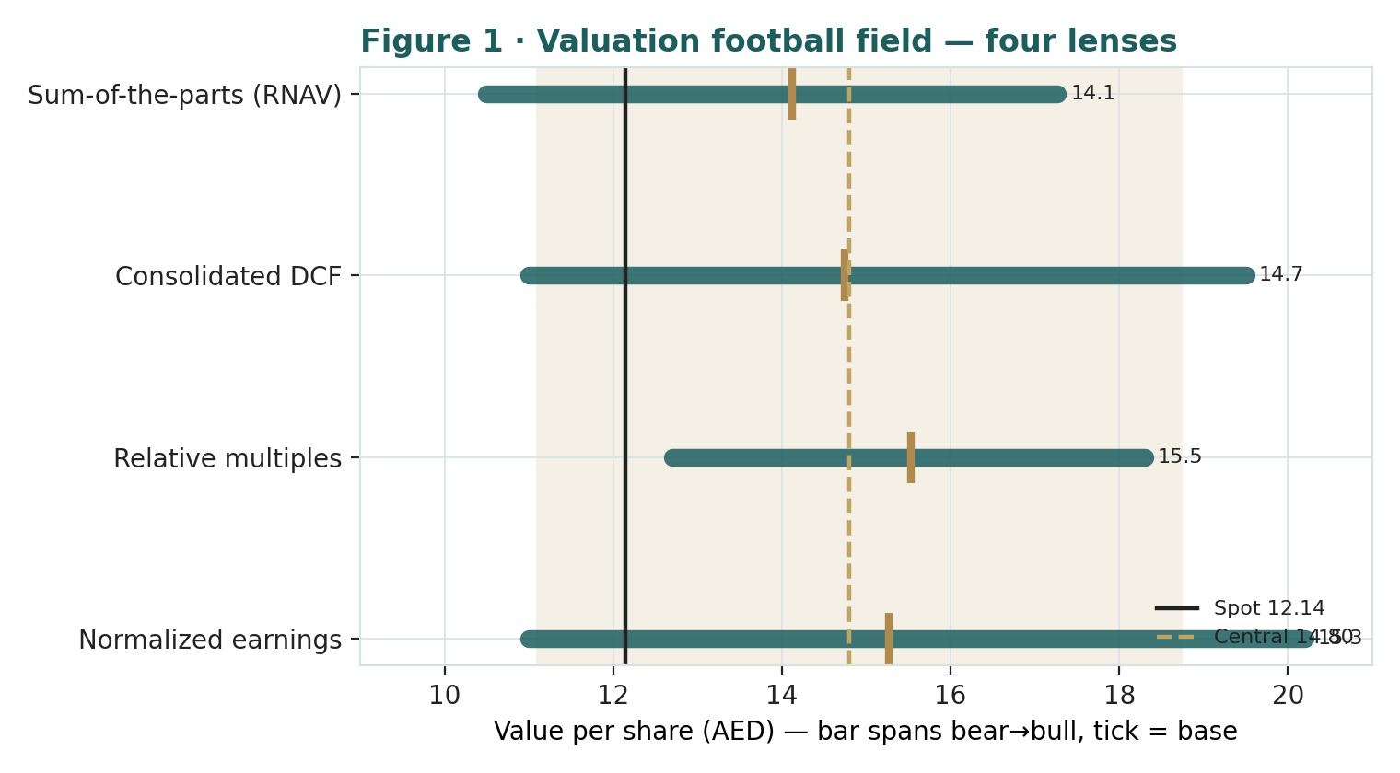
Figure 1 · Valuation football field — four lenses. Bars span bear–bull; the brass tick is each base case; the gold band is the blended central range; the dark line is spot.
Central fair value ≈ AED 14.80/share, about 22% above spot. The spread of the base lenses (AED 14.12 to AED 15.53) is tight and sits well above the price; the wider bear–bull span (AED 11.08 to AED 18.75) is the honest measure of how much rests on two unobservable inputs — the recurring multiple and the NAV discount. This is not a fairly-valued or an expensive name but a cheap one whose re-rating depends on how much of the recurring value and how narrow a discount the market will credit. None of this forecasts direction — §3 describes a wide, roughly balanced price process.
1.6 The assets — a deeper look
The valuation rests on asset-level judgments. For each major piece we set out what it is, how we mark it, and the key tension. One fact recurs: the listed stakes are marked by the market every day, so the genuine judgment calls are the recurring portfolio's multiple and the NAV discount.
Part | Cyclicality | Margin / mark trend | Swing role
Emaar Development (85.4%, listed) | Moderate — off-plan cycle | ~56% NPBT margin; ~5x P/E | Cash & sales engine
Recurring portfolio (owned) | Moderate — retail/tourism | malls ~70% EBITDA; the swing mark | Dominant judgment
Emaar Misr (85.7%, listed) | High — Egypt FX/rate | profitable; EGP→AED translation | Optionality / risk
International development | Moderate | India + other; rough NAV | Small
Emaar Development — the listed build-to-sell engine. The UAE development business (Downtown, Dubai Hills, Beachfront, Creek Harbour) sits in the ~85.4%-owned Emaar Development. In 2025 it did AED 71.1bn of sales, AED 27.5bn of revenue and AED 15.5bn of pre-tax profit at a ~56% margin, with a AED 134bn UAE backlog — yet trades at ~5x earnings. Because it is listed we take Emaar's stake at market; a re-rating of the cheap sub flows straight into Emaar's NAV.
The recurring portfolio — the crown jewel, and the biggest judgment call. Dubai Mall (the world's most-visited mall), the wider mall estate, the Address and Vida hotels, commercial leasing and entertainment generated AED 10.5bn of recurring revenue in 2025 (+13%), malls at 98% occupancy. We estimate recurring EBITDA at ~AED 5.8bn and mark the portfolio at ~14x EBITDA (~AED 81bn) base, 16x bull, 11x bear. This single mark is the largest swing in the SOTP: prime Dubai retail is scarce and high-quality, but the multiple the market will pay for it inside a developer is exactly what the discount debate is about.
Emaar Misr and international. Emaar's ~85.7% stake in the EGX-listed Emaar Misr (Uptown Cairo, Marassi, Mivida) is taken at market and translated to dirham (~AED 3.6bn); it carries genuine Egypt FX and rate risk. International development outside Egypt (principally India) is marked at a rough NAV of ~AED 6bn. Net cash is the conservative floor: the group holds ~AED 25bn, of which we attribute ~AED 18bn to the parent and recurring level, since the listed subsidiaries taken at market already embed their own cash.
1.7 The recurring mark and the NAV discount — the crux
Two judgments drive the valuation more than any other. First, the recurring multiple: ~AED 5.8bn of recurring EBITDA at 14x is ~AED 81bn — but prime Dubai retail could justify 16x (bull) or a sceptic might pay 11x (bear), and every turn of the multiple is worth ~AED 0.7/share. Second, the NAV/conglomerate discount: a diversified Dubai developer with an opaque private recurring mark will not trade at the clean sum of its parts. We apply 20%; the market implies ~31%. If clarity improves — a recurring-portfolio crystallisation (a REIT-style listing), a buyback or capital-return discipline plausible with the Dubai Holding group at ~29.7%, or a continued Dubai up-cycle — that discount can narrow, the principal non-operating source of upside. To justify the current price you must believe a ~30% discount and an ~11x recurring mark both hold.
1.8 Macro and country — rates via the peg, the Dubai cycle, and the pound
Emaar's value is set by the dirham's dollar peg, the Dubai property cycle, and — via Emaar Misr — the Egyptian pound. Rates arrive through the peg: UAE policy rates track the Fed, so higher-for-longer US rates both raise the discount on the recurring annuity and tighten mortgage affordability for the off-plan buyer, while a Fed easing cycle is a tailwind on both channels. The Dubai cycle is the dominant real-economy factor: record 2025 sales and a AED 155bn backlog reflect population growth, the golden-visa regime and global inflows; the risk is a maturing cycle and a visible supply pipeline, with absorption velocity the variable to watch. The pound is second-order: it matters only through the ~AED 3.6bn Emaar Misr stake, where a further EGP devaluation lowers the dirham mark and dents sentiment without moving the core. These levers drive the bear and bull cases in §1.5 and the catalysts in §5.
1.9 RNAV sensitivity — how much the two swing inputs move the value
Holding international NAV and net cash at base, the grid below re-prices the RNAV across the recurring EV/EBITDA multiple and the NAV/conglomerate discount — the two swing factors. The cells near spot (AED 12.14) are highlighted; the value runs from ~AED 10.0 (30% / 11x) to ~AED 18.1 (10% / 18x).
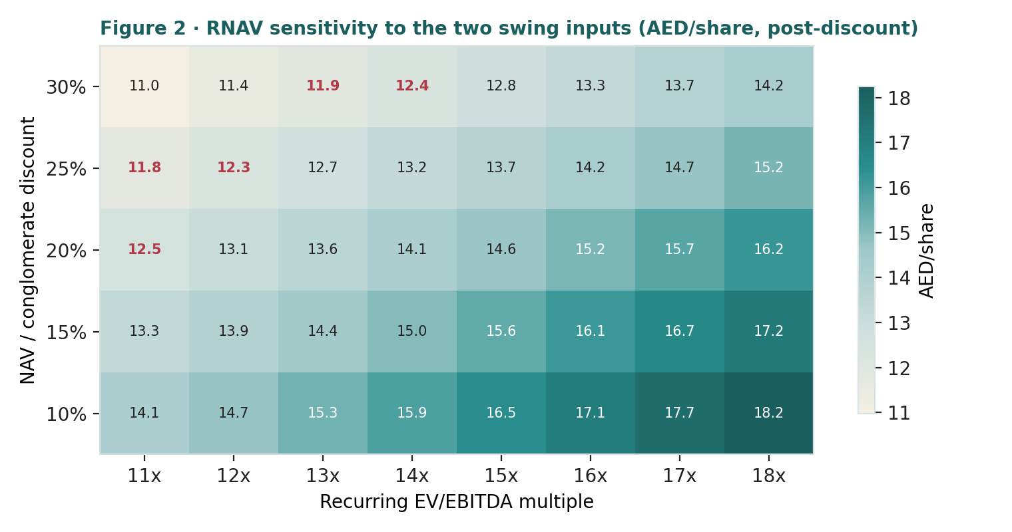
Figure 2 · RNAV sensitivity to the two swing inputs (AED/share, post-discount). Red cells sit near the AED 12.14 spot.
Read it as the bet you are taking: the AED 12.14 price is consistent with roughly an 11–12x recurring mark at the market's ~30% discount — i.e. a conservative multiple and a wide discount both already assumed. A separate DCF grid (WACC × terminal growth) in the Excel companion shows the going-concern lens stays above spot across almost the whole plausible space, dipping toward the price only at a punitive ~14% WACC.
2 Technical and price structure
The tape is mixed, not directional: Emaar ran to AED 17.25, corrected ~29%, and now consolidates above its flattening 20- and 50-day averages but below the 100- and 200-day, with a neutral RSI and a MACD histogram just turning positive — a stock digesting a large move, neither broken nor overheated.
Indicator | Reading | Signal
Spot | AED 12.14 | —
SMA 20 / 50 | 11.93 / 12.01 | above both — short-term steadying
SMA 100 / 200 | 13.04 / 13.53 | below both — longer trend still down
RSI (14) | 51.3 | neutral (neither overbought nor oversold)
MACD (12,26,9) | +0.17 line / +0.14 signal / +0.04 hist | momentum turning positive
ATR (14) | AED 0.40 (3.3%) | moderate daily range
52-week range | AED 10.15 – 17.25 | mid-range, ~29% off the high
Realized vol 60d / 252d | ~46% / ~36% | elevated recently vs the 1-year
Skew / excess kurtosis (252d) | +0.84 / +3.97 | right skew, fat tails
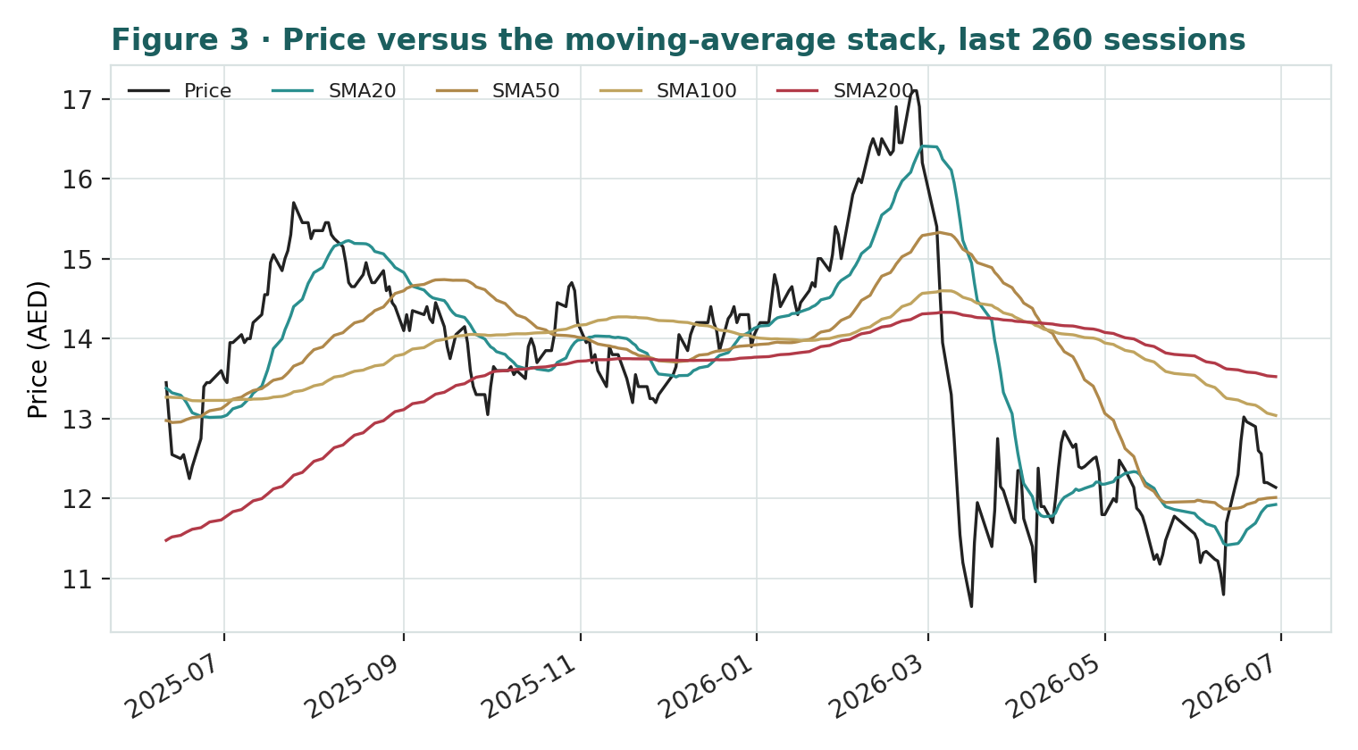
Figure 3 · Price versus the moving-average stack, last 260 sessions — above the short pair, below the long pair; MACD histogram positive.
The honest technical read. Price sits above the 20- and 50-day (both flattening near AED 12) and below a falling 100- and 200-day (AED 13.0–13.5); RSI near 51 is neutral and offers no edge, though the MACD histogram turning positive is a mildly constructive short-term signal. Realized volatility around 36% on the year — and ~46% over the last quarter — with a positive skew and fat tails means moves in either direction can be sharp. Nearest overhead resistance is the AED 13.0–13.5 average band, then the prior high near AED 17.25; nearest support is the AED 11.5 shelf and then the AED 10.15 low. For the probabilistic work this matters in one way: a below-long-trend tape keeps a live downside tail even as the fundamentals argue the other way. §6 reads the resulting zones without forcing a reconciliation.
3 Monte Carlo — a probabilistic price map
We simulate 50,000 three-month price paths (seed 42) using a sixteen-factor stack: seven continuous macro/operating drivers contributing a small net forward drift, and nine discrete events that each fire with a probability and an impact. By design the paths diffuse from spot, and the §1 value gap is kept out of the drift — the fundamental NAV gap lives in §1, not here; §3 maps where price could go from today, not where value sits. Diffusion volatility is the calibrated realized vol (annualized ≈36%, the trailing vol scaled by the calibration multiplier KVOL = 1.15 established in Appendix B). The net external drift is a modest +2.4% over the quarter.
The 16 factors. Continuous (7): US/Fed rate path via the dollar peg (mortgage & discounting), the Dubai residential price & off-plan absorption cycle, DFM / foreign-flows beta, oil / GCC liquidity, population & golden-visa demand, the recurring retail-&-tourism trajectory, and construction cost / margin. Discrete events (9): backlog conversion / strong launches (p~0.50, +6%), Dubai property-cycle re-rating / discount compression (p~0.30, +5%), an Emaar Development / recurring crystallization or special dividend (p~0.25, +4%), a Dubai-Holding ownership-driven re-rating or buyback (p~0.25, +4%), a two-sided quarterly earnings surprise (p~0.40, ±), a Dubai property correction / oversupply fear (p~0.30, −6%), a Fed higher-for-longer affordability shock (p~0.30, −5%), an Egypt macro/FX shock via Emaar Misr (p~0.25, −4%), and a regional geopolitical / risk-off (p~0.25, −6%). Total three-month volatility is ~22% (~43% annualised) and the distribution is mildly right-skewed.
Horizon | 5% | 25% | Median | 75% | 95%
T + 20 sessions (~1m) | 9.98 | 11.22 | 12.18 | 13.22 | 14.86
T + 60 sessions (~3m) | 8.64 | 10.63 | 12.24 | 14.11 | 17.32
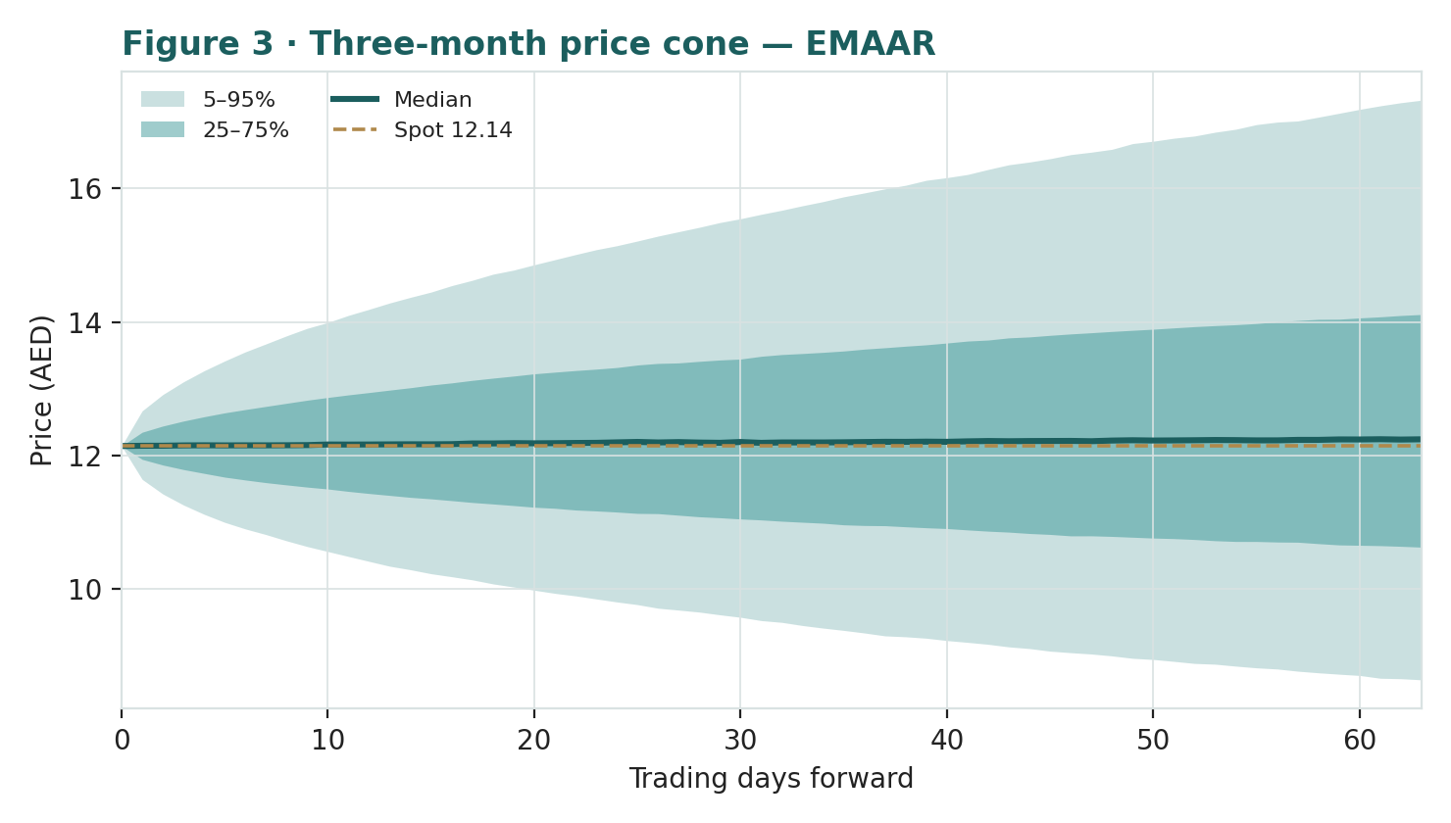
Figure 4 · Three-month price cone — percentile cone of simulated paths from spot; median ~flat, a very wide band.
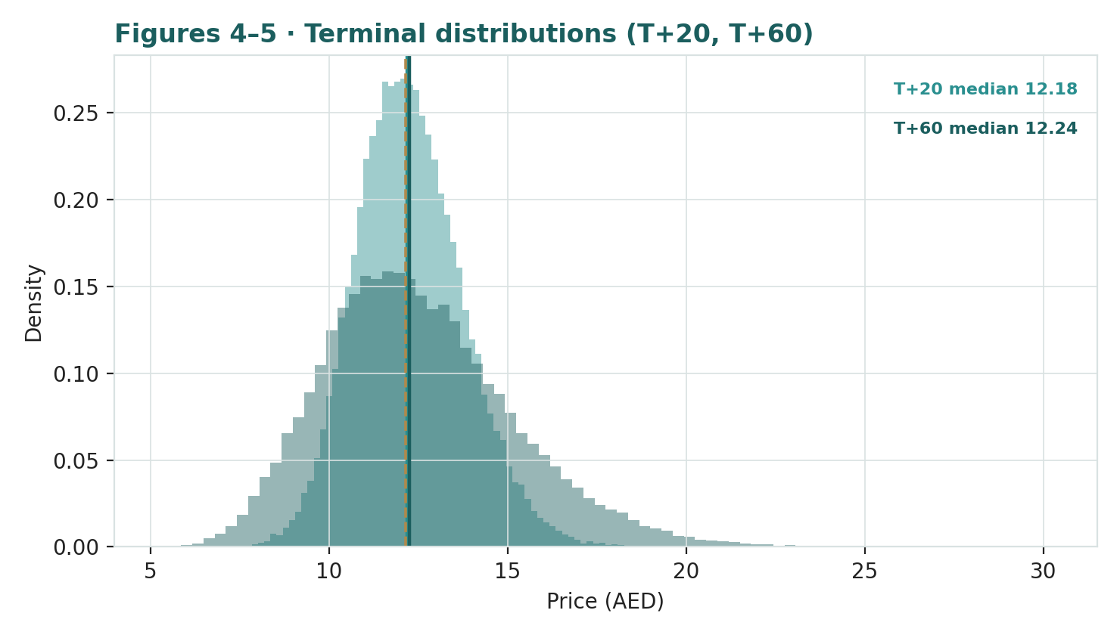
Figures 5–6 · Terminal distributions at T+20 (~1 month) and T+60 (~3 months) — roughly two-sided with a mild right skew and fat tails.
Touch probabilities — chance the price reaches a level at any point in the window
Level | by T+20 | by T+60 | Note
AED 13.00 | 49% | 70% | toward the falling 200-day
AED 14.00 | 20% | 47% | above the 200-day
AED 15.50 | 3% | 23% | toward the prior-high zone
AED 17.25 | 0% | 9% | the 52-week high
AED 11.50 | 55% | 73% | first support test
AED 10.50 | 18% | 44% | deeper pullback toward the low
AED 9.50 | 3% | 21% | below the 52-week low
AED 8.50 | 0% | 8% | bear / stress zone
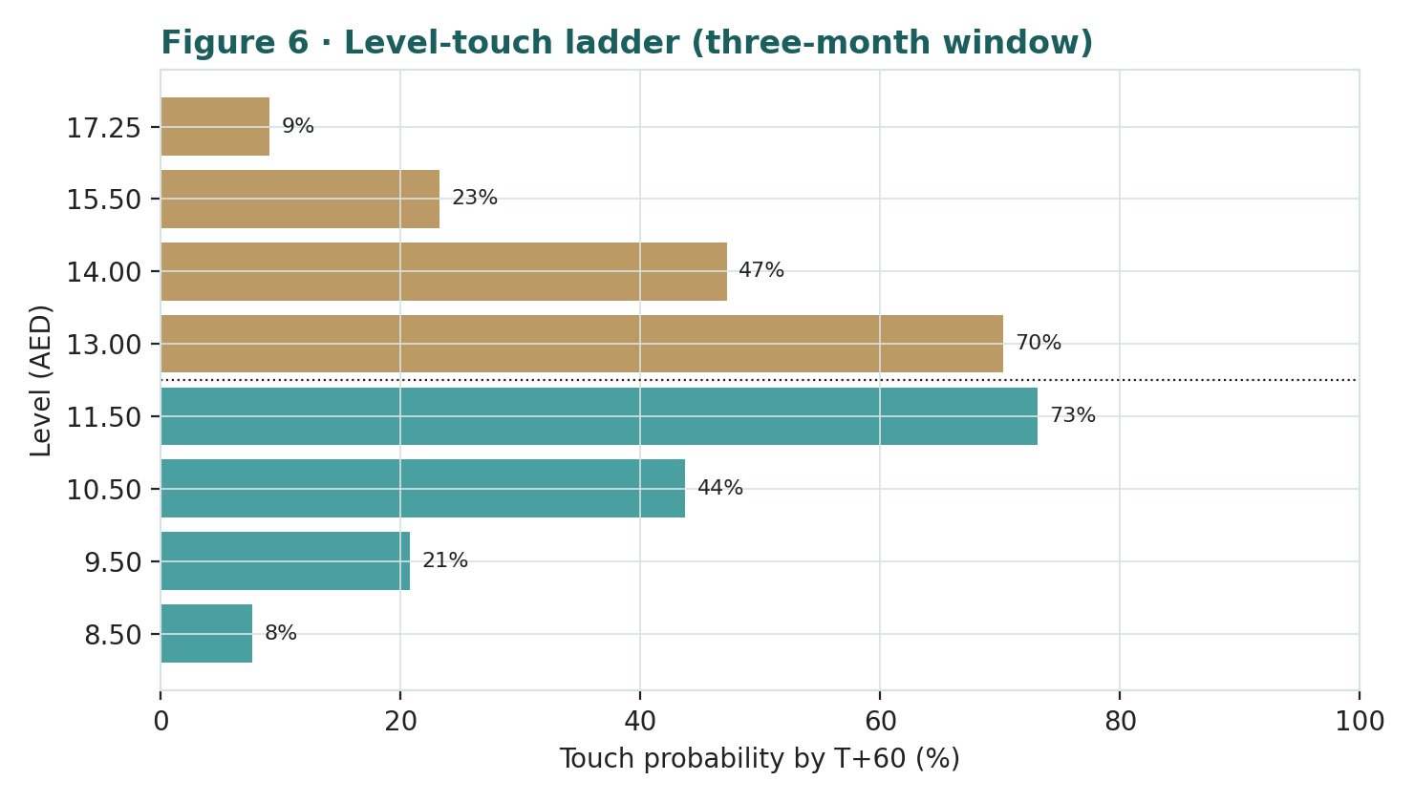
Figure 7 · Upside and downside touch ladders over the three-month window.
What the map says. Over three months a move up to the falling 200-day around AED 13.0 is more likely than not (~70%), a push toward AED 14.0 is ~47%, and a return to the prior high near AED 17.25 a low-probability ~9%. On the downside, a retest of the AED 11.5 shelf is highly likely (~73%) and a deeper slide toward AED 10.5 a non-trivial ~44%. This near-term map and the fundamental finding are not in conflict: the price can wander within a wide band over three months while value sits ~22% above price. The Monte Carlo describes the former; Section 1 the latter.
4 Comparison of the lenses, and a verdict
Lens | What it measures | Base | vs spot
RNAV/SOTP (primary) | gross NAV less 20% discount | AED 14.12 | +16%
Going-concern DCF | conservative fading cash flow | AED 14.74 | +21%
Relative multiples | vs Aldar / sector | AED 15.53 | +28%
Normalized earnings | through-cycle profit | AED 15.27 | +26%
Weighted central | triangulated estimate | AED 14.80 | +22%
Monte Carlo T+60 median | likely 3-month price | AED 12.24 | +1%
Verdict (a fair-value read, not a recommendation). The fundamental lenses agree to an unusual degree that AED 12.14 is cheap: the central estimate is AED 14.80 (+22%), and every base case sits above spot. The conservative DCF, built to fade the cash and cap the terminal, still clears the price by ~21%. The technical picture is mixed — a stock that has corrected ~29% and is consolidating, RSI neutral, MACD turning up — and the three-month price map is wide and roughly centred on spot. A buyer at this level is underwriting one proposition: that the recurring portfolio is credited nearer its private value and the ~31% discount to gross NAV narrows, helped by a supportive anchor shareholder, a possible recurring crystallisation, and a Dubai cycle that holds. If the discount compresses the bull case in the high-AED-17s is reachable; if it widens and Dubai rolls over, the downside to ~AED 11 is real. This study expresses a valuation, not a trade, and certainly not advice.
5 Catalysts to watch
Recurring crystallisation — a REIT or partial monetisation (↑, high impact). A listing or sale of part of the mall/hospitality portfolio would convert an opaque private mark into observable value — the single most powerful lever on the discount.
Discount compression / capital return (↑). A buyback, treasury cancellation, or clearer capital-return policy — plausible with the Dubai Holding group at ~29.7% — would attack the discount directly.
Backlog conversion & new launches (↑). Continued conversion of the AED 155bn backlog and successful new master-plan launches keep the development engine and sales-velocity narrative intact.
A Fed easing cycle (↑). Lower US rates, imported through the peg, ease mortgage affordability and lower the discount on the recurring annuity.
Emaar Development / Emaar Misr re-rating (↑/↓). The two listed stakes are marked to market; a move in either — particularly the cheap ~5x Emaar Development — flows straight into Emaar's NAV.
Dubai correction, higher-for-longer, or Egypt shock (↓). A visible oversupply and price rollover in Dubai, a renewed US rate-hiking scare through the peg, or an EGP devaluation hitting Emaar Misr are the principal near-term downside catalysts.
6 Reading the probability zones
Combining the fundamental anchors with the three-month price map gives a set of zones — descriptive, not directive.
Zone | Range (AED) | What it would mean
Discount compression | 16.0 – 18.5+ | discount narrows toward ~10%; recurring re-rated / crystallised
Re-rating underway | 14.0 – 16.0 | discount drifts toward base; DCF / relative lenses met
Central / undervalued | 13.0 – 14.0 | toward the RNAV base and the 200-day
Discount persists | 11.0 – 13.0 | where spot sits; wide discount holds
Wide-discount / bear | < 11.0 | discount widens; Dubai late-cycle / stress zone
7 Caveats and what would change our mind
The recurring mark is a judgment, and the biggest one. The ~AED 81bn recurring valuation rests on an estimated ~AED 5.8bn EBITDA and a ~14x multiple; a different multiple or EBITDA moves the SOTP materially. The Excel companion lets you change it.
The discount is the second swing factor, and we may have it wrong. A base 20% NAV discount is a modest normalisation from the market's ~31%. If it proves structural, fair value migrates toward the bear case; if crystallisation and capital return land, toward the bull.
Listed stakes move daily. Emaar Development and Emaar Misr are marked to market; a sharp move in either changes the NAV between this study and any later reading. Emaar Misr additionally carries EGP translation risk.
Earnings are normalising off a record. 2025 was a peak on strong recognition; 2026 consensus embeds an ~11% net decline. The normalized lenses assume through-cycle, not peak, earnings — but recognition off the backlog is lumpy.
The Monte Carlo is a price model, not a forecast. It encodes our probability estimates for events that have not happened; the factor probabilities are inputs, not facts, and the model says nothing about value.
RSI / momentum reminder. RSI ~51 is neutral — it offers no edge. Do not mistake a ~29% correction for a margin of safety; the margin of safety, if any, is in the discount to NAV, not the tape.
Appendix A Financial statements (AED bn)
Actuals (FY2023–FY2025) are anchored to Emaar's consolidated disclosure (revenue, EBITDA and net profit per Emaar IR / DFM filings; balance-sheet and cash-flow totals per the latest filings). Forecast columns (2026e–2030e) are the preparer's illustrative operating build that ties to the Excel companion; 2026e is set modestly below 2025 on normalisation (consensus ~11% net decline). Sub-lines of the balance sheet are approximate allocations; the recurring portfolio's market value sits above its carrying value, the source of the RNAV uplift.
A.1 Consolidated income statement (AED bn) — three years actual, five years forecast
Income statement | 2023a | 2024a | 2025a | 2026e | 2027e | 2028e | 2029e | 2030e
Development revenue | 18.5 | 27.0 | 39.0 | 36.0 | 37.5 | 39.0 | 40.5 | 42.0
Recurring revenue | 8.2 | 8.5 | 10.5 | 11.0 | 11.5 | 12.0 | 12.5 | 13.0
Total revenue | 26.7 | 35.5 | 49.6 | 47.0 | 49.0 | 51.0 | 53.0 | 55.0
growth YoY | — | +33% | +40% | −5% | +4% | +4% | +4% | +4%
Operating profit (EBIT) | 11.5 | 17.5 | 24.0 | 22.5 | 23.5 | 24.5 | 25.5 | 26.5
OP margin | 43% | 49% | 48% | 48% | 48% | 48% | 48% | 48%
Net finance income & assoc. | 1.0 | 1.2 | 1.7 | 1.3 | 1.4 | 1.5 | 1.6 | 1.7
Pre-tax profit | 12.5 | 18.7 | 25.7 | 23.8 | 24.9 | 26.0 | 27.1 | 28.2
Tax & minorities | −1.5 | −5.0 | −6.8 | −8.0 | −8.4 | −8.7 | −9.1 | −9.4
Net profit attributable | 11.0 | 13.7 | 18.9 | 15.8 | 16.5 | 17.3 | 18.0 | 18.8
EPS (AED) | 1.24 | 1.55 | 2.14 | 1.79 | 1.87 | 1.96 | 2.04 | 2.13
Note. Development dominates revenue; the recurring portfolio is smaller but higher-margin and more durable. FY2025 was a record on strong recognition off the AED 155bn backlog; 2026e is set modestly below on normalisation. UAE 9% corporate tax applies from 2023; minorities reflect the ~15% of Emaar Development and ~14% of Emaar Misr held by others. Actuals anchored to Emaar IR; sub-lines approximate.
A.2 Consolidated balance sheet (AED bn) — three years actual, five years forecast
Balance sheet | 2023a | 2024a | 2025a | 2026e | 2027e | 2028e | 2029e | 2030e
Cash & bank balances | 28 | 32 | 35 | 37 | 39 | 41 | 43 | 46
Trade & other receivables | 10 | 11 | 12 | 13 | 14 | 15 | 16 | 17
Development properties (WIP) | 42 | 45 | 48 | 50 | 52 | 54 | 56 | 58
Investment properties (malls/hotels) | 58 | 62 | 66 | 68 | 70 | 72 | 74 | 76
PP&E, associates & other | 23 | 24 | 26 | 27 | 28 | 29 | 30 | 31
Total assets | 161 | 174 | 187 | 195 | 203 | 211 | 219 | 228
Payables & customer advances | 46 | 51 | 56 | 59 | 62 | 65 | 68 | 71
Borrowings, bonds & leases | 11 | 11 | 10 | 10 | 10 | 10 | 10 | 10
Other liabilities | 4 | 4 | 4 | 4 | 4 | 4 | 4 | 4
Total liabilities | 61 | 66 | 70 | 73 | 76 | 79 | 82 | 85
Equity attributable | 62 | 70 | 80 | 86 | 92 | 98 | 104 | 110
Non-controlling interests | 12 | 13 | 15 | 16 | 17 | 18 | 19 | 20
Total equity | 74 | 83 | 95 | 102 | 109 | 116 | 123 | 130
BVPS — attributable (AED) | 7.01 | 7.92 | 9.05 | 9.73 | 10.41 | 11.09 | 11.76 | 12.44
Net cash (cash − debt) | 17 | 21 | 25 | 27 | 29 | 31 | 33 | 36
Note. Totals anchored to Emaar's reported balance sheet (assets ~AED 187bn, equity ~AED 95bn, cash ~AED 35bn, debt ~AED 10bn at end-2025); sub-lines approximate. Investment properties (recurring malls/hotels) are carried at ~AED 66bn BELOW their market value — the RNAV marks them to ~AED 81bn via EV/EBITDA, the source of the NAV uplift. Equity attributable ~AED 80bn = book ~AED 9.05/share (P/B ~1.3x). Large customer advances reflect off-plan pre-sales. Net cash ~AED 25bn.
A.3 Consolidated cash flow (simplified)
Cash flow | 2023a | 2024a | 2025a | 2026e | 2027e | 2028e | 2029e | 2030e
Operating cash flow | 14.0 | 17.0 | 20.0 | 18.0 | 19.0 | 20.0 | 21.0 | 22.0
Capex (investing) | −2.0 | −2.2 | −2.5 | −2.5 | −2.6 | −2.7 | −2.8 | −2.9
Financing (dividends/other) | −6.5 | −7.5 | −8.8 | −9.0 | −9.2 | −9.5 | −9.8 | −10.1
Free cash flow (OCF+capex) | 12.0 | 14.8 | 17.5 | 15.5 | 16.4 | 17.3 | 18.2 | 19.1
Emaar generates very strong operating cash flow and reinvests modestly — an asset-light off-plan model with escrowed pre-sales — so free cash flow is high and funds a ~100%-of-share-capital dividend (AED 8.8bn, ~AED 1.0/share, ~8% yield). That cash quality is why even the conservative fading DCF in 1.2 clears the price; a buyback or treasury cancellation would be an incremental catalyst on the discount.
Appendix B Step 0 — calibration backtest
Before publishing any probabilistic price map we test the engine against Emaar's own five-year history: does a lognormal three-month price model, fed with realized volatility, produce calibrated intervals?
Result. Using non-overlapping three-month windows over the five-year history (17 windows), a walk-forward trailing drift (drift-shrink 0.70) and a volatility uplift of KVOL = 1.15x on the trailing realized volatility, the probability-integral-transform (PIT) mean is 0.51, the 50/80/90% bands cover at 47/88/94%, and the Kolmogorov–Smirnov test does not reject calibration (p ≈ 0.95). Because Emaar has a strong secular uptrend, a zero-drift engine was materially mis-calibrated (PIT mean ~0.62); the drift-aware walk-forward version passes cleanly. We therefore build the Monte Carlo drift from forward factors rather than baking in the past uptrend, and carry realized momentum only as one editable factor. The window count is small, so coverage figures are noisy, but the engine shows no directional bias.
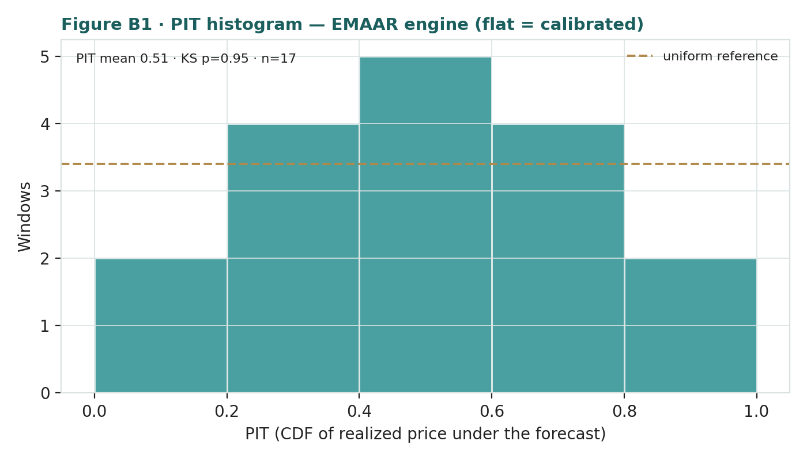
Figure B1 · PIT histogram — close to uniform after the walk-forward drift and 1.15x volatility uplift; no strong directional bias.
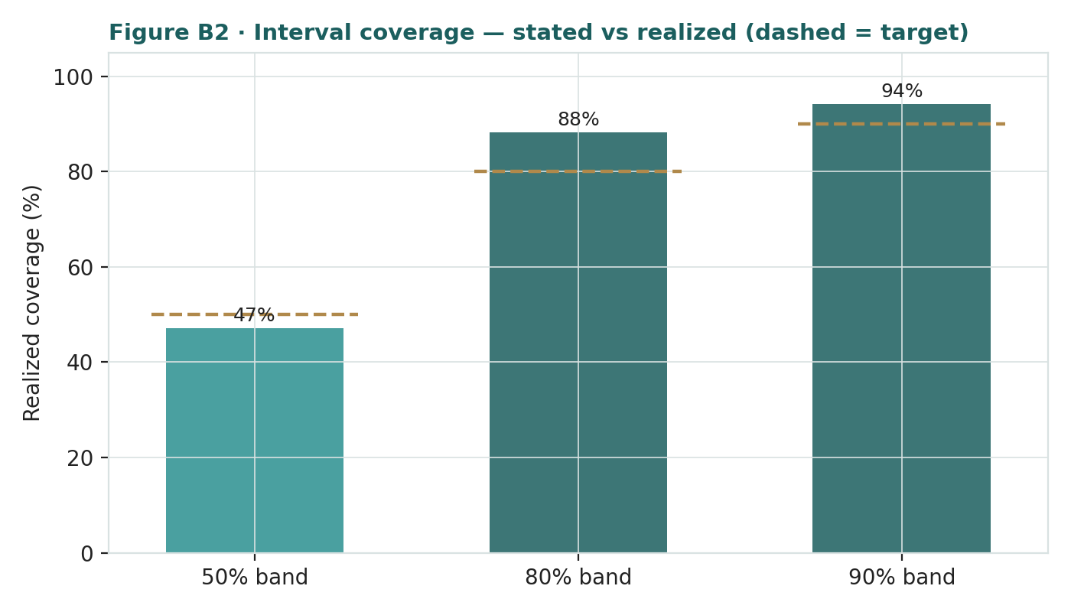
Figure B2 · Interval coverage — stated vs realized band coverage over the five-year history (dashed = target).
Appendix C Peer set, sector structure, and risks
C.1 The competitive map
Metric | Emaar (EMAAR) | Aldar (Abu Dhabi) | Emaar Development
Business | developer + recurring + holdco | AD developer + recurring | UAE build-to-sell (sub)
Trailing P/E | ~5.7x | ~9–11x | ~5x
EV/EBITDA | ~3.2x | ~10–13x | n/m
Discount to gross NAV | ~31% | n/a (operating) | n/a
Dividend yield | ~8% | ~4% | ~5%
ROE | ~25% | ~15–18% | very high (asset-light)
C.2 Principal risks
Recurring mark & NAV discount — the dominant factors; a low recurring multiple and a persistently wide discount keep the shares below NAV regardless of asset quality.
Dubai property cycle — a maturing cycle, a visible supply pipeline, or a price rollover would hit both development sales and the recurring portfolio.
US rates via the dirham peg — higher-for-longer US policy tightens mortgage affordability and raises the discount rate on recurring cash flows.
Egypt exposure — a further EGP devaluation or Egyptian macro shock lowers the Emaar Misr mark and dents sentiment.
Listed-stake volatility — Emaar Development and Emaar Misr are marked to market; their moves change the NAV directly.
Governance / concentration — the Dubai Holding group at ~29.7% is a supportive anchor, but concentrates influence over capital allocation.
About this series
Testahil publishes independent, educational valuation studies. Each is an attempt to reason transparently about what a security is worth, with every assumption shown and a companion model so readers can disagree productively. The house style is distributions, not tips: we describe ranges and probabilities, not targets, and we do not tell anyone what to do. Studies are framed as educational analysis, the preparer is not licensed by any securities regulator, and holdings are disclosed.
Disclosure & Disclaimer
Not investment advice. This document is educational and informational only. It is not, and must not be relied upon as, investment, financial, legal, accounting or tax advice, nor an offer, solicitation or recommendation to buy, sell or hold any security. It contains no price target and no rating.
No licence; no advisory relationship. The preparer is not registered or licensed with any securities or financial regulator in any jurisdiction, holds no brokerage or investment-advisory authorisation, and is not acting as your adviser or fiduciary. Nothing here is personalised to your circumstances.
Holdings disclosure. The preparer may hold, and may in the future take or dispose of, a position in the security discussed in this report, and may transact at any time without notice. This is a potential conflict of interest you should weigh.
Sources & accuracy. Reported financial and operating figures are drawn from Emaar's public disclosure and other public sources believed reliable but not independently verified; they may contain errors or be superseded. Forward-looking inputs — the recurring mark, the NAV discount, projections, multiples, the DCF and Monte-Carlo factor probabilities — are the preparer's own judgments and are inherently uncertain.
Forward-looking statements. Any statements about the future are estimates subject to risks and uncertainties; actual results may differ materially. The Monte Carlo models price, not value, and encodes subjective probabilities for events that have not occurred.
No reliance; your responsibility. Do your own research and consult a licensed professional before making any decision. You are solely responsible for your investment decisions and their outcomes. To the maximum extent permitted by law, the preparer accepts no liability for any loss arising from use of this document.
Currency & figures. All figures are in UAE dirham (AED) unless stated; bn denotes billion. Emaar Misr figures originate in Egyptian pounds and are translated to dirham. Rounding may cause totals to differ slightly. Spot price and market data are as of 29 June 2026 and change continuously.

TESTAHIL · Independent Valuation Study · Educational Analysis · Emaar Properties PJSC (DFM: EMAAR) · edition 01-07-2026 · reporting currency AED

Appendix D Expert panel — three independent methods
Premise. Three independent experts, three genuinely different methods, none seeing the others' work. Each is drawn from Testahil's standing Expert Persona Library and applied to Emaar; the divergence between them is the signal and is not averaged away. For a real-estate developer the library casts the Accountant (Expert 1, RNAV at realizable value), the Demand analyst (Expert 2, absorption-driven DCF) and the Macro-Policy strategist (Expert 3, scenario-weighted real-options). Each fair value below is derived from shown workings, and each carries a falsification condition so the persona can be scored over time. Discount rates are set to the UAE (dirham-pegged) regime, ~11–12% nominal — not Egypt's ~18–22%.
EXPERT PANEL — three independent methods (Appendix D)
Expert 1 — Accountant (RNAV at realizable value) | conservative marks + cash conversion | AED 13.0 | The floor
Expert 2 — Demand (absorption-driven DCF) | Dubai sales-velocity / backlog re-load | AED 16.5 | Most bullish
Expert 3 — Macro-Policy (scenario-weighted) | Fed path / Dubai cycle / EGP weights | AED 14.0 | Macro-weighted middle
Panel range | Spread = the recurring-mark & discount question | AED 13.0–16.5 | Centres ~AED 14.5
Bottom line. Every read points the same way on value and disagrees only on magnitude. The fundamental central sits near AED 14.80 — about 22% above the AED 12.14 spot — the three experts span AED 13.0–16.5, and each one turns on a single question: how much of the recurring portfolio's private value, and how narrow a discount, the market will credit. The technical tape is the lone near-neutral dissenter, which is why the three-month distribution centres near spot with a wide right tail rather than already at fair value.
D.1 Expert 1 — the Accountant (RNAV at realizable value)
Worldview and tradition. The Graham–Dodd realization school: a business is worth what its assets realize net of every claim, and reported profit is trusted only as it converts to cash. Expert 1 marks each asset to a conservative realizable value with explicit haircuts, tests earnings quality through the operating-cash-flow-to-net-income bridge, and bridges to equity net of all claims and a cash-conversion overlay.
When it works / when it fails. Best where a business is capital- and working-capital-heavy and value rests on assets rather than a franchise multiple — exactly a developer with a large recurring property base. It fails by systematically undervaluing a genuine compounding franchise; Expert 1 will be too conservative if the recurring portfolio deserves a premium mark or the discount genuinely collapses.
Standard workings. (1) mark each asset to a conservative realizable value with explicit haircuts; (2) test earnings quality via the OCF-to-net-income bridge; (3) bridge to equity net of all claims and off-balance obligations, with a cash-conversion overlay; (4) sensitivity on the swing marks.
Expert 1 — realizable RNAV (AED bn) | Mark | Value
Emaar Development stake (85.4%) | at market | 47.2
Emaar Misr stake (85.7%) | at market | 3.6
Recurring portfolio | haircut to 12x (vs 14x) | 69.6
International development | haircut NAV | 5.0
Net cash (parent, conservative) |  | 16.0
Gross realizable NAV |  | 141.4
(−) discount for holdco / cash-conversion | 25%
Expert 1 fair value / share |  | AED 13.0
Worked example — the cash-conversion test. Expert 1's edge is that Emaar's profits convert to cash unusually well: an asset-light off-plan model with escrowed pre-sales, ~AED 20bn of operating cash flow on ~AED 19bn of attributable earnings, and ~AED 25bn of net cash. That is why he marks near AED 13 rather than deep below the price — the balance sheet is a fact and the cash is real. But he haircuts the recurring portfolio to 12x (an unlisted mark he cannot observe) and trims net cash to the parent level, keeping him below the headline RNAV.
Sensitivity on the swing input (the recurring haircut). At 11x recurring his fair value is ~AED 12.4 (roughly spot); at 14x, ~AED 14.1. His whole range sits within a few dirham of the price — the message is that the downside is well-protected by realizable assets and cash, not that there is dramatic upside.
How Expert 1 cross-examines the others. To Expert 2: "Your absorption DCF books years of unbuilt sales as value today — show me the cash arrives before you capitalise it." To Expert 3: "Scenarios are guesses; the balance sheet is a fact — I don't need your discount to narrow, the assets already realize above the price."
Verdict, falsification, market-implied. Fair value ~AED 13.0 — modestly above spot, a floor built on realizable assets and cash quality. Falsification: a durable lift or collapse in cash conversion, or the recurring mark proving very different from 12x. At AED 12.14 the market is paying roughly realizable-asset value with little credit for the franchise — a cheap but not spectacular entry.
D.2 Expert 2 — the Demand analyst (absorption-driven DCF, adapted for Dubai)
Worldview and tradition. The growth-and-franchise school: a developer is worth the cash its order book will generate, and the franchise is absorption velocity — the rate at which it launches, sells and re-loads land. Expert 2's method is emerging-market-coded (an inflation-hedge framing); here it is adapted to Dubai's low-inflation, dollar-pegged, population-and-visa-driven demand, where the engine is off-plan sales velocity rather than an inflation hedge.
When it works / when it fails. Best where demand is structural — Dubai's population growth, the golden-visa regime, and global capital inflows. It fails by extrapolating a cyclical peak or waving away a cash trap; Expert 2 is most exposed if Dubai absorption slows or the supply pipeline floods.
Standard workings. (1) size the order book (contracted sales, run-rate, backlog); (2) convert to recognised revenue via percentage-of-completion cohort math; (3) margin to attributable earnings; (4) discount the equity stream with a fading growth path; (5) sensitivity on the growth path.
Expert 2 — absorption build | Value
Revenue backlog (AED bn) | 155
Recurring annuity (capitalised, AED bn) | ~85
Blended attributable margin on backlog | ~35%
Equity discount rate (AED) | ~11%
Backlog re-load / growth path | fading from double-digit
Expert 2 fair value / share | AED 16.5
Worked example — recognition is arithmetic. Expert 2's core claim: AED 155bn of backlog is already contracted, and its conversion to revenue is percentage-of-completion arithmetic over the next few years, not a forecast. Add a recurring annuity that grew 13% in 2025 and re-loading land velocity that filled the backlog faster than it drained, and he argues the market is capitalising a compounding franchise at ~6x earnings. His fair value of ~AED 16.5 reflects the signed order book plus the annuity, discounted at ~11%.
Sensitivity on the swing input (absorption / growth path). If Dubai absorption holds its recent pace, Expert 2's fair value pushes toward AED 19; if absorption slows to mid-cycle and the re-load stalls, it falls toward AED 13. His range is the widest of the three — the franchise is worth a great deal if velocity persists, far less if the cycle turns.
How Expert 2 cross-examines the others. To Expert 1: "You're liquidating a compounding franchise at scrap — the sales are signed and the annuity is growing." To Expert 3: "Population and visas are structural, not a scenario — and the backlog keeps converting regardless of the branch you draw."
Verdict, falsification, market-implied. Fair value ~AED 16.5 — the most bullish of the three, resting on the backlog and absorption velocity. Falsification: absorption slowing — affordability breaking through the rate channel, or a Dubai supply glut. At AED 12.14 the market is pricing the backlog to convert at compressed margins and the velocity to fade — a bet Expert 2 will take the other side of.
D.3 Expert 3 — the Macro-Policy strategist (scenario-weighted)
Worldview and tradition. Policy and macro regimes price the asset as a set of options on which world arrives. In a developed, dollar-pegged market Expert 3's weight is lower than in a frontier market and his levers change: the Fed path (imported through the dirham peg), the Dubai property-cycle stance, oil and GCC liquidity, and — via Emaar Misr — Egyptian macro and FX. He prices bull/base/bear as configurations of those levers and probability-weights them.
When it works / when it fails. Best when binary macro catalysts dominate — a rate-regime turn, a Dubai policy shift, an Egypt devaluation. It fails through false precision; the probabilities are judgments and a tree can miss the branch that grows.
Standard workings. (1) identify the 3–5 policy levers; (2) define bull/base/bear as lever configurations; (3) re-run the base valuation under each; (4) probability-weight; (5) stress the weights.
Expert 3 — scenario tree | Prob | Fair value
Bull — Fed eases, Dubai cycle extends, EGP stable | 30% | AED 17.5
Base — rates plateau, cycle matures, EGP drifts | 45% | AED 14.0
Bear — higher-for-longer, Dubai correction, EGP shock | 25% | AED 10.0
Probability-weighted fair value |  | AED 14.0
Worked example — rates arrive through the peg. Expert 3's central insight is that Emaar's discount rate and its end-buyer's mortgage are both set in Washington, because the dirham is pegged to the dollar. In the bull branch a Fed easing cycle lifts both the recurring annuity's value and off-plan affordability; in the bear branch higher-for-longer does the reverse and coincides with a maturing Dubai cycle and an Egyptian pound under pressure. Weighting the branches gives ~AED 14.0 — above spot, but with a fat bear tail he refuses to ignore.
Sensitivity on the swing input (the scenario weights). Shift 10 points from base to bull and his fair value rises toward AED 14.9; shift 10 points to bear and it falls toward AED 13.0. The weights, not the branch values, are where reasonable people will most disagree.
How Expert 3 cross-examines the others. To Expert 1: "Your realizable value assumes an orderly market — a rate shock or a Dubai correction changes what 'realizable' means." To Expert 2: "Absorption is a policy variable in disguise — it lives or dies on the rate path imported through the peg."
Verdict, falsification, market-implied. Fair value ~AED 14.0 — above spot, with an explicit bear tail. Falsification: a fourth, unmodelled policy shock dominating, or the scenario set being mis-specified. At AED 12.14 the market is pricing something close to Expert 3's bear-weighted blend — the shares already discount a fair amount of macro risk.
D.4 The three in one room
Put the three in front of the single asset they most disagree on — the recurring mall/hospitality portfolio — and the same fact reads three ways.
Expert 2: "Dubai Mall is the most-visited mall on earth, malls at 98% occupancy, recurring revenue up 13% — this is a growing annuity and 14x understates it. Mark it at 16x and the stock is worth AED 17."
Expert 1: "It's an unlisted mark I can't observe. I'll credit 12x and no more — show me a transaction before you capitalise it richer. The cash is real; the multiple is a guess."
Expert 3: "And the multiple the market will pay for a Dubai mall is itself a rate story — it compresses when the Fed hikes and the cap rate rises. Whatever the mark, a 31% discount to the whole is a macro barometer; crystallise the portfolio into a REIT and the discount, not the multiple, is what re-rates."
Same portfolio; three readings — a growing franchise (Expert 2), a conservative realizable mark (Expert 1), and a rate-sensitive annuity behind a crystallisable discount (Expert 3). The spread between them is the honest measure of how much of Emaar's value rests on a single unobservable: what the recurring portfolio is really worth, and how much of it the market will credit.
D.5 Reading the divergence
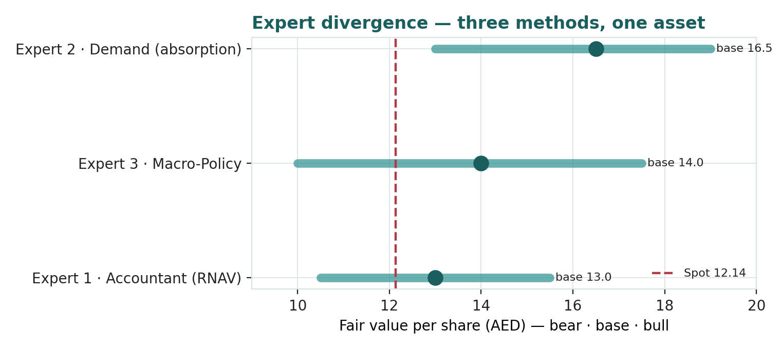
Expert divergence — three methods, one asset. Point markers are each expert's base fair value; bars span bear-to-bull. All three sit above spot; Expert 2 highest (backlog/absorption), Expert 1 lowest (conservative realizable marks).
Expert | Method | The one assumption that drives it | Base fair value
Expert 1 · Accountant | RNAV at realizable value | the recurring haircut & cash-conversion overlay | AED 13.0
Expert 2 · Demand | absorption-driven DCF | Dubai sales-velocity / backlog re-load | AED 16.5
Expert 3 · Macro-Policy | scenario-weighted real-options | the scenario weights (Fed path, Dubai cycle, EGP) | AED 14.0
What the spread measures. The three fair values run from AED 13.0 to AED 16.5, all above spot, centred near AED 14.5 — close to the study's weighted central of AED 14.80. The dispersion is not noise: it is a map of where the value is contested. Expert 1 anchors the floor on realizable assets and cash; Expert 2 prices the franchise off the signed backlog; Expert 3 weights the macro branches. That every method lands above the AED 12.14 price is the study's central finding — Emaar is cheap on realizable assets, on its order book, and on a macro-weighted blend — while the width of the spread names exactly what is taken on trust: the recurring portfolio's multiple and the discount the market will pay for a diversified Dubai developer. Neither is observable today; both are what a buyer at this level is really underwriting.

Expert personas are analytical lenses from Testahil's standing library, not individuals; their outputs are descriptive fair-value ranges, never recommendations, ratings or price targets.

