Testahil · Independent Valuation Study First Abu Dhabi Bank PJSC (ADX: FAB)
Testahil · Independent Valuation Study — Educational Analysis Not investment advice
Independent Valuation Study — Educational Analysis
First Abu Dhabi Bank PJSC (ADX: FAB)
Fundamental analysis · Technical analysis · Monte Carlo simulation — one integrated read
Anchor: AED 17.40 (3 Jul 2026 close) · ~11.05bn shares · market cap ~AED 192bn (~US$52bn) · the largest bank in the UAE and one of the largest in the Middle East, formed from the 2017 merger of National Bank of Abu Dhabi and First Gulf Bank · Aa3 / AA− / AA− (Moody's / S&P / Fitch), stable · the dirham is pegged to the US dollar at USD/AED 3.6725 · prices and probabilities computed 3 Jul 2026 from the attached daily history · primary lens: dividend-discount / residual-income (DDM) on book value · the sustainable-ROE-versus-cost-of-equity gap and the cost-of-risk normalisation are the swing factors.
READ FIRST — what this document is, and is not. This study is a valuation exercise and an expression of personal analytical opinion, published free of charge for educational purposes: it shows how one analyst applies fundamental, technical and probabilistic methods to a listed company, and invites scrutiny of that methodology. It is NOT investment advice, NOT a recommendation or solicitation to buy, sell or hold any security, and NOT directed at the circumstances of any reader. The preparer is not licensed by any securities regulator in any jurisdiction, holds no brokerage or advisory authorisation, provides no financial consultancy, manages no money, and accepts no fees, funds or clients. See the Disclosure & Disclaimer at the end. All values are model outputs presented as ranges and distributions because no single number should be relied on. Reported financials are the company's own disclosure (FY2025 results); forward-looking inputs — the cost of equity, the sustainable ROE and cost of risk, the terminal multiples, the DCF and the Monte-Carlo factor probabilities — are the preparer's judgments and are flagged throughout. Figures are in UAE dirham (AED), which is pegged to the US dollar; per-share figures in AED. Consult a licensed financial advisor before any investment decision.

Headline
The model's read: modestly undervalued, with the upside resting on the gap between FAB's sustainable return on equity and its cost of equity, and on how gently the cost of risk normalises as US rate cuts compress an asset-sensitive margin. At AED 17.40 the shares sit about 14% below our weighted central estimate of AED 19.9. The four lenses cluster tightly: the primary dividend-discount / residual-income model lands at AED 19.8, an FCFE (capital-generation) cross-check at AED 20.7, a conservative relative read on book value and peer earnings at AED 18.8 (the floor), and a normalised-return-on-tangible-equity read at AED 19.9 (the ceiling). The whole answer turns on two linked judgments — where FAB's through-cycle return on equity settles once the Federal Reserve easing cycle has run its course and the margin has re-based, and how far the cost of risk drifts up from today's benign ~49 basis points. FY2025 was a record year (net profit AED 21.1bn, +24%; return on tangible equity ~20%; the highest dividend in the bank's history at AED 0.80), and the case rests on whether a AA-rated, systemically-important Gulf bank should trade at ~1.6× book and ~9.4× earnings when it is still earning close to a 20% return on tangible equity. Technically the tape is neutral rather than the mirror-image weakness one sometimes sees — price sits on its 20-, 50- and 200-day averages, RSI near 49, MACD marginally negative — so price and value are close, not violently opposed. Over three months the Monte Carlo places the 5th–95th percentile band at roughly AED 13.4–21.5, with a median just below spot.
Valuation summary — every read at a glance
One table for the four reads that follow — what the business is worth (fundamental), what the tape is doing (technical), where price could travel over three months (Monte Carlo), and how three independent expert methods land. Every row is developed in the sections and appendices below.
Lens / read | What it measures | Output | Takeaway
FUNDAMENTAL — what the business is worth (the anchor)
Dividend-discount / residual income (primary) | PV of dividends + terminal book × justified P/B | AED 19.8 | +14% vs spot
FCFE-DCF (capital generation) | Net income less capital retained for RWA growth | AED 20.7 | +19%
Relative multiples | Justified P/B–ROE and peer forward P/E | AED 18.8 | +8% · the floor
Normalized ROTE | Sustainable ROTE capitalised | AED 19.9 | +15% · the ceiling
Weighted central | Blend 40 / 20 / 15 / 25 | AED 19.9 | +14% vs AED 17.40
TECHNICAL — what the tape is doing (timing, not value)
Trend & momentum | Price vs the 20/50/100/200-day averages | On 20/50/200, below 100 | Neutral, consolidating
Momentum / range | RSI · MACD · 52-week range | RSI 49 · MACD −0.03 · 15.5–20.7 | Mid-range, balanced
MONTE CARLO — where price could go in 3 months (paths from spot)
T+20 sessions | 50,000 paths · 16 factors | p5 14.97 · p50 17.32 · p95 19.75 | Median ≈ spot
T+60 sessions | same engine, longer horizon | p5 13.37 · p50 17.05 · p95 21.45 | Wide, mildly right-skewed
EXPERT PANEL — three independent methods (Appendix D)
Expert 1 — capital & returns (residual income) | Justified P/B on sustainable ROE vs COE | AED 19.8 | The anchor
Expert 2 — credit cycle (stressed earnings) | Value off normalised cost of risk | AED 18.0 | Most conservative
Expert 3 — macro-policy (scenario-weighted) | Fed path / oil / geopolitics scenarios | AED 19.5 | Policy-driven
Panel range | Spread = the ROE-and-credit question | AED 18.0–19.8 | Centres ~AED 19.1
Bottom line. Every read points the same way on value and disagrees only on magnitude. The fundamental central sits near AED 19.9 — about 14% above the AED 17.40 spot — the three experts span AED 18.0–19.8, and each turns on a single linked question: whether FAB's through-cycle return on equity holds a wide enough premium over its cost of equity to justify a re-rating from ~1.6× book. The technical tape is neutral rather than a dissenter, which is why the three-month distribution centres just below spot with a wide, mildly right-skewed tail rather than already at fair value.
Company overview — First Abu Dhabi Bank at a glance
Item | Value
Listed entity | First Abu Dhabi Bank PJSC (ADX: FAB)
What it is | The largest bank in the UAE; universal banking — corporate & investment, personal, private, and global markets
Spot / date | AED 17.40 · 3 Jul 2026 close
Shares · market cap | ~11.05bn · ~AED 192bn (~US$52bn)
FY2025 operating income / net profit | AED 36.7bn (+16% YoY) · AED 21.1bn (+24%)
Return on tangible equity (FY2025) | ~20% (a cyclical peak on the rate cycle)
Cost-to-income · NIM (FY2025) | ~21.8% · ~1.9% (reported)
Asset quality | NPL ~2.8% (improving) · ~100% coverage · cost of risk ~49bps
Capital · liquidity | CET1 ~13.9% · LCR ~142%
Dividend (FY2025) | AED 0.80 per share (highest ever) · ~43% payout on attributable profit
Ratings | Aa3 / AA− / AA− (Moody's / S&P / Fitch), stable
Largest shareholder | Mubadala Investment Company (~37–40%, via subsidiaries); foreign-ownership limit 40%
Chairman · Group CEO · Group CFO | Sheikh Tahnoon bin Zayed Al Nahyan · Hana Al Rostamani · Lars Kramer
Currency | AED, pegged to USD at 3.6725
Source: FAB FY2025 results and investor disclosure, ADX data, rating-agency releases. Values rounded. Reported NIM and RoTE use the bank's own definitions; the companion model uses a model-basis NIM that reconciles to reported net interest income.
1 Fundamental valuation
We value FAB as a bank, and triangulate four lenses. The primary lens is a dividend-discount / residual-income model (DDM) because a bank's value is a claim on the dividends its capital can throw off, and the natural terminal anchor is a justified price-to-book multiple driven by the spread between the return on equity and the cost of equity. An FCFE (capital-generation) DCF, a relative read on book value and peer earnings, and a normalised-return-on-tangible-equity capitalisation complete the set. The weights and the football field are in §1.5; the swing factors — the sustainable ROE-versus-cost-of-equity gap and the cost-of-risk path — are dissected in §1.7 and the sensitivity grid in §1.9. Throughout, the cost of equity is published explicitly as a risk-free rate plus an equity risk premium, not buried in a black-box discount rate.
1.1 Dividend-discount / residual income — the primary lens
The model discounts an explicit five-year dividend stream at the cost of equity, then adds a terminal value equal to the end-of-forecast book value per share times a justified price-to-book multiple. That justified multiple is the residual-income identity, P/B = (ROE − g) / (Ke − g): a bank that earns exactly its cost of equity is worth book; every point of sustainable ROE above the cost of equity is worth a premium. We publish the cost of equity as Ke = risk-free rate + β × equity risk premium = 4.5% + 1.00 × 6.5% = 11.0%, with the beta near the market (FAB is a large, liquid index heavyweight) and inside the house 0.8–1.3 band. Terminal growth is 4.5%, roughly nominal GDP for the peg economy; the sustainable terminal ROE is 15.5%, deliberately below the ~17–20% the bank earns today because Fed easing compresses an asset-sensitive margin and the cost of risk normalises from a benign trough.
DDM explicit stream (AED/share) | FY26E | FY27E | FY28E | FY29E | FY30E
Dividend per share (DPS) | 0.85 | 0.91 | 0.97 | 1.06 | 1.20
Discount factor @ Ke 11.0% | 0.901 | 0.812 | 0.731 | 0.659 | 0.593
PV of DPS | 0.77 | 0.74 | 0.71 | 0.70 | 0.71
Explicit five-year dividend stream, discounted at the 11.0% cost of equity. Every input links to the model's Assumptions sheet.
DDM valuation (base case) | Value
Σ PV of explicit dividends, FY26–30E (AED/share) | 3.62
Terminal book value per share, end-FY30E (AED) | 16.13
Justified terminal P/B = (ROE − g)/(Ke − g) | 1.69×
Terminal value per share (AED) | 27.29
PV of terminal value (AED) | 16.20
DDM fair value per share (AED) | 19.81
terminal as % of value | 82%
implied P/E on FY26E EPS | 10.5×
DDM base ≈ AED 19.8/share, with a bear–bull span of roughly AED 16.9–22.8 driven by the terminal ROE and the cost of equity (see §1.9). The terminal value is 82% of the answer — unavoidable for a going-concern bank, and exactly why we disclose it and sensitise it rather than bury it: the number is a bet that FAB sustains a ~4-point ROE premium over an 11% cost of equity into perpetuity. The implied ~10.5× forward P/E is a full but not stretched multiple for a AA-rated franchise still compounding book value in the high-single digits.
1.2 FCFE discounted cash flow — the capital-generation cross-check
For a bank the enterprise-DCF is meaningless — interest is operating, not financing — so the cash-flow lens is free cash flow to equity: the profit left for shareholders after retaining the capital the balance sheet must hold as it grows. We take profit attributable to ordinary shareholders, subtract the capital absorbed by each year's growth in risk-weighted assets at a 13.5% CET1 target (ΔRWA × 13.5%), discount the resulting FCFE at the same 11.0% cost of equity used in the DDM, and add a Gordon terminal on the final-year FCFE. The full five-year build is shown below — no step collapsed to a single output line.
FCFE build (AED bn) | FY26E | FY27E | FY28E | FY29E | FY30E
Profit attributable to ordinary | 20.9 | 21.8 | 22.8 | 24.3 | 26.4
less capital retained for RWA growth | (8.1) | (8.7) | (8.2) | (8.8) | (8.1)
Free cash flow to equity (FCFE) | 12.9 | 13.1 | 14.5 | 15.5 | 18.3
Discount factor @ Ke 11.0% | 0.901 | 0.812 | 0.731 | 0.659 | 0.593
PV of FCFE | 11.6 | 10.6 | 10.6 | 10.2 | 10.9
Free cash flow to equity, five-year explicit forecast. Capital retained = the increase in risk-weighted assets each year times the 13.5% CET1 target. Every input links to the model's Assumptions sheet.
The cost of equity is 4.5% risk-free + 1.00 beta × 6.5% equity risk premium = 11.0%; terminal growth is 4.5%. Carrying the explicit stream to a valuation:
FCFE-DCF valuation (base case) | Value
Σ PV of explicit FCFE, FY26–30E (AED bn) | 53.9
Terminal value — Gordon on FY30E FCFE, g 4.5% (AED bn) | 294.5
PV of terminal value (AED bn) | 174.8
Equity value (AED bn) | 228.7
÷ shares outstanding (bn) | 11.05
Fair value per share (AED) | 20.7
Terminal value as % of equity value | 76%
FCFE base ≈ AED 20.7/share. Across the (Ke, g) sensitivity the value spans ~AED 17.2 (Ke 11.5%, g 4.0%) to ~AED 21.5 (Ke 10.5%, g 5.0%) — the full grid is in §1.9. It is the most generous of the four lenses and terminal-heavy at 76% of value, so we treat it as a corroborating cross-check rather than the anchor, and disclose the terminal dependency rather than bury it. What it says is that even after funding a high-single-digit RWA growth path at a conservative capital target, FAB throws off enough distributable capital — FCFE covers the dividend ~1.3–1.4× every year — to support a value comfortably above the current price.
1.3 Relative multiples
Two market-anchored legs, blended equally. The first applies a justified price-to-book — again (ROE − g)/(Ke − g), here on a near-sustainable 16.5% ROE — to current book value per share of ~AED 10.6. The second applies a peer forward P/E of 9.5× (where large Gulf banks trade) to FY26E earnings per share of ~AED 1.90. FAB screens mid-pack on book value despite top-tier scale and asset quality.
Relative basis | Value
Book value per share, FY25 (AED) | 10.59
Justified P/B on 16.5% ROE | 1.85×
value per share — P/B leg (AED) | 19.55
FY26E EPS (AED) | 1.90
Peer forward P/E | 9.5×
value per share — P/E leg (AED) | 18.01
Relative fair value (50/50 blend, AED) | 18.78
Relative base ≈ AED 18.8 — the most conservative lens, and probably closest to where a sceptic anchors. It treats FAB as a solid but unexceptional Gulf bank rather than a structural compounder, and credits none of the franchise's scale, funding cost or international optionality beyond what the peer multiple already embeds.
1.4 Normalized return on tangible equity — the earnings-power lens
For a bank the cleanest normalisation is on tangible equity, which strips the ~AED 11bn of goodwill and intangibles left from the NBAD–FGB merger. We take a sustainable through-cycle return on tangible equity of 18% — below the ~20% peak but above a recessionary trough — and capitalise it with a warranted price-to-tangible-book, (ROTE − g)/(Ke − g), on tangible book value per share of ~AED 9.6.
Normalized-ROTE basis | Value
Tangible book value per share, FY25 (AED) | 9.59
Sustainable ROTE (through cycle) | 18.0%
Warranted P/TB = (ROTE − g)/(Ke − g) | 2.08×
Normalized fair value (AED/share) | 19.92
Normalized-ROTE base ≈ AED 19.9 — the recovery-and-quality lens and the effective ceiling of the central case. It is, in effect, the bet that FAB's ~20% return on tangible equity re-bases only modestly, to ~18%, rather than collapsing toward the cost of equity as rates fall.
1.5 Synthesis — four lenses
We weight the DDM most heavily because it respects a bank's economics as a claim on dividend-paying capital; the FCFE-DCF and normalized-ROTE lenses carry the earnings-power thesis; the relative lens anchors the floor.
Lens | Weight | Bear | Base | Bull
Dividend-discount / residual income | 40% | 16.9 | 19.8 | 22.8
FCFE-DCF | 20% | 17.2 | 20.7 | 21.5
Relative multiples | 15% | 16.0 | 18.8 | 20.5
Normalized ROTE | 25% | 18.0 | 19.9 | 23.5
Weighted central |  | 17.1 | 19.9 | 22.4
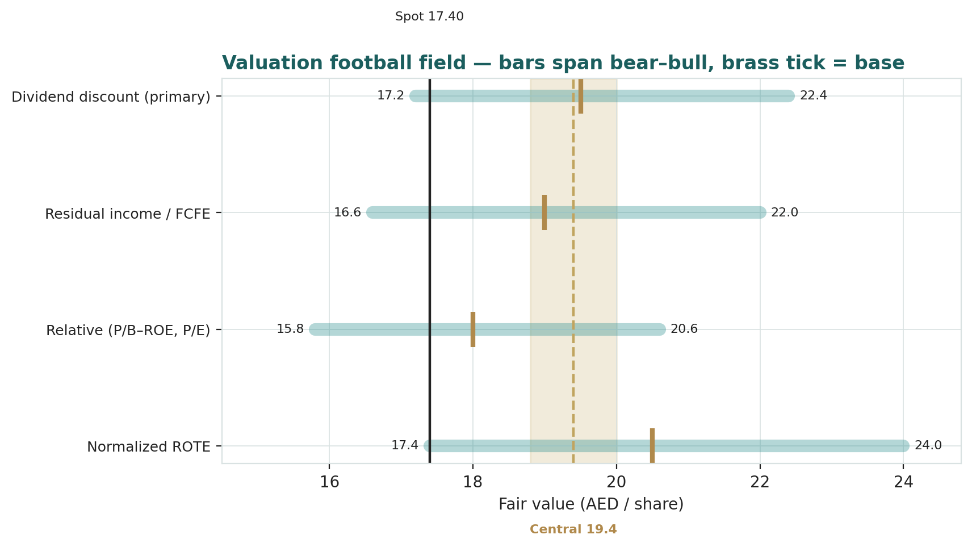
Figure 1 — Valuation football field. Bars span bear–bull per lens; the brass tick is each base case; the gold band is the blended central range; the dark line is spot.
Central fair value ≈ AED 19.9/share, about 14% above spot. The spread of the lenses (AED 18.8 to 20.7 at base) is itself the message: this is not a deep-value screen nor an obviously expensive one, but a modestly-undervalued, high-quality franchise whose re-rating depends on the market crediting a durable ROE premium rather than on any single operating surprise.
1.6 The bank beneath the multiple — a deeper look
FAB is a scale-and-funding story. It is the balance-sheet champion of the UAE — roughly AED 1.4tn in assets, AED 616bn of loans, AED 841bn of deposits at end-2025 — with a deposit franchise and an Aa3 rating that give it one of the lowest costs of funds in the region, the raw material of a durable net interest margin. FY2025 was a genuine record: operating income AED 36.7bn (+16%), lifted by a step-change in non-interest income to ~45% of revenue as fees, FX and markets activity surged; net profit AED 21.1bn (+24%); return on tangible equity around 20%. Asset quality improved (non-performing loans down toward 2.8% with ~100% coverage) and the cost of risk ran benign at ~49 basis points. The table scores the drivers that matter for the through-cycle return.
Driver | Level (FY2025) | Trend | Swing role
Net interest margin | ~1.9% reported | Compressing as Fed cuts | Dominant
Non-interest income mix | ~45% of revenue | Elevated (record markets year) | Quality / durability
Cost of risk | ~49 bps | Benign; normalises up | Earnings swing
Cost-to-income | ~21.8% | Best-in-class; mild upward drift | Efficiency anchor
CET1 / capital | ~13.9% | Comfortable buffer | Dividend capacity
The two questions that set the value are visible in that table: how quickly the margin re-bases as US rates fall (FAB is asset-sensitive, so a lower-for-longer path helps net interest income while a fast easing cycle hurts it), and whether the record non-interest-income year is a new base or a high-water mark. Both feed directly into the sustainable ROE that the primary lens capitalises.
1.7 The ROE-versus-cost-of-equity gap and the cost of risk — the crux
Two judgments drive the valuation more than any other, and — following the house discipline — we sensitise each on its own observable driver in real units rather than on an abstract margin percentage. First, where the sustainable return on equity settles relative to the 11% cost of equity. FAB earns ~17% on ordinary equity and ~20% on tangible equity today; the residual-income identity means every point of that sustainable return above the cost of equity is worth roughly a fifth of a turn of book. The driver underneath is the net interest margin, and the driver underneath that is the rate path: FAB is asset-sensitive, so the swing input in native units is the Federal Reserve / EIBOR trajectory (in basis points) feeding the margin (in basis points). Second, the cost of risk. Today's ~49 basis points is a benign-cycle figure; a normalisation toward a through-cycle ~70–80 basis points would shave several points off the return on equity without any change in the franchise. Our base case assumes a gentle drift up (to ~55–65 bps over the forecast) and a sustainable ROTE of 18%; the bear case pairs a faster margin re-base with an ~90 bps cost of risk. The §1.9 grid prices exactly this — the return on equity against the cost of equity — and the market's AED 17.40 is consistent with roughly a 15–15.5% sustainable ROE at an ~11.5–12% cost of equity: some normalisation already in the price, but not a full de-rating.
1.8 Macro and country — the peg, the Fed, oil and the region
FAB is a leveraged play on the Abu Dhabi sovereign and the US monetary cycle at once. The dirham peg to the US dollar means UAE monetary policy imports the Federal Reserve's: the Fed easing path is the single most important external variable, because FAB's asset-sensitive balance sheet earns more when rates stay high for longer and less as they fall. Oil and Gulf liquidity set the backdrop — a firm oil price supports government deposits, project lending and system liquidity, while a sharp fall would tighten both. Non-oil growth and credit demand in Abu Dhabi and Dubai (real estate, trade, tourism, government-related entities) drive loan volumes, and the sovereign's Aa2/AA rating anchors FAB's own funding cost. The principal tail is regional geopolitics: an escalation in the Gulf security environment would widen risk premia and pressure the shares directly, which is why it carries the largest negative weight in the §3 factor stack. These levers are the swing factors behind the bear and bull cases in §1.5 and the catalysts in §5.
1.9 DDM sensitivity — how the ROE and cost-of-equity swing move the value
Holding the five-year dividend path and terminal growth at base, the table re-prices the DDM across the sustainable terminal return on equity and the cost of equity — the two levers the crux turns on. The value runs from about AED 15.2 (14% ROE at an 12% cost of equity) to about AED 28.2 (18% ROE at a 10% cost of equity); the cells near spot cluster around a 15–15.5% ROE at an 11.5–12% cost of equity.
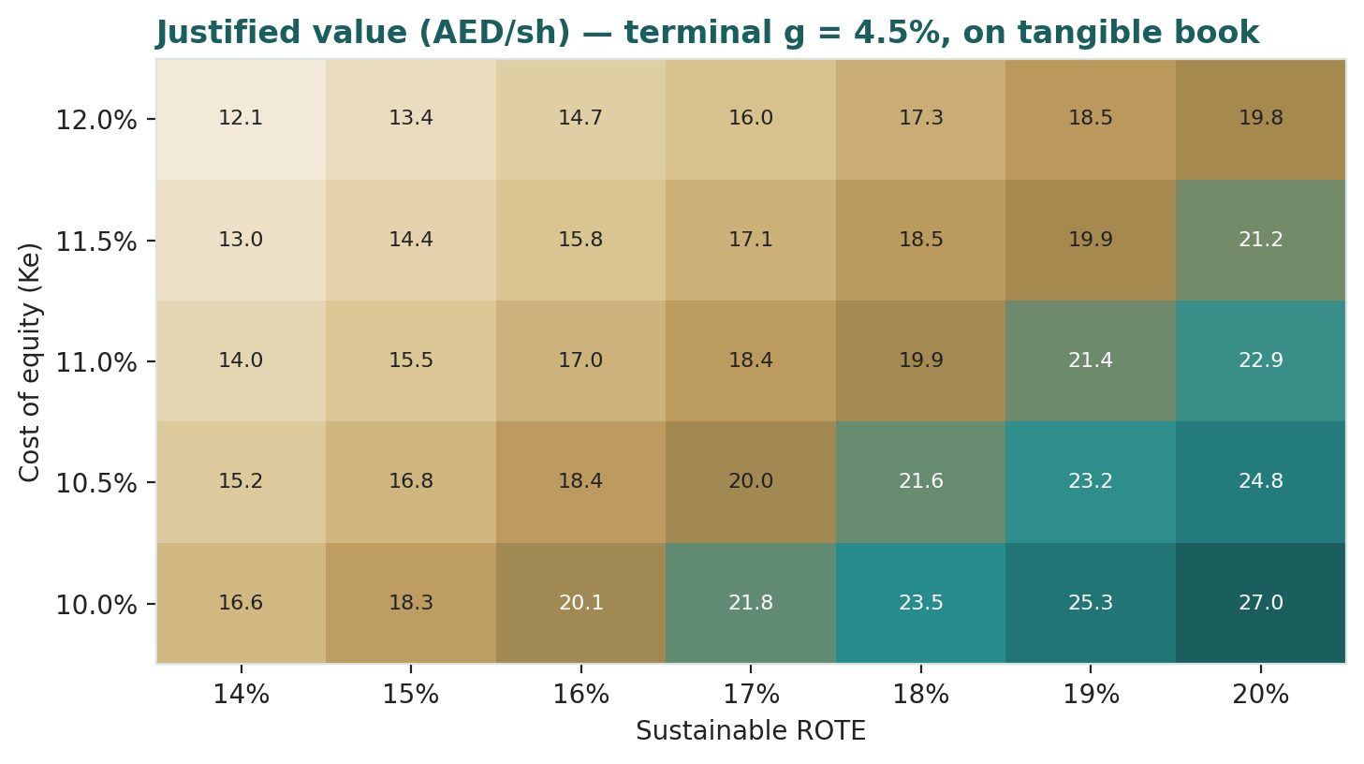
Figure 2 — DDM sensitivity to the sustainable-ROE and cost-of-equity swing inputs (AED/share). Cells near spot (AED 17.40) are shaded toward the centre.
Read it as the bet you are taking: the market price is consistent with roughly a 15–15.5% sustainable return on equity at an 11.5–12% cost of equity — that is, a partial margin-and-credit normalisation already discounted, but not the full re-base the bear case fears. Crossing to a durable 16–17% return at an 11% cost of equity is what a re-rating toward the high-19s to low-20s would require.
2 Technical and price structure
The tape is neutral and balanced — a marked contrast to the fundamental picture, which leans modestly cheap. FAB trades essentially on top of its 20-, 50- and 200-day moving averages and just below its 100-day, RSI sits near the midpoint at ~49, and the MACD histogram is only marginally negative. The structure is a consolidation inside a broad 15.5–20.7 range, without the stretched, oversold character that would flag either capitulation or an imminent snap-back.
Indicator | Reading | Signal
Spot | AED 17.40 | —
SMA 20 / 50 | 17.33 / 17.34 | On both — flat short-term trend
SMA 100 / 200 | 18.00 / 17.52 | Below 100, on 200 — neutral trend
RSI (14) | 49.1 | Mid-range — neither over-bought nor over-sold
MACD (12,26,9) | 0.04 line / 0.06 signal / −0.03 hist | Marginally negative — flat momentum
52-week range | AED 15.48 – 20.70 | Middle of range
Realized vol (252d) | 28.7% | Moderate
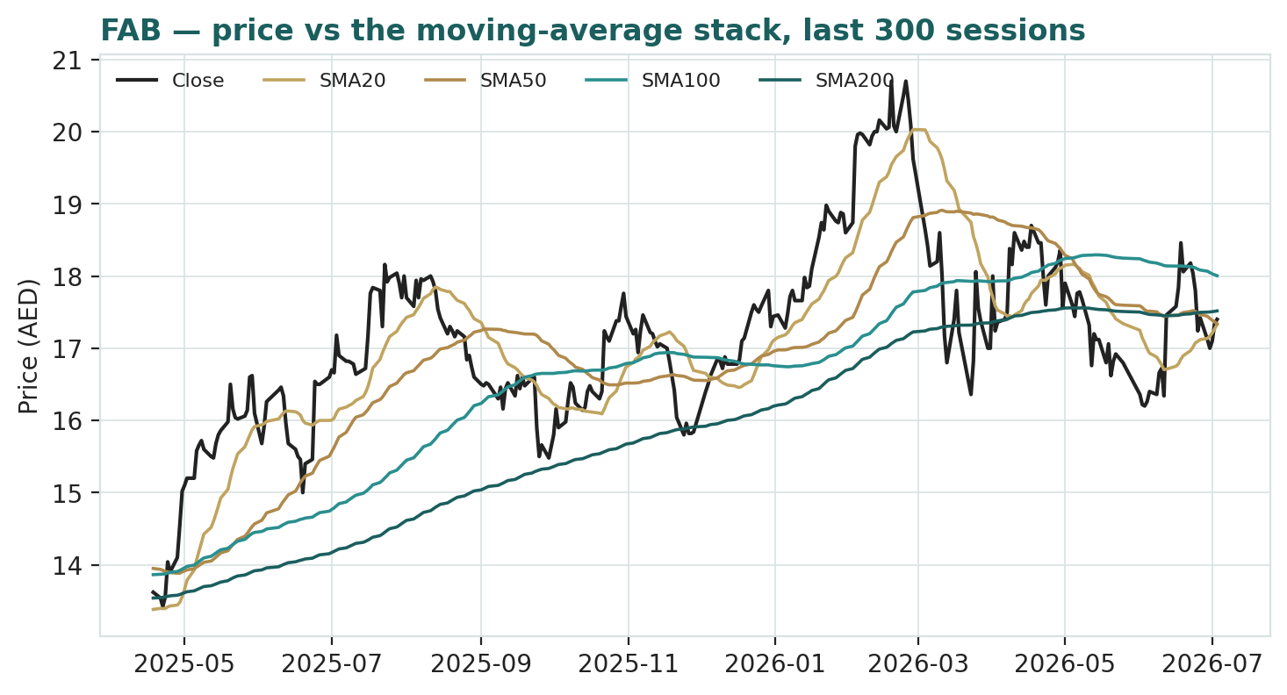
Figure 3 — Price versus the moving-average stack, last ~260 sessions.
For the probabilistic work this matters in one way: a neutral, mid-range tape neither widens the near-term downside tail (as an over-bought, above-trend market would) nor argues for a mean-reversion bounce (as a deeply over-sold one would). Price and value are close, and the three-month distribution in §3 reflects that — a cone centred near spot, its width set by the stock's own volatility rather than by a directional technical signal.
3 Monte Carlo — a probabilistic price map
We simulate 50,000 three-month price paths (seed 42) using a sixteen-factor stack: seven continuous macro/operating drivers and nine discrete events that each fire with a probability and an impact. By design the paths diffuse from spot, and the §1 value gap is kept out of the drift — the fundamental fair-value gap lives in §1, not here; §3 maps where price could go from today, not where value sits. Width is sized by the house YZ-HAR engine — a gap-aware Yang-Zhang variance proxy feeding a pooled log-HAR cascade (variance lags 1/5/22) that projects the average daily variance over the next 60 sessions — so the cone is regime-conditional rather than a flat trailing-vol tube. Innovations are unit-variance Student-t(5), giving a tighter interquartile body and honest tails. Because FAB is an international (non-EGX) name, the drift is set to zero: a confident trend drift breaks at a regime turn, and a pegged-currency bank at a rate-cycle inflection is exactly where that risk bites. The annualised diffusion volatility is ~30.7%.
Continuous factor (7) | Dir. | Discrete event (9) | Prob. | Mean impact
US/Fed policy-rate path (via the peg) | ± | Q2-26 results (NIM / CoR / fees) | 90% | +0.4%
Oil & Gulf sovereign liquidity | + | Dividend / distribution signal | 35% | +1.0%
UAE non-oil GDP / credit growth | + | Geopolitical / regional security | 30% | −7.5%
ADX / EM-frontier foreign flows | ± | Asset-quality / Stage-2/3 shift | 25% | −4.5%
Regional deposit / dollarization | + | Sovereign rating / GRE credit event | 25% | +1.0%
US 10-year / global risk-free | ± | Fed pivot / rate-path repricing | 30% | +1.5%
Real-estate & construction cycle (UAE) | + | M&A / capital action | 25% | +1.0%
 |  | Index / MSCI flow rebalancing | 30% | +1.0%
 |  | Large block / govt-stake placement | 20% | −3.0%
Percentile map (AED/share):
Horizon | p5 | p25 | p50 | p75 | p95
T+20 sessions | 14.97 | 16.44 | 17.32 | 18.18 | 19.75
T+60 sessions | 13.37 | 15.53 | 17.05 | 18.59 | 21.45
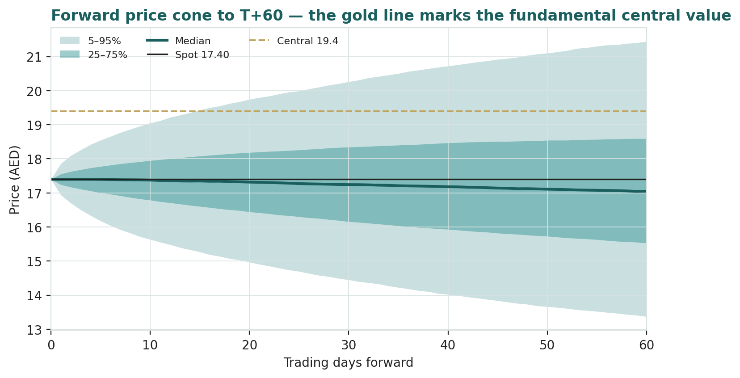
Figure 4 — Forward price cone to T+60. Median tracks spot; the gold dotted line marks the AED 19.9 fundamental central value, deliberately above the cone.
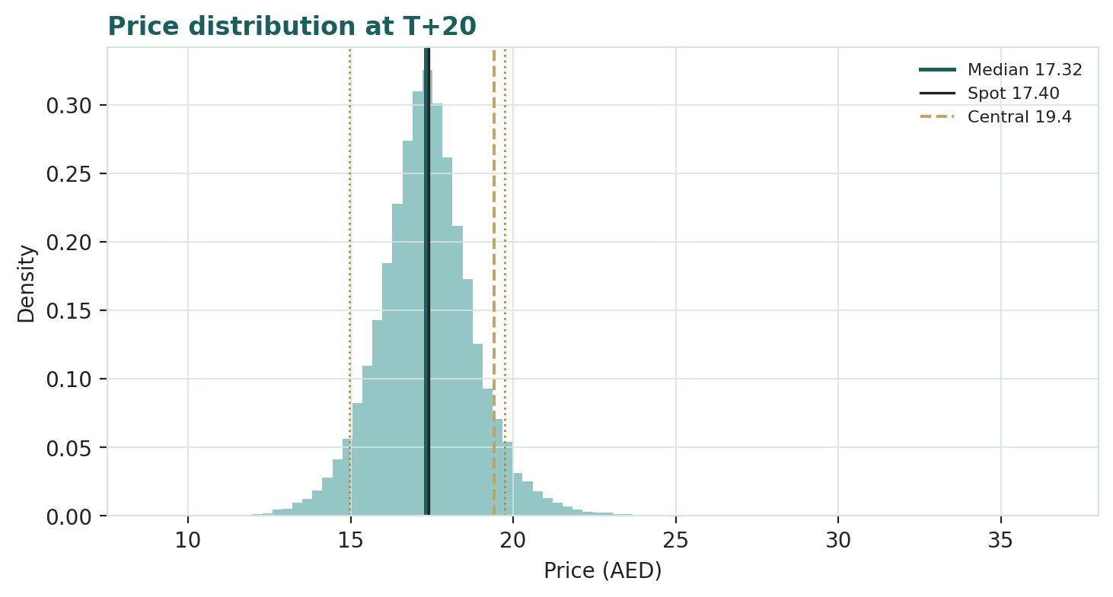
Figure 5 — Price distribution at T+20.
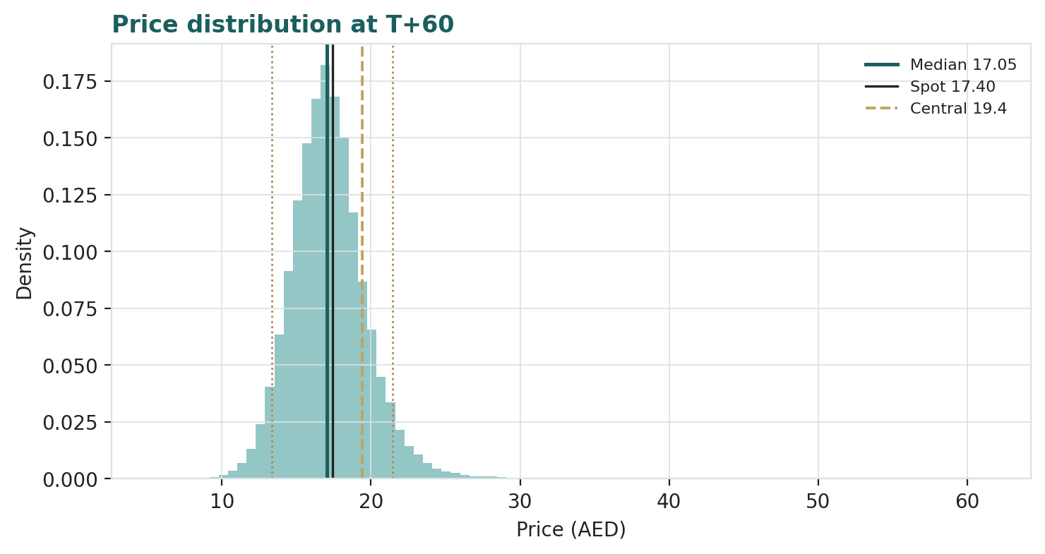
Figure 6 — Price distribution at T+60.
Level-touch ladder — the probability that price touches a level at any point by the horizon (running maximum for upside, running minimum for downside):
Level (AED) | T+20 touch | T+60 touch | Note
20.0 | 6% | 22% | Toward the 52-week high
19.0 | 18% | 40% | Near the DDM / relative floor
18.5 | 30% | 52% | Below central fair value
18.0 | 51% | 68% | Just above spot
17.0 | 64% | 81% | Just below spot
16.5 | 40% | 66% | Lower band
16.0 | 24% | 52% | Mid downside
15.0 | 8% | 29% | Toward the 52-week low
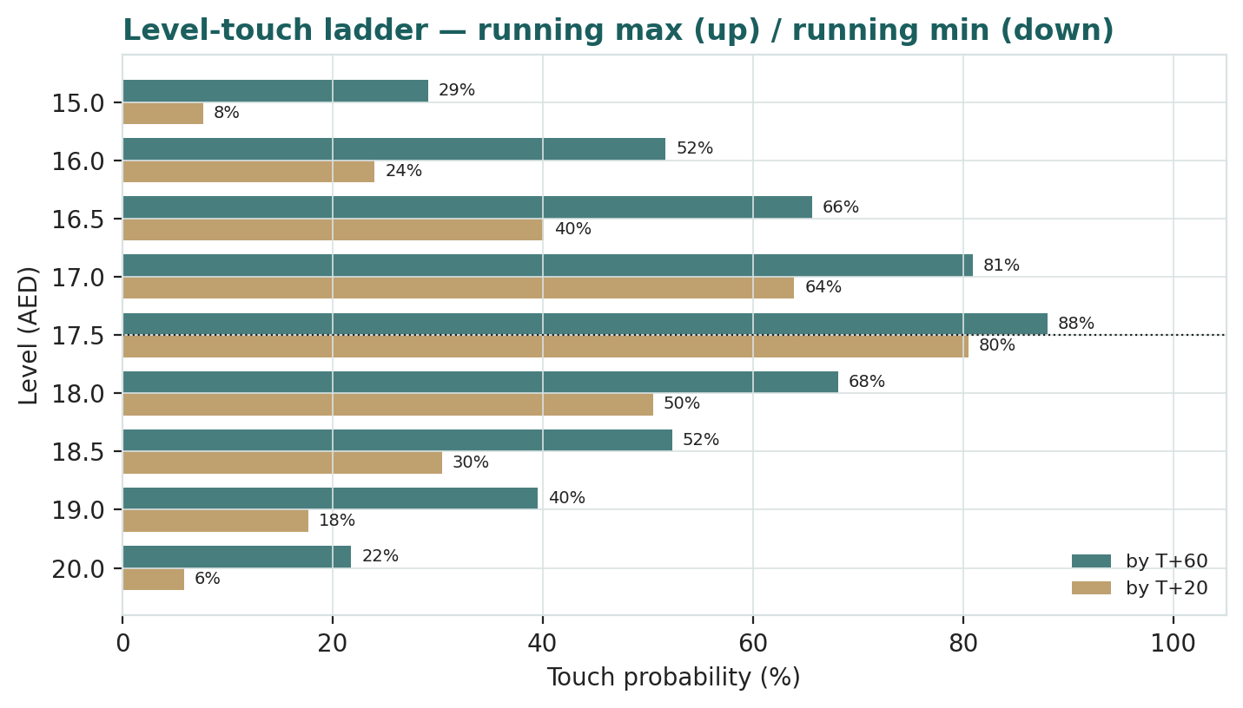
Figure 7 — Level-touch probabilities to T+20 and T+60.
4 Comparison of the lenses, and a verdict
Three readings sit side by side. The fundamental lenses cluster at AED 18.8–20.7 with a central AED 19.9 — modestly above spot, contingent on the sustainable return on equity. The technical picture is neutral, balanced in the middle of a broad range. The probabilistic map says that over three months price is roughly centred just below spot with a wide ~31% vol band — the median is AED 17.05, not AED 19.9, because the simulation does not assume the value gap closes inside the quarter.
Lens | Reads | Central / implication
Fundamental (4-lens) | Modestly cheap | AED 19.9 (~+14%)
Technical | Neutral / mid-range | Support ~15.5; resistance at the range top ~20.7
Monte Carlo (3-month) | Centred near spot, wide | Median AED 17.05; p5–p95 AED 13.4–21.5
Verdict (a fair-value read, not a recommendation). FAB looks modestly undervalued on fundamentals, with a clear and unusually concentrated swing factor: whether its through-cycle return on equity holds a wide enough premium over its cost of equity to justify a re-rating from ~1.6× book. The neutral technical tape and the near-spot three-month distribution argue that any re-rating is a question of the market crediting durable returns over several quarters — as rates fall and the cost of risk normalises — rather than of an imminent move. The honest summary is a value modestly above price, a near-term distribution centred just below price, and an outcome that hinges on one financial question. Readers should weigh the lenses themselves; we publish the distribution, not a target.
5 Catalysts to watch
• Q2-2026 results. First clean read on whether the net interest margin is holding as US rates fall, and whether the record non-interest-income run is sustaining.
• Federal Reserve rate path. The single biggest external lever via the peg — the pace and depth of cuts sets the trajectory of an asset-sensitive margin.
• Cost of risk and asset quality. Any drift up in Stage-2/3 loans or the cost of risk from today's benign ~49 bps would compress the return on equity.
• Dividend and capital policy. Whether the record AED 0.80 dividend and a comfortable ~13.9% CET1 translate into a rising payout or buyback.
• Oil and Gulf liquidity. A firm oil price supports government deposits and system liquidity; a sharp fall would tighten both.
• Regional geopolitics. An escalation in the Gulf security environment would widen risk premia and pressure the shares directly.
• Loan and deposit growth. The pace of UAE non-oil credit demand (real estate, trade, GREs) sets balance-sheet growth and net interest income.
• Index and ownership events. MSCI/index rebalancing flows and any change around the Mubadala stake or the 40% foreign-ownership limit.
6 Reading the probability zones
Translating the three-month distribution into plain zones, anchored on spot AED 17.40 and the fair-value cluster:
Zone (T+60) | Range | Approx. probability | What it would mean
Deep downside | < AED 15.5 | ~25% | Risk-off / faster margin re-base; tests the 52-week low
Lower band | AED 15.5–16.5 | ~16% | Cost of risk normalises faster; relative lens dominates
Around spot | AED 16.5–17.5 | ~18% | Status quo; value gap unclosed
Upper band | AED 17.5–18.5 | ~16% | Return premium credited; toward the DDM base
Strong upside | > AED 18.5 | ~26% | Durable ROE re-rating and a benign rate path together
The distribution is close to symmetric with a slightly heavier upper tail from the discrete upside events (a Fed pivot repricing, a dividend surprise, index flows). It is not a forecast; it is the spread of outcomes consistent with the stock's own volatility and the factor stack.
7 Caveats and what would change our mind
• The rate path is the model. FAB is asset-sensitive; a faster or deeper Fed easing cycle compresses the margin and the return on equity more than we assume, pulling the central value toward — or below — spot.
• The non-interest-income base is uncertain. FY2025's record markets and fees year may be a high-water mark rather than a new base; a mean-reversion in that line would lower the sustainable return.
• Cost of risk can normalise sharply. Today's ~49 bps is a benign-cycle figure; a credit event among government-related entities or a real-estate wobble could push it well past our through-cycle assumption.
• The terminal dominates. 82% of the DDM (and 76% of the FCFE-DCF) is terminal value — a durable-ROE-versus-cost-of-equity bet dressed as a five-year model; small moves in either input move the answer materially, which is why we sensitise both.
• Concentration and the sovereign. FAB's fortunes are tied to Abu Dhabi's sovereign and a handful of large relationships; a sovereign-rating or GRE credit event would hit funding cost and asset quality at once.
• Geopolitics is a fat tail. A regional security escalation is low-probability but high-impact, and would widen risk premia regardless of the operating story.
• Technical reminder. A neutral, mid-range tape offers no timing edge in either direction; the technical read here is context, not a trigger.

Appendix A Financial statements
Selected consolidated figures. FY2023–FY2025 are the company's own disclosure; FY2026–FY2030 are the model's forecast (formulas linking to the companion workbook's Assumptions sheet). Figures in AED billion unless stated. Some FY2023–24 line items (operating expenses, impairment, associates) are apportioned to tie to disclosed pre-tax and net profit; the balance sheet's other-asset and other-liability lines are plugs so totals tie exactly to disclosed size.
A.1 Income statement (consolidated, AED bn)
Line | FY23 | FY24 | FY25 | FY26E | FY27E | FY28E | FY29E | FY30E
Net interest income | 19.4 | 19.5 | 20.3 | 21.0 | 22.2 | 23.6 | 25.2 | 27.0
Non-interest income | 8.1 | 12.1 | 16.4 | 17.3 | 18.5 | 19.8 | 21.0 | 22.3
Total operating income | 27.5 | 31.6 | 36.7 | 38.4 | 40.7 | 43.4 | 46.2 | 49.3
Operating expenses | (6.1) | (6.9) | (8.0) | (8.4) | (9.2) | (10.0) | (10.6) | (11.3)
Pre-provision operating profit | 21.5 | 24.7 | 28.7 | 29.9 | 31.6 | 33.4 | 35.6 | 38.0
Impairment / cost of risk | (3.2) | (3.5) | (3.0) | (3.6) | (4.2) | (5.0) | (5.4) | (5.3)
Associates / other | (0.7) | (1.3) | (1.3) | (1.2) | (1.2) | (1.1) | (1.1) | (1.0)
Profit before tax | 17.6 | 19.9 | 24.4 | 25.2 | 26.2 | 27.3 | 29.2 | 31.6
Tax | (1.2) | (2.8) | (3.3) | (3.5) | (3.7) | (3.8) | (4.1) | (4.4)
Net profit | 16.4 | 17.1 | 21.1 | 21.6 | 22.5 | 23.5 | 25.1 | 27.2
Attributable to ordinary | 15.9 | 16.5 | 20.4 | 20.9 | 21.8 | 22.8 | 24.3 | 26.4
EPS (AED) | 1.43 | 1.49 | 1.85 | 1.90 | 1.97 | 2.06 | 2.20 | 2.39
DPS (AED) | 0.71 | 0.75 | 0.80 | 0.85 | 0.91 | 0.97 | 1.06 | 1.20
FY2025 net profit and EPS reconcile to disclosure (EPS is after AT1 coupon deductions). FY2026–FY2030 are formulas linking to Assumptions. Cost of risk and margin normalise gently through the forecast.
A.2 Balance sheet (consolidated, AED bn)
Line | FY23 | FY24 | FY25 | FY26E | FY27E | FY28E | FY29E | FY30E
Loans & advances (net) | 485 | 528 | 616 | 678 | 739 | 798 | 861 | 922
Investment securities | 230 | 240 | 260 | 281 | 303 | 325 | 347 | 368
Total assets | 1,171 | 1,210 | 1,400 | 1,512 | 1,633 | 1,748 | 1,870 | 1,982
Customer deposits | 758 | 786 | 841 | 908 | 972 | 1,040 | 1,102 | 1,168
Ordinary shareholders' equity | 102 | 110 | 117 | 129 | 140 | 152 | 165 | 178
AT1 capital | 10.0 | 10.2 | 10.4 | 10.4 | 10.4 | 10.4 | 10.4 | 10.4
Total equity | 114 | 123 | 135 | 147 | 158 | 170 | 183 | 196
Risk-weighted assets | 680 | 710 | 748 | 808 | 872 | 934 | 999 | 1,059
CET1 capital (equity − goodwill) | 91 | 99 | 106 | 118 | 129 | 141 | 154 | 167
CET1 ratio | 13.4% | 13.9% | 14.2% | 14.5% | 14.8% | 15.1% | 15.4% | 15.8%
Loans, deposits, equity and RWA are anchored to disclosure; other-asset / other-liability plugs make totals tie (balance check = 0 across all years). FY2026–FY2030 are formulas. The CET1 proxy (equity − goodwill/intangibles) runs ~30 bps above the regulatory figure because it excludes minor deductions.
A.3 Cash flow — capital generation (consolidated, AED bn)
A bank does not report a conventional free-cash-flow statement, so the cash-flow view that matters is capital generation: the profit attributable to ordinary shareholders, less the capital each year's balance-sheet growth must absorb (the increase in risk-weighted assets at the 13.5% CET1 target), gives free cash flow to equity — the pool from which dividends and buybacks are actually paid. This is the stream discounted in §1.2. FY2023 free cash flow to equity is shown blank because the model has no prior-year RWA from which to compute the FY2023 increase.
Line | FY23 | FY24 | FY25 | FY26E | FY27E | FY28E | FY29E | FY30E
Profit attributable to ordinary | 15.9 | 16.5 | 20.4 | 20.9 | 21.8 | 22.8 | 24.3 | 26.4
Growth in risk-weighted assets (ΔRWA) | — | 30 | 38 | 60 | 65 | 61 | 65 | 60
less capital retained (ΔRWA × 13.5%) | — | (4.1) | (5.1) | (8.1) | (8.7) | (8.2) | (8.8) | (8.1)
Free cash flow to equity (FCFE) | — | 12.4 | 15.3 | 12.9 | 13.1 | 14.5 | 15.5 | 18.3
Dividends paid | (7.8) | (8.3) | (8.8) | (9.4) | (10.0) | (10.7) | (11.7) | (13.2)
FCFE cover of dividend (×) | — | 1.5 | 1.7 | 1.4 | 1.3 | 1.4 | 1.3 | 1.4
Capital-generation cash flow. FCFE = profit attributable to ordinary − ΔRWA × 13.5% CET1 target. Dividends = DPS × ~11.05bn shares. FCFE covers the dividend every forecast year, so the payout is self-funding while capital builds.
A.4 Per-share, returns and capital markers
Metric | FY23 | FY24 | FY25 | FY26E | FY27E | FY28E
BVPS (AED) | 9.23 | 9.96 | 10.59 | 11.63 | 12.70 | 13.79
TBVPS (AED) | 8.24 | 8.96 | 9.59 | 10.64 | 11.70 | 12.79
Return on ordinary equity | 15.5% | 15.0% | 17.5% | 16.3% | 15.5% | 14.9%
Return on tangible equity | 17.4% | 16.6% | 19.3% | 17.8% | 16.9% | 16.1%
Net interest margin (model) | — | — | ~1.8% | ~1.7% | ~1.7% | ~1.7%
Cost-to-income | 22.0% | 21.8% | 21.8% | 22.0% | 22.5% | 23.0%
Cost of risk (bps) | 66 | 66 | 49 | 53 | 58 | 63
Dividend payout | 50% | 50% | 43% | 45% | 46% | 47%
Dividend yield (on spot) | 4.1% | 4.3% | 4.6% | 4.9% | 5.2% | 5.6%
Source: company results FY2023–FY2025; forecast = companion model. Model-basis NIM reconciles to reported net interest income and runs below the bank's reported ~1.9% (different earning-asset base).
Appendix B Step 0 — calibration backtest
Before any forecast we test the Monte Carlo lens on FAB's own five years of history: at each origin, using only data available to that date, we generate a three-month-ahead distribution with the same engine used in §3 and score the realised close against it. The grade is skill versus a naïve benchmark — a zero-drift random-walk lognormal cone at the trailing realised volatility — measured by CRPS skill (which must exceed zero) and the interval (Winkler) score. The PIT histogram and interval-coverage table are produced as calibration diagnostics only; band-containment is never the pass criterion, because rewarding coverage rewards width.
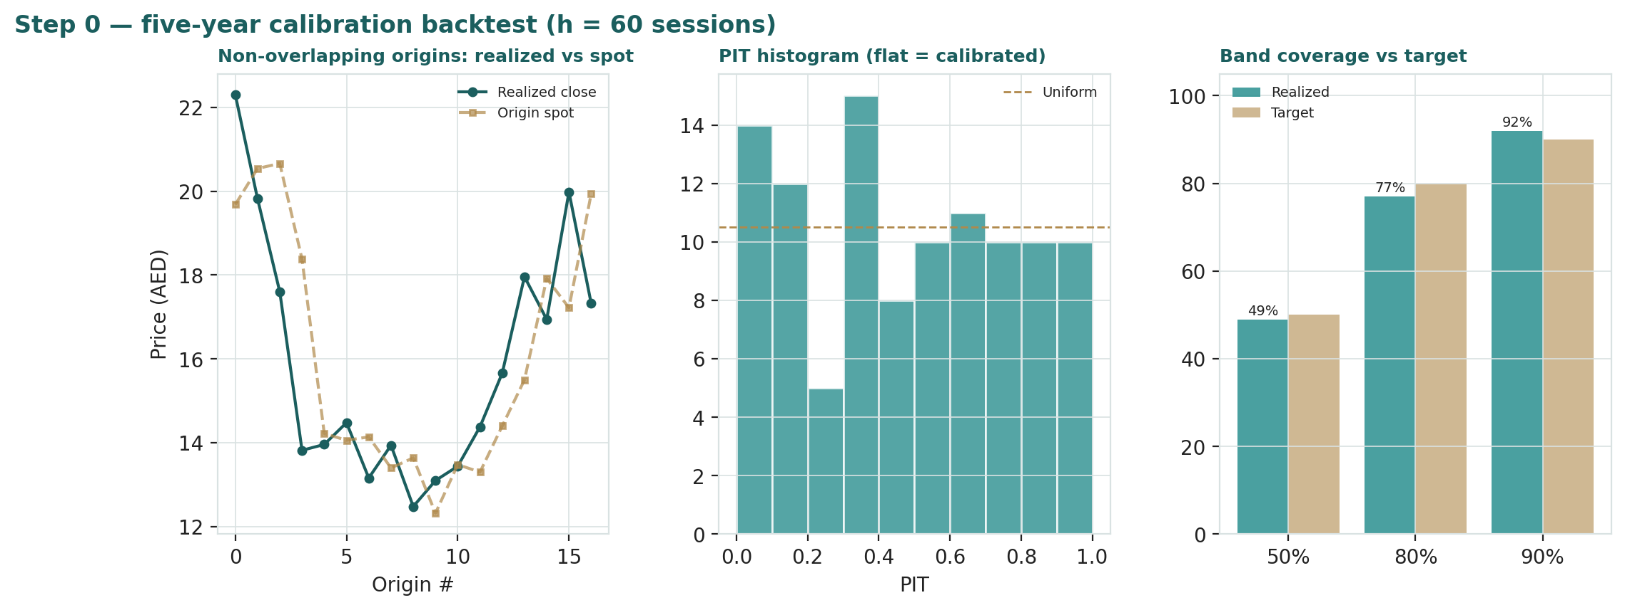
Figure B-1 — Calibration backtest: quarterly cone replay, PIT histogram, and interval coverage versus target.
Window scheme | n | CRPS skill | 50% band | 80% band | 90% band | PIT mean
Non-overlapping (step 63d) | 17 | −0.03 | 35% | 71% | 94% | 0.50
Monthly origins (step 21d) | 50 | +0.00 | 42% | 76% | 92% | 0.49
Fortnightly (step 10d) | 105 | +0.00 | 49% | 77% | 92% | 0.48
Target | — | > 0 | 50% | 80% | 90% | 0.50
On the two overlap-corrected schemes the engine essentially matches the random-walk benchmark on CRPS (skill marginally positive), with a close-to-flat PIT and coverage within tolerance; the small negative on the 17-window non-overlapping scheme is a low-sample artefact rather than a width error. For a pegged-currency bank whose returns are close to a driftless random walk, matching — not beating — the benchmark is the honest outcome, and the zero-drift specification is the correct one. The lens is accepted for the §3 forward run, and this cohort is logged to the Calibration Ledger with its anchor volatility and horizon so the benchmark can be rebuilt.
Appendix C Peer set, sector structure, and risks
FAB's peer set is the large Gulf banks — scale UAE and wider GCC franchises that share the dollar-peg monetary backdrop and a sovereign-anchored funding cost. Marks are illustrative context, not model inputs.
Bank | Market | P/B | P/E | ROE
First Abu Dhabi Bank | UAE (ADX) | 1.6× | 9.4× | 17.5%
Emirates NBD | UAE (DFM) | 1.1× | 6.5× | 19.0%
Abu Dhabi Commercial Bank | UAE (ADX) | 1.2× | 8.5× | 14.0%
Dubai Islamic Bank | UAE (DFM) | 1.2× | 7.0× | 17.0%
Abu Dhabi Islamic Bank | UAE (ADX) | 2.1× | 9.5× | 23.0%
Qatar National Bank | Qatar (QSE) | 1.6× | 10.0× | 17.0%
Al Rajhi Bank | KSA (Tadawul) | 3.6× | 18.0× | 19.0%
Saudi National Bank | KSA (Tadawul) | 1.5× | 13.0× | 11.0%
Sector structure. Gulf banking is a scale-and-funding game played on a dollar-pegged rate cycle: net interest margins rose with the Fed's hiking campaign and now compress as it eases, so the sector's near-term earnings trajectory is a rate story, while its longer-term one is a non-oil-diversification and credit-quality story. FAB sits mid-pack on price-to-book (~1.6×) despite top-tier scale, the region's strongest ratings, best-in-class efficiency and a ~20% return on tangible equity — a discount the bull case attributes to its lower headline dividend yield and the market's caution about a rate-cycle peak. Principal risks: a faster-than-expected margin re-base as the Fed eases; a mean-reversion in the record non-interest-income line; a cost-of-risk normalisation or a government-related-entity credit event; concentration in the Abu Dhabi sovereign and a handful of large relationships; and regional geopolitical escalation.

Appendix D The expert valuation panel
Every Testahil study closes with a panel of standing expert personas — drawn from the house Expert Persona Library, not invented for the occasion, so that each accumulates a track record across studies and a quarterly update is a re-run, not a re-training. For a bank we cast the three whose methods both fit a large, systemically-important lender and genuinely disagree: Expert 1 (capital and returns — residual income and the justified price-to-book), Expert 2 (the credit cycle — value off a normalised, through-cycle cost of risk rather than a benign trough), and Expert 3 (macro-policy — a scenario-weighted read anchored on the Fed path, oil and regional risk). Each runs a genuinely different method, derives its fair value from shown workings, and states a falsification condition. Labels are Expert 1 / 2 / 3; the personas are cast by method from the library.
D.1 Expert 1 — capital and returns: residual income and the justified price-to-book
Worldview and tradition. A bank is a machine for turning capital into a spread over the cost of that capital. Its worth is book value plus the present value of the residual income — the return on equity above the cost of equity, applied to the equity base — earned into the future. The natural terminal anchor is the justified price-to-book identity, P/B = (ROE − g)/(Ke − g): earn exactly the cost of equity and you are worth book; earn a durable premium and you deserve a multiple of it. This is the discipline of the return-on-equity investor, for whom the whole game is the width and durability of the ROE-minus-COE gap.
When the method works / fails. It works for a stable, well-capitalised deposit franchise whose returns are genuinely through-cycle — precisely FAB's profile. It fails when the return on equity is unstable or unsustainable (a bank riding a temporary rate spike, or one under-provisioned so that reported returns are borrowed from the future), and when the cost of equity is mis-set: because the answer is dominated by the terminal, a half-point error in either the sustainable ROE or the cost of equity swings the value materially.
Standard workings. (1) Establish current book and tangible book per share. (2) Set a sustainable through-cycle ROE, below the rate-cycle peak. (3) Publish the cost of equity as risk-free plus beta times equity risk premium. (4) Compute the justified P/B and apply it to forward book; add the present value of the interim dividends. The worked example below uses book value per share of AED 10.6, a sustainable ROE of 15.5%, a cost of equity of 11.0% and terminal growth of 4.5%.
Expert 1's residual-income build | Value
Book value per share, FY25 (AED) | 10.59
Sustainable through-cycle ROE | 15.5%
Cost of equity (4.5% rf + 1.0 × 6.5% ERP) | 11.0%
Terminal growth | 4.5%
Justified P/B = (ROE − g)/(Ke − g) | 1.69×
Terminal book per share, end-FY30 (AED) | 16.13
PV of terminal value + interim dividends | → AED 19.8/sh
Worked sensitivity (swing = sustainable ROE and cost of equity). At a 14% sustainable ROE the fair value falls to ~AED 17.0; at 17% it rises to ~AED 22.0. Holding ROE at 15.5%, a 12% cost of equity gives ~AED 16.8 and a 10% cost of equity ~AED 23.8. Cross-examination. He tells Expert 2 that stressing the cost of risk to a downturn level every year understates a franchise that spends most of the cycle in benign conditions — the through-cycle ROE already embeds an average provision. He tells Expert 3 that scenario-weighting is just his single sustainable ROE with extra steps: the probability-weighted return on equity is what he capitalises directly.
How he reads FAB specifically. He is unusually comfortable here because FAB's return has been remarkably stable across a decade that included an oil crash, a pandemic and a full rate cycle — the tangible-equity return has sat in a ~16–20% band throughout, never dipping toward the cost of equity. That stability is his whole case: a franchise whose funding cost is anchored by an Aa3 rating and a dominant deposit share does not need a booming rate environment to clear its hurdle. He notes that FAB's ~1.6× book is below where he has historically been willing to pay for a mid-teens sustainable return, and reads the gap as the market pricing a rate-cycle peak it expects to unwind — a timing worry, not a franchise one. He would pay up to ~1.85× book for the sustainable return he models and treats anything below ~1.5× as a clear margin of safety.
Verdict, falsification, market-implied. Fair AED 19.8 (range AED 17.5–22.5). Falsified if FAB's sustainable return on equity proves lower than its cost of equity — if the margin re-base and cost-of-risk normalisation together pull the through-cycle ROE below ~11% — in which case the bank is worth book or less. He would also fold if the beta assumption is wrong: at a 1.2 beta the cost of equity rises to ~11.8% and his fair value slips toward AED 18. The market's AED 17.40 implies a sustainable ROE of roughly 15–15.5% at an 11.5–12% cost of equity: a partial normalisation already discounted, and in his reading an over-discount of a durable return.
D.2 Expert 2 — the credit cycle: value off a normalised cost of risk
Worldview and tradition. A bank's reported profit in a benign year is a loan against the future; the only honest earnings number is one charged a through-cycle provision. This expert distrusts a ~49-basis-point cost of risk the way a value investor distrusts peak-cycle margins: it will not last, and the multiple paid on it is paid on borrowed profit. He values the bank on normalised earnings — reported pre-provision profit less a mid-cycle impairment charge — and applies a sober multiple. His tradition is that of the bank-credit analyst who has seen a benign book turn.
When the method works / fails. It is indispensable near the top of a credit cycle, when reported returns flatter and consensus extrapolates them. It fails by being too bearish in a structurally-improved book: if FAB's asset quality is genuinely better than history (concentrated in strong government-related and prime corporate names, ~100% covered), then a full downturn provision every year understates the sustainable return. The art is choosing the normalised charge.
Standard workings. (1) Take pre-provision operating profit. (2) Replace the reported cost of risk with a through-cycle charge (here ~80 bps on loans, well above today's ~49 bps). (3) Tax the result and strip AT1 coupons to get normalised attributable profit. (4) Apply a sober through-cycle P/E (~9×, at the low end of the peer range, for a bank whose earnings he views as quality-adjusted downward). The worked example stresses the FY26 book.
Expert 2's stressed-earnings build | Value
Pre-provision operating profit, FY26E (AED bn) | ~29.9
Normalised cost of risk (~80 bps on loans) | (5.4)
Associates / other | (1.2)
Normalised PBT (AED bn) | ~23.3
less tax and AT1 coupons | → ~19.3
Normalised attributable / share (AED) | ~1.75
Through-cycle P/E | 9.0×–10.5×
Fair value | → AED 18.0/sh
Worked sensitivity (swing = normalised cost of risk). At a 65-bps normalised charge (a milder normalisation) the value rises to ~AED 19.5; at 100 bps (a genuine downturn) it falls to ~AED 16.0. Cross-examination. He tells Expert 1 that a justified P/B struck on a 15.5% ROE quietly assumes today's benign provisioning persists — capitalise a return that is itself borrowed from an under-charged loan book and you double-count the optimism. He tells Expert 3 that his 'geopolitical tail' and 'GRE credit event' are not tail risks to be probability-shaded but the very thing a normalised cost of risk is meant to carry in the base case.
How he reads FAB specifically. His unease is concentrated, not diffuse: FAB's book is heavily weighted to Abu Dhabi government-related entities, large corporates and UAE real estate, so the cost of risk is not a smooth actuarial series but a step function that stays benign for years and then jumps when a single large name or the property cycle turns. He points to the bank's own history — impairment ran at ~66 bps as recently as FY2023–24 before the FY2025 drop to ~49 — as evidence that the benign figure is the exception, not the trend. He credits the ~100% coverage and improving non-performing ratio, but argues coverage protects the balance sheet, not the earnings multiple: a normalised charge still has to flow through the income statement he capitalises. He is explicit that he is not calling a crisis; he is refusing to pay a peak multiple on a trough provision.
Verdict, falsification, market-implied. Fair AED 18.0 (range AED 15.5–20.5) — the most conservative of the three: fairly valued, only a slim margin of safety. Falsified by evidence that FAB's book is structurally lower-risk than history — several years of sub-50-bps cost of risk through a genuine slowdown, or a demonstrated resilience in a real-estate or GRE stress. The market price is close to his number: on a stressed-credit basis, the price is about right, and his quarrel is with the two more optimistic experts rather than with the tape.
D.3 Expert 3 — macro-policy: a scenario-weighted read
Worldview and tradition. A pegged-currency bank is a macro instrument before it is a stock. Its earnings are a function of variables set outside the building — the Federal Reserve's rate path (imported through the peg), the oil price and the sovereign liquidity it drives, and the region's security premium. This expert refuses a single point estimate; he builds three coherent worlds, values the bank in each, and probability-weights them. His tradition is that of the top-down macro strategist, for whom the distribution of policy outcomes is the distribution of value.
When the method works / fails. It is the right lens precisely when the swing variable is exogenous and regime-like — a rate cycle turning, an oil shock, a geopolitical break — which is FAB's situation exactly. It fails when it becomes a way to avoid a view (three scenarios averaged to the base case add nothing), and when the scenario probabilities are guesses dressed as analysis. Its discipline is that each world must be internally coherent — a rate, a margin, a cost of risk and a growth rate that belong together.
Standard workings. (1) Define scenarios. Bull: a shallow Fed-easing path, firm oil, benign region — margin holds, ROTE ~19%, fair value ~AED 23. Base: a measured easing cycle, stable oil, contained risk — margin re-bases gently, ROTE ~18%, fair value ~AED 19.9. Bear: a fast easing cycle or an oil/geopolitical shock — margin compresses, cost of risk jumps, ROTE ~14%, fair value ~AED 15.5. (2) Probability-weight.
Expert 3's scenario weighting | Prob. | Fair value
Bull — shallow cuts, firm oil, benign region | 25% | AED 23.0
Base — measured easing, stable oil | 50% | AED 19.9
Bear — fast cuts / oil or geopolitical shock | 25% | AED 15.5
Probability-weighted fair value |  | → AED 19.6
Worked sensitivity (swing = scenario probabilities). Shift 15 points from base into the bear (a more hawkish-on-growth, risk-off stance) and the weighted value falls to ~AED 18.5; shift 15 points into the bull and it rises to ~AED 20.7. Cross-examination. He tells Expert 1 that a single sustainable ROE hides the asymmetry: the same franchise is worth AED 23 or AED 15.5 depending on a policy path neither of them controls, and the distribution is the point. He tells Expert 2 that a permanent downturn provision is just his bear scenario asserted as the base — the benign world has real weight, and pricing only the bad one throws away half the distribution.
How he reads FAB specifically. He treats the peg as the master variable: because the UAE cannot set its own policy rate, FAB's margin is a direct function of a Federal Reserve reaction function decided in Washington, and the interesting question is the shape of the easing path, not whether it happens. A shallow, data-dependent cut cycle keeps front-book yields elevated and is worth several dirhams; a recession-driven fast cut cycle compresses the margin just as the cost of risk rises — the two bad things arrive together, which is why his bear scenario is more severe than a simple margin haircut. He overlays oil (the swing factor for sovereign deposits and system liquidity) and the regional security premium as second-order but fat-tailed. He is candid that his edge is not forecasting the Fed but insisting the value is a distribution: the same balance sheet is a different asset in each world, and collapsing that to a point estimate discards the information.
Verdict, falsification, market-implied. Fair AED 19.5 (range AED 15.5–23.0). Falsified if FAB's earnings decouple from the macro drivers — if the bank demonstrates that diversification and non-interest income have broken the historical link between its return and the rate cycle, so that the scenarios collapse toward one another. The market price sits toward his bear-to-base boundary, implying the market weights the downside scenario more heavily than he does — which he reads not as mispricing but as an unusually cautious risk premium he is happy to be paid to accept.
D.5 The three in one room
The single question they most disagree on is what return FAB sustainably earns on its capital once the rate cycle has turned — and how much of today's benign cost of risk is real.
Expert 1: "FY2025 was a record, yes, but the franchise earns close to 20% on tangible equity and I only ask it to hold 15.5% through the cycle. At an 11% cost of equity that is a four-point premium — worth 1.7 times book. The market pays 1.6 times. The argument is the durability of the return, and I think it is durable."
Expert 2: "Your 15.5% is charged a 49-basis-point provision that will not survive a real slowdown. Charge it 80 through the cycle and the return, and the multiple it deserves, both come down. I am not bearish on the franchise — I am bearish on the idea that this is a normal loss year."
Expert 3: "You are both asserting a single number for something a central bank decides. The same bank is worth twenty-three dirhams in a shallow-cut, firm-oil world and fifteen-and-a-half in a fast-cut or shock world. Weight them. The price is not wrong — it is the market putting more weight on the downside than either of you will admit."
D.6 Reading the divergence
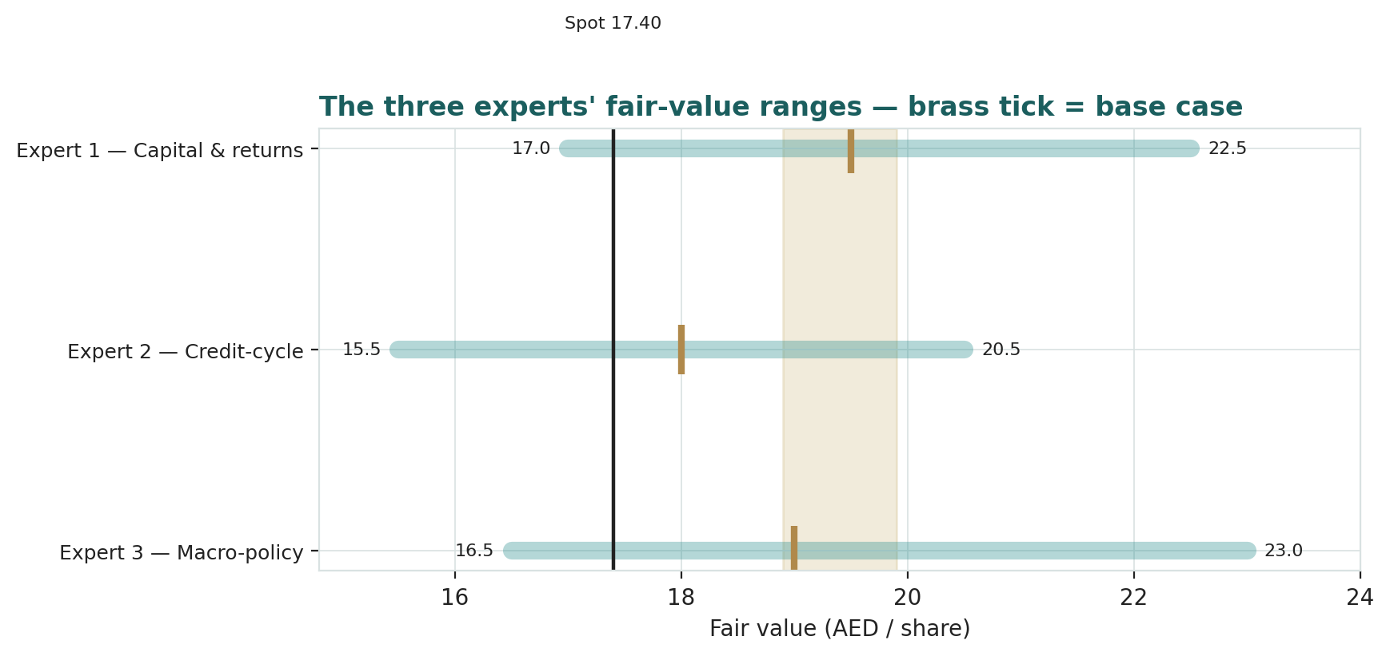
Figure D-1 — The three experts' fair-value ranges. Brass ticks are base cases; the gold band is the central, the dark line is spot. The spread is almost entirely a sustainable-ROE and cost-of-risk disagreement.
Expert | Method | Single swing assumption | Base fair value
Expert 1 | Residual income / justified P/B | Sustainable ROE vs cost of equity | AED 19.8
Expert 2 | Stressed / normalised earnings | Through-cycle cost of risk | AED 18.0
Expert 3 | Macro-policy scenarios | Fed-path / oil / risk probabilities | AED 19.5
The spread — AED 18.0 to 19.8 at base — is narrow, and it is almost entirely one disagreement: none of the three contests FAB's scale, funding cost, capital or the existence of a ~20% peak return. What separates them is whether that return is durable (Expert 1), quietly over-earned on a benign provision (Expert 2), or contingent on a policy path (Expert 3). The AED 1.8 spread is therefore a clean measure of a single uncertainty — the sustainable return on FAB's capital once rates fall and the cost of risk normalises. Resolve that, and the three converge.
Each expert's point fair value (and bull/base/bear) is logged with the study date (3 Jul 2026) and spot (AED 17.40) as an internal per-expert track record, kept separate from the core Calibration Ledger.
About this series
Testahil publishes independent, educational valuation studies. Each is an attempt to reason transparently about what a security is worth, with every assumption shown and a companion model so readers can disagree productively. The house style is distributions, not tips: we describe ranges and probabilities, not targets, and we do not tell anyone what to do. Studies are framed as educational analysis, the preparer is not licensed by any securities regulator, and holdings are disclosed.
Disclosure & Disclaimer
Not investment advice. This document is educational and informational only. It is not, and must not be relied upon as, investment, financial, legal, accounting or tax advice, nor an offer, solicitation or recommendation to buy, sell or hold any security. It contains no price target and no rating.
No licence; no advisory relationship. The preparer is not registered or licensed with any securities or financial regulator in any jurisdiction, holds no brokerage or investment-advisory authorisation, and is not acting as your adviser or fiduciary. Nothing here is personalised to your circumstances.
Holdings disclosure. The preparer may hold, and may in the future take or dispose of, a position in the security discussed in this report, and may transact at any time without notice. This is a potential conflict of interest you should weigh.
Sources & accuracy. Reported financial and operating figures are drawn from the company's public disclosure and other public sources believed reliable but not independently verified; they may contain errors or be superseded. Forward-looking inputs — the cost of equity, the sustainable ROE and cost of risk, projections, multiples, the DCF and Monte-Carlo factor probabilities — are the preparer's own judgments and are inherently uncertain.
Forward-looking statements. Any statements about the future are estimates subject to risks and uncertainties; actual results may differ materially. The Monte Carlo models price, not value, and encodes subjective probabilities for events that have not occurred.
No reliance; your responsibility. Do your own research and consult a licensed professional before making any decision. You are solely responsible for your investment decisions and their outcomes. To the maximum extent permitted by law, the preparer accepts no liability for any loss arising from use of this document.
Currency & figures. Figures are in UAE dirham (AED), which is pegged to the US dollar at 3.6725; bn denotes billion. Rounding may cause totals to differ slightly. Spot price and market data are as of 3 July 2026 and change continuously.
TESTAHIL · Independent Valuation Study · Educational Analysis · First Abu Dhabi Bank PJSC (ADX: FAB) · edition 03-07-2026 · reporting currency AED

