Testahil · Independent Valuation Study - Educational Analysis Not investment advice
Independent Valuation Study - Educational Analysis
Fawry for Banking Technology and Electronic Payments (S.A.E.) (EGX: FWRY)
Fundamental analysis · Technical analysis · Monte Carlo simulation - one integrated read
Anchor: EGP 18.40 (1 Jul 2026 close) · ~3,905 mn shares · mkt cap ~EGP 71.8 bn · Egypt's largest digital-payments and consumer-fintech platform (54.8 mn monthly users, 377k agents, EGP 943.6 bn FY25 throughput) · prices and probabilities computed 1 Jul 2026 from the attached daily history · primary lens: five-year FCFF (DCF) on the operating business, with a segment SOTP and growth-multiple cross-checks · swing factors: the CBE rate cycle (the multiple vs the float income) and the durability of 57% EBITDA margins.
READ FIRST - what this document is, and is not. This study is a valuation exercise and an expression of personal analytical opinion, published free of charge for educational purposes. It is NOT investment advice, NOT a recommendation or solicitation to buy, sell or hold any security, and NOT directed at the circumstances of any reader. The preparer is not licensed by any securities regulator, manages no money, and accepts no fees, funds or clients. All values are model outputs presented as ranges and distributions because no single number should be relied on. Reported financials are the company's own disclosure (FY2025 earnings release, 5 Mar 2026; FY2024 release, 2 Mar 2025); FY23 net income is derived from the company's disclosed +124.6% FY24 growth; the D&A/ESOP/provisions wedge, non-operating interest income and most balance-sheet lines are the preparer's estimates pending the EAS financial statements, and are flagged. Forward-looking inputs - the growth fade, margins, multiples, the DCF and the Monte-Carlo factor probabilities - are the preparer's judgments. See the Disclosure & Disclaimer at the end.
Headline
At EGP 18.40 the market pays about 25% above the weighted fundamental centre of ~EGP 14.7. The cash-flow lenses cluster below spot - a 24%-WACC DCF says 11.5, normalized growth ~15, the segment SOTP ~16.4 - and only the relative-multiple lens (20x FY26E earnings) reaches the price. FY2025 was outstanding: revenue +57% to EGP 8.65 bn, company-defined EBITDA margin 57.4%, net profit +80% to EGP 2.89 bn. The premium in the price is therefore not a bet on FY25 - it is a bet that 30% growth and record margins persist while the CBE cuts rates, and that is exactly where the risk sits: cuts re-rate the multiple but compress the treasury income earned on the float. The three-month probability map leans mildly higher: a 25-75% band of EGP 17.0-22.1 around a 19.4 median.
Valuation summary - every read at a glance
One table for the four reads that follow - what the business is worth (fundamental), what the tape is doing (technical), where price could travel over three months (Monte Carlo), and how three independent expert methods land. Every row is developed in the sections and appendices below.
Lens / read | What it measures | Output | Takeaway
FUNDAMENTAL - what the business is worth (the anchor)
Consolidated DCF (primary) | 5-yr operating FCFF at 24% WACC | EGP 11.5 | -38% vs spot
SOTP (segments) | Marked segment EVs + net cash | EGP 16.4 | -11%
Relative multiples | 20x FY26E EPS vs peers | EGP 20.3 | +10% · the ceiling
Normalized growth | Two-stage EPS x fair P/E | EGP 15.0 | -18%
Weighted central | Blend 40 / 20 / 15 / 25 | EGP 14.7 | -20% vs 18.40
TECHNICAL - what the tape is doing (timing, not value)
Trend & momentum | Price vs 20/50/100/200-day | Below 20/50, above rising 200 | Consolidating uptrend
MONTE CARLO - where price could travel (3 months)
T+60 distribution | 16-factor, 50k paths, seed 42 | P25-P75 EGP 17.0-22.1 | Mild upward drift
EXPERT PANEL - three independent methods
Expert 1 / 2 / 3 | Growth EPS · Quality-of-earnings · Rate cycle | EGP 15.0 / 10.5 / 15.5 | Cluster below spot

Company overview - Fawry for Banking Technology and Electronic Payments at a glance
Item | Value
Exchange / ticker | EGX: FWRY
Sector | Digital payments & consumer fintech
Fiscal year-end | 31 December
Shares outstanding | ~3,905 mn
Spot / market cap | EGP 18.40 / ~EGP 71.8 bn
FY25 revenue / net profit | EGP 8,651 mn (+57%) / EGP 2,889 mn (+80%)
EBITDA margin (co-def.) | 57.4% (+7.6 pts)
Scale | 54.8 mn monthly users · 377k agents · EGP 943.6 bn throughput
Gross loan book | EGP 5.7 bn (MSME + consumer)
Dividend | None - earnings reinvested
52-week range | EGP 11.06 - 21.25

Source: Fawry FY2025 earnings release (5 Mar 2026) and FY2024 release (2 Mar 2025), fawry.com / EGX disclosure; Investing.com for EPS; prices from the attached daily history.
1 Fundamental valuation
1.1 Consolidated DCF - the primary lens
The primary lens is a five-year FCFF on the operating business: EBIT (company-defined EBITDA less the full D&A/ESOP/provisions wedge), taxed at 26%, plus the non-cash wedge back, less capex (~8-9% of revenue) and working capital, discounted at a 24% nominal EGP WACC with 12% terminal growth. Non-operating interest income is deliberately excluded from the DCF and carried only as net cash, so the operating franchise is valued clean.
Result: operating EV ~EGP 42.8 bn, plus ~EGP 2.0 bn attributable net cash = equity ~EGP 44.8 bn, or EGP 11.5/share. The 24% WACC is built for an EGP holder - ~20-21% risk-free plus a moderate premium for a capital-light, founder-led platform - and the 12% terminal deliberately sits below nominal GDP so perpetuity growth is never doing the work. At Egyptian discount rates, five years of superb growth still only carries so far - the terminal assumption dominates, which is the honest weakness of any DCF at these rates.
One design choice deserves emphasis: excluding the float interest from the DCF is not conservatism for its own sake - it keeps the operating franchise and the rate bet in separate rooms, so a CBE decision changes the net-cash line and the discount rate, never the modelled franchise itself. The lens synthesis then reassembles the pieces with the weights declared.
1.2 Reverse-DCF cross-check
Reverse-engineering the price: EGP 18.40 is equity of ~EGP 71.8 bn, implying an operating EV near EGP 70 bn. The table translates that into the assumption you must hold to pay spot; none is impossible, all three are the bull case.
What would change the implication is watchable: each MPC meeting moves the implied-WACC row directly, and each quarterly margin print tests the implied-persistence row - the reverse-DCF is a scoreboard, not a verdict.
What spot implies | Implied level | Base case
Operating EV backed out of 18.40 | ~EGP 70 bn | EGP 42.8 bn
or nominal WACC | ~19-20% | 24%
or terminal growth | ~15-16% | 12%
or growth/margin persistence | 20%+ at 55%+ for a decade | fading to 12% / 52%

The fourth row is the quiet one: a decade at 20%+ growth and 55%+ margins has been achieved by almost no payments company at scale anywhere - Adyen came closest and repriced violently the one half-year it slipped. Spot embeds that base rate without naming it.
1.3 Relative multiples
On FY26E earnings the stock trades at 20.0x (EPS ~EGP 0.92), and 24.9x trailing. EV/EBITDA on FY26E is ~11x. Global payment platforms span roughly 18-28x forward earnings; the domestic comp, e-finance (EFIH), trades in the same growth-scarcity zone. A 22x fair forward multiple - crediting the scarcity of profitable 30% growth on the EGX - supports ~EGP 20.3, the most generous lens on the field.
The frame worth keeping: dLocal and Adyen earn their premium multiples with USD cash flows; Fawry's are EGP - the peer band should be entered from the bottom, not the middle, which is why this lens carries the smallest weight.
EV/EBITDA cross-frame: at ~11x FY26E company-defined EBITDA, the market already awards Fawry a developed-market processor multiple on an emerging-market cost of capital - the mismatch every lens in this study keeps re-finding from a different angle.
1.4 Normalized earnings power
Two-stage normalized growth: FY26E EPS EGP 0.92, growth fading 20% to 12% over five years, capitalised at a ~24% cost of equity, supports a fair multiple near 16x and ~EGP 15.0/share. This is the lens that pays for the compounding without paying for the rate cuts.
Its distance from the DCF (~EGP 3.5) is pure duration arithmetic - the same fade capitalised as a multiple versus discounted year-by-year - and its distance from spot (~EGP 3.4) is the market's rate-cut premium, made visible.
A useful bridge: capitalizing the same fade at a 19% cost of equity - the deep-easing world - lifts the fair multiple toward 20x and this lens to ~EGP 18.4, i.e. spot. Normalized growth at today's rates says 15; at tomorrow's hoped-for rates it says the market price. That is the whole argument in one sentence.
1.5 Synthesis - five lenses
Five lenses, one field: the DCF anchors low (11.5) because EGP discount rates are brutal to long-duration cash flows; the SOTP (16.4) and normalized growth (15.0) sit mid-field; relative multiples (20.3) alone reach above spot. Weighting 40/20/15/25 puts the central fair value at ~EGP 14.7 - about 20% below the price.
The weights are declared, not fitted: the DCF leads because payments is a cash-flow business; the SOTP carries the segment reality; the multiple lens is deliberately lightest because it imports the market's own optimism as evidence.
Lens | Fair value (EGP) | Weight
Consolidated DCF (primary) | 11.5 | 40%
SOTP (segments) | 16.4 | 20%
Relative multiples | 20.3 | 15%
Normalized growth | 15.0 | 25%
Weighted central | 14.7 | 100%

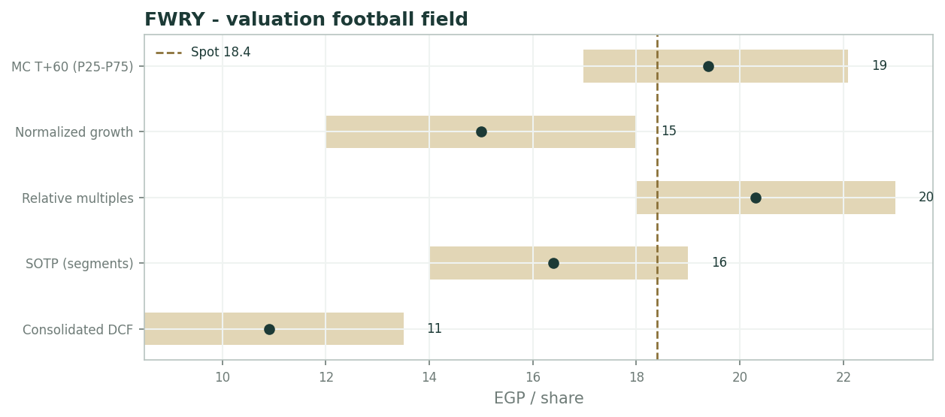
Valuation football field - lens ranges vs spot
1.6 The segments - where the growth lives
FY25 revenue by segment, per the earnings release - the scorecard shows where the growth now lives. The engine has visibly rotated from payments to financial services: higher-margin, but credit-carrying, with the gross loan book at EGP 5.7 bn and compounding at ~80%.
That rotation is the strategic fact of the year: the acceptance/agent network is becoming the distribution layer for a consumer-finance business, which changes both the margin structure and the risk book.
Segment | FY25 revenue | Growth | Read
Banking services | EGP 3.51 bn | +52% | Agent banking + acceptance; EGP 643 bn throughput
Financial services | EGP 2.38 bn | +135% | Lending/BNPL/insurance; the loan book lives here
ADP (bill payments) | EGP 2.01 bn | +17.6% | The legacy cash-cow, maturing
Supply chain + tech | EGP 0.75 bn | +43% / n.m. | Optionality, small base

1.7 The rate cycle and the 57% margin - the crux
The crux cuts both ways. CBE easing re-rates the equity (every point off the discount rate is worth roughly EGP 1.5-2.0/share in the DCF) and fuels the consumer-credit engine - but it compresses the treasury and float income (an estimated ~EGP 790 mn in FY26) that today flatters net profit. Tightening does the reverse.
Layered on top is the durability question: the 57.4% EBITDA margin is company-defined (it excludes ESOP, provisions, leasing and non-operating interest), and free InstaPay rails plus bank apps press on take rates. Quantified, a 10bp take-rate erosion on the acceptance book costs roughly EGP 0.9 bn of throughput-revenue equivalent over the plan - second only to the rate path itself. The value case hinges on those two files, not on whether FY25 was real. It was.
Sequencing matters too: the float-income compression arrives with the first cuts, while the credit-growth and multiple benefits build over quarters - so the earliest easing phase is mechanically the least flattering window for reported profit, a timing wrinkle the market tends to discover in real time.
1.8 Macro and country
Macro: Egypt's financial-inclusion push, cash digitisation and the CBE's Soft POS launch (Feb 2026) are secular tailwinds; the EGP and the policy-rate path are the cyclical swing. A weaker pound raises nominal throughput but keeps the discount rate punitive; disinflation and cuts do the opposite.
Regulatory posture toward fintech remains supportive, with licensing (neobanking) the gating item - and the same regulator's free InstaPay rails are the competitive counterweight, a reminder that the state is both patron and rival here.
The competitive file is regulatory at heart: InstaPay's free rails cap consumer-transfer monetisation, so Fawry's answer - moving up the stack into credit, insurance and merchant software - is strategy dictated by the regulator's own architecture.
1.9 WACC x terminal-growth grid
Sensitivity is dominated by the discount rate and the terminal assumption: WACC 22/24/26% moves the DCF roughly EGP 14.1/11.5/9.6; terminal growth 10/12/14% swings it by a similar magnitude the other way. The honest DCF envelope is ~EGP 8.5-14; only rate-cut-grade assumptions push it toward spot. The grid is illustrative and consistent with the live two-way table in the companion Excel.
WACC \ g | 10% | 12% | 14%
22% | 12.6 | 14.1 | 16.2
24% | 10.2 | 11.5 | 13.2
26% | 8.6 | 9.6 | 10.9

2 Technical and price structure
Price EGP 18.40 sits just below the 20-day (18.7) and 50-day (19.5), on the 100-day (18.9), and comfortably above a rising 200-day (17.0) - a consolidation in the upper third of a strong 12-month advance (52-week range 11.06-21.25). RSI(14) at ~55 is neutral: neither the overbought extreme of the spring run nor oversold.
The tape says pause-in-uptrend, not reversal: pullbacks to the rising 200-day have been bought all year, and the 17.0-17.5 shelf is the level that would have to fail before the technical read changes.
Indicator | Reading
Spot | EGP 18.40
SMA 20 / 50 / 100 / 200 | 18.7 / 19.5 / 18.9 / 17.0
RSI(14) | ~55 (neutral)
52-week range | EGP 11.06 - 21.25
Structure | Below 20/50-day, above rising 200-day

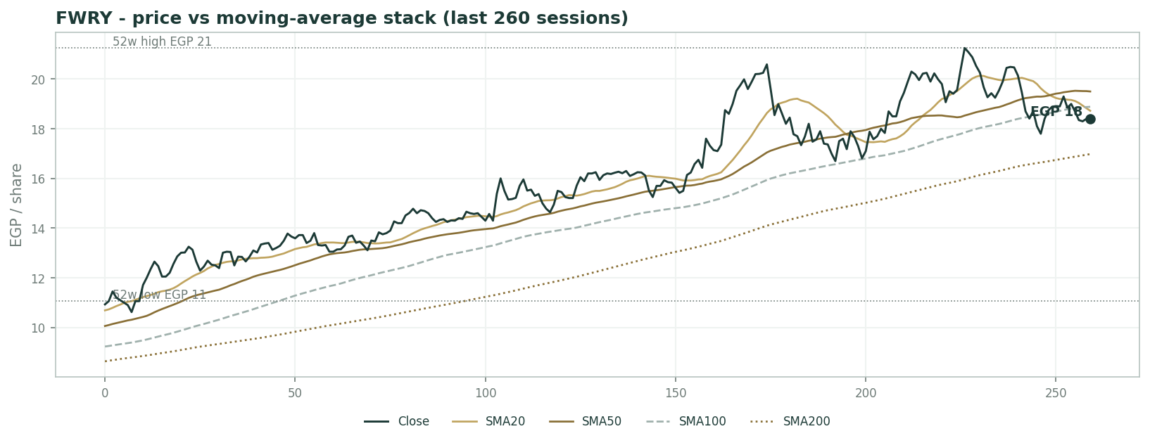
Price vs moving-average stack (last 260 sessions)
3 Monte Carlo - a probabilistic price map
Paths diffuse from spot; the §1 value gap is kept out of the drift, so the three lenses stay independent. 16-factor model - 7 continuous + 9 discrete - 50,000 paths, seed 42.
Horizon | P5 | P25 | P50 | P75 | P95
T+20 | 15 | 17 | 19 | 20 | 23
T+60 | 14 | 17 | 19 | 22 | 27

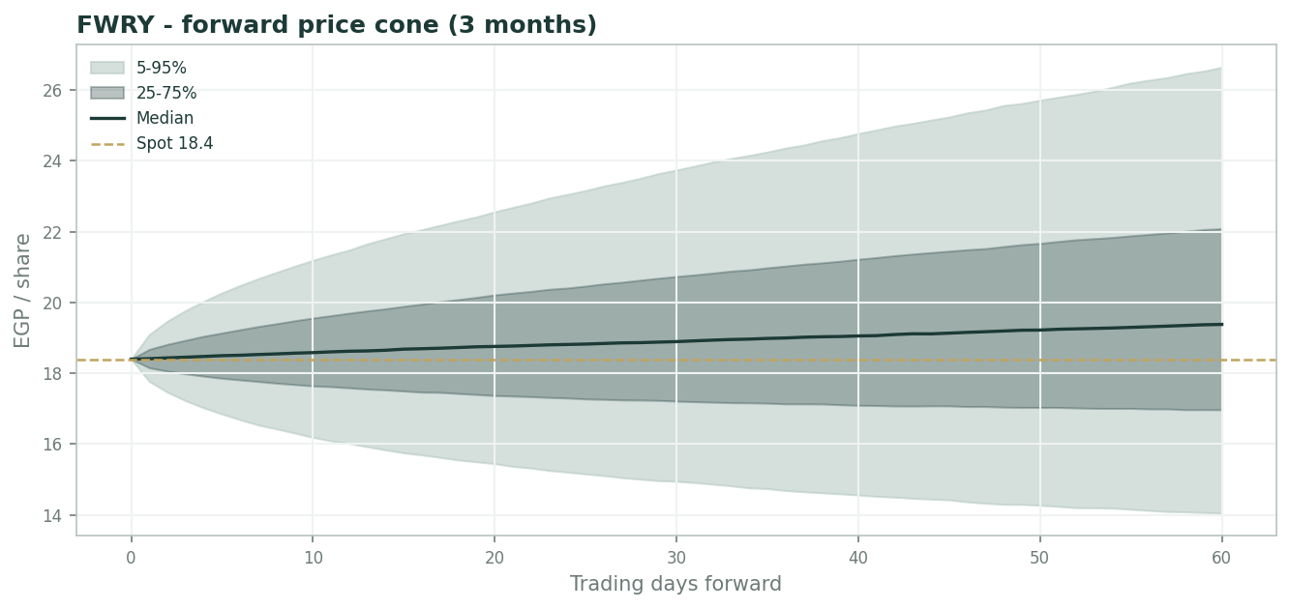
Forward price cone (3 months)
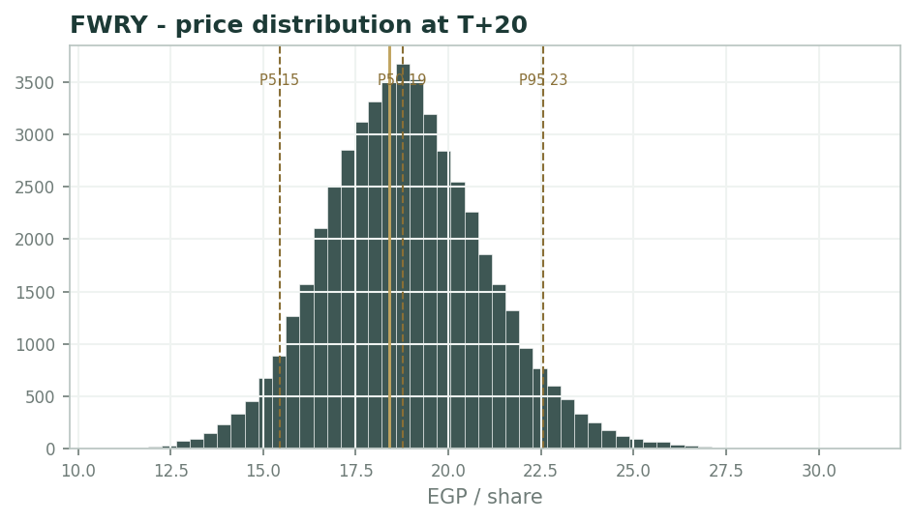
Price distribution at T+20
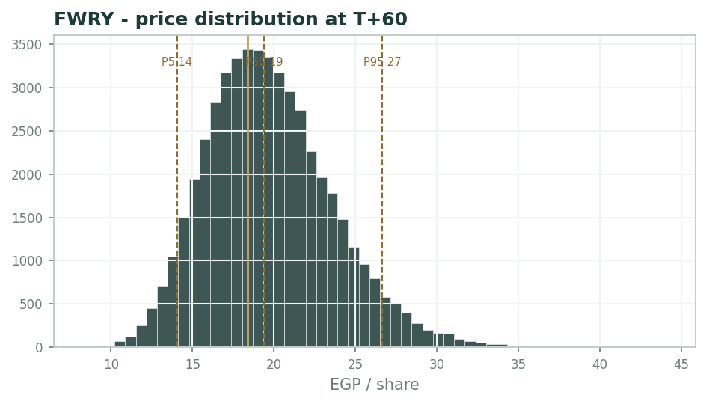
Price distribution at T+60
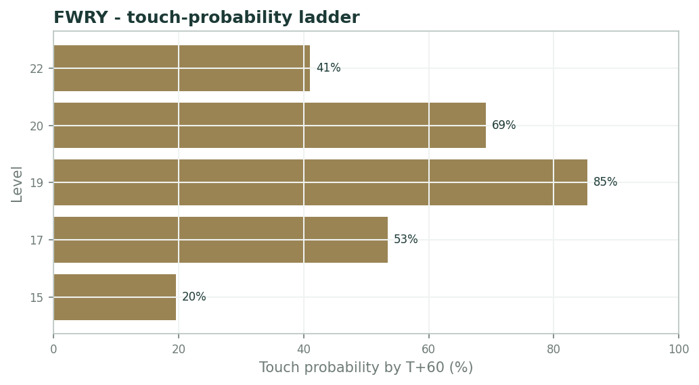
Touch-probability ladder by T+60
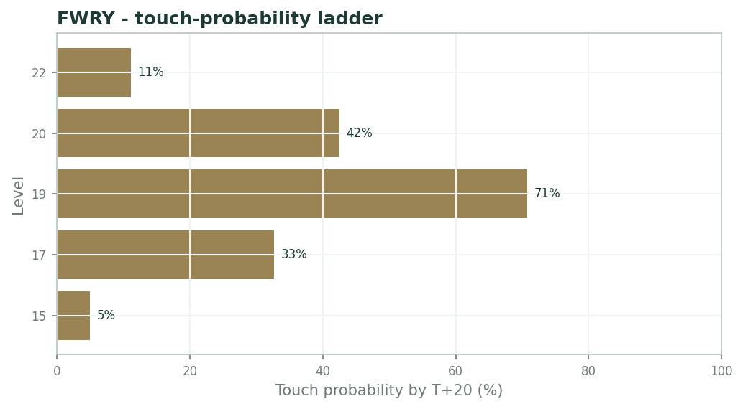
Touch-probability ladder by T+20
The distribution leans mildly higher (median 19.4 vs spot 18.40) with a fatter upside tail - P95 at EGP 26.6 versus P5 at 14.0 - reflecting the growth-momentum and rate-cut event factors.
Touch probabilities by T+60: EGP 18 ~79%, EGP 20 ~69%, EGP 22 ~41%; downside, EGP 16 ~34%. By T+20 the same levels run ~68%, ~42%, ~11% and ~14% - the near ladder is the far ladder compressed, with the asymmetry (up-levels likelier than equidistant down-levels) already visible at one month.
4 Comparison of the lenses, and a verdict
The lenses split cleanly by what they pay for: audited cash flows discounted at Egyptian rates (DCF 11.5, quality-of-earnings ~10.5) sit far below spot; growth-respecting lenses (normalized 15, SOTP 16.4) close half the gap; only the market-multiple lens (20.3) clears the price. Weighted central ~EGP 14.7 vs spot 18.40.
Verdict: a superb business trading roughly 25% above its blended fundamental value - fairly-to-richly valued, with the premium a live bet on CBE cuts plus margin and growth persistence, and the distribution's own skew showing the market leaning the same way.
5 Catalysts to watch
- Quarterly results cadence - 2Q26 (mid-Aug 2026) is the next print; watch Financial-services growth and the loan book's asset quality.
- CBE rate decisions - each cut re-rates the multiple and compresses float income; the single biggest swing.
- Soft POS commercial rollout following the CBE's February 2026 launch, and neobanking licensing progress.
- Take-rate evidence versus free InstaPay rails and bank apps in the ADP segment.
- Any first dividend or capital-return signal from the growing cash generation.
6 Reading the probability zones
Below ~EGP 14 (P5-P25) the stock is cheap on every lens including the strict DCF - the zone where the rate-cycle bet is free. EGP 14.5-16.5 is the weighted fundamental band. EGP 17-22 (the P25-P75 band, containing spot) is priced for continued execution plus the start of easing. Above ~EGP 26.6 (P95) requires blow-out growth and deep cuts together - a demanding pair.
Zone | Range (EGP) | What it means
Cheap on all lenses | < 14 | P5-P25; below even the strict DCF
Weighted fundamental band | 14.5 - 16.5 | DCF, SOTP and normalized interleave
Execution + easing priced | 17 - 22 | P25-P75, contains spot
Blow-out + deep cuts | > 26.6 | P95; demanding pair

7 Caveats and what would change our mind
FY23 net income is derived from the company's disclosed +124.6% FY24 growth (after-NCI basis) rather than read directly; the D&A/ESOP/provisions wedge, non-operating interest income, and most balance-sheet lines are estimates pending the EAS financial statements; attributable net cash of EGP 2 bn is a judgment; company-defined EBITDA is not audited operating profit - the wedge between them is the quality-of-earnings question Expert 2 prices; the 5.7 bn loan book carries credit risk not separately modelled; and the whole valuation is hostage to the CBE path, which is outside the model.
Appendix A Financial statements
A.1 Income statement - 3 years historical + 5-year forecast
Line | FY23 | FY24 | FY25 | FY26E | FY27E | FY28E | FY29E | FY30E
Revenue | 3,271 | 5,511 | 8,651 | 11,246 | 14,058 | 16,869 | 19,737 | 22,698
Gross profit |  | 3,622 | 5,960 | 7,760 | 9,700 | 11,640 | 13,619 | 15,662
EBITDA (company-defined) | 1,318 | 2,747 | 4,968 | 6,298 | 7,732 | 9,110 | 10,461 | 11,803
D&A, ESOP & provisions | 560 | 1,050 | 1,909 | 2,249 | 2,812 | 3,374 | 3,947 | 4,540
EBIT | 758 | 1,697 | 3,059 | 4,049 | 4,920 | 5,736 | 6,513 | 7,263
Net interest & investment income | 380 | 750 | 900 | 790 | 670 | 570 | 485 | 410
PBT | 1,138 | 2,447 | 3,959 | 4,839 | 5,590 | 6,306 | 6,998 | 7,673
Tax & minorities | 423 | 840 | 1,070 | 1,258 | 1,453 | 1,639 | 1,820 | 1,995
Net income (after NCI) | 715 | 1,607 | 2,889 | 3,581 | 4,137 | 4,666 | 5,179 | 5,678

A.2 Balance sheet
Line | FY23 | FY24 | FY25 | FY26E | FY27E | FY28E | FY29E | FY30E
Cash & treasury investments | 2,500 | 4,200 | 6,500 | 11,378 | 17,220 | 24,004 | 31,723 | 40,381
Gross loan portfolio (MSME+consumer) | 1,500 | 3,100 | 5,700 | 7,695 | 10,388 | 14,024 | 18,933 | 25,559
Borrowings & securitisation (est.) | 1,200 | 2,600 | 4,500 | 6,075 | 8,201 | 11,072 | 14,947 | 20,178
Net working capital | 65 | 110 | 173 | 225 | 281 | 337 | 395 | 454
Total equity (attributable) | 2,400 | 3,900 | 5,650 | 9,231 | 13,367 | 18,034 | 23,212 | 28,891

A.3 Cash flow
Line | FY23 | FY24 | FY25 | FY26E | FY27E | FY28E | FY29E | FY30E
Net income (after NCI) | 715 | 1,607 | 2,889 | 3,581 | 4,137 | 4,666 | 5,179 | 5,678
+ D&A, ESOP & provisions (non-cash) | 560 | 1,050 | 1,909 | 2,249 | 2,812 | 3,374 | 3,947 | 4,540
- Increase in NWC | 0 | -45 | -63 | -52 | -56 | -56 | -57 | -59
Cash from operations | 1,275 | 2,612 | 4,735 | 5,778 | 6,892 | 7,984 | 9,069 | 10,159
- Capex | -450 | -620 | -820 | -900 | -1,050 | -1,200 | -1,350 | -1,500
Cash from investing | -450 | -620 | -820 | -900 | -1,050 | -1,200 | -1,350 | -1,500
Net change in cash | 825 | 1,992 | 3,915 | 4,878 | 5,842 | 6,784 | 7,719 | 8,659

A.4 Discounted cash flow (5-year forecast)
Line | FY26E | FY27E | FY28E | FY29E | FY30E
EBIT | 4,049 | 4,920 | 5,736 | 6,513 | 7,263
NOPAT = EBIT x (1-tax) | 2,996 | 3,641 | 4,244 | 4,820 | 5,375
+ Non-cash addback | 2,249 | 2,812 | 3,374 | 3,947 | 4,540
- Capex | -900 | -1,050 | -1,200 | -1,350 | -1,500
- Increase in net WC | -52 | -56 | -56 | -57 | -59
FCFF | 4,293 | 5,346 | 6,362 | 7,360 | 8,355
Discount factor | 0.806 | 0.650 | 0.524 | 0.423 | 0.341
PV of FCFF | 3,462 | 3,477 | 3,337 | 3,113 | 2,850

DCF build | Value
Sum PV of explicit FCFF | 16,239
Terminal value (Gordon) | 77,982
PV of terminal value | 26,600
Operating enterprise value | 42,840
+ Attributable net cash | 2,000
Equity value | 44,840
Fair value per share | 11.48

Appendix B Step 0 - calibration backtest
Step 0 replayed non-overlapping quarterly 3-month forecasts across the full five years. With the volatility multiplier at 0.95, the 50/80/90% bands covered 53 / 82 / 88% of realized outcomes and the PIT histogram is approximately uniform - calibration passes (n = 17 quarterly windows).
Band | Target | Realized
50% | 50% | 53%
80% | 80% | 82%
90% | 90% | 88%

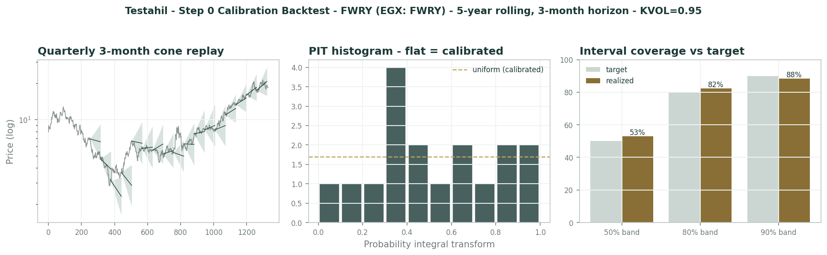
Calibration backtest - cone replay, PIT histogram, interval coverage
Appendix C Peer set, sector structure, and risks
Peers: domestically e-finance Investment Group (EGX: EFIH) is the closest listed comparable; regionally and globally the read-across set is profitable payment platforms (dLocal, Adyen, PayPal at the mature end). Sector structure: distribution is the moat - 377k agents and 36 member banks feed a two-sided network the free InstaPay rails cannot replicate for cash-in/cash-out - while the CBE rate cycle drives both the discount rate and the float income.
Principal risks: policy-rate path, take-rate compression on free rails, credit quality in the fast-growing MSME/consumer book, key-man and regulatory/licensing risk, and EGX flow concentration in a crowded local favourite.
Appendix D The expert valuation panel
D.1 Expert 1 - growth-adjusted earnings power (two-stage)
Worldview and tradition. A scalable platform is worth its forward earnings at a multiple that respects both the growth and the local cost of equity. Fawry compounds revenue at 30%+ with operating leverage; the question is only what a fair multiple is when the risk-free alternative in EGP yields north of 20%.
The tradition is growth-at-a-reasonable-price transplanted to emerging-market discount rates: earnings power is the anchor, the fade is explicit, and the multiple is derived from the fade rather than borrowed from a peer screen. Nothing is paid for terminal dreams - the fade ends at nominal-GDP growth.
Applied here it reduces to one question: what does a pound of Fawry's FY26 earnings deserve when growth fades 20%->12% over five years and the alternative earns 20%+ risk-free? Derive that, multiply, stop.
When it works / when it fails. Works for profitable compounders with visible unit economics and a long runway - financial inclusion and cash digitisation are exactly that. Fails when the growth is bought (credit losses arriving later), when the margin definition inflates earnings, or when the discount-rate regime shifts under you.
The honest weakness in this case is the earnings base itself: FY26E EPS includes ~EGP 790 mn of treasury interest earned on the float, which is a rate call, not a franchise. Expert 2 prices that objection; I hold the reported base and answer it in the multiple.
Standard workings. Two steps: establish the forward earnings base from the model, then derive the fair multiple from the fade. FY26E net income EGP 3,581 mn on 30% revenue growth and a 56% EBITDA margin gives EPS EGP 0.92 on 3,905 mn shares; a 20%->12% five-year fade at a ~24% cost of equity supports ~16x.
Every input is a blue cell in the companion Excel - the growth path, the margin fade, the tax-and-minorities rate - so the base can be red-penned without touching the method.
Step | Value
FY26E net income | EGP 3,581 mn
/ shares (mn) | 3,905
FY26E EPS | EGP 0.92
Fair P/E (20%->12% fade at ~24% Ke) | 16x
Fair value per share | EGP 14.7
P/E band 13-20x | EGP 12.0 - 18.4

Worked example. EPS FY26E = 3,581 / 3,905 = EGP 0.92. Fair multiple 16x -> EGP 14.7. At spot 18.40 the implied multiple is 20.0x FY26E - the market pays about four turns for duration.
Run it on stripped EPS (excluding treasury interest, ~EGP 0.77) at the same 16x and the answer is EGP 12.3 - the two-pound gap between my base and Expert 2's is almost entirely one income line.
Sensitivity on the swing input. The multiple is the swing; the EPS base is second.
Swing input | Fair value (EGP/sh)
Fair P/E 13 / 16 / 20x | 12.0 / 14.7 / 18.4
FY26E EPS +/-10% | +/- ~1.5
Ex-treasury EPS base (0.77) | 12.3 at 16x

Cross-examination. To Expert 2: your wedge is real but mostly non-cash - ESOP and provisions are growth investment expensed early; punishing them in the earnings base and again in a low multiple double-charges a platform for scaling. And your 13x sits below what the market pays for slower Egyptian consumer names.
To Expert 3: rates are your story, but Fawry grew EPS 80% through the tightest money in Egypt's modern history; execution, not the CBE, is the driver - your scenarios move my multiple two turns either way, they do not move the franchise.
Verdict, falsification, and what the price implies. Fair ~EGP 15.0 (12-18). At 18.40 the market prices either a sustained 20x-plus multiple or upside to my growth fade.
Price-implied: buyers at spot are underwriting the top of my band - a defensible growth view, but one that leaves no room for a single soft quarter. Falsification: two consecutive quarters of sub-20% revenue growth, or the EBITDA margin printing below 45%.
Method note. The fade is the entire engine of this lens: hold 20% for ten years instead of five and the fair multiple runs past 22x; end the fade at 8% and even 13x is generous. I publish the path so the disagreement lands on an assumption rather than an outcome - and the model's blue cells let any reader re-run their own fade in minutes.
D.2 Expert 2 - quality of earnings - the accountant's strip-down
Worldview and tradition. Pay for audited operating profit, not a company-defined aggregate. Fawry's 57.4% 'EBITDA' excludes ESOP, provisions, leasing and non-operating interest; the honest base is EBIT after the full wedge, taxed, plus the cash - nothing else.
The tradition is the quality-of-earnings school: reconcile every headline metric back to what an auditor signs, refuse house blends, and let the reconciliation - not the narrative - set the base. Where the wedge between the company's number and the audited number is a fifth of revenue, the wedge is the story.
The test case here is one line: EGP 4,968 mn of company-defined EBITDA against roughly EGP 3,060 mn of EAS operating profit. My valuation is simply the refusal to capitalize the difference.
When it works / when it fails. Works whenever a company's headline metric is a house blend - it anchors value to what is signed, and it caught every EGX accounting disappointment of the last decade early. Fails when the stripped items genuinely are non-recurring or genuinely are investment, where it under-values a clean compounder - and Fawry's NBFI growth is real, so my base is deliberately harsh.
It also refuses all credit for optionality (neobank licence, Soft POS) on principle: options are bought, not paid for at par.
Standard workings. Strip to operating NOPAT, apply a processor's multiple, add only the cash. FY26E EBITDA (company-defined) 6,297 less the 20%-of-revenue wedge (D&A, ESOP, provisions) 2,249 = EBIT 4,048; taxed at 26% = NOPAT ~2,996.
The 13x on operating NOPAT is chosen between a payments processor (11x) and a platform (15x) - generous for the strictness of the base, deliberate so the answer cannot be dismissed as punitive arithmetic.
Step | Value
FY26E EBITDA (company-defined) | EGP 6,297 mn
- wedge (D&A, ESOP, provisions, 20% of rev) | EGP 2,249 mn
EBIT | EGP 4,048 mn
x (1 - 26%) | NOPAT EGP 2,996 mn
x 13 | EGP 38,950 mn
+ attributable net cash | EGP 2,000 mn
Equity value | EGP 40,950 mn
Fair value per share | EGP 10.5

Worked example. 2,996 x 13 = EGP 38.9 bn; add EGP 2.0 bn net cash; divide by 3,905 mn shares = EGP 10.5. Even at 15x the answer is EGP 12.0 - well under spot.
Reconciled the other way: spot 18.40 equals ~24x my audited-basis operating earnings - a platform multiple on a processor's signed numbers.
Sensitivity on the swing input. The multiple and the wedge are the dials.
Swing input | Fair value (EGP/sh)
Multiple 11 / 13 / 15x | 9.0 / 10.5 / 12.0
Wedge +/-2 pts of revenue | -/+ ~0.8
Net cash 0 / 2 / 4 bn | 10.0 / 10.5 / 11.0

Cross-examination. To Expert 1: your 16x sits on EPS that includes ~EGP 790 mn of treasury interest - strip it and your EPS is 0.77, your value EGP 12.3, and suddenly we are two accountants arguing over one turn of multiple.
To Expert 3: agreed the rate cycle matters, but mostly through that interest line - which is precisely why it should not be capitalised at a growth multiple; your scenario A gives the multiple with one hand and takes the float income with the other, and the net is smaller than your tree admits.
Verdict, falsification, and what the price implies. Fair ~EGP 10.5 (9-12.5). Spot pays roughly 24x audited-basis operating earnings - a full growth premium on the least generous reading of the accounts.
Price-implied: the market is capitalizing the company's definition of profit, not the auditor's. That has been a profitable trust so far; my lens exists for the day it is not. Falsification: the wedge between company-defined EBITDA and EAS operating profit narrowing below 12% of revenue for a full year.
Method note. The wedge is not an accusation - ESOP and provisioning are legitimate costs of scaling a lender - it is a classification: growth investment belongs in the multiple's assumptions, not in the earnings base. Until the EAS reconciliation narrows, the signed number is the only base I will multiply, and the burden of proof sits with the blend, not the audit.
D.3 Expert 3 - the rate cycle - value as a CBE policy variable
Worldview and tradition. For an EGP fintech the CBE sets both the discount rate on the equity and the yield on the float. Cuts re-rate the multiple and fuel consumer credit, but compress the treasury income; hikes do the reverse. Model the policy path and you have modelled most of the value.
The tradition is regime analysis for rate-geared financials: when one committee's corridor decision moves both your numerator and your denominator, a point estimate is a coin call in a suit - the honest output is the weighted tree and, more importantly, its width.
The offices that matter are nameable: the MPC (the corridor), the finance ministry (T-bill supply that sets the float's yield), and the FRA (the licences that gate the next leg).
When it works / when it fails. Works when the local rate cycle dominates both numerator and denominator - Egypt mid-easing-cycle qualifies, and Fawry's float and MMF make it doubly geared. Fails as a standalone lens for franchise questions - take rates, free InstaPay rails, competitive spend - that no rate path answers.
I anchor the probabilities on checkable things: the inflation glide path, the IMF review calendar, and real-rate arithmetic - and publish them so they can be argued with rather than believed.
Standard workings. Three regimes, each a full re-solve of the model (discount rate, treasury income, credit growth together), probability-weighted.
Scenario A is not a free lunch: it re-rates the multiple and grows the loan book but cuts the float yield ~40% - the internal offset is why my bull number is 21, not 25.
Scenario | Value / prob.
A - deep easing: rates -500bp+, WACC ~19%, float income -40% | ~EGP 21 / 30%
B - base: gradual cuts | ~EGP 15 / 45%
C - stall / EGP stress: funding costs bite the book | ~EGP 10 / 25%
Probability-weighted | ~EGP 15.6

Worked example. 0.30x21 + 0.45x15 + 0.25x10 = EGP 15.6/share, with an honest EGP 10-21 span that is the width of the policy question, not of Fawry's execution.
The internal netting is the insight: each 100bp of easing adds ~EGP 1.5-2.0 through the DCF leg but removes ~EGP 80-90 mn of pre-tax float income (~EGP 0.02 of EPS) - the stock is less rate-geared than its fans and critics both assume.
Sensitivity on the swing input. The corridor is the swing; the float is the counterweight.
Swing input | Fair value (EGP/sh)
Each 100bp off the WACC | + ~1.5-2.0
Each 100bp off deposit/treasury yields | - ~EGP 0.3 (capitalized)
Loan-book growth +/-20% | +/- ~0.8

Cross-examination. To Expert 1: your fair multiple IS a rate call - at a 19% cost of equity your same 0.92 EPS is worth 20x, at 26% it is worth 13x; you have simply frozen my scenario B and called it fundamentals.
To Expert 2: the cash and float you add back at face are the very assets whose earning power halves in the easing scenario the bulls are praying for - your floor is rate-dependent too, you have just hidden the exposure in the 'net cash' line.
Verdict, falsification, and what the price implies. Fair ~EGP 15.5 (10-21, widest). Spot 18.40 sits inside my bull leg - the market is already paying for the cuts.
Price-implied: spot weights my scenarios roughly 45/40/15 - fatter on A than the inflation arithmetic justifies today. The market, in one line, is long the MPC. Falsification: the CBE path: >400bp of cuts within 12 months confirms the bull leg; no cuts plus renewed EGP pressure confirms the bear.
Method note. The tree's discipline is that every branch re-solves the same model - no branch is allowed a special multiple or a convenient margin - so the 10-21 width is generated, not asserted, and it narrows only as the MPC removes branches. A tree whose width never moves is decoration; mine is scheduled to shrink eight times a year.
D.5 The three in one room
Put in one room, the three collide on a single line item: the 57.4% margin. Expert 1 calls it proof of operating leverage and pays a growth multiple on the earnings it produces. Expert 2 slides the EAS accounts across the table: strip the ESOP, the provisions and the treasury interest, and the audited operating margin is in the thirties - price that, or admit you are pricing a press release. Expert 3 shrugs at them both: whichever margin you pick, its value swings on the CBE - cut rates and Expert 1 is right about the multiple but loses the float income; hold them and Expert 2's discount rate crushes the terminal value. The margin is one number; the three are pricing three different regimes - and the next MPC statement arbitrates before the next audit does.
D.6 Reading the divergence
Base fair values of EGP 15.0 / 10.5 / 15.5 against spot 18.40 - but the ranges are the story: 12-18, 9-12.5, and 10-21. The spread does not measure disagreement about Fawry's FY25 - all three accept it - it measures how much of the price is the rate cycle and how much is the accounting definition of profit.
What closes it has a calendar: the MPC meetings arbitrate Expert 3's tree, the quarterly EAS reconciliation arbitrates Expert 2's wedge, and two more prints of 20%+ growth would push Expert 1's fade - the divergence is not academic, every leg of it expires within twelve months.
Expert | Method | Fair value (EGP) | Swing assumption
Expert 1 | Growth earnings power | 15.0 (12-18) | Fair P/E on the growth fade
Expert 2 | Quality of earnings | 10.5 (9-12.5) | The EBITDA-to-EAS wedge
Expert 3 | Rate-cycle scenarios | 15.5 (10-21) | The CBE policy path


Expert fair values vs spot
A reader keeping score should note the asymmetry of the three bets: Expert 2's is the only one that cannot be rescued by good news elsewhere - a rate cut helps Expert 3, a growth beat helps Expert 1, but only the EAS reconciliation itself can move the audited wedge.
About this series
Testahil publishes independent, educational valuation studies. The house style is distributions, not tips: we describe ranges and probabilities, not targets. Studies are framed as educational analysis, the preparer is not licensed by any securities regulator, and holdings are disclosed.
Disclosure & Disclaimer
Not investment advice. This document is educational and informational only. It is not, and must not be relied upon as, investment, financial, legal, accounting or tax advice, nor an offer, solicitation or recommendation to buy, sell or hold any security. It contains no price target and no rating.
No licence; no advisory relationship. The preparer is not registered or licensed with any securities or financial regulator in any jurisdiction, holds no brokerage or investment-advisory authorisation, and is not acting as your adviser or fiduciary. Nothing here is personalised to your circumstances.
Holdings disclosure. The preparer may hold, and may in the future take or dispose of, a position in the security discussed in this report, and may transact at any time without notice. This is a potential conflict of interest you should weigh.
Sources & accuracy. Reported financial and operating figures are drawn from the company's public disclosure and other public sources believed reliable but not independently verified; they may contain errors or be superseded. Forward-looking inputs are the preparer's own judgments and are inherently uncertain.
Forward-looking statements. Any statements about the future are estimates subject to risks and uncertainties; actual results may differ materially. The Monte Carlo models price, not value, and encodes subjective probabilities for events that have not occurred.
No reliance; your responsibility. Do your own research and consult a licensed professional before making any decision. You are solely responsible for your investment decisions and their outcomes. To the maximum extent permitted by law, the preparer accepts no liability for any loss arising from use of this document.
Currency & figures. Group figures are in EGP. Rounding may cause totals to differ slightly. Spot price and market data are as of the study date and change continuously.
TESTAHIL · Independent Valuation Study · Educational Analysis · Fawry for Banking Technology and Electronic Payments (S.A.E.) (EGX: FWRY) · edition 01-07-2026 · reporting currency EGP

