Testahil · Independent Valuation Study — Educational Analysis Not investment advice

Independent Valuation Study — Educational Analysis
GB Corp S.A.E. (EGX: GBCO)
Fundamental analysis · Technical analysis · Monte Carlo simulation — one integrated read
Anchor: EGP 31.25 (7 Jul 2026 close) · 1,085.5 mn shares · mkt cap ~EGP 33.9 bn · the continuing listed entity of the former GB Auto (Ghabbour), renamed GB Corp in 2023, housing GB Auto (passenger cars, commercial vehicles & construction equipment, tires & trading, light mobility; Egypt · Iraq · Jordan), GB Capital (leasing, factoring, consumer finance, SME lending) and associate stakes led by MNT-Halan · prices and probabilities computed 7 Jul 2026 from the attached daily history · primary lens: split-the-legs sum-of-the-parts (operating company + captive lender, §3.5-F5) · the MNT-Halan stake percentage is now the dominant swing factor, ahead of Auto cash conversion and the Egyptian nominal-rate path.
READ FIRST — what this document is, and is not.
This study is a valuation exercise and an expression of personal analytical opinion, published free of charge for educational purposes: it shows how one analyst applies fundamental, technical and probabilistic methods to a listed company, and invites scrutiny of that methodology. It is NOT investment advice, NOT a recommendation or solicitation to buy, sell or hold any security, and NOT directed at the circumstances of any reader. The preparer is not licensed by any securities regulator in any jurisdiction, holds no Egyptian (FRA) or other brokerage or advisory authorisation, provides no financial consultancy, manages no money, and accepts no fees, funds or clients. See the Disclosure & Disclaimer at the end.
All values are model outputs presented as ranges and distributions because no single number should be relied on. Reported financials are the company’s own disclosure (FY23–FY25 earnings releases; 1Q26 release, 14 May 2026); forward-looking inputs — the marks on GB Capital and the MNT-Halan stake, the complexity discount, the multiples, the DCF and the Monte-Carlo factor probabilities — are the preparer’s judgments and are flagged throughout. A note on identity: GB Corp S.A.E. is the renamed GB Auto S.A.E. (Ghabbour Auto); the EGX ticker is GBCO (price history continues the former AUTO listing). Consult a licensed financial advisor before any investment decision.

Headline
The model's read: meaningfully undervalued on a now-confirmed number — and that number raises a real puzzle the market hasn't obviously resolved. At EGP 31.25 the shares sit about 14% below our weighted central estimate of EGP 35.7. The four lenses spread wider than usual: the split-the-legs sum-of-the-parts lands at 38.4 after a 10% complexity discount (pre-discount 42.6), a conservative relative read at 28.9 marks the floor, and a normalized mid-cycle read at 32.9 sits in between. One update belongs up front: GB Corp's own 9-June-2026 press release on MNT-Halan's Al Ahly Capital-led round states the resulting stake directly — 41.61% (down from 42.58% pre-transaction) — a current, dated, company-confirmed figure, not an estimate. Applying 41.61% to the round's USD 1.4bn valuation values the stake alone at ≈EGP 27.7bn — ≈82% of GB Corp's market cap pre-discount (≈73% after this study's 10% complexity discount) — of GB Corp's entire spot market cap either way. That is now a confirmed fact, not a sourcing gap, and it is genuinely strange: it implies the market prices almost nothing into a real, profitable, EGP 66bn-revenue auto business, which points to one of two things — either the market applies a far steeper discount to this private mark than this study's 10% complexity haircut (illiquidity, minority-stake, execution-risk on the second closing), or GB Corp is genuinely mispriced. This study cannot settle which; §7 returns to it. The stake is now the largest single input in the model — every 5 percentage points is worth ≈EGP 3.3/share — ahead of the Auto-leg cash-conversion question that would otherwise be the crux (FY25 revenue grew 49% but working capital swallowed EGP 8.1bn and Auto net debt rose to EGP 15.2bn; the DCF still depends on working-capital intensity gliding from 28.5% of revenue back toward its FY23–24 range and on the pace of Egyptian nominal-rate cuts). Technically the stock is the mirror image of a cheap chart: above all four moving averages, RSI in the low-60s, five months into a new all-time-high zone. Over three months the Monte Carlo — whose secular drift is the configuration that passed the Step 0 calibration gate — places the 5th–95th percentile band at roughly EGP 24–51 with a median near 35; that engine is completely unaffected by the stake correction, since it prices the stock's own path, not the SOTP.
Valuation summary — every read at a glance
One table for the four reads that follow — what the business is worth (fundamental), what the tape is doing (technical), where price could travel over three months (Monte Carlo), and how three independent expert methods land. Every row is developed in the sections and appendices below.
Lens / read | What it measures | Output | Takeaway
FUNDAMENTAL — what the business is worth (the anchor)
Split-legs SOTP (primary) | Auto DCF + lender book + associate marks, less discount | EGP 38.4 | +23% vs spot
Pre-discount NAV | The same legs, no complexity discount | EGP 42.6 | +36%
Relative multiples | FY26E EPS × justified P/E | EGP 28.9 | -8% · the floor
Normalized earnings | Mid-cycle PAT × through-cycle P/E | EGP 32.9 | +5%
Weighted central | Blend 40 / 15 / 20 / 25 | EGP 35.7 | +14% vs EGP 31.25
TECHNICAL — what the tape is doing (timing, not value)
Trend & momentum | Price vs the 20/50/100/200-day averages | Above all four | Strong uptrend
Momentum / range | RSI · MACD · 52-week range | RSI 63 · MACD +0.04 · 19.1–33.4 | Extended, not euphoric
MONTE CARLO — where price could go in 3 months (paths from spot)
T+20 sessions | 50,000 paths · 16 factors | p5 26 · p50 32.5 · p95 40 | Median above spot
T+60 sessions | same engine, longer horizon | p5 24 · p50 35 · p95 51 | Wide, right-skewed
EXPERT PANEL — three independent methods (Appendix D)
Expert 1 — split-legs NAV | Marks each leg; fair discount | EGP 39.2 | The anchor
Expert 1 — split-legs NAV | Marks each leg; fair discount | EGP 39.2 | Most bullish
Expert 2 — normalized earnings power | Mid-cycle PAT × multiple | EGP 32.9 | Most conservative
Expert 3 — cash returns (ROCE vs WACC) | Economic profit on capital employed | EGP 38.7 | —
Panel range | Spread = the MNT-Halan stake question | EGP 32.9–39.2 | Centres ~EGP 39

Bottom line. The reads spread wider than usual, and every disagreement now traces to the same open question: not what GB Corp's MNT-Halan stake is (confirmed: 41.61%, 9-Jun-2026), but what that stake is actually worth and why the market doesn't price it at face value. The fundamental central sits near EGP 36 — 14% below the EGP 31.25 spot — the three experts span 33–39, and the tape (unusually) sits closer to spot than the fundamental work — either the market is applying a much steeper discount to the private MNT-Halan mark than this study's 10%, or it doesn't fully trust the round's valuation, or GB Corp really is mispriced. The three-month Monte Carlo distribution is unaffected either way: it prices the stock's own historical path, and its median sits above spot only because the engine's secular drift survived the calibration gate; Appendix B shows exactly how thin that margin is.
Company overview — GB Corp at a glance
Item | Value
Listed entity | GB Corp S.A.E. (EGX: GBCO; formerly GB Auto / Ghabbour Auto, AUTO)
What it owns | GB Auto (PC assembly & distribution, CV&CE, tires & trading, light mobility) · GB Capital (Drive Finance, GB Lease & Factoring, rentals, Kredit) · associates: MNT-Halan, Bedaya, Kaf
Spot / date | EGP 31.25 · 7 Jul 2026 close
Shares · market cap | 1,085.5 mn · ~EGP 33.9 bn
FY25 revenue / net profit | EGP 80,229.8 mn (+48.7% YoY) · EGP 2,880.0 mn (3.6% margin)
1Q26 revenue / net profit | EGP 21,570.8 mn (+28.7%) · EGP 435.8 mn (−30.4%, regional drag + finance cost)
Segment split (FY25, pre-elim.) | GB Auto EGP 66.4 bn (83%) · GB Capital EGP 14.7 bn (17%); Capital = ~47% of segment net profit
Auto net debt / group equity | EGP 15.2 bn (2.39× Auto EBITDA; 2.14× at 1Q26) · attributable equity EGP 28.8 bn (BVPS 26.5)
52-week range | EGP 19.10 – 33.40 (all-time high 3 Feb 2026)
Ownership · leadership | Ghabbour family ~63.4% · free float ~36.6% · Group CEO Nader Ghabbour
Corporate events | MNT-Halan first-close capital increase at USD 1.4 bn valuation (Jun 2026) · Sadat CKD facility inaugurated Jun 2026 · 2Q26 results due 11 Aug 2026

Source: company 4Q23/4Q24/4Q25 and 1Q26 earnings releases, EGX data, MNT-Halan transaction press release (Jun 2026). Values rounded.
1 Fundamental valuation
We value GB Corp as an operating company with a captive finance arm and split the legs (§3.5-F5): blending an auto assembler-distributor, a leveraged lender and an unlisted fintech associate into one multiple would blur three different economics. The primary lens is therefore a split-legs sum-of-the-parts: the Auto operating leg on a free-cash-flow DCF; GB Capital on its adjusted operating book times a return-justified multiple; the MNT-Halan-led associate stakes at GB Corp’s own last-confirmed disclosed ownership, cross-checked against the June-2026 funding round. A relative-multiple read and a normalized mid-cycle read complete the set. The weights and the football field are in §1.5; the dominant swing factor is now the MNT-Halan stake itself (box below §1.1), ahead of Auto cash conversion — dissected in §1.7 — and the sensitivity grids in §1.9.
1.1 Split-the-legs sum-of-the-parts — the primary lens
Each leg is marked on the basis that fits it. The Auto leg takes the §1.2 DCF value; GB Capital is marked on the company’s own adjusted-ROAE equity base (the disclosure that strips the MNT-Halan revaluation out of the equity denominator: NP EGP 1,366 mn / 15.1% adjusted ROAE ⇒ ~EGP 9.5 bn of operating book) at 1.0× — the return-justified multiple for a mid-teens-ROE lender whose margin is a beneficiary of the easing cycle; and the associates are marked by applying GB Corp’s own current, confirmed stake to the June-2026 funding round (USD 1.4 bn × 41.61% × EGP/USD ≈ 47.5 ⇒ ≈EGP 27.7 bn). UPDATE (09-07-2026): an earlier draft of this study used an unsourced ~20% stake estimate, later corrected to 42.58% (GB Corp’s last-disclosed figure at the time, from a 28-Jul-2024 press release). GB Corp has since confirmed the current figure directly: its 9-June-2026 press release on MNT-Halan’s Al Ahly Capital-led capital increase states "GB Corp’s ownership stake in MNT-Halan will be adjusted to 41.61%, compared to 42.58% prior to the transaction" — a dated, current, company-confirmed number, now used as the base case without a staleness caveat. Within the associates line, MNT-Halan is the overwhelming majority of the value (≈99%), with Bedaya and Kaf the ≈EGP 0.4 bn residual. From the sum we deduct a 10% complexity discount for the wrapper: an auto operator, an NBFI and an unlisted fintech in one listing will not trade at the clean sum of its parts.
Leg (base case) | Basis | Value (EGP mn)
GB Auto operating leg | FCFF DCF (§1.2): EV 24,740 − net debt 15,210 − NCI 800 | 8,730
GB Capital lending leg | Adjusted operating book 9,500 × 1.0× | 9,500
Associate — MNT-Halan (41.61%, confirmed 9-Jun-2026) | USD 1.4 bn Jun-26 round × 41.61% stake × 47.5 EGP/USD | 27,671
Other associates (Bedaya, Kaf) | Residual carrying value | 390
Σ Equity value (pre-discount) | = EGP 42.6 / share | 46,291
less: complexity / conglomerate discount | 10% | (4,629)
SOTP equity value | = EGP 38.4 / share | 41,662

SOTP base ≈ EGP 38.4/share, with a wide bear–bull span of 21–61 — driven mainly by the discount applied to the MNT-Halan mark and the Auto margin/working-capital path (§1.9). The market-implied read is now a confirmed puzzle rather than a sourcing question: market cap less the lender and the associates at the confirmed 41.61% stake implies a deeply negative value for the Auto leg — impossible for a profitable, EGP 66bn-revenue business. Since the stake itself is no longer in question, the honest reads are that the market applies a much steeper discount to this private mark than this study’s 10%, doesn’t fully trust the USD 1.4bn valuation’s read-through to GB Corp’s economic interest, or GB Corp is genuinely mispriced. §7 discusses which is most plausible.
What the MNT-Halan stake is worth inside this valuation — now a confirmed number, and a real puzzle
Because this single line dominates the whole valuation, here is its exact footprint, using GB Corp’s own 9-June-2026 confirmed figure:
MNT-Halan in the GBCO valuation | Value
Confirmed value at the June-2026 round (41.61% stake) | USD 1.4 bn × 41.61% × 47.5 = EGP 27,671 mn
Per share, pre-discount | EGP 25.49 — 60% of the EGP 42.6 pre-discount NAV
Per share, after the 10% discount | EGP 22.94 — same 60% share of the EGP 38.4 SOTP
As a share of the market price (EGP 31.25) | ≈82% pre-discount / ≈73% post-discount — confirmed, and the puzzle (see below)
Every 5 percentage points of stake (for context) | ≈EGP 3.3/share of SOTP fair value — no longer the open question it was

The market-cap puzzle — what a confirmed 41.61% stake actually implies
With the stake now confirmed rather than estimated, the residual uncertainty shifts entirely to the mark and the discount, not the ownership percentage. The table below shows how sensitive the SOTP would have been to the stake question that is now closed, followed by what actually needs explaining:
GB stake in MNT-Halan | MNT-Halan value (EGP mn) | SOTP fair value/sh | Note
20.00% | 13,300 | 26.5 | prior placeholder — wrong, superseded
25.00% | 16,625 | 29.2
30.00% | 19,950 | 32.0
35.45% | 23,574 | 35.0
40.00% | 26,600 | 37.5
42.58% | 28,316 | 38.9 | the interim correction — pre-transaction figure, now superseded
41.61% | 27,671 | 38.4 | CONFIRMED current (GB Corp PR, 9-Jun-2026) — base case

In plain terms: the stake question this study originally flagged as its biggest uncertainty is now closed — GB Corp confirmed 41.61% in writing on 9 June 2026. What remains open is not “what does GB Corp own” but “what is that ownership worth, and why doesn’t the market price it at face value.” A confirmed 41.61% stake in a company marked at USD 1.4bn is worth ≈82% of GB Corp’s entire market cap pre-discount (≈73% after this study’s 10% complexity discount) — either the market is applying a steep private-mark discount this study’s 10% doesn’t capture, or GB Corp is genuinely mispriced. The bear case in this study’s football field (§1.5) reflects the former via a much heavier discount on the stake; the base case takes the confirmed number at the round’s valuation. §7 returns to this as the study’s central open question.
1.2 The Auto-leg DCF — the cash-flow engine of the SOTP
The Auto leg is built bottom-up on disclosed units × ASP per line of business (the data-discipline gate is cleared: volumes and revenue are published per LoB, so ASP is arithmetic, not guesswork — the driver table is in §1.6 and Appendix A). Gross margin glides from 13.8% (FY26E, absorbing the regional drag visible in 1Q26’s 12.4%) back to 14.5% — below FY24’s FX-windfall 19.2% by design; GS&A holds ~7%; capex follows the EGP 3 bn 2026 guidance then normalizes; and the crux — net working capital — glides from 28.5% of revenue (FY25) to 21.5% by FY30E as the payables re-extension completes and the Sadat stock-build unwinds. WACC is built bottom-up from sourced inputs, not house defaults (§1.8 table): Ke = 22.55% rf + 1.0 β × 9.41% ERP = 31.96%, blended with after-tax debt to 22.94%; terminal growth 11.5% nominal EGP.
EGP mn | FY26E | FY27E | FY28E | FY29E | FY30E
Auto revenue | 78,550 | 95,736 | 112,459 | 128,714 | 144,761
EBITDA | 6,677 | 8,616 | 10,571 | 12,228 | 13,752
D&A | (864) | (1,053) | (1,237) | (1,416) | (1,592)
EBIT | 5,813 | 7,563 | 9,334 | 10,812 | 12,160
NOPAT = EBIT × (1 − 28%) | 4,185 | 5,445 | 6,721 | 7,785 | 8,755
+ D&A | 864 | 1,053 | 1,237 | 1,416 | 1,592
− Capex | (3,000) | (2,400) | (2,500) | (2,600) | (2,800)
− Δ working capital | (1,899) | (3,118) | (2,494) | (2,533) | (2,163)
FCFF | 151 | 980 | 2,964 | 4,068 | 5,384
Discount factor | 0.813 | 0.662 | 0.538 | 0.438 | 0.356
PV of FCFF | 122 | 648 | 1,595 | 1,780 | 1,917

DCF bridge | EGP mn
Σ PV of explicit FCFF (FY26–30E) | 6,063
Terminal value (Gordon, g = 11.5%) | 52,462
PV of terminal value | 18,677
Enterprise value — Auto leg | 24,740
Terminal value as % of EV (device A-7) | 75%
less: Auto net debt · Auto NCI | (15,210) · (800)
Auto equity value | 8,730

Two honesty notes. First, 75% of the EV sits in the terminal value — this is a growth-and-rates bet dressed as a five-year model, which is why §1.9 sensitizes the WACC × terminal-g grid rather than hiding it. Second, the explicit-period FCFF is thin (EGP 0.2 bn in FY26E) precisely because growth consumes working capital; the value is in the steady state, not the ramp. Both are disclosed rather than blended away (device A-8).
1.3 Relative multiples
On FY25 earnings GB Corp trades at ~11.8× P/E and ~1.18× book. On the FY26E build (~EGP 3.3 bn attributable, EPS ~3.04) the forward P/E is ~10.3×. A justified multiple for the blend — an EM auto distributor (typically 8–12×) plus a mid-teens-ROE NBFI (6–10×) with an unlisted fintech kicker — sits around 8–11×. We mark the lens on the FY26E EPS.
Relative basis | Bear | Base | Bull
FY26E net profit (EGP mn) | 3,300 | 3,300 | 3,300
Justified P/E | 8.0× | 9.5× | 11.0×
Fair value (EGP/share) | 24.3 | 28.9 | 33.4

Relative base ≈ EGP 28.9 — the most conservative lens and probably where a sceptic anchors: it pays for this year’s earnings and gives nothing for the working-capital release or the associate optionality.
1.4 Normalized earnings power — where this sits in the cycle
Cycle position first (device A-6): GB’s FY25 passenger-car volume of 56.5k units is roughly double the 2023 trough (27.0k) but still well short of the company’s mid-2010s run-rate, and the Egyptian market’s 210k registrations in 2025 — +40% y/y — remain below the pre-2016-devaluation peak; the recovery is mid-cycle, not late-cycle. Margins are past their peak, though: FY24’s 19.2% Auto gross margin carried an FX-scarcity windfall that is normalizing (14.8% FY25, 12.4% in 1Q26). Mid-cycle earnings power therefore blends recovering volumes with normalized margins: ~EGP 4.2 bn of group PAT (Auto ~2.2 bn at 14.5% GPM on FY27-scale revenue + Capital ~1.7 bn + associates), against FY25’s reported 2.9 bn.
Normalized-earnings basis | Bear | Base | Bull
Mid-cycle PAT (EGP mn) | 3,600 | 4,200 | 4,800
Justified P/E | 7.5× | 8.5× | 9.5×
Fair value (EGP/share) | 24.9 | 32.9 | 42.0

Normalized base ≈ EGP 32.9 — the ceiling of the central case: in effect the bet that the volume recovery completes while margins hold the post-windfall floor.
1.5 Synthesis — four lenses
We weight the SOTP most heavily because it respects the differing economics of the legs; the pre-discount NAV carries the discount-narrowing case; the relative lens anchors the floor; normalized earnings carries the recovery thesis.
Lens | Weight | Bear | Base | Bull
Split-legs SOTP | 40% | 21 | 38.4 | 61
Pre-discount NAV | 15% | 26 | 42.6 | 63
Relative multiples | 20% | 24 | 28.9 | 33
Normalized earnings | 25% | 25 | 32.9 | 42
Weighted central |  | 23.3 | 35.7 | 51.0

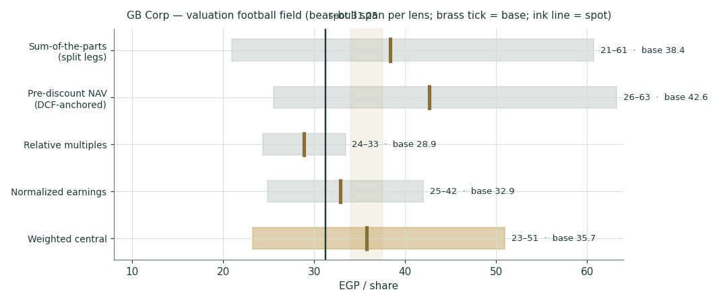
Figure 1 — Valuation football field. Bars span bear–bull per lens; the brass tick is each base case; the gold band is the blended central range; the light line is spot.
Central fair value ≈ EGP 35.7/share, 14% below spot. Unlike a typical Testahil football field, the width here is not really four independent views converging — the SOTP and pre-discount NAV lenses (38.4 and 42.6) both carry the same MNT-Halan stake assumption, so they move together with it, while the relative (28.9) and normalized (32.9) lenses don’t touch the stake at all and sit much closer to spot. That split is itself informative: strip out the MNT-Halan question and this is a fairly-priced operator; include it at the last disclosed stake and it looks meaningfully cheap. Which is right depends entirely on a number this study cannot currently confirm to the decimal (§1.1 box).
1.6 The legs — a deeper look, and the units × ASP driver table
Leg | Cyclicality | Margin / return trend | Capital intensity | Swing role
GB Auto — PC (80% of Auto rev) | High (rates, FX, imports) | GPM normalizing 14.8% → ~14% | Very high (working capital) | Dominant
GB Auto — CV&CE, trading, mobility | Moderate | Bus exports scaling | Moderate | Diversifier
GB Capital | Credit-cycle | Adj. ROAE 15.1%; NIM 5.0%; NPL 2.1–2.5% | Leverage 0.86× D/E | Compounder
Associates (MNT-Halan et al.) | Venture-like | Revenue +50% (1Q26); loan book > USD 1.7 bn | Off balance sheet | Optionality

The bottom-up build (§3.5-B/C — gate cleared: every driver below is disclosed or arithmetic on disclosed figures):
Driver (disclosed) | FY23 | FY24 | FY25 | FY26E | FY30E
PC volume (units) | 26,994 | 42,043 | 56,548 | 63,334 | 90,921
PC ASP (EGP mn/unit) | 0.61 | 0.87 | 0.93 | 0.99 | 1.27
PC revenue (EGP mn) | 16,544 | 36,533 | 52,827 | 62,717 | 115,821
CV&CE revenue | 2,323 | 3,985 | 5,957 | 7,818 | 14,921
Light-Mobility revenue | 854 | 1,378 | 2,204 | 3,008 | 6,217
Trading (tires + parts) | 2,507 | 3,816 | 4,243 | 5,007 | 7,803
GB Auto total revenue | 23,854 | 47,065 | 66,358 | 78,550 | 144,761

FY25 PC mix: 31,349 CKD / 25,199 CBU; Egypt 80.5% of PC revenue, Iraq/Jordan 19.5%. Sources: 4Q23/4Q24/4Q25 releases, Tables 2–7. Forecast drivers are the house’s own flagged view.
1.7 The crux: the MNT-Halan mark and discount, then cash conversion and the rate path
Three judgments drive the valuation, in order of size. First and now by far the largest: not what GB Corp’s MNT-Halan stake is — that is confirmed (41.61%, 9-Jun-2026 press release, §1.1 box) — but what a private mark this large should be discounted by, given that taking it at face value implies the stake alone is worth ≈82% of GB Corp’s entire market cap pre-discount (≈73% after this study’s uniform 10% complexity discount). This study applies that 10% discount uniformly across all three legs; a reader who believes the market is applying a much steeper illiquidity/minority discount specifically to the MNT-Halan mark should treat the SOTP bear case, not the base case, as the more realistic anchor. Second, where Auto working-capital intensity settles (the observable, disclosed unit: net Auto working capital as % of Auto revenue — device A-1). It ran 18.7% in FY23, 22.9% in FY24 and 28.5% in FY25 as import-restriction payables normalized and inventory was pre-built for Sadat; we glide it to 21.5% by FY30E. Each percentage point of steady-state intensity is worth roughly EGP 4–5/share of SOTP value. Third, the Egyptian nominal-rate path: the 22.94% WACC against 11.5% terminal growth is an 11.4-pt real spread struck off a 22.55% sourced risk-free rate; every 100 bp the CBE easing cycle takes out of that spread adds ~EGP 3/share (§1.9 grid). A fourth, binary-style exposure (§3.5-E device 6, applied cross-class): roughly a fifth of PC revenue is Iraq/Jordan, where the regional conflict cut 1Q26 volumes — a full-year regional freeze would take ~EGP 1.5–2 bn off Auto gross profit, worth ~EGP 2–3/share.
1.8 Macro and country — rates, the pound, imports and the region
GB Corp is a leveraged play on Egyptian nominal normalization. The CBE has cut 825 bp since April 2025 and held its deposit rate at 19.00% through the April and May 2026 meetings with inflation ~14.6%; every cut lowers GB Capital’s funding cost on a fixed-rate-lending book, lowers the Auto customer’s instalment, and compresses the discount rate this study applies. The EGP (~47–48/USD, firmer y/y) sets CKD input costs and the EGP value of the MNT-Halan mark — a step-devaluation is the single nastiest macro scenario for both margin and multiple. Import policy and Chinese entrants (BYD’s Egypt entry; grey imports into Iraq) set the competitive ceiling on ASPs; localization (Sadat, 46%+ local content on core CKD lines) is the structural answer. Every input in the cost-of-capital build below is sourced from a named, checkable source — not a house default (house rule §3.5-G, rebuilt 09-07-2026):
Cost-of-capital build | Value | Source
Risk-free rate (rf) | 22.55% | Egypt 10Y local govt bond yield, investing.com, 3-Jul-2026
Equity beta (β) | 1.00 | GBCO-vs-EGX30 regression attempted (n=5 annual: β=−0.15, R²=0.01, unusable); house default per protocol when no reliable regression obtainable
Equity risk premium (ERP, CDS-based, primary) | 9.41% | Damodaran's original country-risk file, Egypt row (ctryprem.html)
— ERP, rating-based (alternative, “standard practice”) | 13.94% | Same source, rating-based column
Cost of equity Ke = rf + β × ERP | 31.96% | (CDS-based, primary; 36.49% on the rating-based alternative)
Pre-tax cost of debt | 20.70% | CBE weighted-average EGP bank lending rate, <12mo tenor, Feb-2026
After-tax cost of debt (28% tax) | 14.90% | Debt is ~100% EGP-denominated — 5 disclosed facilities checked, all EGP, no USD facility found
Weights (E / D) | 47.1% / 52.9% | Market cap (spot × shares) vs. FY25 disclosed group borrowings
WACC | 22.94% | (25.08% on the rating-based ERP alternative — see §1.9)
Terminal growth (nominal EGP) | 11.5% | House view, sensitized in the grid below

Two honesty notes on this build. First, GBCO’s own beta could not be reliably estimated: five annual observations against the EGX30 produced a negative, statistically meaningless slope (R² ≈ 1%), so beta is set to 1.0 rather than borrowed from cross-country auto-sector peers, which would import Auto & Truck operating risk from markets with entirely different capital structures and macro regimes. Second, the equity risk premium was initially mis-sourced in an earlier draft (a secondary source’s claimed 14.87% did not match Damodaran’s own published 13.94%/9.41%) — corrected here after checking his original file directly, and logged in the house Fundamental Driver Ledger so the same mistake cannot recur silently on a future study.
1.9 Sensitivity — the margin, the discount, and the rate spread
Holding the lender and associate marks (and the MNT-Halan stake, at the confirmed 41.61%) fixed, the first grid re-prices the SOTP across the Auto gross-margin path and the complexity discount; the second across the WACC × terminal-growth spread — now built bottom-up rather than assumed (§1.8), so this grid is the honest range around a sourced base case, not around a house guess. The stake is no longer the open question — what matters now is the discount applied to its mark, sensitized in the §1.1 box, since it dominates both of these grids combined.
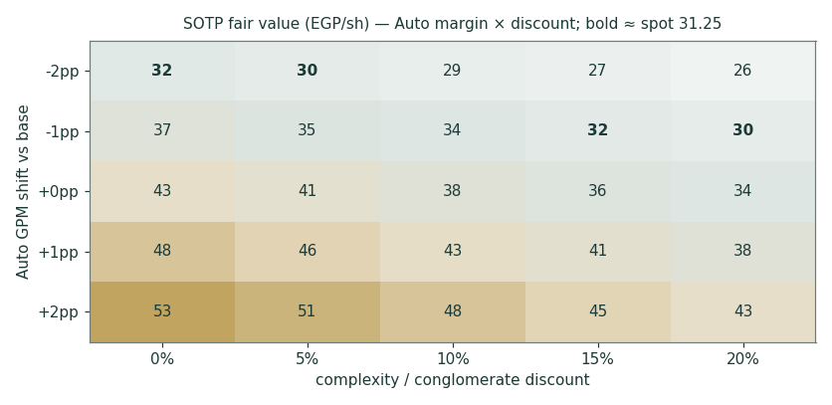
Figure 2 — SOTP fair value (EGP/share) across the Auto GPM shift and the complexity discount. Bold cells sit nearest spot (EGP 31.25).
WACC \ terminal g | 9.5% | 10.5% | 11.5% | 12.5% | 13.5%
20.9% | 39.7 | 41.5 | 43.6 | 46.2 | 49.5
21.9% | 37.6 | 39.0 | 40.7 | 42.8 | 45.3
22.9% | 35.8 | 37.0 | 38.4 | 40.0 | 42.0
23.9% | 34.3 | 35.3 | 36.4 | 37.7 | 39.3
24.9% | 33.0 | 33.8 | 34.8 | 35.9 | 37.1

SOTP fair value (EGP/share, post-discount) across WACC × terminal growth. Base cell 22.9% × 11.5% = 38.4. The WACC axis is centred on the sourced bottom-up build (§1.8: rf 22.55% + β 1.0 × ERP 9.41%, blended with after-tax Kd 14.9%), not a round-number guess. This grid holds the confirmed 41.61% MNT-Halan stake fixed; it is not the dominant sensitivity in this study (see §1.1).
2 Technical and price structure
The tape is strong and extended. GBCO trades above all four major moving averages, the MACD histogram has just re-crossed positive, and RSI sits in the low-60s — firm, not yet euphoric. The structure is a stair-step advance: a February spike to the EGP 33.40 all-time high, a two-month consolidation into the April low near 24, and a renewed leg that has carried price back within ~6% of the high. The 52-week low at 19.10 is the deep floor; the 20-day average near 30 is the trend’s first support.
Indicator | Reading | Signal
Spot | EGP 31.25 | —
SMA 20 / 50 | EGP 30.0 / 28.2 | Above both — short-term up
SMA 100 / 200 | EGP 27.8 / 26.7 | Above both — trend up
RSI (14) | 62.8 | Firm; below overbought
MACD (12,26,9) | +1.15 line / +1.11 signal / +0.04 hist | Bullish, momentum re-building
52-week range | EGP 19.10 – 33.40 | Upper tenth of range
Realized vol (252d) | 35.6% | Elevated but off crisis highs

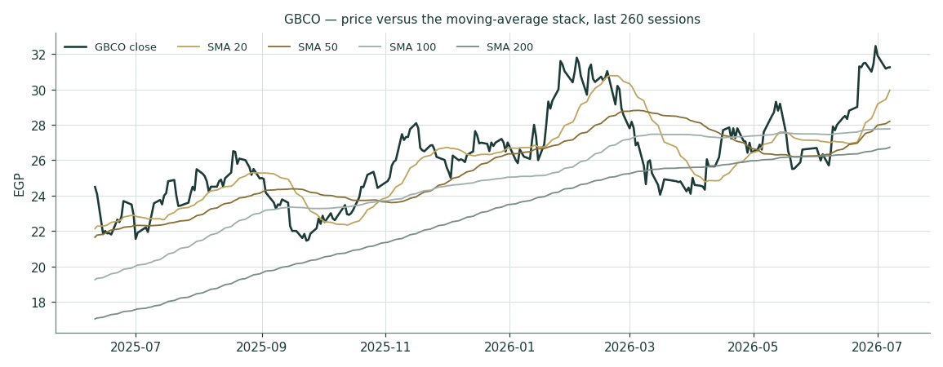
Figure 3 — Price versus the moving-average stack, last 260 sessions.
For the probabilistic work this matters in one way: an above-trend, momentum-positive tape thickens the near-term upside tail even where the fundamental work says value has been reached. The technical and fundamental pictures genuinely disagree here — unusually, with the tape the more bullish — and §6 reads the resulting probability zones without forcing a reconciliation.
3 Monte Carlo — a probabilistic price map
The probability read below opens the section, per house presentation: computed from the same 50,000 paths as everything that follows, it is a summary of the distribution, not an input to it.
The probability read (T+60)
P(price above spot) | 71%
P(+10%) vs P(−10%) — the odds | 54% vs 15% · 3.6 : 1
Median level, and its move | EGP 34.98 (+11.9%)
The 50% band (25th–75th) | EGP 30.6 – 40.1 (-2% / +28% of spot)
Touch(+10%) / touch(−10%) at any point | 76% / 38%

We simulate 50,000 three-month price paths (seed 42) with the house YZ-HAR v2 engine: width from a pooled log-HAR cascade (variance lags 1/5/22) on a gap-aware Yang-Zhang variance proxy, projecting the average daily variance over the next 60 sessions (annualized ≈ 49.6% at this origin — regime-conditional by construction, with no calibration multiplier: the retired KVOL floor is replaced by the HAR width itself); shape from unit-variance Student-t(5) innovations via a per-path chi-square mixture (tighter interquartile body, honest tails); and drift that is asset-class-conditional — here the secular expanding-window drift (+9.8% per quarter), because that is the configuration that passed the Step 0 gate on this name while zero drift failed it (Appendix B). A sixteen-factor stack layers on top: seven continuous macro/operating drivers contributing a small net forward drift and nine discrete events that each fire with a probability and an impact, together adding a modest +1.5% over the quarter.
By design the paths diffuse from spot as near-term price and deliberately do not embed the fundamental NAV — the value gap of §1 is kept out of the drift. The fundamental gap lives in §1, not here; §3 maps where price could go from today, not where value sits. The upward median you see is the stock’s own measured secular behaviour surviving a calibration test — never a target, and never the §1 value gap smuggled in.
Continuous factor (7) | Dir. | Discrete event (9) | Prob. | Mean impact
Egypt PC demand / rate-cut cycle | + | 2Q26 results (11 Aug 2026) | 90% | +0.5%
EGP/USD drift (CKD import content) | ± | MNT-Halan second closing ≥ $1.4 bn | 45% | +1.5%
CBE easing (affordability + Capital NIM) | + | CBE cut ≥ 100 bp (Aug/Oct MPC) | 50% | +1.0%
Iraq / Jordan regional-conflict drag | − | Regional escalation spillover | 25% | −2.5%
Chinese grey-import competition | − | BYD Egypt entry / price shock | 35% | −1.0%
Localization / CKD mix & Sadat ramp | + | Sadat ramp / new CKD model | 55% | +0.6%
Funding-cost & provisioning cycle | − | Dividend / capital-return surprise | 15% | +0.8%
 |  | EGP step-devaluation | 12% | −2.0%
 |  | EGX flows / index event | 25% | +0.8%

Percentile map (EGP/share)
Horizon | p5 | p25 | p50 | p75 | p95
T+20 sessions | 26.1 | 30.0 | 32.5 | 35.1 | 40.5
T+60 sessions | 24.0 | 30.6 | 35.0 | 40.1 | 51.1

Lead with the 50% band, not the tails: a quarter ahead, half of all paths finish between roughly EGP 31 and 40; at one month the band is ~EGP 30–35 (width ≈ ÷√3). The 5–95% cone is context, not a forecast.
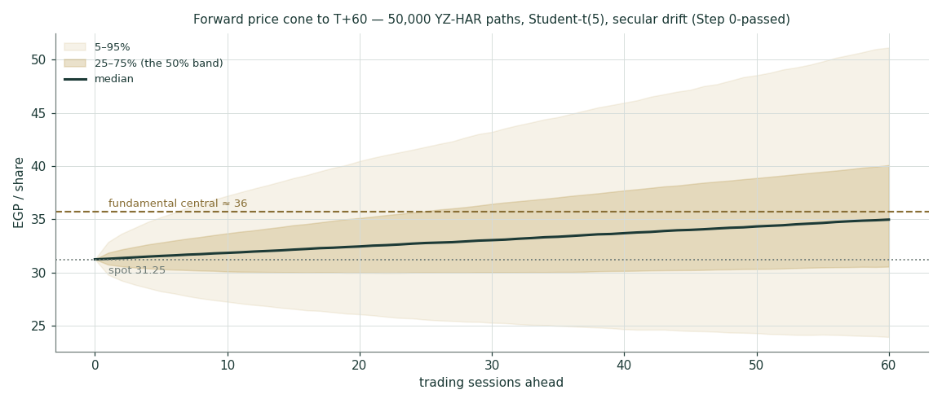
Figure 4 — Forward price cone to T+60. The median drifts up with the calibrated secular term; the gold dashed line marks the EGP 30 fundamental central, deliberately below the median path.
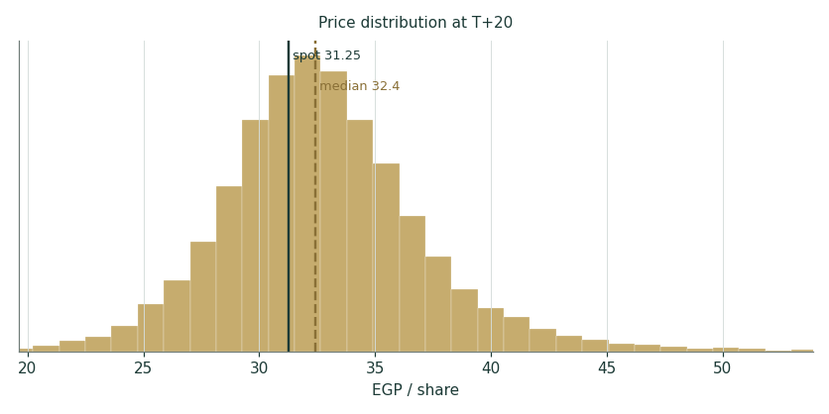
Figure 5 — Price distribution at T+20.
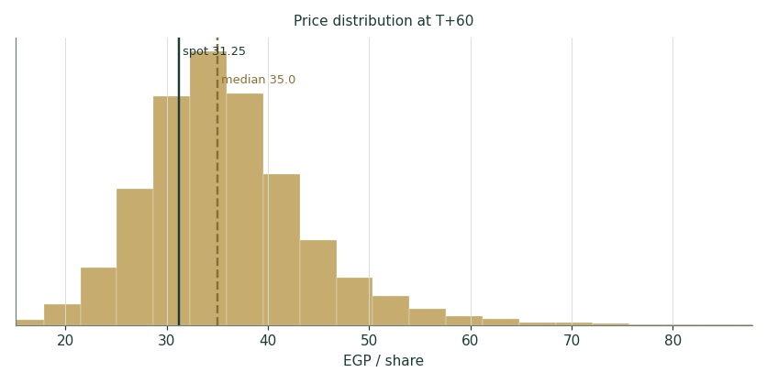
Figure 6 — Price distribution at T+60.
Level-touch ladder
The probability that price touches a level at any point by the horizon (running max for upside, running min for downside):
Level (EGP) | T+20 touch | T+60 touch | Note
40 | 8% | 37% | Blue-sky; +28%
38 | 15% | 50% | Upper zone gateway
36 | 29% | 64% | Above the Feb high zone
34 | 51% | 79% | New-high territory
32 | 82% | 93% | Just above spot
30 | 53% | 64% | The 20-day / round number
28 | 22% | 37% | The 50/100-day shelf
26 | 9% | 20% | April-low zone

4 Comparison of the lenses, and a verdict
Three readings sit side by side, and for once they genuinely disagree. The fundamental lenses spread 29–38.4 with a central 35.7 — meaningfully below spot — but that reading is now dominated by a confirmed input (the MNT-Halan stake, 41.61%, §1.1) whose mark, not its existence, is the open question. The technical picture sits closer to the middle: above every average, momentum positive, six percent from an all-time high, but not pricing in anything like the fundamental lenses' implied re-rating. The probabilistic map is the one piece entirely unaffected by any of this: its median (35) sits above spot because the engine’s calibrated secular drift — the EGX repricing that has carried this stock thirteen-fold in five years — has not yet statistically died; that is a description of measured price behaviour, not a claim about value, and it does not know or care what GB Corp’s associate stake is worth.
Lens | Reads | Central / implication
Fundamental (4-lens) | Meaningfully undervalued — if the mark holds | EGP 35.7 (+14%)
Technical | Strong / extended | Support 30.0 / 28.2 (20d/50d); resistance 33.4 (ATH)
Monte Carlo (3-month) | Drift-up, right-skewed | Median 35; p5–p95 24–51

Verdict (a fair-value read, not a recommendation). GBCO reads meaningfully undervalued on fundamentals (+14% central) — and unlike the first draft of this study, that verdict now rests on a confirmed number: GB Corp's own 9-June-2026 press release states its MNT-Halan stake as 41.61%. What is not confirmed is what that stake is actually worth to the market: taking the round's USD 1.4bn valuation at face value implies the stake alone is worth ≈82% of GB Corp's market cap pre-discount (≈73% after this study's 10% complexity discount), either reading well above what the market plainly credits. Strip the associate leg out and the remaining business — Auto plus GB Capital — reads close to fairly valued against spot, in line with what the tape and the Monte Carlo distribution already show. The honest summary is: the operating business is priced about right; whether the shares are cheap depends on how much of a discount the market is entitled to apply to an unlisted, minority financial-services stake — a legitimate valuation question this study raises rather than settles. The bear–bull span (EGP 23–51) is wide enough on its own to demand real humility, and readers should treat the stake-sensitivity table in §1.1 as showing where the discount debate lives, not the single central number. We publish the distribution, not a target.
5 Catalysts to watch
- 2Q26 results (11 Aug 2026). First read on whether the 1Q26 margin dip (12.4% Auto GPM) was the regional-drag trough; watch Egypt PC volumes vs the +42% 1Q pace and the finance-cost line as CBE cuts feed through.
- CBE MPC meetings (Aug / Oct 2026). Each 100 bp cut lowers GB Capital funding costs, customer instalments and this study’s discount rate — the single most mechanical catalyst.
- The MNT-Halan mark and discount — no longer the stake. GB Corp confirmed its current stake (41.61%, 9-Jun-2026); the open question now is whether the market accepts the round’s USD 1.4bn valuation at face value or applies a steeper illiquidity/minority discount. Any secondary transaction, analyst note, or further disclosure bearing on how the market should mark an unlisted 41.61% stake is the single most value-relevant catalyst left.
- MNT-Halan second closing. The round’s first close (9 Jun 2026) already fixed GB Corp’s post-transaction stake at 41.61%; a second closing would mainly test whether the USD 1.4bn valuation holds or moves, not the ownership percentage itself.
- Sadat ramp and new CKD models. The June-2026 inauguration adds capacity and local content; model announcements and the inventory unwind are the visible working-capital catalysts.
- BYD entry pricing. The clearest competitive threat to PC ASPs and share in the recovering Egyptian market.
- Iraq / Jordan normalization. ~19.5% of PC revenue; any de-escalation restores the fastest-margin sales in the mix.
- The pound. A step-devaluation is the compound risk (CKD costs, rates, the EGP value of every mark); continued stability is the quiet tailwind.
- Dividend decision. FY25 paid ~EGP 0.35/share (~13% payout); with Auto deleveraging to 2.14× ND/EBITDA, a payout step-up would mark the cash-conversion inflection this study is waiting for (device A-2 schedule in Appendix A).
6 Reading the probability zones
Translating the three-month distribution into plain zones, anchored on spot EGP 31.25 and the fair-value cluster:
Zone (T+60) | Range | Approx. probability | What it would mean
Deep downside | < EGP 26 | ~9% | Regional escalation / devaluation; tests the April shelf
Lower band | EGP 26–30 | ~14% | Margin proof delayed; relative-multiple lens dominates
Around spot | EGP 30–34 | ~22% | Status quo; fair value and price coexist
Upper band | EGP 34–38 | ~22% | Cuts + WC release credited; new-high extension
Strong upside | > EGP 38 | ~34% | Secular repricing continues; discount narrows toward NAV

The distribution is right-skewed by construction — the calibrated secular drift plus fat-tailed innovations put roughly a third of terminal mass above EGP 38, more than any other single zone. Read that with Appendix B open: the drift term passed its test, but on 17 non-overlapping windows with a thin margin. It is the spread of outcomes consistent with the stock’s own measured behaviour and the factor stack; it is not a forecast.
7 Caveats and what would change our mind
- The MNT-Halan stake is confirmed; what it is worth is not. GB Corp’s own 9-June-2026 press release states its current stake directly: 41.61%, down from 42.58% pre-transaction. That removes the sourcing uncertainty this study originally flagged. What remains genuinely open is the mark: taking the round’s USD 1.4bn valuation at face value implies the stake alone is worth ≈EGP 27.7bn — ≈82% of GB Corp’s market cap pre-discount, ≈73% after this study’s uniform 10% complexity discount. If the market is right to discount that mark far more heavily than 10%, the SOTP compresses toward the relative and normalized lenses, i.e. toward fair value, not undervalued.
- Working capital is the second-order model. The DCF’s Auto-leg value lives in the glide from 28.5% to 21.5% WC intensity; if 26–28% is the new structural cost of holding share (import finance, CKD stock), the Auto leg is worth EGP 4–8/share less — a real but now secondary lever next to the mark-and-discount question above.
- Terminal-value dependency. 75% of the Auto EV is terminal value at a 10.5-pt WACC−g spread; the §1.9 grid is the honest statement that this is partly a bet on Egyptian nominal normalization.
- The drift is empirical, and thin. Secular drift passed Step 0 (CRPS skill +3.2% non-overlapping, +9.6% monthly) where zero drift failed — but the bootstrap CI spans zero (P(skill>0) ≈ 0.62 on 17 windows). A regime turn — the exact failure mode that killed trend drift on Samsung and Tata — would flip the median read; we will re-test every quarter and cut the drift the moment it fails.
- The associate mark is real but private, and now the study’s central bet. MNT-Halan’s USD 1.4bn is a genuine transaction price — cash changed hands — but for an unlisted company and, per public reporting, only an initial tranche of an ongoing round (a second closing remains open, size and terms undisclosed). The stake applied to it (41.61%) is now confirmed and current, not the uncertainty it was; the bear case in the football field instead applies a much heavier discount to the mark itself, which is why its EGP 24 floor sits far below the base case.
- The lender is a credit cycle. GB Capital’s 15% adjusted ROAE and 2.1–2.5% NPLs are cycle-friendly numbers struck in an easing cycle; a funding-market seizure or NPL spike would break the 1.0× book mark.
- Consolidation approximations. The consolidated forecast maps eliminations, minority interests and the grouped balance-sheet layout with stated simplifications (flagged in the model); segment disclosure, not audited consolidation schedules, is the source.
- Technical reminder. An extended tape above every average mean-reverts routinely; the strong chart says nothing about value and can unwind 10% without touching the thesis. The technical read is context, not a trigger.
Appendix A Financial statements
Selected consolidated figures, as reported (4Q23 / 4Q24 / 4Q25 earnings releases; 1Q26 release 14 May 2026). EGP million. FY23 operating profit is shown after provisions for cross-year consistency with the FY25 layout. The five-year forecast is the model build (companion Excel, Income Statement sheet, formula-linked to Assumptions).
A.1 Income statement (consolidated, EGP mn)
Line | FY23 | FY24 | FY25 | FY26E | FY27E | FY28E | FY29E | FY30E
GB Auto revenue | 23,854 | 47,065 | 66,358 | 78,550 | 95,736 | 112,459 | 128,714 | 144,761
GB Capital revenue | 4,951 | 7,384 | 14,743 | 21,377 | 27,790 | 34,738 | 41,686 | 49,189
Eliminations | (488) | (479) | (872) | (1,099) | (1,359) | (1,619) | (1,874) | (2,133)
Total revenue | 28,317 | 53,970 | 80,230 | 98,828 | 122,168 | 145,578 | 168,525 | 191,817
Gross profit | 6,884 | 10,515 | 12,431 | 14,633 | 18,600 | 22,760 | 26,551 | 30,417
S&M and administration | (3,431) | (4,844) | (6,547) | (7,906) | (9,651) | (11,355) | (13,061) | (14,770)
Other income · provisions | 250 | 150 | 747 | 791 | 977 | 1,165 | 1,348 | 1,535
Operating profit | 3,703 | 5,821 | 6,631 | 7,518 | 9,926 | 12,570 | 14,838 | 17,182
Associates | 1,066 | 868 | 975 | 1,250 | 1,430 | 1,630 | 1,830 | 2,030
EBIT | 4,770 | 6,689 | 7,606 | 8,768 | 11,356 | 14,200 | 16,668 | 19,212
FX gains (losses) | (1,499) | (292) | (37) | — | — | — | — | —
Net finance cost | (966) | (2,398) | (3,702) | (4,100) | (3,800) | (3,500) | (3,300) | (3,100)
Earnings before tax | 2,304 | 3,999 | 3,867 | 4,668 | 7,556 | 10,700 | 13,368 | 16,112
Income taxes | (493) | (939) | (1,086) | (1,307) | (2,116) | (2,996) | (3,743) | (4,511)
NP before minority interest | 1,811 | 3,060 | 2,780 | 3,361 | 5,441 | 7,704 | 9,625 | 11,601
Minority interest | 80 | (132) | 100 | (67) | (109) | (154) | (193) | (232)
Net profit (attributable) | 1,891 | 2,928 | 2,880 | 3,294 | 5,332 | 7,550 | 9,433 | 11,369

Forecast columns are the live model build (rounded); the Excel is the source of truth and reprices from Assumptions.
A.2 Balance sheet (consolidated, EGP mn) — grouped house layout
Line | FY23 | FY24 | FY25 | FY26E | FY28E | FY30E
PP&E, intangibles, ROU & inv. property | 6,937 | 10,361 | 13,389 | 15,665 | 19,821 | 23,414
Investments in associates | 10,732 | 11,744 | 13,690 | 14,940 | 18,000 | 21,860
GB Capital loan book (on BS) | 7,681 | 11,483 | 17,518 | 23,650 | 37,542 | 53,158
Inventories | 6,366 | 21,134 | 24,650 | 28,278 | 35,987 | 42,849
Trade receivables — Auto | 1,744 | 3,709 | 5,317 | 6,284 | 8,997 | 11,581
Advances, debtors & other current | 1,039 | 2,942 | 4,671 | 5,498 | 7,591 | 9,337
Cash & cash equivalents | 4,504 | 7,421 | 9,524 | 6,371 | 2,744 | 4,779
Other assets | 3,581 | 3,932 | 2,601 | 2,602 | 2,602 | 2,602
TOTAL ASSETS | 42,585 | 72,725 | 91,359 | 103,287 | 133,283 | 169,579
Equity attributable | 19,839 | 25,439 | 28,789 | 31,625 | 43,463 | 61,568
Non-controlling interests | 1,363 | 1,978 | 1,801 | 1,869 | 2,090 | 2,515
Borrowings | 12,518 | 22,609 | 38,041 | 43,541 | 54,341 | 66,241
Trade & notes payables | 7,399 | 19,718 | 18,437 | 21,961 | 28,864 | 35,360
Leases · provisions · other · DT | 1,467 | 2,982 | 4,291 | 4,291 | 4,291 | 4,291
Balance check (assets − L&E) | 0 | 0 | 0 | 0 | 0 | 0

Historic columns are grouped from the disclosed segment balance sheets (release Tables 12–13); a small reallocation between “advances & debtors” and “other assets” aligns the grouped layout to the disclosed Auto working-capital figures — flagged in the model. Forecast rolls forward on the clean-surplus construction; the check row is zero.
A.3 GB Auto segment and cash-flow markers · the DPS schedule (device A-2)
GB Auto segment | FY23 | FY24 | FY25
Revenue | 23,854 | 47,065 | 66,358
Gross margin | 24.4% | 19.2% | 14.8%
EBITDA · margin | 3,795 · 15.9% | 5,881 · 12.5% | 6,363 · 9.6%
Net working capital · % of revenue | 4,466 · 18.7% | 10,784 · 22.9% | 18,917 · 28.5%
Net debt · ND/EBITDA | 2,922 · 0.77× | 5,292 · 0.90× | 15,210 · 2.39×
Capital employed · ROCE | 10,231 · 35.9% | 18,731 · 31.5% | 28,513 · 21.3%
Capex | ~1,100 | 2,642 | 2,695

Dividend schedule | FY25A | FY26E | FY27E | FY28E | FY29E | FY30E
Payout of attributable NP | ~13% | 14% | 15% | 16% | 18% | 20%
DPS (EGP) | 0.35 | 0.42 | 0.74 | 1.11 | 1.56 | 2.09
Yield at spot | 1.1% | 1.4% | 2.4% | 3.6% | 5.0% | 6.7%
Stress check | Bear-case FY27E NP ~3.6 bn still covers a 15% payout 6.7×; the constraint is the lending book’s equity appetite, not earnings.

Forecast-vs-actual scorecard (device A-3) and new-vs-old reconciliation (A-4): not applicable on an initiation; both tables become standing sections from the first 3-month update, scoring these FY26E lines against the print.
Appendix B Step 0 — calibration backtest
Before any forecast we test the Monte Carlo lens on GBCO’s own five years of history: at seventeen non-overlapping origins (h = 60 trading days), using only data available at each origin, the YZ-HAR engine generates the three-month-ahead distribution and the realized close is scored against it. The grade is skill versus a naïve benchmark — a zero-drift random-walk lognormal cone on trailing realized vol — measured by CRPS skill (must be > 0) and the Winkler interval score; the PIT histogram and coverage table are diagnostics only, since band-containment rewards width.
Configuration / scheme | n | CRPS skill | Interval skill | 50 / 80 / 90% coverage | PIT mean
Zero drift — non-overlapping | 17 | −1.6% | −0.4% | 47 / 82 / 88% | 0.62 (right-skewed)
Secular drift — non-overlapping | 17 | +3.2% | −6.0% | 59 / 76 / 94% | 0.53
Secular drift — monthly origins | 49 | +9.6% | −8.4% | 53 / 86 / 92% | 0.57

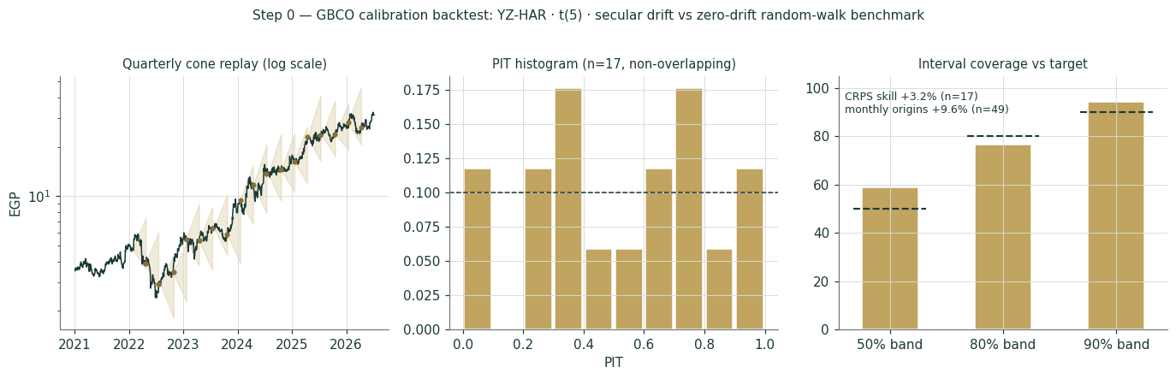
Figure B-1 — Calibration backtest: quarterly cone replay (log scale), PIT histogram, and interval coverage versus target, secular-drift configuration.
Zero drift fails the gate on this name: negative CRPS skill and a PIT pushed into the upper deciles — the classic signature of a distribution that keeps under-calling a secular uptrend (GBCO is a thirteen-bagger over the sample, the same EGP-repricing dynamic as the EGX developers). Re-running with the asset-class secular drift switched on — the prescribed recalibration path — flips the result: CRPS skill +3.2% on non-overlapping windows and +9.6% on monthly origins, with the PIT mean back near 0.5 and no material U-shape. The interval score gives some of that back (the t(5) tails price protection the benchmark doesn’t carry), and a block bootstrap on the 17 windows puts the 90% CI on CRPS skill at roughly [−0.17, +0.18] — P(skill > 0) ≈ 0.62. The lens is accepted with that thinness stated: seventeen windows is decent validation, not robust proof, and the drift term is re-tested every quarter with a hard kill rule. Flag for the record: GBCO is the first EGX non-developer to carry the secular drift — adopted empirically here, exactly as the protocol requires, not by asset-class default.
Appendix C Peer set, sector structure, and risks
GB Corp has no clean single comparable — an auto assembler-distributor, an NBFI and a fintech associate in one wrapper. The peer set is therefore split by leg.
Leg | Closest peers | Typical valuation
Auto assembly & distribution | Saudi/GCC auto distributors, Türk Traktör, EGX consumer durables | EV/EBITDA ~4–6×; P/E ~8–12×
NBFI / consumer & SME finance | Contact Financial (CNFN), EFG finance arm, Raya finance leg | P/B ~1.0–1.8× on mid-teens ROE
Fintech associate | Fawry (FWRY), e-Finance (EFIH); MNT-Halan private rounds | Private marks; last round USD 1.4 bn

Sector structure. Egypt’s PC market is in a policy-assisted recovery (~210k registrations in 2025, +40% y/y) with the CBE easing cycle restoring affordability, localization incentives reshaping the CKD/CBU mix, and Chinese entrants (BYD) resetting price points. Consumer and SME finance is growing faster than banking credit off a low base, with securitization deepening as a funding market. Principal risks: a structurally higher working-capital intensity; a renewed EGP devaluation; regional conflict freezing Iraq/Jordan; BYD-led price competition; credit-cycle deterioration in the lending book; a private-market re-price of MNT-Halan; and execution on Sadat.
Appendix D The expert valuation panel
Every Testahil study closes with a panel of standing expert personas — drawn from the house Expert Persona Library, not invented for the occasion, so that each accumulates a track record across studies and a quarterly update is a re-run, not a re-training. For GBCO we cast the industrial trio, adding the cash-returns lens because the name is capital-heavy: Expert 1 (the accountant — split-legs NAV and the marks), Expert 2 (earnings power — normalized mid-cycle earnings and multiples), Expert 3 (cash returns — return on capital against its cost). Each runs a different method, derives its fair value from shown workings, and states a falsification condition. The macro-policy lens — rates, the pound, the region — runs through the body (§1.8, §5) rather than as a separate persona.
D.1 Expert 1 — the split-legs NAV and the marks
Worldview. A group is worth the sum of its parts at realizable value, less a discount for the wrapper. Mark each leg to what it would fetch on its own; then argue only about the discount.
When it works / fails. Best where the legs are separable and independently markable; fails hardest when the discount applied to a private mark is itself contestable — exactly his position on MNT-Halan now.
Expert 1’s marks (EGP mn) | Value
Auto leg (accepts the §1.2 DCF) | 8,730
GB Capital at 1.0× adjusted book | 9,500
Associates: MNT-Halan 27,671 (41.61% confirmed × USD 1.4bn) + other 390 | 28,061
Σ = EGP 42.6/share pre-discount | 46,291
Fair wrapper discount 8% (operator, not a passive holdco) | → EGP 39.2/share

Sensitivity (swing = the discount on the mark, now that the stake is settled): at a 25% discount on MNT-Halan alone his NAV falls to ≈EGP 33/share; at 50%, ≈EGP 28. He concedes this openly: “the stake isn’t the argument anymore — the argument is what a 41.61% minority stake in an unlisted fintech is worth to a public-market buyer who can’t sell it, and that’s a discount rate question, not an ownership question.” Cross-examination: he tells Expert 2 that capitalizing mid-cycle earnings double-counts assets he has already marked at full value; he tells Expert 3 that a 15-point ROCE haircut on the Auto leg is small next to the swing available just from how hard you discount an illiquid stake.
Verdict, falsification, market-implied. Fair EGP 39.2 (range 21–61) — still his widest range, now driven by the discount debate rather than an unconfirmed stake. Falsified by a real secondary transaction in MNT-Halan shares at a materially different price, or by the second closing repricing the round away from USD 1.4bn. The market price implies a discount on the associate leg far steeper than his stated 8% wrapper discount — in his own view, evidence the market doesn’t trust the round’s marked value to transfer cleanly to a 41.61% minority holder.
D.2 Expert 2 — normalized earnings power
Worldview. An operating business is worth a fair multiple of its sustainable mid-cycle earnings; peaks (FY24’s FX windfall) and troughs (FY23) are noise to be stripped out.
When it works / fails. Best with a through-cycle record (three disclosed years spanning trough, windfall and normalization is workable); fails at structural breaks — if BYD resets Egyptian ASPs permanently, his normalization is simply wrong.
Expert 2’s normalization | Value
Mid-cycle group PAT (EGP mn) | 4,200
Shares (mn) → normalized EPS | 1,085.5 → EGP 3.87
Justified through-cycle P/E (EM auto + NBFI blend) | 8.5×
Fair value | → EGP 32.9/share

Sensitivity (swing = the multiple / the margin): at 7.5× EGP 29.0; at 9.5×, 36.8; a 1-pt miss on mid-cycle Auto GPM costs ~EGP 2.5. Cross-examination: he tells Expert 1 that an NAV struck off a trough-margin DCF understates a business whose volumes are still mid-cycle; he tells Expert 3 that cash-conversion pessimism ignores that working capital is a stock, not a perpetual flow — it releases exactly when growth normalizes.
Verdict, falsification, market-implied. Fair EGP 32.9 (range 25–42) — the most bullish. Falsified by Auto gross margin stuck below ~13% through FY27, or the Egyptian PC market rolling over. The market implies normalized earnings ~5% below his: it mostly believes him.
D.3 Expert 3 — cash returns: ROCE against the cost of capital
Worldview. A business creates value only when each pound of capital earns above its cost, in cash. He looks past the income statement to the economic-profit spread — and past reported returns to returns ex one-offs.
When it works / fails. Best for capital-intensive compounders where the reinvestment spread is the story; fails where the capital base is temporarily inflated by a one-off build (his own caveat here: FY25’s WC bulge may be exactly that).
Expert 3’s economic-profit test | Value
Auto capital employed (FY25) | 28,513
Auto ROCE — FY25 vs FY23/24 | 21.3% vs 35.9% / 31.5%
WACC (his hurdle) | ~22%
Spread ≈ nil ⇒ Auto EV ≈ 0.9× CE | 25,662 → equity 9,652
Lender at 0.9× book · associate at 0.85× (his own haircut on the mark, stake now confirmed) | 8,550 · 23,852
GB Capital ROAE, headline vs adjusted (one-off stripped) | 7.9% vs 15.1%
Fair value | → EGP 38.7/share

Sensitivity (swing = the ROCE fade, and the discount he applies to the mark): if ROCE re-approaches 30% as WC releases, his Auto mark rises to ≈EGP 3/share more; but moving his associate haircut from 0.85× to 0.60× costs ≈EGP 7/share — larger than his preferred ROCE lever. Cross-examination: he tells Expert 2 that mid-cycle earnings without the capital cost to hold them is a half-truth — FY25 grew profit 49% in revenue terms and consumed EGP 8bn doing it; he tells Expert 1 that an 8% wrapper discount doesn’t begin to capture the illiquidity of a 41.61% stake in a company that has never had a public exit.
Verdict, falsification, market-implied. Fair EGP 38.7 (range ≈32–48) — even his conservative method lands well above spot once the confirmed stake is applied at the round’s valuation, which he flags as the real finding here: the stake was never the issue, the mark is. Falsified either by a durable ROCE recovery above ~28–30%, or by a real secondary sale of MNT-Halan shares at a price meaningfully below the round’s implied valuation. The market price sits well below his number: on a cash-returns basis the market looks unconvinced by the mark at face value, not by GB Corp’s ownership of it.
D.5 The three in one room
The stake question that dominated the first draft of this study is now settled — GB Corp confirmed 41.61% in writing on 9 June 2026. What the three disagree on now is what that confirmed stake is worth.
Expert 1: “The company told us what it owns. Fine — now the argument is honest: it’s about the discount, not the number. I apply 8% for the wrapper. If you think that’s too thin for an illiquid minority stake, argue the discount, not the disclosure.”
Expert 3: “Your own arithmetic says a confirmed 41.61% stake is worth 82% of the entire market cap before any discount, 73% after yours. That was true when the number was uncertain and it’s just as true now that it isn’t. The company being honest about its ownership doesn’t make the market’s skepticism about the mark go away — if anything it sharpens the question.”
Expert 2: “You’re both still arguing about a number that was never in my model. Mid-cycle earnings power doesn’t care what MNT-Halan is worth, confirmed or not. If you want the one lens immune to this whole argument, it’s mine — and notice it’s also the one closest to where the market actually prices the stock.”
D.6 Reading the divergence
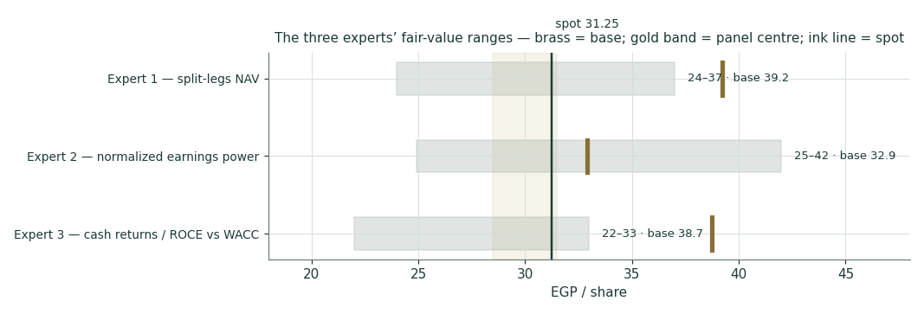
Figure D-1 — The three experts’ fair-value ranges. Brass ticks are base cases; the gold band is the panel centre; the light line is spot. The spread is now almost entirely the MNT-Halan discount question.
Expert | Method | Single swing assumption | Base fair value
Expert 1 | Split-legs NAV | Discount on the MNT-Halan mark (8% wrapper) | EGP 39.2
Expert 2 | Normalized earnings power | Mid-cycle PAT 4.2 bn × 8.5× (stake-blind) | EGP 32.9
Expert 3 | Cash returns / ROCE vs WACC | ROCE fade + 0.85× haircut on the mark | EGP 38.7

The spread — EGP 32.9 to 39.2 at base — is wide for what is otherwise a set of broadly-agreeing methods, and it is now almost entirely one disagreement: not the volumes, not the lender’s profitability, not the Auto cash-conversion path, and — since 9 June 2026 — not the MNT-Halan stake either (all three experts now accept 41.61% as fact). What separates them is purely how much to discount that confirmed stake’s marked value. Expert 2 sidesteps the question entirely by never pricing the stake; Experts 1 and 3 both use the confirmed figure but disagree on the haircut. Unlike the working-capital disagreement in an earlier draft of this study — a genuine business uncertainty that resolves with quarterly prints — this one may never fully resolve, since private-mark discounts are inherently a matter of judgment rather than a fact that prints on a schedule. Until a real secondary transaction in MNT-Halan shares provides an independent data point, Expert 2’s stake-blind number remains the one estimate in the room immune to this whole argument.
Each expert’s point fair value (and bull/base/bear) is logged with the study date (8 Jul 2026) and spot (EGP 31.25) as an internal per-expert track record, kept separate from the core Calibration Ledger.
About this series
Testahil publishes independent, educational valuation studies. Each is an attempt to reason transparently about what a security is worth, with every assumption shown and a companion model so readers can disagree productively. The house style is distributions, not tips: we describe ranges and probabilities, not targets, and we do not tell anyone what to do. Studies are framed as educational analysis, the preparer is not licensed by any securities regulator, and holdings are disclosed.
Disclosure & Disclaimer
Not investment advice. This document is educational and informational only. It is not, and must not be relied upon as, investment, financial, legal, accounting or tax advice, nor an offer, solicitation or recommendation to buy, sell or hold any security. It contains no price target and no rating.
No licence; no advisory relationship. The preparer is not registered or licensed with any securities or financial regulator in any jurisdiction — including Egypt’s Financial Regulatory Authority (FRA) — holds no brokerage or investment-advisory authorisation, and is not acting as your adviser or fiduciary. Nothing here is personalised to your circumstances.
Holdings disclosure. The preparer may hold, and may in the future take or dispose of, a position in the security discussed in this report, and may transact at any time without notice. This is a potential conflict of interest you should weigh.
Sources & accuracy. Reported financial and operating figures are drawn from the company’s public disclosure and other public sources believed reliable but not independently verified; they may contain errors or be superseded. Forward-looking inputs — the leg marks (including the discount applied to GB Corp’s confirmed MNT-Halan stake), the complexity discount, projections, multiples, the DCF and Monte-Carlo factor probabilities — are the preparer’s own judgments and are inherently uncertain.
Forward-looking statements. Any statements about the future are estimates subject to risks and uncertainties; actual results may differ materially. The Monte Carlo models price, not value, and encodes subjective probabilities for events that have not occurred.
No reliance; your responsibility. Do your own research and consult a licensed professional before making any decision. You are solely responsible for your investment decisions and their outcomes. To the maximum extent permitted by law, the preparer accepts no liability for any loss arising from use of this document.
Currency & figures. Figures are in Egyptian pounds (EGP), millions unless stated; bn denotes billion. FX at study date: USD/EGP ≈ 47.5 (flagged estimate). Rounding may cause totals to differ slightly. Spot price and market data are as of 7 July 2026 and change continuously.
TESTAHIL · Independent Valuation Study · Educational Analysis · GB Corp S.A.E. (EGX: GBCO) · edition 08-07-2026 · reporting currency EGP

