Testahil · Independent Valuation Study — Educational Analysis | Not investment advice

Independent Valuation Study — Educational Analysis
Heliopolis Company for Housing & Development — Misr El Gadida (EGX: HELI)
Fundamental analysis · Technical analysis · Monte Carlo simulation — one integrated read
Anchor: EGP 6.43 (1 Jul 2026 close) · 4,005.3 mn shares · mkt cap ≈ EGP 25.8 bn · the 120-year-old, 72.25% state-owned owner of New Heliopolis City (5,885 feddans, east Cairo), converting a raw land bank into contracted co-development annuities after the EGP 15 bn Heliopark sale of 2023 · prices and probabilities computed 1 Jul 2026 from the attached daily history · primary lens: sum-of-the-parts RNAV on the land bank and the signed partnership contracts · the land marks, the RNAV discount and the pace of the state’s privatization agenda are the swing factors.
READ FIRST — what this document is, and is not. This study is a valuation exercise and an expression of personal analytical opinion, published free of charge for educational purposes: it shows how one analyst applies fundamental, technical and probabilistic methods to a listed company, and invites scrutiny of that methodology. It is NOT investment advice, NOT a recommendation or solicitation to buy, sell or hold any security, and NOT directed at the circumstances of any reader. The preparer is not licensed by any securities regulator in any jurisdiction, holds no Egyptian FRA or other brokerage or advisory authorisation, provides no financial consultancy, manages no money, and accepts no fees, funds or clients. See the Disclosure & Disclaimer at the end. All values are model outputs presented as ranges and distributions because no single number should be relied on. Reported financials are the company’s own EGX disclosure (FY2025 statements published March 2026; Q1-2026 published June 2026; standardised presentation retrieved via S&P Capital IQ on 3 Jul 2026); forward-looking inputs — the land and partnership marks, the RNAV discount, the multiples, the DCF and the Monte-Carlo factor probabilities — are the preparer’s judgments and are flagged throughout. A note on the calendar: the company moved from a June fiscal year to a calendar fiscal year (an 18-month transition period ended December 2022), so FY2023 onward are January–December years. Consult a licensed financial advisor before any investment decision.

Headline
The model’s read: undervalued on the land it has already contracted, with the answer resting on execution pace and the state’s discount. At EGP 6.43 the shares sit roughly 31% below our weighted central estimate of EGP 8.40. Two anchor lenses agree closely — a sum-of-the-parts RNAV on the land bank and a DCF on the partnership cash flows both land at EGP 8.30 — while a conservative relative-multiple read (EGP 7.45) marks the floor and a normalized-earnings-power read (EGP 9.25) marks the ceiling. The story is a conversion: after selling the 1,695-feddan Heliopark plot to the National Social Insurance Authority for EGP 15 bn in 2023, HELI has committed roughly 4,800 feddans of New Heliopolis to revenue-sharing co-developments — Madinet Masr (491 fd, a contracted minimum of EGP 53.2 bn over nine years), G Developments (~1,800 fd), Middle East Development (1,759 fd), MG (77 fd) and the SODIC East tail — so the value case now rests on contracted annuities rather than raw-land hope. Technically the stock is digesting a 92% year-to-date run: above its 100- and 200-day averages, sitting exactly on the 20/50-day pair, RSI neutral at 49. Over three months the Monte Carlo places the 5th–95th percentile band at roughly EGP 4.84–9.27, with the interquartile 50% band at EGP 5.95–7.60 and a median just above spot.

Valuation summary — every read at a glance
One table for the four reads that follow — what the business is worth (fundamental), what the tape is doing (technical), where price could travel over three months (Monte Carlo), and how three independent expert methods land. Every row is developed in the sections and appendices below.
Lens / read | What it measures | Output | Takeaway
FUNDAMENTAL — what the business is worth (the anchor)
Sum-of-the-parts RNAV (primary) | Land & contracts marked, less discount | EGP 8.30 | +29% vs spot
DCF (partnership cash flows) | Discounted 5-yr FCFF + terminal | EGP 8.30 | +29%
Relative multiples | FY26E EPS × justified P/E | EGP 7.45 | +16% · the floor
Normalized earnings | Mid-cycle recurring NI × P/E | EGP 9.25 | +44% · the ceiling
Weighted central | Blend 40 / 20 / 15 / 25 | EGP 8.40 | +31% vs EGP 6.43
TECHNICAL — what the tape is doing (timing, not value)
Trend & momentum | Price vs the 20/50/100/200-day averages | Above 100/200; at 20/50 | Uptrend pausing
Momentum / range | RSI · MACD · 52-week range | RSI 49 · MACD ≈ 0 · 3.00–7.08 | Digestion, not distribution
MONTE CARLO — where price could go in 3 months (paths from spot)
T+20 sessions | 50,000 paths · 16 factors | p5 5.37 · p50 6.54 · p95 7.89 | Median ≈ spot
T+60 sessions | same engine, longer horizon | p5 4.84 · p50 6.74 · p95 9.27 | Right-skewed
EXPERT PANEL — three independent methods (Appendix D)
Expert 1 — forensic RNAV | Marks vs book, discount audit | EGP 8.60 | The anchor
Expert 2 — contracted-annuity DCF | Absorption-tested cash flows | EGP 7.90 | The panel floor
Expert 3 — macro-policy & privatization | Rates, EGP, state agenda | EGP 7.00 | Most state-sceptical
Panel range | Spread = the execution-and-state question | EGP 7.00–8.60 | Centres ~EGP 7.85

Bottom line. Every read points the same way on value and disagrees only on magnitude. The fundamental central sits near EGP 8.40 — about 31% above the EGP 6.43 spot — the three experts span EGP 7.00–8.60, and each turns on a single question: whether the signed partnership contracts pay on schedule under a 72% state owner. The tape, for once, is not the dissenter — it has already travelled from EGP 3.35 in January to 7.08 in the spring — which is why the three-month distribution centres just above spot with a fat right tail rather than at fair value: the market has priced the pivot, not yet the annuities.

Company overview — Misr El Gadida at a glance
Item | Value
Listed entity | Heliopolis Company for Housing & Development — Misr El Gadida (EGX: HELI)
Founded | 1906 (Baron Empain’s Heliopolis Oasis Company); Egypt’s oldest listed developer
Controlling owner | Holding Company for Construction & Development (state) — 72.25%; free float ≈ 27.7%
What it owns | New Heliopolis City land bank (5,885 fd, Decree 193/1995) · Heliopolis-district heritage & rental assets (Korba, Merryland, Sheraton units) · New Obour plot (60 fd)
Spot / date | EGP 6.43 · 1 Jul 2026 close
Shares · market cap | 4,005.3 mn (par EGP 0.25; 2025 bonus tripled the count) · ≈ EGP 25.8 bn
Net debt (Mar-26) | EGP 4.95 bn (EGP 6.6 bn debt less EGP 1.6 bn cash) — the 2025 land-purchase leverage
FY2025 revenue / net profit | EGP 3.14 bn (+197%) · EGP 2.71 bn (+6%)
FY2025 dividend | EGP 0.435/share proposed Apr-2026 (≈ EGP 1.74 bn; ~6.8% yield at spot)
FY2026 company guide | Revenue ≈ EGP 3.07 bn; total profit ≈ EGP 3.5 bn; Q2 net profit +30% YoY (CEO, 25 Jun 2026)
52-week range | EGP 3.00 – 7.08
CEO / MD | Sameh El-Sayed Hammouda (since 2023)

Source: company EGX disclosures, FY2025 statements, Asharq Business, Arab Finance, Mubasher; S&P Capital IQ standardised statements retrieved 3 Jul 2026. Values rounded.

1 Fundamental valuation
We value HELI as what it has become: a land estate manager converting one very large, very old asset — the New Heliopolis land bank granted under Decree 193/1995 — into two kinds of cash: lump-sum land monetisations (Heliopark, the auction plots) and long-dated revenue-sharing annuities from co-development contracts with private developers. The primary lens is a sum-of-the-parts RNAV because the assets are separable and, unusually for an EGX developer, two of the largest are now anchored by disclosed contractual minimums. A DCF on the partnership cash flows, a relative-multiple cross-check and a normalized-earnings-power read complete the set. The weights and the football field are in §1.5; the swing factors — the land marks and the state discount — are dissected in §1.7 and the sensitivity grid in §1.9.

1.1 Sum-of-the-parts RNAV — the primary lens
Each block of the estate is marked on the basis that best fits it. The two JDAs with disclosed economics — Madinet Masr and MG — are marked at the present value of their contractual minimum guarantees (a floor, not a hope), discounted at 21% and taxed at 22.5%. The two large JDAs whose terms are undisclosed — G Developments (~1,800 fd) and Middle East Development (1,759 fd) — are marked at a per-feddan present value of EGP 9 mn, roughly one quarter of the per-feddan PV implied by the Madinet Masr floor, to respect both the earlier vintage of those contracts and the absence of disclosed minimums. The SODIC East residual carries a lower EGP 6 mn/fd for its sold-through tail. Unallocated plots are marked at a cash EGP 8 mn/fd — deliberately below an inflation-adjusted read of the 2023 Heliopark benchmark (EGP 8.85 mn/fd in New Cairo, a better location). The Heliopolis-district heritage and rental portfolio — the Korba buildings, Merryland, the Sheraton units now attracting hotel-conversion offers — carries a EGP 6 bn judgment mark against a EGP ~2 bn book. From the gross asset value we deduct capitalised overhead and net debt, then apply the RNAV discount.
Component (base case) | Basis | Value (EGP mn)
Madinet Masr JDA (491 fd) | PV of EGP 53.18 bn / 9-yr minimum guarantee | 16,500
MG Urban Development JDA (77 fd) | PV of EGP 3.394 bn / 14-yr minimum (32.1% share) | 1,100
Middle East Development JDA (1,759 fd) | EGP 9 mn PV per feddan (terms undisclosed) | 15,831
G Developments JDA (~1,800 fd) | EGP 9 mn PV per feddan (terms undisclosed) | 16,200
SODIC East residual (655 fd) | EGP 6 mn PV per feddan (sold-through tail) | 3,930
Unallocated NH + auction plots (~350 fd) | EGP 8 mn cash per feddan | 2,800
New Obour plot (60 fd) | EGP 8 mn cash per feddan | 480
Heritage & rental portfolio | Judgment mark (Korba · Merryland · Sheraton) | 6,000
Σ Gross asset value |  | 62,841
less: PV of unallocated overhead | ~5× SG&A run-rate | (2,500)
less: net debt (Mar-26) |  | (4,952)
NAV, pre-discount | = EGP 13.83 / share | 55,389
less: RNAV discount | 40% — state control, timing, disclosure opacity | (22,156)
RNAV equity value | = EGP 8.30 / share | 33,233

RNAV base ≈ EGP 8.30/share, with a bear–bull span of EGP 4.60–12.40 driven mainly by the marks on the undisclosed-term JDAs and by the discount itself (§1.9). The pre-discount NAV of EGP 13.83 says the market is paying EGP 6.43 for EGP 13.83 of marked assets — a ~54% implied discount, materially wider than the 40% we judge fair for a state-controlled but contract-anchored estate, and that gap is the crux of the case.

1.2 DCF on the partnership cash flows — the cross-check
The natural check on the asset sum is to discount the cash the estate should actually throw off. We build FCFF from the FY2026E–FY2030E model in Appendix A: operating revenue ramping from the company’s own EGP 3.07 bn FY26 guide toward EGP 8.3 bn as the Madinet Masr minimum (≈ EGP 6 bn/yr average) and the Middle East and G Developments schedules mature; a declining land-auction gains line; the 75-feddan hospitality project’s EGP 5 bn capex spread over three years; and a working-capital cycle that first absorbs the 2025 land purchase and then releases it. We discount at a 20.5% EGP WACC (an equity cost near 24–25% blended with cheaper debt) and fade to a 12% nominal terminal growth — roughly long-run Egyptian inflation plus a real point or two.
The build, year by year (EGP mn). The full construction — identical to the DCF sheet of the companion workbook, where every line links to the Assumptions layer:
EGP mn | FY26E | FY27E | FY28E | FY29E | FY30E
EBIT | 2,332 | 3,526 | 4,780 | 5,750 | 6,465
Land-sale & other gains | 2,600 | 1,200 | 900 | 700 | 500
Tax on EBIT + gains (22.5%) | (1,110) | (1,063) | (1,278) | (1,451) | (1,567)
NOPAT | 3,822 | 3,663 | 4,402 | 4,999 | 5,398
+ D&A | 35 | 40 | 45 | 50 | 55
− Capex | (1,000) | (1,500) | (1,500) | (500) | (200)
− Δ Working capital | (940) | (640) | 360 | 360 | 360
Free cash flow to firm (FCFF) | 1,917 | 1,563 | 3,307 | 4,909 | 5,613
Discount factor @ 20.5% WACC | 0.830 | 0.689 | 0.572 | 0.474 | 0.394
PV of FCFF | 1,591 | 1,076 | 1,890 | 2,328 | 2,209

From cash flows to value per share:
Valuation bridge | Value
Σ PV of explicit FCFF, FY26E–FY30E (EGP mn) | 9,095
Terminal value = FY30E FCFF × (1 + g) / (WACC − g) = 5,613 × 1.12 / (20.5% − 12.0%) | 73,958
PV of terminal value (× 0.394) | 29,110
Enterprise value (EGP mn) | 38,205
less: net debt, Mar-26 (EGP mn) | (4,952)
Equity value (EGP mn) | 33,253
÷ shares outstanding (mn) | 4,005.3
DCF fair value per share (EGP) | 8.30

Terminal value is 76% of enterprise value — unavoidable at Egyptian discount rates, and the reason the bear/base/bull grid below moves so much on a point of WACC. The explicit years are deliberately lumpy: FY26–27 carry the hospitality capex and the working-capital absorption of the 2025 land purchase; FY28 onward the inventory releases and the Madinet Masr minimum matures.
DCF input | Bear | Base | Bull
FY30E FCFF (EGP mn) | 4,100 | 5,613 | 6,900
WACC | 23.5% | 20.5% | 18.5%
Terminal growth | 10% | 12% | 13%
Fair value (EGP/share) | 4.90 | 8.30 | 12.10

The DCF base of EGP 8.30 lands on top of the RNAV — reassuring, since the two methods share almost no inputs beyond the discount rate. Its width is a fair warning: at Egyptian discount rates the terminal value is acutely sensitive, and a point of WACC moves the answer by roughly EGP 1.5 per share.

1.3 Relative multiples
On its own guided numbers HELI is optically cheap: EGP 3.5 bn of FY2026E profit against a EGP 25.8 bn market capitalisation is 7.3× earnings, with a ~6.8% dividend yield already declared for FY2025 and paid in two 2026 instalments. Price-to-book (2.4× on a EGP 2.64 BVPS) is the one multiple that flatters nothing here — the land sits at decades-old cost, so book is close to meaningless and we do not lean on it. We mark the relative lens on FY2026E EPS of EGP 0.88 and a justified 8.5× — a premium to the 5–7× of leveraged EGX developers, a discount to TMGH’s ~11×, reflecting contracted revenue with state-owner governance.
Relative basis | Bear | Base | Bull
FY26E EPS (EGP) | 0.88 | 0.88 | 0.88
Justified P/E | 6.0× | 8.5× | 11.0×
Fair value (EGP/share) | 5.20 | 7.45 | 9.60

Relative base ≈ EGP 7.45 — the most conservative lens, and probably where a sceptic anchors. It capitalises only next year’s profit, credits nothing for the ~EGP 50 bn of contracted minimums that sit beyond FY2026, and treats the land bank as inventory rather than optionality.

1.4 Normalized earnings power
If the partnership system reaches its designed run-rate — the Madinet Masr average of ~EGP 6 bn a year, the Middle East and G Developments schedules contributing on the 2025 evidence (EGP 594 mn from Middle East alone in its first year), MG’s minimum, rental income from the heritage estate and interest on the cash the system throws off — recurring pre-tax income settles near EGP 6.8 bn and recurring net income near EGP 5.3 bn, without assuming any further lump-sum land sales at all. We apply a justified through-cycle 7.0× to that mid-cycle figure — below the 8.5× of §1.3 because run-rate earnings deserve a lower multiple than a growth year.
Normalized-earnings basis | Bear | Base | Bull
Mid-cycle recurring net income (EGP mn) | 4,300 | 5,300 | 6,000
Justified P/E | 6.0× | 7.0× | 8.0×
Fair value (EGP/share) | 6.40 | 9.25 | 12.00

Normalized-earnings base ≈ EGP 9.25 — the run-rate lens and the ceiling of the central case. It is, in effect, the bet that the contracts pay as written and the auctions become gravy rather than the meal.

1.5 Synthesis — four lenses
We weight the RNAV most heavily because it is the lens the contracts were written for; the DCF and normalized-earnings lenses carry the execution thesis; the relative lens anchors the floor.
Lens | Weight | Bear | Base | Bull
Sum-of-the-parts RNAV | 40% | 4.60 | 8.30 | 12.40
DCF (partnership cash flows) | 20% | 4.90 | 8.30 | 12.10
Relative multiples | 15% | 5.20 | 7.45 | 9.60
Normalized earnings | 25% | 6.40 | 9.25 | 12.00
Weighted central |  | 5.20 | 8.40 | 11.80

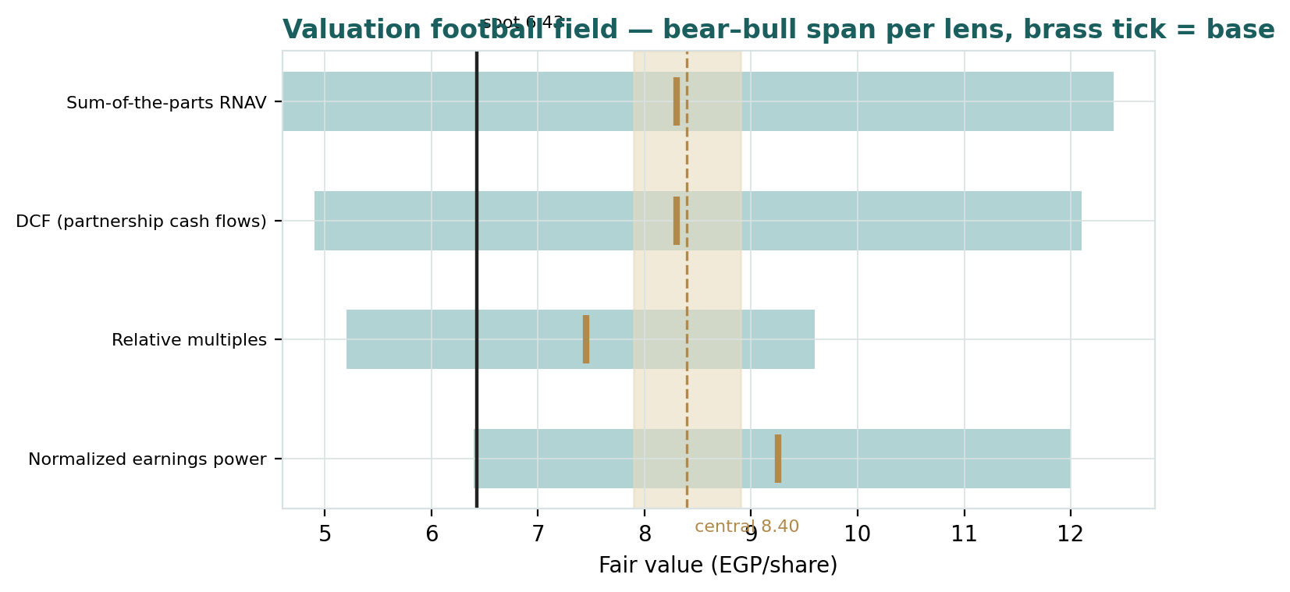
Figure 1 — Valuation football field. Bars span bear–bull per lens; the brass tick is each base case; the gold band is the blended central range; the dark line is spot.
Central fair value ≈ EGP 8.40/share, about 31% above spot. The spread of the lenses (EGP 7.45 to 9.25 at base) is itself the message: this is no longer a raw-land lottery ticket but a contract-execution story, and the lenses disagree mainly on how much of the contracted book to credit today.

1.6 The estate — a deeper look at the blocks
New Heliopolis City (5,885 fd on the Cairo–Suez road, past Shorouk and Badr) is the engine. Roughly 4,800 fd are now committed to five co-developments; ~350 fd of prime unallocated plots (the eight auction lots, Green Kasaba, the 75-fd hospitality site) remain for cash monetisation; the balance is infrastructure, services and earlier self-developed districts. In 2025 the company also redeployed the Heliopark proceeds into the balance sheet itself: inventory rose from EGP 4.6 bn to EGP 16.9 bn as land and development work-in-progress was recognised at cost, funded by EGP ~5.9 bn of new borrowings — the pivot from cash-rich seller to invested developer that defines the current leverage. The Heliopolis-district portfolio — century-old Korba heritage buildings, the Merryland grounds, the Sheraton housing stock — is the quiet second asset, now drawing hotel-conversion partnership offers. The table scores each block on the axes that matter.
Block | Cash visibility | Duration | Counterparty risk | Swing role
Madinet Masr JDA (491 fd) | Contracted minimum, EGP 1.1 bn at signing | 9–12 yrs | Listed developer | Dominant
G Developments (~1,800 fd) | Undisclosed; sales begun | 10+ yrs | Private (New Giza) | Large, opaque
Middle East Dev (1,759 fd) | EGP 594 mn to HELI in 2025 | 10+ yrs | Private (El Gammal) | Large, proving
MG JDA (77 fd) | Contracted minimum | 14 yrs | Private | Small, contracted
SODIC East tail (655 fd) | Revenue share, selling since 2019 | Tail | Listed developer | Steady
Unallocated + auctions (~350 fd) | Lump-sum cash | Near-term | — | Optionality
Heritage & rental portfolio | Rent + conversion offers | Perpetual | — | Hidden asset

1.7 The land marks and the state discount — the crux
Two judgments drive the valuation more than any other. First, what a feddan of committed partnership land is worth today: the Madinet Masr contract implies a present value near EGP 34 mn per feddan on its floor alone, yet we mark the undisclosed-term JDAs at EGP 9 mn — a 74% haircut for opacity, vintage and timing. If the G Developments and Middle East contracts prove even half as rich per feddan as Madinet Masr’s, the RNAV rises by roughly EGP 4 per share; every EGP 1 mn/fd on those two blocks alone is worth EGP 0.53/share pre-discount. Second, the RNAV discount: a 72.25% state-controlled company with episodic disclosure will not trade at the clean sum of its parts. We apply 40%; the market is implying ~54%. The discount is also where the option lives — the Holding Company for Construction & Development has repeatedly examined monetising its stake (the lapsed 2019–20 strategic-investor tender, a rejected Qatari Diar approach, a ~EGP 20 bn internal valuation reported in 2023), and any credible stake-sale or management-partnership step would compress it violently. Every five points of discount is EGP 0.69/share.

1.8 Macro and country — rates, the pound, absorption and the state
HELI is a leveraged play on four Egyptian macro levers. Rates: a 20.5% WACC prices EGP money as it is; each point of CBE easing that flows into discount rates adds roughly EGP 0.8/share to the DCF and re-rates every developer’s NAV discount. The pound: land is Egypt’s inflation hedge of record — the 2022 and 2024 devaluation steps each repriced East-Cairo land upward within quarters, which is precisely why the 2023 Heliopark price already looks quaint; conversely, a further step would raise HELI’s partners’ build costs and slow delivery. Absorption: the entire annuity book depends on private developers pre-selling New Heliopolis units into an off-plan market that has so far stayed liquid (Madinet Masr’s own launch on HELI land is the largest in its history); the Suez-road corridor competes with Madinaty, Rehab, Shorouk, Badr and the New Capital for the same buyer. The state: HELI is a flagship of the public-business-sector portfolio; the privatization programme is both the largest upside catalyst (stake sale, discount compression) and the standing governance overhang (dividend and reinvestment decisions serve a 72% owner whose objectives are not purely commercial). These levers set the bear and bull cases of §1.5 and the catalysts of §5.

1.9 RNAV sensitivity — marks × discount
Holding the contracted-minimum PVs and net debt at base, the grid re-prices the RNAV across a uniform shift on the land and partnership block (86% of gross asset value) and the RNAV discount. The value runs from EGP 4.6 (−30% / 55%) to EGP 12.4 (+30% / 25%).
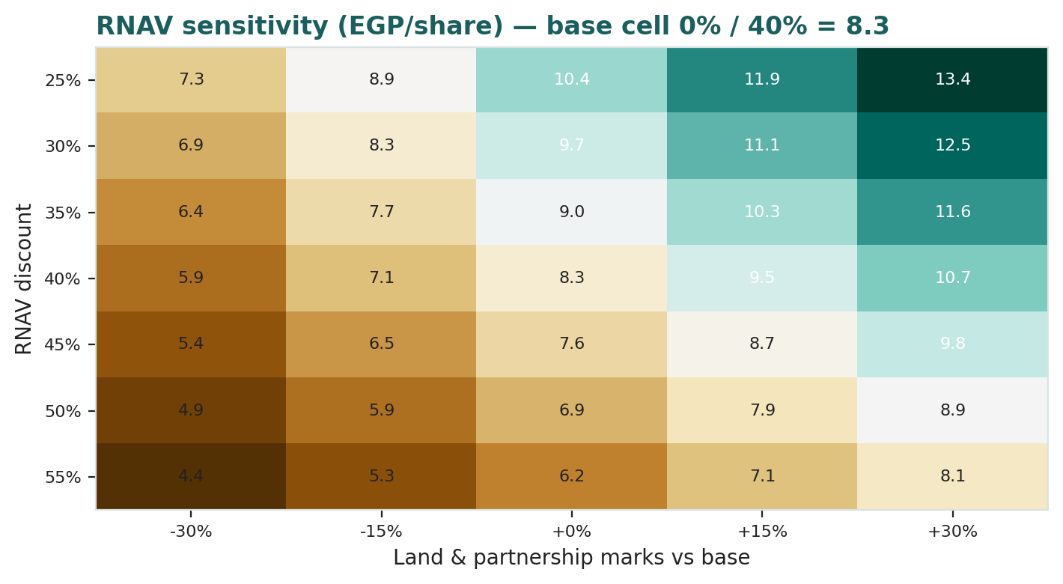
Figure 2 — RNAV sensitivity to the land marks and the state discount (EGP/share). The base cell (0% / 40%) is EGP 8.3; spot 6.43 sits near the −15% / 50% cell.
Read it as the bet you are taking: the market price is consistent with land marks ~15% below ours at a ~50% discount — i.e. the market already credits the contracts partially, but at a governance discount we think two privatization headlines wide.

2 Technical and price structure
The tape is a strong trend catching its breath. HELI has nearly doubled year-to-date — EGP 3.35 in early January to a 7.08 high in the spring — on the FY2025 results, the EGP 0.435 dividend and the partnership pipeline. Price now sits exactly on the 20/50-day pair, comfortably above the 100- and 200-day averages, with momentum flat rather than negative: RSI is dead-neutral at 49 and the MACD histogram is a hair below zero. The structure reads as consolidation inside an uptrend — a two-month sideways range between roughly 6.10 and 7.08 — with the 200-day at 4.54 far below as trend support.
Indicator | Reading | Signal
Spot | EGP 6.43 | —
SMA 20 / 50 | EGP 6.49 / 6.43 | At both — range-bound short term
SMA 100 / 200 | EGP 5.67 / 4.54 | Above both — primary trend up
RSI (14) | 48.9 | Neutral; overbought spring reading worked off
MACD (12,26,9) | −0.00 line / +0.02 signal / −0.02 hist | Flat; momentum reset
52-week range | EGP 3.00 – 7.08 | Upper third of range
Realized vol (252d) | 35.0% | Elevated but off the 2024 peaks

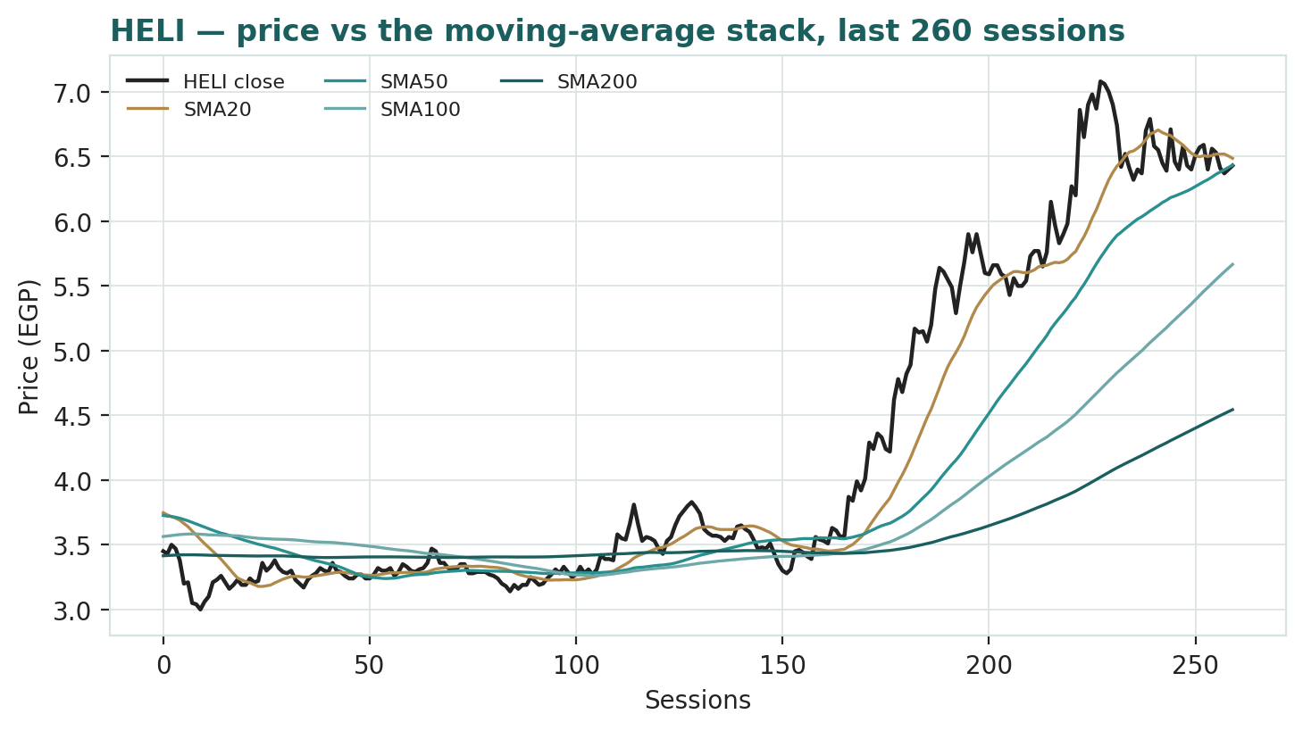
Figure 3 — Price versus the moving-average stack, last 260 sessions.
For the probabilistic work this matters in one way: a paused uptrend with neutral momentum neither widens nor skews the near-term tails much by itself — the skew in §3 comes from the event stack (privatization and partnership headlines on the right, devaluation and regional risk on the left), not from the tape.

3 Monte Carlo — a probabilistic price map
We simulate 50,000 three-month price paths (seed 42) using a sixteen-factor stack: seven continuous macro/operating drivers contributing a small net forward drift, and nine discrete events that each fire with a probability and an impact. By design the paths diffuse from spot, and the §1 value gap is kept out of the drift — the fundamental RNAV gap lives in §1, not here; §3 maps where price could go from today, not where value sits. Diffusion width is sized by the YZ-HAR engine of Appendix B: a pooled log-HAR cascade (variance lags 1/5/22) on a gap-aware Yang-Zhang variance proxy projects the average daily variance over the next 60 sessions (annualized ≈ 38.2% at this origin), and innovations are unit-variance Student-t(5) via a per-path variance mixture — a tighter interquartile body with honest tails. Per the Step-0 verdict, the secular drift is OFF for HELI (drift-on failed the CRPS gate; Appendix B); the only drift is the +4.0% net quarterly contribution of the seven continuous factors. Simulated path volatility, with events, prints 43.4% annualized.
Continuous factor (7) | Dir. | Discrete event (9) | Prob. | Mean impact
CBE policy-rate path (easing cycle) | + | H1-2026 results & partnership revenue print | 85% | +1.5%
EGP/USD rate | − | New JDA / partnership award (Green Kasaba, hotels) | 45% | +4.0%
Inflation (CPI) / real-asset bid | ± | Stake-sale / privatization step by the state holding | 20% | +8.0%
EGX30 & foreign flows | + | Land-auction outcome (8 New Heliopolis plots) | 50% | +2.0%
Brent / Gulf liquidity | + | Dividend / capital-action surprise | 20% | +2.0%
East-Cairo land & off-plan absorption | + | Geopolitical / regional risk shock | 30% | −10.0%
Build-cost inflation pass-through | − | EGP devaluation step | 20% | −5.0%
 |  | NUCA / land-title or regulatory dispute | 15% | −4.0%
 |  | Partner execution slippage (MASR / G Dev / Middle East) | 20% | −3.0%

Percentile map (EGP/share):
Horizon | p5 | p25 | p50 | p75 | p95
T+20 sessions | 5.37 | 6.09 | 6.54 | 7.01 | 7.89
T+60 sessions | 4.84 | 5.95 | 6.74 | 7.60 | 9.27

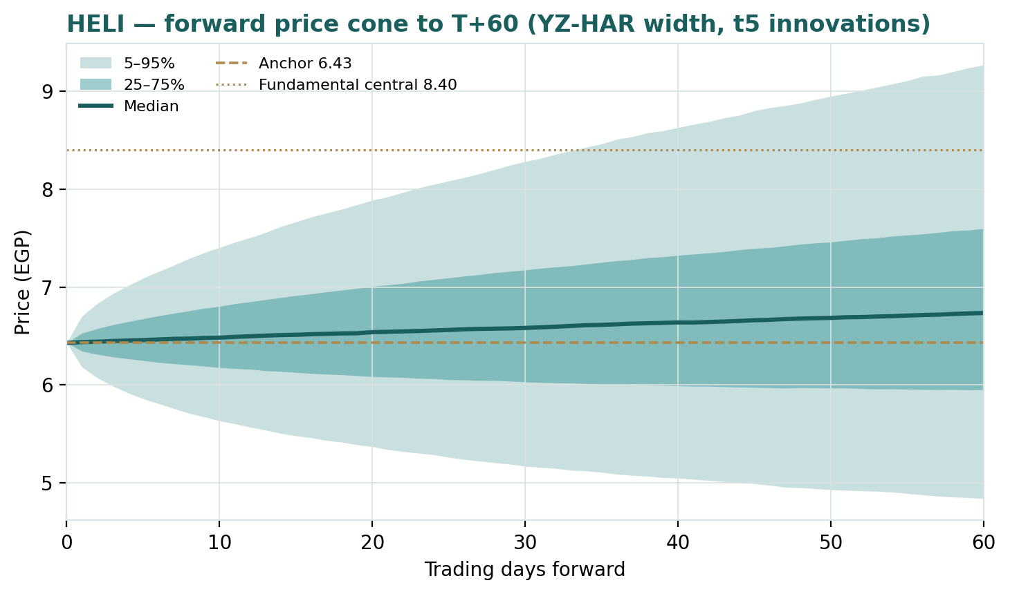
Figure 4 — Forward price cone to T+60. Median tracks just above spot; the gold dotted line marks the EGP 8.40 fundamental central value, deliberately above the cone.
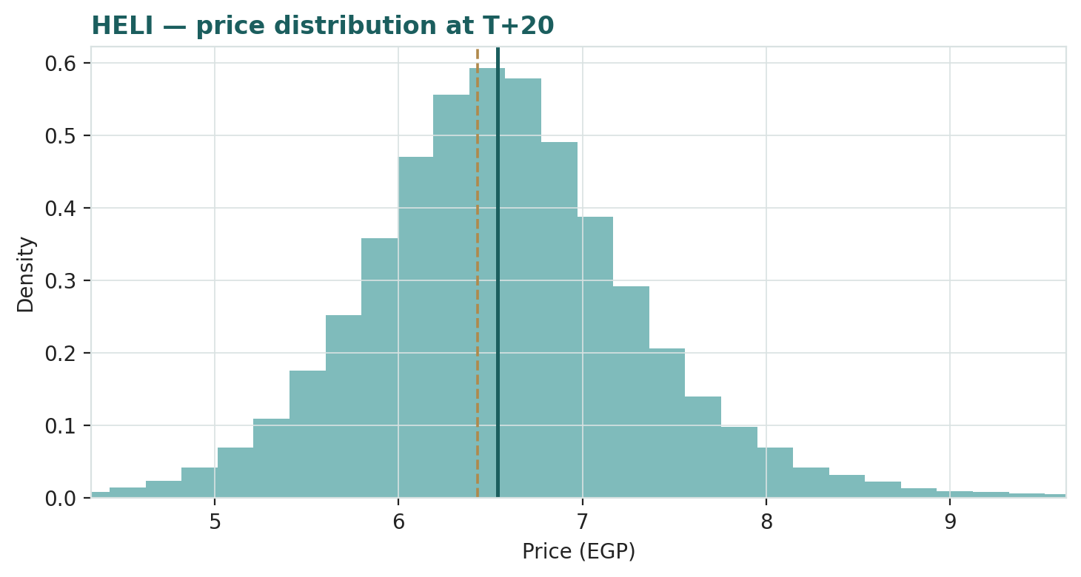
Figure 5 — Price distribution at T+20.
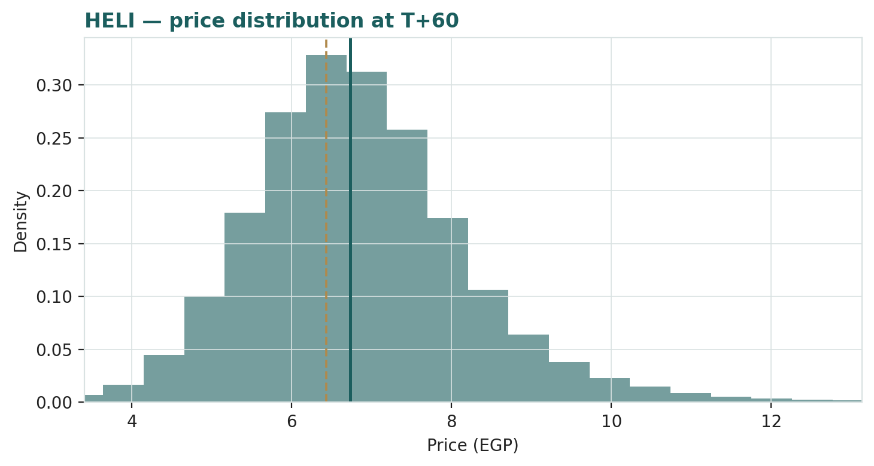
Figure 6 — Price distribution at T+60.
Level-touch ladder — the probability that price touches a level at any point by the horizon (running max for upside, running min for downside):
Level | T+20 touch | T+60 touch | Note
EGP 8.00 | 6% | 28% | Beyond the 52-wk high
EGP 7.50 | 16% | 44% | Above the spring peak zone
EGP 7.00 | 39% | 67% | The spring high / relative lens
EGP 6.75 | 59% | 79% | Top of the current range
EGP 6.10 | 46% | 63% | Bottom of the current range
EGP 5.75 | 21% | 41% | Below-range support
EGP 5.40 | 9% | 25% | Mid downside
EGP 5.00 | 3% | 13% | Toward the 200-day zone

4 Comparison of the lenses, and a verdict
Three readings sit side by side. The fundamental lenses cluster at EGP 7.45–9.25 with a central 8.40 — well above spot, contingent on the contracts paying and the state behaving. The technical picture is constructive but extended: a doubled stock consolidating above trend. The probabilistic map says that over three months price is roughly centred just above spot with a 50% band of EGP 5.95–7.60 — the median is 6.74, not 8.40, because the simulation does not assume the value gap closes inside the quarter.
Lens | Reads | Central / implication
Fundamental (4-lens) | Undervalued | EGP 8.40 (~+31%)
Technical | Uptrend, pausing | Range 6.10–7.08; trend support 4.54–5.67
Monte Carlo (3-month) | Centred, right-skewed | Median 6.74; p5–p95 4.84–9.27; 50% band 5.95–7.60

Verdict (a fair-value read, not a recommendation). HELI looks meaningfully undervalued on fundamentals, with an unusually well-anchored asset case: two of the five partnership contracts carry disclosed minimum guarantees, the dividend is declared, and the balance-sheet pivot is already made. The concentrated swing factors are the marks on the two opaque mega-JDAs and the 40-versus-54 discount argument — which is really an argument about the state as owner. The honest summary is a value about a third above price, a near-term distribution centred on price with a fat right tail from the privatization and partnership event stack, and a downside protected less by the chart than by a 6.8% declared yield and contracted floors. Readers should weigh the lenses themselves; we publish the distribution, not a target.

5 Catalysts to watch
- H1-2026 results (≈ Aug 2026). The CEO has pre-guided Q2 net profit +30% YoY; the print tests the partnership-revenue ramp against the EGP 3.07 bn full-year guide.
- Partnership revenue recognition. Madinet Masr’s EGP 1.1 bn signing payment and first-phase launches; Middle East Development’s second-year run-rate after EGP 594 mn in 2025; any first disclosure of the G Developments economics.
- The eight-plot auction and Green Kasaba. Cash clearing prices for New Heliopolis land would mark the whole unallocated block to market — and, by read-through, the JDA blocks.
- New partnerships. The 75-fd hospitality/retail project (designs complete, EGP 5 bn budget), the Smash sporting-club offer (30 fd), and the hotel-conversion offers on the Heliopolis-district stock.
- The state’s agenda. Any step by the Holding Company for Construction & Development toward a stake sale or strategic-management partnership — the single largest potential re-rating event, and a stated government intention since 2018.
- Dividend instalments. The two 2026 instalments of the EGP 0.435 FY2025 coupon; the payout decision on FY2026’s guided EGP 3.5 bn.
- CBE easing path and the pound. Rate cuts compress the discount architecture that prices every EGX developer; a devaluation step cuts both ways (asset repricing up, execution costs up).
- NUCA and title matters. The April-2026 settlement over 710,000 sqm in New Heliopolis removed one overhang; the residual regulatory interface with the New Urban Communities Authority remains a watch item.

6 Reading the probability zones
Translating the three-month distribution into plain zones, anchored on spot EGP 6.43 and the fair-value cluster:
Zone (T+60) | Range | Approx. probability | What it would mean
Deep downside | < EGP 5.00 | ~7% | Devaluation or regional shock; trend support tested
Lower band | EGP 5.00–5.75 | ~13% | Consolidation fails; execution doubts dominate
Around spot | EGP 5.75–6.75 | ~31% | Digestion continues; contracts on schedule, unrewarded
Upper band | EGP 6.75–7.75 | ~28% | Range resolves up on H1 results / auction prints
Strong upside | > EGP 7.75 | ~22% | Privatization step or new JDA; toward the RNAV lens

The distribution is right-skewed — the upper two zones carry half the mass — because the discrete upside events (a stake-sale step at 20% probability and +8% mean impact, a new JDA at 45%) outweigh the left-tail shocks in expectation. It is not a forecast; it is the spread of outcomes consistent with the stock’s own volatility and the factor stack.

7 Caveats and what would change our mind
- The marks are the model. Two-thirds of the RNAV rests on per-feddan judgments for contracts whose terms are undisclosed; if the G Developments and Middle East economics prove thin, the central value falls toward the relative lens.
- The state is the swing owner. A 72.25% holder can set dividends, related-party land moves and management with limited reference to minorities; the 40% discount could as easily widen to 55% as narrow.
- Minimum guarantees are only as good as enforcement. The Madinet Masr floor is a contract with a listed counterparty; the others are private. A stressed off-plan market tests every schedule at once.
- Leverage is new. EGP 6.6 bn of debt against EGP 1.6 bn of cash, taken to buy land at a 2025 price — a further rate spike or delayed collections would pinch coverage before the annuities mature.
- Earnings mix is lumpy. FY2023’s EGP 7.8 bn and FY2024’s interest-carried EGP 2.6 bn show how much of reported profit is timing; our normalized lens may itself be normalizing too early.
- Technical reminder. A doubled stock can consolidate for quarters; neutral RSI says nothing about value. The technical read is context, not a trigger.

Appendix A Financial statements
Consolidated figures, EGP mn. FY2023–FY2025 as reported to the EGX (standardised presentation, S&P Capital IQ, retrieved 3 Jul 2026); FY2026E–FY2030E are the preparer’s model — drivers on the Assumptions sheet of the companion workbook. FY2023 includes the EGP 15 bn Heliopark sale; the fiscal year is calendar (January–December) from 2023.

A.1 Income statement (EGP mn)
Line | FY23 | FY24 | FY25 | FY26E | FY27E | FY28E | FY29E | FY30E
Operating revenue | 15,580 | 1,055 | 3,135 | 3,070 | 4,600 | 6,200 | 7,400 | 8,300
Cost of revenue | (3,365) | (294) | (268) | (368) | (644) | (930) | (1,110) | (1,245)
Gross profit | 12,215 | 761 | 2,867 | 2,702 | 3,956 | 5,270 | 6,290 | 7,055
SG&A | (262) | (193) | (278) | (330) | (390) | (450) | (500) | (550)
Other operating, net | (1,356) | 410 | 152 | (40) | (40) | (40) | (40) | (40)
EBIT | 10,597 | 978 | 2,741 | 2,332 | 3,526 | 4,780 | 5,750 | 6,465
Land-sale & other gains | — | — | — | 2,600 | 1,200 | 900 | 700 | 500
Interest income | 262 | 2,436 | 738 | 500 | 420 | 450 | 520 | 600
Interest expense | (338) | (246) | (114) | (900) | (800) | (650) | (500) | (380)
Other non-operating | (36) | — | 8 | — | — | — | — | —
Pre-tax income | 10,485 | 3,168 | 3,373 | 4,532 | 4,346 | 5,480 | 6,470 | 7,185
Income tax | (2,676) | (608) | (668) | (1,020) | (978) | (1,233) | (1,456) | (1,617)
Net income | 7,809 | 2,560 | 2,705 | 3,512 | 3,368 | 4,247 | 5,014 | 5,568
EPS (EGP) | 1.95 | 0.64 | 0.68 | 0.88 | 0.84 | 1.06 | 1.25 | 1.39

A.2 Balance sheet (EGP mn)
Line | FY23 | FY24 | FY25 | FY26E | FY27E | FY28E | FY29E | FY30E
Cash & ST investments | 10,658 | 4,858 | 1,761 | 748 | 416 | 1,368 | 3,692 | 6,476
Receivables | 889 | 578 | 762 | 1,002 | 1,242 | 1,482 | 1,722 | 1,962
Inventory (land & WIP) | 2,438 | 4,588 | 16,862 | 17,662 | 18,162 | 17,662 | 17,162 | 16,662
Other current assets | 1,737 | 3,617 | 658 | 658 | 658 | 658 | 658 | 658
PP&E, net | 53 | 21 | 1,681 | 2,646 | 4,106 | 5,561 | 6,011 | 6,156
Other long-term assets | 40 | 718 | 632 | 632 | 632 | 632 | 632 | 632
Total assets | 15,815 | 14,380 | 22,356 | 23,348 | 25,216 | 27,363 | 29,877 | 32,546
Payables & accrued | 741 | 371 | 1,857 | 1,957 | 2,057 | 2,157 | 2,257 | 2,357
Total debt | 1,601 | 615 | 6,478 | 5,600 | 5,300 | 4,800 | 4,300 | 3,800
Taxes payable & other current | 3,878 | 1,482 | 1,407 | 1,407 | 1,407 | 1,407 | 1,407 | 1,407
Other long-term liabilities | 832 | 2,508 | 2,296 | 2,296 | 2,296 | 2,296 | 2,296 | 2,296
Total liabilities | 7,052 | 4,976 | 12,038 | 11,260 | 11,060 | 10,660 | 10,260 | 9,860
Shareholders' equity | 8,762 | 9,403 | 10,317 | 12,087 | 14,155 | 16,702 | 19,616 | 22,684
Net cash / (debt) | 9,057 | 4,243 | (4,717) | (4,852) | (4,884) | (3,432) | (608) | 2,676
Book value per share (EGP) | 2.19 | 2.35 | 2.58 | 3.02 | 3.53 | 4.17 | 4.90 | 5.66

A.3 Cash flow (EGP mn)
Line | FY23 | FY24 | FY25 | FY26E | FY27E | FY28E | FY29E | FY30E
Net income | 7,809 | 2,560 | 2,705 | 3,512 | 3,368 | 4,247 | 5,014 | 5,568
D&A | 6 | 7 | 20 | 35 | 40 | 45 | 50 | 55
Working-capital change | 2,715 | (7,974) | (4,038) | (940) | (640) | 360 | 360 | 360
Operating cash flow | 10,530 | (5,407) | (1,313) | 2,607 | 2,768 | 4,652 | 5,424 | 5,983
Capex | (30) | (4) | (1,680) | (1,000) | (1,500) | (1,500) | (500) | (200)
Free cash flow | 10,500 | (5,411) | (2,993) | 1,607 | 1,268 | 3,152 | 4,924 | 5,783
Dividends paid | (45) | (1,787) | (1,742) | (1,742) | (1,300) | (1,700) | (2,100) | (2,500)
Debt drawn / (repaid), net | (1,000) | (986) | 5,863 | (878) | (300) | (500) | (500) | (500)
Other investing / financing | (9,407) | 9,317 | (9,538) | — | — | — | — | —
Net change in cash | 48 | 1,133 | (8,410) | (1,013) | (332) | 952 | 2,324 | 2,783
Cash, end of period | 10,658 | 4,858 | 1,761 | 748 | 416 | 1,368 | 3,692 | 6,476

Sources: FY2023–FY2025 company EGX disclosures via S&P Capital IQ standardised statements (retrieved 3 Jul 2026); FY2023 other-investing line = certificate-of-deposit placement of Heliopark proceeds, FY2024 = maturities, FY2025 = land purchase settled through investing per the standardised mapping. Forecasts are the preparer’s judgments.

Appendix B Step 0 — calibration backtest
Before any forecast we test the Monte-Carlo lens on HELI’s own five and a half years of history: at seventeen non-overlapping quarterly origins (January 2022 – April 2026) we generate the three-month-ahead distribution using only data available at that date, score the realized close against it, and grade the result as skill versus a naïve benchmark — a zero-drift random-walk lognormal cone on the trailing realized vol. The grade is CRPS skill (must be > 0) and the Winkler interval score; the PIT histogram and coverage table are diagnostics only, because band containment rewards width. Width comes from the pooled log-HAR cascade (lags 1/5/22) on a gap-aware Yang-Zhang variance proxy, fit across the six-name EGX developer panel with strictly no lookahead; shape is unit-variance Student-t(5).
The drift verdict. The EGX-developer class default (secular drift ON) failed on HELI: CRPS skill printed −2.2%, because an expanding-mean drift trained on the 2022–24 run overshoots precisely at the regime turns — the same fragility that moved RAYA to drift-off. With drift OFF, the engine beats the benchmark on both grades and is adopted: HELI’s history is step-jumps around policy events (the Oct-2022 devaluation quarter, the Jan-2026 re-rating), not a smooth private-developer trend. This departure from the class default is flagged as a standing configuration for HELI.
Configuration | n | CRPS skill | Winkler (90%) skill | Verdict
Secular drift ON (class default) | 17 | −2.2% | +3.5% | Fails the CRPS gate
Secular drift OFF (adopted) | 17 | +3.1% | +3.0% | Passes — adopted

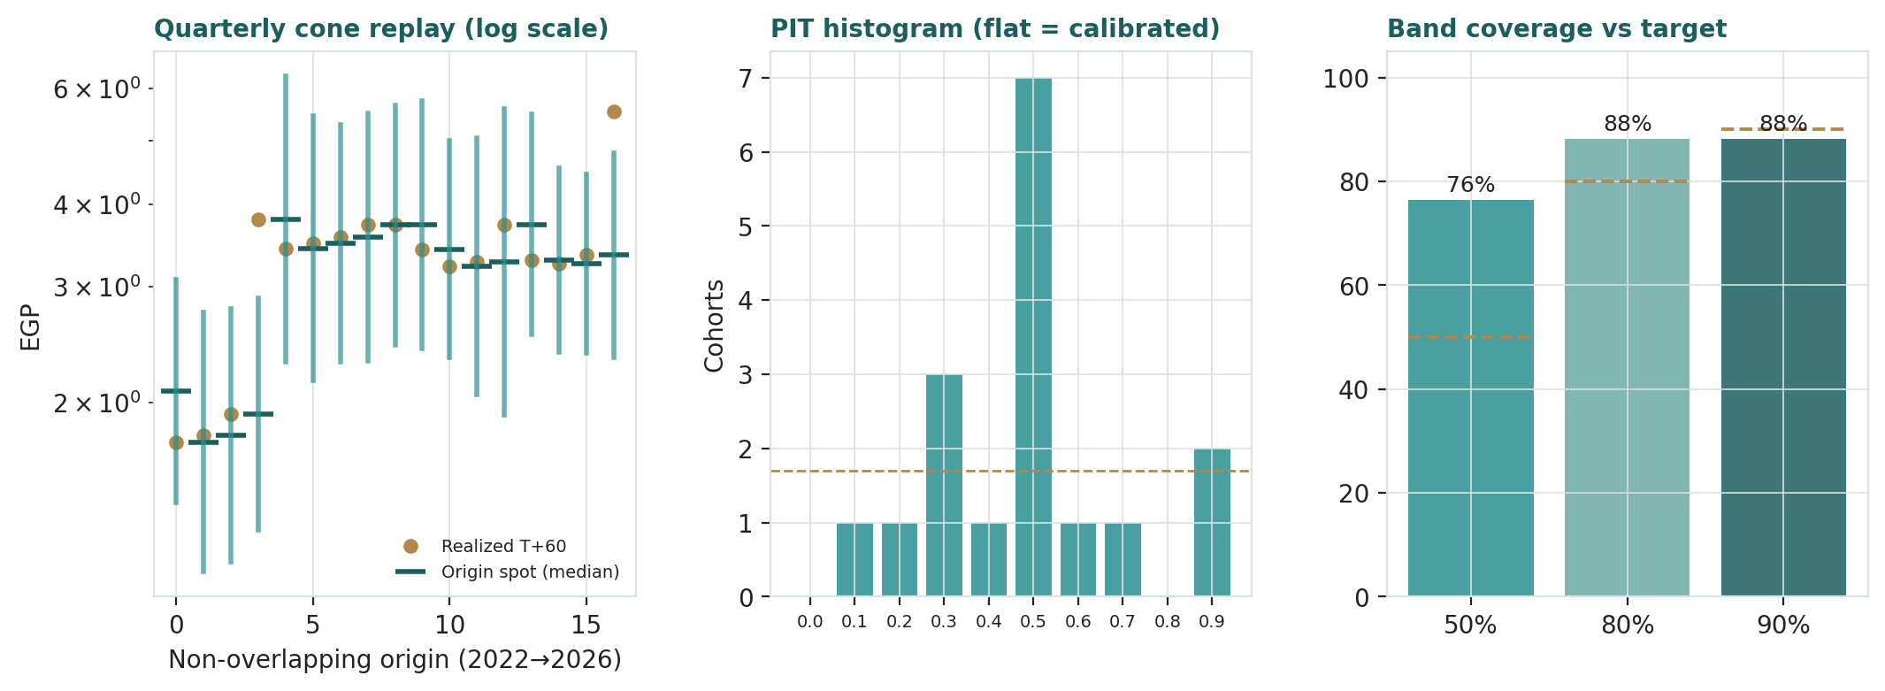
Figure B-1 — Calibration backtest (drift OFF): quarterly cone replay (log scale), PIT histogram, and interval coverage versus target.
Diagnostic (drift OFF) | 50% band | 80% band | 90% band | PIT mean
Realized coverage (n = 17) | 76% | 88% | 88% | 0.53
Target | 50% | 80% | 90% | 0.50

Coverage over-shoots at the 50% band — the body of the forecast is somewhat wide for this name, which is what caps the CRPS skill at +3.1% rather than higher — while the 80/90% bands sit near target and the PIT is centre-heavy rather than U-shaped (two 0.99 tail cohorts are the devaluation and re-rating quarters; no width setting absorbs a +65% policy jump, nor should it pretend to). The lens beats the benchmark with honest tails and is accepted; this configuration carries into the §3 forward run. Artifacts (per-origin scores, PIT, coverage) live in files/ with this study.

Appendix C Peer set, sector structure, and risks
HELI’s closest comparables are the EGX land-bank developers, but none shares its exact shape — a state-controlled estate whose revenue is other developers’ sales.
Peer | Close (1 Jul 26) | Shape | Read-across to HELI
Talaat Moustafa (TMGH) | EGP 70.10 | Scale developer + hospitality; ~11× fwd P/E | The multiple ceiling; also HELI’s neighbour (Madinaty/Rehab flank Heliopark)
Madinet Masr (MASR) | — | Land-bank developer; ex-state heritage | Direct counterparty on 491 fd; its launch success is HELI revenue
Palm Hills (PHDC) | EGP 9.62 | High-turn launcher; ~5–7× P/E | The leveraged-developer floor multiple
SODIC (OCDI) | EGP 20.61 | Premium brand; ~8× P/E | Partner on SODIC East; quality-governance benchmark
Emaar Misr (EMFD) | EGP 13.50 | Net-cash coastal developer | What a clean balance sheet is worth in the sector
Orascom Dev. (ORHD) | EGP 37.90 | Town developer, recurring hotels | The recurring-income re-rating template

Sector structure. EGX real estate is a land-bank-optionality sector: developers hold decades of raw land at historic cost, monetise through off-plan sales that customers finance, and trade at 40–60% discounts to stated NAVs that widen with rates and governance doubt and compress on monetisation proof. The state’s privatization programme overlays everything HELI-specific. Principal risks: opaque JDA economics on ~3,560 fd; state-owner governance and related-party land decisions; partner execution and off-plan absorption in a crowded east-Cairo corridor; new leverage against a 2025-price land purchase; devaluation and rate shocks; NUCA/title interfaces; and the lumpiness of land-gain earnings that makes any single year unrepresentative.

Appendix D The expert valuation panel
Every Testahil study closes with a panel of standing expert personas — drawn from the house Expert Persona Library, not invented for the occasion, so that each accumulates a track record across studies and a quarterly update is a re-run, not a re-training. For a state-controlled land-bank developer we cast the real-estate trio whose methods genuinely disagree here: Expert 1 (the forensic accountant — what the books hide and what the marks must prove), Expert 2 (the demand analyst — whether east-Cairo absorption can carry the contracted schedules), and Expert 3 (the macro-policy strategist — rates, the pound, and the state as owner). Each runs a different method, derives its fair value from shown workings, and states a falsification condition.

D.1 Expert 1 — the forensic RNAV: marks against the books
Worldview and tradition. She belongs to the Graham-and-audit tradition: a company is a set of verifiable claims, and valuation is the act of testing management’s asserted values against what the accounts, the contracts and third-party transactions will actually support. For a land company the books are almost useless as values (cost-basis land) and priceless as evidence (what was paid, what was received, what was pledged). Her craft is reconciliation: every mark must trace to a document.
When the method works / when it fails. It works best exactly here — separable assets, observable third-party transactions (Heliopark at EGP 15 bn cash; Madinet Masr’s EGP 1.1 bn signing cheque; Middle East’s EGP 594 mn first-year remittance), and a balance sheet whose 2025 transformation is itself a dated, priced land transaction. It fails when the evidence is stale or the wrapper destroys value faster than the assets earn it — a controlling owner can convert asset value into agency cost indefinitely, and no reconciliation catches intent.
Standard workings. (1) Anchor every block to its nearest documented transaction. (2) Convert contracted minimums to PV at the country discount rate, after tax. (3) For undocumented blocks, triangulate a per-feddan value from the documented ones and haircut for opacity. (4) Deduct everything the wrapper costs — overhead PV, net debt — before any discount. (5) Apply a discount only for what cannot be documented: control, timing, disclosure.
Expert 1’s reconciliation (EGP mn) | Evidence anchor | Mark
Madinet Masr JDA (491 fd) | Signed floor EGP 53.18 bn/9y; 1.1 bn received | 16,500
MG JDA (77 fd) | Signed floor EGP 3.394 bn/14y | 1,100
Middle East JDA (1,759 fd) | EGP 594 mn actual 2025 remittance, capitalised | 16,700
G Developments JDA (1,800 fd) | Won vs two bidders; no disclosed terms — Heliopark-derived floor | 14,900
SODIC East tail (655 fd) | Seven years of remittance history | 3,900
Unallocated + auctions + Obour (410 fd) | Heliopark EGP 8.85 mn/fd (2023), rolled at land CPI | 3,400
Heritage & rental portfolio | Insurance/replacement basis less obsolescence | 6,500
Gross asset value |  | 63,000
less: overhead PV · net debt | Audited | (7,450)
NAV pre-discount = EGP 13.87/sh |  | 55,550
Fair discount 38% (documented floors reduce opacity) |  | → EGP 8.60/sh

Worked example — capitalising the Middle East remittance. The 2025 cheque was EGP 594 mn in the contract’s first full selling year. She models remittances ramping at 25% for three years (launch curve), flat for five, fading 10% thereafter, at a 21% discount and 22.5% tax: PV ≈ EGP 16.7 bn, i.e. EGP 9.5 mn per feddan — within 6% of the study’s judgment mark, derived from a cheque rather than a comp. That convergence from independent evidence is why she trusts the block.
Sensitivity — the swing input is the discount. At 30% her NAV yields EGP 9.71; at 38%, 8.60; at 45%, 7.63; at 55% (the market’s implied), 6.24. Her entire disagreement with the price is eleven points of discount.
Cross-examination. To Expert 2 she says: your absorption curves are forecasts; my floors are signatures — the Madinet Masr minimum pays even in your bear tape, so you double-penalise by haircutting a guaranteed schedule for demand risk. To Expert 3 she says: you price the owner’s sins twice — once in your 25% equity cost and again in a governance overlay; pick one, because the same pound cannot be discounted for the same fear in two places.
Verdict, falsification, market-implied. Fair EGP 8.60 (range 5.40–12.80). Falsified if a documented floor fails to pay on schedule — above all a missed Madinet Masr instalment — or if a related-party land transfer prices materially below her marks, which would void the evidentiary chain. The market price implies a 54% discount to her NAV: the market is treating signed contracts as if they were still hopes.

D.2 Expert 2 — the demand analyst: can east Cairo absorb the schedule?
Worldview and tradition. He comes from the housing-economics school: land has no intrinsic value, only a derived one — the residual of what households will pay for units, less the cost to build and the developer’s required return. A contracted minimum is only worth its PV if the underlying sales occur; otherwise it is a claim in a workout. So he values HELI by building the demand first: units, prices, absorption, then the revenue share that flows back.
When the method works / when it fails. It works where the demand pool is measurable and the project pipeline is public — both true for the Cairo–Suez corridor, the most launched-into corridor in Egypt. It fails at financial-repression moments when property becomes a currency substitute and absorption decouples from affordability, as in 2023–24 — his own framework under-called that surge, and he says so.
Standard workings. (1) Size the corridor’s annual absorption (units and EGP) from developer disclosures. (2) Allocate HELI-land projects a market share consistent with brand and price point. (3) Convert partner sales to HELI revenue via the disclosed share ratios; test the minimums against the modelled sales. (4) Discount the resulting HELI cash-flow schedule; add the non-partnership assets at cash value.
Expert 2’s demand model | Bear | Base | Bull
East-Cairo new-launch absorption (EGP bn/yr) | 260 | 320 | 390
HELI-land projects’ share of corridor | 5.5% | 7.5% | 9.5%
Implied partner sales on HELI land (EGP bn/yr) | 14.3 | 24.0 | 37.1
HELI blended revenue take | 22% | 24% | 26%
HELI partnership revenue at run-rate (EGP bn/yr) | 3.1 | 5.8 | 9.6
Years to run-rate | 5 | 3 | 2
PV of partnership stream (EGP bn) | 13.5 | 22.6 | 33.8
+ non-partnership assets & heritage, − net debt (EGP bn) | 6.4 | 9.0 | 9.6
Equity value (EGP bn) / per share | 19.9 / 4.97 | 31.6 / 7.90 | 43.4 / 10.84

Worked example — testing the Madinet Masr minimum. The floor averages EGP 5.9 bn/yr to HELI. At the contract’s 36.5%/20% blended ≈ 26% take, that requires partner sales of ~EGP 23 bn/yr on 491 feddans — about 7% of his base corridor absorption on 10% of the corridor’s active land. Demanding, not heroic: Madinet Masr’s own EGP 202 bn/12-yr sales target implies EGP 16.8 bn/yr, so the floor binds early and the share ratio carries the later years. He therefore credits the floor at 90% in base, 70% in bear.
Sensitivity — the swing input is corridor absorption. Each EGP 30 bn/yr of corridor absorption is worth roughly EGP 0.85/share to HELI at his base share and take. His EGP 7.90 assumes the 2024–25 off-plan pace cools 15%; a mere repeat of 2025 prints EGP 9+.
Cross-examination. To Expert 1 he says: your floors are signatures on future sales — in a frozen market the counterparty renegotiates or litigates, and your PV discovers it was a demand forecast wearing a contract’s clothes. To Expert 3 he says: your macro pessimism proves too much — if rates and the pound crush absorption, they crush every EGX developer’s NAV, yet buyers keep treating apartments as the only trustworthy savings account in the country; repression is his demand tailwind, not his risk.
Verdict, falsification, market-implied. Fair EGP 7.90 (range 5.60–10.80) — the panel’s floor on base cases. Falsified by two consecutive quarters of corridor pre-sales down >25% YoY, or by HELI partnership revenue printing below EGP 2 bn in 2027. The market price implies corridor absorption ~20% below his base forever — a housing-bust assumption he sees no evidence for.

D.3 Expert 3 — the macro-policy strategist: the state, the rate and the pound
Worldview and tradition. She is a sovereign-and-policy analyst: for a majority-state-owned Egyptian asset, the dominant risk factor is not the business but the regime of policy around it — the interest-rate path that sets every discount rate, the currency that reprices every real asset, and the owner whose objectives blend fiscal, social and commercial motives. Valuation is scenario-weighting across policy states, not a single model.
When the method works / when it fails. It works where policy variance dominates cash-flow variance — true here: HELI’s 2022–26 chart is a sequence of policy events (devaluations, the state-directed Heliopark sale to the state’s own insurance authority, the privatization discourse). It fails when it becomes an excuse for never valuing the asset — a permanent 55% discount is a mood, not an estimate — and when genuine micro progress (signed floors, cheques received) deserves credit that a top-down frame withholds.
Standard workings. (1) Define policy scenarios with probabilities: continued orthodox easing + privatization step; muddle-through; stress (devaluation + fiscal dominance). (2) In each, set the discount rate, the land repricing factor and the state-behaviour overlay (dividend reliability, related-party risk). (3) Take the study’s pre-discount NAV as the common asset base and re-price it per scenario. (4) Probability-weight.
Expert 3’s scenario grid | Prob. | Discount rate | NAV repricing | State overlay (disc.) | Value/sh
Reform: easing + stake-sale step | 30% | 18% | +10% | 25% | 11.45
Muddle-through (base policy) | 45% | 21% | 0% | 45% | 7.05
Stress: devaluation + dominance | 25% | 26% | −15% real | 60% | 4.30
Probability-weighted |  |  |  |  | ≈ 7.00

Worked example — the reform scenario. A stake-sale step (her 30% branch) is not hypothetical: the holding company ran a strategic-investor tender in 2019–20, rejected a Qatari Diar approach, and was reported valuing HELI internally near EGP 20 bn in 2023 — at a third of today’s asset evidence. In that branch she cuts the overlay to 25% (an anchor investor polices related-party risk), reprices land +10% on easing, and discounts at 18%: EGP 11.45/share. The whole option is worth EGP 1.3/share of her weighted value — the market, she notes, prices it near zero.
Sensitivity — the swing input is the stress probability. Move stress from 25% to 40% (taking weight from muddle-through) and her value falls to EGP 6.19; move it to 15% and she prints 7.55. Her fair value is, honestly, a probability distribution over Egyptian policy wearing a share price.
Cross-examination. To Expert 1 she says: your documents were all written inside one policy regime — the Heliopark buyer was the state’s own insurance fund, and the same hand that signed your floors can waive them; documentation is not independence. To Expert 2 she says: your absorption is itself a policy artefact — repression drives your buyers, and the day Egypt offers a positive real deposit rate, your demand curve meets its true self.
Verdict, falsification, market-implied. Fair EGP 7.00 (range 4.30–11.45) — the most state-sceptical of the three. Falsified upward by a formal stake-sale mandate or an anchor-investor announcement (she would immediately migrate weight to the reform branch); falsified downward by a devaluation step >20% or a related-party land transfer below market. The market at 6.43 is pricing roughly her muddle-through branch alone — no reform option, and only partial stress.

D.5 The three in one room
The single asset they most disagree on is the pair of undisclosed mega-JDAs — G Developments’ 1,800 feddans and Middle East’s 1,759 — nearly half the estate, marked on inference.
Expert 1: “I hold a EGP 594 mn cheque from one of them and a competitive-tender record from the other. Capitalise the cheque and you get nine and a half million a feddan — evidence, not hope. The blocks are worth thirty billion.”
Expert 2: “Your cheque is year one of a launch curve into the most crowded corridor in Egypt. I’ll give you the cheque; I won’t give you twenty-five years of it growing. The blocks are worth what the buyers of Shorouk and Badr can absorb after Madinaty and the New Capital eat first.”
Expert 3: “You are both marking paper issued under one owner. The same state that guaranteed the floors sold Heliopark to itself. Until a real third party pays for a piece of this company — not its land, the company — every mark of yours carries my overlay.”
Expert 1, rebutting: “Then audit the counterparty, not the owner. Madinet Masr is a listed company with its own board, its own lenders and an EGP 202 bn sales programme it has published to its own shareholders — it cannot quietly renegotiate a floor that its auditors have already recognised. The paper is only as soft as the weakest signatory, and here both signatories file accounts.”
Expert 2, closing: “And both signatories sell into the same queue of buyers. If the corridor absorbs, every one of us is low; if it doesn’t, the floors become the ceiling and the litigation calendar becomes the cash-flow statement. Watch the pre-sales, not the press releases — the 2027 partnership-revenue print settles this table.”

D.6 Reading the divergence
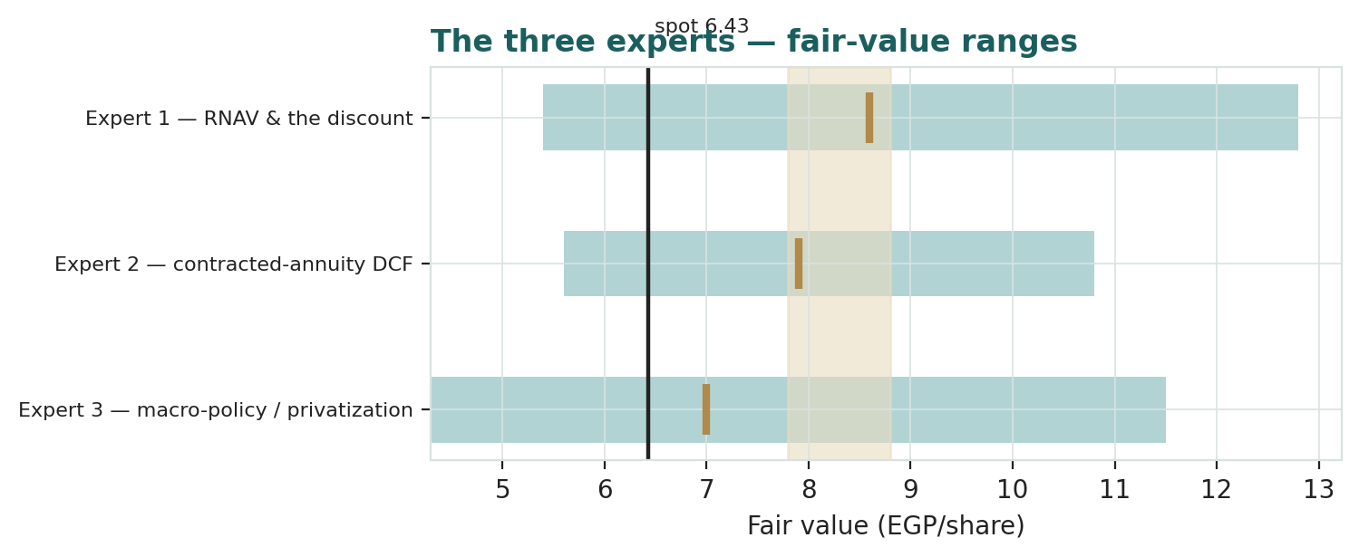
Figure D-1 — The three experts’ fair-value ranges. Brass ticks are base cases; the gold band is the study’s central; the dark line is spot. The spread is a discount-and-demand disagreement, not an asset one.
Expert | Method | Single swing assumption | Base fair value
Expert 1 | Forensic RNAV vs the books | Fair discount 38% on documented floors | EGP 8.60
Expert 2 | Corridor-absorption DCF | East-Cairo absorption EGP 320 bn/yr | EGP 7.90
Expert 3 | Policy-scenario weighting | Stress probability 25% | EGP 7.00

The spread — EGP 7.00 to 8.60 at base — is narrow for an EGX developer, and it is not an argument about the land: all three accept the estate and the contracts as real. What separates them is how much of a state-controlled promise to discount — Expert 1 trusts documents, Expert 2 trusts demand only as far as affordability, Expert 3 trusts nothing that one owner can rewrite. The EGP 1.60 spread is therefore a clean measure of a single uncertainty: the credibility of contracts written under a majority state owner. A stake sale resolves it in one direction; a waived floor in the other. Each expert’s point fair value (and bull/base/bear) is logged with the study date (3 Jul 2026) and spot (EGP 6.43) as an internal per-expert track record, kept separate from the core Calibration Ledger.

About this series
Testahil publishes independent, educational valuation studies. Each is an attempt to reason transparently about what a security is worth, with every assumption shown and a companion model so readers can disagree productively. The house style is distributions, not tips: we describe ranges and probabilities, not targets, and we do not tell anyone what to do. Studies are framed as educational analysis, the preparer is not licensed by any securities regulator, and holdings are disclosed.

Disclosure & Disclaimer
Not investment advice. This document is educational and informational only. It is not, and must not be relied upon as, investment, financial, legal, accounting or tax advice, nor an offer, solicitation or recommendation to buy, sell or hold any security. It contains no price target and no rating.
No licence; no advisory relationship. The preparer is not registered or licensed with any securities or financial regulator in any jurisdiction (including Egypt’s Financial Regulatory Authority), holds no brokerage or investment-advisory authorisation, and is not acting as your adviser or fiduciary. Nothing here is personalised to your circumstances.
Holdings disclosure. The preparer may hold, and may in the future take or dispose of, a position in the security discussed in this report, and may transact at any time without notice. This is a potential conflict of interest you should weigh.
Sources & accuracy. Reported financial and operating figures are drawn from the company’s public disclosure and other public sources believed reliable but not independently verified; they may contain errors or be superseded. Forward-looking inputs — the land and partnership marks, the RNAV discount, projections, multiples, the DCF and Monte-Carlo factor probabilities — are the preparer’s own judgments and are inherently uncertain.
Forward-looking statements. Any statements about the future are estimates subject to risks and uncertainties; actual results may differ materially. The Monte Carlo models price, not value, and encodes subjective probabilities for events that have not occurred.
No reliance; your responsibility. Do your own research and consult a licensed professional before making any decision. You are solely responsible for your investment decisions and their outcomes. To the maximum extent permitted by law, the preparer accepts no liability for any loss arising from use of this document.
Currency & figures. All figures are in Egyptian pounds (EGP); bn denotes billion, mn million, fd feddan (4,200 m²). Rounding may cause totals to differ slightly. Spot price and market data are as of 1 July 2026 and change continuously.
TESTAHIL · Independent Valuation Study · Educational Analysis · Heliopolis Company for Housing & Development (EGX: HELI) · edition 03-07-2026 · reporting currency EGP

