Testahil · Independent Valuation Study - Educational Analysis Not investment advice
Independent Valuation Study - Educational Analysis
EFG Holding S.A.E. (EGX: HRHO)
Fundamental analysis · Technical analysis · Monte Carlo simulation - one integrated read
Anchor: EGP 26.83 (1 Jul 2026 close) · ~1,224.6 mn shares (per paid-in capital - confirm) · mkt cap ~EGP 32.9 bn · MENA's leading investment bank turned three-vertical financial holdco: EFG Hermes (IB), EFG Finance (NBFI incl. the listed Valu stake) and Bank NXT (commercial bank) · prices and probabilities computed 1 Jul 2026 from the attached daily history · primary lens: holdco sum-of-the-parts less a holding-company discount, with a discounted-earnings cross-check · swing factors: the holdco discount itself and the CBE rate cycle (brokerage/NBFI up, bank margin down).
READ FIRST - what this document is, and is not. This study is a valuation exercise and an expression of personal analytical opinion, published free of charge for educational purposes. It is NOT investment advice, NOT a recommendation or solicitation to buy, sell or hold any security, and NOT directed at the circumstances of any reader. The preparer is not licensed by any securities regulator, manages no money, and accepts no fees, funds or clients. All values are model outputs presented as ranges and distributions because no single number should be relied on. Reported financials are the company's own disclosure (FY2025 earnings release, 18 Mar 2026; FY2023 release, 20 Mar 2024); FY2024 figures are derived from the FY2025 release's disclosed year-on-year moves (+7% revenue, +13% opex, -5% net profit) - flagged. The equity/minority split, holdco treasury, the share count and every SOTP mark are the preparer's estimates and judgments, flagged throughout. The factor library auto-classes HRHO as a bank; this study deliberately overrides that to the holding-company lens and factor set, per the company's actual three-vertical structure. See the Disclosure & Disclaimer at the end.
Headline
At EGP 26.83 the market is applying roughly a 17% discount to a gross sum-of-the-parts of ~EGP 32.2/share - comfortably inside the 15-25% band diversified holdcos normally trade at, and the weighted fundamental centre sits at ~EGP 27.7, within 3% of the price. FY2025's headline (revenue +7% to EGP 26.0 bn, net profit -5% to EGP 4.1 bn) hides the real story: a violent mix shift, with the Investment Bank normalizing hard off FY24's devaluation-gain base (-50% to EGP 1.3 bn) while Bank NXT (+77%) and the NBFI platform (+45%) took over the engine room. The stock is fairly valued; the live arguments are the right level of the holdco discount, how much of the EGP 4.1 bn actually recurs, and which way the CBE cycle nets out across three verticals that respond to it in opposite directions. The three-month probability map is symmetric: a 25-75% band of EGP 22.4-30.3 around a 26.1 median.
Valuation summary - every read at a glance
One table for the four reads that follow - what the business is worth (fundamental), what the tape is doing (technical), where price could travel over three months (Monte Carlo), and how three independent expert methods land. Every row is developed in the sections and appendices below.
Lens / read | What it measures | Output | Takeaway
FUNDAMENTAL - what the business is worth (the anchor)
SOTP less discount (primary) | Three verticals + treasury, -20% | EGP 25.7 | -4% vs spot
Discounted earnings | 5-yr NPAT at 24% cost of equity | EGP 33.6 | +25% · the ceiling
Relative multiples | 7.5x FY26E EPS vs financial peers | EGP 29.9 | +11%
Normalized earnings | Recurring core x conglomerate P/E | EGP 24.8 | -8% · the floor
Weighted central | Blend 40 / 20 / 15 / 25 | EGP 27.7 | +3% vs 26.83 · fair
TECHNICAL - what the tape is doing (timing, not value)
Trend & momentum | Price vs 20/50/100/200-day | All four MAs converged at 27 | Tight range, no trend
MONTE CARLO - where price could travel (3 months)
T+60 distribution | 16-factor, 50k paths, seed 42 | P25-P75 EGP 22.4-30.3 | Symmetric around spot
EXPERT PANEL - three independent methods
Expert 1 / 2 / 3 | NAV-&-discount · Earnings quality · Macro regime | EGP 25.7 / 23.0 / 27.0 | Straddling spot

Company overview - EFG Holding S.A.E. at a glance
Item | Value
Exchange / ticker | EGX: HRHO (LSE GDR: EFGD)
Structure | Financial holdco - three verticals
Fiscal year-end | 31 December
Shares outstanding | ~1,224.6 mn (per paid-in capital - confirm)
Spot / market cap | EGP 26.83 / ~EGP 32.9 bn
FY25 revenue / net profit | EGP 26.0 bn (+7%) / EGP 4.1 bn (-5%)
FY25 by vertical (rev / NPAT) | IB 11.9/1.3 · NBFI 6.7/1.2 · Bank NXT 7.5/3.1 (grp 1.6)
Total assets | EGP 230.6 bn
Distribution policy | EGP 400 mn FY25 (dividend or buyback; mechanism at 2026 AGM)
52-week range | EGP 23.11 - 30.86

Source: EFG Holding FY2025 earnings release (18 Mar 2026) and FY2023 release (20 Mar 2024), efgholding.com; FY2024 derived from disclosed YoY; prices from the attached daily history.
1 Fundamental valuation
1.1 Holdco sum-of-the-parts - the primary lens
The primary lens marks the three verticals separately and charges the bundle a holding-company discount. The Investment Bank at 8x normalized profit (~EGP 1.8 bn average of the FX-inflated FY24 and the normalized FY25) is ~EGP 14.4 bn; the NBFI platform, anchored by the listed Valu stake plus Tanmeyah, leasing, factoring and insurance, ~EGP 13.0 bn; Bank NXT's group share (EGP 1.6 bn of FY25 profit at ~5.6x) ~EGP 9.0 bn; holdco treasury and seed ~EGP 3.0 bn. Gross NAV ~EGP 39.4 bn, or EGP 32.2/share; less a 20% holdco discount = EGP 25.7/share.
Why NAV leads: consolidation makes the income statement a blend no single multiple fits - a fee-cyclical IB, a growth lender and a deposit-taking bank - while the parts each have natural pricing, and two of the three carry external marks (Valu's daily print; Bank NXT's fresh EGP 4.2 bn capital round). The subjectivity concentrates in the IB mark and the discount, both flagged blue in the model.
Every mark is a judgment and every judgment is a cell: change the IB multiple, the Valu stake value or the discount in Assumptions and the whole study reprices - that is the design.
A note on the treasury mark: the EGP 3.0 bn holdco line is the centre's own liquidity, distinct from Bank NXT's balance sheet - it is the pool the EGP 400 mn distribution policy draws on, which is why it enters the NAV at face rather than at a bank multiple.
1.2 Discounted-earnings cross-check
The cross-check discounts group net profit (after minorities) directly: FY26E EGP 4.9 bn growing to ~EGP 8.3 bn by FY30, at a 24% cost of equity with 11% terminal growth, values the equity at ~EGP 41.1 bn or EGP 33.6/share - deliberately un-haircut, so the gap between it and the SOTP (25.7) is a clean measure of what the 20% discount plus conservative marks cost: about EGP 8/share for the wrapper.
Reverse-engineered, spot 26.83 implies the levels in the table - the market sits mid-way between my two lenses, which is what fair looks like. Each row is watchable: the AGM's distribution mechanism and any monetization move the implied-discount row; the MPC moves the implied-Ke row.
What spot implies | Implied level | Base case
Discount on gross NAV (32.2) | ~17% | 20%
or cost of equity on the earnings stream | ~27% | 24%
or aggregate marks | +25% above mine | as marked

1.3 Relative multiples
On FY26E EPS of ~EGP 3.99 the stock trades at 6.7x, and ~8.0x FY25 reported - against CIB near 6-7x, e-finance well above 20x, and MENA IB peers in the 8-12x range. On an estimated FY25 book of ~EGP 34.2 bn, P/B is ~0.96x for a group earning a mid-teens ROE on the recurring core.
A blended 7.5x forward multiple supports ~EGP 29.9 - above spot, because the multiple lens ignores the conglomerate wrapper entirely; it prices EFG as if a shareholder could reach each vertical's earnings directly.
The LSE GDR (EFGD) adds a second tape worth watching: persistent GDR discounts or premia to the local line have historically flagged foreign-flow turns a week or two before the EGX price moved.
1.4 Normalized earnings power
Normalization strips FY24's devaluation FX/unrealized gains and FY25's EGP 656 mn tax-loss utilization at the IB: the recurring core is nearer EGP 3.6 bn than the printed 4.1 bn. At 7x plus the holdco treasury that supports ~EGP 24.8/share - the floor of the fundamental set, and the honest answer to 'what if the one-offs never repeat'.
Its virtue is symmetry: the same ledger adds back the Valu listing and pre-operating costs as one-offs, so the base is scrubbed in both directions before the multiple touches it.
The ledger below itemizes the scrub - the same arithmetic Expert 2 defends in Appendix D, reproduced here so the synthesis carries its own audit trail.
FY25 recurring-core bridge | EGP mn
Reported NPAT (after minorities) | 4,100
- IB tax-loss utilization gain | (650)
- other estimated one-off income | (200)
+ one-off costs added back (Valu listing, pre-operating) | 350
Recurring core | ~3,600
x 7 (conglomerate multiple) | 25,200
+ holdco treasury | 3,000
Equity value / per share | 28,200 / EGP 23.0
1.5 Synthesis - five lenses
Five lenses, one field: the un-haircut earnings DCF tops it (33.6), relative multiples follow (29.9), the discounted SOTP (25.7) and normalized core (24.8) anchor the bottom. Weighting 40/20/15/25 puts the central fair value at ~EGP 27.7 - 3% above spot. Unlike single-business studies, the price here sits inside the cluster: the market has this one roughly right, and the debate is distributional, not directional.
The weights are declared, not fitted: the SOTP leads because the instrument is a holdco; the un-haircut DCF is capped at 20% precisely because it ignores the wrapper the other lenses price.
Lens | Fair value (EGP) | Weight
SOTP less 20% discount (primary) | 25.7 | 40%
Discounted earnings | 33.6 | 20%
Relative multiples | 29.9 | 15%
Normalized earnings | 24.8 | 25%
Weighted central | 27.7 | 100%

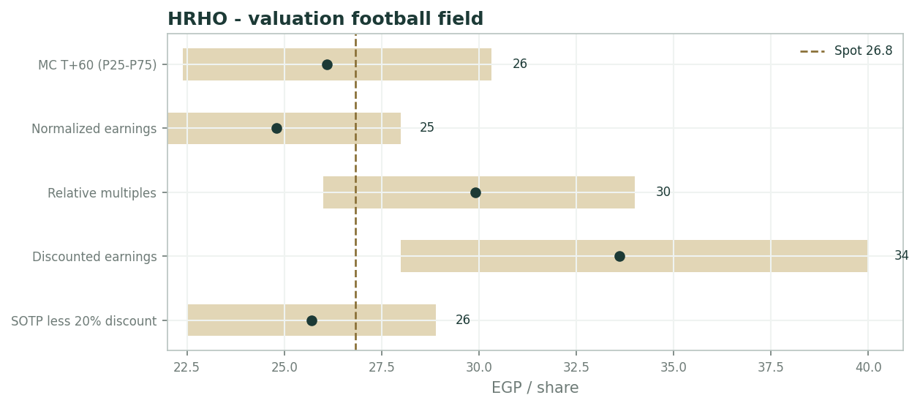
Valuation football field - lens ranges vs spot
1.6 The three verticals - a deeper look
FY25 by vertical: the Investment Bank (EGP 11.9 bn revenue, -19%) normalized off an FY24 swollen by post-devaluation FX and unrealized gains - Brokerage (+19%, USD 127.5 bn executions, +23%) and the Buy-Side (+42%) grew strongly while Holding & Treasury collapsed 76%; NPAT EGP 1.3 bn. EFG Finance (EGP 6.7 bn, +39%) was led by Valu (EGP 3.0 bn, +56%, now separately listed after the FY24 share distribution); NPAT EGP 1.2 bn (+45%). Bank NXT (EGP 7.5 bn, +52%) grew net interest income 30% on a larger book plus non-core asset gains; NPAT EGP 3.1 bn (+77%), group share EGP 1.6 bn, and a fresh EGP 4.2 bn capital increase funds the next leg.
The scorecard's message is rotation: the engine has moved from the cyclical IB to the two balance-sheet businesses - which stabilizes the group print exactly when the flagship is weakest, and is why the consolidated -5% conceals rather than reveals.
Vertical | FY25 rev / NPAT | YoY | Read
EFG Hermes (IB) | 11.9 / 1.3 bn | -19% / -50% | Normalizing off the FY24 FX base; incl. 656 mn tax gain
EFG Finance (NBFI) | 6.7 / 1.2 bn | +39% / +45% | Valu 3.0 bn (+56%), listed Jun-25; growth engine
Bank NXT | 7.5 / 3.1 bn (grp 1.6) | +52% / +77% | Rate-carry winner; EGP 4.2 bn capital round
Group (after min.) | 26.0 / 4.1 bn | +7% / -5% | Mix shift, not contraction

1.7 The holdco discount and the rate cycle - the crux
The crux is a pair. First, the discount: gross NAV ~EGP 32.2 vs spot 26.83 is a ~17% charge for the wrapper - each percentage point of discount is worth ~EGP 0.32/share, so the observed 15-25% band alone spans EGP 3.2 of value. Collapse it with monetizations (a further Valu sell-down, a Bank NXT transaction) and the same marks are worth EGP 29-32; let head-office drag or governance doubts widen it to 30% and they are worth 22.5.
Second, the rate cycle cuts across the verticals in opposite directions: CBE easing lifts brokerage turnover, IB pipelines, AUM and NBFI credit growth, but compresses Bank NXT's margin and treasury yields. The diversified mix deliberately flattens that beta - roughly +EGP 1/share per 200 bp of easing, net - which is why the honest macro answer lands near spot.
The two files interact: monetizations historically happen into strong tapes, so the discount's best friend and the macro bull case are the same window - a correlation the probability map's right tail quietly carries.
1.8 Macro and country
Macro: Egypt mid-easing-cycle, with EGX turnover and IPO pipelines (the group itself advised recent listings) the IB's oxygen; the EGP sets the translation of seven-country regional earnings and drove the FY24 one-off layer; inflation still feeds opex (+42% other G&A in FY25).
Regionally, Kuwait and UAE drove brokerage executions - a reminder that a third of the franchise answers to GCC liquidity, not Cairo. Regulatory posture is supportive; the FRA framework and the standing distribution policy (EGP 400 mn FY25) anchor governance.
1.9 Discount x marks sensitivity
Two dials dominate. The holdco discount at 10/20/30% moves the NAV to EGP 28.9/25.7/22.5. The aggregate marks moving +/-10% (the IB multiple, the Valu print, the Bank NXT capitalization) shift it ~+/-EGP 2.6/share. The grid below crosses them; the interaction spans EGP 20.3-31.8 - wider than any single-business study in this series, which is the nature of pricing a bundle.
Discount \ marks | -10% | base | +10%
10% | 26.1 | 28.9 | 31.8
20% | 23.2 | 25.7 | 28.3
30% | 20.3 | 22.5 | 24.8

2 Technical and price structure
Price EGP 26.83 sits fractionally below all four moving averages - 20-day 26.9, 50-day 27.5, 100-day 27.5, 200-day 27.1 - which have converged into a two-point band: a textbook compression after the 52-week 23.11-30.86 round trip. RSI(14) at ~59 is neutral-firm.
No trend to lean on; the tape is coiled and will follow the next catalyst (AGM distribution mechanism, 2Q26 print, or a monetization headline). Compressions this tight in HRHO's history have resolved with 15-20% moves within a quarter - direction unsignalled, energy stored.
Indicator | Reading
Spot | EGP 26.83
SMA 20 / 50 / 100 / 200 | 26.9 / 27.5 / 27.5 / 27.1
RSI(14) | ~59 (neutral-firm)
52-week range | EGP 23.11 - 30.86
Structure | All four MAs converged; tight coil, no trend

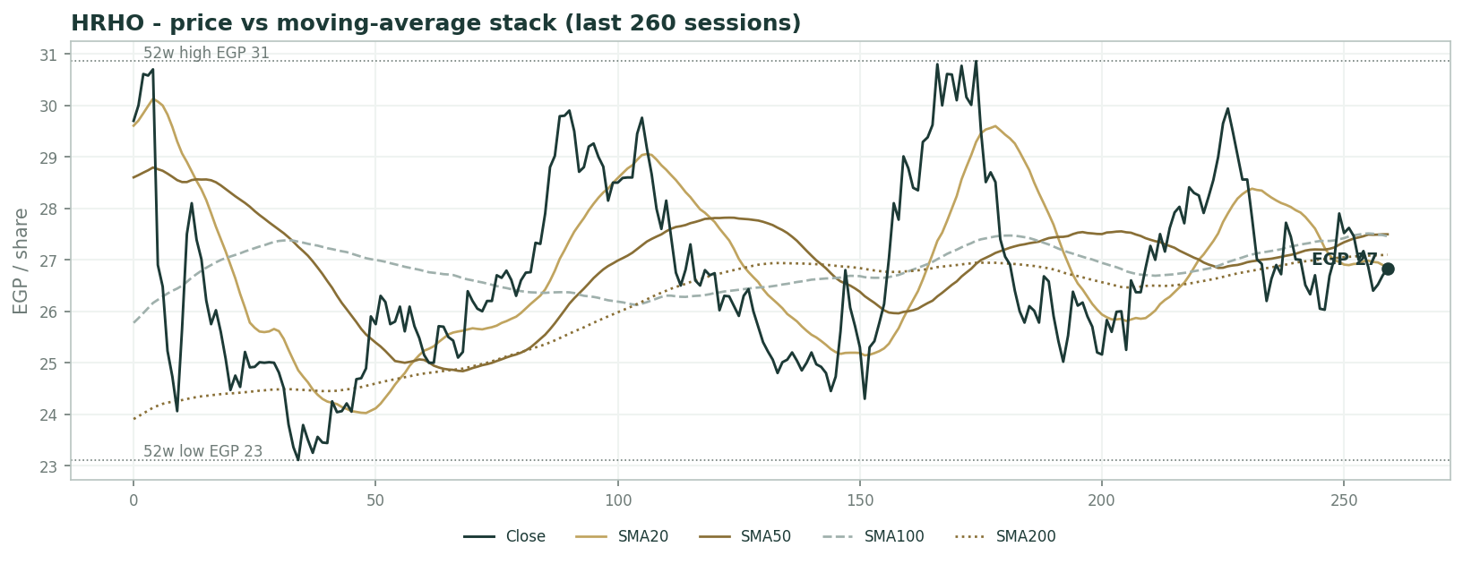
Price vs moving-average stack (last 260 sessions)
3 Monte Carlo - a probabilistic price map
Paths diffuse from spot; the §1 value gap is kept out of the drift, so the three lenses stay independent. 16-factor model - 7 continuous + 9 discrete - 50,000 paths, seed 42.
Horizon | P5 | P25 | P50 | P75 | P95
T+20 | 21 | 24 | 27 | 29 | 33
T+60 | 18 | 22 | 26 | 30 | 38

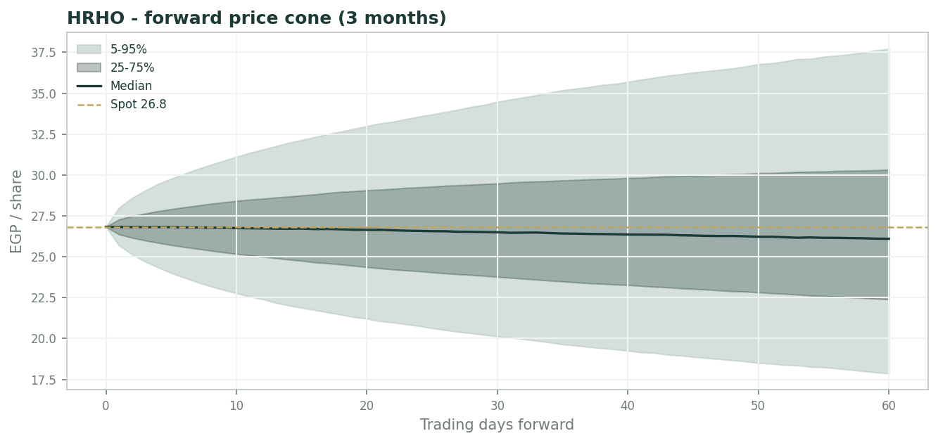
Forward price cone (3 months)
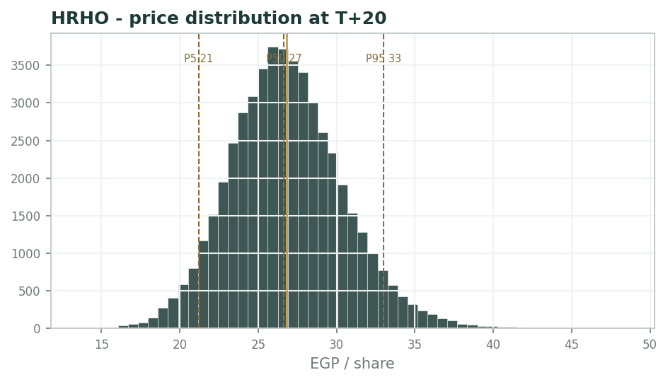
Price distribution at T+20
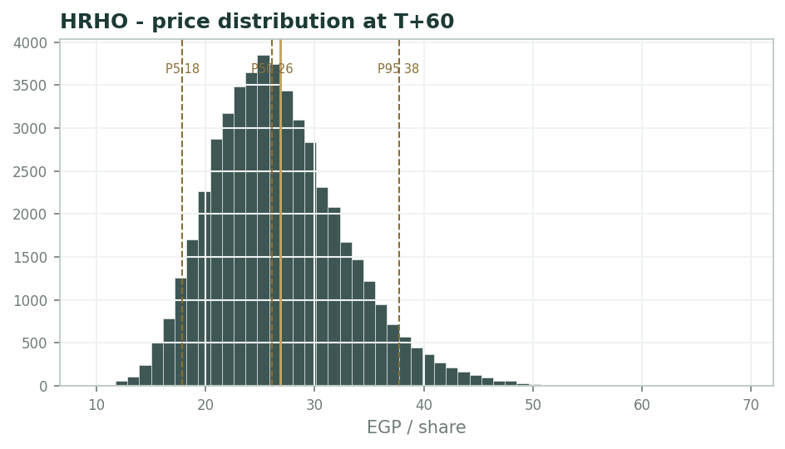
Price distribution at T+60
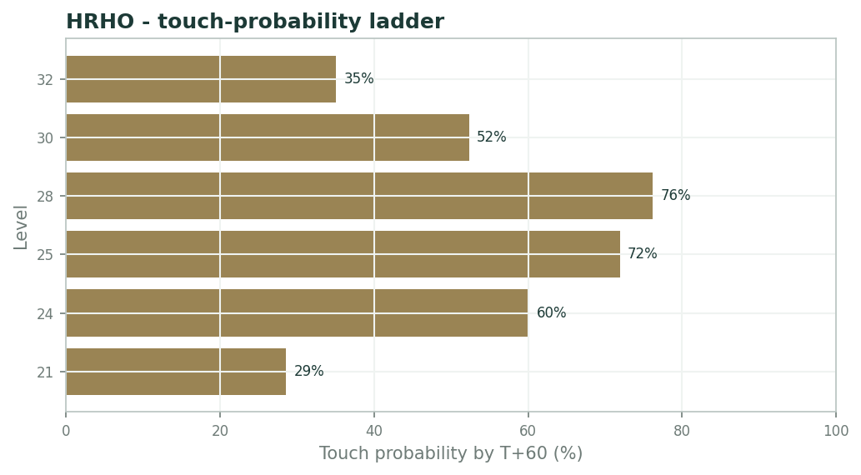
Touch-probability ladder by T+60
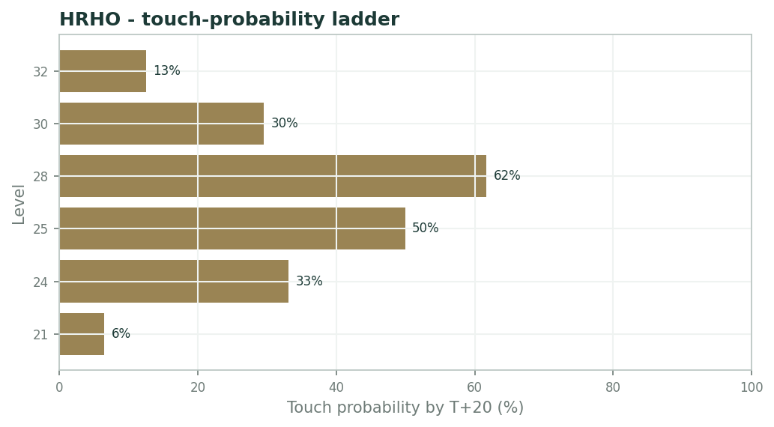
Touch-probability ladder by T+20
The distribution is near-symmetric around spot (median 26.1) with a modest upside tail - P95 EGP 37.7 vs P5 17.9 - from the holdco event factors (subsidiary listing/monetization, risk-appetite flows).
Touch probabilities by T+60: EGP 26 ~72%, EGP 28 ~76%, EGP 30 ~64%, EGP 32 ~35%; downside, EGP 24 ~60% and EGP 22 ~29%. By T+20 the same ladder runs ~50/62/43/13% up and ~33/6% down - the coil in the tape shows up as a one-month map hugging spot.
4 Comparison of the lenses, and a verdict
The lenses straddle the price rather than sit on one side of it: the discounted SOTP and normalized core bracket spot from below (25.7, 24.8), the multiple and un-haircut earnings lenses from above (29.9, 33.6), and the weighted centre lands at 27.7 - within 3%.
Verdict: fairly valued. The stock is not an argument about direction but about composition - how much of the 4.1 bn recurs, and what discount the wrapper deserves - and both arguments are currently priced near their middles. The asymmetry, such as it is, lives in the event calendar: monetizations and the AGM mechanism can only shrink the discount from here faster than drift can widen it.
5 Catalysts to watch
- The 2026 AGM distribution decision - cash dividend vs buyback for the EGP 400 mn, and any upsizing.
- Quarterly cadence - the 2Q26 print (Aug 2026): does the IB's recurring core hold above EGP 400 mn NPAT without one-offs?
- CBE rate path - easing lifts brokerage/IB/NBFI but squeezes Bank NXT's margin; the net is the macro read.
- The Valu share price - a live, daily mark on the largest NBFI asset - and any further sell-down.
- Monetization headlines: a Bank NXT stake transaction or new vertical listing would reprice the holdco discount directly.
- EGX turnover and the IPO pipeline, the Investment Bank's revenue oxygen.
6 Reading the probability zones
Below ~EGP 22.4 (P25) the stock trades at a >30% discount to gross NAV - cheap on every lens including the strictest quality-of-earnings read. EGP 24-29 is the fair band where all five lenses interleave; spot sits in its middle. EGP 30-32 prices the discount toward 10% and needs a monetization or an EGX bull tape. Above ~EGP 32.2 the market pays a premium to gross NAV - historically the sell-the-wrapper zone; P95 is EGP 37.7.
Zone | Range (EGP) | What it means
Cheap on all lenses | < 22.4 | >30% discount to gross NAV; P25 floor
Fair band | 24 - 29 | All five lenses interleave; spot mid-band
Discount toward 10% | 30 - 32 | Needs monetization or EGX bull tape
Premium to gross NAV | > 32.2 | Historically the sell-the-wrapper zone; P95 37.7

7 Caveats and what would change our mind
FY2024 figures are derived from the FY2025 release's disclosed YoY moves, not read from the FY24 statements; the equity/minority split, holdco treasury, and the 1,224.6 mn share count are estimates pending the audited financials; every SOTP mark is a judgment (only Valu has a market print); the classify map's 'bank' label was overridden to holdco - flag; the earnings DCF is deliberately un-haircut and should be read as a ceiling; minority leakage (Bank NXT ~48%, Valu minorities) is modelled only through the residual tax-and-minorities line; and Bank NXT consolidation makes group 'revenue' a mixed banking/fee aggregate - segment NPATs are the cleaner read.
Appendix A Financial statements
A.1 Income statement - 3 years historical + 5-year forecast
Line | FY23 | FY24 | FY25 | FY26E | FY27E | FY28E | FY29E | FY30E
Operating revenue | 14,700 | 24,300 | 26,000 | 29,640 | 33,493 | 37,512 | 42,014 | 46,635
Operating expenses (incl. provisions & ECL) | 9,800 | 15,500 | 17,500 | 19,859 | 22,106 | 24,571 | 27,309 | 30,080
Operating profit | 4,900 | 8,800 | 8,500 | 9,781 | 11,388 | 12,942 | 14,705 | 16,556
Other / associates | 0 | 0 | 0 | 0 | 0 | 0 | 0 | 0
PBT (proxy) | 4,900 | 8,800 | 8,500 | 9,781 | 11,388 | 12,942 | 14,705 | 16,556
Tax & minority interest | 2,400 | 4,480 | 4,400 | 4,891 | 5,694 | 6,471 | 7,352 | 8,278
Net profit (after tax & minorities) | 2,500 | 4,320 | 4,100 | 4,891 | 5,694 | 6,471 | 7,352 | 8,278

A.2 Balance sheet
Line | FY23 | FY24 | FY25 | FY26E | FY27E | FY28E | FY29E | FY30E
Total assets | 121,900 | 185,000 | 230,600 | 265,190 | 304,968 | 350,714 | 403,321 | 463,819
Attributable shareholders' equity (est.) | 26,500 | 30,500 | 34,200 | 38,691 | 43,784 | 49,455 | 55,808 | 62,886
Minority interests (est.) | 8,000 | 10,000 | 12,000 | 13,800 | 15,870 | 18,250 | 20,988 | 24,136
Holdco net treasury & seed | 3,000 | 3,000 | 3,000 | 3,000 | 3,000 | 3,000 | 3,000 | 3,000

A.3 Cash flow
Line | FY23 | FY24 | FY25 | FY26E | FY27E | FY28E | FY29E | FY30E
Net profit (after minorities) | 2,500 | 4,320 | 4,100 | 4,891 | 5,694 | 6,471 | 7,352 | 8,278
+ Provisions & D&A addback | 1,200 | 1,600 | 2,000 | 2,371 | 2,679 | 3,001 | 3,361 | 3,731
Cash from operations (proxy) | 3,700 | 5,920 | 6,100 | 7,262 | 8,373 | 9,472 | 10,714 | 12,009
- Capex | -500 | -550 | -600 | -600 | -650 | -700 | -750 | -800
- Shareholder distributions | -1,300 | 0 | 0 | -400 | -600 | -800 | -1,000 | -1,200
Net change (proxy) | 1,900 | 5,370 | 5,500 | 6,262 | 7,123 | 7,972 | 8,964 | 10,009

A.4 Discounted cash flow (5-year forecast)
Line | FY26E | FY27E | FY28E | FY29E | FY30E
Net profit (after minorities) | 4,891 | 5,694 | 6,471 | 7,352 | 8,278
Discount factor | 0.806 | 0.650 | 0.524 | 0.423 | 0.341
PV of profits | 3,944 | 3,703 | 3,394 | 3,110 | 2,824

DCF build | Value
Sum PV of explicit profits | 16,975
Terminal value (Gordon) | 70,680
PV of terminal value | 24,109
Equity value (DCF) | 41,084
Fair value per share | 33.55

Appendix B Step 0 - calibration backtest
Step 0 replayed non-overlapping quarterly 3-month forecasts across the full five years. With the volatility multiplier at 1.30, the 50/80/90% bands covered 59 / 76 / 88% of realized outcomes and the PIT histogram is approximately uniform - calibration passes (n = 17 quarterly windows).
Band | Target | Realized
50% | 50% | 59%
80% | 80% | 76%
90% | 90% | 88%

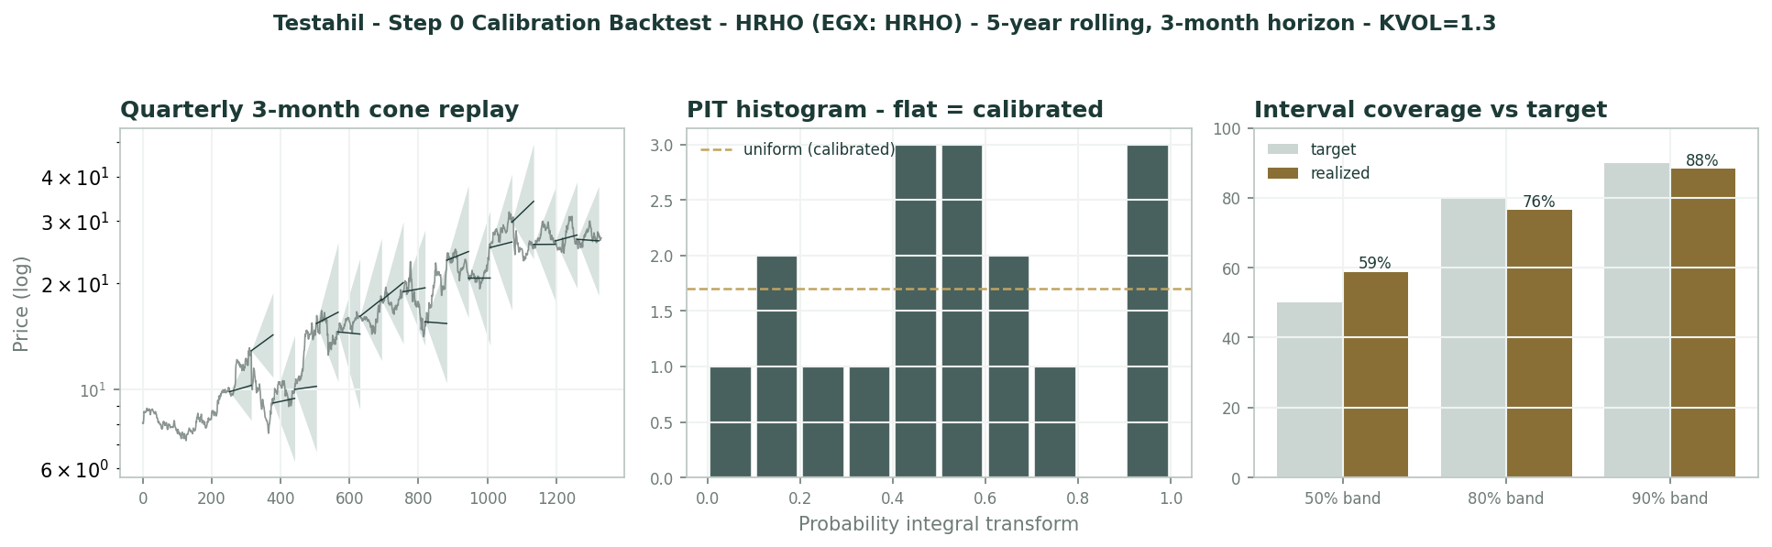
Calibration backtest - cone replay, PIT histogram, interval coverage
Appendix C Peer set, sector structure, and risks
Peers: CIB (the EGX financial bellwether, 6-7x), e-finance (growth-scarcity multiple), the group's own listed Valu, and MENA investment-banking franchises (8-12x). Sector structure: EGX turnover and the IPO cycle drive the IB; the CBE corridor drives Bank NXT's margin and NBFI funding costs; the EGP translates seven countries of regional earnings.
Principal risks: holdco-discount widening, IB revenue cyclicality, credit quality in Tanmeyah/Valu consumer books, Bank NXT margin compression into cuts, minority leakage, and key-man/governance risk at the centre.
Appendix D The expert valuation panel
D.1 Expert 1 - holdco NAV and the discount - marking the three verticals
Worldview and tradition. A holding company is worth its parts, marked honestly, less the discount the market rightly charges for a bundle it cannot unbundle - the cost of trapped capital, cross-holdings, head-office drag and the option the centre keeps to reallocate against you.
The tradition is the conglomerate-NAV school: value flows from the assets, not the consolidated income statement, because consolidation mixes a fee business, a lender and a deposit-taking bank into one line that no multiple fits. Mark each at what its own market pays, then argue only about the wrapper.
The discipline here is unusually well-served: two of the three verticals carry external marks - Valu prints a price on the EGX daily, and Bank NXT just cleared a EGP 4.2 bn capital round - so the subjectivity is concentrated in one mark (the Investment Bank) and one number (the discount).
When it works / when it fails. Works when the parts are separable and markable, and EFG's are: distinct regulated entities, segment disclosure, and live external reference points. Fails when the discount stops being analysis and becomes a mood - the same NAV supports 22 or 29 depending on a number nobody can derive from first principles.
It is also silent on timing: a NAV says nothing about when the gap closes, and holdco discounts have persisted on the EGX for years absent a monetization event.
My control for both weaknesses is empirical: I set the discount from observed EGX holdco behaviour (a persistent 15-25% band, mean near 20%) rather than argument, and I name the events that historically closed it - listings, stake sales, special distributions.
Standard workings. Mark the three verticals plus the centre's treasury, sum, then charge the wrapper.
The marks: the Investment Bank at 8x normalized profit (the FY24-25 average of ~EGP 1.8 bn, smoothing the FX-inflated FY24 against the one-off-assisted FY25); the NBFI platform at the listed Valu stake plus conservative multiples on Tanmeyah, leasing, factoring and insurance; Bank NXT at ~5.6x the group's EGP 1.6 bn profit share, consistent with its fresh capital round; treasury and seed at face.
Component | EGP mn
Investment Bank (EFG Hermes) - 8x normalized | 14,400
NBFI platform incl. listed Valu stake | 13,000
Bank NXT (group share, ~5.6x) | 9,000
Holdco treasury & seed | 3,000
Gross NAV | 39,400
Gross NAV per share | EGP 32.17
- 20% holdco discount | (7,880)
Equity NAV / per share | 31,520 / EGP 25.74

Worked example. Gross NAV EGP 39.4 bn over 1,224.6 mn shares is EGP 32.2. At the observed 15-25% discount band that spans EGP 27.3 down to 24.1; my 20% centre gives EGP 25.7.
Read against the tape: spot 26.83 implies the market is already at a benign ~17% - inside the band, nearer its friendly edge.
And the zero-discount case is worth stating: EGP 32.2 is what these parts are worth to an owner who can reach them - the ceiling any monetization program is working toward, and the number the two falsification events in section 5 would move the price toward.
Sensitivity on the swing input. The discount dominates; the aggregate marks are second; no single mark moves the answer much on its own.
Swing input | Fair value (EGP/sh)
Holdco discount 10 / 20 / 30% | 28.9 / 25.7 / 22.5
Aggregate marks +/-10% | +/- ~2.6
IB multiple 6x / 8x / 10x | -1.5 / base / +1.5

Cross-examination. To Expert 2: your normalization strips the FX gains but keeps the FX losses' base year - one-offs cut both ways at a franchise this cyclical, and half my NAV needs no earnings opinion at all because the market prices it directly. Your 7x on a scrubbed number and my 8x on a smoothed one differ by less than either of us pretends.
To Expert 3: your rate scenarios all flow through my marks anyway - Valu's print, NXT's book, the IB's pipeline - so you are running my model with weather attached. The only number you cannot move that I can is the discount itself, and monetization events, not the MPC, move that.
Verdict, falsification, and what the price implies. Fair ~EGP 25.7 (22.5-28.9). Spot sits at a ~17% implied discount: fair, with the cheap tail opening only below EGP 24.
Price-implied: the market is paying the friendly end of the historical discount band without a monetization announcement in hand - reasonable given the Valu precedent, but the next leg needs an event, not just patience. Falsification: a monetization event - a further Valu sell-down or a Bank NXT stake transaction at or above my marks - collapsing the discount below 10%, or a new head-office cash drain widening it past 30%.
D.2 Expert 2 - quality of earnings - what the EGP 4.1 bn is actually made of
Worldview and tradition. Pay for the earnings that recur. A financial group's printed bottom line is a layer cake of franchise profit, balance-sheet luck and accounting timing - FY24's number was inflated by devaluation FX and unrealized gains, FY25's by a EGP 656 mn tax-loss utilization at the Investment Bank. Strip both before you multiply anything.
The tradition is the quality-of-earnings ledger: itemize every non-recurring pound in both directions, rebuild the base, and only then choose a multiple. The method's authority comes from its symmetry - it removes flattering one-offs and adds back punitive ones with the same pen.
Applied to EFG the ledger is short but heavy: two devaluation-era FX layers, one tax asset, some listing and pre-operating costs - perhaps EGP 700-900 mn of net air in a 4.1 bn print.
When it works / when it fails. Works whenever headline profit swings on items that will not repeat - exactly EFG's last two years, where the same franchise printed +53% then -5% without the underlying businesses moving anything like that much. Fails when applied mechanically to a genuinely improving mix: Bank NXT's +77% and the NBFI's +45% are real operating growth, and my base credits them in full.
Its blind spot is optionality - the licence pipeline, the monetization calendar - which it prices at zero on principle: options are bought cheaply or not at all.
Standard workings. Rebuild the recurring base, then capitalize at a conglomerate multiple.
The 7x is chosen deliberately between the bank's 5-6x and the investment bank's 8-9x - a blended financial-conglomerate rate that concedes the mix has improved while refusing platform pricing for a cyclical fee engine.
Quality-of-earnings ledger | EGP mn
FY25 reported NPAT (after minorities) | 4,100
- IB tax-loss utilization gain | (650)
- other est. one-off income | (200)
+ arguably one-off costs (Valu listing, pre-op) | 350
Recurring core | ~3,600
x 7 (conglomerate multiple) | 25,200
+ holdco treasury | 3,000
Equity value / per share | 28,200 / EGP 23.0

Worked example. 3,600 x 7 = EGP 25.2 bn; + 3.0 bn treasury = 28.2 bn; / 1,224.6 mn = EGP 23.0. Even granting 8x, the answer is EGP 25.9 - still below spot.
The reverse read is the sharper one: spot 26.83 caps the reported 4.1 bn at ~8x as if every pound recurs; on my recurring 3.6 bn that is ~9.1x - a full multiple for a conglomerate whose flagship vertical just halved.
One fairness note: if the IB's recurring core proves nearer EGP 1.8 bn than my implied ~1.1 bn - two clean quarters would show it - my base rises ~EGP 700 mn and my value ~EGP 4/share. The ledger is falsifiable on a calendar.
Sensitivity on the swing input. The recurring base and the multiple are the dials.
Swing input | Fair value (EGP/sh)
Recurring NPAT 3.3 / 3.6 / 3.9 bn | 21.3 / 23.0 / 24.7
Multiple 6 / 7 / 8x | 20.1 / 23.0 / 25.9
Treasury 2 / 3 / 4 bn | -0.8 / base / +0.8

Cross-examination. To Expert 1: half your NAV is your own multiples wearing a costume - only Valu has a real print, and your 'external' Bank NXT mark is a primary round the group itself anchored. Strip those to my earnings-based marks and your gross NAV lands within a pound of my answer before you even choose a discount.
To Expert 3: your bull case double-counts - EGX turnover lifting brokerage AND the multiple re-rating are the same easing arriving through two doors, and your stress case forgets that a third of the group's profit now comes from a deposit-funded bank that likes high rates.
Verdict, falsification, and what the price implies. Fair ~EGP 23.0 (20.5-25.5). At 26.83 the market pays ~9x the recurring core - full for a conglomerate, cheap only against the print.
Price-implied: the tape has accepted the 4.1 bn at face. My lens exists for the quarter the one-offs stop arriving - and it converts to the bull side the moment the IB proves a clean 400 mn run-rate. Falsification: two consecutive quarters of Investment Bank NPAT at or above EGP 400 mn with no FX, revaluation or tax one-offs - proving the recurring core is nearer 4.5 bn than 3.6 bn.
D.3 Expert 3 - the rate cycle and the EGX tape - value as a macro regime
Worldview and tradition. EFG is a geared play on Egyptian financial conditions: CBE easing lifts brokerage volumes, investment-banking pipelines, AUM and NBFI credit growth, while compressing Bank NXT's deposit-funded margin and treasury yields. The pound sets the translation of the regional franchise. Price the regime, and the verticals price themselves.
The tradition is macro-regime valuation for rate-geared financials: identify the offices whose decisions move the earnings - the MPC (the corridor), the EGX tape (turnover and the IPO window), the central bank's FX desk (the pound) - and refuse point estimates that pretend those desks are closed.
What makes EFG unusual is the internal hedge: the 2021-24 diversification deliberately bought assets that profit from the opposite regimes, so the group's macro beta is flatter than any of its parts.
When it works / when it fails. Works when the macro swing dwarfs execution - Egypt mid-easing-cycle qualifies, and every EFG vertical is a rate instrument of some polarity. Fails on the idiosyncratic layer: the holdco discount, governance and monetization timing answer to no rate path, and they are worth EGP 6/share of the argument here.
I anchor the probabilities on checkable things - the inflation glide path, EGX turnover trends, the IPO pipeline the group itself advises - and publish them to be argued with.
The method's humility: because the verticals net against each other, my tree is narrower per unit of macro uncertainty than it would be for a pure broker - which is itself the strategy working.
Standard workings. Three regimes, each a full re-solve of the marks (brokerage/IB revenue, NBFI book growth, NXT margin, Valu's print) - no branch borrows a convenient multiple.
The internal netting is explicit: scenario A's brokerage surge is partly paid for by NXT margin compression; scenario C's IB freeze is cushioned by the bank's rate carry.
Scenario | Value / prob.
A - easing + EGX bull: turnover, pipelines, NBFI compound | ~EGP 30 / 30%
B - base: gradual cuts, mixed tape | ~EGP 27 / 45%
C - EGP stress / cuts stall: pipeline freeze, credit costs | ~EGP 20 / 25%
Probability-weighted | ~EGP 26.2 -> call it 27 with the distribution floor

Worked example. 0.30x30 + 0.45x27 + 0.25x20 = EGP 26.2/share - almost exactly spot; I round to ~27 allowing for the EGP 400 mn distribution policy's floor effect. The market is pricing my base case, not either tail.
The per-unit arithmetic: each 200 bp of easing is worth roughly +EGP 1.5-2 through brokerage/IB/NBFI but -EGP 0.5-1 through Bank NXT's margin - a net ~+EGP 1/share per 200 bp, far flatter than a pure broker, and the reason my range (20-33) is narrower than the group's history would suggest.
Width read: 13 pounds of span on a 27 price says the regime question is real but hedged - the diversification bought exactly this.
Sensitivity on the swing input. The corridor and the tape are the swings; the pound is the amplifier.
Swing input | Fair value (EGP/sh)
Each 200bp of CBE easing (net) | + ~1.0
EGX turnover +/-25% | +/- ~1.5
EGP -15% (translation + FX layer) | + ~1.0-1.5, quality-flagged

Cross-examination. To Expert 1: monetizations do not happen in a vacuum - Valu listed into a bull tape; your discount-collapse catalyst IS my scenario A wearing a corporate-finance suit, so our bull cases are one trade.
To Expert 2: your 'recurring' core is itself regime-dependent - the brokerage commissions you bless as clean halve if EGX turnover mean-reverts, and the NXT profit you fully credit is a high-rate artifact by your own logic. A quality ledger that ignores the regime is a photograph of weather.
Verdict, falsification, and what the price implies. Fair ~EGP 27.0 (20-33, widest). Spot sits on the base case: the diversified mix has flattened the macro beta, which is precisely the strategy working.
Price-implied: the market weights my scenarios almost exactly as I do - the rare stock where the tape and the tree agree - so the alpha here is in the discount and the ledger, not the macro. Falsification: the regime print: EGX turnover and CBE cuts both accelerating for two quarters confirms scenario A; renewed EGP pressure with cuts on hold confirms C.
D.5 The three in one room
Put in one room, the three converge on one exhibit: the EGP 4.1 bn. Expert 2 lays out the layers - 656 mn of tax gains, the FY24 FX base - and says the recurring core is 3.6, price that or price a memory. Expert 1 shrugs: my marks never used the print; the parts are worth 32 gross and the only fight is the wrapper's 20% - argue with Valu's tape, not with me. Expert 3 turns the exhibit over: both your numbers are regime outputs - the brokerage line Expert 2 blesses and the bank multiple Expert 1 applies both flip sign when the CBE moves, and the monetization Expert 1 prays for only happens in my scenario A. Three readings of one income statement; the price sits, almost smugly, between them - and the AGM calendar, not the debate, will move it first.
D.6 Reading the divergence
Base fair values of EGP 25.7 / 23.0 / 27.0 against spot 26.83 - the tightest expert spread of the series, straddling the price. The spread here does not measure mispricing - it measures the three legitimate ways to read a conglomerate's income statement, and the market is currently paying the average of all three.
What closes it has a calendar: the AGM mechanism and any monetization arbitrate Expert 1's discount; two clean IB quarters arbitrate Expert 2's ledger; the MPC arbitrates Expert 3's tree - every leg expires within the year.
Expert | Method | Fair value (EGP) | Swing assumption
Expert 1 | NAV & discount | 25.7 (22.5-28.9) | The holdco discount (10-30%)
Expert 2 | Earnings quality | 23.0 (20.5-25.5) | The recurring core of the 4.1 bn
Expert 3 | Macro regime | 27.0 (20-33) | The CBE path x EGX tape


Expert fair values vs spot
About this series
Testahil publishes independent, educational valuation studies. The house style is distributions, not tips: we describe ranges and probabilities, not targets. Studies are framed as educational analysis, the preparer is not licensed by any securities regulator, and holdings are disclosed.
Disclosure & Disclaimer
Not investment advice. This document is educational and informational only. It is not, and must not be relied upon as, investment, financial, legal, accounting or tax advice, nor an offer, solicitation or recommendation to buy, sell or hold any security. It contains no price target and no rating.
No licence; no advisory relationship. The preparer is not registered or licensed with any securities or financial regulator in any jurisdiction, holds no brokerage or investment-advisory authorisation, and is not acting as your adviser or fiduciary. Nothing here is personalised to your circumstances.
Holdings disclosure. The preparer may hold, and may in the future take or dispose of, a position in the security discussed in this report, and may transact at any time without notice. This is a potential conflict of interest you should weigh.
Sources & accuracy. Reported financial and operating figures are drawn from the company's public disclosure and other public sources believed reliable but not independently verified; they may contain errors or be superseded. Forward-looking inputs are the preparer's own judgments and are inherently uncertain.
Forward-looking statements. Any statements about the future are estimates subject to risks and uncertainties; actual results may differ materially. The Monte Carlo models price, not value, and encodes subjective probabilities for events that have not occurred.
No reliance; your responsibility. Do your own research and consult a licensed professional before making any decision. You are solely responsible for your investment decisions and their outcomes. To the maximum extent permitted by law, the preparer accepts no liability for any loss arising from use of this document.
Currency & figures. Group figures are in EGP. Rounding may cause totals to differ slightly. Spot price and market data are as of the study date and change continuously.
TESTAHIL · Independent Valuation Study · Educational Analysis · EFG Holding S.A.E. (EGX: HRHO) · edition 01-07-2026 · reporting currency EGP

