Testahil · Independent Valuation Study — Educational Analysis Not investment advice

Independent Valuation Study — Educational Analysis
International Holding Company PJSC (ADX: IHC)
Fundamental analysis · Technical analysis · Monte Carlo simulation — one integrated read
Anchor: AED 382.30 (3 Jul 2026 close) · ~2,180m shares · market cap ~AED 833bn (USD 227bn) · the Abu Dhabi flagship of the Royal Group / Sheikh Tahnoon bin Zayed ecosystem — ~1,300 subsidiaries across eight verticals (real estate & construction, marine & dredging, energy, hospitality, food & agriculture, technology, financial services, services) · prices and probabilities computed 3 Jul 2026 from the attached daily history · primary lens: holding-company sum-of-the-parts (look-through NAV) · the premium of the market price to reconstructable NAV — not any single mark — is the swing factor.
READ FIRST — what this document is, and is not. This study is a valuation exercise and an expression of personal analytical opinion, published free of charge for educational purposes: it shows how one analyst applies fundamental, technical and probabilistic methods to a listed company, and invites scrutiny of that methodology. It is NOT investment advice, NOT a recommendation or solicitation to buy, sell or hold any security, and NOT directed at the circumstances of any reader. The preparer is not licensed by any securities regulator in any jurisdiction, holds no brokerage authorisation, provides no financial consultancy, manages no money, and accepts no fees, funds or clients. See the Disclosure & Disclaimer at the end. All values are model outputs presented as ranges and distributions because no single number should be relied on. Reported financials are the company's own disclosure (FY2025 audited results, 15 Feb 2026) and S&P Global Market Intelligence; forward-looking inputs — the look-through marks on the listed stakes, the marks on the unlisted platforms (IRH, RIQ, the private tail), the multiples, the DCF and the Monte-Carlo factor probabilities — are the preparer's judgments and are flagged throughout. FY2023 and several balance-sheet line items are estimated to balance to disclosed totals, and are flagged. The preparer may hold, and may in the future take or dispose of, a position in the security discussed in this report. Consult a licensed financial advisor before any investment decision.

Headline
The model's read: on every fundamental lens IHC is worth a fraction of its market price. At AED 382 the shares trade at roughly 2.7× our weighted central fundamental estimate of ~AED 105 — a premium of about 266%. This is the inverse of the discount that conglomerate holding companies almost universally trade at, and it is the whole story of the name. A look-through sum-of-the-parts — IHC's ~60% of Alpha Dhabi (which itself holds NMDC and Aldar), its look-through interest in the merging Multiply / 2PointZero / Ghitha entity, its other listed subsidiaries, plus book- and mark-based values for the unlisted platforms (IRH metals, RIQ reinsurance, and the long private tail) and holdco net cash — lands near AED 120 per share. A deliberately conservative operating DCF, which excludes portfolio revaluation and associate income (an investment holdco's value sits in the assets, not in operating cash), lands lower at ~AED 81. A peer-multiple read (~AED 102) and a mid-cycle normalized-earnings read (~AED 91) bracket the middle. Every lens sits far below AED 382. The premium is real and may persist — it reflects scarcity (a thin, low-turnover float), sponsor and sovereign-ecosystem backing, index and passive demand, and the market's willingness to capitalise IHC's demonstrated capital-compounding at a multiple no cash-flow model underwrites — but it is a premium a fundamental exercise cannot manufacture, and this study says so plainly.
Technically the tape is the opposite of dramatic: the shares sit below every major moving average in a stepwise-descending stack (MA20 384.85, MA50 388.23, MA100 391.46, MA200 395.65), with RSI at 42.9 and MACD mildly negative — a soft, corrective drift inside an extraordinarily tight 52-week range of AED 380.0–404.0. Over three months the Monte Carlo places the 5th–95th percentile band at roughly AED 323–462, with the median a touch above spot on the net-positive factor overlay. By design those paths diffuse from today's price; the fundamental value gap is kept out of the drift.
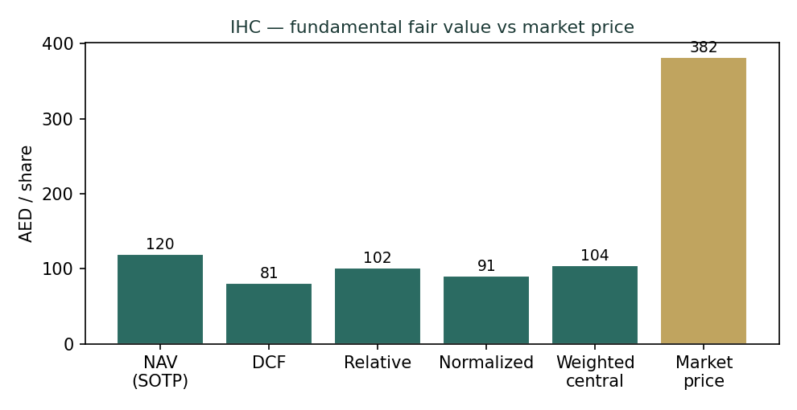
Figure 1. Every fundamental lens sits far below the market price; the gap is the premium.
Valuation summary — every read at a glance
One table for the four reads that follow — what the business is worth (fundamental), what the tape is doing (technical), where price could travel over three months (Monte Carlo), and how three independent expert methods land. Every row is developed in the sections and appendices below.
Lens / read | What it measures | Output | Takeaway
FUNDAMENTAL — what the business is worth (the anchor)
Sum-of-the-parts (primary) | Look-through NAV, holdco net cash | AED 120 | −69% vs spot
Consolidated DCF | Operating FCFF, 5-yr + TV | AED 81 | −79% · the floor
Relative multiples | Peer P/E & P/B on attributable | AED 102 | −73%
Normalized earnings | Mid-cycle, ex-revaluation × P/E | AED 91 | −76% · the ceiling proxy
Weighted central | Blend 45 / 15 / 20 / 20 | AED 105 | −73% vs AED 382
TECHNICAL — what the tape is doing (timing, not value)
Trend & momentum | Price vs 20/50/100/200-day | Below all four | Weak, corrective
Momentum / range | RSI · MACD · 52-wk range | RSI 42.9 · MACD -1.945 · 380.0–404.0 | Soft, very tight
MONTE CARLO — where price could go in 3 months (paths from spot)
T+20 sessions | 50,000 paths · 16 factors | p5 341 · p50 384 · p95 428 | Median ≈ spot
T+60 sessions | same engine, longer horizon | p5 323 · p50 391 · p95 462 | Right-skewed
EXPERT PANEL — three independent methods (Appendix D)
Expert 1 — NAV & the discount | Look-through NAV, premium test | AED 120 | The anchor
Expert 2 — the accountant | Quality of earnings, ex-gains | AED 96 | Most conservative
Expert 3 — macro & the premium | Scarcity / flow / sponsor premium | AED 235 | Most bullish
Panel range | Spread = the premium question | AED 96–235 | All below spot 382
Bottom line. Every read points the same way — the market price embeds a large premium to fundamental value — and the reads disagree only on how large. The fundamental central sits near AED 105; the three experts span AED 96–235; and even the most premium-friendly expert lands below the AED 382 spot. The question the whole study turns on is not 'what is a part worth' but 'what premium to reconstructable NAV is warranted, and can it persist'.
Company overview — IHC at a glance
Item | Value
Listed entity | International Holding Company PJSC (ADX: IHC)
What it is | Abu Dhabi investment holding company; ~1,300 subsidiaries across 8 verticals
Spot / date | AED 382.30 · 3 Jul 2026 close
Shares · market cap | ~2,180 m · ~AED 833 bn (USD 227 bn)
Balance sheet (FY2025) | Total assets AED 428.6 bn · total equity AED 250.7 bn · cash & bank AED 74.9 bn
Attributable equity | ~AED 151.5 bn (BVPS ~AED 69.5) · minority interest ~AED 99 bn
Total borrowings | ~AED 100.5 bn; group broadly net-cash on marketable securities
FY2025 revenue / PAT | AED 111.4 bn (+29.1% YoY) · AED 34.7 bn PAT (+35.1%) · EPS AED 9.93
Key listed subs | Alpha Dhabi (~60%, holds NMDC ~77% & Aldar); merging Multiply / 2PointZero / Ghitha (~AED 120 bn)
Dividend | Near-zero payout; capital reinvested / recycled
Chairman / control | Sheikh Tahnoon bin Zayed Al Nahyan (Royal Group ecosystem)
52-week range | AED 380.0 – 404.0
Source: IHC FY2025 audited results (15 Feb 2026), ADX disclosures, S&P Global Market Intelligence. Values rounded; FY2023 and some line items estimated to disclosed totals (flagged in Appendix A).
1 Fundamental valuation
We value IHC as a holding company — the price of a claim on a portfolio of businesses and stakes, not the price of a single operating enterprise. The primary lens is therefore a look-through sum-of-the-parts (SOTP / holdco NAV): each leg is marked on the basis that fits it — listed stakes at their look-through market value, unlisted platforms at book or a defensible mark — holding-level net cash is a single explicit line, and there is no blanket conglomerate discount layered on top (the disciplined-holdco mechanics of the house methodology). A deliberately conservative operating DCF, a peer-multiple cross-check and a mid-cycle normalized-earnings read complete the set. The weights and the football field are in §1.5; the SOTP-per-share table is in §1.6; the crux — the premium the market pays over reconstructable NAV — is dissected in §1.7 and the sensitivity grids are in §1.9. A framing note carried throughout: IHC's reported profit is investment-led. In FY2025, associate income and fair-value gains were larger than operating EBITDA — group PAT of AED 34.7 bn sits above an operating EBITDA of ~AED 22.7 bn — so an operating cash-flow model structurally understates the name, and the asset sum, not the DCF, must anchor the valuation.
1.1 Look-through sum-of-the-parts — the primary lens
Each leg is marked on a spot basis. IHC's ~60% of Alpha Dhabi is taken at Alpha Dhabi's own ADX market cap (AED 69.5 bn) — because Alpha Dhabi itself consolidates NMDC (~77%) and holds Aldar, valuing IHC's Alpha Dhabi stake at Alpha Dhabi's market price captures that whole tree at market, with no double-count. The merging Multiply / 2PointZero / Ghitha entity (~AED 120 bn combined) is taken at IHC's estimated look-through interest. Other listed subsidiaries are a look-through block. The unlisted platforms — IRH (metals & mining), RIQ (reinsurance) and the long private tail across industrial, food, technology, healthcare and education — are marked on book or a defensible estimate, and these marks are flagged as the house's own view, not company disclosure. From the summed gross asset value we add holding-level net cash. No arbitrary discount is applied — the SOTP result is the fundamental fair value, and the market's premium to it is examined separately in §1.7.
Part (base case) | Basis | Value (AED bn)
Alpha Dhabi Holding (~60%) | ADX market cap × stake (holds NMDC, Aldar) | 41.7
Merged Multiply / 2PointZero / Ghitha | Entity value ~AED 120 bn × look-through | 66.0
Other listed subsidiaries | Look-through market | 25.0
IRH — metals & mining | Book / mark (unlisted, flagged) | 40.0
RIQ — reinsurance | Book / mark (unlisted, flagged) | 8.0
Private industrial / food / tech + tail | Book-based (~1,300 subs, flagged) | 60.0
Σ Gross asset value (GAV) |  | 240.7
plus: holding-level net cash | single explicit line | 20.0
NAV (pre-premium) | = AED 119.6 / share | 260.7
NAV premium / (discount) applied | 0% (base = NAV) | 0.0
SOTP fair value | = AED 119.6 / share | 260.7
SOTP base ≈ AED 120/share, with a bear–bull span of roughly AED 95–175 driven mainly by the unlisted-platform marks and the applied premium (see §1.9). Set against the AED 382 spot, the market is paying ~3.2× the reconstructable look-through NAV — a premium of ~220% to NAV, the crux of the whole name.
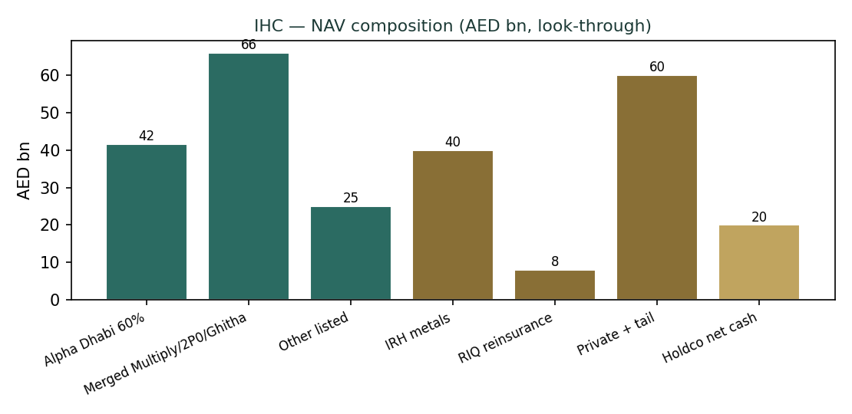
Figure 2. NAV composition (AED bn, look-through). Teal = listed; brass = unlisted; gold = net cash.
1.2 Consolidated DCF — the deliberately conservative cash-flow cross-check
A consolidated free-cash-flow-to-firm model is the natural check on the asset sum, with one caveat stated up front: it is built on operating cash only and excludes the portfolio revaluation and associate income that dominate IHC's reported profit. It therefore lands below the SOTP by construction, and is best read as a floor on the operating businesses rather than a valuation of the whole holding company. We fade revenue growth from +12% to +7% over five years, hold the operating EBITDA margin near 20%, tax NOPAT at the UAE 9% rate, add back D&A and deduct capex (~6% of revenue) and the change in working capital to reach free cash flow to the firm, and discount at a WACC built from an explicit cost of equity (Ke = rf + ERP). The full per-year build, the discounting of every year, the terminal value and the bridge to a per-share value are shown below in full — nothing is collapsed to a single output line.
DCF free-cash-flow build (AED bn):
AED bn | FY26E | FY27E | FY28E | FY29E | FY30E
Revenue | 124.8 | 137.2 | 149.6 | 161.6 | 172.9
EBITDA (20% margin) | 25.0 | 27.4 | 29.9 | 32.3 | 34.6
less: D&A (5% of revenue) | (6.2) | (6.9) | (7.5) | (8.1) | (8.6)
EBIT | 18.7 | 20.6 | 22.4 | 24.2 | 25.9
less: tax on EBIT (9%) | (1.7) | (1.9) | (2.0) | (2.2) | (2.3)
NOPAT | 17.0 | 18.7 | 20.4 | 22.1 | 23.6
add: D&A | 6.2 | 6.9 | 7.5 | 8.1 | 8.6
less: capex (6% of revenue) | (7.5) | (8.2) | (9.0) | (9.7) | (10.4)
less: ΔWorking capital | (0.3) | (0.2) | (0.2) | (0.2) | (0.2)
Free cash flow to firm (FCFF) | 15.5 | 17.1 | 18.7 | 20.2 | 21.6
Discount factor @ WACC 9.3% | 0.915 | 0.837 | 0.766 | 0.701 | 0.641
PV of FCFF | 14.2 | 14.3 | 14.3 | 14.2 | 13.9
DCF valuation bridge (AED bn):
DCF valuation bridge | Value
Σ PV of FCFF (FY26–30) | 70.9
Terminal value = FCFF₃₀ × (1+g) / (WACC − g) | 386.2
PV of terminal value | 247.6
Enterprise value | 318.4
Terminal value as % of EV (device A-7) | 77.8%
less: consolidated net debt | (25.6)
less: minority interest (proportional) | (115.9)
Attributable equity value | 177.0
Cost of equity Ke = rf 4.3% + β 1.0 × ERP 5.5% | 9.8%
WACC · terminal growth g | 9.3% · 3.5%
DCF fair value per share | AED 81
DCF base ≈ AED 81/share. Terminal value is 77.8% of EV — a high-terminal structure, disclosed here rather than buried and sensitized on the WACC × g grid in §1.9 (device A-7). We do not blend this AED 81 with the SOTP's AED 120 into a single point (device A-8); the football field in §1.5 carries both, and the weighted central respects the SOTP's primacy for a holding company.
1.3 Relative multiples
Conglomerate holding companies almost universally trade at single-digit-to-low-teens P/E and, very often, a discount to book. IHC trades at ~38× trailing P/E and ~5.5× attributable book. Applying peer-appropriate multiples to IHC's own normalized attributable earnings and book gives a fundamental cross-check well below spot. We use a normalized attributable net income of ~AED 18 bn (stripping the lumpiest fair-value gains) at a justified 12× P/E, and attributable book of ~AED 151.5 bn at a justified 1.5× P/B, and take the average of the two marks.
Relative mark | Basis | Value / share
P/E on normalized attributable NI | AED 18.0 bn × 12× | AED 99
P/B on attributable book | AED 151.5 bn × 1.5× | AED 104
Relative — blended (average) |  | AED 102
Memo — IHC current P/E | spot × shares ÷ attrib NI FY25 | ~38×
Memo — IHC current P/B | spot × shares ÷ attrib book | ~5.5×
Relative base ≈ AED 102/share. The memo lines make the outlier plain: even generous justified multiples (12× / 1.5×) are a fraction of what the market currently pays.
1.4 Normalized earnings power — with peak / mid-cycle framing
For a holding company we replace a developer-style property-cycle frame with a peak / mid-cycle earnings frame (device A-6). IHC's FY2025 profit sits at a cyclical high, inflated by portfolio revaluation and deal gains that need not recur: group PAT of AED 34.7 bn against operating EBITDA of ~AED 22.7 bn is the tell — a large slice of profit is non-cash fair-value uplift. Mid-cycle recurring attributable earnings — operating income plus a normalized, through-the-cycle contribution from associates and the investment book, but excluding one-off revaluation spikes — are closer to ~AED 16.5 bn. Capitalized at a mid-cycle 12×, that is ~AED 91/share.
Normalization | Value
Reported attributable NI (FY2025, peak) | ~AED 21.6 bn
less: estimated one-off revaluation / deal gains | (~AED 5.1 bn)
Mid-cycle recurring attributable earnings | ~AED 16.5 bn
× mid-cycle P/E | 12×
Normalized fair value per share | AED 91
Normalized base ≈ AED 91/share. The exercise is deliberately conservative on the recurrence of investment gains — the point of the frame is that the market appears to capitalize peak, revaluation-inflated earnings as though they were a durable run-rate.
1.5 Synthesis — five lenses and the football field
We weight the four fundamental lenses toward the SOTP, which is the correct anchor for a holding company, and treat the operating DCF as a conservative floor. No lens is blended into a single point; the football field shows the full spread against spot.
Lens | Bear | Base | Bull | Weight
Sum-of-the-parts (NAV) | 95 | 120 | 175 | 45%
Consolidated DCF (operating) | 55 | 81 | 130 | 15%
Relative multiples | 85 | 102 | 160 | 20%
Normalized earnings (mid-cycle) | 80 | 91 | 145 | 20%
Weighted central | 78 | 105 | 150 | 100%
Spot |  | 382
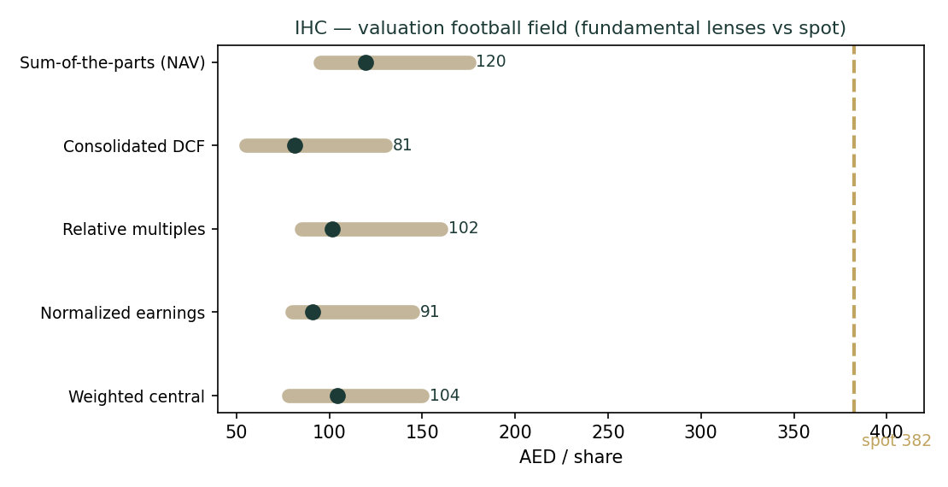
Figure 3. Valuation football field — every fundamental lens sits far below spot (gold).
Weighted central ≈ AED 105/share versus AED 382 spot — a market premium to fundamental value of ~266%. The reads cluster in a AED 81–120 base band; the disagreement among them is small relative to their common distance from the market price. The valuation question is not resolved by choosing among the lenses — it is displaced entirely onto the premium, which §1.7 confronts directly.
1.6 The holding-company assets — a deeper look, and the SOTP-per-share table
The holdco 'Data Miner' below restates the SOTP on a per-share, %-of-value basis (the disciplined-holdco table), so the contribution of each leg is explicit. The listed stakes — Alpha Dhabi and the merging Multiply / 2PointZero / Ghitha entity — are ~45% of gross asset value and are the marks a reader can most readily verify against live ADX prices. The unlisted platforms are ~45% and are the flagged estimates: IRH (metals, including tin and copper exposure) is the largest and the most uncertain; RIQ (reinsurance) is early-stage; the private tail is book-based across a very large number of subsidiaries. Holding-level net cash is the remaining ~8%.
Leg | AED bn | AED / share | % of GAV
Alpha Dhabi (~60%, incl. NMDC / Aldar) | 41.7 | 19.1 | 17%
Merged Multiply / 2PointZero / Ghitha | 66.0 | 30.3 | 27%
Other listed subsidiaries | 25.0 | 11.5 | 10%
IRH — metals & mining | 40.0 | 18.3 | 17%
RIQ — reinsurance | 8.0 | 3.7 | 3%
Private industrial / food / tech + tail | 60.0 | 27.5 | 25%
Gross asset value | 240.7 | 110.4 | 100%
Holding-level net cash | 20.0 | 9.2
NAV per share | 260.7 | 119.6
Note on the disciplined-holdco mechanics: holding-level net cash is a single explicit line (not a blanket discount); each leg carries its own basis; and where a leg is a regulated or price-capped operator (for example a monopoly concession such as Emirates Driving Company inside the tail), its value is normalized on the cap rather than on a peak print — though such regulated exposure is a small share of IHC's value, so the device is noted for completeness rather than being decisive here.
1.7 The premium to NAV — the crux, swung in observable units
The single fact that determines whether IHC is 'expensive' is the premium the market assigns to reconstructable NAV. We swing the crux in observable units rather than an abstract margin (device A-1): the two levers are the NAV premium / discount the market applies, and the mark on the unlisted private tail (the least-verifiable leg). At the base marks, spot AED 382 implies a ~220% premium to look-through NAV of AED 120 (a 3.2× multiple of NAV). To justify the market price on fundamentals alone, one must either mark the private platforms at multiples far above book, or accept a persistent triple-digit premium to NAV — a premium with no analogue among conglomerate holdcos, which trade at discounts.
Binary-event framing (device from the RE overlay, generalized): IHC's price is unusually dependent on a small number of structural supports — a thin, low-turnover float; sponsor and sovereign-ecosystem backing; and index / passive demand. A material change in any one — a large secondary placement that widens the float, a governance or related-party event, or a shift in index treatment — could compress the premium sharply, independent of any change in the underlying assets. Conversely, continued capital-compounding and value-crystallizing deals (the Modon divestment is the template) can sustain it. The premium, not the asset marks, is where the risk and the opportunity both sit.
1.8 Macro and country — the UAE, oil, flows, and the ecosystem
IHC's fundamentals are levered to the Abu Dhabi and wider GCC macro: oil and sovereign liquidity (which fund the ecosystem's deal-making and support asset prices), the AED peg to the US dollar (so UAE rates track the Fed), ADX and MSCI-EM flows, and the region's AI / technology-capital cycle in which IHC and adjacent Royal Group entities are central. Frontier and emerging-market exposure — India (Sammaan Capital), Pakistan (FWBL) and African metals via IRH — adds translation and sentiment risk. None of these is a near-term cliff; collectively they set the backdrop against which the premium is either sustained or compressed, and they are the continuous factors in the Monte Carlo (§3).
1.9 Sensitivity — the crux, and the DCF, in grids
Two grids. The first swings the primary-lens SOTP on the NAV premium and the private-tail mark (both observable / flagged levers, per device A-1). The second swings the operating DCF on WACC × terminal g, and — because the DCF is a high-terminal structure (TV 77.8% of EV) — makes that dependency explicit (device A-7). The published cost of equity (Ke = rf 4.3% + β 1.0 × ERP 5.5% = 9.8%; β held in the 0.8–1.3 house band rather than the observed −0.24, which is a thin-float artifact) anchors the WACC.
SOTP fair value per share — NAV premium (rows) × private-tail mark AED bn (cols):
 | 40 | 50 | 60 | 70 | 80
−20% | 88 | 92 | 96 | 99 | 103
−10% | 99 | 104 | 108 | 112 | 116
0% | 110 | 115 | 120 | 124 | 129
+10% | 122 | 127 | 132 | 137 | 142
+20% | 133 | 138 | 144 | 149 | 155
DCF fair value per share — WACC (rows) × terminal g (cols):
 | 2.5% | 3.0% | 3.5% | 4.0% | 4.5%
8.3% | 84 | 91 | 100 | 111 | 124
8.8% | 77 | 83 | 90 | 98 | 109
9.3% | 71 | 75 | 81 | 88 | 96
9.8% | 65 | 69 | 74 | 80 | 86
10.3% | 60 | 64 | 68 | 73 | 78
Across the entire span of both grids — even a +20% NAV premium on generous private marks, or an 8.3% WACC with 4.5% terminal growth — the fundamental value stays far below the AED 382 spot. The point estimate is not the story; the premium is.
2 Technical and price structure
The tape is soft and, above all, tight. IHC sits below all four major moving averages, arranged in a stepwise-descending stack (the 200-day above the 100-day above the 50-day above the 20-day above price) — the classic signature of a mild, orderly downtrend. Momentum is negative but not extreme (RSI in the low-40s, MACD modestly below its signal). What stands out is the range: a 52-week band of barely 6% (AED 380–404), reflecting the very low turnover and buy-and-hold ownership that also make the observed beta (−0.24) an artifact rather than a true low-risk signal. Price and value point the same direction here — both say 'no near-term catalyst to close the gap' — but for opposite reasons: the fundamentals say expensive, the tape says quietly drifting.
Indicator | Reading | Signal
Price | AED 382.3 | below all MAs
MA20 / MA50 | 384.85 / 388.23 | price below both
MA100 / MA200 | 391.46 / 395.65 | descending stack
RSI (14) | 42.9 | neutral-soft
MACD (12/26/9) | -1.945 (sig -1.617, hist -0.328) | mildly bearish
52-week range | AED 380.0 – 404.0 | very tight (~6%)
52-week change | -4.9% | mild drawdown
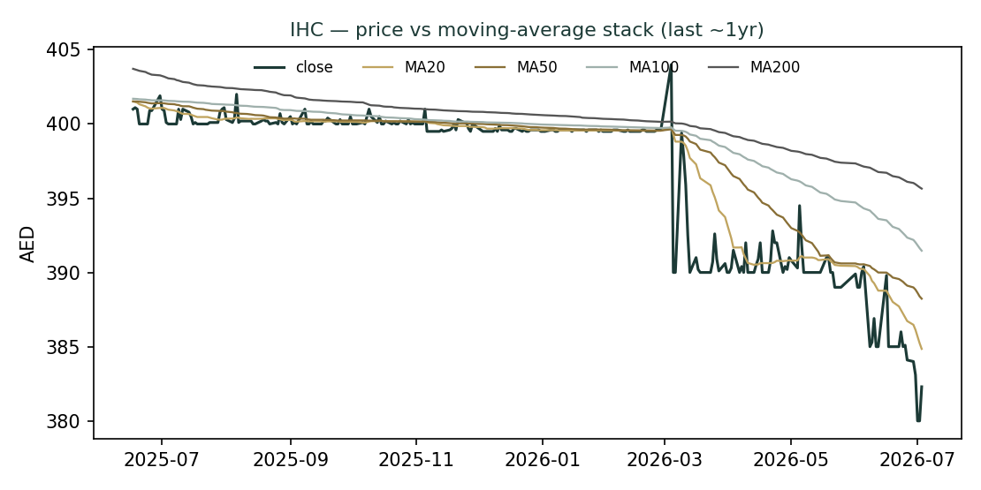
Figure 4. Price below a descending moving-average stack; a soft, low-volatility drift.
3 Monte Carlo — a probabilistic price map
We simulate 50,000 three-month price paths (seed 42) with the house YZ-HAR engine: width is set by a gap-aware Yang-Zhang variance proxy fed through a log-HAR cascade (regime-conditional, so it is tight in IHC's current calm tape); shape is unit-variance Student-t(5) via a per-path variance mixture (an honest body with fatter tails than a Gaussian); and drift is zero — IHC is an international name, and the house rule turns secular drift off for non-EGX names precisely because a confident trend extrapolation breaks at a regime turn (and IHC's own 9× run-up has already given way to a plateau). On top of that diffusion sit sixteen external factors — seven continuous macro / operating drivers contributing a small net forward tilt, and nine discrete events that each fire with a probability and an impact. By design the paths diffuse from spot as near-term price, and deliberately do not embed the fundamental NAV — the value gap of §1 is kept out of the drift, so the fundamental and probabilistic lenses stay independent. The regime-conditional volatility prints low (YZ-HAR σ ≈ 6.1% annualized), while the discrete event overlay widens the realized path vol to ≈ 24% and skews the distribution modestly positive (net factor drift ≈ 2.5% over the quarter). Read the 50% interquartile band first; the 90% tail is the fat-tailed outer envelope, not the central expectation.
Percentile | T+20 (AED) | T+60 (AED)
95th | 428 | 462
75th | 397 | 418
50th (median) | 384 | 391
25th | 376 | 365
5th | 341 | 323
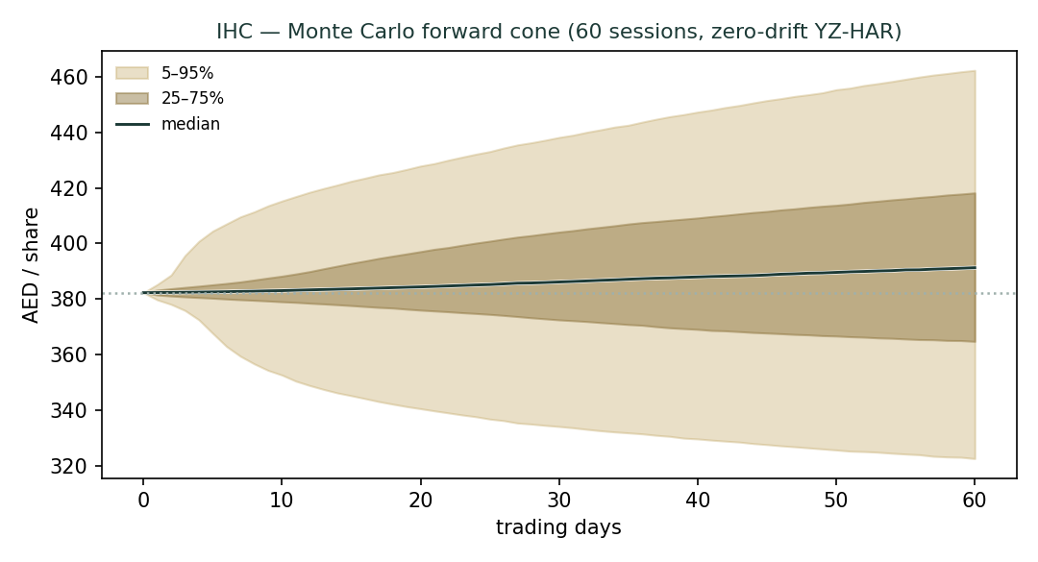
Figure 5. Monte Carlo forward cone (60 sessions). Gold 5–95%, brass 25–75%, white median; spot dashed.
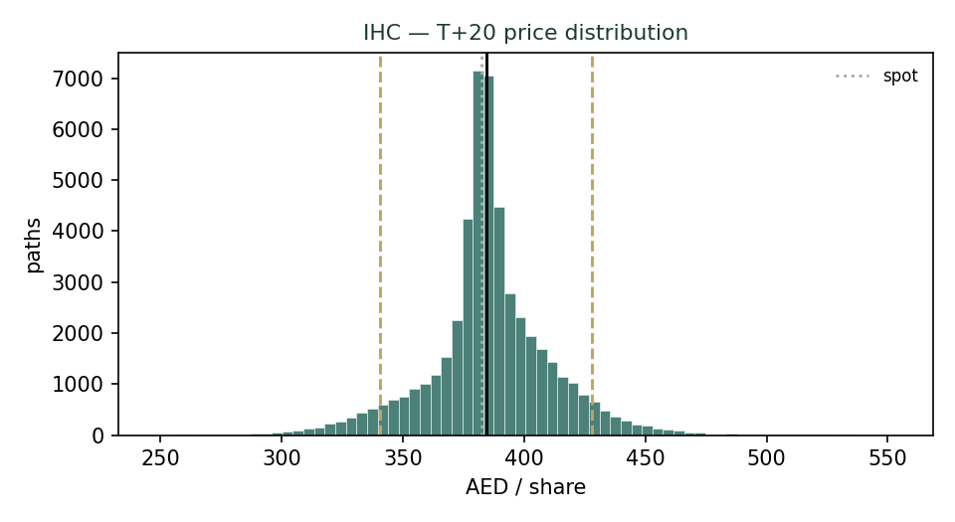
Figure 6. T+20 price distribution.
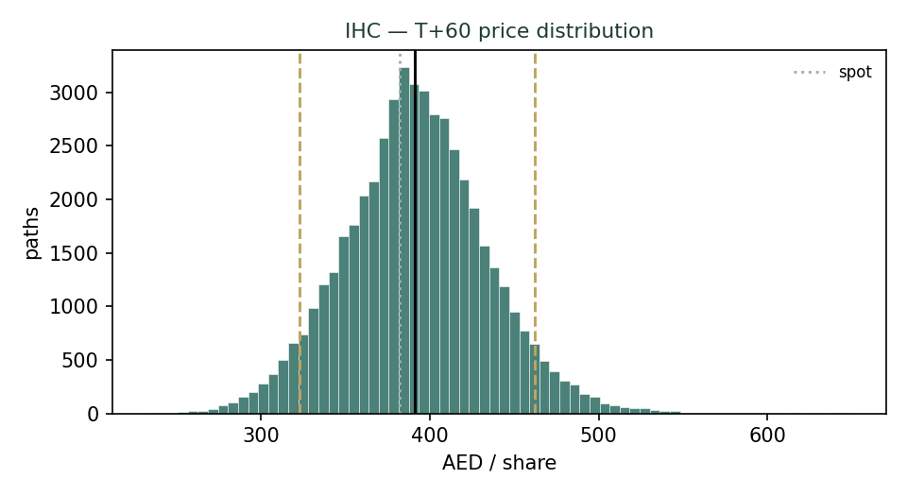
Figure 7. T+60 price distribution — right-skewed by the net-positive event overlay.
Touch-probability ladders — the chance a path trades at or through a level at least once by the horizon:
Level | × spot | P(touch) T+60
AED 394 | 1.03× | 67%
AED 405 | 1.06× | 51%
AED 421 | 1.10× | 33%
AED 440 | 1.15× | 17%
AED 459 | 1.20× | 8%
AED 371 | 0.97× | 47%
AED 359 | 0.94× | 34%
AED 344 | 0.90× | 20%
AED 325 | 0.85× | 9%
AED 306 | 0.80× | 3%
4 Comparison of the lenses, and a verdict
Three lenses, three time-horizons, one instrument. The fundamental lens says IHC is worth ~AED 105 on a blended central basis, anchored by a look-through NAV of ~AED 120 — a value far below the AED 382 market price. The technical lens says the tape is drifting softly lower inside an unusually tight range, with no momentum toward closing that gap in either direction. The probabilistic lens says the next quarter's price most likely diffuses around spot, with a 50% interquartile band of roughly AED 365–418 and a fat-tailed 5–95% envelope of AED 323–462.
The verdict is a study in what our method does and does not claim. On fundamentals, IHC is one of the most expensive large-cap holding companies anywhere relative to reconstructable NAV — the inverse of the usual conglomerate discount. But 'expensive on fundamentals' is not a price forecast: the premium is supported by real, if non-fundamental, structures (scarcity, sponsor and sovereign backing, index and passive demand, and a demonstrated capital-compounding record), and those structures can persist for a long time. The Monte Carlo, by design, does not bet on the premium closing — it maps where price travels from today. The honest integrated read: a large and well-understood gap between price and fundamental value, a soft tape, and a quarter-ahead distribution centred near spot. The reader is left with the premium as the object of judgment, quantified rather than asserted.
5 Catalysts to watch
Catalyst | Direction | Why it matters
Multiply / 2PointZero / Ghitha merger completion | + / structure | Simplifies the tree; crystallizes a large listed leg
Value-crystallizing divestments (Modon template) | + | Turns marks into cash; validates NAV
IRH / private-platform IPO or transaction | + / verification | Would mark the least-verifiable leg to a real price
Large M&A / acquisition announcement | + | IHC is deal-active; skews the near-term distribution up
Index / passive treatment or float change | + / − | Passive demand supports, a widened float compresses, the premium
Oil / GCC sovereign-liquidity swing | + / − | Funds the ecosystem; supports regional asset prices
Governance / related-party / disclosure event | − | Could compress the premium independent of assets
EM / frontier exposure (India, Pakistan, Africa) | + / − | Translation and sentiment via IRH and finance stakes
6 Reading the probability zones
Reading the three-month (T+60) distribution as zones rather than a point. Lead with the interquartile band — the genuine quarter-ahead uncertainty — not the outer tail.
Zone | AED band | Reading
Lower tail (below p5) | < 323 | <5% — needs a real shock (governance, risk-off)
Lower-middle (p5–p25) | 323 – 365 | soft-drift / mild-pullback zone
Core interquartile (p25–p75) | 365 – 418 | most likely; median ≈ 391
Upper-middle (p75–p95) | 418 – 462 | deal / merger / flow upside zone
Upper tail (above p95) | > 462 | <5% — needs a large positive catalyst
The distribution is mildly right-skewed: the net-positive factor overlay (a deal-active flagship with a pending merger and index / flow support) pulls the upside tail a little wider than the downside. None of this speaks to the §1 value gap — these are near-term price zones from spot, not statements about fair value.
7 Caveats and what would change our mind
The load-bearing uncertainties, stated plainly. (1) The unlisted-platform marks — IRH, RIQ and the private tail, ~45% of gross asset value — are the house's own flagged estimates, not disclosure; a real transaction or IPO could move them materially in either direction, and a much higher verifiable mark would narrow (though, on our numbers, not close) the premium. (2) The earnings-quality question — a large share of IHC's reported profit is non-cash fair-value gain; if those gains prove durable and cash-generative rather than one-off, the normalized-earnings and DCF lenses are too conservative. (3) The premium's persistence — we do not forecast it closing, and a reader who believes the scarcity / sponsor / flow structure is permanent should weight the macro-premium expert (Appendix D, Expert 3) more heavily. (4) Thin float and low turnover make both the observed beta and the daily volatility unreliable guides — we use a house beta of 1.0 and a regime-conditional YZ-HAR vol rather than the observed −0.24 / sticky-tape figures. What would change our mind on the fundamentals: a verifiable, transaction-based revaluation of the private platforms well above book, or evidence that the investment gains are a durable realized run-rate rather than marks.
Appendix A Financial statements
Three years historical plus a five-year forecast (AED bn). FY2025 is audited (15 Feb 2026); FY2023 and several balance-sheet line items are estimated to balance to disclosed totals and are flagged. The forecast is deliberately conservative — organic revenue deceleration, a normalized (below-peak) investment-income line, and near-zero dividends. Every figure ties to the companion model.
A.1 Income statement (AED bn)
AED bn | FY23e | FY24A | FY25A | FY26E | FY27E | FY28E | FY29E | FY30E
Revenue | 62.0 | 86.3 | 111.4 | 124.8 | 137.2 | 149.6 | 161.6 | 172.9
EBITDA | 12.4 | 17.3 | 22.7 | 25.0 | 27.4 | 29.9 | 32.3 | 34.6
D&A | (3.1) | (4.3) | (5.0) | (6.2) | (6.9) | (7.5) | (8.1) | (8.6)
EBIT | 9.3 | 13.0 | 17.6 | 18.7 | 20.6 | 22.4 | 24.2 | 25.9
Investment / associate income & FV gains | 26.6 | 17.0 | 22.7 | 12.0 | 12.0 | 12.0 | 12.0 | 12.0
Net finance cost | (2.0) | (2.8) | (3.5) | (3.2) | (3.0) | (2.8) | (2.6) | (2.4)
Profit before tax | 33.9 | 27.2 | 36.8 | 27.5 | 29.6 | 31.6 | 33.6 | 35.5
Tax | (1.0) | (1.6) | (2.1) | (2.5) | (2.7) | (2.8) | (3.0) | (3.2)
Profit after tax (group) | 32.9 | 25.7 | 34.7 | 25.0 | 26.9 | 28.8 | 30.6 | 32.3
Minority interest | (12.9) | (10.0) | (13.1) | (9.5) | (10.2) | (10.9) | (11.6) | (12.3)
Attributable net income | 20.0 | 15.7 | 21.6 | 15.5 | 16.7 | 17.9 | 19.0 | 20.0
EPS (AED) | 9.17 | 7.19 | 9.93 | 7.12 | 7.66 | 8.19 | 8.70 | 9.20
A.2 Balance sheet (AED bn)
AED bn | FY23e | FY24A | FY25A | FY26E | FY27E | FY28E | FY29E | FY30E
Cash & bank | 45.0 | 55.2 | 74.9 | 92.6 | 111.9 | 131.7 | 153.0 | 175.8
Financial investments & associates | 155.0 | 191.6 | 178.8 | 201.1 | 216.3 | 231.5 | 247.6 | 263.9
Property, plant & equipment | 70.0 | 85.0 | 95.0 | 101.2 | 108.1 | 115.6 | 123.7 | 132.3
Other assets | 60.0 | 70.0 | 80.0 | 77.4 | 85.1 | 92.8 | 100.2 | 107.2
Total assets | 330.0 | 401.8 | 428.6 | 472.3 | 521.4 | 571.6 | 624.5 | 679.2
Total borrowings | 80.0 | 92.0 | 100.5 | 105.0 | 108.0 | 110.0 | 112.0 | 114.0
Other liabilities | 50.0 | 65.5 | 77.4 | 77.4 | 85.1 | 92.8 | 100.2 | 107.2
Total liabilities | 130.0 | 157.5 | 177.9 | 182.4 | 193.1 | 202.8 | 212.2 | 221.2
Attributable equity | 120.0 | 140.0 | 151.5 | 167.0 | 183.7 | 201.6 | 220.5 | 240.6
Minority interest | 80.0 | 104.3 | 99.2 | 108.7 | 118.9 | 129.9 | 141.5 | 153.7
Total equity | 200.0 | 244.3 | 250.7 | 275.7 | 302.6 | 331.5 | 362.0 | 394.3
Note: FY2023 and the split of assets (investments as a plug) and liabilities are estimated to balance to disclosed totals; the accounting identity (assets = equity + liabilities) holds in every column in the model.
A.3 Cash flow (AED bn)
AED bn | FY23e | FY24A | FY25A | FY26E | FY27E | FY28E | FY29E | FY30E
EBITDA | 12.4 | 17.3 | 22.7 | 25.0 | 27.4 | 29.9 | 32.3 | 34.6
Tax paid | (1.0) | (1.6) | (2.1) | (2.5) | (2.7) | (2.8) | (3.0) | (3.2)
ΔWorking capital | (1.0) | (1.2) | (1.4) | (0.3) | (0.2) | (0.2) | (0.2) | (0.2)
Cash flow from operations | 10.4 | 14.5 | 19.2 | 22.2 | 24.5 | 26.8 | 29.0 | 31.2
Capex | (3.7) | (5.2) | (6.7) | (7.5) | (8.2) | (9.0) | (9.7) | (10.4)
Free cash flow | 6.7 | 9.3 | 12.5 | 14.7 | 16.3 | 17.8 | 19.3 | 20.8
Ending cash & bank | 45.0 | 55.2 | 74.9 | 92.6 | 111.9 | 131.7 | 153.0 | 175.8
Appendix B Step 0 — calibration backtest
Before valuing IHC we tested the forecasting engine on IHC's own five-year history: a rolling backtest, h = 60 trading sessions, at each origin using only prior data, scoring the realized close against the engine's distribution. The grade is skill versus a naïve benchmark (a zero-drift random-walk lognormal cone at trailing realized vol), measured by CRPS skill (must be > 0) and the interval (Winkler) score. Band-coverage and the PIT histogram are diagnostics only — they reward width and are never the pass criterion.
Metric | YZ-HAR engine | Benchmark | Skill
Mean CRPS (price units) | 13.3992 | 14.1234 | +0.0513
Mean Winkler (80%) | 109.035 | 111.008 | +0.0178
PIT mean (full sample) | 0.555 | — | target 0.50
90% coverage (full sample) | 0.799 | — | diagnostic
Result: the engine beats the random-walk benchmark on CRPS skill (+0.0513) and on the interval score (+0.0178), the pass criterion. The full-sample PIT carries an upper-tail spike, and its cause is instructive and fully disclosed: it is isolated to the 2021–22 hyper-growth origins, when IHC compounded ~9× and no zero-drift cone could contain the run (in that sub-period the engine's CRPS skill is slightly negative and PIT ~0.85). That regime has ended. In the current plateau regime (2023 onward) — the forward-relevant one — the engine is essentially perfectly calibrated: CRPS skill +0.298, PIT mean 0.471, and 90% coverage 0.91. Zero drift is retained per the house international-name rule; extrapolating IHC's historical run-up forward is exactly the regime-turn trap the rule guards against. The engine is fit for the §3 forecast.
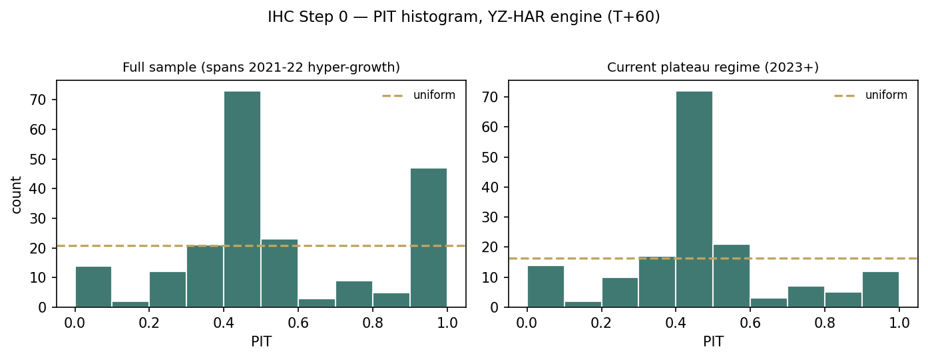
Figure B1. PIT histogram — full sample (left) vs current plateau regime (right). The upper-tail mass is the 2021–22 growth phase.
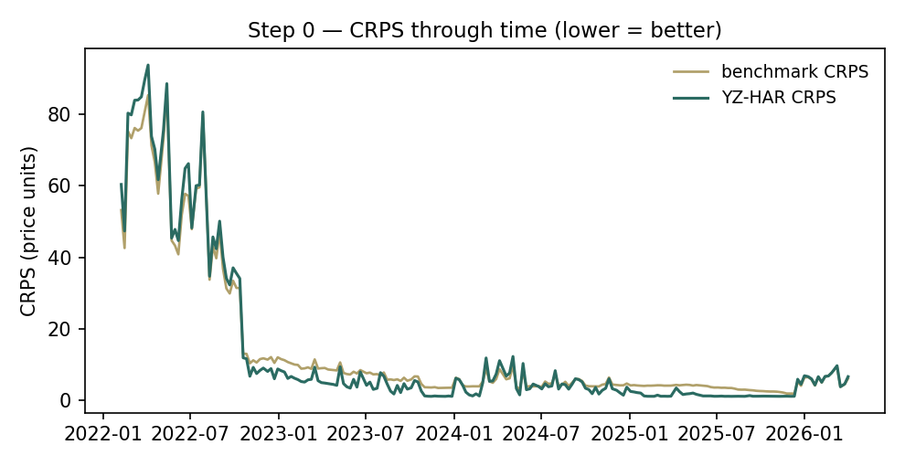
Figure B2. CRPS through time — YZ-HAR (teal) below benchmark (gold) on the great majority of origins.
Appendix C Peer set, sector structure, and risks
Illustrative peer multiples (flagged). Conglomerate holding companies typically trade at 8–14× P/E and, very often, a discount to book; IHC is a large outlier on both.
Peer / comparator | P/E | P/B | NAV disc / (prem)
Alpha Dhabi Holding (ADX, IHC ~60%) | ~15× | ~1.5× | ~0%
Regional GCC investment holdco (avg) | ~12× | ~1.3× | 10–25% disc
Global diversified conglomerate (avg) | ~13× | ~1.4× | 10–30% disc
Global listed-holding / investor co (avg) | ~11× | ~1.1× | 15–35% disc
International Holding Company (IHC) | ~38× | ~5.5× | large premium
Sector & structure. IHC sits atop the Royal Group / Sheikh Tahnoon bin Zayed ecosystem — ~1,300 subsidiaries across eight verticals. Free float is modest and turnover low, so the daily tape is very sticky (the observed −0.24 beta is a float artifact, not a low-risk signal). Reported profit is investment-led: associate income and fair-value gains routinely exceed operating EBITDA, which is why the look-through SOTP, not an operating DCF, is the primary lens. Key risks: (1) concentration on the sponsor / key-man and related-party governance; (2) lumpy revaluation earnings that need not recur; (3) compression of the market's premium to NAV — the dominant price risk; (4) EM / frontier and FX exposure (India, Pakistan, African metals); (5) thin float and low liquidity on size.
About this series
Testahil publishes independent, educational valuation studies under a single house methodology: a fundamental anchor, a technical read, and a probabilistic Monte Carlo map, each computed transparently and presented as ranges and distributions rather than a single number or a rating. Every study closes with a standing panel of expert personas — cast by method from the house library, not invented per study — so that each accumulates a track record across studies, and every forecast is logged to a calibration ledger and graded against a naïve benchmark as its horizon matures. The house tagline is 'distributions, not tips'.
Disclosure & Disclaimer
Not investment advice. This document is an educational valuation exercise and an expression of personal analytical opinion. It is not investment advice, and not a recommendation or solicitation to buy, sell or hold any security. It is not directed at the circumstances of any particular reader.
No license, no clients. The preparer is not licensed or authorised by any securities regulator in any jurisdiction, holds no brokerage authorisation, provides no financial consultancy, manages no money, and accepts no fees, funds or clients.
No rating, no target price. Testahil does not issue ratings or price targets. All values are model outputs presented as ranges and probability distributions because no single number should be relied upon.
Sources and estimates. Reported financials are the company's own disclosure (FY2025 audited results, 15 Feb 2026) and third-party data providers; forward-looking inputs — the look-through marks on listed stakes, the marks on the unlisted platforms, the multiples, the DCF and the Monte-Carlo factor probabilities — are the preparer's judgments and are flagged throughout. Some historical figures are estimated to balance to disclosed totals.
Position disclosure. The preparer may hold, and may in the future take or dispose of, a position in the security discussed in this report.
Consult a professional. Consult a licensed financial advisor before making any investment decision. You are solely responsible for your own investment decisions.
Appendix D The expert valuation panel
Every Testahil study closes with a panel of standing expert personas — drawn from the house Expert Persona Library, not invented for the occasion, so each accumulates a track record across studies and a quarterly update is a re-run, not a re-training. For a holding company the library casts the three whose methods both fit the instrument and genuinely disagree: Expert 1 (NAV and the discount), Expert 2 (the accountant — quality of earnings), and Expert 3 (macro and policy — the scarcity / flow / sponsor premium). Each runs a different method, derives its fair value from shown workings, and states a falsification condition. The three disagree not on what a part is worth but on the one question the name turns on — the premium to reconstructable NAV — and, tellingly, all three land below the market price.
D.1 Expert 1 — NAV and the discount
Worldview and tradition. Expert 1 values a holding company the only way that respects its nature: mark the parts, sum them, net the holding-level debt, and let the resulting NAV be the fair value. A conglomerate is a claim on a portfolio; the right price is the portfolio's value, adjusted by the discount or premium the market has historically assigned to that specific holdco — no more, no less.
When it works / fails. It works when the parts are separately valuable and reasonably markable — listed stakes at market, unlisted at book or transaction. It fails when a large share of value is unlisted and un-transacted (so the marks are soft), or when the holdco's premium / discount is unstable — both of which apply to IHC in part, which is why Expert 1 flags the private-tail mark as the soft leg.
Standard workings. (i) Mark the listed stakes look-through at market; (ii) mark the unlisted platforms at book or a defensible estimate; (iii) sum to gross asset value; (iv) add holding-level net cash as a single explicit line; (v) apply the name's own historical premium / discount — here, for a fair-value estimate, Expert 1 declines to bake in the extreme market premium and strikes NAV at par.
Expert 1's marks (AED bn) | Value
Listed stakes (Alpha Dhabi, merged entity, other) | 132.7
Unlisted platforms (IRH, RIQ, private tail) | 108.0
Gross asset value | 240.7
plus: holding-level net cash | 20.0
NAV (at par) | 260.7
NAV per share | AED 120
A note on the discount-band tradition. Expert 1's school normally anchors the applied premium / discount to the name's own trading history — for most conglomerate holdcos that means a persistent discount (a global peer trading at, say, a 25% discount to NAV against an eight-year average of 30%). IHC inverts this: its history is one of a persistent large premium. Expert 1 deliberately declines to import that historical premium into a fair-value estimate — doing so would simply recover the market price and make the exercise circular — and instead strikes NAV at par, treating the premium as the object to be judged, not an input. This is the single most important methodological choice in his read, and he states it openly.
Worked example / sensitivity (swing = the applied premium). At a 0% premium NAV is AED 120; at a −10% discount AED 108; at a +20% premium AED 144; to reach the AED 382 spot requires a ~+220% premium — a figure with no analogue among conglomerate holdcos. He runs a second swing on the soft leg — the private tail — from AED 40 bn to AED 80 bn, which moves NAV from AED 110 to AED 129: even doubling the least-verifiable mark leaves the value a third of spot. Cross-examination. Expert 1 tells Expert 2 that stripping the investment gains to a harsh run-rate understates a portfolio whose stakes are marked at market, not at earnings; he tells Expert 3 that a 'supportable premium' is still a premium, and that no cash-flow underwrites it.
Verdict, falsification, and what the market price implies. Fair value AED 120; the market pays 3.2× that. Falsified if a verifiable transaction (an IRH IPO, a private-platform sale) marks the unlisted legs far above book, or if the holdco premium proves structurally permanent across a full cycle — in which case NAV-at-par understates. What the market price implies, on his marks: buyers at AED 382 are paying AED 262 per share — the whole of a second IHC — for something that is not in the asset sum at all. Either the private platforms are worth roughly three times his book mark, or the market is capitalizing a premium he regards as a sentiment, not a value.
D.2 Expert 2 — the accountant (quality of earnings)
Worldview and tradition. Expert 2 trusts cash and audited operating results, and distrusts marks. Her question of any company, and especially an investment holdco, is: how much of the reported profit is realized, recurring, cash-generative earnings, and how much is non-cash fair-value uplift that reverses as easily as it appears? She capitalizes only the durable part.
When it works / fails. It works as a discipline against capitalizing peak, mark-driven earnings; it fails if it is too harsh — if the investment gains are, in fact, a durable realized run-rate (a serial capital-recycler that consistently sells assets at a profit does convert marks to cash), the normalization understates.
Standard workings. (i) Start from reported attributable profit; (ii) strip the estimated one-off revaluation and deal gains; (iii) arrive at a mid-cycle recurring attributable earnings figure; (iv) capitalize at a mid-cycle multiple; (v) cross-check against the operating DCF (which, excluding investment income entirely, is the floor).
Expert 2's normalization (AED bn) | Value
Reported attributable NI (FY2025, peak) | 21.6
less: one-off revaluation / deal gains | (5.1)
Mid-cycle recurring attributable earnings | 16.5
× mid-cycle P/E | 12×
Earnings-power value per share | AED 91
Operating-DCF floor cross-check | AED 81
How she separates one-off from recurring. Expert 2 does not simply guess the strip. She looks at the wedge between group PAT and operating EBITDA — AED 34.7 bn against ~AED 22.7 bn in FY2025 — and treats the excess as investment / associate income and fair-value movement, then asks how much of that line is cash realized (dividends received, gains on completed disposals such as the Modon exit) versus unrealized mark-to-market on the portfolio. Only the realized, repeatable portion earns a place in her run-rate; the rest is set aside as a balance-sheet event, not an earnings event. The AED 5.1 bn she strips from attributable profit is her estimate of the unrealized / non-repeatable slice — flagged, like every forward input, as judgment rather than disclosure.
Worked example / sensitivity (swing = normalized earnings / multiple). At AED 16.5 bn × 10× she gets AED 76; at AED 18 bn × 12× she gets AED 99; her central is ~AED 91, and blending in the AED 81 operating-DCF floor pulls her point to ~AED 96. Cross-examination. Expert 2 tells Expert 1 that marking stakes at market imports the very revaluation optimism she strips — the listed subs are themselves richly valued — and that book is a firmer anchor than market for a thin-float ecosystem; she tells Expert 3 that a premium justified by 'flows' is not earnings, and cannot be capitalized.
Verdict, falsification, and what the market price implies. Fair value ~AED 96 — the most conservative of the three. Falsified if the fair-value gains prove durable and cash-generative (realized, not just marked) over a full cycle, in which case her run-rate is too low. What the market price implies, on her numbers: to justify AED 382 the market must be capitalizing something close to peak, revaluation-inflated attributable earnings (~AED 21.6 bn) at roughly 38× — a multiple that assumes both that the gains recur and that they deserve a rich growth rating. She regards that as two heroic assumptions stacked on one line she does not trust.
D.3 Expert 3 — macro and policy (the premium)
Worldview and tradition. Expert 3 starts from the observation that IHC's price has, for years, embedded a large and persistent premium to NAV, and asks not whether that is 'justified' by cash flows — it plainly is not — but whether the structures that produce it are durable enough to be, in effect, part of the instrument. He treats the premium as a policy / market-structure variable and tries to size the premium those structures can support.
When it works / fails. It works when a name's price is genuinely set by scarcity, flows and sponsorship rather than by discounted cash flows — sovereign-adjacent flagships with thin floats and index / passive demand can trade at durable premiums. It fails if the structure changes — a widened float, a governance shock, or a shift in index or sponsor support — at which point the supportable premium collapses toward NAV.
Standard workings. (i) Establish NAV as the floor (AED 120, from Expert 1); (ii) identify the premium-supporting structures — float scarcity / low turnover, sponsor and sovereign backing, index / passive demand, and a capital-compounding record; (iii) size a 'supportable' premium from comparable scarcity-premium situations and the durability of each support; (iv) apply it to NAV, and stress it on the structures rather than on cash flows.
Expert 3's premium build | Value
NAV floor (from Expert 1) | AED 120
Scarcity / low-float support | + premium
Sponsor / sovereign-ecosystem support | + premium
Index / passive-demand support | + premium
Supportable premium to NAV (est.) | ~95%
Macro-premium value per share | AED 235
Where the premium comes from — the comparables. Expert 3 grounds the 'supportable premium' in situations where price has durably diverged from asset value for structural reasons: sovereign-adjacent flagships with thin floats and heavy passive ownership, scarcity names that index funds must hold at any valuation, and founder / sponsor vehicles where a single aligned owner both controls the float and signals long-horizon commitment. IHC has all three characteristics at once — a controlling sponsor in the Royal Group ecosystem, a modest free float with low turnover, and index / passive demand that scales with its market capitalization rather than its fundamentals. He does not claim these justify any premium; he claims they can sustain one, and that the burden is to size it, not to deny it.
Worked example / sensitivity (swing = the supportable premium). At a +60% premium he gets AED 192; at +95%, AED 235; at +130%, AED 276 — and even his most generous case sits below the AED 382 spot, i.e. the market is currently pricing a premium above what even the premium's advocate will defend. Cross-examination. Expert 3 tells Expert 1 that NAV-at-par ignores a decade of evidence that this specific name does not trade at NAV and never has; he tells Expert 2 that quality-of-earnings purism misses the point — the price is not set by earnings at all, but by who wants to own a scarce sovereign-adjacent compounder.
Verdict, falsification, and what the market price implies. Fair value ~AED 235 — the most bullish, yet still a discount to spot. Falsified if the float widens materially, a governance event lands, or index / sponsor support wanes — in which case the supportable premium compresses toward Expert 1's NAV. What the market price implies, even on his generous frame: at AED 382 the market prices a ~220% premium to NAV against the ~95% he can defend — so the marginal buyer is paying not only for the structural premium he models but for a further ~125 points of premium on top of it. His conclusion is the study's in miniature: the premium is real and may persist, but the current price extends it beyond what even its advocate will underwrite.
D.5 The three in one room
Expert 1: "Mark the parts. The listed stakes are worth what ADX says; the private platforms are worth roughly book. Sum them, add the cash, and you have AED 120 a share. The market pays three times that. The argument is the premium, not the marks."
Expert 2: "And half the reported profit is a mark, not a cash. Strip the revaluation gains to a recurring run-rate and the earnings power is AED 90-odd — the operating cash alone barely supports AED 80. You are both capitalizing optimism: you at the stake level, the market at the group level."
Expert 3: "You are both valuing a company. The market is pricing a scarce, sovereign-backed compounder that almost no one can buy in size and that indices must own. That structure has held for years; it can support a large premium — I can defend AED 235. But notice what that means: even I, the premium's advocate, land below AED 382. The market is pricing more premium than the premium is worth."
Expert 1: "Then we agree on the only thing that matters. My AED 120, your AED 235 — pick anywhere in between, and the market is still above all of us. The disagreement among the three of us is smaller than the disagreement between any of us and the tape."
Expert 2: "Which is the honest place to leave the reader: not with a number, but with a premium to weigh — and the knowledge that on cash, on assets, and even on scarcity, the price is asking a lot."
D.6 Reading the divergence
Expert | Method | One assumption that drives it | Fair value
Expert 1 | Look-through NAV | Premium struck at par (0%) | AED 120
Expert 2 | Quality of earnings | Investment gains are mostly one-off | AED 96
Expert 3 | Macro / premium | A ~95% premium to NAV is supportable | AED 235
The spread — AED 96 to AED 235 at base — is wide, and it is almost entirely a premium disagreement: none of the three contests the marks on the listed stakes, the existence of the private platforms, or the balance sheet. What separates them is how to treat the gap between reconstructable NAV and the market price. Expert 1 refuses to capitalize it; Expert 2 refuses to capitalize the earnings behind it; Expert 3 sizes the part of it that structure can support. The AED 139 spread is therefore a clean measure of one uncertainty — how much of IHC's premium to NAV is durable — and the single most important fact in the whole study is that all three experts, across the full width of that disagreement, land below the AED 382 market price. Resolve the premium's durability, and the three converge; either way, the fundamental case says the market is paying for more premium than any of the three will underwrite.
Panel calibration note. Consistent with the house method, each expert's point fair value is logged with the study date and spot as an internal per-expert calibration layer, separate from the core Calibration Ledger that grades the §3 probabilistic forecast: Expert 1 (NAV & discount) AED 120, Expert 2 (accountant) AED 96, Expert 3 (macro / premium) AED 235, at a spot of AED 382 on 3 Jul 2026. Because these are the same three personas cast from the library on every holding-company study, a future re-run on fresh data is a re-scoring of the same methods, not a re-training — so the panel accumulates a comparable track record, and a subsequent update will show, line by line, how each expert's prior estimate fared against the realized print (the fundamental analogue of the Step 0 ledger). No expert here recommends an action; each states a value, the one assumption that drives it, and the condition under which it is wrong.

Testahil · Independent Valuation Study — Educational Analysis · International Holding Company PJSC (ADX: IHC) · edition 04 Jul 2026 · prices & probabilities computed from the attached daily history · not investment advice.

