Testahil · Independent Valuation Study — Educational Analysis | Not investment advice

Independent Valuation Study — Educational Analysis
Infosys Limited (NSE: INFY)
Fundamental analysis · Technical analysis · Monte Carlo simulation — one integrated read
Anchor: ₹1,042 (6 Jul 2026 close) · ~414 cr shares · mkt cap ~₹4.32 tn (₹431,679 cr) · a global IT-services and AI-first consulting franchise, net cash and zero-debt · prices and probabilities computed 6 Jul 2026 from the attached daily history · primary lens: discounted cash flow (FCFF) · the swing factor is GenAI's effect on the labour-arbitrage revenue model and the operating margin.
READ FIRST — what this document is, and is not. This study is a valuation exercise and an expression of personal analytical opinion, published free of charge for educational purposes: it shows how one analyst applies fundamental, technical and probabilistic methods to a listed company, and invites scrutiny of that methodology. It is NOT investment advice, NOT a recommendation or solicitation to buy, sell or hold any security, and NOT directed at the circumstances of any reader. The preparer is not licensed by any securities regulator in any jurisdiction, holds no Indian or other brokerage authorisation, provides no financial consultancy, manages no money, and accepts no fees, funds or clients. All values are model outputs presented as ranges and distributions because no single number should be relied on. Reported financials are the company's own disclosure (FY26 results, 23 April 2026); forward-looking inputs — the DCF, the multiples, the normalized-earnings marks and the Monte-Carlo factor probabilities — are the preparer's judgments and are flagged throughout. Consult a licensed financial advisor before any investment decision.

Headline
The model's read: a quality compounder de-rated to a value multiple, with the upside resting on the labour-arbitrage model surviving GenAI and the margin holding. At ₹1,042 the shares sit about 19% below our weighted central estimate of ₹1,242. The four lenses point the same way but by different amounts: a deliberately conservative intrinsic DCF marks the floor at ₹1,143 (+10%), while the shareholder-yield (₹1,267), relative-multiple (₹1,284) and normalized-earnings (₹1,368) reads — which credit a re-rating back toward the multiple Infosys has historically commanded — mark the ceiling. The stock trades on ~14.6× trailing earnings and ~9.4× EV/EBITDA against a franchise that still earns a ~33% return on equity, converts more than 100% of profit to cash, and returned over ₹37,500 cr to owners in FY26. The bear case is not leverage or accounting — it is that generative AI compresses the pyramid the whole industry is built on. That single question, not the balance sheet, is why the range is wide.
Valuation summary — every read at a glance
Lens / read | What it measures | Output | Takeaway
FUNDAMENTAL — what the business is worth (the anchor)
DCF (intrinsic FCFF) — primary | Explicit 5-yr FCFF, WACC 12%, g 4.5% | ₹1,143 | +10% vs ₹1,042
Owner earnings / shareholder yield | Normalized FCF/share capitalized | ₹1,267 | +22%
Relative multiples | Fwd EV/EBITDA re-rating | ₹1,284 | +23%
Normalized earnings power | Normalized EPS × justified P/E | ₹1,368 | +31%
Weighted central | Blend 40 / 15 / 25 / 20 | ₹1,242 | +19% vs ₹1,042
TECHNICAL — what the tape is doing (timing, not value)
Trend / momentum | Below all MAs; RSI ~37; MACD negative | Weak | Floor near 52-wk low ~₹985
MONTE CARLO — where price could go in 3 months (paths from spot)
T+60 distribution | 50,000 paths, YZ-HAR, seed 42 | Median ₹1,058 | p5–p95 ₹845–₹1,326
EXPERT PANEL — three independent methods (Appendix C)
Expert 1 — normalized earnings power | Mid-cycle margin × justified P/E | ₹1,368 | Most bullish
Expert 2 — cash returns (DCF + ROIC) | Return on capital vs ~12% WACC | ₹1,143 | The anchor
Expert 3 — scenario-weighted macro | GenAI-demand real options | ₹1,150 | Most conservative
Panel range | Spread = the GenAI question | ₹1,143–₹1,368 | Centres ~₹1,220

Weights: the intrinsic DCF carries the most weight as the cash-based anchor; the relative and normalized lenses carry the re-rating thesis; the shareholder-yield lens is the cross-check that the cash actually reaches owners.
Infosys at a glance
Item | Value
Listing | NSE / BSE: INFY · ADR: INFY (NYSE)
Business | Global IT services, consulting and next-generation digital / AI services
Spot price | ₹1,042 (6 Jul 2026 close)
Shares outstanding | ~414 cr (~4,142 mn)
Market capitalisation | ₹431,679 cr (~₹4.32 tn · ~$5 bn)
Net cash | ~₹43,000 cr (zero borrowings)
FY26 revenue | ₹178,650 cr ($20,158 mn · +9.6% INR / +3.1% cc)
FY26 operating margin | 20.3% reported · ~21.0% adjusted
FY26 net profit / EPS | ₹29,440 cr · EPS ₹72
FY26 free cash flow | ₹33,097 cr (>100% of PAT)
FY26 deal wins (TCV) | $14.9 bn large-deal total contract value
Capital returned FY26 | >₹37,500 cr (dividends ₹48/sh + buyback)
Return on equity | ~33%
FY27 guidance | Revenue +1.5% to +3.5% cc · operating margin 20–22%
Primary valuation lens | Discounted cash flow (FCFF) — single-segment IT-services franchise
Central fair value | ₹1,242 (range ₹995–₹1,556) · +19% vs spot

1 Fundamental valuation — what the business is worth
Infosys is a single operating business — a global IT-services and consulting franchise — so the valuation does not need a sum-of-the-parts. Cash flow is the natural language for it: the company is asset-light, converts more than 100% of accounting profit into free cash, carries no debt, and hands the surplus back to owners every year. The discounted-cash-flow lens is therefore primary, and three further lenses — owner earnings, relative multiples, and normalized earnings power — cross-check it. The four are then weighted into a single football field rather than blended into a false-precision point.
1.1 Primary lens — discounted cash flow (FCFF)
We forecast five explicit years of free cash flow to the firm, discount them at a 12.0% weighted-average cost of capital, and add a Gordon terminal value at 4.5% perpetual growth. Because the balance sheet is all-equity, the WACC is simply the cost of equity, published transparently rather than as a black box:
Ke = rf + β × ERP = 6.5% + 0.90 × 6.0% = 11.9%, rounded to a 12.0% discount rate. Net cash is added back after discounting; no debt means no separate cost-of-debt leg. Revenue compounds at 5–7% through the window (in line with the reported book and a recovering discretionary cycle), the operating margin holds in the guided 21–22% band, tax runs at 26%, and capex stays light at ~1.9% of revenue.
₹ cr | FY27E | FY28E | FY29E | FY30E | FY31E
Revenue | 187,582 | 198,837 | 212,756 | 227,649 | 242,446
growth % | 5.0% | 6.0% | 7.0% | 7.0% | 6.5%
EBITDA | 44,457 | 48,119 | 52,551 | 56,229 | 59,884
Less: D&A | (5,065) | (5,369) | (5,744) | (6,147) | (6,546)
EBIT | 39,392 | 42,750 | 46,806 | 50,083 | 53,338
EBIT margin % | 21.0% | 21.5% | 22.0% | 22.0% | 22.0%
Less: tax @ 26% | (10,242) | (11,115) | (12,170) | (13,022) | (13,868)
NOPAT (EBIT × (1−t)) | 29,150 | 31,635 | 34,637 | 37,061 | 39,470
Add: D&A | 5,065 | 5,369 | 5,744 | 6,147 | 6,546
Less: capex | (3,400) | (3,700) | (4,000) | (4,300) | (4,600)
Less: Δ working capital | (1,385) | (1,745) | (2,157) | (2,308) | (2,294)
Free cash flow to firm | 29,431 | 31,559 | 34,224 | 36,599 | 39,123
Discount factor @ 12.0% | 0.893 | 0.797 | 0.712 | 0.636 | 0.567
PV of FCFF | 26,277 | 25,159 | 24,360 | 23,260 | 22,199

Free cash flow to the firm, five-year explicit forecast. Every input links to the model's Assumptions sheet. Capex and Δ working capital shown in parentheses.
DCF bridge (₹ cr unless stated) | Value
Sum of PV of explicit FCFF (FY27–31E) | 121,255
Terminal value (Gordon, g = 4.5%) | 545,110
PV of terminal value | 309,310
Enterprise value | 430,565
Terminal value as % of EV | 71.8%
Add: net cash | 43,000
Equity value | 473,565
÷ shares (cr) | 414
DCF fair value per share | ₹1,143

The DCF marks intrinsic fair value at ₹1,143 per share — about 10% above spot. Note the terminal value is 72% of enterprise value (device A-7 disclosure): like every going-concern DCF this is materially a bet on the perpetual-growth-versus-discount-rate spread, which is why §1.9 sensitizes both. This is the deliberately conservative floor of the four lenses; it credits no re-rating and no margin expansion beyond the guided band.
1.2 Cash-flow cross-check — owner earnings and shareholder yield
A simpler cash lens values Infosys on the cash it actually returns. FY26 free cash flow was ₹33,097 cr, a ~7.7% free-cash-flow yield at spot; the company paid ₹48 a share in dividends (a ~4.6% yield) and bought back stock on top. Capitalising a normalized, modestly-growing owner-earnings stream — mid-cycle FCF per share around ₹80 growing with the book, at a yield the market has historically accepted for a franchise of this quality — supports a value of ₹1,267 per share. It is the honesty check on the DCF: the cash the DCF projects is the same cash owners have been receiving.
Owner earnings | Value
FY26 free cash flow (₹ cr) | 33,097
FCF per share | ₹80
FCF yield at spot | 7.7%
Dividend per share (FY26) | ₹48
Dividend yield at spot | 4.6%
Capitalised owner-earnings value / share | ₹1,267

1.3 Relative multiples — the re-rating lens
Infosys trades at ~14.6× trailing earnings and ~9.4× EV/EBITDA. That is a discount both to its own five-year history (which has spent long stretches nearer 22–26× earnings) and to its closest listed peers. The relative lens asks a single question: if the discretionary-demand cycle recovers and the GenAI fear proves overdone, what does the stock earn back? Applying a still-conservative ~17–18× forward earnings / ~11× forward EV/EBITDA — below the historical peak, not at it — supports ₹1,284 per share.
Company | P/E | EV/EBITDA | Div yield | ROE
Infosys (spot) | 14.6× | 9.4× | 4.6% | ~33%
Tata Consultancy Services | 22× | 15× | 3.4% | ~50%
HCLTech | 20× | 12× | 3.9% | ~23%
Wipro | 18× | 11× | 2.6% | ~16%
LTIMindtree | 26× | 17× | 1.6% | ~26%
Accenture (US, ref.) | 24× | 15× | 1.8% | ~30%

Peer multiples are the preparer's approximate sector read for relative context, not live quotes; they frame the discount, and are not a recommendation. Infosys row shaded.
1.4 Normalized earnings power
Where are we in the cycle? IT-services demand is cyclical around a secular-growth trend, and FY26 sits closer to a discretionary trough than a peak: clients have deferred transformation spend, and pricing is under GenAI scrutiny. Normalizing to mid-cycle — revenue growth back toward high-single digits, the operating margin at the top of the guided band as utilization and GenAI-tooling benefits accrue — lifts sustainable EPS toward ₹83–₹91. Capitalising that at a justified ~18× (still below the historical average multiple for the franchise) supports ₹1,368 per share — the most optimistic of the four lenses because it credits both a demand recovery and a re-rating. Peak/mid/trough framing (device A-6): we treat current earnings as mid-to-trough, not peak, and normalize upward with that stated explicitly.
1.5 Synthesis — four lenses, weighted
No single lens is the answer; each measures a different thing. We weight the intrinsic DCF most heavily as the cash-based anchor, give the relative and normalized lenses the re-rating thesis, and use owner-earnings as the cross-check that the cash reaches owners. The result is a range, presented as a football field, not a single blended number — the divergent DCF and multiple values are kept visibly apart (device A-8).
Lens | Weight | Bear | Base | Bull
DCF (intrinsic FCFF) | 40% | ₹941 | ₹1,143 | ₹1,474
Owner earnings / yield | 15% | ₹1,010 | ₹1,267 | ₹1,540
Relative multiples | 25% | ₹1,015 | ₹1,284 | ₹1,605
Normalized earnings power | 20% | ₹1,065 | ₹1,368 | ₹1,672
Weighted central | 100% | ₹995 | ₹1,242 | ₹1,556

Weighted central fair value ₹1,242 (bear ₹995 · bull ₹1,556), about +19% above the ₹1,042 spot. The spread from bear to bull is wide by design — it is almost entirely the GenAI question of §1.7, not balance-sheet or accounting risk.
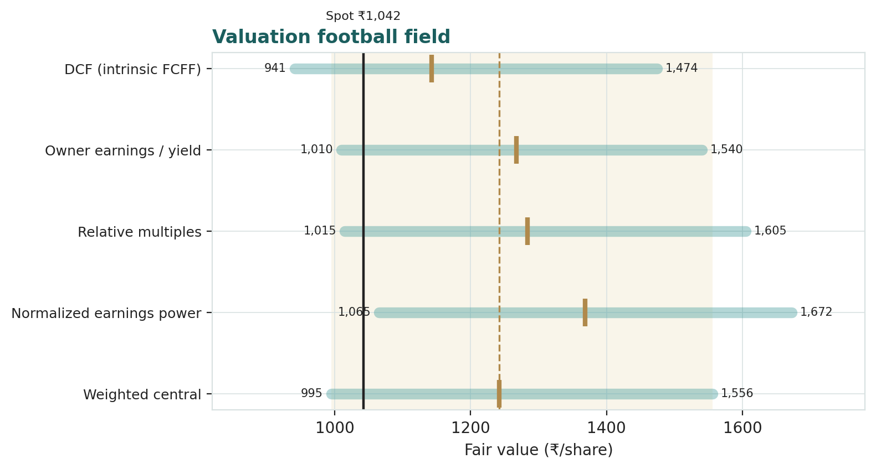
Figure 1 — Valuation football field. Each bar is one lens's bear-to-bull range; the marker is its base case. The vertical line is spot; the shaded band is the weighted central estimate.
1.6 A deeper look — verticals and geographies
Infosys is one business, but its revenue is spread across industry verticals and regions, and the scorecard shows where the cycle is biting and where the durable demand sits.
Vertical | ~Share | Read | Cycle
Financial services | ~28% | Largest vertical; rate-sensitive, but core-modernisation demand durable | Neutral
Retail / CPG / logistics | ~15% | Discretionary-spend exposed; first to cut, first to recover | Cyclical
Communications / media | ~11% | Cost pressure on clients; steady rather than growth | Soft
Energy / utilities / resources | ~12% | Energy-transition and grid-modernisation spend supportive | Positive
Manufacturing | ~15% | ER&D and digital-engineering demand structurally growing | Positive
Hi-tech / life sciences / other | ~19% | GenAI-platform build-out both a threat and an opportunity | Watch

Geography | Share | Read
North America | 55.7% | Dominant market; USD revenue, discretionary-cycle sensitive
Europe | 28.6% | Growing share; cost-takeout and vendor-consolidation demand
India | 2.6% | Small; domestic digital / government
Rest of world | 13.1% | Middle East, APAC, LatAm — diversifying

1.7 The crux — generative AI and the labour-arbitrage model
Every lens above turns on one question, and it is not financial: does generative AI compress the people-pyramid that IT services is built on? The industry bills a spread between the offshore cost of an engineer-hour and the price charged for it, leveraged across a pyramid of juniors. If GenAI automates the junior tier, two things can happen at once — revenue per project falls (fewer billable hours) and margin rises (cheaper delivery). The net is genuinely two-sided, which is why the fair-value range is wide. We sensitize the crux in observable units — the change in effective realized revenue per delivered unit of work, and the offsetting delivery-margin change — not an abstract EBITDA-margin percentage (device A-1):
GenAI scenario | Observable driver move | Fair value / sh
Bear — AI deflates pricing faster than cost | Revenue/unit −8 to −12%; margin +50–100 bp only | ₹995
Base — pricing and cost move together | Revenue/unit −2 to −4%; margin +100–150 bp | ₹1,242
Bull — AI is a demand and margin tailwind | New AI-build revenue offsets deflation; margin +150–250 bp | ₹1,556

The base case assumes Infosys does what the leaders have done through prior technology shifts — cannibalise its own hours and keep the margin — rather than being disintermediated. That is a judgment, and it is the single assumption most worth disagreeing with.
1.8 Macro and country context
Three macro variables sit under the model. First, US and European discretionary-technology demand: the revenue book is ~84% North America plus Europe, so the client capex cycle there is the top-line driver. Second, the rupee: Infosys bills largely in dollars and reports in rupees, so a weaker rupee flatters reported revenue and margin (a natural hedge on the offshore cost base) — we hold USD/INR at ~88 and treat further depreciation as upside, not base. Third, the US labour and immigration backdrop (visa costs, onshore wage inflation) shapes the delivery-margin path. None of these is a solvency risk for a net-cash company; they are swing factors on the pace, not the direction, of value.
1.9 Primary-lens sensitivity — WACC × terminal growth
Because the DCF's terminal value is ~72% of enterprise value, the fair value is most sensitive to the discount rate and the perpetual-growth assumption. The grid below reprices the DCF across both; our base (12.0% WACC, 4.5% g) sits mid-grid at ₹1,143.
WACC ↓ / g → | 3.5% | 4.0% | 4.5% | 5.0% | 5.5%
11.0% | ₹1,178 | ₹1,237 | ₹1,306 | ₹1,385 | ₹1,480
11.5% | ₹1,109 | ₹1,160 | ₹1,219 | ₹1,286 | ₹1,364
12.0% | ₹1,049 | ₹1,093 | ₹1,143 | ₹1,200 | ₹1,266
12.5% | ₹996 | ₹1,034 | ₹1,077 | ₹1,127 | ₹1,183
13.0% | ₹948 | ₹981 | ₹1,019 | ₹1,062 | ₹1,110

Figure/Table — DCF fair value per share across WACC and terminal growth. Base case (12.0% × 4.5%) is the shaded row / centre. The spread shows how much of the value is a terminal-spread bet.
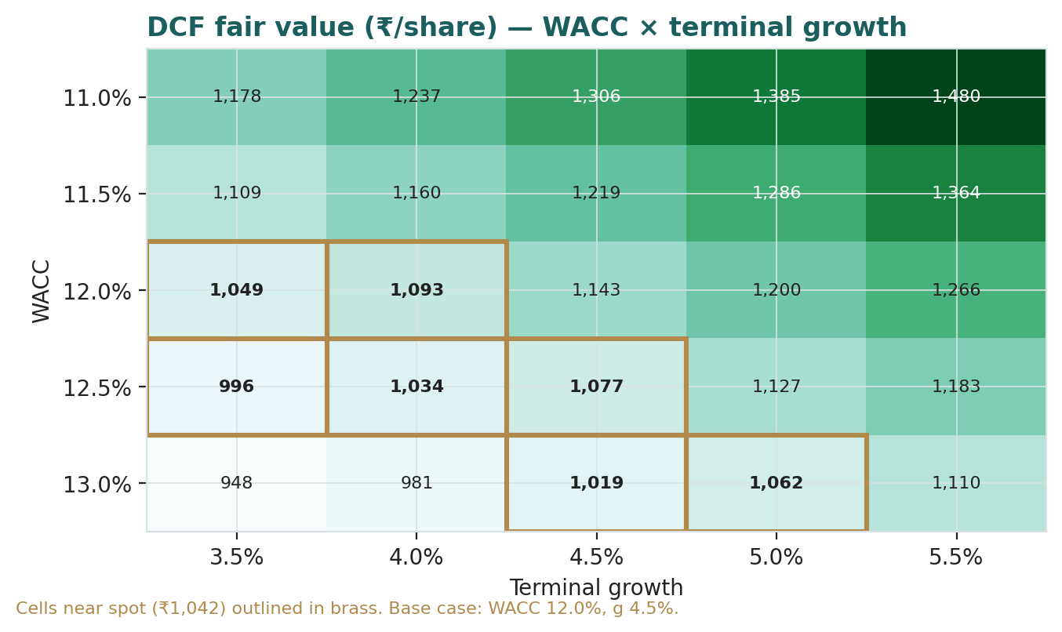
Figure 2 — the same sensitivity as a heat map; cells near spot are shaded warm.
2 Technical and price structure
The tape and the fundamentals disagree right now, and that disagreement is the opportunity the study is built around. On value, the business looks cheap; on price, the trend is clearly down. Both can be true — technicals describe timing and positioning, not worth.
Indicator | Level | Read
Spot | ₹1,042 | —
20-day SMA | ₹1,085 | Spot below
50-day SMA | ₹1,138 | Spot below
100-day SMA | ₹1,230 | Spot below
200-day SMA | ₹1,395 | Spot well below — primary downtrend
RSI (14) | 36.6 | Weak, not yet oversold (<30)
MACD line / signal | -39.6 / -37.9 | Below signal — bearish
MACD histogram | -1.75 | Negative
52-week range | ₹985 – ₹1,690 | Spot ~8% of range
Realized vol (252d) | 28.8% | Elevated

The stock sits below every major moving average with a negative MACD and a sub-40 RSI — an unambiguous downtrend, with the rising support near the 52-week low around ₹985 the level the tape is defending. A technician waits for price to reclaim the 20- and 50-day averages before calling a turn; a value buyer reads the same chart as the discount the fundamentals are offering. The Monte-Carlo section that follows quantifies, from this exact price structure, where the next three months could land.
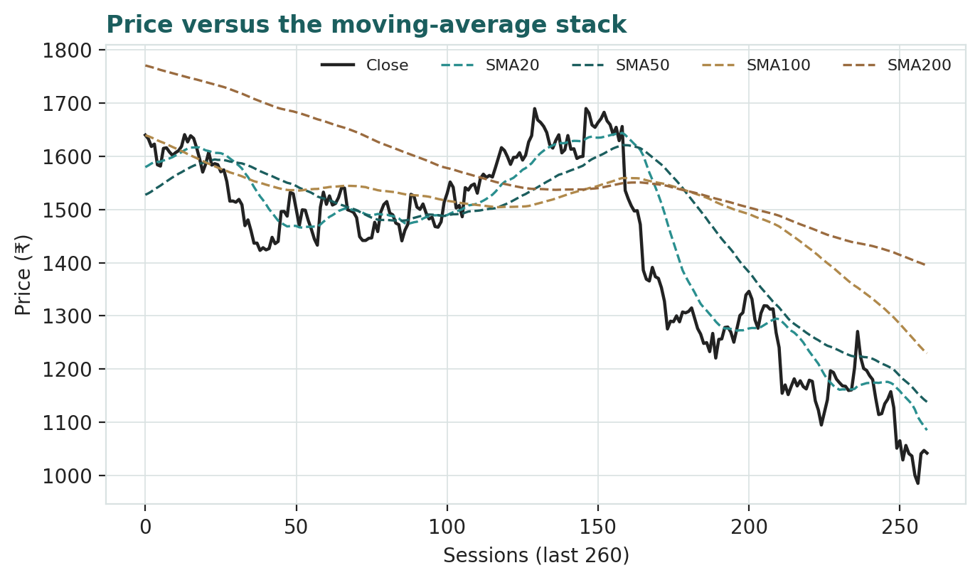
Figure 3 — price against its 20/50/100/200-day moving-average stack. Price is below all four; the shaded zone marks the 52-week low support.
3 Monte Carlo — where price could go in three months
The fundamental sections ask what Infosys is worth. This section asks a different question: given how this specific stock actually moves, where could the price be in one and three months? We simulate 50,000 price paths from today's spot and read the distribution. The paths diffuse from spot, and the §1 value gap is deliberately kept out of the drift — this is a picture of price risk, not a restatement of fair value.
The probability read
The probability read (T+60, 50,000 paths) | Value
P(price above spot) at T+60 | 55%
P(+10%) vs P(−10%) | 26% vs 17% (odds ~1.5 : 1 up)
Median level (and % move) | ₹1,058 (+1.6%)
50% band (25th–75th) | ₹972 – ₹1,151 (17% of spot)
Touch(+10%) vs Touch(−10%) | 44% vs 33%

Read in plain terms: a near-even coin on direction (55% above spot), tilted modestly up by the net factor skew, with a positive touch asymmetry — over a quarter the stock is about 1.5 times more likely to be 10% higher than 10% lower. This is honest factor skew on a zero-drift diffusion, not a manufactured trend. The 50% band is the number to hold onto: half the paths land within roughly ₹972–₹1,151.
3.1 Engine — width, shape, drift
Width is set by a Yang-Zhang / HAR volatility engine rather than plain trailing-252-day close-to-close vol: a pooled log-HAR cascade projects average daily variance over the next 60 sessions from a gap-aware, open-high-low-close variance proxy, so the cone is tight in calm tape and wide in stormy tape. Shape uses Student-t(5) innovations so the tails are honest without inflating the interquartile body. Drift is asset-class-conditional and, for an international IT-services name, the secular drift is set to zero — a confident trend drift breaks at exactly the regime turns that matter, so direction is left to come only from the factor stack, never from extrapolating the past return.
Engine parameter | Value
Annualised HAR volatility | 27.0%
Realised 60-day path volatility (simulated) | 29.5%
Innovation shape | Student-t(5), unit variance
Secular drift | Zero (international class)
Net factor contribution to 3-month drift | +2.5%
Paths / seed | 50,000 / 42

3.2 The 16-factor overlay
On top of the zero-drift diffusion sit sixteen factors — seven continuous macro / sector channels and nine discrete events over the quarter. They net to a small positive drift and, more importantly, an honest skew: the GenAI-deflation and US-recession tails pull down, the capital-return and deal-momentum factors push up.
Continuous factor (7) | Sign | 3m drift | 3m vol
US/EU discretionary IT-spend cycle | + | +1.5% | 5%
USD/INR (bills USD, reports INR) | + | +0.8% | 4%
GenAI / automation deflation | - | -1.2% | 5%
Fed-path / global risk appetite | mixed | +0.4% | 5%
India / EM equity flows (Nifty beta) | + | +0.6% | 6%
Wage inflation / supply-side cost | - | -0.6% | 3%
Large-deal TCV / bookings momentum | + | +0.5% | 4%

Discrete event (9) | Sign | Prob | Impact | Spread
Q1 FY27 results (late-Jul) | mixed | 85% | +0.4% | ±3%
FY27 revenue-growth guidance revision | mixed | 45% | +0.5% | ±3%
Mega-deal win or loss (>$0.5bn TCV) | mixed | 45% | +1.0% | ±4%
US recession / discretionary-spend freeze | - | 20% | -3.0% | ±3%
GenAI pricing-deflation / insourcing shock | - | 25% | -2.0% | ±3%
Buyback / special-dividend announcement | + | 25% | +2.0% | ±2%
Visa / H-1B immigration-policy shock | - | 20% | -1.5% | ±2%
USD/INR sharp move | mixed | 30% | +0.5% | ±3%
Index / passive-flow rebalancing | + | 25% | +0.8% | ±2%

3.3 Forecast distribution — percentiles
Horizon | 5th | 25th | Median | 75th | 95th
T+20 (~1 month) | ₹918 | ₹998 | ₹1,047 | ₹1,099 | ₹1,193
T+60 (~3 months) | ₹845 | ₹972 | ₹1,058 | ₹1,151 | ₹1,326

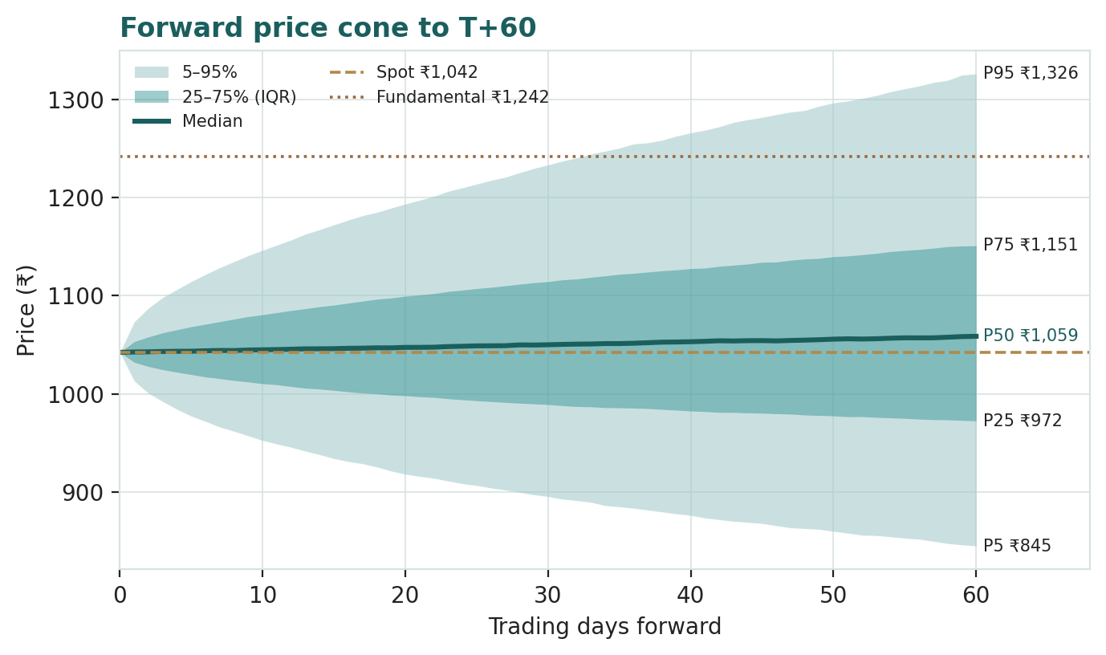
Figure 4 — forward price cone from spot. Shaded bands are the 50% (25th–75th) and 90% (5th–95th) intervals; the dashed line is the simulated median. The horizontal marker is the §1 weighted central fair value, shown for reference only — it does not steer the paths.
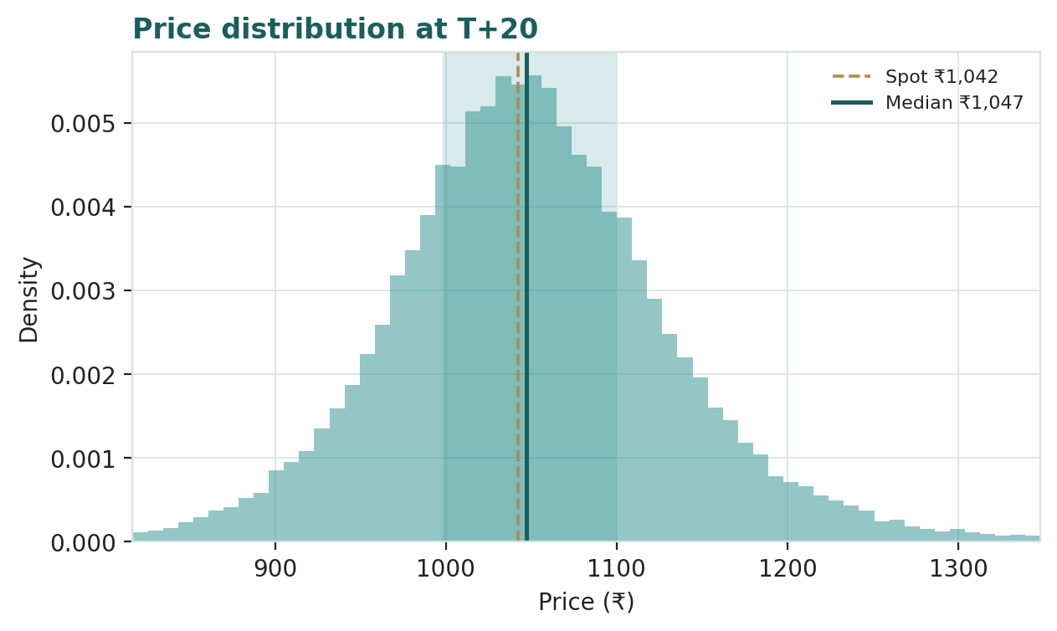
Figure 5 — distribution of simulated price at T+20 (~1 month).
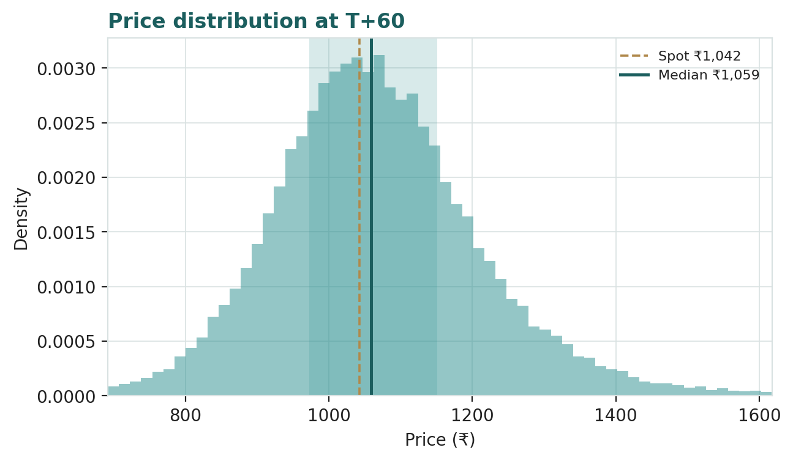
Figure 6 — distribution of simulated price at T+60 (~3 months). The right tail is fatter — the factor skew.
3.4 Touch probabilities
A touch probability is the chance the path reaches a level at any point in the window, not just closes there — the relevant number for anyone thinking in terms of levels.
Level | Touch by T+20 | Touch by T+60
₹1,250 | 3% | 17%
₹1,200 | 7% | 27%
₹1,150 | 17% | 43%
₹1,100 | 40% | 65%
₹1,050 | 82% | 90%
₹1,000 | 45% | 64%
₹950 | 16% | 38%
₹900 | 5% | 20%

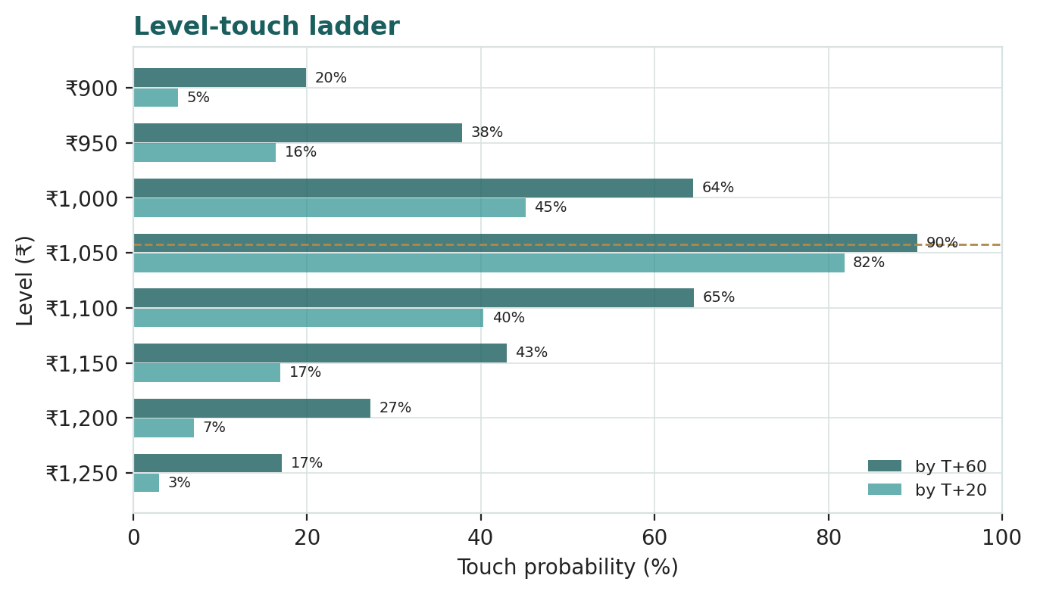
Figure 7 — touch-probability ladder. Upside levels in brass, downside in teal; the height is the probability the path reaches that level within the horizon.
4 Comparison of the lenses, and a verdict
The two disciplines tell a coherent story. Fundamentally, Infosys looks like a high-quality compounder — net cash, ~33% return on equity, >100% cash conversion, a consistent capital-return record — that has been de-rated to a value multiple (~14.6× earnings, ~9.4× EV/EBITDA). The four lenses centre near ₹1,242, about +19% above spot, with the conservative DCF marking the floor at ₹1,143 and the re-rating lenses marking the ceiling. Technically, the stock is in a clear downtrend below all its moving averages, defending the 52-week-low support. Probabilistically, the next quarter is a near-even coin tilted modestly up, with a fatter right tail than left.
Putting them together: the market is pricing a real risk — that generative AI structurally erodes the labour-arbitrage model — and until the tape confirms a demand recovery, the trend can stay down even if the business is cheap. The gap between the weak tape and the cheap fundamentals is precisely the disagreement an educational study exists to make visible. What would resolve it is evidence on the crux: the Q1 FY27 print, the guidance revision, and the first hard data on whether GenAI is deflating pricing faster than it is cutting cost. This is an analysis of value and probability, not a recommendation — the reader supplies the decision.
5 Catalysts to watch
Catalyst | Why it matters | Impact
Q1 FY27 results (late July) | First read on the FY27 growth trajectory and margin | High
FY27 guidance revision | Raise or cut of the +1.5–3.5% cc revenue band | High
Large-deal TCV momentum | Book-to-bill and mega-deal wins/losses (>$0.5bn) | High
GenAI pricing evidence | Hard data on realized-rate deflation vs delivery-cost savings | Decisive
US / EU discretionary demand | Client-capex signals from the top verticals | High
USD/INR path | Rupee weakness = reported-margin tailwind | Medium
Capital-return surprise | Buyback or special dividend on the net-cash pile | Medium
Visa / immigration policy | Onshore-cost and delivery-model risk | Medium

6 Reading the probability zones
The same 50,000 paths, bucketed into price zones at the three-month horizon, translate the distribution into plain probabilities of where price lands:
Zone (T+60) | Probability | Interpretation
Below ₹950 | 20% | Deeper value / capitulation
₹950 – ₹1,000 | 13% | Retest of the lows
₹1,000 – ₹1,080 | 24% | Base-case drift around spot
₹1,080 – ₹1,150 | 18% | Recovery toward first resistance
Above ₹1,150 | 25% | Re-rating underway

The single most-likely zone is ₹1,000–₹1,080 around spot (24%), but the distribution is two-sided: a ~20% chance of a deeper drop below ₹950 and a ~25% chance of a move above ₹1,150 toward the fundamental range. Lead with the 50% band, not the tails.
7 Caveats and what would change our mind
• The GenAI thesis is the whole game. Our base case assumes Infosys cannibalises its own billable hours and keeps the margin, as the leaders did through prior technology shifts. If instead GenAI deflates pricing faster than it cuts cost, or clients insource, the bear case (and lower) is where value sits. This single judgment drives the width of the range.
• Forward inputs are the preparer's, not the company's. The DCF growth and margin path, the justified multiples, the normalized-earnings marks and the Monte-Carlo factor probabilities are analytical judgments, flagged throughout; only the reported historicals are the company's disclosure.
• The tape can stay wrong on value for a long time. A cheap stock in a downtrend can get cheaper. The technical structure is genuinely weak, and nothing here times a turn.
• Cyclicality is real. IT-services demand is cyclical; a US/EU discretionary-spend freeze would hit the top verticals first and would move the whole distribution down.
• Currency cuts both ways. We treat further rupee depreciation as upside, but a sharp rupee appreciation would compress reported revenue and margin.
• This is not advice. It is an educational valuation exercise. It is not a recommendation, and it is not calibrated to any reader's circumstances or risk tolerance.

Appendix A Financial statements
Three years of reported history (company IFRS INR press releases, FY24–FY26) and a five-year forecast driven off the model's Assumptions sheet. All figures ₹ cr unless stated.
A.1 Income statement
₹ cr | FY24 | FY25 | FY26 | FY27E | FY28E | FY29E | FY30E | FY31E
Revenue | 153,670 | 162,990 | 178,650 | 187,582 | 198,837 | 212,756 | 227,649 | 242,446
growth % | — | 6.1% | 9.6% | 5.0% | 6.0% | 7.0% | 7.0% | 6.5%
EBITDA | 35,970 | 38,911 | 41,166 | 44,457 | 48,119 | 52,551 | 56,229 | 59,884
Less: D&A | (4,160) | (4,520) | (4,900) | (5,065) | (5,369) | (5,744) | (6,147) | (6,546)
EBIT | 31,810 | 34,391 | 36,266 | 39,392 | 42,750 | 46,806 | 50,083 | 53,338
EBIT margin % | 20.7% | 21.1% | 20.3% | 21.0% | 21.5% | 22.0% | 22.0% | 22.0%
Other income | 3,080 | 3,560 | 3,510 | 3,600 | 3,800 | 4,000 | 4,300 | 4,600
Profit before tax | 34,890 | 37,951 | 38,487 | 42,992 | 46,550 | 50,806 | 54,383 | 57,938
Less: tax | (8,657) | (11,238) | (9,047) | (11,178) | (12,103) | (13,210) | (14,140) | (15,064)
Net profit (PAT) | 26,233 | 26,713 | 29,440 | 31,814 | 34,447 | 37,597 | 40,243 | 42,874
EPS (₹) | 63.3 | 64.5 | 71.1 | 76.8 | 83.2 | 90.8 | 97.2 | 103.5
DPS (₹) | 46 | 46 | 48 | 53.1 | 57.9 | 62.8 | 67.6 | 72.4

A.1 — Income statement: 3 years actual (FY24–FY26) + 5 years forecast (FY27E–FY31E).
A.2 Balance sheet
₹ cr | FY24 | FY25 | FY26 | FY27E | FY28E | FY29E | FY30E | FY31E
PP&E + intangibles | 24,000 | 24,500 | 25,000 | 23,335 | 21,667 | 19,922 | 18,076 | 16,130
Goodwill | 7,800 | 7,900 | 8,000 | 8,000 | 8,000 | 8,000 | 8,000 | 8,000
Trade receivables | 31,502 | 33,413 | 36,623 | 38,454 | 40,762 | 43,615 | 46,668 | 49,701
Other current assets | 16,904 | 17,929 | 19,652 | 20,634 | 21,872 | 23,403 | 25,041 | 26,669
Cash + investments | 46,000 | 47,000 | 43,075 | 45,170 | 46,541 | 47,724 | 48,506 | 49,032
Total assets | 126,206 | 130,742 | 132,350 | 135,593 | 138,841 | 142,665 | 146,291 | 149,533
Shareholders' equity | 86,800 | 88,200 | 90,000 | 91,814 | 93,261 | 94,858 | 96,101 | 96,976
Trade + other payables | 24,587 | 26,078 | 28,584 | 30,013 | 31,814 | 34,041 | 36,424 | 38,791
Borrowings | 0 | 0 | 0 | 0 | 0 | 0 | 0 | 0
Net cash | 46,000 | 47,000 | 43,075 | 45,170 | 46,541 | 47,724 | 48,506 | 49,032
Balance check | 0 | 0 | 0 | 0 | 0 | 0 | 0 | 0

A.2 — Balance sheet: 3 actual + 5 forecast. Zero borrowings; balance check = 0 in every year.
A.3 Cash flow (forecast)
₹ cr | FY27E | FY28E | FY29E | FY30E | FY31E
Net profit (PAT) | 31,814 | 34,447 | 37,597 | 40,243 | 42,874
Add: D&A | 5,065 | 5,369 | 5,744 | 6,147 | 6,546
Less: Δ working capital | (1,385) | (1,745) | (2,157) | (2,308) | (2,294)
Operating cash flow | 35,495 | 38,071 | 41,184 | 44,081 | 47,127
Less: capex | (3,400) | (3,700) | (4,000) | (4,300) | (4,600)
Free cash flow | 32,095 | 34,371 | 37,184 | 39,781 | 42,527
Less: dividends | (22,000) | (24,000) | (26,000) | (28,000) | (30,000)
Less: buyback | (8,000) | (9,000) | (10,000) | (11,000) | (12,000)
Closing cash + investments | 45,170 | 46,541 | 47,724 | 48,506 | 49,032

A.3 — Forecast cash flow; closing cash ties to the balance-sheet cash line each year.

Appendix B Peer set, sector structure, and risks
B.1 Peer set
Infosys sits second by revenue among India's listed IT-services majors, behind TCS and ahead of HCLTech and Wipro, with LTIMindtree a mid-cap comparator and Accenture the global reference. On every quality metric the franchise is top-tier; the discount to peers on P/E and EV/EBITDA is the relative-lens opportunity of §1.3.
Company | P/E | EV/EBITDA | Div yield | ROE
Infosys (spot) | 14.6× | 9.4× | 4.6% | ~33%
Tata Consultancy Services | 22× | 15× | 3.4% | ~50%
HCLTech | 20× | 12× | 3.9% | ~23%
Wipro | 18× | 11× | 2.6% | ~16%
LTIMindtree | 26× | 17× | 1.6% | ~26%
Accenture (US, ref.) | 24× | 15× | 1.8% | ~30%

B.2 Sector structure
Indian IT services bills a spread between the offshore cost of an engineer-hour and the price charged for it, leveraged across a pyramid of experience tiers and a global delivery footprint. The structural growth driver is enterprises' continued digitisation; the structural risk is that generative AI compresses the pyramid. The sector is dollar-revenue, rupee-cost — a natural currency hedge — and asset-light, which is why the leaders run net cash and return most of their free cash flow to owners.
B.3 Risk register
Risk | Type | Note
GenAI / automation deflation | Structural | Pricing and pyramid compression — the central debate
Discretionary-demand cycle | Cyclical | US/EU client-capex freeze hits the top verticals first
Client / vertical concentration | Moderate | Financial services ~28% of revenue
Currency (USD/INR) | Two-sided | Rupee strength compresses reported margin; weakness a tailwind
Immigration / visa policy | Moderate | Onshore-cost and delivery-model risk
Wage inflation / attrition | Cyclical | Utilisation and margin channel
Capital-allocation drift | Low | Strong record; net cash could tempt over-payment on M&A

Appendix C The expert panel — three methods, three verdicts
We close, as every Testahil study does, by handing Infosys to three independent valuation traditions and letting them disagree. Each runs a genuinely different method, shows its workings, sensitizes its swing input, cross-examines the other two, and states what would prove it wrong. They are labelled Expert 1, 2 and 3; the point is the divergence, and what it measures.
Expert 1 — earnings power through the cycle
Worldview. “A business is worth a multiple of what it earns through the cycle, not at the bottom of one.” Expert 1 values Infosys on normalized earnings power capitalised at a justified multiple, cross-checked against peers. The discipline is to normalize to mid-cycle and to justify the multiple, not to chase a trough print or a peak one.
When it works / fails. Works for a stable, high-return franchise with a long multiple history — exactly this. Fails when the business is structurally impaired (a normalized multiple on a melting ice cube is a trap), which is why the GenAI question sits at the centre of the cross-examination.
Workings.
Expert 1 — normalized earnings | Value
Normalized revenue (mid-cycle, ₹ cr) | ~205,000
Normalized EBIT margin | 22.0%
Normalized EPS (₹) | ~91
Justified P/E | 18.0×
Fair value / share (base) | ₹1,368
Range (bear–bull) | ₹1,065 – ₹1,672

Worked example. Normalized EPS ~91 × an 18× justified multiple ≈ ₹1,368. The 18× is deliberately below the franchise's own historical average — a haircut for the GenAI uncertainty — yet still well above the ~14.6× the market pays today.
Sensitivity (swing = justified P/E). At 16× the value is ~₹1,452; at 20× ~₹1,815. Each turn of the multiple is ~₹91 per share — the multiple, not the earnings, is the swing.
Cross-examination. To Expert 2: “your DCF buries the same re-rating in a terminal-growth assumption; I make it explicit.” To Expert 3: “your scenario weights are just a probability-weighted version of my multiple — say what you think the business earns.”
Verdict, falsification, market-implied. Base ₹1,368. Falsified if normalized margin settles below ~20% or the justified multiple proves to be sub-14× (i.e. the market is right that the model is impaired). The market price implies ~14.6× trough-ish earnings — pricing little cycle recovery and no re-rating.
Expert 2 — cash returns (DCF and ROIC versus WACC)
Worldview. “Cash is the only thing you can spend.” Expert 2 discounts explicit free cash flow to the firm and asks whether return on invested capital clears the cost of capital — if it does, growth creates value; if not, growth destroys it. This is the study's anchor lens.
When it works / fails. Works best for a cash-generative, net-cash business where the cash is real and returned — again, exactly this. Fails when terminal value dominates (it does here at ~72% of EV), which is why the swing is the discount rate and the terminal spread, disclosed and sensitized rather than hidden.
Workings.
Expert 2 — DCF / cash returns | Value
Sum of PV, explicit FCFF (₹ cr) | 121,255
PV of terminal value (₹ cr) | 309,310
Enterprise value (₹ cr) | 430,565
TV as % of EV | 71.8%
Add net cash (₹ cr) | 43,000
Equity value (₹ cr) | 473,565
Fair value / share (base) | ₹1,143
Ke = rf + β×ERP | 6.5% + 0.90×6.0% = 11.9% → 12.0%
Range (bear–bull) | ₹941 – ₹1,474

Worked example. Five years of FCFF from 29,431 to 39,123 ₹ cr, discounted at 12%, sum to 121,255; the terminal value discounts to 309,310; plus net cash gives equity of 473,565 ₹ cr, or ₹1,143 per share. ROIC on an asset-light, net-cash base runs far above the 12% WACC, so growth here is value-accretive.
Sensitivity (swing = WACC). At 11% WACC / 4.5% g the value is ~₹1,306; at 13% ~₹1,019. The full grid is §1.9. Terminal-spread dependence is the honest weakness of the lens.
Cross-examination. To Expert 1: “a justified multiple is an assumption; my terminal value at least forces you to state the growth and discount rate behind it.” To Expert 3: “scenarios are useful, but discount the cash in each one — a probability without a cash flow is just a mood.”
Verdict, falsification, market-implied. Base ₹1,143 — the anchor. Falsified if free cash conversion falls durably below ~90% of PAT or if ROIC drops toward the cost of capital (GenAI compresses returns). The market price implies a discount rate well above 12% or terminal growth well below 4.5% — i.e. the market demands a higher risk premium than the cash record warrants.
Expert 3 — scenario-weighted macro and real options
Worldview. “I don't pick a side; I weight the odds.” Expert 3 refuses a single point, builds explicit GenAI-demand scenarios, assigns probabilities, and reports the probability-weighted value and the spread. The method treats the GenAI transition as a real option — genuinely two-sided — rather than a one-way threat.
When it works / fails. Works when the central uncertainty is discrete and macro-driven, as here. Fails if the probabilities are just reverse-engineered to a pre-formed answer — the discipline is to fix the scenario economics first, then weight.
Workings — GenAI-demand scenarios.
Scenario | Prob | Value / sh
Disruption — AI deflates the model | 25% | ₹995
Muddle-through — pricing & cost balance | 50% | ₹1,242
Tailwind — AI is net demand-accretive | 25% | ₹1,556
Probability-weighted value | 100% | ₹1,150

Worked example. 0.25×995 + 0.50×1242 + 0.25×1556 ≈ ₹1,150. The tight weighted centre hides a wide spread — that spread, not the point, is the message.
Sensitivity (swing = disruption probability). Shift 15 points of weight from muddle-through to disruption and the value falls toward ₹950; shift it to tailwind and it rises toward ₹1,450. The reader's own GenAI view reprices the whole thing.
Cross-examination. To Expert 1 and Expert 2: “you both quote a base case as if the GenAI question were settled; I make the disagreement itself the output, which is the only honest thing to do while the evidence is still coming.”
Verdict, falsification, market-implied. Base ₹1,150. Falsified if the scenarios collapse to near-certainty either way (the option resolves). The market price implies a disruption probability materially above the ~25% Expert 3 assigns — the market is pricing more downside than the balanced scenario set.
The three in one room
Put them at one table and the argument is entirely about generative AI. Expert 1 says: “the franchise has survived every prior technology shift and kept its margin; normalize and re-rate.” Expert 2 says: “show me the cash — it is still converting above 100% and clearing its cost of capital; until that breaks, the DCF holds.” Expert 3 says: “you are both assuming the answer; the point is that we don't yet know, and a quarter of the weight sits in a real-disruption tail.” They agree Infosys is cheap on today's numbers; they disagree on whether today's numbers survive. That is the single asset they most disagree on — the durability of the labour-arbitrage margin.
Reading the divergence
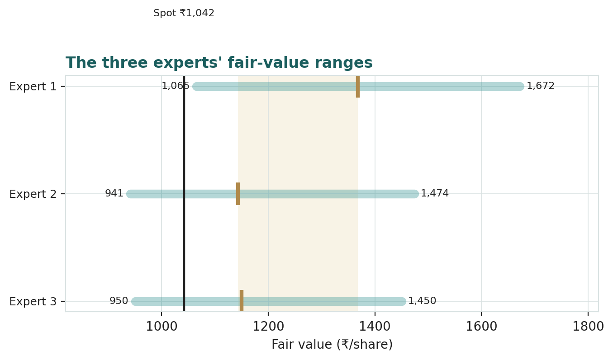
Figure C-1 — the three experts' fair-value ranges. Bars are bear-to-bull; markers are base cases; the vertical line is spot.
Expert | The one assumption that drives it | Base FV
Expert 1 — earnings power | Normalized margin / justified P/E (18x) | ₹1,368
Expert 2 — cash returns (anchor) | WACC (12%) / speed of ROIC fade | ₹1,143
Expert 3 — scenario-weighted | GenAI-demand scenario probabilities | ₹1,150

What the spread measures. The panel ranges from ₹1,143 (the conservative cash anchor) to ₹1,368 (normalized earnings power re-rated), centring near ₹1,220. The distance between them is not modelling noise — it is the price of the single open question in this name: whether generative AI compresses the labour-arbitrage margin or leaves it intact. When that evidence arrives, the spread collapses. Until then, the honest output is the range, not a point.

About this series
Testahil publishes independent, educational valuation studies that integrate three lenses — fundamental valuation, technical price structure, and Monte-Carlo probability — into one read. The house philosophy is distributions, not tips: we publish fair-value ranges and probability distributions, never a rating, price target, or buy / sell / hold call. Every study is offered free of charge, as an invitation to scrutinise the methodology. The Monte-Carlo engine is scored publicly, study by study, against a naïve random-walk benchmark, so the calibration record is open rather than asserted.
Disclosure & Disclaimer
• 1. Not investment advice. This document is an educational valuation exercise and an expression of personal analytical opinion. It is not investment advice, and not a recommendation or solicitation to buy, sell or hold any security. It does not take account of the financial circumstances, objectives or risk tolerance of any reader.
• 2. No licence, no clients, no fees. The preparer is not licensed or registered by any securities or financial-markets regulator in any jurisdiction, holds no brokerage or advisory authorisation, manages no money, provides no financial consultancy, and accepts no fees, funds or clients.
• 3. Not a rating or price target. All values are model outputs presented as ranges and probability distributions. No figure herein is a rating, a target price, or a forecast of the actual future price of the security.
• 4. Sources and estimates. Reported financial figures are drawn from the company's own disclosures (FY26 results, 23 April 2026, IFRS INR). Forward-looking inputs — including the discounted-cash-flow assumptions, relative multiples, normalized-earnings marks and Monte-Carlo factor probabilities — are the preparer's own judgments and estimates, and are flagged as such throughout.
• 5. No liability. The preparer accepts no liability for any loss arising from the use of this document. Markets involve risk, including loss of principal. Past performance and modelled scenarios are not reliable indicators of future results. Readers must consult a licensed financial advisor before any investment decision and rely on their own independent judgment.
• 6. Position disclosure. The preparer may hold, and may in the future take or dispose of, a position in the security discussed in this report.

Testahil · Independent Valuation Study — Educational Analysis · Infosys Limited (NSE: INFY) · Edition 6 Jul 2026 · Prices and probabilities computed from the attached daily history · Not investment advice.

