TESTAHIL · Independent Valuation Study
Educational analysis · Not investment advice

Industries Qatar
Industries Qatar Q.P.S.C. (QSE: IQCD)
Fundamental analysis · Technical analysis · Monte Carlo simulation — one integrated read
Spot QR 11.07 · close 05 Jul 2026 · 6.05bn shares · market cap ≈ QR 67.0bn (~US$ 18.4bn) · a cash-rich, debt-free Qatari industrial holding company whose fair value the five lenses put at roughly QR 10.8 — fairly valued, with the swing resting on petrochemical normalization.

Read first
What this is. An educational, independent valuation of Industries Qatar (QSE: IQCD) that reads the fundamentals, the price structure, and a Monte Carlo simulation as one integrated picture. It is not investment advice, carries no recommendation, and states no price target.
How to read the number. We publish a fair-value range and a probability distribution, never a single 'target'. The central figure is where five independent lenses cluster; the cone around it is the instrument's genuine three-month uncertainty, not decoration.
Two clocks. Keep them separate. (1) Risk-adjusted fair value — the roughly twelve-month anchor the lenses trıangulate. (2) Full-execution value — a multi-year ceiling if petrochemical margins normalize and the Ammonia-7 and Ras Laffan pipeline all land. Only the Monte Carlo percentiles are true three-month figures.
Primary lens. Holding-company sum-of-the-parts: each of the three segments valued on normalized mid-cycle earnings and a justified multiple, plus net cash, less a modest holdco discount — cross-checked by a DCF, relative multiples, normalized earnings power, and a dividend-discount model.
Currency. Qatari riyal (QR), pegged at USD/QR 3.64. Figures in QR billion unless stated.
Disclosure. The preparer may hold, and may in the future take or dispose of, a position in the security discussed in this report.

Headline
The model's read: fairly valued, with the upside resting on petrochemical margins normalising and the Ammonia-7 and Ras Laffan pipeline delivering. At QR 11.07 the shares sit within about 2% of our weighted central estimate of QR 10.8. Five lenses cluster tightly: a sum-of-the-parts (QR 10.38) marks the conservative floor, a consolidated DCF (QR 11.0) the ceiling, and relative multiples, normalized earnings and a dividend-discount read all sit around QR 11. The whole answer turns on the petrochemical leg — QAPCO and QAFAC — which earned just QR 0.7bn in 2025 and only QR 4mn in the first quarter of 2026 as regional conflict disrupted Gulf logistics, against a fertilizer leg (QAFCO) that is the durable cash anchor and a steel leg that is a small restart option. Technically the stock mirrors the fundamentals — below every major moving average, RSI about 36, MACD negative — so price and value pull the same way. Over three months the Monte Carlo places the 5th–95th band at roughly QR 8.84–14.08, with the median at spot and a right skew.
Valuation summary — every read at a glance
One table for the four reads that follow — what the business is worth (fundamental), what the tape is doing (technical), where price could travel over three months (Monte Carlo), and how three independent expert methods land. Every row is developed in the sections and appendices below.
Lens / read | What it measures | Output | Takeaway
FUNDAMENTAL — what the business is worth (the anchor)
Sum-of-the-parts (primary) | Marked parts + net cash − discount | QR 10.38 | −6% · the floor
Consolidated DCF | Discounted 5-yr FCFF | QR 11.0 | +3% · the ceiling
Relative multiples | Normalized P/E vs 16.3× history | QR 11.02 | ≈ spot
Normalized earnings | Mid-cycle earnings × P/E | QR 11.02 | ≈ spot
Dividend discount | 2-stage, 100% payout | QR 11.07 | ≈ spot · yield floor
Weighted central | Blend 35 / 20 / 15 / 15 / 15 | QR 10.8 | −2% vs QR 11.07
TECHNICAL — what the tape is doing (timing, not value)
Trend & momentum | Price vs the 20/50/100/200-day | Below all four | Weak, corrective
Momentum / range | RSI · MACD · 52-week range | RSI 36 · MACD -0.24 · QR 10.6–13.4 | Stretched down
MONTE CARLO — where price could go in 3 months (paths from spot)
T+20 sessions | 50,000 paths · 16 factors | p5 9.6 · p50 11.1 · p95 12.7 | Median ≈ spot
T+60 sessions | same engine, longer horizon | p5 8.8 · p50 11.2 · p95 14.1 | Wide, right-skewed
EXPERT PANEL — three independent methods (Appendix D)
Expert 1 — NAV & discount | Holdco discount on marked parts | QR 10.6 | The anchor
Expert 2 — accountant | Realizable value + cash quality | QR 9.8 | Most conservative
Expert 3 — macro-policy | Scenario-weighted options | QR 11.2 | Scenario-weighted
Panel range | Spread = the petchem question | QR 9.8–11.2 | Centres ~QR 10.5

Bottom line. Every read points the same way on value and disagrees only on magnitude. The fundamental central sits near QR 10.8 — within 2% of the QR 11.07 spot — the three experts span QR 9.8–11.2, and each turns on a single question: whether the petrochemical leg's margin normalises from its early-2026 trough. The technical tape agrees the stock is unloved, oversold and below trend, which is why the three-month distribution centres near spot with a wide right tail rather than already above fair value — with a roughly 6% dividend yield paying the holder to wait.
Industries Qatar at a glance
Item | Value
Ticker / exchange | IQCD / Qatar Stock Exchange (QSE)
Business | Holding company: fertilizers (QAFCO), petrochemicals (QAPCO, QAFAC), steel (Qatar Steel)
Spot price | QR 11.07 (close 05 Jul 2026)
52-week range | QR 10.60 – 13.41
Shares outstanding | 6.05 billion
Market capitalization | ≈ QR 67.0bn (~US$ 18.4bn)
Net cash | ≈ QR 8.5bn (debt-free)
Ownership | QatarEnergy ≈ 51%; free float ≈ 49% (foreign limit 49%)
FY2025 net profit | QR 4.3bn (−8% YoY); EPS QR 0.71
Dividend | QR 0.71/share FY2025 (100% payout); yield ≈ 6%
Segment mix (FY25 NI) | Fertilizers QR 2.7bn · Petrochemicals QR 0.7bn · Steel QR 0.71bn
Key near-term event | QAFCO Ammonia-7 (blue ammonia) online Q2-2026
Reporting currency | Qatari riyal (QR), pegged USD/QR 3.64

1 · Fundamental valuation
Industries Qatar is a holding company, so the natural starting point is not a single consolidated multiple but the sum of its three operating parts, each valued on its own economics, plus the balance-sheet cash, less a discount for the holding structure. We then cross-check that sum-of-the-parts against four independent lenses. The picture that emerges is consistent: a stock trading close to the fair value of its parts, with the uncertainty concentrated almost entirely in the petrochemical leg.
1.1 · Primary lens — holding-company sum-of-the-parts
We value each segment on normalized mid-cycle earnings and a justified price-to-earnings multiple appropriate to that industry, then add net cash and subtract a modest holdco discount. Normalizing matters here because 2025 was not a clean year for any leg: fertilizers had an unusually strong run on tight nitrogen supply, petrochemicals were at a cyclical trough, and steel carried a QR 0.222bn impairment reversal. We strip those distortions before applying a multiple.
Segment / step | Norm. NI (QRbn) | P/E (x) | Value (QRbn) | Basis
Fertilizers (QAFCO, 100%) | 2.50 | 14.5 | 36.3 | World-scale, low-cost gas; +Ammonia-7
Petrochemicals (QAPCO 80% / QAFAC 50%) | 1.30 | 13.0 | 16.9 | Recovery from trough; Ras Laffan ramp
Steel (100%) | 0.50 | 7.5 | 3.8 | Restarted DRI; cyclical, low multiple
Segment enterprise value |  |  | 56.9
Add: net cash |  |  | 8.5 | Debt-free
Gross asset value |  |  | 65.4
Less: holdco discount (4%) |  |  | (2.6) | Clean 3-segment, 100% payout
Equity value |  |  | 62.8
Fair value per share |  |  | QR 10.38

The sum-of-the-parts lands at QR 10.38 — about 6% below spot. That is our most conservative lens, and it is telling: on the multiples a global fertilizer or chemicals investor would pay, the parts are worth a little less than the market pays for the whole. The gap is the Qatari quasi-sovereign premium — a net-cash, index-heavy, 100%-payout name in a pegged currency trades richer than its pure-play peers, and that premium is real but finite.
1.2 · Cash-flow cross-check — consolidated DCF
Because Industries Qatar pays out essentially all of its earnings and holds net cash, its free cash flow to the firm and its dividends are close cousins; a discounted-cash-flow model and a dividend-discount model should broadly agree, and they do. We build a five-year explicit FCFF forecast on the proportionate basis IQ itself reports, then a Gordon terminal value. The cost of equity is stated explicitly: a Qatar risk-free rate of 4.5% plus a beta of 0.95 times a 5.5% equity-risk premium gives Ke ≈ 9.7%; because the company is unlevered, the WACC is essentially the same.
QR bn | FY26E | FY27E | FY28E | FY29E | FY30E
EBITDA | 5.7 | 6.3 | 6.6 | 6.9 | 7.1
Less: D&A | (1.8) | (1.9) | (2.0) | (2.0) | (2.1)
EBIT | 3.9 | 4.4 | 4.6 | 4.9 | 5.0
NOPAT (EBIT×(1−3%)) | 3.8 | 4.3 | 4.5 | 4.7 | 4.9
Add: D&A | 1.8 | 1.9 | 2.0 | 2.0 | 2.1
Less: capex | (2.0) | (1.9) | (1.9) | (2.0) | (2.1)
Less: Δ working capital | (0.3) | (0.3) | (0.2) | (0.2) | (0.2)
Free cash flow to firm | 3.3 | 4.0 | 4.4 | 4.6 | 4.7
Discount factor @ 9.7% | 0.91 | 0.83 | 0.76 | 0.69 | 0.63
PV of FCFF | 3.0 | 3.3 | 3.3 | 3.2 | 3.0

Summing the present values of the explicit cash flows and the discounted terminal value gives an enterprise value of about QR 58bn; adding net cash lifts equity value to roughly QR 66–69bn, or QR 11.0–11.4 per share. The terminal value is about 74% of enterprise value — high, as it always is for a low-WACC mature cash generator — so we disclose that dependency openly and sensitize it on the WACC-by-terminal-growth grid in §1.9 rather than burying it. We do not average the DCF and the sum-of-the-parts into a single false-precision point; the football field in §1.5 shows both.
1.3 · Relative multiples
Industries Qatar trades at roughly 15.6× its 2025 earnings and about 16× on a normalized basis — modestly below its own ten-year median of about 16.3×, and above global sector peers. Pure-play nitrogen producers (CF Industries) trade near 11×; global fertilizer majors (Nutrien, Yara) near 12×; GCC petrochemical names (Sipchem, Advanced) near 15×; SABIC, the regional bellwether, richer. The premium IQCD carries over the cheaper end of that range is the quasi-sovereign, net-cash, high-payout quality that local index demand pays for. Applying a justified 15.5× to normalized group earnings of about QR 4.3bn gives QR 11.0 per share.
Peer | P/E (x) | Div yield | Note
SABIC (Saudi) | 18.0 | 4.5% | Global chemicals bellwether
Sipchem / Advanced (Saudi) | 15.0 | 5.0% | GCC petrochemicals
CF Industries (US) | 11.0 | 2.0% | Pure-play nitrogen
Nutrien / Yara | 12.0 | 5.0% | Global fertilizer majors
QSE large-cap median | 15.5 | 4.5% | Local quasi-sovereign premium
Industries Qatar | 15.6 | 6.0% | Spot; ~16.3× 10y median

1.4 · Normalized earnings power
Where is Industries Qatar in its cycle? Mixed, and that is the whole story. Fertilizers are near a cyclical high — 2025 nitrogen prices were supported by export restrictions from China and sanctioned producers, and QAFCO's 46% EBITDA margin reflects that. Petrochemicals are near a cyclical trough — Chinese overcapacity has crushed polyethylene spreads, and the first quarter of 2026 saw the segment earn almost nothing. Steel is recovering off a low base as mothballed facilities restart. Normalizing each leg to a mid-cycle level — fertilizers a touch below 2025, petrochemicals well above the trough, steel modestly above breakeven — gives mid-cycle group earnings of about QR 4.3bn, essentially the 2025 reported figure but with a very different composition. At a justified 15.5× that is QR 11.0 per share.
1.5 · Synthesis — five lenses and the football field
Five independent lenses, weighted by how much we trust each for this instrument, cluster tightly around QR 11. The sum-of-the-parts (35%) is the primary lens and the conservative anchor; the DCF (20%) is the cash-flow cross-check; relative multiples, normalized earnings and the dividend-discount model (15% each) triangulate around it. The blended central is about QR 10.9, within 2% of spot.
Lens | Bear (QR) | Base (QR) | Bull (QR) | Weight
Sum-of-the-parts | 5.87 | 10.38 | 15.96 | 35%
Consolidated DCF | 7.70 | 11.00 | 14.86 | 20%
Relative multiples | 7.74 | 11.02 | 13.49 | 15%
Normalized earnings | 7.36 | 11.02 | 14.18 | 15%
Dividend discount | 7.15 | 11.07 | 15.39 | 15%
Blended central | 6.93 | 10.80 | 15.02 | 100%

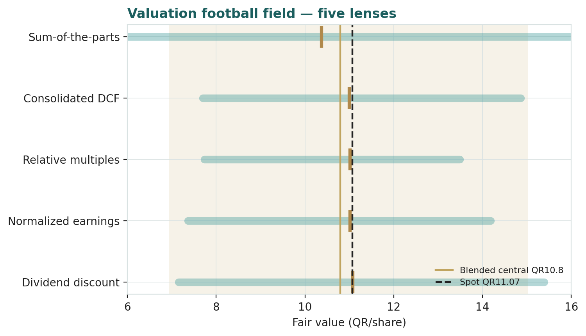
Figure 1 · Valuation football field — five lenses. The brass mark is each lens's base case; the gold band is the blended bear-to-bull range; the dashed line is spot.
The football field makes the shape of the uncertainty visible. Every lens's base case sits between QR 10.4 and QR 11.4 — a tight cluster around spot. But each lens's own bear-to-bull span is wide, and they widen in the same direction: the petrochemical swing. That is why the blended range runs from about QR 6.9 to QR 15.0 even though the central estimates agree.
1.6 · A deeper look at the three legs
The holding-company Data Miner below shows each segment's contribution. Fertilizers are 64% of the value and the bulk of the cash generation; petrochemicals are the swing; steel is a small restart option.
Segment | IQ stake | FY25 NI (QRbn) | Q1-26 NI (QRbn) | FY25 EBITDA mgn | Character
Fertilizers (QAFCO) | 100% | 2.70 | 0.495 | 46% | World-scale urea/ammonia; +Ammonia-7 Q2-26; cheap gas moat
Petrochemicals | 80% / 50% | 0.70 | 0.004 | — | Ethylene/PE + MTBE/methanol; China oversupply; Ras Laffan
Steel | 100% | 0.71 | 0.196 | — | Restarted DRI/melting; cyclical; one-off reversal in 2025

QAFCO — the fertilizer leg — is the crown jewel: 100%-owned, world-scale, fed by some of the cheapest gas on the planet, and now adding the Ammonia-7 'blue ammonia' train that comes online in the second quarter of 2026 and could lift group earnings by roughly a tenth. Its EBITDA margin of 46% in 2025 is a peak-ish figure, so we normalize slightly below it, but the franchise is durable. The petrochemical leg — QAPCO (80%, with TotalEnergies holding the other 20% until the JV expires in 2029) plus QAFAC (50%, fuel additives) — is where the value swings. It earned QR 0.7bn in 2025 and almost nothing in early 2026, hammered by Chinese polyethylene overcapacity and, acutely, by regional conflict disrupting Gulf logistics in March. Against that, the new Ras Laffan petrochemical complex and a ramping PVC facility are real future capacity. Steel is the smallest leg and the most cyclical: largely idle for years, now partly restarted, carrying a QR 0.222bn impairment reversal in 2025 that we strip out.
1.7 · The crux — the petrochemical swing, in real units
Every valuation of Industries Qatar comes down to one question: where do petrochemical margins normalize? We sensitize that crux in observable units — the segment's normalized earnings and the multiple the market pays for them — not an abstract margin assumption. The grid below reprices the whole sum-of-the-parts as the petrochemical leg moves from its trough (QR 0.6bn) to a mid-cycle recovery (QR 2.1bn), across a range of multiples.
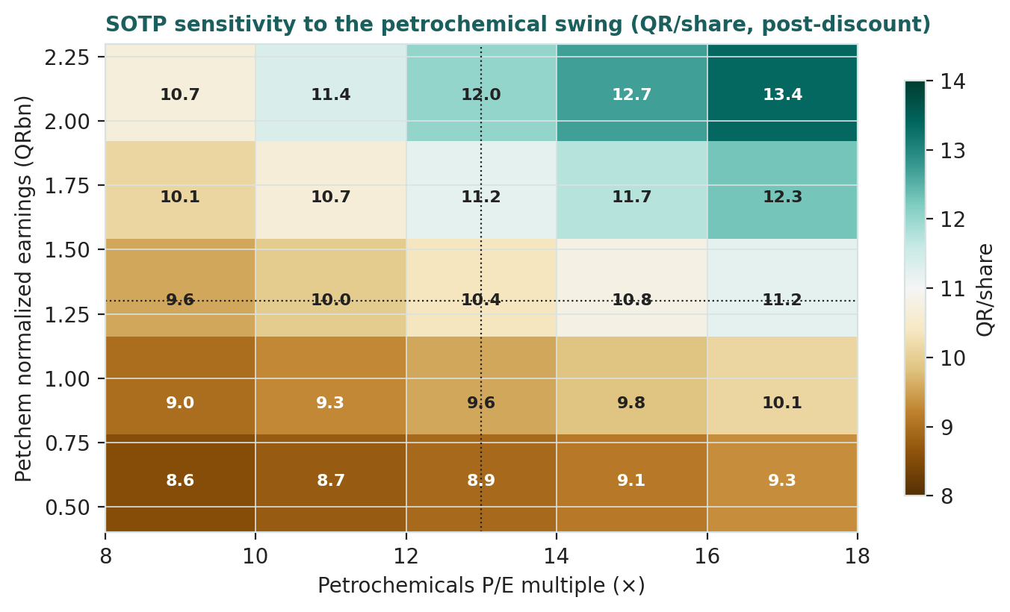
Figure 2 · Sum-of-the-parts fair value (QR/share, post-discount) as the petrochemical leg's normalized earnings and multiple vary. Fertilizers and steel held at base.
Read the corners. If petrochemicals stay near the trough and the market pays a trough multiple, the parts are worth about QR 8.5 — a fifth below spot. If the leg recovers to mid-cycle and re-rates, the parts are worth well into the QR 12–13 range. Spot sits close to the middle of that grid, which is exactly why the stock screens fairly valued: the market is pricing a partial, not full, petrochemical recovery. The observable driver behind the grid is the polyethylene-to-feedstock spread and Chinese operating rates — market quantities, not guesses — and both are near multi-year lows today.
1.8 · Macro and country
Industries Qatar is a leveraged play on four macro variables and one geopolitical one. Global nitrogen prices drive the fertilizer leg; polyethylene and fuel-additive spreads drive petrochemicals; the price of natural gas sets the feedstock cost (Qatar's structural advantage); and the energy complex moves all three together. The riyal's peg to the US dollar removes currency risk for a dollar-based reader but ties Qatari discount rates to US ones — a headwind for a high-payout yield name when US rates are elevated. The geopolitical variable is acute and current: the first quarter of 2026 showed how directly regional conflict around the Gulf can disrupt IQ's production, logistics and export volumes. That risk is not hypothetical for this name; it is in the most recent print.
1.9 · Sensitivity — the DCF on WACC × terminal growth
Because the DCF's terminal value is about three-quarters of enterprise value, the fair value is sensitive to the discount rate and the assumed long-run growth. The grid makes that dependency explicit rather than hiding it inside a single number.
WACC ╲ g | 2.0% | 2.5% | 3.0% | 3.5% | 4.0%
9.0% | 11.9 | 12.7 | 13.7 | 15.0 | 16.6
9.5% | 11.0 | 11.6 | 12.4 | 13.3 | 14.5
10.0% | 10.2 | 10.7 | 11.4 | 12.1 | 13.1
10.5% | 9.6 | 10.0 | 10.5 | 11.1 | 11.9
11.0% | 9.0 | 9.4 | 9.8 | 10.3 | 10.9

At our base WACC of about 9.7% and 3% terminal growth the DCF sits around QR 11.0–11.4; a percentage point of WACC either way moves it roughly ±QR 1.3. The point is not the single cell but the tilt: this is a duration-sensitive, low-growth cash generator, and its fair value is as much a bet on the discount rate as on the operations.
2 · Technical and price structure
The tape is weak and has been for a year. At QR 11.07 the price sits below all four moving averages — the 20-day (QR 11.37), 50-day (QR 11.85), 100-day (QR 11.79) and 200-day (QR 12.07) — a full bearish stack. The 14-day RSI at about 36 is approaching oversold without being washed out. MACD is negative (-0.24 line versus -0.22 signal), and the histogram is mildly negative, so momentum is soft but no longer accelerating downward. The stock is near the floor of its QR 10.60–13.41 twelve-month range, and its trailing realized volatility is about 20%.
Indicator | Reading | Interpretation
Spot | QR 11.07 | —
SMA 20 / 50 | QR 11.37 / 11.85 | Price below both — short-term weak
SMA 100 / 200 | QR 11.79 / 12.07 | Price below both — full bearish stack
RSI (14) | 36 | Approaching oversold
MACD (12/26/9) | -0.24 / -0.22 / -0.02 | Negative, flattening
52-week range | QR 10.60 – 13.41 | Near the low
Realized vol (252d) | 20% | Moderate

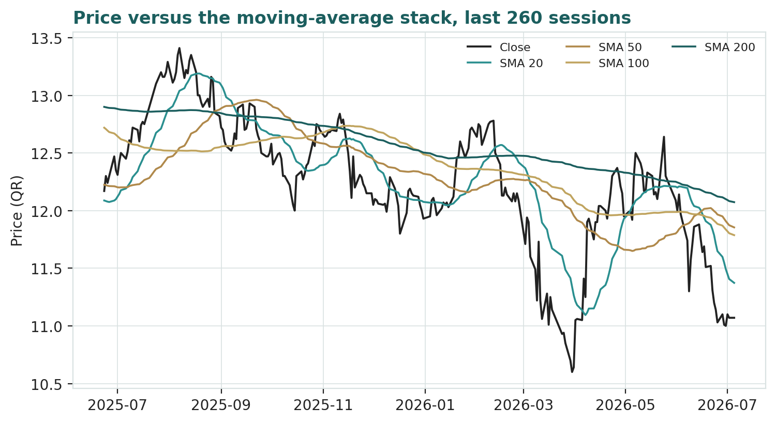
Figure 3 · Price versus the moving-average stack, last 260 sessions. Price sits below all four averages — a full bearish alignment.
The technical read reinforces the fundamental one: this is an unloved, oversold quasi-sovereign at the bottom of its range. That is not a signal — we publish no signals — but it frames the Monte Carlo, which centres its three-month distribution on spot rather than assuming any trend continuation.
3 · Monte Carlo simulation
The simulation sizes three-month uncertainty with the YZ-HAR engine, not a naive trailing-volatility cone. Width comes from a pooled log-HAR variance cascade (lags 1, 5 and 22) built on a gap-aware Yang-Zhang variance proxy, so the cone is tight in calm tape and wide in a storm. Shape comes from unit-variance Student-t(5) innovations — a tighter interquartile body and honest tails. Drift is asset-class-conditional: because Industries Qatar is an international, non-EGX name with a flat five-year price history, the secular own-history drift is switched off; only a small net tilt from the sixteen factors remains. Paths diffuse from spot, and the §1 value gap is deliberately kept out of the drift.
Fifty thousand paths, seed 42, over sixty trading days give a projected annualized volatility of about 22%. The variance-ratio diagnostic is 0.86 — below one, meaning the stock's quarterly dispersion is tighter than a random walk would imply, a mild mean-reversion the engine reflects. The distribution centres on spot with a right skew, because the discrete catalysts (Ammonia-7, a gas or urea shock, a Ras Laffan ramp) are net positive while the single large downside is regional conflict.
Horizon | p5 | p25 | p50 (median) | p75 | p95
T+20 (≈1 month) | 9.62 | 10.60 | 11.13 | 11.67 | 12.73
T+60 (≈3 months) | 8.84 | 10.24 | 11.21 | 12.25 | 14.08

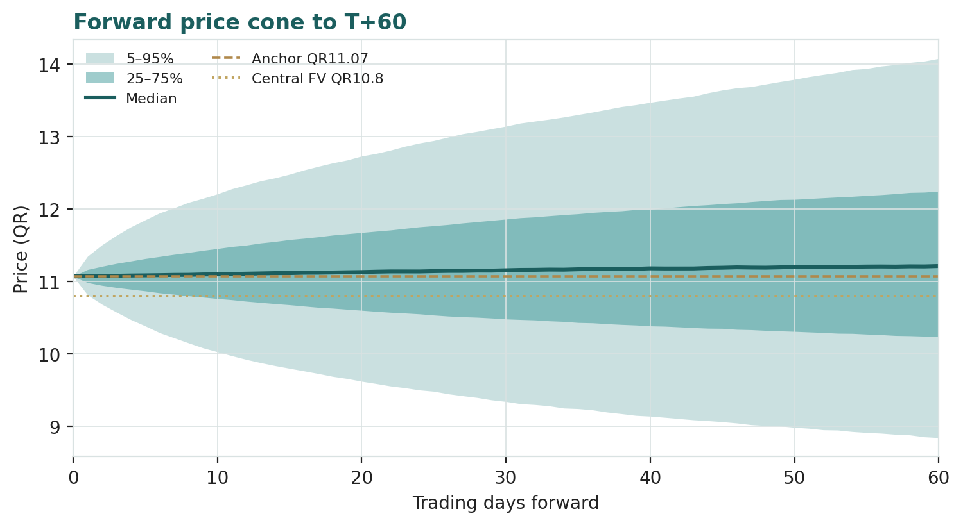
Figure 4 · Forward price cone to T+60. Median in teal, 25–75% and 5–95% bands shaded; brass dashed = spot anchor, gold dotted = central fair value.
Lead with the 50% band, not the tail. Over three months the interquartile range is QR 10.24–12.25 — the genuine coin-flip zone. The wider 5–95% span of QR 8.84–14.08 is the tail, and the right side is fatter than the left, reflecting the catalyst skew.
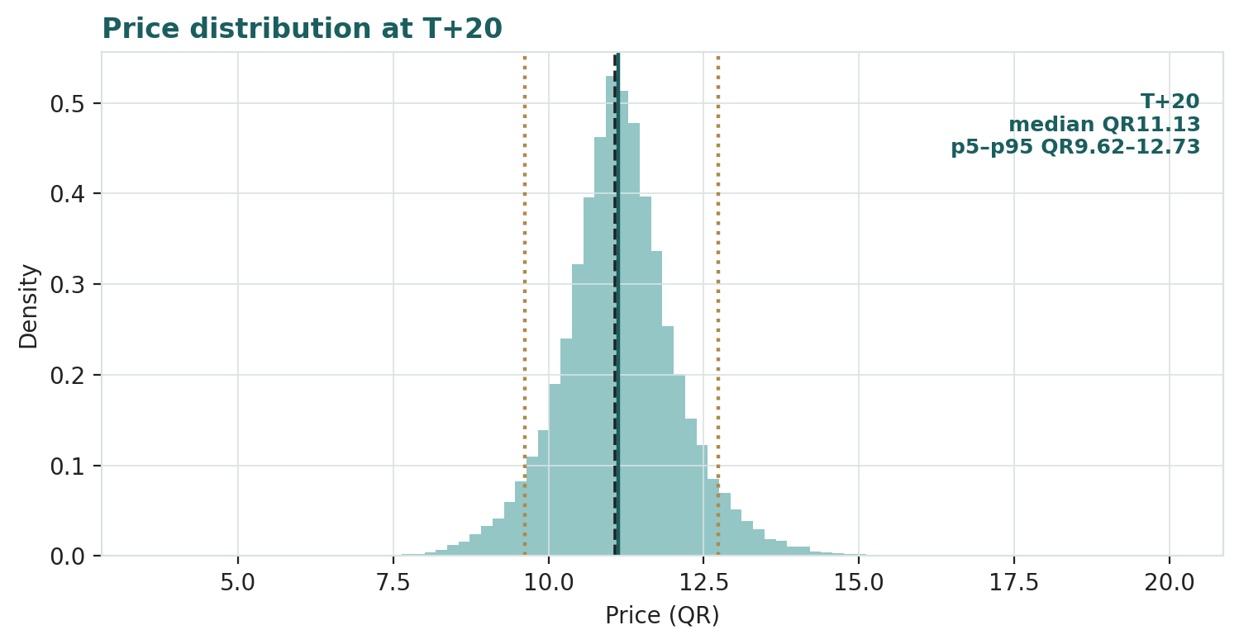
Figure 5 · Price distribution at T+20 (≈ one month). Median and 5th/95th percentiles marked; dashed = spot.
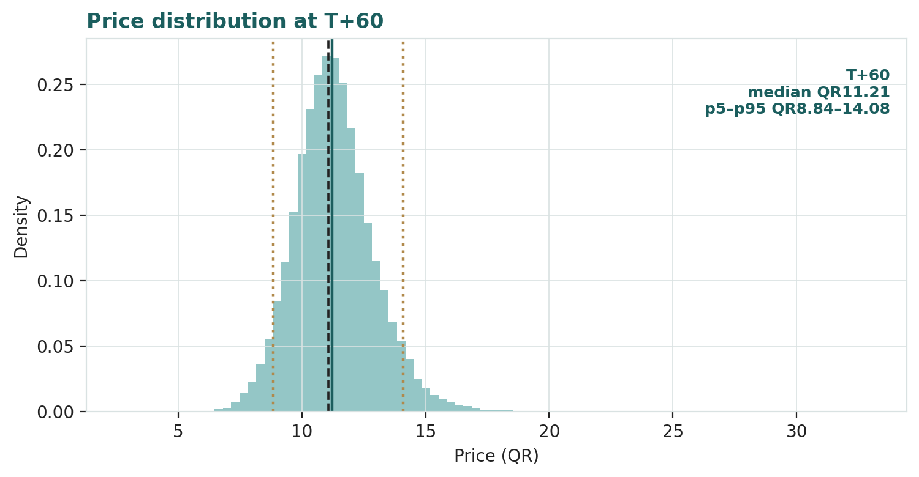
Figure 6 · Price distribution at T+60 (≈ three months). The right skew from the catalyst set is visible in the tail.
The touch-probability ladder reads the same distribution as the chance the price trades through a level at any point before the horizon — always higher than the chance of ending there.
Level | P(touch by T+20) | P(touch by T+60)
QR 13.00 | 6% | 29%
QR 12.00 | 27% | 58%
QR 11.50 | 53% | 77%
QR 10.50 | 30% | 50%
QR 10.00 | 12% | 29%
QR 9.50 | 5% | 16%

4 · Comparing the lenses, and a verdict
The fundamental lenses, the technical read and the Monte Carlo tell one coherent story. Fundamentally, five methods cluster at about QR 10.8 — within 2% of spot — so Industries Qatar is fairly valued, marginally rich if anything, on its parts. Technically, it is oversold and unloved at the bottom of its range. Probabilistically, the three-month distribution is centred on spot with a modest upward skew. None of these is a recommendation; together they say the same thing three ways — the stock is priced for a partial petrochemical recovery, with a roughly 6% dividend yield paying the holder to wait and the Ammonia-7 and Ras Laffan pipeline as the upside options.
The lenses disagree only at the edges, and the disagreement is informative. The sum-of-the-parts (QR 10.4) is the most conservative because it values the parts on global sector multiples; the DCF (QR 11.4) is the most generous because its terminal value capitalizes the pipeline. The gap between them — about a riyal — is the quasi-sovereign premium plus the growth options. We do not split that difference into a false-precision target; the range is the answer.
5 · Catalysts to watch
Catalyst | Timing | What it changes | Skew
QAFCO Ammonia-7 start-up | Q2-2026 | Blue-ammonia train; ~10% potential earnings uplift | Up
Petrochemical spread recovery | 2026–27 | Chinese operating rates and PE margins normalizing | Up
Ras Laffan complex ramp | 2026+ | New ethane cracker and PE/PVC trains | Up
Regional conflict / Gulf logistics | Ongoing | Direct hit to production and export volumes (see Q1-26) | Down
Urea price direction | Ongoing | Export restrictions vs weak farmer affordability | Both
QAPCO–TotalEnergies 2029 | 2029 | IQ could acquire the 20% stake (~+5% EPS) | Up
Dividend / payout | Semi-annual | 100% payout; DPS tracks earnings recovery | Both

6 · Reading the probability zones
The three-month distribution divides into zones. Below about QR 10.24 (the lower quartile) sits the downside quarter — a petrochemical relapse, a fresh logistics shock, or softer urea. Between QR 10.24 and QR 12.25 is the central half, the coin-flip zone where fair value and spot both sit. Above QR 12.25 is the upside quarter — Ammonia-7 landing cleanly, spreads recovering, or a gas-price spike lifting the complex. The right tail (toward QR 14.08) is fatter than the left because the catalyst set is net positive; the left tail (toward QR 8.84) is thinner but real, and its main driver is geopolitical.
Zone | Range (T+60) | Probability | What lives there
Downside quarter | < QR 10.24 | 25% | Petchem relapse; logistics shock; softer urea
Central half | QR 10.24–12.25 | 50% | Fair value ≈ spot; partial recovery priced
Upside quarter | > QR 12.25 | 25% | Ammonia-7 lands; spreads recover; gas spike

7 · Caveats and what would change our mind
This is an educational study built from public information; several of its inputs are the preparer's judgment, and it would be wrong to read the central figure as precision. The segment normalizations, the justified multiples, the holdco discount, the petrochemical mid-cycle assumption and the terminal-growth rate are all defensible views, not facts. What would change our mind: a durable petrochemical recovery (or a deeper, longer trough than we assume); Ammonia-7 delivering materially more or less than the roughly 10% uplift expected; a re-escalation of regional conflict that structurally raises IQ's risk premium; a move in US rates that re-rates the whole high-yield complex; or any change to the 100% payout policy. The single biggest swing remains the petrochemical leg — a genuinely wide input we have shown as a range rather than disguised as a point.

Appendix A · Financial statements
Figures on IQ's proportionate basis (its share of joint-venture revenue and earnings), QR billion, rounded. Historicals from IQ's FY2023–FY2025 reports and the Q1-2026 release; forecasts are the preparer's, driven off the Assumptions layer in the companion model. Shown for scale and structure, not to the last decimal.
A.1 · Income statement
QR bn | FY23 | FY24 | FY25 | FY26E | FY27E | FY28E | FY29E | FY30E
Revenue | 17.9 | 16.4 | 16.5 | 16.0 | 17.0 | 17.6 | 18.1 | 18.5
EBITDA | 7.0 | 6.6 | 6.4 | 5.7 | 6.3 | 6.6 | 6.9 | 7.1
D&A | (1.7) | (1.8) | (1.8) | (1.8) | (1.9) | (2.0) | (2.0) | (2.1)
EBIT | 5.3 | 4.9 | 4.6 | 3.9 | 4.4 | 4.6 | 4.9 | 5.0
Net interest income | 0.3 | 0.3 | 0.3 | 0.3 | 0.3 | 0.3 | 0.3 | 0.3
Net profit | 4.7 | 4.5 | 4.3 | 3.8 | 4.2 | 4.5 | 4.7 | 4.8
EPS (QR) | 0.78 | 0.74 | 0.71 | 0.63 | 0.69 | 0.74 | 0.78 | 0.79
DPS (QR) | 0.77 | 0.74 | 0.71 | 0.63 | 0.69 | 0.74 | 0.78 | 0.79

A.2 · Balance sheet
QR bn | FY23 | FY24 | FY25 | FY26E | FY27E | FY28E | FY29E | FY30E
Cash & bank balances | 9.9 | 9.2 | 8.5 | 8.5 | 8.5 | 8.5 | 8.5 | 8.5
Other current assets | 7.5 | 7.6 | 7.7 | 7.7 | 7.7 | 7.7 | 7.7 | 7.7
PP&E and projects | 19.5 | 19.8 | 20.0 | 20.0 | 20.0 | 20.0 | 20.0 | 20.0
Investments & other | 4.3 | 4.4 | 4.5 | 4.5 | 4.5 | 4.5 | 4.5 | 4.5
Total assets | 41.2 | 41.0 | 40.7 | 40.7 | 40.7 | 40.7 | 40.7 | 40.7
Total liabilities | 2.1 | 2.0 | 2.0 | 2.0 | 2.0 | 2.0 | 2.0 | 2.0
Total equity | 39.1 | 39.0 | 38.7 | 38.7 | 38.7 | 38.7 | 38.7 | 38.7

A.3 · Cash flow
QR bn | FY23 | FY24 | FY25 | FY26E | FY27E | FY28E | FY29E | FY30E
Operating cash flow | 4.8 | 4.6 | 4.4 | 4.1 | 4.7 | 4.9 | 5.1 | 5.2
Capex | (2.4) | (2.3) | (2.2) | (2.0) | (1.9) | (1.9) | (2.0) | (2.1)
Free cash flow | 2.4 | 2.3 | 2.2 | 2.1 | 2.8 | 3.0 | 3.1 | 3.1
Dividends paid | (4.7) | (4.5) | (4.3) | (3.8) | (4.2) | (4.5) | (4.7) | (4.8)

Dividends exceed free cash flow in most years — the 100% earnings payout is funded partly from the cash pile, which is why the balance is drawn down modestly over time even as it stays comfortably net cash.
Appendix B · Step 0 calibration backtest
Before running the forward simulation we test the engine honestly: a five-year rolling backtest at a sixty-day horizon, generating the three-month-ahead distribution at each origin using only data available then, and scoring the realized price against it. The grade is skill versus a naive zero-drift random-walk cone — measured by CRPS skill (which must be positive) and the interval score — not band coverage, which merely rewards width.
Scheme | CRPS skill | Winkler-50 skill | 90% coverage | PIT
Fortnightly (n=101) | +0.006 | +0.022 | 0.92 | ≈ uniform
Monthly (n=48) | +0.002 | +0.004 | 0.92 | ≈ uniform
Non-overlapping (n=16) | −0.013 | −0.002 | 0.88 | ≈ uniform

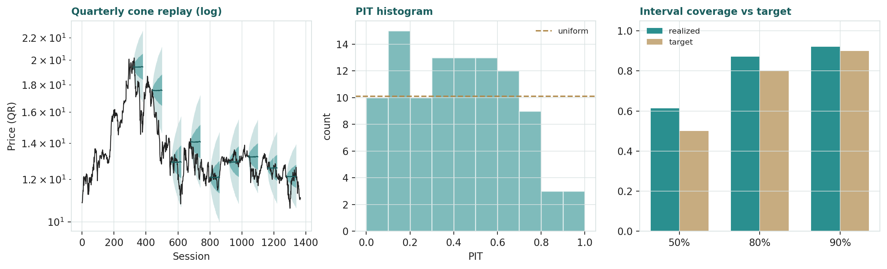
Figure B-1 · Calibration diagnostics. Left: quarterly cone replay (log scale). Centre: PIT histogram (roughly uniform). Right: interval coverage versus target.
On the two higher-powered schemes — fortnightly and monthly, which have real statistical mass — the engine beats the random-walk benchmark on CRPS skill with a roughly uniform PIT and on-target coverage. The low-powered non-overlapping scheme (only sixteen windows) is marginally negative, which we report rather than hide. The honest conclusion: Industries Qatar is a stable, low-volatility, near-Gaussian-at-a-quarter, high-dividend name, so the naive cone is genuinely hard to beat; the engine's edge here is the mild mean-reversion the variance-ratio captures, and it clears the bar where the sample supports a verdict.
Appendix C · Peer set, sector structure and risks
Industries Qatar has no perfect comparable — it is a three-way holding company, not a pure play. The closest reads are SABIC and the GCC petrochemical names on the chemicals side, and CF Industries, Nutrien and Yara on nitrogen; regionally, the QSE large-cap cohort sets the quasi-sovereign multiple. The structure below and the risk list frame what the peer multiples do and do not capture.
Entity | IQ stake | What it makes
QAFCO (fertilizers) | 100% | Ammonia, urea, melamine, formaldehyde — world-scale, low-cost gas
QAPCO (petrochemicals) | 80% | Ethylene, LDPE/LLDPE, sulphur; TotalEnergies holds 20% to 2029
QAFAC (fuel additives) | 50% | Methanol and MTBE; reclassified to 50%-owned subsidiary in 2024
Qatar Steel | 100% | Billets, rebar, DRI/HBI; partly restarted from mothballed state

Risk | Severity | Note
Petrochemical cycle | High | Chinese overcapacity; PE spreads at multi-year lows
Geopolitical / Gulf security | High | Direct disruption to production and logistics (Q1-26)
Commodity price (urea/gas) | Medium | Nitrogen and gas swings move margins directly
US rate / peg linkage | Medium | High-payout yield name; QAR pegged to USD
Concentration / control | Medium | QatarEnergy ~51%; minority-holder influence limited
Execution (Ammonia-7/Ras Laffan) | Medium | Pipeline delivery underpins the growth options

About this series
Testahil publishes independent, educational valuation studies under a single house method: a fundamental valuation on the instrument-appropriate lens, a technical read, and a Monte Carlo simulation calibrated against a random-walk benchmark, closed by a panel of method experts. We publish fair-value ranges and probability distributions — never ratings, targets, or buy/sell language. Every study is scored after the fact in a public calibration ledger.
Disclosure & disclaimer
Not investment advice. This document is educational and does not constitute investment advice, a recommendation, an offer, or a solicitation to buy or sell any security. It states no rating and no price target.
No licence. The preparer is not a licensed financial advisor and is not regulated by the Egyptian Financial Regulatory Authority or any other body. Nothing here is a regulated research recommendation.
Holdings disclosure. The preparer may hold, and may in the future take or dispose of, a position in the security discussed in this report.
Sources. Figures are drawn from public company disclosures, filings and reputable aggregators, with reporting dates noted where used; some inputs are the preparer's own estimates and are flagged as such.
Forward-looking. Any forward-looking statements, forecasts, scenarios and probabilities are uncertain by nature, may prove wrong, and should not be relied upon. Past performance and simulated outcomes do not guarantee future results.
No reliance. Readers must make their own independent decisions and seek professional advice suited to their circumstances. The preparer accepts no liability for any loss arising from use of this document. All figures in Qatari riyal (QR) unless stated; USD conversions at USD/QR 3.64.

testahil.com · Educational analysis · Not investment advice · Industries Qatar (QSE: IQCD) · Edition 05-07-2026

Appendix D · The expert panel
We close by handing Industries Qatar to three method experts, each cast for a holding company and each running a genuinely different valuation. Expert 1 values the group as a discounted collection of assets. Expert 2 is an accountant who trusts only realizable value and cash. Expert 3 is a macro-policy strategist who prices the group as a bundle of options on commodities and regional risk. They are labelled Expert 1, 2 and 3; their fair values are derived from shown workings, and each states what would prove them wrong.
Expert 1 · Net asset value and the holding-company discount
Worldview. A holding company is worth the sum of what its pieces would fetch, plus the cash, minus a discount for the friction of holding them together — the conglomerate's tax on its own complexity. Expert 1's tradition is the break-up analyst's: value each leg on the multiple its own industry commands, add the balance sheet, and argue about the discount. The method works when the parts are separable and their markets are liquid; it fails when the parts are so entangled that no piece could actually be sold, or when the 'discount' is really a permanent feature of controlled ownership.
Standard workings. Expert 1 takes normalized mid-cycle earnings for each of the three legs — fertilizers QR 2.5bn, petrochemicals QR 1.3bn, steel QR 0.5bn — applies industry multiples of 14.5×, 13× and 7.5×, sums to a segment enterprise value of QR 56.9bn, adds QR 8.5bn of net cash for QR 65.4bn of gross asset value, and applies a holdco discount. The discount is the argument. For a clean, three-segment, 100%-payout, net-cash structure controlled by a stable sovereign shareholder, Expert 1 sees little justification for a large haircut — the dividend certainty is worth something — and settles on 4%, giving equity value of QR 62.8bn and QR 10.38 per share as the base.
Leg / step | Norm. NI (QRbn) | Multiple | Value (QRbn)
Fertilizers | 2.50 | 14.5× | 36.3
Petrochemicals | 1.30 | 13.0× | 16.9
Steel | 0.50 | 7.5× | 3.8
Net cash | — | — | 8.5
Less 4% discount | — | — | (2.6)
Equity value | — | — | 62.8
Per share | — | — | QR 10.38

Why these multiples. Expert 1 defends each mark from its own peer set. The 14.5× on fertilizers is a premium to CF Industries' 11× and Yara's 12×, justified because QAFCO is 100%-owned, world-scale, and fed by structurally cheaper gas than any Western nitrogen producer — a genuine cost moat that earns a higher multiple through the cycle. The 13× on petrochemicals is a mid-cycle number, above the trough the segment trades through today but below the 15× the market pays GCC chemical names in good times; Expert 1 is explicit that this multiple assumes a recovery, and that the assumption is the vulnerability. The 7.5× on steel is deliberately low — steel is cyclical, globally oversupplied, and Qatar Steel spent years mothballed — so Expert 1 refuses to pay a franchise multiple for a restart. Net cash is taken at face value because it is exactly that: cash and bank balances, not goodwill.
Sensitivity. The swing input is the holdco discount and the petrochemical multiple together. At a 0% discount and a recovered 15× petrochemical multiple the parts are worth about QR 15; at a 10% discount and a 9× trough multiple, about QR 7.5. Expert 1's base of QR 10.6 (a hair above the mechanical 10.38, giving some credit for the pipeline) sits in the middle. Expert 1 notes the discount itself is not academic: Industries Qatar has historically traded around and sometimes above its parts, precisely because the 100% payout converts the holding structure's cash into a certain dividend — the opposite of the trapped-cash problem that earns most conglomerates a wide discount.
Cross-examination. Expert 1 tells Expert 2 that marking everything to conservative realizable value ignores that these are cash-generating franchises, not liquidation assets — QAFCO is not going to be sold for scrap. And Expert 1 tells Expert 3 that pricing the group as a basket of macro options is elegant but unfalsifiable: at some point you have to put a multiple on the earnings. Verdict: QR 10.6, fairly valued. Falsification: if a segment were actually put up for sale at a multiple far from Expert 1's mark, the method's core assumption — that quoted-peer multiples equal realizable value — would be tested directly. Market-implied: at spot QR 11.07 the market is paying about a 6% premium to the mechanical parts, which Expert 1 reads as the quasi-sovereign premium.
Expert 2 · The accountant — realizable value and cash quality
Worldview. Trust the balance sheet and the cash, distrust the multiple. Expert 2's tradition is the auditor's: earnings can be dressed by one-offs, cycles and accounting choices, but cash conversion and realizable asset value are harder to fake. This is the most conservative of the three methods, and it is deliberately so — it works as a floor, and it fails as a ceiling, because it systematically undervalues genuine franchise and growth.
Standard workings. Expert 2 starts from the same segment earnings but strips them harder: the 2025 fertilizer figure is flagged as near a cyclical peak and marked down; the petrochemical figure is taken close to its actual depressed run-rate rather than a hoped-for recovery; the steel figure has its impairment reversal removed. Expert 2 then applies conservative, sub-peer multiples and adds cash at face value. Crucially, Expert 2 examines cash quality: IQ generated positive operating cash flow every quarter, free cash flow of about QR 1.9bn in the first nine months of 2025, and funds a 100% payout partly from the cash pile — sustainable for now, but a drawdown to watch. The result is a deliberately low base: QR 9.8 per share.
Leg / step | Norm. NI (QRbn) | Multiple | Value (QRbn)
Fertilizers (marked down from peak) | 2.30 | 12.0× | 27.6
Petrochemicals (near run-rate) | 0.90 | 10.0× | 9.0
Steel (ex one-off) | 0.40 | 6.0× | 2.4
Net cash at face value | — | — | 8.5
Less 6% discount | — | — | (2.9)
Equity value | — | — | 44.6
Per share | — | — | ≈ QR 9.8 (rounded)

When the method works and fails. Expert 2's floor is most reliable exactly when the others are least — at a cyclical top, when reported earnings flatter and multiples look cheap on numbers that will not repeat. It is least reliable at a trough, when it marks a franchise to its worst quarter and calls a durable business impaired. For Industries Qatar today the two legs sit at opposite ends of that trap: fertilizers near a peak (where Expert 2's caution is well-placed) and petrochemicals near a trough (where it is probably too harsh). That tension is why Expert 2 lands lowest of the three, and why it is honest about being a floor rather than a fair value.
Cash-conversion detail. Expert 2's second discipline is to check that reported profit is real cash. Here it largely is: IQ's operating cash flow tracked net income closely through 2025, capital expenditure of about QR 2.2bn was funded from operations, and the cash pile sat near QR 8.5bn at the start of 2026. The one yellow flag is that a 100% payout exceeds free cash flow in most years, so the dividend is topped up from the balance sheet — sustainable while the cash lasts, but a slow drawdown Expert 2 watches. A move to a below-earnings payout would, paradoxically, strengthen this balance-sheet view even as the market read it as bad news.
Sensitivity. Expert 2's number is most sensitive to the fertilizer normalization: if 2025's strength proves durable rather than peak-ish, the floor lifts toward QR 11; if nitrogen prices mean-revert hard, it drops toward QR 8.5.
Cross-examination. Expert 2 tells Expert 1 that a 4% discount is too generous for a company whose largest segment just earned QR 4mn in a quarter — complexity and cyclicality deserve a wider haircut. And Expert 2 tells Expert 3 that options on a recovery are worth nothing until they are in the cash flow. Verdict: QR 9.8, modestly rich versus spot. Falsification: a sustained run of petrochemical earnings well above the depressed run-rate, or fertilizer holding its 2025 strength for several years, would show the conservative marks were too harsh. Market-implied: the market pays QR 11.07, about 13% above Expert 2's floor — the gap is the franchise and growth Expert 2 refuses to pay for.
Expert 3 · The macro-policy strategist — scenario-weighted options
Worldview. Industries Qatar is not really an earnings stream; it is a bundle of options on urea, on polyethylene spreads, on the price of gas, and — crucially — on regional peace. Expert 3's tradition is the macro strategist's: define scenarios, attach probabilities, value the group in each, and take the weighted average. The method works when the value genuinely hinges on a few external variables (it does here); it fails when it becomes a way to smuggle in optimism through generous scenario weights.
Standard workings. Expert 3 builds three states. In the base case (55%), petrochemicals recover partially, Ammonia-7 lands on schedule, urea holds, and regional tensions stay contained — worth about QR 11.5. In the bull case (20%), spreads recover fully, a gas or urea shock lifts the complex, and the Ras Laffan pipeline re-rates the group — worth about QR 15.5. In the bear case (25%), regional conflict re-escalates and disrupts logistics as it did in early 2026, petrochemicals stay at the trough, and urea softens — worth about QR 7.5. The probability-weighted value is about QR 11.2.
Scenario | Probability | Value (QR) | Contribution
Bull — full recovery + shock + Ras Laffan | 20% | 15.5 | 3.10
Base — partial recovery, Ammonia-7 lands | 55% | 11.5 | 6.33
Bear — conflict re-escalates, trough holds | 25% | 7.5 | 1.88
Probability-weighted value | 100% | — | ≈ QR 11.2

When the method works and fails. Scenario-weighting earns its keep precisely when a name's value hinges on a few external variables that a point estimate cannot capture — and Industries Qatar qualifies, because its worth genuinely turns on urea, on polyethylene spreads, on gas, and on regional peace. It fails when the scenarios become a vehicle for smuggling in a predetermined answer through convenient weights; Expert 3 guards against that by tying each state to an observable — a urea price, an operating rate, a conflict headline — rather than a mood. The discipline is that the weights must be defensible to someone who disagrees, and the 25% bear weight is deliberately not trivial because the first quarter of 2026 showed the bear state is live, not tail.
What the options framing captures that the others miss. A static sum-of-the-parts prices the petrochemical leg at one number; an accountant prices it near zero. Neither captures that the leg is genuinely optional — worth little if the trough persists, worth a great deal if spreads recover and Ras Laffan ramps — and that optionality has value even before it pays off. Expert 3's probability weighting is a crude option pricing: it assigns the recovery a chance and a magnitude rather than an all-or-nothing point, which is why the scenario-weighted value (QR 11.2) sits above the accountant's floor and near the NAV analyst's mark. The cost of the method is that its inputs are the least observable of the three.
Sensitivity. Expert 3's number is most sensitive to the bear-case probability — the geopolitical weight. Raising it from 25% to 40% pulls the weighted value below QR 10.5; the first quarter of 2026 is a live reminder that the bear case is not remote. The second lever is the bull-case magnitude, which rests on the pipeline and a spread recovery that has not yet begun.
Cross-examination. Expert 3 tells Expert 1 that a static sum-of-the-parts misses the optionality entirely — the value is in the distribution, not the point. And Expert 3 tells Expert 2 that marking to the trough ignores that troughs end, and that a franchise fed by the cheapest gas on earth has embedded optionality a liquidation view cannot see. Verdict: QR 11.2, fairly valued. Falsification: a structural, multi-year re-rating of Gulf risk (up or down) that the scenario weights do not anticipate would invalidate the weighting. Market-implied: at QR 11.07 the market is pricing almost exactly Expert 3's probability-weighted base — the market and the strategist agree.
The three in one room
Put them together and the argument narrows to one asset: the petrochemical leg. Expert 1 values it at QR 16.9bn on a normalized 13× — a recovery he assumes but cannot see yet. Expert 2 will barely credit it, marking it near its QR 4mn quarterly run-rate and calling the recovery speculative. Expert 3 doesn't argue the point estimate at all — he prices the recovery as an option with a probability, which is why his fair value ends up between the other two. The fertilizer leg they broadly agree on (QAFCO is a genuine franchise); the steel leg is too small to fight over. So the entire spread between QR 9.8 and QR 11.2 is a single disagreement about one question — how much to pay today for a petrochemical recovery that has not started — dressed three different ways.
The exchange sharpens when they turn to the balance sheet. Expert 2 points out that whatever multiple the others assign the operating legs, roughly QR 8.5bn — about QR 1.40 per share — is simply cash, and that this floor is the one number none of them disputes. Expert 1 agrees but adds that the cash is only worth face value because it is paid out; a hoarded pile would earn a discount. Expert 3 closes the point by noting that the cash is also what lets Industries Qatar fund a 100% payout through the petrochemical trough without cutting the dividend — the balance sheet is what converts a cyclical earnings stream into the steady 6% yield that supports the price. On that, at least, all three agree: the dividend is real, and it is what the holder is paid to wait with.
Reading the divergence
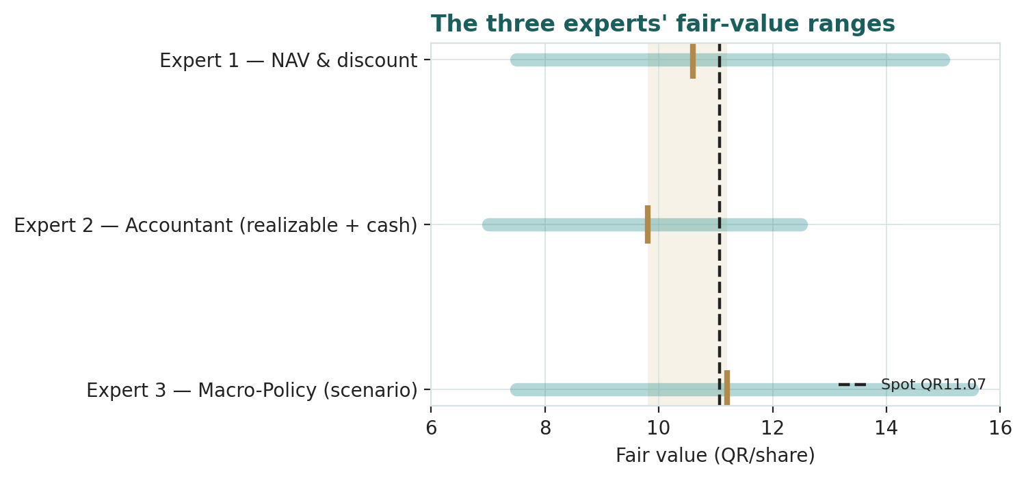
Figure D-1 · The three experts' fair-value ranges. Brass marks are base cases; the gold band spans the base estimates; dashed = spot.
The experts span QR 9.8 to QR 11.2 at the base — a tight 14% spread, unusually narrow, because all three are anchored to the same net-cash balance sheet and the same durable fertilizer franchise. The one assumption driving each: Expert 1 the holdco discount and recovery multiple; Expert 2 the fertilizer normalization and cash sustainability; Expert 3 the geopolitical probability weight. What the spread measures is not whether Industries Qatar is cheap or dear — all three land near spot — but how you choose to treat a single unresolved question: the petrochemical recovery. Value it (Expert 1), refuse to (Expert 2), or price it as an option (Expert 3), and you get QR 10.6, QR 9.8, or QR 11.2. The market, at QR 11.07, sits at the optimistic end of that narrow band — paying for a partial recovery, with the dividend paying it to wait.
Expert | Base (QR) | Bear / Bull (QR) | Single driving assumption
Expert 1 — NAV & discount | 10.6 | 7.5 / 15.0 | Holdco discount + recovery multiple
Expert 2 — Accountant | 9.8 | 7.0 / 12.5 | Fertilizer normalization + cash quality
Expert 3 — Macro-Policy | 11.2 | 7.5 / 15.5 | Geopolitical scenario weight

testahil.com · Educational analysis · Not investment advice · Industries Qatar (QSE: IQCD) · Edition 05-07-2026

