TESTAHIL · Independent Valuation Study — Educational Analysis · Not investment advice
Ibnsina Pharma — is it worth it?
Ibnsina Pharma S.A.E. (EGX: ISPH)
Fundamental analysis · Technical analysis · Monte Carlo simulation — one integrated read
Spot EGP 11.67 (close 07 Jul 2026) · 1,008 mn shares · market cap ~EGP 11.76 bn · Egypt's #1–2 pharmaceutical distributor — thin margins, near-zero cash-conversion cycle, growth financed by suppliers.
READ FIRST
This document is an educational analysis, not investment advice, and contains no recommendation, rating or price target. The preparer is not licensed by any securities regulator, holds no brokerage authorisation, manages no money and accepts no fees or clients. All values are model outputs presented as ranges and distributions because no single number should be relied on. Reported financials are the company's own disclosure (FY2023–FY2025 consolidated results, EGX filings); forward-looking inputs — the DCF, the multiples, the normalized-earnings marks and the Monte-Carlo factor probabilities — are the preparer's judgments and are flagged throughout. A few balance-sheet items (net interest-bearing debt, working-capital splits) are estimated to tie to disclosed totals and are flagged.
Illustrative Monte Carlo — a specific limitation on this name. For Ibnsina Pharma the probabilistic engine (§3) did NOT beat its naïve zero-drift random-walk benchmark in the Step-0 calibration backtest: its CRPS skill is negative on every window scheme. The §3 price map is therefore included for illustration and methodological transparency only — to show how the engine works and to bound the stock's own quarter-ahead uncertainty — and must not be relied upon as an accurate forecast for this stock. It is retained because the same engine adds value on other names and may do so for Ibnsina as its history lengthens and the calibration is refreshed. Consult a licensed financial advisor before any decision.

Headline
The model's read: cheap on fundamentals, but priced for Egyptian risk. Ibnsina Pharma is the number-one/number-two drug distributor in Egypt, and the disclosed financials tell a clean scale story — revenue up from EGP 33.9 bn (FY23) to EGP 76.6 bn (FY25), EBITDA margin edging from 4.6% toward 5.1%, net profit up 4.5x to EGP 952 mn. Our four fundamental lenses cluster around a central fair value of EGP 17.8 per share (range EGP 12.8–22.7) against a spot of EGP 11.67 — roughly +52%. That is close to where the visible analyst range sits (~EGP 14.5–21).
But the market prices ISPH at only ~4.2x trailing EV/EBITDA and ~12x earnings — a deep discount to global healthcare distributors — and it is doing so for reasons that are real, not irrational: a razor-thin net margin (~1.2%) that is highly geared to Egypt's very high interest rates, heavy balance-sheet leverage funded by supplier credit, and receivables risk in a stressed macro. The gap between our fundamental central and the price is therefore best read as a bet on two things normalising together — the drug-re-pricing cycle feeding through to margins, and the CBE rate path easing finance costs — rather than as a free lunch. This study is issued with a calibration caveat: the Monte-Carlo forecast engine does not beat a random walk for this particular name, so §3 is an honest probability map, not a validated forecast.
Valuation summary — every read at a glance
One table for the reads that follow — what the business is worth (fundamental), what the tape is doing (technical), where price could travel over three months (Monte Carlo — illustrative for this name), and how three independent expert methods land. Every row is developed in the sections and appendices below.
Lens / read | What it measures | Output | Takeaway
FUNDAMENTAL — what the business is worth (the anchor)
Discounted cash flow (primary) | Discounted 5-yr FCFF + terminal | EGP 19.8 | +70% vs spot
Relative multiples | Trailing EV/EBITDA, re-rated | EGP 16.7 | +43%
Normalized earnings | Mid-cycle net margin × P/E | EGP 18.0 | +54% · the ceiling
Dividend / yield floor | Sustainable DPS capitalised | EGP 11.0 | −6% · the floor
Weighted central | Blend 45 / 25 / 20 / 10 | EGP 17.8 | +52% vs EGP 11.67
TECHNICAL — what the tape is doing (timing, not value)
Trend & moving averages | Price vs 20/50/100/200-day | Below the two short | Consolidating
Momentum / range | RSI · MACD · 52-week range | RSI 40 · MACD −0.09 · 9.09–12.75 | Neutral-to-soft
MONTE CARLO — illustrative only · calibration failed (§3)
T+20 sessions | 50,000 paths · 16 factors | p5 10.16 · p50 11.75 · p95 13.52 | ≈ spot (illustrative)
T+60 sessions | same engine, longer horizon | p5 9.29 · p50 11.91 · p95 15.18 | Wide (illustrative)
EXPERT PANEL — three independent methods (Appendix C)
Expert 1 — earnings-power | Normalized net margin × P/E | EGP ~20.1 | Most bullish
Expert 2 — cash-returns | FCFF yield / ROIC vs WACC | EGP ~15.5 | Mid
Expert 3 — accountant | Asset-backing + sustainable EPS | EGP ~13.5 | Most conservative
Panel range | Spread = the net-margin question | EGP 13.5–20.1 | Centres ~16.8

Bottom line. Every fundamental read points the same way — cheap — and disagrees only on magnitude: the central sits near EGP 17.8, about +52% above the EGP 11.67 spot, and the three experts span EGP 13.5–20.1, each turning on one question — whether the thin net margin normalises as Egyptian rates ease. The technical tape is neutral-to-soft, below its short averages; and the three-month Monte Carlo is illustrative only for this name (it does not beat a random walk, §3), so it frames near-term uncertainty rather than direction.
Company overview
Ibnsina Pharma S.A.E. (founded 2001, listed on the EGX in December 2017) stores, imports and distributes pharmaceuticals, OTC products, cosmetics, food supplements and medical supplies to more than 35,000 customers — retail pharmacies, wholesalers, hospitals and healthcare institutions — from a national network of warehouses and a delivery fleet. It is the #1–2 distributor by market share (~24% per IQVIA). The economics are those of a distribution utility: an ~8% gross margin on very high volume, an ~5% EBITDA margin, a ~1.2% net margin, and — crucially — a near-zero (historically slightly negative) cash-conversion cycle, so growth is financed largely by suppliers ('spontaneous financing') rather than equity.
Item | Value
Ticker / exchange | ISPH · EGX (Egyptian Exchange)
Reporting currency | EGP
Spot / close date | EGP 11.67 · 07 Jul 2026
Shares outstanding | 1,008 mn (par EGP 0.25; capital EGP 252 mn)
Market capitalisation | ~EGP 11.76 bn
Net interest-bearing debt (est.) | ~EGP 4.5 bn (flagged estimate)
FY25 revenue / EBITDA / net profit | EGP 76,597 mn / 3,880 mn / 952 mn
FY25 EPS / DPS (approx.) | EGP 0.94 / ~0.10 (payout ~17%)
Business | #1–2 Egyptian pharma distributor (~24% share)
Cash-conversion cycle | ≈ 0 days (receivables ~90 + inventory ~30 − payables ~119)
Beta (reported) | ~1.0
52-week range | EGP 9.09 – 12.75
At a glance. Source: company disclosure (FY25 consolidated), EGX, market data as of 07 Jul 2026.
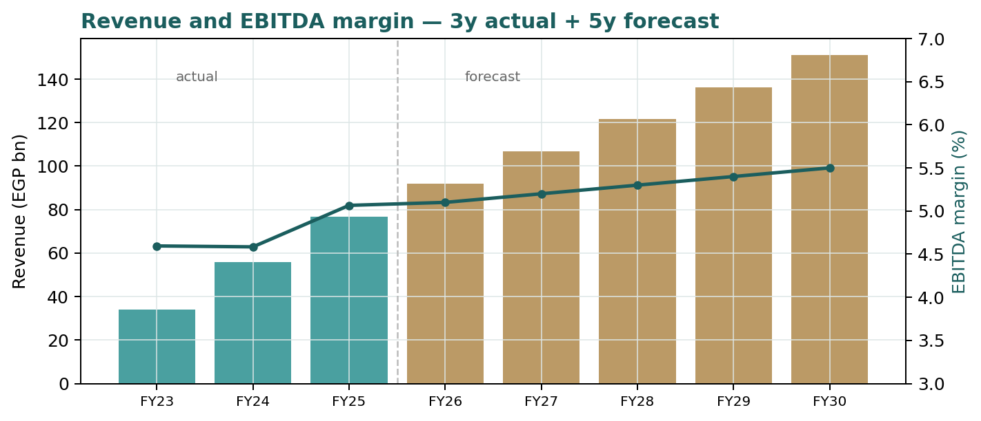
Figure 1 — Revenue and EBITDA margin: three years actual, five years forecast (EGP bn / %).
1 Fundamental valuation
We value ISPH with a discounted cash-flow model as the primary lens (a going-concern distributor with a light-asset model and a stable, defensive demand base fits DCF better than an asset-based method), cross-checked against relative multiples and a normalized-earnings lens, with a dividend-yield floor. All four are combined in a football field rather than blended into a single point.
1.1 Primary lens — discounted cash flow (FCFF)
We build free cash flow to the firm over an explicit five-year horizon (FY26–FY30), discount at a WACC of 25.8%, and add a Gordon terminal value at 12.5% nominal growth. The cost of equity is stated explicitly as Ke = rf + β·ERP = 23.5% + 1.15×6.0% = 30.4%, reflecting Egypt's high nominal risk-free rate; the pre-tax cost of debt is 26%. Revenue growth fades from the re-pricing-driven ~20% toward ~11%; EBITDA margin expands modestly on scale from 5.1% to 5.5%; capex stays light (~0.6% of sales) and the near-zero cash-conversion cycle keeps the working-capital drag small.
EGP mn | FY26E | FY27E | FY28E | FY29E | FY30E
Revenue | 91,916 | 106,623 | 121,550 | 136,136 | 151,111
EBITDA | 4,688 | 5,544 | 6,442 | 7,351 | 8,311
D&A | 414 | 480 | 547 | 613 | 680
EBIT | 4,274 | 5,065 | 5,895 | 6,739 | 7,631
NOPAT = EBIT×(1−t) | 3,312 | 3,925 | 4,569 | 5,223 | 5,914
+ D&A | 414 | 480 | 547 | 613 | 680
− Capex | 551 | 640 | 729 | 817 | 907
− Δ working capital | 337 | 324 | 328 | 321 | 329
Free cash flow to firm | 2,838 | 3,442 | 4,058 | 4,697 | 5,358
Discount factor | 0.795 | 0.632 | 0.502 | 0.399 | 0.318
PV of FCFF | 2,256 | 2,175 | 2,039 | 1,876 | 1,701
DCF waterfall — full five-year build (row order per house standard). Forecast inputs are the preparer's judgments.
DCF bridge | EGP mn / per share
Σ PV of explicit FCFF (FY26–30) | 10,048
Terminal value (Gordon) | 45,364
PV of terminal value | 14,405
Enterprise value | 24,453
less: net interest-bearing debt | (4,500)
Equity value | 19,953
Fair value per share | EGP 19.79
Terminal value as % of EV | 59%
Bear / base / bull (WACC×g grid) | EGP 13.7 / 19.8 / 23.7
Terminal value is 59% of EV — a meaningful (but not extreme) terminal dependency; disclosed and sensitized per device A-7. See the WACC×g grid in §1.9.
1.2 Cash-flow cross-check
The DCF's engine is FCFF, so the cross-check is a sanity read on cash generation rather than a second model. ISPH's near-zero cash-conversion cycle is the distinguishing feature: receivables of ~90 days and inventory of ~30 days are almost fully funded by ~119 days of supplier payables, so incremental revenue absorbs little net working capital and FCFF tracks NOPAT plus D&A minus modest capex. The risk sits in the tails of that cycle — an acceleration in re-pricing forces the company to buy inventory in cash at higher prices before it can collect, temporarily inflating debt (management flagged exactly this for the first three quarters of 2025). FY26 FCFF of ~EGP 2,838 mn on an EV of ~EGP 24,453 mn is a forward FCFF yield around 12%.
1.3 Relative multiples
The market values ISPH at ~4.2x trailing EV/EBITDA and ~12x earnings. Global and EM healthcare distributors typically trade 6–10x EV/EBITDA, but that gap is a fair Egyptian risk discount, not a mispricing on its own. Anchoring on trailing FY25 EBITDA of EGP 3,880 mn and allowing a modest re-rating to 5.5x as margins and rates normalise gives:
EV/EBITDA lens | Value
Trailing EBITDA (FY25) | EGP 3,880 mn
Target multiple (bear/base/bull) | 4.5x / 5.5x / 7.0x
Implied fair value / share | EGP 12.9 / 16.7 / 22.5
Multiple anchored on trailing (not forward) EBITDA to avoid double-counting growth already in the DCF.
1.4 Normalized earnings power
The swing variable for a thin-margin, highly-levered distributor is the net margin, which is compressed today by finance costs. Normalizing the net margin toward ~1.7–1.9% as CBE rates ease (from a FY25 ~1.2%) and applying a justified P/E of ~10x to FY27E revenue gives an earnings-power fair value that brackets the DCF:
Normalized-earnings lens | Value
FY27E revenue | EGP 106,623 mn
Normalized net margin (bear/base/bull) | 1.4% / 1.7% / 2.0%
Justified P/E | 8.5x / 10.0x / 12.0x
Implied fair value / share | EGP 12.6 / 18.0 / 25.4
Peak/mid-cycle framing: current net margin is trough-like (rate-compressed), so we normalize UP — but conservatively.
1.5 Synthesis — four lenses and the football field
We weight the DCF most heavily (it captures the cash economics), the relative and normalized lenses next, and a dividend-yield floor lightly. We publish the football field rather than a blended point: the lenses are far enough apart that a single averaged number would be false precision (device A-8).
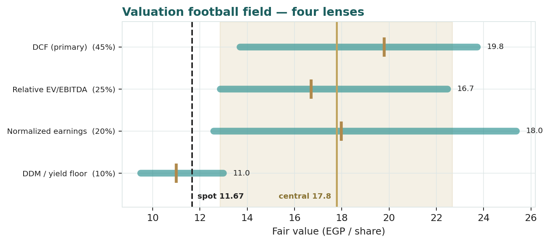
Figure 2 — Valuation football field. Bars span bear–bull; ticks mark each lens's base; gold line is the weighted central; dashed line is spot.
1.6 Deeper look — channels and a scorecard
ISPH sells through three channels: retail pharmacies (the largest, ~46% of FY23 revenue), wholesale (~33%), and tenders & private hospitals (~20%). Retail's share has been managed down since 2022 as the company tightened credit limits to control receivables risk — a deliberate quality-over-share choice that distinguishes it from struggling competitors who chased share by extending terms. Growth is now driven by re-pricing (inflation pass-through on a regulated drug basket) and market-share gains as financially-stable ISPH wins supplier agreements.
Scorecard | Read
Market position | #1–2 distributor, ~24% share (IQVIA) — scale leader
Revenue quality | Defensive (pharma demand, population +2%/yr) + inflation re-pricing
Margin trajectory | EBITDA margin expanding on scale (5.1%→5.5%); net margin rate-gated
Cash conversion | ≈ 0-day cycle — capital-light growth, supplier-financed
Balance-sheet risk | High leverage (D/E ~3.5x, mostly payables); receivables the watch-item
Capital returns | Small dividend (~17% payout); reinvestment + deleveraging priority
Segment / quality scorecard. Channel mix from FY23 disclosure; FY25 mix not separately disclosed.
1.7 The crux — finance-cost leverage on a thin margin
The single swing factor is not revenue (defensive and re-priced) but the net margin, and the net margin is a lever pulled by Egypt's interest rate. On ~EGP 76 bn of revenue at an ~8% gross margin and ~5% EBITDA margin, the distance between EBITDA and net profit is dominated by finance cost. We therefore sensitize the crux in real observable units — the CBE policy-rate path and its pass-through to the net margin — not an abstract 'margin %':
Net margin → | 1.0% | 1.4% | 1.8% | 2.2%
Net profit FY27E (EGP mn) | 1,066 | 1,493 | 1,919 | 2,346
EPS FY27E (EGP) | 1.06 | 1.48 | 1.90 | 2.33
Value at 10x P/E (EGP) | 10.6 | 14.8 | 19.0 | 23.3
Crux sensitivity in real units. A ~100 bp of CBE easing that lifts the net margin from ~1.0% to ~1.8% roughly doubles EPS — the whole bull case in one row.
The mirror risk is a receivables event: a stressed pharmacy channel or a sharp devaluation that impairs collectability would hit the balance sheet before the P&L. This is why ISPH's conservative credit policy is a feature, not a drag.
1.8 Macro and country
ISPH is a leveraged bet on Egyptian macro normalisation. Three variables dominate:
Macro driver | Channel to ISPH
CBE policy rate | Directly sets finance cost; cuts expand the net margin (the crux)
EGP / USD | Imported-drug cost and re-pricing lag; devaluation squeezes then re-prices
Drug price regulation | Re-pricing decisions set the pace of nominal revenue pass-through
Inflation | Nominal revenue tailwind; also lifts opex and working-capital funding need
Population / demand | Structural ~2%/yr volume growth; defensive, inelastic demand
Country lens. Egypt's disinflation-and-rate-cut path is the key swing for the equity.
1.9 Primary-lens sensitivity — WACC × terminal growth
Because ~59% of DCF value is terminal, the fair value is sensitive to the WACC−g spread. The grid below (fair value per share, EGP) shows the range; the base case (WACC ~25.8%, g 12.5%) is highlighted in the text.
 | g 10.5% | g 11.5% | g 12.5% | g 13.5% | g 14.5%
WACC 29.0% | 13.7 | 14.3 | 15.0 | 15.7 | 16.6
WACC 27.0% | 16.0 | 16.8 | 17.7 | 18.8 | 20.0
WACC 25.8% | 17.7 | 18.7 | 19.8 | 21.1 | 22.6
WACC 24.0% | 20.8 | 22.1 | 23.7 | 25.5 | 27.8
WACC 22.0% | 25.3 | 27.3 | 29.7 | 32.7 | 36.4
DCF fair value (EGP/share) across WACC × terminal growth. Base case bold in text: EGP 19.8.
2 Technical and price structure
ISPH trades at EGP 11.67, just below its short-term moving averages and near the middle of a EGP 9.09–12.75 52-week range. The moving-average stack is tightly bunched (SMA20 11.96, SMA50 11.68, SMA100 11.39, SMA200 11.23), consistent with a consolidation after the 2024–25 re-rating. RSI at 40 is neutral-to-soft; MACD is mildly negative (line -0.038, signal 0.047, histogram -0.086). Realised volatility is ~35% annualised. Net: a quiet, range-bound tape with the 200-day (~EGP 11.23) as the pivot.
Indicator | Value | Read
Spot | EGP 11.67 | —
SMA 20 / 50 | 11.96 / 11.68 | price just below — soft
SMA 100 / 200 | 11.39 / 11.23 | 200-day is the pivot
RSI (14) | 40 | neutral-to-soft
MACD line / signal / hist | -0.038 / 0.047 / -0.086 | mildly bearish
Realised vol (252d, ann.) | 35% | moderate for EGX
52-week range | 9.09 – 12.75 | mid-range
Technical indicators as of 07 Jul 2026. Technicals describe tape, not value.
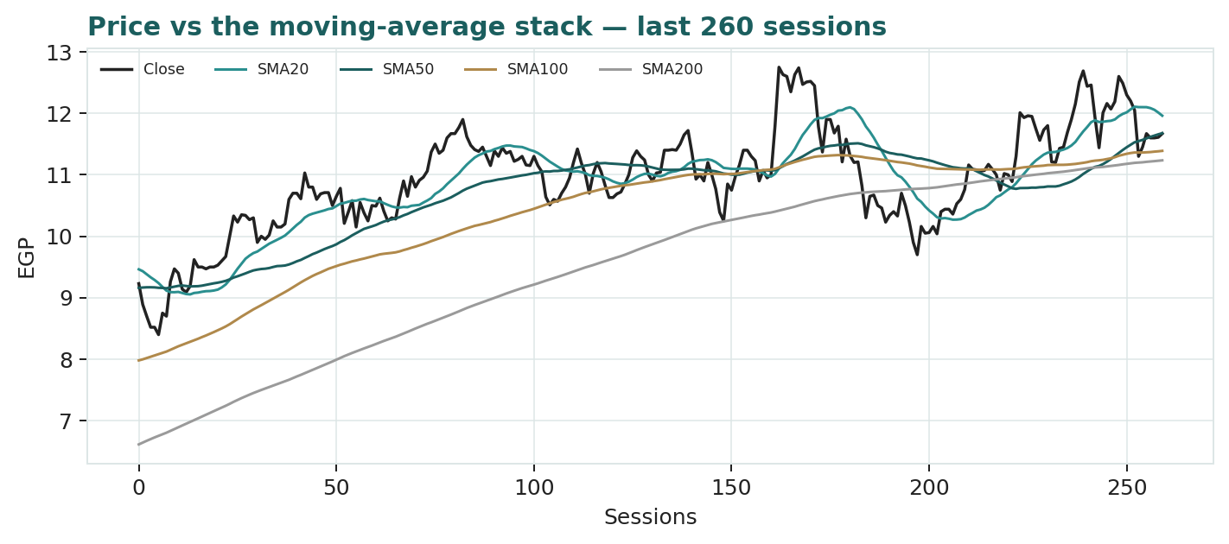
Figure 3 — Price versus the moving-average stack, last 260 sessions.
3 Monte Carlo — a probabilistic price map (illustrative only)
Illustrative only. For Ibnsina Pharma this Monte-Carlo map did NOT beat a naïve zero-drift random-walk cone in the Step-0 calibration: CRPS skill is negative on every window scheme. ISPH is a jump-driven, devaluation-sensitive name whose realised 60-day moves are dominated by a few large re-pricing/FX steps; a naïve wide cone already captures that dispersion, and the engine's regime-conditioning and fat tails add no forecasting edge over it. The percentiles below are shown to demonstrate the method and to bound the stock's own quarter-ahead uncertainty — they are NOT a reliable forecast for this name and should not be relied upon. We retain the section for transparency and because the same engine adds value on other names.

We simulate 50,000 three-month price paths (seed 42) with a sixteen-factor stack: seven continuous macro/operating drivers contributing a small net forward drift, and nine discrete events that each fire with a probability and an impact. By design the paths diffuse from spot and the §1 value gap is kept out of the drift — the fundamental question lives in §1; §3 only maps where price could wander. Diffusion volatility is sized by the house YZ-HAR engine (a gap-aware Yang-Zhang variance proxy feeding a pooled log-HAR cascade over variance lags 1/5/22), widened by a horizon variance-ratio of 1.86 to match this name's genuine multi-day dispersion, landing at an annualised ~29%; innovations are unit-variance Student-t(5). Drift is set to zero (the honest choice for a name whose calibration failed), leaving only a modest net contribution from the continuous factors — direction is not manufactured.
The probability read (T+60)
Probability read | Value
P(price above spot) | 56%
P(+10%) vs P(−10%) | 29% vs 19% (odds 1.57:1)
Median level (and move) | EGP 11.91 (+2.0%)
50% band (25th–75th) | EGP 10.85 – 13.06 (19% of spot)
Touch +10% / −10% | 49% / 36%
Read first. Computed from the same 50,000 paths as the fan chart — presentation only, it does not feed the drift or width. A near-even map with a slight upward catalyst skew.
The factor stack
Continuous factor (7) | Dir. | Discrete event (9) | Prob. | Mean impact
Egyptian pharma-market volume | + | Quarterly results print | 85% | +0.4%
Drug re-pricing / pass-through | + | CBE rate decision (cut) | 45% | +1.0%
CBE policy-rate path | + | Further re-pricing round | 40% | +1.2%
EGP/USD (imported-drug cost) | − | New supplier / distribution deal | 35% | +0.6%
EGX30 & foreign flows | + | EGP devaluation step | 25% | −3.0%
Working-capital / supplier credit | ± | Drug shortage / disruption | 20% | −1.5%
Market share vs competition | + | Dividend / capital action | 30% | +0.6%
 |  | Receivables / credit event | 20% | −1.2%
 |  | Index / passive rebalancing | 25% | +0.5%
Sixteen-factor stack (illustrative). Downside events (FX step, shortage, credit) are lower-probability but larger — the honest touch asymmetry.
Percentile map and cone
Horizon | p5 | p25 | p50 | p75 | p95
T+20 sessions | 10.16 | 11.14 | 11.75 | 12.39 | 13.52
T+60 sessions | 9.29 | 10.85 | 11.91 | 13.06 | 15.18
Percentile map (EGP/share), illustrative. Read the 25–75% band first; the 90% tail is the outer envelope.
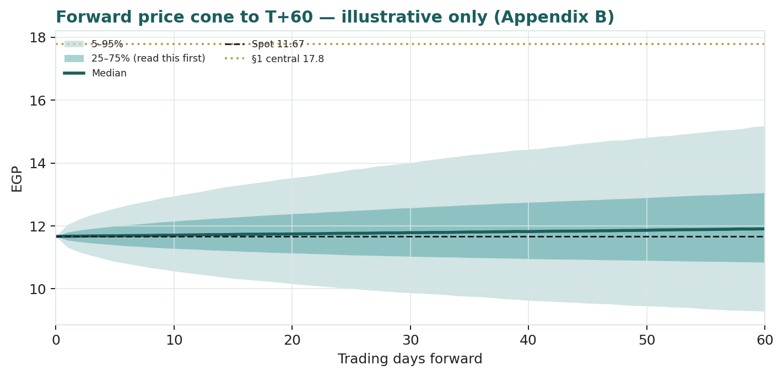
Figure 4 — Forward price cone to T+60. Median tracks spot; gold dotted line marks the ~EGP 17.8 fundamental central. Illustrative only.
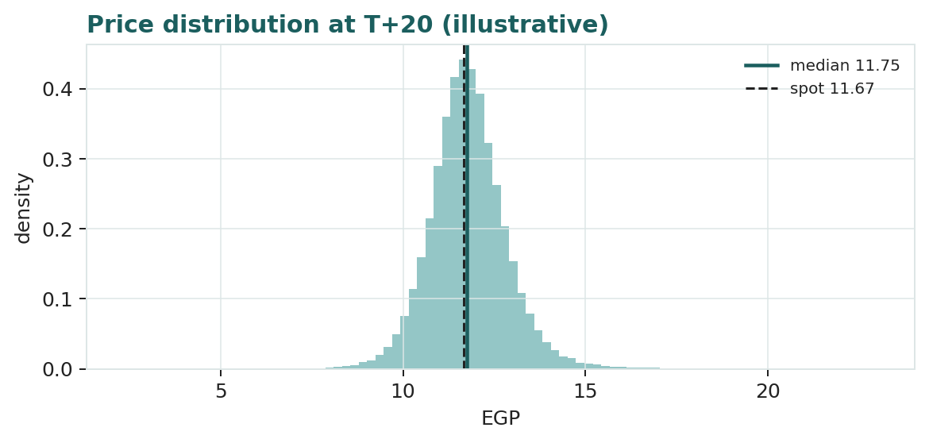
Figure 5 — Price distribution at T+20 (illustrative).
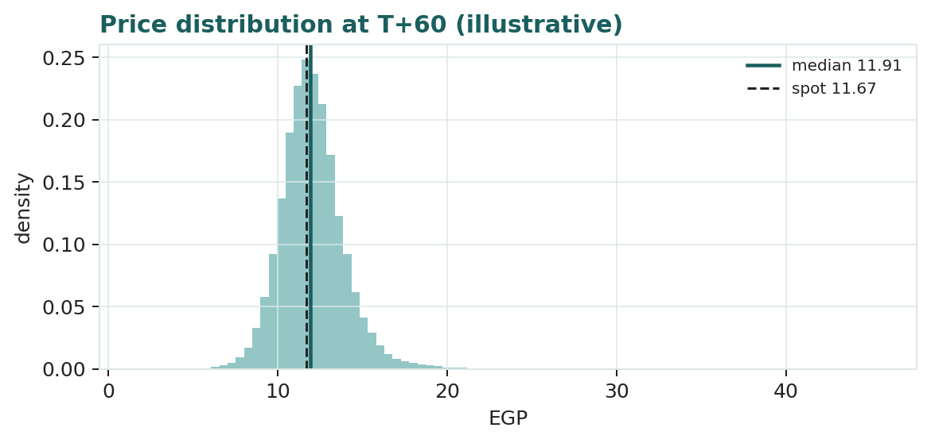
Figure 6 — Price distribution at T+60 (illustrative).
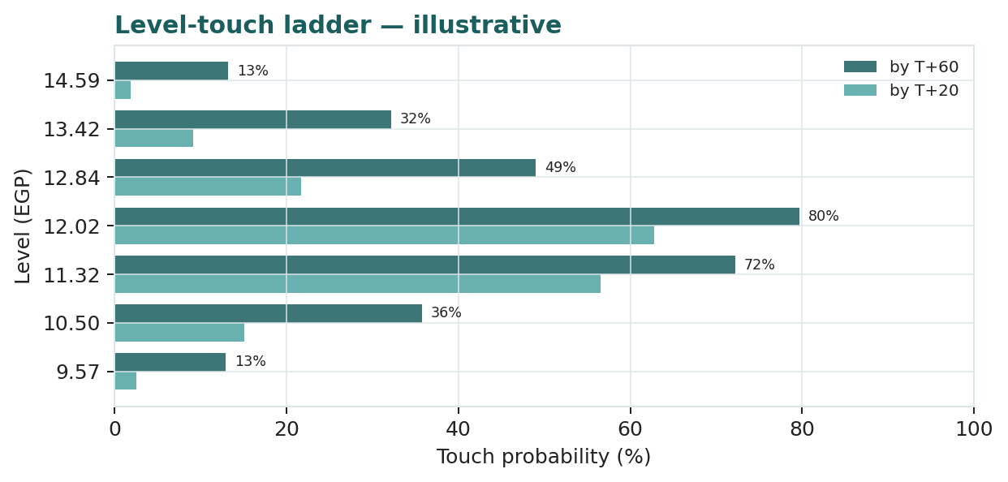
Figure 7 — Level-touch ladder to T+20 and T+60 (illustrative).
4 Comparison of the lenses, and a verdict
The three fundamental methods agree on direction and disagree on degree. The DCF is the most optimistic (EGP 19.8), because it capitalises the margin-and-scale story into a terminal value; the relative multiple is the most grounded (EGP 16.7), because it anchors on what the market pays today for EBITDA; the normalized-earnings lens sits between (EGP 18.0). The dividend-yield floor (~EGP 11) sits at spot, reflecting the small payout. Weighting them gives a central of EGP 17.8 — about +52% above the price.
Verdict: on fundamentals ISPH looks cheap, and the disagreement across lenses is narrow enough (EGP 11–20) to give the read some weight. But the discount to that fair value is compensation for genuine risk — a razor-thin net margin geared to Egyptian rates, heavy leverage, and receivables exposure — so the gap is a normalisation bet, not a mispricing to be assumed away. The Monte-Carlo section adds no independent forecasting signal here; it only frames near-term uncertainty. We publish a fair-value range and a probability map, not a rating or a target.
5 Catalysts to watch
Catalyst | Direction | Why it matters
CBE rate cuts | + | Directly expands the net margin — the crux
Drug re-pricing decisions | + | Sets the pace of nominal revenue pass-through
Quarterly margin prints | ± | Evidence the EBITDA-margin scale story is real
Working-capital normalisation | + | Debt was flagged to rise then normalise through 2025
New supplier agreements | + | Market-share gains as stable ISPH wins portfolios
EGP devaluation step | − | Squeezes imported-drug cost before re-pricing catches up
Receivables / credit event | − | Balance-sheet risk in a stressed pharmacy channel
Catalysts. The rate path and the re-pricing cadence dominate.
6 Reading the probability zones
Read as an illustrative map (not a forecast): the 25–75% band spans roughly EGP 10.8–13.1 at T+60 — about 19% of spot — which is the instrument's genuine quarter-ahead uncertainty, not padding. The distribution carries a slight upward tilt (P above spot 56%, odds 1.57:1) driven by the re-pricing/rate-cut catalyst set, offset by lower-probability but larger downside events (an FX step, a credit event). The fundamental central (~EGP 17.8) sits above the T+60 median (~EGP 11.9) — the value gap that §1 argues, which §3 deliberately does not price in.
Zone (T+60) | Level (EGP) | Interpretation
Upper tail (p95) | 15.18 | re-pricing + rate cuts land together
Upper quartile (p75) | 13.06 | modest re-rating
Median (p50) | 11.91 | near spot, slight up-tilt
Lower quartile (p25) | 10.85 | macro stalls
Lower tail (p5) | 9.29 | FX / credit shock
Probability zones (illustrative).
7 Caveats and what would change our mind
Caveat / risk | What would change the read
Calibration failed (§3) | The engine does not beat a random walk for ISPH — §3 is not a forecast
Net-margin normalisation is a bet | If CBE easing stalls and the net margin stays ~1.2%, DCF/normalized fall sharply
Terminal-value heavy DCF (59% of EV) | A higher WACC or lower terminal g compresses fair value (see §1.9 grid)
Leverage & finance cost | A prolonged high-rate environment keeps net profit suppressed
Receivables / credit risk | A material write-down would hit book value and the Accountant's case
Net-debt estimate | Net interest-bearing debt (~EGP 4.5 bn) is estimated to tie to disclosed totals
FX / re-pricing lag | A sharp devaluation squeezes margins until re-pricing catches up
What would change our mind. The single most important is whether the net margin structurally recovers.

Appendix A Financial statements
Consolidated, EGP mn. FY23–FY25 are the company's own disclosure (EGX filings); FY26–FY30 are the model's forecast. Finance-cost and tax history are estimated to tie to reported net profit.
A.1 Income statement
EGP mn | FY23 | FY24 | FY25 | FY26E | FY27E | FY28E | FY29E | FY30E
Revenue | 33,949 | 55,842 | 76,597 | 91,916 | 106,623 | 121,550 | 136,136 | 151,111
EBITDA | 1,560 | 2,560 | 3,880 | 4,688 | 5,544 | 6,442 | 7,351 | 8,311
EBITDA margin | 4.6% | 4.6% | 5.1% | 5.1% | 5.2% | 5.3% | 5.4% | 5.5%
D&A | 170 | 230 | 300 | 414 | 480 | 547 | 613 | 680
EBIT | 1,390 | 2,330 | 3,580 | 4,274 | 5,065 | 5,895 | 6,739 | 7,631
Net finance cost | (1,120) | (1,650) | (2,650) | (2,757) | (3,199) | (3,647) | (4,084) | (4,533)
Net profit (after NCI)* | 214 | 615 | 952 | 1,175 | 1,446 | 1,743 | 2,057 | 2,401
EPS (EGP) | 0.21 | 0.61 | 0.94 | 1.17 | 1.43 | 1.73 | 2.04 | 2.38
*FY26–30 net profit = NOPAT less after-tax finance cost (simplified). Source: company FY23–25; forecast = model.
A.2 Balance sheet (working-capital markers)
EGP mn | FY23 | FY24 | FY25 | FY26E | FY27E | FY28E | FY29E | FY30E
Receivables (~90d) | 8,371 | 13,769 | 18,887 | 22,664 | 26,291 | 29,971 | 33,568 | 37,260
Inventory (~30d) | 2,567 | 4,223 | 5,792 | 6,950 | 8,062 | 9,191 | 10,294 | 11,426
Trade payables (~119d) | 10,183 | 16,750 | 22,975 | 27,570 | 31,981 | 36,458 | 40,833 | 45,325
Net working capital | 755 | 1,242 | 1,704 | 2,045 | 2,372 | 2,704 | 3,029 | 3,362
Net interest-bearing debt | 2,100 | 3,200 | 4,500 | 5,040 | 5,645 | 6,322 | 7,081 | 7,931
Working capital = days × sales/COGS. Near-zero cash-conversion cycle. Net debt FY23–24 estimated; FY25 per disclosure.
A.3 Cash flow (simplified)
EGP mn | FY23 | FY24 | FY25 | FY26E | FY27E | FY28E | FY29E | FY30E
Net profit | 214 | 615 | 952 | 1,175 | 1,446 | 1,743 | 2,057 | 2,401
+ D&A | 170 | 230 | 300 | 414 | 480 | 547 | 613 | 680
− Increase in net WC | 0 | (487) | (462) | (341) | (327) | (332) | (324) | (333)
− Capex | (204) | (335) | (460) | (551) | (640) | (729) | (817) | (907)
Free cash flow to firm | 180 | 23 | 331 | 697 | 959 | 1,228 | 1,529 | 1,841
Simplified FCFF bridge. Near-zero cash-conversion cycle keeps the working-capital draw small.
A.4 Per-share & ratio dashboard
Metric | FY23 | FY24 | FY25 | FY26E | FY27E
EPS (EGP) | 0.21 | 0.61 | 0.94 | 1.17 | 1.43
EBITDA margin | 4.6% | 4.6% | 5.1% | 5.1% | 5.2%
Net margin | 0.6% | 1.1% | 1.2% | 1.3% | 1.4%
Net debt / EBITDA | 1.3x | 1.2x | 1.2x | 1.1x | 1.0x
P/E at spot (x) | 55.0x | 19.1x | 12.4x | 10.0x | 8.1x
EV/EBITDA at spot (x) | 10.4x | 6.4x | 4.2x | 3.5x | 2.9x
Standardized dashboard (identical fields across every Testahil study).

Appendix B Peer set, sector structure, and risks
Egyptian pharmaceutical distribution is a scale-and-working-capital game. The top two players — Ibnsina and UCP/Pharma Overseas — hold the bulk of the organised market; demand is defensive (population +2%/yr, inelastic drug consumption) with an inflation re-pricing overlay. Very high local interest rates compress the multiples the market will pay relative to global distributors, and receivables quality separates the winners from the strugglers.
Comparable | Market | Type | Typical EV/EBITDA
Ibnsina Pharma (ISPH) | Egypt (EGX) | Pharma distribution #1–2 | ~4.2x (spot)
UCP / Pharma Overseas | Egypt (private) | Pharma distribution | n/a (unlisted)
MENA healthcare distributors | MENA | Distribution / logistics | 5–8x
Global EM pharma distributors | Global EM | Distribution | 6–10x
Peer set. ISPH's discount to global distributors is a fair Egyptian-risk gap, not a mispricing on its own.
Sector risks: interest-rate persistence (finance-cost drag), FX/devaluation (imported-drug cost, re-pricing lag), drug-pricing regulation (pace of pass-through), and channel credit risk (pharmacy solvency). Structural supports: defensive demand, consolidation toward scale leaders, and re-pricing as an inflation hedge.

Appendix C The expert panel
Three independent valuation experts, each running a genuinely different method on the same disclosures, cast for a working-capital-heavy distributor: an earnings-power specialist (normalized multiple), a cash-returns specialist (ROIC/FCF — the distributor crux), and an accountant (balance-sheet and receivables quality). They are labelled Expert 1/2/3; each shows workings, a sensitivity on their swing input, how they cross-examine the others, a verdict and a falsification condition. Macro-policy runs through §1.8 and §5 rather than as a fourth persona.
C.1 Expert 1 — Earnings-power (normalized multiple)
Worldview and tradition. Value is a normalized mid-cycle earnings stream times a justified multiple. Current EPS is trough-like because finance costs are rate-compressed; the right anchor is what ISPH earns once the net margin normalises. Works best for stable-demand franchises with a cyclical cost line; fails when the 'normal' never returns.
Step | Value
FY27E revenue | EGP 106,623 mn
Normalized net margin | 1.9%
Normalized net profit | EGP ~2,026 mn
Justified P/E | 10.0x
Fair value per share | EGP ~20.1
Worked example (base). Bear 1.5%×8.5x → ~13.5; bull 2.2%×12x → ~27.9.
Sensitivity on the swing input.
Net margin → | 1.4% | 1.9% | 2.4%
Value at 10x (EGP) | 14.8 | 20.1 | 25.4

Cross-examination. Challenges the Accountant for anchoring on a rate-compressed trough as if it were permanent, and the Cash-returns expert for ignoring the multiple re-rating that comes with margin recovery.
Verdict. ISPH is cheap: EGP ~20 base, roughly 70% above spot, if — and only if — the net margin normalises toward ~1.9%.
Falsification condition. If the net margin has not risen above ~1.6% by FY27 despite CBE easing, the normalization thesis is falsified and fair value collapses toward the multiple lens.
What the market price implies. At EGP 11.67 the market implies a normalized net margin barely above today's ~1.2% — i.e. it does not believe the margin recovers.
C.2 Expert 2 — Cash-returns (ROIC / FCF)
Worldview and tradition. Value is the present value of cash the business actually throws off, and the quality test is return on invested capital versus the cost of capital. For a distributor the magic is the near-zero cash-conversion cycle — growth funded by suppliers, not shareholders — but the discipline is that the net margin is thin, so FCFF must be verified, not assumed. Works best where cash conversion is clean; fails when working capital swings violently.
Step | Value
FY26E FCFF | EGP ~2,830 mn
Enterprise value (DCF) | EGP ~24,400 mn
Forward FCFF yield | ~11–12%
Fair FCFF yield (Egypt, levered) | ~14%
Implied EV → equity / share | EGP ~15.5
Worked example (base). A demanded ~14% FCFF yield on near-term FCFF, growing.
Sensitivity on the swing input.
FCFF yield demanded → | 12% | 14% | 16%
Fair value (EGP) | ~18.5 | ~15.5 | ~13.2

Cross-examination. Challenges Earnings-power for capitalising a terminal margin the cash flows have not yet shown, and agrees with the Accountant that the receivables cycle is the real risk — but reads the near-zero CCC as a strength that funds growth cheaply.
Verdict. Fair value ~EGP 15.5 — cheap, but less so than the earnings-power lens, because a levered Egyptian distributor deserves a high demanded cash yield.
Falsification condition. If the cash-conversion cycle turns materially positive (working capital starts absorbing cash as re-pricing accelerates and collection lags), FCFF falls and the case weakens.
What the market price implies. At EGP 11.67 the market demands a forward FCFF yield well above 16% — pricing in either weaker cash conversion or higher-for-longer rates.
C.3 Expert 3 — Accountant (balance-sheet & receivables quality)
Worldview and tradition. Value starts from the balance sheet and the durability of reported earnings, with a heavy discount for leverage and collectability risk. On ~EGP 76 bn of revenue the receivables book is large and the leverage (mostly supplier payables, but real interest-bearing debt too) is high; conservative value is asset-backing plus a modest multiple on sustainable — not peak-hope — earnings. Works best as a downside anchor; fails by being too cautious in a genuine recovery.
Step | Value
Book value per share (approx.) | EGP ~2.9
Sustainable net profit (haircut) | EGP ~1,300 mn
Multiple on sustainable earnings | ~9x
Asset-backing + earnings blend | EGP ~13.5
Fair value per share | EGP ~13.5
Worked example (base). A conservative blend; receivables provisioning is the swing.
Sensitivity on the swing input.
Receivables provision → | base | +2% | +4%
Fair value (EGP) | ~13.5 | ~11.5 | ~9.8

Cross-examination. Challenges Earnings-power for treating a rate-cut that has not happened as banked, and Cash-returns for trusting FCFF that depends on collecting a large, macro-sensitive receivables book on time.
Verdict. Fair value ~EGP 13.5 — the stock is modestly cheap, but the margin of safety is thin given the leverage and receivables exposure.
Falsification condition. If a receivables write-down or a covenant/finance-cost squeeze materialises, book value and sustainable earnings both fall and fair value drops toward EGP 10.
What the market price implies. At EGP 11.67 the market is close to the Accountant's conservative fair value — it is pricing the risks, not the recovery.
C.5 The three in one room
Put the three in a room and the argument is about one number: the net margin two years out. Expert 1 (Earnings-power) says CBE easing plus scale lifts it to ~1.9%, and the stock is worth ~EGP 20. Expert 2 (Cash-returns) says show me the cash — the near-zero CCC is real and funds growth, but a levered Egyptian distributor deserves a ~14% cash yield, so ~EGP 15.5. Expert 3 (Accountant) says you are both banking a rate cut and a clean receivables book that a devaluation could impair; anchored on today's balance sheet, ~EGP 13.5. They agree the business is good and the direction is up; they disagree on whether the thin net margin structurally recovers or stays pinned by finance costs and credit risk.
C.6 Reading the divergence
Expert | Method | Fair value (EGP) | The one assumption driving it
Expert 1 | Earnings-power (normalized × P/E) | ~20.1 | Net margin normalises to ~1.9%
Expert 2 | Cash-returns (FCFF yield) | ~15.5 | Demanded FCFF yield ~14%
Expert 3 | Accountant (asset + sustainable) | ~13.5 | Receivables/leverage haircut holds
Spread | — | 13.5 – 20.1 | Does the net margin recover?
The football field of expert fair values. The ~EGP 6.6 spread is a direct measure of disagreement over net-margin normalisation.
The spread (EGP 13.5–20.1, midpoint ~16.8) brackets the study's four-lens central of EGP 17.8 and sits above spot. What the spread measures is not modelling noise but a single real question — whether Egypt's disinflation feeds through to ISPH's net margin. Resolve that one variable and the three experts converge.

About this series
Testahil ('is it worth it?') publishes independent, educational valuation studies of listed equities and metals. Each study integrates a fundamental valuation, a technical read and a Monte-Carlo probability map, and is graded against a public calibration ledger: every forecast is scored, after the fact, against a naïve random-walk benchmark, and a forecast only 'succeeds' if it beats that benchmark on CRPS skill with a well-calibrated distribution. Studies present fair-value ranges and probability distributions — never a rating, a target price or advice. This study is issued with a calibration caveat and its §3 is therefore illustrative.
Disclosure & Disclaimer
1. Not investment advice. This report is an educational and analytical exercise. It is not investment advice, not a recommendation, and not an offer or solicitation to buy or sell any security. It contains no rating and no price target.
2. No licence, no advisory relationship. The preparer is not licensed or registered with any securities regulator in any jurisdiction, holds no brokerage or advisory authorisation, manages no money, and accepts no fees, funds or clients. Nothing here creates an advisory relationship.
3. Model outputs, not facts. All valuations are outputs of models built on assumptions that are uncertain and may be wrong. They are presented as ranges and distributions precisely because no single number should be relied upon. Reported financials are the company's own disclosure; forward-looking inputs are the preparer's judgments and are flagged.
4. Calibration limitation on this name. For Ibnsina Pharma the Monte-Carlo engine did not beat a naïve random-walk benchmark in the Step-0 backtest. The §3 probability map is illustrative and must not be relied upon as a forecast for this stock.
5. No liability. The preparer accepts no liability for any loss arising from any use of this document. Markets involve risk, including loss of capital. Consult a licensed financial advisor before making any decision.
6. Holdings disclosure. The preparer may hold, and may in the future take or dispose of, a position in the security discussed in this report.

TESTAHIL · Independent Valuation Study · Educational Analysis · Ibnsina Pharma S.A.E. (EGX: ISPH) · edition 07-07-2026 · reporting currency EGP

