Testahil · Independent Valuation Study — Educational Analysis Not investment advice
Independent Valuation Study — Educational Analysis
Juhayna Food Industries (EGX: JUFO)
Fundamental analysis · Technical analysis · Monte Carlo simulation — one integrated read
Anchor: EGP 29.99 (01 Jul 2026 close) · 1,176.76 m shares · mkt cap ~EGP 35.3 bn · Egypt’s largest branded dairy, yoghurt and juice producer (dairy · fermented/yoghurt · juice · concentrates & agriculture), the continuing listed entity after the February-2025 four-company merger · prices and probabilities computed 01 Jul 2026 from the attached daily history · primary lens: going-concern discounted cash flow (FCFF), cross-checked by relative multiples, normalized earnings and a segment sum · gross-margin normalization (after the orange-concentrate super-cycle) and the Egyptian rate path (WACC) are the swing factors.
READ FIRST — what this document is, and is not. This study is a valuation exercise and an expression of personal analytical opinion, published free of charge for educational purposes: it shows how one analyst applies fundamental, technical and probabilistic methods to a listed company, and invites scrutiny of that methodology. It is NOT investment advice, NOT a recommendation or solicitation to buy, sell or hold any security, and NOT directed at the circumstances of any reader. The preparer is not licensed by the Egyptian Financial Regulatory Authority (FRA) or by any securities regulator in any jurisdiction, holds no brokerage authorisation, provides no financial consultancy, manages no money, and accepts no fees, funds or clients. See the Disclosure & Disclaimer at the end. All values are model outputs presented as ranges and distributions because no single number should be relied on. Reported financials are the company’s own disclosure (FY25 audited results, 12 March 2026; FY24/FY23 comparatives, 25 March 2025); forward-looking inputs — the margins, the multiples, the DCF and the Monte-Carlo factor probabilities — are the preparer’s judgments and are flagged throughout. A note on the accounts: FY25 consolidates the four Juhayna-group companies merged in February 2025, so FY25 gross margin is not strictly like-for-like with FY24. Consult a licensed financial advisor before any investment decision.
Headline
The model’s read: modestly rich to fair, with the downside cushioned by a genuine secular (nominal-EGP) uptrend and the upside resting on gross margin normalizing. At EGP 29.99 the shares sit about 13% above our weighted central estimate of ~EGP 26. Revenue has compounded hard — EGP 15.5 bn → 24.3 bn → 30.0 bn across FY23–FY25 on a mix of volume and price — but FY25 net profit fell to EGP 1.9 bn (from EGP 2.7 bn) as FY24’s exceptional orange-concentrate margins normalized and finance costs rose on a capex-driven leverage build (net debt EGP 0.2 bn → 2.0 bn → 5.96 bn). The four lenses span EGP 20.5 (segment sum, the floor) to EGP 28.7 (relative and normalized earnings, the ceiling), with a discounted-cash-flow anchor at EGP 24.3. Technically — and unusually for our studies — the tape agrees with the secular story rather than fighting it: price trades above its 50-, 100- and 200-day averages and near the top of its 52-week range, with only a mild momentum cooling. Over three months the Monte Carlo places the 5th–95th percentile band at roughly EGP 24–43, with the median drifting to ~EGP 32 — that upward tilt is the name’s own nominal secular drift, and it sits deliberately above the EGP 26 fundamental central because the simulation maps where price travels, not where value sits.
Valuation summary — every read at a glance
One table for the four reads that follow — what the business is worth (fundamental), what the tape is doing (technical), where price could travel over three months (Monte Carlo), and how three independent expert methods land. Every row is developed in the sections and appendices below.
Lens / read | What it measures | Output | Takeaway
FUNDAMENTAL — what the business is worth (the anchor)

Discounted cash flow (primary) | 5-yr FCFF, nominal EGP | EGP 24.3 | −19% vs spot
Relative multiples | Fwd EBITDA × peer EV/EBITDA | EGP 28.7 | −4%
Normalized earnings | Mid-cycle PAT × justified P/E | EGP 28.7 | −4% · the ceiling
Segment sum | Segment EBIT × sector multiples | EGP 20.5 | −32% · the floor
Weighted central | Blend 40 / 25 / 25 / 10 | EGP 26.1 | −13% vs EGP 30
TECHNICAL — what the tape is doing (timing, not value)

Trend & momentum | Price vs 20/50/100/200-day | Above 50/100/200 | Constructive
Momentum / range | RSI · MACD · 52-wk | RSI 51 · MACD hist -0.21 · EGP 20.1–31.8 | Near highs, cooling
MONTE CARLO — where price could go in 3 months (paths from spot)

T+20 sessions | 50,000 paths · 16 factors | p5 26.0 · p50 30.7 · p95 36.2 | Median just above spot
T+60 sessions | same engine, longer horizon | p5 24.2 · p50 32.1 · p95 42.6 | Wide, up-drifting
EXPERT PANEL — three independent methods (closing appendix)

Expert 1 — normalized earnings power | Mid-cycle margin × multiple | EGP 28.5 | Most constructive
Expert 2 — accountant (RNAV / cash quality) | Realizable assets, cash conversion | EGP 24.5 | The sceptic
Expert 3 — cash returns (DCF / ROIC) | Return on capital vs WACC | EGP 24.0 | Most cautious
Panel range | Spread = margin & capital | EGP 24–28.5 | Centres ~EGP 25.7
Bottom line. The reads agree that Juhayna is not deep value and not clearly expensive; they disagree only on how much of the FY24 margin was structural. The fundamental central sits near EGP 26 — about 13% below the EGP 30 spot — the three experts span EGP 24–28.5, and each turns on one question: whether gross margin normalizes back toward the FY24 profile or settles nearer the FY25 reported trough. The technical tape, for once, is not the dissenter — price is above trend and near its highs, which is why the three-month distribution drifts up from spot even though the fundamental value gap is modestly negative.
Company overview — Juhayna at a glance
Item | Value
Listed entity | Juhayna Food Industries S.A.E. (EGX: JUFO)
What it owns | Dairy · fermented/yoghurt · juice · concentrates & agriculture · distribution
Spot / date | EGP 29.99 · 01 Jul 2026 close
Shares · market cap | 1,176.76 m · ~EGP 35.3 bn
Net debt (mgmt, FY25) | EGP 5,960 m (interest-bearing loans + facilities less cash)
FY25 revenue / net profit | EGP 29,984 m (+23.4% YoY) · EGP 1,910 m (−30% YoY)
FY25 gross margin | 22.9% reported (25.3% operational, ex-merger) vs 30.4% in FY24
Largest segment | Dairy — ~51% of FY25 revenue
52-week range | EGP 20.08 – EGP 31.80
Founder / chairman | Safwan Thabet (founder); Seif Thabet (CEO)
Corporate event | February-2025 merger of four Juhayna-group companies; capital EGP 941.4 m → 1,176.8 m
Source: Juhayna FY25 audited results (12 Mar 2026), FY24/FY23 comparatives (25 Mar 2025), EGX disclosures, exchange data. Values rounded.
1 Fundamental valuation
We value Juhayna as a going concern — a branded, capital-intensive food producer that turns imported and local soft commodities into packaged dairy, yoghurt and juice — and triangulate four lenses. The primary lens is a discounted-cash-flow (FCFF) model, because the business is an operating cash-flow compounder rather than a collection of separable marks, and because the whole valuation question is a cash question: whether the heavy capex of the current expansion phase, and the working capital that dairy and agriculture tie up, leave enough free cash once margins normalize. A relative-multiple read, a normalized-earnings-power read and a segment sum complete the set, chosen so that no single assumption — one multiple, one discount rate, one normalized margin — carries the answer alone; where the four lenses agree we can be more confident, and where they diverge the divergence is itself informative. The weights and the football field are in §1.5; the swing factor — gross-margin normalization — is dissected in §1.7, the macro backdrop in §1.8, and the sensitivity grid in §1.9. All figures are nominal Egyptian pounds, which matters throughout: in a high-inflation economy the discount rate, the terminal growth and the revenue trajectory are all nominal, and it is the relationships between them, not their levels, that drive value.
1.1 Discounted cash flow (FCFF) — the primary lens
We build free cash flow to the firm as NOPAT plus D&A, less capex and the increase in net working capital, over an explicit five-year window (FY26E–FY30E), and fade to a Gordon terminal. Because both the discount rate and the terminal growth are struck in nominal pounds, it is the spread between them — not either level alone — that carries the answer. We use a WACC of 19.5% (a mid-to-high-teens EGP risk-free reflecting Egypt’s still-elevated but falling policy rate, a defensive beta, and a modest debt weight) and a 12% nominal terminal growth (long-run EGP inflation plus a little real growth). Capex is front-loaded — 9% of sales in FY26E tapering to ~5% by FY30E — so free cash flow is thin early and builds as the expansion matures.
DCF (base case) | Value
Σ PV of explicit FCFF, FY26E–FY30E (EGP m) | 5,948
PV of terminal value (EGP m) | 28,552
Enterprise value (EGP m) | 34,500
less: net debt (EGP m) | (5,960)
Equity value (EGP m) | 28,540
Fair value per share | EGP 24.25
Terminal value as % of EV | 83%
DCF base ≈ EGP 24.3/share, with a bear–bull span of about EGP 20–34 driven by the WACC and the normalized margin (§1.9). The 83% terminal weight is a fair warning — most of the value sits beyond the explicit window, which is unavoidable for a compounder whose near-term free cash is suppressed by its own growth spending, and it is why we cross-check the DCF against three lenses that do not depend on a terminal value.
Five-year FCFF projection (EGP m). The explicit build below drives the bridge above: NOPAT plus D&A, less capex and the increase in net working capital, discounted at the 19.5% WACC. Free cash flow is thin in FY26E as capex and the working-capital build absorb operating cash, then climbs sharply as capex intensity tapers from 9% toward 5% of sales.
FCFF build | FY26E | FY27E | FY28E | FY29E | FY30E
EBIT | 4,975 | 6,173 | 7,446 | 8,807 | 9,926
NOPAT = EBIT × (1−tax) | 3,856 | 4,784 | 5,771 | 6,825 | 7,693
+ D&A | 695 | 863 | 1,042 | 1,234 | 1,445
− Capex | (3,292) | (3,367) | (3,376) | (3,253) | (3,267)
− Δ net working capital | (1,078) | (1,185) | (1,165) | (1,162) | (1,212)
Free cash flow to firm | 180 | 1,095 | 2,272 | 3,644 | 4,659
Discount factor @ 19.5% | 0.837 | 0.700 | 0.586 | 0.490 | 0.410
PV of FCFF | 151 | 767 | 1,331 | 1,787 | 1,912
Terminal value = FY30E FCFF × (1+g) / (WACC−g) at g = 12%, discounted five years → PV EGP 28,552 m. Σ PV of explicit FCFF EGP 5,948 m + PV terminal EGP 28,552 m = EV EGP 34,500 m; less net debt EGP 5,960 m = equity EGP 28,540 m = EGP 24.25/share. Full linked build on the DCF sheet of the companion model.
1.2 Relative multiples — the market cross-check
On forward numbers Juhayna screens close to its Egyptian staples peers. We mark the relative lens on forward (FY26E) EBITDA of ~EGP 5,670 m and a peer-set EV/EBITDA of 7.0× — a premium to Obour Land (a smaller, net-cash cheese play at ~6.5×) for scale and brand, and a discount to Gulf names such as Almarai (~12×) for country risk, illiquidity and leverage.
Relative basis | Bear | Base | Bull
Forward EBITDA (EGP m) | 5,670 | 5,670 | 5,670
EV/EBITDA multiple | 6.0× | 7.0× | 8.0×
Fair value (EGP/share) | 24.0 | 28.7 | 33.0
Relative base ≈ EGP 28.7 — a touch below spot. It treats Juhayna as an average Egyptian staples compounder and assigns no premium for the vertical-integration (own-farm) story or the distribution reach.
1.3 Normalized earnings power
If gross margin settles around a normalized 25–26% (above the FY25 reported trough, below the FY24 concentrate peak) and finance costs ease as rates fall, mid-cycle net profit is well above FY25. We normalize FY26E net profit to ~EGP 2,809 m and apply a justified through-cycle P/E of 12× — in line with Egyptian food peers and below Gulf dairy.
Normalized-earnings basis | Bear | Base | Bull
Mid-cycle net profit (EGP m) | 2,809 | 2,809 | 2,809
Justified P/E | 10.0× | 12.0× | 14.0×
Fair value (EGP/share) | 24.0 | 28.7 | 33.0
Normalized-earnings base ≈ EGP 28.7 — the recovery lens. It is, in effect, the bet that FY25’s margin dip was a concentrate-and-merger air-pocket rather than the new normal, and that Q1-26 (net profit doubling year-on-year to EGP 668.6 m) marks the turn.
1.4 Segment sum — the conservative cross-check
Because Juhayna reports by segment, we can sum the parts: each segment’s FY25 revenue at a normalized operating margin and a segment-appropriate EV/EBIT multiple, less net debt. This is deliberately conservative — it is struck on the FY25 segment mix, in which the concentrates & agriculture line collapsed from EGP 3.2 bn to EGP 1.4 bn as orange-concentrate prices normalized — so it marks the floor rather than the central read.
Segment (FY25 rev, EGP m) | EBIT % | EV/EBIT | Segment EV (EGP m)
Dairy — 15,310 | 13% | 7.0× | 13,932
Fermented / yoghurt — 6,929 | 16% | 8.0× | 8,869
Juice — 6,254 | 14% | 7.5× | 6,567
Concentrates & agri — 1,401 | 10% | 5.0× | 701
Distribution — 90 | 3% | 4.0× | 11
Σ Enterprise value |  |  | 30,080
less: net debt |  |  | (5,960)
Segment-sum equity = EGP 20.5/share |  |  | 24,120
Segment-sum base ≈ EGP 20.5 — the most cautious lens, anchored on a trough year for the concentrates line. Grown to a forward mix it would sit closer to the relative read; we keep it trailing to preserve it as a genuine floor.
1.5 Synthesis — four lenses
We weight the DCF most heavily because the whole thesis is a cash question; the relative and normalized lenses carry the recovery view and anchor to the market; the segment sum marks the floor.
Lens | Weight | Bear | Base | Bull
Discounted cash flow | 40% | 20.4 | 24.3 | 34.0
Relative multiples | 25% | 24.0 | 28.7 | 33.0
Normalized earnings | 25% | 24.0 | 28.7 | 33.0
Segment sum | 10% | 18.0 | 20.5 | 28.0
Weighted central |  | 22.0 | 26.1 | 32.9
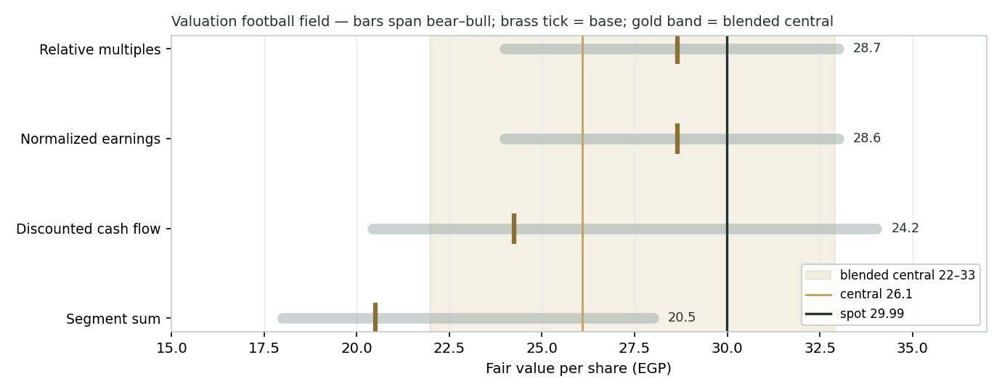
Figure 1 — Valuation football field. Bars span bear–bull per lens; the brass tick is each base case; the gold band is the blended central range; the dark line is spot.
Central fair value ≈ EGP 26.1/share, about 13% below spot. The spread of the lenses (EGP 20.5 to 28.7 at base) is itself the message: this is a fairly-priced compounder whose re-rating — or de-rating — depends on one operating outcome, gross margin, and one macro variable, the pace at which Egyptian rates fall.
1.6 The business — a deeper look
Dairy is the anchor (~51% of FY25 revenue) — plain and flavoured milk, the steadiest volume and margin. Fermented (yoghurt and Zabado/Rayeb) is the highest-margin line and the brand heart. Juice (Bekhero, Pure) is discretionary and more exposed to down-trading in a squeezed-income economy. Concentrates & agriculture is the vertical-integration and export leg — the most volatile, as FY24–FY25 showed. The table scores each part on the axes that matter.
Segment | Cyclicality | Margin trend | Capital intensity | Swing role
Dairy | Low | Steady | High (farms/plant) | Cash anchor
Fermented / yoghurt | Low | Firm, premium | Moderate | Margin engine
Juice | Moderate | Pressured (inputs) | Moderate | Down-trading risk
Concentrates & agri | High | Normalizing down | High | The volatility
1.7 Gross-margin normalization — the crux
One judgment drives the valuation more than any other: where gross margin settles. FY24 printed 30.4%, lifted by an exceptional run in orange-concentrate prices that flattered the agriculture leg; FY25 reported 22.9%, depressed by that normalization and by the dilution of consolidating four merged entities (management’s operational, ex-merger figure was 25.3%). We assume a normalized ~25–26.5%, trending up as pricing catches input costs and mix improves. Every percentage point of gross margin is worth roughly EGP 1.5–2.0 per share at the group level (§1.9). The second, smaller swing is finance cost: FY25’s EGP 1,169 m more than doubled FY24’s as the leverage build funded capex; as the central bank eases, this line should fall, lifting net profit without any operating improvement.
1.8 Macro and country — the pound, inflation, rates and the consumer
Juhayna is a domestic-demand business wrapped around a currency story. The Egyptian pound is the double-edged sword: its multi-year devaluation is the engine of the nominal-price uptrend that Step 0 detects and the drift term rewards, but it also raises the cost of imported inputs — wheat, oils, packaging resin — that sit in cost of sales, so a sharp step-devaluation squeezes margin before pricing catches up. The central bank’s rate path is the discounting variable: as inflation falls from its 2023–24 peaks and the CBE eases, the WACC in our DCF should decline, which is the single largest source of upside to the fundamental value. Consumer purchasing power sets volume and the risk of down-trading from branded to private label, especially in juice; staple-food subsidy and price policy is a wildcard that can help (demand support) or hurt (price caps). These levers are the swing factors behind the bear and bull cases in §1.5 and the catalysts in §5.
1.9 DCF sensitivity — how much the WACC and terminal growth move the value
Holding the operating build at base, the grid re-prices the DCF across the WACC and the nominal terminal growth. The value runs from about EGP 16 (WACC 22% / g 10%) to the mid-EGP-30s (WACC 17.5% / g 14%); the base cell (19.5% / 12%) lands near EGP 24.
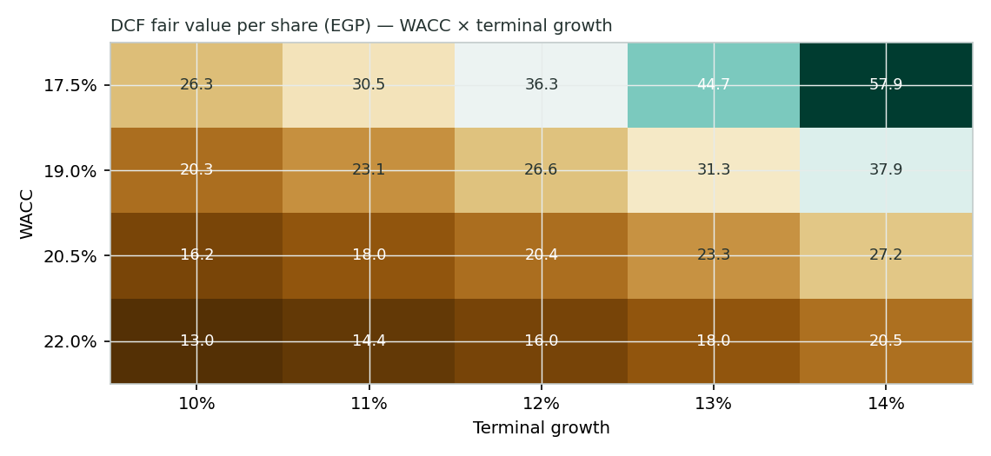
Figure 2 — DCF fair value per share (EGP), WACC × terminal growth. The base case is WACC 19.5%, g 12%.
Read it as the bet you are taking: the current price of EGP 30 is consistent with a WACC nearer 18% (faster disinflation) or a normalized margin above our base — i.e. the market is pricing a fuller recovery than our cautious central case assumes.
2 Technical and price structure
The tape is constructive and, for once, aligned with the fundamentals’ secular story. Juhayna trades above its 50-, 100- and 200-day moving averages and near the top of its 52-week range; the only near-term caution is that price has slipped just below the 20-day average and the MACD histogram has turned mildly negative — a shallow pause within an uptrend, not a breakdown. The rising 200-day average (EGP 26.2) is the visible trend floor.
Indicator | Reading | Signal
Spot | EGP 29.99 | —
SMA 20 / 50 | EGP 30.30 / 29.19 | Below 20, above 50 — mild pause
SMA 100 / 200 | EGP 28.26 / 26.22 | Above both — trend up
RSI (14) | 51.2 | Neutral
MACD (12,26,9) | +0.30 line / +0.51 signal / -0.21 hist | Positive but cooling
52-week range | EGP 20.08 – 31.80 | Upper part of range
Realized vol (252d) | 30.0% | Moderate
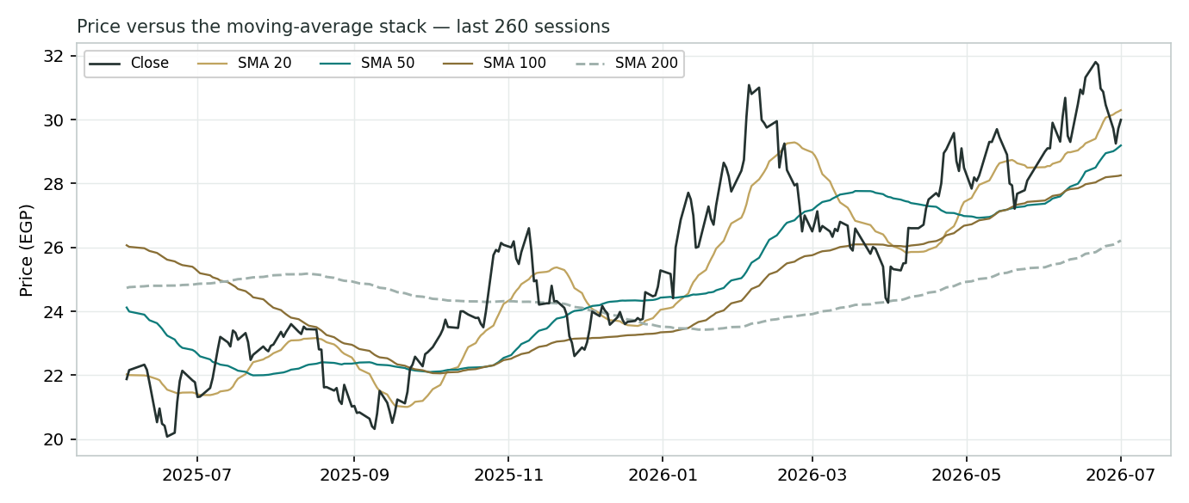
Figure 3 — Price versus the moving-average stack, last 260 sessions.
For the probabilistic work this matters in one way: an above-trend tape near its highs, combined with the name’s positive secular drift, tilts the near-term distribution gently upward — which is exactly what the Monte Carlo shows, even as the fundamental lenses argue the price is a little rich. The technical and fundamental pictures do not so much disagree as operate on different clocks, and §6 reads the resulting zones without forcing them together.
3 Monte Carlo — a probabilistic price map
We simulate 50,000 three-month price paths (seed 42) with the YZ-HAR engine: width from a gap-aware Yang–Zhang variance proxy fed through a pooled log-HAR cascade (regime-conditional, so the cone is tight in calm tape and wide in storm); Student-t(5) innovations for honest tails with a tighter interquartile body; and an asset-class-conditional secular drift that is ON for this name. A sixteen-factor stack layers on top — seven continuous drivers contributing a small net forward drift and nine discrete events that each fire with a probability and an impact.
By design the paths diffuse from spot, and the §1 value gap is kept out of the drift — the fundamental value lives in §1, not here; §3 maps where price could go from today, not where value sits. That is why the median cone drifts up to ~EGP 32 on the name’s own nominal trend while the gold line marks the EGP 26 fundamental central, deliberately below it. Diffusion volatility from the engine is 37.4% annualized; the net secular drift is +8.7% over the quarter.
Continuous factor (7) | Dir. | Discrete event (9) | Prob. | Mean impact
Secular nominal-EGP drift | + | Q2-26 results (Aug 2026) | 80% | +0.5%
Inflation (CPI) / pricing power | ± | Gross-margin normalization signal | 45% | +1.5%
EGP/USD (imported inputs) | − | EGP step-devaluation / IMF review | 25% | −2.5%
Soft-commodity inputs (wheat/oils) | − | Soft-commodity supply shock | 25% | −1.5%
Consumer real wages / volume | + | Subsidy / staple-price policy | 30% | +1.0%
CBE policy-rate path | − | New product / capacity launch | 40% | +1.5%
EGX30 & foreign flows | + | Purchasing-power cycle turn | 30% | +1.5%
 |  | Pricing pass-through success/fail | 40% | +1.0%
 |  | Competitive / private-label move | 35% | −1.0%
Percentile map (EGP/share):
Horizon | p5 | p25 | p50 | p75 | p95
T+20 sessions | 26.0 | 28.9 | 30.7 | 32.5 | 36.2
T+60 sessions | 24.2 | 29.0 | 32.1 | 35.5 | 42.6
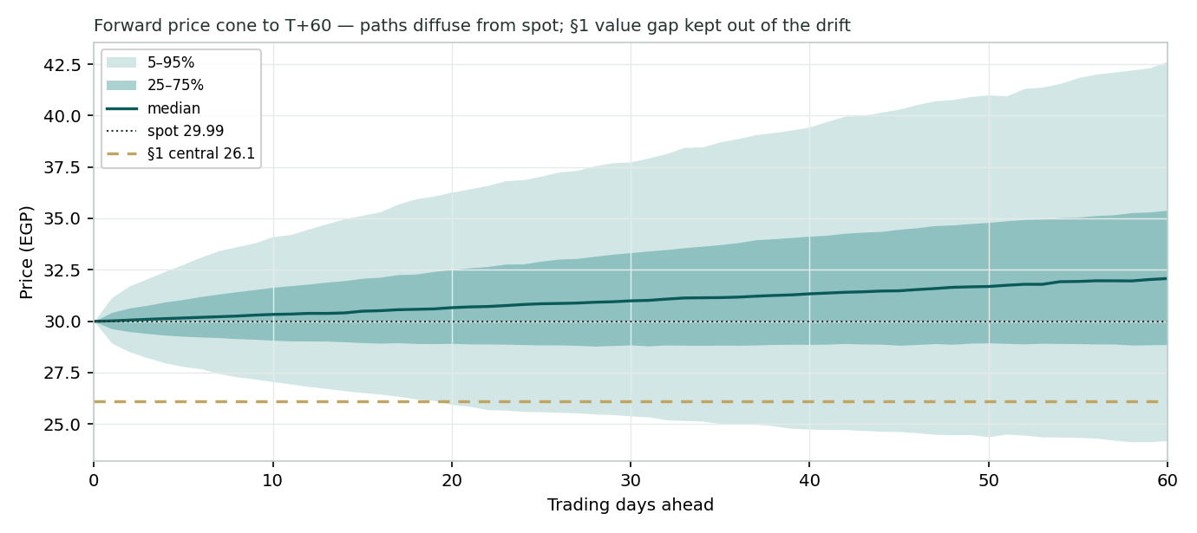
Figure 4 — Forward price cone to T+60. The median drifts up on the secular drift; the gold dotted line marks the EGP 26 fundamental central, deliberately below the cone.
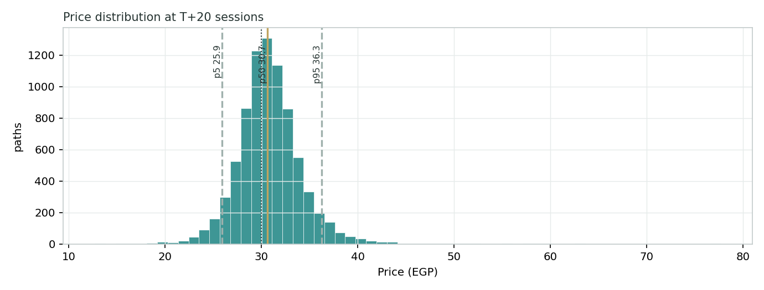
Figure 5 — Price distribution at T+20.
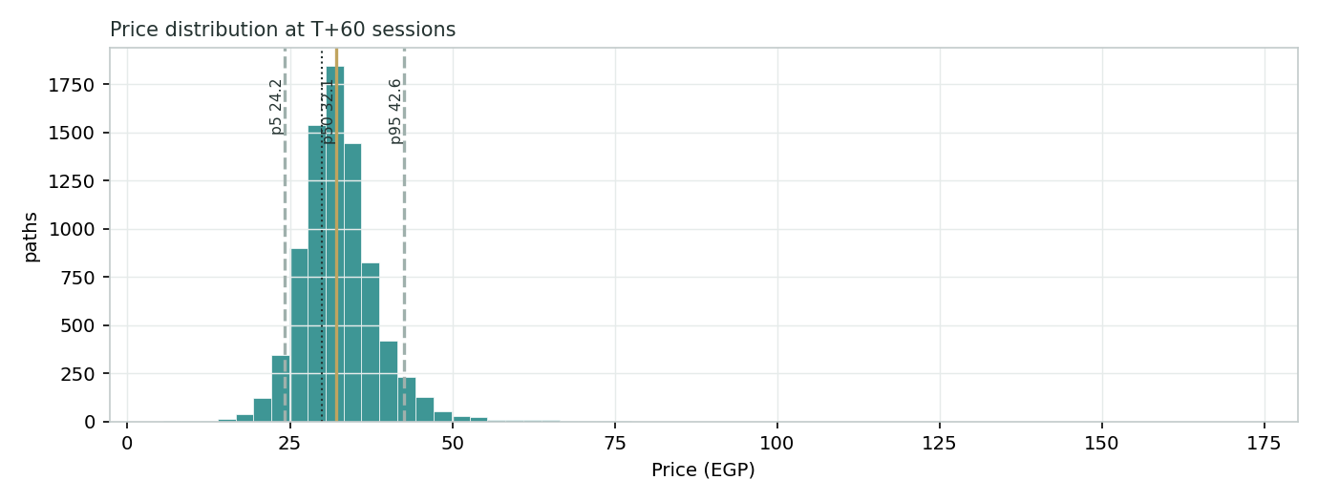
Figure 6 — Price distribution at T+60.
Level-touch ladder — the probability that price touches a level at any point by the horizon (running max for upside, running min for downside). Lead with the 50% interquartile body, not the tails:
Level | T+20 touch | T+60 touch | Note
EGP 40 | 2% | 14% | Toward a new high
EGP 36 | 8% | 34% | Upside stretch
EGP 34 | 20% | 52% | Above the 25–75 body
EGP 32 | 48% | 75% | Near T+60 median
EGP 30 | 91% | 96% | At spot
EGP 28 | 30% | 46% | Lower body
EGP 26 | 8% | 22% | Near §1 central
EGP 24 | 2% | 10% | Toward 52-wk floor
4 Comparison of the lenses, and a verdict
Three readings sit side by side. The fundamental lenses cluster at EGP 20.5–28.7 with a central EGP 26 — modestly below spot, contingent on margin. The technical picture is constructive — above trend, near the highs, mildly cooling. The probabilistic map says that over three months price drifts gently up from spot on the nominal trend, with a wide band (p5–p95 ~EGP 24–43) and a median around EGP 32 — above the EGP 26 fundamental central because the simulation does not assume the value gap closes inside the quarter.
Lens | Reads | Central / implication
Fundamental (4-lens) | Modestly rich | EGP 26 (~−13%)
Technical | Constructive / near highs | Trend floor at the 200-day ~EGP 26; highs ~EGP 32
Monte Carlo (3-month) | Up-drifting, wide | Median EGP 32; p5–p95 EGP 24–43
Verdict (a fair-value read, not a recommendation). Juhayna looks modestly rich to fair on cautious cash-flow assumptions, with a clear and concentrated swing factor: where gross margin settles after the concentrate super-cycle and the merger noise. The constructive tape and the up-drifting three-month distribution reflect a genuine nominal secular trend — the pound’s trajectory in a high-inflation economy — rather than a closing value gap. The honest summary is a value modestly below price, a near-term distribution that drifts up from price on that trend, and an outcome that hinges on one margin line recovering — which is why the bear–bull span (EGP 22–33) is wide. Readers should weigh the lenses themselves; we publish the distribution, not a target.
5 Catalysts to watch
- Q2-26 results (Aug 2026). First read on whether the Q1-26 margin recovery (net profit doubling YoY) is sustaining.
- Gross-margin trajectory. Whether reported margin converges on the ~25–26% operational level as concentrate prices and merger effects wash through.
- CBE rate path. Every cut lowers the DCF WACC and eases the finance-cost line — the largest non-operating lever.
- EGP and the IMF review. A step-devaluation raises input costs before pricing catches up; the pound’s path also drives the nominal trend.
- Soft-commodity inputs. Wheat, oils and resin prices feed straight into cost of sales.
- Capex and free cash. Evidence that the expansion capex is tapering and free cash is building as the model assumes.
- Consumer demand / down-trading. Volume in juice and premium dairy against private-label competition in a squeezed-income economy.
- Distribution & new SKUs. Route-to-market expansion and launches that lift volume and mix.
6 Reading the probability zones
Translating the three-month distribution into plain zones, anchored on spot EGP 30 and the fair-value cluster near EGP 26:
Zone (T+60) | Range | Approx. probability | What it would mean
Deep downside | < EGP 26 | ~22% | Margin stays at the FY25 trough / risk-off; toward the §1 central and 200-day
Lower band | EGP 26–29 | ~24% | Modest de-rate to fair value; segment/DCF lenses dominate
Around spot | EGP 29–33 | ~28% | Status quo; the nominal drift holds price near-to-above spot
Upper band | EGP 33–37 | ~17% | Margin recovery credited + faster rate cuts
Strong upside | > EGP 37 | ~9% | Full normalization toward FY24 margins with disinflation
The distribution is close to symmetric around the drifting median, with a slightly heavier upper tail from the positive discrete events (margin-normalization signal, launches, purchasing-power turn). It is not a forecast; it is the spread of outcomes consistent with the stock’s own volatility and the factor stack.
7 Caveats and what would change our mind
- Margin is the model. The central value swings most on where gross margin settles; a structurally lower margin (say the FY25 reported level persisting) would pull the central value toward the low-EGP-20s.
- The drift is nominal, not real. The secular drift that lifts the Monte Carlo median is the pound’s devaluation working through nominal prices; in real terms the return is far smaller, and a sharp disinflation would flatten it.
- WACC sensitivity. At a nominal 19.5% WACC the DCF is highly geared to the rate path; a stall in disinflation lifts the WACC and cuts the value materially.
- Merger comparability. FY25 consolidates four merged entities, so year-on-year margin and balance-sheet comparisons are not strictly like-for-like; the operational figures are estimates.
- Capex and cash timing. Free cash can stay thin for a year or two if the expansion capex runs longer than modelled, even as profit recovers.
- Input and FX shock. A step-devaluation or a soft-commodity spike squeezes margin before pricing can pass it through.
- Technical reminder. An above-trend tape near its highs can persist or mean-revert; the technical read is context, not a trigger, and says nothing about value.
Appendix A Financial statements
Selected consolidated figures, as reported (FY25 audited results, 12 March 2026; FY24/FY23 comparatives, 25 March 2025). All in EGP millions. FY25 consolidates the four merged Juhayna-group entities and is not strictly like-for-like with prior years on margin. Forecast columns FY26E–FY30E are the preparer’s model (fully linked in the companion Excel).
A.1 Income statement (consolidated, EGP m)
Line | FY23 | FY24 | FY25 | FY26E | FY27E | FY28E | FY29E | FY30E
Net revenue | 15,536 | 24,303 | 29,984 | 36,581 | 43,166 | 49,640 | 56,094 | 62,825
Gross profit | 3,610 | 7,390 | 6,881 | 9,145 | 11,007 | 12,906 | 14,865 | 16,649
Gross margin | 23.2% | 30.4% | 22.9% | 25.0% | 25.5% | 26.0% | 26.5% | 26.5%
EBIT | 1,802 | 4,693 | 3,573 | 4,975 | 6,173 | 7,446 | 8,807 | 9,926
EBITDA | 2,133 | 5,083 | 4,095 | 5,670 | 7,036 | 8,489 | 10,041 | 11,371
Net finance cost | (321) | (596) | (1,169) | (1,350) | (1,300) | (1,200) | (1,100) | (1,000)
Net profit | 1,022 | 2,735 | 1,910 | 2,809 | 3,776 | 4,841 | 5,973 | 6,918
Net margin | 6.6% | 11.3% | 6.4% | 7.7% | 8.7% | 9.8% | 10.6% | 11.0%
EPS (EGP) | 0.87 | 2.32 | 1.62 | 2.39 | 3.21 | 4.11 | 5.08 | 5.88
EPS on 1,176.76 m post-merger shares (FY23–FY24 restated to the current count). FY24 gross margin was lifted by exceptional orange-concentrate prices.
A.2 Balance sheet (consolidated, EGP m)
Line | FY23 | FY24 | FY25 | FY26E | FY27E | FY28E | FY29E | FY30E
PP&E + projects | 3,377 | 5,399 | 7,898 | 9,187 | 10,357 | 11,405 | 12,325 | 13,109
Inventory | 2,784 | 4,177 | 5,816 | 6,950 | 8,201 | 9,432 | 10,658 | 11,937
Receivables | 838 | 1,505 | 2,034 | 2,488 | 2,935 | 3,376 | 3,814 | 4,272
Cash & other | 1,123 | 1,855 | 1,696 | 800 | 800 | 800 | 920 | 3,421
Total assets | 9,109 | 13,591 | 18,410 | 21,558 | 24,436 | 27,264 | 30,127 | 34,570
Total equity | 4,250 | 6,339 | 8,033 | 10,280 | 13,275 | 16,904 | 21,282 | 26,415
Interest-bearing debt | 1,301 | 3,759 | 7,052 | 8,235 | 8,902 | 8,528 | 7,052 | 7,052
Total liabilities | 4,859 | 7,251 | 10,378 | 11,278 | 11,161 | 10,360 | 8,845 | 8,155
Forecast: working capital driven off revenue; PP&E rolls forward with capex less D&A; debt draws a revolver through the capex build then repays; cash held at an EGP 800 m floor. Balances by construction.
A.3 Cash flow (consolidated, EGP m)
Line | FY23 | FY24 | FY25 | FY26E | FY27E | FY28E | FY29E | FY30E
Operating cash flow | 1,410 | 2,368 | 1,996 | 2,850 | 3,300 | 3,972 | 4,700 | 5,363
Capex | (562) | (2,357) | (2,980) | (3,292) | (3,367) | (3,376) | (3,253) | (3,267)
Free cash flow to firm | 179 | 1,095 | 2,272 | 3,644 | 4,659 | — | — | —
Dividends | (141) | (188) | (282) | (562) | (755) | (968) | (1,195) | (1,384)
FCFF row is the DCF free-cash line (NOPAT + D&A − capex − ΔWC); operating-cash and capex are the statement/indirect figures. Source: Juhayna FY25 & FY24 earnings releases; forecast per the companion model.
Appendix B Step 0 — calibration backtest
Before any forecast we test the Monte Carlo lens on Juhayna’s own five years of history: at each origin, using only prior data, we generate a three-month-ahead distribution and score the realized close against it, on non-overlapping 60-session windows. The grade is skill versus a zero-drift random-walk cone, measured by CRPS skill and the interval (Winkler) score; the PIT histogram and interval coverage are diagnostics only. The engine passes with the secular drift ON — the configuration that beats the benchmark — because Juhayna’s nominal-EGP price carries a genuine uptrend (devaluation and inflation pass-through), and, unlike international names, that trend did not reverse out of the cone at the 2024–25 drawdowns.
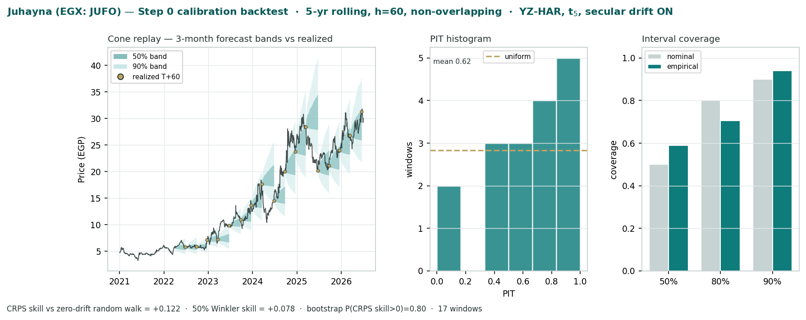
Figure B-1 — Calibration backtest: quarterly cone replay, PIT histogram, and interval coverage versus target.
Metric | Result | Read
CRPS skill vs random walk | +0.122 | Beats the benchmark (> 0) ✓
Winkler-50 interval skill | +0.078 | The 50% band we lead with beats ✓
Winkler-80 / 90 interval skill | −0.18 / −0.17 | Honest t5 tails cost the outer bands
PIT mean / shape | 0.62 · right-skewed | Not U-shaped; no window outside the cone
Bootstrap P(CRPS skill > 0) | 0.80 | Moderate, not overwhelming (17 windows)
50 / 80 / 90% coverage | 59% / 71% / 94% | Diagnostic only
Engine vol (annualized) | 36.4% | YZ-HAR, c2c-calibrated
Coverage and PIT are shown for completeness only; the pass is on CRPS and the 50% interval, both positive. The slight rightward PIT tilt reflects the stock’s persistent nominal rise (an under-shooting median, inherent to an expanding-window drift), not a width error. This configuration carries into the §3 forward run.
Appendix C Peer set, sector structure, and risks
Juhayna’s cleanest comparables are the Egyptian branded-food names, with Gulf dairy as a premium reference.
Peer | P/E | EV/EBITDA | Note
Obour Land (EGX: OLFI) | 11.4× | 6.5× | Dairy/cheese, net-cash
Edita Food (EGX: EFID) | 11.0× | 7.5× | Snacks, high margin
Domty (EGX: DOMTY) | 12.0× | 7.0× | Cheese/milk
Almarai (Tadawul) | 18.0× | 12.0× | KSA dairy, premium
Egypt-staples median | 11.4× | 7.0× | Applied basis for JUFO
Sector structure. Egyptian packaged food is a defensive, branded-volume market with structural tailwinds — a young, growing population and rising penetration of packaged dairy — set against a squeezed consumer and imported-input inflation. Branded players compete with private label and with each other on distribution reach and price pass-through. Principal risks: a structurally lower gross margin; a step-devaluation of the pound raising input costs; a stall in disinflation holding the WACC high; prolonged expansion capex keeping free cash thin; down-trading to private label; and merger-integration and comparability noise in the accounts.
Appendix D The expert valuation panel
Every Testahil study closes with a panel of standing expert personas — drawn from the house Expert Persona Library, not invented for the occasion, so that each accumulates a track record across studies and a quarterly update is a re-run on fresh data, not a re-training. The discipline is that each expert runs a genuinely different method (three DCFs that agree would be cosmetic), derives its fair value from shown workings rather than assertion, and states a falsification condition — the observation that would prove it wrong. For a capital-intensive, working-capital-heavy branded producer the library’s casting map gives the industrial trio, and we cast the three whose methods both fit the instrument and genuinely disagree: Expert 1 (normalized earnings power and multiples — the recovery case), Expert 2 (the accountant — realizable assets and the quality of cash conversion — the sceptic), and Expert 3 (cash returns — discounted free cash flow and return on capital versus its cost — the capital-discipline case, added because the name is capital-heavy). The macro-policy lens — the pound, the rate path and inflation — runs through the body (§1.8, §5) rather than as a separate persona, because for Juhayna it is a variable inside every method rather than a competing method of its own. Their point fair values are logged with the study date and spot as an internal per-expert calibration layer, kept separate from the core Calibration Ledger.
D.1 Expert 1 — normalized earnings power
Worldview and tradition. An operating company is worth a fair multiple of its sustainable, mid-cycle earnings power; peaks and troughs are noise to be stripped out. This is the earnings-power tradition of Graham’s “normal earnings” and the sell-side through-cycle model: find what the business earns in a representative year, not a lucky or unlucky one, and pay a justified multiple for it. Applied to Juhayna, he asks what the group earns once the orange-concentrate super-cycle that flattered FY24 and the merger dilution that depressed FY25 both wash out, and what a branded, growing, domestic-demand franchise in a high-inflation economy should command against its Egyptian peers.
When it works / fails. Best for stable or cyclical operating businesses with a genuine track record, and in relative-value contexts where peers anchor the multiple; it fails at structural breaks, where the past is not the future. If Juhayna’s gross margin is permanently lower — private-label erosion in juice, a durably weaker pound raising input costs faster than pricing can recover them, or a mix shift toward lower-margin distribution — then his normalization is not conservatism, it is simply the wrong number, and the multiple compounds the error.
Standard workings & worked example. The steps are: (1) normalize revenue and margin to a mid-cycle year; (2) derive sustainable net profit and EPS; (3) apply a justified P/E judged against the name’s own history and Egyptian staples peers, adjusted for quality, growth and risk; (4) cross-check on EV/EBITDA and free-cash-flow yield. He takes FY26E as a fair mid-cycle proxy — revenue of ~EGP 36.6 bn, a normalized gross margin of 25% (above the FY25 reported trough, below the FY24 peak), and a finance-cost line already easing as rates fall — which yields net profit of ~EGP 2,809 m and EPS of EGP 2.39. Against Obour Land and Edita at ~11× and a scale-and-brand premium, he applies 12×.
Expert 1’s normalization | Value
Normalized net profit, FY26E (EGP m) | 2,809
Shares (m) → normalized EPS | 1,176.76 → EGP 2.39
Justified P/E (Egyptian staples + scale premium) | 12.0×
Cross-check: EV/EBITDA on ~EGP 5.7 bn | ~7× → consistent
Fair value | → EGP 28.7
Sensitivity (swing = normalized margin / multiple). The answer is roughly linear in both: at a 10× multiple EGP 24, at 14× EGP 33; hold the multiple and a one-point-higher normalized gross margin adds close to EGP 2. His central rests on the margin recovering to 25% and the market paying a mid-teens-of-earnings multiple that Egyptian food has historically supported. Cross-examination. He tells Expert 2 that marking on today’s trough cash conversion understates a franchise whose working capital is a function of growth, not distress, and that will convert far better once the expansion phase matures; he tells Expert 3 that ROIC pessimism during a build-out ignores the operating leverage that arrives when new capacity fills and pricing catches input costs.
Verdict, falsification, market-implied. Fair EGP 28.5 (range EGP 24–33) — the most constructive of the three. Falsified by a structural margin re-rating down — gross margin stuck near the FY25 reported level through a full cycle, or an Egyptian-staples multiple de-rating below ~10×. The market price of EGP 30 implies normalized earnings a touch above his base: on his method, the shares already credit most of the recovery and offer little further margin of safety.
D.2 Expert 2 — the accountant (RNAV and the quality of cash)
Worldview and tradition. The Graham–Dodd realization school — a business is worth what its assets realize net of every claim, and reported profit is trusted only to the extent it converts to cash. He reasons from the balance sheet, which he regards as a fact, and treats the income statement as a narrative to be audited against the cash-flow statement. This lens is especially apt where a company is capital-intensive, working-capital-heavy and levering up to fund growth — which describes Juhayna precisely after two years in which net debt tripled while it built farms, plant and inventory.
When it works / fails. Best where value rests on the balance sheet and on the quality of cash conversion, and where profit is booked before cash arrives; it fails by systematically undervaluing a genuine compounding franchise if the haircuts are too severe — the standing risk of the realization school is that it prices a growing brand as a pile of assets.
Standard workings & worked example. The steps are: (1) test earnings quality via the operating-cash-flow-to-net-income bridge; (2) mark equity conservatively at realizable value, with explicit haircuts; (3) bridge to a per-share value through a cash-conversion overlay; (4) run a sensitivity on the overlay. Juhayna’s tell is working capital: inventory (~19% of sales) and receivables (~7%) together run near 26% of sales and are rising in absolute terms every year, so a large slice of each year’s profit is reinvested in stock and credit rather than returned as cash. In FY25, operating cash of EGP 2.0 bn sat below net profit plus D&A, income tax paid jumped, and net debt rose to EGP 5.96 bn — the classic signature of a business whose accrual profit outruns its cash. He applies a cash-conversion overlay of ~0.85 to FY26E earnings, values the quality-adjusted stream at a sober 10×, then adds measured credit for the realizable value of the brand and the route-to-market that a pure cash-overlay would miss.
Expert 2’s cash-quality test | Value
FY26E net profit (EGP m) | 2,809
OCF-to-net-income bridge (FY25 read-across) | < 1.0 — accrual > cash
Cash-conversion overlay (WC build, capex) | × ~0.85
Quality-adjusted earnings → P/E 10× | ~EGP 20.3 / sh
+ realizable value of brand / distribution | → EGP 24.5
Sensitivity (swing = the cash-conversion overlay). This is the whole argument: at a 0.95 overlay (working capital stabilizing) the value rises to ~EGP 27; at 0.75 (a heavier drag, or a step-up in inventory days) it falls to ~EGP 21. The band EGP 21–27 is therefore a direct read on how much of Juhayna’s reported profit he believes reaches shareholders as cash. Cross-examination. He tells Expert 1 that a P/E on booked profit ignores that the profit is partly immobilized in inventory and financed by debt whose interest has doubled; he tells Expert 3 that even a DCF flatters the early years unless the working-capital drag and the capex are modelled honestly, and he notes approvingly that the primary model does exactly that (the early free-cash line is thin for precisely this reason).
Verdict, falsification, market-implied. Fair EGP 24.5 (range EGP 21–27) — cautious, and close to the DCF anchor. Falsified by a durable lift in cash conversion — working capital stabilizing as a share of sales and capex tapering, so that operating cash catches accrual profit. The market price sits ~20% above his mark: on a cash-quality basis he judges the shares full, and would want either a cheaper entry or visible evidence that the expansion is converting to cash before paying up.
D.3 Expert 3 — cash returns: DCF and ROIC versus the cost of capital
Worldview and tradition. A business is worth the cash it returns over its life, and it creates value only when each unit of capital earns above its cost. This is the economic-profit tradition — Rappaport, Stern Stewart, the McKinsey ROIC school — that looks past accounting earnings to free cash flow and to the spread between the return on invested capital and the weighted-average cost of capital. For Juhayna the question is sharpened by the environment: in a nominal-EGP world where the cost of capital is near twenty percent, a company reinvesting nearly a tenth of sales must clear an unusually high bar for that reinvestment to create rather than destroy value.
When it works / fails. Best for capital-intensive businesses where returns on capital are the crux, and for steady cash generators; it fails where reinvestment economics are genuinely changing, so that past ROIC misleads — which is the live risk here, because the current capex either matures into high-return capacity or it does not, and the historical spread cannot yet tell us which.
Standard workings & worked example. The steps are: (1) build free cash flow to the firm (NOPAT + D&A − capex − change in working capital); (2) compute ROIC against the WACC — the economic-profit spread; (3) discount the explicit five-year stream plus a terminal value consistent with returns fading toward the cost of capital; (4) run a sensitivity on the WACC and on the speed of the fade. This is the primary lens of the study, so his numbers are the DCF itself: explicit FCFF that climbs from a thin EGP 180 m in FY26E to EGP 4,659 m in FY30E as capex intensity falls, a 19.5% nominal WACC, a 12% nominal terminal growth, and an enterprise value of EGP 34.5 bn. What he stresses is the ROIC read behind it: through the build phase, with capital going in faster than the returning cash, the ROIC–WACC spread is thin, so he credits little premium to invested capital and leans on the terminal only to the extent returns are sustained.
Expert 3’s economic-profit test | Value
Σ PV explicit FCFF (EGP m) | 5,948
PV terminal value (EGP m) | 28,552
Enterprise value (EGP m) | 34,500
less: net debt (EGP m) | (5,960)
ROIC vs WACC (build phase) | ~ near WACC → little premium to capital
Fair value | → EGP 24.0
Sensitivity (swing = WACC / ROIC fade). The value is highly geared to the discount rate, which is the point: at an 18% WACC (faster disinflation) it rises to ~EGP 30 — the current price — and at 22% it falls to ~EGP 19. The single most important thing that could happen to his number is therefore not operational at all; it is the pace at which Egyptian rates come down. Cross-examination. He tells Expert 1 that mid-cycle earnings without the capital cost to produce them is a half-truth — the expansion consumes the very cash a P/E capitalizes, and a multiple silently assumes reinvestment earns its keep; he tells Expert 2 that realizable asset marks still have to earn their cost of capital to be worth book, and that a brand which cannot clear its WACC is worth less than its accounting equity.
Verdict, falsification, market-implied. Fair EGP 24.0 (range EGP 19–30) — the most cautious of the three, and fairly-valued with no margin of safety. Falsified by a durable ROIC lift above WACC — the expansion capex maturing into high-return capacity, or a faster-than-modelled fall in the cost of capital as inflation normalizes. The market price sits above his central and squarely at his high case: on a cash-returns basis, the price already assumes either the rate cuts or the returns that he will not yet underwrite.
D.5 The three in one room
The single line they most disagree on is gross margin — specifically, whether the FY24 profile returns, whether the profit it would generate actually converts to cash given the working-capital and capex drag, and whether that cash clears the cost of the capital now being spent. Put the three at one table and the argument is not about the brand or the growth, which none of them contests; it is about the path from reported profit to shareholder value.
Expert 1: “FY25 was a concentrate air-pocket and merger noise, and Q1-26 — net profit doubling year-on-year — is the tell that the margin is already turning. Normalize it to 25% and Juhayna earns close to EGP 2.8 bn. The market is paying about twelve times that, which is a fair, even unremarkable, multiple for a branded compounder in a market with this much runway. You two are pricing a growth business as if it were ex-growth.”
Expert 3: “And to earn your EGP 2.8 bn it is spending nearly a tenth of sales on capex at a nominal cost of capital near twenty percent. Capitalize the earnings by all means — but subtract the cash to make them, and the hurdle that cash must clear. Through the build phase the return on capital barely beats the rate. I credit no premium to book, and I note your own multiple only works if the pound’s rate cuts arrive on schedule.”
Expert 2: “You are both booking profit that is sitting in inventory and financed by debt that tripled in two years. In FY25 operating cash came in below profit plus depreciation — the accrual outran the cash. Show me the conversion, not the accrual. Mark it on realizable value with an honest overlay and the shares are full right here. I am happy to pay up when the working capital stops eating the profit; not before.”
D.6 Reading the divergence
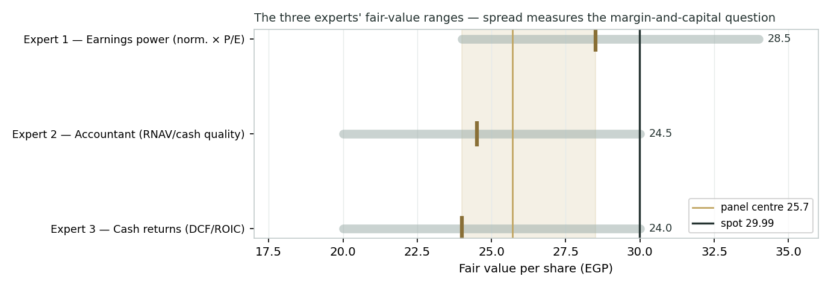
Figure D-1 — The three experts’ fair-value ranges. Brass ticks are base cases; the gold band is the central; the dark line is spot. The spread is a margin-and-capital disagreement.
Expert | Method | Single swing assumption | Base fair value
Expert 1 | Normalized earnings power | Normalized margin / 12× P/E | EGP 28.5
Expert 2 | Accountant (RNAV / cash quality) | Cash-conversion overlay | EGP 24.5
Expert 3 | Cash returns / ROIC | WACC vs ROIC fade | EGP 24.0
The spread — EGP 24 to 28.5 at base — is narrow for an operating business, and it is almost entirely a margin-and-capital disagreement: none of the three contests the strength of the brand, the volume growth, or the domestic-demand tailwind. What separates them is the translation from profit to value. Expert 1 trusts the normalized margin and the multiple, so he sits highest; Expert 2 discounts the reported profit for the cash it does not yet convert; Expert 3 charges that profit for the cost of the capital being spent to produce it. Read together, they map the same uncertainty from three sides — and they converge on the answer to one question. If gross margin recovers toward the FY24 profile and Egyptian rates fall, all three drift toward the low-EGP-30s; if the margin settles near the FY25 reported trough and rates stay high, all three fall toward the low-EGP-20s. The EGP 4.5 spread is therefore a clean measure of a single operating-and-macro outcome, not three different views of the company. Resolve the margin and the rate path, and the panel collapses to a point — which is why the study leads with a distribution rather than a target.
Each expert’s point fair value (and bull/base/bear) is logged with the study date (01 Jul 2026) and spot (EGP 29.99) as an internal per-expert track record, kept separate from the core Calibration Ledger.
About this series
Testahil publishes independent, educational valuation studies. Each is an attempt to reason transparently about what a security is worth, with every assumption shown and a companion model so readers can disagree productively. The house style is distributions, not tips: we describe ranges and probabilities, not targets, and we do not tell anyone what to do. Studies are framed as educational analysis, the preparer is not licensed by any securities regulator, and holdings are disclosed.
Disclosure & Disclaimer
Not investment advice. This document is educational and informational only. It is not, and must not be relied upon as, investment, financial, legal, accounting or tax advice, nor an offer, solicitation or recommendation to buy, sell or hold any security. It contains no price target and no rating.
No licence; no advisory relationship. The preparer is not registered or licensed with the Egyptian Financial Regulatory Authority or any securities or financial regulator in any jurisdiction, holds no brokerage or investment-advisory authorisation, and is not acting as your adviser or fiduciary. Nothing here is personalised to your circumstances.
Holdings disclosure. The preparer may hold, and may in the future take or dispose of, a position in the security discussed in this report, and may transact at any time without notice. This is a potential conflict of interest you should weigh.
Sources & accuracy. Reported financial and operating figures are drawn from the company’s public disclosure and other public sources believed reliable but not independently verified; they may contain errors or be superseded. Forward-looking inputs — the margins, projections, multiples, the DCF and Monte-Carlo factor probabilities — are the preparer’s own judgments and are inherently uncertain.
Forward-looking statements. Any statements about the future are estimates subject to risks and uncertainties; actual results may differ materially. The Monte Carlo models price, not value, and encodes subjective probabilities for events that have not occurred.
No reliance; your responsibility. Do your own research and consult a licensed professional before making any decision. You are solely responsible for your investment decisions and their outcomes. To the maximum extent permitted by law, the preparer accepts no liability for any loss arising from use of this document.
Currency & figures. Figures are in Egyptian pounds (EGP), millions unless stated. FX reference at study date: USD/EGP ~49.5. Rounding may cause totals to differ slightly. Spot price and market data are as of 01 July 2026 and change continuously.
TESTAHIL · Independent Valuation Study · Educational Analysis · Juhayna Food Industries (EGX: JUFO) · edition 03-07-2026 · reporting currency EGP

