Testahil · Independent Valuation Study — Educational Analysis | Not investment advice

Independent Valuation Study — Educational Analysis
El Nasr Clothing & Textiles Co. (Kabo) · (EGX: KABO)
Fundamental analysis · Technical analysis · Monte Carlo simulation — one integrated read
Anchor: EGP 7.00 (06 Jul 2026 close) · ~565m shares · mkt cap ~EGP 3.96bn · a private-sector Alexandria knitwear manufacturer and exporter (brands Kabo, Jil, Super Kabo), listed on the EGX since 1995, fiscal year July–June · prices and probabilities computed 06 Jul 2026 from the attached daily history · primary lens: revalued net asset value (RNAV) on a going-concern basis · the swing factor is the realizable value of the company's legacy Alexandria land against a collapsed operating earnings base. Note: the Monte Carlo layer failed Testahil's calibration gate on KABO and is carried for illustration only — no probabilistic price forecast is published (see §3 and Appendix B).
READ FIRST — what this document is, and is not.
This study is a valuation exercise and an expression of personal analytical opinion, published free of charge for educational purposes: it shows how one analyst applies fundamental, technical and probabilistic methods to a listed company, and invites scrutiny of that methodology. It is NOT investment advice, NOT a recommendation or solicitation to buy, sell or hold any security, and NOT directed at the circumstances of any reader. The preparer is not licensed by any securities regulator in any jurisdiction, holds no brokerage authorisation, provides no financial consultancy, manages no money, and accepts no fees, funds or clients. See the Disclosure & Disclaimer at the end. All values are model outputs presented as ranges because no single number should be relied on. Reported financials are the company's own disclosure via the EGX; because KABO is a thinly-covered small-cap, several historical line items and the balance-sheet split are reconstructed on a fiscal-year (July–June) basis and are flagged as estimates throughout — the land-revaluation mark that drives the primary lens is the preparer's own judgment, not a disclosed figure, and is sensitised rather than asserted. A note on the Monte Carlo: unlike a standard Testahil study, no probabilistic price forecast is published here, because the engine did not beat its naïve benchmark on this security (Appendix B); the simulation is shown only as an illustrative volatility map. Consult a licensed financial advisor before any investment decision.

Headline
The model's read: the tape and the fundamentals point in opposite directions, and the gap is an asset story that is not yet on the page. At EGP 7.00 the shares trade at about 3.4× audited book value (~EGP 2.04/share) and near an all-time high, while reported earnings have collapsed — nine-month FY2024/25 attributable profit was EGP 9.4m against EGP 193m a year earlier. Every fundamental lens lands well below the price: a going-concern discounted-cash-flow of the operating business is worth under EGP 1/share at Egyptian discount rates, a relative price-to-book read sits near EGP 2.6, and even a revalued net asset value that generously credits a re-mark of the legacy Alexandria land reaches only ~EGP 3.3. The weighted central estimate is ~EGP 2.39 — roughly a third of the market price. The entire distance between value and price is a single, undisclosed variable: what the company's land and buildings would realise if revalued or monetised. On the tape the stock is the opposite of its fundamentals — above all four major moving averages, RSI in the high-70s, MACD positive — a strong, overbought uptrend rather than a value gap waiting to close. Because the Monte Carlo engine failed its calibration test on KABO (Appendix B), we publish no three-month price distribution; the illustrative cone is shown only to describe the stock's volatility, not to forecast it.
Valuation summary — every read at a glance
One table for the reads that follow — what the business is worth (fundamental), what the tape is doing (technical), an illustrative volatility map (Monte Carlo, not a forecast here), and how three independent expert methods land. Every row is developed in the sections and appendices below.
Lens / read | What it measures | Output | Takeaway
FUNDAMENTAL — what the business is worth (the anchor)
Revalued NAV (primary) | Book equity + land/asset re-mark, less haircuts | EGP 3.28 | −53% vs spot · the anchor
Going-concern DCF | Discounted 5-yr operating cash flows | EGP 0.55 | −92% · the floor of operations
Relative multiples | Justified price-to-book | EGP 2.65 | −62%
Normalized earnings | Mid-cycle EPS × through-cycle P/E | EGP 1.24 | −82%
Weighted central | Blend 45 / 15 / 25 / 15 | EGP 2.39 | −66% vs EGP 7.00
TECHNICAL — what the tape is doing (timing, not value)
Trend & momentum | Price vs the 20/50/100/200-day averages | Above all four | Strong, extended
Momentum / range | RSI · MACD · 52-week range | RSI 78 · MACD +0.05 · EGP 4.71–7.13 | Overbought
MONTE CARLO — ILLUSTRATIVE ONLY (failed calibration — no forecast published)
Step 0 gate | CRPS skill vs random-walk cone | −0.010 (fails > 0) | Engine has no edge on KABO
Illustrative cone | 50,000 paths · shown for volatility only | p5 4.79 · p50 7.12 · p95 10.68 | Not a probability forecast
EXPERT PANEL — three independent methods (closing appendix)
Expert 1 — revalued NAV | Land/asset re-mark, less discount | EGP 3.10 | The anchor
Expert 2 — normalized earnings | Mid-cycle margin × multiple | EGP 1.30 | Most conservative on ops
Expert 3 — scenario / policy | EGP, land-monetisation & restructuring odds | EGP 2.40 | The catalyst bet
Panel range | Spread = the land question | EGP 1.30–3.10 | Centres ~EGP 2.45

Bottom line. Every fundamental read points the same way: on its operations and its audited assets, KABO is worth a fraction of its market price. The reads disagree only on how much latent asset value to credit — from ~EGP 0.9 (operating cash flows alone) to ~EGP 3.3 (a generous land re-mark). The technical tape is the lone dissenter, strong and overbought near an all-time high. The honest summary is a value well below price, a momentum picture well above it, and a gap that only closes if the company's land is worth far more than its books show — and is actually revalued or sold. We publish the range and the distribution of expert views, not a target.
Company overview — El Nasr Clothing & Textiles (Kabo) at a glance
Item | Value
Listed entity | El Nasr Clothing & Textiles Co. S.A.E — "Kabo" (EGX: KABO; Reuters KABO.CA; ISIN EGS33061C010)
What it does | Manufacture and export of knitted apparel — underwear, loungewear, sportswear, polos, T-shirts (brands Kabo, Jil, Super Kabo)
Founded · listed | 1940 (Alexandria) · EGX-listed since February 1995
Spot / date | EGP 7.00 · 06 Jul 2026 close
Shares · market cap | ~565m (mkt-cap-derived, flagged) · ~EGP 3.96bn
Book equity · BVPS | ~EGP 1152m · ~EGP 2.04/share (reviewed, ~Mar 2025)
Price-to-book | ~3.4× audited book
Total assets · liabilities | ~EGP 1834m · ~EGP 683m
Interest-bearing debt | ~EGP 559m (debt/equity ~48.6%)
FY2024 revenue / earnings | EGP ~1,020m (+72% YoY on EGP devaluation) · net ~EGP 129m (FX-boosted)
9M FY2024/25 earnings | EGP 9.4m attributable, vs EGP 193m in 9M FY2023/24 — a ~95% collapse
Dividends | None — KABO has never paid a dividend
Employees | ~2,997
52-week range | EGP 4.71 – 7.13 (all-time high EGP 7.30, Nov 2025)
Fiscal year | 1 July – 30 June

*Source: EGX/Mubasher disclosures, company reviewed financial statements (period to 31 Mar 2025), and exchange data. KABO is thinly covered; the share count is derived from market capitalisation and several historical splits are reconstructed on a fiscal-year basis. Figures rounded; flagged items are the preparer's estimates.*
1 Fundamental valuation
We value KABO as an asset-heavy operating company whose market price has detached from its earnings. At EGP 7.00 the stock trades near an all-time high and at roughly three-and-a-half times audited book value, while nine-month FY2024/25 attributable profit fell about 95% year-on-year. A company this profitable would not command that multiple; a company this asset-rich might — if the assets are worth far more than the books show. The primary lens is therefore a revalued net asset value (RNAV), because the only coherent case for the price is that KABO's legacy Alexandria land and buildings, carried near historical cost, would realise a large re-mark. We cross-check that against three going-concern lenses — a discounted-cash-flow of the operating business, a relative price-to-book read, and a normalized-earnings-power read — none of which, on their own economics, gets close to the price. The weights and the football field are in §1.5; the swing factor — the land mark — is dissected in §1.7 and the sensitivity grid in §1.9. The lens choice is a judgment call and is flagged: for a marginally-profitable manufacturer trading at a large premium to book, RNAV is the disciplined way to ask whether assets, not earnings, back the price.
1.1 Revalued net asset value — the primary lens
RNAV starts from the audited net assets and asks what they would realise, component by component, with explicit haircuts on anything speculative or illiquid. KABO's audited equity is ~EGP 1,152m (~EGP 2.04/share). The realizable-value question is almost entirely about property, plant and equipment — specifically the land and buildings of a company that has manufactured in Alexandria since 1940 and is very likely carrying that real estate at depreciated historical cost far below current market. We add a flagged land-and-buildings re-mark, a conservative brand value for Kabo/Jil (which does not sit on the balance sheet), and a working-capital realizability haircut. The land re-mark is the preparer's own estimate — KABO does not disclose an asset register or a monetisation plan — and it is sensitised, not asserted, in §1.9.
RNAV component (base case) | EGP m | EGP / share
Audited book equity (net assets, reviewed) | 1,152 | 2.04
+ Land & buildings revaluation uplift (estimate) | 700 | 1.24
+ Brand value (Kabo / Jil, off-balance-sheet, estimate) | 50 | 0.09
− Working-capital / inventory realizability haircut | (50) | (0.09)
RNAV equity (base) | 1,852 | 3.28

RNAV base ≈ EGP 3.28/share, with a bear–bull span of ~EGP 1.90–4.50 driven almost entirely by the land mark (§1.9). Read the base carefully: even after generously crediting EGP 0.7bn of hidden land value — more than 60% of the entire audited asset base again — the RNAV lands at less than half the EGP 7.00 price. To justify the price on assets alone, the land would have to be worth roughly EGP 2.8bn above book, a figure the company has never disclosed. RNAV is the most price-sympathetic lens available, and it still says the market is paying for assets it cannot see.
1.2 Going-concern DCF — the cash-flow cross-check
The natural check on an asset sum is what the operating business generates in cash. Here the result is stark. KABO is a low-margin knitwear maker (gross margin ~16%) whose FY2024 earnings were inflated by a one-off currency-translation windfall as the pound devalued; the sustainable, mid-cycle picture is a business earning perhaps EGP 55–95m net on ~EGP 1.2–1.8bn of revenue. Discounted at an Egyptian cost of capital, and after deducting net debt, the equity is worth very little. We publish the cost of equity explicitly as Ke = risk-free + beta × equity-risk-premium = 17.5% + 0.95 × 6.0% = 23.2%; blended with an after-tax cost of debt of ~15.5% at an 88/12 equity/debt mix, the WACC is ~22%, with a nominal-EGP terminal growth of 13.5%. The full waterfall follows — every row shown, from revenue to the present value of each year's free cash flow.
DCF waterfall — going concern (EGP m) | FY26e | FY27e | FY28e | FY29e | FY30e
Revenue | 1,180 | 1,320 | 1,470 | 1,630 | 1,800
EBITDA (13.5% margin) | 159.3 | 178.2 | 198.5 | 220.1 | 243.0
− D&A | (45.0) | (48.0) | (51.0) | (54.0) | (57.0)
EBIT | 114.3 | 130.2 | 147.5 | 166.1 | 186.0
NOPAT = EBIT × (1 − 22.5%) | 88.6 | 100.9 | 114.3 | 128.7 | 144.2
+ D&A | 45.0 | 48.0 | 51.0 | 54.0 | 57.0
− Capex | (55.0) | (58.0) | (61.0) | (64.0) | (67.0)
− Δ working capital | (35.0) | (30.0) | (32.0) | (34.0) | (36.0)
Free cash flow to firm | 43.6 | 60.9 | 72.3 | 84.7 | 98.2
Discount factor @ 22% WACC | 0.820 | 0.672 | 0.551 | 0.451 | 0.370
PV of FCFF | 35.7 | 40.9 | 39.8 | 38.2 | 36.3

Summing the parts: PV of explicit FCFF = EGP 190.9m; terminal value = FCFF₅ × (1+g)/(WACC−g) = 98.2 × 1.135 / 0.085 = EGP 1,311m, whose present value is EGP 485.2m — so terminal value is ~72% of enterprise value, disclosed here rather than buried. Enterprise value = 190.9 + 485.2 = EGP 676m; less net debt of ~EGP 370m (interest-bearing debt ~559m, less estimated cash ~189m, flagged) leaves equity of ~EGP 306m, or ~EGP 0.54/share. The lens spans EGP 0.25 (WACC 24% / g 13%) to EGP 1.10 (WACC 20% / g 14%).
DCF sensitivity | Bear | Base | Bull
Normalized EBITDA margin | 12.0% | 13.5% | 15.0%
WACC (Ke = rf + β·ERP) | 24% | 22% | 20%
Terminal growth (nominal EGP) | 13.0% | 13.5% | 14.0%
Fair value (EGP / share) | 0.25 | 0.54 | 1.10

Going-concern DCF base ≈ EGP 0.54 — the floor, and the single most important number in the study. It says the operating business, valued honestly at Egyptian discount rates and net of its debt, is worth well under EGP 1 a share. Everything above that in the price is either latent asset value or hope. This is not a quirk of aggressive inputs: at a ~22% WACC, a low-margin manufacturer with meaningful leverage simply cannot support a EGP 7.00 equity value from cash flows.
1.3 Relative multiples
Reported earnings are too volatile for a clean P/E — they swung from a devaluation windfall to near-zero inside a year — so the cleanest relative lens for an asset-heavy manufacturer is price-to-book. KABO trades at ~3.4× book against distressed EM textile peers that typically change hands at 0.5–1.5× book. We apply a justified P/B of ~1.3× — a premium to troubled peers for the genuine export franchise and the latent asset value, but nowhere near the current multiple.
Relative basis | Bear | Base | Bull
Justified price-to-book | 0.8× | 1.3× | 2.0×
× Book value (EGP 2.04 / share) | 1.63 | 2.65 | 4.08
Memo: normalized P/E cross-check (EPS 0.124 × 8–12×) | 0.99 | 1.24 | 1.49

Relative base ≈ EGP 2.65 on price-to-book — the second-highest lens, and the closest thing to where a sceptic who credits some asset premium would anchor. On earnings multiples the read is lower still (~EGP 1.0–1.5). Either way, the current 3.4× book is an outlier for the sector.
1.4 Normalized earnings power
If the weak pound persists, KABO's export revenues stay structurally higher in EGP terms than pre-devaluation, so mid-cycle earnings are above the FY2024/25 trough even after stripping the one-off translation gains. We normalize net income to ~EGP 70m mid-cycle (bear 55m, bull 96m) and apply a through-cycle P/E of ~10× — modestly above the textile-sector average for the export/FX-hedge quality of the franchise.
Normalized-earnings basis | Bear | Base | Bull
Mid-cycle net income (EGP m) | 55 | 70 | 96
Shares (m) → normalized EPS (base) | 565 → 0.124
Justified through-cycle P/E | 8× | 10× | 12×
Fair value (EGP / share) | 0.78 | 1.24 | 2.04

Normalized-earnings base ≈ EGP 1.24 — the recovery-of-operations lens, and still far below price. Note the honest tension with §1.7: this lens assumes the devaluation-boosted export margin is durable; if input costs (cotton, energy, wages) fully catch up with the weaker pound, mid-cycle earnings drift back toward the bear.
1.5 Synthesis — four lenses
We weight the RNAV most heavily because, for a name trading at a large premium to book with weak earnings, the asset value is the only coherent support for the price; the relative price-to-book read carries the sceptic's anchor; the DCF and normalized-earnings lenses set the going-concern floor.
Lens | Weight | Bear | Base | Bull
Revalued NAV (primary) | 45% | 1.90 | 3.25 | 4.50
Going-concern DCF | 15% | 0.25 | 0.55 | 1.10
Relative (price-to-book) | 25% | 1.63 | 2.65 | 4.08
Normalized earnings | 15% | 0.78 | 1.24 | 2.04
Weighted central |  | 1.42 | 2.39 | 3.52

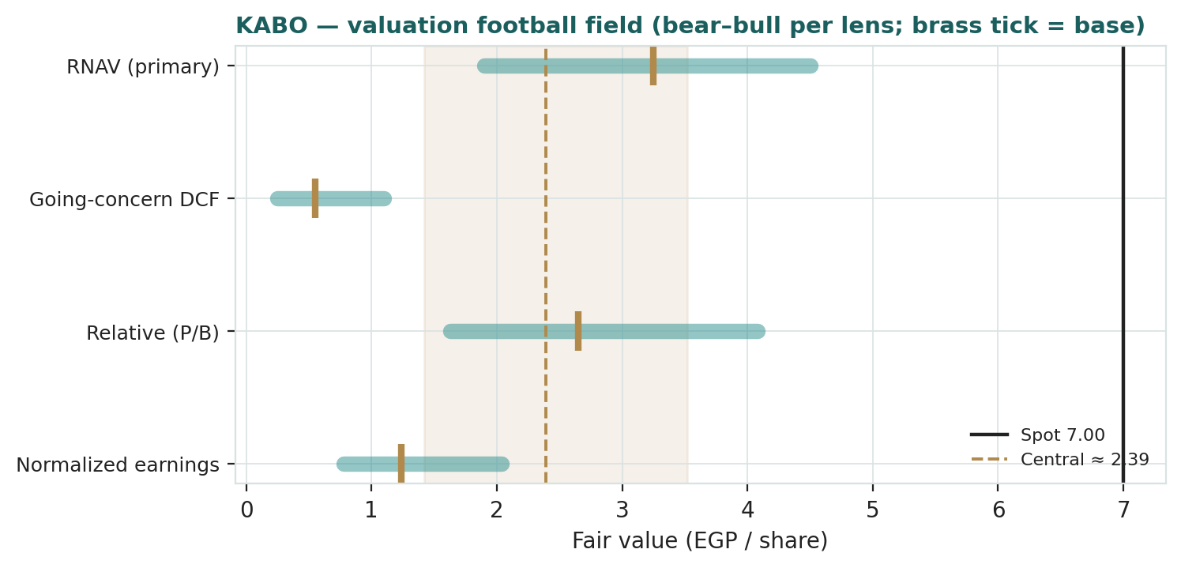
Figure 1 — Valuation football field. Bars span bear–bull per lens; the brass tick is each base case; the gold band is the blended central range; the dark line is spot EGP 7.00, which sits above every lens.
Central fair value ≈ EGP 2.39/share, about two-thirds below spot. The spread of the lenses (EGP 0.55 to 3.25 at base) is itself the message: this is not a business whose fair value is in reasonable doubt around the price — every method agrees the operating-and-audited-asset value is a fraction of EGP 7.00. What is in doubt is how much unbooked land value to add, and whether it will ever be realised.
1.6 The assets — a deeper look
Because the whole case rests on the balance sheet, it is worth scoring each asset on how realizable it actually is. The uncomfortable truth for the bull is that the most valuable asset — the land — is also the least liquid: it sits under operating factories, is not disclosed parcel-by-parcel, and cannot be monetised without either relocating production or a corporate transaction. The brand has value but is not separable. Inventory and receivables are close to book but are ordinary working capital, not hidden value.
Asset / segment | Realizability | Carrying vs market | Role in the case
Land & buildings (Alexandria) | Low — owner-occupied, indivisible | Likely well below market | The entire swing
Plant & machinery | Low — specialised, second-hand | Near or below book | Operating base
Inventory & receivables | Moderate — ordinary WC | Near book | Working capital, not value
Brand (Kabo / Jil / Super Kabo) | Low — not separable from the business | Off balance sheet | Optionality only

1.7 The land re-mark — the crux
One variable drives this valuation more than all the others combined: what KABO's legacy Alexandria real estate is worth, and whether it is ever revalued or sold. The arithmetic is unforgiving. For the EGP 7.00 price (market cap ~EGP 3.96bn) to be backed by assets, the realizable value of KABO's property would need to exceed its book carrying value by roughly EGP 2.8bn — nearly triple the entire current book asset base — with that uplift concentrated in land. That is not impossible: a company manufacturing in Alexandria since 1940 may sit on large, well-located parcels carried at a fraction of today's land prices, and Egyptian industrial land has re-rated sharply in nominal terms through successive devaluations. But it is undisclosed. KABO publishes no asset register, no independent land valuation, and no monetisation plan; there is no RERA-style escrow or handover schedule to model against. So the land re-mark is, at this stage, the market's hope rather than a modelled fact — which is exactly why RNAV is the right lens and why we sensitise the mark rather than assert a single number. The bull case is a specific, testable claim: that a revaluation or sale will crystallise land worth multiples of book. Until the company discloses the parcels or announces a transaction, a disciplined analyst credits a conservative uplift (our EGP 0.7bn base) and treats the rest as optionality.
1.8 Macro and country — the pound, rates, cotton and the consumer
KABO is a leveraged, export-oriented small-cap, so Egyptian macro sets its fortunes more than management does. The pound is double-edged: a weaker EGP lifts export revenues in local terms (the source of the FY2024 windfall) but raises the local-currency cost of imported cotton, yarn and energy, so the net margin effect depends on the lag between the two. Interest rates matter mechanically — a company with ~EGP 559m of debt is squeezed when the CBE corridor is high, and any 2026 easing cycle is a direct relief to finance costs and to the discount rate in §1.2. Input costs — global cotton and fibre prices, plus domestic energy-tariff and minimum-wage steps — set the gross margin. And regional freight (Red Sea disruption raising shipping costs and lead times) bears directly on an exporter. These levers, not a new product line, are what move the bear and bull cases and drive the catalysts in §5.
1.9 RNAV sensitivity — how the land mark and the discount move the value
The table re-prices RNAV across the land-and-buildings re-mark (rows) and the discount a buyer might apply to a hard-to-monetise, owner-occupied asset base (columns). The cell nearest spot (EGP 7.00) sits at the far corner — a ~EGP 2.8bn re-mark applied at par — which is the asset value the price implies.
Land re-mark (EGP m) ↓ / applied discount → | Par (0%) | −20% | −40%
0 (book only) | 2.04 | 1.63 | 1.22
700 (base) | 3.28 | 2.62 | 1.97
1,400 | 4.52 | 3.62 | 2.71
2,100 | 5.76 | 4.61 | 3.46
2,800 (≈ price-implied) | 6.99 | 5.59 | 4.19

Read it as the bet the price is taking: EGP 7.00 is consistent only with a land re-mark near EGP 2.8bn credited at par — i.e., the market is fully pricing a large, undisclosed, un-discounted land revaluation. Any realistic monetisation discount, or any smaller re-mark, pulls the asset value well below the price.
2 Technical and price structure
The tape is strong and stretched to the upside — the exact opposite of the fundamentals. KABO trades above all four major moving averages, the MACD histogram is positive, and RSI sits at 78, well into overbought territory. The structure is a momentum advance that has carried price to an all-time high near EGP 7.13 on heavy volume. For a thinly-traded small-cap, that combination — new highs, overbought oscillators, a positive MACD — describes a speculative run, not a value re-rating; it says nothing about whether the price is supported by worth.
Indicator | Reading | Signal
Spot | EGP 7.00 | —
SMA 20 / 50 | EGP 6.30 / 6.19 | Above both — short-term up
SMA 100 / 200 | EGP 6.14 / 6.15 | Above both — trend up
RSI (14) | 78.5 | Overbought (>70)
MACD (12,26,9) | +0.093 line / +0.040 signal / +0.053 hist | Bullish — positive momentum
52-week range | EGP 4.71 – 7.13 | At the top / all-time high
Realized vol (252d) | 34.5% | Elevated
Realized vol (60d) | 29.3% | —

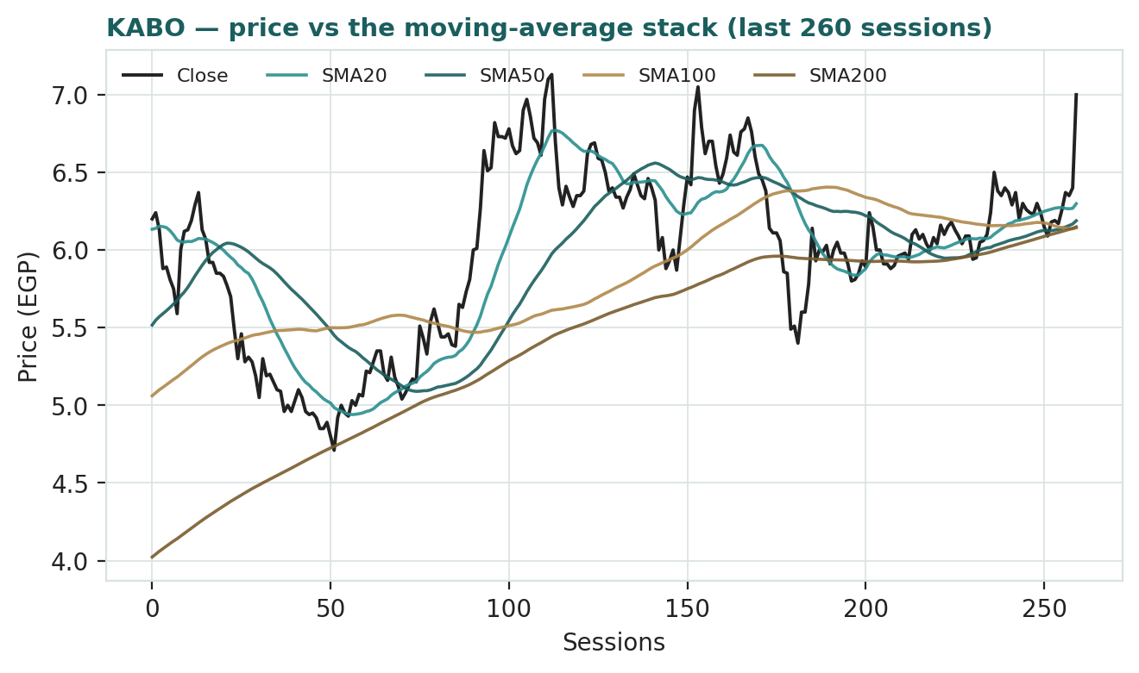
Figure 3 — Price versus the moving-average stack, last 260 sessions. Price sits above every average, the mirror image of a stock trading below fair value.
For the probabilistic work this matters in one way: an overbought, extended tape near an all-time high carries a wider near-term downside tail — mean-reversion after a vertical move is common — even as momentum is up. The technical and fundamental pictures genuinely disagree about direction of risk, and §6 reads the (illustrative) probability zones without forcing a reconciliation.
3 Monte Carlo — an illustrative volatility map (not a published forecast)
Monte Carlo shown for illustration only — no probabilistic price forecast is published for KABO. Why:
Every calibration of the engine failed Testahil's pass test on this security. Across a five-year rolling backtest (60-session horizon, 57 origins, 2021–2026), the model's three-month price distribution did not beat a naïve zero-drift random-walk cone on CRPS skill (best −0.007; canonical −0.010, 95% CI −0.042 to +0.020) or on the interval (Winkler) score (−0.055). KABO is a thinly-traded small-cap whose quarter-ahead price is dominated by discrete, unforecastable jumps — today's move to an all-time high came on roughly six times normal volume — and by a lumpy, currency-driven drift, so a smooth diffusion cone earns no skill over the naïve benchmark. Under Testahil's standing rule — a forecast counts only if it beats the random-walk cone on CRPS with a roughly uniform PIT — the Monte Carlo layer is therefore carried as an illustrative volatility map only. The numbers below describe how wide the stock's own three-month range tends to be; they are not probabilities we stand behind as a forecast. The fundamental (RNAV) and technical reads carry this study. Full calibration evidence is in Appendix B.

With that caveat foremost, we simulate 50,000 three-month paths (seed 42) from spot using the house sixteen-factor stack — seven continuous drivers and nine discrete events — with zero secular drift (KABO is not an EGX developer, and drift-on scored worse in Step 0). By design the paths diffuse from spot, and the §1 value gap is deliberately kept out of the drift. Because the engine has no demonstrated edge here, read everything below as a description of dispersion, not a prediction of direction.
The probability read (illustrative — reconciles with the cone below, but is not a forecast)
Probability read at T+60 (illustrative) | Value
P(price above spot) | 53%
P(+10%) vs P(−10%) · odds | 36% vs 29% · 1.22×
Median level · % move | EGP 7.12 · +1.7%
50% band (25th–75th) · as % of spot | EGP 6.12 – 8.28 · ~31%
Touch +10% / touch −10% by T+60 | 63% / 55%

These figures merely summarise the same 50,000 illustrative paths the cone uses; they are presentation-only and, because the engine failed Step 0, are not a probability forecast for KABO. The near-even P(up) and the modest positive skew come from the two-sided factor stack (a land-revaluation or squeeze catalyst on the upside; input-cost, freight and dilution events on the downside), not from any published directional view.
The sixteen factors (illustrative overlay)
Continuous factor (7) | Dir. | Discrete event (9) | Prob. | Mean impact
EGP/USD rate (exporter tailwind) | + | Quarterly earnings print (FY Jul–Jun) | 55% | +0.5%
CBE policy-rate path | − | Land / asset revaluation or monetisation | 15% | +10.0%
Input cost (cotton/yarn/energy/wages) | − | EGP step-devaluation | 20% | +5.0%
EGX30 & retail / foreign flows | + | Capital action / rights issue | 15% | −3.0%
Global apparel / export demand | + | Major export-order win / loss | 35% | +2.0%
Global cotton / fibre price | − | Input-cost / energy-tariff shock | 30% | −4.0%
Latent-asset / land-revaluation sentiment | + | Geopolitical / Red Sea freight | 25% | −5.0%
 |  | Speculative squeeze / retail momentum | 30% | +6.0%
 |  | Governance / auditor / disclosure event | 20% | −3.0%

Percentile map (illustrative, EGP / share)
Horizon | p5 | p25 | p50 | p75 | p95
T+20 sessions | 5.58 | 6.46 | 7.03 | 7.67 | 8.92
T+60 sessions | 4.79 | 6.12 | 7.12 | 8.28 | 10.68

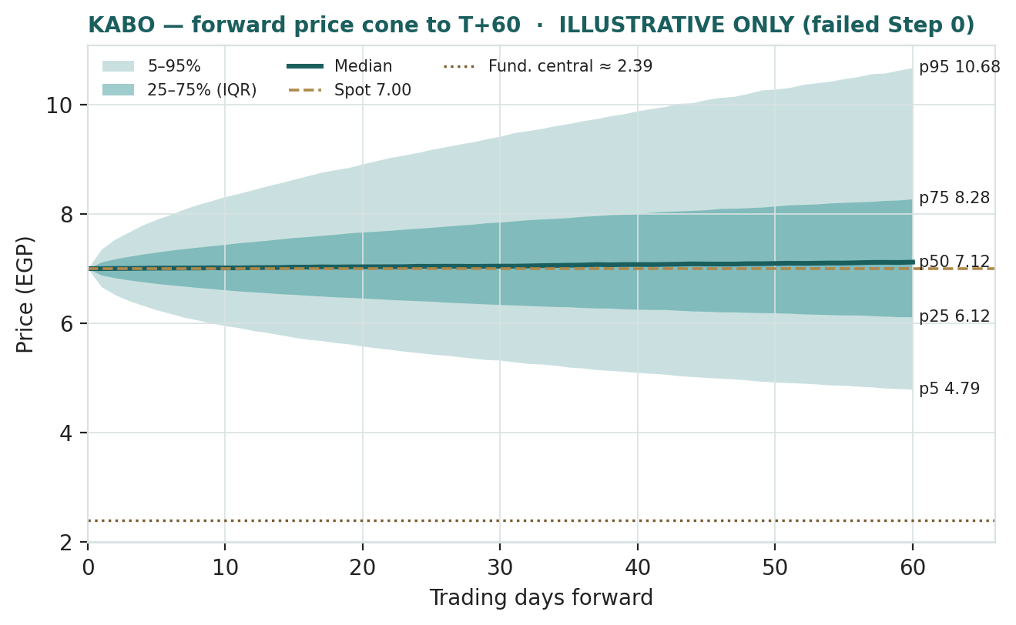
Figure 4 — Forward price cone to T+60, ILLUSTRATIVE ONLY (the engine failed Step 0). Median tracks spot; the gold dotted line marks the ~EGP 2.44 fundamental central, deliberately far below the cone. Lead with the 50% interquartile band, not the 90% tail.
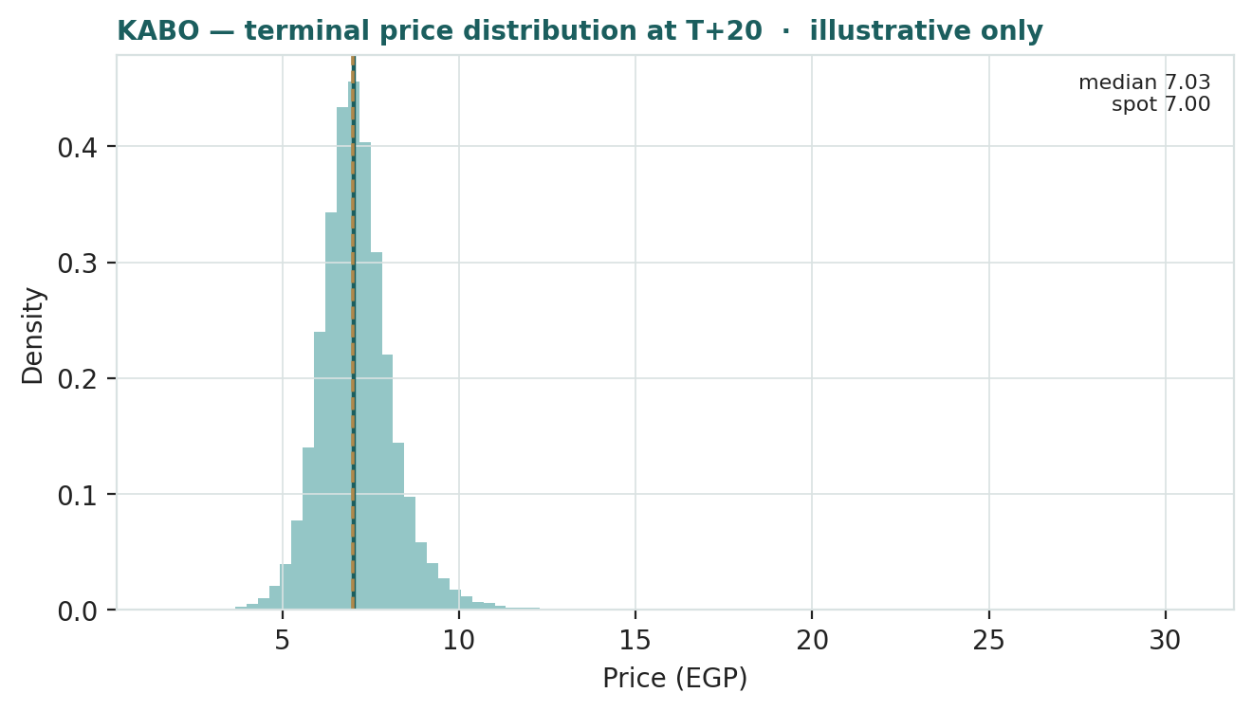
Figure 5 — Illustrative price distribution at T+20.
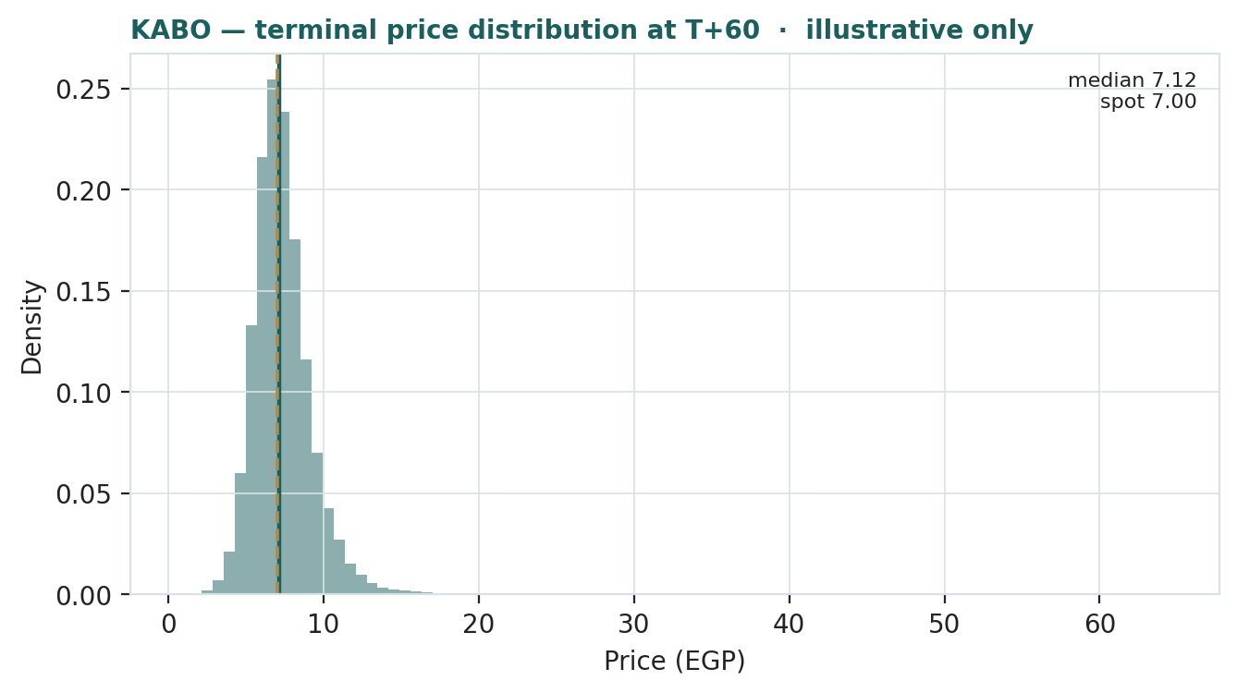
Figure 6 — Illustrative price distribution at T+60.
Level-touch ladder (illustrative) — the probability that price touches a level at any point by the horizon (running max for upside, running min for downside):
Level (EGP) | T+60 touch | Note
8.40 | see chart | Toward a fresh high
7.70 | ~63% | +10% from spot
7.00 | ~100% | Spot
6.30 | ~55% | −10% from spot
5.60 | see chart | Toward the moving-average stack

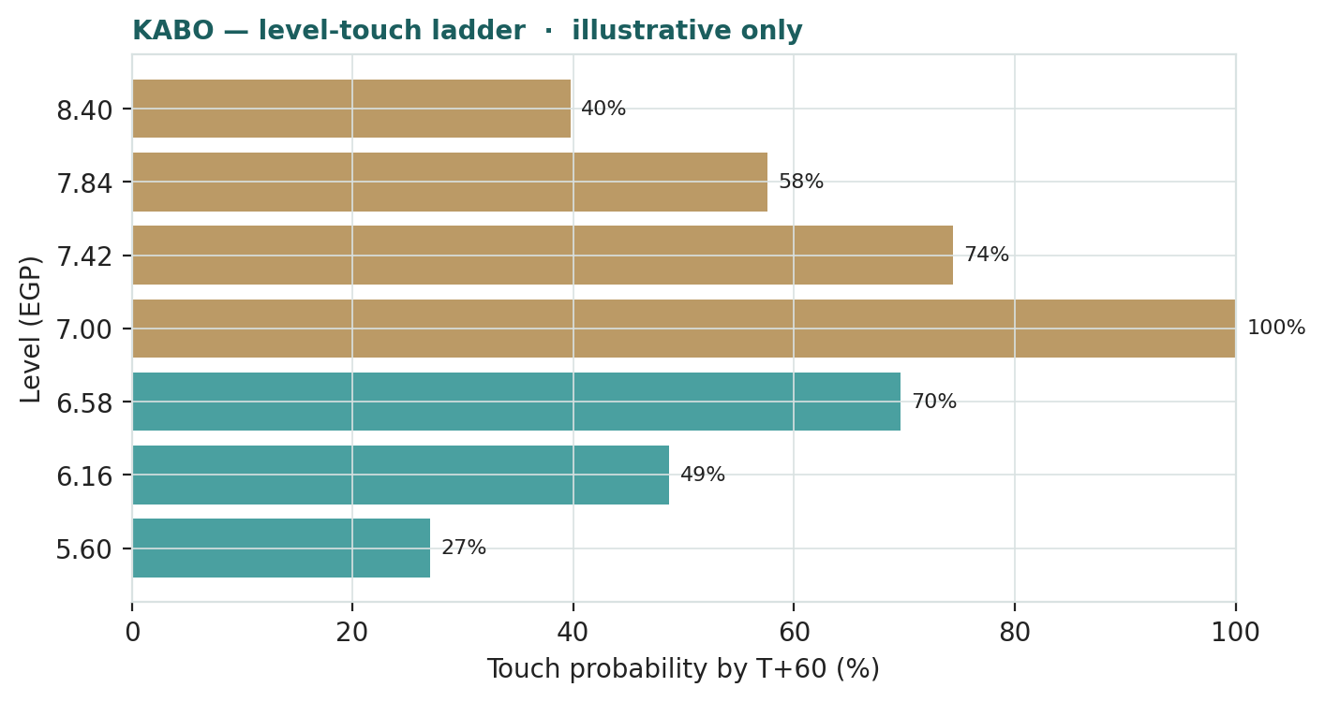
Figure 7 — Illustrative level-touch ladder to T+60.
To repeat the essential caveat: none of the figures in §3 is a forecast we endorse for KABO. They quantify the stock's characteristic three-month dispersion so a reader can see how violently a small-float name like this can move, and they are reconciled with each other — but the engine did not earn the right to make a directional claim on this security. That is the whole point of the Step 0 gate.
4 Comparison of the lenses, and a verdict
Three readings sit side by side, and for once they do not need reconciling to tell a clear story. The fundamental lenses cluster at EGP 0.55–3.25 with a central ~EGP 2.39 — every method well below the EGP 7.00 price, and agreeing that on its operations and audited assets the business is worth a fraction of where it trades. The technical picture is the opposite: strong, overbought, at an all-time high. The probabilistic map is, uniquely for a Testahil study, withheld as a forecast — the engine failed its calibration test on KABO — and shown only to describe the stock's wide three-month dispersion.
Lens | Reads | Central / implication
Fundamental (4-lens) | Richly valued vs assets & earnings | EGP 2.39 (~−66% vs spot)
Technical | Strong / overbought / all-time high | Extended above the EGP 6.1–6.3 MA stack
Monte Carlo (illustrative) | No forecast published — failed Step 0 | Wide dispersion; ~±31% 50% band

Verdict (a fair-value read, not a recommendation). KABO looks expensive on every fundamental lens, and the gap between price and value is unusually clean: it is one undisclosed variable, the realizable value of the legacy Alexandria land. On its operating cash flows the equity is worth under EGP 1 a share; on a generous asset re-mark it reaches ~EGP 3.3; the market pays EGP 7.00. That price is coherent only if the land is worth roughly EGP 2.8bn above book and the market is fully crediting a revaluation that has not been disclosed or announced. The technical strength confirms that momentum, not disclosed value, is currently setting the price. The honest summary is a value well below price, a tape well above it, and a bull case that depends entirely on an asset event the company has not put on the table. Readers should weigh the lenses themselves; we publish the range and the divergence of expert views, not a target — and, on this name, no probabilistic price forecast at all.
5 Catalysts to watch
• Land disclosure, independent valuation, or monetisation. The one catalyst that could validate the price — an asset register, a third-party land valuation, a sale-and-leaseback, or a relocation-and-redevelopment plan. Absent this, the bull case stays unproven.
• Quarterly earnings (FY July–June). Whether the export gross margin stabilises or the ~95% year-on-year profit collapse continues as input costs catch up with the weaker pound.
• The pound and the CBE rate path. A further EGP step-devaluation lifts export revenue in local terms; a rate-cutting cycle relieves finance costs on ~EGP 559m of debt and lifts the DCF.
• Input costs. Global cotton and fibre prices, and domestic energy-tariff and minimum-wage steps — the swing on gross margin.
• Capital actions. Any further rights issue (KABO recently deployed EGP 57m of raised capital) would dilute; watch for board decisions on capital.
• Red Sea / freight. Shipping-cost and lead-time pressure bears directly on an exporter's competitiveness and working capital.
• Liquidity and speculative flows. A small float and heavy retail participation mean the price can move sharply on flows unrelated to fundamentals — as the recent surge to an all-time high on ~6× normal volume illustrates.
6 Reading the probability zones (illustrative only)
Because the engine failed Step 0, the zones below are not a forecast — they translate the illustrative three-month distribution into plain bands so a reader can see the shape of the stock's own dispersion, nothing more. Anchored on spot EGP 7.00:
Zone (T+60, illustrative) | Range | Approx. share of paths | What it would look like
Deep downside | < EGP 5.50 | ~13% | Mean-reversion toward the MA stack / risk-off
Lower band | EGP 5.50–6.50 | ~20% | Pullback from the all-time high
Around spot | EGP 6.50–7.50 | ~30% | Consolidation at the high
Upper band | EGP 7.50–9.00 | ~24% | Momentum continues
Strong upside | > EGP 9.00 | ~13% | Squeeze, or a land / monetisation catalyst

The distribution is roughly symmetric around spot with a slightly heavier upper tail from the discrete upside events (a land catalyst, a squeeze). It is not a forecast; it is the spread of outcomes consistent with the stock's own volatility and the illustrative factor stack, shown because the engine has not earned the right to point a direction on this name.
7 Caveats and what would change our mind
• The land mark is the model. The entire distance between price and fundamental value is one undisclosed number. Our EGP 0.7bn base re-mark could be far too low (if the parcels are large and prime) or too high (if they are encumbered or hard to monetise). Disclosure of an asset register or an independent valuation would move the RNAV materially in either direction.
• Data quality. KABO is thinly covered; the share count is derived from market capitalisation, and several historical line items and the balance-sheet split are reconstructed on a fiscal-year basis and flagged as estimates. They are shown for scale and trajectory, not audited precision.
• Earnings volatility and FX. Reported earnings swing violently with the pound — a devaluation windfall one year, near-zero the next. A single year is not a trend, and our normalization is a judgment.
• Leverage and rates. ~EGP 559m of debt makes the going-concern DCF hyper-sensitive to the discount rate; a lower Egyptian cost of capital would lift it, a higher one could push equity value toward zero.
• Liquidity and speculation. A small float means flows, not fundamentals, can set the price for extended periods — in either direction.
• Monte Carlo. No probabilistic price forecast is published for KABO; the engine failed its calibration test (Appendix B). The illustrative cone should not be read as a forecast.

Appendix A Financial statements
Selected consolidated figures on a fiscal-year (July–June) basis: three years of history and a five-year forecast. KABO is thinly disclosed; FY2024 and the 9M FY2024/25 print are anchored to EGX/aggregator disclosure, while the FY2023 and FY2025 full-year splits and all forecasts are the preparer's reconstruction and are flagged. Shown for scale and trajectory, not as audited statements.
A.1 Income statement (consolidated, EGP m)
Line | FY23 | FY24 | FY25e | FY26e | FY27e | FY28e | FY29e | FY30e
Revenue | 593 | 1,020 | 1,050 | 1,180 | 1,320 | 1,470 | 1,630 | 1,800
Gross profit | 95 | 194 | 145 | 189 | 211 | 235 | 261 | 288
EBITDA | 88 | 180 | 120 | 159 | 178 | 199 | 220 | 243
− D&A | (36) | (40) | (42) | (45) | (48) | (51) | (54) | (57)
EBIT | 52 | 140 | 78 | 114 | 130 | 148 | 166 | 186
Net finance cost | (8) | (18) | (55) | (48) | (44) | (40) | (36) | (33)
Net FX / one-off | 12 | 45 | (5) | 0 | 0 | 0 | 0 | 0
PBT | 56 | 167 | 18 | 66 | 86 | 108 | 130 | 153
Tax (~22.5%) | (4) | (38) | (2) | (15) | (19) | (24) | (29) | (34)
Net income (attributable) | 52 | 129 | 16 | 51 | 67 | 84 | 101 | 119

*FY2024 was inflated by a currency-translation windfall (net FX gains as the pound devalued); 9M FY2024/25 attributable profit was EGP 9.4m against EGP 193m a year earlier. The forecast assumes the weaker pound keeps export revenue structurally higher while margins normalise to mid-cycle.*
A.2 Balance sheet (consolidated, EGP m)
Line | FY23 | FY24 | FY25 | FY26e | FY27e | FY28e | FY29e | FY30e
Property, plant & equipment (net) | 600 | 720 | 780 | 790 | 800 | 810 | 820 | 830
Inventory | 350 | 480 | 500 | 540 | 585 | 630 | 680 | 730
Trade & other receivables | 250 | 340 | 360 | 390 | 425 | 460 | 500 | 540
Cash & equivalents | 90 | 140 | 150 | 175 | 210 | 255 | 310 | 375
Other assets | 60 | 80 | 44 | 45 | 46 | 47 | 48 | 49
Total assets | 1,350 | 1,760 | 1,834 | 1,940 | 2,066 | 2,202 | 2,358 | 2,524
Interest-bearing debt | 380 | 520 | 559 | 540 | 520 | 500 | 480 | 460
Payables & other liabilities | 120 | 150 | 123 | 197 | 276 | 348 | 423 | 490
Total liabilities | 500 | 670 | 682 | 737 | 796 | 848 | 903 | 950
Total equity (attributable) | 850 | 1,090 | 1,152 | 1,203 | 1,270 | 1,354 | 1,455 | 1,574

*Total assets, total liabilities and equity for FY2025 tie to the reviewed balance sheet (total assets EGP 1,834m; liabilities EGP 683m; equity EGP 1,152m). The asset-line split and all other years are reconstructed and flagged. Equity grows by retained earnings — KABO pays no dividend. PP&E is carried near depreciated cost; the RNAV land re-mark in §1 is NOT reflected here.*
A.3 Cash flow (consolidated, EGP m)
Line | FY23 | FY24 | FY25 | FY26e | FY27e | FY28e | FY29e | FY30e
Net income | 52 | 129 | 16 | 51 | 67 | 84 | 101 | 119
+ D&A | 36 | 40 | 42 | 45 | 48 | 51 | 54 | 57
− Δ working capital | (40) | (90) | (35) | (35) | (30) | (32) | (34) | (36)
Operating cash flow | 48 | 79 | 23 | 61 | 85 | 103 | 121 | 140
− Capex | (45) | (60) | (55) | (55) | (58) | (61) | (64) | (67)
Free cash flow | 3 | 19 | (32) | 6 | 27 | 42 | 57 | 73
Net financing & other | 10 | 31 | 41 | 19 | 8 | 3 | (2) | (8)
Net change in cash | 13 | 50 | 9 | 25 | 35 | 45 | 55 | 65

*Source: company FY2024 disclosure and 9M FY2024/25 review; other years reconstructed and flagged. KABO's cash generation is thin — the business barely self-funds its working-capital growth and maintenance capex, which is why the going-concern equity value in §1.2 is low.*
Appendix B Step 0 — calibration backtest (result: fails; Monte Carlo demoted to illustrative)
Before publishing any forecast, Testahil tests the Monte Carlo engine on the security's own five years of history: at monthly origins it generates a three-month-ahead distribution using only prior data, scores the realized close against it, and asks whether it beats a naïve zero-drift random-walk cone. On KABO it does not — under any configuration tried. This is why §3 carries no forecast.
Calibration metric | Result | Pass gate | Verdict
CRPS skill — canonical (YZ·mean-HAR·t5) | −0.0098 | > 0 | FAIL
CRPS skill — best config (YZ·median-HAR·t5) | −0.0068 | > 0 | FAIL
CRPS skill — 95% confidence interval | −0.042 to +0.020 | lower bound > 0 | FAIL (straddles 0)
Interval (Winkler) skill | −0.055 | > 0 | FAIL
PIT mean | 0.573 | ≈ 0.50 | Skewed high

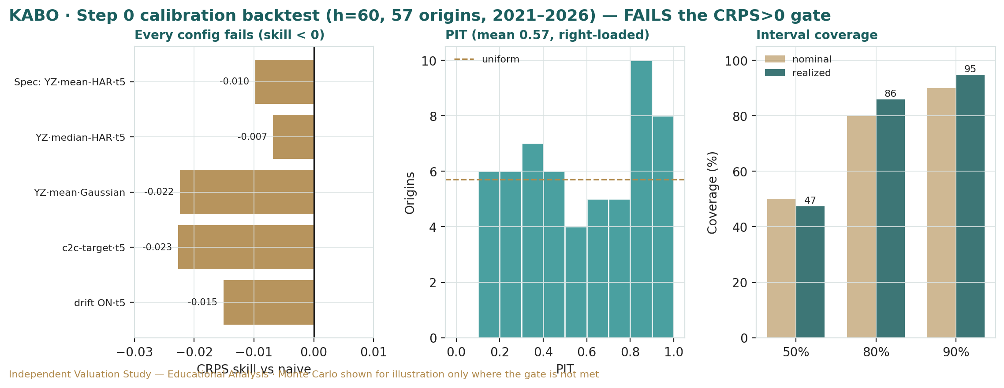
Figure B-1 — Calibration backtest on KABO: quarterly cone replay, PIT histogram, and interval coverage versus target. The engine's cone does not contain the realized path at its stated rates with any skill over the naïve benchmark.
Every alternative configuration also failed, so the result is not an artefact of one modelling choice:
Configuration tested | CRPS skill vs random-walk
YZ · mean-HAR · t5 (canonical spec) | −0.0098
YZ · median-HAR · t5 (best config) | −0.0068
YZ · mean · Gaussian innovations | −0.0224
Close-to-close vol target · t5 | −0.0227
Drift ON · t5 | −0.0151

The interval-coverage diagnostic (n = 57 monthly origins) and the per-year skill show why. The 80% and 90% bands over-cover while the 50% band under-covers, and the PIT mean of 0.573 sits above 0.50 — the zero-drift cone systematically sat below a stock that trended up, so the realized price landed high in the distribution. Split by year, the engine had marginal positive skill during the 2022–23 devaluation era (when a lumpy currency drift briefly helped) but turned sharply negative in 2024–26, netting negative across the sample.
Coverage / PIT diagnostic | Target | KABO (n=57)
50% band containment | 50% | 47.4%
80% band containment | 80% | 86.0%
90% band containment | 90% | 94.7%
PIT mean | 0.50 | 0.573

Per-year CRPS skill | 2021 | 2022 | 2023 | 2024 | 2025 | 2026
YZ·mean-HAR·t5 | +0.003 | +0.056 | +0.019 | −0.010 | −0.029 | −0.180

Conclusion — why no Monte Carlo forecast is published for KABO.
Under Testahil's standing rule, a probabilistic forecast is published only if the engine beats a zero-drift random-walk cone on CRPS skill (> 0) with a roughly uniform PIT. KABO fails on both counts, under every configuration tried, because its quarter-ahead price is driven by discrete, unforecastable jumps and a lumpy currency drift that a smooth diffusion cannot capture. We therefore carry the Monte Carlo as an illustrative volatility map only (§3) and rest the study on the fundamental (RNAV) and technical reads. Band-containment is a diagnostic, never the grade — an honestly-wide cone that fails CRPS is still a failed forecast.

Appendix C Peer set, sector structure, and risks
KABO has no clean listed comparable — it is a sub-scale, private-sector knitwear exporter with a latent-asset overlay. The peer set is indicative, split between EGX textile names and distressed emerging-market apparel makers.
Peer / comparator | Market | Typical valuation / note
Oriental Weavers (ORWE) | EGX | Carpets; scaled exporter; ~1.0–1.6× book; dividend-paying
Arab Cotton Ginning (ACGC) | EGX | Cotton processing; asset-heavy; cyclical
Nile Cotton Ginning / spinning peers | EGX | Legacy textile; asset value vs weak earnings
Distressed EM knitwear / apparel | Global | Typically 0.5–1.2× book on thin margins

Sector structure. Egyptian textiles are a two-tier world: a weak-pound tailwind for exporters (revenues in hard currency, much of the cost base in EGP) against structural pressures — high energy and financing costs, ageing plant, intense low-cost competition from Asia, and thin, volatile margins. Value in the legacy names increasingly rests on the real estate under the factories rather than on the manufacturing itself, which is exactly the KABO question. Principal risks: an undisclosed or over-estimated land value (the swing in both directions); reconstructed financials for a thinly-covered name; violent FX-driven earnings swings; heavy leverage into a high-rate environment; a small, speculative float; input-cost and freight shocks; and a Monte Carlo layer that could not be calibrated and is therefore not a forecast.

Appendix D The expert valuation panel
Premise. Three independent experts, three genuinely different methods, none seeing the others' work; the divergence is the signal and is not averaged away into a single number. The point is not consensus but a clean map of where the disagreement lives — and here it lives in one place. The discipline that makes the section real is threefold: each expert runs a genuinely different method, so agreement (when it comes) is informative rather than an artefact of shared assumptions; each fair value is derived from shown workings, never asserted; and each states a falsification condition, so the persona can be scored against realized prices over time. None of the three is allowed to wave at a number — a discipline that matters most on a name like KABO, where the temptation is to invent a land value and back into the price.
Every Testahil study closes with a panel of standing expert personas — drawn from the house Expert Persona Library, not invented for the occasion, so that each accumulates a track record across studies and a quarterly update is a re-run, not a re-training. For an asset-heavy industrial whose price has detached from its earnings, we cast the three whose methods both fit the instrument and genuinely disagree: Expert 1 (revalued net assets at realizable value and earnings quality), Expert 2 (normalized through-cycle earnings and multiples), and Expert 3 (scenario-weighted policy and catalyst odds). Each runs a different method, derives its fair value from shown workings, and states a falsification condition. The single asset they disagree on is the land, and that disagreement is the whole valuation.
D.1 Expert 1 — revalued net assets at realizable value
Worldview. The realization school: a business is worth what its assets would fetch, net of every claim, and reported profit is trusted only insofar as it converts to cash. This lens is at its sharpest exactly where value rests on assets that are not yet realized — a company sitting on legacy land carried at historical cost is its natural subject.
When it works / fails. Best where the business is capital-intensive and working-capital-heavy, leverage is rising, and the value case rests on unbuilt or unrealized assets — all true of KABO. It fails by systematically undervaluing a genuine compounding franchise, which KABO, on its margins and cash conversion, is not.
Standard workings. (1) mark each asset to a conservative realizable value with explicit haircuts; (2) test earnings quality through the operating-cash-flow-to-net-income bridge; (3) bridge to equity by subtracting all claims and applying a cash-conversion overlay; (4) sensitise on the swing marks. Applied to KABO, the earnings-quality test is unflattering — FY2024's reported profit was mostly a non-cash currency-translation gain — which pushes him firmly onto the asset side.
Expert 1's marks (EGP m) | Value | EGP / share
Audited book equity (net assets) | 1,152 | 2.04
+ Land & buildings re-mark (conservative) | 700 | 1.24
+ Brand value (Kabo / Jil, off-B/S) | 50 | 0.09
− Working-capital realizability haircut | (75) | (0.13)
− Illiquidity / monetisation friction | (75) | (0.13)
Fair value | 1,752 | 3.10

Earnings-quality bridge. Before he will value the operations at all, he runs the operating-cash-flow-to-net-income bridge, and it fails his test: FY2024's headline EGP 129m of profit was dominated by a non-cash currency-translation gain, while operating cash flow was a fraction of it and free cash flow barely positive. When reported profit does not become cash, he discounts the income statement entirely and leans on the balance sheet — which is why, for KABO, he is almost purely an asset valuer. Illiquidity friction. His two haircuts are deliberate: the working-capital haircut reflects that inventory and receivables in a distressed textile chain rarely realise book, and the monetisation-friction haircut reflects a fact the bulls skate over — the land sits under working factories, so it cannot be sold without relocating production, financing a new site, and absorbing redundancy and disruption costs. A gross land value is not a net one.
Worked example & sensitivity (swing = the land re-mark). At no re-mark he is at book, EGP 2.04; at EGP 700m, EGP 3.10 after his frictions; at EGP 1,400m, EGP 4.35; at the EGP 2,800m the price implies, EGP 6.9 — but he refuses to credit an undisclosed mark that large without an asset register. Cross-examination. He tells Expert 2 that capitalising mid-cycle earnings on a business that barely converts profit to cash is a half-truth; he tells Expert 3 that no probability weighting manufactures asset value the company has not disclosed — the land is either there on a valuation or it is a story.
Verdict, falsification, market-implied. Fair EGP 3.10 (range EGP 1.90–4.60). Falsified if the land re-mark proves illusory — encumbered, over-stated, or impossible to monetise — or, conversely, if a durable lift in cash conversion makes the earnings lens the better anchor. The market price implies a land re-mark near EGP 2.8bn credited at par, far above his conservative EGP 0.7bn, so on his read the stock is pricing assets he cannot yet verify.
D.2 Expert 2 — normalized through-cycle earnings power
Worldview. An operating business is worth a fair multiple of its sustainable, mid-cycle earnings; peaks and troughs are noise to be stripped out. He asks what KABO earns through a full currency-and-cost cycle, and what the market should pay for it.
When it works / fails. Best for stable or cyclical operating businesses with a track record. It fails precisely where book and cash diverge sharply from earnings, or at a structural break — and KABO's earnings, whipsawed by the pound, test the method's limits, which is why he ends up the most conservative of the three on the operations.
Standard workings. (1) normalize revenue and margin to mid-cycle, stripping the FY2024 FX windfall; (2) derive sustainable earnings and EPS; (3) apply a justified multiple against the sector and the name's own history; (4) cross-check against EV/EBITDA and free-cash-flow yield. The cross-check is sobering: on thin free cash flow, KABO's FCF yield at the current price is negligible.
Expert 2's normalization | Value
Mid-cycle net income (EGP m) | 70
Shares (m) → normalized EPS | 565 → EGP 0.124
Justified through-cycle P/E (export/FX quality) | 10.5×
Fair value | → EGP 1.30 / share

Cross-checks and cycle position. He never trusts a single P/E, so he triangulates. On EV/EBITDA the stock is not cheap once net debt is added to a ~EGP 4bn market cap against mid-cycle EBITDA of ~EGP 180–240m; on free-cash-flow yield it is worse, because maintenance capex and working-capital growth consume most of operating cash. He is explicit about where current earnings sit in the cycle: FY2024 was a peak (a devaluation windfall), 9M FY2024/25 a trough (EGP 9.4m), and the truth is somewhere in between — which is exactly why he normalizes rather than annualising either. His justified multiple carries a small premium to the distressed-textile average for the export/FX-hedge quality of the franchise, but no more; a sub-scale knitwear maker with volatile margins does not earn a growth multiple.
Worked example & sensitivity (swing = normalized margin / multiple). At 8× he is at EGP 0.99; at 12×, EGP 1.49; if the durable export margin is really ~8% net (EGP 96m mid-cycle) at 12×, EGP 2.04. Cross-examination. He tells Expert 1 that a land mark you cannot monetise is not worth book-plus to a going concern; he tells Expert 3 that scenario trees do not change what the factory earns through the cycle — they only re-price the catalyst.
Verdict, falsification, market-implied. Fair EGP 1.30 (range EGP 0.80–2.20) — the most cautious on operations. Falsified by a structural margin re-rating: up if the weak-pound export franchise proves durable and scalable, down if input costs fully catch up and mid-cycle earnings drift to the bear. The market implies normalized earnings or a multiple far above his — on his read, the price is not paying for earnings at all, which is his whole point.
D.3 Expert 3 — scenario-weighted policy and catalyst odds
Worldview. In a frontier market, policy and corporate events outrank fundamentals: the FX regime, the rate path, and — for KABO specifically — the odds of a land-monetisation or restructuring event set the value more than the sewing floor does. He prices the stock as a set of options on which world arrives.
When it works / fails. Best in policy-driven markets with binary catalysts and an FX regime in flux — a good description of KABO, whose entire bull case is a discrete asset event. It fails through false precision: the probabilities are judgments, and a tree can miss the branch that actually grows.
Standard workings. (1) identify the levers that set value — the EGP path, the CBE rate path, the probability of a land re-mark or sale, the input-cost regime, and speculative liquidity; (2) define bull/base/bear as configurations of those levers; (3) re-run the base valuation under each so the scenario values are derived, not asserted; (4) probability-weight; (5) stress the weights.
Expert 3's scenario tree | Value (EGP/sh) | Probability
Bear — no land event, margins compress, rates stay high | 1.00 | 35%
Base — partial land re-mark credited, margins hold, rates ease | 2.60 | 45%
Bull — land monetisation / sale announced | 5.00 | 20%
Probability-weighted fair value | ≈ 2.40 | 100%

The levers, and how the scenarios are derived. He does not assert the three values; he re-runs the base valuation under each configuration of five levers — the EGP path (a weaker pound lifts export revenue but raises input costs), the CBE rate path (easing relieves ~EGP 559m of debt and lifts the DCF), the probability of a land re-mark or sale, the input-cost regime, and speculative liquidity in a small float. The bear is those levers set adversely (no land event, margins compress, rates stay high) and re-solves to ~EGP 1.00; the base credits a partial land re-mark with stable margins and easing rates and re-solves to ~EGP 2.60; the bull is a disclosed monetisation and re-solves to ~EGP 5.00. Stressing the weights. Because the answer is dominated by one probability, he stresses it explicitly rather than hiding it inside a point estimate — and concedes the method's weakness, that the true land-event odds are unknowable and a fourth branch (a disorderly devaluation, a delisting) could dominate the tree.
Worked example & sensitivity (swing = the land-event probability). Weighted value = 0.35×1.00 + 0.45×2.60 + 0.20×5.00 ≈ EGP 2.40. Lift the bull (land-event) probability from 20% to 30% and the weighted value rises to ~EGP 2.85; cut it to 10% and it falls to ~EGP 2.0. Cross-examination. He tells Expert 1 that even a real land value is worth little without a policy or corporate path to crystallise it — the NAV discount is itself an option on a catalyst; he tells Expert 2 that in a devaluation regime, 'mid-cycle' earnings are set by the currency, not the factory, so a single normalized number is a moving target.
Verdict, falsification, market-implied. Fair EGP 2.40 (range EGP 1.00–5.00) — the widest, because the outcome is genuinely binary. Falsified if a fourth, unmodelled shock dominates — a disorderly devaluation, a forced delisting, or a governance rupture. The market price implies a land-event probability well above his 20% base: the tape is pricing the catalyst as more likely, and sooner, than he judges it to be.
A note on how the three fit together. Their falsification conditions are complementary, which is what makes the panel useful rather than three voices talking past each other. Expert 1 is proven wrong if the land mark is illusory or if cash conversion durably improves; Expert 2 is proven wrong by a structural margin re-rating in either direction; Expert 3 is proven wrong if the catalyst tree is mis-specified. A reader can therefore watch a small set of concrete triggers — an asset register or valuation (tests Expert 1), a run of quarters showing the export margin holding or fading (tests Expert 2), and any board action toward monetisation (tests Expert 3) — and know which expert the new fact vindicates. Each expert's call is logged with today's date and spot as an internal per-expert track record, so that over successive quarterly re-runs the panel earns, or loses, the reader's trust on evidence rather than eloquence.
D.5 The three in one room
The single asset they most disagree on is the land under the Alexandria factories — the same fact, three readings.
Expert 1: "Mark the assets. Book equity is EGP 2 a share; credit a conservative re-mark on legacy Alexandria land and I get to EGP 3. That is what is real. The other EGP 4 in the price is a land valuation nobody has published."
Expert 2: "And even my generous read of the operations is EGP 1.30. This business barely converts profit to cash. Whatever the land is worth, you are not being paid to wait for it out of earnings — the free-cash yield here is a rounding error."
Expert 3: "You are both valuing a static picture. The whole question is a probability: will the land be revalued or sold, and when? Assign it a fifth and the stock is worth EGP 2.40; assign it a half and it is worth far more. The market has quietly assigned it a high number — that is the bet, and it is a policy-and-corporate bet, not an accounting one."
Expert 1: "A probability of what, exactly? Until there is an asset register, you are weighting a number none of us has seen. I would rather anchor on the audited book I can stand behind and add a conservative mark than dress an unknown in decimal places."
Expert 2: "We agree on more than it sounds. All three of our base cases are below the price. Whatever we each think of the land, the market is paying today for an event that has not happened — and paying a going-concern multiple the earnings cannot support in the meantime."
D.6 Reading the divergence
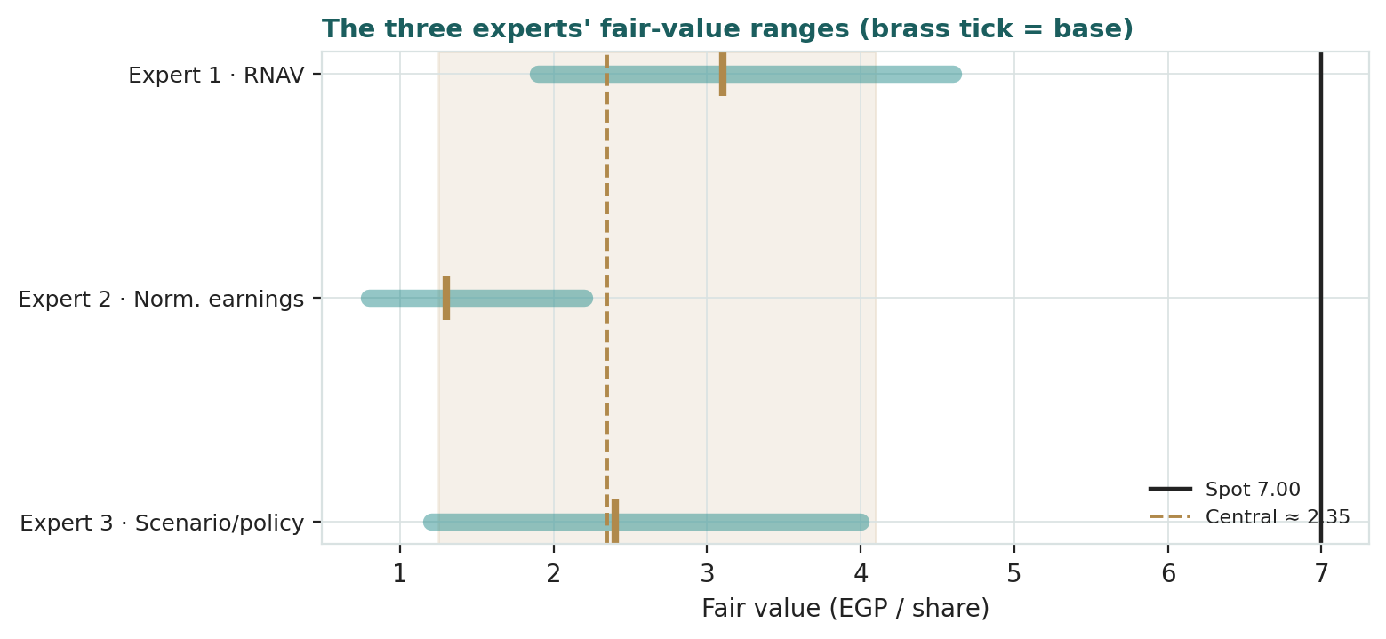
Figure D-1 — The three experts' fair-value ranges. Brass ticks are base cases; the gold band is the central; the dark line is spot EGP 7.00. The spread is almost entirely a land-value disagreement, and every base sits below spot.
Expert | Method | Single swing assumption | Base fair value
Expert 1 | Revalued net assets | The land re-mark (conservative EGP 0.7bn) | EGP 3.10
Expert 2 | Normalized earnings power | Mid-cycle margin × ~10.5× | EGP 1.30
Expert 3 | Scenario / policy | Probability of a land-monetisation event | EGP 2.40

The spread — EGP 1.30 to 3.10 at base — is not a disagreement about the factory; none of the three contests that the operating business is worth little at Egyptian discount rates. It is a disagreement about the land: how much unbooked value to credit (Expert 1), whether it matters to a going concern that cannot monetise it (Expert 2), and the probability that it is ever crystallised (Expert 3). The EGP 1.80 spread is therefore a clean measure of one thing — how much of KABO's value rests on an undisclosed asset and the odds it is realised. And all three base cases sit below spot, which is the panel's shared message: on every method, the market is paying for a land event that has not happened.
What the spread does NOT contain is as telling as what it does: there is no argument here about the manufacturing business, the brand, or the balance-sheet liabilities — all three experts price those similarly and modestly. The entire EGP 1.80 range is a proxy for a single unknown. That is unusually clean, and it tells a reader exactly what to watch: not the next quarter's margin, but any disclosure that puts a number on the land. Resolve that one fact — an asset register, an independent valuation, or a transaction — and the three experts converge quickly; leave it undisclosed, and the price is a standing bet on a catalyst.
*Each expert's point fair value (and bull/base/bear) is logged with the study date (06 Jul 2026) and spot (EGP 7.00) as an internal per-expert track record, kept separate from the core Calibration Ledger.*
About this series
Testahil publishes independent, educational valuation studies. Each is an attempt to reason transparently about what a security is worth, with every assumption shown and a companion model so readers can disagree productively. The house style is distributions, not tips: we describe ranges and probabilities, not targets, and we do not tell anyone what to do. On this name we go a step further and publish no probabilistic price forecast at all, because the engine did not earn one — a discipline we would rather show than hide. Studies are framed as educational analysis, the preparer is not licensed by any securities regulator, and holdings are disclosed.
Disclosure & Disclaimer
Not investment advice. This document is educational and informational only. It is not, and must not be relied upon as, investment, financial, legal, accounting or tax advice, nor an offer, solicitation or recommendation to buy, sell or hold any security. It contains no price target and no rating.
No licence; no advisory relationship. The preparer is not registered or licensed with any securities or financial regulator in any jurisdiction, holds no brokerage or investment-advisory authorisation, and is not acting as your adviser or fiduciary. Nothing here is personalised to your circumstances.
Holdings disclosure. The preparer may hold, and may in the future take or dispose of, a position in the security discussed in this report, and may transact at any time without notice. This is a potential conflict of interest you should weigh.
Sources & accuracy. Reported financial and operating figures are drawn from the company's public disclosure and other public sources believed reliable but not independently verified; KABO is thinly covered, and several historical line items, the share count and the balance-sheet split are reconstructed on a fiscal-year basis and flagged as estimates. Forward-looking inputs — above all the land-and-buildings re-mark that drives the primary lens, plus the projections, multiples, the DCF and the Monte-Carlo factor probabilities — are the preparer's own judgments and are inherently uncertain.
Forward-looking statements. Any statements about the future are estimates subject to risks and uncertainties; actual results may differ materially. The Monte Carlo models price, not value, encodes subjective probabilities for events that have not occurred, and — on this security — failed its calibration test and is therefore published only as an illustrative volatility map, not a forecast.
No reliance; your responsibility. Do your own research and consult a licensed professional before making any decision. You are solely responsible for your investment decisions and their outcomes. To the maximum extent permitted by law, the preparer accepts no liability for any loss arising from use of this document.
Currency & figures. Figures are in Egyptian pounds (EGP) unless stated; m denotes million and bn billion. Rounding may cause totals to differ slightly. Spot price and market data are as of 06 July 2026 and change continuously.
TESTAHIL · Independent Valuation Study · Educational Analysis · El Nasr Clothing & Textiles Co. (Kabo) (EGX: KABO) · edition 06-07-2026 · reporting currency EGP

