Independent Valuation Study — Educational Analysis
Kakao Corp. (KRX: 035720)
Fundamental analysis · Technical analysis · Monte Carlo simulation — one integrated read
Anchor: KRW 33,150 (26 Jun 2026 close) · ~440.7m shares · mkt cap ~KRW 14.6tn · Korea's dominant messaging-and-platform holding company · listed-affiliate stakes (KakaoBank, KakaoPay, Kakao Games, SM Entertainment) and unlisted subsidiaries (Kakao Entertainment, Kakao Mobility) · prices & probabilities computed 26 Jun 2026 from the attached daily price history · independent holding-company sum-of-the-parts on transaction-marked assets · the holding-company discount is the swing factor.
READ FIRST — what this document is, and is not. This study is a valuation exercise and an expression of personal analytical opinion, published free of charge for educational purposes: it shows how one analyst applies fundamental, technical and probabilistic methods to a listed company, and invites scrutiny of that methodology. It is NOT investment advice, NOT a recommendation or solicitation to buy, sell or hold any security, and NOT directed at the circumstances of any reader. The preparer is not licensed by any securities regulator in any jurisdiction, holds no Korean or other brokerage authorisation, provides no financial consultancy, manages no money, and accepts no fees, funds or clients. See the Disclosure & Disclaimer at the end. All values are model outputs presented as ranges and distributions because no single number should be relied on. Reported financials are Kakao's own disclosure; forward-looking inputs — the holding-company discount, the marks on unlisted subsidiaries, the value of the core platform, the multiples, the DCF and the Monte-Carlo factor probabilities — are the preparer's judgments and are flagged throughout. Consult a licensed financial advisor before any investment decision.
Headline
The model's read: roughly fairly valued, with the upside resting on the holding-company discount closing. At KRW 33,150 the shares trade about 3% below our weighted central estimate of KRW 34,258; spot sits within a few percent of most fundamental lenses. Kakao is Korea's dominant messaging platform — KakaoTalk reaches almost the entire population — wrapped inside a holding company whose value sits largely in listed and unlisted stakes (KakaoBank, KakaoPay, Kakao Entertainment, Kakao Mobility) rather than in its own reported earnings. The shares have fallen ~36% over the past year to sit at their 52-week low, roughly 53% below the 52-week high. The question is not whether Kakao owns valuable assets — it plainly does — but whether the market's ~36% discount to their sum is the right price.
Five independent lenses cluster between KRW 24,517 and KRW 46,401; the weighted central estimate is KRW 34,258, about 3% above spot. The holding-company sum-of-the-parts — listed stakes at market, unlisted subsidiaries at transaction marks, the core KakaoTalk platform on a multiple, plus parent net cash, less a 32% holding-company discount — lands at KRW 35,216 (+6%). A consolidated DCF that values only Kakao's owned operating cash flow, deliberately excluding the equity-method stake values, lands far lower at KRW 24,517 (-26%) — confirming that the operating engine alone does not carry the price; the value is in the stakes. Relative multiples (KRW 31,223) and through-cycle earnings power (KRW 32,948) sit close to spot. Only the discount-compression case at KRW 46,401 (+40%) — gross NAV at a narrow 22% discount — reaches the upside; the wide-discount case at KRW 21,745 (-34%) is the downside. We do not adopt either tail as the base.
This is a statement about valuation, not direction. Kakao's tape is weak — the shares sit at multi-year lows, below all three falling moving averages, with an oversold RSI near 27 — and a single 16-factor Monte Carlo (KakaoTalk ad/commerce, AI monetization, KOSPI flows, USD/KRW, plus nine discrete events including regulatory action and stake crystallization; 50,000 paths, seed 42) puts both the T+20 and T+60 medians near spot (~KRW 33,300 and ~33,600) inside a very wide cone — Kakao's realized volatility is ~51%. A beaten-down holding company can stay cheap for a long time. What a buyer at this level underwrites is that the holding-company discount narrows toward its historical range, that AI monetization (the OpenAI tie-up and the in-house Kanana model) begins to show in Talk Biz, and that the listed and unlisted stakes hold or crystallize their value — not a margin of safety on reported earnings, which capture little of the asset base. The downside tail belongs to a persistently wide or widening discount, ad-market softness and regulatory action; the upside to discount compression, stake crystallization (a Kakao Entertainment or Mobility listing) and Korea's value-up re-rating.
Company overview — Kakao at a glance
Kakao Corp. (KRX: 035720) is the operating and holding company behind KakaoTalk, the messaging application used by essentially the entire South Korean population and the hub of a broad mobile ecosystem. Its profit engine is "Talk Biz" — advertising and commerce inside KakaoTalk — which carries a 30%-plus operating margin. Around it sit a portal (Daum), an in-house AI effort (Kanana) and a portfolio of majority- and minority-owned platform businesses: KakaoBank (a leading internet-only bank), KakaoPay (fintech/payments), Kakao Entertainment (webtoons, music and IP), Kakao Mobility (ride-hailing and mobility), Kakao Games, and a direct stake in SM Entertainment. The defining feature for valuation is structural: most of Kakao's value sits in those listed and unlisted stakes, which lie largely outside its consolidated reported earnings — so the stock is best read as a holding company trading at a discount to the sum of its parts, not as a multiple on its income statement. Two 2025-26 developments matter: the founder, Kim Beom-su, was acquitted in October 2025 of stock-manipulation charges tied to the SM acquisition, removing an overhang that had threatened a forced divestiture of the bank; and Kakao struck a partnership with OpenAI to embed ChatGPT inside KakaoTalk while building its own Kanana models.
Item | Value (as disclosed / derived)
Listing / sector | KRX: 035720 · internet software & platform (messaging holding company)
Ultimate context | Founder-led (Kim Beom-su); founder acquitted Oct 2025, bank-divestiture overhang removed
Share price (26 Jun 2026 close) | KRW 33,150
Shares outstanding | ~440.7m
Market capitalisation | ~KRW 14.6tn (~USD 10.6bn)
FY2025 revenue / OP / net | KRW 8.10tn / 0.73tn / 0.53tn (record)
Gross NAV per share (SOTP) | ~KRW 51,788
Discount to gross NAV at spot | ~36%
Key listed stakes | KakaoBank ~27% · KakaoPay ~45% · Kakao Games ~15% · SM Ent ~21%
Key unlisted subs | Kakao Entertainment ~66% · Kakao Mobility ~57%
Book value per share (FY2025) | ~KRW 23,800 attributable (P/B ~1.4x)
2025a P/E | ~27.8x (reported earnings exclude most stake value)
AI angle | OpenAI ChatGPT-in-KakaoTalk + in-house Kanana
52-week range | KRW 32,250 – 71,600 (spot at the low)
Company-level figures are sourced from Kakao's public disclosure (Kakao IR / DART) and other public sources; forward-looking inputs — the holding-company discount, the unlisted marks, the core-platform value, the 2026e-2030e projections, the multiples, the DCF and the Monte-Carlo factor probabilities — are the preparer's derived estimates, not company disclosure, and are flagged throughout.
1 Fundamental valuation
A messaging-and-platform holding company is not valued like a property developer or a bank: there is no land bank to revalue and no loan book to provision, but a portfolio of stakes — some listed and marked daily by the market, some unlisted and marked only by transactions — sitting above a modest, profitable core platform and a pile of parent net cash. The primary lens is therefore a holding-company sum-of-the-parts (SOTP): take each listed stake at its market value, each unlisted subsidiary at a transaction-implied mark, the core KakaoTalk operating business on a cash-flow multiple, add parent net cash, and then apply a holding-company discount to reflect that the market never pays full asset value for a holdco. We then cross-check that figure three ways — a consolidated DCF on the owned operating business, relative multiples, and a through-cycle earnings-power calculation. Reported financials are Kakao's disclosure; the marks, the core value and the discount are our judgments, shown explicitly so you can disagree.
1.1 Holding-company sum-of-the-parts — the primary lens
The crux of the whole exercise is the discount, not the assets. Summed at our marks, Kakao's gross asset value is about KRW 22.8 trillion, or KRW 51,788 per share — the listed stakes alone (KakaoBank, KakaoPay, Kakao Games, SM) are worth ~KRW 5.9tn at market, the two large unlisted subsidiaries (Kakao Entertainment, Kakao Mobility) ~KRW 8.4tn at transaction marks, the core KakaoTalk platform ~KRW 7.0tn, and parent net cash ~KRW 1.5tn. The market, however, never credits a holding company with the full sum: at spot the shares price a ~36% discount to that gross NAV. Our base case applies a 32% discount — slightly tighter than the market, on the view that the founder's acquittal and the value-up agenda argue for some normalisation — giving a base SOTP of KRW 35,216, about 6% above spot.
SOTP component (base case) | Ownership | Mark | Value (KRW tn)
KakaoBank (listed, at market) | 27.2% | mkt | 2.88
KakaoPay (listed, at market) | 44.5% | mkt | 2.56
Kakao Games (listed, at market) | 14.7% | mkt | 0.13
SM Entertainment (listed, direct) | 20.8% | mkt | 0.33
Kakao Entertainment (unlisted) | 66.0% | KRW 8tn EV | 5.28
Kakao Mobility (unlisted) | 57.3% | KRW 5.5tn EV | 3.15
Core platform (Talk Biz + Daum + AI) | 100% | ~10x EBITDA | 7.00
(+) Parent net cash |  |  | 1.50
Gross NAV |  |  | 22.82
Gross NAV / share |  |  | KRW 51,788
(−) Holdco discount (base) |  | 32%
Value / share (base) |  |  | KRW 35,216
The three SOTP cases bracket the discount debate. The discount-compression (bull) case narrows the holding-company discount to 22%, lifts the unlisted marks (Kakao Entertainment to ~KRW 10tn, Mobility to ~KRW 6.5tn) and strengthens the core — it reaches KRW 46,401 (+40%). The wide-discount (bear) case widens the discount to 48% and cuts the marks — the "the discount is structural and the assets are stale" view — and falls to KRW 21,745 (-34%). The width of that range, KRW 21,745 to KRW 46,401, is the honest measure of how much the answer depends on one's view of the holding-company discount and the private marks, neither of which the market observes directly.
1.2 Consolidated DCF — the cash-flow cross-check
The SOTP values Kakao on its assets; a DCF asks a narrower, more demanding question — what is Kakao's own operating cash flow worth, before crediting any of the stakes? We project unlevered free cash flow to the firm (FCFF) for 2026e-2030e on the consolidated operating business, discount at a KRW WACC of 9.5%, add a normalised terminal value and parent net cash, and — deliberately — add none of the equity-method stake values. The result, KRW 24,517, is far below both spot and the SOTP, and that gap is the point: it shows that Kakao's owned operating engine alone does not justify the price; the value lives in the stakes the SOTP captures.
FCFF build (KRW tn) | 2026e | 2027e | 2028e | 2029e | 2030e
Operating profit | 0.80 | 0.92 | 1.05 | 1.18 | 1.30
NOPAT (after 22% tax) | 0.62 | 0.72 | 0.82 | 0.92 | 1.01
(+) D&A | 0.57 | 0.60 | 0.63 | 0.66 | 0.69
(−) Capex | (0.80) | (0.84) | (0.88) | (0.92) | (0.96)
(−) Δ Working capital | (0.05) | (0.03) | (0.02) | (0.02) | (0.02)
Unlevered FCFF | 0.34 | 0.45 | 0.55 | 0.64 | 0.72
DCF bridge to value | KRW tn | per share
PV of explicit FCFF (2026e-2030e) | 2.0
(+) PV of terminal value (norm. FCFF, g 3.0%) | 7.3
Enterprise value (operating) | 9.3
(+) Parent net cash | 1.5
Equity value | 10.8
DCF value / share |  | KRW 24,517
vs spot |  | -26%
Why the DCF lands so far below the SOTP. At KRW 24,517 the cash-flow lens sits well below the asset-based KRW 35,216 and below spot — by construction, because it excludes the market value of KakaoBank, KakaoPay and the other stakes. It also reflects that Kakao reinvests heavily: capex steps up above depreciation as the company funds AI, content and infrastructure, so free cash flow stays modest even as earnings recover. A bull will object that this lens ignores most of the asset base — correct, and exactly why we treat the DCF as a narrow cross-check rather than the primary lens. But it makes the central point unambiguous: Kakao is an asset story, not an operating-cash-flow story, and any thesis must rest on the stakes and the discount. Sensitivity grids are in 1.9.
1.3 Relative multiples
On reported earnings Kakao screens expensive; the comparison is misleading. At KRW 33,150 the shares trade at ~27.8x FY2025 earnings — optically rich next to Naver (~12-16x) and most platform peers. But that multiple is a function of a denominator that captures almost none of the stake value: Kakao's listed affiliates are equity-method or marked outside operating profit, so the P/E lens systematically understates the company. Blending EV/Sales (1.8x on KRW 8.1tn revenue), EV/EBITDA (9x) and P/E (20x on normalised net) gives KRW 31,223 (-6%). The honest reading: the relative lens is the least informative for a holding company, and is included mainly to show why the P/E comparison to Naver should not be taken at face value.
Relative lens | Metric | Multiple | Implied / sh
EV / Sales | KRW 8.10tn rev | 1.8x | KRW ~36,400
EV / EBITDA | KRW 1.30tn EBITDA | 9.0x | KRW ~29,800
P / E (normalised net) | KRW 0.60tn | 20x | KRW ~27,200
Blended relative value |  |  | KRW 31,223
1.4 Normalized earnings power
Strip out impairments and the AI-investment drag and ask what Kakao earns in a normal year. Adding back the one-off goodwill impairments and normalising the loss-making New Initiatives, a defensible through-cycle net profit is ~KRW 0.66tn — above the noisy reported figures. At a 22x multiple (a platform premium, but applied to earnings that still exclude the stakes) that is KRW 32,948 (-1%), essentially at spot. Like the relative lens, this measures only the operating earnings and so understates a company whose value is mostly in its holdings; it is included as a discipline, not as the primary anchor.
1.5 Synthesis — five lenses
The five methods and weights are below. We lean on the holding-company SOTP (the right structure for a holdco) and split the remaining weight across the relative and normalized lenses and a modest weight on the discount-compression case, with the DCF carried as a corroborating cross-check that deliberately isolates the operating business.
Method | KRW / sh | vs spot | Weight
SOTP — base (32% discount) | 35,216 | +6% | 25%
SOTP — bull (22% discount) | 46,401 | +40% | 15%
Consolidated DCF (FCFF) | 24,517 | -26% | 10%
Relative multiples (blended) | 31,223 | -6% | 25%
Normalized earnings power | 32,948 | -1% | 25%
WEIGHTED CENTRAL | 34,258 | +3% | 100%
Figure 1 · Valuation football field — five lenses. Spot sits a few percent below the weighted central and inside the cluster; the DCF sits lowest (it excludes the stakes), the discount-compression case highest.
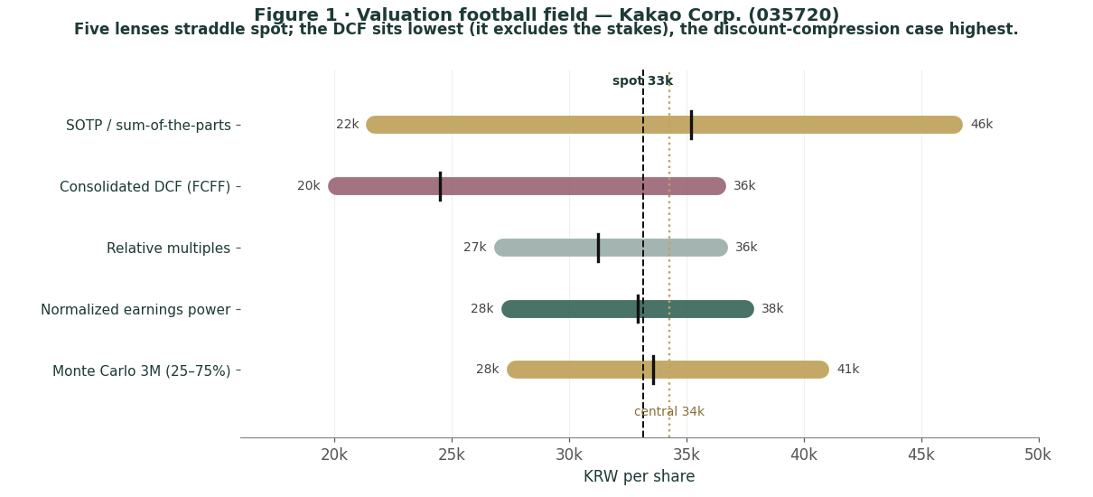
How to read this. The clustering is tight and straddles spot — the signature of a roughly fairly valued stock rather than an obvious bargain or an obvious short. The dispersion is driven almost entirely by one input, the holding-company discount: at the market's ~36% the stock is fair; at a normalised ~22% it is materially undervalued; at a widened ~48% it is expensive. None of this forecasts direction — the next sections describe a weak but mean-reverting price process — it states that, on the fundamentals, the debate is about the discount, not the assets.
1.6 The holding-company assets — a deeper look
The valuation rests on asset-level judgments. For each major holding we set out what it is, where it stands competitively, and how we mark it. One fact recurs: the listed stakes are marked by the market every day, so the genuine judgment calls are the two large unlisted subsidiaries and the core platform.
Asset scorecard
Asset | Stake | Mark basis | Key tension
KakaoBank | 27.2% | market | rate-cycle sensitive; lock-up/overhang
KakaoPay | 44.5% | market | path to sustained profit
Kakao Games | 14.7% | market | stake cut after LY Corp sell-down
SM Entertainment | 20.8% | market | content cyclicality
Kakao Entertainment | 66.0% | KRW 8tn (deal mark) | 2023 PIF/GIC mark was higher
Kakao Mobility | 57.3% | KRW 5.5tn (deal mark) | near-breakeven; regulatory scrutiny
Core platform (Talk Biz) | 100% | ~10x EBITDA | ad-cycle; New-Initiatives losses
KakaoBank and KakaoPay — the listed fintech core
KakaoBank is one of Korea's leading internet-only banks, profitable and scaled; KakaoPay is a major payments and fintech platform still working toward sustained profitability. Together they are the largest slice of the listed stake value (~KRW 5.4tn at market). Because they trade publicly, we take them at market and do not normalise — but their own share prices are rate- and sentiment-sensitive, and a re-rating of either flows straight into Kakao's NAV. Kakao Games (stake cut to ~15% after the June-2026 LY Corp sell-down) and the direct SM Entertainment stake are smaller listed positions carried at market.
Kakao Entertainment — the largest unlisted mark, and the biggest judgment call
Webtoons, music and IP, 66%-owned, is the single largest unlisted asset. A 2023 investment by Saudi Arabia's PIF and Singapore's GIC implied a valuation around KRW 11tn; we haircut that to ~KRW 8tn in the base case to reflect a softer content cycle and the staleness of the mark, with KRW 10tn in the bull and KRW 6tn in the bear. A Kakao Entertainment IPO — long discussed — would crystallise this value and is one of the more powerful upside catalysts in the Monte Carlo.
Kakao Mobility — scaling, near-breakeven, scrutinised
Ride-hailing and broader mobility, 57%-owned, marked at ~KRW 5.5tn EV on 2025 transaction reference points. It is approaching profitability but operates under regulatory scrutiny over commission practices. Like Kakao Entertainment, a listing or stake sale would crystallise the mark.
The core platform — small in value, large in importance
KakaoTalk's Talk Biz (advertising and commerce) carries a 30%-plus operating margin and is the profit engine; Daum and the AI effort (Kanana) sit alongside, with the loss-making New Initiatives (cloud, AI, healthcare) a drag we net against. We mark the whole core at ~KRW 7tn on roughly 10x EBITDA. It is only a fraction of gross NAV, but it is the part that monetises AI and carries the advertising cycle — the operational story even as the stakes carry the value.
1.7 The holding-company discount — the crux of the valuation
Because most of Kakao's value sits in stakes, the entire valuation reduces to one question on which reasonable people disagree: what discount to gross NAV is appropriate?
Why holdcos trade at a discount. Markets routinely pay less than the sum of the parts for a holding company — for double taxation on eventual disposals, for the cost of the holdco overhead, for the risk that capital is allocated to the controlling shareholder's preferences rather than minorities', and for the simple illiquidity and opacity of unlisted marks. For Korean conglomerates the discount has historically been wide, part of the broader "Korea discount". Kakao has carried an additional, company-specific overhang from the founder's legal jeopardy and from regulatory scrutiny of its platforms.
Why it might narrow. Three forces argue for some compression. The founder's acquittal in October 2025 removed the tail risk of a forced bank divestiture and a leadership vacuum. Korea's value-up programme — directors' fiduciary duty to all shareholders, mandatory cancellation of repurchased treasury shares, stronger board independence — pressures exactly the governance discount holdcos suffer. And a crystallisation event, an IPO or sale of Kakao Entertainment or Kakao Mobility, would convert an opaque private mark into observable cash and narrow the discount mechanically.
What the price implies. At KRW 33,150 the market prices a ~36% discount to our gross NAV. Our base case applies 32% — a modest normalisation, not a heroic one — and lands ~6% above spot. To reach the bull case at KRW 46,401 the discount must compress to ~22%, roughly the tighter end of the historical range and consistent with a successful crystallisation or value-up re-rating. To justify a bearish view you must believe the discount stays at ~48% — that the assets are stale and the governance discount permanent. That is the debate, stated plainly: not what Kakao owns, but how much of it the market will ever credit.
1.8 Korea — governance, the value-up re-rating, the founder, and the won
A valuation of Kakao that ignores Korea is incomplete, because four Korea-specific forces — the historical "Korea discount", a sweeping governance reform now under way, the founder's legal resolution, and the won — bear directly on the discount the shares deserve.
The Korea discount and the value-up reform. Korean equities have long traded below global peers, rooted in family-controlled conglomerate structures with cross-shareholdings, modest shareholder returns and minority-shareholder conflict. Since 2024 Korea has pursued a Japan-style "Corporate Value-Up" programme that gained real legal teeth in 2025-26: directors' fiduciary duty to all shareholders, mandatory cancellation of repurchased treasury shares within a year, stronger board independence, and dividend-tax reform. The KOSPI has re-rated sharply on the agenda. For a holding company like Kakao the most relevant lever is treasury-share cancellation and clearer capital-return discipline, both of which attack the governance component of the holdco discount.
The founder's acquittal — overhang removed. In October 2025 Kim Beom-su was acquitted of the stock-manipulation charges tied to the 2023 SM Entertainment acquisition. That outcome removed two specific tail risks that had weighed on the shares: a possible forced divestiture of KakaoBank (a financial-holding-company ownership question that turned on the founder's conviction) and a leadership vacuum at the top of the group. Its removal is part of why our base discount is tighter than the market's.
The won is a second-order factor. Kakao is a domestic-revenue business, so USD/KRW translation matters far less than it does for an exporter; it enters the Monte Carlo only as a small factor via sentiment and the value of any overseas content revenue. The dominant Korea factor for Kakao is governance and the discount, not the currency.
1.9 DCF sensitivity — how much the cross-check moves
The consolidated DCF lands at KRW 24,517. The grid shows how the per-share figure moves with the discount rate and terminal growth. Across the plausible space the DCF stays well below both spot and the SOTP — because it excludes the stakes, no reasonable WACC/g combination closes the gap, which is exactly the point of the cross-check.
WACC \ g | 2.0% | 2.5% | 3.0% | 3.5% | 4.0%
8.5% | 26,900 | 28,700 | 30,800 | 33,300 | 36,300
9.0% | 24,900 | 26,400 | 28,100 | 30,100 | 32,500
9.5% | 23,100 | 24,400 | 25,800 | 27,500 | 29,400
10.0% | 21,500 | 22,600 | 23,800 | 25,200 | 26,800
10.5% | 20,100 | 21,000 | 22,000 | 23,200 | 24,500
Reading the grid. Only the most generous corner (low discount rate, high growth) approaches the lower edge of the relative/normalized lenses, and the base cell (WACC 9.5%, g 3.0%) sits at ~KRW 25,800. The operating cash-flow lens cannot reach spot on its own — you have to add the stakes, which is what the SOTP does. The DCF's role is to quantify how much of the price is asset value versus operating value: most of it.
2 Technical and price structure
Technicals describe the price, not the value. They matter here for one reason: a stock at multi-year lows, below every moving average and oversold, is as capable of a sharp mean-reverting bounce as of further drift lower. The structure is a sustained, extended downtrend — the mirror image of a melt-up.
Indicator | Reading | Interpretation
Spot vs 52-week range | 33,150 / 32,250 – 71,600 | at the 52-week low
Off the 52-week high | KRW 33,150 vs 71,600 | -54% from the high
SMA 20 / 50 / 200 | 38,888 / 42,949 / 54,261 | falling stack; price below all (bearish)
RSI (14) | ~27 | oversold
ATR (14) | 1,968 (5.9%) | elevated daily range
Realized vol 60d / 252d | ~54% / ~51% | high and persistent
Skew / excess kurtosis (252d) | -0.30 / +4.5 | mild left skew, fat tails
Figure 2 · Price with moving-average stack — a falling 20/50/200 structure; spot below the 200-day at the 52-week low.
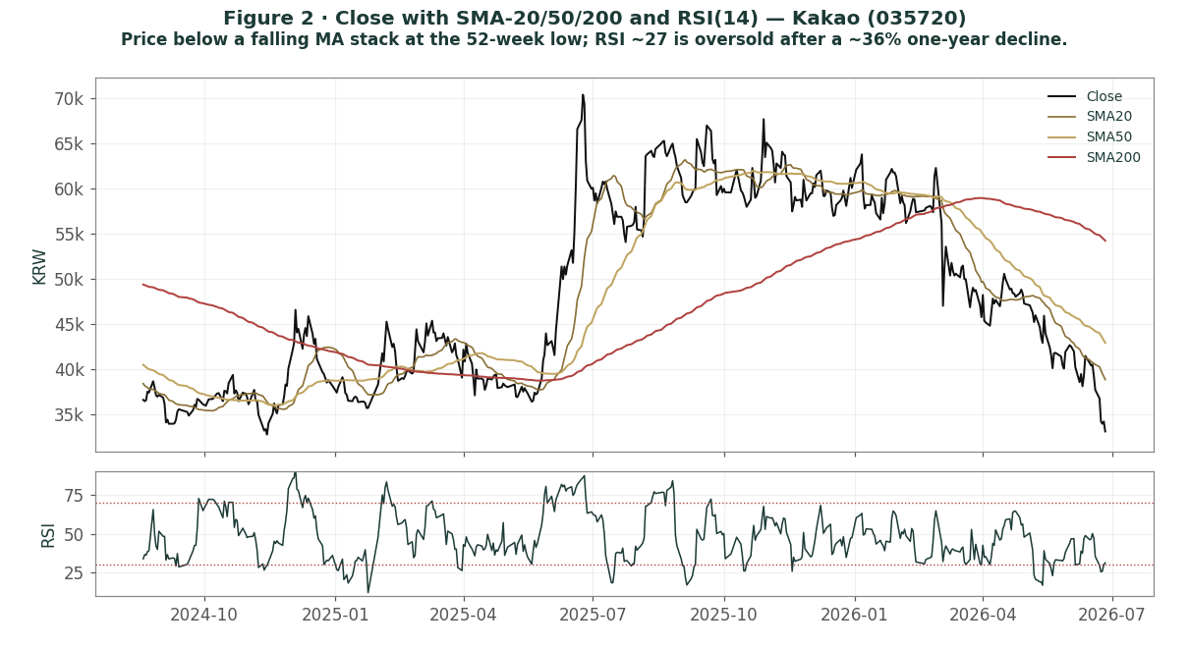
The honest technical read. The trend is down and the moving averages are stacked bearishly, with price beneath all three; RSI near 27 is oversold, which often precedes a bounce but is not, on its own, a reversal signal. Realized volatility around 51% and fat tails mean moves in either direction can be violent. Nearest meaningful resistance is the falling 20-day around KRW 38,900, then the 50-day near KRW 42,900. The technical and fundamental pictures are consistent: a beaten-down asset trading at a wide discount, where the fundamental question is whether that discount is too wide.
3 Monte Carlo — a probabilistic price map
This models the price over the next three months, not value. We simulate 50,000 paths (seed 42) from a 16-factor structure — seven continuous drivers and nine discrete event risks — calibrated to Kakao's own realized volatility. It answers "where could the price plausibly be, and with what probability", not "what is Kakao worth". The paths diffuse from spot as a near-term price process and deliberately do not embed the fundamental NAV — the value gap of Section 1 is kept out of the drift, so the fundamental and probabilistic lenses stay independent.
The 16 factors. Continuous (7): KakaoTalk advertising & commerce trajectory, AI monetization (OpenAI / Kanana) ramp, KOSPI / foreign-flows beta, USD/KRW translation, the narrowing of New-Initiatives losses, ad-market / consumer-spend softness, and the content/games trajectory. Discrete events (9): AI traction / ChatGPT-in-Kakao monetization (p~0.35, +7%), holdco-discount compression / value-up via treasury cancellation (p~0.35, +5%), stake crystallization — a Kakao Entertainment or Mobility sale/IPO (p~0.30, +5%), a KakaoBank/KakaoPay re-rating (p~0.30, +3%), a two-sided quarterly ad/commerce surprise (p~0.40, ±), an ad-market disappointment (p~0.35, −6%), regulatory/antitrust action under the platform law (p~0.30, −5%), the founder-acquittal appeal reviving bank-divestiture risk (p~0.15, −8%), and a broad KOSPI/EM risk-off (p~0.25, −6%).
Net three-month drift is roughly flat (~+1%), total three-month volatility ~28% (~57% annualised), and the distribution is mildly right-skewed — the positive catalyst set (discount compression, crystallization, AI) modestly outweighs the negative in expectation, while the downside events are sharper per event. The drift is built from these forward factors rather than from raw trailing momentum: on a literal extrapolation of the past year's ~36% decline the median would sit far lower, but we do not assume the downtrend simply continues, and carry the realized momentum only as one editable factor among sixteen.
Horizon | 5% | 25% | Median | 75% | 95%
T + 20 sessions (~1m) | 25,404 | 29,799 | 33,294 | 37,199 | 43,634
T + 60 sessions (~3m) | 21,022 | 27,714 | 33,584 | 40,697 | 53,651
Figure 3 · Three-month fan chart — percentile cone of simulated paths from spot; median ~flat, a very wide band.
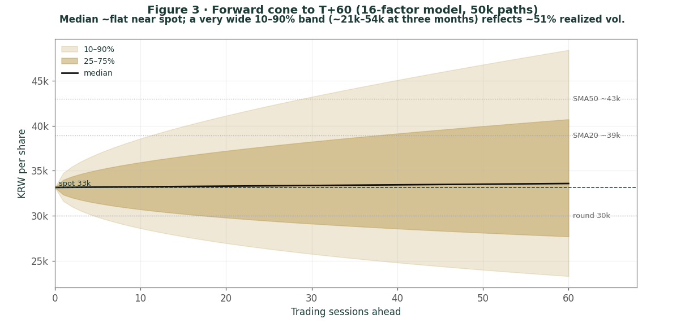
Figure 4 · Distribution of the price at T+20 (~1 month) — roughly two-sided around spot.
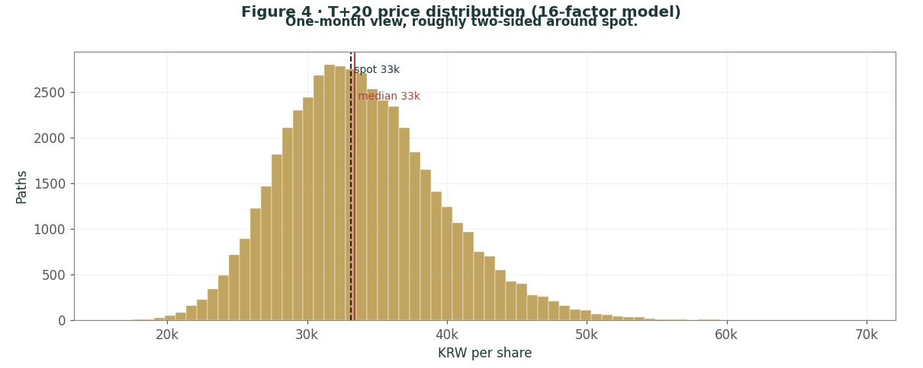
Figure 5 · Distribution of the price at T+60 (~3 months); note the mild right skew and fat tails.
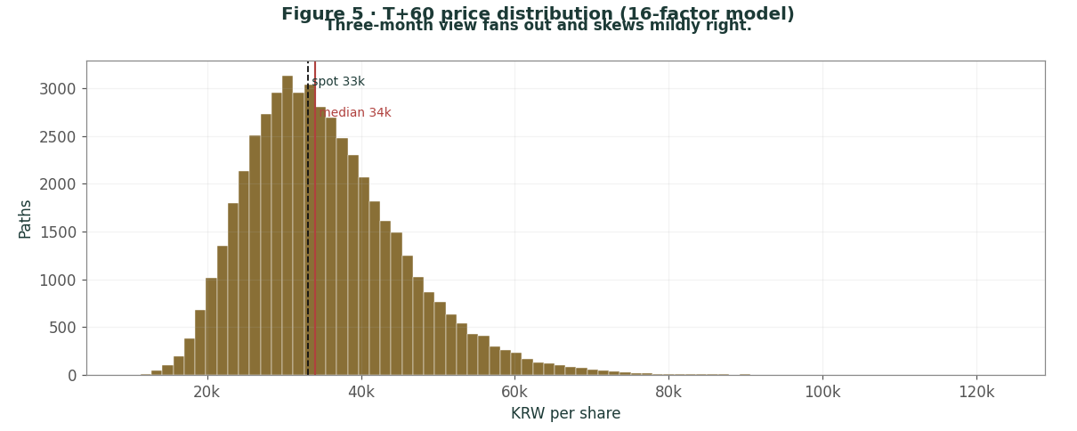
Touch probabilities — chance the price reaches a level at any point in the window
Level | by T+20 | by T+60 | Note
KRW 37,000 | 51% | 71% | toward the 20-day
KRW 40,000 | 26% | 52% | toward the 50-day
KRW 44,000 | 9% | 33% | above the 50-day
KRW 32,000 | 83% | 90% | first support test
KRW 28,000 | 30% | 54% | deeper pullback
KRW 24,000 | 5% | 24% | toward the DCF / bear zone
Figure 6 · Upside and downside touch ladders over the three-month window.
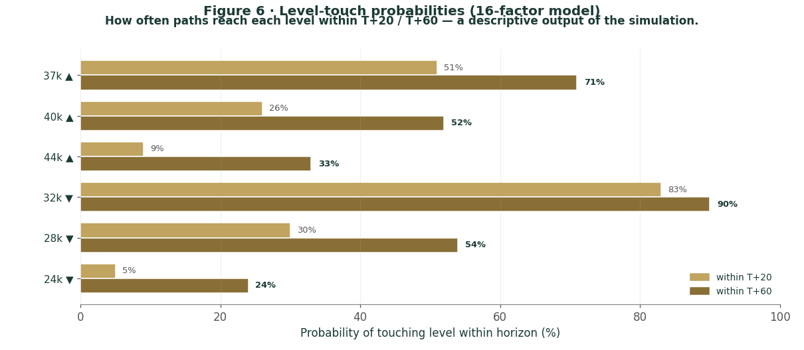
What the map says. Over three months a move up to the falling 20-day around KRW 37,000 is more likely than not (~71%), while a push above the 50-day toward KRW 44,000 is a lower-probability ~33% — an oversold bounce is plausible but the falling averages sit overhead. On the downside, a retest of support near KRW 32,000 is highly likely (~90%) and a deeper slide toward KRW 28,000 is a non-trivial ~54%. Crucially, this near-term map and the fundamental finding are not in conflict: the price can wander within a wide band over three months while value sits a few percent above price. The Monte Carlo describes the former; Section 1 describes the latter.
4 Comparison of the lenses, and a verdict
Lens | What it measures | Output | vs spot
SOTP base (primary) | gross NAV less 32% discount | KRW 35,216 | +6%
SOTP bull | discount compresses to 22% | KRW 46,401 | +40%
Consolidated DCF | owned operating cash flow only | KRW 24,517 | -26%
Relative multiples | vs Naver / sector | KRW 31,223 | -6%
Normalized earnings | through-cycle profit | KRW 32,948 | -1%
Weighted central | triangulated estimate | KRW 34,258 | +3%
Monte Carlo T+60 median | likely 3-month price | 33,584 | +1%
Verdict — roughly fairly valued; the whole case is a holding-company-discount bet. The fundamental lenses agree to an unusual degree that KRW 33,150 is close to fair: the central estimate is KRW 34,258 (+3%), and the lenses straddle spot. The cash-flow cross-check, which deliberately ignores the stakes, is the most conservative and shows how much of the value is asset rather than operating cash flow. The technical trend is weak — the shares sit at their 52-week low, oversold below falling averages — and the three-month price map is wide and roughly centred on spot. A buyer at this level is not buying an obvious discount to value, nor an obvious overvaluation, but is underwriting one proposition: that the ~36% holding-company discount narrows toward its historical range, helped by the founder's acquittal, the value-up agenda, AI monetization in Talk Biz, and the eventual crystallisation of the unlisted stakes. If the discount compresses, the bull case at KRW 46,401 is reachable; if it widens or the private marks prove stale, the downside to the bear case is large. This study expresses a valuation, not a trade, and certainly not advice.
5 Catalysts to watch
Stake crystallization — IPO or sale (↑, high impact). A listing or sale of Kakao Entertainment or Kakao Mobility would convert an opaque private mark into observable value and is the single most powerful lever on the holding-company discount.
Holdco-discount / value-up (↑). Treasury-share cancellation, a clearer capital-return policy, or governance steps in the spirit of Korea's reforms would attack the discount directly.
AI monetization (↑). Evidence that the OpenAI ChatGPT-in-KakaoTalk integration and the in-house Kanana models lift Talk Biz advertising and commerce would re-rate the core platform and the growth narrative.
Quarterly advertising & commerce (↑/↓). The direction of Talk Biz ad and commerce revenue is the clearest read on the operating engine and the consumer cycle.
KakaoBank / KakaoPay re-rating (↑/↓). Because the listed fintech stakes are the largest slice of NAV, a move in either flows straight into Kakao's value.
Regulatory / appeal (↓). Platform-law antitrust action, commission-practice scrutiny at Kakao Mobility, or a successful prosecution appeal of the founder's acquittal are the principal near-term downside catalysts.
6 Reading the probability zones
Combining the fundamental anchors with the three-month price map gives a set of zones — descriptive, not directive.
Zone | Range (KRW) | What it would mean
Discount compression | 44,000 – 53,000+ | discount narrows toward ~22%; crystallisation/value-up
Re-rating underway | 37,000 – 44,000 | discount drifts toward base; oversold bounce
Central / fair | 33,000 – 37,000 | where spot and the SOTP base sit
Discount persists | 28,000 – 33,000 | wide discount holds; ad-market soft
Wide-discount / bear | < 25,000 | discount widens; DCF / stale-marks zone
7 Caveats and what would change our mind
The unlisted marks are judgments, and stale. The Kakao Entertainment (~KRW 8tn) and Mobility (~KRW 5.5tn) marks rest on dated transactions; a crystallisation event could reset them materially in either direction. This is the single biggest source of error in the SOTP.
The discount is the swing factor, and we may have it wrong. A base discount of 32% is a modest normalisation from the market's ~36%. If the governance discount proves permanent, fair value migrates toward the bear case; if crystallisation and value-up land, toward the bull. Reasonable analysts will choose differently; the Excel companion lets you change the discount and every mark.
Listed stakes move daily. KakaoBank, KakaoPay, Kakao Games and SM are marked to market; a sharp move in any — particularly the two fintech names — changes the NAV between the date of this study and any later reading.
The Monte Carlo is a price model, not a forecast. It encodes our probability estimates for events that have not happened. The factor probabilities are inputs, not facts, and the model says nothing about value.
RSI / momentum reminder. RSI ~27 is oversold, which often precedes a bounce — but a stock in a sustained downtrend with realized vol near 51% can keep falling. Do not mistake "oversold" for a margin of safety; the margin of safety, if any, is in the discount to NAV, not the indicator.
Appendix A Financial statements (KRW tn)
Actuals (FY2023-FY2025) are Kakao's consolidated disclosure under K-IFRS (revenue and operating profit per Kakao IR; balance-sheet totals per the latest filings). FY2022-2023 figures are shown on Kakao's restated basis (after the accounting-policy change and subsidiary streamlining), which is why 2025 — at KRW 8.10tn — was the first year above KRW 8tn. Forecast columns (2026e-2030e) are the preparer's illustrative operating build that ties to the Excel companion; they are deliberately below management's 2026 guidance of >10% revenue growth and a ~10% operating margin, which the later years approach. Sub-lines of the balance sheet are approximate allocations to the reported totals. The holding-company stake values sit largely outside these consolidated lines.
A.1 Consolidated income statement (KRW tn)
Income statement | 2023a | 2024a | 2025a | 2026e | 2027e | 2028e | 2029e | 2030e
Platform revenue | 3.50 | 3.90 | 4.32 | 4.75 | 5.25 | 5.70 | 6.15 | 6.60
Content revenue | 4.06 | 3.97 | 3.78 | 3.65 | 3.65 | 3.70 | 3.75 | 3.80
Total revenue | 7.56 | 7.87 | 8.10 | 8.40 | 8.90 | 9.40 | 9.90 | 10.40
growth YoY | — | +4% | +3% | +4% | +6% | +6% | +5% | +5%
(Operating expenses) | (7.06) | (7.38) | (7.37) | (7.60) | (7.98) | (8.35) | (8.72) | (9.10)
Operating profit | 0.50 | 0.49 | 0.73 | 0.80 | 0.92 | 1.05 | 1.18 | 1.30
OP margin | 6.6% | 6.3% | 9.0% | 9.5% | 10.3% | 11.2% | 11.9% | 12.5%
Net non-operating & associates | (0.40) | (0.65) | (0.05) | 0.00 | 0.02 | 0.03 | 0.04 | 0.05
Pre-tax profit/(loss) | 0.10 | (0.16) | 0.68 | 0.80 | 0.94 | 1.08 | 1.22 | 1.35
Income tax & minority interests | (0.05) | 0.00 | (0.15) | (0.22) | (0.24) | (0.26) | (0.27) | (0.27)
Net profit/(loss) attributable | 0.05 | (0.16) | 0.53 | 0.58 | 0.70 | 0.82 | 0.95 | 1.08
net margin | 0.7% | (2.1%) | 6.5% | 6.9% | 7.9% | 8.7% | 9.6% | 10.4%
EPS (KRW) | 113 | (363) | 1,203 | 1,316 | 1,588 | 1,861 | 2,156 | 2,451
Note. Platform (Talk Biz, Portal, Mobility/Pay/other) is growing and now exceeds Content (Games, Story, Music, Media), which has declined as Games revenue fell. FY2024 was a net loss of ~KRW 0.16tn on large goodwill/intangible impairments; FY2025 returned to a record net profit of KRW 0.53tn. Reported earnings capture little of the listed-stake value, which is why the holding-company SOTP — not the income statement — is the primary lens.
A.2 Consolidated balance sheet (KRW tn)
Balance sheet | 2023a | 2024a | 2025a | 2026e | 2027e | 2028e | 2029e | 2030e
Cash & cash equivalents | 5.8 | 6.5 | 6.8 | 7.2 | 7.7 | 8.2 | 8.8 | 9.5
ST financial instruments & other | 2.3 | 2.4 | 2.5 | 2.5 | 2.5 | 2.5 | 2.5 | 2.5
Trade & other receivables | 1.4 | 1.5 | 1.5 | 1.6 | 1.7 | 1.8 | 1.9 | 2.0
Total current assets | 9.5 | 10.4 | 10.8 | 11.3 | 11.9 | 12.5 | 13.2 | 14.0
Property, plant & equipment | 2.8 | 3.0 | 3.2 | 3.4 | 3.6 | 3.8 | 4.0 | 4.2
Goodwill & intangible assets | 8.0 | 7.7 | 7.5 | 7.5 | 7.5 | 7.5 | 7.5 | 7.5
Investments in associates | 3.4 | 3.5 | 3.5 | 3.6 | 3.7 | 3.8 | 3.9 | 4.0
Other non-current assets | 2.8 | 2.4 | 2.8 | 2.8 | 2.8 | 2.8 | 2.8 | 2.8
Total non-current assets | 17.0 | 16.6 | 17.0 | 17.3 | 17.6 | 17.9 | 18.2 | 18.5
Total assets | 26.5 | 27.0 | 27.8 | 28.6 | 29.5 | 30.4 | 31.4 | 32.5
Trade & other payables | 2.0 | 2.1 | 2.2 | 2.3 | 2.4 | 2.5 | 2.6 | 2.7
Other current liabilities | 2.8 | 3.0 | 3.3 | 3.3 | 3.3 | 3.3 | 3.3 | 3.3
Total current liabilities | 4.8 | 5.1 | 5.5 | 5.6 | 5.7 | 5.8 | 5.9 | 6.0
Borrowings, bonds & leases | 2.5 | 2.7 | 2.9 | 2.9 | 2.9 | 2.9 | 2.9 | 2.9
Other non-current liabilities | 0.5 | 0.5 | 0.4 | 0.4 | 0.4 | 0.4 | 0.4 | 0.4
Total liabilities | 7.8 | 8.3 | 8.8 | 8.9 | 9.0 | 9.1 | 9.2 | 9.3
Equity attributable to owners | 11.0 | 10.3 | 10.5 | 11.0 | 11.6 | 12.3 | 13.1 | 14.0
Non-controlling interests | 7.7 | 8.4 | 8.5 | 8.7 | 8.9 | 9.0 | 9.1 | 9.2
Total equity | 18.7 | 18.7 | 19.0 | 19.7 | 20.5 | 21.3 | 22.2 | 23.2
Total liabilities & equity | 26.5 | 27.0 | 27.8 | 28.6 | 29.5 | 30.4 | 31.4 | 32.5
BVPS — attributable (KRW) | 24,960 | 23,370 | 23,830 | 24,960 | 26,320 | 27,910 | 29,720 | 31,770
Net cash (cash − debt) | 3.3 | 3.8 | 3.9 | 4.3 | 4.8 | 5.3 | 5.9 | 6.6
Note. Totals are anchored to Kakao's reported balance sheet (total assets ~KRW 27.8tn, total equity ~KRW 19.0tn, cash ~KRW 6.8tn, debt ~KRW 2.9tn at end-2025); sub-lines are approximate allocations. Large non-controlling interests (~KRW 8.5tn) reflect the consolidated stakes in KakaoPay, Kakao Entertainment, Mobility and Games; equity attributable to owners is ~KRW 10.5tn, a book value of ~KRW 23,800/share (P/B ~1.4x). Book value understates the holding-company NAV because the listed stakes carry little book value relative to market — which is why the discount-to-NAV, not P/B, is the more informative gauge.
A.3 Consolidated cash flow (simplified)
Cash flow | 2023a | 2024a | 2025a | 2026e | 2027e | 2028e | 2029e | 2030e
Operating cash flow | 0.92 | 0.95 | 1.10 | 1.18 | 1.27 | 1.40 | 1.53 | 1.67
Capex (investing) | -0.58 | -0.60 | -0.55 | -0.80 | -0.84 | -0.88 | -0.92 | -0.96
Free cash flow | 0.34 | 0.35 | 0.55 | 0.38 | 0.43 | 0.52 | 0.61 | 0.71
The point of A.3 for the valuation. Kakao generates solid operating cash flow but reinvests heavily in content, AI and infrastructure, so free cash flow is modest. That gap, together with the fact that the consolidated lines exclude the equity-method stakes, is why the DCF in 1.2 lands far below the asset-based SOTP.
Appendix B Step 0 — calibration backtest
Before publishing any probabilistic price map we test the engine against Kakao's own five-year history: does a lognormal three-month price model, fed with realized volatility, produce calibrated intervals?
Result. Using non-overlapping three-month windows over the post-split history (13 windows) and a volatility uplift of 1.15x on the trailing realized volatility, the probability-integral-transform (PIT) mean is ~0.47, the 50/80/90% bands cover at roughly 62/77/85%, and the Kolmogorov-Smirnov test does not reject calibration (p ≈ 0.63). The window count is small, so the coverage figures are noisy, but the engine shows no strong directional bias and is not materially mis-calibrated. Unlike a strongly trending name, Kakao's history does not exhibit a large secular drift to correct for; the engine passes without a drift override. We therefore build the Monte Carlo drift from forward factors rather than baking in the recent decline, and carry realized momentum only as one editable factor.
Figure B1 · PIT histogram — close to uniform after the 1.15x volatility uplift; no strong directional bias.
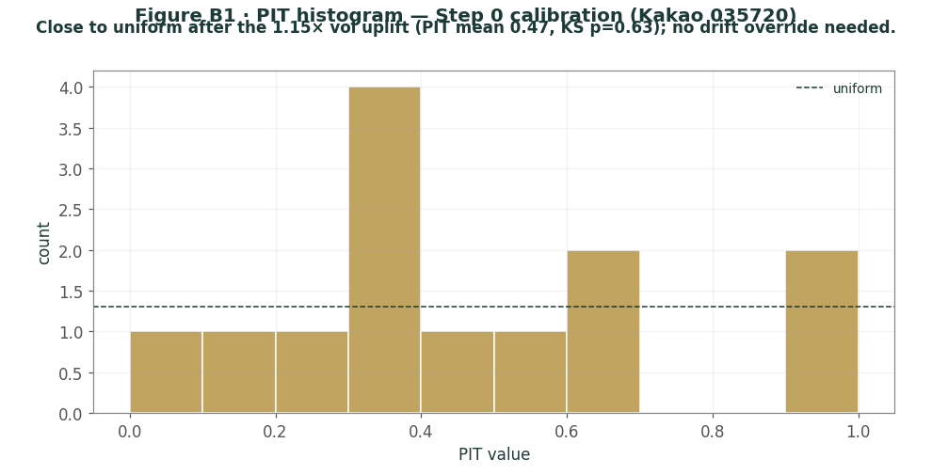
Figure B2 · Interval coverage — stated vs realized band coverage over the post-split history.
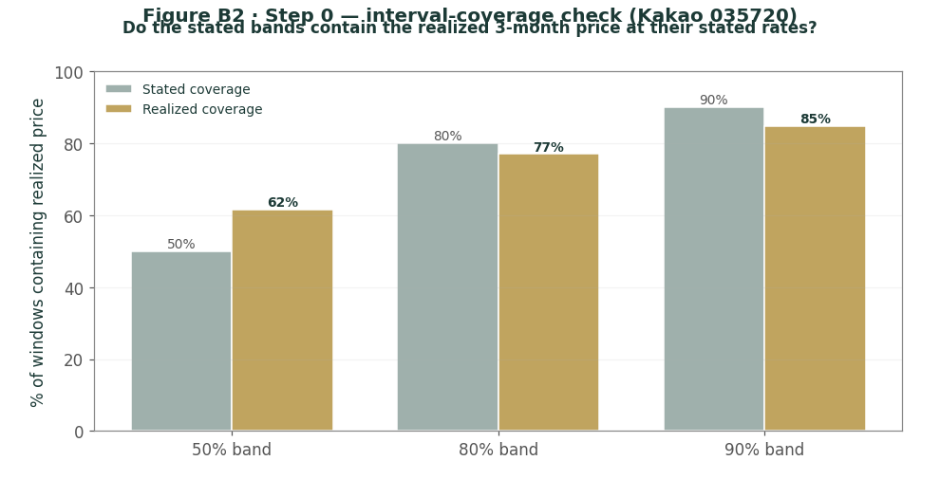
Appendix C Peer set, sector structure, and risks
C.1 The competitive map
Arena | Leader | Kakao | Note
Messaging (Korea) | KakaoTalk | #1 | near-universal reach
Search / portal | Naver | Daum #2 | Naver dominant in search
Internet banking | KakaoBank / Toss | top tier | KakaoBank listed, profitable
Fintech / payments | KakaoPay / Toss / Naver Pay | top tier | path to profit
Webtoons / IP | Kakao / Naver | co-leader | global content push
Mobility | Kakao Mobility | #1 | regulatory scrutiny
AI (Korea) | Naver / Kakao | challenger | OpenAI tie-up + Kanana
C.2 Principal risks
Holding-company discount — the dominant factor; a persistently wide or widening discount keeps the shares below NAV regardless of asset value.
Stale or impaired private marks — the Kakao Entertainment and Mobility valuations rest on dated transactions and could be reset down.
Ad-market and consumer cycle — Talk Biz advertising and commerce, the operating engine, is sensitive to domestic consumer spending.
Regulatory / antitrust — platform-law action and commission-practice scrutiny (notably at Kakao Mobility) can pressure both the core and the subsidiaries.
Listed-stake volatility — KakaoBank, KakaoPay, Kakao Games and SM are marked to market; their moves change the NAV directly.
Governance / founder — the value-up agenda cuts in Kakao's favour, but a successful appeal of the founder's acquittal would revive the bank-divestiture overhang.
About this series
Testahil publishes independent, educational valuation studies. Each is an attempt to reason transparently about what a security is worth, with every assumption shown and a companion model so readers can disagree productively. The house style is distributions, not tips: we describe ranges and probabilities, not targets, and we do not tell anyone what to do. Studies are framed as educational analysis, the preparer is not licensed by any securities regulator, and holdings are disclosed.
Disclosure & Disclaimer
Not investment advice. This document is educational and informational only. It is not, and must not be relied upon as, investment, financial, legal, accounting or tax advice, nor an offer, solicitation or recommendation to buy, sell or hold any security. It contains no price target and no rating.
No licence; no advisory relationship. The preparer is not registered or licensed with any securities or financial regulator in any jurisdiction, holds no brokerage or investment-advisory authorisation, and is not acting as your adviser or fiduciary. Nothing here is personalised to your circumstances.
Holdings disclosure. The preparer may hold, and may in the future take or dispose of, a position in the security discussed in this report, and may transact at any time without notice. This is a potential conflict of interest you should weigh.
Sources & accuracy. Reported financial and operating figures are drawn from Kakao's public disclosure and other public sources believed reliable but not independently verified; they may contain errors or be superseded. Forward-looking inputs — the holding-company discount, the unlisted marks, projections, multiples, the DCF and Monte-Carlo factor probabilities — are the preparer's own judgments and are inherently uncertain.
Forward-looking statements. Any statements about the future are estimates subject to risks and uncertainties; actual results may differ materially. The Monte Carlo models price, not value, and encodes subjective probabilities for events that have not occurred.
No reliance; your responsibility. Do your own research and consult a licensed professional before making any decision. You are solely responsible for your investment decisions and their outcomes. To the maximum extent permitted by law, the preparer accepts no liability for any loss arising from use of this document.
Currency & figures. All figures are in Korean won (KRW) unless stated; tn denotes trillion. Rounding may cause totals to differ slightly. Spot price and market data are as of 26 June 2026 and change continuously.
TESTAHIL · Independent Valuation Study · Educational Analysis · Kakao Corp. (KRX: 035720) · edition 28-06-2026 · reporting currency KRW

