Testahil · Independent Valuation Study — Educational Analysis Not investment advice

Independent Valuation Study — Educational Analysis
Lecico Egypt (S.A.E.) (EGX: LCSW)
Fundamental analysis · Technical analysis · Monte Carlo simulation — one integrated read
Anchor: EGP 29.45 (6 Jul 2026 close) · 80.0m shares · market cap ~EGP 2,356m (~EGP 2.36bn) · one of the Middle East's largest sanitary-ware and tile makers, ~55% of revenue exported (majority of sanitary-ware volume) yet reported in Egyptian pounds · prices and probabilities computed 6 Jul 2026 from the attached daily history · primary lens: going-concern free-cash-flow-to-firm (FCFF) DCF, triangulated with four other lenses · the swing factors are the EGP/USD path and whether booked earnings convert to cash.
READ FIRST — what this document is, and is not. This study is a valuation exercise and an expression of personal analytical opinion, published free of charge for educational purposes: it shows how one analyst applies fundamental, technical and probabilistic methods to a listed company, and invites scrutiny of that methodology. It is NOT investment advice, NOT a recommendation or solicitation to buy, sell or hold any security, and NOT directed at the circumstances of any reader. The preparer is not licensed by any securities regulator in any jurisdiction (including Egypt's Financial Regulatory Authority), holds no brokerage or advisory authorisation, provides no financial consultancy, manages no money, and accepts no fees, funds or clients. See the Disclosure & Disclaimer at the end. All values are model outputs presented as ranges and distributions because no single number should be relied on. Reported financials are the company's own disclosure (FY2025 results, 28 February 2026; Q1-2026 filing); forward-looking inputs — the DCF, the multiples, the marks and the Monte-Carlo factor probabilities — are the preparer's judgments and are flagged throughout. Consult a licensed financial advisor before any investment decision.

Headline
The model's read: modestly-to-meaningfully undervalued on fundamentals, with the upside resting on the pound resuming a gradual slide and on the company converting profit into cash. At EGP 29.45 the shares sit about 26% below our weighted central estimate of EGP 37. The five fundamental lenses cluster tightly — a going-concern DCF at 37, relative multiples at 39, a normalized-earnings read at 39, a conservative owner-earnings read at 32, and an asset/reproduction floor at 36 — so even the most cautious lens sits above spot. The whole answer turns on two linked questions. First, the Egyptian pound: Lecico exports the majority of its highest-margin product (sanitary ware) but reports in pounds, so the pound's ~8% strengthening since end-2024 (from ~50.8 to ~47 per dollar), combined with domestic energy-cost hikes, cut the 2025 EBIT margin to a trough 9.5% from 17.3% a year earlier. Second, cash conversion: 2025 operating cash flow was negative (EGP −196m) as a EGP 706m working-capital absorption swallowed the profit, and the company pays no dividend. Technically the tape is the opposite of the fundamentals' caution — the stock trades above all four major moving averages, RSI is in the low-60s and the MACD histogram is positive, a firm short-term uptrend. Over three months the Monte Carlo places the 5th–95th percentile band at roughly EGP 22–44, with a median modestly above spot at EGP 31.

Valuation summary — every read at a glance
One table for the four reads that follow — what the business is worth (fundamental), what the tape is doing (technical), where price could travel over three months (Monte Carlo), and how three independent expert methods land. Every row is developed in the sections and appendices below.
Lens / read | What it measures | Output | Takeaway
FUNDAMENTAL — what the business is worth (the anchor)

FCFF DCF (primary) | Discounted 5-yr cash flows | EGP 37 | +26% vs spot
Relative multiples | Normalized EV/EBITDA + P/E | EGP 39 | +32%
Normalized earnings | Mid-cycle EPS × justified P/E | EGP 39 | +32%
FCFE / owner-earnings | Conservative cash capacity | EGP 32 | +9% · the floor
Asset / reproduction | Realizable net-asset value | EGP 36 | +22%
Weighted central | Blend 30 / 20 / 25 / 10 / 15 | EGP 37 | +26% vs 29.45
TECHNICAL — what the tape is doing (timing, not value)

Trend & momentum | Price vs the 20/50/100/200-day averages | Above all four | Firm uptrend
Momentum / range | RSI · MACD · 52-week range | RSI 61 · MACD +0.12 hist · EGP 22.4–29.7 | Constructive
MONTE CARLO — where price could go in 3 months (paths from spot)

T+20 sessions | 50,000 paths · 16 factors | p5 24.3 · p50 30.0 · p95 37.0 | Median ≈ spot
T+60 sessions | same engine, longer horizon | p5 21.7 · p50 31.0 · p95 44.4 | Wide, right-skewed
EXPERT PANEL — three independent methods (Appendix D)

Expert 1 — normalized earnings power | Mid-cycle EBIT × multiple | EGP 40 | Most bullish
Expert 2 — accountant (RNAV + cash quality) | Realizable assets, cash conversion | EGP 31 | Most conservative
Expert 3 — cash returns (DCF + ROIC) | Return on capital vs ~21% WACC | EGP 35 | The middle
Panel range | Spread = the cash-conversion question | EGP 31–40 | Centres ~EGP 35

Bottom line. Every fundamental read points the same way on value and disagrees only on magnitude: the central sits near EGP 37 — about 26% above the EGP 29.45 spot — and the three experts span EGP 31–40. The technical tape is, for once, in agreement in direction — a firm short-term uptrend — while the three-month distribution centres modestly above spot at EGP 31 with a wide right tail. The case is a cyclical margin trough (2025) that the market has priced as if it were the new normal, with two genuine risks holding the shares down: the pound's recent strength against a majority-export cost base, and a working-capital trap that has turned reported profit into negative cash. We publish the distribution, not a target.

Company overview — Lecico Egypt at a glance
Item | Value
Listed entity | Lecico Egypt (S.A.E.) (EGX: LCSW; also LSE: LECI)
What it makes | Sanitary ware (64% of revenue) · ceramic & porcelain tiles (32%) · brassware (4%)
Founded / base | 1959 · Alexandria, Egypt; plants in Egypt (and legacy Lebanon operations being wound down)
Spot / date | EGP 29.45 · 6 Jul 2026 close
Shares · market cap | 80.0m · EGP 2,356m (~EGP 2.36bn)
Net debt (Dec-2025) | EGP 1,270m reported (bank facilities + current loans − cash); ~EGP 1,660m incl. leases + LT notes
FY2025 revenue / EBITDA margin | EGP 7,803.7m (+17.4% YoY) · 12.6% (a trough year, down from 20.0%)
Export share | ~55% of group revenue; ~81% of sanitary-ware volume
52-week range | EGP 22.40 – 29.72
Book value / share · P/B | EGP 49.7 · 0.59×
Dividend | None (stand-alone accumulated losses block distribution)

Source: company FY2025 results (28 Feb 2026), Q1-2026 filing, EGX disclosures, exchange data. Values rounded.

1 Fundamental valuation
We value Lecico as a going-concern manufacturer and triangulate five lenses. The primary lens is a free-cash-flow-to-firm (FCFF) DCF, because Lecico is a cash-generating (if presently cash-absorbing) operating business whose worth is the discounted stream it can produce, not the break-up of its parts. A relative-multiple read, a normalized-earnings-power read, a conservative owner-earnings (FCFE) read and an asset/reproduction floor complete the set. The weights and the football field are in §1.5; the swing factors — the pound and cash conversion — are dissected in §1.7, the macro backdrop in §1.8, and the primary-lens sensitivity grid in §1.9. Throughout, we forecast top-down on normalized margins rather than manufacturing volume/price splits the company does not fully disclose; where Lecico does disclose (segment revenue, gross margins and export share), we use the disclosed figures.

1.1 FCFF discounted cash flow — the primary lens
We build a five-year explicit forecast in nominal Egyptian pounds and fade it into a Gordon terminal. Revenue grows 10–13% a year — nominal growth reflecting fading inflation (~14% now) plus modest volume from new export channels — while the EBITDA margin recovers from its 2025 trough of 12.6% toward a mid-cycle ~14.5% as the pound's strength unwinds, energy costs are passed through, and efficiency gains land. The cost of capital is published explicitly (see §1.9 and §3.5-G): a pure-local cost of equity of rf 22% + beta 1.0 × ERP 6% = 28%, blended with a ~15% hard-currency cost of equity on the ~55% export base, giving a blended Ke ~21%; with a small debt benefit this yields a WACC of ~21%. Terminal growth is 11% (nominal EGP, below current inflation).
DCF line (EGP m) | 2026E | 2027E | 2028E | 2029E | 2030E
Revenue | 8,740 | 9,876 | 11,062 | 12,278 | 13,506
EBITDA margin | 11.5% | 12.5% | 13.5% | 14.0% | 14.5%
EBITDA | 1,005 | 1,234 | 1,493 | 1,719 | 1,958
less: D&A | (265) | (300) | (340) | (380) | (420)
EBIT | 740 | 934 | 1,153 | 1,339 | 1,538
NOPAT = EBIT×(1−22.5%) | 574 | 724 | 894 | 1,038 | 1,192
plus: D&A | 265 | 300 | 340 | 380 | 420
less: Capex | (650) | (500) | (480) | (500) | (520)
less: Δ working capital | (250) | (300) | (310) | (320) | (320)
Free cash flow to firm | (61) | 224 | 444 | 598 | 772
Discount factor @ 21% | 0.83 | 0.68 | 0.56 | 0.47 | 0.39
PV of FCFF | (51) | 153 | 250 | 279 | 298

Summing the present values of the explicit years (EGP 930m) and the discounted terminal value (EGP 3,304m, from a terminal FCFF of EGP 772m grown at 11% and capitalised at 21% − 11%) gives an enterprise value of ~EGP 4,234m. Deducting reported net debt of EGP 1,270m leaves equity of ~EGP 2,964m, or EGP 37/share. Two honest warnings travel with this number. First, note that 2026 FCFF is negative — the capex programme (over EGP 650m planned) and the working-capital drag out-run operating cash even as profit recovers; the cash case is back-end-loaded. Second, the terminal value is ~78% of enterprise value (device A-7): this is, in large part, a terminal-growth-versus-discount-rate bet dressed as a five-year model, so §1.9 sensitises it in full rather than burying it.

1.2 Owner-earnings / FCFE — the cash-flow cross-check
Because Lecico pays no dividend (stand-alone accumulated losses block distribution), the usual dividend-discount cross-check is not available; the honest analogue is an owner-earnings capacity read — what the business could distribute once working capital normalises and capex moderates. We take a steady-state owner-earnings capacity of ~EGP 430m (roughly the mid-cycle NOPAT less maintenance capex and normalised working-capital growth), capitalise it at a local-heavy Ke − g of ~13.5%, and then apply a 20% haircut for the near-term negative free cash and the working-capital trap.
Owner-earnings cross-check | Value
Steady-state owner-earnings capacity (EGP m) | 430
Capitalisation rate (Ke − g) | 13.5%
Implied equity value (EGP m) | 3,185
less: haircut for negative near-term FCF / WC trap (20%) | (637)
Equity value (EGP m) | 2,548
Fair value / share (EGP) | ~32

FCFE base ≈ EGP 32 — deliberately the most conservative lens, and the closest to where a cash-focused sceptic anchors. It treats the working-capital absorption as a structural feature until proven otherwise, and it is the number that says "even discounting the cash problem hard, the shares are not expensive."

1.3 Relative multiples
On its own trough numbers Lecico screens cheap on every metric. At spot, market capitalisation of EGP 2,356m plus reported net debt of EGP 1,270m is an enterprise value of ~EGP 3,626m — about 3.7× trailing 2025 EBITDA of EGP 981m, and closer to 3.0× on a normalized ~EGP 1,150m. Trailing earnings put the shares on ~9.7× (2025 EPS EGP 3.05) and ~5–6× on normalized earnings, and the stock trades at just 0.59× book value.
Relative basis | Bear | Base | Bull
Normalized EBITDA (EGP m) | 1,000 | 1,100 | 1,250
EV/EBITDA multiple | 3.5× | 4.0× | 4.75×
Fair value (EGP/share) | 28 | 39 | 52

Relative base ≈ EGP 39. Regional ceramics peers trade richer — RAK Ceramics ~5–6× EV/EBITDA, Saudi Ceramics ~6–8×, Indian names (Kajaria, Cera) at growth multiples of 18–28× — so even a modest 4.0× on Lecico's normalized EBITDA, an EGX-appropriate discount to those peers, lands well above spot. The lens treats Lecico as a cyclical building-materials manufacturer at a trough, not a structural compounder, and assigns no premium for the export franchise.

1.4 Normalized earnings power
Lecico's earnings sit at a clear trough: 2025 EBIT margin of 9.5% compares with 17.3% in 2024 and 19.4% in 2023, and the 2022 result was an operating loss. Through the cycle the business has earned a mid-cycle EBIT margin closer to ~13%. Normalizing net income to ~EGP 460m (roughly the 2023 level, and below the FX-inflated 2024 of EGP 890m) gives normalized EPS of ~EGP 5.75; a justified through-cycle P/E of ~6.8× — below regional peers, reflecting Egypt-specific policy and currency risk — yields the value.
Normalized-earnings basis | Bear | Base | Bull
Mid-cycle net income (EGP m) | 350 | 460 | 620
Normalized EPS (EGP) | 4.4 | 5.75 | 7.75
Justified P/E | 6.0× | 6.8× | 6.8×
Fair value (EGP/share) | 27 | 39 | 53

Normalized-earnings base ≈ EGP 39 — the recovery lens, and, with the relative read, the joint high of the central case. It is, in effect, the bet that 2025 was the trough and not the new normal — a bet §1.7 examines in the pound.

1.5 Synthesis — five lenses
We weight the DCF most heavily as the primary going-concern anchor, give the recovery thesis to the relative and normalized-earnings lenses, keep a real weight on the conservative owner-earnings read (because cash conversion is the genuine risk), and let the asset/reproduction value anchor the floor. We never blend divergent methods into a single point (device A-8); the football field, plus the three-month distribution, is the honest representation.
Lens | Weight | Bear | Base | Bull
FCFF DCF | 30% | 24 | 37 | 54
Relative multiples | 20% | 28 | 39 | 52
Normalized earnings | 25% | 27 | 39 | 53
FCFE / owner-earnings | 10% | 22 | 32 | 44
Asset / reproduction | 15% | 30 | 36 | 44
Weighted central |  | 26 | 37 | 51

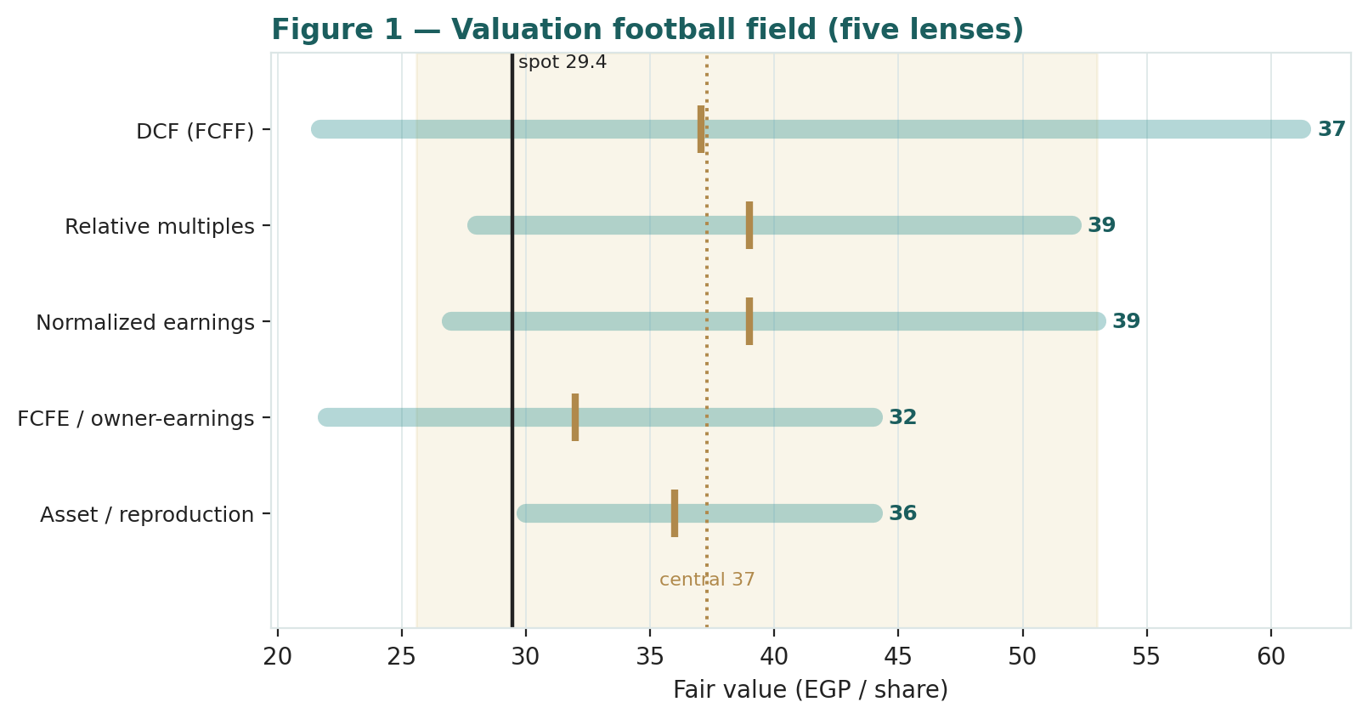
Figure 1 — Valuation football field. Bars span bear–bull per lens; the brass tick is each base case; the gold band is the blended central range; the dark line is spot.
Central fair value ≈ EGP 37/share, about 26% above spot. The spread of the lenses (EGP 32 to 39 at base) is unusually tight — this is not a name where the methods disagree about what the business is worth, but one where the market has priced a cyclical trough as permanent. The debate, as §1.6 and §1.7 show, is not the multiple; it is whether the earnings are real, in the sense of converting to cash.

1.6 The segments and the balance sheet — a deeper look
Lecico is three businesses under one roof, and the disclosed segment detail is unusually clean, so we use it directly rather than manufacture splits. Sanitary ware (EGP 5,014.6m, 64.3% of revenue) is the engine: 81.4% of its volume is exported, chiefly to Europe and the Gulf, at a 26.1% gross margin — a genuine hard-currency earner reported in pounds. Tiles (EGP 2,488.8m, 31.9%) are largely domestic (7.8% export) at a thinner 13.8% gross margin, geared to the Egyptian construction and consumer cycle. Brassware (EGP 300.4m, 3.8%) is small but the richest at 44.1%. Across the group, ~55% of revenue is exported — the single most important structural fact for the valuation.
Segment (FY2025) | Revenue (EGP m) | % of revenue | Export % | Gross margin | Swing role
Sanitary ware | 5,014.6 | 64.3% | 81.4% | 26.1% | Dominant · FX-geared
Tiles | 2,488.8 | 31.9% | 7.8% | 13.8% | Domestic-cycle anchor
Brassware | 300.4 | 3.8% | ~0% | 44.1% | Small · high-margin
Total | 7,803.7 | 100% | ~55% | 22.9%

The balance sheet is where the caution lives. Inventory (EGP 2,880m) and receivables (EGP 1,659m) together are EGP 4,539m — well over half of total assets of EGP 8,537m — and they grew by EGP 564m in 2025, absorbing the year's profit. Net debt rose ~125% to EGP 1,270m, lifting net-debt/EBITDA to ~1.3× (from ~0.4× a year earlier). Book value is EGP 49.7 a share, so at EGP 29.45 the stock trades at 0.59× book — a level that itself argues an asset floor, provided the inventory and receivables realise. The scorecard below rates each part on the axes that matter.
Part / axis | Cyclicality | Margin trend | Cash intensity | Read
Sanitary ware (export) | Moderate | Trough → recovery on weaker EGP | High (WC) | The value engine
Tiles (domestic) | Higher | Thin, demand-led | High (WC) | The cyclical leg
Working capital | — | Absorbing cash | Very high | The crux risk
Balance sheet | — | Debt rising | — | 0.59× book = floor

1.7 The pound and cash conversion — the crux
Two linked judgments drive the valuation more than any other, and both are best expressed in observable units rather than an abstract margin percentage (device A-1). First, the Egyptian pound. Lecico earns hard currency on the majority of its sanitary-ware volume but reports in pounds, so a stronger pound mechanically compresses reported EGP revenue and margin on the export leg. The pound strengthened from ~50.8 per dollar at end-2024 to ~47 by mid-2026 — roughly 8% — and that, more than any operating failure, is what took the 2025 EBIT margin to 9.5% from 17.3%. The crux is therefore the EGP/USD path: consensus looks for a gradual resumption of depreciation toward EGP 52–54 by end-2026, which would lift export EGP revenue and margin; a pound that stays strong (or strengthens further on portfolio inflows) keeps the squeeze on. Second, cash conversion. 2025 operating cash flow was negative EGP 196m — against positive EGP 537m in 2024 — because a EGP 706m working-capital absorption swallowed the profit; the company pays no dividend. Until that reverses, a cash-focused investor will discount the earnings heavily, which is precisely why the shares trade where they do.
Read the two together and the investment question is clean: the multiple lenses say the shares are ~25% cheap if the pound behaves and the cash comes; the market is pricing as if neither will. The bear case is not that the business is worth little — even the asset floor is above spot — but that the value stays trapped.

1.8 Macro and country — the pound, rates, energy and tariffs
Lecico is an Egyptian exporter, so its value is set as much by policy as by management. The pound is the master variable, above; a weaker pound is, unusually, good for reported margins here. Rates: the Central Bank of Egypt held its overnight deposit rate at 19% through the first half of 2026 (down from a ~27% peak), having paused its easing cycle amid regional tension and energy-cost shocks; a resumption of cuts would lower the carry on Lecico's heavy working capital and support domestic tile demand. Inflation eased to ~14.6% by May 2026 from 30%-plus at the peak, which slows the nominal-revenue tailwind but also the input-cost pressure. Energy is the direct cost channel: natural gas (kiln fuel) rose ~21% in September 2025, diesel ~13% in October 2025, and petroleum products a further 14–17% in March 2026 — a real margin drag for a gas-intensive ceramics maker. Trade and freight (Red Sea disruption raising the cost and time of European exports) are the tail risk to the export leg. These levers sit behind the bear and bull cases in §1.5 and the catalysts in §5.

1.9 Primary-lens sensitivity — how WACC and terminal growth move the value
Because the DCF's terminal value is ~78% of enterprise value, the fair value is genuinely sensitive to the discount rate and terminal growth. The grid re-prices the DCF across a WACC of 19–23% and terminal growth of 9–13%; the base case (WACC 21%, g 11%) sits at EGP 37, and the cells near spot are shaded.
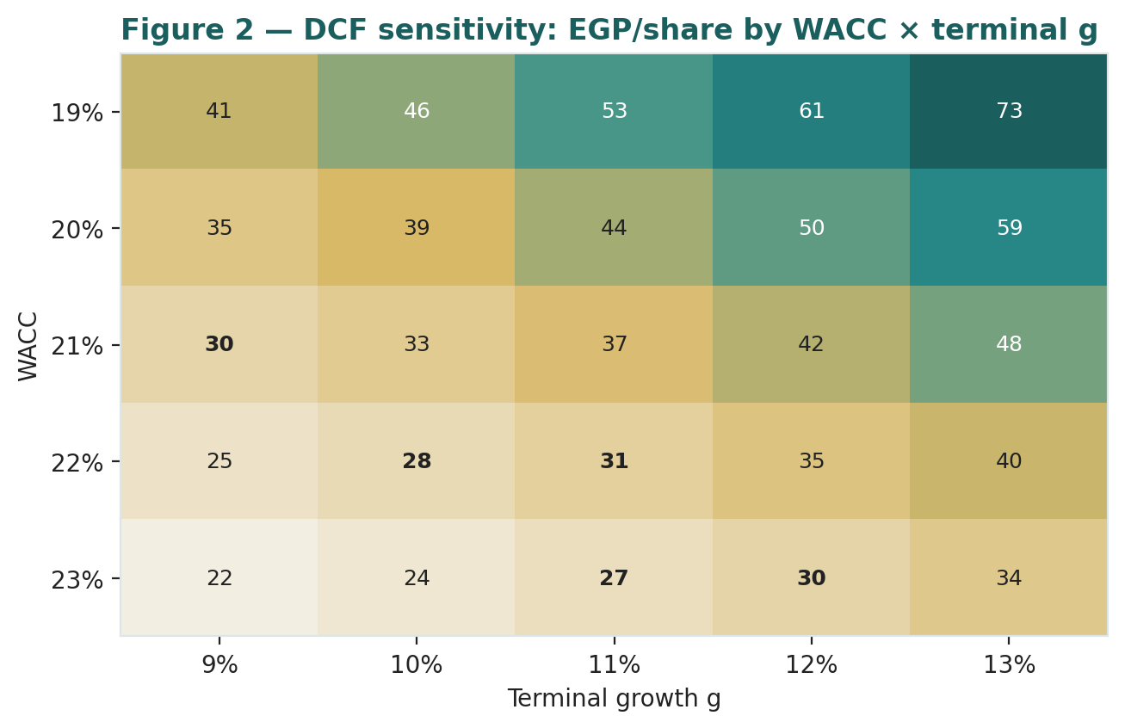
Figure 2 — DCF sensitivity: fair value (EGP/share) by WACC × terminal growth. Base case WACC 21% / g 11% = EGP 37.
Read it as the bet you are taking: the market price of EGP 29.45 is broadly consistent with a WACC around 22–23% and terminal growth at the low end — i.e. a market that demands a high real return and credits Lecico with little durable nominal growth. Our base sits one notch more constructive on both. We publish the cost of equity explicitly as rf + ERP and sensitise on this grid rather than presenting a single black-box WACC (§3.5-G).

2 Technical and price structure
The tape is constructive and, for once, does not contradict the fundamentals' direction. Lecico trades above all four major moving averages, the MACD histogram is positive, and RSI sits in the low-60s — firm but not yet overbought. The most recent session (6 July) closed up 3.66% on above-average volume, pushing the price to the top of its 52-week range. The structure is a steady grind higher off the EGP 22 area, with the 52-week high at EGP 29.72 as the immediate overhead level.
Indicator | Reading | Signal
Spot | EGP 29.45 | —
SMA 20 / 50 | 27.63 / 27.22 | Above both — short-term up
SMA 100 / 200 | 26.31 / 26.03 | Above both — trend up
RSI (14) | 61.4 | Firm, not overbought
MACD (12,26,9) | +0.44 line / +0.32 signal / +0.12 hist | Bullish, positive momentum
52-week range | EGP 22.40 – 29.72 | Upper end of range
Realized vol (252d) | ~30% | Moderate, calmer than history

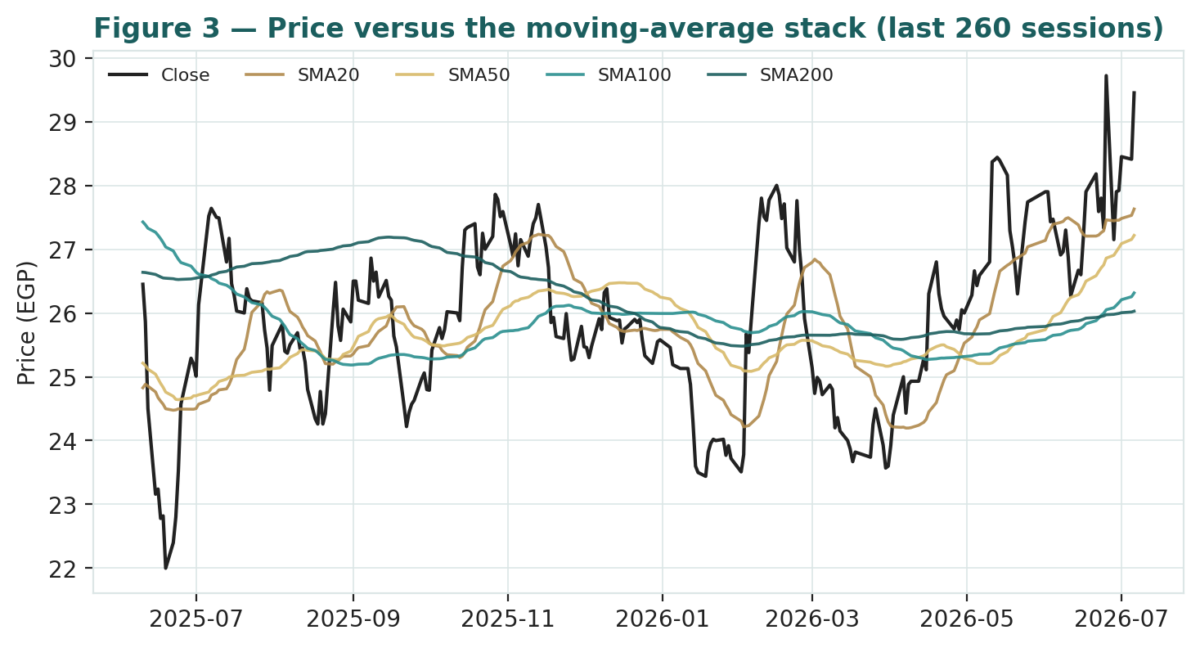
Figure 3 — Price versus the moving-average stack, last 260 sessions.
For the probabilistic work this matters in one way: an above-trend tape with positive momentum tilts the near-term distribution modestly to the upside, consistent with — but not the cause of — the fundamental undervaluation. Momentum is context, not a trigger, and it says nothing about value; §6 reads the resulting probability zones without forcing the two into a single story.

3 Monte Carlo — a probabilistic price map

The probability read
Before the paths, the five-row summary of where they land — computed from the same 50,000 three-month paths that draw the cone below, and presentation-only (it never feeds the drift or the width).
Probability read (T+60) | Value
P(price above spot) | 60%
P(+10%) vs P(−10%) | 42% vs 22% (odds ~1.9 : 1)
Median level / % move | EGP 31.0 (+5.3%)
50% band (25th–75th) | EGP 27.1 – 35.5 (≈29% of spot)
Touch(+10%) / touch(−10%) | 66% / 46%

The read shows a modest upward tilt — a 60% chance of finishing above spot and roughly 1.9-to-1 odds on a +10% move versus a −10% move — that is the honest reflection of Lecico's own calibrated secular drift, not the fundamental value gap, which is deliberately kept out of the drift. The direction shown is only ever what survived the Step 0 backtest.

The engine and the factors
We simulate 50,000 three-month price paths (seed 42) with the YZ-HAR engine: the diffusion width is the regime-conditional volatility projected by a log-HAR cascade on a gap-aware Yang-Zhang variance proxy (annualized ≈42%, materially calmer than the five-year average because the tape has settled); the innovations are unit-variance Student-t(5), for a tight interquartile body and honest tails; and the drift is Lecico's own Step-0-calibrated secular drift of ≈+19% a year (a regime-dampened half of the raw five-year nominal mean). On top of this diffusion sit sixteen factors: seven continuous macro/operating drivers contributing a small net forward drift (≈+2.2% over the quarter), and nine discrete events that each fire with a probability and an impact. By design the paths diffuse from spot, and the §1 value gap is kept out of the drift — §3 maps where price could go from today, not where value sits.
Continuous factor (7) | Dir. | Discrete event (9) | Prob. | Mean impact
EGP/USD (weaker lifts export EGP revenue) | + | H1-2026 results print (~Aug) | 55% | +1.0%
Natural gas & diesel energy cost | − | EGP devaluation step / sharp FX move | 30% | +4.0%
Egypt construction / consumer demand | + | Energy / gas price reset (further hike) | 30% | −4.5%
European / export-market demand | + | New US / Asia export-channel ramp | 45% | +4.5%
CBE policy-rate path | + | Geopolitical / Red Sea freight shock | 30% | −5.5%
EGX30 & foreign flows | + | CBE rate-cut resumption | 35% | +2.5%
Egyptian inflation (CPI) | ± | Lebanon / Poland restructuring charge | 25% | −2.0%
 |  | Receivables / payment-terms event | 30% | −2.0%
 |  | Index / foreign-flow rebalancing | 25% | +2.0%

Percentile map (EGP/share):
Horizon | p5 | p25 | p50 | p75 | p95
T+20 sessions | 24.3 | 27.8 | 30.0 | 32.4 | 37.0
T+60 sessions | 21.7 | 27.1 | 31.0 | 35.5 | 44.4

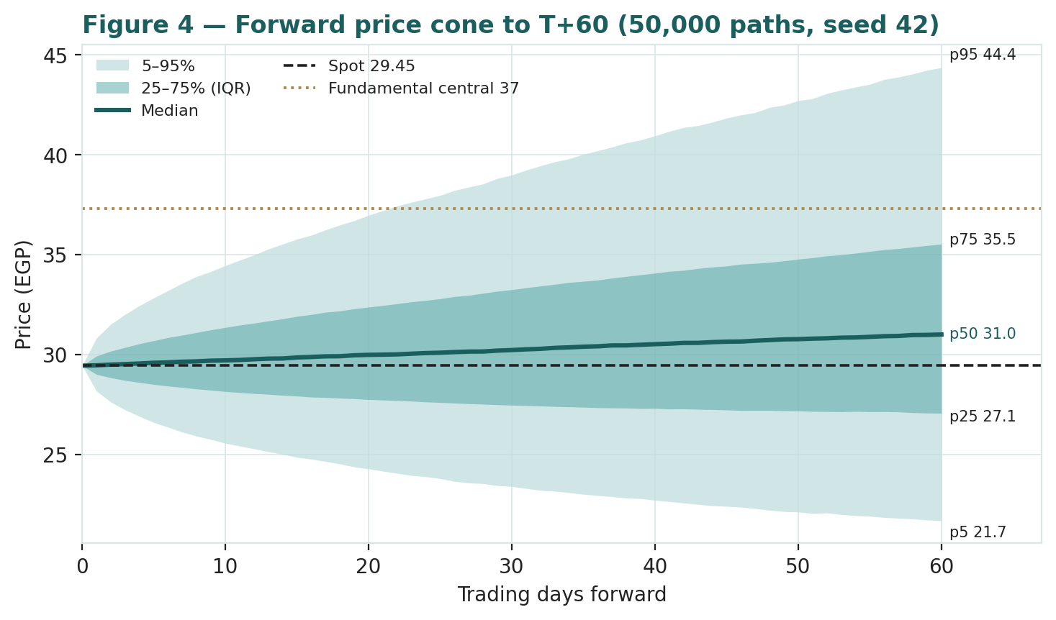
Figure 4 — Forward price cone to T+60. Median tracks modestly above spot; the brass dotted line marks the EGP 37 fundamental central value, deliberately above the cone.
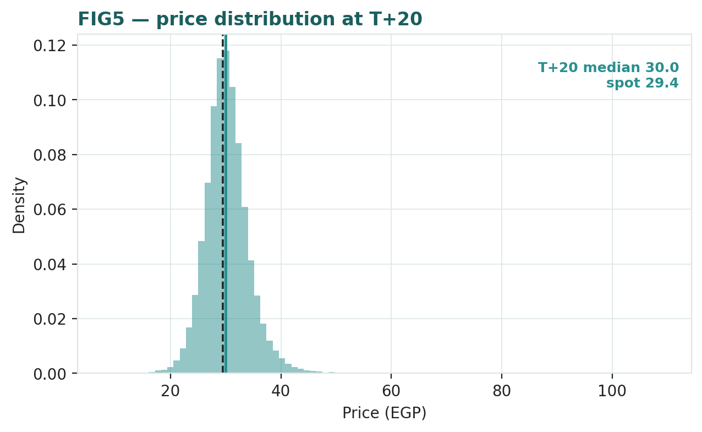
Figure 5 — Price distribution at T+20.
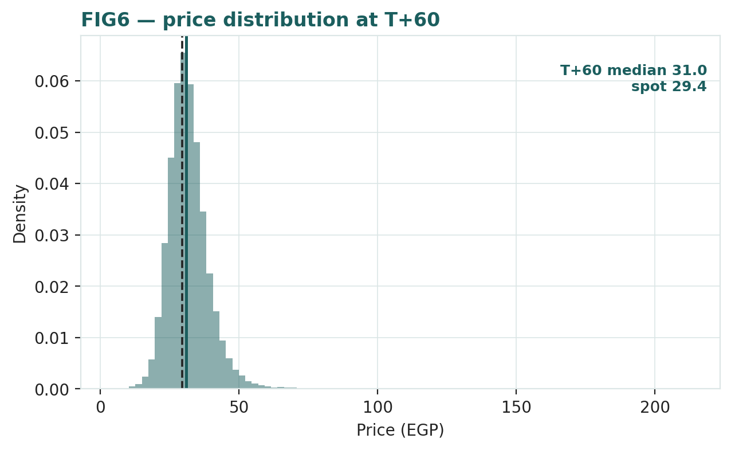
Figure 6 — Price distribution at T+60.
Level-touch ladder — the probability that price touches a level at any point by the horizon (running max for upside, running min for downside):
Level (EGP) | T+20 touch | T+60 touch | Note
35.3 | 14% | 41% | Toward the normalized/DCF cluster
33.0 | 32% | 61% | Above the 52-week high
30.9 | 62% | 80% | Just above spot
28.9 | 70% | 80% | Just below spot
26.5 | 26% | 46% | Mid downside
24.4 | 9% | 25% | Toward the 52-week low
22.1 | 2% | 11% | The 52-week low zone

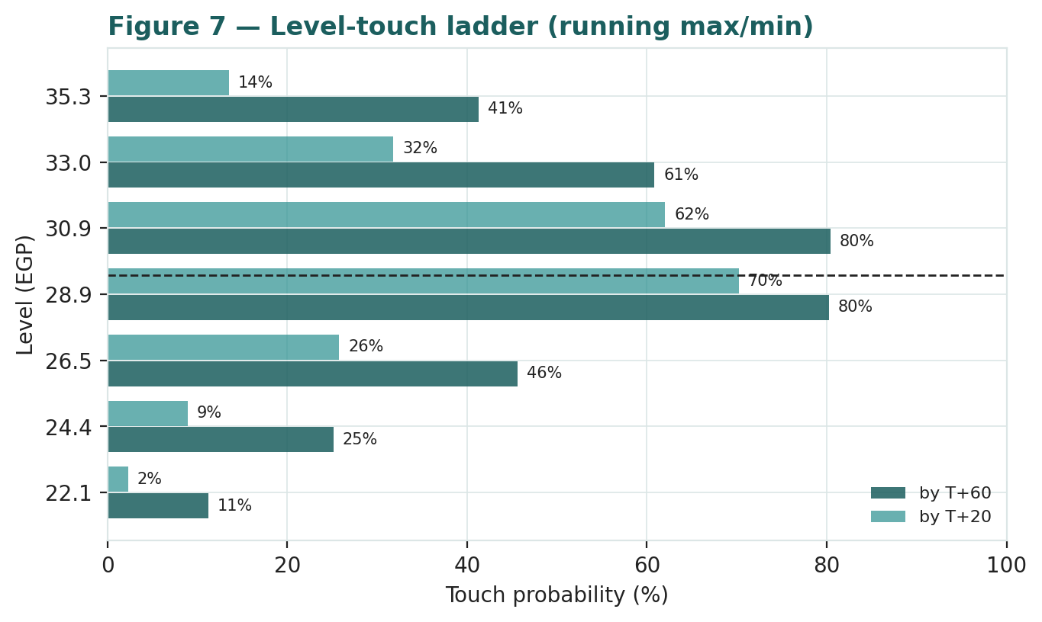
Figure 7 — Level-touch ladder (running max for upside, running min for downside).

4 Comparison of the lenses, and a verdict
Three readings sit side by side. The fundamental lenses cluster tightly at EGP 32–39 with a central EGP 37 — meaningfully above spot, contingent on the pound and cash conversion. The technical picture agrees in direction for once: a firm short-term uptrend, above all moving averages, with the 52-week high at EGP 29.72 as the immediate hurdle. The probabilistic map says that over three months price is modestly right-skewed around spot with a wide ±~30% band — the median is EGP 31, above spot but well below the EGP 37 fundamental central, because the simulation does not assume the value gap closes inside the quarter.
Lens | Reads | Central / implication
Fundamental (5-lens) | Meaningfully cheap | EGP 37 (~+26%)
Technical | Firm uptrend | Support at the MA stack EGP 26–28; resistance at EGP 29.7
Monte Carlo (3-month) | Modestly right-skewed | Median EGP 31; p5–p95 EGP 22–44

Verdict (a fair-value read, not a recommendation). Lecico looks meaningfully cheap on fundamentals, with an unusually tight cluster of lenses and two clear, observable swing factors: the pound and cash conversion. Unlike a typical value name, the technical tape is not fighting the thesis — it is trending higher — but the three-month distribution still centres nearer spot than fair value, because a re-rating requires operating proof (a weaker pound feeding margins, a working-capital reversal feeding cash) that plays out over quarters, not weeks. The honest summary is a value about a quarter above price, a near-term distribution tilted modestly up, and an outcome that hinges on two things the company only partly controls — which is why the bear–bull span (EGP 26–51) is wide even though the base-case lenses agree. Readers should weigh the lenses themselves; we publish the distribution, not a target.

5 Catalysts to watch
• H1-2026 results (≈ August 2026). The first clean read on whether the margin is stabilising and, critically, whether operating cash flow has turned positive as working capital normalises.
• The Egyptian pound. Any resumption of gradual depreciation toward EGP 52–54/USD lifts export EGP revenue and margin directly; renewed strength keeps the squeeze on. This is the single most important external lever.
• Energy tariffs. Further natural-gas or diesel price resets raise kiln and transport costs; a pause or subsidy adjustment would relieve the cost line.
• CBE rate path. A resumption of rate cuts lowers the carry on Lecico's heavy working capital and supports domestic tile demand.
• New export channels. Evidence of the US/Asia sanitary-ware volume ramp converting into revenue and utilisation.
• Working-capital and the balance sheet. A reversal of the 2025 inventory/receivables build — the difference between reported profit and real cash — and any move toward reinstating a dividend once accumulated losses clear.

6 Reading the probability zones
Translating the three-month distribution into plain zones, anchored on spot EGP 29.45 and the fair-value cluster:
Zone (T+60) | Range | Approx. probability | What it would mean
Deep downside | < EGP 24 | ~11% | Pound strengthens / risk-off; tests the 52-week low
Lower band | EGP 24–28 | ~19% | Trough persists; cash-conversion worry dominates
Around spot | EGP 28–34 | ~37% | Status quo; value gap unclosed
Upper band | EGP 34–40 | ~21% | Recovery credited; toward the DCF/normalized cluster
Strong upside | > EGP 40 | ~11% | Weaker pound + cash reversal together

The distribution is right-skewed, with a heavier upper tail from the calibrated secular drift and the discrete upside events (a devaluation step, a new export channel, rate cuts). It is not a forecast; it is the spread of outcomes consistent with the stock's own volatility and the factor stack.

7 Caveats and what would change our mind
• The pound cuts both ways. The central case assumes a gradual resumption of depreciation; a structurally stronger pound (persistent portfolio inflows, a firmer external position) would keep the export margin squeezed and pull the central value toward — or below — spot. This is a mechanical, not an operating, risk.
• Cash conversion is the real test. If the working-capital absorption proves structural rather than cyclical, the earnings never become cash, the balance sheet keeps levering, and the FCFE lens (EGP 32) — not the DCF (EGP 37) — is the right anchor. Watch the operating-cash-flow line above all.
• The DCF is terminal-heavy. With ~78% of enterprise value in the terminal, the fair value is a terminal-growth-versus-WACC bet; §1.9 sensitises it, but a single point of WACC or a point of terminal growth moves the answer materially.
• Energy and freight. Further gas/diesel hikes, or a prolonged Red Sea disruption to European exports, are direct margin and volume risks not fully in the base case.
• Disclosure and accounting. Lecico's accounts carry audit matters around hyperinflation accounting (IAS 29) and the Lebanon wind-down; reported book value and margins should be read with that in mind.
• Technical / momentum reminder. The tape is above trend and could persist or reverse; momentum is context, not a trigger, and says nothing about value.

Appendix A Financial statements
Selected consolidated figures, as reported (FY2025 results, 28 February 2026; Q1-2026 filing). All figures in EGP million unless stated. FY2025 is a margin trough, driven by the stronger pound against a majority-export cost base and by domestic energy-cost hikes. Forecast years are the preparer's estimates, driven by the Assumptions layer of the companion model.

A.1 Income statement (consolidated, EGP m)
Line | 2023A | 2024A | 2025A | 2026E | 2027E | 2028E | 2029E | 2030E
Revenue | 4,844 | 6,645 | 7,804 | 8,740 | 9,876 | 11,062 | 12,278 | 13,506
EBITDA | — | 1,330 | 981 | 1,005 | 1,234 | 1,493 | 1,719 | 1,958
D&A | — | 179 | 238 | 265 | 300 | 340 | 380 | 420
EBIT | 941 | 1,151 | 743 | 740 | 934 | 1,153 | 1,339 | 1,538
Net finance & other | — | 82 | (281) | (260) | (252) | (244) | (236) | (228)
Profit before tax | — | 1,232 | 462 | 480 | 682 | 909 | 1,103 | 1,310
Tax | — | (313) | (202) | (108) | (154) | (205) | (248) | (295)
Net profit after tax | — | 919 | 259 | 372 | 528 | 705 | 855 | 1,015
Minority interest | — | (29) | (15) | (19) | (26) | (35) | (43) | (51)
Net profit attributable | 446 | 890 | 244 | 353 | 502 | 669 | 812 | 965
EPS (EGP) | 5.58 | 11.13 | 3.05 | 4.42 | 6.27 | 8.37 | 10.15 | 12.06

Note: FY2024 net finance income includes ~EGP 362m of devaluation/FX gains, so 2024 attributable profit is not a clean run-rate. Forecast below EBIT uses the statutory 22.5% tax rate and ~5% minority; the elevated 2025 effective tax (~44%) reflects non-deductible items and loss-making subsidiaries.

A.2 Balance sheet (consolidated, EGP m)
Line | 2023A | 2024A | 2025A | 2026E | 2027E | 2028E | 2029E | 2030E
Cash & equivalents | — | 352 | 314 | 320 | 360 | 400 | 440 | 480
Inventory | — | 2,543 | 2,880 | 3,226 | 3,645 | 4,083 | 4,532 | 4,986
Receivables | — | 1,444 | 1,659 | 1,858 | 2,100 | 2,352 | 2,611 | 2,872
Total current assets | — | 4,340 | 4,854 | 5,404 | 6,105 | 6,835 | 7,583 | 8,338
PP&E | — | 3,322 | 3,586 | 3,971 | 4,171 | 4,311 | 4,431 | 4,531
Total assets | — | 7,747 | 8,537 | 9,473 | 10,373 | 11,244 | 12,111 | 12,966
Bank facilities + current loans | — | 954 | 1,628 | 1,628 | 1,628 | 1,628 | 1,628 | 1,628
Total liabilities | — | 3,891 | 4,431 | 4,556 | 4,703 | 4,858 | 5,020 | 5,190
Non-controlling interest | — | 122 | 128 | 128 | 128 | 128 | 128 | 128
Total equity (attributable) | 3,200 | 3,735 | 3,978 | 4,331 | 4,833 | 5,502 | 6,314 | 7,278

Forecast balance sheet is indicative: cash and interest-bearing debt are held roughly flat as inputs, working-capital lines scale with revenue, PP&E rolls forward at capex less D&A, and equity rolls forward with retained net income. It illustrates the working-capital intensity rather than a fully-articulated three-statement tie-out.

A.3 Cash flow (consolidated, EGP m)
Line | 2024A | 2025A | 2026E | 2027E | 2028E | 2029E | 2030E
EBITDA | 1,330 | 981 | 1,005 | 1,234 | 1,493 | 1,719 | 1,958
Δ working capital | (318) | (706) | (250) | (300) | (310) | (320) | (320)
Tax paid | (201) | (328) | (108) | (154) | (205) | (248) | (295)
Interest paid | (282) | (299) | (260) | (252) | (244) | (236) | (228)
Operating cash flow | 537 | (196) | 387 | 528 | 734 | 915 | 1,115
Capex | (285) | (467) | (650) | (500) | (480) | (500) | (520)
Free cash flow to firm | 252 | (663) | (61) | 224 | 444 | 598 | 772

Source: company full-year results FY2024–FY2025 and Q1-2026 filing. Figures rounded. The negative 2025 operating cash flow, on a EGP 706m working-capital absorption, is the single most important cautionary fact in the accounts.

Appendix B Peer set, sector structure, and risks
Lecico's cleanest comparables are other listed ceramics and sanitary-ware makers, though most trade at a premium reflecting either richer domestic demand (Gulf) or structural-growth ratings (India).
Peer | Market | EV/EBITDA | P/E | Note
Lecico (LCSW) | EGX | ~3.7× | ~9.7× | Trough margins; 0.59× book
RAK Ceramics | Abu Dhabi (ADX) | ~5–6× | ~8–10× | Regional ceramics leader
Saudi Ceramics | Tadawul | ~6–8× | ~12–16× | Domestic KSA demand
Kajaria Ceramics | India (NSE) | ~20–28× | ~40–55× | Structural-growth premium
Cera Sanitaryware | India (NSE) | ~18–24× | ~30–40× | Sanitaryware growth
Geberit / Villeroy&Boch | SIX / XETRA | ~10–14× | ~18–25× | High-end European

Sector structure. Ceramics and sanitary ware are cyclical building materials: demand tracks construction and consumer spending, kilns are gas-intensive (so energy tariffs are a direct margin lever), and exporters are geared to the reporting-currency cross. Lecico's edge is a low-cost Egyptian manufacturing base, scale, and a genuine export franchise in sanitary ware; its constraints are a working-capital-heavy model, a levering balance sheet and Egypt-specific policy and currency risk. Principal risks: a structurally stronger pound; further energy-cost hikes; a persistent working-capital absorption keeping free cash negative; the absence of a dividend; audit matters around hyperinflation accounting and the Lebanon wind-down; and Red Sea freight disruption to European exports.

About this series
Testahil publishes independent, educational valuation studies. Each is an attempt to reason transparently about what a security is worth, with every assumption shown and a companion model so readers can disagree productively. The house style is distributions, not tips: we describe ranges and probabilities, not targets, and we do not tell anyone what to do. Studies are framed as educational analysis, the preparer is not licensed by any securities regulator, and holdings are disclosed.

Disclosure & Disclaimer
*Not investment advice.* This document is educational and informational only. It is not, and must not be relied upon as, investment, financial, legal, accounting or tax advice, nor an offer, solicitation or recommendation to buy, sell or hold any security. It contains no price target and no rating.
*No licence; no advisory relationship.* The preparer is not registered or licensed with any securities or financial regulator in any jurisdiction (including Egypt's Financial Regulatory Authority), holds no brokerage or investment-advisory authorisation, and is not acting as your adviser or fiduciary. Nothing here is personalised to your circumstances.
*Holdings disclosure.* The preparer may hold, and may in the future take or dispose of, a position in the security discussed in this report, and may transact at any time without notice. This is a potential conflict of interest you should weigh.
*Sources & accuracy.* Reported financial and operating figures are drawn from the company's public disclosure (FY2025 results, Q1-2026 filing, EGX disclosures) and other public sources believed reliable but not independently verified; they may contain errors or be superseded. Forward-looking inputs — the DCF, the multiples, the marks, projections and Monte-Carlo factor probabilities — are the preparer's own judgments and are inherently uncertain.
*Forward-looking statements.* Any statements about the future are estimates subject to risks and uncertainties; actual results may differ materially. The Monte Carlo models price, not value, and encodes subjective probabilities for events that have not occurred.
*No reliance; your responsibility.* Do your own research and consult a licensed professional before making any decision. You are solely responsible for your investment decisions and their outcomes. To the maximum extent permitted by law, the preparer accepts no liability for any loss arising from use of this document.
*Currency & figures.* Figures are in Egyptian pounds (EGP) unless stated; m denotes million and bn billion. FX at study date: USD/EGP ~47. Rounding may cause totals to differ slightly. Spot price and market data are as of 6 July 2026 and change continuously.
TESTAHIL · Independent Valuation Study · Educational Analysis · Lecico Egypt (S.A.E.) (EGX: LCSW) · edition 06-07-2026 · reporting currency EGP

Appendix C The expert valuation panel
Every Testahil study closes with a panel of standing expert personas — drawn from the house Expert Persona Library, not invented for the occasion, so that each accumulates a track record across studies and a quarterly update is a re-run, not a re-training. The value of a standing panel is precisely that its members can be held to account: each expert's point fair value is logged with the study date and spot, so that when the next print lands we can see which method read Lecico best and which read it worst, the same discipline the Step 0 backtest applies to the Monte Carlo lens. For Lecico — a capital-heavy building-materials manufacturer at a cyclical trough — we cast the three whose methods both fit the instrument and genuinely disagree: Expert 1 (normalized earnings power and relative multiples), Expert 2 (the accountant: realizable-asset value and earnings quality), and Expert 3 (cash returns — discounted cash flow and return on capital versus its cost). Three experts who ran three discounted-cash-flow models and agreed would be cosmetic; these three run genuinely different machinery and, as a result, disagree in a way that is informative. Each derives its fair value from shown workings, states a falsification condition, and cross-examines the other two. The macro-policy lens — the pound, rates, energy — runs through the body of the study (§1.8, §5) rather than as a separate persona, because for Lecico it is a driver every expert must already incorporate rather than a distinct valuation method.

C.1 Expert 1 — normalized earnings power and relative multiples
Worldview and tradition. An operating business is worth a fair multiple of its sustainable, mid-cycle earnings; peaks and troughs are noise to be stripped out. He stands in the through-the-cycle tradition of the normalized-earnings analyst: a single trough or peak year tells you almost nothing about intrinsic worth, because a cyclical manufacturer's reported profit swings far more than its underlying earning power. He asks what Lecico earns across a full cycle — averaging the fat years and the lean — and what a rational buyer of that earnings stream should pay, benchmarked against the company's own history and its regional peers, and adjusted down for Egypt's policy and currency risk.
When it works / fails. The lens is at its best for cyclical operating businesses with a genuine through-cycle track record, and Lecico has one: EBIT margins of 19.4% (2023), 17.3% (2024) and 9.5% (2025), around a mid-cycle nearer 13%. It fails at structural breaks — if the margin is permanently lower because the pound stays strong and energy stays dear, then averaging the past is averaging a world that no longer exists, and his normalization is simply wrong. He guards against this by normalizing conservatively (to 13%, not the 18% of the good years) and by cross-checking the earnings multiple against an EV/EBITDA and a free-cash-flow yield.
Standard workings & worked example. Normalize the EBIT margin to a mid-cycle ~13% (versus the 2025 trough of 9.5% and the 2023–24 average nearer 18%), derive normalized net income of ~EGP 460m and EPS of ~EGP 5.75, and apply a justified through-cycle P/E of ~6.8× — a deliberate discount to regional peers for Egypt risk.
Expert 1's normalization | Value
Normalized mid-cycle EBIT margin | ~13%
Normalized net income (EGP m) | 460
Normalized EPS (EGP) | 5.75
Justified P/E | 6.8×
Fair value | → EGP 40/share

Sensitivity (swing = normalized margin / multiple). At a 6.0× P/E, EGP 35; at 8.0×, EGP 46; a mid-cycle margin one point lower cuts ~EGP 4. Cross-examination. He tells Expert 2 that valuing a manufacturer on its realizable break-up assets in a trough year understates a business that will earn far more mid-cycle; he tells Expert 3 that ROIC pessimism ignores the operating leverage of a margin recovery.
Verdict, falsification, market-implied. Fair EGP 40 (range EGP 27–53). Falsified by a structural margin re-rating down — Lecico stuck below ~10% EBIT through a cycle because the pound and energy permanently compress the export leg. The market price implies normalized earnings well below his — it does not yet believe the recovery.

C.2 Expert 2 — the accountant: realizable-asset value and cash quality
Worldview and tradition. The Graham-Dodd realization school — a business is worth what its assets realize net of every claim, and reported profit is trusted only as far as it converts to cash. He is the balance-sheet sceptic: the income statement is an opinion, the balance sheet is closer to a fact, and cash is the only thing that is truly real. His method is especially apt for a capital-and-working-capital-heavy manufacturer whose 2025 profit conspicuously did not become cash — the exact pattern that his whole discipline exists to catch, where accounting earnings are booked years or quarters before (or, here, instead of) the cash arriving.
When it works / fails. Best where the business is asset-heavy, working-capital-heavy and levering, and where value rests on inventory and receivables actually realising — a precise description of Lecico, whose inventory and receivables are over half of total assets and grew EGP 564m in the year. It fails by systematically undervaluing a genuine compounding franchise: if Lecico is really a low-cost exporter that will earn well through the cycle, marking it to a conservative break-up value in a trough understates it. He accepts that risk as the price of not being fooled by a booking.
Standard workings & worked example. Mark each asset to a conservative realizable value — inventory at an 80% recovery, receivables at 85%, PP&E at 90% of book — deduct all liabilities and minority, and then apply a cash-conversion overlay, because 2025 operating cash flow was negative.
Expert 2's realizable-asset bridge (EGP m) | Value
Total assets (Dec-2025) | 8,537
less: inventory / receivable / PP&E haircuts | (1,184)
less: total liabilities and minority | (4,559)
Realizable equity | 2,794
Cash-conversion overlay (negative OCF) | (~10%)
Fair value | → EGP 31/share

Sensitivity (swing = the haircut / cash overlay). Lighter haircuts and no cash overlay lift him toward EGP 42; a deeper inventory haircut takes him to EGP 22. Cross-examination. He tells Expert 1 that mid-cycle earnings the company cannot turn into cash are a booking, not a value — "2025 booked EGP 244m of profit and lost EGP 196m of cash"; he tells Expert 3 that a terminal value 78% of enterprise value is a forecast dressed as a fact.
Verdict, falsification, market-implied. Fair EGP 31 (range EGP 22–42) — the most conservative of the three: cheap on assets, but only if the assets realise. Falsified by a durable lift in cash conversion — a working-capital reversal that turns operating cash flow decisively positive. The market price sits just below his realizable-equity floor, which is the closest thing here to a hard support.

C.3 Expert 3 — cash returns: DCF and ROIC versus the cost of capital
Worldview and tradition. A business creates value only when each unit of capital earns above its cost. He belongs to the economic-profit / return-on-capital school: growth is worth paying for only when it is profitable growth, and a company that reinvests at a return below its cost of capital destroys value no matter how fast the top line rises. Cash, not booked profit, is the test; he looks past the income statement to free cash flow and to the ROIC-minus-WACC spread, and he is instinctively suspicious of a valuation whose worth sits mostly in a terminal year he cannot see.
When it works / fails. Best for capital-intensive businesses where returns on capital are the crux — and Lecico, with EGP 5.2bn of invested capital and a working-capital-heavy model, is squarely that. It fails where reinvestment economics are genuinely changing, which is a live risk here: the entire bull thesis is a margin recovery that would lift returns, so a backward-looking ROIC understates a business on the cusp of earning its cost of capital. He manages this by modelling the ROIC path forward (trough 2025 → recovering 2028) rather than freezing it at the trough, and by publishing the WACC transparently so the reader sees the hurdle the returns must clear.
Standard workings & worked example. Build FCFF (as in §1.1), discount at a ~21% WACC published as rf + ERP, and test ROIC against WACC. At the 2025 trough, NOPAT of ~EGP 575m on invested capital of ~EGP 5,250m is an ROIC of ~11% — well below the ~21% WACC, so the company is currently destroying economic value; as margins normalize toward 2028, ROIC recovers to ~14–15%, still short of the hurdle.
Expert 3's cash-returns test | Value
DCF enterprise value (EGP m) | 4,234
less: net debt | (1,270)
Equity value (EGP m) | 2,964
ROIC 2025 vs WACC | ~11% vs ~21%
ROIC 2028e | ~14–15%
Fair value | → EGP 35/share

Sensitivity (swing = WACC / ROIC fade). At a 19% WACC, EGP 45; at 23%, EGP 28. Cross-examination. He tells Expert 1 that mid-cycle earnings without the capital cost to produce them is a half-truth — Lecico's working capital consumes the very cash a P/E capitalizes; he tells Expert 2 that a pure break-up mark ignores whether the assets, run as a going concern, earn their cost of capital (right now they do not).
Verdict, falsification, market-implied. Fair EGP 35 (range EGP 23–54) — the middle of the three: cheap, but the capital does not yet earn its keep. Falsified by a durable ROIC lift above WACC — a margin recovery that sticks and a working-capital model that stops absorbing cash. The market price is a little below his number; on a cash-returns basis the shares are modestly cheap, not deeply so.

C.4 The three in one room
The single fact they most disagree on is the same one: whether Lecico's booked profit is real, in the sense of becoming cash and earning its cost of capital. It is worth noting how unusual this is — in most names the three methods disagree about the nature of the business, and the fair values scatter widely; here they agree on the nature and disagree only on one accounting-quality question, which is why the range is narrow and collapses on a single data point.
Expert 1: "2025 was a trough — a strong pound and an energy shock, not a broken business. Normalize the margin to mid-cycle and Lecico earns ~EGP 460m; the market is paying about six times that. The recovery is the value, and it is not yet in the price."
Expert 2: "Normalize all you like — in 2025 the company booked EGP 244m of profit and lost EGP 196m of cash to working capital. I value what the assets realize net of the debt that is now rising: about EGP 31 a share. Show me the cash before you pay for the earnings."
Expert 3: "You are both partly right. The cash is real eventually — my DCF is EGP 35 — but the capital to produce those earnings currently returns 11% against a 21% cost. Until that spread turns positive, I credit no premium to what the business earns."
The moderator's question — what would move you? Expert 1 concedes he is wrong if two clean cycles pass with EBIT stuck below 10%; then the trough was the trend. Expert 2 concedes he is too low if a single year turns operating cash decisively positive while the balance sheet de-levers; then the assets were never the point. Expert 3 concedes the middle is too cautious if ROIC crosses WACC and stays there; then the capital earns its keep and his hurdle is met. Notice that all three falsification conditions point at the same line in the same statement — the operating cash flow — from three directions. That is the tell that the disagreement, though expressed as three different fair values, is really one question wearing three hats.

C.5 Reading the divergence
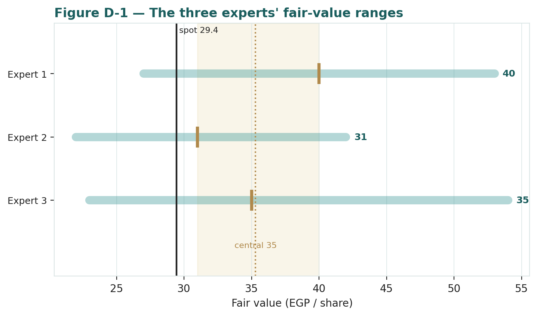
Figure C-1 — The three experts' fair-value ranges. Brass ticks are base cases; the gold band is the central, the dark line is spot. The spread is almost entirely a cash-conversion disagreement.
Expert | Method | Single swing assumption | Base fair value
Expert 1 | Normalized earnings power | Mid-cycle EBIT margin / 6.8× P/E | EGP 40
Expert 2 | Accountant (RNAV + cash quality) | Asset haircut + cash-conversion overlay | EGP 31
Expert 3 | Cash returns / ROIC | WACC (~21%) and the ROIC-fade speed | EGP 35

The spread — EGP 31 to 40 at base — is narrow, and it is almost entirely a cash-conversion disagreement: none of the three contests that Lecico is a real, exporting, low-cost manufacturer trading below book. What separates them is whether the earnings become cash and earn their cost of capital. Expert 1 says yes (normalize the trough); Expert 2 says prove it (the cash was negative); Expert 3 says eventually, but the capital does not yet earn its keep. The EGP 9 spread is therefore a clean measure of one uncertainty — the quality of Lecico's cash conversion — and it is a narrow spread precisely because that single uncertainty, while real, is bounded: even the sceptic's realizable-asset floor sits above spot. This is the useful signal of a standing panel. When three methods that usually diverge widely instead cluster within EGP 9, the disagreement has been localised to one testable question, and the investor knows exactly what to watch: not the margin, not the multiple, not the macro, but the operating-cash-flow line. Resolve that — one clean quarter of decisively positive operating cash flow, a working-capital build that reverses rather than compounds — and the three converge upward; see it worsen, and Expert 2's floor becomes the ceiling. The panel's job is not to produce a single number but to name the one thing whose resolution collapses the range, and here it has done so.
Each expert's point fair value (and bull/base/bear) is logged with the study date (6 Jul 2026) and spot (EGP 29.45) as an internal per-expert track record, kept separate from the core Calibration Ledger. When Lecico next reports, this panel is re-run — not re-trained — on the fresh numbers, and the three logged fair values are scored against the print, so that over successive studies we learn which method reads this name best and hold each persona to the same forecast-versus-actual discipline the Step 0 backtest applies to the price engine.

