Independent Valuation Study — Educational Analysis
LG Energy Solution, Ltd. (KRX: 373220)
Fundamental analysis · Technical analysis · Monte Carlo simulation — one integrated read
Anchor: KRW 331,500 (26 Jun 2026 close) · 234m shares · mkt cap ~KRW 77.6tn · the world's #3 EV-battery maker and a leading energy-storage (ESS) supplier · reported profitability is carried by the US IRA Advanced Manufacturing Production Credit (AMPC), which accrues largely to joint-venture non-controlling interests — so the parent's owners were attributed a net loss in 2024 and 2025 · prices & probabilities computed 26 Jun 2026 from the attached daily price history · primary lens is a going-concern free-cash-flow valuation with AMPC modelled explicitly · the EV-demand cycle and US tax policy are the swing factors.
READ FIRST — what this document is, and is not. This study is a valuation exercise and an expression of personal analytical opinion, published free of charge for educational purposes: it shows how one analyst applies fundamental, technical and probabilistic methods to a listed company, and invites scrutiny of that methodology. It is NOT investment advice, NOT a recommendation or solicitation to buy, sell or hold any security, and NOT directed at the circumstances of any reader. The preparer is not licensed by any securities regulator in any jurisdiction, holds no Korean or other brokerage authorisation, provides no financial consultancy, manages no money, and accepts no fees, funds or clients. See the Disclosure & Disclaimer at the end. All values are model outputs presented as ranges and distributions because no single number should be relied on. Reported financials are LG Energy Solution's own audited disclosure; forward-looking inputs — the AMPC retention assumption, the discounted-cash-flow build, the peer multiples, the normalised-earnings and capacity marks, and the Monte-Carlo factor probabilities — are the preparer's judgments and are flagged throughout. Consult a licensed financial advisor before any investment decision.
Headline
The model's read: modestly expensive on triangulated fundamentals, with very wide two-sided uncertainty driven by the EV cycle and US tax policy. At KRW 331,500 the shares trade well above our weighted central estimate of KRW 248,000, which sits about 25% below spot. LG Energy Solution is the world's third-largest electric-vehicle battery maker — roughly a 9% global share behind China's CATL and BYD — and one of the largest suppliers of grid and data-centre energy storage. Its defining feature for valuation is structural and easy to miss: although the consolidated group eked out a small net profit in 2025 (KRW 80.8bn), the profit attributable to the parent's owners — the holders of this stock — was a net loss of KRW 1,072.8bn (EPS −4,585), because the US production credits that carry the business flow through North-American joint ventures where partners such as GM hold the non-controlling interests. Trailing P/E is therefore meaningless. The question is not whether LG Energy Solution has a valuable franchise — it plainly does — but whether KRW 331,500 fairly prices a recovery that current owner-level earnings do not yet show.
Four independent lenses span an unusually wide range, from KRW 188,000 to KRW 322,000, and the weighted central estimate is KRW 248,000, about 25% below spot. The primary lens — a going-concern discounted-cash-flow (FCFF) model that follows the capital-spending peak down toward maintenance and lets margins recover, then subtracts net debt and the large minority interest to isolate the parent's equity — lands lowest at KRW 146,000, because even crediting a recovery to mid-cycle margins, a discounted-cash-flow value cannot carry the price once the heavy net-debt and minority-interest bridge is subtracted. Relative multiples on mid-cycle EBITDA (KRW 322,000) and through-cycle normalised earnings (KRW 300,000) sit closer to or just below spot, since growth names earn a forgiving multiple. An EV-per-GWh capacity/replacement cross-check (KRW 188,000) is low, as it should be for an asset-heavy view. The bear case at KRW 150,000 reflects an AMPC cut plus prolonged EV weakness; the bull case at KRW 415,000 — above spot — captures full recovery, an energy-storage / AI-datacentre super-cycle and the credit retained.
This is a statement about valuation, not direction. LG Energy Solution's tape is weak — the shares sit roughly 15% above their 52-week low, below all three falling moving averages, with RSI near 33 after a sharp ~21% slide over the past three months — and a single 16-factor Monte Carlo (EV-demand volumes, battery/lithium pricing, the energy-storage and AI-datacentre ramp, KRW, KOSPI beta, plus nine discrete events including an AMPC policy cut and large supply wins; 50,000 paths, seed 42) puts both the T+20 and T+60 medians near spot (~KRW 332,000 and ~334,000) inside a very wide cone — realized volatility runs near 55% annualised. A high-multiple cyclical at the trough of an investment cycle can stay mispriced in either direction for a long time. What a buyer at this level underwrites is that North-American EV demand stabilises, that energy storage and the 46-series cylindrical / robotics franchises scale, that the US production credit is retained, and that capital spending normalises so the parent's attributed earnings inflect back to positive — not a margin of safety on current owner earnings, which are negative. The downside tail belongs to an AMPC repeal and a deeper EV air-pocket; the upside to an energy-storage super-cycle, a faster margin recovery and a value-up re-rating.
Company overview — LG Energy Solution at a glance
LG Energy Solution, Ltd. (KRX: 373220) is the battery maker spun out of LG Chem and listed in January 2022 in what was then Korea's largest-ever IPO. It manufactures lithium-ion batteries for three end-markets: electric vehicles (the core), energy-storage systems (ESS — grid and, increasingly, AI data-centre back-up), and IT / small-format applications. It is the world's third-largest EV-battery supplier with roughly a 9% global share, behind CATL (~39%) and BYD, and a clear leader outside China. Its North-American footprint is built around joint ventures with major automakers — Ultium Cells with General Motors, plus ventures with Honda, Hyundai, Stellantis and Toyota — which is the structural fact that drives the accounts: the US Inflation Reduction Act's Advanced Manufacturing Production Credit (the 45X / AMPC) is earned at those plants, and because the automakers hold large minority stakes in them, much of the credit-driven profit is attributed to non-controlling interests rather than to LG Energy Solution's own shareholders. Three growth vectors matter for the forward story: energy storage, where the company is expanding LFP capacity in North America and reports a 140GWh order backlog; the 46-series cylindrical cell (a Tesla format, now also being designed into robotics — the company supplies six global robotics firms) with a backlog above 300GWh; and a mid-to-low-end push into LFP and high-voltage mid-nickel chemistries. For 2026 management guides to a mid-teens-to-20% revenue increase, a mid-single-digit operating margin, and — critically for cash — a capital-spending cut of more than 40%.
Snapshot (KRW unless noted; figures from LG Energy Solution's audited FY2025 consolidated statements and IR disclosure; spot and ratios as of 26 Jun 2026)
Item | Value (as disclosed / derived)
Listing / sector | KRX: 373220 · lithium-ion batteries (EV, ESS, IT) — capital-intensive manufacturer
Spot / shares / market cap | KRW 331,500 · 234.0m shares · ~KRW 77.6tn
Enterprise value | ~KRW 96.3tn (market cap + net debt ~KRW 18.7tn)
FY2025 revenue / op. profit | KRW 23.67tn / KRW 1.35tn (5.7% margin, incl. AMPC)
Operating profit ex-AMPC | ~ (KRW 0.30tn) — an operating loss excluding the production credit
Profit to owners / EPS (FY25) | (KRW 1,072.8bn) / (KRW 4,585) — a net loss to parent shareholders
Profit to non-controlling interests | +KRW 1,153.6bn (the JV minority share of credit-driven profit)
Equity to owners / BVPS | KRW 20.22tn / ~KRW 86,400 (P/B ~3.8x)
Net debt | ~KRW 18.7tn (borrowings ~KRW 22.5tn less cash ~KRW 3.8tn)
Global position | #3 EV-battery maker (~9% share); leader ex-China; ESS & cylindrical growth
2026 guidance | revenue +15–20%; mid-single-digit OP margin; capex −40%+; ESS the engine
Swing factors | EV-demand cycle · US AMPC/IRA policy · energy-storage ramp · KRW
Company-level figures are from LG Energy Solution's audited consolidated financial statements (Deloitte Anjin, opinion dated 5 March 2026) and IR disclosure; forward-looking inputs — the AMPC retention assumption, the 2026e–2030e projections, the multiples, the DCF and the Monte-Carlo factor probabilities — are the preparer's derived estimates, not company disclosure, and are flagged throughout.
1 Fundamental valuation
A battery manufacturer is valued differently from a property developer or a bank: there is no land bank to revalue and no loan book to provision, but a large, depreciating asset base, a deeply cyclical revenue line, and — uniquely here — a layer of US tax credits whose economics are split with joint-venture partners. The primary lens is therefore a going-concern discounted-cash-flow model (FCFF) that projects the operating business through the current investment-cycle trough, with the AMPC modelled as an explicit, policy-risk-haircut line, and then bridges from the consolidated enterprise value to the parent's equity by subtracting both net debt and the minority interest. We cross-check that anchor three ways — relative EV/EBITDA against battery peers, a through-cycle normalised-earnings calculation, and an EV-per-GWh capacity/replacement view. Reported financials are LG Energy Solution's audited disclosure; the projections, the AMPC haircut, the multiples and the capacity marks are the preparer's judgments, shown explicitly so a reader can disagree.
The crux of the whole exercise is who earns the profit, not whether profit exists. In 2025 the group reported KRW 1.35tn of operating profit at a 5.7% margin — but KRW 1.65tn of that sat in "other operating income", essentially the North-American production credit. Strip the credit out and the operating result was a loss of roughly KRW 0.30tn; in 2024 the ex-credit operating loss was about KRW 0.91tn. Below the operating line, finance costs on ~KRW 22.5tn of borrowings and other items pulled pre-tax profit down to KRW 0.41tn, and after tax the group netted just KRW 80.8bn. The decisive split is the last one: of that profit, KRW 1,153.6bn was attributed to non-controlling interests (the automaker partners in the US JVs that earn the credit) and KRW (1,072.8bn) — a loss — to the owners of the parent. The same pattern held in 2024 (NCI +1,357.3bn; owners (1,018.7bn)). The non-controlling-interest line on the balance sheet jumped from KRW 4.2tn at end-2023 to KRW 9.9tn at end-2024 as the JV build-out and credit accrual landed. For the holder of KRX:373220, then, the franchise is currently loss-making at the owner level, and the valuation must rest on the inflection back to positive parent earnings as capex falls and utilisation recovers — not on any trailing multiple.
1.1 Going-concern DCF (FCFF) — the primary lens
We project unlevered free cash flow to the firm for 2026e–2030e on the consolidated operating business, discount at a KRW WACC of 9.0% (a high-beta cost of equity reflecting ~0.55 realized volatility, blended with after-tax debt at the company's ~22% debt weight), apply a 3.5% terminal growth rate, and then bridge to the parent: enterprise value less net debt of ~KRW 18.7tn less the minority interest of ~KRW 9.1tn. The shape of the cash flow is the whole story. Operating cash flow is solid and rising (KRW 5.1tn in 2024, KRW 4.4tn in 2025) because depreciation on a ~KRW 41tn plant base is enormous; capital spending, however, peaked at KRW 12.4tn (2024) and KRW 10.8tn (2025), so free cash flow was deeply negative — roughly (KRW 6.4tn) in 2025. Management now guides capex down more than 40% for 2026, toward ~KRW 6.5tn, and we taper it toward ~KRW 5.5tn maintenance thereafter while revenue recovers (+17% in 2026e on guidance, easing to +9% by 2030e) and the operating margin climbs from ~6% toward ~12–13% at mid-cycle. On those assumptions unlevered free cash flow to the firm inflects from about (KRW 0.7tn) in 2026e to positive from 2027e and ~KRW 4.5tn by 2030e. Discounted, the consolidated enterprise value lands around KRW 62tn; netting net debt (~KRW 18.7tn) and the minority interest (~KRW 9.1tn) leaves parent equity of roughly KRW 34tn, or about KRW 146,000 per share — well below spot. The message is not that the franchise is worthless but that a disciplined cash-flow lens, which refuses to extrapolate a multi-decade super-cycle, values the equity below the growth premium the market is paying.
1.1a FCFF build (KRW tn) — the explicit five-year projection
FCFF build (KRW tn) | 2026e | 2027e | 2028e | 2029e | 2030e
Operating profit (incl. AMPC) | 1.66 | 2.20 | 2.99 | 4.06 | 5.28
NOPAT (after 22% tax) | 1.30 | 1.72 | 2.33 | 3.17 | 4.12
(+) D&A | 5.0 | 5.3 | 5.6 | 5.9 | 6.2
(−) Capex | (6.5) | (5.8) | (5.5) | (5.5) | (5.5)
(−) Δ Working capital | (0.5) | (0.45) | (0.4) | (0.35) | (0.3)
Unlevered FCFF | (0.70) | 0.76 | 2.03 | 3.22 | 4.51
Discount factor @ 9.0% | 0.917 | 0.842 | 0.772 | 0.708 | 0.650
PV of FCFF | (0.64) | 0.64 | 1.57 | 2.28 | 2.93
1.1b DCF bridge to value — consolidated EV, then to the parent
DCF bridge to value | KRW tn | per share
PV of explicit FCFF (2026–30) | 6.78
(+) PV of terminal value (g 3.5%) | 55.22
Enterprise value | 62.00
(−) Net debt | (18.73)
(−) Minority interest (NCI) | (9.11)
Parent equity value | 34.16
DCF value / share |  | KRW 146,000
vs spot |  | −56%
1.2 Relative multiples — EV/EBITDA against the battery peer set
EBITDA is the cleanest comparator here because depreciation is so large that it swamps reported profit. LG Energy Solution's trailing EBITDA is depressed (operating profit plus ~KRW 4–5tn of D&A ≈ KRW 5.5–6tn), which is why its own trailing EV/EBITDA screens at ~21x — a recovery-name artifact, not a steady-state multiple. CATL, the scale leader, trades near 10.4x EV/EBITDA and 3.1x book; Samsung SDI's earnings are currently too depressed for its ~86x P/E to be meaningful. Applying a modest premium-to-CATL multiple of ~11x — justified by LG Energy Solution's US/IRA-protected, ex-China position and its energy-storage growth — to mid-cycle EBITDA of ~KRW 9.5tn (the 2028e level, as utilisation recovers) gives an enterprise value near KRW 105tn; less net debt and minority interest, that is parent equity of roughly KRW 322,000 per share, essentially at spot. The same multiple on near-term 2026e EBITDA (~KRW 6.7tn) lands far lower (~KRW 180,000), which frames the debate precisely: the relative lens supports today's price only if you grant mid-cycle EBITDA and a premium multiple. On book, the shares trade at ~3.8x the KRW 86,400 owner book value — a premium to CATL's 3.1x, the more so given LG Energy Solution's negative trailing owner earnings.
Relative lens | Metric | Multiple | Implied / sh
Mid-cycle EV/EBITDA | EBITDA ~KRW 9.4tn | 11x (CATL ~10.4x) | KRW 322,000
Near-term EV/EBITDA | 2026e EBITDA ~6.7tn | 11x | ~KRW 180,000 (cycle low)
Price / book | 3.8x | CATL ~3.1x | premium to peer
Blended relative value |  |  | KRW 322,000
1.3 Normalised through-cycle earnings
Because owner-level earnings are currently negative, a trailing P/E is useless; the question is what the parent earns in a normal year once the JV plants are utilised, the ESS mix lifts margins, and the wholly-owned operations stop bleeding. We normalise to a mid-cycle parent net income of roughly KRW 2.5–3.0tn — the recovery our DCF projection reaches by 2029e–2030e, when the parent's attributed result swings firmly positive — which is about KRW 11,000–13,000 of normalised EPS. At a through-cycle multiple of ~22–24x, a premium that a leading, growing battery maker has historically commanded, that is roughly KRW 300,000 per share. The lens is honest about its fragility: it depends entirely on the parent-attribution inflection, and a permanent leakage of profit to the JV partners would lower it materially. It is included as a discipline on the DCF, not as an independent anchor.
1.4 EV per GWh — a capacity / replacement cross-check
A capacity lens asks what the asset base is worth on a build-cost basis. LG Energy Solution operates on the order of ~300–350GWh of nameplate capacity (with a 300GWh+ cylindrical backlog and expanding ESS lines). A new gigafactory costs roughly USD 60–100m per GWh to build; at today's enterprise value of ~KRW 96.3tn the market values the company at well above USD 200m per GWh — two to three times replacement cost. Crediting the leader a premium to bare replacement (for qualified capacity, customer relationships and the AMPC stream) of ~KRW 180bn per GWh (~USD 130m) implies an enterprise value near KRW 63tn; less net debt and minority interest, parent equity of about KRW 188,000 per share. Like the DCF, this asset-anchored view sits well below spot — together they say the market is paying a large premium over both discounted cash flow and replacement cost, which only the growth lenses (relative, normalised) can justify.
1.5 Synthesis — four lenses
The methods and weights are below. We lean on the going-concern DCF (the right structure for a single-business manufacturer) and the relative lens, with meaningful weight on normalised earnings and a smaller weight on the capacity cross-check. The result is a weighted central estimate of KRW 248,000 — about 25% below spot — bracketed by a bear case of KRW 150,000 and a bull case of KRW 415,000.
Method | KRW / sh | vs spot | Weight
Going-concern DCF (FCFF, parent) | 146,000 | -56% | 25%
Relative multiples (EV/EBITDA) | 322,000 | -3% | 30%
Normalised through-cycle earnings | 300,000 | -9% | 27%
EV / capacity (per GWh) | 188,000 | -43% | 18%
Weighted central | 248,000 | -25% | 100%
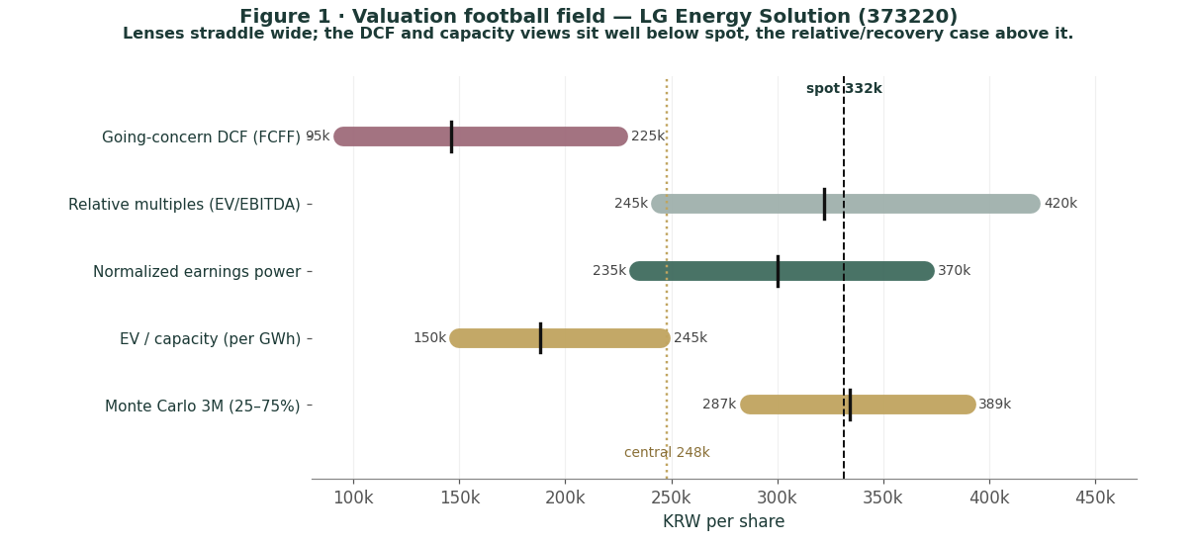
Figure 1 · Valuation football field — four lenses plus the Monte-Carlo 25–75% band. The DCF and capacity views sit well below spot; the relative and normalised lenses straddle it. Spot is above the weighted central — the signature of a modestly expensive stock, not an obvious bargain.
How to read this. The lenses do not cluster — they span a wide range, and that dispersion is itself the finding. Anchor on near-term fundamentals (discounted cash flow, replacement cost) and the stock looks ~30–40% rich; grant mid-cycle EBITDA and a growth multiple (relative, normalised) and it looks roughly fair. The weighted central sits below spot because we give the disciplined cash-flow lens real weight and refuse to underwrite a multi-decade super-cycle in the base case. None of this forecasts direction — the next sections describe a weak but two-sided price process — it states that, on the fundamentals, the price embeds a growth premium that current owner-level earnings do not yet support.
1.6 The operating businesses — a deeper look
LG Energy Solution is a single-product manufacturer sold into three end-markets, each at a different point in its own cycle. The scorecard sets out where each stands; the genuine forward driver is the shift in mix from electric vehicles toward energy storage.
Business | Position | Cycle now | Key tension
EV batteries (~75% of sales) | #3 global; ex-China leader | trough | N. American EV slowdown; Chinese cost
Energy storage (ESS) | scaling; 140GWh backlog | upcycle | execution; LFP ramp; on balance sheet
Cylindrical / 46-series | Tesla; six robotics firms | growth | yield; 300GWh+ backlog; format shift
IT / small-format | mature | stable | commoditised, price-driven
North-American JVs | GM (Ultium), Honda, others | building | AMPC accrues to JV partners (NCI)
Business scorecard — the three end-markets and the JV structure. Energy storage is the swing to the upside; the JV line is the swing to the crux.
Automotive cells — the core, in a cyclical trough
LG Energy Solution's revenue fell from a KRW 33.7tn peak in 2023 to KRW 25.6tn in 2024 and KRW 23.7tn in 2025 — a ~30% drawdown — as North-American EV demand slowed (the "EV chasm" between early adopters and the mass market), metal prices fell and dragged average selling prices down, and customers managed inventories tightly. That cyclical trough, not a structural break, is what the depressed owner earnings reflect; automotive cells are roughly three-quarters of sales, so the segment's recovery — volumes stabilising and utilisation climbing back toward the large plant base — is the single biggest swing in the model.
Energy storage (ESS) — the swing to the upside
The clearest forward driver is ESS. The global energy-storage market is growing far faster than EVs — management cites >40% growth — propelled by grid build-out and, increasingly, AI data-centre back-up power. LG Energy Solution is expanding LFP-based ESS capacity in North America (targeting >60GWh, more than 80% in the region), began local US production in Michigan in 2025, and reports a 140GWh ESS backlog. ESS sits largely on the company's own balance sheet rather than in the JVs, so margin and profit from it accrue more fully to the parent — which is precisely why it matters for the owner-attribution inflection.
Cylindrical 46-series — the new platform, and robotics optionality
The 46-series cylindrical cell — a Tesla format, now also designed into humanoid robotics, with a 300GWh+ backlog spanning Tesla and six robotics firms — and a mid-to-low-end LFP / high-voltage mid-nickel push diversify the demand base beyond passenger EVs. Management also notes that tighter US "Prohibited Foreign Entity" rules disadvantage Chinese rivals, a competitive tailwind for a localised, IRA-qualified producer. None of this carries a discrete line in the base numbers; it is optionality layered on top of the automotive recovery.
What it means for the model
The base case assumes EV volumes stabilise and grow modestly (management guides to >10% global EV-production growth in 2026), ESS scales rapidly, and the mix shift plus cost-downs lift the operating margin from ~6% toward ~12–13% by the end of the projection. That recovery, more than any single number, is what carries the DCF and the normalised-earnings lens. If EV demand instead double-dips, the trough extends and the bear case governs.
1.7 The AMPC and the minority interest — the crux of the valuation
Because the production credit is what makes LG Energy Solution profitable, and because that profit is shared with joint-venture partners, the entire valuation reduces to two linked questions: will the credit persist, and how much of the resulting profit ever reaches the parent's shareholders?
What the AMPC is, and where it lands. The US Inflation Reduction Act's section 45X Advanced Manufacturing Production Credit pays battery makers a per-kWh subsidy for cells and modules produced in the United States. LG Energy Solution earns it at its US plants, several of which are joint ventures with automakers (GM in Ultium; others with Honda, Hyundai, Stellantis, Toyota). In the accounts the credit appears chiefly in "other operating income" — KRW 1.65tn in 2025, KRW 1.48tn in 2024 — and it is the difference between a reported operating profit and an operating loss. Quarter by quarter in 2025 the dependence is stark: Q1 operating profit of KRW 375bn included KRW 458bn of credit; Q2's KRW 492bn included KRW 491bn (the company noted it was profitable even without the credit that quarter, on mix); Q4 was an operating loss of KRW 122bn despite KRW 333bn of credit.
Why the owners are attributed a loss. The US JV plants that earn the credit are partly owned by the automakers, who hold the non-controlling interests. So the credit-driven profit is split: in 2025, KRW 1,153.6bn of group profit went to those minorities and KRW (1,072.8bn) — a loss — to the parent's owners, whose share of the wholly-owned operations bears the EV-demand weakness and the group's finance costs. This is not an accounting quirk to be normalised away; it is the economic structure of the business as it stands. Any bullish thesis must therefore argue that the parent's attributed earnings inflect positive — as utilisation of the wholly-owned and majority lines recovers, as ESS (largely on the company's own balance sheet) scales, and as finance costs ease with deleveraging — not merely that the group earns credits.
What the price implies. At KRW 331,500 the market is plainly looking through current owner-level losses to that inflection. Our base case assumes the credit is largely retained (with a policy-risk haircut embedded in the projected margin) and that parent earnings turn positive from 2027e; that supports the DCF's KRW 146,000 and, with mid-cycle EBITDA, the relative lens's KRW 322,000. A bull assumes full retention, a faster ESS-led margin recovery and a re-rating — the KRW 415,000 case. A bear assumes the credit is curtailed by a hostile US administration and EV demand stays weak, so the parent's losses persist — the KRW 150,000 case. That, stated plainly, is the debate: not whether the franchise has value, but how much of the credit survives and how much of the resulting profit the parent's shareholders ever see.
1.8 Korea — governance, the value-up re-rating, and the won
Three Korea-specific forces bear on the valuation, though less decisively than the AMPC and the EV cycle. First, the won: unlike a domestic platform, LG Energy Solution is an exporter that sells in dollars and earns dollar-denominated credits, so a weaker won is, on balance, helpful to reported results and is carried as a small positive factor in the Monte Carlo. Second, Korea's "Corporate Value-Up" programme — directors' fiduciary duty to all shareholders, treasury-share cancellation, stronger board independence — has re-rated the KOSPI and could compress the governance component of the discount that Korean large-caps carry, though LG Energy Solution's issue is earnings attribution, not governance per se. Third, the cost of capital: a ~0.55 realized volatility implies a high beta and therefore a high cost of equity, which is why our 9.0% WACC, modest as it looks, still values the equity below spot. None of these is the swing factor — the credit and the cycle are — but each nudges the discount the shares deserve.
1.9 DCF sensitivity — how much the cross-check moves
The going-concern DCF lands at ~KRW 146,000 for the parent. The grid shows how the per-share figure moves with the discount rate and the terminal growth rate; because the value is overwhelmingly terminal (free cash flow is only modestly positive within the explicit window), the answer is highly sensitive to both.
Parent value/sh (KRW) | g = 2.5% | g = 3.0% | g = 3.5% | g = 4.0% | g = 4.5%
WACC 8.5% | 130,000 | 151,000 | 176,000 | 207,000 | 246,000
WACC 9.0% | 108,000 | 125,000 | 146,000 | 171,000 | 201,000
WACC 9.5% | 89,000 | 104,000 | 121,000 | 141,000 | 166,000
WACC 10.0% | 73,000 | 85,000 | 100,000 | 117,000 | 137,000
WACC 10.5% | 58,000 | 69,000 | 82,000 | 96,000 | 112,000
Reading the grid. Only the generous top-right corner (low discount rate, high terminal growth) reaches the mid-200,000s and the lower edge of the relative lens; the base cell sits near KRW 146,000, and no plausible WACC/g combination closes the gap to spot on cash flow alone. That is the point of the cross-check: the price is supported by mid-cycle multiples and the recovery narrative, not by discounted operating cash flow, which — net of debt and the minority interest — values the equity well below KRW 331,500. The Excel companion lets a reader change the WACC, the terminal growth, the AMPC haircut and the capex taper and watch the bridge move.
2 Technical and price structure
Technicals describe the price, not the value. They matter here for one reason: a high-beta cyclical that has fallen sharply, sits below every moving average and is approaching oversold is as capable of a violent mean-reverting bounce as of further drift lower. The structure is a clear downtrend off the spring high, with the shares in the lower third of their 52-week range.
Indicator | Reading | Interpretation
Spot vs 52-week high | KRW 331,500 / 514,000 | off the high −36%
52-week range | 288,000 – 514,000 | +15% off the low
SMA 20 / 50 / 200 | 399,725 / 423,510 / 407,345 | falling stack (bearish)
RSI (14) | 33 | approaching oversold
ATR (14) | 24,357 (7.3%) | elevated daily range
Realized vol 60d / full | 61% / 55% | recent vol > long-run
Skew / excess kurtosis | +0.42 / +2.5 | right-skewed, fat tails
Technical indicators at the 26-Jun-2026 close.
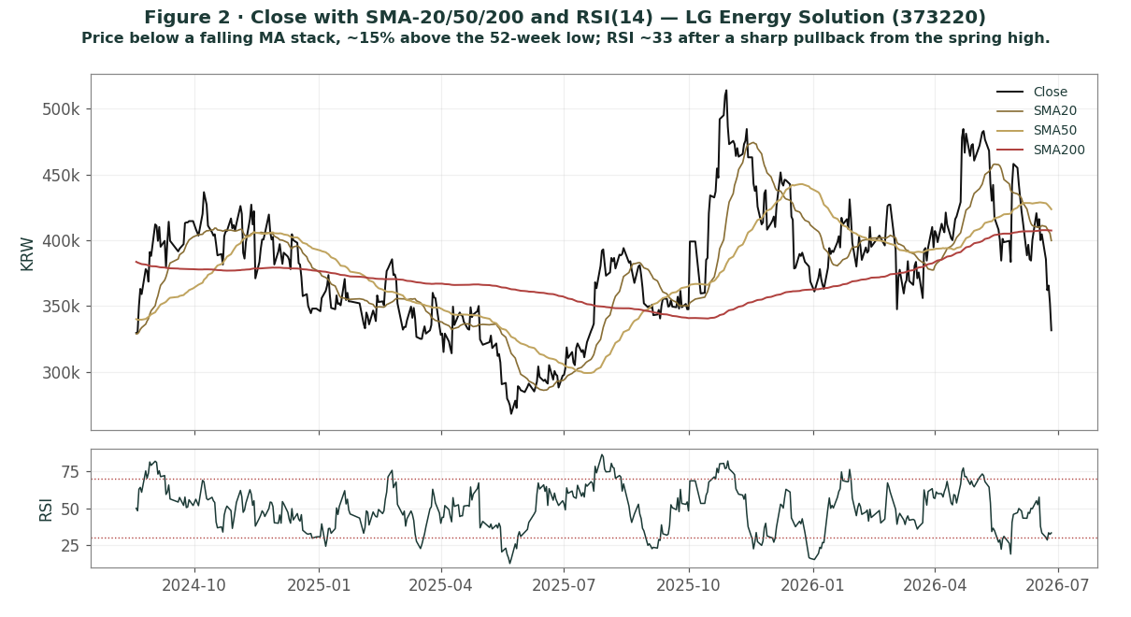
Figure 2 · Close with moving-average stack and RSI(14). Price sits below a falling 20/50/200 structure, ~15% above the 52-week low, with RSI ~33 after a ~21% three-month slide.
The honest technical read. The trend is down and the moving averages are stacked bearishly (spot KRW 331,500 against the 20-day ~KRW 400,000, 50-day ~KRW 424,000 and 200-day ~KRW 407,000), with price beneath all three. RSI near 33 is approaching oversold — which often precedes a bounce but is not, on its own, a reversal signal — and ATR near KRW 24,400 (~7% of price) confirms how violent daily ranges are; realized volatility near 55% annualised means moves in either direction can be large. The 52-week range is KRW 288,000–514,000, so spot sits about 15% above the low and ~36% below the high. Nearest meaningful resistance is the falling 20-day near KRW 400,000, then the 50-day near KRW 424,000. The technical and fundamental pictures are consistent: a beaten-down cyclical trading at a premium to discounted cash flow, where the question is whether the recovery the price embeds actually arrives.
3 Monte Carlo — a probabilistic price map
This models the price over the next three months, not value. We simulate 50,000 paths (seed 42) from a 16-factor structure — seven continuous drivers and nine discrete event risks — calibrated to LG Energy Solution's own realized volatility, scaled by the 0.84x factor that passed the Step-0 backtest (Appendix B). It answers "where could the price plausibly be, and with what probability", not "what is the company worth". The paths diffuse from spot as a near-term price process and deliberately do not embed the fundamental valuation — the ~25% gap of Section 1 is kept out of the drift, so the fundamental and probabilistic lenses stay independent.
The 16 factors. Continuous (7): EV-battery demand / volumes, energy-storage and AI-data-centre demand, battery ASP / lithium pricing, cost-down and efficiency, USD/KRW translation, KOSPI / market beta, and the 46-series cylindrical / robotics ramp. Discrete events (9): a major OEM or ESS supply win (p~0.28, +7%), an energy-storage / AI-data-centre mega-order (p~0.28, +6%), an oversold technical bounce (p~0.38, +5%), an AMPC / IRA policy cut (p~0.22, −15%), an EV-demand negative shock (p~0.24, −8%), an earnings miss or guidance cut (p~0.26, −6%), a lithium / metal-price spike that squeezes margin (p~0.15, −5%), a Korea value-up / index-flow event (p~0.22, +4%), and a utilisation / capacity positive surprise (p~0.22, +5%).
Net three-month drift is roughly flat (~+1%), total three-month volatility ~23% (~55% annualised), and the distribution is mildly right-skewed — the positive catalyst set (supply wins, the storage ramp, an oversold bounce) modestly outweighs the negative in expectation, while the single sharpest event is the AMPC cut on the downside. The drift is built from these forward factors rather than from raw trailing momentum: a literal extrapolation of the past quarter's ~21% decline would put the median far lower, but we do not assume the downtrend simply continues, and carry realized momentum only as one editable factor among sixteen.
Percentiles of the simulated price (KRW per share)
Horizon | 5% | 25% | Median | 75% | 95%
T+20 (~1 month) | 268,200 | 304,400 | 332,400 | 363,000 | 411,900
T+60 (~3 months) | 230,500 | 286,900 | 334,200 | 389,200 | 484,500
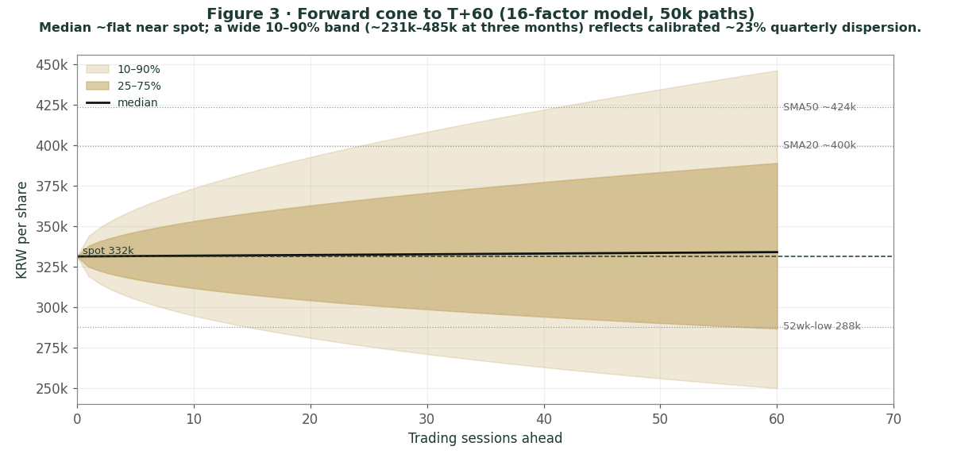
Figure 3 · Three-month fan chart — percentile cone of simulated paths from spot; median ~flat, a very wide 10–90% band (~231k–485k at three months).
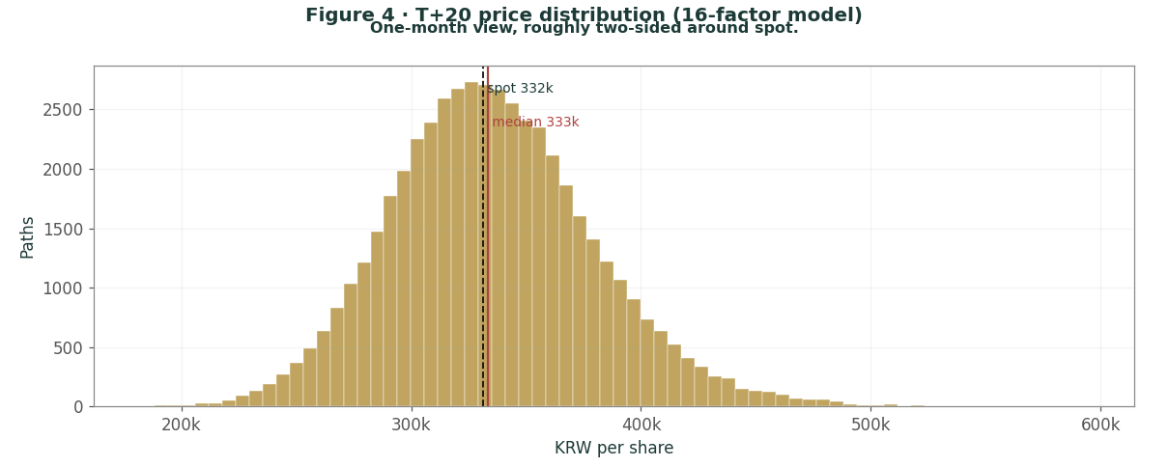
Figure 4 · Distribution of the price at T+20 (~1 month) — roughly two-sided around spot.
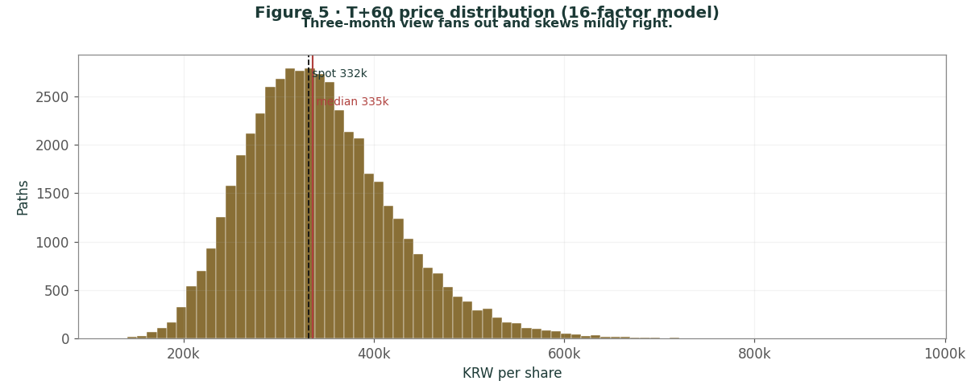
Figure 5 · Distribution of the price at T+60 (~3 months); note the mild right skew and fat tails.
Level-touch probabilities — chance the price reaches a level at any point in the window
Level | by T+20 | by T+60 | Note
370,000 ▲ | 33% | 59% | toward the falling 20-day
410,000 ▲ | 8% | 32% | toward the 50-day
450,000 ▲ | 2% | 16% | above the 50-day
300,000 ▼ | 35% | 59% | first support test
270,000 ▼ | 9% | 31% | deeper pullback
240,000 ▼ | 1% | 13% | toward the DCF / bear zone
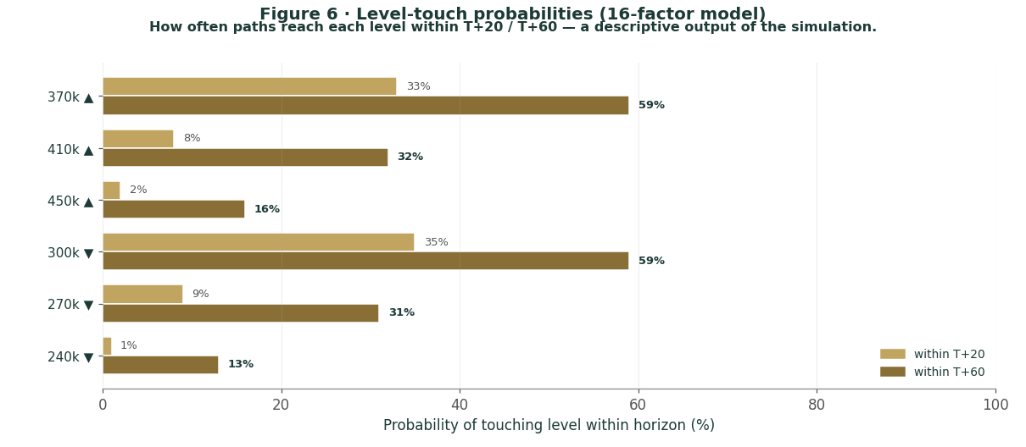
Figure 6 · Upside and downside touch ladders over the three-month window.
What the map says. Over three months a move up to the falling 20-day around KRW 370,000 is a coin-flip-ish ~59%, while a push above KRW 410,000 toward the 50-day is a lower-probability ~32% — an oversold bounce is plausible but the falling averages sit overhead. On the downside, a slide to KRW 300,000 is about as likely (~59%), and a deeper retest toward KRW 270,000 is a non-trivial ~31%. Crucially, this near-term map and the fundamental finding are not in conflict: the price can wander within a wide band over three months while the fundamental lenses sit ~25% below spot. The Monte Carlo describes the former; Section 1 describes the latter, and the two are deliberately decoupled.
4 Comparison of the lenses, and a verdict
Lens | What it measures | Output | vs spot
Going-concern DCF (FCFF) | operating cash flow, net of debt & minorities | 146,000 | -56%
Relative multiples | mid-cycle EV/EBITDA vs CATL | 322,000 | -3%
Normalised earnings | through-cycle parent earnings power | 300,000 | -9%
EV / capacity | asset / replacement value per GWh | 188,000 | -43%
Weighted central |  | 248,000 | -25%
Monte Carlo median (T+60) | near-term price process (not value) | 334,200 | +1%
Verdict — modestly expensive; the whole case is an EV-cycle and AMPC-policy bet. The fundamental lenses span an unusually wide range, but their weighted centre, KRW 248,000, sits about 25% below spot. The disciplined cash-flow and capacity lenses — which refuse to extrapolate a super-cycle — say the shares are ~30–40% rich; the relative and normalised lenses, which grant mid-cycle EBITDA and a growth multiple, say roughly fair. The technical trend is weak — the shares sit in the lower third of their range, below falling averages, RSI ~33 — and the three-month price map is wide and roughly centred on spot. A buyer at this level is not buying an obvious discount to value; they are underwriting one proposition: that North-American EV demand stabilises, that energy storage and the cylindrical/robotics franchises scale, that the US production credit is retained, and that the parent's attributed earnings inflect back to positive as capex normalises. If that recovery lands, the bull case at KRW 415,000 is reachable; if the credit is curtailed or EV demand double-dips, the downside to the bear case at KRW 150,000 is large. This study expresses a valuation, not a trade, and certainly not advice.
5 Catalysts to watch
US tax policy — the AMPC (↑/↓, highest impact). Any change to the section 45X production credit under the current US administration is the single largest swing factor; retention supports the base case, curtailment drives the bear case.
Energy-storage and AI-data-centre orders (↑). New ESS order wins and capacity ramps — especially North-American, on-balance-sheet volume — are the clearest evidence of the parent-earnings inflection and the most powerful upside lever.
EV-demand trajectory (↑/↓). North-American and European EV-volume data, and major customers' inventory behaviour, drive the top line and utilisation; a stabilisation lifts margins, a double-dip extends the trough.
OEM and format wins (↑). New supply agreements, 46-series cylindrical design-ins (including robotics), and LFP / mid-nickel program awards diversify demand and support volumes.
Quarterly margin and capex (↑/↓). The ex-credit operating margin and the pace of the guided >40% capex cut are the clearest reads on the cash-flow inflection that the DCF turns on.
KRW and Korea value-up (↑). A weaker won helps dollar revenue and credits; governance / index-flow developments can compress the discount Korean large-caps carry.
6 Reading the probability zones
Combining the fundamental anchors with the three-month price map gives a set of zones — descriptive, not directive.
Zone | Range (KRW) | What it would mean
Recovery re-rating | 410,000 – 485,000+ | ESS/AI super-cycle, credit retained, margins inflect
Bounce underway | 370,000 – 410,000 | oversold mean-reversion toward the falling averages
Central / churn | 300,000 – 370,000 | where spot sits; cycle stabilising, debate unresolved
Fundamental gap | 240,000 – 300,000 | price drifts toward the relative/normalised lenses
Bear / AMPC-cut | < 200,000 | credit curtailed and EV weak; DCF / capacity zone
7 Caveats and what would change our mind
The AMPC is a policy variable, and it is the swing factor. Reported profitability depends on the US production credit; a hostile change to section 45X would reset the earnings base and the valuation in the bear direction. This is the single biggest source of error in the model, and it is a political judgment we cannot make with confidence.
The minority-interest treatment is a simplification. We subtract the minority interest at its ~KRW 9.1tn book value to isolate the parent's equity. If the JV partners' economic share of the credit-earning plants is worth more than book, parent value is lower than our estimate; if the wholly-owned and ESS businesses come to dominate value, it is higher. The Excel companion lets a reader change this bridge.
The DCF is terminal-heavy and assumption-sensitive. Free cash flow is only modestly positive within the explicit window, so the answer leans on the terminal — and therefore on the WACC, the terminal growth, the margin recovery and the capex taper. Reasonable analysts will choose differently; section 1.9 shows the range.
The Monte Carlo is a price model, not a forecast. It encodes our probability estimates for events that have not happened. The factor probabilities are inputs, not facts, and the model says nothing about value.
RSI / momentum reminder. RSI ~33 is approaching oversold, which often precedes a bounce — but a high-beta name in a downtrend with realized vol near 55% can keep falling. Do not mistake "oversold" for a margin of safety; the margin of safety, if any, is in the recovery the price already embeds, not the indicator.
Appendix A Financial statements (KRW tn)
Actuals for FY2024 and FY2025 are LG Energy Solution's audited consolidated figures under K-IFRS (Deloitte Anjin, opinion dated 5 March 2026); FY2023 revenue and operating profit are from company disclosure, with other FY2023 lines estimated and flagged. Forecast columns (2026e–2030e) are the preparer's illustrative operating build that ties to the Excel companion; they assume management's 2026 guidance (revenue +15–20%, mid-single-digit operating margin, capex −40%+) and a gradual margin recovery thereafter. The AMPC line is the production credit (mostly in "other operating income"); "operating profit ex-AMPC" is shown to make the credit dependence explicit. Note the owner / non-controlling split: the credit-driven profit accrues largely to the JV minorities, so the parent's attributed result is the relevant figure for the stock.
A.1 Consolidated income statement (KRW tn)
Income statement | 2023a | 2024a | 2025a | 2026e | 2027e | 2028e | 2029e | 2030e
Total revenue | 33.75 | 25.62 | 23.67 | 27.70 | 31.40 | 35.20 | 38.70 | 42.20
growth YoY | — | (24%) | (8%) | +17% | +13% | +12% | +10% | +9%
AMPC / other op. income | 0.66 | 1.48 | 1.65 | 1.55 | 1.65 | 1.75 | 1.80 | 1.90
Operating profit (incl. AMPC) | 2.16 | 0.58 | 1.35 | 1.66 | 2.20 | 2.99 | 4.06 | 5.28
OP margin | 6.4% | 2.2% | 5.7% | 6.0% | 7.0% | 8.5% | 10.5% | 12.5%
Operating profit ex-AMPC | 1.50 | (0.91) | (0.30) | 0.11 | 0.55 | 1.24 | 2.26 | 3.38
Pre-tax profit | 1.80 | 0.35 | 0.41 | 0.60 | 1.30 | 2.40 | 3.40 | 4.50
Net profit — group total | 1.40 | 0.34 | 0.08 | 0.50 | 1.10 | 1.90 | 2.70 | 3.60
of which non-controlling int. | 0.60 | 1.36 | 1.15 | 0.80 | 0.70 | 0.70 | 0.70 | 0.70
Net profit — to owners | 0.80 | (1.02) | (1.07) | (0.30) | 0.40 | 1.20 | 2.00 | 2.90
EPS — to owners (KRW) | 3,400 | (4,354) | (4,585) | (1,280) | 1,710 | 5,130 | 8,550 | 12,390
Note. FY2023 net lines are estimates (only revenue and operating profit are disclosed for that year here). The decisive feature is the owner / non-controlling split: in 2024–25 the production-credit profit accrued to the JV minorities and the parent's owners were attributed a net loss; the projection shows that result inflecting positive from 2027e as utilisation recovers, ESS scales and finance costs ease — the inflection on which the DCF and the normalised-earnings lens rest.
A.2 Consolidated balance sheet (KRW tn)
Balance sheet | 2023a | 2024a | 2025a | 2026e | 2027e | 2028e | 2029e | 2030e
Cash & cash equivalents | 4.5 | 3.90 | 3.78 | 4.5 | 5.5 | 6.5 | 7.5 | 9.0
Property, plant & equipment | 30.0 | 38.35 | 40.79 | 42.0 | 43.0 | 44.0 | 45.0 | 46.0
Total assets | 47.5 | 60.31 | 67.15 | 69.0 | 71.0 | 73.0 | 76.0 | 79.0
Borrowings, bonds & leases | 12.5 | 15.39 | 22.51 | 22.0 | 21.0 | 20.0 | 19.0 | 18.0
Total liabilities | 23.1 | 29.34 | 37.83 | 38.0 | 38.0 | 38.0 | 38.5 | 39.0
Equity attributable to owners | 20.20 | 21.12 | 20.22 | 20.5 | 21.0 | 22.0 | 23.5 | 25.5
Non-controlling interests | 4.17 | 9.85 | 9.11 | 9.5 | 10.0 | 10.5 | 11.0 | 11.5
Total equity | 24.37 | 30.97 | 29.32 | 30.0 | 31.0 | 32.5 | 34.5 | 37.0
BVPS — owners (KRW) | 86,300 | 90,250 | 86,390 | 87,600 | 89,700 | 94,000 | 100,400 | 109,000
Net debt (debt − cash) | 8.0 | 11.49 | 18.73 | 17.5 | 15.5 | 13.5 | 11.5 | 9.0
Note. FY2024 and FY2025 totals are the audited figures (total assets KRW 67.1tn, equity to owners KRW 20.2tn, non-controlling interests KRW 9.1tn, borrowings KRW 22.5tn, cash KRW 3.8tn at end-2025); FY2023 is partly estimated. The non-controlling-interest line jumped from KRW 4.2tn (end-2023) to KRW 9.9tn (end-2024) as the US JV build-out and credit accrual landed — the balance-sheet signature of the same dynamic that drives the owner-loss attribution. Net debt rose sharply in 2025 on the capacity build and is projected to fall as free cash flow turns positive.
A.3 Consolidated cash flow (simplified, KRW tn)
Cash flow | 2023a | 2024a | 2025a | 2026e | 2027e | 2028e | 2029e | 2030e
Operating cash flow | 4.0 | 5.11 | 4.43 | 5.0 | 6.0 | 7.0 | 7.8 | 8.5
Capital expenditure | (10.0) | (12.40) | (10.83) | (6.5) | (5.8) | (5.5) | (5.5) | (5.5)
Free cash flow | (6.0) | (7.29) | (6.40) | (1.5) | 0.2 | 1.5 | 2.3 | 3.0
The point of A.3 for the valuation. Operating cash flow is solid and rising, but the capital-spending peak (KRW 12.4tn in 2024, KRW 10.8tn in 2025) drove free cash flow deeply negative. The guided >40% capex cut for 2026 and the taper thereafter are what turn free cash flow positive from 2027e — the inflection that the DCF in 1.1 discounts, and the reason the cash-flow lens, while below spot, is not catastrophic.
Appendix B Step 0 — calibration backtest
Before running the forward simulation we backtest the engine on LG Energy Solution's own history (since the January-2022 IPO, ~4.4 years). We generate 3-month-ahead forecast distributions on a rolling basis, then check two things: are the probability-integral-transform (PIT) values uniform (no systematic bias), and do the 50/80/90% bands contain the realized price at their stated rates? LG Energy Solution's trailing volatility over-disperses 3-month outcomes (the violent 2022 IPO-period volatility inflates the trailing window), so the engine required a volatility scale of 0.84x — a deflator, the opposite of most names — to pass.
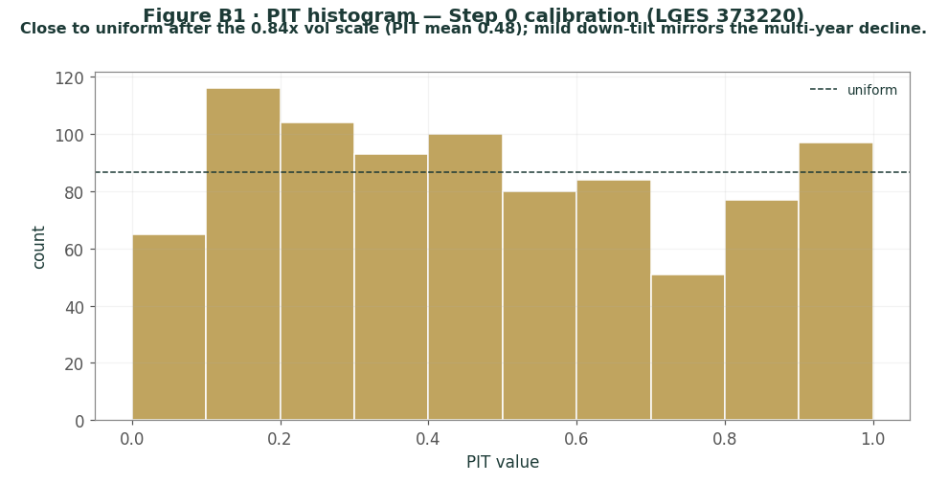
Figure B1 · PIT histogram — close to uniform after the 0.84x volatility scale (PIT mean ~0.48); the mild downward tilt mirrors the multi-year price decline and is honestly flagged.
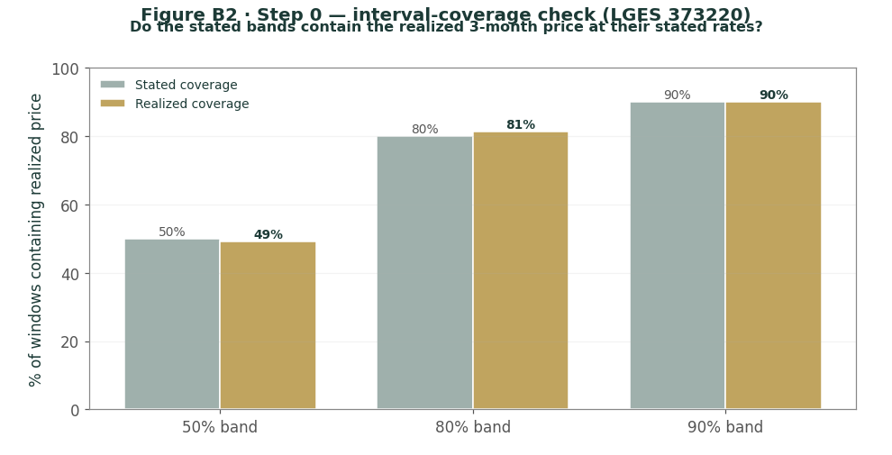
Figure B2 · Interval coverage — stated vs realized band coverage; 49/81/90% against the 50/80/90% targets.
The calibration passes: coverage is 49/81/90% against the 50/80/90% targets and the PIT spread matches uniform. The only blemish is a mild downward PIT tilt (mean ~0.48 rather than 0.50) — the realized price lands a touch below the forecast median on average, a genuine reflection of LG Energy Solution's multi-year decline, the mirror image of a secular-uptrend name. It is mild enough to pass without a drift override, so the forward simulation uses the calibrated 0.84x scale and a factor-built drift.
Appendix C Peer set, sector structure, and risks
C.1 The competitive map
Arena | Leader | LG Energy Solution | Note
Global EV batteries | CATL (~39%) | #3, ~9% share | Korean trio (LGES/SK On/Samsung SDI) ~16% and ceding share to China
Ex-China / North America | LG Energy Solution | leader | IRA-qualified local capacity; "Prohibited Foreign Entity" rules favour it
Energy storage (ESS) | CATL | scaling fast | 140GWh backlog; LFP capacity building in North America
Cylindrical / 46-series | Panasonic / LGES | 300GWh+ backlog | Tesla format; design-ins at six robotics firms
Valuation (EV/EBITDA) | CATL ~10.4x | ~21x trailing (depressed) | LGES screens high on trough EBITDA; ~11x on mid-cycle
C.2 Principal risks
US policy / AMPC repeal. The dominant risk: curtailment of the section 45X credit would reset reported profitability and the valuation.
EV-demand double-dip. A renewed slowdown in North-American or European EV sales would extend the revenue trough and delay the margin recovery.
Minority-interest leakage. If the credit-driven profit continues to accrue to JV partners rather than the parent, owner-level earnings may not inflect as projected.
Chinese competition and price. CATL and BYD's scale and cost advantage, and falling battery / lithium prices, pressure ASPs and share.
Leverage and capex. Net debt of ~KRW 18.7tn and a large depreciation load mean execution on the capex cut and the cash-flow inflection is essential; a stalled recovery would strain the balance sheet.
Technology shifts. Solid-state, LFP/sodium and format transitions could erode the value of installed capacity if LG Energy Solution is late.
About this series
Testahil publishes independent, educational valuation studies. Each is an attempt to reason transparently about what a security is worth, with every assumption shown and a companion model so readers can disagree productively. The house style is distributions, not tips: we describe ranges and probabilities, not targets, and we do not tell anyone what to do. Studies are framed as educational analysis, the preparer is not licensed by any securities regulator, and holdings are disclosed.
Disclosure & Disclaimer
Not advice; educational only. This document is an independent, educational valuation study and an expression of personal analytical opinion. It is not investment advice, not a research report prepared for any client, and not a recommendation or solicitation to buy, sell or hold any security. It does not take account of any reader's objectives, financial situation or needs. Consult a licensed financial advisor before making any investment decision.
No licence; no business relationship. The preparer is not licensed or registered as an investment adviser, broker-dealer, research analyst or financial professional by any securities regulator in any jurisdiction, holds no Korean or other brokerage authorisation, manages no money, solicits no clients, and accepts no fees, funds or accounts.
Holdings disclosure. The preparer may hold, and may in the future take or dispose of, a position in the security discussed in this report, and may transact at any time without notice. This is a potential conflict of interest you should weigh.
Sources & accuracy. Reported financial and operating figures are drawn from LG Energy Solution's audited consolidated financial statements and public disclosure and other public sources believed reliable but not independently verified; they may contain errors or be superseded. Forward-looking inputs — the AMPC retention assumption, the projections, the multiples, the minority-interest bridge, the DCF and the Monte-Carlo factor probabilities — are the preparer's own judgments and are inherently uncertain.
No liability. To the maximum extent permitted by law, the preparer accepts no liability for any loss arising from any use of this document. All values are model outputs and may differ materially from actual outcomes. Past performance and backtests do not guarantee future results.
Currency & figures. All figures are in Korean won (KRW) unless stated; "tn" denotes trillion and "bn" billion. Per-share values are rounded. Valuation is computed on the parent's attributable equity (234.0m shares) as of the 26 June 2026 close.

