Testahil · Independent Valuation Study — Educational Analysis Not investment advice
Lulu Retail Holdings PLC (ADX: LULU)
Fundamental analysis · Technical analysis · Monte Carlo simulation — one integrated read
Anchor: AED 0.94 (10 Jul 2026 close) · 10,328.9 mn shares · mkt cap ~AED 9.7 bn · 277 stores and ~1.40m sqm across six GCC states — #1 in the GCC modern grocery market on a 13.5% share, and #1 in four of its six countries. Reporting currency US$ (AED pegged 3.6725). This study builds the company the way a retailer is built — stores → space → sales density → revenue → operating leverage → EBITDA — and it does so almost entirely from the company's own disclosure, because Lulu discloses more than most analysts use: segment revenue AND segment EBITDA, the hypermarket/express format split, and, in Q1-2026, the growth rate of its own operating cost base.
READ FIRST — what this document is, and is not. This study is a valuation exercise and an expression of personal analytical opinion, published free of charge for educational purposes. It is NOT investment advice, NOT a recommendation or solicitation to buy, sell or hold any security, and NOT directed at the circumstances of any reader. The preparer is not licensed by any securities regulator, holds no brokerage or advisory authorisation, manages no money, and accepts no fees or clients. All values are model outputs presented as ranges and distributions, because no single number should be relied on.
Reported financials are the company's own disclosure — the FY2023–FY2025 audited consolidated financial statements (Deloitte & Touche ME, unqualified, 18 March 2026) and the Q1-2026 interim results (11 May 2026). The Q1-2026 press release discloses revenue (−2.9%), gross profit (US$449mn), EBITDA (US$192mn), net income (US$47mn), the operating-cost growth rate (+1.1% excluding depreciation), and a store table showing 11 Express openings totalling 20,153 sqm less one 227 sqm Mini Market closure — 10 NET, taking the estate to 277. Every one of those numbers is used here as reported. Forward-looking inputs — store additions, the sales-density path, mature-store cost inflation, the cost of capital, the exit multiple and the Monte-Carlo factor probabilities — are the preparer's judgments and are flagged throughout.
THREE STRUCTURAL CAVEATS, STATED UP FRONT. (1) LULU listed on 14 November 2024. Its 410 sessions of history yield only two non-overlapping 60-day test windows, against the eighteen or so a meaningful test needs. There is NO name-level calibration verdict for LULU and this study claims none: the Monte Carlo is validated on the 14-name UAE market panel. (2) The DCF terminal is an observable exit EV/EBITDA multiple, NOT a Gordon formula — at the sourced WACC of 5.64% a Gordon terminal implies an 88% terminal-value share, which is a bet on the discount rate wearing a valuation's clothes. (3) Bank debt and lease liabilities are DERIVED from the company's stated leverage ratios rather than read off a debt note; the derivation is cross-checked twice — against right-of-use assets, and against the disclosed interest expense — and flagged everywhere it appears.

The company. Lulu Retail is the shop most of the Gulf actually buys its groceries in. Grown from a single Abu Dhabi store by Yusuff Ali M.A. into 277 hypermarkets, express and mini-market stores across all six GCC states, it serves more than 690,000 shoppers a day from 130 nationalities, and it does so by importing directly: an on-the-ground sourcing presence in 19 countries, buying from 85, an own-import chain deep enough that when the Strait of Hormuz closed in the spring of 2026 the company airlifted staples and kept every store open and stocked. It is the largest modern grocer in the GCC on a 13.5% share, and number one in Oman, Qatar, Kuwait and Bahrain. It listed on ADX in November 2024 at AED 2.04 in the year's largest UAE IPO — a purely secondary sale in which the founding family took AED 6.32bn off the table and the company itself received nothing. The stock has since fallen 54%. The business earns a 23% gross margin, turns it into a 9.9% EBITDA margin, sells 30% private label, grew e-commerce 61% last quarter, and pays out almost all of its accounting profit — while covering that dividend 1.4 times over in cash. What it does not do is grow quickly. And what this study will show is that its sales per square metre are falling.

Q1-2026 — the print this study is built on, read carefully
Lulu reported Q1-2026 on 11 May 2026. Revenue fell 2.9% to US$2,020mn; gross profit was US$449mn (a 22.2% margin, against 22.3% a year earlier — broadly flat); EBITDA was US$192mn (9.5%); net income was US$47mn. Eleven new stores opened — all Express format, totalling 20,153 sqm — and one Mini Market was closed, taking the estate to 277. E-commerce grew 61% to US$150mn (7.9% of sales). Private label reached 30.2%.
Now read the shape of it, because the headline hides the shape. Management is explicit: trading in January and February was in line with expectations. The slowdown came in March — and it was not in food. Consumer Packaged Goods and Fresh Food both grew year-on-year. Lifestyle fell modestly. Electrical fell sharply, and "mostly during March". This is the signature of a discretionary-demand deferral, concentrated in one month, coinciding with the hardening of the Strait of Hormuz closure and a Brent price that passed US$100 on 8 March. It is not the signature of a grocery business losing its customers.
And management is equally explicit about the cost side: operating expenses excluding depreciation increased by just 1.1% year-on-year — despite eleven new stores — because there was "a mid-single digit percentage reduction in staff costs in existing stores". That single sentence is the most valuable disclosure in the release, and §1.3 uses it to rebuild this company's entire cost model without assuming anything.

Headline
The weighted fundamental central sits at AED 1.28 against a 0.94 spot — about +36.0% — inside a bear–bull span of 0.78–1.74. The operative number is not the margin. It is sales per square metre, which fell -1.4% across FY2025 and roughly -8% in Q1-2026. Lulu is adding space into declining productivity, and because operating costs track space while revenue tracks space × density, the EBITDA margin falls whenever density falls faster than mature-store costs can be cut. That is not a model. It is arithmetic on four disclosed numbers, and it reproduces the Q1 margin bridge exactly: -73bp of margin, of which -65bp is operating deleverage and only -7bp is gross margin. Meanwhile the 60-session Monte Carlo is near-flat (median AED 0.93, -0.7%): the 7.45% dividend yield exceeds the 3.65% money-market rate, pulling the price centre down, and a post-war event ledger pushes it back up. Two clocks, not a contradiction.

Valuation summary — every read at a glance
Lens | Bear | Base | Bull | Weight | One-line read
FCFF DCF (segment-built) | 0.66 | 1.54 | 2.39 | 30% | six countries built from space and density; WACC 5.64%; terminal 7.5× FY30E EBITDA
Relative EV/EBITDA | 0.90 | 1.18 | 1.46 | 30% | 6.5–8.5× FY26E; spot 6.63× — but 7.15× after leases (§1.5)
Dividend discount | 0.70 | 1.15 | 1.50 | 25% | 6.0 fils; the payout is 96% of earnings but 1.40× covered by CASH
Normalized earnings | 0.91 | 1.16 | 1.41 | 15% | through-cycle EPS 0.083 × 11–17× GCC staples
Weighted central | 0.78 | 1.28 | 1.74 | 100% | +36.0% vs spot; the crux is sales density

The bear central of AED 0.78 sits 17% BELOW spot. It is the world in which the March demand shock proves structural: density keeps falling ~1pp a year, the cost programme runs out, and the FY30E margin erodes to 7.8%.

The operating dashboard — what actually drives this company
KPI | FY2024 | FY2025 | Q1-2026 | Reading
Stores | 247 | 267 | 277 | 11 opened (all Express) less 1 closed = 10 NET
Retail space (m sqm) | 1.307 | 1.380 | 1.400 | Q1 added 20,153 sqm less a 227 sqm closure
Sales density (US$/sqm) | 5,832 | 5,749 | — | -1.41% FY25; ~-8% Q1-26 — the crux
Revenue (US$ mn) | 7,621 | 7,934 | 2,020 | +4.1% FY25; −2.9% Q1-26 (Jan/Feb in line; March fell)
Gross margin | 23.16% | 22.98% | 22.23% | vs 22.3% in Q1-25 — broadly flat
Cash opex growth | +6.5% | +5.5% | +1.1% | DISCLOSED. Mature-store staff costs fell mid-single-digit.
EBITDA margin | 10.39% | 9.86% | 9.50% | vs 10.23% in Q1-25 → -73bp
Like-for-like sales | +2.3% | +2.3% | n/d | Q4-25 turned NEGATIVE at −1.1%
Category mix | — | — | CPG & Fresh UP | Lifestyle down; Electrical sharply down, mostly in March
Private label % of sales | 29.6% | 29.8% | 30.2% | rising — but the gross margin is not
E-commerce % of sales | ~4.5% | 6.0% | 7.9% | +61% y/y
Loyalty-linked sales | — | ~67% | ~70% | 610k new members in the quarter
Capex % of revenue | 1.79% | 1.75% | 1.3% | DISCLOSED Q1 — inside the 1.2–1.5% guide
Net debt / EBITDA (IFRS-16) | — | 3.2× | 3.3× | 1.1× / 0.9× excluding leases
Dividend per share | 3 fils | 7 fils | — | 1.40× covered by cash; 96% of earnings

1 Fundamental valuation
A grocery retailer is not a revenue-growth percentage. It is an estate — a fixed quantity of square metres, on long leases, staffed by people whose wages do not fall when footfall does. Revenue is what that estate produces per square metre. Margin is what survives the cost base after it does. This section builds Lulu in that order, and it does so from disclosure: the company reports revenue and EBITDA by country, publishes its hypermarket/express format split and its average hypermarket size, and — in the Q1-2026 release — states the growth rate of its own operating expenses. Those three disclosures are enough to rebuild the machine.

1.1 The estate — and the number nobody quotes
Lulu ended FY2025 with 267 stores and 1.380m square metres, having added 20 stores and 72,926 sqm. In Q1-2026 it opened 11 more — all Express — totalling 20,153 sqm (1,832 sqm each) and closed one 227 sqm Mini Market, for a net 19,926 sqm. Space grew 5.6% in FY2025. Revenue grew 4.11%. Those two numbers do not agree, and the disagreement is the whole story.
 | FY2024 | FY2025 | Q1-2026
Retail space (m sqm) | 1.307 | 1.380 | 1.400 (net +19,926 sqm)
Revenue (US$ mn) | 7,621 | 7,934 | 2,020
SALES DENSITY (US$ per sqm) | 5,832 | 5,749 | —
change, year on year | — | -1.41% | ~-8.1%

Sales density — revenue per square metre — is the central operating metric of grocery retail, and Lulu does not report it. Derived from the space and revenue the company does report, it fell -1.41% in FY2025. In Q1-2026 it fell roughly -8%. The Q1 figure carries one estimate — first-quarter 2025 space, which the company does not disclose — so it is BOUNDED (-9.4% to -4.3%) rather than asserted, the bound depending entirely on how FY2025's twenty openings were phased through that year. It is negative on every assumption. Lulu is adding square metres into declining productivity.
How to read Figure 2. Both panels show the same thing — how hard each square metre of shop floor is working — from two angles. The left panel is the level: floor space (the bars) keeps climbing while density (the line) falls away from it. The right panel is the rate of change, laid out in time order, and it is the one to look at: zero means a square metre sold exactly what it sold a year ago, and Lulu has been below zero since FY2025. Q1-2026 is the cliff. The bars to the right of it are not history — they are this study's assumptions, and the gap between them and the green line is precisely what separates this study from management's guidance.
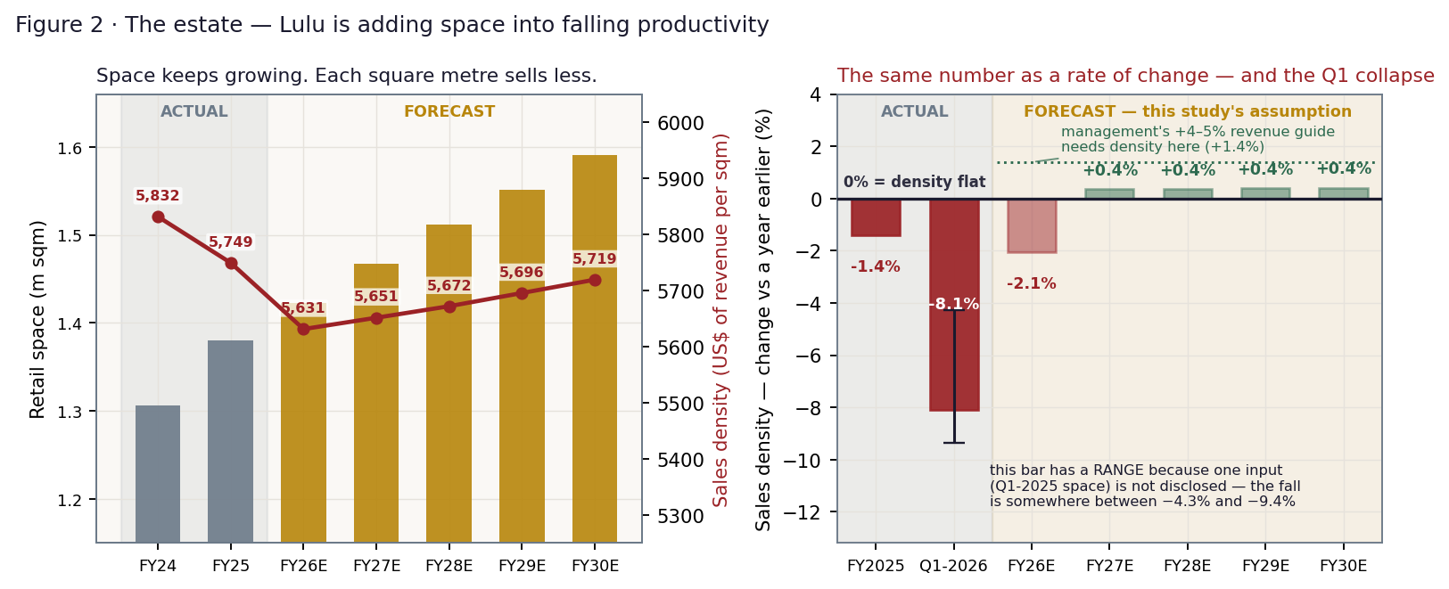
Figure 2 · Both panels show the SAME metric — sales density, the revenue each square metre of shop floor produces in a year. LEFT: the level. Gold bars are floor space (left axis) and the red line is density (right axis); the shaded band on the left of each panel is what has actually happened, the rest is this study's forecast. Space rises every year; the line does not follow it. RIGHT: the same density as a RATE OF CHANGE, in time order. Zero is the line that matters — above it each square metre sells more than it did a year earlier; below it, less. Lulu has been below it since FY2025, and in Q1-2026 it fell off a cliff. That one bar carries a range because a single input behind it (first-quarter 2025 floor space) is not disclosed, so the fall can only be placed between −4.3% and −9.4% rather than pinned exactly; it is negative on every assumption. The pale bars to its right are what this study ASSUMES happens next — a partial recovery to −2.1% in FY2026, then stabilisation. The dotted green line is what management's +4–5% revenue guidance requires instead: density rising +1.4%. The distance between the pale bars and that green line is the entire disagreement between this study and the company.

1.2 Six countries — and the Saudi problem, measured properly
Lulu discloses revenue and EBITDA by country. It also publishes its format split (123 hypermarkets, of which 43 in the UAE, 30 in Saudi Arabia, 21 in Oman, 11 in Qatar, 8 in Kuwait, 9 in Bahrain) and the average selling area of a hypermarket (9,200 sqm). Combine those with the 1,832 sqm Express store the Q1 release reveals, and segment space can be rebuilt — reconstructing the disclosed 1.380m sqm estate to within 0.6%. Which means segment density can be computed. And that is a far sharper instrument than revenue per store:
FY2025 | Revenue | Share | EBITDA | Margin | Stores | % hyper | Space (k sqm) | Density $/sqm
UAE | 2,920 | 36.8% | 357.5 | 12.24% | 116 | 37% | 526 | 5,548
KSA | 1,518 | 19.1% | 70.7 | 4.66% | 65 | 46% | 338 | 4,489
Oman | 1,189 | 15.0% | 132.4 | 11.14% | 32 | 66% | 212 | 5,605
Qatar | 1,122 | 14.1% | 133.0 | 11.85% | 24 | 46% | 124 | 9,027
Kuwait | 696 | 8.8% | 98.9 | 14.21% | 17 | 47% | 90 | 7,771
Other | 489 | 6.2% | -10.3 | -2.11% | 13 | 69% | 90 | 5,457
Group | 7,934 | 100% | 782.2 | 9.86% | 267 | 46% | 1,380 | 5,749

Saudi sells US$4,489 per square metre. Qatar sells US$9,027. Saudi is not merely subscale — it is the opposite of subscale. Forty-six percent of its stores are hypermarkets, the same share as the group, so its estate is big. It is simply unproductive: 22% below the group's density and half of Qatar's. That is why, backing out the implied operating cost at the group contribution margin, Saudi runs opex at 22.1% of revenue against the UAE's 14.5%. It is paying for hypermarket space that is not selling. A 4.66% EBITDA margin is the arithmetic consequence.
The forward risk is mix: roughly two-thirds of the 50-store 2026–28 plan goes to the UAE and Saudi, and every percentage point of group revenue that shifts to Saudi costs 6.4 basis points of group EBITDA margin, because the non-Saudi business blends to 11.09%. In this model that drag barely bites — Saudi's revenue share moves from 19.1% to only 19.1% by FY30E — and it does not bite because Saudi is not growing. Its density is the weakest in the group and the new stores are being offset by the old ones. That is not comfort. It is the same problem wearing a different hat.
Provenance: segment revenue and segment EBITDA are disclosed; segment GROSS margin is not. The model therefore attributes the entire country margin spread to operating cost at the group contribution margin. In reality some of Saudi's gap is gross margin (it discounts harder against Panda, Othaim and BinDawood). The forecast is insensitive to the split because both are modelled at segment level — but the reader should know the attribution is a modelling choice. Segment space is derived from the disclosed format split and the disclosed 9,200 sqm hypermarket average; it reconstructs the disclosed group estate to 0.6%, which is what licenses it.
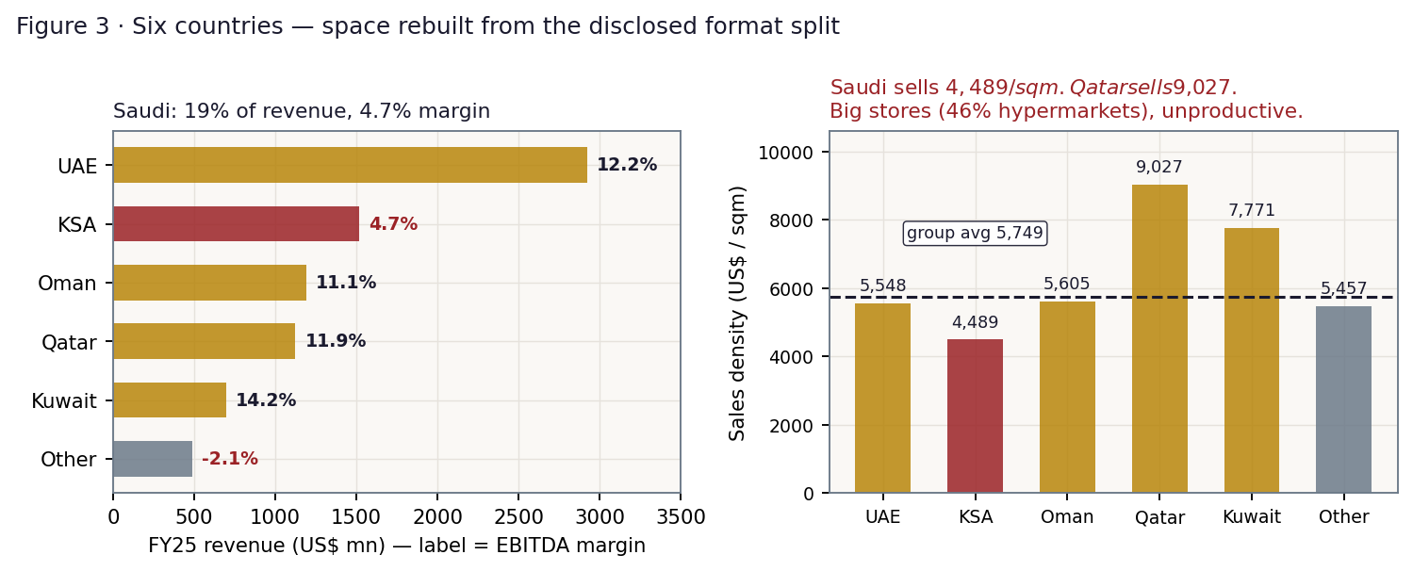
Figure 3 · Six countries. Saudi is 19% of revenue at a 4.7% margin — and sells half of what Qatar sells per square metre.

1.3 The cost model — rebuilt from disclosure, not assumed
The Q1-2026 release states that operating expenses excluding depreciation grew 1.1%, and that mature-store staff costs fell mid-single-digit. Set that against space, which grew 5.65% year-on-year, and the cost base decomposes cleanly:
The engine, in two lines. OPERATING COST tracks SPACE: opex(t) = opex(t−1) × (1 + space growth) × (1 + mature-store cost inflation)
REVENUE tracks SPACE × DENSITY: revenue(t) = revenue(t−1) × (1 + space growth) × (1 + sales-density growth)
⇒ the EBITDA margin is flat only when DENSITY GROWTH = MATURE-STORE COST INFLATION. That break-even is derived, not assumed, and it is the whole company in one line: every point of density lost must be met by a point cut from the cost of running the stores you already have.

 | Space growth | Cash opex growth | ⇒ mature-store inflation | Density growth | Margin consequence
FY2025 (audited) | 5.60% | 5.53% | -0.07% | -1.41% | density fell 1.4pp below mature inflation → margin −23bp on deleverage
Q1-2026 (disclosed) | 5.65% | +1.10% | -4.30% | -8.09% | density fell 3.8pp below mature inflation → margin -65bp on deleverage

The derived mature-store inflation of -4.3% is not an assumption — it is what falls out of the disclosed opex growth once space is accounted for, and it independently corroborates the company's own words ("a mid-single digit percentage reduction in staff costs in existing stores"). Lulu has real short-run cost elasticity, and it used it.
And now the Q1 margin can be bridged with nothing modelled at all — every input below is a disclosed figure:
Q1 EBITDA margin bridge | Value | Source
Q1-2025 EBITDA margin | 10.23% | derived from the disclosed −2.9% revenue, 22.3% gross margin and +1.1% opex growth
− contribution margin (gross margin −10bp) | -7bp | gross profit US$449mn on revenue US$2,020mn = 22.23%, vs 22.3%
− OPERATING DELEVERAGE (revenue −2.9%, opex +1.1%) | -65bp | opex/revenue 15.88% → 16.54%
= Q1-2026 EBITDA margin | 9.50% | DISCLOSED: EBITDA US$192mn ÷ revenue US$2,020mn

Nine-tenths of the margin decline is operating deleverage. The gross margin barely moved — the company held it "broadly flat" through a war that closed its main import artery, which on its own is a remarkable operational result. The margin fell because revenue fell while the cost of the estate did not, and the estate had just grown. That is the mechanism, it is not in dispute, and it means the FY2026 margin is not a lever management pulls. It is a consequence of the density they achieve.
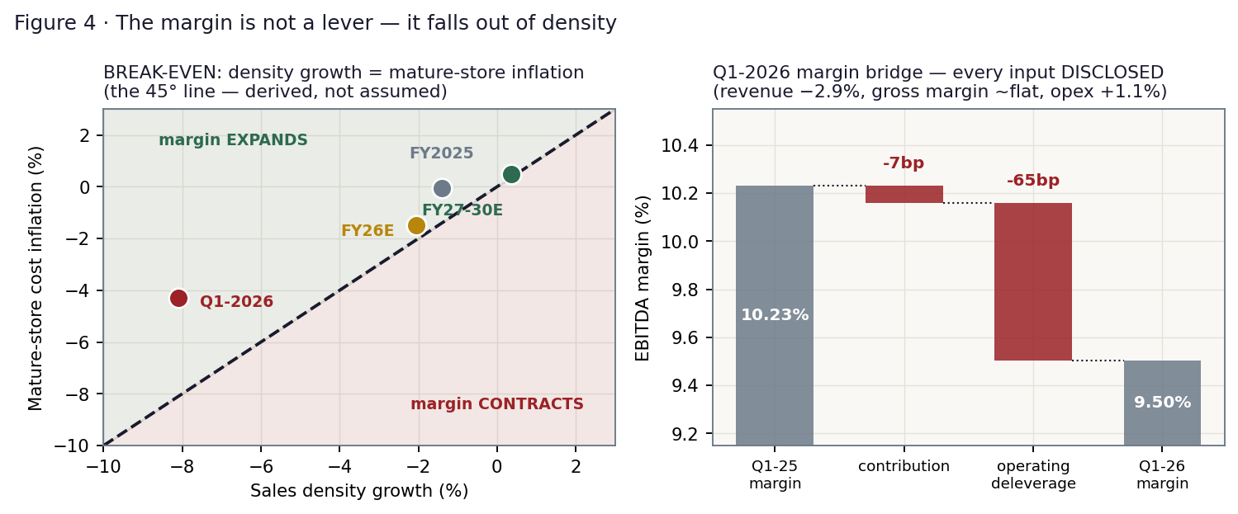
Figure 4 · Left: the break-even is the 45° line — density growth must equal mature-store cost inflation. Right: the Q1 margin bridge, built entirely from disclosed figures.
A note on what this study previously claimed. An earlier draft asserted that the break-even revenue growth for a flat margin was "+4.44%", and that this figure was management's +4–5% guidance — making the guidance self-referential. That claim was an artifact of an assumed cost rule (55% variable opex, 2% inflation) and it does not survive the Q1 disclosure. The break-even is not a revenue number at all. It is the density-versus-mature-cost condition above. The claim is withdrawn.

1.4 The FCFF DCF — the full waterfall, fed by the estate
Every revenue and EBITDA figure below is the sum of six country models driven by space and density, with the cost rule of §1.3 applied to each. FY2026 carries the actual Q1 store and space additions; the store count runs from 285 to 345, consistent with the disclosed 18–20 for FY2026 and 50 across 2026–28. Capex is set at the 1.3% of sales the company reported for Q1 — not the top of the 1.2–1.5% guided band, which an earlier draft used.
US$ mn | FY26E | FY27E | FY28E | FY29E | FY30E
Stores (period end) | 285 | 301 | 317 | 331 | 345
Retail space (m sqm) | 1.422 | 1.467 | 1.512 | 1.551 | 1.590
Sales density (US$/sqm) | 5,631 | 5,651 | 5,672 | 5,696 | 5,719
density growth | -2.1% | +0.4% | +0.4% | +0.4% | +0.4%
Revenue | 8,010 | 8,291 | 8,576 | 8,834 | 9,096
growth | +1.0% | +3.5% | +3.4% | +3.0% | +3.0%
Cash opex | 1,361 | 1,409 | 1,457 | 1,500 | 1,544
growth | +1.4% | +3.5% | +3.4% | +3.0% | +2.9%
EBITDA | 776 | 812 | 840 | 866 | 892
EBITDA margin | 9.69% | 9.80% | 9.80% | 9.81% | 9.81%
− D&A | (392) | (405) | (416) | (426) | (437)
= EBIT | 384 | 408 | 424 | 441 | 456
NOPAT (EBIT × (1 − 12.0%)) | 338 | 359 | 374 | 388 | 401
+ D&A | 392 | 405 | 416 | 426 | 437
− Capex (PPE) | (104) | (108) | (111) | (115) | (118)
− Lease additions (new right-of-use) | (248) | (253) | (253) | (252) | (252)
− ΔOperating working capital | (3) | (13) | (13) | (12) | (12)
= FCFF | 374 | 390 | 412 | 435 | 456
× Discount factor @ WACC | 0.947 | 0.896 | 0.848 | 0.803 | 0.760
= PV of FCFF | 354 | 349 | 350 | 350 | 347

Bridge to equity | US$ mn |  | The terminal — the decision that matters
Sum of PV of FCFF (5 yrs) | 1,750 |  | Exit EV/EBITDA on FY30E EBITDA | 7.5×
PV of terminal value | 5,088 |  | Terminal value | 6,694
Enterprise value | 6,838 |  | TV as % of EV | 74%
− Net debt (bank, ex-lease) | (860) |  | Implied perpetual growth in that multiple | -1.10%
− Lease liabilities (IFRS-16) | (1,643) |  | A Gordon terminal would give instead | 16,220
Equity value | 4,335 |  | i.e. Gordon ÷ exit-multiple | 2.42×
Value per share (AED) | 1.54 |  | WACC − g spread under Gordon | 2.89%

The exit multiple implies a perpetual growth rate of -1.10% — NEGATIVE. It is the conservative choice. A Gordon terminal at a 2.89% spread would produce a terminal value 2.42× larger and an 88% TV share: a bet on the discount rate, not a valuation of a grocer. Note also that this FCFF charges lease additions in full AND the bridge deducts the lease liability — a deliberately conservative double-charge on a lease-financed estate, which understates the DCF by roughly 8% against a clean after-lease treatment.

1.5 Relative value — and the lease question, answered rather than raised
Lulu trades at 6.63× FY26E EV/EBITDA against Abdullah Al Othaim's ~8.9× — apparently a 26% discount to the closest listed comparable. Post-IFRS-16 EBITDA excludes rent, so a company that leases its estate reports a higher EBITDA, and a lower EV/EBITDA, than an otherwise identical company that owns it. Lulu leases almost everything: US$1,643mn of lease liabilities against US$1,412mn of owned property. On an after-lease basis — EBITDAaL against an enterprise value that excludes lease debt — Lulu trades at 7.15×, not 6.63×.
Metric | LULU at spot | What it uses | Why it matters
EV / EBITDA (post-IFRS-16) | 6.63× | EV incl. leases 5,147 ÷ EBITDA 776 | the headline — the basis on which every peer quote is struck
EV / EBITDAaL (after leases) | 7.15× | EV ex-leases 3,504 ÷ EBITDAaL 490 | HIGHER — the honest ABSOLUTE multiple for a lease-heavy retailer
EV / Sales | 0.65× | EV incl. leases ÷ revenue | thin-margin sanity check
P / E (FY26E) | 13.41× | spot ÷ FY26E EPS of AED 0.070 | levered, and the leverage is large
Dividend yield | 7.45% | 7 fils declared ÷ spot | the reason most holders are here

The tension, resolved — because raising it and then ignoring it would be worse than never raising it. IFRS-16 flatters the ABSOLUTE multiple of any lease-heavy retailer. It does NOT, by itself, break the RELATIVE comparison — because Al Othaim's ~8.9× is computed on exactly the same basis as Lulu's 6.63×, and the same distortion applies to both. The comparison only breaks if the two have materially different lease intensities. Saudi grocers lease heavily too; the sources captured for this study do not disclose Al Othaim's lease book, so the residual cannot be measured — and that limitation is stated rather than hidden.
The relative lens is therefore run on the conventional post-IFRS-16 basis, which is internally consistent with the peer quotes available. But the reader is owed the absolute number, and it is this: at 7.15× EBITDAaL, Lulu is NOT cheap on a stand-alone cash basis. It is cheap RELATIVE to the way its peers are quoted. Those are different claims and this study makes only the second one.
Sensitivity: on EBITDAaL of US$490mn, an after-lease multiple of 7.0× gives AED 0.91, 8.0× gives 1.09, and 9.0× gives 1.26. If Al Othaim owns materially more of its estate than Lulu does, the true discount is narrower than 26% and the relative lens is generous.

Applied conventionally: 6.5× / 7.5× / 8.5× on FY26E EBITDA of US$776mn gives AED 0.90 / 1.18 / 1.46. Note the bear multiple lands at 0.90 — essentially spot. The market is already paying the bottom of the grocery band.

1.6 The dividend — 96% of earnings, 1.4× covered by cash
Lulu declared 7 fils for FY2025 against EPS of AED 0.073 — a 96% payout against a stated 75% policy. Read off the income statement, that looks over-distributed. Read off the cash flow, it is not:
US$ mn | FY2025A | FY26E | FY27E | FY28E | FY29E | FY30E
EBITDA | 782 | 776 | 812 | 840 | 866 | 892
− cash lease payments (principal + interest) | (278) | (286) | (295) | (304) | (313) | (322)
− bank interest | (63) | (63) | (63) | (63) | (63) | (63)
− cash tax | (27) | (27) | (30) | (32) | (34) | (36)
− capex (PPE, at the disclosed 1.3% of sales) | (139) | (104) | (108) | (111) | (115) | (118)
= free cash flow | 275 | 296 | 317 | 330 | 342 | 353
Dividend bill at 7 fils | 197 | 197 | 197 | 197 | 197 | 197
COVER | 1.40× | 1.50× | 1.61× | 1.68× | 1.74× | 1.79×

The dividend is 96% of accounting profit and 1.40× covered by cash, and both are true. Depreciation (US$388mn) is nearly three times capex (US$139mn) because the leases ARE the capex: Lulu does not buy its stores, it rents them, the rent is already deducted above as a cash lease payment, and right-of-use depreciation is a non-cash charge sitting on top of a cash rent that has already been paid. Strip the double-count and the payout is comfortable, and stays comfortable — cover 1.50× to 1.79× across the forecast. The base-case DPS is therefore 6.0 fils: below the trailing 7.0, because the board may yet choose to read its own 75%-of-earnings policy literally, but well above what an earnings-only reading would suggest. A cash-covered 7.45% yield is a materially better reason to own this than an uncovered one.
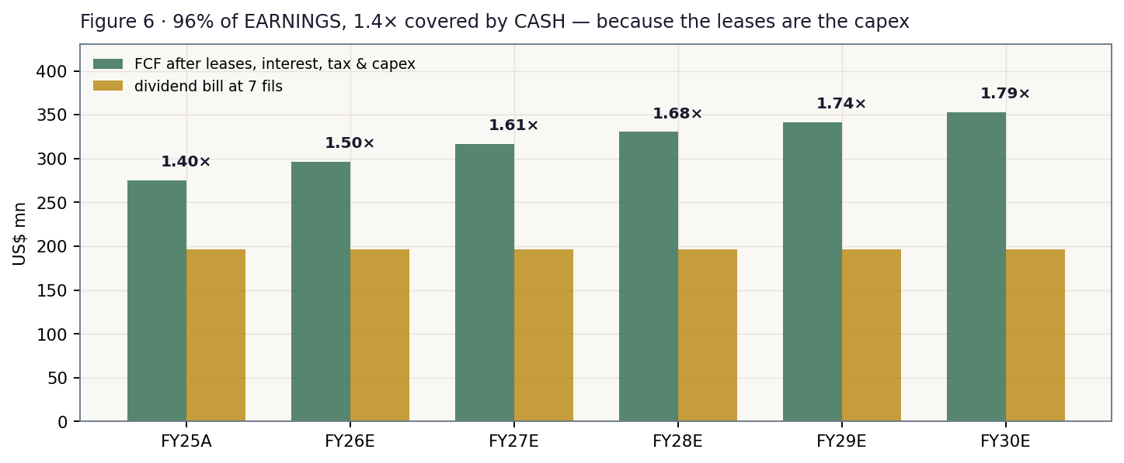
Figure 6 · Free cash flow after leases, interest, tax and capex, against the dividend bill at 7 fils. Cover ratios above each pair.

1.7 Normalized earnings power
Through-cycle: the FY23–FY25 average EBITDA margin (10.20%) applied to FY26E revenue, depreciated, levered and taxed as today, gives a normalized EPS of AED 0.083. GCC consumer staples trade 11–17×. The base 14× gives AED 1.16 — within two fils of the relative lens, a useful confirmation from a method that shares almost no machinery with it.
Normalized EPS × P/E | 11× | 14× (base) | 17×
AED 0.083 | 0.91 | 1.16 | 1.41

1.8 Synthesis — four lenses, one field
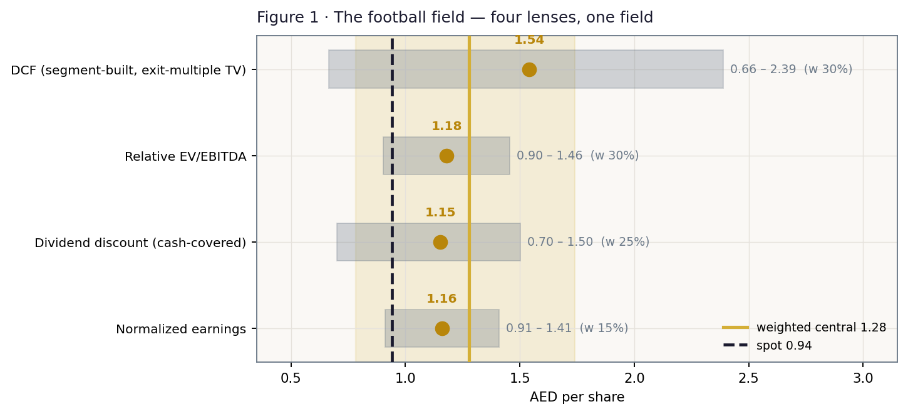
Figure 1 · The football field: each lens's bear–bull span, its base (brass), spot (ink), and the weighted central band (gold).
Three of the four lenses cluster between AED 1.15 and 1.18. The DCF sits higher at 1.54 because it capitalises five years of EBITDA growth (US$776mn → 892mn) before applying the same 7.5× the relative lens applies today — and because, as §1.4 notes, its lease treatment is deliberately conservative. The returns test supports the enterprise reads: FY2025 ROIC of 9.9% against a WACC of 5.6% is a +4.3pp spread, and ROE is 20.4%. Thin, but positive. This is not a melting ice cube being correctly marked down.

1.9 The crux — sales per square metre
Everything above collapses into one number, and it is not the margin — the margin is downstream (§1.3). The square metres are contracted. So FY2026 revenue is a statement about density, and density is the crux:
FY26E density | Revenue (US$ mn) | Revenue growth | EBITDA margin | DCF | Relative @7.5× | The world
-8.0% | 7,523 | -5.2% | 8.56% | 1.09 | 0.83 | Q1-2026 persists all year
-6.0% | 7,687 | -3.1% | 8.95% | 1.24 | 0.94 | no recovery at all
-4.0% | 7,850 | -1.1% | 9.32% | 1.39 | 1.06 | a hard second half
-2.0% | 8,014 | +1.0% | 9.67% | 1.55 | 1.18 | THE BASE — partial recovery
+0.0% | 8,177 | +3.1% | 10.01% | 1.70 | 1.29 | density stabilises
+2.0% | 8,341 | +5.1% | 10.34% | 1.85 | 1.41 | management's +4–5% guide

Read it as the causal chain it is: density → revenue → operating leverage → margin → value. Q1-2026 printed roughly -8%. This study's base assumes -2.1% for the year — a partial recovery, consistent with a March shock that was one month long and concentrated in Electrical. Management's +4–5% revenue guide requires density to GROW +1.4% — i.e. a full recovery and then some. That is the gap between this study and the company, stated in the company's own operating currency.
And the crux has a date. On 19 August 2026 Lulu reports H1-2026. Note what that print will contain: a second quarter that ran entirely inside the blockade (the US naval blockade ran 13 April to 29 May; the Islamabad MOU was signed on 17 June). H1 will look bad. The question the market must answer is not what Q2 did — it is what management says about H2, now that the strait has reopened.
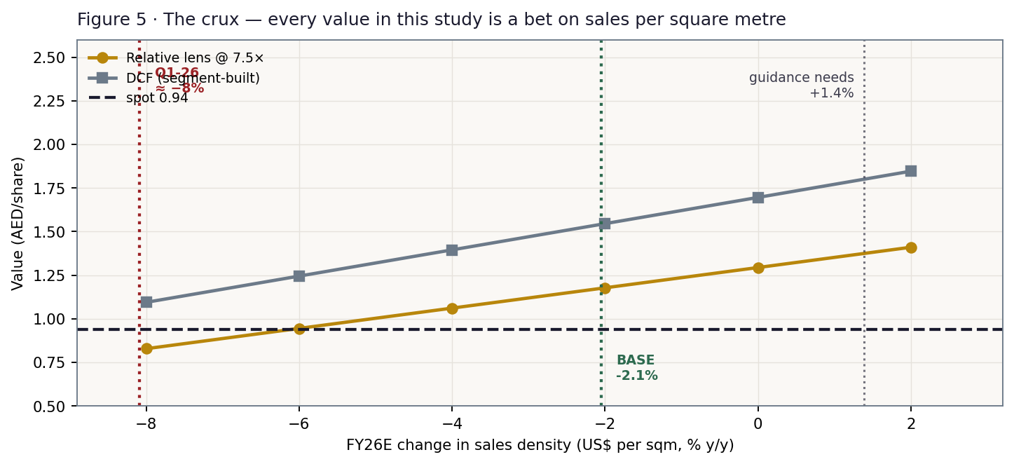
Figure 5 · The crux. Every value in this study is a bet on sales per square metre.

1.10 The cost of capital — sourced, dated, and an honest problem with beta
Sourced market input | Value | Date | Source
Risk-free rate — AED T-Bond (Jan-2031 tranche) | 4.30% | 23 May 2026 | UAE Ministry of Finance auction cut-off — the LOCAL bond, never a UST shortcut
Cross-check — 7-yr AED T-Sukuk (Feb-2033) | 4.13% | Apr 2026 | the longest AED tenor that exists; there is no 10-year
ERP — rating basis (UAE, Aa2) | 4.87% | 5 Jan 2026 | Damodaran ORIGINAL country file: 4.23% mature + 0.64% CRP
ERP — CDS basis (Abu Dhabi) | 4.93% | 5 Jan 2026 | same file; there is no UAE-federal CDS row
CBUAE base rate (the MC carry anchor) | 3.65% | 17 Jun 2026 | Central Bank of the UAE — tracks the Fed under the peg
3-month EIBOR | ~3.93% | Jul 2026 | cross-check on the cost of debt
Cost of debt (pre-tax) | 5.30% | FY2025 | interest US$149.4mn ÷ derived avg interest-bearing debt = 5.28%
Effective tax on EBIT | 12.0% | FY2025 | audited group ETR 11.85%, drifting up with the Saudi mix
AED/USD peg | 3.6725 | — | fixed — no devaluation channel to model

Build | Value | Note
Cost of equity, Ke = rf + β × ERP | 6.68% | 4.30% + 0.489 × 4.87%
Cost of debt, after tax | 4.66% | 5.30% × (1 − 12%)
Weights E / D | 48% / 52% | mkt cap US$2,644mn vs interest-bearing debt US$2,833mn (bank + IFRS-16 leases)
WACC — rating / CDS basis | 5.64% / 5.65% | both published, per house rule

The beta is real, and it is still uncomfortable. A genuine regression — Lulu's weekly returns against an equal-weighted index of the fourteen ADX/DFM blue chips in our own coverage library — returns β = 0.489 (SE 0.161, R² 9.9%, n=86). It passes the usability gate on every prong and is robust: a Dimson correction moves it to 0.476, so it is not a stale-pricing artifact, and the sample halves give 0.539 and 0.491. The decomposition explains it — Lulu's annualised volatility is 25.6% against the market's 18.2%, but its correlation with that market is only 0.29. Some 92% of its risk is idiosyncratic, and CAPM prices only the other 8%.
That gives a Ke of 6.68% — lower than any marginal holder of a 30%-float ADX mid-cap with 25.6% volatility would actually accept. The honest response is not to overwrite the measurement but to remove the model's dependence on it. Because the terminal is an observable exit multiple rather than a growth formula, the whole beta range from 0.49 to 1.40 moves the DCF by only AED 0.21 (§1.11). One caveat the grid does not remove: a low WACC still inflates the present value of the explicit five years (US$1,750mn of the US$6,838mn enterprise value). At β = 1.0 the DCF falls to AED 1.42 — still well above spot, but the reader should know where the sensitivity lives.
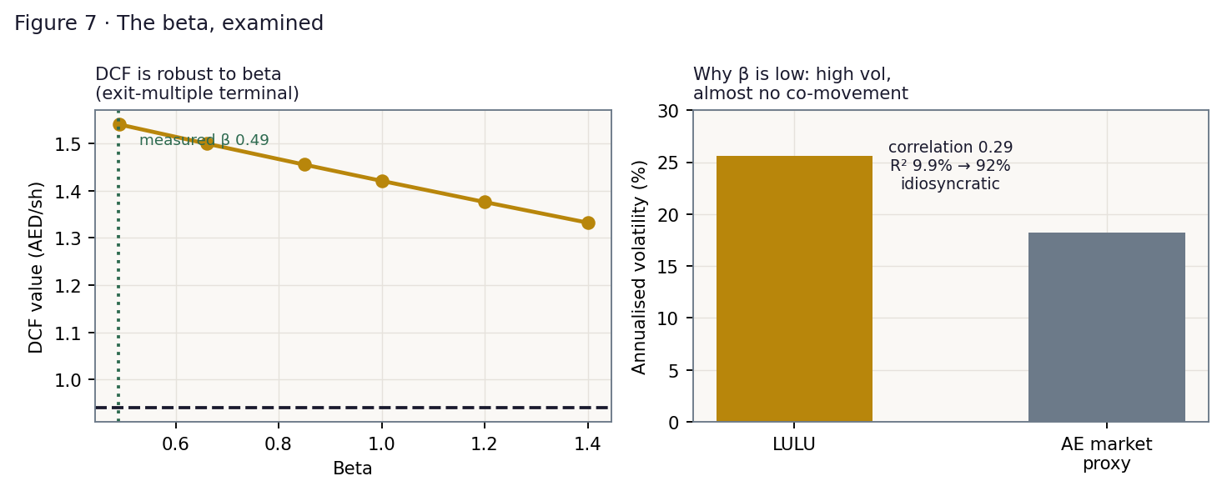
Figure 7 · The beta, examined. Left: with an exit-multiple terminal the DCF barely moves across the plausible range. Right: why beta is low.

1.11 Sensitivity
WACC \ exit multiple | 6.0× | 6.5× | 7.5× | 8.5× | 9.5×
5.64% | 1.18 | 1.30 | 1.54 | 1.78 | 2.02
6.24% | 1.13 | 1.25 | 1.48 | 1.71 | 1.95
6.84% | 1.08 | 1.19 | 1.42 | 1.65 | 1.88
7.44% | 1.03 | 1.14 | 1.36 | 1.59 | 1.81
8.04% | 0.99 | 1.09 | 1.31 | 1.52 | 1.74

Highlighted cells bracket spot at AED 0.94.
Beta | Ke | WACC | DCF (AED/sh) | Reading
0.49 | 6.69% | 5.64% | 1.54 | the MEASURED beta
0.66 | 7.51% | 6.04% | 1.50
0.85 | 8.44% | 6.49% | 1.46
1.00 | 9.17% | 6.84% | 1.42 | the house fallback
1.20 | 10.14% | 7.31% | 1.38
1.40 | 11.12% | 7.78% | 1.33 | a beta Lulu's own data does not support

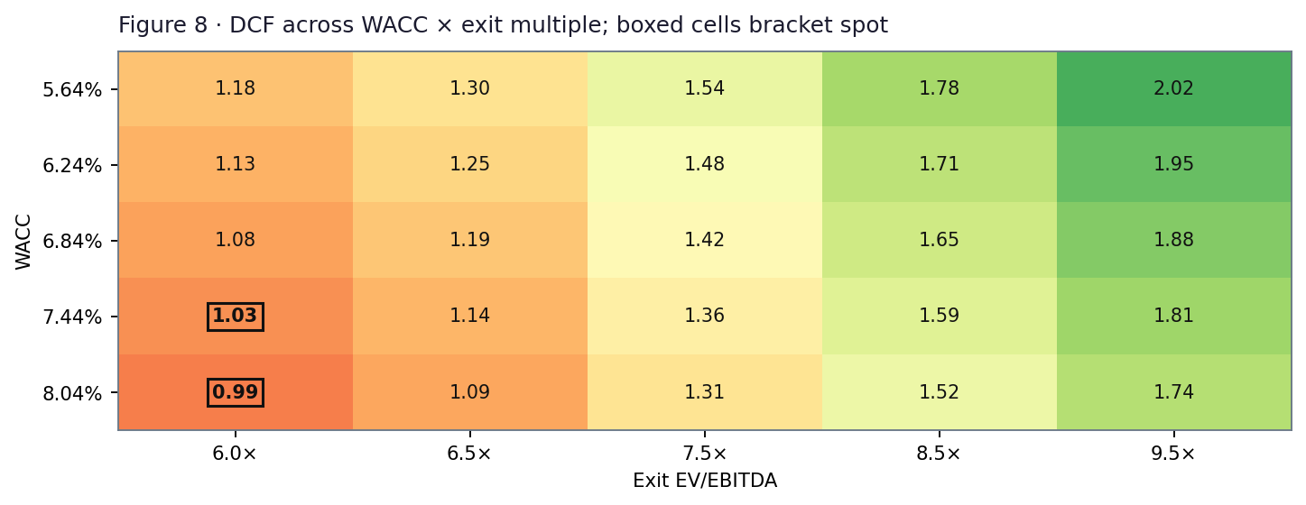
Figure 8 · DCF across WACC × exit multiple. Boxed cells bracket spot.

2 Technical and price structure
Indicator | Value | Reading
Price vs SMA 20 / 50 | 0.97 / 0.99 | below both — no near-term bid
Price vs SMA 100 / 200 | 1.01 / 1.08 | below both — the stack is fully bearish-ordered
RSI (14) | 37 | weak, but not washed out
MACD (12,26,9) | -0.014 / -0.012 / -0.003 | histogram negative — momentum still down
52-week range | 0.93 – 1.29 | spot sits 3% up the range
Move 20d / 60d / 252d | -2.1% / -7.8% / -24.2% | a year of persistent de-rating
From the IPO price (2.04) | -53.9% | the entire listed history is one drawdown
All-time low | 0.93 | set 23-Mar-2026 — the week the strait closed
Realised volatility (252d) | 22.3% | well above the ADX blue-chip average of ~18%

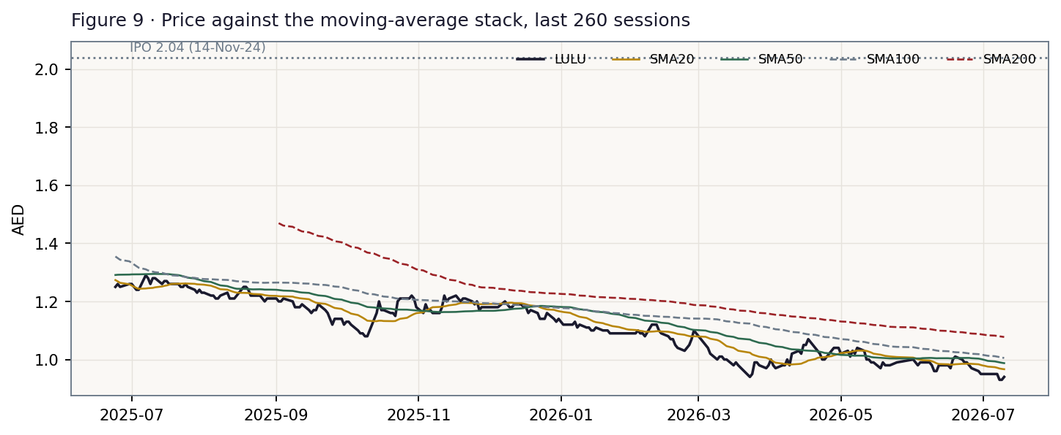
Figure 9 · Price against the moving-average stack, last 260 sessions.
This is a downtrend. The stock is below every moving average, the stack is bearish-ordered, and it has spent its entire listed life below its IPO price. The March-2026 low at 0.93 was set the week the strait closed. The chart and the lenses disagree, and this study does not pretend otherwise. The resolution is a date, not an argument.

3 Monte Carlo — a probabilistic price map

The probability read, before anything else
Question | Answer
P(price above spot at T+60)? | 48.0%
P(≥ +10%) vs P(≤ −10%) — the odds | 25.3% vs 25.9% → odds 0.98
Median path | AED 0.93 (-0.7%)
The 50% band (25th–75th) | 0.84 – 1.04
Touch ±10% anytime within T+60 | up 41% (to 1.05) / down 48% (to 0.85)

Where the centre comes from: the dividend yield (7.45% on the declared 7 fils) exceeds the money-market rate (3.65%), so the forward-consistent price centre drifts DOWN by the excess — about -0.9% over 60 sessions. The event ledger then pushes back UP by +0.2%, because at the 10 July anchor the war has ended (Islamabad MOU, 17 June), the naval blockade is lifted and the strait is reopening — developments the March-quarter print cannot reflect. Net: a near-flat centre. The holder is not losing money in that world: total return ≈ the risk-free rate, delivered as dividend. Dual framing: at the stated 75% policy DPS, q falls to 5.59% and the carry drift roughly halves to -0.4%.
Engine, and what this calibration does and does not claim. Carry-anchored Yang-Zhang HAR with a Student-t(10) shape and a 1.049 width calibration. Both are READ LIVE from the UAE market profile — they are not chosen. The (ν, width_cal) pair is fitted by maximum likelihood on the pooled 14-name ADX/DFM panel (237 non-overlapping 60-day windows) and validated leave-one-name-out; ν is only weakly identified (every value from 5 to Gaussian sits inside the 95% likelihood interval), which is why the PAIR is fitted and neither coordinate is quoted as precise. Other markets in this engine carry ν = 4 (Egypt), 6 (Saudi), 12 (US) and Gaussian (Korea) — there is no universal tail. 50,000 paths, seed 42. The signal term is OFF for this market: ablation on the panel could not establish one, so the fallback rule applies and the engine runs carry-only.
Independence: the fundamental gap of §1 does NOT enter the Monte-Carlo drift. If it did, the cone would merely restate the DCF and the calibration ledger would be marking its own homework.
THE HONEST LIMIT. Lulu has 410 sessions of history — exactly TWO non-overlapping 60-day test windows, against the eighteen or so a meaningful test needs. There is NO name-level verdict and none is asserted. The engine is validated at the MARKET level instead: across the fourteen ADX/DFM names in the panel it scores a pooled forecast skill of +0.49% against a carry-anchored random walk, with a 90% bootstrap interval of [−0.40%, +1.50%] — a statistical dead heat, meaning the cone is honestly calibrated but NO single-name edge is claimed. The price history was screened for corporate actions and bad prints before any of this was fitted: 410 sessions, zero repairs needed, and 248.8 trading days a year against the exchange's real calendar.

The seven continuous forces
# | Force | Sign
1 | Sales density — the crux. Operating cost tracks space; revenue tracks space × density | ±
2 | GCC grocery market growth (~4.2% CAGR to 2028) and the 50-store 2026–28 rollout | +
3 | Mature-store cost programme — Q1 delivered a mid-single-digit staff-cost cut | +
4 | Discounter and aggregator competition, concentrated in Saudi | −
5 | Saudi density (US$4,489/sqm vs a group US$5,749) and the mix drag as the estate shifts there | −
6 | Private label (30.2%) and e-commerce (+61%) — but the gross margin has been flat-to-down for three years | ±
7 | Fed / CBUAE rate path — the carry anchor moves with it | ±

The ten discrete events
# | Event | P | Impact
1 | H1-2026 (19-Aug): Q2 revenue also falls — a 2nd down quarter (the strait was blockaded through Apr–May) | 70% | -2.0%
2 | H1-2026: FY26 revenue guidance (+4–5%) formally withdrawn or cut | 45% | -3.0%
3 | H1-2026: guidance held — density stabilises as the March non-food deferral unwinds | 35% | +3.0%
4 | Hormuz normalisation (MOU 17-Jun; blockade lifted) feeds into an H2 non-food recovery | 55% | +2.5%
5 | Renewed escalation or re-closure of the strait | 15% | -3.5%
6 | Cost programme delivers again: mature-store opex down a 2nd consecutive period | 50% | +1.5%
7 | Interim DPS held at 3.5 fils (the 1.40× cash cover is defended) | 60% | +1.5%
8 | Interim DPS cut toward the 75%-of-earnings policy | 25% | -2.5%
9 | Placement / lock-up release from the 70.44% controlling stake | 10% | -2.5%
10 | Re-rating toward Al Othaim's ~8.9× from LULU's 6.6× | 15% | +2.0%
 | Net event-ledger drift |  | +0.2%

The ledger is now net slightly positive, and the reason is a date rather than an opinion: the Islamabad MOU was signed on 17 June, the US naval blockade was lifted, and commercial traffic through the strait resumed. The Q1 print — the last hard information the market has — predates all of it. Set against that, the 19 August H1 report will contain a Q2 that ran entirely inside the blockade and will therefore look poor. The ledger prices both, and they roughly cancel.

Percentile map (AED per share)
Percentile | T+20 | T+60 | move at T+60
5th | 0.80 | 0.71 | -24.1%
25th | 0.88 | 0.84 | -10.4%
50th | 0.94 | 0.93 | -0.7%
75th | 1.00 | 1.04 | +10.2%
95th | 1.10 | 1.22 | +30.1%

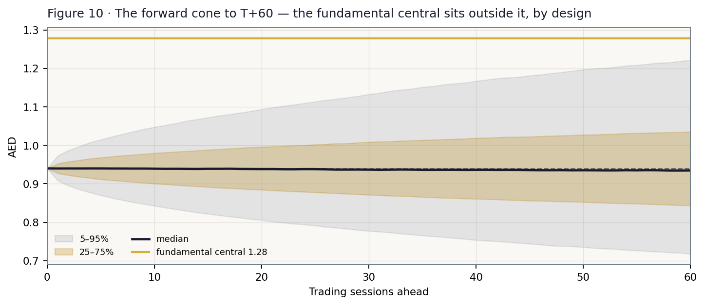
Figure 10 · The forward cone to T+60. The fundamental central sits outside it, by design.
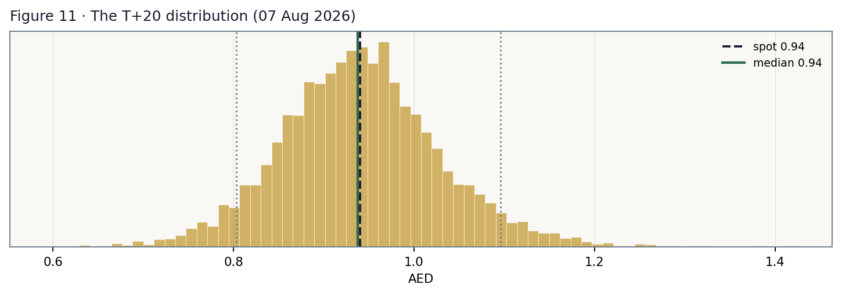
Figure 11 · The T+20 distribution.
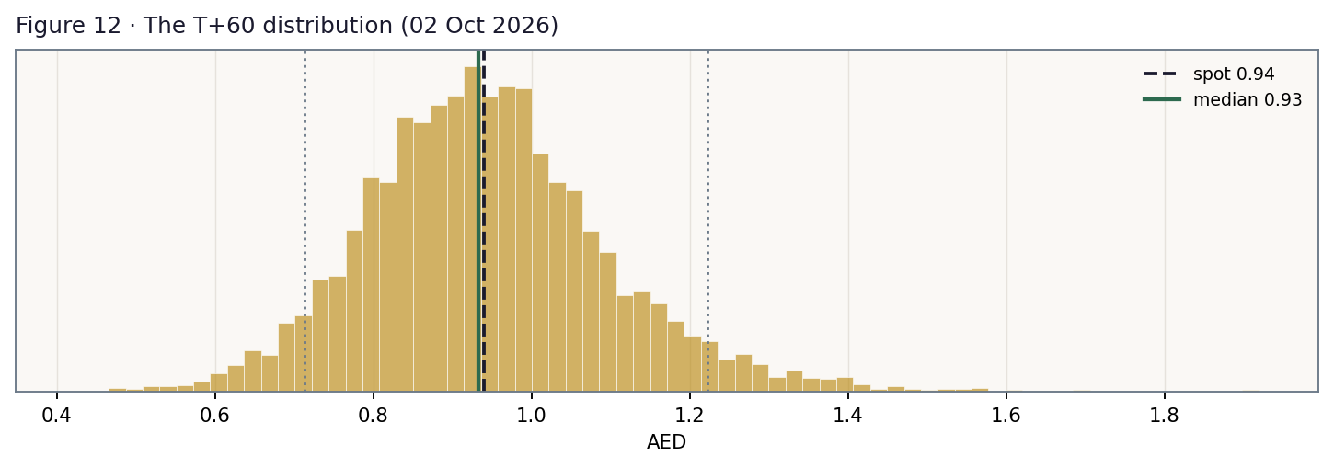
Figure 12 · The T+60 distribution.

Level-touch ladder
Level | vs spot | P(touch by T+20) | P(touch by T+60)
AED 1.30 | +38.3% | 0% | 4%
AED 1.20 | +27.7% | 1% | 11%
AED 1.10 | +17.0% | 7% | 27%
AED 1.05 | +11.7% | 18% | 41%
AED 1.00 | +6.4% | 40% | 62%
AED 0.95 | +1.1% | 79% | 88%
AED 0.90 | -4.3% | 54% | 73%
AED 0.85 | -9.6% | 22% | 48%
AED 0.80 | -14.9% | 7% | 28%
AED 0.75 | -20.2% | 2% | 14%

4 Comparison of the lenses, and a verdict
Clock | Figure | What it is | What it is not
T+60 sessions | median 0.93 · 50% band 0.84–1.04 | calibrated price probabilities | a forecast of the news
~12 months | central 1.28 (0.78–1.74) | risk-adjusted fair-value range | a price target
Multi-year | DCF 1.54 | terminal store economics at 7.5× | a 2026 expectation

Verdict, in the house's only permitted form: the distribution says undervalued on a twelve-month view, with the gap gated behind one operating number — a fair-value range of roughly AED 0.78–1.74 with its weight at about 1.28, against a market at 0.94. What the market is pricing is not a discount rate (no plausible beta reaches spot) and not a cost problem (mature-store costs fell in Q1). It is a permanent loss of sales density — the assumption that the ~8% productivity fall of Q1-2026 is the new level rather than a war-shock trough. The company's own disclosure argues against that reading: January and February were in line, the collapse was in March, it was in Electrical and Lifestyle rather than food, and it coincided exactly with the closure of the strait. But one quarter is a thin basis for any conclusion, and the bear case — in which the deferral proves permanent — lands at AED 0.78, 17% below spot. This is a genuinely two-sided distribution and the study says so.

5 Catalysts to watch
When | Event | Why it matters
19 Aug 2026 | H1-2026 results | THE crux. Contains Q2 — which ran entirely inside the blockade — and, more importantly, management's read on H2
19 Aug 2026 | Interim dividend declaration | The 1.4× cash cover says it can be held. Whether the board reads its own 75% policy literally is the question
H2 2026 | Post-MOU normalisation of the strait | Deferred Electrical and Lifestyle demand either returns or it does not. This IS the density question
H2 2026 | FY26 revenue guidance re-affirmed or withdrawn | Guidance needs 9M revenue +7.1% after a −2.9% Q1, i.e. density +1.4% for the year
Through 2026 | Store openings against the 18–20 target | But watch SPACE and DENSITY, not the count — 11 Express stores add cost before they add sales
Ongoing | Mature-store cost programme | Q1 delivered a mid-single-digit staff-cost cut. If it persists, the break-even density falls with it
Ongoing | Saudi density (US$4,489/sqm) | The weakest link. Recovery toward the group average is worth more than any new store
Ongoing | Any placement from the 70.44% controlling stake | The overhang. Priced as a discrete factor, not a valuation discount

6 Reading the probability zones
Zone (AED at T+60) | Probability | The world in which it happens
below 0.80 | 16.0% | H1 shows Q2 falling again AND guidance is pulled AND the dividend is cut
0.80–0.90 | 24.3% | a poor H1 with no credible H2 recovery story; the March low gives way
0.90–1.00 | 27.1% | the base world: H1 is weak but explained; the carry does the work; the tape waits for Q3
1.00–1.10 | 17.6% | H1 weak but H2 guided to recover, dividend held, strait normalising
above 1.10 | 14.9% | density recovers AND the payout is defended AND the deferred non-food demand returns

7 Caveats and what would change our mind
# | Trigger | Consequence for this study
1 | H1-2026 shows the March weakness spreading INTO food (CPG/Fresh turn negative) | This is the falsifier that matters. It would mean the density loss is a grocery problem, not a war-driven non-food deferral. The base collapses toward the bear.
2 | FY26 sales density falls ~6% or worse for the full year | Revenue below ~US$7.8bn. At −6% density the DCF is AED 1.24 and the central is at spot.
3 | Mature-store opex turns POSITIVE again while density is still falling | The cost programme has run out. The break-even (§1.3) moves against the company on both sides at once.
4 | The interim DPS is cut below ~2.6 fils despite the 1.4× cash cover | Signals the board reads its 75%-of-earnings policy literally. The DDM re-anchors to bear and the yield support weakens from 7.45% to ~5.5%.
5 | Saudi density falls below ~US$4,200/sqm | The 65-store Saudi estate becomes value-destroying rather than merely unproductive.
6 | Lulu trades above ~8.5× FY26E EV/EBITDA (or ~9× EBITDAaL) | The relative discount closes and this study's central argument is spent.

Structural caveats, each stated where it bites: (a) NO name-level Monte-Carlo calibration exists for Lulu — 410 sessions give two test windows against the eighteen or so a meaningful test needs; (b) bank debt and lease liabilities are DERIVED from the stated 3.2×/1.1× ratios, cross-checked twice (lease liabilities are 93% of right-of-use assets; derived lease interest US$87.1mn plus bank interest US$63.1mn = US$150.1mn against a disclosed US$149.4mn); (c) FY2024/FY2025 trade payables are not disclosed, so operating working capital is held at the FY2023 ratio of 4.48%; (d) Q1-2026 sales density requires an estimate of first-quarter 2025 space and is therefore BOUNDED (-9.4% to -4.3%), not asserted; (e) segment SPACE is derived from the disclosed format split and the disclosed 9,200 sqm hypermarket average — it reconstructs the disclosed group estate to 0.6%, which is what licenses it, but it is a derivation; (f) segment GROSS margin is not disclosed, so the country margin spread is attributed entirely to operating cost; (g) the beta is measured, not assumed, but 92% of Lulu's variance is idiosyncratic and the resulting Ke is lower than any marginal holder would demand — the response was to remove the model's dependence on it, and to show the β=1.0 case (AED 1.42) explicitly.

Appendix A Financial statements
Historicals are the company's own disclosure. EBITDA is RECONCILED from the audited lines, never lifted from a press-release "adjusted" figure — FY2024 shows a US$5.6mn definitional gap between the two. Forecast revenue and EBITDA are the SUM OF SIX COUNTRY MODELS driven by space and density.

A.1 Income statement — 3-year historical + 5-year forecast (US$ mn)
US$ mn | FY23 | FY24 | FY25 | FY26E | FY27E | FY28E | FY29E | FY30E
Revenue | 7,278 | 7,621 | 7,934 | 8,010 | 8,291 | 8,576 | 8,834 | 9,096
Gross profit | 1,675 | 1,765 | 1,823 | — | — | — | — | —
gross margin | 23.0% | 23.2% | 23.0% | — | — | — | — | —
Cash opex (ex-D&A) | 1,195 | 1,273 | 1,343 | 1,361 | 1,409 | 1,457 | 1,500 | 1,544
EBITDA | 753 | 792 | 782 | 776 | 812 | 840 | 866 | 892
EBITDA margin | 10.35% | 10.39% | 9.86% | 9.69% | 9.80% | 9.80% | 9.81% | 9.81%
D&A | (385) | (384) | (388) | (392) | (405) | (416) | (426) | (437)
EBIT | 368 | 408 | 394 | 384 | 408 | 424 | 441 | 456
Finance costs, net | (153) | (169) | (162) | (160) | (158) | (156) | (154) | (152)
Profit before tax | 215 | 239 | 232 | 224 | 250 | 268 | 287 | 304
Tax | (23) | (22) | (27) | (27) | (30) | (32) | (34) | (36)
Net profit | 192 | 216 | 205 | 197 | 220 | 237 | 252 | 268
EPS (AED) | 0.068 | 0.077 | 0.073 | 0.070 | 0.078 | 0.084 | 0.090 | 0.095

A.2 The segment build (US$ mn)
Revenue | FY25A | FY26E | FY27E | FY28E | FY29E | FY30E | FY25 density $/sqm
UAE | 2,920 | 2,981 | 3,104 | 3,227 | 3,337 | 3,447 | 5,548
KSA | 1,518 | 1,517 | 1,578 | 1,638 | 1,687 | 1,735 | 4,489
Oman | 1,189 | 1,191 | 1,228 | 1,265 | 1,302 | 1,340 | 5,605
Qatar | 1,122 | 1,124 | 1,155 | 1,186 | 1,217 | 1,248 | 9,027
Kuwait | 696 | 717 | 746 | 776 | 806 | 836 | 7,771
Other | 489 | 479 | 482 | 484 | 486 | 489 | 5,457
Group | 7,934 | 8,010 | 8,291 | 8,576 | 8,834 | 9,096 | 5,749

EBITDA | FY25A | FY26E | FY27E | FY28E | FY29E | FY30E | FY25 margin
UAE | 357.5 | 362.0 | 380.0 | 395.1 | 408.5 | 422.0 | 12.24%
KSA | 70.7 | 62.2 | 64.5 | 65.1 | 65.1 | 65.0 | 4.66%
Oman | 132.4 | 130.4 | 135.7 | 139.8 | 144.0 | 148.2 | 11.14%
Qatar | 133.0 | 131.3 | 136.0 | 139.6 | 143.3 | 147.0 | 11.85%
Kuwait | 98.9 | 101.7 | 107.0 | 111.7 | 116.5 | 121.4 | 14.21%
Other | -10.3 | -11.3 | -10.9 | -10.9 | -11.0 | -11.0 | -2.11%
Group | 782.2 | 776.3 | 812.2 | 840.4 | 866.3 | 892.5 | 9.86%

A.3 Balance sheet — condensed (US$ mn)
US$ mn | Dec-23 | Dec-24 | Dec-25 | Mar-26
Cash & equivalents | 278 | 346 | 330 | n/d
Inventories | 1,375 | 1,474 | 1,491 | n/d
Trade & other receivables | 332 | 412 | 399 | n/d
Trade & other payables | 1,380 | n/d | n/d | n/d
Property, plant & equipment | 1,461 | 1,438 | 1,412 | n/d
Right-of-use assets | 1,868 | 1,726 | 1,766 | n/d
Total assets | 8,004 | 5,451 | 5,440 | n/d
Bank borrowings (DERIVED, FY25) | 1,129 | n/d | 1,190 | n/d
Lease liabilities (DERIVED, FY25) | 2,001 | n/d | 1,643 | n/d
Total equity | 767 | 993 | 1,005 | n/d
Net debt — INCLUDING IFRS-16 leases | n/d | n/d | 2,503 | 2,503
× EBITDA | — | — | 3.2× | 3.3×
Net debt — EXCLUDING leases | n/d | n/d | 860 | n/d
× EBITDA | — | — | 1.1× | 0.9×

Two cross-checks on the derived debt split. (1) The derived lease liability of US$1,643mn is 93% of right-of-use assets — the ratio a mature lease book should show. (2) Applying the 5.30% cost of debt to the derived split gives lease interest US$87.1mn plus bank interest US$63.1mn = US$150.1mn against a disclosed US$149.4mn — a 0.5% error from two independent routes. Dual framing: leverage is 3.2× including IFRS-16 leases and 1.1× excluding; the company states both and this model uses the INCLUDING basis throughout, because its EBITDA is post-IFRS-16 and the two must match. On working capital, the company's US$205mn "deficit" is current assets minus current liabilities — contaminated by short-term debt; OPERATING working capital was POSITIVE US$326mn in FY2023 (4.48% of revenue), and that is what the model uses.

A.4 Cash flow — and the FCFF reconciliation receipt (US$ mn)
US$ mn | FY24 | FY25
Net cash from operating activities | 358 | 596
Capex — property, plant & equipment | (142) | (139)
Lease principal repaid (financing) | (186) | (191)
Dividends paid | — | (183)

The receipt. Route A — the NOPAT waterfall of §1.4 — gives FY2025 FCFF of US$323.6mn. Route B rebuilds it from the audited cash-flow statement: operating cash flow 596.4, plus after-tax interest 131.5, less PPE capex 138.5, less lease additions 258.8 = US$330.6mn. Two routes, two statements, 2.2% apart. The test that licenses route B: EBITDA 782.2 − interest 149.4 − cash tax 27.5 − OCF 596.4 = 8.9 ≈ zero, which only reconciles if interest is already an operating item.

Appendix B Peers, risks, and sources

B.1 The comparable set
Name | EV/EBITDA | EBITDA margin | Div. yield | Note
LULU — at spot 0.94 | 6.63× | 9.7% | 7.45% | 7.15× on EBITDAaL — see §1.5
Abdullah Al Othaim (Tadawul 4001) | ~8.9× | ~6.5% | ~6.7% | the TIGHTEST structural comp — Saudi grocery
Spinneys 1961 (DFM) | n/d | 20.0% | ~4.6% | premium/Waitrose model — NOT margin-comparable
BinDawood (Tadawul 4161) | n/d | n/d | n/d | Saudi grocery
Tesco (LSE) | ~6.5× | n/d | n/d | international mass grocer
Ahold Delhaize (AMS) | ~5.5× | n/d | n/d | international mass grocer
Majid Al Futtaim / Carrefour UAE | n/d | n/d | n/d | the largest UAE competitor — UNLISTED

Peer multiples are secondary vendor data, flagged as such; they set a RANGE (6.5–8.5×), never a point. None of Lulu's own financial-statement lines comes from an aggregator. And per §1.5, the comparison is clean as a RELATIVE measure but not as an ABSOLUTE one until every name is put on an after-lease basis, which the captured sources do not permit.

B.2 Risk register
Risk | How it reaches the share price | Where it is priced
Sales density keeps falling | revenue → operating deleverage → margin → every lens | §1.9 crux grid — the largest sensitivity in the study
The March deferral proves permanent, not transient | the base case assumes a partial recovery | falsifier #1; bear case AED 0.78
Saudi: US$4,489/sqm on 46%-hypermarket space | drags group margin; a 1pp mix shift costs 6.4bp | §1.2; falsifier #5
The mature-store cost programme runs out | the break-even density rises against the company | §1.3; falsifier #3
Dividend cut despite the 1.4× cash cover | yield support weakens | DDM bear; discrete factor 25% / −2.5%
Renewed closure of the strait | demand, not supply — the stores stayed stocked | discrete factor 15% / −3.5%
70.44% controlling-stake overhang | supply of stock | discrete factor 10% / −2.5%
No name-level calibration | model risk on the MC cone only | READ FIRST, §3, §7 and the ledger

B.3 What was searched, what was found — and what was not
Every finding below is dated and attributed. The rows marked “Searched — not found” are deliberate: a figure that was looked for and does not exist is as much a part of the record as one that does, and each of them is carried through the study as an explicit limitation rather than quietly filled with an estimate.
Scope | What kind of finding | Finding (condensed) | Source | Date
Global | Structural | AED hard-pegged to USD at 3.6725; CBUAE Base Rate 3.65% tracks the Fed. AED T-Bond programme is the study's rf source: Jan-2031 tranche cleared 4.30% (23-May-26 auction); longest AED tenor is the 7-yr Feb-2033 T-Sukuk at 4.13% (Apr-26). N… | UAE Ministry of Finance T-Bond a… | 23 May 2026
Global | Structural | Global food commodity prices and freight are LULU's principal input cost. The 2026 Strait of Hormuz crisis (US/Israel strikes and IRGC VHF closure warnings 28-Feb-26; formal IRGC closure announced 2-Mar-26; 'complete control' declared 4-M… | Company Q1-2026 results commenta… | 11 May 2026
Global | COLOR | Global grocery retail is a low-growth, low-margin, defensive category. Global retail sector EV/EBITDA ~11.7x (all retail); listed food retailers cluster far lower at ~5-7x (Tesco, Ahold Delhaize, Carrefour), with Jeronimo Martins at a pre… | Statista global retail sector mu… | 11 Jul 2026
Global | Structural | LULU sources from 85 countries via 19 sourcing centres — an unusually deep own-import chain for a regional grocer. The Hormuz disruption tested it directly; management reported all stores remained open and well-stocked, which is the falsi… | Company Q1-2026 earnings release | 11 May 2026
Country | COLOR | UAE Aa2 (Moody's). GDP +5.6% (2025), non-oil +6.1%. Inflation 1.3% avg 2025; food inflation easing. Peg intact — no devaluation channel. Q1/Q2-2026 growth sharply decelerated on the Hormuz closure. KSA: Vision-2030 population and retail g… | CBUAE; World Bank; Damodaran cou… | 11 Jul 2026
Country | Unlocks a driver | UAE 9% federal corporate tax effective for FYs beginning on/after 1-Jun-2023. KSA subsidiary taxed under Saudi CIT/zakat. Group effective tax rate FY2025 = 11.85% (27.499 / 232.031), FY2024 = 9.35% — rising with the KSA mix. No price caps… | FY2025 audited consolidated fina… | 18 Mar 2026
Country | Structural | The 2026 regional escalation / Strait of Hormuz closure is the dominant country-ring event: it hit during the MARCH portion of Ramadan (c.18-Feb to 19-Mar-2026), grocery's seasonal peak. LULU's Q1-2026 revenue fell 2.9% and net income fel… | Company Q1-2026 earnings release… | 11 May 2026
Industry | COLOR | GCC grocery market projected to reach c.US$101bn by 2028, a 4.2% CAGR 2023-28 (modern retail ~4.8%). LULU held 13.5% of the GCC modern offline grocery market in 2023 — #1 overall, and #1 in Oman, Qatar, Kuwait and Bahrain; #2 in the UAE; … | Euromonitor International, cited… | 14 Nov 2024
Industry | Structural | Grocery pricing is pass-through-constrained and promotional. LULU's gross margin has been flat-to-down: 23.02% (FY23) -> 23.16% (FY24) -> 22.98% (FY25), and 22.2% in Q1-2026. The EBITDA margin fell to 9.5% in Q4-2025 and again 9.5% in Q1-… | FY2023-FY2025 audited FS; Q1-202… | 11 May 2026
Industry | Structural | Discounters and quick-commerce aggregators are entering GCC grocery. Saudi broker commentary on Al Othaim explicitly names 'new discounters such as Lulu' and convenience formats (BinDawood's 'dash') as margin pressures — i.e. the discount… | Al-Jazira Capital broker note on… | 11 Jul 2026
Industry | Unlocks a driver | E-commerce is additive, not substitutive, for LULU: FY2025 online sales US$451.1m, +38.6%, 6.0% of retail sales; Q1-2026 US$150m, +61%, 7.9% of sales. About half the estate is e-commerce enabled; quick-commerce (45-90 min) live; Amazon pa… | FY2025 results; Q1-2026 earnings… | 11 May 2026
Industry | Structural | Closest listed comps and their marks: Spinneys (DFM) FY2025 adj. EBITDA margin 20.0% on a premium/Waitrose positioning (fresh 64.2%, private label 45.4% of sales) — not structurally comparable; Abdullah Al Othaim Markets (Tadawul 4001) EV… | Spinneys FY2025 results release … | 11 Jul 2026
Company | Unlocks a driver | FY2023/FY2024/FY2025 audited consolidated FS (Deloitte & Touche ME, unqualified, 18-Mar-2026) captured. FY2025: revenue 7,933.970; gross profit 1,822.836; other operating income 302.553; operating expenses (1,731.157) incl. D&A; finance c… | FY2025 audited consolidated fina… | 18 Mar 2026
Company | Structural | FY2026 guidance issued 13-Feb-26 and REITERATED at Q1 on 11-May-26 (i.e. after the Q1 miss): revenue +4-5%; FLAT EBITDA margin; net profit +10%; 18-20 new stores; capex 1.2-1.5% of sales. Medium-term: 50 new stores 2026-28; dividend polic… | Q1-2026 earnings release / resul… | 11 May 2026
Company | Changes the base case | Q1-2026 (11-May-26): revenue US$2,020m (-2.9% YoY); gross margin 22.2%; EBITDA US$192m (9.5% margin); net income US$47m (-33% YoY); 277 stores (+10 in the quarter); net debt US$2.5bn = 3.3x IFRS-16 / 0.9x ex-lease; e-commerce US$150m (+61… | Q1-2026 earnings release | 11 May 2026
Company | COLOR | Store network FY2025: 267 stores (123 hypermarkets, 118 express, 26 mini) — UAE 116, KSA 65, Oman 32, Qatar 24, Kuwait 17, Bahrain 13; 1.38m sqm retail space (+5.6%). Loyalty: 8.4m members, ~67% of revenue member-linked. c.680-690k daily … | FY2025 results presentation / IR… | 13 Feb 2026
Company | Structural | FY2025 net profit fell 5.4% on continuing operations (204.532 vs 216.280) and the FY2025 dividend of 7 fils (US$196.9m) was ~96% of net profit, against a STATED 75% payout policy. FY2024 also carried US$32.9m of discontinued-operations pr… | FY2025 audited FS; dividend decl… | 18 Mar 2026
Company | Structural | Lulu International Holdings Limited holds 70.44% post-IPO (FY2025 audited FS, Note 1); ultimate controlling party Mr. Yusuffali M.A. IPO 14-Nov-2024 at AED 2.04 was a 100% SECONDARY offering (AED 6.32bn to the selling shareholder; no prim… | FY2025 audited FS Note 1; IPO pr… | 18 Mar 2026
Company | COLOR | No management change, buyback, capital raise or rating action identified for FY2025/H1-2026. Dividend paid semi-annually (interim 3.5 fils + final 3.5 fils for FY2025). Next scheduled print: H1-2026 results, 19-Aug-2026. | Company IR calendar / results an… | 11 May 2026
Company | Searched — not found | Negative search — nothing found (multi-year revenue/margin guidance beyond FY2026; capital-markets day; maintenance-vs-growth capex split; any company-disclosed valuation guide or target multiple — none exist) | negative search | 11 Jul 2026
Company | Searched — not found | Negative search — nothing found (FY2024/FY2025 trade payables line and the full cash-conversion cycle — disclosed only inside the audited notes, not in the captured summary statements; FY2023 is the last fully-disclosed year) | negative search | 11 Jul 2026
Country | Unlocks a driver | Cost-of-capital inputs sourced, not assumed. rf = 4.30% (AED T-Bond Jan-2031 tranche cut-off, UAE MoF auction 23-May-26) — the LOCAL government bond, never a US-Treasury shortcut, even under a peg; cross-check 4.13% on the 7-yr Feb-2033 T… | UAE MoF auction release; Damodar… | 23 May 2026
Company | Changes the base case | Q1-2026 press release (11-May-26) DISCLOSES the operating cost base: 'operating expenses (excluding depreciation) increased by just 1.1% year-on-year' and 'a mid-single digit percentage reduction in staff costs in existing stores'. Combin… | Lulu Retail Q1-2026 press release | 11 May 2026
Company | Unlocks a driver | Q1-2026 store table: 11 stores opened, ALL EXPRESS format, totalling 20,153 sqm (= 1,832 sqm each); one Mini Market closed (227 sqm) => 10 NET, 267 -> 277. Country split of openings: UAE 6, KSA 2, Kuwait 2, Oman 1. KSA store count 65 -> 6… | Lulu Retail Q1-2026 press release | 11 May 2026
Company | Unlocks a driver | Company website discloses the format split (123 hypermarkets: UAE 43, KSA 30, Oman 21, Qatar 11, Kuwait 8, Bahrain 9) and the average hypermarket selling area (9,200 sqm). With the 1,832 sqm Express figure this reconstructs SEGMENT SPACE,… | luluretail.com — Retail | Jul 2026
Company | Context | Q1-2026 trading SHAPE: 'Trading in January and February was in line with the Company's expectations'; 'March saw a slowdown, particularly in non-food'. By category: CPG and Fresh Food INCREASED y/y; Lifestyle modestly down; Electrical 'a … | Lulu Retail Q1-2026 press release | 11 May 2026

Appendix C The expert valuation panel
Three genuinely different traditions. Each shows its workings, sensitises its own weakest dial in real units, states a view on today's price, and names a falsifier.

C.1 Expert 1 — the multiple
The tradition. Grocery is a multiple-priced sector — stable demand, thin margins, little terminal optionality — so the honest question is not "what is this worth" but "what does this trade for, and why does this one trade for less". Her method is a spread analysis, and she is careful to say which kind of claim she is making.
Step | Value
LULU FY26E EBITDA (US$ mn) | 776
Al Othaim — the closest structural comp | ~8.9×
International mass grocers (Tesco, Ahold) | 5.5–6.5×
LULU: bigger and more diversified than Al Othaim, thinner-margined than Spinneys | 7.5× (base)
Implied EV (US$ mn) | 5,822
− Net debt incl. IFRS-16 leases | (2,503)
÷ 10,328.9 mn shares × 3.6725 | AED 1.18

Sensitivity: at 6.5× she gets 0.90 (essentially spot); at 8.5×, 1.46. On today's price: "Lulu trades at 6.63× headline and 7.15× after leases. I want to be precise about what I am claiming: Lulu is cheap RELATIVE to how its peers are quoted. On an absolute after-lease basis it is not cheap at all. Those are different sentences and I will not blur them." Weakest assumption: that Al Othaim is genuinely comparable, and that its lease intensity resembles Lulu's — which the disclosed sources cannot confirm. Falsifier: if FY26 EBITDA settles below ~US$720mn, the discount is not a discount; it is a correct re-rating.

C.2 Expert 2 — the accountant
The tradition. Signed statements and nothing else. Guidance is marketing; multiples are moods. He rebuilds what an owner could actually have banked in FY2025 — and for a lease-heavy retailer that means insisting on the charge everyone else omits: the cost of renewing the leases the EBITDA depends on. Having charged it, he is careful NOT to charge it a second time.
Step | US$ mn
Net cash from operating activities (FY25, audited) | 596.4
+ after-tax interest (interest sits inside OCF) | 131.5
− capex on property, plant & equipment | (138.5)
− NEW lease additions — the charge the EBITDA hides | (258.8)
= owner cash earnings, unlevered and after the cost of the leased estate | 330.6
× 13.0× cash multiple | 4,298
− BANK net debt only (the lease cost is already charged above — deducting the lease liability too would double-count) | (860)
÷ 10,328.9 mn shares × 3.6725 | AED 1.22

Sensitivity: at 11× he gets AED 0.99; at 15×, AED 1.46. On today's price: "The market is getting the cash engine at a discount, and the cash engine is the only thing here I can audit. I will also say what my colleagues have not: this dividend is 1.40× covered by cash. It is 96% of earnings, and earnings are the wrong statement to read a dividend off when depreciation is three times capex." Weakest assumption: that FY2025 operating cash flow of 596.4 — up 66% on FY2024's 358.1 — is a run-rate rather than a working-capital swing. That is a real weakness and I will not pretend otherwise. Falsifier: FY2026 operating cash flow below ~US$450mn while EBITDA holds.

C.3 Expert 3 — the regime tree
The tradition. He prices states of the world. When a valuation reduces to a single operating variable — does sales density recover? — the honest method is to name the states, revalue under each, and weight them.
Regime | P | What it does | AED/sh
Recovery: the March deferral unwinds, FY26 density ~flat, margin holds | 30% | revenue toward guidance; all four lenses to bull | 1.74
Grind: partial recovery, density ~−2%, margin ~9.7% | 45% | the weighted central — the base world | 1.28
Impairment: Q1 density persists, the cost programme runs out, DPS to policy | 25% | DCF at 6.5× exit and β=1.0; DDM to bear | 0.78
Probability-weighted value |  |  | 1.29

Sensitivity: ten points of probability moved from grind to recovery adds AED +0.05; the same shift to impairment costs −AED 0.05. On today's price: spot is roughly this tree with the recovery branch deleted. Weakest assumption: the 25% impairment weight — one quarter is a thin basis for calling a structural break in either direction, and I hold that weight precisely because the evidence is thin. Falsifier: the 19 August print, and specifically whether the weakness has spread into food.

C.4 Cross-examination
Expert 1 to the others: "The accountant capitalises a single year's cash flow at a multiple he pulled from the same air he accuses me of breathing — and a year in which operating cash flow jumped 66%, which he then calls a run-rate. The strategist assigns probabilities to a quarter that has not happened. I am the only one here quoting a price someone actually paid this morning."
Expert 2 to the others: "Her method is 'a company in another country trades at 8.9×' — and she has just conceded she cannot put that company on the same lease basis as this one. My number is built from figures an auditor signed, and I am the only one who charged this company for the leases its EBITDA is standing on — once, and only once."
Expert 3 to the others: "You are both pricing a business whose central question is unresolved. The accountant's FY25 cash flow is a pre-war number. The classicist's 7.5× is a peace-time multiple. Neither of you has priced the possibility that the deferred demand simply does not come back — and refusing to weight that state is not caution. It is a 100% bet on the middle one."

C.5 The three in one room
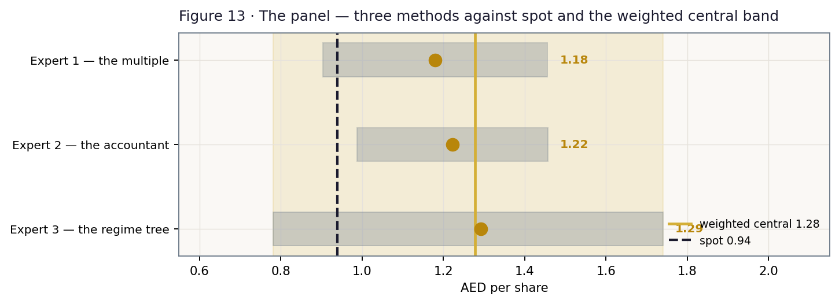
Figure 13 · The panel's ranges against spot and the weighted central band.
All three land above spot and land close together: AED 1.22, 1.18 and 1.29 — a spread of about eleven fils across three methods that share almost no machinery. One trusts the market's own multiple, one trusts only the audited cash, one refuses to trust either without weighting the states, and none can get to 94 fils. Note what none of them does: none of them needs the margin to expand. The base case has the FY26E EBITDA margin at 9.69% — below FY2025's 9.86% — and stabilising rather than recovering thereafter. The value is not in a margin story. It is in a business generating US$296mn of free cash flow and paying a cash-covered 7.45% yield while trading at 6.63× EBITDA.

C.6 Reading the convergence
When three methods with nothing in common converge above the price, the market is usually pricing something none of them has modelled. Here it is nameable: the market is pricing a permanent loss of sales density — the assumption that the ~8% productivity fall of Q1-2026 is structural rather than a war-shock trough. The company's own disclosure argues the other way: two of the three months were in line, the collapse was in Electrical and Lifestyle rather than food, and it landed exactly as the strait closed and Brent passed US$100. The strait has since reopened. But one quarter is one quarter, and the panel's weakest link is that it is reasoning about a recovery from a single data point. The question is not theological. It has a date. On 19 August 2026 Lulu reports H1, and the number to read is not the headline — it is whether the weakness has spread into food. If it has, the density loss is real and this study is wrong. If it has not, the market has mistaken a war for a business. Either way it will be recorded on the public Calibration Ledger, pass or fail.

About this series
Testahil publishes independent, methodology-first valuation studies: fair-value ranges and probability distributions, never ratings or price targets. Every Monte-Carlo forecast is registered, graded on maturity (T+20 and T+60 cohorts), and published — pass or fail — on the public Calibration Ledger at testahil.com. For Lulu the name-level backtest could not be run — 410 sessions of listed history yield two test windows, against the eighteen or so a meaningful test needs — so the cone here is validated on the fourteen-name UAE market panel rather than on Lulu itself, and it is that panel — not a Lulu-specific fit — which licenses it. The cohort registered here matures 07 Aug 2026 (T+20) and 02 Oct 2026 (T+60).

Disclosure & Disclaimer
1. No advice. This document is educational analysis and personal opinion. It is not investment advice, a recommendation, an offer, or a solicitation to buy or sell any security, and it is not directed at the circumstances of any person.
2. No licence. The preparer is not licensed by the SCA, the FRA, or any other securities regulator, holds no advisory or brokerage authorisation, manages no client money, and accepts no fees or clients in connection with this work.
3. Sources. Company figures are Lulu Retail's own published disclosure (the FY2023–FY2025 audited consolidated financial statements including the country-segment note, the Q1-2026 interim results of 11 May 2026, and the company's published store-format data); market data are dated quotes from the named venues and vendors. Figures marked DERIVED — the bank/lease debt split, right-of-use additions, segment space, and Q1-2026 sales density — are computed from disclosed figures, cross-checked where possible, and flagged wherever they appear. Errors are possible; the preparer corrects them publicly when found.
4. Judgments. All forecasts, drivers, multiples, probabilities and scenario weights are the preparer's judgments, flagged as such, and will be wrong in ways that matter. Ranges and distributions are the only honest output format; no single number in this document is a prediction.
5. Risk. Securities involve risk of loss, including total loss. Past calibration performance — including the public ledger — does not guarantee future forecast quality. This security in particular carries no name-level calibration record. Consult a licensed financial advisor before any investment decision.
6. Positions. The preparer may hold, or may take, a position in the security discussed, and owes readers no duty to update this document. Publication date: 12 July 2026.

