Testahil · Independent Valuation Study — Educational Analysis Not investment advice

Independent Valuation Study — Educational Analysis
Saudi Arabian Mining Company (Ma'aden) · Tadawul: 1211
Fundamental analysis · Technical analysis · Monte Carlo simulation — one integrated read
Anchor: SAR 58.80 (5 Jul 2026 close) · ~3.88 bn shares · mkt cap ~SAR 228 bn (~US$60.8 bn) · net debt ~SAR 24 bn · Saudi Arabia's national mining champion, ~64% owned by the Public Investment Fund, spanning phosphate (the largest business), aluminium, and gold & base metals, with a large new-minerals and exploration pipeline · prices and probabilities computed 5 Jul 2026 from the attached daily history · reporting currency SAR (pegged to USD at 3.75) · primary lens: sum-of-the-parts by commodity segment · the swing factors are the commodity price deck (DAP, LME aluminium, gold) and whether the multi-year growth capex earns its cost of capital.
READ FIRST — what this document is, and is not. This study is a valuation exercise and an expression of personal analytical opinion, published free of charge for educational purposes: it shows how one analyst applies fundamental, technical and probabilistic methods to a listed company, and invites scrutiny of that methodology. It is NOT investment advice, NOT a recommendation or solicitation to buy, sell or hold any security, and NOT directed at the circumstances of any reader. The preparer is not licensed by any securities regulator in any jurisdiction, holds no brokerage or advisory authorisation, provides no financial consultancy, manages no money, and accepts no fees, funds or clients. All values are model outputs presented as ranges and distributions because no single number should be relied on. Reported financials are the company's own disclosure (FY2025 results and quarterly filings); forward-looking inputs — the segment marks, the commodity price deck, the multiples, the DCF and the Monte-Carlo factor probabilities — are the preparer's judgments and are flagged throughout. A calibration note: the Monte-Carlo engine was backtested five years on Ma'aden and did not beat a plain random-walk cone, so Section 3 is presented as an honest probability map, not a skill-validated forecast (see Appendix B). Consult a licensed financial advisor before any investment decision.

Headline
The model's read: richly valued, with the entire premium resting on the growth pipeline and sovereign backing rather than on today's cash flows. At SAR 58.8 the shares sit about 40% above our weighted central estimate of SAR 42 — or, put the other way, the fundamental central is roughly 29% below the market price. The four lenses agree on direction and disagree only on how large the premium is: a sum-of-the-parts by commodity segment lands at SAR 44, a consolidated DCF at SAR 47, a peer-anchored relative read marks the floor at SAR 26, and a mid-cycle earnings-power read the ceiling at SAR 42. Every one of them sits below spot. The reason is visible in two numbers: Ma'aden trades at roughly 15.6× EV/EBITDA and 31× earnings, versus global diversified miners at 5–7× and phosphate and aluminium peers at 5–8×. That is not a mispricing to be arbitraged away in a quarter; it is the price the market puts on a tier-one, gas-advantaged, PIF-backed resource platform in the middle of a multi-year build-out — Phosphate 3, a gold-production doubling, and international expansion through Manara Minerals. The honest way to hold both facts at once is the two-clocks framing: on the near-term clock (a ~12-month, risk-adjusted fair value) the stock looks expensive; on the second clock (full execution of the 2040 strategy, mid-to-late decade) the business could grow into today's price, but that is not a near-term figure and must not be presented as one. Technically the tape agrees with the fundamentals for once: the shares are below all four major moving averages, RSI is in the low-30s, and the MACD histogram is negative — price and value are pulling the same way, down, in the near term. Over three months the Monte Carlo places the 5th–95th band at roughly SAR 46–78 with a median at spot; it maps where price could travel, not where value sits, and the SAR 42 fundamental line is deliberately below that cone.
Valuation summary — every read at a glance
One table for the four reads that follow — what the business is worth (fundamental), what the tape is doing (technical), where price could travel over three months (Monte Carlo), and how three independent expert methods land. Every row is developed in the sections and appendices below.
Lens / read | What it measures | Output | Takeaway
FUNDAMENTAL — what the business is worth (the anchor)
Sum-of-the-parts (primary) | Segment marks less net debt | SAR 44 | −25% vs spot
Consolidated DCF | Discounted 5-yr FCFF | SAR 47 | −19%
Relative multiples | Peer EV/EBITDA | SAR 26 | −56% · the floor
Mid-cycle earnings | Through-cycle NI × P/E | SAR 42 | −28% · the ceiling
Weighted central | Blend 40 / 20 / 15 / 25 | SAR 42 | −29% vs SAR 58.8
TECHNICAL — what the tape is doing (timing, not value)
Trend & momentum | Price vs the 20/50/100/200-day averages | Below all four | Weak, corrective
Momentum / range | RSI · MACD · 52-week range | RSI 34 · MACD −0.22 · 51–80 | Stretched down
MONTE CARLO — where price could go in 3 months (paths from spot)
T+20 sessions | 50,000 paths · 16 factors | p5 51 · p50 59 · p95 69 | Median ≈ spot
T+60 sessions | same engine, longer horizon | p5 46 · p50 60 · p95 78 | Wide, right-skewed
EXPERT PANEL — three independent methods (Appendix D)
Expert 1 — mid-cycle earnings power | Through-cycle commodity earnings | SAR 44 | The normalizer
Expert 2 — cash returns (DCF + ROIC) | Return on capital vs ~9.3% WACC | SAR 34 | Most conservative
Expert 3 — strategic / macro-policy | PIF backing & Vision-2030 premium | SAR 48 | Most constructive
Panel range | Spread = the premium question | SAR 34–48 | Centres ~SAR 42

Bottom line. Every read points the same way on value — below spot — and disagrees only on magnitude. The fundamental central sits near SAR 42, about 29% under the SAR 58.8 price; the three experts span SAR 34–48, and each one turns on a single question: whether the growth pipeline and the sovereign-backed multiple justify a price at 15.6× EV/EBITDA. The technical tape, unusually, agrees: oversold and below trend. The three-month distribution centres near spot with a wide right tail — because the simulation maps price, and does not assume the value gap closes inside the quarter.
Company overview — Ma'aden at a glance
Item | Value
Listed entity | Saudi Arabian Mining Company (Ma'aden) — Tadawul: 1211
What it owns | Phosphate (Ma'aden Phosphate + Waad Al Shamal) · Aluminium (bauxite, alumina, smelter, rolling) · Gold & Base Metals · New Minerals / exploration / Manara Minerals (international)
Spot / date | SAR 58.80 · 5 Jul 2026 close
Shares · market cap | ~3.88 bn · ~SAR 228 bn (~US$60.8 bn)
Consolidated net debt | ~SAR 24 bn (FY2025); net debt / EBITDA ~1.5×
FY2025 revenue / EBITDA margin | SAR 38.58 bn (+19% YoY) · ~42% EBITDA margin
FY2025 net profit (attributable) / EPS | SAR 7.35 bn (+156% YoY) · SAR 1.89
Largest business | Phosphate — ~54% of revenue, ~61% of segment EBITDA (47% margin)
Major shareholder | Public Investment Fund (PIF) ~64%; free float on Tadawul
52-week range (to anchor) | SAR 51.1 – 79.5
Realized volatility (252d) | ~32.4% annualized
Structural feature | SAR pegged to USD at 3.75 — commodity revenue is USD-linked; no material FX-translation swing
Strategy | 2040 growth plan: Phosphate 3, gold-production doubling (Mansourah-Massarah, Ar Rjum), exploration, rare earths, and international M&A via Manara (50/50 with PIF)
Source: Ma'aden FY2025 results and quarterly filings; Tadawul / exchange data; company disclosures. Values rounded.
1 Fundamental valuation
We value Ma'aden as an integrated, multi-commodity producer and triangulate four lenses. The primary lens is a sum-of-the-parts by commodity segment, because the three businesses trade on genuinely different economics — a world-class, gas-advantaged phosphate franchise; a mid-cost, energy-intensive aluminium chain; and a high-margin, ramping gold and base-metals unit — and a single group multiple would blur them. A consolidated DCF, a peer-anchored relative cross-check and a mid-cycle earnings-power read complete the set. Two features simplify the picture relative to a cross-border name: Ma'aden reports in riyals and the riyal is pegged to the dollar, so there is no currency-translation swing to model, and the whole enterprise sits inside one tax and regulatory regime. The weights and the football field are in §1.5; the swing factors — the commodity deck and the returns on the growth capex — are dissected in §1.7, and the sensitivity grid in §1.9.
1.1 Sum-of-the-parts by commodity segment — the primary lens
Each business is marked on a normalized, near-forward EBITDA (broadly FY2027E, capturing the first phase of Phosphate 3 and the gold ramp) and a peer-plus EV/EBITDA multiple that reflects its quality and growth. Phosphate earns the highest multiple: a 47% EBITDA margin, structurally top-decile on the back of sub-$2/mmbtu domestic gas, and a large expansion underway. Aluminium is marked on a mid-cost multiple; gold and base metals on a premium reflecting the production-doubling pipeline; and a residual new-minerals, exploration and Manara-stake bucket is given a conservative option-value mark. From the summed enterprise value we deduct consolidated net debt.
Part (base case) | Basis | Value (SAR bn)
Phosphate | SAR 11.0 bn norm. EBITDA × 10.5× | 115.5
Aluminium | SAR 3.0 bn norm. EBITDA × 7.0× | 21.0
Base Metals & New Minerals (gold/copper) | SAR 4.5 bn norm. EBITDA × 10.0× | 45.0
New minerals / exploration / Manara | Option-value mark | 14.0
Σ Enterprise value |  | 195.5
less: consolidated net debt |  | (24.0)
Equity value | = SAR 44.2 / share | 171.5
SOTP base ≈ SAR 44/share, with a bear–bull span of roughly SAR 28–60 driven mainly by the phosphate multiple and the DAP price (see §1.9). Note what this says: even on near-forward, growth-inclusive marks and multiples set above the miner peer group, the parts sum to about three-quarters of the market price. The remaining gap is the value of the longer-dated pipeline and the sovereign-backing premium — the second clock — which this lens deliberately does not capitalize.
1.2 Consolidated DCF — the cash-flow cross-check
A consolidated free-cash-flow-to-firm model is the natural check on the asset sum. We build FCFF from EBIT to NOPAT (taxed at an 8% effective zakat-and-tax rate), add back D&A, and subtract the heavy growth capex (~SAR 7–9 bn a year) and the increase in working capital. The near-term free cash is real but modest — the capex programme absorbs much of a strong EBITDA — and it rises as projects complete. We fade a mid-single-digit growth into a 3.5% terminal and discount at a 9.3% WACC. The cost of equity is built explicitly as Ke = 4.5% risk-free + 0.95 × 5.5% ERP ≈ 9.7% (§1.8 and §3.5-G); the WACC blends that with an after-tax cost of debt at market weights.
Free cash flow to the firm, five-year explicit forecast — every line shown, not just the output:
Line | FY26E | FY27E | FY28E | FY29E | FY30E
EBIT | 11.0 | 12.5 | 13.7 | 14.9 | 16.1
NOPAT = EBIT × (1 − 8% tax) | 10.1 | 11.5 | 12.6 | 13.7 | 14.8
+ D&A | 5.8 | 6.4 | 6.9 | 7.4 | 7.8
− Capex | (9.0) | (9.0) | (8.0) | (7.5) | (7.0)
− Increase in net working capital | (1.2) | (1.1) | (1.0) | (0.9) | (0.8)
Free cash flow to firm (FCFF) | 5.7 | 7.8 | 10.5 | 12.7 | 14.8
Discount factor @ 9.3% WACC | 0.915 | 0.837 | 0.766 | 0.701 | 0.641
PV of FCFF | 5.2 | 6.5 | 8.0 | 8.9 | 9.5
DCF roll-up to valuation | SAR bn
Σ PV of explicit FCFF (FY26E–FY30E) | 38.1
Terminal value (Gordon, g 3.5%) | 265.2
PV of terminal value | 170.0
Enterprise value | 208.1
TV as % of EV (device A-7 disclosure) | 81.7%
less: net debt | (24.0)
Equity value | 184.1
DCF fair value per share | SAR 47
Cost of equity shown explicitly: Ke = rf 4.5% + β 0.95 × ERP 5.5% ≈ 9.7%; the 9.3% WACC blends that with an after-tax cost of debt at market weights. The valuation is terminal-heavy — the PV of the terminal value is ~82% of enterprise value (device A-7), so the answer is as much a bet on the terminal-growth-versus-WACC spread as on the five explicit years; we disclose that rather than bury it. Every input links to the model's Assumptions sheet.
Sensitivity — bear / base / bull on the three swing inputs:
DCF input | Bear | Base | Bull
Normalized near-term FCFF (SAR bn) | 4.5 | 5.7 | 7.0
WACC | 10.5% | 9.3% | 8.5%
Terminal growth | 2.5% | 3.5% | 4.0%
Fair value (SAR/share) | 30 | 47 | 62
The DCF base of SAR 47 lands above the SOTP and below spot — a coherent middle. At a 9.3% WACC the implied EV of ~SAR 208 bn is ~12.4× near-term EBITDA, still a full turn or two below the market's 15.6× — the DCF, like every lens here, says the price embeds more than the modellable cash flows.
1.3 Relative multiples
On peer multiples Ma'aden screens expensive, and this is the most conservative lens — the floor a sceptic anchors to. We mark a normalized group EBITDA of ~SAR 16.5 bn against a blended diversified-miner multiple of 7.5× — already a premium to the 5–7× at which BHP, Rio, Vale and Anglo trade, and to the 5–8× of the phosphate and aluminium peer sets, in deference to Ma'aden's cost position and growth. Even so, the implied EV of ~SAR 124 bn, less net debt, is worth only about SAR 26/share.
Relative basis | Bear | Base | Bull
Normalized EBITDA (SAR bn) | 15.0 | 16.5 | 18.0
Blended EV/EBITDA multiple | 6.5× | 7.5× | 9.0×
Fair value (SAR/share) | 20 | 26 | 38
Relative base ≈ SAR 26 — less than half the market price. It treats Ma'aden as a commodity miner rather than a strategic growth vehicle, and assigns no separate value to the exploration and new-minerals optionality. It is the honest peer-anchored number, and the width of the gap to spot is precisely the size of the premium the other lenses debate.
1.4 Mid-cycle earnings power
For a commodity producer, normalized earnings means mid-cycle commodity prices, not a return to a single peak year. We normalize net income to ~SAR 6.3 bn — below the FY2025 print of SAR 7.35 bn, because 2025 caught strong DAP and a surging gold price near the top of their ranges (device A-6: current earnings sit toward the upper part of the cycle, not mid) — and apply a justified through-cycle P/E of 26×, high for a miner but defensible for a low-cost, high-growth, sovereign-backed name.
Mid-cycle-earnings basis | Bear | Base | Bull
Mid-cycle net income (SAR bn) | 4.8 | 6.3 | 7.6
Justified through-cycle P/E | 22× | 26× | 30×
Fair value (SAR/share) | 28 | 42 | 58
Mid-cycle base ≈ SAR 42 — the ceiling of the central case, and the bet that commodity prices hold near recent strength and the growth multiple survives. It is, in effect, the most generous fundamental read one can defend without capitalizing the un-built pipeline.
1.5 Synthesis — four lenses
We weight the SOTP most heavily because it respects the differing economics of the segments; the DCF and mid-cycle lenses carry the growth and normalization case; the relative lens anchors the peer-cheapness floor.
Lens | Weight | Bear | Base | Bull
Sum-of-the-parts | 40% | 28 | 44 | 60
Consolidated DCF | 20% | 30 | 47 | 62
Relative multiples | 15% | 20 | 26 | 38
Mid-cycle earnings | 25% | 28 | 42 | 58
Weighted central |  | 27 | 42 | 57
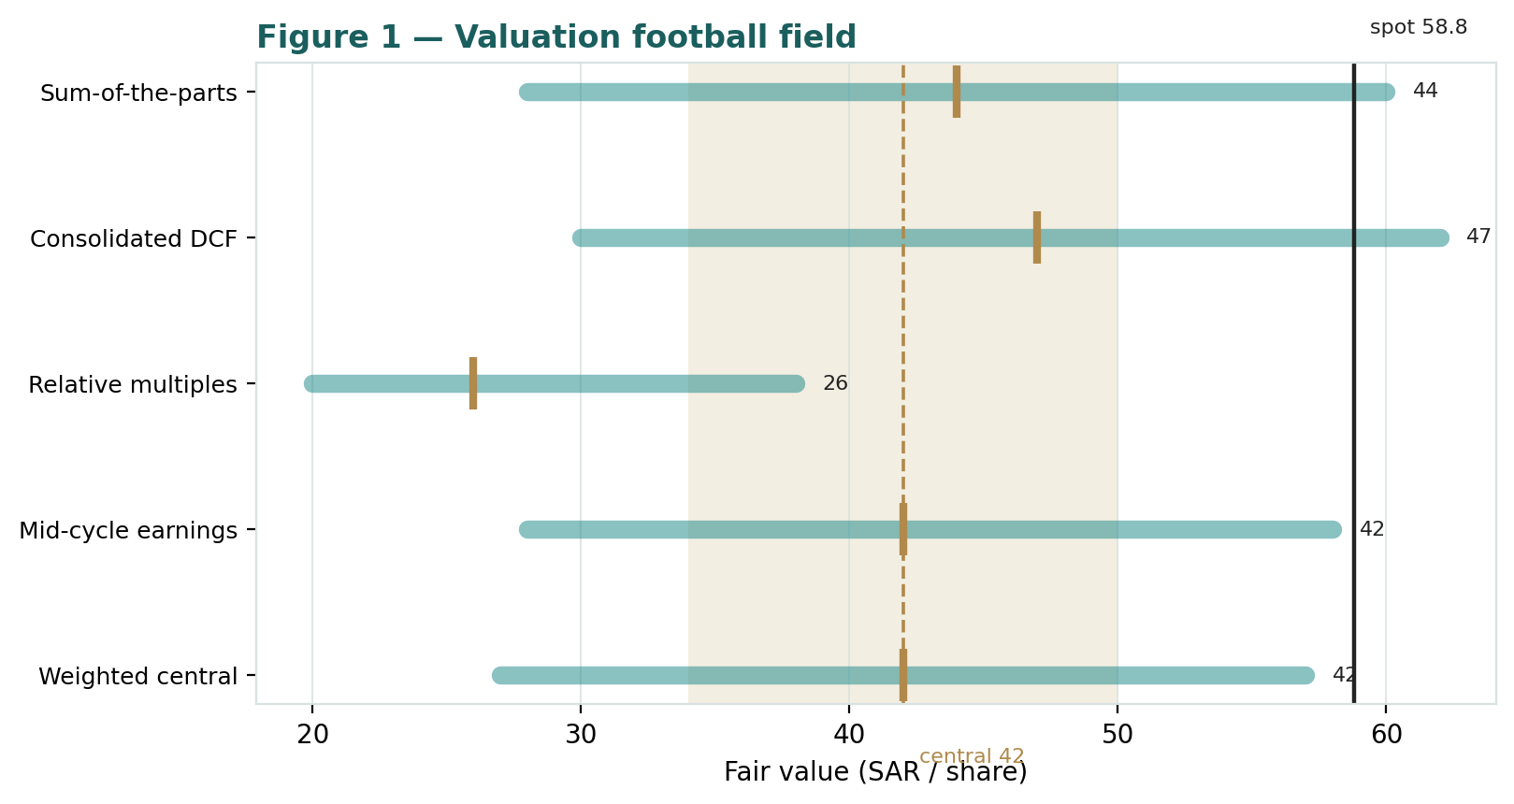
Figure 1 — Valuation football field. Bars span bear–bull per lens; the brass tick is each base case; the gold band is the blended central range; the dark line is spot.
Central fair value ≈ SAR 42/share, about 29% below spot. The spread of the lenses (SAR 26 to SAR 47 at base) is itself the message: this is not a cheap stock on any near-term measure. The question the market answers with its price is whether a tier-one, gas-advantaged, PIF-backed platform mid-build deserves 15.6× EV/EBITDA. Our lenses say the modellable value is nearer SAR 42; the ~SAR 17 gap to spot is the market's capitalization of the pipeline and the sovereign put.
1.6 The segments — a deeper look
Phosphate (FY2025: revenue SAR 20.8 bn, EBITDA SAR 9.8 bn, a 47% margin) is the value engine: Ma'aden mines its own rock, makes its own ammonia from cheap domestic gas, and exports DAP and specialty fertilizers into Asia and Africa — an integrated, structurally low-cost chain whose margin is the envy of the global industry, and which is being enlarged by the Phosphate 3 project toward a step-change in capacity. Aluminium (revenue SAR 11.0 bn, EBITDA SAR 2.6 bn) is a full bauxite-to-rolled-products chain, now consolidated after Ma'aden bought out its partners' stakes; it is mid-cost, energy- and LME-sensitive, and the swing business for group margin quarter to quarter. Gold & Base Metals (revenue SAR 6.8 bn, EBITDA SAR 3.5 bn) is the highest-margin ounce-producer, ramping Mansourah-Massarah and targeting a doubling of gold output by the end of the decade, with copper and base-metals exploration as the option. The table scores each part on the axes that matter.
Segment | Cyclicality | Margin trend | Capital intensity | Swing role
Phosphate | Moderate (agri) | Peak-ish, ~47% | Very high (Phosphate 3) | Dominant · value engine
Aluminium | High (LME + energy) | Recovering off lows | High | Quarter-to-quarter swing
Gold & Base Metals | High (gold price) | Rising, high margin | High (mine build) | Growth optionality
New Minerals / Manara | N/M (pre-revenue) | N/M | Exploration / M&A | Long-dated option

1.7 The crux — commodity prices and the return on the growth capex
Two judgments drive the valuation more than any other. First, where the commodity deck sits. Phosphate is roughly 55% price-geared: at a DAP price near US$650/t FOB the phosphate EBITDA supports the SOTP; a move to US$500/t or US$800/t swings the whole valuation materially (see §1.9). LME aluminium (~US$2,700/t) and gold (~US$3,300/oz) add the second and third legs. Because the riyal is pegged, these USD prices flow to the riyal top line without an FX buffer either way. Second, whether the growth capex earns its cost of capital. Ma'aden is spending on the order of SAR 7–9 bn a year — Phosphate 3, the gold build, exploration, and international deals through Manara — against an EBITDA near SAR 16 bn. That absorbs most of the free cash today; the bet is that the incremental capital returns above the ~9.3% WACC once the projects ramp. If it does, the second clock validates today's price; if the projects come in late or over budget, or commodity prices fade, the near-term clock (a fair value near SAR 42) is the one that governs. The table frames the swing in observable units rather than an abstract margin.
Swing driver | Bear | Base | Bull | Channel
DAP price (FOB, US$/t) | 500 | 650 | 800 | Phosphate EBITDA (~55% geared)
LME aluminium (US$/t) | 2,300 | 2,700 | 3,100 | Aluminium EBITDA
Gold (US$/oz) | 2,800 | 3,300 | 3,800 | Base-metals EBITDA
Incremental ROIC on growth capex | < WACC | ≈ WACC | > WACC | Justifies the premium

1.8 Macro and country — Saudi Arabia, PIF, the peg and the commodity cycle
Ma'aden is a rare thing: a national-champion miner inside a fiscally strong, reforming state. Four levers matter. The riyal peg to the dollar (SAR 3.75) removes translation risk and anchors the cost of capital; a de-peg is a low-probability tail, but it is the tail that would most change this model. PIF ownership (~64%) is both a support and a feature of the premium — it aligns Ma'aden with Vision-2030's minerals ambition (the Kingdom values its untapped resources in the trillions of dollars) and lowers its effective cost of capital, but it also means the free float is thin and the stock trades partly as a policy vehicle. The domestic gas price — regulated and very low — is the structural source of the phosphate and aluminium cost advantage; a reset higher would compress the crown-jewel margin. And the global commodity cycle — Chinese and Indian fertilizer and construction demand, the gold price, LME aluminium — sets the top line. These levers sit behind the bear and bull cases in §1.5 and the catalysts in §5. Because there is no FX swing and one tax regime, the cost of equity is cleaner than for a cross-border name: Ke = rf 4.5% + β 0.95 × ERP 5.5% ≈ 9.7% (the realized beta is a low ~0.46, reflecting a controlled, index-heavy, steadily-trending stock; we floor it to the house 0.8–1.3 band so the discount rate is not flattered by a statistically low number), sensitized on the WACC × terminal-g grid below.
Ke / WACC × terminal-g | g = 2.5% | g = 3.0% | g = 3.5% | g = 4.0%
WACC 8.5% | 41 | 45 | 50 | 57
WACC 9.3% (base) | 36 | 41 | 47 | 54
WACC 10.5% | 30 | 33 | 37 | 42
The grid shows the DCF's sensitivity: at the base WACC, the value runs from SAR 36 to SAR 54 across a plausible terminal-growth band — every cell below spot, underlining that the premium is not a WACC artefact.
1.9 SOTP sensitivity — the DAP price and the phosphate multiple
Holding aluminium, gold and the other parts at base, the grid re-prices the SOTP across the DAP price and the phosphate EV/EBITDA multiple — the two inputs that move the primary lens most. The value runs from the high-SAR-20s to the low-SAR-60s; the cells nearest spot (SAR 58.8) show the DAP price and multiple the market is effectively paying for.
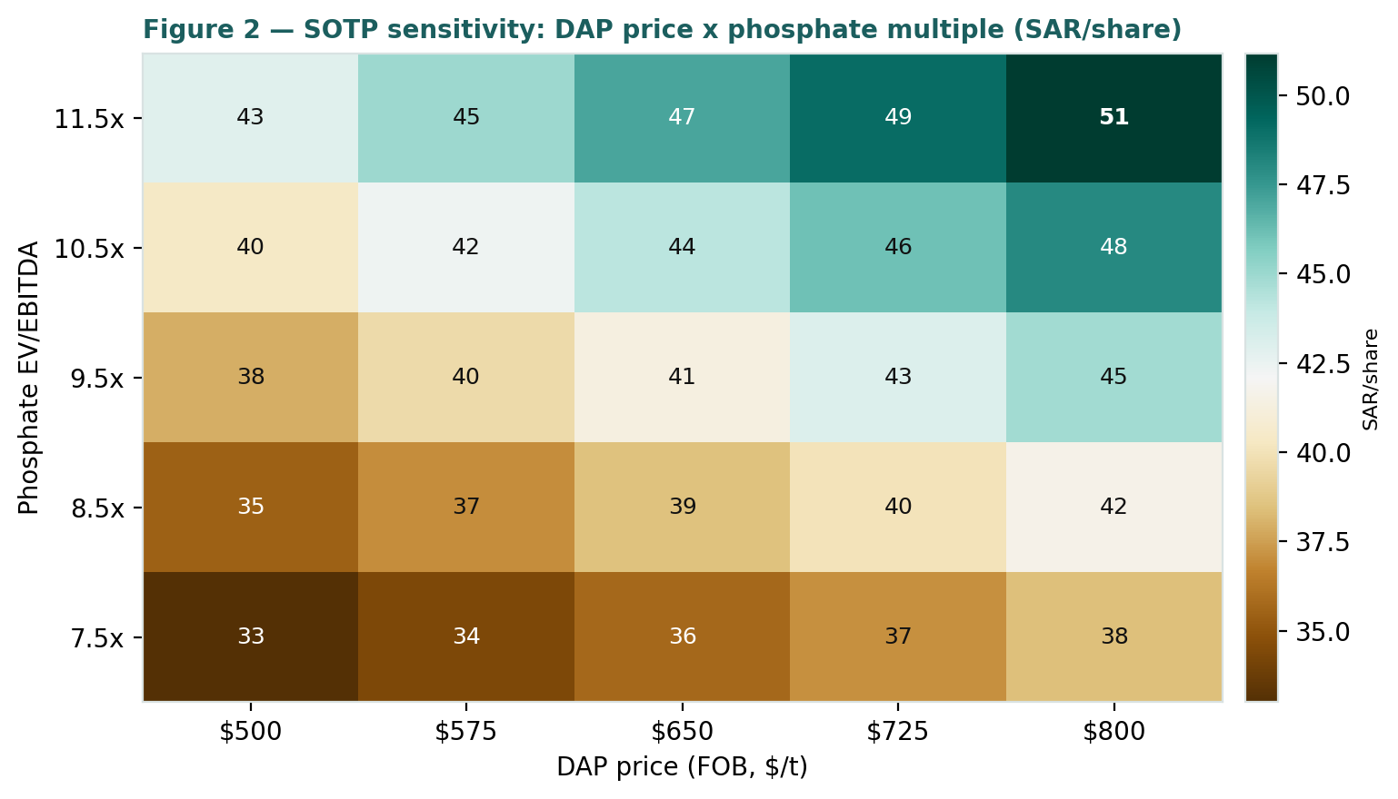
Figure 2 — SOTP sensitivity to the DAP price and the phosphate multiple (SAR/share).
Read it as the bet you are taking: the market price is consistent with roughly an 11× phosphate multiple on a DAP price near US$800/t — i.e. a near-peak commodity deck and a growth multiple already in the price.
2 Technical and price structure
The tape is weak and stretched to the downside, and for once it agrees with the fundamentals. Ma'aden trades below all four major moving averages, the MACD histogram is negative, and RSI sits in the mid-30s — approaching, but not yet at, oversold. The structure is corrective: a de-rating from the high-70s toward the high-50s, with the trailing-year low near SAR 51 as the visible floor.
Indicator | Reading | Signal
Spot | SAR 58.8 | —
SMA 20 / 50 | SAR 61.0 / 63.2 | Below both — short-term down
SMA 100 / 200 | SAR 66.6 / 65.1 | Below both — trend down
RSI (14) | 34.3 | Approaching oversold
MACD (12,26,9) | −1.13 line / −0.91 signal / −0.22 hist | Bearish, momentum negative
52-week range | SAR 51.1 – 79.5 | Lower third of range
Realized vol (252d) | 32.4% | Moderately elevated
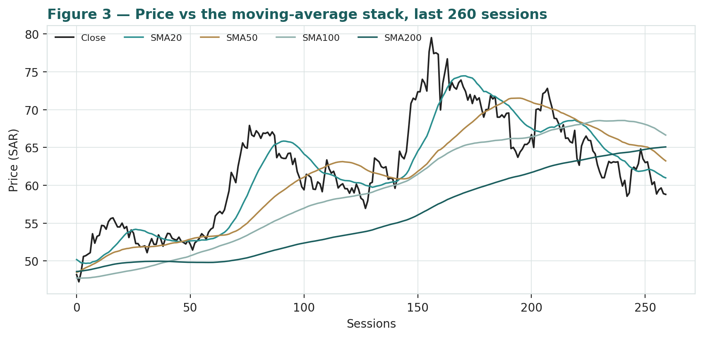
Figure 3 — Price versus the moving-average stack, last 260 sessions.
For the probabilistic work this matters in one way: an oversold, below-trend tape and a fundamentally rich valuation point the same direction over the near term, which is why the three-month distribution — while centred on spot by construction — carries a left tail that the fundamentals do not argue against. Section 6 reads the resulting probability zones.
3 Monte Carlo — a probabilistic price map
We simulate 50,000 three-month price paths (seed 42) using a sixteen-factor stack: seven continuous macro/commodity drivers contributing a small net forward drift, and nine discrete events that each fire with a probability and an impact. By design the paths diffuse from spot, and the §1 value gap is kept out of the drift — the fundamental value sits in §1, not here; §3 maps where price could go from today, not where value sits. A calibration caveat governs this section (Appendix B): on Ma'aden the engine did not beat a plain zero-drift random-walk cone, so we present §3 as an honest, regime-conditional probability map rather than a skill-validated forecast, and we size the width from the trailing realized volatility (~32.4% annualized) — the fair, well-behaved width for this name — with the net external drift a modest +2.2% over the quarter from the factor stack.
Continuous factor (7) | Dir. | Discrete event (9) | Prob. | Mean impact
DAP / phosphate price | + | Q2-FY26 results (mid-Aug) | 85% | +0.4%
LME aluminium price | + | Commodity price spike (DAP/Al/gold) | 25% | +3.0%
Gold price (base-metals leg) | + | Global recession / demand shock | 20% | −4.5%
Global growth / China demand | + | Phosphate 3 milestone (on/behind) | 35% | +1.0%
Natural-gas feedstock cost | − | Ar Rjum / gold-doubling catalyst | 25% | +1.5%
USD real rate / DXY | − | Manara international M&A | 25% | +1.0%
TASI & passive / MSCI-EM flows | + | Dividend-initiation / capital-return | 20% | +2.0%
 |  | PIF / Vision-2030 policy or index flow | 25% | +1.2%
 |  | Gas-supply / feedstock / regulatory reset | 20% | −3.0%
Percentile map (SAR/share):
Horizon | p5 | p25 | p50 | p75 | p95
T+20 sessions | 50.7 | 55.6 | 59.2 | 63.1 | 69.1
T+60 sessions | 46.1 | 53.9 | 60.1 | 67.1 | 78.4
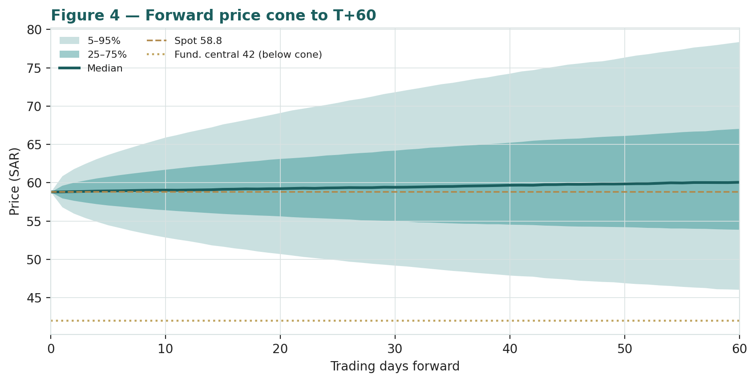
Figure 4 — Forward price cone to T+60. Median tracks spot; the gold dotted line marks the SAR 42 fundamental central value, deliberately below the cone.
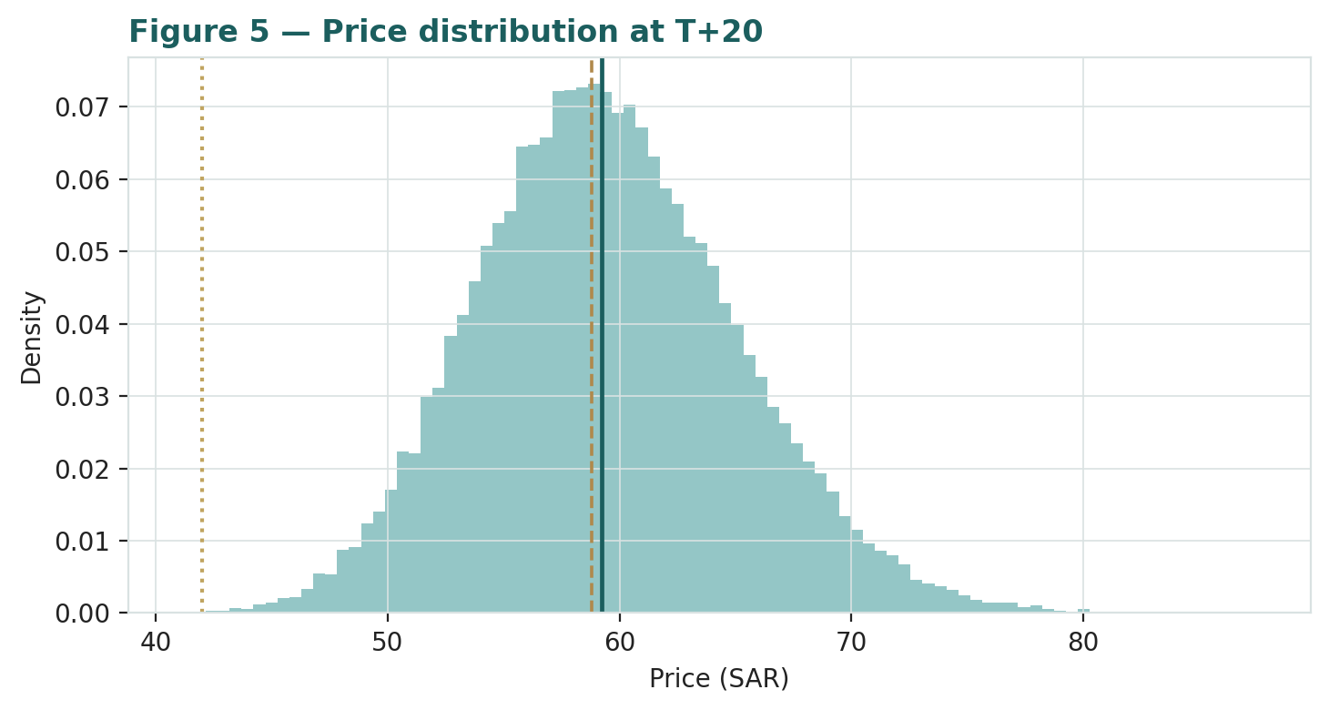
Figure 5 — Price distribution at T+20.
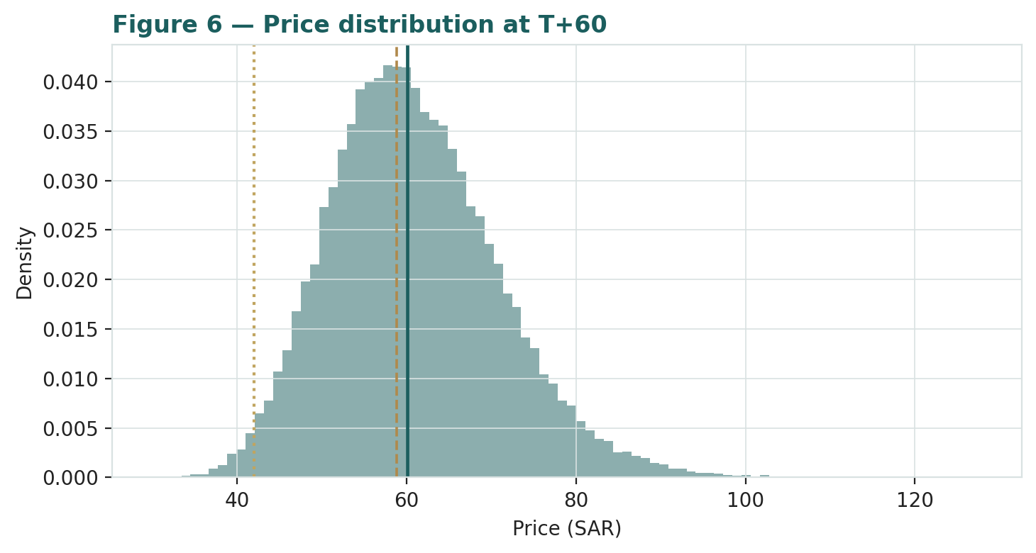
Figure 6 — Price distribution at T+60.
Leading with the 50% interquartile band (house presentation rule): over three months the middle-half of outcomes spans roughly SAR 54–67, and at T+20 roughly SAR 56–63 — that interquartile width, not the 90% tail, is the instrument's genuine quarter-ahead uncertainty. Level-touch ladder — the probability that price touches a level at any point by the horizon (running max for upside, running min for downside):
Level | T+20 touch | T+60 touch | Note
SAR 80 | 0% | 6% | Toward 52-wk high
SAR 72 | 3% | 22% | Upper tail
SAR 66 | 20% | 48% | Above the MA stack
SAR 62 | 52% | 73% | Just above spot
SAR 58 | 76% | 85% | Around spot
SAR 54 | 28% | 51% | Just below spot
SAR 50 | 6% | 25% | Toward the 52-wk low
SAR 46 | 1% | 9% | Below the range / near central
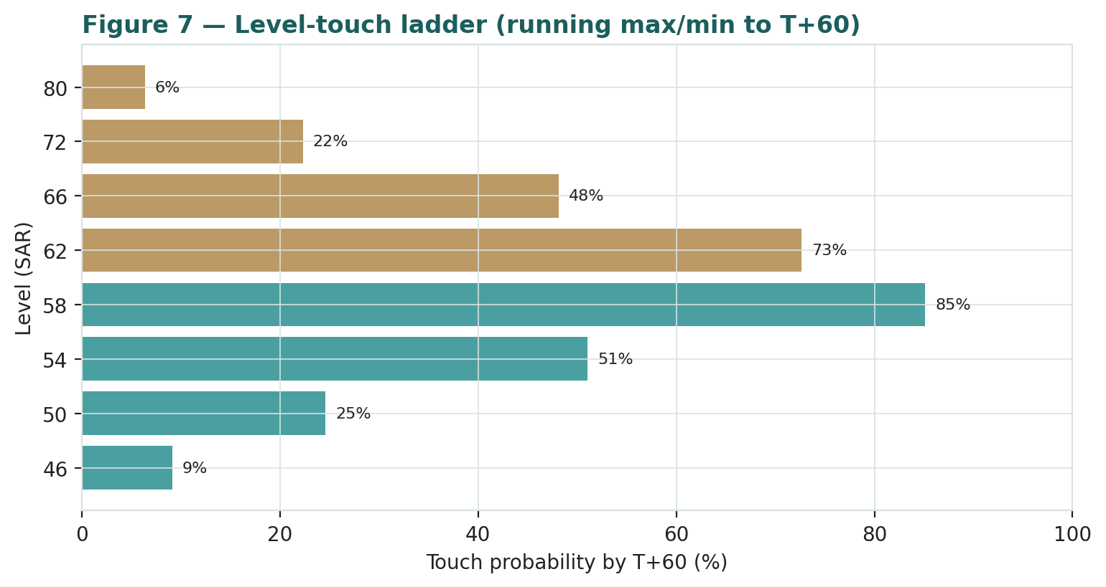
Figure 7 — Level-touch ladder to T+60.
4 Comparison of the lenses, and a verdict
Three readings sit side by side. The fundamental lenses cluster at SAR 26–47 with a central SAR 42 — clearly below spot, contingent on the growth pipeline. The technical picture agrees: weak, below-trend, oversold-leaning, with the visible floor near SAR 51. The probabilistic map says that over three months price is roughly symmetric around spot with a wide band — the median is SAR 60, not SAR 42, because the simulation does not assume the value gap closes inside the quarter.
Lens | Reads | Central / implication
Fundamental (4-lens) | Richly valued | SAR 42 (~−29%)
Technical | Weak / oversold | Floor ~SAR 51; resistance at the MA stack SAR 63–67
Monte Carlo (3-month) | Symmetric, wide | Median SAR 60; p5–p95 SAR 46–78
Verdict (a fair-value read, not a recommendation). Ma'aden looks richly valued on every fundamental lens, with the entire premium resting on one broad proposition: that a tier-one, gas-advantaged, PIF-backed platform mid-build deserves ~15.6× EV/EBITDA. The technical weakness and the wide, spot-centred three-month distribution argue that any resolution is a question of commodity prices and project delivery over quarters and years, not an imminent move. The honest summary is a value materially below price, a near-term distribution centred on price, and an outcome that hinges on the second clock — the growth pipeline earning its cost of capital. Readers should weigh the lenses themselves; we publish the distribution, not a target.
5 Catalysts to watch
- Q2-FY26 results (mid-Aug 2026). First read on whether phosphate and gold margins are holding near their recent strength and how aluminium is tracking.
- The commodity deck. DAP FOB price, LME aluminium and the gold price — the three legs of the top line, each USD-priced and flowing through the peg.
- Phosphate 3 progress. Milestones, capex phasing and first-output timing on the flagship expansion — the single biggest driver of the growth case.
- Gold-doubling pipeline. Mansourah-Massarah ramp and Ar Rjum development toward the end-of-decade doubling target.
- Manara Minerals / international M&A. Any new stake (following Vale Base Metals and the copper interests) — a swing on strategy and capital allocation.
- Domestic gas price. Any reset of the regulated feedstock price would move the crown-jewel phosphate and aluminium margins directly.
- Capital return. Ma'aden pays no dividend today; an initiation or a clear capital-return signal would be a re-rating catalyst.
- PIF / index events. Free-float changes, MSCI/passive rebalancing flows, and any Vision-2030 policy step touching the minerals sector.
6 Reading the probability zones
Translating the three-month distribution into plain zones, anchored on spot SAR 58.8 and the fair-value cluster near SAR 42:
Zone (T+60) | Range | Approx. probability | What it would mean
Deep downside | < SAR 50 | ~18% | Commodity fade / risk-off; tests the 52-wk low, toward fundamental value
Lower band | SAR 50–56 | ~24% | De-rating continues; relative-multiple lens gains weight
Around spot | SAR 56–63 | ~30% | Status quo; the premium holds, value gap unclosed
Upper band | SAR 63–72 | ~19% | Strong commodities + pipeline credit; back toward the highs
Strong upside | > SAR 72 | ~9% | Commodity spike and/or a capital-return or M&A catalyst
The distribution is close to symmetric, with a modestly heavier upper tail from the discrete upside events (a commodity spike, a capital-return signal, index flows). It is not a forecast; it is the spread of outcomes consistent with the stock's own volatility and the factor stack, and — per Appendix B — it is presented as a probability map, not a skill-validated one.
7 Caveats and what would change our mind
- The premium is the whole question. Our central sits ~29% below spot; if the growth capex durably earns well above its cost of capital, the second-clock value grows into — or past — today's price, and our lenses would be too conservative.
- Commodity prices are the top line. The deck (DAP, aluminium, gold) is struck near recent strength; a fade toward mid-cycle would pull every lens lower, a spike would lift them.
- The peg is load-bearing. The whole model assumes SAR 3.75. A de-peg is a low-probability tail, but the one that would most change the answer.
- Gas is the moat. The phosphate and aluminium cost advantage rests on a very low regulated gas price; a reset higher compresses the crown jewel.
- Capex suppresses cash. The build-out means free cash can stay thin for years even as profit grows, which the DCF treats but cannot precisely time; execution risk on Phosphate 3 and the gold build is real.
- Thin float, policy vehicle. With PIF ~64%, the free float is small and the stock trades partly on policy and flow, which can push price far from fundamental value in either direction.
- Calibration honesty. The Monte-Carlo engine showed no skill over a random-walk cone on this name; §3 is a probability map, not a validated forecast, and should be read as context, not signal.

Appendix A Financial statements
Selected consolidated figures, presented as three years of reported history (FY2023–FY2025) plus a five-year forecast (FY2026E–FY2030E). FY2023–FY2025 are as reported (Ma'aden FY2025 results and quarterly filings); FY2026E–FY2030E are the preparer's forecast, driven by the model's Assumptions sheet. SAR bn. FY2023 weak-year figures are approximate (post-2022 commodity peak); FY2024–FY2025 per company disclosure.
A.1 Income statement (consolidated, SAR bn)
Line | FY23 | FY24 | FY25 | FY26E | FY27E | FY28E | FY29E | FY30E
Revenue | 27.9 | 32.6 | 38.6 | 41.5 | 45.5 | 49.0 | 52.5 | 56.0
EBITDA | 9.5 | 12.3 | 16.1 | 16.8 | 18.9 | 20.6 | 22.3 | 24.0
D&A | (5.5) | (6.0) | (6.6) | (5.8) | (6.4) | (6.9) | (7.4) | (7.8)
EBIT | 4.0 | 6.3 | 9.5 | 11.0 | 12.5 | 13.7 | 14.9 | 16.1
Net finance cost | (2.1) | (1.9) | (1.9) | (1.5) | (1.4) | (1.3) | (1.2) | (1.1)
JV/associates + other | 0.3 | 0.3 | 0.7 | 0.5 | 0.5 | 0.6 | 0.6 | 0.7
Profit before zakat & tax | 2.2 | 4.7 | 8.3 | 10.0 | 11.6 | 13.0 | 14.3 | 15.7
Zakat & income tax | (0.2) | (0.4) | (0.7) | (0.8) | (0.9) | (1.0) | (1.1) | (1.3)
Non-controlling interests | (0.4) | (1.5) | (0.3) | (0.6) | (0.6) | (0.7) | (0.7) | (0.8)
Net profit (attributable) | 1.6 | 2.9 | 7.4 | 8.6 | 10.1 | 11.4 | 12.5 | 13.6
Note: FY2024 net profit +82% and FY2025 +156% YoY per company disclosure; EPS FY2025 ≈ SAR 1.89. Forecast EPS/margins in the Per-Share & Ratios sheet.
A.2 Balance sheet (consolidated, SAR bn)
Line | FY23 | FY24 | FY25 | FY26E | FY27E | FY28E | FY29E | FY30E
PP&E + intangibles | 92.0 | 101.0 | 108.0 | 111.2 | 115.1 | 118.2 | 120.8 | 123.0
Inventory + receivables + other CA | 18.0 | 19.5 | 21.5 | 22.8 | 25.0 | 27.0 | 28.9 | 30.8
Cash & equivalents | 8.5 | 9.0 | 11.0 | 13.7 | 17.5 | 21.5 | 25.9 | 30.5
Total assets | 118.5 | 129.5 | 140.5 | 147.7 | 157.6 | 166.7 | 175.6 | 184.3
Borrowings (gross debt) | 30.0 | 31.0 | 35.0 | 35.0 | 35.0 | 35.0 | 35.0 | 35.0
Payables + provisions + other | 25.5 | 30.6 | 26.9 | 27.7 | 28.5 | 29.4 | 30.3 | 31.2
Non-controlling interests | 15.0 | 16.0 | 17.0 | 17.6 | 18.2 | 18.9 | 19.6 | 20.4
Equity (attributable) | 48.0 | 51.9 | 61.6 | 67.4 | 75.9 | 83.4 | 90.7 | 97.5
Net debt = borrowings − cash | 21.5 | 22.0 | 24.0 | 21.3 | 17.5 | 13.5 | 9.1 | 4.5
Note: FY2025 attributable equity ~SAR 61.6 bn (+19% YoY) per disclosure; net-debt/EBITDA ~1.5×. Forecast balances rolled from the Income Statement and Assumptions; the statement foots each year.
A.3 Cash flow (forecast, SAR bn)
Line | FY26E | FY27E | FY28E | FY29E | FY30E
Net profit (attributable) | 8.6 | 10.1 | 11.4 | 12.5 | 13.6
+ Non-controlling interests | 0.6 | 0.6 | 0.7 | 0.7 | 0.8
+ D&A | 5.8 | 6.4 | 6.9 | 7.4 | 7.8
− Increase in net working capital | (1.2) | (1.1) | (1.0) | (0.9) | (0.8)
Operating cash flow | 13.8 | 16.0 | 18.0 | 19.7 | 21.4
− Capex | (9.0) | (9.0) | (8.0) | (7.5) | (7.0)
Free cash flow (pre-financing) | 4.8 | 7.0 | 10.0 | 12.2 | 14.4
The near-term free cash is modest as the growth capex absorbs a strong operating cash flow; it rises sharply as Phosphate 3 and the gold build complete — the pattern the DCF capitalizes and the reason the terminal value is a high share of EV.
A.4 Discounted cash flow
The complete five-year DCF build — FCFF for each of FY26E–FY30E, the discount factor and PV of every year, the terminal value, TV as a percentage of enterprise value, and the walk to equity value and fair value per share — is shown in full in §1.2 above. It is driven entirely by the model's Assumptions sheet (the DCF tab), so any change to a growth rate, margin, capex line, the WACC or the terminal growth reprices it automatically.
Appendix B Step 0 — calibration backtest
Before any forecast we test the Monte Carlo lens on Ma'aden's own five years of history: at each origin, using only data up to that date, we generate the three-month-ahead distribution and score the realized close against it, on the established forecasting-science measures — CRPS skill versus a zero-drift random-walk lognormal cone (the grade), with PIT and interval coverage as diagnostics only.
The result, reported honestly: on Ma'aden the engine does not beat the random-walk benchmark. Across non-overlapping (n=17), monthly (n=50) and fortnightly (n=105) origin schemes, the CRPS skill is at or below zero (−0.052 / −0.017 / −0.009), and no permitted configuration turns it durably positive — the Yang-Zhang intraday-range width under-projects a name whose moves come from overnight gaps and multi-day trends, and the stock's five-year secular uptrend means a zero-drift forecast is biased low while a full secular drift over-corrects and breaks at the pullbacks. Ma'aden is a highly liquid, PIF-controlled index heavyweight whose quarter-ahead close is already well-described by a plain random-walk cone; the engine's extra machinery adds no skill here.
Window scheme | n | CRPS skill vs RW | cov 50% | cov 90% | PIT mean
Non-overlapping (step 63d) | 17 | −0.052 | 24% | 59% | 0.55
Monthly origins (step 21d) | 50 | −0.017 | 36% | 74% | 0.58
Fortnightly (step 10d) | 105 | −0.009 | 36% | 76% | 0.56
Target | — | > 0 | ~50% | ~90% | ~0.50
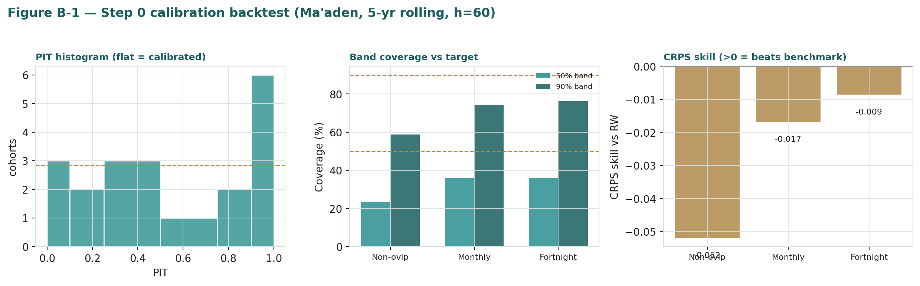
Figure B-1 — Step 0 calibration backtest (Ma'aden, 5-yr rolling, h=60): PIT histogram, band coverage vs target, and CRPS skill (all three schemes below zero).
Conclusion. The lens is not accepted as skill-validated for this name. Per the house rule, rather than forcing a pass with retired techniques (a kvol width multiplier or standalone drift shrinkage), we present Section 3 as an honest regime-conditional probability map — width sized from the trailing realized volatility, drift near zero — carrying no calibration warranty. This cohort will be logged in the Calibration Ledger as a genuine 'no-skill' grade; that is an honest, publishable result, not a failure to conceal.
Appendix C Peer set, sector structure, and risks
Ma'aden has no single clean comparable — it is a phosphate champion, an aluminium chain and a gold miner in one integrated company. The peer set is therefore split by commodity.
Segment | Closest peers | Typical valuation
Phosphate / fertilizer | Mosaic, Nutrien, OCP, ICL | EV/EBITDA ~5–8×; cyclical
Aluminium | Alcoa, Norsk Hydro, EGA, Alba | EV/EBITDA ~4–6×
Gold / base metals | Barrick, Newmont, AngloGold | EV/EBITDA ~6–9×
Diversified majors | BHP, Rio Tinto, Vale, Anglo | EV/EBITDA ~5–7×; P/E ~8–14×
Sector structure. Global mining is cyclical and capital-hungry; returns are made and lost on commodity prices and on cost position. Ma'aden's edge is structural cost — cheap domestic gas underwrites top-decile phosphate and aluminium margins — combined with a large, sovereign-funded growth pipeline and a low, PIF-anchored cost of capital. That combination is why it trades at roughly 15.6× EV/EBITDA and 31× earnings versus 5–9× across the peer groups: the market is capitalizing growth and strategic status, not current cash flows. Principal risks: a fade in the commodity deck (DAP, aluminium, gold); a higher domestic gas price; execution or cost overruns on Phosphate 3 and the gold build; the riyal peg; thin free float and policy-vehicle dynamics; and — the overarching one — a multiple that already prices a great deal of future success.
About this series
Testahil publishes independent, educational valuation studies. Each is an attempt to reason transparently about what a security is worth, with every assumption shown and a companion model so readers can disagree productively. The house style is distributions, not tips: we describe ranges and probabilities, not targets, and we do not tell anyone what to do. Studies are framed as educational analysis, the preparer is not licensed by any securities regulator, and holdings are disclosed.
Disclosure & Disclaimer
Not investment advice. This document is educational and informational only. It is not, and must not be relied upon as, investment, financial, legal, accounting or tax advice, nor an offer, solicitation or recommendation to buy, sell or hold any security. It contains no price target and no rating.
No licence; no advisory relationship. The preparer is not registered or licensed with any securities or financial regulator in any jurisdiction, holds no brokerage or investment-advisory authorisation, and is not acting as your adviser or fiduciary. Nothing here is personalised to your circumstances.
Holdings disclosure. The preparer may hold, and may in the future take or dispose of, a position in the security discussed in this report, and may transact at any time without notice. This is a potential conflict of interest you should weigh.
Sources & accuracy. Reported financial and operating figures are drawn from the company's public disclosure and other public sources believed reliable but not independently verified; they may contain errors or be superseded. Forward-looking inputs — the segment marks, the commodity price deck, the projections, multiples, the DCF and Monte-Carlo factor probabilities — are the preparer's own judgments and are inherently uncertain.
Forward-looking statements. Any statements about the future are estimates subject to risks and uncertainties; actual results may differ materially. The Monte Carlo models price, not value, and encodes subjective probabilities for events that have not occurred; on this name it did not beat a random-walk benchmark and is presented as a probability map only.
No reliance; your responsibility. Do your own research and consult a licensed professional before making any decision. You are solely responsible for your investment decisions and their outcomes. To the maximum extent permitted by law, the preparer accepts no liability for any loss arising from use of this document.
Currency & figures. Figures are in Saudi riyals (SAR); bn denotes billion. The riyal is pegged to the US dollar at 3.75. Commodity prices are quoted in USD. Rounding may cause totals to differ slightly. Spot price and market data are as of 5 July 2026 and change continuously.
TESTAHIL · Independent Valuation Study · Educational Analysis · Saudi Arabian Mining Company (Ma'aden) — Tadawul: 1211 · edition 05-07-2026 · reporting currency SAR

Appendix D The expert valuation panel
Every Testahil study closes with a panel of standing expert personas — drawn from the house Expert Persona Library, not invented for the occasion, so that each accumulates a track record across studies and a quarterly update is a re-run, not a re-training. Ma'aden is a capital-heavy industrial, so we cast the three whose methods both fit a growth-stage, multi-commodity producer and genuinely disagree: Expert 1 (mid-cycle earnings power and relative multiples), Expert 2 (cash returns — DCF and return on invested capital versus its cost), and Expert 3 (the strategic / macro-policy lens — the sovereign-backing and Vision-2030 premium). Each runs a different method, derives its fair value from shown workings, and states a falsification condition. The commodity and country context runs through the body (§1.7, §1.8, §5) and is the arena in which the three disagree.
D.1 Expert 1 — mid-cycle earnings power and relative multiples
Worldview and tradition. An operating business is worth a fair multiple of its sustainable mid-cycle earnings; commodity peaks and troughs are noise to be stripped out. This is the Graham-and-Dodd normalized-earnings tradition applied to a cyclical: you do not capitalize a boom year, and you do not write off a bust one — you find the middle of the cycle and pay a sensible multiple for it. For a miner, that means building a mid-cycle price deck (DAP, aluminium, gold at their multi-year central levels rather than today's), running it through the cost structure, and applying a through-cycle P/E benchmarked both to the global peer group and to the name's own trading history. The multiple carries the quality judgment — a top-decile cost position and a real growth pipeline earn a premium to a marginal-cost miner, but not an unbounded one.
When it works / fails. Best for producers with a through-cycle track record and a defensible cost position, where the cycle genuinely mean-reverts around a stable centre; it fails at structural breaks — if the growth capex permanently lifts the earnings base to a new plateau, mid-cycle normalization on the old base understates it; and if gas or commodity economics shift down for good, the same normalization overstates. Its discipline is also its blind spot: by refusing to pay for the peak, it will always look too cautious in a genuine up-cycle, and by refusing to write off the trough, too generous in a structural decline.
Standard workings & worked example. The method proceeds in four steps. First, set the mid-cycle deck: a DAP price near US$650/t (below the recent US$700+ but well above the last trough), aluminium near US$2,700/t, gold near US$3,300/oz — each a multi-year central estimate, not a spot mark. Second, run the deck through the segment cost structures to a normalized group EBITDA of roughly SAR 16.5 bn and, after D&A, finance, tax and minorities, a normalized attributable net income of about SAR 6.3 bn — deliberately below the FY2025 print of SAR 7.35 bn, because 2025 caught DAP and gold near the top of their ranges. Third, divide by the ~3.88 bn share count for a normalized EPS of about SAR 1.62. Fourth, apply a justified through-cycle P/E of 27× — rich for a miner, defensible for a low-cost, high-growth, sovereign-backed one, and roughly a third of the way from the peer group (5–14× P/E) toward the market's 31×.
Expert 1's normalization | Value
Mid-cycle net income (SAR bn) | 6.3
Shares (bn) → normalized EPS | 3.88 → SAR 1.62
Justified through-cycle P/E (low-cost, high-growth, sovereign) | 27×
Fair value | → SAR 44 / share
Sensitivity (swing = the multiple / the deck). At 22× ≈ SAR 36; at 30× ≈ SAR 49; a US$800/t DAP deck lifts normalized NI toward SAR 7.6 bn and the value toward SAR 53. Cross-examination. He tells Expert 2 that ROIC pessimism ignores the operating leverage of the phosphate and gold ramps; he tells Expert 3 that a 'strategic premium' with no earnings behind it is faith, not valuation.
Verdict, falsification, market-implied. Fair SAR 44 (range SAR 28–60). Falsified by a structural margin re-rating down — a gas-price reset or a durable commodity slump that resets mid-cycle earnings below SAR 5 bn. The market implies normalized earnings ~35% above his: it is paying for a deck and a growth base he will not yet underwrite.
D.2 Expert 2 — cash returns: DCF and ROIC versus the cost of capital
Worldview and tradition. A business creates value only when each unit of capital earns above its cost — the economic-profit, or EVA, tradition. Booked profit is an opinion; cash is a fact, and the return on invested capital measured against the weighted-average cost of capital is the only test that matters. For a heavy spender like Ma'aden the question is stark: the company reinvests most of a strong operating cash flow every year, so the entire equity story reduces to whether that SAR 7–9 bn of annual growth capex — Phosphate 3, the gold build, exploration, Manara deals — will earn a return comfortably above the ~9.3% WACC once it ramps, or merely at it. If the spread is positive and durable, value compounds; if it is thin, the company is running to stand still, converting shareholder cash into a bigger but not more valuable asset base.
When it works / fails. Best for capital-intensive producers where returns on capital are the crux and where the invested base is measurable; it fails where reinvestment economics are about to change sharply — precisely the situation in a large build-out that has not yet ramped, because today's ROIC (capital already spent, cash flow not yet arriving) understates the steady-state return the projects will eventually earn. The method is honest about the present and agnostic about the promise; its discipline is to refuse to credit a return until it shows up in cash.
Standard workings & worked example. Build free cash flow to the firm from EBIT to NOPAT (taxed at the 8% effective rate), add D&A, subtract capex and the working-capital build — the five-year schedule in Appendix A.4. Then compute the return on invested capital: a normalized NOPAT of about SAR 11.5 bn against an invested-capital base of roughly SAR 120 bn is a ROIC near 9.6%, only a hair above the 9.3% WACC — a thin economic-profit spread. Value the equity as the present value of the FCFF stream with the modest excess return fading toward the cost of capital; because the near-term free cash is suppressed by the capex and the terminal value therefore carries ~82% of enterprise value, the honest mark sits close to the modelled DCF but haircut for the thinness of the spread and the years of execution risk before it widens.
Expert 2's economic-profit test | Value
Normalized NOPAT (SAR bn) | ~11.5
Invested capital (SAR bn) | ~120
ROIC vs WACC | ~9.6% vs ~9.3% → thin positive spread
Heavy capex suppresses near-term FCF | mark near modelled DCF
Fair value | → SAR 34 / share
Sensitivity (swing = WACC / ROIC ramp). At an 8.5% WACC ≈ SAR 41; at 10.5% ≈ SAR 28; if the new capacity earns a clear premium ROIC, the value rises toward the mid-40s. Cross-examination. He tells Expert 1 that mid-cycle earnings without the capital cost to produce them is a half-truth — Phosphate 3 and the gold build consume the very cash a P/E capitalizes; he tells Expert 3 that a sovereign put lowers the discount rate but does not by itself raise the return on capital.
Verdict, falsification, market-implied. Fair SAR 34 (range SAR 22–50) — the most cautious of the three: a thin economic-profit spread and years of heavy capex. Falsified by a durable ROIC lift well above WACC once the projects ramp. The market price is far above his number — on a strict cash-returns basis, the stock is expensive.
D.3 Expert 3 — the strategic / macro-policy lens
Worldview and tradition. Some assets are worth more than their standalone cash flows because of who owns them and what they are for — the strategic-asset, or sum-of-the-parts-plus-control, tradition that top-down and macro investors bring to national champions. Ma'aden is the designated vehicle for the Kingdom's minerals ambition under Vision 2030, funded and de-risked by a sovereign wealth fund that treats it as strategic infrastructure, sitting on a resource endowment the state values in the trillions and armed with a structural cost moat in cheap domestic gas. To this investor, those facts are not soft narrative: a credible sovereign backer genuinely lowers the cost of capital (default risk falls, patient capital is available, the runway lengthens through cycles that would force a normal miner to retrench), and a state-scale mandate creates option value — first-mover access to the domestic resource base, and an international M&A platform in Manara — that a discounted-cash-flow of today's assets simply cannot see.
When it works / fails. Best where sovereign backing, strategic priority and a resource endowment are real, durable and aligned with minority holders; it fails if the premium is really just momentum and thin-float scarcity dressed up as strategy — if policy priorities shift, the free float normalizes and dilutes the scarcity, or the promised growth does not convert to cash, the premium can compress hard and fast. The lens is also the easiest to abuse: without a bound, 'strategic value' becomes a licence to justify any price, which is why this expert insists on sizing the premium explicitly and testing what is left if it is stripped out.
Standard workings & worked example. Start from the fundamental base — a blend of the SOTP and DCF at roughly SAR 42 — and then add two explicit, bounded credits rather than an open-ended premium. First, a cost-of-capital credit: if the sovereign backing genuinely shaves ~100 bps off the discount rate, the DCF value rises by about SAR 4/share. Second, an optionality credit for the trillion-dollar resource base and the Manara international platform, sized conservatively at about SAR 2/share — real, but not a blank cheque. The sum is a fair value near SAR 48. The discipline is that every rand of premium is named and capped, and the base is shown, so a reader can see exactly how much of the number is cash flow and how much is strategy.
Expert 3's strategic build | Value
Fundamental base (SOTP/DCF blend) | ~SAR 42
Sovereign cost-of-capital credit (≈ −100 bps discount) | +~SAR 4
Resource-base + Manara optionality (bounded) | +~SAR 2
Fair value | → SAR 48 / share
Sensitivity (swing = the size of the premium). A larger sovereign credit and full pipeline optionality push toward SAR 60+ (near spot); strip the premium entirely and he collapses to the fundamental SAR 42. Cross-examination. He tells Expert 1 and Expert 2 that both under-price a genuinely lower cost of capital and a state-scale runway; they tell him that even a generous, bounded premium lands at SAR 48 — still below spot — so the market is paying for more optionality than any disciplined premium can justify.
Verdict, falsification, market-implied. Fair SAR 48 (range SAR 30–64) — the most constructive of the three, and still ~18% below spot. Falsified if the sovereign priority or the free-float dynamics change, or if the growth does not convert to cash. The market implies a premium even larger than a disciplined strategic case supports.
D.5 The three in one room
The single thing they most disagree on is the premium — specifically, whether a sovereign-backed, gas-advantaged growth platform deserves to trade far above the cash it currently generates.
Expert 1: “Normalize the earnings to a fair mid-cycle deck and put a rich-but-defensible 27× on them and you get SAR 44. The market is paying for a commodity deck near the top of its range and a growth base that has not printed yet.”
Expert 2: “And to grow that base Ma'aden spends most of its cash flow every year. Capitalize the earnings, but subtract the capital to make them. The return on capital barely clears the hurdle; I credit no premium to the invested base — SAR 34.”
Expert 3: “You are both pricing an ordinary miner. This one has a state behind it, a cost moat, and a resource base measured in trillions. That is worth a lower discount rate and a bounded premium — SAR 48. But note: even I, the bull, land below the price.”
D.6 Reading the divergence
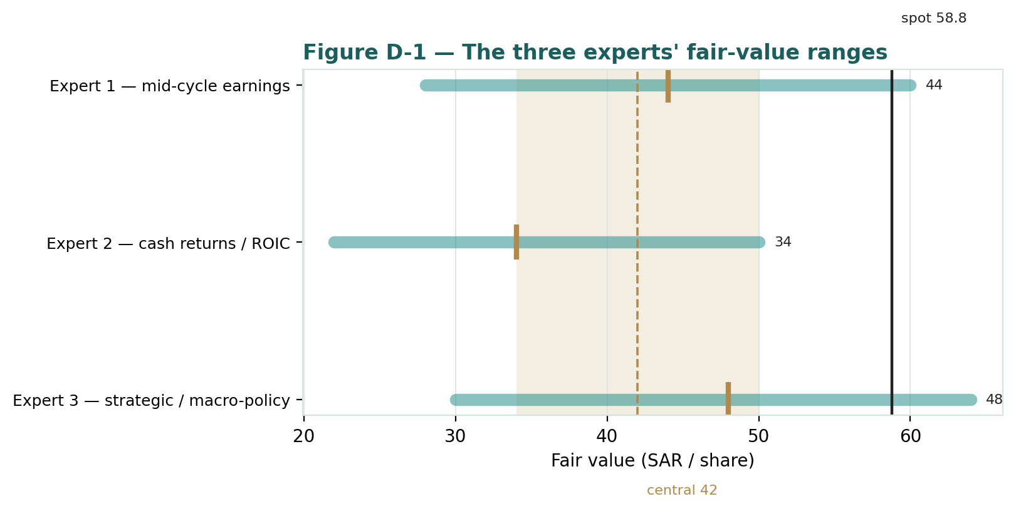
Figure D-1 — The three experts' fair-value ranges. Brass ticks are base cases; the gold band is the central, the dark line is spot. The spread is a premium disagreement, and all three sit below spot.
Expert | Method | Single swing assumption | Base fair value
Expert 1 | Mid-cycle earnings power | Normalized deck / 27× P/E | SAR 44
Expert 2 | Cash returns / ROIC | ROIC versus a ~9.3% WACC | SAR 34
Expert 3 | Strategic / macro-policy | Size of the sovereign premium | SAR 48
The spread — SAR 34 to SAR 48 at base — is narrow, and it is entirely a premium disagreement: none of the three contests the phosphate cost advantage, the gold ramp, or the balance sheet. What separates them is how much a sovereign-backed growth platform should trade above the cash it makes today. Expert 1 says a rich earnings multiple (but the deck is near-peak); Expert 2 says almost nothing until the capital earns its keep; Expert 3 says a bounded premium is fair but even that lands below the price. The SAR 14 spread is a clean measure of one uncertainty — the value of Ma'aden's strategic status and pipeline over and above its modellable cash flows. Resolve that, and the three converge; and notably, all three sit below the SAR 58.8 market price, which is the whole study in one sentence.
What would make them converge is concrete and watchable. If Phosphate 3 and the gold build ramp on time and on budget and print the returns management projects, Expert 2's ROIC spread widens, his SAR 34 rises toward the mid-40s, and the three close from below. If instead the commodity deck fades toward mid-cycle, Expert 1's normalized earnings fall and his ceiling drops toward Expert 2's floor. And if the free float widens or policy priorities shift, Expert 3's premium compresses and the whole cluster settles nearer the fundamental base. The one thing none of the three scenarios does is lift the trio above today's price without a genuine, cash-backed step-change in returns — which is precisely why the study's central estimate sits ~29% below spot and why the honest read is a rich valuation resting entirely on the second clock. A disciplined reader watches the capex-return evidence quarter by quarter and lets the distribution, not a target, frame the decision.
Each expert's point fair value (and bull/base/bear) is logged with the study date (5 Jul 2026) and spot (SAR 58.80) as an internal per-expert track record, kept separate from the core Calibration Ledger.

