Testahil · Independent Valuation Study — Educational Analysis | Not investment advice
Independent Valuation Study — Educational Analysis
NVIDIA Corporation (NASDAQ: NVDA)
Fundamental analysis · Technical analysis · Monte Carlo simulation — one integrated read
Anchor: $196.44 (06 Jul 2026 close) · ~24.3bn diluted shares · market cap ~$4.77tn · the dominant designer of AI accelerators and owner of the CUDA software platform, with Data Center now ~90% of revenue · prices and probabilities computed 06 Jul 2026 from the attached daily history · primary lens: a five-year discounted-cash-flow model on a net-cash balance sheet (WACC = Ke) · the durability and length of the AI data-center compute cycle, and the China export-control overhang, are the swing factors.
READ FIRST — what this document is, and is not. This study is a valuation exercise and an expression of personal analytical opinion, published free of charge for educational purposes: it shows how one analyst applies fundamental, technical and probabilistic methods to a listed company, and invites scrutiny of that methodology. It is NOT investment advice, NOT a recommendation or solicitation to buy, sell or hold any security, and NOT directed at the circumstances of any reader. The preparer is not licensed by any securities regulator in any jurisdiction, holds no brokerage or investment-advisory authorisation, provides no financial consultancy, manages no money, and accepts no fees, funds or clients. See the Disclosure & Disclaimer at the end. All values are model outputs presented as ranges and distributions because no single number should be relied on. Reported financials are the company's own disclosure (FY26 Form 10-K, 25 Feb 2026, fiscal year ended 25 Jan 2026; and the Q1 FY27 release, 27 May 2026); forward-looking inputs — the DCF drivers and discount rate, the multiples, the terminal value and the Monte-Carlo factor probabilities — are the preparer's own judgments and are flagged throughout. NVIDIA's fiscal year ends in late January; “FY26” denotes the year ended 25 Jan 2026. Figures are in US dollars. Consult a licensed financial advisor before any investment decision.

Headline
The model's read: roughly fairly valued, with the upside resting on the length of the AI data-center compute cycle and the downside on a China-plus-digestion shock. At $196 the shares sit about 4% below our weighted central estimate of $204. The primary lens — a disciplined five-year discounted-cash-flow model — lands at $189, essentially on top of spot; a relative-multiple cross-check reads $200; and a forward-earnings-power read ($230) marks the ceiling, with a conservative bear case near $147 as the floor. The whole answer turns on one thing: how long hyperscaler and sovereign AI capital spending sustains the growth runway. FY26 revenue grew 65% to $216bn with Data Center ~90% of the mix; the case rests on whether the ~$650–700bn of 2026 AI infrastructure spend — potentially approaching ~$1tn by 2027 — keeps compounding long enough to justify a valuation that is roughly four-fifths terminal value. Technically the tape is mid-range and mildly heavy: price sits just below its 20-, 50- and 100-day averages but above the 200-day, RSI is in the low-40s and the MACD histogram is slightly negative — neither confirming nor contradicting the fundamentals. Over three months the Monte Carlo places the 5th–95th-percentile band at roughly $132–$283, with a median a shade below spot.

Valuation summary — every read at a glance
One table for the four reads that follow — what the business is worth (fundamental), what the tape is doing (technical), where price could travel over three months (Monte Carlo), and how three independent expert methods land. Every row is developed in the sections and appendices below.
Lens / read | What it measures | Output | Takeaway
FUNDAMENTAL — what the business is worth (the anchor)
Discounted cash flow (primary) | 5-yr FCFF, WACC = Ke, net cash | $189 | ≈ spot · the anchor
Relative multiples | Fwd EV/EBITDA + fwd P/E | $200 | +2%
Forward earnings power | FY28E EPS × through-cycle P/E | $230 | +17% · the ceiling
Weighted central | Blend 45 / 25 / 30 | $204 | +4% vs $196
TECHNICAL — what the tape is doing (timing, not value)
Trend & momentum | Price vs 20/50/100/200-day averages | Below 3 of 4 | Mildly heavy
Momentum / range | RSI · MACD · 52-week range | RSI 43 · MACD −0.8 hist · $158–236 | Mid-range
MONTE CARLO — where price could go in 3 months (paths from spot)
T+20 sessions | 50,000 paths · 16 factors | p5 156 · p50 195 · p95 244 | Median ≈ spot
T+60 sessions | same engine, longer horizon | p5 132 · p50 193 · p95 283 | Wide, near-even
EXPERT PANEL — three independent methods (Appendix C)
Expert 1 — cash returns (DCF + ROIC) | Return on capital vs 10.5% WACC | $189 | The anchor
Expert 2 — forward earnings power | Through-cycle EPS × multiple | $230 | Most bullish
Expert 3 — macro-policy scenario tree | China + capex-cycle probability tree | $168 | Most conservative
Panel range | Spread = the compute-durability question | $168–230 | Centres ~$196
Bottom line. The reads cluster tightly and disagree mainly on magnitude. The fundamental central sits near $204 — about 4% above the $196 spot — the three experts span $168–230, and each one turns on a single question: how durable the AI data-center compute cycle proves. The technical tape is mildly heavy rather than decisively weak, which is why the three-month distribution centres just below spot with a wide, roughly two-sided range rather than a strong directional tilt.

Company overview — NVIDIA at a glance
Item | Value
Listed entity | NVIDIA Corporation (NASDAQ: NVDA)
What it does | Designs GPUs and AI accelerators (Data Center, Gaming, Pro Visualization, Automotive) and owns the CUDA software platform
Spot / date | $196.44 · 06 Jul 2026 close
Shares · market cap | ~24.3bn diluted · ~$4.77tn
Balance sheet | Net cash ~$54bn (cash & marketable securities ~$62.6bn vs ~$8.5bn notes); ~$22bn non-marketable strategic investments
FY26 revenue / gross margin | $215.9bn (+65% YoY) · 71.1% GAAP
Data Center share of revenue | ~90% (FY26 DC $193.7bn)
52-week range | $158.24 – $235.74
Founder-CEO · CFO | Jensen Huang · Colette Kress
Recent prints | Q1 FY27 (27 May 2026): revenue $81.6bn (+85% YoY); Q2 FY27 guide ~$91bn
Source: NVIDIA FY26 Form 10-K (25 Feb 2026), Q1 FY27 release (27 May 2026), exchange data. Values rounded.

1 Fundamental valuation
We value NVIDIA on the cash it can generate, and triangulate four lenses. The primary lens is a five-year discounted cash-flow model (DCF), because the business is a single, highly integrated franchise whose worth is the present value of an extraordinary but finite super-normal earnings stream — not a collection of separable parts. A reverse-DCF sanity check, a relative-multiple cross-check and a forward-earnings-power read complete the set. The weights and the football field are in §1.5; the swing factor — the durability of the AI data-center compute cycle — is dissected in §1.7 and the sensitivity grid in §1.9. Because the balance sheet is net cash, the weighted-average cost of capital equals the cost of equity throughout.

1.1 Discounted cash flow — the primary lens
We forecast five explicit years of free cash flow to the firm and a Gordon terminal value. Revenue is built from two legs — Data Center (the engine) and everything else (Gaming, Pro Visualization, Automotive, OEM) — with Data Center growth fading from the mid-70s percent in FY27E toward high-single-digits by FY31E as the base compounds and the law of large numbers bites. Gross margin steps down gently from ~74.5% toward ~71% as the mix normalizes and competition builds; operating expenses, D&A and capex are held to disciplined percentages of revenue; and the working-capital build — large, because revenue more than triples over the window — is modelled explicitly off the balance sheet. NOPAT is EBIT taxed at 16%. The cost of equity is stated openly as Ke = risk-free 4.3% + β 1.30 × ERP 4.8% = 10.5%; with net cash, that is also the WACC. Terminal growth is 4.5%.
$m (FY end late Jan) | FY27E | FY28E | FY29E | FY30E | FY31E
Revenue | 361,140 | 478,213 | 584,420 | 669,843 | 729,092
EBITDA | 238,353 | 313,230 | 374,029 | 419,322 | 445,475
− D&A | (5,417) | (7,173) | (8,766) | (10,717) | (11,665)
EBIT | 232,935 | 306,057 | 365,263 | 408,604 | 433,810
NOPAT = EBIT×(1−t) | 195,666 | 257,087 | 306,821 | 343,228 | 364,400
+ D&A | 5,417 | 7,173 | 8,766 | 10,717 | 11,665
− Capex | (9,029) | (11,955) | (15,195) | (18,086) | (20,415)
− Δ net working capital | (35,633) | (28,917) | (26,233) | (21,099) | (14,635)
Free cash flow to firm (FCFF) | 156,422 | 223,388 | 274,159 | 314,760 | 341,017
Discount factor @ 10.5% | 0.905 | 0.818 | 0.740 | 0.670 | 0.606
PV of FCFF | 141,507 | 182,819 | 202,976 | 210,815 | 206,623
Free cash flow to the firm, five-year explicit forecast. Every input links to the model's Assumptions sheet.
Enterprise-to-equity bridge | $m / $-per-share
Σ PV of explicit FCFF (FY27–31) | 944,740
Terminal value (Gordon on FY31 FCFF, g = 4.5%) | 5,900,041
PV of terminal value | 3,574,850
Enterprise value | 4,519,589
+ Net cash + strategic investments | 76,344
Equity value → per share | $189
Terminal value as % of EV | 79%
Implied EV / FY27E EBITDA | 19.0×
DCF base ≈ $189/share, a whisker below the $196 spot, with a bear–bull span of roughly $124–$251 driven almost entirely by the discount rate and terminal growth (see §1.9). The single most important disclosure here is that 79% of enterprise value sits in the terminal value — this is, honestly, a bet on NVIDIA still earning a premium return well beyond the five-year window, dressed in the discipline of a cash-flow model. That is not a flaw unique to this name; it is the mathematics of any franchise growing far faster than its discount rate. We make the dependency visible and sensitize it directly rather than bury it, and we deliberately do not blend this DCF with the multiple-based reads into a single false-precision point — the football field in §1.5 is the honest replacement.

1.2 Reverse DCF — what price is paying for
The natural check on a forward DCF is to invert it: hold the discount rate and terminal assumption fixed and ask what free-cash-flow growth the current price already embeds. At $196 the market is capitalizing roughly a 12% compound annual FCF growth over the explicit window, on top of a terminal that already sustains a premium return. In plain terms, the tape is not pricing a mania; it is pricing continued, decelerating-but-durable compute demand — a longer super-normal runway than the five explicit years alone contain. That reframes the debate. The bull case is not “growth re-accelerates”; it is “the runway is longer and the fade gentler than five years of explicit cash flows can hold.” The bear case is not “NVIDIA is overpriced on today's numbers” — on FY27E cash flow it plainly is not — but “the super-normal period ends sooner, or at a lower plateau, than the terminal value assumes.” The whole valuation therefore lives in the durability question of §1.7, which is exactly why we lead the expert panel with a cash-returns anchor and close it with a macro-policy scenario tree.
A second cash cross-check: on the model's own numbers NVIDIA earns a return on capital employed near 62% against a 10.5% cost of capital (trailing FY26 NOPAT over equity-plus-debt; netting the ~$62bn excess cash lifts it far higher). The economic-profit spread is vast and is the core of the cash-returns expert's case in Appendix C — the question the DCF poses is not whether returns exceed the cost of capital today, but for how many years they persist before fading toward it.

1.3 Relative multiples
Against its own forward numbers NVIDIA does not screen expensive for its growth. On FY27E figures the shares trade around 24× forward earnings and roughly 20× forward EV/EBITDA — rich in absolute terms, but with earnings still growing at a pace that puts the PEG below one. We mark the relative lens conservatively, on FY27E EBITDA and EPS and multiples toward the low end of where a durable, cash-generative compute franchise has traded, precisely because multiple-based reads are the ones most exposed if the cycle cools.
Relative basis | Bear | Base | Bull
Fwd EV/EBITDA multiple | 16× | 20× | 24×
Fwd P/E multiple | 20× | 24× | 28×
Fair value (blend, $/share) | 160 | 200 | 250
Relative base ≈ $200 — marginally above spot, and the lens a growth-oriented buyer would anchor on. It treats NVIDIA as a premium but cyclical compute leader rather than a permanent compounder, and assigns no separate option value to sovereign-AI or new end-markets beyond what the multiple already implies.

1.4 Forward earnings power
For a hyper-growth semiconductor franchise, “normalized” trailing earnings are near-meaningless — every year resets the base — so we replace the classic normalized-earnings lens with a forward earnings-power read: take a year far enough out that the initial Blackwell/Rubin ramp has matured (FY28E) and apply a through-cycle multiple. FY28E GAAP EPS is modelled at $10.94; a disciplined 21× — below the current forward multiple, acknowledging that growth will have decelerated by then — yields the ceiling of the central case.
Forward-earnings basis | Value
FY28E diluted EPS ($) | 10.94
Through-cycle P/E | 21×
Fair value ($/share) | 230
Forward-earnings base ≈ $230 — the recovery-and-durability lens and the ceiling of the central case. It is, in effect, the bet that the compute cycle still has multiple years of growth left and that the market will still pay a premium-but-normalizing multiple for it in two years' time.

1.5 Synthesis — four lenses
We weight the DCF most heavily because it respects the cash economics and the finiteness of the super-normal period; the forward-earnings lens carries the durability/upside thesis; the relative lens anchors the middle; and the reverse-DCF informs the discipline rather than adding a separate point.
Lens | Weight | Bear | Base | Bull
Discounted cash flow (primary) | 45% | 124 | 189 | 251
Relative multiples | 25% | 160 | 200 | 250
Forward earnings power | 30% | 164 | 230 | 306
Weighted central |  | 147 | 204 | 287
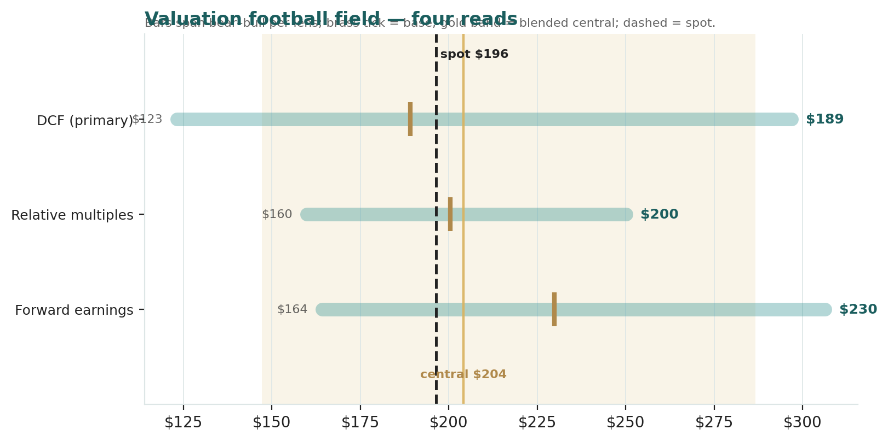
Figure 1 — Valuation football field. Bars span bear–bull per lens; the brass tick is each base case; the gold band is the blended central range; the dark dashed line is spot.
Central fair value ≈ $204/share, about 4% above spot. The spread of the lenses ($189 to $230 at base) is itself the message: this is neither a deep-value nor a clearly-expensive name at $196, but a roughly fairly-valued franchise whose re-rating in either direction depends on one thing — how long the AI data-center compute cycle runs.

1.6 The business up close — Data Center dominance and the scorecard
NVIDIA is now, to a first approximation, a Data Center company with valuable satellites. In FY26 Data Center revenue was $193.7bn — about 90% of the $215.9bn group total — up from $47.5bn just two years earlier, a ~2.0×-per-year trajectory driven by the Hopper→Blackwell accelerator cycle and the CUDA software moat that keeps developers locked to the platform. Gaming, Pro Visualization and Automotive together (~$22bn) are healthy, cash-generative and strategically useful, but they no longer move the valuation. The scorecard below rates each leg on the axes that matter.
Segment | Growth | Margin trend | Moat | Swing role
Data Center (AI accelerators) | Very high, decelerating | Elite, gently normalizing | CUDA + systems + supply | Dominant — the whole story
Gaming | Moderate | Steady | Strong brand / installed base | Cash anchor
Pro Viz / Automotive / OEM | Low–moderate | Improving | Niche / emerging | Optionality
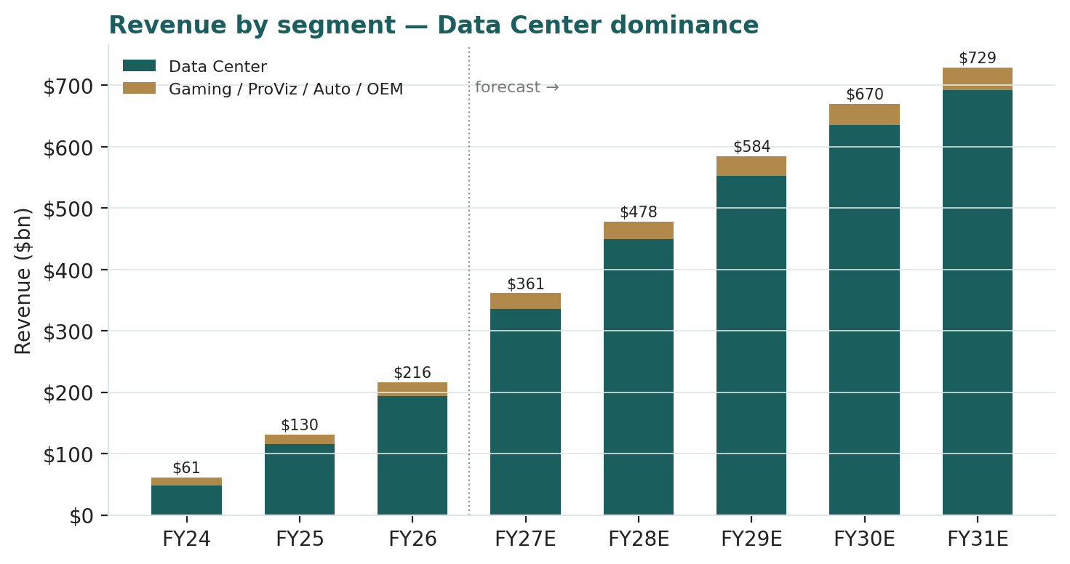
Figure 9 — Revenue by leg, showing Data Center's rise to ~90% of the mix (FY24–FY26 actual, FY27E–31E forecast).

1.7 The crux — AI-capex durability, China, and customer concentration
Three judgments drive this valuation more than any other, and — per house rule — each is sensitized on an observable driver in real units, never an abstract margin percentage.
(1) AI data-center capex durability — the master variable. NVIDIA's Data Center revenue is a direct function of how much the world's hyperscalers and sovereigns spend on AI infrastructure. Aggregate 2026 spend is tracking ~$650–700bn and could approach ~$1tn by 2027 on current guidance; the swing input is the compound growth of that spend and, through it, NVIDIA's Data Center growth path. Our base fades DC growth from ~73% (FY27E) toward ~9% (FY31E). Hold everything else and the value is roughly linear in that fade:
Data Center 5-yr revenue CAGR | Implied DCF value ($/share) | Read
~18% (sharp digestion) | ~150 | Capex plateaus early
~26% (base fade) | ~189 | Base case
~33% (durable super-cycle) | ~240 | Runway extends
(2) China export controls. US restrictions on advanced-accelerator exports to China removed a materially profitable market: the H20 line was effectively banned in April 2025 (a ~$5.5bn charge), and current FY27 guidance explicitly excludes China Data Center. The observable driver is the dollar revenue China could contribute if access were restored versus permanently foreclosed — a swing we size at roughly $15–25bn of annualized Data Center revenue, i.e. ~$8–12/share of DCF value, that the base case does not credit. It is a two-sided policy variable, not a forecastable operating line, which is why it enters the Monte Carlo as a discrete event and the expert panel as the macro-policy scenario tree's largest node.
(3) Customer concentration. A large share of Data Center revenue flows from a handful of hyperscalers, several of whom are simultaneously designing their own custom silicon (Google TPU, Amazon Trainium, Meta MTIA) and buying merchant GPUs from AMD. The risk is not disappearance but negotiating leverage and in-sourcing at the margin — a slow compression of either volume growth or price. We treat this as a haircut to the DC growth path and to terminal margins rather than a discrete event; it is the single best reason the bear-case fade is as steep as it is.

1.8 Macro and policy — US export rules, the AI-capex cycle, and rates
NVIDIA sits at the intersection of three macro forces. US export policy is the most name-specific: the Commerce Department's evolving controls on advanced accelerators set the addressable market in China and, increasingly, in other jurisdictions — a stroke-of-the-pen variable that can add or remove tens of billions of revenue. The AI-capex cycle is the demand engine: hyperscaler and sovereign spending has been the single largest driver of the stock, and its trajectory — still expanding, but watched obsessively for any sign of digestion — is the master risk. Rates and liquidity matter twice over: a higher real yield lifts the discount rate applied to a long-duration, terminal-value-heavy cash-flow stream, and tighter financial conditions can slow the very capex that funds NVIDIA's revenue. These levers sit behind the bear and bull cases in §1.5 and the catalysts in §5.

1.9 DCF sensitivity — how WACC and terminal growth move the value
Holding the operating forecast at base, the grid re-prices the DCF across the cost of equity (= WACC, net cash) and the terminal growth rate — the two inputs that dominate a terminal-heavy valuation. Cells near spot ($196) sit toward the centre; the value runs from ~$124 (12.5% / 3.0%) to ~$251 (9.5% / 5.0%).
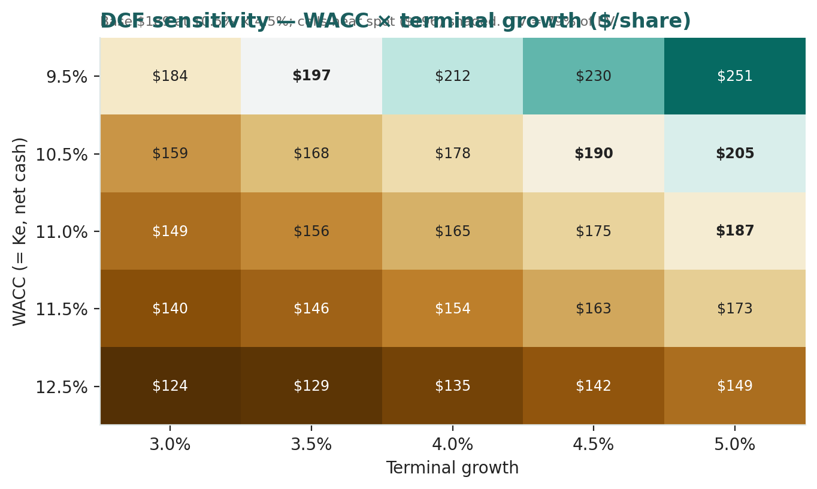
Figure 2 — DCF sensitivity to WACC and terminal growth ($/share). Base cell (10.5% / 4.5%) ≈ $189–190; cells near spot shaded.
Read it as the bet you are taking: the market price is consistent with roughly a 10.5% cost of equity and a mid-single-digit terminal growth — i.e. a durable but decelerating franchise, with neither a growth collapse nor a permanent super-cycle fully in the price.

2 Technical and price structure
The tape is mid-range and mildly heavy rather than decisively weak. NVIDIA trades just below its 20-, 50- and 100-day moving averages but remains above the 200-day, RSI sits in the low-40s (neutral, tilted soft), and the MACD histogram is slightly negative. The structure is a consolidation well off the highs, with the 52-week low at $158 as the visible floor and $236 as the ceiling.
Indicator | Reading | Signal
Spot | $196.44 | —
SMA 20 / 50 | $202 / $210 | Below both — short-term soft
SMA 100 / 200 | $197 / $191 | Below 100, above 200 — mixed
RSI (14) | 42.9 | Neutral, tilted soft
MACD (12,26,9) | −4.06 line / −3.28 signal / −0.78 hist | Mildly bearish
52-week range | $158.24 – $235.74 | Middle of range
Realized vol (252d) | 35.1% | Elevated, typical for the name
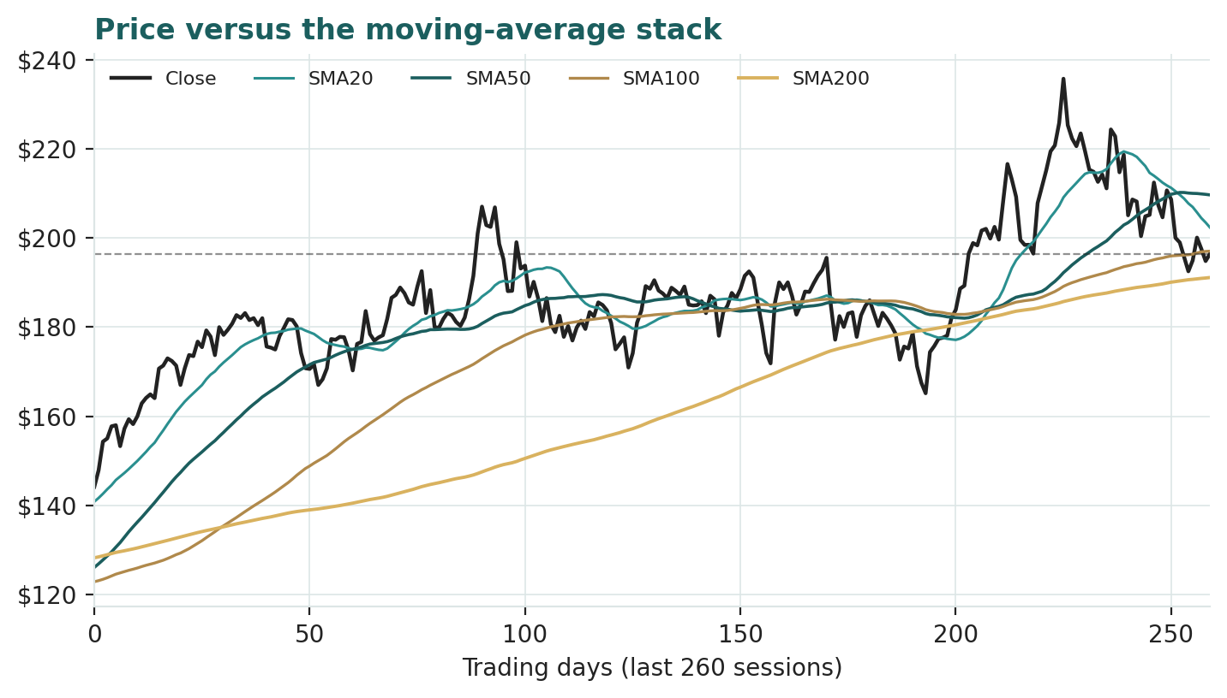
Figure 3 — Price versus the moving-average stack, last 260 sessions.
For the probabilistic work this matters in one way: a mid-range tape with elevated realized volatility produces a wide, roughly two-sided three-month distribution rather than a strong directional tilt. The technical and fundamental pictures are not in sharp conflict here — both read “roughly fair, wide uncertainty” — and §6 reads the resulting probability zones without forcing a reconciliation.

3 Monte Carlo — a probabilistic price map
We simulate 50,000 three-month price paths (seed 42) with the house YZ-HAR engine: width is set by a Yang-Zhang / HAR volatility cascade built on the OHLC history, innovations are unit-variance Student-t(5) for honest tails, and — because NVIDIA is an international, non-EGX name — the diffusion carries zero secular drift. A sixteen-factor stack layers on top: seven continuous macro/operating drivers and nine discrete events, each with a probability and a two-sided impact. By design the paths diffuse from spot, and the §1 value gap is deliberately kept out of the drift — the fundamental value lives in §1, not here; §3 maps where price could go from today, not where value sits. Forward volatility from the YZ-HAR cascade annualizes to ~45%; the factor stack is close to net-neutral in direction, as an honest read of a two-sided setup should be.

The probability read
Computed from the same 50,000 paths as the fan chart — presentation only; it does not feed the drift or the width.
Probability read (T+60) | Value
P(price above spot) | 47%
P(+10%) vs P(−10%) | 30% vs 34% (odds 0.89)
Median level · % move | $193 · −1.6%
50% band (25th–75th) | $167 – $223 (−15% / +14%)
Touch(+10%) · touch(−10%) | 57% · 59%
The read is near-even with a slight downward tilt: median a shade below spot, marginally higher odds of a 10% fall than a 10% rise, and near-symmetric touch probabilities. That is the honest signal of a zero-drift diffusion on a mid-range tape — direction is not manufactured; what little tilt exists comes from the factor skew and the fat left tail, not from any assumed trend.

The factor stack
Continuous factor (7) | Dir. | Discrete event (9) | Prob. | Mean impact
AI data-center capex cycle | + | Q2 FY27 results vs $91bn guide | 85% | +1.0%
US 10-yr real yield / rate path | − | Hyperscaler capex-guidance shift | 55% | +0.5%
Semis / AI equity beta & Nasdaq flows | ± | China export-control change | 35% | −1.0%
Gross-margin / pricing (Blackwell→Rubin) | ± | Rubin (Vera Rubin) ramp / supply news | 40% | +0.5%
USD / global liquidity | ± | AI-capex-fatigue / bubble scare | 30% | −2.0%
Competitive intensity (AMD, ASICs vs CUDA) | − | Custom-silicon competitive win/loss | 30% | −1.2%
Supply chain (TSMC CoWoS / HBM) | ± | Major partnership / mega-order | 45% | +1.5%
 |  | Capital-return / buyback surprise | 25% | +1.0%
 |  | Index / options-flow rebalancing | 30% | +0.5%

Percentile map ($/share)
Horizon | p5 | p25 | p50 | p75 | p95
T+20 sessions | 156 | 180 | 195 | 212 | 244
T+60 sessions | 132 | 167 | 193 | 223 | 283
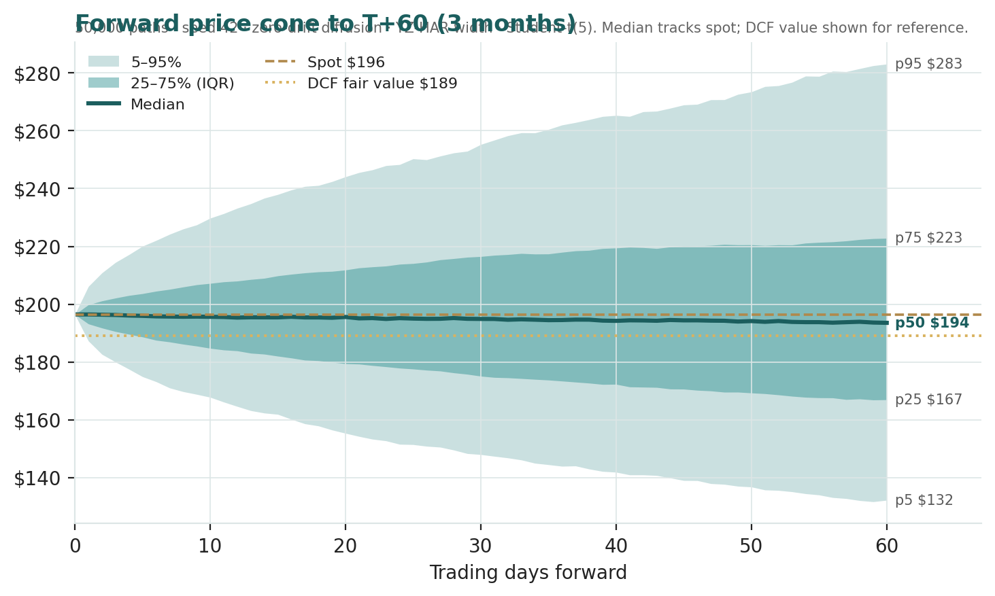
Figure 4 — Forward price cone to T+60. Median tracks a shade below spot; the gold dotted line marks the $189 DCF fair value, shown for reference and deliberately kept out of the drift.
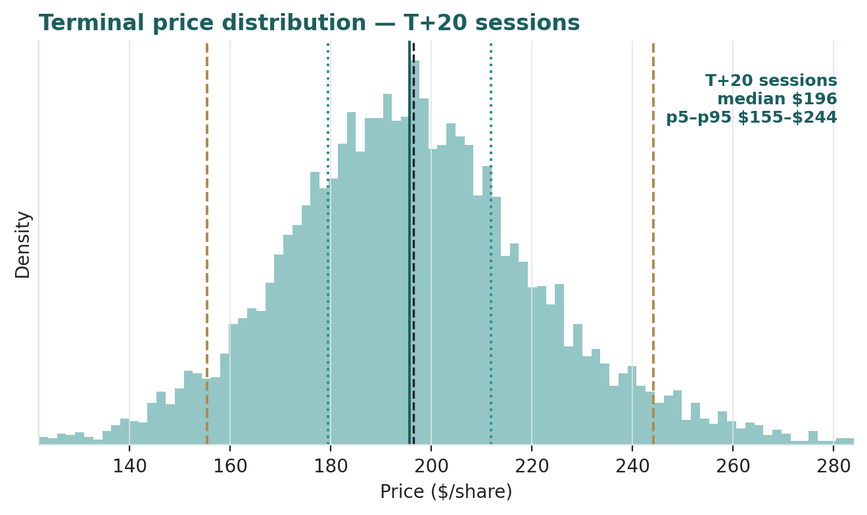
Figure 5 — Price distribution at T+20.
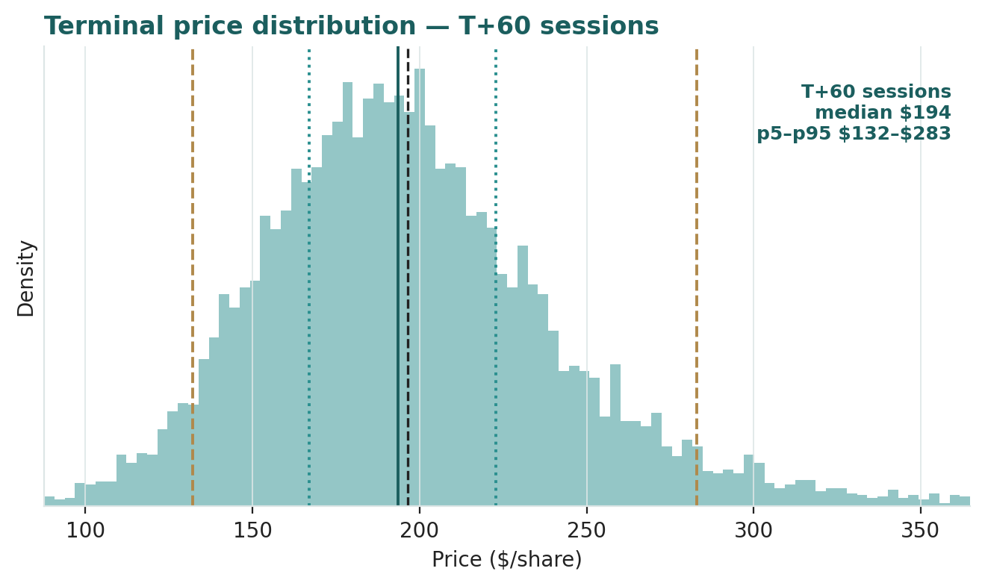
Figure 6 — Price distribution at T+60.

Level-touch ladder
The probability that price touches a level at any point by the horizon (running maximum for upside, running minimum for downside):
Level | T+20 touch | T+60 touch | Note
$240 | 10% | 29% | Toward 52-wk high zone / forward-earnings lens
$230 | 17% | 39% | Forward-earnings lens
$220 | 29% | 52% | Upper band
$210 | 48% | 67% | Near the 50-day average
$200 | 76% | 85% | Just above spot
$190 | 69% | 82% | Near DCF value, just below spot
$180 | 41% | 64% | Lower band
$170 | 22% | 48% | Toward the 25th percentile
$160 | 10% | 34% | Toward the 52-wk low
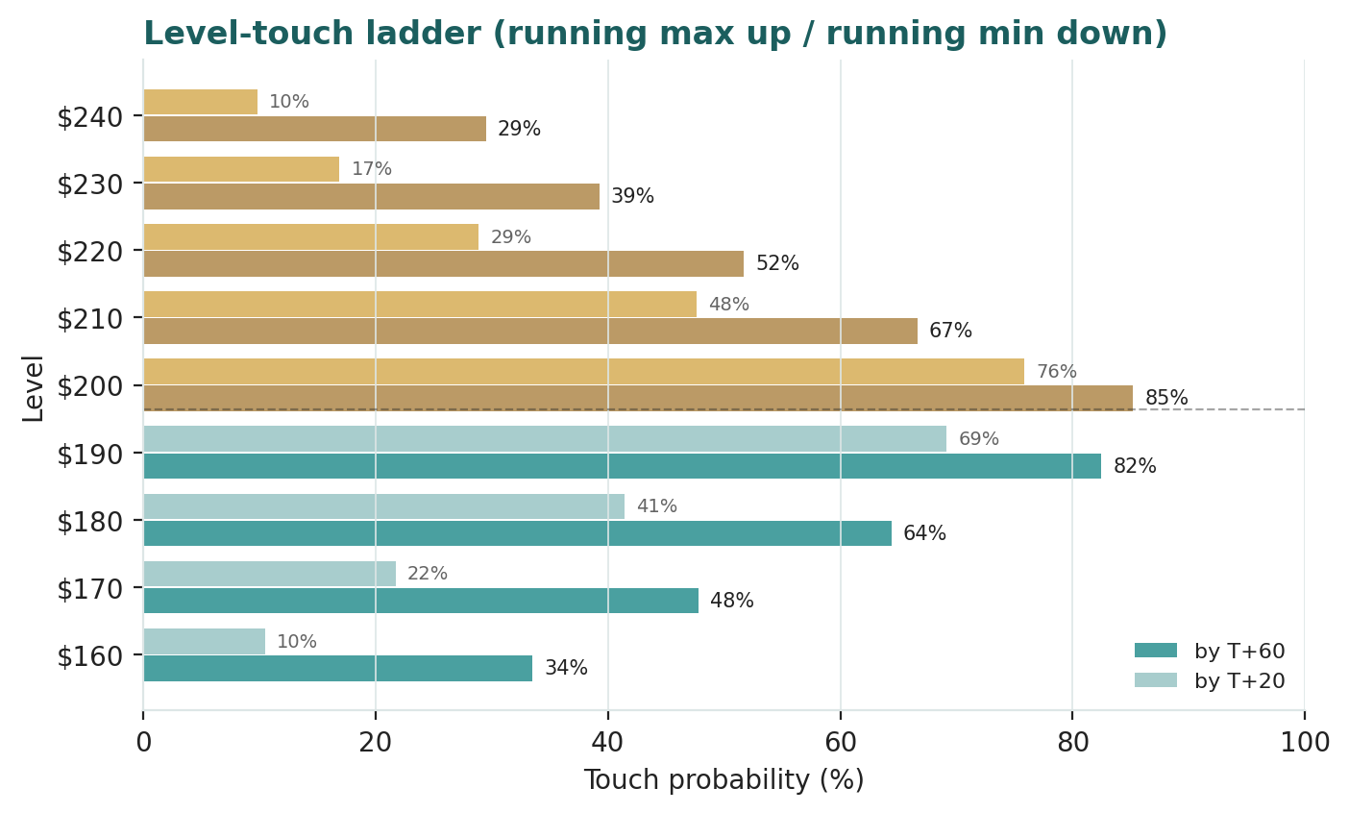
Figure 7 — Touch-probability ladder, T+20 and T+60.

4 Comparison of the lenses, and a verdict
Three readings sit side by side. The fundamental lenses cluster at $189–$230 with a central $204 — modestly above spot, contingent on the length of the compute cycle. The technical picture is mildly heavy but mid-range, with the visible floor at $158. The probabilistic map says that over three months price is roughly two-sided around spot with a wide ~45%-vol band — the median is $193, not $204, because the simulation does not assume the (small) value gap closes inside the quarter.
Lens | Reads | Central / implication
Fundamental (4-lens) | Roughly fair | $204 (~+4%)
Technical | Mildly heavy, mid-range | Floor $158; resistance at the 20/50-day $202–210
Monte Carlo (3-month) | Two-sided, wide | Median $193; p5–p95 $132–283
Verdict (a fair-value read, not a recommendation). NVIDIA looks roughly fairly valued at $196, with an unusually concentrated swing factor: the durability of AI data-center capex. On FY27E cash flow the business is not expensive; on a terminal-value basis it is priced for a durable but decelerating super-cycle, and the honest uncertainty is how many more years that cycle runs. The near-term distribution centred just below spot argues that any re-rating is a question of operating proof over quarters — each earnings print and each hyperscaler capex guide — not of an imminent move. The honest summary is a value modestly above price, a near-term distribution centred on price, and an outcome that hinges on one macro-operating variable — which is why the bear–bull span ($147–$287) is wide. Readers should weigh the lenses themselves; we publish the distribution, not a target.

5 Catalysts to watch
- Q2 FY27 results (≈ late Aug 2026). First clean read on whether revenue is tracking the ~$91bn guide and whether Data Center growth is holding or beginning to digest.
- Hyperscaler capex guidance (MSFT / GOOGL / AMZN / META). The quarterly capex commentary from NVIDIA's largest customers is the single best leading indicator of Data Center demand.
- Rubin (Vera Rubin) ramp. Execution on the next accelerator platform — supply, yields, and customer uptake — sets the FY28 trajectory.
- China export policy. Any change to the rules on advanced accelerators (H20/H200-class and beyond) re-opens or forecloses tens of billions of Data Center revenue.
- Custom-silicon and AMD competitive signals. Evidence on in-sourcing (TPU/Trainium/MTIA) and MI-series wins/losses at major accounts speaks directly to pricing power and the terminal margin.
- Supply chain (TSMC CoWoS / HBM). Advanced-packaging and high-bandwidth-memory availability remain the physical ceiling on how much NVIDIA can ship.
- Capital return. Buyback pace and dividend policy against a rapidly growing net-cash pile.
- AI-capex-durability sentiment. Any credible signal of digestion — a GPU-rental price crack, a hyperscaler capex pause — would compress the multiple faster than the cash flows.

6 Reading the probability zones
Translating the three-month distribution into plain zones, anchored on spot $196 and the fair-value cluster:
Zone (T+60) | Range | Approx. probability | What it would mean
Deep downside | < $160 | ~20% | Capex digestion / China shock / risk-off; tests the 52-wk low
Lower band | $160–$180 | ~17% | Growth cools; relative-multiple lens dominates
Around spot | $180–$205 | ~24% | Status quo; the small value gap stays unclosed
Upper band | $205–$225 | ~15% | Durability credited; toward the forward-earnings lens
Strong upside | > $225 | ~24% | Runway extends + China re-opens or a mega-order lands
The distribution is close to two-sided, with fat tails on both ends — a heavy left tail from the capex-fatigue and China-shock events, and a heavy right tail from the mega-order, China-reopening and buyback events. It is not a forecast; it is the spread of outcomes consistent with the stock's own volatility and the factor stack.

7 Caveats and what would change our mind
- The terminal value is the model. Roughly four-fifths of DCF value sits beyond the five-year window; our fade (DC growth to ~9%, terminal g 4.5%) could prove optimistic or conservative. A structurally shorter super-cycle would pull the central value toward — or below — spot.
- Concentration and in-sourcing. A handful of customers drive Data Center, and they are building their own silicon. A faster-than-modelled shift to custom chips would compress both growth and terminal margin.
- China is a policy coin-flip. The base case credits no China Data Center revenue; restoration would add value, permanent foreclosure removes optionality. It is a stroke-of-the-pen variable we cannot forecast, only bound.
- Supply, not just demand, can bind. CoWoS packaging and HBM supply are the physical ceiling; a shortfall caps revenue regardless of demand.
- Rate sensitivity is real. A long-duration, terminal-heavy cash-flow stream is unusually sensitive to the discount rate; a higher real yield re-prices it directly (see §1.9).
- Technical reminder. A mid-range tape says little about value; mean-reversion moves in either direction are common and are context, not a trigger.

Appendix A Financial statements
Selected consolidated figures. Historicals are as reported (FY26 Form 10-K, 25 Jan 2026 fiscal year-end); the five forecast years are the model's own projections, every line linked to the Assumptions sheet. All figures in US$ millions unless noted. NVIDIA's fiscal year ends in late January.

A.1 Income statement ($m)
Line | FY24 | FY25 | FY26 | FY27E | FY28E | FY29E | FY30E | FY31E
Data Center revenue | 47,525 | 115,186 | 193,737 | 335,165 | 449,121 | 552,419 | 635,282 | 692,457
Other revenue | 13,397 | 15,311 | 22,201 | 25,975 | 29,092 | 32,001 | 34,562 | 36,635
Total revenue | 60,922 | 130,497 | 215,938 | 361,140 | 478,213 | 584,420 | 669,843 | 729,092
Gross profit | 44,290 | 97,873 | 153,532 | 269,049 | 353,878 | 426,627 | 482,287 | 517,656
Gross margin | 72.7% | 75.0% | 71.1% | 74.5% | 74.0% | 73.0% | 72.0% | 71.0%
Operating expenses | 11,318 | 16,420 | 23,132 | 36,114 | 47,821 | 61,364 | 73,683 | 83,846
Operating income (EBIT) | 32,972 | 81,453 | 130,400 | 232,935 | 306,057 | 365,263 | 408,604 | 433,810
D&A | 1,508 | 1,864 | 3,000 | 5,417 | 7,173 | 8,766 | 10,717 | 11,665
EBITDA | 34,480 | 83,317 | 133,400 | 238,353 | 313,230 | 374,029 | 419,322 | 445,475
Net income (GAAP) | 29,760 | 72,880 | 120,067 | 204,066 | 265,907 | 316,061 | 352,888 | 374,480
Diluted EPS ($) | 1.19 | 2.94 | 4.90 | 8.40 | 10.94 | 13.01 | 14.52 | 15.41
Three years actual + five years forecast. FY24–26 from company filings; FY27E–31E are model projections.

A.2 Balance sheet ($m)
Line | FY24 | FY25 | FY26 | FY27E | FY28E | FY29E | FY30E | FY31E
Cash + marketable securities | 25,984 | 43,210 | 62,556 | 151,278 | 300,986 | 495,385 | 723,805 | 971,902
Accounts receivable | 9,999 | 23,065 | 38,466 | 64,283 | 85,122 | 104,027 | 119,232 | 129,778
Inventories | 5,282 | 10,080 | 21,403 | 35,753 | 47,343 | 57,858 | 66,314 | 72,180
Strategic & other assets | 6,000 | 17,000 | 44,000 | 44,000 | 44,000 | 44,000 | 44,000 | 44,000
PP&E, goodwill & intangibles | 18,463 | 18,246 | 39,878 | 43,489 | 48,272 | 54,700 | 62,068 | 70,818
Total assets | 65,728 | 111,601 | 206,303 | 338,803 | 525,723 | 755,970 | 1,015,420 | 1,288,678
Shareholders' equity | 42,978 | 79,327 | 168,540 | 296,506 | 479,913 | 706,974 | 963,862 | 1,235,342
Debt (notes payable) | 9,709 | 8,463 | 8,463 | 8,463 | 8,463 | 8,463 | 8,463 | 8,463
Accounts payable | 2,699 | 3,466 | 6,300 | 10,834 | 14,346 | 17,533 | 20,095 | 21,873
Other liabilities | 10,342 | 20,345 | 23,000 | 23,000 | 23,000 | 23,000 | 23,000 | 23,000
Total liab. & equity | 65,728 | 111,601 | 206,303 | 338,803 | 525,723 | 755,970 | 1,015,420 | 1,288,678
Net cash / (debt) | 16,275 | 34,747 | 54,093 | 142,815 | 292,523 | 486,922 | 715,342 | 963,439
Three years actual + five years forecast; the balance sheet ties (assets = liabilities + equity) in every year. Cash rolls via the cash-flow statement; PP&E/goodwill rolls forward at capex less D&A.

A.3 Cash flow — forecast ($m)
Line | FY27E | FY28E | FY29E | FY30E | FY31E
Net income | 204,066 | 265,907 | 316,061 | 352,888 | 374,480
+ D&A | 5,417 | 7,173 | 8,766 | 10,717 | 11,665
− Δ net working capital | (35,633) | (28,917) | (26,233) | (21,099) | (14,635)
Operating cash flow | 173,850 | 244,164 | 298,594 | 342,506 | 371,511
− Capex | (9,029) | (11,955) | (15,195) | (18,086) | (20,415)
Free cash flow | 164,822 | 232,208 | 283,399 | 324,420 | 351,097
− Dividends | (6,100) | (7,500) | (9,000) | (11,000) | (13,000)
− Net buybacks | (70,000) | (75,000) | (80,000) | (85,000) | (90,000)
Net change in cash | 88,722 | 149,708 | 194,399 | 228,420 | 248,097
Source: NVIDIA FY24–FY26 filings for historicals; forecast is the model's own projection. Figures rounded; rounding may cause totals to differ slightly.

Appendix B Peer set, sector structure, and risks
NVIDIA has no clean single comparable — it is at once a semiconductor designer, a systems vendor and a software-platform owner. The peer set is best read by lens rather than as one group.
Comparison lens | Closest peers | Typical valuation
AI-accelerator / merchant GPU | AMD | Fwd P/E ~30–40×; growth-priced
Broad semiconductors | Broadcom, TSMC, ASML | Fwd P/E ~20–35×; cyclical-growth
Custom-silicon substitutes | Google TPU, Amazon Trainium, Meta MTIA | In-house; not separately priced
Mega-cap compounders | the large-cap tech complex | Fwd P/E ~20–30×
Sector structure. The AI-accelerator market is a fast-growing, supply-constrained duopoly-plus-in-sourcing: NVIDIA holds an estimated ~80%+ of merchant AI-accelerator share on the strength of the CUDA software moat and full-system offering, AMD is the credible number two, and the largest customers are simultaneously building their own chips. Demand is set by hyperscaler and sovereign AI capex; supply is gated by TSMC advanced packaging (CoWoS) and high-bandwidth memory. The cycle is young but intensely watched for digestion. Principal risks: a shorter-than-expected AI-capex super-cycle; customer concentration and in-sourcing of silicon; US export controls foreclosing China and other markets; supply ceilings on packaging and memory; competitive erosion of pricing power; and the discount-rate sensitivity of a long-duration, terminal-heavy valuation.

Appendix C The expert valuation panel
Every Testahil study closes with a panel of standing expert personas — drawn from the house Expert Persona Library, not invented for the occasion, so that each accumulates a track record across studies and a quarterly update is a re-run, not a re-training. For NVIDIA we cast the three whose methods both fit a cash-generative, terminal-heavy compute franchise and genuinely disagree: Expert 1 (cash returns — DCF and return on capital versus its cost), Expert 2 (forward earnings power and relative multiples), and Expert 3 (a macro-policy scenario tree over the capex cycle and China). Each runs a different method, derives its fair value from shown workings, and states a falsification condition. The earnings-quality lens — customer concentration — runs through the body (§1.6–1.7) rather than as a separate persona.

C.1 Expert 1 — cash returns: DCF and ROIC versus the cost of capital
Worldview. A business creates value only when each unit of capital earns above its cost, and cash — not booked profit — is the test. He values the firm as the present value of its free cash flows and cross-checks that the return on capital clears the hurdle by a margin wide enough to justify the price.
When it works / fails. Best for cash-generative franchises with a clear reinvestment runway; it fails when the super-normal period's length is the entire question — precisely the tension here, which is why he leads but does not close the panel.
Standard workings & worked example. Build FCFF for five explicit years, discount at Ke = rf + β×ERP (= WACC, net cash), add a Gordon terminal value, and sanity-check against the economic-profit spread (ROIC − WACC).
Expert 1's cash-returns build | Value
Σ PV of explicit FCFF (FY27–31, $m) | 944,740
PV of terminal value ($m) | 3,574,850
Enterprise value ($m) | 4,519,589
+ net cash + strategic ($m) | 76,344
Return on capital employed vs WACC | ~62% vs 10.5% → vast positive spread
Fair value | → $189/share
Sensitivity (swing = WACC / terminal g). At 9.5% / 5.0% $251; at 12.5% / 3.0% $124. Cross-examination. He tells Expert 2 that a forward P/E capitalizes earnings without charging for the capital and the years required to earn them; he tells Expert 3 that a probability tree over policy is useful for the tails but cannot replace a disciplined estimate of the cash the franchise actually throws off.
Verdict, falsification, market-implied. Fair $189 (range $124–251) — essentially at spot. Falsified by a durable ROIC collapse toward WACC (mass in-sourcing, or a competitive break in pricing power). The market price implies a slightly longer super-normal runway than his five explicit years hold — the reverse-DCF's ~12% embedded FCF CAGR.

C.2 Expert 2 — forward earnings power and relative multiples
Worldview. A growth business is worth a fair multiple of the earnings it will sustainably produce a year or two out; today's trailing base is noise in a franchise doubling its revenue. He normalizes to a matured-ramp forward year and applies a through-cycle multiple.
When it works / fails. Best for franchises with a visible earnings trajectory and a peer multiple to anchor on; it fails at structural breaks — if growth stops abruptly, his forward normalization is simply wrong.
Standard workings & worked example. Take FY28E EPS (post initial Blackwell/Rubin ramp), apply a justified through-cycle P/E below the current forward multiple, and cross-check against forward EV/EBITDA.
Expert 2's normalization | Value
FY28E diluted EPS ($) | 10.94
Through-cycle P/E | 21×
Cross-check: fwd EV/EBITDA | ~20×
Fair value | → $230/share
Sensitivity (swing = the multiple). At 18× $197; at 25× $274. Cross-examination. He tells Expert 1 that a DCF's terminal value is just a multiple in disguise, and a more honest one is a forward P/E on a year you can see; he tells Expert 3 that policy tail-risk is real but the base case is a growth machine the tree under-weights.
Verdict, falsification, market-implied. Fair $230 (range $164–306) — the most bullish of the three. Falsified by a demand cliff — AI-capex digestion that caps FY28 earnings well below $10.94. The market implies forward earnings power somewhat below his: it does not yet fully credit two more years of the cycle.

C.3 Expert 3 — a macro-policy scenario tree over the capex cycle and China
Worldview. For a name whose revenue is set by other companies' capital budgets and by government export rules, the right tool is not a point estimate but a probability tree over the states of the world. He weights scenarios and takes the expected value, giving explicit mass to the tails the cash-flow model treats as a base case.
When it works / fails. Best where a few external variables dominate and are genuinely uncertain; it fails if the analyst's scenario probabilities are miscalibrated — the method is only as good as the tree.
Standard workings & worked example. Define three states — durable super-cycle, base fade, and digestion/China-shock — attach probabilities and a fair value to each (anchored on the DCF re-run under each state), and take the weighted mean.
State | Prob. | Fair value | Driver
Durable super-cycle | 30% | $240 | Runway extends; China partly re-opens
Base fade | 45% | $189 | DC growth decelerates on plan
Digestion / China shock | 25% | $120 | Capex plateaus early; China foreclosed
Probability-weighted |  | $168 | Expected value across states
Sensitivity (swing = the digestion probability). At 15% digestion $180; at 35% $155. Cross-examination. He tells Expert 1 that a single discounted stream buries a 25%-probability plateau inside an average and calls it precision; he tells Expert 2 that a forward multiple on a good-state EPS ignores the quarter of the tree where the capex cycle turns.
Verdict, falsification, market-implied. Fair $168 (range $120–240) — the most conservative of the three. Falsified by a policy resolution that removes the China node (a durable export settlement, in either direction) or by hyperscaler capex guidance that collapses the digestion branch. The market price sits above his expected value — it weights the good states more heavily than he does.

C.5 The three in one room
The single question they most disagree on is how long the AI data-center compute cycle runs — and therefore how much of today's price is a durable franchise versus a late-cycle multiple.
Expert 2: “FY28 earnings power is $10.94 and the cycle is nowhere near done. Put a modest 21× on it and the shares are worth $230 — the market is under-crediting the next two years.”
Expert 3: “And a quarter of the probability mass is a world where hyperscalers digest and China stays shut. Capitalize the good state if you like, but weight the branch where the capex cycle turns. Expected value is $168, not $230.”
Expert 1: “You are both arguing about the runway. Discount the actual cash — five explicit years and an honest terminal — and it is worth $189, right on top of spot. The return on capital is enormous; the only question the price is really asking is how many years it lasts, and that is the terminal value, made visible.”

C.6 Reading the divergence
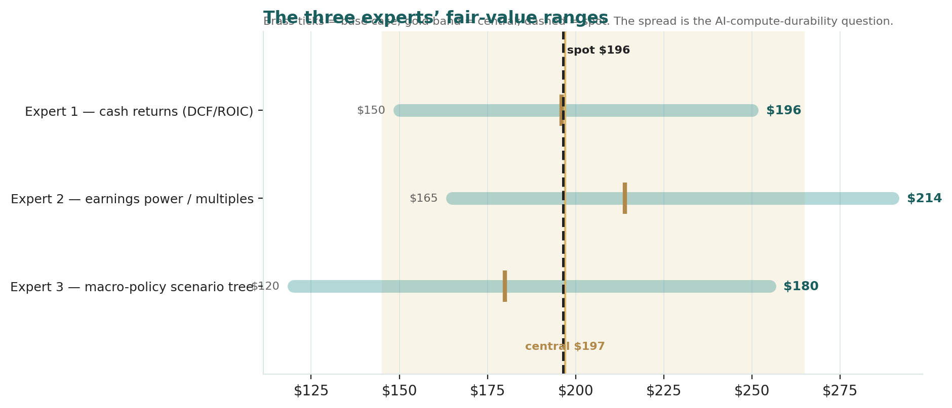
Figure C-1 — The three experts' fair-value ranges. Brass ticks are base cases; the gold band is the central; the dark dashed line is spot. The spread is almost entirely a compute-durability disagreement.
Expert | Method | Single swing assumption | Base fair value
Expert 1 | Cash returns / DCF + ROIC | WACC (= Ke) vs terminal growth | $189
Expert 2 | Forward earnings power | FY28E EPS × 21× multiple | $230
Expert 3 | Macro-policy scenario tree | Probability of digestion / China shock | $168
The spread — $168 to $230 at base — is narrow for a name this volatile, and it is almost entirely a disagreement about the length of the compute cycle: none of the three contests NVIDIA's technology lead, its cash generation, or its balance sheet. What separates them is how much of a durable super-normal runway to credit. Expert 2 credits the most (forward earnings), Expert 3 the least (a probability-weighted tree with real tail mass), and Expert 1 sits between them with a disciplined cash-flow anchor at spot. The $62 spread is therefore a clean measure of one uncertainty — how many years the AI data-center cycle sustains super-normal returns. Resolve that, and the three converge.
Each expert's point fair value (and bull/base/bear) is logged with the study date (06 Jul 2026) and spot ($196.44) as an internal per-expert track record, kept separate from the core Calibration Ledger.

About this series
Testahil publishes independent, educational valuation studies. Each is an attempt to reason transparently about what a security is worth, with every assumption shown and a companion model so readers can disagree productively. The house style is distributions, not tips: we describe ranges and probabilities, not targets, and we do not tell anyone what to do. Studies are framed as educational analysis, the preparer is not licensed by any securities regulator, and holdings are disclosed.

Disclosure & Disclaimer
Not investment advice. This document is educational and informational only. It is not, and must not be relied upon as, investment, financial, legal, accounting or tax advice, nor an offer, solicitation or recommendation to buy, sell or hold any security. It contains no price target and no rating.
No licence; no advisory relationship. The preparer is not registered or licensed with any securities or financial regulator in any jurisdiction, holds no brokerage or investment-advisory authorisation, and is not acting as your adviser or fiduciary. Nothing here is personalised to your circumstances.
Holdings disclosure. The preparer may hold, and may in the future take or dispose of, a position in the security discussed in this report, and may transact at any time without notice. This is a potential conflict of interest you should weigh.
Sources & accuracy. Reported financial and operating figures are drawn from the company's public disclosure (including the FY26 Form 10-K and Q1 FY27 release) and other public sources believed reliable but not independently verified; they may contain errors or be superseded. Forward-looking inputs — the DCF drivers and discount rate, the multiples, the terminal value and the Monte-Carlo factor probabilities — are the preparer's own judgments and are inherently uncertain.
Forward-looking statements. Any statements about the future are estimates subject to risks and uncertainties; actual results may differ materially. The Monte Carlo models price, not value, and encodes subjective probabilities for events that have not occurred.
No reliance; your responsibility. Do your own research and consult a licensed professional before making any decision. You are solely responsible for your investment decisions and their outcomes. To the maximum extent permitted by law, the preparer accepts no liability for any loss arising from use of this document.
Currency & figures. All figures are in US dollars ($). NVIDIA's fiscal year ends in late January; “FY26” denotes the year ended 25 Jan 2026. Rounding may cause totals to differ slightly. Spot price and market data are as of 06 July 2026 and change continuously.
TESTAHIL · Independent Valuation Study · Educational Analysis · NVIDIA Corporation (NASDAQ: NVDA) · edition 06-07-2026 · reporting currency USD

