Testahil · Independent Valuation Study — Educational Analysis · Not investment advice

Independent Valuation Study — Educational Analysis
Qatar Gas Transport Company Q.P.S.C. (Nakilat) · QE: QGTS
Fundamental analysis · Technical analysis · Monte Carlo simulation — one integrated read
Anchor: QAR 4.319 (05 Jul 2026 close) · ~5.54 bn shares · market cap ~QAR 23.9 bn (~USD 6.6 bn) · the world's largest LNG shipping company, whose fleet earns long-dated (20–25-year) time-charter hire from QatarEnergy affiliates · reporting currency Qatari riyal · prices and probabilities computed 05 Jul 2026 from the attached daily history · primary lens: a discounted cash-flow model on the contracted charter fleet, cross-checked by a dividend-discount model, relative multiples and a fleet-replacement NAV · the discount rate on a bond-like contracted stream, the returns on the 69→112-vessel newbuild programme, and Strait-of-Hormuz geopolitical risk are the swing factors.
READ FIRST — what this document is, and is not. This study is a valuation exercise and an expression of personal analytical opinion, published free of charge for educational purposes: it shows how one analyst applies fundamental, technical and probabilistic methods to a listed company, and invites scrutiny of that methodology. It is NOT investment advice, NOT a recommendation or solicitation to buy, sell or hold any security, and NOT directed at the circumstances of any reader. The preparer is not licensed by any securities regulator in any jurisdiction, holds no brokerage authorisation, provides no financial consultancy, manages no money, and accepts no fees, funds or clients. All values are model outputs presented as ranges and distributions because no single number should be relied on. Reported financials are the company's own disclosure (FY2025 results, 21 Jan 2026); forward-looking inputs — the DCF, the dividend model, the multiples, the fleet marks and the Monte-Carlo factor probabilities — are the preparer's judgments and are flagged throughout.
Illustrative Monte Carlo — a specific limitation on this name. For Nakilat the probabilistic engine (§3) did NOT beat its naïve random-walk benchmark in the Step-0 calibration backtest (Appendix B): its CRPS skill is essentially zero. The §3 price map is therefore included for illustration and methodological transparency only — to show how the engine works — and must not be relied upon as an accurate forecast for this stock. It is retained because the same engine adds value on other names and may do so for Nakilat as its history lengthens and the calibration is refreshed. Consult a licensed financial advisor before any decision.

Headline
The model's read: fairly valued, an income-and-growth infrastructure stock trading close to its worth. At QAR 4.319 the shares sit almost exactly on our weighted central fair value of ~QAR 4.29 (-0.7% vs spot) — this is neither a deep-value nor an expensive name, but a bond-like contracted cash stream priced efficiently. The four lenses tell a consistent story about a stock whose worth is dominated by the discount rate applied to two decades of QatarEnergy-backed charter hire: a discounted cash-flow model on the in-place fleet is the one lens materially above spot (base ~QAR 4.90), because it fully credits the long duration of the contracts and the deleveraging tail as 25-year vessel debt amortises against 40-year vessel lives; the income (dividend-discount ~QAR 3.56), relative-multiple (~QAR 4.00) and fleet-replacement NAV (~QAR 4.06) lenses cluster just below spot and mark the floor. Nakilat earns a ~3.3% dividend yield on a ~47% payout, grows earnings mid-single-digit as a newbuild programme lifts the fleet from 69 to 112 vessels, and carries an investment-grade balance sheet (subsidiary rated Aa3 / AA−). Technically the tape is neutral — price sits just below a flat moving-average stack, RSI near 49, MACD marginally negative — a quiet, range-bound chart that matches the fundamentals. Over three months the Monte Carlo places the 5th–95th band at roughly QAR 3.60–5.36 with the median at spot; but per Appendix B that engine does not out-forecast a plain random walk for this unusually stable, near-driftless, thin-tailed stock, so we lead with the fundamentals, not the cone.
Valuation summary — every read at a glance
One table for the four reads that follow — what the business is worth (fundamental), what the tape is doing (technical), where price could travel over three months (Monte Carlo, illustrative only for this name), and how three independent expert methods land. Every row is developed in the sections and appendices below.
Lens / read | What it measures | Output | Takeaway
FUNDAMENTAL — what the business is worth (the anchor)
DCF on contracted FCFF (primary) | Discounted 5-yr charter cash flows + terminal | QAR 4.90 | +13.5% · the high lens
Two-stage dividend-discount | Fleet-driven DPS growth then fade | QAR 3.56 | -17.6% · income floor
Relative multiples | EV/EBITDA & P/E vs LNG-infra peers | QAR 4.00 | -7.3%
Fleet-replacement NAV | En-bloc vessel value less net debt | QAR 4.06 | -6.0% · asset floor
Weighted central | Blend 40 / 20 / 15 / 25 | QAR 4.29 | -0.7% vs spot
TECHNICAL — what the tape is doing (timing, not value)
Trend & momentum | Price vs 20/50/100/200-day averages | Just below all four | Neutral, range-bound
Momentum / range | RSI · MACD · 52-week range | RSI 49 · MACD −0.009 · 4.03–4.97 | Balanced
MONTE CARLO — 3-month price map (illustrative only — engine ties benchmark, App. B)
T+20 sessions | 50,000 paths · 16 factors | p5 3.86 · p50 4.34 · p95 4.88 | Median ≈ spot
T+60 sessions | same engine, longer horizon | p5 3.60 · p50 4.40 · p95 5.36 | Wide, mild right skew
EXPERT PANEL — three independent methods (closing appendix)
Expert 1 — cash returns (DCF + ROIC) | Contracted cash vs cost of capital | QAR 4.60 | Most bullish
Expert 2 — earnings power × multiple | Mid-cycle EPS × justified P/E | QAR 4.40 | The anchor
Expert 3 — fleet-replacement NAV | En-bloc fleet less net debt | QAR 4.05 | Most conservative
Panel range | Spread = charter-renewal & discount-rate question | QAR 4.05–4.60 | Centres ~QAR 4.35
Bottom line. Every read lands in a tight QAR 3.56–4.90 band around the QAR 4.319 spot, and the four lenses disagree only on how much credit to give the long tail of contracted cash. The fundamental central sits at ~QAR 4.29 — essentially fair value — the three experts span QAR 4.05–4.60, and each turns on a single question: the discount rate appropriate to a two-decade, QatarEnergy-backed charter stream and the returns Nakilat earns on the vessels it is now building. The technical tape and the (illustrative) three-month distribution both centre on spot, which is why this reads as a hold-your-own income compounder rather than a mispricing.
Company overview — Nakilat at a glance
Item | Value
Listed entity | Qatar Gas Transport Company Q.P.S.C. (Nakilat) — QE: QGTS (Qatar Exchange)
What it owns / does | World's largest LNG shipping fleet; long-term time charters to QatarEnergy affiliates; FSRU & LPG carriers; ship-repair / fabrication JVs (Erhama Bin Jaber Al Jalahma Shipyard)
Spot / date | QAR 4.319 · 05 Jul 2026 close
Shares · market cap | ~5.54 bn · QAR 23.9 bn (~USD 6.6 bn)
Net debt (FY25) | ~QAR 18.2 bn · enterprise value ~QAR 42.1 bn
FY25 revenue / EBITDA | QAR 4.04 bn (+10.1%) · EBITDA ~QAR 2.88 bn
FY25 net profit / EPS | QAR 1.69 bn (+3.1%) · EPS QAR 0.305
Dividend / yield / payout | DPS QAR 0.144 (14.4 dirhams) · yield 3.3% · payout 47%
Valuation ratios | P/E 14.2× · P/B 1.73× · EV/EBITDA 14.6×
Fleet | ~69 LNG carriers (29 wholly-owned + 40 in JVs) + 1 FSRU + 2 LPG; expanding to 112 vessels
Newbuild programme | 25 LNG carriers (QatarEnergy charters, Nakilat-owned) + 2 LNG + 4 LPG/ammonia; first delivery end-2026; KEXIM-financed
Credit rating (Nakilat Inc) | Aa3 / A1 (Moody's) · AA− / A+ (S&P) — stable
52-week range | QAR 4.03 – 4.97 · realized vol (252d) ~23%
CEO · listing | Eng. Abdullah Al-Sulaiti · listed on the Qatar Exchange since 2005
Source: company FY2025 results (21 Jan 2026), Qatar Exchange disclosures, rating-agency releases, exchange data. Values rounded.
1 Fundamental valuation
We value Nakilat as a contracted-infrastructure operator whose economics resemble a portfolio of long-dated, inflation-lightly-escalated leases more than those of a cyclical shipowner. Almost all of its vessels earn fixed time-charter hire from QatarEnergy affiliates under agreements running twenty to twenty-five years, so revenue and cash flow are unusually visible and the whole valuation reduces, in the end, to the discount rate one applies to that stream and to the returns earned on the vessels now being built. We triangulate four lenses. The primary lens is a discounted cash-flow model on the in-place contracted fleet, because a going-concern DCF is the natural way to capitalise a two-decade cash stream and to value the deleveraging tail — 25-year vessel debt amortising against 40-year vessel lives. A two-stage dividend-discount model cross-checks it on the cash actually returned; a relative-multiple read anchors it against listed LNG-shipping and infrastructure peers; and a fleet-replacement NAV marks the assets. The weights and the football field are in §1.5; the swing factor — the discount rate and the newbuild economics — is dissected in §1.7 and the sensitivity grid in §1.9. Current earnings sit at mid-cycle: neither a spot-rate peak (Nakilat barely touches the spot market) nor a trough, but a steadily rising contracted base, which is the right footing on which to normalise.
1.1 Discounted cash flow on the contracted fleet — the primary lens
We model free cash flow to the firm for the in-place fleet over five explicit years and capitalise a terminal value. Charter hire grows in the low-single digits as contract escalators and a handful of wholly-owned deliveries lift revenue; the EBITDA margin holds near 71% (a vessel-leasing economics, mostly depreciation and finance cost below the line); depreciation tracks the fleet; tax is negligible (Qatar levies no corporate tax on Qatari-owned income). Crucially, the terminal free cash flow is struck with fleet-renewal capital expenditure set equal to depreciation — a genuine steady state in which the fleet is continuously replaced — so the terminal figure is roughly the after-tax operating profit, not an inflated cash number. The large newbuild programme (the 69→112-vessel expansion, ~QAR 25 bn of gross capital, largely financed by Korean export-credit debt) is deliberately kept OUT of this equity bridge and sized separately in §1.7 as a contracted-growth item that is roughly value-neutral-to-accretive; folding QAR 25 bn of capex and its matching debt into a five-year window would swamp the going-concern signal. The equity-accounted joint-venture fleet (Nakilat's ~40 partly-owned vessels) is not in this firm cash flow either, so it is added as a separate stub valued on its earnings.
Cost of capital (shown explicitly). We publish the cost of equity as Ke = risk-free rate + β × equity-risk premium = 4.5% + 0.8 × 5.5% = 8.9%, applying the house floor beta of 0.8 even though Nakilat's realised beta is far lower (~0.34) — a conservative choice, since a lower beta would raise fair value. Blending in investment-grade, export-credit-agency debt at a ~4.75% after-tax cost (no tax shield is needed at a ~0% tax rate) on a ~43% net-debt weight gives a WACC of ~7.5% in the base case, which we sensitise across 6.5–8.0% in §1.9. Terminal growth is 1.5% (charter escalation), sensitised 1.0–2.5%.
Free cash flow to the firm (QAR bn) | Yr 1 | Yr 2 | Yr 3 | Yr 4 | Yr 5
Charter revenue | 4.20 | 4.37 | 4.54 | 4.73 | 4.91
EBITDA (~71% margin) | 2.98 | 3.10 | 3.23 | 3.35 | 3.49
− Depreciation & amortisation | 0.92 | 0.94 | 0.96 | 0.97 | 0.99
EBIT | 2.06 | 2.17 | 2.27 | 2.38 | 2.50
NOPAT (EBIT × (1 − tax), tax ~0) | 2.06 | 2.17 | 2.27 | 2.38 | 2.50
+ Depreciation & amortisation | 0.92 | 0.94 | 0.96 | 0.97 | 0.99
− Maintenance / drydock capex | 0.59 | 0.60 | 0.62 | 0.63 | 0.64
− Change in working capital | 0.00 | 0.00 | 0.00 | 0.00 | 0.00
Free cash flow to firm | 2.39 | 2.50 | 2.61 | 2.73 | 2.85
Discount factor @ 7.5% | 0.930 | 0.865 | 0.805 | 0.749 | 0.697
PV of FCFF | 2.22 | 2.16 | 2.10 | 2.04 | 1.98
Free cash flow to the firm, five-year explicit forecast. Every input links to the model's Assumptions sheet. Terminal FCFF is struck with renewal capex = D&A (steady-state fleet replacement).
DCF bridge to equity value | QAR bn | Per share
Σ PV of explicit FCFF (yrs 1–5) | 10.51 | 1.90
Terminal value (g 1.5%, WACC 7.5%) — 65% of EV | 42.21 | —
PV of terminal value | 29.40 | 5.31
Enterprise value — operations | 39.92 | 7.21
+ Joint-venture fleet stub (JV income × 8.5) | 5.44 | 0.98
Enterprise value — total | 45.36 | 8.19
− Net debt | (18.20) | (3.29)
Equity value → fair value / share | 27.16 | 4.90
Terminal-value dependency (disclosed). The terminal value is ~65% of enterprise value — high, as it must be for any long-duration contracted asset, so we make the dependency explicit rather than bury it and sensitise WACC × g directly in §1.9. Bear, base and bull differ on the discount rate, the charter-revenue path and the JV multiple:
DCF input | Bear | Base | Bull
Charter-revenue CAGR (5-yr) | 1.5% | 4.0% | 6.5%
EBITDA margin | 68.5% | 71.0% | 73.0%
WACC | 8.25% | 7.50% | 6.75%
Terminal growth | 1.0% | 1.5% | 2.0%
JV stub multiple | 7.0× | 8.5× | 10.0×
Fair value (QAR / share) | 2.41 | 4.90 | 8.67
The DCF base of ~QAR 4.90 is the one lens materially above spot, precisely because it is the only method that capitalises the full two-decade duration and the post-2030 deleveraging. Its width is the honest warning: a bond-like asset's value is a discount-rate bet, and half a point of WACC moves it a long way (§1.9).
1.2 Two-stage dividend-discount — the cash-flow cross-check
Because Nakilat is a reliable, decade-long dividend payer, a dividend-discount model is the natural check on the DCF. We grow the FY25 dividend of QAR 0.144 at ~8.5% for six years — the fleet expands ~10% in vessel count while debt amortises, a combination that can lift the payout faster than earnings — then fade to a 3.0% terminal, discounting at the 8.9% cost of equity. The result, ~QAR 3.56, sits below spot, and that is informative rather than alarming: a dividend-discount model credits only the ~47% of earnings paid out, not the ~53% retained to build the 112-vessel fleet, so it is the conservative income floor. A note of realism flagged by the data: during the newbuild supercycle the dividend is covered by earnings but not fully by current free cash flow (the cash payout ratio runs above 100%), the gap bridged by drawing on the balance sheet — sustainable given the investment-grade rating, but a reason not to lean on the income lens alone.
Two-stage DDM | Bear | Base | Bull
Stage-1 DPS growth (6 yrs) | 5.0% | 8.5% | 10.0%
Terminal DPS growth | 2.0% | 3.0% | 3.5%
Cost of equity (Ke) | 9.2% | 8.5% | 8.0%
Fair value (QAR / share) | 2.37 | 3.56 | 4.62
1.3 Relative multiples
On its own numbers Nakilat trades at ~14.2× trailing earnings, ~1.73× book and ~14.6× EV/EBITDA, yielding ~3.3%. Against listed LNG owners this is a full-but-defensible rating: the spot-exposed names (Flex LNG, Capital Clean Energy Carriers) trade around 12–14× EV/EBITDA and yield far more (~9–10%), but they carry spot-market risk and shorter contract cover, whereas Nakilat's hire is fixed for two decades against an investment-grade counterparty — worth a premium multiple and a lower yield. We therefore mark the relative lens on the group EBITDA and a premium-to-peer 14× base multiple, which lands almost exactly on spot; a P/E cross-read on a mid-cycle ~QAR 0.335 EPS at ~13× corroborates it.
Relative basis (EV/EBITDA) | Bear | Base | Bull
EBITDA (QAR bn) | 2.88 | 2.88 | 2.88
EV/EBITDA multiple | 12.5× | 14.0× | 15.5×
Fair value (QAR / share) | 3.22 | 4.00 | 4.78
Peer / comparator | Contract profile | Typical EV/EBITDA | Dividend yield
Nakilat (QGTS) | 20–25-yr QatarEnergy charters | ~14–15× | ~3.3%
Flex LNG (FLNG) | Mix of long charters + some spot | ~13× | ~9–10%
Capital Clean Energy (CCEC) | Long charters + newbuild growth | ~11–13× | ~4–5%
ADNOC L&S | Integrated logistics + shipping | ~9–11× | ~3–4%
Bahri (Saudi) | VLCC / product / dry — cyclical | ~7–9× | ~4–6%
Relative base ≈ QAR 4.00 — essentially spot, and probably where a peer-anchored sceptic lands. It treats Nakilat as a premium contracted operator without assigning separate value to the option embedded in the newbuild programme, which §1.7 addresses.
1.4 Fleet and charter-backlog coverage — the contracted-earnings frame
For a cyclical shipowner one would normalise mid-cycle earnings; for Nakilat that step is near-meaningless, because earnings are not cyclical — they are contracted. The analogue of normalized-earnings power here is charter-backlog coverage: how many years of visible, fixed hire underpin the current price, and how the 69→112-vessel programme extends it. Nakilat's in-place fleet carries roughly two decades of remaining average charter cover with QatarEnergy affiliates; the 25 new LNG carriers are pre-chartered on delivery to the same counterparty, and the six wholly-owned LPG/ammonia and LNG vessels add owned capacity. The table frames the earnings not by cycle position but by contract duration and counterparty quality — the true drivers of what the stream is worth.
Contracted-earnings frame | Reading
Fleet today | ~69 LNG carriers (29 wholly-owned + 40 in JVs), 1 FSRU, 2 LPG carriers
Average remaining charter cover | ~20 years (long-term time charters to QatarEnergy affiliates)
Counterparty | QatarEnergy affiliates — investment-grade, sovereign-linked
Newbuild programme | 25 LNG (pre-chartered to QatarEnergy) + 2 LNG + 4 LPG/ammonia (wholly-owned)
Fleet on completion | 112 vessels — first delivery end-2026, phased to ~2029
Cycle position of earnings | Mid-cycle & contracted — not peak, not trough; a rising fixed base
FY25 EPS / normalised EPS | QAR 0.305 / ~QAR 0.32–0.34 as newbuilds ramp
1.5 Synthesis — four lenses
We weight the DCF most heavily because it is the method that respects the contracted duration and the deleveraging tail that define this asset; the dividend-discount model carries the income reality; the relative lens anchors the peer discipline; and the fleet-replacement NAV marks the assets as a floor. No single lens is decisive, and the spread is itself the message.
Lens | Weight | Bear | Base | Bull
DCF (contracted FCFF) | 40% | 2.41 | 4.90 | 8.67
Two-stage DDM | 20% | 2.37 | 3.56 | 4.62
Relative multiples | 15% | 3.22 | 4.00 | 4.78
Fleet-replacement NAV | 25% | 3.18 | 4.06 | 5.16
Weighted central |  | 2.71 | 4.29 | 6.40
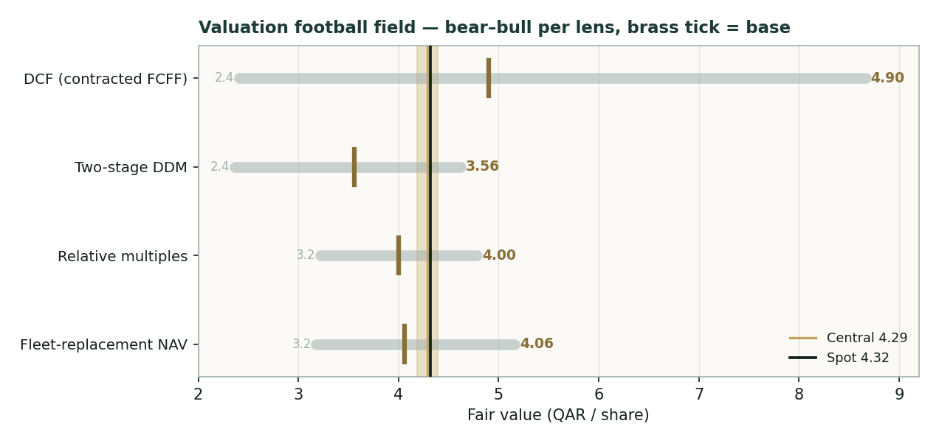
Figure 1 — Valuation football field. Bars span bear–bull per lens; the brass tick is each base case; the gold band is the blended central range; the dark line is spot.
Central fair value ≈ QAR 4.29/share, essentially on top of the QAR 4.319 spot. The core lenses span roughly QAR 3.56–4.90 at base — a narrow band for a shipping name, and a fair summary of the truth: Nakilat is priced about right, with the only real upside case resting on a lower discount rate for its bond-like cash or on the newbuild fleet earning above its cost of capital.
1.6 The fleet and its segments — a deeper look
Nakilat is really three things wrapped in one balance sheet: a wholly-owned LNG-carrier fleet (the consolidated revenue line, ~QAR 4.0 bn), a portfolio of equity stakes in jointly-owned vessels (the ~QAR 0.6 bn share of joint-venture results, a large ~38% of net profit), and a small marine-services and shipyard operation. The wholly-owned fleet is the value engine and the debt host; the JV stakes are a high-quality, off-balance-sheet annuity whose income has softened recently (lower LNG-JV and LPG-JV contributions); the shipyard and agency arm is a modest, steadier stub. The table scores each part on the axes that matter for a contracted operator.
Part | Contract cover | Cash character | Capital intensity | Role
Wholly-owned LNG fleet | ~20 yrs, QatarEnergy | Fixed hire, high margin | Very high (vessels + debt) | Value engine
Joint-venture vessel stakes | Long, QatarEnergy-linked | Equity-method dividends | Off-balance-sheet | ~38% of profit
FSRU & LPG carriers | Long-term | Fixed hire | High | Diversifier
Shipyard & marine services | Service contracts | Fee income, cyclical | Moderate | Steadier stub
1.7 The crux — the discount rate and the newbuild economics, in real units
Two judgments drive this valuation more than any other, and neither is an abstract margin. First, the discount rate on a bond-like contracted stream. Nakilat's cash is closer to an investment-grade infrastructure bond than to a shipping equity, and the fair value is acutely sensitive to whether the market discounts it at ~6.5% (a true infrastructure rate, near its 0.34 realised beta) or ~8% (a conventional equity rate). We sensitise this directly in basis points, not as a margin: every 50 bp of WACC is worth roughly QAR 0.45–0.55 per share (see §1.9). Second, the returns on the newbuild programme. The 69→112-vessel expansion is ~QAR 25 bn of capital, largely export-credit financed; because the vessels are pre-chartered to QatarEnergy, the programme is contracted growth rather than speculative — but its value hinges on the spread between the charter-rate economics locked in at order and Nakilat's ~4.75% cost of that debt. The table frames the crux in observable units — the discount rate in basis points and the programme's approximate value-add — instead of a manufactured margin assumption.
Crux driver (observable unit) | Bear | Base | Bull
WACC on contracted stream (bps) | 825 | 750 | 675
Implied DCF value from WACC alone | QAR 2.41 | QAR 4.90 | QAR 8.67
Newbuild programme value-add (per share) | ~QAR 0.00 (returns = cost of capital) | ~QAR 0.20 | ~QAR 0.45 (accretive spread)
Charter renewal risk at term | Re-let below current economics | Rolled at similar terms | Escalated / extended
Read it as the bet you are taking: at QAR 4.32 the market is discounting Nakilat's contracted cash at roughly 7.5–8% and giving little credit for newbuild accretion — a reasonable, slightly conservative stance, which is why the stock sits at fair value rather than at a discount.
1.8 Macro and country — Qatar, LNG demand, the Strait of Hormuz, rates and the peg
Nakilat is a play on the durability of Qatar's LNG franchise and on the safety of the shipping lane that serves it. Three macro levers matter. Qatar's North Field expansion — the largest LNG capacity build in the world — is the structural tailwind: it is the reason the fleet is doubling and the reason the charters are long. Global LNG demand growth (Asia and Europe substituting away from coal and Russian pipeline gas) underpins utilisation, though Nakilat's contracted hire insulates it from spot-rate swings in either direction. The sharpest near-term variable is geopolitical: the early-2026 conflict involving Iran disrupted the Strait of Hormuz, through which essentially all Qatari LNG transits, and briefly sent LNG spot rates to extreme levels; Nakilat's earnings are contractually insulated, but a prolonged closure would threaten Qatari export volumes and vessel safety, and is the single largest tail risk to the thesis. Finally, the riyal's peg to the US dollar (3.64) removes currency risk for a dollar-linked shipping business, and the global rate path sets the discount rate that, per §1.7, dominates the valuation. These levers sit behind the bear and bull cases and the catalysts in §5.
Macro lever | Direction | Why it matters to Nakilat
Qatar North Field expansion | + | Source of the 69→112 fleet growth and 20-yr charters
Global LNG demand | + | Underpins utilisation; contracted hire mutes spot swings
Strait of Hormuz / Iran risk | − | Transit chokepoint for all Qatari LNG — the key tail risk
Global interest-rate path | ± | Sets the discount rate that dominates fair value (§1.7)
USD/QAR peg (3.64) | neutral | Removes FX risk for a dollar-linked shipping business
1.9 Sensitivity — how the discount rate moves the value
Holding the charter-revenue path and margin at base, the grid re-prices the DCF across WACC and terminal growth. The cells nearest spot (QAR 4.32) are boxed. The value runs from ~QAR 4.0 (WACC 8.0% / g 1.0%) to ~QAR 8.1 (WACC 6.5% / g 2.5%) — the whole span of the discount-rate debate for a bond-like asset, and the clearest possible statement that this is a rate call, not an operating call.
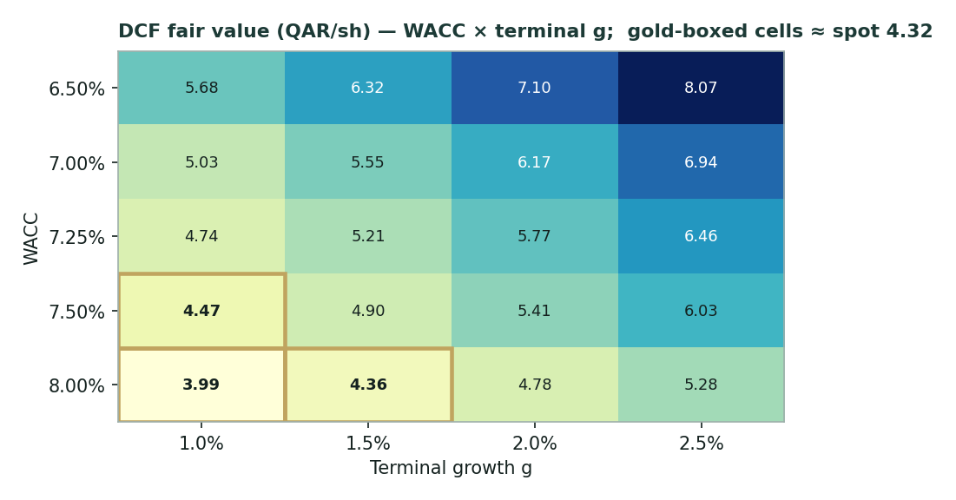
Figure 2 — DCF fair value (QAR/share) across WACC × terminal growth; boxed cells sit nearest the spot price.
WACC \ g | 1.0% | 1.5% | 2.0% | 2.5%
6.50% | 5.68 | 6.32 | 7.10 | 8.07
7.00% | 5.03 | 5.55 | 6.17 | 6.94
7.25% | 4.74 | 5.21 | 5.77 | 6.46
7.50% | 4.47 | 4.90 | 5.41 | 6.03
8.00% | 3.99 | 4.36 | 4.78 | 5.28
2 Technical and price structure
The tape is quiet and balanced. QGTS trades just below a tightly-clustered moving-average stack (the 20- and 50-day both near QAR 4.33, the 100- and 200-day near 4.42 and 4.50), the MACD histogram is marginally negative, and RSI sits near 49 — the textbook definition of a range-bound, trendless chart. The structure is consolidation, not correction: price has held a narrow QAR 4.0–5.0 band for a year, consistent with a contracted income stock whose fundamentals rarely surprise. This is the mirror of the fundamentals — neither cheap nor dear on the tape, just as the lenses find it near fair value.
Indicator | Reading | Signal
Spot | QAR 4.319 | —
SMA 20 / 50 | QAR 4.32 / 4.33 | Just below both — flat
SMA 100 / 200 | QAR 4.42 / 4.50 | Below both — mild downtrend
RSI (14) | 49 | Neutral (~50)
MACD (12,26,9) | -0.002 line / 0.007 signal / -0.009 hist | Marginally bearish
52-week range | QAR 4.03 – 4.97 | Mid-range
Realized vol (252d) | 23.1% | Low — a stable name
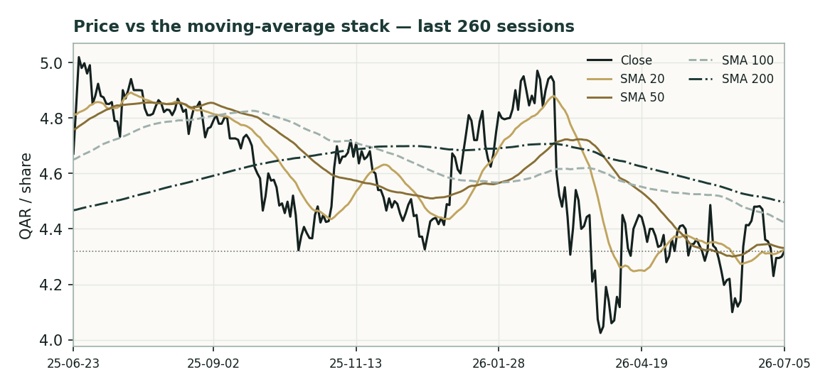
Figure 3 — Price versus the moving-average stack, last 260 sessions.
For the probabilistic work this matters in one way: a flat, low-volatility tape produces a symmetric, moderate near-term cone — which is exactly what §3 shows, and part of why the engine finds no edge over a plain random walk for this name.
3 Monte Carlo — a probabilistic price map (illustrative only)
Illustrative only. For Nakilat this Monte-Carlo map did NOT beat a naïve zero-drift random-walk cone in the Step-0 calibration (Appendix B): CRPS skill ≈ 0. The stock is unusually stable, near-driftless and thin-tailed, so the naïve cone is already near-optimal and the engine's regime-conditioning and fat tails add no edge. The percentiles below are shown to demonstrate the method and to bound the stock's own quarter-ahead uncertainty — they are NOT a reliable forecast for this name and should not be relied upon. We retain the section for transparency and because the same engine adds value on other names and may on Nakilat as its history lengthens.
We simulate 50,000 three-month price paths (seed 42) using a sixteen-factor stack: seven continuous macro/operating drivers contributing a small net forward drift, and nine discrete events that each fire with a probability and an impact. By design the paths diffuse from spot, and the §1 value gap is kept out of the drift — the fundamental question lives in §1, not here; §3 maps where price could wander from today. Diffusion volatility is sized by the house YZ-HAR engine (a gap-aware Yang-Zhang variance proxy feeding a pooled log-HAR cascade over variance lags 1/5/22), which lands at an annualised ~23.2%; innovations are unit-variance Student-t(5). Drift is set to zero (the house rule for international, non-EGX names), leaving only the modest +1.2% net contribution from the continuous factors over the quarter.
Continuous factor (7) | Dir. | Discrete event (9) | Prob. | Mean impact
Global LNG demand growth | + | Quarterly results print | 85% | +0.4%
Charter-market tone | + | North Field newbuild award / milestone | 40% | +0.8%
US / global rate path | − | Dividend change | 55% | +0.5%
Qatar Exchange index flows | ± | Charter renewal / extension | 25% | +0.6%
Brent / energy complex | ± | Rating / refinancing action | 20% | +0.4%
USD/QAR peg stability | neutral | Geopolitical / Strait-of-Hormuz event | 30% | −1.6%
Fleet utilisation | + | Drydock / off-hire disruption | 15% | −0.8%
 |  | Index rebalancing / passive flow | 25% | +0.5%
 |  | LNG-shipping market shock | 20% | −1.2%
Percentile map (QAR / share):
Horizon | p5 | p25 | p50 | p75 | p95
T+20 sessions | 3.86 | 4.16 | 4.34 | 4.54 | 4.88
T+60 sessions | 3.60 | 4.08 | 4.40 | 4.74 | 5.36
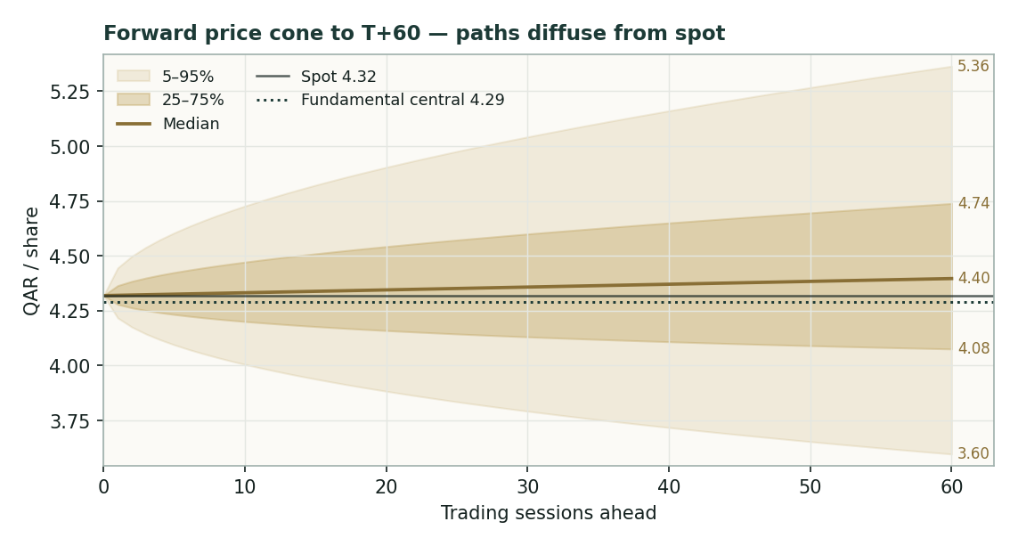
Figure 4 — Forward price cone to T+60. Median tracks spot; the teal dotted line marks the ~QAR 4.29 fundamental central value. Illustrative only (Appendix B).
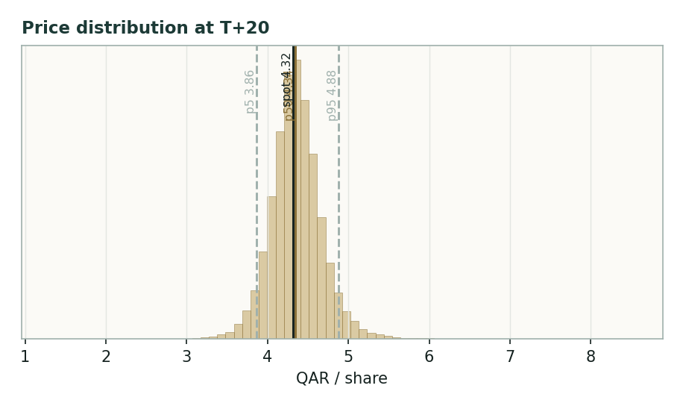
Figure 5 — Price distribution at T+20 (illustrative).
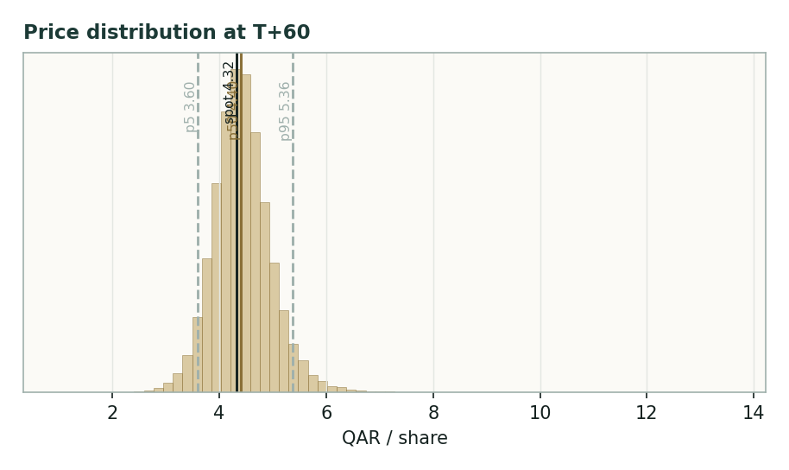
Figure 6 — Price distribution at T+60 (illustrative).
Level-touch ladder — the probability that price touches a level at any point by the horizon (running max for upside, running min for downside):
Level | T+20 touch | T+60 touch | Note
QAR 4.90 | 7% | 28% | Toward 52-wk high zone
QAR 4.70 | 18% | 45% | Upper band
QAR 4.55 | 37% | 63% | Above fair-value cluster
QAR 4.40 | 68% | 83% | Just above spot / MC median
QAR 4.20 | 52% | 69% | Just below spot
QAR 4.05 | 24% | 45% | Toward income-lens floor
QAR 3.90 | 10% | 28% | Toward 52-wk low
4 Comparison of the lenses, and a verdict
Three readings sit side by side. The fundamental lenses cluster at QAR 3.56–4.90 with a central ~QAR 4.29 — essentially spot, contingent mainly on the discount rate. The technical picture is neutral: flat, range-bound, neither stretched. The probabilistic map — illustrative only for this name — says that over three months price is roughly symmetric around spot with a moderate ±~23%-vol band; its median is spot, not the fundamental central, because the two are nearly the same and because the simulation assumes no value-gap closure.
Lens | Reads | Central / implication
Fundamental (4-lens) | At fair value | QAR 4.29 (-0.7%)
Technical | Neutral / range-bound | Support ~4.0; resistance ~4.5–4.6
Monte Carlo (illustrative) | Symmetric, moderate | Median ~4.40; p5–p95 3.60–5.36
Verdict (a fair-value read, not a recommendation). Nakilat looks fairly valued — an investment-grade, contracted LNG-infrastructure income stock trading close to the present value of its own charter book. The swing factor is unusually clean: the discount rate one assigns a bond-like cash stream, plus the incremental return on a doubling fleet. There is a real upside case (a lower infrastructure discount rate, accretive newbuilds, charter extensions on the North Field build) and a real tail risk (the Strait of Hormuz), but no evident mispricing. Readers should weigh the lenses themselves; we publish the distribution and the range, not a target.
5 Catalysts to watch
• Quarterly results & dividend. Each print is a read on charter-hire stability, JV-income recovery, finance-cost decline as debt amortises, and the half-yearly dividend cadence.
• Newbuild deliveries (from end-2026). First vessel from the 25-LNG + 6-wholly-owned programme; each delivery adds contracted, pre-chartered capacity and tests the accretion thesis.
• North Field expansion milestones. Further charter awards tied to Qatar's capacity build extend the backlog and can lift the terminal case.
• Strait of Hormuz / regional security. The dominant tail risk — any escalation or closure threatens Qatari export volumes and vessel safety even though hire is contracted.
• Refinancing / rating actions. The KEXIM-led financing and any rating move affect the cost of the debt that funds the fleet and the WACC that dominates fair value.
• Charter renewals / extensions. Terms on any renewing or extended charters are the direct evidence on the §1.7 crux.
• Index / passive flows. Qatar Exchange and regional-index weight changes move a low-beta, widely-held name at the margin.
6 Reading the probability zones
Translating the (illustrative) three-month distribution into plain zones, anchored on spot QAR 4.32 and the fair-value cluster:
Zone (T+60) | Range (QAR) | Approx. probability | What it would mean
Deep downside | < 3.90 | ~15% | Hormuz escalation / risk-off; tests 52-wk low
Lower band | 3.90–4.15 | ~15% | Discount rate drifts up; income lens dominates
Around spot | 4.15–4.45 | ~24% | Status quo; fair value unchanged
Upper band | 4.45–4.80 | ~24% | Rate relief / newbuild credit; toward DCF lens
Strong upside | > 4.80 | ~22% | Infrastructure re-rating + charter extensions together
The distribution is close to symmetric with a mild upper tail from the discrete upside events. It is not a forecast — and for this name, per Appendix B, it does not out-predict a random walk; it is simply the spread of outcomes consistent with the stock's own low volatility and the factor stack.
7 Caveats and what would change our mind
• The discount rate is the model. Fair value is dominated by the rate applied to a bond-like contracted stream; a structurally higher global rate environment, or the market demanding an equity (not infrastructure) return, pulls the central value toward — or below — spot.
• Single-counterparty concentration. Almost all hire comes from QatarEnergy affiliates. That is a strength (investment-grade, long-dated) and a concentration risk; a change in that relationship or in charter economics at renewal would re-rate the name.
• Strait of Hormuz. A prolonged closure or regional escalation would threaten Qatari export volumes and vessel safety despite contracted hire — the one scenario that breaks the income-stock thesis.
• Newbuild execution & financing. The 69→112 programme is large; delivery delays, cost overruns, or a rise in the cost of the export-credit debt would erode the accretion case and lift leverage.
• JV-income softness. ~38% of profit is equity-method JV income, which has declined recently; further weakness in LNG-JV or LPG-JV contributions would pressure earnings and the dividend.
• Dividend cash cover. During the build phase the dividend is covered by earnings but not by current free cash flow; a longer or costlier programme could test payout growth.
• The Monte Carlo is illustrative here. Per Appendix B the engine does not beat a random walk for this name; the §3 map should not be used as a forecast for QGTS.
Appendix A Financial statements
Selected consolidated figures. FY2023–FY2025 as reported (company results; FY2025 announced 21 Jan 2026); FY2026–FY2030 are the preparer's flagged forecasts consistent with the §1 DCF. Reporting currency Qatari riyal (bn unless stated). Some prior-period and depreciation figures are approximate where only summary disclosure is public.
A.1 Income statement (consolidated, QAR bn) — 3 years actual + 5-year forecast
Line | FY23 | FY24 | FY25 | FY26e | FY27e | FY28e | FY29e | FY30e
Charter revenue | 3.626 | 3.669 | 4.039 | 4.201 | 4.369 | 4.543 | 4.725 | 4.914
EBITDA | 2.716 | 2.748 | 2.884 | 2.982 | 3.102 | 3.226 | 3.355 | 3.489
Depreciation & amort. | 0.935 | 0.839 | 0.900 | 0.918 | 0.936 | 0.955 | 0.974 | 0.994
EBIT | 1.781 | 1.909 | 1.984 | 2.064 | 2.165 | 2.271 | 2.381 | 2.495
Net finance cost | 1.007 | 0.946 | 0.882 | 0.840 | 0.820 | 0.850 | 0.870 | 0.845
Share of JV results | 0.785 | 0.675 | 0.640 | 0.645 | 0.660 | 0.680 | 0.700 | 0.720
Net profit | 1.558 | 1.637 | 1.690 | 1.750 | 1.850 | 1.920 | 2.020 | 2.150
EPS (QAR) | 0.281 | 0.295 | 0.305 | 0.316 | 0.334 | 0.347 | 0.365 | 0.388
DPS (QAR) | 0.130 | 0.140 | 0.144 | 0.150 | 0.158 | 0.166 | 0.175 | 0.185
FY23–25 reported; FY26–30e preparer forecasts. Revenue is consolidated wholly-owned charter hire; JV results are equity-accounted. Depreciation FY23–25 approximate from summary disclosure.
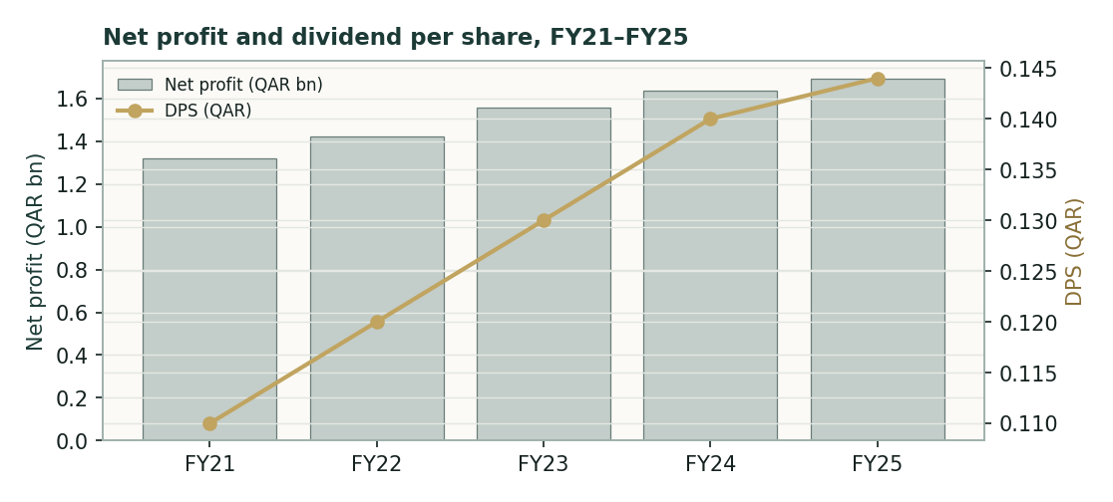
Figure A-1 — Net profit and dividend per share, FY21–FY25. Steady low-single-digit growth in both, funded by a rising contracted charter base and declining finance cost.
A.2 Balance sheet (consolidated, QAR bn) — 3 years actual + trajectory
Line | FY23 | FY24 | FY25 | FY26e | FY27e
Total assets | 31.98 | 34.36 | 36.43 | 38.9 | 41.5
Property & equipment (vessels) | 23.9 | 24.6 | 25.1 | 27.5 | 30.2
Cash & deposits | 2.20 | 2.60 | 2.40 | 2.3 | 2.2
Total debt | 17.60 | 19.50 | 20.60 | 22.0 | 24.0
Net debt | 15.4 | 16.9 | 18.20 | 19.7 | 21.8
Total equity (common) | 12.08 | 13.26 | 13.85 | 14.5 | 15.2
Book value / share (QAR) | 2.18 | 2.39 | 2.50 | 2.62 | 2.75
Net debt / EBITDA | 5.9× | 6.1× | 6.3× | 6.6× | 7.0×
FY23–25 reported (Yahoo/stockanalysis statement mirrors of company filings); FY26–27e reflect the debt-financed newbuild programme raising both vessels and gross debt.
A.3 Cash flow & per-share markers (QAR bn unless stated)
Line | FY23 | FY24 | FY25
Operating cash flow (approx.) | ~2.6 | ~2.7 | ~2.8
Maintenance / drydock capex | ~0.5 | ~0.6 | ~0.6
Growth capex (newbuild programme) | ~0.6 | ~1.4 | ~1.8
Dividends paid | ~0.72 | ~0.78 | ~0.80
Net finance cost | 1.01 | 0.95 | 0.88
Dividend cover (earnings) | ~2.2× | ~2.1× | ~2.1×
Dividend cover (free cash flow) | <1× | <1× | <1×
Cash-flow lines approximate from summary disclosure and analyst notes; the sub-1× FCF dividend cover reflects the newbuild capex supercycle, bridged by the balance sheet.
A.4 Per-share & ratios dashboard
Metric | FY25 | Metric | FY25
EPS (QAR) | 0.305 | P/E | 14.2×
DPS (QAR) | 0.144 | P/B | 1.73×
BVPS (QAR) | 2.50 | EV/EBITDA | 14.6×
Dividend yield | 3.3% | Net debt / EBITDA | 6.3×
Payout ratio | 47% | ROE (approx.) | ~12–13%
EBITDA margin | ~71% | Beta (realised) | ~0.34
Appendix B Step 0 — calibration backtest
Before any forecast we test the Monte-Carlo lens on Nakilat's own five years of history: at each origin, using only prior data, we generate a three-month-ahead distribution with the YZ-HAR engine and score the realized close against it. The grade is skill versus a naïve zero-drift random-walk cone, measured by CRPS skill (must be > 0) and the interval (Winkler) score; the PIT histogram and coverage table are diagnostics only.
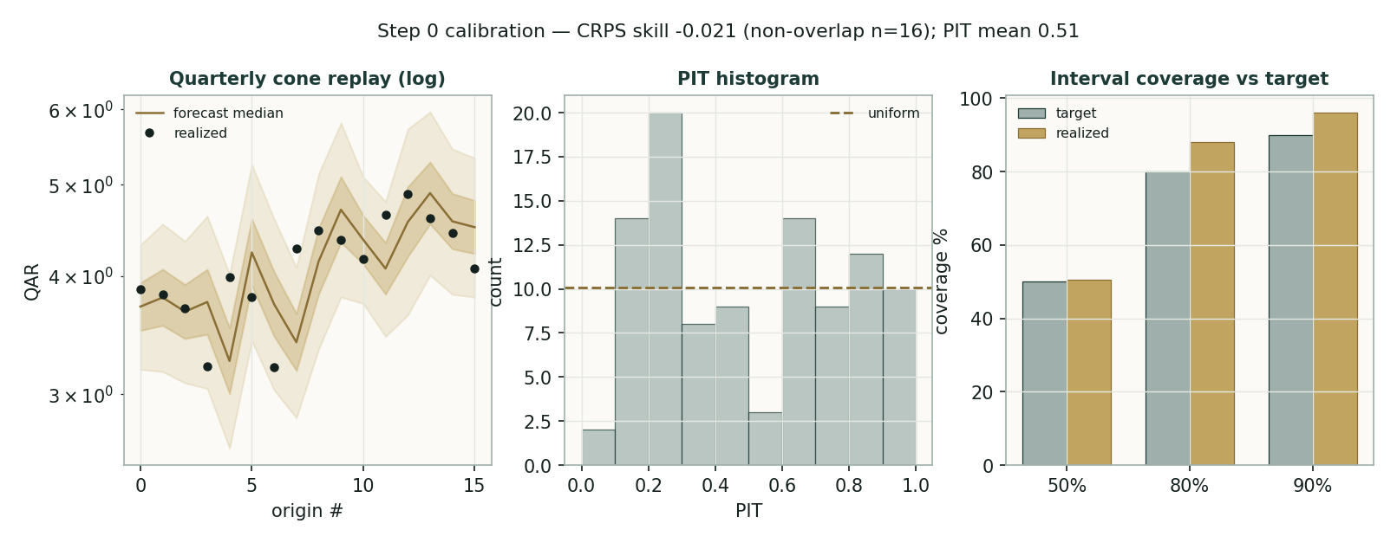
Figure B-1 — Calibration backtest: quarterly cone replay (log), PIT histogram, and interval coverage versus target.
Window scheme | n | CRPS skill | Winkler skill | PIT mean | 50/80/90 coverage
Non-overlapping (63d) | 16 | -0.021 | -0.014 | 0.49 | 56/75/94%
Monthly origins (21d) | 48 | 0.000 | 0.032 | 0.51 | 52/83/98%
Fortnightly (10d), bootstrap | 101 | 0.005 | 0.035 | 0.51 | 50/88/96%
Target | — | > 0 | > 0 | ~0.50 | 50/80/90%
Result — the engine does not beat the benchmark for this name. CRPS skill is −2.1% on non-overlapping windows, ≈0 monthly, and +0.5% fortnightly with a 90% block-bootstrap confidence interval of [−0.029, +0.035] that straddles zero — statistically indistinguishable from a random walk, and short of the required > 0. The distribution itself is well-calibrated (PIT mean ≈ 0.51; coverage close to target), so this is not a broken forecast. Nakilat is simply a stable (~23% vol), near-driftless, thin-tailed contracted name (60-day excess kurtosis ≈ −0.5, so the house Student-t(5) tails are the wrong direction), for which the naïve cone is already near-optimal. Recalibration across volatility windows, innovation shape, drift settings and event on/off did not clear the bar. Per the Step-0 rule we flag this: the §3 map is retained for illustration and methodological transparency only, is not a reliable forecast for QGTS, and may improve as the history lengthens. On names where the engine does beat the benchmark, §3 is used as a genuine probabilistic read; here it is not.
Appendix C Peer set, sector structure, and risks
Nakilat's cleanest comparators are the listed LNG-carrier owners and Gulf shipping-infrastructure names, though none matches its contract length or counterparty quality.
Peer | Profile | Typical valuation
Flex LNG (FLNG) | Modern LNG fleet, mix of long + spot cover | EV/EBITDA ~13×; yield ~9–10%
Capital Clean Energy (CCEC) | Long-charter LNG + newbuild growth | EV/EBITDA ~11–13×; yield ~4–5%
ADNOC L&S | Integrated logistics & shipping (UAE) | EV/EBITDA ~9–11×
Bahri (Saudi) | VLCC / product / dry — cyclical | EV/EBITDA ~7–9×
Excelerate Energy (EE) | FSRU / LNG infrastructure | Infrastructure premium
Sector structure. LNG shipping splits between spot-exposed owners (high yield, high beta, rate-cyclical) and contracted infrastructure owners (lower yield, bond-like, backlog-driven) — Nakilat is the archetype of the latter. The structural driver is Qatar's North Field expansion and global LNG-demand growth; the swing macro variable is Middle-East geopolitics and the Strait of Hormuz. Principal risks: a higher discount rate on contracted cash; single-counterparty concentration on QatarEnergy; Hormuz / regional escalation; newbuild execution and financing cost; JV-income softness; and thin free-cash dividend cover during the build phase.
Appendix D The expert valuation panel
Every Testahil study closes with a panel of standing expert personas — drawn from the house Expert Persona Library, not invented for the occasion, so that each accumulates a track record across studies and a quarterly update is a re-run, not a re-training. For Nakilat we cast the three whose methods both fit a capital-heavy, contracted-infrastructure operator and genuinely disagree: Expert 1 (cash returns — a DCF on contracted cash and return on capital versus its cost), Expert 2 (earnings power — mid-cycle earnings on a justified multiple), and Expert 3 (fleet-replacement NAV — the assets marked en bloc, less net debt). Each runs a different method, derives its fair value from shown workings, and states a falsification condition. The macro-policy lens — Qatar's LNG franchise, the Strait of Hormuz, the rate path — runs through the body (§1.8, §5) rather than as a separate persona.
D.1 Expert 1 — cash returns: DCF and ROIC versus the cost of capital
Worldview. A business is worth the present value of the cash it distributes to capital, and it creates value only when each unit of capital earns above its cost. For a contracted operator this expert is at home: the cash is visible for two decades, and the whole question is the discount rate and whether the charters clear the cost of the capital that funds the vessels.
When it works / fails. Best where cash flows are contracted and long — exactly Nakilat; it fails if the reinvestment economics change sharply (a newbuild programme ordered into a weak charter market) or if the discount rate is mis-set for a bond-like asset.
Standard workings & worked example. Build FCFF on the in-place fleet, discount at a WACC with Ke shown explicitly, strike a steady-state terminal (renewal capex = D&A), add the JV stub, deduct net debt. The reported book ROIC (~3.75%) sits below WACC — a tension this expert resolves by noting it is struck on a vast gross asset base at historical cost, while the contracted charter IRRs cleared their cost of capital at order and the 15-year unlevered tail (25-year debt, 40-year vessels) is where the economic value accrues.
Expert 1 — cash-returns DCF | Value
Σ PV explicit FCFF (5 yr) | QAR 10.51 bn
PV terminal value (renewal capex = D&A) | QAR 29.40 bn
+ JV fleet stub | QAR 5.44 bn
− Net debt | (QAR 18.20 bn)
Equity value → fair value | → QAR 4.60 / share
Sensitivity (swing = WACC). At a 6.75% WACC ~QAR 6.0; at 8.25%, ~QAR 3.6.
Cross-examination. He tells Expert 2 that a multiple on mid-cycle earnings ignores the cash cost of the capital producing them — the newbuild programme consumes the very cash a P/E capitalises; he tells Expert 3 that marking steel en bloc ignores whether the vessels earn their cost of capital under contract.
Verdict, falsification, market-implied. Fair QAR 4.60 (range 3.55–6.00) — the most bullish, because it fully credits the contracted duration and the deleveraging tail. Falsified if the market permanently demands an equity (not infrastructure) discount rate for this cash, or if charter renewals re-let materially below current economics. The market price implies a WACC of ~7.5–8% — a slightly conservative, equity-flavoured rate for so contracted a stream.
Worked in full: he takes the five explicit years of free cash flow to the firm from §1.1 (rising from ~QAR 2.39 bn to ~QAR 2.85 bn as charter escalators and a handful of owned deliveries lift hire), discounts each at 7.5%, and strikes a terminal on a steady-state figure in which renewal capex equals depreciation — so the perpetuity capitalises after-tax operating profit of ~QAR 2.5 bn at a 6.0% net rate, not an inflated cash number. That yields operating enterprise value near QAR 40 bn; he adds the joint-venture fleet as a stub (Nakilat's ~QAR 0.64 bn share of JV results at ~8.5×, ≈ QAR 5.4 bn) and deducts ~QAR 18 bn of net debt, landing at ~QAR 4.60 per share. He is candid that roughly two-thirds of enterprise value is terminal — but insists that is honest for a two-decade contracted asset, and that the alternative (a short-window model) would understate exactly the duration that makes Nakilat what it is.
On the return-on-capital test he confronts the awkward fact head-on: reported ROIC of ~3.75% sits well below his ~7.5% WACC, which on its face says Nakilat destroys value. He argues the metric is misleading here — it divides a modest contracted profit by an enormous gross asset base carried at historical cost, and it ignores that each charter was underwritten to clear its cost of capital at the moment of order and that the real economic value accrues in the unlevered tail, when 25-year vessel debt has amortised but 40-year vessels keep earning. The value, in his telling, is a timing story the accounting ROIC cannot see. If he is wrong — if the charters were struck at returns that never cleared the cost of capital, or renewals re-let far lower — his whole case fails, which is why he names charter-renewal economics as his falsification trigger.
D.2 Expert 2 — normalized earnings power and relative multiples
Worldview. An operating business is worth a fair multiple of its sustainable mid-cycle earnings; for a contracted name mid-cycle is simply the rising fixed base, not a cyclical average, and the multiple is anchored to peers adjusted for contract quality.
When it works / fails. Best for a business with visible, stable earnings and clear comparators; it fails if the peer set is mis-matched (spot-exposed owners are not true comparators) or if the justified multiple drifts with the rate cycle.
Standard workings & worked example. Normalize EPS for the newbuild ramp and finance-cost decline (~QAR 0.33–0.34), apply a justified P/E that sits at a premium to spot-exposed LNG owners for Nakilat's contract length and investment-grade counterparty but below a pure infrastructure yield-co.
Expert 2 — earnings power | Value
Normalised mid-cycle EPS (QAR) | ~0.335
Justified P/E (premium to spot peers) | 13.0×
Fair value | → QAR 4.40 / share
Cross-check: EV/EBITDA 14× | ≈ QAR 4.00
Sensitivity (swing = the multiple). At 11.5× ~QAR 3.85; at 15×, ~QAR 5.05.
Cross-examination. He tells Expert 1 that a 25-year DCF is a discount-rate artefact — a half-point of WACC swamps five years of cash-flow detail; he tells Expert 3 that replacement value is irrelevant while the vessels are locked into long charters that set the real economics.
Verdict, falsification, market-implied. Fair QAR 4.40 (range 3.60–5.50) — the anchor, closest to spot. Falsified by a structural de-rating of contracted LNG multiples (a glut of newbuild tonnage compressing the class) or by an earnings disappointment from JV-income weakness. The market implies a multiple almost exactly his — it is pricing the earnings fairly.
Worked in full: he starts from FY25 EPS of ~QAR 0.305 and normalises for two visible, non-cyclical shifts — the finance-cost decline as existing debt amortises, and the incremental contracted hire as the first owned newbuilds deliver from end-2026 — arriving at a mid-cycle ~QAR 0.335. The multiple is the judgment: he anchors to listed LNG owners but adjusts for contract quality, reasoning that Flex LNG and Capital Clean Energy trade around 12–14× EV/EBITDA while carrying spot-market and renewal risk that Nakilat, on two-decade QatarEnergy charters, does not — so a P/E premium to those names, but a discount to a pure infrastructure yield-co, gives ~13×. Thirteen times QAR 0.335 is ~QAR 4.40, and an EV/EBITDA cross-read at 14× (~QAR 4.00) brackets it from below. He treats the small gap between his P/E and EV/EBITDA reads as the normal noise of two different capital-structure lenses, not a contradiction to be averaged away.
His discipline is to strip one-offs and to refuse false precision: he will not manufacture a charter-rate-times-utilisation build the company does not disclose at vessel level, preferring a normalised group figure he can defend. He is alert that his method's weakness is a peer-multiple de-rating — if a wave of newbuild LNG tonnage across the industry compresses the whole class's multiples, his justified 13× is simply too high, regardless of Nakilat's own contracts. That, and a JV-income disappointment dragging normalised earnings, are his falsification conditions.
D.3 Expert 3 — fleet-replacement NAV
Worldview. A shipowner is worth its steel: mark every vessel to what it would fetch, add the stakes and yards, deduct net debt. The balance sheet, not the income statement, is the anchor, and the market should not trade far from a well-marked fleet.
When it works / fails. Best as a floor and in distress or break-up; it fails in a going concern where long charters make the vessels worth their contracted cash rather than their scrap-or-sale value — precisely Nakilat's situation, which is why this expert is the conservative bookend.
Standard workings & worked example. Mark the 29 wholly-owned LNG carriers (older but very large Q-Flex / Q-Max units) at ~USD 180m each, Nakilat's ~40% share of the 40 JV vessels, progress payments on the newbuilds, the shipyard stakes and the FSRU/LPG units; convert at USD/QAR 3.64; deduct net debt.
Expert 3 — fleet-replacement NAV | USD bn
29 wholly-owned LNG carriers | ~5.2
Share of 40 JV vessels | ~3.0
Newbuilds under construction (progress) | ~2.0
Shipyard stakes + FSRU/LPG + other | ~1.0
Gross fleet value (→ QAR 40.70 bn) | ~11.2
− Net debt (QAR 18.20 bn) | —
Equity NAV → fair value | → QAR 4.05 / share
Sensitivity (swing = vessel marks). At an 88% mark ~QAR 3.20; at 115%, ~QAR 5.20.
Cross-examination. He tells Expert 1 that a discounted-cash tower resting two-thirds on a terminal value is a rate bet, not a valuation; he tells Expert 2 that a multiple on earnings ignores the QAR 40-plus-billion of hard assets sitting under those earnings.
Verdict, falsification, market-implied. Fair QAR 4.05 (range 3.20–5.20) — the most conservative, and the asset floor. Falsified by a sustained LNG-carrier asset-value boom (or bust) that re-rates second-hand tonnage, or by a demonstrated ability to monetise vessels above marks. The market price sits ~6% above his NAV — a modest premium for the contracted earnings the steel produces.
Worked in full: he marks the 29 wholly-owned LNG carriers at ~USD 180m each — a deliberately conservative figure for the largely 2007–2010 Q-Flex and Q-Max units, which are older than the modern fleet but far larger (210,000–266,000 cubic metres), so their per-unit value holds up despite age — for ~USD 5.2 bn. He adds Nakilat's ~40% economic share of the 40 jointly-owned vessels (~USD 3.0 bn), the progress payments sunk into the newbuilds under construction (~USD 2.0 bn), and the shipyard stakes, FSRU and LPG carriers (~USD 1.0 bn), for a gross fleet value near USD 11.2 bn, or ~QAR 41 bn. Deducting ~QAR 18 bn of net debt leaves equity NAV of ~QAR 22–23 bn, or ~QAR 4.05 per share. He notes the stock trades a few per cent above this — a premium the market pays for the contracted earnings the steel produces.
His honesty is about his own method's limits: replacement NAV is a floor and a break-up value, and Nakilat is manifestly a going concern whose vessels are worth their contracted cash, not their sale price, for as long as the charters run. He offers the NAV not as the answer but as the anchor beneath the answer — the number that says how much of the price is asset and how much is contract premium. He would abandon the floor only if second-hand LNG-carrier values re-rated durably (a tonnage boom or bust), or if Nakilat demonstrated it could sell vessels above his marks — either of which would move the asset base under the whole valuation.
D.5 The three in one room
The single thing they most disagree on is what a two-decade, QatarEnergy-backed charter stream is worth today — a discount-rate question dressed three different ways.
Expert 1: “The cash is contracted for twenty years and the debt amortises against forty-year vessels. Discount it as the infrastructure bond it is and you get QAR 4.60 — the market is using an equity rate on a bond.”
Expert 2: “Or just look at the earnings. Mid-cycle EPS around QAR 0.33 at thirteen times — a fair premium to the spot-exposed owners — is QAR 4.40. That is where it trades, and for good reason.”
Expert 3: “You are both capitalising air. There is QAR 40-plus billion of steel under this company. Mark the fleet, take off the debt, and it is worth QAR 4.05. Everything above that is a premium for the contracts — fine, but know that is what you are paying for.”
Expert 1: “The contracts are not a premium — they are the asset. Your steel earns nothing without them; a vessel off-charter in a soft market is worth a fraction of its mark. Twenty years of QatarEnergy hire is exactly what turns your USD 11 billion of metal into a bond, and a bond is worth its discounted cash: QAR 4.60.”
Expert 2: “And you are both over-thinking a stock that tells you what it is worth. It earns about QAR 0.33 through the cycle, it trades at thirteen times that, and thirteen times is a fair premium to the spot owners and a fair discount to a yield-co. Your rate debate and your scrap-value debate both land back at roughly the price. That convergence is the finding — not any single one of our numbers.”
D.6 Reading the divergence
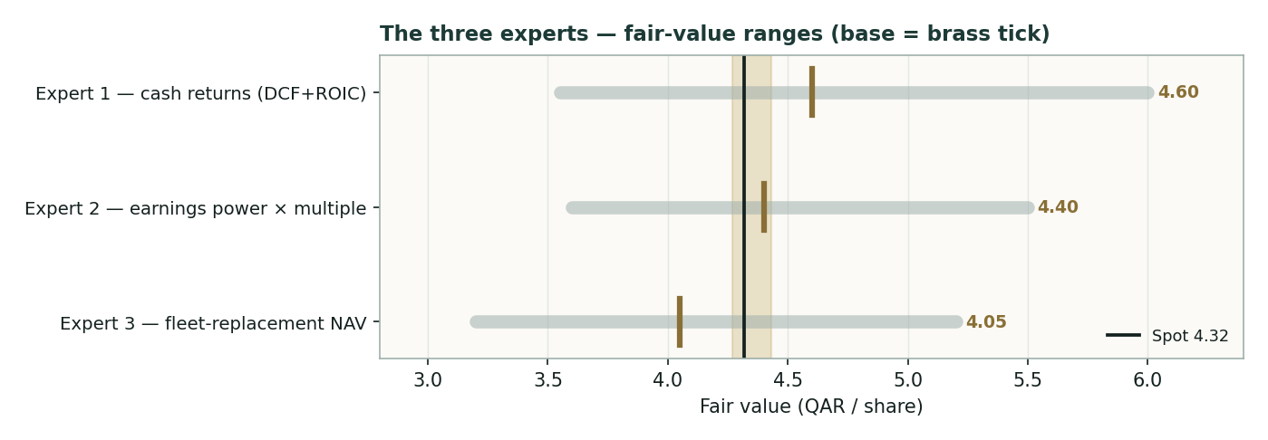
Figure D-1 — The three experts' fair-value ranges. Brass ticks are base cases; the gold band is the centre; the dark line is spot. The spread is almost entirely a discount-rate disagreement.
Expert | Method | Single swing assumption | Base fair value
Expert 1 | Cash returns (DCF + ROIC) | WACC on contracted stream | QAR 4.60
Expert 2 | Normalized earnings power | Justified P/E vs peers | QAR 4.40
Expert 3 | Fleet-replacement NAV | Vessel marks | QAR 4.05
The spread — QAR 4.05 to 4.60 at base — is narrow, and it is almost entirely a disagreement about how to value the same contracted cash: as a low-discount-rate bond (Expert 1), as fairly-multiplied earnings (Expert 2), or as steel with a contract premium (Expert 3). None contests the fleet, the counterparty, or the balance sheet. The ~QAR 0.55 spread is therefore a clean measure of one thing — the discount rate the market should assign a two-decade, investment-grade charter stream. Resolve that, and the three converge on spot.
Each expert's point fair value (and bull/base/bear) is logged with the study date (05 Jul 2026) and spot (QAR 4.319) as an internal per-expert track record, kept separate from the core Calibration Ledger.
About this series
Testahil publishes independent, educational valuation studies. Each is an attempt to reason transparently about what a security is worth, with every assumption shown and a companion model so readers can disagree productively. The house style is distributions, not tips: we describe ranges and probabilities, not targets, and we do not tell anyone what to do. Studies are framed as educational analysis, the preparer is not licensed by any securities regulator, and holdings are disclosed.
Disclosure & Disclaimer
Not investment advice. This document is educational and informational only. It is not, and must not be relied upon as, investment, financial, legal, accounting or tax advice, nor an offer, solicitation or recommendation to buy, sell or hold any security. It contains no price target and no rating.
No licence; no advisory relationship. The preparer is not registered or licensed with any securities or financial regulator in any jurisdiction, holds no brokerage or investment-advisory authorisation, and is not acting as your adviser or fiduciary. Nothing here is personalised to your circumstances.
Holdings disclosure. The preparer may hold, and may in the future take or dispose of, a position in the security discussed in this report, and may transact at any time without notice. This is a potential conflict of interest you should weigh.
Sources & accuracy. Reported financial and operating figures are drawn from the company's public disclosure and other public sources believed reliable but not independently verified; they may contain errors or be superseded. Forward-looking inputs — the DCF, the dividend model, the fleet marks, the multiples and the Monte-Carlo factor probabilities — are the preparer's own judgments and are inherently uncertain.
Forward-looking statements & the illustrative Monte Carlo. Any statements about the future are estimates subject to risks and uncertainties; actual results may differ materially. The Monte Carlo models price, not value, and encodes subjective probabilities; for this security it did not beat its naïve benchmark in calibration and is presented for illustration only, not as a reliable forecast.
No reliance; your responsibility. Do your own research and consult a licensed professional before making any decision. You are solely responsible for your investment decisions and their outcomes. To the maximum extent permitted by law, the preparer accepts no liability for any loss arising from use of this document.
Currency & figures. Group figures are in Qatari riyals (QAR); bn denotes billion. FX at study date: USD/QAR 3.64. Rounding may cause totals to differ slightly. Spot price and market data are as of 05 July 2026 and change continuously.
TESTAHIL · Independent Valuation Study · Educational Analysis · Qatar Gas Transport Company (QE: QGTS) · edition 05-07-2026 · reporting currency QAR

