Independent Valuation Study — Educational Analysis
Sixth of October Development & Investment — SODIC (EGX: OCDI)
Fundamental analysis · Technical analysis · Monte Carlo simulation — one integrated read
Anchor: EGP 22.80 (23 Jun 2026 close) · 1.289bn shares (post-merger) · mkt cap ~EGP 29.4bn · net debt ~EGP 2.5bn · free float ~14.5% (Aldar Properties + ADQ own ~85.5%) · prices & probabilities computed 24 Jun 2026 from the attached OCDI price history (1 Jun 2021 – 23 Jun 2026, 1,226 sessions), back-adjusted at the August-2025 statutory merger · independent bottom-up valuation, derived project inputs
READ FIRST — what this document is, and is not. This study is a valuation exercise and an expression of personal analytical opinion, published free of charge for educational purposes: it shows how one analyst applies fundamental, technical and probabilistic methods to a listed company, and invites scrutiny of that methodology. It is NOT investment advice, NOT a recommendation or solicitation to buy, sell or hold any security, and NOT directed at the circumstances of any reader. The preparer is not licensed by the Egyptian Financial Regulatory Authority (FRA) or any other regulator, provides no financial consultancy, manages no money, and accepts no fees, funds or clients. See the Disclosure & Disclaimer at the end. All values are model outputs presented as ranges and distributions because no single number should be relied on. Project-level inputs are DERIVED estimates calibrated to disclosed totals and market comparables — SODIC publishes no project-level economics — and are flagged throughout. SODIC's share count and price history are adjusted for the August-2025 statutory absorption of seven subsidiaries (2.6196 new shares per old share; GAFI Decision 365/2-2025). Consult a licensed financial advisor before any investment decision.

Headline
The model’s read: the three-month distribution skews modestly constructive, and the stock trades below the model’s risk-adjusted value after a ~28% three-month run that has carried it to within a whisker of its 52-week high. An independent, clean-sheet bottom-up build — every development project valued from units × price/m² and m² × construction-cost/m² and only the unsold remainder counted (already-sold units sit in the contracted backlog, so nothing is double-counted), the two revenue-share joint ventures (New Sphinx with Rula, Eastvale/MADA with MIDAR) carried at SODIC’s economic share with no land cost, the June/Marriott hotel and the Eastown District / retail base valued as separate EBITDA-multiple segments, minority treated as negligible, the EGP 106bn contracted backlog valued as the single largest, most-certain block, and ~EGP 2.5bn of net debt subtracted — puts risk-adjusted fair value at EGP 26.43, ~16% above the EGP 22.80 market; full execution of the modelled pipeline is worth EGP 30.77 (+35%). A consolidated whole-company FCFF DCF (EGP 27.36, +20%) corroborates the asset-based build, and a four-lens synthesis — SOTP/RNAV, DCF, relative multiples and a discount-to-NAV reading — centres on ~EGP 27.7 (+22%). The defensible floor — net debt plus the contracted backlog plus the two operating segments, all risk-weighted, with every development project set to zero — is ~EGP 16.7, which sits ~27% BELOW the current price: unlike a deep-value, trades-below-net-cash screen, SODIC carries net debt and the market is already paying for partial pipeline execution, so the case is execution-driven (backlog conversion, the Eastvale/New Sphinx JV ramp, margin normalization), not a balance-sheet mispricing. Technically the picture is a strong but stretched uptrend: price closed 22.80 just below the 23.14 period high, riding above a rising stack of moving averages (SMA20 21.30, SMA50 21.46, SMA150 19.42, SMA200 18.67), with RSI(14) elevated at ~62 (Wilder) — intact but mature, short of the classic 70 overbought line. A single 10-factor Monte Carlo (CBE rate, FX, inflation, EGX flows, Brent/Gulf liquidity, geopolitics, JV land monetization, launch execution, North-Coast season, mortgage credit; 50,000 paths, seed 42, diffusion set to the split-adjusted realized volatility of ~46.6%) puts the T+20 median at ~23.2 and the T+60 median at ~24.0, with a right tail to ~36. Net: the modelled value sits above the market and well above the bear floor, but the floor is beneath the price — the thesis rests on execution, and the right tail of the distribution belongs to the JV launches and backlog delivery, the left tail to FX/geopolitical macro and a momentum reversal from these stretched levels. This study estimates values and probabilities — it does not recommend actions, and the project-level inputs that drive the upside are the preparer’s estimates, not company disclosure.

Company overview — SODIC at a glance
Sixth of October Development & Investment (EGX: OCDI), trading as SODIC, is one of Egypt’s leading premium real-estate developers. It is a diversified developer with three businesses: a development engine spanning large master-planned communities across West Cairo, East Cairo and the North Coast; an owned-hotel presence (a June hotel under a Marriott Tribute affiliation, plus Forty West hospitality); and a recurring-income base (Eastown District retail and offices, Portal, and community retail). A consortium of Aldar Properties (UAE) and ADQ acquired control in 2021 and retains ~85.5%, leaving a thin ~14.5% free float. The defining recent event is corporate, not operational: in August 2025 SODIC completed a statutory absorption of seven subsidiaries, lifting the share count from ~356m to ~1.289bn — all per-share figures here use the post-merger count, and the price history is back-adjusted at the merger seam so the technical and volatility reads are continuous.
Item | Value (as disclosed / derived)
Listing / sector | EGX: OCDI · real-estate development
Controlling shareholder | Aldar Properties + ADQ consortium — ~85.5%
Free float | ~14.5% (thin; liquidity-constrained)
Share price (23 Jun 2026 close) | EGP 22.80
Shares outstanding (post-merger) | 1,289,293,586 (2.6196 new per old; GAFI 365/2-2025)
Market capitalisation | ~EGP 29.4bn
Net cash / (debt) | ~(EGP 2.5bn) — modest net debt (cash ~4.4 vs debt ~6.9)
FY2025 revenue | EGP 21.26bn (+118% YoY)
FY2025 gross profit / margin | EGP 7.63bn / 36%
FY2025 net profit / EPS | EGP 4.49bn (+77%) / EGP 3.47
Book value per share (FY2025) | ~EGP 31.0
FY2025 contracted sales | EGP 48.4bn (1,788 units)
Contracted backlog (31 Dec 2025) | ~EGP 106bn (+22% vs ~87bn YE24)
Net cash collections (FY2025) | EGP 20.1bn · units delivered 2,083
Company-level figures are SODIC press-release / vendor-sourced (S&P Capital IQ / EGX filings) and should be verified against the audited FY2025 accounts. Backlog, segment and project splits are the preparer’s derived estimates, not company disclosure. FY2024 detail is derived/aggregator-sourced (the implied 56% FY2024 gross margin sits above FY2025’s 36% and should be verified).
Shareholding & control. The Aldar/ADQ consortium holds ~85.5%; the public free float is ~14.5%. The operating subsidiaries inside SODIC are effectively wholly owned post-absorption, so subsidiary minority interest is negligible; the consortium’s stake is the controlling holding in OCDI itself, not a minority inside the company. The thin float is structural: liquidity is limited and the share price can move sharply on modest flow, which inflates realized volatility relative to the underlying business.
Development portfolio. Eight development assets plus a large contracted backlog and a ~16–23m m² land bank (expanded by ~6.3m m² in 2025). The communities span West Cairo (SODIC West, The Estates/VYE, Allegria, Forty West, New Sphinx), East Cairo (SODIC East, Eastown/EDNC, Villette, Eastvale/MADA) and the North Coast (Ogami, June, Caesar). Two of the eight — New Sphinx (with landowner Rula) and Eastvale/MADA (with MIDAR) — are revenue-share joint ventures, valued at SODIC’s economic share. Project-level economics are detailed in §1.6; the snapshot below positions the portfolio.

Development portfolio — snapshot (derived)
Project | Location | Stage / structure | Unsold GDV (EGPbn, est.)
SODIC East | New Cairo | Flagship East-Cairo community; selling | 31.3
New Sphinx City | West Cairo (Rula JV) | Revenue-share JV; signed May 2025 | 29.5
Eastvale / MADA | Mostakbal (MIDAR JV) | Rev-share JV; launched Nov 2025 (~21bn sold 2025) | 22.5
Ogami | North Coast | Coastal; strong 2025 absorption | 21.9
The Estates / VYE | New Zayed | Premium West-Cairo; selling | 18.2
June + Caesar | North Coast | Coastal + June hotel (Marriott) | 12.3
SODIC West & legacy | Sheikh Zayed | Largely delivered; remainder selling | 6.9
Villette / Eastown | New Cairo | Maturing; remainder + recurring base | 4.5
Pipeline total (unsold) |  |  | 147.3
Derived/indicative; SODIC does not disclose project-level economics. “Unsold GDV” is the estimated gross sales value of the unsold remainder only (sold % excluded); JV figures are SODIC’s economic share with zero land cost (the revenue ceded to the partner is the implicit land cost). Ordered by unsold GDV.

1. Fundamental analysis
How a developer is valued — and how this section is built. A property developer is not a single cash stream, and it is not valued like an industrial company. The standard practice among international research houses is to value a developer primarily on a sum-of-the-parts revalued net asset value (RNAV): each project, the land bank and the recurring assets are valued separately and summed to a gross asset value, then net cash is added (or net debt subtracted) to reach net asset value, and a discount-to-NAV is considered to reflect how the market prices the sector. A consolidated discounted cash flow (DCF) and trading multiples serve as cross-checks. The key point — and the reason a developer’s accounts behave the way they do — is that the business is valued on the worth of its assets and the cash they generate, NOT by projecting a decades-long balance sheet: inventory, work-in-progress and customer advances are point-in-time stocks that net to zero as a project completes, not a forecast series to be rolled forward for twenty years. This study follows that practice. It presents four fundamental lenses — (1) SOTP/RNAV, (2) consolidated DCF, (3) relative multiples, and (4) a discount-to-NAV reading — and then synthesises them into a single representative figure and a range. Projected statements are shown only over a near-term five-year horizon, where a balance sheet is informative; the valuation itself rests on project cash flows and asset values. Critically, we never stack a perpetuity-growth terminal value on top of a finite-pipeline SOTP — the pipeline already captures the worth of the land bank as it is monetized.
The building blocks. SODIC is a diversified developer: a development business spanning eight communities, an owned-hotel presence at June (Marriott Tribute affiliation) and Forty West, and a recurring-income base (Eastown District retail/offices, Portal, community retail). Each development is valued as its own DCF and summed (the SOTP); hotels and recurring income are valued on EBITDA multiples appropriate to those asset types. The contracted backlog and the mature selling phases are the existing business; the newer JV launches (Eastvale, New Sphinx) are pipeline option value — worth a great deal if they execute, little if they don’t — so each is weighted by an execution probability. Minority is negligible (the operating subsidiaries are effectively wholly owned), and the two JVs are carried at SODIC’s economic share. Net debt is then subtracted to reach equity value.
Each project is built bottom-up from its unit mix priced per square metre, with construction and land costed per square metre, and only the unsold remainder is valued — already-sold units sit in the contracted backlog, so nothing is double-counted. Each cohort carries an EGP price escalator (~14%/yr) on a 10%-down-plus-instalment collection schedule; a 5% perpetual-growth (Gordon) terminal value captures development beyond the modelled pipeline (a minor contributor). No project-level data is disclosed by the company: the unit mixes, sold-percentages, buildable ratios, per-project prices and construction costs, the segment EBITDA and the backlog split are the preparer’s estimates, calibrated so that the model reproduces SODIC’s disclosed FY2025 totals (revenue EGP 21.26bn, gross margin 36%, backlog EGP 106bn, ~EGP 2.5bn net debt). They are flagged as blue inputs in the companion Excel and are illustrative, not authoritative.

1.1 Method 1 — Sum-of-the-parts / revalued net asset value (RNAV)
The primary lens for a developer. Each business is valued by the method that fits it and summed to an operating enterprise value, then net debt is subtracted and minority (negligible) removed. The right-hand column shows the risk-adjusted (execution-weighted) per-share contribution and is the figure we lead with; full execution removes the haircut and is noted at the foot. All per-share figures are on the 1.289bn post-merger share count.
Component (bottom-up build) | Gross EV/sh | Exec prob | Risk-adj EV/sh | What it is
Contracted backlog | 15.66 | 95% | 14.88 | already sold (~EGP 106bn); ~6-yr delivery — the core of the value
SODIC East | 3.01 | 85% | 2.56 | flagship New-Cairo community; remainder here
The Estates / VYE | 1.85 | 90% | 1.67 | premium New-Zayed; well-progressed
Ogami | 1.85 | 75% | 1.39 | North-Coast; strong 2025 absorption
Eastvale / MADA (MIDAR JV) | 1.65 | 80% | 1.32 | rev-share at SODIC econ. share; the dominant new driver
New Sphinx City (Rula JV) | 1.61 | 55% | 0.88 | rev-share, early-stage; heavily risk-weighted
June + Caesar | 0.96 | 80% | 0.77 | North-Coast coastal communities
SODIC West & legacy | 0.53 | 92% | 0.48 | mature; remainder selling
Villette / Eastown | 0.43 | 88% | 0.38 | maturing New-Cairo community
Terminal value (5% g) | 0.43 | 60% | 0.26 | development beyond the modelled pipeline
Development + backlog subtotal | 28.00 | — | 24.59 | the property engine
Hospitality (June / Forty West) | 1.63 | 70% | 1.14 | EBITDA EGP 0.30bn × 7.0×
Recurring income (EDNC / Portal / retail) | 3.10 | 85% | 2.64 | annuity base — EBITDA EGP 0.50bn × 8.0×
Operating EV / share | 32.71 | — | 28.37 | all three businesses, risk-weighted
(–) Net debt × parent share | (1.94) | — | (1.94) | ~EGP 2.5bn net debt ÷ shares
Base-case equity value / share | 30.77 | — | 26.43 | +35% / +16% vs 22.80
Figures rounded to two decimals; per-stream components may not sum exactly to the subtotals shown. Reconciles to the Valuation sheet of the companion Excel.
Full-execution variant. The bridge above is risk-adjusted (each line weighted by its execution probability). Setting every probability to 100% — all projects, the backlog, both segments and the terminal value delivering as modelled — lifts operating EV to EGP 32.71/share and equity value to EGP 30.77 (+35% vs 22.80). The distance between the two, EGP 26.43 versus 30.77, is the execution haircut the risk-adjusted case applies. Note the backlog alone (EGP 14.88 risk-adjusted) is more than half the equity value: this is a contracted-cash-flow story first, a pipeline-optionality story second.

1.2 Method 2 — Consolidated discounted cash flow (FCFF)
A whole-company cross-check. Rather than summing project DCFs, the consolidated DCF treats SODIC as one unlevered free-cash-flow stream — total customer collections less construction, land, SG&A, corporate overhead and cash tax — discounted at the same 18.5% WACC over an explicit schedule to 2048, with a conservative 5% perpetual-growth (Gordon) terminal value, and the hotel and recurring segments and net debt then added. It returns EGP 27.36/share. That it lands between the risk-adjusted SOTP (26.43) and the gross SOTP (30.77), and within ~3% of the risk-adjusted figure, is the point: two independent constructions of the same business corroborate each other — the test a single method cannot pass on its own. The detailed cash-flow build and the bridge to equity value are set out in full in §1.7.

1.3 Method 3 — Relative multiples and discount-to-NAV
Where the intrinsic methods ask what the assets are worth, relative multiples ask what the market pays for comparable developers. The EGX real-estate sector trades around 8–9× trailing earnings and ~1.9× sales, and developers characteristically trade at a discount to NAV. Each row pairs SODIC’s current multiple with a fair range drawn from sector and peer levels, and the implied equity value per share.
Lens | OCDI now | Fair range | Implied EGP/sh
Price / book (BVPS ≈ EGP 31.0) | 0.73× | 0.9 – 1.1× | 27.9 – 34.1
Price / earnings (norm. EPS ≈ 2.8) | 8.1× ttm | 8 – 11× | 22.4 – 30.8
EV / backlog (EGP 106bn) | 0.30× | 0.40 – 0.50× | 30.9 – 39.2
Discount to RNAV (vs gross / risk-adj) | 26% / 14% | 25 – 35% | 19.8 – 20.0
Relative blended midpoint | — | — | ≈ 28.2
The relative lenses cluster around EGP 28 — broadly in line with the intrinsic NAV/DCF of ~26–31. SODIC screens cheap on price-to-book (0.73×, below the sector’s ~1.0–1.2×) and on a single-digit trailing P/E, while the EV/backlog lens implies meaningful upside if the market re-rates the contracted book toward sector norms. The most conservative lens — applying a 25–35% holding discount to NAV — gives ~EGP 20; the discount-to-NAV gap is narrower than for cash-rich peers because SODIC carries net debt rather than net cash. The two families of method answer different questions and are deliberately not blended into one number without judgement.

1.4 Fundamental valuation — synthesis
Four lenses, one picture. For an asset-rich developer with a large, partly-contracted land bank, the intrinsic methods (SOTP/RNAV and consolidated DCF) carry the most weight; relative multiples enter as a market-reality cross-check. The weighted figure below is the study’s single representative fundamental value — but the range, not the point, is what matters.
Fundamental method | EGP/sh | vs spot | Weight
SOTP / RNAV — risk-adjusted | 26.43 | +16% | 35%
Consolidated DCF (FCFF) | 27.36 | +20% | 25%
SOTP / RNAV — full execution | 30.77 | +35% | 15%
Relative multiples — blended | 28.15 | +23% | 25%
Weighted central fundamental value | 27.74 | +22% | 100%
Figures rounded; the weighted central value is EGP 27.74. Weights are judgemental, reflecting an asset-rich developer best anchored on intrinsic value.
Reading it. The fundamental range runs from a defensible floor of ~EGP 16.7 — net debt + the contracted backlog + the two segments, all risk-weighted, with every development project and the terminal value set to zero — to a full-execution ceiling of EGP 30.8, with a central estimate near EGP 27.7. At spot 22.80 the market prices a ~14% discount to the risk-adjusted NAV and ~26% to the gross NAV — meaningful but not extreme. Note the ordering, which is the inverse of a cash-rich developer like Emaar Misr: SODIC’s risk-weighted floor sits BELOW the market price, so the market is not ignoring the balance sheet — it is paying for the contracted business and segments and ascribing partial, not zero, value to the development pipeline. The upside therefore rests on execution and re-rating, not on a discount-to-cash anomaly.
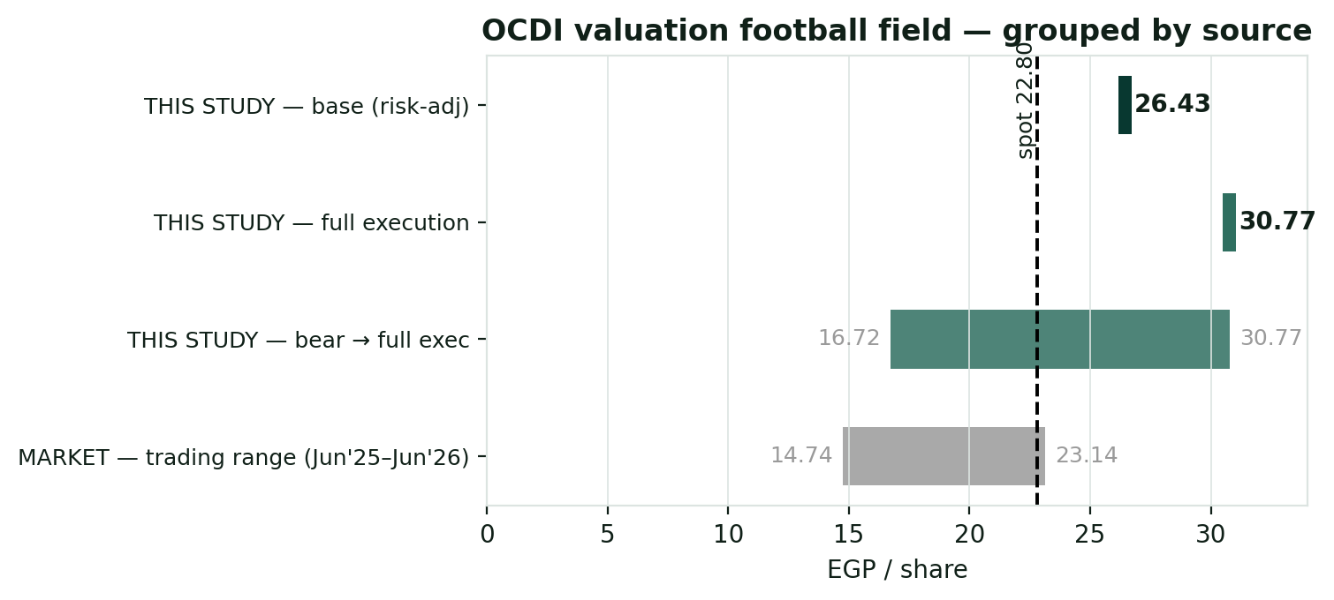
Figure 1. Fundamental range vs the market. THIS STUDY: the risk-adjusted SOTP/RNAV base of EGP 26.43 — close to the synthesised central estimate of ~EGP 27.7 — sits inside a bear-to-full-execution range of 16.72–30.77; full execution 30.77; the consolidated DCF (27.36) anchors the same middle. MARKET: the trading range (Jun’25–Jun’26, 14.74–23.14, split-adjusted) and spot 22.80 (dashed), from the attached price history. At spot the market pays for roughly the contracted business and segments and part of the development pipeline.

1.5 The three operating streams — development, hospitality, recurring
Three businesses, three methods. The base value is the sum of three businesses valued by the method that fits each: development + backlog by discounted cash flow (24.59/sh risk-adjusted, dominated by the backlog), and two operating segments capitalised on EBITDA multiples. Hospitality and recurring income are distinct — different revenue, different cyclicality, hence different multiples — and the model keeps them apart. The companion Excel carries a dedicated Segments sheet; the table below sets all three streams side by side.
Dimension | Development + backlog | Hospitality (June) | Recurring income
What it is | 8 communities sold as units — SODIC East/West, Estates, Ogami, June, Eastvale & New Sphinx JVs — plus the EGP 106bn backlog | Owned hotel at June (Marriott Tribute) and Forty West hospitality | Eastown District (EDNC) retail & offices, Portal, community retail inside the communities
Revenue driver | Units × price/m², collected over down-payment + instalments — mostly EGP | Room nights × ADR + F&B + events — partly USD-linked | Rents + footfall + service fees — mostly EGP
Cyclicality | Cyclical — launch timing, mortgage availability, FX on build cost | High — tourism, FX, seasonal (North Coast) | Low — contractual, sticky
Valuation basis | Discounted cash flow per project (SOTP) + backlog + terminal | EBITDA × 7.0× | EBITDA × 8.0× (an annuity premium)
Risk-adj EV (EGP bn) | 31.7 | 1.5 | 3.4
Contribution / share (risk-adj) | 24.59 | 1.14 | 2.64
Key fundamentals — FY2025. Revenue EGP 21.26bn (+118% YoY); gross profit EGP 7.63bn (36% margin); operating profit EGP 5.55bn (26%); net profit EGP 4.49bn (+77%); EPS EGP 3.47 (on the 1.289bn post-merger count). Gross contracted sales EGP 48.4bn (1,788 units) — among the largest in the listed sector — with the mix concentrated in East Cairo (52%, of which Eastvale alone ~EGP 21bn ≈ 44% of the total), West Cairo (21%) and the North Coast (27%, Ogami ~17%). Net cash collections EGP 20.1bn; units delivered 2,083; the contracted backlog rose to EGP 106bn (31 Dec 2025) from ~EGP 87bn a year earlier. A structural feature to read through: the reported FY2025 gross margin of 36% is well below the legacy ~56% figure — H1-2025 ran ~58% on EGP 4.8bn of revenue while H2 ran ~29% on ~EGP 16.5bn, reflecting accelerated bulk handovers, merger-related consolidation and full current-cost land loading on newer phases. The forecast anchors on the blended ~36%, not the legacy figure (the model loads full current-cost land and construction against legacy low-cost inventory, so modelled margins sit below historical reported margins). Unlike cash-rich peers, SODIC carries modest net debt (~EGP 2.5bn: cash ~4.4 vs bank debt ~6.9, after two 2025 facilities — a CIB EGP 2.45bn bridge and a Banque Misr EGP 3bn revolver), so it is more rate-sensitive than a net-cash developer. All figures are vendor-/press-sourced and should be verified against the audited accounts.

1.6 Development portfolio — project-by-project economics (derived)
This subsection expands the SOTP into its per-project building blocks. Each project is valued as the UNSOLD remainder only — already-sold units sit in the contracted backlog — from a derived unit mix (units × price/m²) and a derived cost stack (m² × construction-cost/m², plus land, except the JVs which bear no land cost), discounted at the 18.5% WACC, then weighted by an execution probability. The gross development value (GDV) shown is the preparer’s estimate of the unsold gross sales value of each community; the per-share figures are the project DCFs expressed on 1.289bn shares. Every number here is a DERIVED estimate calibrated to disclosed company totals, not a company disclosure.

Per-project value bridge — base WACC, execution-weighted (EGP)
Component | Location / note | GDV unsold (EGPbn) | Gross EV/sh | Exec prob | Risk-adj EV/sh
Contracted backlog | already sold (~EGP 106bn) | ~106.0 | 15.66 | 95% | 14.88
SODIC East | New Cairo | 31.3 | 3.01 | 85% | 2.56
New Sphinx City (JV) | West Cairo, ~55% econ. share | 29.5 | 1.61 | 55% | 0.88
Eastvale / MADA (JV) | Mostakbal, ~60% econ. share | 22.5 | 1.65 | 80% | 1.32
Ogami | North Coast | 21.9 | 1.85 | 75% | 1.39
The Estates / VYE | New Zayed | 18.2 | 1.85 | 90% | 1.67
June + Caesar | North Coast | 12.3 | 0.96 | 80% | 0.77
SODIC West & legacy | Sheikh Zayed | 6.9 | 0.53 | 92% | 0.48
Villette / Eastown | New Cairo | 4.5 | 0.43 | 88% | 0.38
Terminal value (5% g) | beyond modelled pipeline | — | 0.43 | 60% | 0.26
Development + backlog subtotal |  |  | 28.00 | — | 24.59
Hospitality segment | June / Forty West (EBITDA × 7.0×) | — | 1.63 | 70% | 1.14
Recurring-income segment | EDNC / Portal / retail (× 8.0×) | — | 3.10 | 85% | 2.64
Operating EV / share | all three businesses |  | 32.71 | — | 28.37
(–) Net debt × parent share | ~EGP 2.5bn net debt | — | (1.94) | — | (1.94)
Equity value / share | gross / risk-adjusted |  | 30.77 | — | 26.43
Derived estimates only. Development block ordered by unsold GDV. “GDV unsold” is the estimated gross sales value of the unsold remainder; backlog GDV (~EGP 106bn) is the contracted, already-sold value. The risk-adjusted column flows into the SOTP (§1.1); the gross column is the full-execution case. Reconciles to the Valuation sheet of the companion Excel.

1.7 Consolidated DCF — detailed cash-flow build and sensitivity
This subsection sets out the consolidated (whole-company) FCFF discounted cash flow underlying Method 2 in full, in the format of a standard developer DCF. SODIC is treated as one unlevered free-cash-flow stream: customer collections less construction, land, SG&A, corporate overhead and cash tax. The explicit near-term build (2026e–2030e) is shown line by line below; the model runs an explicit collection schedule to 2048 as the contracted and launched pipeline is delivered, after which a 5% perpetual-growth (Gordon) terminal value captures development beyond the modelled pipeline. The hotel and recurring segments (valued on EBITDA multiples) and net debt are then netted to reach equity value. WACC is 18.5% (nominal EGP); terminal growth 5%. Early-year FCFF is modest-to-negative because collections fund a heavy build phase — characteristic of a developer mid-cycle.

Consolidated FCFF DCF — unlevered free cash flow (EGP bn)
EGP bn | 2026e | 2027e | 2028e | 2029e | 2030e
Customer collections | 15.60 | 19.69 | 24.05 | 28.39 | 30.86
Construction spend | (12.97) | (14.07) | (15.33) | (16.09) | (16.00)
Land spend | (0.00) | (0.00) | (0.00) | (0.00) | (0.00)
SG&A | (2.08) | (2.37) | (2.56) | (2.43) | (1.47)
Corporate overhead | (0.88) | (1.19) | (1.54) | (1.89) | (2.24)
Cash tax (on EBIT) | (0.74) | (1.22) | (1.81) | (2.50) | (3.38)
Unlevered FCFF | (1.08) | 0.82 | 2.82 | 5.47 | 7.76
Discount factor @ 18.5% WACC | 0.84 | 0.71 | 0.60 | 0.51 | 0.43
PV of FCFF | (0.91) | 0.59 | 1.69 | 2.77 | 3.32
FCFF is unlevered (interest excluded; the levered cash-flow statement is in Appendix A). Collections, construction and land are the bottom-up project schedules; figures may not sum exactly due to rounding.

DCF bridge to equity value
EGP bn unless stated | Value
PV of FCFF, 2026e–2030e | 7.46
PV of FCFF, 2031e–2048e (remaining explicit period) | 23.66
PV of explicit FCFF (Σ, 2026e–2048e) | 31.12
(+) Terminal value (5% g, Gordon) | 0.55
Development enterprise value (consolidated DCF) | 31.67
(+) Hospitality segment EV (EBITDA 0.30 × 7.0×) | 2.10
(+) Recurring-income segment EV (EBITDA 0.50 × 8.0×) | 4.00
Operating enterprise value | 37.77
(–) Minority interest (negligible) | 0.00
(–) Net debt × parent share | (2.50)
Equity value (consolidated DCF) | 35.27
Shares outstanding (bn) | 1.289
VALUE PER SHARE — consolidated DCF (EGP) | 27.36
Memo: vs spot EGP 22.80 | +20%
WACC 18.5% (nominal EGP); terminal growth 5%. The consolidated DCF is the whole-company cross-check on the SOTP (§1.1). Net debt subtracted at the group figure (parent-attributable ~100%).
Sensitivity. The two dominant levers are the discount rate (WACC) and the cash-collection / pricing assumptions. The grids below recompute the value per share (gross, full-execution basis) across WACC against (i) the down-payment at contract — a proxy for collection speed — and (ii) the selling-price level. They are produced by the model engine, which re-runs the full per-project SOTP at each combination.
Sensitivity 1 — value/share, gross (EGP): WACC × down-payment at contract
WACC ↓ / DP → | 5% | 10% | 15% | 20% | 25%
16% | 33.65 | 35.82 | 38.00 | 40.17 | 42.34
18% | 29.47 | 31.69 | 33.90 | 36.12 | 38.33
20% | 26.03 | 28.26 | 30.50 | 32.74 | 34.98
22% | 23.13 | 25.38 | 27.62 | 29.87 | 32.11
24% | 20.68 | 22.92 | 25.16 | 27.40 | 29.64
Sensitivity 2 — value/share, gross (EGP): WACC × selling-price level (×)
WACC ↓ / price → | 0.85× | 0.925× | 1.00× | 1.075× | 1.15×
16% | 29.21 | 32.52 | 35.82 | 39.13 | 42.43
18% | 25.76 | 28.72 | 31.69 | 34.65 | 37.61
20% | 22.93 | 25.60 | 28.26 | 30.93 | 33.60
22% | 20.56 | 22.97 | 25.38 | 27.79 | 30.20
24% | 18.55 | 20.73 | 22.92 | 25.11 | 27.30
Base case shaded conceptually at WACC ~18.5%, down-payment 10%, price level 1.00× → ~EGP 30.77 gross. Values are gross (full-execution) per share; the risk-adjusted SOTP applies execution probabilities on top (see §1.1). Value is highly WACC-sensitive — a long-duration developer carrying net debt — from ~EGP 38 at 16% to ~EGP 25 at 24%.

2. Technical analysis
All technical inputs below are computed directly from the attached OCDI daily price history (1 Jun 2021 – 23 Jun 2026, 1,226 sessions), back-adjusted at the August-2025 statutory merger so the series is continuous across the share-count change.
Timeframe | Trend | Read
Weekly / long | Strong up | Secular bull; price rides well above a rising SMA150 (19.42) and SMA200 (18.67); successive higher highs into the 23.14 period high — trend firmly intact, ~+55% off the 52-week low
Daily | Up, extended | Price 22.80 sits above SMA5 (21.96), SMA20 (21.30) and SMA50 (21.46), all rising; RSI(14) ~62 (Wilder) is elevated but below the 70 overbought line; the advance is mature and stretched rather than fresh (+28% over three months, +6% over one)
Hourly / short | At resistance | 22.80 is within a whisker of the 23.14 period high; a clean break opens blue-sky, while failure here risks a pullback toward the 21.3 (SMA20) / 21.5 (SMA50) supports given the stretched reading

Resistance | Pivot | Support
R3 blue-sky above 23.14 (no prior trades) | spot 22.80 | S1 21.30 (SMA20)
R2 round 24.0 / fair-value zone 27 | ATR(14) 0.75 (3.3%) | S2 21.46 (SMA50) / 19.5 structure-break
R1 23.14 (period high) | range 14.74–23.14 (Jun’25–Jun’26) | S3 19.42 (SMA150) / 18.67 (SMA200)
Daily ATR(14) is EGP 0.75 (3.3% of price); realized volatility is ~41% annualized on the trailing 60 sessions (full-sample ~47%), with pronounced positive skew (+0.93) and fat tails (excess kurtosis +2.4) — all measured from the attached history. The moving-average configuration is unambiguously constructive: price sits above a rising 50-day and well above the 150-day, the hallmark of an intact uptrend. The tension is that the same tape is stretched (RSI ~62 on Wilder’s method, approaching but not at the 70 overbought line) right at the 23.14 ceiling, on a thin ~14.5% float that amplifies both directions. A daily close that holds above 23.14 confirms continuation into blue-sky; a rejection here, with RSI rolling over, would be the textbook setup for a mean-reversion pullback toward the 21.5–21.3 moving-average supports.

3. Monte Carlo simulation — one model, ten external factors
Method. One simulation, not a model zoo: 50,000 daily paths to T+60 (≈ three months), seed 42, anchored at EGP 22.80. Ten external factors drive the paths. Five are continuous (compounding daily with drift): the CBE policy-rate path, the EGP/USD rate, inflation, the EGX30/foreign-flow beta, and Brent/Gulf liquidity. Five are discrete events (each occurring with a stated probability on a random session, with a stated impact): a geopolitical/regional-security shock, JV land monetization (Eastvale/New Sphinx), project-launch execution, the North-Coast coastal-demand season, and mortgage-credit conditions. The diffusion volatility is set to SODIC’s split-adjusted, OHLC-realized annualized volatility of ~46.6% — which already embeds historical factor-driven volatility, so the continuous factors contribute forward DRIFT only (no double-counting). The factors are adapted to SODIC’s nature — net debt makes the rate channel a genuine headwind/tailwind (unlike a net-cash peer), the June hotel and North-Coast exposure make the coastal season a material lever, and the Eastvale/New Sphinx JVs replace a cross-border driver as the key idiosyncratic catalyst. Every drift, probability and impact below is an explicit, editable judgment — the table IS the model.

3.1 The ten external factors — calibration (3-month)
Factor (10 external drivers) | Type | 3M drift / prob. | Channel
1 CBE policy-rate path | continuous | +2.0% | discounting; a genuine lever given net debt
2 EGP/USD exchange rate | continuous | −2.0% | FX translation; USD hotel revenue + imported inputs
3 Inflation (CPI) | continuous | +1.5% | real-asset hedge bid; construction costs
4 EGX30 & foreign flows | continuous | +1.5% | market beta, liquidity (amplified by thin float)
5 Brent oil / Gulf liquidity | continuous | +0.5% | GCC buyer purchasing power; North-Coast demand
6 Geopolitical / regional security | event (p=30%) | −10% (±5%) | risk-premium shock
7 JV land monetization (Eastvale / New Sphinx) | event (p=30%) | +5% (±4%) | JV progress, sentiment — the dominant new driver
8 Project launch & sales execution | event (p=55%) | +6% (±4%) | SODIC East / Ogami / Eastvale — the catalyst
9 North-Coast / coastal-demand season | event (p=45%) | +5% (±5%) | June hotel & coastal sales — a material lever
10 Mortgage finance & credit | event (p=35%) | +2% (±5%) | affordability, sales velocity
Net expected 3-month factor contribution ≈ +8% before idiosyncratic noise; the live total 3-month σ ≈ 0.239 (annualized ~47.8%), matching the Step 0 calibration (PIT mean 0.56, coverage 50/81/88 at the 50/80/90% bands). The continuous factors compound daily; the event factors arrive as discrete jumps on a random session within the window.

3.2 Percentile estimates (anchor 22.80, 50,000 paths)
Horizon | 5% | 25% | Median | 75% | 95%
T+20 (~1 month) — engine | 18.31 | 21.08 | 23.21 | 25.56 | 29.35
T+60 (~3 months) — engine | 16.08 | 20.38 | 24.03 | 28.30 | 35.79
T+60 — live (closed form) | 16.71 | 21.07 | 24.76 | 29.09 | 36.69
The T+60 distribution is right-skewed: median ~24.0, with the launch and JV/coastal events carrying the upside shoulder and the geopolitical jump the left tail. Live-vs-engine T+60 median reconciliation is EGP 0.73 (the events skew the simulated median modestly below the closed form). Note these paths diffuse from spot and do not embed the fundamental NAV — they describe near-term price, not value; the risk-adjusted NAV (26.43) sits at the upper edge of the three-month cone.

3.3 Forward cone — percentile cone to T+60
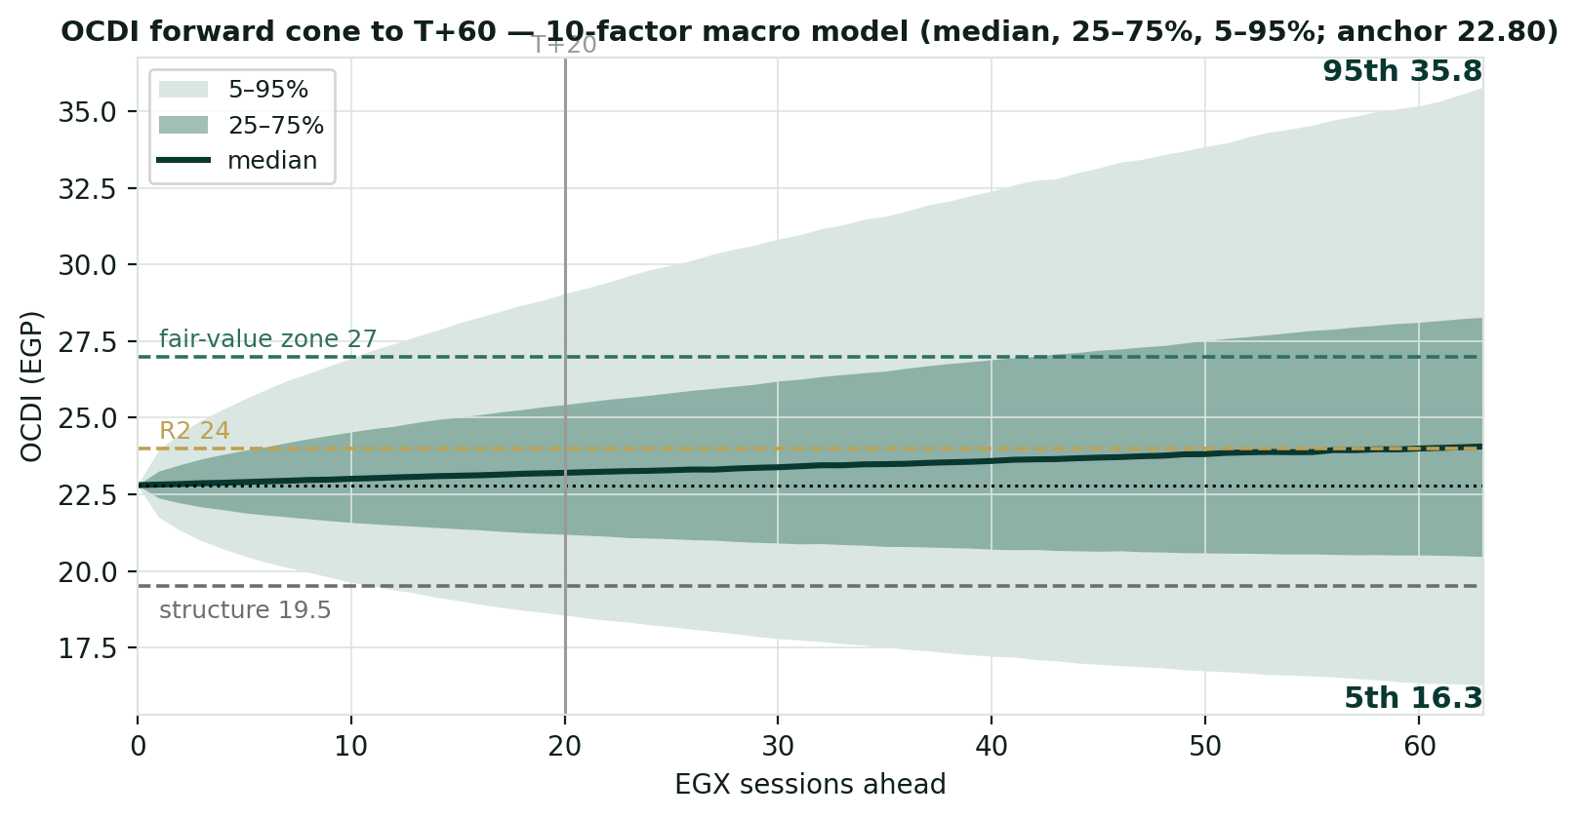
Figure 2. Forward cone (median, 25–75%, 5–95%) from the 10-factor model. The median drifts to ~23.2 by T+20 and ~24.0 by T+60; the 5–95% band spans ~18.3–29.4 at one month and ~16.1–35.8 at three. Dashed reference levels: fair-value zone 27, R2 24, structure-break 19.5; dotted: spot 22.80; vertical mark at T+20.

3.4 Probability bell curves at T+20 and T+60
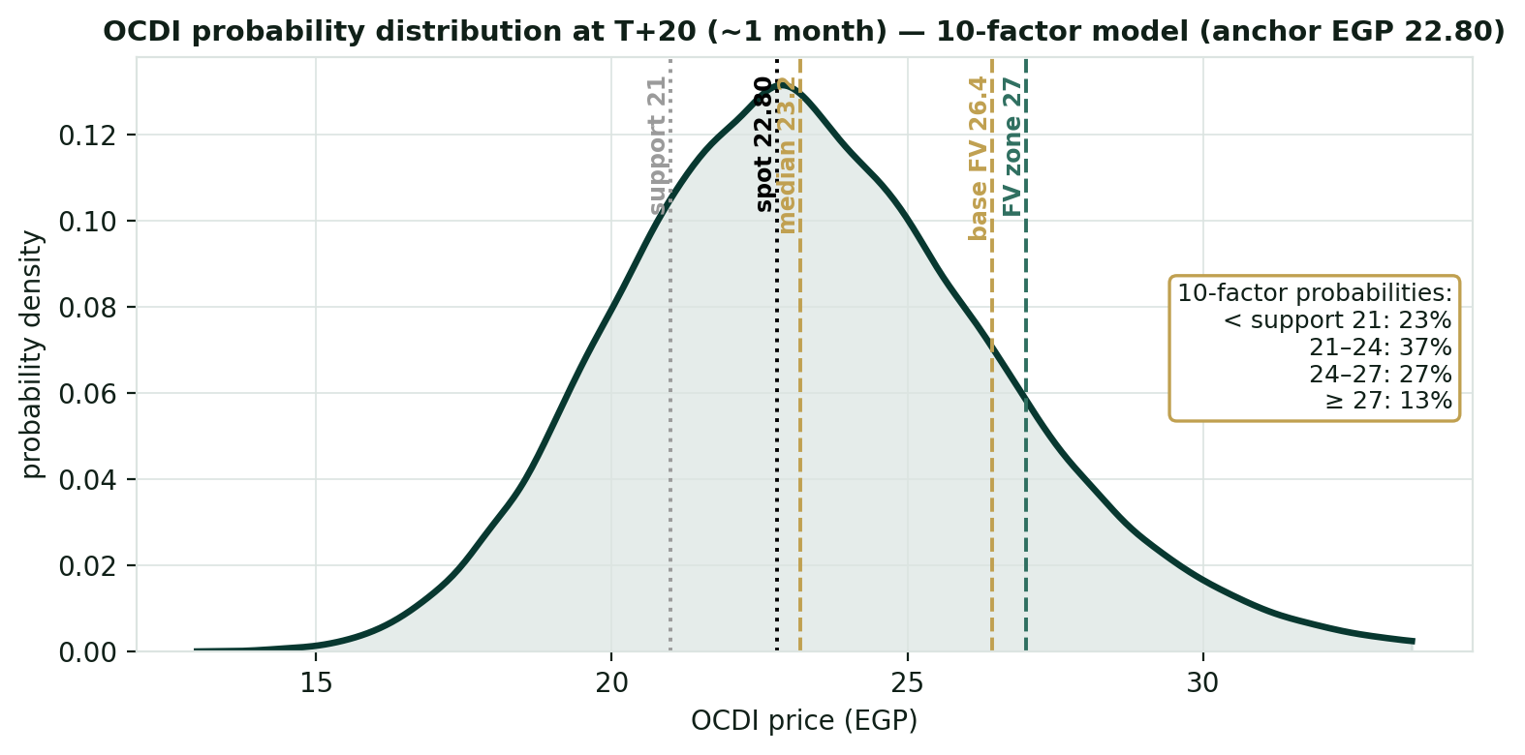
Figure 3. T+20 distribution (10-factor model): the body sits around spot, with ~29% below the 21 support, the bulk in 21–25, and a thin tail above the 27 fair-value zone (largely out of reach on a one-month horizon).
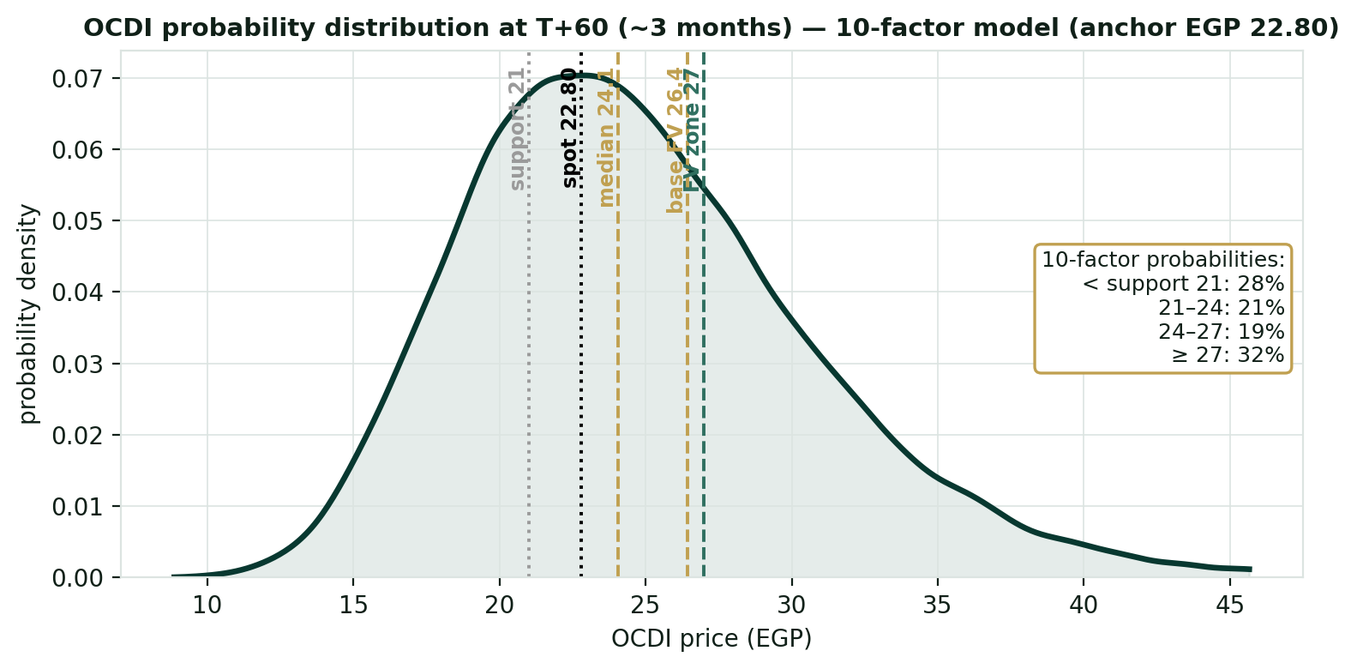
Figure 4. T+60 distribution (10-factor model). The three-month view fans out and skews right — median ~24.0, with ~32% of paths finishing above the 27 fair-value zone while ~29% still finish below the 21 support. This is where the catalyst factors pay; the geopolitical jump keeps the left tail honest. The risk-adjusted NAV (26.43) sits at the upper edge of the cone.

3.5 Level-touch probabilities
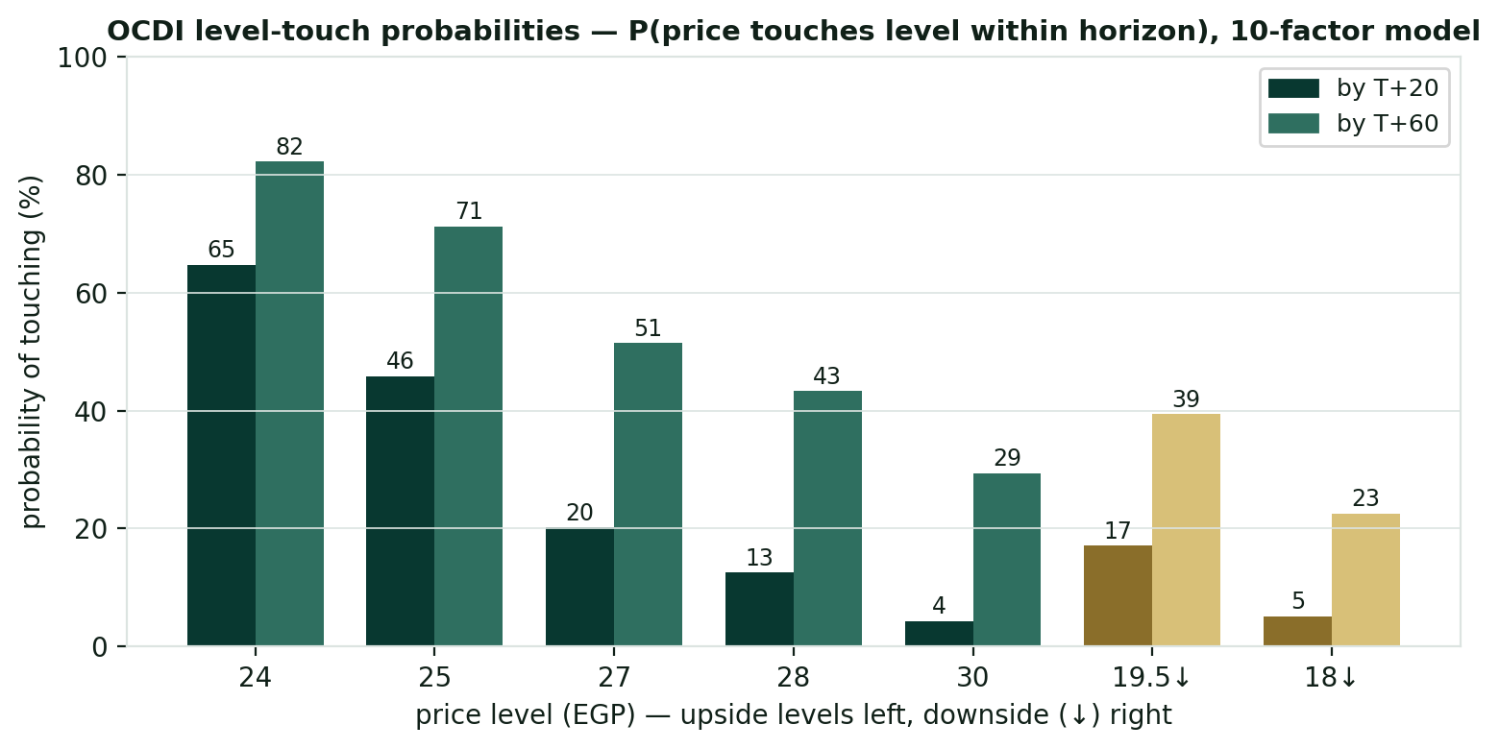
Figure 5. Level-touch probabilities (10-factor model) — probability of the price touching each level within each horizon (T+20 / T+60): upside 24 = 66%/82%, 25 = 48%/72%, 27 = 22%/52%, 28 = 14%/44%, 30 = 5%/30%; downside 19.5 = 19%/41%, 18 = 6%/24%. A descriptive output of the simulation: how often paths reach each level, nothing more.
Price level (EGP) | Touch by T+20 | Touch by T+60
24 (round / R2) | 66% | 82%
25 | 48% | 72%
27 (fair-value zone) | 22% | 52%
28 | 14% | 44%
30 | 5% | 30%
19.5 (structure-break, downside) | 19% | 41%
18 (downside) | 6% | 24%

4. Comparison — fundamental vs technical vs Monte Carlo
Lens | Core output | What it says | Analytical implication
Fundamental | Risk-adj EGP 26.43; full execution 30.77; central ~27.7; bear floor ~16.7 | Risk-adjusted value ~16% above market; the bear floor sits ~27% BELOW price | Modelled value sits above price, but the floor-below-market result means the case is execution-driven (backlog, JV ramp, margins), not a discount-to-cash anomaly
Technical | Strong uptrend, stretched; price at the 23.14 ceiling above a rising MA stack; RSI ~62 (Wilder) | A mature, intact advance that is stretched right at resistance on a thin float | Momentum favours continuation only on a clean break of 23.14; from these stretched levels, rejection risks a pullback to 21.5–21.3
Monte Carlo (10-factor) | T+20 median 23.2 (~29% finish below 21); T+60 median 24.0 (~32% finish ≥ 27) | One month is two-sided around spot; three months skew right as the launch and JV/coastal events pay | Time favours the right tail, but the NAV is at the upper edge of the three-month cone — value realization is a multi-quarter story
Verdict: the three lenses tell one story on different clocks — the fundamental value sits ~16–22% above price (risk-adjusted to central), the tape is in a strong but stretched uptrend pinned at the 23.14 ceiling, and the three-month distribution skews right on launch execution and the JV/coastal catalysts while leaving the full NAV at the very edge of the quarter. The contrast with a cash-rich developer is instructive: SODIC is NOT priced below its balance sheet — it carries net debt, and the market already ascribes partial value to the pipeline, so the gap to fair value is a re-rating-and-execution story, not a mispricing of net cash. The fundamental case and the secular uptrend point the same way; the Monte Carlo simply says the next month is two-sided and stretched while the quarter can pay if the JV launches and backlog deliveries land. What, if anything, follows for any individual depends on circumstances this study does not know and does not address.

5. Catalyst calendar
Catalyst | Date | In window | Read
CBE MPC | Jul 2026 | within T+20 | The CBE has cut sharply since 2025 then paused amid regional-conflict inflation risk; further cuts re-rate SODIC’s long-duration cash flows and ease its net-debt carry — a genuine lever, unlike for net-cash peers
North-Coast summer season | Jun–Aug 2026 | in window | Peak Ogami / June resort sales and June-hotel occupancy — a pivotal seasonal lever (event p = 45%)
Eastvale & New Sphinx JV progress | 2026 | in window | Sales velocity on the two revenue-share JVs; Eastvale (~EGP 21bn contracted in 2025) is the largest single swing factor in the pipeline and a modelled event (launch p = 55%, JV p = 30%)
Q2 results (backlog → revenue) | ~mid-Aug | T+60 | Revenue-recognition story as the EGP 106bn backlog converts; watch whether the FY2025 36% gross margin stabilizes or normalizes upward
Backlog delivery cadence | 2026–2028 | partly | On-schedule delivery and collection of the contracted book underpins ~EGP 15/share of risk-adjusted value — the core of the thesis

6. Reading the probabilities — significant zones (analysis, not guidance)
This section translates the simulation into the price zones where the three lenses say something analytically distinct. It is a map of the distribution — not a plan, not guidance, and not calibrated to any reader’s circumstances.
- 22.80–23.14 — the ceiling test. Spot sits a whisker below the 23.14 period high; above it is blue-sky with no prior trading. 66% of simulated paths touch 24.0 within one month (82% within three), so the round-number break is well within reach — but the move is occurring from an elevated RSI of ~62 (just below the 70 overbought line).
- 24.0–27.0 — the re-rating zone. The event factors (launch p = 55%, JV/coastal) place most of the right tail here; 48%/72% of paths touch 25 and 22%/52% touch 27 (T+20/T+60). This band is where the modest discount to NAV begins to close if execution lands.
- 27.0–36.0 — the upper-distribution / NAV zone. Only 14%/44% of paths touch 28 and 5%/30% touch 30 within the horizons — effectively the upper reach of the three-month cone. The risk-adjusted NAV (26.43) sits at the lower edge of this band; full-execution NAV (30.77) is reached only on strong execution within the quarter.
- 21 / 19.5 / 18.7 — the structural-floor zone. Below the 21 support the extended advance is in question (downside touch of 19.5 ≈ 19% by T+20, 41% by T+60); below ~18.7 (SMA200) the secular uptrend itself would be challenged (touch of 18 ≈ 6%/24%). These are the levels at which the market would price SODIC at or below the model’s risk-weighted floor (~16.7).

7. Caveats
- The project-level inputs are estimates, not disclosure — this is the assumption that moves the number most. SODIC publishes no project-by-project economics. The unit mixes, sold-percentages, buildable ratios, prices and construction costs per m², the segment EBITDA (~EGP 0.30bn hospitality, ~EGP 0.50bn recurring) and the backlog (~EGP 106bn) are all the preparer’s estimates, calibrated only to reproduce disclosed company-level totals. They are illustrative; audited segment notes or a project disclosure would materially reshape the SOTP.
- JV economics are modelled, not disclosed. New Sphinx (Rula) and Eastvale/MADA (MIDAR) are carried as revenue shares at SODIC economic shares of ~55% and ~60% with zero land cost; the actual splits are undisclosed and drive these projects’ high apparent margins. Eastvale is the single largest new value driver, so its terms matter disproportionately.
- The opening balance sheet is derived. The FY2025 balance-sheet composition (inventory ~60, other assets ~25.5, payables ~2.0, plug ~1.0) is derived to tie to disclosed totals (assets ~89.9 = liabilities ~49.9 + equity ~40); the FY2024 balance sheet is not pinned. Pin the exact 31 Dec 2025 bank-debt and net-debt figure from the audited statement before relying on the SOTP bridge.
- Margins are normalized below history. Forecast gross margins (~36–42%) sit below the legacy ~56% because the model loads full current-cost land and construction against legacy low-cost inventory; the FY2025 blended 36% (with a ~58% H1 / ~29% H2 split) is the anchor, and reported vs modelled margins are not directly comparable.
- Bottom-up valuation is assumption-driven. WACC 18.5%, each project’s sold/unsold split, the JV economic shares, ~14% price escalation, the normalized terminal FCFF, and the hotel/recurring EBITDA and exit multiples are all judgments calibrated to disclosed totals, not audited project-level data. As a long-duration developer carrying net debt, the value is highly WACC-sensitive. Illustrative ranges, not precision.
- Thin free float amplifies everything. With ~85.5% held by the Aldar/ADQ consortium, only ~14.5% floats; liquidity is limited and the price can move sharply on modest flow, which also inflates realized volatility relative to the underlying business.
- Monte Carlo factors are independent. No cross-correlation matrix or volatility clustering (rate cuts and FX moves are in reality linked); each factor’s drift, probability and impact is judgment, not estimation; event timing within the window is uniform-random. The three-month price distribution should not be conflated with the fundamental value. Technical inputs are computed from the attached vendor price history and not reconciled to exchange tick data.
Momentum-reading note (educational). A standard divergence read: price rising while RSI stalls or falls under its moving average is the classic bearish-divergence configuration — momentum fading into strength. Price and RSI rising together marks a healthy trend; an elevated RSI (here ~62 on Wilder’s method, below the classic 70 overbought line) in an uptrend is not itself a sell signal but flags a tape vulnerable to mean-reversion if price is rejected at resistance. On the downside, price falling while RSI rises flags seller exhaustion. These are descriptive patterns for reading momentum, not signals to act on.

Appendix A — Summary financial statements
Reported actuals (FY2024–FY2025) are SODIC press-release / vendor-sourced and should be verified against the audited accounts; FY2023 revenue (~EGP 10.3bn) and net income (~EGP 1.4bn) are aggregator-derived and shown for context only. The forecast (2026e–2030e) is the study’s independent bottom-up model, shown over the near-term five-year horizon only — consistent with developer-valuation practice, a multi-decade accrual balance sheet is not projected (the valuation rests on project cash flows and asset values, §1). Two things to read through: (i) FY2025 spans the August-2025 statutory merger, so EPS/BVPS are on the 1.289bn post-merger count and intermediate income-statement lines (COGS, SG&A, interest, tax) are derived from disclosed Revenue/GP/OP/NI; and (ii) the forecast loads full land and construction cost into COGS, so reported and modelled gross margins are not directly comparable.

Summary income statement (EGP bn)
EGP bn | FY2024a | FY2025a | 2026e | 2027e | 2028e | 2029e | 2030e
Revenue | 9.75 | 21.26 | 17.67 | 23.76 | 30.71 | 37.89 | 44.87
growth (YoY) | — | +118% | −17% | +34% | +29% | +23% | +18%
Cost of revenue / COGS | (4.27) | (13.63) | (11.31) | (14.61) | (18.38) | (22.21) | (25.84)
Gross profit | 5.48 | 7.63 | 6.36 | 9.15 | 12.33 | 15.68 | 19.03
gross margin | 56% | 36% | 36% | 39% | 40% | 41% | 42%
SG&A | (2.18) | (1.95) | (2.08) | (2.37) | (2.56) | (2.43) | (1.47)
Corporate overhead | — | — | (0.88) | (1.19) | (1.54) | (1.89) | (2.24)
EBITDA | 3.30 | 5.68 | 3.39 | 5.59 | 8.23 | 11.35 | 15.31
EBITDA margin | 34% | 27% | 19% | 24% | 27% | 30% | 34%
D&A | (0.06) | (0.13) | (0.11) | (0.14) | (0.18) | (0.23) | (0.27)
EBIT | 3.24 | 5.55 | 3.29 | 5.44 | 8.05 | 11.13 | 15.04
Net interest & investment income | 0.03 | 0.24 | (1.38) | (1.55) | (1.65) | (1.38) | (0.55)
Profit before tax | 3.26 | 5.79 | 1.91 | 3.89 | 6.39 | 9.74 | 14.49
Tax | (0.73) | (1.30) | (0.43) | (0.88) | (1.44) | (2.19) | (3.26)
Net income (consolidated) | 2.53 | 4.49 | 1.48 | 3.02 | 4.96 | 7.55 | 11.23
EPS (EGP) | 1.96 | 3.47 | 1.15 | 2.34 | 3.84 | 5.86 | 8.71
Actuals: intermediate lines (COGS, SG&A, interest, tax) are derived from disclosed Revenue/GP/OP/NI; verify vs audited. Forecast is an operating build; 2026e interest reflects the net-debt carry and revolver. EPS forecast on 1.289bn shares. Reported vs modelled gross margins are not directly comparable (the forecast loads full land + construction into COGS).

Summary balance sheet (EGP bn)
EGP bn | FY2025a | 2026e | 2027e | 2028e | 2029e | 2030e
Cash & equivalents | 4.4 | 3.0 | 3.0 | 3.0 | 3.0 | 7.3
Receivables (on-balance-sheet) | 9.1 | — | — | — | — | —
Inventory (development properties) | 60.0 | 61.7 | 61.1 | 58.1 | 51.9 | 42.1
Other assets (PP&E, inv. property, other) | 16.4 | 25.5 | 25.5 | 25.5 | 25.5 | 25.5
Total assets | 89.9 | 90.2 | 89.6 | 86.6 | 80.5 | 74.9
Bank debt (current + long-term) | 6.9 | 7.8 | 8.3 | 6.9 | 2.8 | 0.0
Customer advances / contract liabilities | 40.0 | 37.9 | 33.9 | 27.2 | 17.7 | 3.7
Payables & other liabilities | 3.0 | 3.0 | 3.0 | 3.0 | 3.0 | 3.0
Total liabilities | 49.9 | 48.7 | 45.1 | 37.1 | 23.5 | 6.7
Total equity | 40.0 | 41.5 | 44.5 | 49.5 | 57.0 | 68.2
Total liabilities & equity | 89.9 | 90.2 | 89.6 | 86.6 | 80.5 | 74.9
Memo: net cash / (debt) | (2.5) | (4.8) | (5.3) | (3.9) | 0.3 | 7.3
Memo: BVPS (EGP) | 31.03 | 32.17 | 34.51 | 38.36 | 44.21 | 52.92
The forecast balance sheet is a simplified developer balance sheet calibrated to disclosed FY2025 totals (assets/liabilities/equity, net debt). Fixed plugs hold non-core items flat (other assets, payables), so it does not continue the audited line-item detail and will not tie line-by-line to the reported balance sheet. Net debt repays to a net-cash position by 2029e on the modelled delivery. FY2024 balance sheet not pinned. BVPS on 1.289bn shares. Off-balance-sheet: ~EGP 72bn instalment receivables on undelivered units and the ~EGP 106bn backlog are not on the accrual balance sheet — they drive the valuation.

Summary cash flow statement (EGP bn)
EGP bn | 2026e | 2027e | 2028e | 2029e | 2030e
Collections from customers | 15.60 | 19.69 | 24.05 | 28.39 | 30.86
Construction + land spend | (12.97) | (14.07) | (15.33) | (16.09) | (16.00)
SG&A + corporate overhead | (2.96) | (3.56) | (4.10) | (4.32) | (3.71)
Tax + interest paid | (1.81) | (2.43) | (3.09) | (3.57) | (3.81)
Operating cash flow | (2.15) | (0.38) | 1.53 | 4.40 | 7.33
Investing cash flow (capex) | (0.11) | (0.14) | (0.18) | (0.23) | (0.27)
Financing cash flow (debt draw / repay) | 0.85 | 0.52 | (1.35) | (4.17) | (2.75)
Net change in cash | (1.40) | 0.00 | 0.00 | 0.00 | 4.31
Memo: free cash flow (OCF + capex) | (2.26) | (0.52) | 1.35 | 4.17 | 7.06
Forecast operating cash flow is levered (after interest); the consolidated DCF (§1.7) uses unlevered FCFF, which excludes interest. Financing reflects the revolver draw in 2026e–27e and repayment from 2028e; dividends are not separately modelled. Reported memo: net cash collections FY2024 ~EGP 15bn, FY2025 EGP 20.1bn — the full audited cash-flow statement was not pulled; pin OCF/ICF/FCF from audited.

Appendix B — Per-share data and key ratios
Valuation multiples are shown at the 23 Jun 2026 price of EGP 22.80 and the 1.289bn post-merger share count (forward-looking), in the manner of a standard data sheet. FY2024 balance-sheet measures (BVPS, P/B, ROE) are not meaningful (“n/m”) because the FY2024 balance sheet is not pinned; earnings multiples are shown for both actual years.

Per-share data & valuation metrics (at EGP 22.80)
EGP bn unless stated | FY2024a | FY2025a | 2026e | 2027e | 2028e | 2029e | 2030e
Net income (consolidated) | 2.53 | 4.49 | 1.48 | 3.02 | 4.96 | 7.55 | 11.23
EPS (EGP) | 1.96 | 3.47 | 1.15 | 2.34 | 3.84 | 5.86 | 8.71
BVPS (EGP) | n/m | 31.03 | 32.17 | 34.51 | 38.36 | 44.21 | 52.92
Net cash / (debt) per share (EGP) | n/m | (1.94) | (3.69) | (4.09) | (3.04) | 0.19 | 5.67
P/E (×) | 11.6× | 6.6× | 19.9× | 9.7× | 5.9× | 3.9× | 2.6×
P/B (×) | n/m | 0.73× | 0.71× | 0.66× | 0.59× | 0.52× | 0.43×
EV / EBITDA (×) | n/m | 5.6× | 10.1× | 6.2× | 4.1× | 2.6× | 1.4×
ROE (%) | n/m | 11.2% | 3.6% | 7.0% | 10.6% | 14.2% | 17.9%
Net margin (%) | 26.0% | 21.1% | 8.4% | 12.7% | 16.2% | 19.9% | 25.0%
P/E, P/B, EV/EBITDA at EGP 22.80 and market cap ~EGP 29.4bn (constant) — forward-looking. EV = market cap + net debt. ROE = net income / average equity. SODIC trades below book (P/B 0.73×) — a developer-sector characteristic, sharpened by the post-merger equity base. Dividends per share not modelled. Illustrative, not company guidance.

Appendix C — Sector multiples, peer context and key investment risks

C.1 Sector and peer context
Method 3 (§1.3) anchors the relative lenses to the EGX real-estate sector. As of early 2026 the listed Egyptian real-estate sector traded at roughly 8.9× trailing earnings (above its ~8.1× three-year average) and ~1.9× sales, with sector earnings forecast to grow ~18% annually — corroborating the 8–11× P/E and ~1.9× sales fair-range bands used in the study (source: Simply Wall St / EGX sector data, 2026; verify live before use).

OCDI vs EGX real-estate sector — multiples
Metric | OCDI (at EGP 22.80) | EGX real-estate sector
Price / earnings (ttm) | ~6.6× (FY2025) | ~8.9× (3-yr avg ~8.1×)
Price / sales | ~1.4× | ~1.9×
Price / book | 0.73× (below book) | ~1.0–1.2×
Forward earnings growth | backlog + JV ramp (operating) | ~18% p.a. (sector forecast)
SODIC screens cheap on both earnings (single-digit trailing P/E) and book (0.73×) — appropriate for a developer whose reported revenue and earnings understate a ~EGP 106bn backlog and a large land bank, which is precisely why an RNAV/SOTP lens, not a sales or earnings multiple, is the appropriate primary method (§1.1). Sector data: Simply Wall St / EGX, 2026. Per-name peer multiples were not independently sourced for this edition; verify against live quotes before any use.
Operational peer positioning. By contracted sales, SODIC is among the largest listed Egyptian developers in a sector the consultants describe as entering a “healthy correction” (top-10 contracted sales declining year-on-year), with demand concentrating among large, well-capitalised names. Periods below are not strictly like-for-like (Q1-2026 peers vs SODIC FY2025) — for scale context only.

EGX developers — contracted sales (EGP bn)
Developer | Contracted sales | Period / note
Talaat Moustafa Group (TMG) | 49.1 | Q1-2026; largest listed developer by sales / land bank
SODIC (OCDI) | 48.4 | FY2025 full year
Tatweer Misr | 43.8 | Q1-2026; Ain Sokhna momentum
Emaar Misr (EMFD) | 35.6 | Q1-2026; net-cash balance sheet
Hyde Park Developments | 25.3 | Q1-2026; steady execution
Source: The Board Consulting / Daily News Egypt, 2026 reviews. Contracted sales are an operating metric, not a valuation input; SODIC’s EGP 48.4bn is gross contracted sales for FY2025, distinct from the ~EGP 106bn cumulative backlog used in the SOTP.

C.2 Key investment risks
The study’s Caveats (§7) discuss the assumptions that move the number most. The structured table below sets the principal upside and downside risks side by side, in the manner of a standard research risk section.
Direction | Risk | Description
Upside | Project-launch execution | SODIC East, Ogami and especially the Eastvale launch/absorption are the largest single upside factor (Monte Carlo launch p = 55%); successful execution begins to close the discount to NAV.
Upside | Eastvale / New Sphinx JV ramp | Two revenue-share JVs at SODIC’s economic share; Eastvale contributed ~EGP 21bn of 2025 contracted sales — the dominant new value driver and a material right-tail catalyst (event p = 30%).
Upside | North-Coast / coastal-demand season | Peak Ogami / June resort sales and June-hotel occupancy (event p = 45%) — a pivotal seasonal lever for a developer with owned hospitality and North-Coast exposure.
Upside | Backlog conversion / NAV re-rating | ~EGP 106bn backlog converting to revenue at low execution risk; narrowing of the ~14–26% discount to NAV toward sector norms — the core of the thesis.
Upside | Rate cuts / real-asset hedge | EGP-priced inventory re-rates with inflation; CBE rate cuts re-rate the long-duration cash flows and ease the net-debt carry — a genuine tailwind given SODIC’s leverage.
Downside | Derived-input risk (largest) | Project economics, segment EBITDA and the backlog are the preparer’s estimates, not disclosure; audited segment/JV data could materially reshape the SOTP.
Downside | JV economics undisclosed | The economic shares on New Sphinx (Rula) and Eastvale (MIDAR) are modelled; less-favourable splits would cut the two largest new contributors.
Downside | Net debt / rate sensitivity | Unlike net-cash peers, SODIC carries ~EGP 2.5bn net debt and a long-duration cash-flow profile, so it is more exposed to higher-for-longer rates and EGP weakness on build costs.
Downside | Margin normalization | Whether the FY2025 36% gross margin holds, recovers, or compresses further — the H1/H2 split (58%/29%) shows how lumpy recognition can be.
Downside | Thin free float (~14.5%) | Limited liquidity; the price can move sharply on modest flow, which also inflates realized volatility relative to the underlying business.
Downside | Macro / geopolitical shocks | Regional-security shock (event p = 30%), EGP depreciation, and the CBE rate path; mortgage-credit conditions affect affordability and sales velocity.
Downside | Momentum reversal | The stock is extended near its 52-week high (RSI ~62); a rejection at the 23.14 ceiling risks a mean-reversion pullback toward the 21.5–21.3 moving-average supports.
Risk descriptions synthesise the study’s Caveats (§7) with developer-sector factors; Monte Carlo probabilities are the study’s editable judgments (§3.1). Not exhaustive, and not calibrated to any reader’s circumstances.

Appendix — About this series: the standing format
Every instrument analysed in this educational series follows the same standing format, in order:
- Headline — the analytical read, timeframe and key numbers, one paragraph.
- 1. Fundamental analysis — DCF + multiples + NAV/SOTP (per-project for developers; EBITDA-multiple segments where diversified) → football field → fair-value range.
- 2. Technical analysis — weekly/daily/hourly trend, levels table, ATR/volatility.
- 3. Monte Carlo simulation — ONE model: ten external macro factors, 50,000 paths; factor table + percentile table + forward cone + bell curves (T+20/T+60) + level-touch probabilities.
- 4. Comparison — fundamental vs technical vs Monte Carlo — one table reconciling the three lenses + a verdict: where they agree, where they differ, and on what clock.
- 5. Catalyst calendar · 6. Probability map · 7. Caveats + momentum note · closing Disclosure & Disclaimer.
Each forecast is logged to an append-only calibration ledger so the methodology can be scored over time.

Disclosure & Disclaimer — read in full
Nature of this document. This study is an educational valuation exercise and an expression of the preparer’s personal analytical opinion, based exclusively on publicly available information and on assumptions stated in the text and the accompanying model. It is published free of charge, on a standing periodic schedule, to demonstrate methodology and to invite scrutiny and critique of that methodology.
No advice, no recommendation, no solicitation. Nothing in this document constitutes investment advice, financial consultancy, securities analysis services, a research recommendation, a rating, a price target, an offer, or a solicitation or invitation to buy, sell, hold, subscribe for or otherwise deal in any security or financial instrument. No statement herein is directed at, or calibrated to, the investment objectives, financial situation, risk tolerance or particular needs of any person.
No licensed activity. The preparer is not licensed or registered with the Egyptian Financial Regulatory Authority (FRA) or any other securities regulator; does not carry on financial consultancy, securities evaluation or analysis services, portfolio management, brokerage, promotion or any other regulated activity; does not manage money; and does not accept clients, fees, subscriptions or funds of any kind.
Publication independence. This study was prepared and published independently, on a pre-set schedule, and is not intended to — and must not be used to — influence the market price of any security.
Estimates and uncertainty. All valuations, scenarios, probabilities and levels are model outputs resting on explicit, subjective assumptions; they are illustrative, highly uncertain, and likely to prove wrong in material respects. In particular, the project-level inputs underlying the valuation are the preparer’s estimates, not company disclosure. They are deliberately presented as ranges and distributions because no single number should be relied on. Public and vendor-sourced data are believed reliable but are not guaranteed; vendor-derived figures are flagged as such where used.
No liability. To the maximum extent permitted by applicable law, the preparer accepts no liability or responsibility whatsoever for any decision made or action taken or not taken, or for any loss or damage of any kind incurred, by any person in reliance on, or in connection with, any part of this document or the accompanying model.
Reader’s responsibility. Any person considering an investment decision should conduct their own independent assessment and consult a financial advisor licensed in their jurisdiction. If the publication of material of this kind is restricted where you are reading it, do not rely on it.
Holdings disclosure. The preparer may hold, and may in the future take or dispose of, a position in the security discussed in this report.
24 June 2026

