Independent Valuation Study — Educational Analysis
Orascom Investment Holding S.A.E. (EGX: OIH)
Fundamental analysis · Technical analysis · Monte Carlo simulation — one integrated read
Anchor: EGP 1.41 (01 Jul 2026 close) · 5,245.69m shares · mkt cap ~EGP 7.40bn (~US$151m at EGP/USD 49.09) · the Sawiris-family listed holding company, whose crown asset is the Giza Pyramids plateau visitor-services concession (Orascom Pyramids Entertainment + the Sound & Light show), sitting beside ~US$114m of cash trapped in North Korea, the 60% Koryolink associate, the Lighthouse Energy renewables fund and an interest-free EUR/USD loan owed back to Koryolink · prices and probabilities computed 01 Jul 2026 from the attached daily history · primary lens: holding-company NAV with the concession valued by DCF · the OPE platform value and the DPRK cash/loan pair are the swing factors.
READ FIRST — what this document is, and is not. This study is a valuation exercise and an expression of personal analytical opinion, published free of charge for educational purposes: it shows how one analyst applies fundamental, technical and probabilistic methods to a listed company, and invites scrutiny of that methodology. It is NOT investment advice, NOT a recommendation or solicitation to buy, sell or hold any security, and NOT directed at the circumstances of any reader. The preparer is not licensed by the Egyptian Financial Regulatory Authority or any other securities regulator in any jurisdiction, holds no brokerage authorisation, provides no financial consultancy, manages no money, and accepts no fees, funds or clients. See the Disclosure & Disclaimer at the end. All values are model outputs presented as ranges and distributions because no single number should be relied on. Reported financials are the company’s own disclosure (IFRS consolidated statements FY2023 and FY2024, audited by KPMG Luxembourg with a qualified opinion; EAS quarterly filings through 9M-2025); forward-looking inputs — the mark on the Pyramids platform, the DPRK recovery assumptions, the holdco discount, the multiples, the DCF and the Monte-Carlo factor probabilities — are the preparer’s judgments and are flagged throughout. A note on the audit: the auditor was unable to verify the recoverability of the North Korean cash and the Koryolink stake; those balances are carried at management’s estimates and this study treats that uncertainty explicitly rather than hiding it. Consult a licensed financial advisor before any investment decision.

Headline
The model’s read: the market has already paid for the Pyramids — the price sits far above what the audited books can support, and the case for EGP 1.41 is a bull case, not a base case. At EGP 1.41 the shares trade roughly 80% above our weighted central estimate of EGP 0.78. The primary lens — a holding-company NAV that marks every asset at its audited carrying value and puts a DCF on the plateau concession — lands at EGP 0.81 after a 15% holdco discount; a consolidated DCF that charges central costs against the operating business is stricter at EGP 0.48; a peer P/NAV read gives EGP 0.72; and only a normalized-earnings view of the concession at maturity (EGP 1.03) approaches the tape. The gap is not a mystery: the market is paying today for three things the accountable NAV does not yet contain — the Pyramids platform at maturity rather than at its ramp-stage DCF, some recovery of the US$114m trapped in North Korea beyond the 50% the auditors allow, and the Sawiris platform premium that Egyptian retail money habitually awards this counter. Technically the stock is the mirror image of TMPV’s setup: a 74% one-year advance consolidating just under the 50-day average with RSI at 62 — the tape is strong precisely where the fundamentals are stretched. Over three months the Monte Carlo — whose drift is the tape’s own validated secular trend, never the §1 value gap — places the 50% band at EGP 1.36–1.80 with a median of 1.57.
Valuation summary — every read at a glance
One table for the four reads that follow — what the business is worth (fundamental), what the tape is doing (technical), where price could travel over three months (Monte Carlo), and how three independent expert methods land. Every row is developed in the sections and appendices below.
Lens / read | What it measures | Output | Takeaway
FUNDAMENTAL — what the business is worth (the anchor)
Holdco NAV (primary) | Marked assets + OPE DCF, less 15% discount | EGP 0.81 | −42% vs spot
Consolidated DCF | FCFF of the operating business + financial assets | EGP 0.48 | −66% · the floor
Relative (P/NAV) | Peer holdco multiple on pre-discount NAV | EGP 0.72 | −49%
Normalized earnings | Concession at maturity × justified P/E | EGP 1.03 | −27% · the ceiling
Weighted central | Blend 45 / 20 / 15 / 20 | EGP 0.78 | −45% vs EGP 1.41
TECHNICAL — what the tape is doing (timing, not value)
Trend & momentum | Price vs the 20/50/100/200-day averages | Above 3 of 4 | Uptrend, consolidating
Momentum / range | RSI · MACD · 52-week range | RSI 62 · MACD ≈ 0 · 0.80–1.58 | Upper quarter of range
MONTE CARLO — where price could go in 3 months (paths from spot)
T+20 sessions | 50,000 paths · 16 factors | p5 1.18 · p50 1.46 · p95 1.80 | Median above spot
T+60 sessions | same engine, longer horizon | p5 1.09 · p50 1.57 · p95 2.23 | Wide, right-skewed
EXPERT PANEL — three independent methods (Appendix D)
Expert 1 — NAV & the holdco discount | Marked parts less discount | EGP 0.81 | The anchor
Expert 2 — forensic accountant | Audited equity, unverifiable marks struck | EGP 0.37 | Most bearish
Expert 3 — macro-policy scenarios | FX × tourism × flows scenario tree | EGP 1.18 | Closest to the tape

Company overview — Orascom Investment Holding at a glance
Item | Value
Listing | EGX: OIH (ISIN EGS693V1C014); GDRs on the LSE (US68555D2062)
Shares outstanding | 5,245,690,620 · paid-in capital EGP 577.0m (par EGP 0.11)
Market cap | ~EGP 7.40bn (~US$151m) at EGP 1.41
Parent | Orascom TMT Investments S.à r.l. — the Sawiris family vehicle; Naguib Sawiris executive chairman
What it is | A holding company: destination entertainment (Giza plateau), a DPRK telecom legacy, a renewables PE fund, legacy property
Crown asset | Orascom Pyramids Entertainment + Sound & Light: visitor services at the Giza Pyramids under a 2018 protocol with the Supreme Council of Antiquities; strict 50-50 revenue share with the state
DPRK block | ~US$114m cash inside North Korea (50% ECL) · 60% of Koryolink, equity-accounted, profits recognized then fully impaired · US$90.5m interest-free loan owed back to Koryolink
Other assets | Lighthouse Energy Fund SCSp US$28.5m (Level-3) · São Paulo investment property (discontinued) · net cash US$45.7m ex-DPRK
FY2024 (IFRS, US$) | Revenue $7.9m · operating loss $22.2m · net loss $6.8m · equity $54.4m
9M-2025 (EAS, EGP) | Revenue EGP 441m (9M-24: 215) · net loss EGP 806m · total assets EGP 9.51bn
Auditor / filings | KPMG Luxembourg — qualified opinion (DPRK cash, Koryolink, OTL Lebanon); chronically late (FY23 IFRS authorised Nov-2025, FY24 in Dec-2025)
Dividends | Never paid; none planned

1 Fundamental valuation
A holding company is worth its assets, not its income statement — and OIH’s income statement is dominated by translation swings, impairment cycles and the accounting pass-through of an associate it cannot consolidate. The primary lens is therefore a holdco NAV: every asset at the mark the audited books can defend, the one growing business (the Pyramids platform) at a DCF, the liabilities at carrying value, and a holdco discount for central costs, governance and the conglomerate wrapper. Three cross-checks follow — a consolidated DCF, a peer P/NAV read and a normalized-earnings view — and §1.5 blends them.
1.1 Holding-company NAV — the primary lens
Ten marks, each with its basis. The USD items convert at EGP/USD 49.09; the Pyramids platform is the standalone DCF of §1.2’s operating engine excluding holdco costs (the 15% discount, not a second deduction, carries those). Two conventions matter and are stated: we deduct either capitalized central costs or a holdco discount, never both; and the DPRK pair is carried at audited marks — cash at 50% recovery, the Koryolink loan near face — rather than netted to the wash many investors assume.
Part | Basis | US$ m | EGP m | EGP / share
Cash & equivalents (ex-DPRK) | Carrying | 45.7 | 2,243 | 0.43
DPRK cash, net of ECL | US$113.9m gross × (1 − 50% ECL) | 57.0 | 2,796 | 0.53
Koryolink 60% associate | Carrying; profits recognized then fully impaired | 12.0 | 589 | 0.11
Lighthouse Energy Fund | Level-3 fund mark (DCF, 7.5–13.5% disc.) | 28.5 | 1,399 | 0.27
Brazil investment property | Carrying, est. (discontinued) | 8.0 | 393 | 0.07
Net working capital & other | Receivables + other − payables/provisions/tax | 0.0 | 0 | 0.00
OPE + Sound & Light platform | Standalone DCF of the plateau concession | 59.1 | 2,900 | 0.55
Loan from Koryolink | Carrying (interest-free; unwinds toward ~US$116m) | (90.5) | (4,443) | (0.85)
Bank borrowings + leases | Carrying (saib facilities at OPE; IFRS-16) | (17.4) | (854) | (0.16)
Σ NAV, pre-discount |  | 102.3 | 5,023 | 0.96
less: holdco discount | 15% — central costs, governance, filing record |  | (753) | (0.14)
NAV fair value |  |  | 4,270 | 0.81

Read the table’s shape before its total. The financial NAV excluding the Pyramids is only EGP 2.12bn (EGP 0.40/share) — and that is after crediting EGP 2.8bn of half-written-down North Korean cash while charging the full EGP 4.4bn loan owed back to Koryolink. Everything above EGP 0.40 is concession value; everything above EGP 0.96 pre-discount is hope. The market capitalisation of EGP 7.40bn therefore implies a Pyramids platform worth roughly EGP 5.3bn pre-discount — 1.8× our DCF and 2.6× the ~EGP 2bn OIH will have invested in it — or, alternatively, full DPRK recovery plus a platform at 1.5× our mark. §1.7 works that arithmetic explicitly.
1.2 Consolidated DCF — the cash-flow cross-check
The cross-check values OIH as a going concern: the operating business (OPE-led) generates FCFF, charged with all holdco costs, discounted at a 20% EGP WACC with 6% terminal growth; the financial assets are then added at their §1.1 marks. It is deliberately the sterner lens — the same central-cost drag the NAV handles with a 15% discount here compounds inside the forecast — and it lands at EGP 0.48.
EGP m | FY25E | FY26E | FY27E | FY28E | FY29E
EBITDA | (224) | 1 | 232 | 468 | 682
less: tax on EBIT | — | — | (0) | (72) | (113)
less: capex | (450) | (500) | (300) | (200) | (150)
less: ΔWC | (30) | (40) | (40) | (35) | (30)
FCFF | (704) | (539) | (108) | 161 | 389
PV @ 20% | (587) | (374) | (63) | 78 | 157

Terminal value EGP 2,949m (FY29E FCFF × 1.06 / 0.14), PV EGP 1,185m; operating EV EGP 383m; plus net financial assets at marks EGP 2,123m → equity EGP 2,507m = EGP 0.48/share. The message of the negative early FCFF is not distress — cash on hand covers the build — it is that the concession consumes its own cash through 2027 and the listed wrapper adds EGP ~400m a year of central costs on top. A buyer of the whole company at today’s price is paying EGP 7.4bn for EGP 2.5bn of DCF value and a call option on everything going right.
1.3 Relative multiples
EGX holding companies habitually trade at 10–50% discounts to accountable NAV — Qalaa deepest, B Investments and EK Holding nearest par. OIH is the outlier premium name. Applying a generous peer P/NAV of 0.75× to the pre-discount NAV gives EGP 0.72; even 1.0× — pricing OIH like the cleanest holdco on the exchange despite a qualified audit and Level-3 marks — reaches only EGP 0.96. A cross-read on the operating business alone (9.0× FY27E EBITDA of EGP 232m, plus financial assets) gives EGP 0.80. On every relative yardstick the stock trades as if its NAV were roughly double what the books show.
Relative read | Basis | EGP / share
P/NAV 0.75× (peer median, generous) | 0.75 × EGP 0.96 pre-discount | 0.72
P/NAV 1.00× (best-in-class holdco) | 1.00 × EGP 0.96 | 0.96
EV/EBITDA 9.0× on FY27E + fin. assets | (9.0 × 232 + 2,123) / 5,245.7m | 0.80
Spot implies | P/NAV ≈ 1.47× pre-discount NAV | 1.41

1.4 Normalized earnings power
The friendliest defensible lens asks what OIH earns once the plateau is mature: entertainment revenue of ~EGP 2.6bn at a 42–44% EBITDA margin, holdco costs held, no FX noise, no DPRK impairment cycle — call it EGP 450m of attributable mid-cycle earnings. At a justified 12× P/E for a growing concession inside a holdco wrapper, that is EGP 1.03/share. Note what this lens quietly assumes: four more years of 20%+ growth executed cleanly, no revision of the 50-50 state share, and a market willing to pay 12× for earnings that today are losses. It is the ceiling of the fundamental range, and it still sits 27% below the tape.
1.5 Synthesis — four lenses
The weights favour the NAV (it is the lens a holdco is actually bought and broken up on), keep the DCF meaningful as the going-concern discipline, and give the two market-facing reads the balance.
Lens | Bear | Base | Bull | Weight
Holdco NAV (primary) | 0.55 | 0.81 | 1.80 | 45%
Consolidated DCF | 0.45 | 0.48 | 1.55 | 20%
Relative (P/NAV) | 0.50 | 0.72 | 1.35 | 15%
Normalized earnings | 0.60 | 1.03 | 1.90 | 20%
Weighted central | 0.53 | 0.78 | 1.70 | 100%

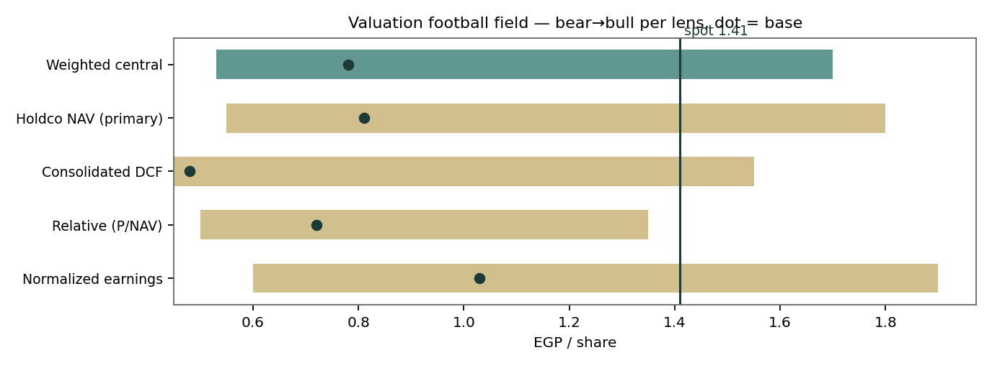
Figure 1 — Valuation football field. Every base sits below spot; only the bull cases reach it. The bull column is not decoration: it is a coherent world (DPRK cash recovered, OPE at maturity, discount gone) — the world the market is charging for today.
1.6 The holding-company assets — a deeper look
A scorecard on the six blocks that matter, marking each for earnings power, verifiability and liquidity — the three things a holdco discount is supposed to price.
Asset block | What it is | Earnings power | Verifiability | Liquidity | Our mark
OPE + S&L | Giza plateau visitor services under the 2018 protocol; e-bus transport, F&B, retail leases, events, sponsorship; ticket revenue stays with the state; 50-50 revenue share, state minimum EGP 20m/yr | Ramping fast — Q3-25 group revenue ×5.8 y/y | Contract terms not fully public | Unlisted; strategic | EGP 2,900m (DCF)
DPRK cash | US$106m at the Foreign Trade Bank of DPRK + US$8m in hand; UNSC exemption (Dec-2018) allows operation, not repatriation | None — blocked | KPMG unable to verify; 50% ECL | Frozen | EGP 2,796m (net)
Koryolink 60% | The DPRK mobile operator (CHEO JV); associate since 2015, KPTC took control economics in the 2022 capital increase | Real profits, all impaired on recognition | Unverifiable | Frozen | EGP 589m (carrying)
KL loan | US$86m (2022) + €30m (2024) lent by Koryolink to OIH interest-free — the mechanism by which cash left the DPRK perimeter | Unwinding cost through finance expense | Audited | Owed, 1–5yr | (EGP 4,443m)
Lighthouse | Renewables PE fund (SCSp), Level-3, marked by DCF at 7.5–13.5% discount rates | Mark-to-model | Fund-reported | Illiquid LP stake | EGP 1,399m
Cash & rest | Group cash ex-DPRK, São Paulo property, receivables net of payables | Deposit income | Audited | High (cash) | EGP 2,636m − 854m debt/leases

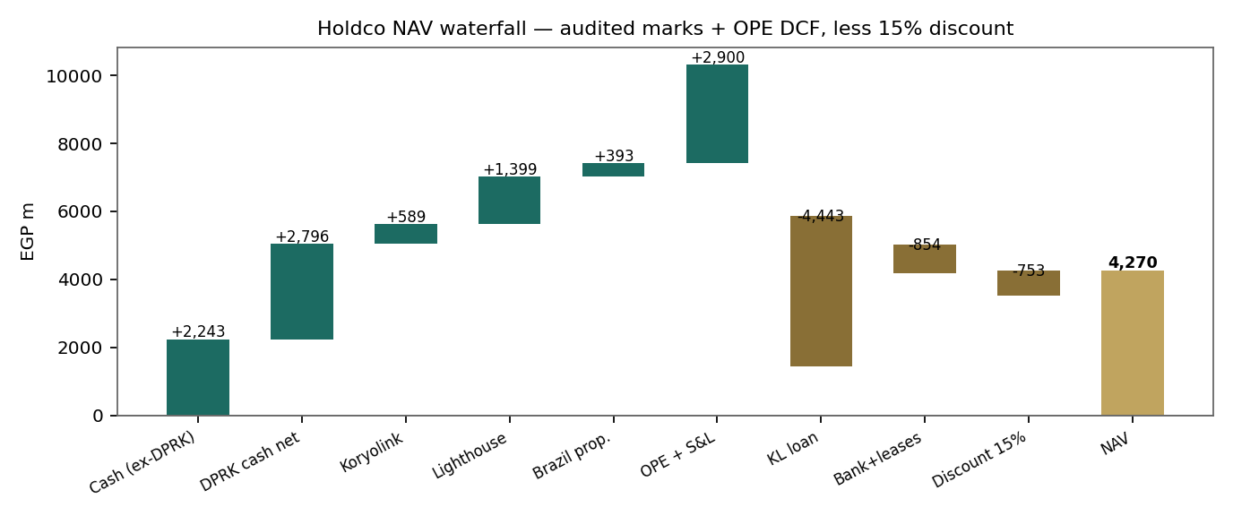
Figure 2 — The NAV waterfall. The Koryolink loan is the largest single bar on the page: the books owe more back to the DPRK associate than they credit for the cash still inside it.
1.7 The Pyramids platform and the DPRK pair — the crux
The Pyramids side. The concession is genuinely exceptional: exclusive visitor services at the single most famous heritage site on earth, adjacent to the Grand Egyptian Museum whose full opening (November 2025) rebased Giza footfall. Management expects the plateau area to generate EGP 3–3.5bn of revenue in 2026, growing 20–25% a year, with 5m visitors targeted; OIH’s cumulative investment steps up to ~EGP 2bn next year and is self-financed from here. But the economics are gated: entry-ticket revenue belongs entirely to the state, OIH monetizes the streams it built (transport, F&B, retail leases, events, sponsorship), and a strict 50-50 revenue share with a state minimum sits on top. Our EGP 2,900m mark is a DCF of those captured streams reaching EGP ~2.6bn of revenue and 44% margins by FY29E. To justify the EGP ~5.3bn the market implies, the platform must roughly double our FY29E revenue capture or hold 25% growth well into the 2030s with no revision of terms — possible, and priced.
The DPRK side. The pair is widely misread as a wash; the audited arithmetic says otherwise. OIH has already extracted ~US$116m of value from Koryolink via interest-free shareholder loans — that cash is in the group — but it is booked as a liability of EGP 4.4bn repayable to an associate OIH owns 60% of yet does not control (KPTC holds the operating reins since the 2022 capital increase diluted OIH from 75%). Meanwhile US$114m of the group’s own cash remains inside DPRK, carried at half. Net, the audited books say the whole DPRK complex is negative EGP ~1.06bn for equity (2,796 + 589 − 4,443). The upside case is not subtle: any sanctions or repatriation path that lets the trapped cash out adds up to EGP 0.53/share, and a settlement that nets the loan against the cash adds more. The downside is equally concrete: a further ECL step to 25% recovery removes EGP 0.27/share, and the loan unwinds toward its US$116m face regardless. This is a real option with a negative carrying value — the market prices the option, the auditor prices the carry.
FX sensitivity — NAV per share (EGP) | EGP/USD 44 | 47 | 49.09 (spot) | 52 | 55
NAV base (post-discount) | 0.75 | 0.79 | 0.81 | 0.85 | 0.89
Financial NAV ex-OPE, pre-discount | 0.36 | 0.39 | 0.40 | 0.43 | 0.45

The FX row above belongs in this section because it is counter-intuitive: OIH is net-long dollars (DPRK cash + USD deposits exceed the EUR/USD Koryolink loan), so EGP weakness raises the EGP NAV — and the pound’s 2025 strengthening (51.0 → 49.1) is precisely what drove the EGP 806m nine-month loss through translation. The 2022–2024 profits ran the same machine in reverse.
1.8 Macro and country — the pound, the tourist, the rate
Three macro dials move this name. The pound: EGP/USD 49.09 today, a 52-week range of 46.6–54.9 with an offshore stress print at 54.6; every pound of depreciation adds ~EGP 0.02 of NAV and, historically, brings the retail flow that trades this counter (20–50m shares a day). The tourist: Egypt’s inbound cycle is the strongest in a decade, the GEM’s first full year is 2026, and the plateau is the funnel — this is the engine under the OPE ramp and the only macro line with a direct revenue link. The rate: CPI at 14.9% (April) with the CBE corridor near 19–20% sets our 20% EGP WACC; every point off the corridor is worth roughly EGP 90m on the OPE DCF. Tail risks are the familiar regional ones — a geopolitical shock hits tourism revenue and the EGX risk premium simultaneously, the one correlation that damages both sides of this balance sheet at once.
1.9 NAV sensitivity — discount × platform value
Holdco discount \ OPE value (EGP m) | 2,000 | 3,000 | 3,450 | 4,500 | 6,000
0% | 0.79 | 0.98 | 1.06 | 1.26 | 1.55
10% | 0.71 | 0.88 | 0.96 | 1.14 | 1.39
15% | 0.67 | 0.83 | 0.90 | 1.07 | 1.31
20% | 0.63 | 0.78 | 0.85 | 1.01 | 1.24
30% | 0.55 | 0.68 | 0.74 | 0.88 | 1.08

Spot (EGP 1.41) is reached nowhere on this grid at base DPRK marks — the nearest cell is a EGP 6bn platform with no discount at all. The tape needs the grid plus the DPRK option: add full trapped-cash recovery (+0.53 pre-discount) and the 6,000/0% corner reads 2.08, the 4,500/15% cell 1.52. That is the map of what EGP 1.41 believes.
2 Technical and price structure
The tape is the exact inverse of the fundamentals: strong, extended and orderly. OIH has advanced 74% over twelve months and 22% year-to-date, sits above the 20-, 100- and 200-day averages, and is consolidating a hair under the 50-day after a pullback from the March high of EGP 1.58. RSI at 62 is constructive without being stretched; the MACD histogram has just crossed back positive from a shallow corrective phase; turnover of ~51m shares a day marks this as one of the exchange’s liquidity bellwethers. Nothing in the price structure is broken — which is precisely the tension of this study.
Indicator | Reading | Signal
Spot | EGP 1.41 | —
SMA 20 / 50 | EGP 1.39 / 1.47 | Above 20, testing the 50 from below
SMA 100 / 200 | EGP 1.37 / 1.24 | Above both — primary uptrend intact
RSI (14) | 61.9 | Constructive; not overbought
MACD (12,26,9) | -0.013 line / -0.019 signal / +0.006 hist | Corrective phase ending; histogram positive
52-week range | EGP 0.80 – 1.58 | Upper quarter of the range
Realized vol (252d) | 41.7% | High — a retail-flow counter
Avg volume (20d) | 51m shares | Deep, speculative liquidity
12-month / YTD change | +74% / +22% | Secular advance intact

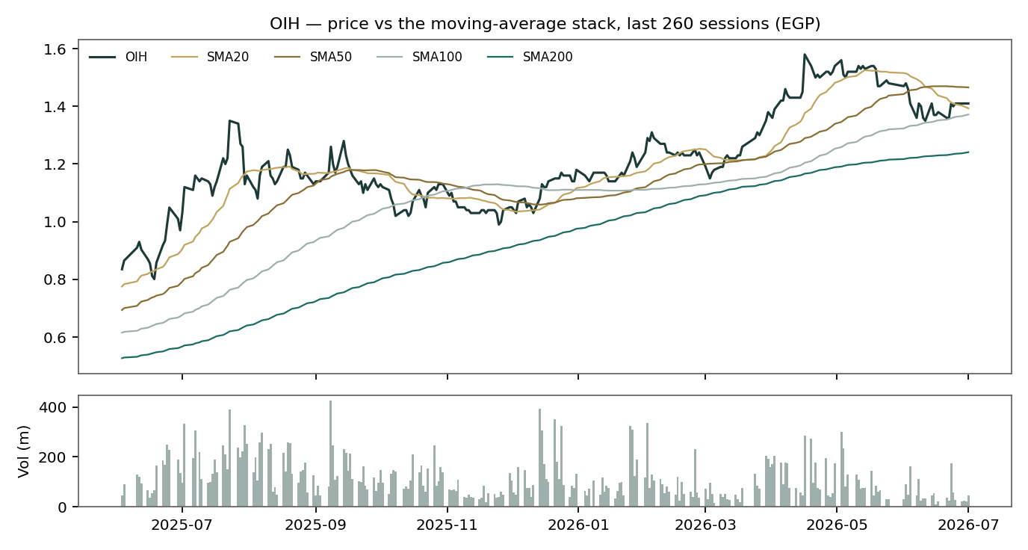
Figure 3 — Price versus the moving-average stack, last 260 sessions, with volume.
For the probabilistic work this matters in one way: a trending, liquid, retail-driven tape justifies the secular drift the Step 0 backtest validated (Appendix B), and it fattens the near-term upside tail even as §1 argues the price is already rich. The technical and fundamental pictures genuinely disagree, and §6 reads the resulting probability zones without forcing a reconciliation.
3 Monte Carlo — a probabilistic price map
We simulate 50,000 three-month price paths (seed 42) using a sixteen-factor stack: seven continuous macro/operating drivers contributing a small net forward drift, and nine discrete events that each fire with a probability and an impact. By design the paths diffuse from spot, and the §1 value gap is kept out of the drift — the fundamental NAV gap lives in §1, not here; §3 maps where price could go from today, not where value sits. Diffusion width is sized by the v2 engine: a pooled log-HAR cascade (variance lags 1/5/22) on a gap-aware Yang-Zhang proxy projects the average daily variance over the next 60 sessions (annualized ≈ 38.3%), and innovations are unit-variance Student-t(5) via a per-path variance mixture — a tighter interquartile body with honest tails. The drift is asset-class-conditional and, for OIH, ON: the expanding-window secular mean of the stock’s own history (+9.8% per quarter), the configuration that beat the random-walk benchmark in Appendix B; the factor layer adds a further +1.9 points net, for a total median lift of +11.8% — the tape’s trend, not our NAV view.
Continuous factor (7) | Dir. | Discrete event (9) | Prob. | Mean impact
EGP/USD rate | + | Geopolitical / regional security | 30% | -12.0%
CBE rate | - | Holdco-discount regime shift | 30% | +4.0%
EGX30 & foreign flows | + | NK sanctions / repatriation event | 20% | +2.0%
Tourism / Giza footfall (GEM effect) | + | OPE concession / government-relations event | 25% | -3.0%
Inflation (CPI) | mixed | Subsidiary catalyst (OPE expansion / new destination) | 35% | +5.0%
USD rates / EM risk appetite | - | Debt restructuring / KL-loan event | 30% | +2.0%
Retail-liquidity regime | + | Portfolio monetization / exit | 25% | +4.0%
 |  | Earnings surprise (FY25 / H1-26 prints) | 50% | +1.0%
 |  | Capital action / related-party transaction | 25% | -3.0%

The factor set is the EGX-holdco library set adapted to OIH’s actual mix — tourism/GEM footfall replaces the energy complex, the FX sign flips positive (OIH is net-long USD), and the DPRK repatriation event enters with a wide two-sided spread. It is flagged calibrated = false pending sign-off; its net contribution is deliberately held near zero so the validated diffusion carries the forecast.
Percentile map (EGP/share):
Horizon | p5 | p25 | p50 | p75 | p95
T+20 sessions | 1.18 | 1.35 | 1.46 | 1.58 | 1.80
T+60 sessions | 1.09 | 1.36 | 1.57 | 1.80 | 2.23

Lead with the body, not the tails: the 50% interquartile band at T+60 is EGP 1.36–1.80 (a width of ~31% of spot — the instrument’s genuine quarter-ahead uncertainty, not padding) and at T+20 it is EGP 1.35–1.58. The median drifts to 1.57 because the drift is the tape’s; a reader who believes §1’s valuation should read the left half of these distributions with particular care.
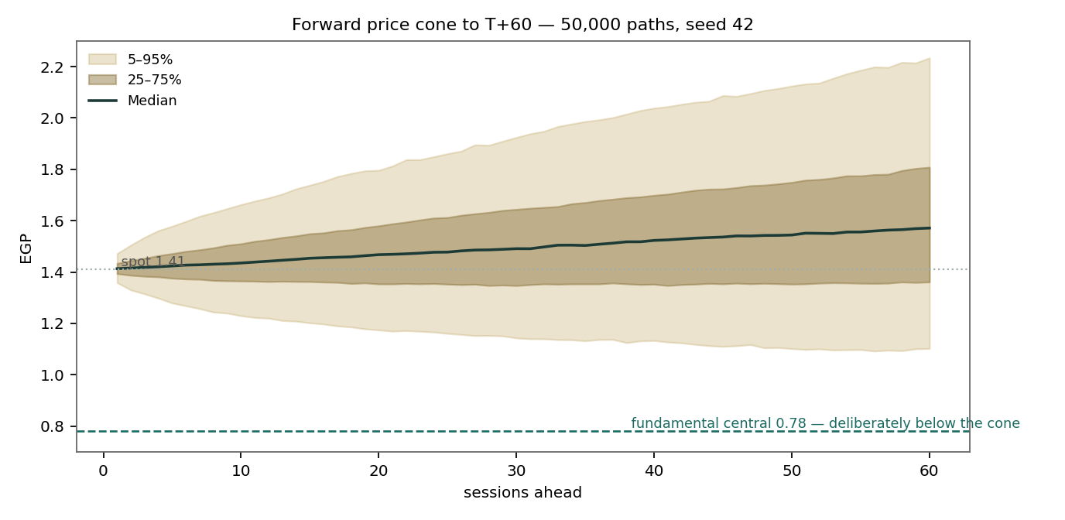
Figure 4 — Forward price cone to T+60. The teal dashed line marks the EGP 0.78 fundamental central value, deliberately below the cone: these paths diffuse from spot and do not embed the fundamental NAV — the value gap of §1 is kept out of the drift.
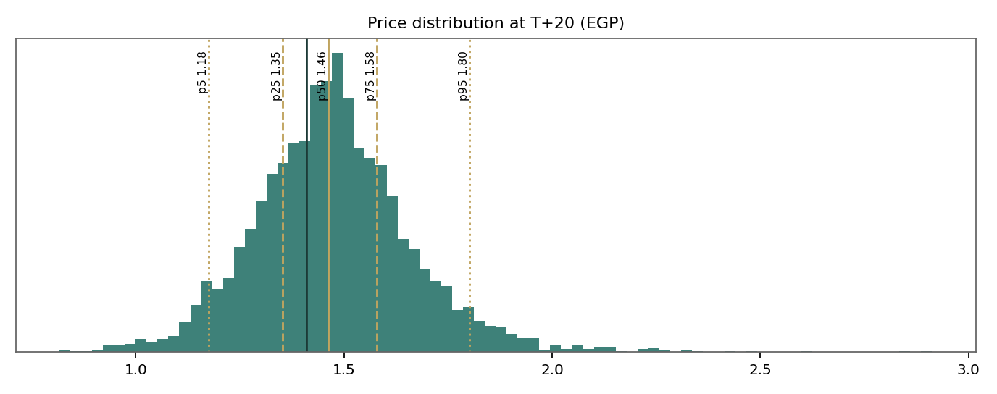
Figure 5 — Price distribution at T+20.
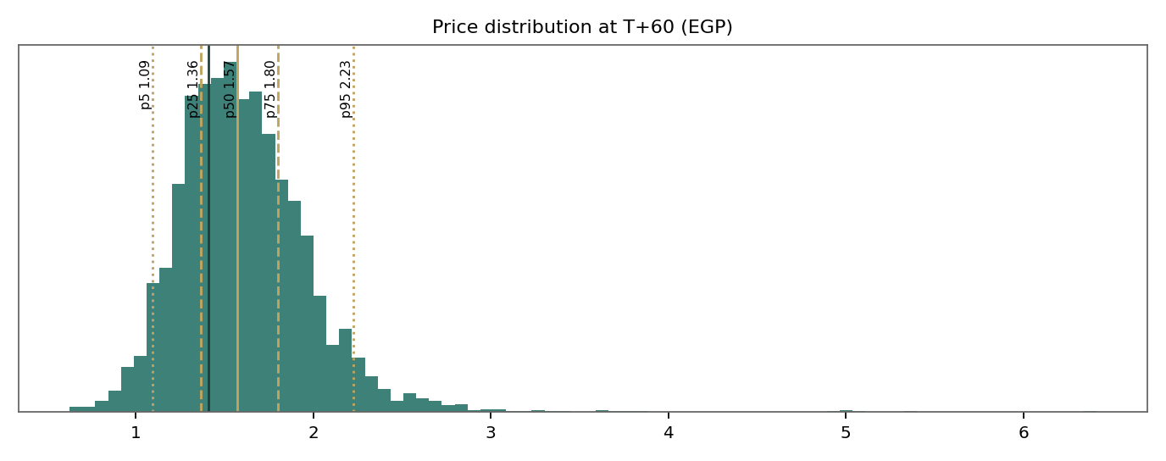
Figure 6 — Price distribution at T+60.
Level-touch ladder — the probability that price touches a level at any point by the horizon (running max for upside, running min for downside):
Level | T+20 touch | T+60 touch | Note
EGP 2.20 | 0.5% | 8.4% | 2× the Jan-2021 listing decade high zone
EGP 2.00 | 1.7% | 17.8%
EGP 1.80 | 7.1% | 36.3% | p75 at T+60
EGP 1.60 | 30.9% | 65.9% | The March high 1.58 sits just below
EGP 1.50 | 59.4% | 82.6% | First resistance band
EGP 1.30 | 29.7% | 45.8% | The 200-day rises toward here
EGP 1.20 | 11.3% | 24.9% | Spring consolidation shelf
EGP 1.10 | 3.7% | 12.1% | Post-breakout support
EGP 1.00 | 1.0% | 5.4%
EGP 0.90 | 0.3% | 2.2% | Only in a regime break

4 Comparison of the lenses, and a verdict
Read | Value / state | Distance to spot
Weighted fundamental central | EGP 0.78 | −45%
Holdco NAV (primary) | EGP 0.81 | −42%
Consolidated DCF | EGP 0.48 | −66%
Relative P/NAV | EGP 0.72 | −49%
Normalized earnings | EGP 1.03 | −27%
Technical trend | Uptrend, consolidating under the 50-day | —
Monte Carlo T+60 median / 50% band | EGP 1.57 / 1.36–1.80 | +11% / −4% to +28%
Expert 1 / 2 / 3 (Appendix D) | EGP 0.81 / 0.37 / 1.18 | −42% / −74% / −16%

Verdict — hold the two clocks apart. On the roughly twelve-month clock of the fundamental lenses, OIH is expensive against everything its books can currently prove: every base-case lens, and every expert including the most macro-friendly, sits below the tape; the price is only reachable in the bull column, where the DPRK cash comes home and the Pyramids platform matures without a revision of terms. On the three-month clock of the Monte Carlo, the validated engine says the trend itself is the most likely near-term path — a median of 1.57 with a 50% band of 1.36–1.80 — because momentum, retail liquidity and the tourism news cycle are real forces this quarter regardless of NAV arithmetic. Neither clock refutes the other, and this house publishes distributions, not tips: the honest statement is that the market is paying today for the bull scenario, and the tape may keep paying for it for a while — with the full-execution, DPRK-recovered NAV of ~EGP 1.7–2.1 a multi-year ceiling that must never be read as a near-term figure. What would reconcile the clocks, in either direction, is listed in §5 and §7.
5 Catalysts to watch
Catalyst | Window | Direction / read
FY2025 EAS + IFRS statements (chronically late) | Q3–Q4 2026 | First full-year look at OPE segment economics; an unqualified DPRK opinion would be a genuine event
H1-2026 EAS results | ~Oct 2026 (on past lags) | Whether the Q3-25 revenue step (EGP 278m in one quarter) annualises
Plateau season: GEM first full year, winter events, concerts | Continuous; peak Oct–Mar | The direct revenue driver; management targets 5m visitors
OPE investment step-up to ~EGP 2bn cumulative | 2026, self-financed | Confirms the concession’s internal economics — or strains cash
EGP path / CBE corridor decisions | Every ~6 weeks | Depreciation lifts EGP NAV and retail flow; cuts lower the 20% WACC
Any DPRK sanctions / repatriation headline | Unscheduled | Up to +0.53/share of trapped cash; two-sided
Koryolink-loan amortisation or settlement | 1–5yr contractual window | A netting settlement would rerate the whole DPRK block
Lighthouse Energy Fund marks / any exit | Fund reporting dates | Level-3 today; a cash exit converts 0.27/share of model value into money
Concession-terms disclosure or renegotiation | Unscheduled | The single largest downside catalyst — the 50-50 share and tenor are not fully public
Capital action / related-party transaction | Unscheduled | The parent’s history argues for watching every EGM agenda

6 Reading the probability zones
Zone at T+60 (EGP) | Probability | How to read it
below 1.00 | 2.5% | Regime break: a geopolitical or concession shock; NAV floor territory
1.00 – 1.20 | 8.0% | Deep pullback to the spring shelf; fundamentals begin to argue the other way
1.20 – 1.41 | 19.8% | Ordinary correction inside the uptrend; the 200-day rises to meet it
1.41 – 1.60 | 23.4% | The modal zone with 1.41–1.60: consolidation under the March high
1.60 – 1.80 | 21.4% | Breakout extension; the tape fully ignoring the NAV
1.80 – 2.10 | 16.8% | The bull column arriving early — usually on a DPRK or results headline
above 2.10 | 8.1% | Melt-up tail; retail counters on this exchange do produce it

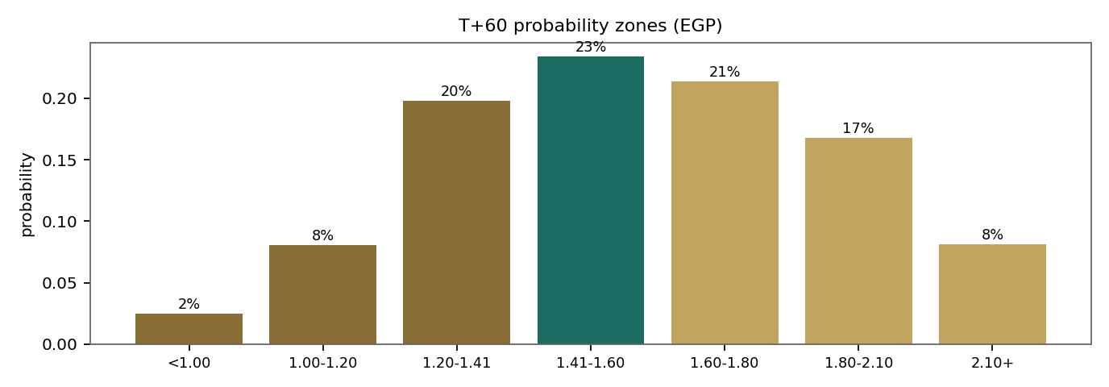
Figure 7 — T+60 probability zones. Roughly 70% of paths finish at or above spot — the engine’s tape-trend view — while every fundamental base case lives in the left three bars. That asymmetry is the study’s tension, stated in probabilities.
The zones are the engine’s output, not a forecast of value. A reader anchored to §1 should note that the model still assigns ~30% to zones below spot and ~10% to zones below EGP 1.20 — the region where price and accountable NAV begin to reconcile from above.
7 Caveats and what would change our mind
Caveats, in candour. (1) The audit opinion is qualified on precisely the balances that dominate the NAV — the DPRK cash, the Koryolink stake — and we cannot verify what KPMG could not. (2) The company files late, chronically: FY2023 IFRS was authorised in November 2025; our 2025 picture rests on EAS quarterlies through September and press-reported figures. (3) Several FY2024 balance-sheet lines are estimated to balance to the disclosed EAS total (flagged in the model), and the FY2023/FY2024 segment split is estimated. (4) The OPE concession’s tenor and full terms are not public; our DCF assumes the disclosed 50-50 share holds and the platform operates well past 2030. (5) The Monte-Carlo factor set is the holdco library adapted to OIH and is flagged calibrated = false; the diffusion, not the factors, carries the forecast. (6) The Lighthouse mark is a Level-3 model value. (7) This is a retail-flow counter with 42% realized volatility: three-month price behaviour can and does detach from any valuation for quarters at a time.
What would change our mind — upward: audited FY2025 accounts showing entertainment-segment EBITDA at or above EGP 400m with an unqualified DPRK opinion; any verified repatriation of trapped cash; a Lighthouse exit at or above carrying; public concession terms longer and cleaner than assumed. Any one of these moves the base NAV toward EGP 1.05–1.30 and two together toward the tape. Downward: a concession-terms revision or state-share increase; a further DPRK ECL step; FY2025 losses persisting into FY2026 beyond the FX line; central costs growing faster than the platform. On the engine: a failed quarter in the Calibration Ledger (CRPS skill below the random-walk benchmark on matured OIH rows) retires this configuration for the name, drift and all.
Appendix A Financial statements
EGP millions. FY22–FY24 are the audited IFRS consolidated statements (presented in US$ ’000, converted at the disclosed average/closing rates); FY25E–FY29E are Testahil estimates from the companion model. Rounding applies.
A.1 Income statement (consolidated, EGP m)
EGP m | FY22 | FY23 | FY24 | FY25E | FY26E | FY27E | FY28E | FY29E
Revenue | 98 | 177 | 358 | 610 | 1,143 | 1,650 | 2,139 | 2,606
Other income | 93 | 4 | 124 | 0 | 0 | 0 | 0 | 0
Opex | -278 | -477 | -784 | -834 | -1,142 | -1,418 | -1,671 | -1,924
EBITDA | -87 | -297 | -302 | -224 | 1 | 232 | 469 | 682
D&A | -11 | -50 | -49 | -61 | -103 | -132 | -150 | -182
EBIT | -98 | -347 | -351 | -285 | -102 | 100 | 319 | 500
Impairments & FX | 487 | -910 | -548 | -700 | 0 | 0 | 0 | 0
Net finance & FVTPL | 537 | -286 | 753 | -160 | -120 | -80 | -40 | 0
Koryolink net | 0 | 0 | 0 | 0 | 0 | 0 | 0 | 0
PBT | 926 | -1,543 | -147 | -1,145 | -222 | 20 | 279 | 500
Tax | -192 | 48 | -142 | 0 | 0 | -4 | -63 | -112
Discontinued | -12 | 289 | 0 | 0 | 0 | 0 | 0 | 0
Net profit/(loss) | 722 | -1,205 | -289 | -1,145 | -222 | 15 | 216 | 387

FY22’s profit and FY23’s loss are the same machine — the pound’s collapse produced FX gains and a one-off gain on discounting the interest-free Koryolink loan in 2022, then the DPRK impairment cycle took EGP 1.5bn in 2023. FY25E’s loss is the mirror image: EGP appreciation on a net-long dollar book, checked against the reported 9M-25 loss of EGP 806m.
A.2 Balance sheet (consolidated, EGP m, 31 Dec)
EGP m | FY22 | FY23 | FY24 | FY25E | FY26E | FY27E | FY28E | FY29E
P&E (incl. ROU) | 460 | 974 | 1,328 | 1,717 | 2,114 | 2,282 | 2,332 | 2,300
Investment property | 202 | 0 | 0 | 0 | 0 | 0 | 0 | 0
Koryolink (assoc.) | 614 | 613 | 612 | 612 | 612 | 612 | 612 | 612
DPRK cash (net) | 2,239 | 1,481 | 2,907 | 2,797 | 2,797 | 2,797 | 2,797 | 2,797
Lighthouse (FVTPL) | 681 | 751 | 1,455 | 1,455 | 1,455 | 1,455 | 1,455 | 1,455
Inventories | 0 | 1 | 3 | 3 | 3 | 3 | 3 | 3
Trade receivables | 270 | 161 | 220 | 238 | 262 | 286 | 307 | 325
Other assets | 72 | 64 | 657 | 669 | 685 | 701 | 715 | 727
Cash | 1,655 | 2,271 | 2,332 | 1,369 | 749 | 597 | 767 | 1,197
Total assets | 6,194 | 6,314 | 9,513 | 8,858 | 8,676 | 8,731 | 8,987 | 9,414
Borrowings (incl. KL loan) | -1,977 | -3,191 | -5,504 | -5,464 | -5,424 | -5,384 | -5,344 | -5,304
Payables & other | -494 | -481 | -285 | -285 | -285 | -285 | -285 | -285
Deferred tax | -306 | -290 | -459 | -459 | -459 | -459 | -459 | -459
Income tax | -102 | -72 | -117 | -117 | -117 | -117 | -117 | -117
Provisions | -215 | -225 | -372 | -372 | -372 | -372 | -372 | -372
Total liabilities | 3,095 | 4,258 | 6,738 | 6,698 | 6,658 | 6,618 | 6,578 | 6,538
Total equity | 3,099 | 2,056 | 2,774 | 2,159 | 2,017 | 2,112 | 2,409 | 2,876

FY24 total assets reconcile to the EAS-disclosed EGP 9,508m within rounding. The equity line is thin against the asset stack because the Koryolink loan sits at near-face while the DPRK cash is half-written — the §1.7 pair in balance-sheet form.
A.3 Cash flow (consolidated, EGP m)
EGP m | FY22 | FY23 | FY24 | FY25E | FY26E | FY27E | FY28E | FY29E
Operating CF | -209 | -239 | -1,529 | -554 | -159 | 107 | 331 | 540
Capex / investing | -20 | 395 | -960 | -450 | -500 | -300 | -200 | -150
Financing CF | 176 | 91 | 1,265 | 40 | 40 | 40 | 40 | 40
Net change in cash | -156 | 206 | -1,287 | -964 | -619 | -153 | 171 | 430
Closing cash | — | — | — | 1,369 | 749 | 597 | 767 | 1,197

The forecast trough is FY27E: the concession build completes, FCFF turns positive in FY28E, and closing cash never approaches zero — the build is funded, which is different from saying it is yet worth its price.
Appendix B Step 0 — calibration backtest
Before any forecast we test the engine on OIH’s own five years of history: at seventeen non-overlapping origins (Feb-2022 → Jan-2026, h = 60 sessions, using only data available at each origin) we generate the three-month distribution and score the realized close against it. The grade is skill versus a naïve benchmark — a zero-drift random-walk lognormal cone on trailing realized vol — measured by CRPS skill (must be > 0) and the Winkler interval score; PIT and band coverage are reported as diagnostics only, because hit-rate rewards width. Two drift configurations were run, and the decision was made by the numbers, not by asset-class habit:
Configuration | CRPS | CRPS skill | W90 skill | W50 skill | Cov 50/80/90 | PIT mean
YZ-HAR t5, drift OFF | 0.0742 | −0.013 | +0.072 | −0.043 | 47% / 88% / 88% | 0.63
YZ-HAR t5, drift ON (accepted) | 0.0669 | +0.086 | +0.203 | +0.105 | 29% / 82% / 88% | 0.57
Random-walk benchmark | 0.0732 | 0.000 | 0.000 | 0.000 | 47% / 88% / 88% | 0.62

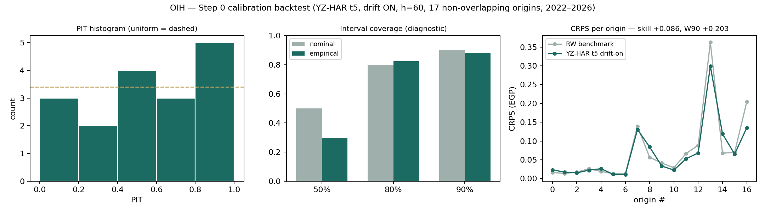
Figure B-1 — Step 0 diagnostics for the accepted configuration: PIT histogram against uniform, interval coverage versus target, and per-origin CRPS against the benchmark.
The zero-drift cone fails on OIH — its PIT mean of 0.63 says realized prices persistently finished in the upper half of its forecasts, because this stock carries a genuine secular advance (EGP 0.17 → 1.41 across the sample). Turning the expanding-window secular drift ON — the same per-name test that turned it OFF for another EGX holdco in this series — beats the benchmark on all three skill metrics with a PIT that is statistically indistinguishable from uniform (χ² p ≈ 0.8 across five bins). The 50% band covered 29% versus a 50% target across seventeen origins (±12pt binomial noise at this sample size); we note it as a diagnostic and did not widen the cone to chase it, because width is exactly what the CRPS grade punishes. The lens is accepted; drift ON, HAR width and t5 shape carry into the §3 forward run, and the forecast enters the Calibration Ledger to be graded at maturity by the same rule.
Appendix C Peer set, sector structure, and risks
OIH has no clean comparable — a heritage-site concession, a sanctioned telecom associate and a renewables LP stake share one wrapper. The peer set is therefore the EGX holdco shelf, compared on structure rather than multiples.
Peer (EGX) | Focus | Discount narrative | Comparability
Qalaa Holdings (CCAP) | Energy/refining (ERC), infrastructure | Deep P/NAV discount; leverage at subsidiaries | Closest listed holdco; the opposite discount regime
B Investments (BINV) | PE-style stakes, consumer & fintech | Modest discount; cash-rich | Cleaner book, no concession or DPRK tails
EK Holding (EKHO) | Gas, fertilizers, NBFC; USD line | Near NAV; USD quotation removes FX drag | The USD-asset overlap parallels OIH’s long-dollar book
Odin Investments (ODIN) | Brokerage-linked micro-holdco | Illiquid, wide bands | Size and retail-liquidity comparator only

Sector structure. EGX holdcos habitually clear at 10–50% below accountable NAV; OIH is the exchange’s outlier premium precisely because its swing asset is ramping and its NAV rests on hard-to-verify marks — the market is pricing the story the books cannot yet carry. Principal risks: revision of the plateau concession’s revenue share or tenor; a further DPRK write-down, or the Koryolink loan unwinding to face with no offsetting recovery; EGP appreciation compressing the EGP NAV and the retail bid together; Level-3 marks (Lighthouse) proving optimistic; the chronic filing lag and qualified opinion persisting; central costs outgrowing the platform; and the governance asymmetries of a parent-controlled holdco (related-party transactions, capital actions) that minority holders absorb rather than shape.
Appendix D The expert valuation panel
Three experts, three genuinely different methods, cast from the house persona library for holding companies: a NAV-and-discount specialist, a forensic accountant, and a macro-policy strategist. Each shows the workings, states a falsification condition, and reads what the market price implies. They are labelled Expert 1/2/3; their point values are logged with today’s date and spot as a per-expert calibration layer, separate from the core Ledger.
D.1 Expert 1 — NAV and the holdco discount
Worldview and tradition. The holdco is a portfolio in a listed wrapper; its value is the sum of its parts at realizable marks, less what the wrapper costs — central overhead, agency risk, illiquidity — expressed as a discount. The tradition runs from Graham’s asset plays through the European holding-company literature (Investor AB, Exor, GBL trade this way daily) to the EGX’s own shelf, where the discount is the market’s standing verdict on governance. When it works: when the parts have observable or at least auditable marks and a path to realization — sales, listings, dividends up the chain. When it fails: when the marks are unverifiable (the method inherits the auditor’s blindness), when the crown asset is a growth business whose DCF swamps the audited stack, and when control never intends to realize anything — a discount can be permanent.
Standard workings. (1) List every asset and liability; (2) mark each at the most defensible basis — carrying for audited financial items, DCF for the operating platform, haircuts stated per line; (3) sum; (4) apply a discount built from comparables and governance scoring; (5) divide by shares; (6) sensitise on the two swing marks.
Step (worked on OIH) | EGP m | EGP / share
Financial assets at audited marks (cash 2,243 + DPRK net 2,796 + Koryolink 589 + Lighthouse 1,399 + Brazil 393 + NWC 0) | 7,420 | 1.41
less: liabilities at carrying (KL loan 4,443 + banks/leases 854) | (5,297) | (1.01)
plus: OPE + S&L platform at standalone DCF | 2,900 | 0.55
NAV pre-discount | 5,023 | 0.96
less: holdco discount 15% (peer range 10–50%; mid-shaded low for a ramping crown asset) | (753) | (0.14)
Expert 1 fair value | 4,270 | 0.81

A concrete worked example — one line, end to end. Take the Lighthouse stake: the FY24 accounts carry it at US$28.522m, a Level-3 mark the fund derives by discounting project cash flows at 7.5–13.5%. My rule marks audited financial items at carrying, so the line enters at 28.5 × 49.09 = EGP 1,399m = EGP 0.267/share, with no haircut and no premium — the haircut for its illiquidity lives once, inside the 15% wrapper discount, not twice. Every line in the table above was built by exactly this two-step: basis first, conversion second, discount last and once.
Sensitivity on the swing input — the platform mark: at EGP 2,000m the value is 0.67; at 4,500m, 1.07; at 6,000m, 1.31 (all at 15%). The discount matters less than the mark: ±10 points of discount moves the answer only ±0.10. Cross-examination. To Expert 2: striking the DPRK block to nil while keeping the loan at face is not conservatism, it is asymmetry — the loan exists *because* value left the DPRK perimeter; strike both or neither. To Expert 3: your scenario tree prices moods; a NAV prices things — show me which line of my table your 1.18 changes, or it is drift, not valuation. Verdict: EGP 0.81 (bear 0.55, bull 1.80). Falsification: audited FY2025 accounts that force any single mark to move by more than EGP 0.15/share — in either direction — against my table. What the price implies: at 1.41 the market carries the platform near EGP 5.3bn pre-discount, or my table plus full DPRK recovery; both are bull-column claims.
D.2 Expert 2 — the forensic accountant
Worldview and tradition. Start from what an auditor signed and subtract what the auditor could not verify. The tradition is quality-of-earnings and quality-of-book work — Schilit’s shenanigans literature, the short-seller’s toolkit applied without the short — and its first move on OIH is to read the opinion: qualified, on exactly the balances the bulls capitalise. When it works: wherever marks are the story; it is the discipline that kept people out of every unverifiable-asset blow-up of the last two decades. When it fails: on genuine growth assets, where audited history systematically understates value — the method priced the Pyramids at its invoices, and invoices are not a concession.
Standard workings. (1) Anchor on audited equity; (2) strike or haircut every unverifiable asset; (3) restore off-book value only where cash flows already evidence it, at cost-based marks; (4) test the liability side at its harshest documented number; (5) no discount — the strikes are the discount.
Step (worked on OIH) | EGP m | EGP / share
Audited IFRS equity, 31-Dec-24 (US$54.4m × 49.09) | 2,671 | 0.51
strike: DPRK cash from 50% to 25% recovery (US$28.5m) | (1,399) | (0.27)
strike: Koryolink associate to nil (control lost 2022; unverifiable) | (589) | (0.11)
haircut: Lighthouse Level-3 mark −30% | (420) | (0.08)
restore: OPE platform above book P&E — at evidenced cost, EGP 2,000m vs EGP ~1,330m carried | 670 | 0.13
memo (not booked): KL loan unwinding to US$116m face would take a further | (1,251) | (0.24)
Expert 2 fair value (excl. memo) | 1,933 | 0.37

A concrete worked example — one strike, end to end. The Koryolink associate: carried at US$12m because equity-method profits (US$8.9m in 2024 alone) are recognized and then impaired the same year — an accounting loop that admits the earnings are real and the access is not. My rule strikes any asset the auditor could not verify AND the holder cannot control: OIH lost operating control in the 2022 capital increase and the auditor is qualified on the balance. Strike to nil: −589 EGP m, −0.11/share. The same test *keeps* the KL loan at carrying, because a liability needs no verification to be owed.
Sensitivity on the swing input — the DPRK recovery rate: at 50% (the board’s own ECL) the value is 0.63; at 0%, 0.10; the entire equity story between 0.10 and 0.63 is one unauditable assumption. Cross-examination. To Expert 1: your 2,900 platform mark rests on revenue the company has never once disclosed by segment in an audited filing — I will pay cost until they show me a segment note. To Expert 3: FX scenarios that lift the NAV are lifting the *DPRK* NAV — you are levering the least verifiable line in the book. Verdict: EGP 0.37 (range 0.25–0.60). Falsification: an unqualified opinion on the DPRK balances, or a first audited entertainment segment note showing EBITDA above EGP 400m — either forces my strikes to reverse and my value toward Expert 1’s. What the price implies: 1.41 is 3.8× my number; the market is not paying for the books at all — it is paying for the story despite them, which is precisely when my method historically earns its keep.
D.3 Expert 3 — the macro-policy strategist
Worldview and tradition. Single-name value in emerging markets is mostly a macro claim wearing a ticker: the currency, the policy rate, the tourism cycle and the flow regime set the multiple before any analyst touches the model. The tradition is top-down EM allocation — regime probabilities first, security selection inside them. When it works: on high-beta, flow-driven counters in policy-heavy markets — which is a literal description of OIH. When it fails: on idiosyncratic events no regime predicts (a concession renegotiation, a sanctions headline), and it never disciplines the entry price — a scenario tree can rationalise almost any spot.
Standard workings. (1) Define the two or three macro axes that actually move the name; (2) build discrete regimes with probabilities; (3) inside each regime, reprice the *mechanical* channels (here: FX × the long-USD book; tourism × the OPE ramp; flows × the holdco discount); (4) probability-weight; (5) stress the weights.
Regime (12-month) | Prob. | EGP/USD | Tourism / flows | Mechanical NAV effect | Value (EGP/sh)
Reflation & carry-unwind: EGP slides, tourism supercycle, retail flow strong | 30% | 54–56 | GEM year-one +25% | FX +0.10 · OPE bull 4,500 · discount → 5% | 1.90
Muddle-through: EGP 48–51, tourism solid, flows neutral | 45% | ~49 | +15–20% | Base marks hold | 1.05
Disinflation & shock: EGP firms, a regional or concession scare | 25% | 44–46 | Footfall shock −20% | FX −0.06 · OPE 2,000 · discount → 25% | 0.55
Probability-weighted |  |  |  |  | 1.18

A concrete worked example — one regime, end to end. The 30% reflation regime: EGP to 55 revalues the net-long dollar book (+US$60m net × 6 pounds of depreciation ≈ +EGP 0.10/share mechanically); GEM year-one tourism lifts the OPE mark to the 4,500 bull DCF (+0.31 pre-discount); and strong retail flow compresses the wrapper discount to 5% (+0.09). Stack those on Expert 1’s own table and it reprices to ~1.90 — no new assets, no story, just the three mechanical channels moving together, which in Egypt they historically do.
Sensitivity on the swing input — the regime weights: shifting ten points from muddle-through to reflation lifts the value to 1.27; ten points to the shock regime cuts it to 1.06 — the answer is robust to ±0.10, which is unusual for this method and reflects how mechanically OIH is wired to its macro. Cross-examination. To Expert 1: your NAV is a photograph; this name is a film — the same table re-marked in the 30% regime *is* my 1.90, so our disagreement is only about whether to price the regime now. To Expert 2: your strikes are right about verification and silent about direction; the pound and the tourist do not read audit opinions. Verdict: EGP 1.18 (range 0.85–1.55 on weight stress). Falsification: two consecutive quarters of tourism arrivals or plateau revenue falling year-on-year, or EGP sustained below 46 — either breaks the mechanical channel my tree runs on. What the price implies: 1.41 sits between my base and reflation regimes — the market holds roughly a 55–60% weight on the friendly half of my tree, which is aggressive but not irrational for this counter.
D.5 The three in one room
Asked for the single asset they most disagree on, all three point at the DPRK block, and the exchange is short. Expert 1: “Carry the pair at audited marks — 2,796 of cash, minus 4,443 of loan — and stop pretending it nets; the books say the complex is worth minus a billion.” Expert 2: “The books say the *auditor couldn’t look*. I strike the assets and keep the liability, because liabilities do not need verifying to be owed.” Expert 3: “You are both pricing a photograph of a frozen thing. It is an option on a policy change, held at negative carry — worth little most years and 0.5 a share the year it moves, and my 30% regime is where such years live.” Expert 1, closing: “Then we agree more than we sound: none of us gets to 1.41 without that option paying — which is the study’s verdict in one sentence.”
D.6 Reading the divergence
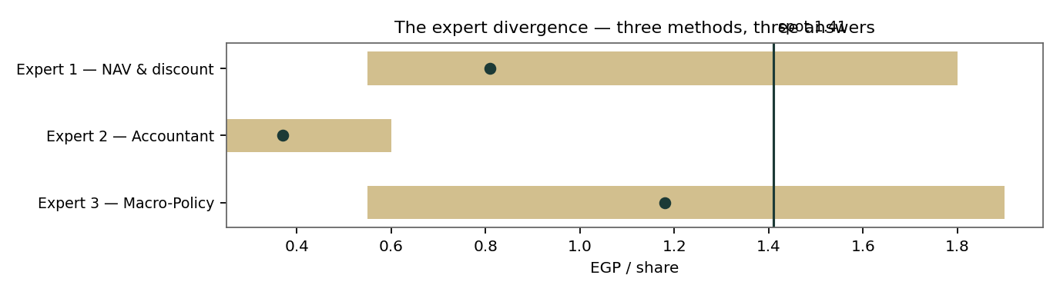
Figure D-1 — Three methods, three answers, one spot price above all of them.
Expert | Fair value | The one assumption doing the work
Expert 1 — NAV & discount | EGP 0.81 | The Pyramids platform is worth its EGP 2,900m DCF, no more yet
Expert 2 — forensic accountant | EGP 0.37 | Nothing the auditor could not verify is worth more than its strike
Expert 3 — macro-policy | EGP 1.18 | A 30% weight on the reflation-and-tourism regime, priced today

What the spread measures. The 0.37–1.18 range is not noise; it is the price of verification. Expert 2 pays only for what is signed, Expert 1 adds what is modelled from evidenced cash flows, Expert 3 adds what the macro regime would do to both. The 0.81 point between them is where evidence currently runs out — and the market, at 1.41, stands 0.23 above even the panel’s most generous member. When a spot price exceeds every method in the room, it is being set by something none of the methods contains: here, the flow, the story and the option. That is not a reason it must fall this quarter — §3 says the opposite is more likely — it is the reason this study keeps its two clocks apart.
About this series
Testahil publishes independent, educational valuation studies. Each is an attempt to reason transparently about what a security is worth, with every assumption shown and a companion model so readers can disagree productively. The house style is distributions, not tips: we describe ranges and probabilities, not targets, and we do not tell anyone what to do. Studies are framed as educational analysis, the preparer is not licensed by any securities regulator, and holdings are disclosed.
Disclosure & Disclaimer
Not investment advice. This document is educational and informational only. It is not, and must not be relied upon as, investment, financial, legal, accounting or tax advice, nor an offer, solicitation or recommendation to buy, sell or hold any security. It contains no price target and no rating.
No licence; no advisory relationship. The preparer is not registered or licensed with any securities or financial regulator in any jurisdiction — including the Egyptian Financial Regulatory Authority — holds no brokerage or investment-advisory authorisation, and is not acting as your adviser or fiduciary. Nothing here is personalised to your circumstances.
Holdings disclosure. The preparer may hold, and may in the future take or dispose of, a position in the security discussed in this report, and may transact at any time without notice. This is a potential conflict of interest you should weigh.
Sources & accuracy. Reported financial and operating figures are drawn from the company’s public disclosure (IFRS consolidated financial statements FY2023 and FY2024; EAS filings via press reporting through 9M-2025) and other public sources believed reliable but not independently verified; they may contain errors or be superseded, and the auditor’s opinion on the FY2023 and FY2024 statements is qualified. Forward-looking inputs — the platform mark, the DPRK recovery assumptions, the holdco discount, projections, multiples, the DCF and Monte-Carlo factor probabilities — are the preparer’s own judgments and are inherently uncertain.
Forward-looking statements. Any statements about the future are estimates subject to risks and uncertainties; actual results may differ materially. The Monte Carlo models price, not value, and encodes subjective probabilities for events that have not occurred.
No reliance; your responsibility. Do your own research and consult a licensed professional before making any decision. You are solely responsible for your investment decisions and their outcomes. To the maximum extent permitted by law, the preparer accepts no liability for any loss arising from use of this document.
Currency & figures. Group figures are in Egyptian pounds (EGP), millions unless stated; audited historicals are IFRS statements presented in US dollars and converted at disclosed rates. FX at study date: EGP/USD 49.09. Rounding may cause totals to differ slightly. Spot price and market data are as of 01 July 2026 and change continuously.
TESTAHIL · Independent Valuation Study · Educational Analysis · Orascom Investment Holding S.A.E. (EGX: OIH) · edition 03-07-2026 · reporting currency EGP

