Independent Valuation Study — Educational Analysis
Orascom Construction PLC (EGX: ORAS)
Fundamental analysis · Technical analysis · Monte Carlo simulation — one integrated read
Anchor: EGP 720 (30 Jun 2026 close) · ~110m shares · mkt cap ≈ EGP 79.3bn (≈ $1.61bn) · a leading global E&C contractor reporting in USD, dual-listed on ADX (primary) and EGX, owner of 50% of BESIX.
READ FIRST — what this is, and what it is not
This is an educational valuation study, not investment advice, not a recommendation, and not a price target. It presents a distribution of fair-value estimates from four independent methods, plus a probabilistic three-month price map from a 16-factor Monte Carlo. Orascom Construction reports in US dollars; the EGX line trades in Egyptian pounds, so every per-share figure is converted at the USD/EGP rate stated in the assumptions (49.2). Two clocks run through the document and must not be mixed: the fundamental fair value is a longer-horizon (roughly twelve-month) anchor, while only the Monte Carlo percentiles are genuine three-month figures. The single largest swing in the whole study is the quality of the company's net cash — how much is truly distributable versus client advances held against future work — and the proposed combination with OCI Global. Figures are unaudited estimates drawn from company disclosure; full sources and disclaimers are at the end.
Headline
The model's read: modestly-to-meaningfully undervalued on the weight of the evidence, but the upside is conditional. At EGP 720 the five lenses span EGP 740 to EGP 1,272; the weighted central estimate is EGP 928, about +29% above spot. The spread itself is the message — it is wide, and it is wide for a reason.
The disagreement is structural. Value the company on its through-cycle earnings and it looks roughly fairly priced — an 8.3x contractor with a fair multiple. Value it on its sum of parts plus its cash pile and it looks cheap, because reported net cash is large and the concessions platform and the 50% BESIX stake carry real, separable value. Which lens is right turns on one question — how much of the net cash is genuinely distributable rather than client advances — and on whether the OCI Global combination completes on constructive terms. Those two issues, not the discount rate, drive the answer.
This is a statement about valuation, not direction. The tape is constructive — the shares sit in the upper quartile of their 52-week range after an eight-fold run from 2021 lows, above a rising 200-day average, in a near-term consolidation. Over three months the Monte Carlo's median is roughly flat at spot; the probability the price touches the central fair value of EGP 928 within the quarter is about 23%. The value gap is a twelve-month thesis, not a three-month trade.
Company overview — Orascom Construction at a glance
Orascom Construction PLC is a global engineering and construction contractor with a track record of large-scale infrastructure, industrial and commercial projects across the Middle East, Africa and the United States. It also develops and owns concessions (renewable power, water), holds a 50% stake in the Belgian contractor BESIX (equity-accounted), and runs a portfolio of building-materials, equipment-services and facility-management businesses. The group reports in US dollars and is dual-listed on the Abu Dhabi Securities Exchange (its primary listing since September 2025) and on the Egyptian Exchange. In FY2025 it delivered revenue of $5,049.8m, EBITDA of $305.0m, and net income attributable to shareholders of $194.8m, with a record consolidated backlog of $9.0bn ($13.0bn including BESIX). The most important shift in the numbers is geographic: US backlog rose 80.6% to represent 32.1% of the total, re-weighting a company long associated with Egypt and the Gulf toward American data-center, aviation and commercial work.
Company-level figures are sourced from Orascom Construction's public disclosure (results announcements and audited financial statements) and other public sources; forward estimates and per-share conversions are the author's own. Balance-sheet lines beyond reported headline totals are estimates anchored to disclosed figures and are flagged as such.
Item | Value (as disclosed / estimated)
Listing / sector | ADX (primary) & EGX: ORAS · engineering & construction
Spot (30 Jun 2026) | EGP 720 (≈ $14.63 at 49.2)
Shares (net of treasury) | ~110m (issued ~116.6m)
Market cap | ≈ EGP 79.3bn (≈ $1.61bn)
FY2025 revenue | $5,049.8m (MEA $2,849.3m · USA $2,200.5m)
FY2025 EBITDA | $305.0m (adjusted $276.0m)
FY2025 net income (attrib.) | $194.8m (adjusted $165.8m); EPS ≈ $1.77
Backlog (31 Dec 2025) | $9,025.4m ($12,963.6m incl. 50% BESIX)
New awards FY2025 | $5,581.4m ($7,241.4m pro forma)
Backlog mix | Egypt 54.3% · USA 32.1% · KSA 7.9% · UAE 3.2%
Concessions | 912.5 MW wind operational; +900 MW signed; water BOO/BOOT
BESIX | 50% stake, equity-accounted; FY2025 contribution $24.7m
Net cash (reported / usable) | ≈ $540m reported · $400m usable (est.)
Dividend | $0.47/sh ($51.8m), ≈ 3.2% yield
Corporate event | Proposed combination with OCI Global (Euronext: OCI)

1 Fundamental valuation
A global contractor is not valued like a property developer or a bank. There is no land bank to revalue and no deposit franchise; the value is the cash the order book converts into over time, plus a handful of separable assets — a 50% stake in BESIX, a growing concessions platform, and a net cash balance — that sit alongside the contracting engine. We therefore lead with a going-concern cash-flow lens and cross-check it three ways: a sum-of-the-parts, relative multiples, and normalized earnings. The four are weighted into a single central estimate, but the weighting matters less than understanding why they disagree.
1.1 Consolidated FCFF — the primary lens
The discounted-cash-flow lens asks the narrow, demanding question: what is the consolidated operating business worth on the cash it generates? We build unlevered free cash flow from normalized operating profit (stripping the $29m of one-off claim and arbitration gains booked in FY2025), tax it, add back depreciation, and subtract capex and a normalized working-capital drag — the last is the crux for a contractor, whose cash swings violently with advances and billings. We grow the base at 8% through an explicit five-year window, fade to a 3.5% terminal, and discount at a 12.0% dollar WACC that reflects a country mix now tilting toward the US and the Gulf. The 50% BESIX stake and the usable net cash are added to the operating enterprise value, not double-counted inside it.
FCFF build (USD m) | 2026e | 2027e | 2028e | 2029e | 2030e
Operating profit (EBIT) | 280 | 305 | 329 | 352 | 372
NOPAT (after 22% tax) | 218 | 238 | 257 | 275 | 290
(+) D&A | 50 | 55 | 59 | 62 | 66
(−) Capex | (80) | (84) | (88) | (92) | (96)
(−) Δ Working capital | (35) | (38) | (41) | (44) | (47)
Unlevered FCFF | 119 | 128 | 139 | 150 | 162
Discount factor @ 12.0% | 0.89 | 0.80 | 0.71 | 0.64 | 0.57
PV of FCFF | 106 | 102 | 99 | 95 | 92

DCF bridge to value | USD m | per share
PV of explicit FCFF (2026–30) | 494 | —
PV of terminal value | 1,119 | —
Operating enterprise value | 1,613 | —
(+) Usable net cash | 400 | —
(+) BESIX 50% stake | 240 | —
Equity value | 2,253 | $20.45
Value per share (EGP) | — | EGP 1,006
vs spot | — | +40%

The DCF lands at EGP 1,006, about +40% above spot. Note how much of the value sits below the operating line: roughly a quarter of the equity value is net cash and the BESIX stake. That is the lens's strength and its vulnerability — if the net cash is less distributable than reported, the DCF is the most exposed of the four.
1.2 Sum-of-the-parts — the asset cross-check
Because Orascom is really several businesses under one roof, a sum-of-the-parts is a natural cross-check. We value the core contracting EV on a peer EV/EBITDA multiple, add the concessions platform (renewable and water assets with long, contracted offtake — worth more than a contracting multiple), the 50% BESIX stake, the building-materials and equipment cluster, and the usable net cash. The marks are deliberately conservative; the concessions platform in particular is young and growing six-fold, and could be worth more on a project-finance basis.
SOTP component | Ownership | Mark | Value (USD m)
Core E&C (operating EV) | 100% | 5.5× EBITDA | 1,133
Concessions platform | various | equity, contracted | 330
BESIX | 50% | ~10× equity income | 240
Building materials / equip / FM | various | ~8× net income | 205
Usable net cash (ex-advances) | — | reported less advances | 400
Equity value | — | — | 2,308
Per share (EGP) | — | — | EGP 1,030

The SOTP lands at EGP 1,030, the high end of the base cluster, because it credits the separable assets in full. It is the bull case for a reason: it assumes the parts could be realized at these marks, which an operating contractor rarely tests.
We also carry a SOTP bull case, marking the core contracting at a higher 6.5× multiple, the concessions platform at a project-finance premium, the BESIX stake higher, and the full reported net cash with no advance haircut. On those marks the parts are worth roughly EGP 1,272 — a genuine upside scenario in which the deal and the disclosure let the market credit the assets in full. The base and bull cases enter the synthesis separately, so the asset lens is represented by a conservative and an optimistic reading rather than a single point.
1.3 Relative multiples
Against global and regional contractors, Orascom screens cheap on enterprise value and fair on earnings — and the gap between those two is, again, the net cash. On adjusted EBITDA the shares trade at roughly 4.4× EV/EBITDA (peers 5–8×); on reported earnings they trade at 8.3× (peers 8–14×). The EV/Sales lens, appropriate for a thin-margin contractor, is included as a third reference.
Relative lens | Metric | Multiple | Implied (EGP)
EV/EBITDA | $276m adj. | 5.5× | EGP 856
P/E (reported) | $194.8m | 10.0× | EGP 870
EV/Sales | $5,049.8m | 0.35× | EGP 968
Relative mean | — | — | EGP 898

The relative mean is EGP 898. The EV/EBITDA reading is the one that makes the stock look cheap; it relies entirely on crediting the net cash as a deduction from enterprise value, which is precisely the assumption under scrutiny.
1.4 Normalized earnings power
Strip the one-offs and ask what Orascom earns in a normal year. FY2025 attributable net income of $194.8m includes a $29m net gain on legacy claims; FY2023's $158.6m was flattered by a $107m disposal gain. Normalized through-cycle earnings are closer to $166m. At a justified 10× — a fair multiple for a cyclical contractor with improving but volatile margins and meaningful country risk — that implies a value near spot.
Normalized earnings | Value
Normalized net income | $166m
Justified P/E | 10.0×
Implied equity value | $1,658m
Per share (EGP) | EGP 740
vs spot | +3%

The normalized lens lands at EGP 740 — essentially spot. This is the bear anchor of the study: it says that if you value Orascom purely on its sustainable earnings and ignore the cash pile and the separable assets, the shares are already fairly priced. The whole bull case lives in the gap between this number and the asset-based lenses.
1.5 Synthesis — five lenses
The four methods and weights are below. We lean on the cash-flow DCF (the right structure for a going concern) and the normalized-earnings lens (the discipline against over-crediting the balance sheet), with the SOTP and relative lenses as the asset and market cross-checks.
Method | EGP / sh | vs spot | Weight
FCFF DCF (primary) | 1,006 | +40% | 25%
SOTP — base | 1,030 | +43% | 18%
SOTP — bull | 1,272 | +77% | 7%
Relative multiples | 898 | +25% | 20%
Normalized earnings | 740 | +3% | 30%
Weighted central | 928 | +29% | 100%

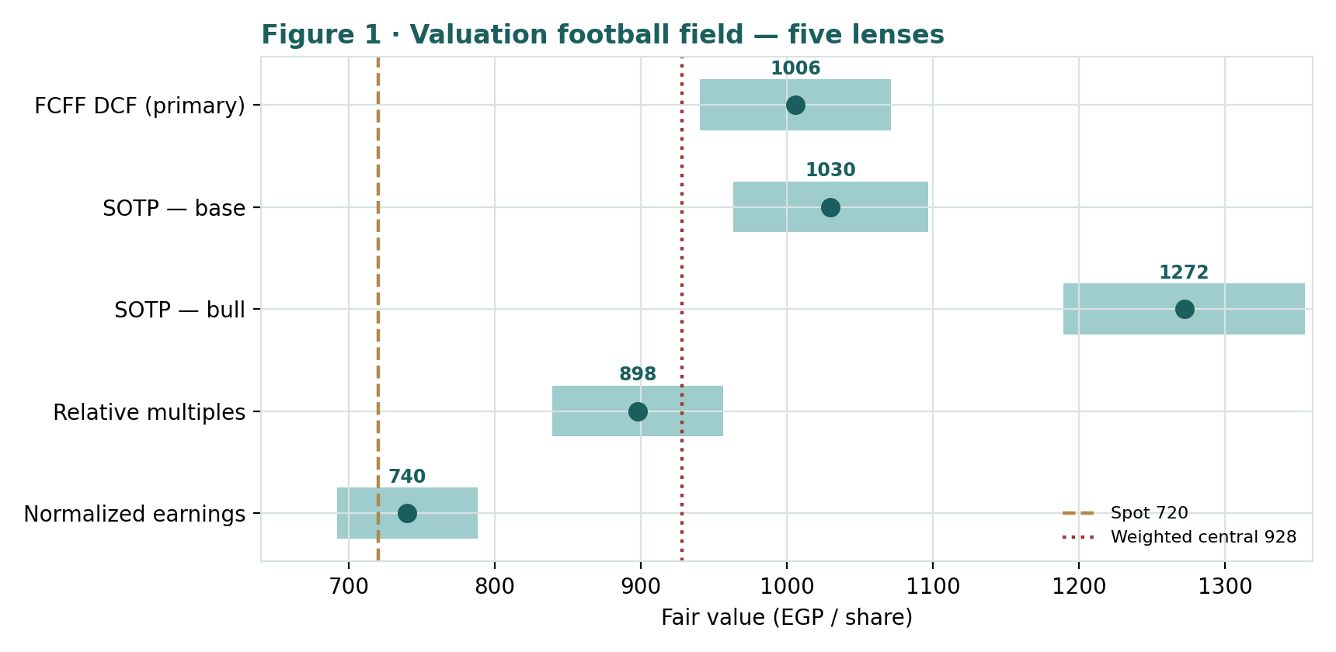
Figure 1 · Valuation football field — five lenses. Spot EGP 720 sits below the weighted central EGP 928; the normalized-earnings lens anchors the low end, the SOTP bull case the high end.
How to read this. The cluster is wide and sits above spot — the signature of a stock the market is pricing cautiously while several independent methods see more value. The spread from EGP 740 to EGP 1,272 is not noise; it is the precise measure of how much of the case rests on the balance sheet rather than the income statement.
1.6 The parts — a deeper look
The valuation rests on asset-level judgments. For each major piece we set out what it is, where it stands, and the key tension.
Asset | Scale | Mark basis | Key tension
Core E&C (Egypt/MENA) | 54% of backlog | EBITDA multiple | IFI-funded FX projects; thin margins
US (Weitz/Contrack) | 32% of backlog | EBITDA multiple | fastest-growing; data centers; +80.6%
Concessions | 912.5 MW + water | contracted equity | young, growing 6×; could re-rate up
BESIX 50% | €6.7bn backlog | equity income × | equity-accounted; own cycle
Materials/equip/FM | 13% of net income | earnings multiple | steady; export steel fabrication
Net cash | ≈ $540m reported | usable haircut | how much is client advances?

1.7 The crux — net-cash quality and the OCI combination
Two issues, not the discount rate, decide whether Orascom is cheap. The first is the quality of the net cash. A contractor collects large advance payments and bills ahead of cost on long projects; that cash sits on the balance sheet but is spoken for — it funds work in progress and is returned in substance as projects complete. Reported net cash of roughly $540m therefore overstates what is genuinely distributable to equity. We mark usable net cash at $400m as a base case; an aggressive reading takes the full figure, a conservative one closer to $300m. That single line moves the DCF and the EV/EBITDA lens by more than any change in WACC, because both add net cash on top of the operating value.
The second is the proposed combination with OCI Global. Orascom's shareholders approved the special resolutions on 22 January 2026; OCI's shareholders have not yet voted, and completion remains subject to regulatory approvals — and a Dutch court has previously blocked an OCI vote. The transaction is a genuine fork: completed on constructive terms it could re-rate the equity and reshape the capital structure; collapsed or completed on poor terms it removes a support the market has partly priced. We do not embed a deal outcome in the fundamental value; we treat it as the dominant catalyst and the widest branch of the scenario tree in §3 and §5.
1.8 Egypt, the dollar, the cross-listing, and the US pivot
Four forces specific to where and how Orascom trades shape the read. First, the company reports in dollars but the EGX line is quoted in pounds, so the USD/EGP rate (≈49.2) is the bridge between the fundamentals and the screen. A further EGP devaluation, counter-intuitively, tends to lift the pound value of a dollar-earning, dollar-reporting asset — the EGX line behaves partly as an FX hedge for domestic investors. Second, the Egyptian backlog is largely foreign-currency denominated and funded by international financial institutions, which insulates a meaningful slice of revenue from local-currency and local-budget risk. Third, country risk still sits in the discount rate: a pure-Egypt cost of capital would be ~18–22%, but with roughly two-thirds of backlog now outside Egypt we use a blended ~12% dollar WACC. Fourth, the US pivot is the structural story — a data-center and aviation backlog growing 80% a year is re-rating the company's geographic and end-market mix faster than its multiple has acknowledged.
1.9 DCF sensitivity — how much the cross-check moves
The DCF lands at EGP 1,006. The grid shows how the per-share figure moves with the discount rate and the terminal growth assumption. Even the conservative corners stay above the normalized-earnings anchor, while the generous corners approach the SOTP.
WACC \ g | 2.5% | 3.0% | 3.5% | 4.0% | 4.5%
10.5% | 1,078 | 1,118 | 1,164 | 1,217 | 1,280
11.0% | 1,030 | 1,065 | 1,104 | 1,150 | 1,202
12.0% | 949 | 976 | 1,006 | 1,040 | 1,078
13.0% | 884 | 905 | 928 | 954 | 983
14.0% | 830 | 847 | 866 | 886 | 908

Reading the grid. Across a plausible band — WACC 10.5–14% and terminal growth 2.5–4.5% — the DCF spans roughly EGP 830 to EGP 1,280. The base case (12.0% / 3.5%) sits comfortably above spot; the lens only approaches fair value at a high discount rate and low growth together.
2 Technical and price structure
Technicals describe the price, not the value. They matter here for one reason: Orascom has run roughly eight-fold from its 2021 lows and now sits in the upper quartile of its 52-week range, so the question is whether the trend is intact or exhausted. The honest read is the former, pausing. The moving-average stack is bullish — the 20-day (EGP 749), 50-day (EGP 686) and 200-day (EGP 514) are in rising order — but spot at EGP 720 has slipped just below the 20-day, a normal consolidation within an uptrend. Momentum is cooling: the MACD histogram is negative (MACD 12.1 below signal 24.9) and RSI is a neutral 50, neither overbought nor oversold.
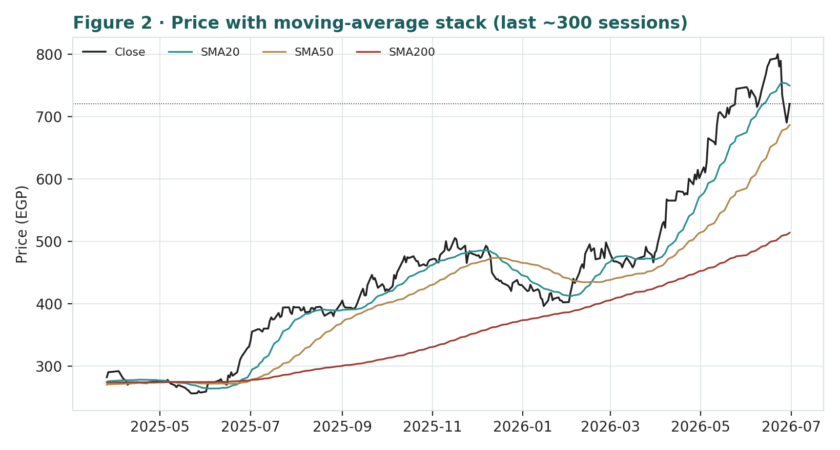
Figure 2 · Price with moving-average stack — a rising 20/50/200 structure; spot consolidating just below the 20-day after a strong advance.
Indicator | Reading | Interpretation
Spot vs 52-week range | 720 / 282–800 | upper quartile, near highs
20 / 50 / 200-day | 749 / 686 / 514 | bullish stack; spot just below 20-day
RSI (14) | 50 | neutral
MACD (12,26,9) | 12.1 / 24.9 / -12.8 | histogram negative; momentum cooling
Trend | above rising 200-day | primary uptrend intact

The honest technical read. The primary trend is up and the structure is constructive, unlike a stock breaking down. But the near-term tape is in a pause — below the 20-day, momentum fading — so a probabilistic price map, not a trend extrapolation, is the right tool for the next quarter.
3 Monte Carlo — a probabilistic price map
This models the price over the next three months, not the value. We simulate 50,000 paths (seed 42) from a 16-factor structure: seven continuous factors that compound a small daily drift, and nine discrete events that arrive with a probability and move the path when they land. The diffusion volatility is calibrated from Orascom's own five-year history with the volatility uplift validated in Appendix B (KVOL 1.40). Crucially, the drift is built only from external macro and event factors; it deliberately does not embed the fundamental value gap from §1. These paths diffuse from spot and do not assume the stock is cheap.
The seven continuous factors.
Continuous factor | 3M drift | 3M vol | Channel
US infrastructure / data-center capex cycle | +0.8% | 6% | Weitz; 32% of backlog, fastest-growing leg
Egypt/MENA FX-funded infra execution | +0.4% | 5% | 54% of backlog; IFI-funded, USD-denominated
EGP/USD translation & EGX cross-listing premium | +0.0% | 5% | USD reporting; EGP-line premium dynamics
EGX30 / foreign flows & EGP-hedge bid | +0.6% | 6% | market beta + trapped-EGP bid for USD assets
Input cost (steel/cement/labour) & margin | -0.6% | 4% | contractor gross-margin channel
Gulf infra-capex & oil-linked liquidity | +0.4% | 5% | KSA/UAE pipeline (Qurayyah, Project Wave)
Interest-rate / working-capital funding cost | -0.4% | 4% | CBE/USD rates; long-cycle WC funding

The nine discrete events.
Discrete event | Prob | Impact μ | Impact σ
OCI Global combination outcome | 45% | +1.0% | 8%
Major contract award (US DC / KSA power / rail) | 50% | +2.5% | 5%
Geopolitical / regional security shock | 30% | -9.0% | 5%
Quarterly earnings / backlog-burn surprise | 50% | +1.0% | 6%
EGP devaluation step / FX-regime move | 30% | +2.0% | 6%
Public-sector receivables / cash-conversion | 30% | -5.0% | 4%
Concessions BOO milestone / monetization | 35% | +2.5% | 4%
Claim / arbitration settlement | 30% | +2.0% | 5%
Dividend / capital-return surprise | 30% | +1.5% | 4%

Net three-month drift is a modest +1.7% — positive, reflecting genuine backlog momentum, but balanced by geopolitical and receivables risk and far smaller than the fundamental gap. Total three-month volatility is about 24% (≈ 47% annualized), and the distribution carries a mild right skew from the positive-event tail (contract awards, concessions milestones, a constructive OCI outcome).
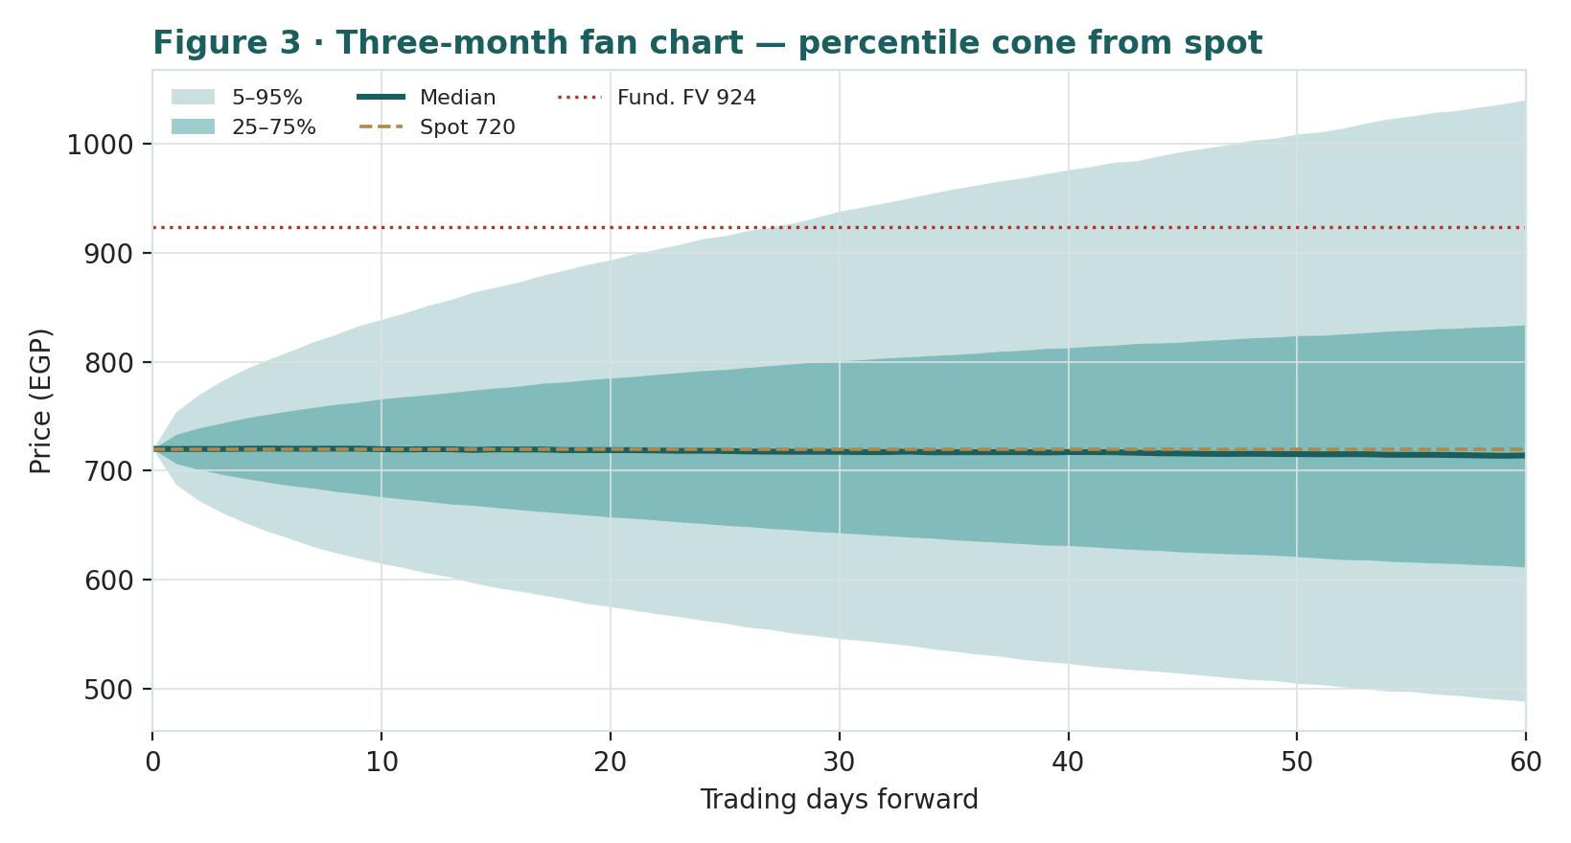
Figure 3 · Three-month fan chart — percentile cone from spot. Median roughly flat; the fundamental fair value (EGP 928) sits in the upper tail.
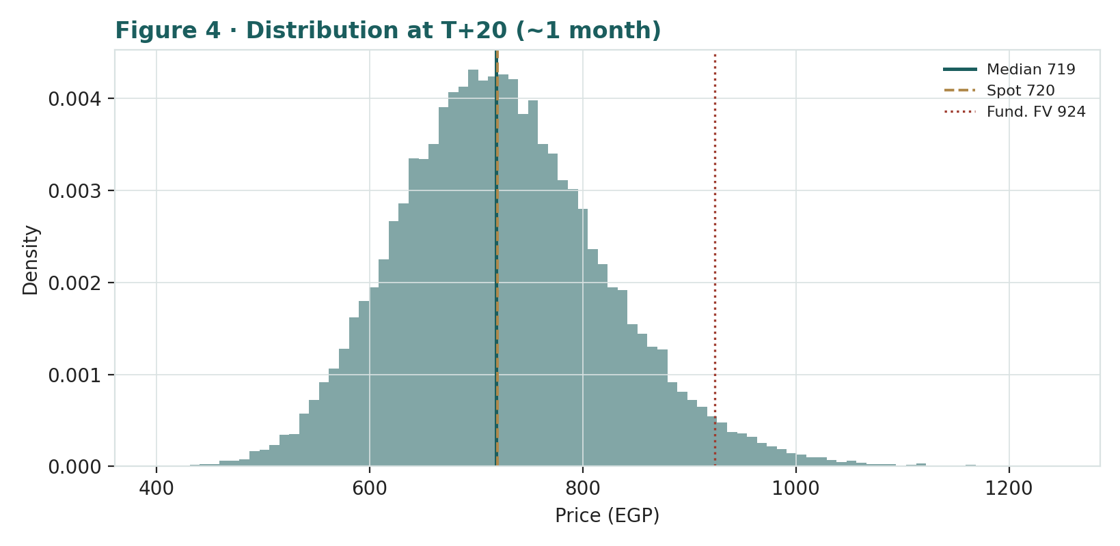
Figure 4 · Distribution of the price at T+20 (~1 month) — roughly two-sided around spot.
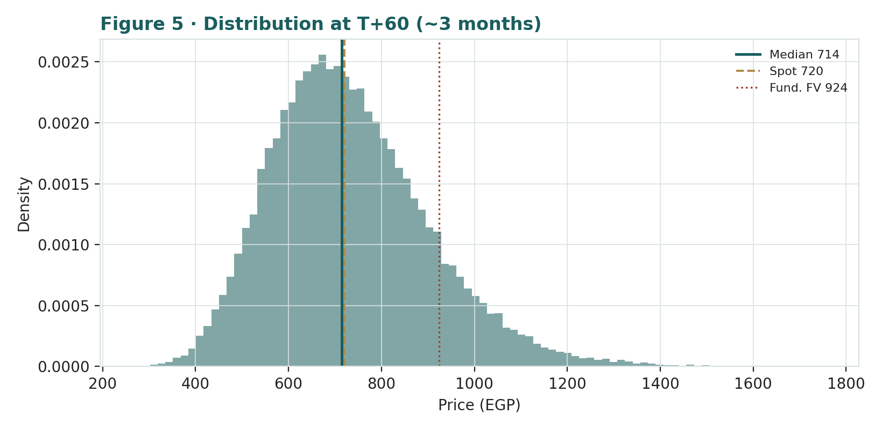
Figure 5 · Distribution of the price at T+60 (~3 months) — note the mild right skew and fat tails.
Horizon | 5% | 25% | Median | 75% | 95%
T+20 (~1m) | 575 | 658 | 719 | 785 | 893
T+60 (~3m) | 488 | 611 | 714 | 834 | 1,040

Touch probabilities — the chance the price reaches a level at any point in the window — are usually higher than end-point probabilities, because a path only has to touch the level once.
Level (EGP) | by T+20 | by T+60 | Note
760 | 58% | 75% | toward the 20-day
800 | 35% | 58% | prior 52-week high zone
850 | 16% | 41% | upside extension
928 (fair value) | 5% | 23% | the §1 central estimate
680 | 57% | 75% | first support
640 | 31% | 57% | toward the 50-day
600 | 14% | 40% | deeper pullback
560 | 5% | 25% | trend-test

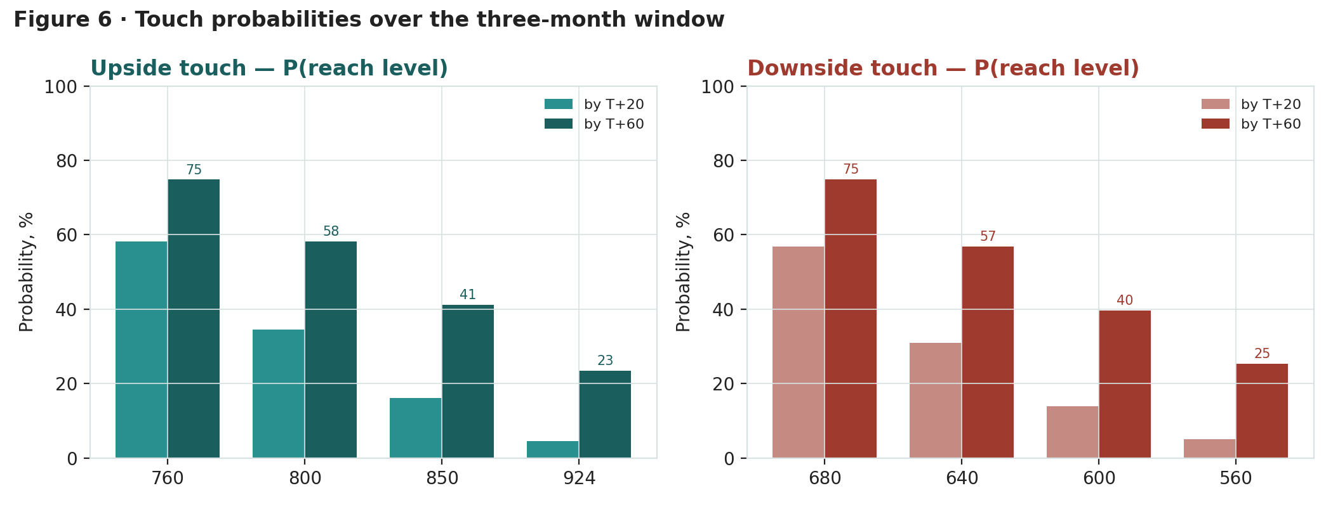
Figure 6 · Upside and downside touch ladders over the three-month window.
What the map says. Over three months the odds are roughly balanced around spot, tilted slightly to the upside by backlog momentum. A move up to the prior-high zone near EGP 800 is a coin-flip by quarter-end (58%); reaching the fundamental fair value of EGP 928 within the quarter is about 23% — possible, but an upper-tail outcome. This is the two-clocks point in numbers: the +29% fundamental upside is a twelve-month judgment, while the three-month price map says the stock is about as likely to test EGP 640 as EGP 800 along the way.
4 Comparison of the lenses, and a verdict
Lens | What it measures | Output | vs spot
FCFF DCF (primary) | going-concern cash flow + net cash + BESIX | EGP 1,006 | +40%
SOTP — base | separable assets at conservative marks | EGP 1,030 | +43%
SOTP — bull | separable assets at premium marks | EGP 1,272 | +77%
Relative multiples | EV/EBITDA, P/E, EV/Sales vs peers | EGP 898 | +25%
Normalized earnings | through-cycle earnings × fair multiple | EGP 740 | +3%
Monte Carlo (3-month) | probabilistic price map | median ≈ flat | two-sided

Verdict — modestly-to-meaningfully undervalued, conditional on the balance sheet and the deal. The weighted central estimate is EGP 928, about +29% above spot, and three of four fundamental lenses sit above the price. But the case is not unconditional: the normalized-earnings lens says the shares are already fair if you value them on sustainable earnings alone, and the asset lenses only pull the average up if the net cash is genuinely distributable and the concessions and BESIX marks hold. The OCI combination is the swing catalyst over the next year. Over the next quarter, the price map is roughly balanced — the upside is a twelve-month thesis to be accumulated patiently, not a three-month trade.
5 Catalysts to watch
- OCI Global combination (↑/↓, high impact). An OCI shareholder vote and regulatory clearances are the dominant near-term catalyst; constructive terms could re-rate the equity, a collapse removes a partly-priced support.
- US backlog conversion (↑). Evidence that the 80%-growing US data-center and aviation backlog converts to revenue and margin at Weitz is the clearest read on the structural re-rating.
- Net-cash clarity / capital return (↑). Any disclosure that sharpens how much cash is truly distributable — a buyback, a special dividend, or clearer working-capital reporting — directly tests the bull case.
- Major contract awards (↑). New mega-tenders in US data centers, KSA power (e.g. Qurayyah-scale), or Egyptian rail/metro add visible backlog and sentiment.
- Concessions milestones (↑). The 900 MW wind PPA and water BOO/BOOT assets reaching commercial operation crystallize the platform's growing value.
- Egypt receivables / FX (↑/↓). Public-sector payment timing and EGP moves drive cash conversion and the pound value of dollar earnings; a devaluation step can cut both ways for the EGX line.
- Geopolitical / regional security (↓). A MENA security shock raises the risk premium across project countries and is the main downside tail in the price map.
6 Reading the probability zones
Combining the fundamental anchors with the three-month price map gives a set of zones — descriptive, not directive.
Zone | Range (EGP) | What it would mean
Fundamental upside | 900 – 1,030 | toward the DCF/SOTP cluster; the value case playing out
Re-rating / prior highs | 780 – 900 | breaks the prior-high zone; momentum plus a catalyst
Fair-value consolidation | 680 – 780 | around spot and the normalized-earnings anchor
Pullback / trend-test | 600 – 680 | toward the 50-day; a healthy retracement
Stress | < 600 | a deal collapse or macro/geopolitical shock

7 Caveats and what would change our mind
- The net cash may be worth less than we mark. Our base case treats $400m of the ~$540m reported net cash as usable. If more is client advances, the DCF and EV/EBITDA lenses fall fastest, and the central estimate drifts toward the normalized-earnings anchor near spot.
- The OCI outcome is unknown and material. We embed no deal result in the fundamental value. A collapse or punitive terms would remove a support the market has partly priced; a clean, accretive combination could lift it above our range.
- Forecasts and balance-sheet detail are estimates. Several statement lines beyond reported headline totals are estimates anchored to disclosed figures; contractor working capital is volatile and our normalized drag may prove optimistic or conservative.
- Contractor earnings are cyclical and thin-margin. A 6% EBITDA margin leaves little error room; a few troubled projects or input-cost spikes can swing net income materially, which is why the normalized lens carries real weight.
- The Monte Carlo is a price model, not a forecast. It encodes our probability estimates for events that have not happened. The factor table is the model; reasonable people would set different numbers and get a different cone.
- RSI / momentum reminder. RSI ~50 is neutral and the MACD histogram is negative — momentum is cooling after a strong run, so near-term the tape may consolidate even if the twelve-month value case is intact.

Appendix A Financial statements (USD m)
Actuals (FY2023–FY2025) are from Orascom Construction's consolidated disclosure (results announcements and audited financial statements). FY2023 net income includes a ~$107m disposal gain; FY2025 includes a $29m net claim/arbitration gain. Forecasts (2026e–2030e) are illustrative, anchored to backlog and segment trajectory. Balance-sheet and cash-flow lines beyond reported totals are estimates.
A.1 Consolidated income statement (USD m)
Income statement | 2023a | 2024a | 2025a | 2026e | 2027e | 2028e | 2029e | 2030e
MEA revenue | 1,842 | 1,611 | 2,849 | 3,050 | 3,300 | 3,520 | 3,700 | 3,870
USA revenue | 1,600 | 1,644 | 2,201 | 2,500 | 2,750 | 2,980 | 3,200 | 3,430
Total revenue | 3,442 | 3,255 | 5,050 | 5,550 | 6,050 | 6,500 | 6,900 | 7,300
growth YoY | — | -5% | +55% | +10% | +9% | +7% | +6% | +6%
Operating expenses | (3,252) | (3,103) | (4,745) | (5,220) | (5,690) | (6,112) | (6,486) | (6,862)
EBITDA | 190 | 152 | 305 | 330 | 360 | 388 | 414 | 438
EBITDA margin | 5.5% | 4.7% | 6.0% | 5.9% | 6.0% | 6.0% | 6.0% | 6.0%
(−) D&A | (30) | (31) | (45) | (50) | (55) | (59) | (62) | (66)
Operating profit (EBIT) | 160 | 121 | 260 | 280 | 305 | 329 | 352 | 372
Net finance, FX & associates | 50 | 29 | 14 | 18 | 23 | 32 | 40 | 48
Pre-tax profit | 210 | 150 | 274 | 298 | 328 | 361 | 392 | 420
Tax & minorities | (51) | (32) | (79) | (88) | (100) | (115) | (127) | (139)
Net income (attrib.) | 159 | 118 | 195 | 210 | 228 | 246 | 265 | 281
net margin | 4.6% | 3.6% | 3.9% | 3.8% | 3.8% | 3.8% | 3.8% | 3.9%
of which one-offs | 107 | 0 | 29 | 0 | 0 | 0 | 0 | 0
Adjusted net income | 52 | 118 | 166 | 210 | 228 | 246 | 265 | 281
EPS (USD) | 1.44 | 1.07 | 1.77 | 1.91 | 2.07 | 2.23 | 2.40 | 2.55

Note. Revenue dipped in 2024 as the EGP devaluation compressed the dollar value of Egyptian work, then rebounded 55% in 2025 on US growth and project progress. Adjusted earnings strip the lumpy one-offs that flatter the headline in 2023 and 2025.
A.2 Consolidated balance sheet (USD m)
Balance sheet | 2023a | 2024a | 2025a | 2026e | 2027e | 2028e | 2029e | 2030e
Cash & equivalents | 696 | 1,041 | 1,100 | 1,180 | 1,270 | 1,360 | 1,450 | 1,540
Trade & other receivables | 1,200 | 1,728 | 2,050 | 2,250 | 2,450 | 2,630 | 2,790 | 2,950
Contract work in progress | 600 | 673 | 820 | 900 | 980 | 1,050 | 1,110 | 1,175
Inventories | 180 | 271 | 330 | 360 | 390 | 420 | 445 | 470
Total current assets | 2,676 | 3,713 | 4,300 | 4,690 | 5,090 | 5,460 | 5,795 | 6,135
Property, plant & equipment | 450 | 500 | 620 | 710 | 800 | 880 | 955 | 1,030
Concessions & infra assets | 250 | 275 | 330 | 370 | 410 | 450 | 485 | 520
Investments (BESIX & assoc.) | 300 | 330 | 360 | 386 | 414 | 444 | 476 | 510
Goodwill & other non-current | 420 | 382 | 490 | 520 | 550 | 580 | 610 | 640
Total non-current assets | 1,420 | 1,487 | 1,800 | 1,986 | 2,174 | 2,354 | 2,526 | 2,700
Total assets | 4,096 | 5,200 | 6,100 | 6,676 | 7,264 | 7,814 | 8,321 | 8,835
Trade & other payables | 1,500 | 2,033 | 2,560 | 2,810 | 3,050 | 3,270 | 3,470 | 3,670
Borrowings (current) | 200 | 230 | 250 | 265 | 280 | 290 | 300 | 310
Advances & billing in excess | 700 | 900 | 1,100 | 1,210 | 1,310 | 1,410 | 1,500 | 1,590
Total current liabilities | 2,400 | 3,163 | 3,910 | 4,285 | 4,640 | 4,970 | 5,270 | 5,570
Borrowings (non-current) | 250 | 290 | 310 | 325 | 340 | 360 | 375 | 390
Other non-current liabilities | 450 | 400 | 500 | 530 | 560 | 590 | 620 | 650
Total liabilities | 3,100 | 3,853 | 4,720 | 5,140 | 5,540 | 5,920 | 6,265 | 6,610
Equity attributable to owners | 696 | 873 | 873 | 996 | 1,149 | 1,284 | 1,408 | 1,537
Non-controlling interests | 300 | 474 | 507 | 540 | 575 | 610 | 648 | 688
Total equity | 996 | 1,347 | 1,380 | 1,536 | 1,724 | 1,894 | 2,056 | 2,225
Total equity & liabilities | 4,096 | 5,200 | 6,100 | 6,676 | 7,264 | 7,814 | 8,321 | 8,835
BVPS — attributable (USD) | 6.32 | 7.92 | 7.92 | 9.04 | 10 | 12 | 13 | 14
Net cash (cash − borrowings) | 246 | 521 | 540 | 590 | 650 | 710 | 775 | 840

Note. Totals are anchored to reported figures (total assets $5.2bn and equity $873.2m at end-2025; cash $1,041m at end-2024). The advances and billing-in-excess line is the reason reported net cash overstates distributable cash — it is the heart of §1.7.
A.3 Consolidated cash flow (simplified, USD m)
Cash flow | 2023a | 2024a | 2025a | 2026e | 2027e | 2028e | 2029e | 2030e
Operating cash flow | 217 | 645 | 520 | 470 | 500 | 540 | 575 | 610
Investing cash flow | 84 | (63) | (150) | (180) | (190) | (200) | (210) | (220)
Financing cash flow | (72) | 3 | (180) | (210) | (220) | (250) | (275) | (290)
Net change in cash | 229 | 584 | 190 | 80 | 90 | 90 | 90 | 100

The point of A.3 for the valuation. Operating cash flow is strong but volatile — $645m in 2024 was advance-driven, $217m in 2023 was not. That swing is exactly why the cash-conversion overlay (the Accountant's tool, below) matters and why we haircut net cash to a usable figure.

Appendix B Step 0 — calibration backtest
Before publishing any probabilistic price map we test the engine against Orascom's own five-year history: does a lognormal model, calibrated to trailing volatility with an uplift, produce three-month forecast distributions that are actually well-calibrated? We score realized prices against the forecast distributions across the history and check two things — the probability-integral-transform (PIT) histogram should be roughly uniform, and the stated 50/80/90% bands should contain the realized price at those rates.
Result. Orascom is a strongly-trending, fat-tailed name (annualized volatility ≈ 34%, excess kurtosis above 10), so it needs a wider volatility uplift than a large-cap — KVOL 1.40, versus 1.30 for a large-cap chip name and a 1.15 default. At that setting the calibration passes: the PIT is flat (no U-shape; quadratic coefficient ≈ 0) and not materially skewed. On clean non-overlapping windows (17 independent forecasts) a Kolmogorov–Smirnov test cannot reject uniformity (p ≈ 0.78). Overlap-corrected block-bootstrap 90% confidence intervals on coverage contain the nominal rate for all three bands: 50% achieved 47.4% [37.5, 57.3], 80% achieved 80.3% [69.9, 89.5], 90% achieved 91.4% [85.1, 96.8]. One honest note: the PIT mean is 0.56, meaning Orascom realized slightly above its own trailing-drift forecast — the uptrend kept accelerating — so the anchor is mildly conservative, not over-promising. The champion drift is retained.
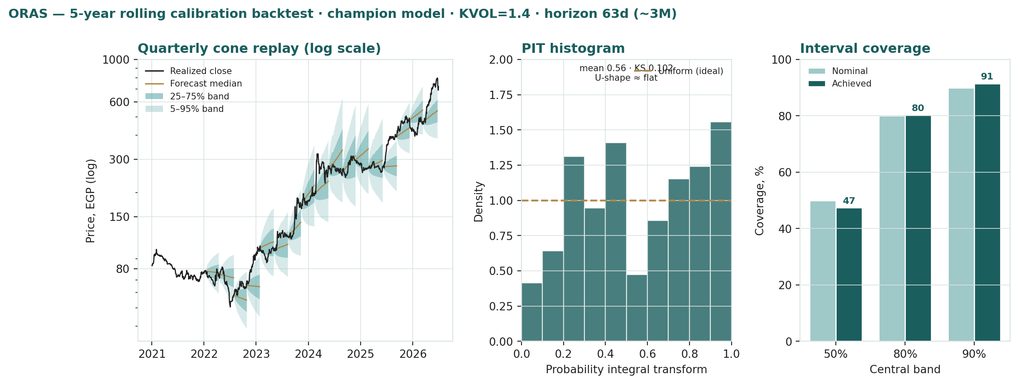
Figure B · Five-year rolling calibration — quarterly cone replay (log scale), PIT histogram, and interval coverage. KVOL 1.40, horizon ~63 trading days.
Appendix C Peer set, sector structure, and risks
C.1 The competitive map. Orascom competes across three arenas — global infrastructure, US commercial/data-center construction, and regional (Egypt/Gulf) EPC — and is benchmarked against a peer set that trades, broadly, at 4–8× EV/EBITDA and 8–14× earnings.
Peer | Market | EV/EBITDA | P/E
WeBuild (Salini) | Italy | ~4–5× | ~10–12×
Vinci | France | ~7–8× | ~13–15×
ACS / Hochtief | Spain | ~5–6× | ~11–13×
Hyundai E&C | Korea | ~4–5× | ~9–11×
Arabian Contracting | KSA | ~7–9× | ~14–18×
Elsewedy Electric | Egypt | ~4–5× | ~6–8×
Orascom (this study) | Egypt/UAE | ~4× | ~8.3×

C.2 Principal risks.
- Net-cash quality — the dominant analytical risk; reported net cash overstates distributable cash by the amount tied up in advances and bonding.
- OCI combination — binary corporate event; outcome and terms are unknown and not embedded in the fundamental value.
- Egypt / FX / receivables — public-sector payment timing and EGP moves drive cash conversion and the pound value of dollar earnings.
- Contractor cyclicality — thin margins leave little room for project losses or input-cost spikes.
- Geopolitical / regional security — a MENA shock raises the risk premium across project countries.
- Estimate risk — several statement lines and forward figures are estimates anchored to disclosed totals.

Appendix D Three (four) experts, four methods
Premise. Four independent experts, four genuinely different methods, none seeing the others. For a global contractor whose value is part cash flow, part assets, and part policy, four lenses earn their place — and they disagree, which is the signal. We cast the Earnings-power analyst, the Accountant, the Cash-returns analyst, and the Macro-Policy strategist. Each runs a different method, each derives a fair value from shown workings, and each states what would prove it wrong. The divergence is not averaged away; it is the map of where the value is contested.
D.1 Expert 1 — the Cash-returns analyst
Worldview and tradition. A business is worth the cash it returns over its life, and it creates value only when it earns above its cost of capital. Expert 1 looks past accounting earnings to free cash flow and to returns on invested capital — does each dollar of capital earn its keep, or quietly destroy value?
When it works / when it fails. Best for capital-intensive, steady cash generators where returns on capital are the crux; fails where reinvestment economics are genuinely changing, so past ROIC misleads — a live risk for Orascom as the US business scales.
Standard workings. (1) build FCFF — NOPAT + D&A − capex − change in working capital; (2) compute ROIC against WACC, the economic-profit spread; (3) discount the explicit free-cash stream plus a terminal value consistent with returns fading toward the cost of capital; (4) sensitivity on WACC and the fade speed.
Expert 1's workings | Value
Normalized FCFF base | $119m
WACC (USD, blended) | 12.0%
ROIC vs WACC | ~13% vs 12% — thin positive spread
Operating EV (DCF) | $1,613m
+ usable net cash + BESIX | $640m
Equity value | $2,253m
Fair value | EGP 980

Sensitivity on the swing input (WACC).
WACC | ROIC spread | Fair value (EGP)
11.0% | ~+2.0pp | 1,075
12.0% (base) | ~+1.0pp | 980
13.0% | ~0.0pp | 900

Worked example and verdict. Expert 1's DCF lands near EGP 1,005, which he trims to ~EGP 980 because the ROIC spread over WACC is thin — a contractor earns only modestly above its cost of capital, so the terminal value should not assume durable excess returns. Even so, he sees a stock trading well below the cash it generates plus the cash it already holds. Sensitivity: a one-point rise in WACC to 13% cuts his value to ~EGP 900; the fade speed matters less than the discount rate. Cross-examination: he tells Expert 2 that a fair multiple on earnings ignores the balance sheet — 'the cash is real and it's on top of the cash flow'; he concedes to Expert 3 that if the net cash is mostly advances, his bridge is overstated. Falsification: a structural fall in returns on capital, or proof that working-capital cash is not the company's to keep. What the price implies: at EGP 720 the market is valuing Orascom at roughly its operating cash flow alone, ascribing little to the net cash or BESIX.
D.2 Expert 2 — the Earnings-power analyst
Worldview and tradition. An operating company is worth a fair multiple of its sustainable, mid-cycle earnings. Expert 2 strips one-off peaks and troughs and asks what the business earns through the cycle and what the market should pay for it.
When it works / when it fails. Best for cyclical operating businesses with a track record and in relative-value contexts; fails at structural breaks, where the past is not the future — and Orascom's US re-weighting is exactly such a possible break.
Standard workings. (1) normalize revenue and margins to mid-cycle; (2) derive sustainable earnings and EPS; (3) apply a justified multiple versus the asset's own history and peers; (4) cross-check against EV/EBITDA and free-cash-flow yield.
Expert 2's workings | Value
FY2025 attributable net income | $194.8m
less one-off claim/disposal gains | −$29m
Normalized through-cycle net | $166m
Normalized EPS | ≈ $1.50
Justified P/E | 10.0×
Fair value | EGP 770

Sensitivity on the swing input (justified multiple).
Justified P/E | Implied equity (USD m) | Fair value (EGP)
9.0× | $1,492m | 690
10.0× (base) | $1,658m | 770
11.0× | $1,824m | 850

Worked example and verdict. On $166m of normalized earnings and a 10× multiple — fair for a thin-margin contractor with rising but volatile profitability and real country risk — Expert 2 gets ~EGP 740, nudged to ~EGP 770 for the credible US growth. To him the stock is roughly fairly valued: 'an 8x contractor is an 8x contractor; the cash flatters the EV multiple but it doesn't change what the business earns.' Sensitivity: 9× gives ~EGP 690, 11× ~EGP 850 — the multiple is the swing, and he will not pay a growth multiple for a contractor. Cross-examination: he tells Expert 1 and Expert 3 that adding a big cash balance to an earnings multiple is double-counting if the cash is working capital; he concedes that if the US franchise structurally lifts margins, his normalization is too low. Falsification: a durable margin re-rating up (US mix, concessions) or down. What the price implies: at EGP 720 the market is paying a fair, not cheap, multiple for the earnings — which is why he is the anchor against the bulls.
D.3 Expert 3 — the Accountant
Worldview and tradition. The Graham–Dodd realization school: a business is worth what its assets realize net of every claim, and reported profit is trusted only as it converts to cash. Especially apt where profit is booked years before the cash arrives — the definition of a long-cycle contractor.
When it works / when it fails. Best where the business is working-capital-heavy and value rests on separable assets; fails by systematically undervaluing a genuine compounding franchise — he may under-credit the US growth engine.
Standard workings. (1) mark each asset to a conservative realizable value with explicit haircuts; (2) test earnings quality via the operating-cash-flow-to-net-income bridge; (3) bridge to equity, less all claims and off-balance obligations, times a cash-conversion overlay; (4) sensitivity on the swing marks.
Expert 3's workings | Value
Core E&C (realizable EV) | $1,133m
Concessions (contracted, credited) | $330m
BESIX 50% (credited) | $240m
Materials/equip/FM | $205m
Reported net cash | $540m
less advance/bonding haircut (≈35%) | −$190m → $350m usable
Fair value | EGP 910

Sensitivity on the swing input (usable net cash).
Usable net cash | Cash-conversion read | Fair value (EGP)
$250m | advances dominate | 820
$350m (base) | moderate haircut | 910
$450m | most cash distributable | 980

Worked example and verdict. Expert 3 is the one expert who is both more bullish and more bearish than the others — bearish on the cash (he haircuts the reported $540m to ~$350m, because the operating-cash-flow-to-income bridge shows how much is advance-funded), but bullish on the hard assets (he credits the concessions platform and BESIX in full, which the market largely ignores). Netting these, he lands at ~EGP 910. Sensitivity: a deeper cash haircut to $250m usable pulls him to ~EGP 820; crediting concessions at a project-finance premium lifts him toward EGP 980. Cross-examination: he tells Expert 1 his net-cash add is too generous and tells Expert 2 his earnings multiple ignores $570m of separable assets — 'the balance sheet is a fact; the income statement is an opinion.' Falsification: a durable lift in cash conversion, or the concessions reaching binding, cash-generating maturity. What the price implies: at EGP 720 the market is crediting the contracting business and essentially none of the concessions platform or the BESIX stake.
D.4 Expert 4 — the Macro-Policy strategist
Worldview and tradition. In frontier and emerging markets, policy outranks fundamentals — the FX regime, the rate path, sovereign action, and here a specific corporate event — move value more than management does. Expert 4 prices the asset as a set of options on which world arrives.
When it works / when it fails. Best in policy-driven markets with binary catalysts and FX regimes in flux; fails through false precision — the probabilities are judgments, and a tree can miss the branch that grows.
Standard workings. (1) identify the policy and event levers that set value — here the OCI combination, the EGP path, the US infrastructure cycle, and regional security; (2) define bull/base/bear as configurations of those levers; (3) re-run the valuation under each so scenario values are derived; (4) probability-weight; (5) stress the weights.
Expert 4's scenario tree | Prob | Fair value (EGP)
Bull — OCI completes accretively, US converts, EGP stable | 30% | 1,150
Base — deal muddle-through, steady execution | 45% | 900
Bear — OCI collapses / geopolitical or receivables shock | 25% | 620
Probability-weighted | 100% | ~900

Sensitivity on the swing input (scenario weights).
Weight shift | Bull/Base/Bear | Weighted FV (EGP)
+15pp to bear | 15 / 45 / 40 | 790
base | 30 / 45 / 25 | 900
+15pp to bull | 45 / 40 / 15 | 1,010

Worked example and verdict. Probability-weighting his three worlds gives ~EGP 900, but the point is the range, not the point: EGP 620 to EGP 1,150. The OCI vote is the branch that moves his tree, and it is unresolved. Sensitivity: shifting 15 points of probability from base to bear (a deal collapse becoming likely) drops his weighted value below EGP 800; the EGP path is second-order because a devaluation cuts both ways for a dollar-earning, pound-quoted line. Cross-examination: he tells the other three that none of them priced the OCI vote or the country risk — 'you are all valuing a company that may be about to change shape.' He absorbs their fair values as sub-cases: Expert 2's earnings view is his base, Expert 1's and Expert 3's asset views are his bull. Falsification: a fourth, unmodelled shock, or the scenario set being mis-specified. What the price implies: at EGP 720 the market is leaning toward his bear-to-base blend — pricing deal and country risk heavily, and giving little weight to the constructive branch.
D.5 The four in one room
Put the four in front of the single fact they most disagree on — the ~$540m of reported net cash, and the OCI vote behind it.
Expert 1: 'The cash is real and it sits on top of the cash flow. At this price you're paying for the operating business and getting the balance sheet free.'
Expert 2: 'It's an 8x contractor. The cash flatters the EV multiple, but it doesn't change what the business earns through the cycle — and I won't pay a growth multiple for EPC.'
Expert 3: 'Half that cash is client advances — show me what's truly distributable. But you're all ignoring the concessions platform and BESIX, which are worth real money the market isn't paying for.'
Expert 4: 'You're all valuing a company that may be about to merge. The OCI vote is the branch that moves the tree, and it hasn't happened. Price the option, not the point estimate.'
Same fact, four readings: a free balance sheet (Expert 1), a flattered multiple (Expert 2), mismarked assets and overstated cash (Expert 3), and an unpriced corporate event (Expert 4). That is the whole valuation in one exchange.
D.6 Reading the divergence
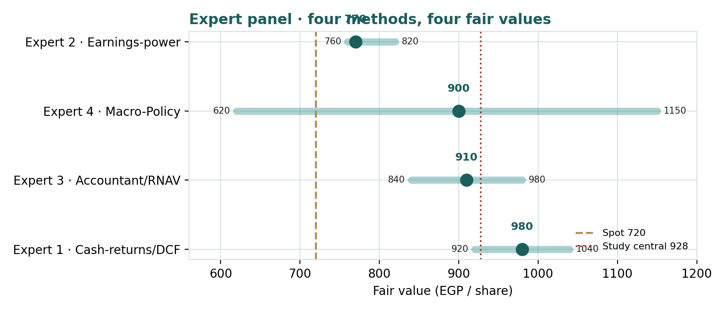
Figure D · The four experts' fair values and ranges, against spot and the study central.
Expert | Fair value (EGP) | The one assumption driving it
Expert 1 · Cash-returns | 980 | net cash + BESIX are real and additive to FCFF
Expert 3 · Accountant | 910 | concessions/BESIX under-marked, but net cash haircut
Expert 4 · Macro-Policy | 900 (620–1,150) | the probability the OCI deal completes constructively
Expert 2 · Earnings-power | 770 | the justified multiple on through-cycle earnings

What the spread measures. The experts cluster near EGP 900 with one outlier — Expert 2's earnings-based EGP 770 — and that gap is the precise measure of how much of Orascom's value rests on the balance sheet rather than the income statement. Value the company on what it earns, and it is roughly fair. Value it on what it owns and the cash it generates, and it is cheap. The difference between those two worlds is the net cash and the separable assets — and whether the OCI combination lets the market re-rate them. The divergence is not a flaw in the analysis; it is an accurate picture of a contested situation, and it is why the central estimate is a distribution, not a point.

About this series
Testahil publishes independent, educational valuation studies. Each is an attempt to reason transparently about what a security might be worth, using several independent methods and an explicit, calibrated probability model — and to record those judgments so they can be scored against what actually happens. The studies present distributions and fair-value ranges, not recommendations, ratings, or price targets. The expert personas are analytical lenses, not individuals, and recur across studies so each can accumulate a track record.
Disclosure & Disclaimer
Not investment advice. This document is educational and informational only. It is not, and must not be relied upon as, investment advice, a recommendation, an offer, or a solicitation to buy or sell any security. It does not constitute a rating or a price target.
No licence; no advisory relationship. The preparer is not registered or licensed with any securities or financial regulatory authority, including Egypt's Financial Regulatory Authority (FRA), and no advisory, fiduciary, or other relationship is created by this document.
Holdings disclosure. The preparer may hold, and may in the future take or dispose of, a position in the security discussed.
Sources & accuracy. Reported financial and operating figures are drawn from Orascom Construction's public disclosure (results announcements and audited financial statements) and other public sources believed reliable but not independently verified. Several balance-sheet, cash-flow, and forward figures are estimates anchored to disclosed totals and are flagged as such. Backlog and new awards are non-IFRS management estimates. Errors and omissions may exist.
Forward-looking statements. Any statements about the future are estimates subject to risks and uncertainties; actual results may differ materially. The Monte Carlo simulation encodes subjective probability judgments and is a price model, not a forecast.
No reliance; your responsibility. Do your own research and consult a licensed professional before making any decision. You are solely responsible for your own investment decisions.
Currency & figures. Orascom Construction reports in US dollars (USD); the EGX line trades in Egyptian pounds (EGP). Per-share figures are converted at the USD/EGP rate stated in the assumptions (≈49.2 as of 29 June 2026) and will change with the exchange rate. Rounding may cause totals to differ slightly.
TESTAHIL · Independent Valuation Study · Educational Analysis · Orascom Construction PLC (EGX: ORAS) · edition 30-06-2026

