Independent Valuation Study — Educational Analysis
Orascom Development Egypt (EGX: ORHD)
Fundamental analysis · Technical analysis · Monte Carlo simulation — one integrated read
Anchor: EGP 39.30 (24 Jun 2026 close) · 1.13bn shares (pre-bonus) · mkt cap ~EGP 44.4bn · net debt ~EGP 2.2bn (~0.2× EBITDA) · majority-owned by Orascom Development Holding AG (SIX: ODHN) · free float the listed remainder · prices & probabilities computed 24 Jun 2026 from the attached ORHD daily price history (3 Jan 2021 – 24 Jun 2026) · independent bottom-up valuation, derived project inputs · a 2.22-for-1 bonus issue (approved 8 Jun 2026) is shown as a memo only and is not yet reflected ex.
READ FIRST — what this document is, and is not. This study is a valuation exercise and an expression of personal analytical opinion, published free of charge for educational purposes: it shows how one analyst applies fundamental, technical and probabilistic methods to a listed company, and invites scrutiny of that methodology. It is NOT investment advice, NOT a recommendation or solicitation to buy, sell or hold any security, and NOT directed at the circumstances of any reader. The preparer is not licensed by the Egyptian Financial Regulatory Authority (FRA) or any other regulator, provides no financial consultancy, manages no money, and accepts no fees, funds or clients. See the Disclosure & Disclaimer at the end. All values are model outputs presented as ranges and distributions because no single number should be relied on. Project-level inputs are DERIVED estimates calibrated to disclosed totals and market comparables — Orascom Development Egypt publishes no project-level economics — and are flagged throughout. Consult a licensed financial advisor before any investment decision.

Headline
The model’s read: the three-month distribution sits roughly balanced around spot, but the fundamental work points materially higher — the stock trades at a meaningful discount to a bottom-up RNAV whose upside concentrates in an under-monetized El Gouna land bank. An independent, clean-sheet bottom-up build — every destination valued from units × price/m² and m² × construction-cost/m², the El Gouna and Taba hotels and the town-management / retail / marina base valued as separate EBITDA-multiple segments, the Byoum JV carried at ORHD’s economic share, minority treated as negligible, and modest net debt (~EGP 2.2bn) subtracted — puts risk-adjusted fair value at EGP 53.79, ~37% above the EGP 39.30 market; full execution of the modelled pipeline is worth EGP 70.52 (+79%). A consolidated whole-company DCF (EGP 63.56) corroborates the asset-based build, and a four-lens synthesis — SOTP/RNAV, DCF, relative multiples and a discount-to-NAV reading — centres on ~EGP 55.8. Unlike the net-cash developer, ORHD carries modest net debt (~0.2× EBITDA) and capitalises most borrowing costs into work-in-progress, so the P&L finance line is suppressed and the discount-to-NAV is an El Gouna land-monetization and Red Sea revaluation story, not a balance-sheet anomaly. The defensible floor — contracted backlog plus the two operating segments, all risk-weighted, with every unlaunched phase and the terminal value at zero and net debt subtracted — is ~EGP 22.5, well below spot. Technically the picture is a mature, stretched advance: price closed 39.30 a whisker below the 39.60 all-time high after a ~108% run off the 18.9 low, riding above a rising stack of moving averages (SMA20 37.7, SMA50 33.6, SMA200 26.5), with RSI(14) elevated at ~65 (Wilder) — a strong, intact uptrend, stretched but not yet at the classic 70 overbought line, with blue-sky above the high and a 2.22-for-1 bonus issue pending that will optically reset the quoted price. A single 10-factor Monte Carlo (CBE rate, FX, inflation, EGX flows, Brent/Gulf liquidity, geopolitics, El Gouna / land monetization, launch execution, Red Sea / coastal season, credit; 50,000 paths, seed 42) puts the T+20 median at ~40.2 and the T+60 median at ~42.1, with a right tail to ~60.
Net: the stock trades below the model’s risk-adjusted value — the gap is the El Gouna land bank and the Red Sea revaluation, not the balance sheet — while the tape is extended near its all-time high; the right tail of the distribution belongs to land monetization, coastal demand and launch execution, the left tail to FX/geopolitical macro and a momentum reversal from these stretched levels. This study estimates values and probabilities — it does not recommend actions, and the project-level inputs that drive the upside are the author’s estimates, not company disclosure.
Company overview — Orascom Development Egypt at a glance
Orascom Development Egypt (EGX: ORHD) is the Egyptian platform of Orascom Development Holding AG, the Swiss-listed integrated developer founded by the Sawiris family. It is not a pure homebuilder but an integrated town developer, operator and hospitality group with three businesses: a development engine spanning several large master-planned destinations — El Gouna and Makadi Heights on the Red Sea, O West in West Cairo, Taba Heights in Sinai, and Byoum in Fayoum; an owned-hotel portfolio of roughly 4,900 keys at El Gouna and Taba Heights, managed by Orascom Hotels Management; and a recurring-income base of town-management fees, retail, marina and commercial leasing inside the communities. The defining asset is the land: ORHD controls one of the largest coastal land banks in Egypt — El Gouna alone spans some 37m m², much of it still undeveloped — carried at low historical cost. Unlike the net-cash developer, the balance sheet carries modest net debt (~EGP 2.2bn, ~0.2× EBITDA), with most borrowing costs capitalised into work-in-progress, so the reported finance line understates gross debt service.
Item | Value (as disclosed / derived)
Listing / sector | EGX: ORHD · real-estate development & hospitality
Parent | Orascom Development Holding AG (SIX: ODHN) — majority
Free float | listed remainder (Sawiris / ODH control)
Share price (24 Jun 2026 close) | EGP 39.30
Shares outstanding (pre-bonus) | ~1.13bn
Bonus issue (approved 8 Jun 2026) | 2.22-for-1 (memo; not yet ex — ~3.65bn shares post)
Market capitalisation | ~EGP 44.4bn
Net debt (debt − cash) | ~EGP 2.2bn (~0.2× EBITDA)
FY2025 revenue | EGP 24.9bn (+14% YoY)
FY2025 EBITDA | ~EGP 8.3bn
FY2025 net profit (attributable) | ~EGP 5.55bn (EPS ~4.91)
Book value per share (FY2025) | ~EGP 13.3
Total assets (FY2025) | ~EGP 59.0bn
Deferred revenue / committed backlog (est.) | ~EGP 42.4bn
Customer advances / contract liabilities (FY2025) | ~EGP 22bn
Company-level figures are vendor-/filing-sourced and should be verified against the audited FY2025 accounts; several balance-sheet lines are estimates pending the audited statements. Backlog, segment and project splits are the author’s derived estimates, not company disclosure. The 2.22-for-1 bonus issue was approved on 8 Jun 2026; the smooth quoted price series implies it is not yet ex, so this study values the ~1.13bn pre-bonus share count and shows the post-bonus count as a memo only.
Shareholding. Orascom Development Holding AG holds a controlling majority of ORHD; the public free float is the listed remainder. The operating subsidiaries inside ORHD are effectively wholly owned, so subsidiary minority interest is negligible; the parent stake is the listed holding company’s interest in ORHD itself, not a minority inside the company. The pending 2.22-for-1 bonus issue will multiply the share count without changing economic value — a mechanical re-base of the quoted price, not a dilution.
Development portfolio. Eight development pieces plus a committed backlog. The destinations span the Red Sea (El Gouna and its premium waterfront, Makadi Heights and a new Makadi seafront plot), West Cairo (O West), Sinai (Taba Heights) and Fayoum (Byoum), complemented by a strategic landbank. Project-level economics are detailed in §1.6; the snapshot below positions the portfolio. Areas and stages are derived/indicative.
Project | Location | Stage | Est. monetizable area
El Gouna | Red Sea | Flagship integrated town; large undeveloped land | ~7.0m m²
O West | West Cairo (6th October) | Cairo growth engine; under development | ~4.5m m²
Makadi Heights | Red Sea (Hurghada) | Second Red Sea town; selling | ~2.5m m²
El Gouna Waterfront | Red Sea | Premium marina/seafront phases | ~1.0m m²
Makadi Seafront | Red Sea | New ~1.0m m² seafront plot | ~1.0m m²
Taba Heights | Sinai | Established resort town; recovery | ~1.5m m²
Byoum | Fayoum | Lakeside; JV at economic share | ~1.2m m²
Landbank / other | Various | Strategic land | ~3.0m m²
Monetizable areas are derived/indicative — the realistically-developable portion of each destination over the modelled horizon, not gross land; Orascom Development Egypt does not disclose project-level economics. El Gouna’s ~37m m² gross land bank is far larger than the ~7m m² modelled as near-to-medium-term saleable product, with the remainder treated as amenity, reserve and very-long-dated.

1. Fundamental analysis
How a developer is valued — and how this section is built. A property developer is not a single cash stream, and it is not valued like an industrial company. The standard practice among international research houses is to value a developer primarily on a sum-of-the-parts revalued net asset value (RNAV): each destination, the landbank and the recurring assets are valued separately and summed to a gross asset value, then cash is added and debt subtracted to reach net asset value, and a discount-to-NAV is applied to reflect how the market prices the sector. A consolidated discounted cash flow (DCF) and trading multiples serve as cross-checks. The key point — and the reason a developer’s accounts behave the way they do — is that the business is valued on the worth of its assets and the cash they generate, NOT by projecting a decades-long balance sheet: inventory, work-in-progress and customer advances are point-in-time stocks that net to zero as a project completes, not a forecast series to be rolled forward for twenty years. This study follows that practice. It presents four fundamental lenses — (1) SOTP / RNAV, (2) consolidated DCF, (3) relative multiples, and (4) a discount-to-NAV reading — and then synthesises them into a single representative figure and a range. Projected statements are shown only over a near-term five-year horizon, where a balance sheet is informative; the valuation itself rests on project cash flows and asset values.
The building blocks. Orascom Development Egypt is an integrated developer: a development business spanning several large destinations, an owned-hotel portfolio at El Gouna and Taba Heights, and a recurring-income base of town-management, retail, marina and commercial income. Each destination is valued as its own DCF and summed (the SOTP); hotels and recurring income are valued on EBITDA multiples appropriate to those asset types. The committed backlog and the mature selling phases are the existing business; the new Makadi seafront plot, the premium El Gouna waterfront and the very-long-dated El Gouna land are pipeline option value — worth a great deal if they execute, little if they don’t — so each is weighted by an execution probability. Minority is negligible (the operating subsidiaries are effectively wholly owned), and the Byoum JV is carried at ORHD’s economic share. Net debt is subtracted to reach equity value.
Each destination is built bottom-up from its unit mix priced per square metre, with construction and land costed per square metre, and only the unsold remainder is valued — already-sold units sit in the committed backlog, so nothing is double-counted. Each cohort carries an EGP price escalator (~14%/yr) on a 10%-down-plus-instalment collection schedule; a 5% perpetual-growth (Gordon) terminal value captures development beyond the modelled pipeline. No project-level data is disclosed by the company: the unit mixes, sold-percentages, buildable ratios, per-project prices and construction costs, the segment EBITDA and the backlog split are the author’s estimates, calibrated so that the model reproduces Orascom Development Egypt’s disclosed FY2025 totals (revenue ~EGP 24.9bn, net profit ~EGP 5.55bn, total assets ~EGP 59bn, customer advances ~EGP 22bn). They are flagged as blue inputs in the companion Excel and are illustrative, not authoritative.
1.1 Method 1 — Sum-of-the-parts / revalued net asset value (RNAV)
The primary lens for a developer. Each business is valued by the method that fits it and summed to an operating enterprise value, then net debt is subtracted. The column shows the risk-adjusted (execution-weighted) per-share contribution; full execution removes the execution haircut and is noted at the foot.
Component (bottom-up build) | Risk-adj EGP/sh | What it is
O West | 9.80 | ~4.5m m² West Cairo growth engine; under development
El Gouna | 9.52 | ~7.0m m² modelled (of ~37m gross); Red Sea flagship
Contracted backlog | 4.56 | already sold (~EGP 42.4bn est.); collected over ~5 yrs
Makadi Heights | 4.06 | ~2.5m m² second Red Sea town; selling
El Gouna Waterfront | 2.44 | premium marina/seafront phases (risk-weighted)
Makadi Seafront + Byoum + Taba | 3.11 | new seafront plot + Fayoum JV + Sinai (risk-weighted)
Landbank + terminal | 2.93 | strategic land + 5% g terminal
Development + backlog subtotal | 36.0 | the property engine
Hospitality (El Gouna + Taba hotels) | 14.22 | ~4,900 keys — EBITDA × 7.0×
Recurring income (town mgmt / retail / marina) | 5.64 | annuity base — EBITDA × 7.5×
Operating EV / share | 55.74 | all three businesses, risk-weighted
Less: net debt (~EGP 2.2bn) | −1.95 | debt − cash, parent-attributable
Less: minority | 0.00 | negligible — operating subsidiaries wholly owned
Base-case equity value | 53.79 | +37% vs 39.30; full execution EGP 70.52 (+79%)
Figures are rounded to two decimals; per-stream components may not sum exactly to the subtotals shown. Reconciles to the Valuation sheet of the companion Excel.
Full-execution variant. The bridge above is risk-adjusted (each line weighted by its execution probability). Setting every probability to 100% — all destinations, the backlog, both segments and the terminal value delivering as modelled — lifts operating EV to EGP 72.46/share and equity value to EGP 70.52 (+79% vs 39.30). The distance between the two, EGP 53.79 versus 70.52, is the execution haircut the risk-adjusted case applies — wider here than for a mature net-cash developer because much of ORHD’s value sits in long-dated, undisclosed El Gouna land.
1.2 Method 2 — Consolidated discounted cash flow (FCFF)
A whole-company cross-check. Rather than summing project DCFs, the consolidated DCF treats Orascom Development Egypt as one unlevered free-cash-flow stream — total collections less construction, land, SG&A, overhead and tax — discounted at the same 18% WACC with a 5% perpetual-growth terminal value, with the hotel and recurring segments and net debt then added. It returns EGP 63.56/share. That it lands within ~10% of the SOTP full-execution figure (70.52) is the point: two independent constructions of the same business corroborate each other — the test a single method cannot pass on its own. The ~10% gap (DCF below SOTP) reflects the consolidated DCF’s heavier near-term discounting of the long-dated El Gouna stream that the per-destination SOTP values more granularly.
1.3 Method 3 — Relative multiples and discount-to-NAV
Where the intrinsic methods ask what the assets are worth, relative multiples ask what the market pays for comparable developers. The EGX real-estate sector trades around 8–9× trailing earnings and ~1.9× sales, and developers characteristically trade at a discount to NAV. Each row pairs Orascom Development Egypt’s current multiple with a fair range drawn from sector and peer levels, and the implied equity value per share.
Lens | ORHD now | Fair range | Implied EGP/sh
Price / book (BVPS ~EGP 13.3) | 2.96× | 2.0 – 3.0× | 26.6 – 39.9
Price / earnings (FY25 EPS ~4.91) | 8.0× | 8 – 11× | 39.3 – 54.0
EV / backlog (~EGP 42.4bn deferred) | 1.1× | 0.9 – 1.3× | 33.8 – 48.8
Discount to RNAV | 27 – 44% | 15 – 25% | 53.0 – 60.0
Relative blended midpoint | — | — | ≈42.0
The relative lenses cluster around EGP 42 — below the intrinsic NAV/DCF of ~54–71 but, unlike the net-cash developer, ABOVE the current price. On near-term earnings ORHD screens roughly in line with the sector (P/E ~8×), even as it looks discounted against its asset base. That gap IS the structural discount-to-NAV the sector carries; the two families of method answer different questions and are deliberately not blended into one number without judgement.
1.4 Fundamental valuation — synthesis
Four lenses, one picture. For an asset-rich developer carrying a large, partly-contracted landbank, the intrinsic methods (SOTP/RNAV and consolidated DCF) carry the most weight; relative multiples enter as a market-reality cross-check. The weighted figure below is the study’s single representative fundamental value — but the range, not the point, is what matters.
Fundamental method | EGP/sh | vs spot | Weight
SOTP / RNAV — risk-adjusted | 53.79 | +37% | 35%
Consolidated DCF (FCFF) | 63.56 | +62% | 25%
SOTP / RNAV — full execution | 70.52 | +79% | 15%
Relative multiples — blended | 42.00 | +7% | 25%
Weighted central fundamental value | ≈55.8 | +42% | 100%
Figures are rounded; the weighted central value is EGP 55.79. Weights are judgemental, reflecting an asset-rich developer best anchored on intrinsic value.
Reading it. The fundamental range runs from a defensible floor of ~EGP 22.5 — the committed backlog plus the two operating segments, all risk-weighted, with every unlaunched phase and the terminal value set to zero and net debt subtracted — to a full-execution ceiling of EGP 70.5, with a central estimate near EGP 55.8. At spot 39.30 the market prices a 27% discount to the risk-adjusted NAV and 44% to the gross NAV — wide for a developer of ORHD’s quality, which is the same as saying the market ascribes little to the unsold El Gouna land bank and the Red Sea revaluation. Note the ordering is the orthodox one here — the risk-weighted floor (~22.5) sits below the market price, so the discount is to the upside case, not a sub-net-asset anomaly; the dominant swing is the derived El Gouna land base and its execution probability, which should be scrutinised first.
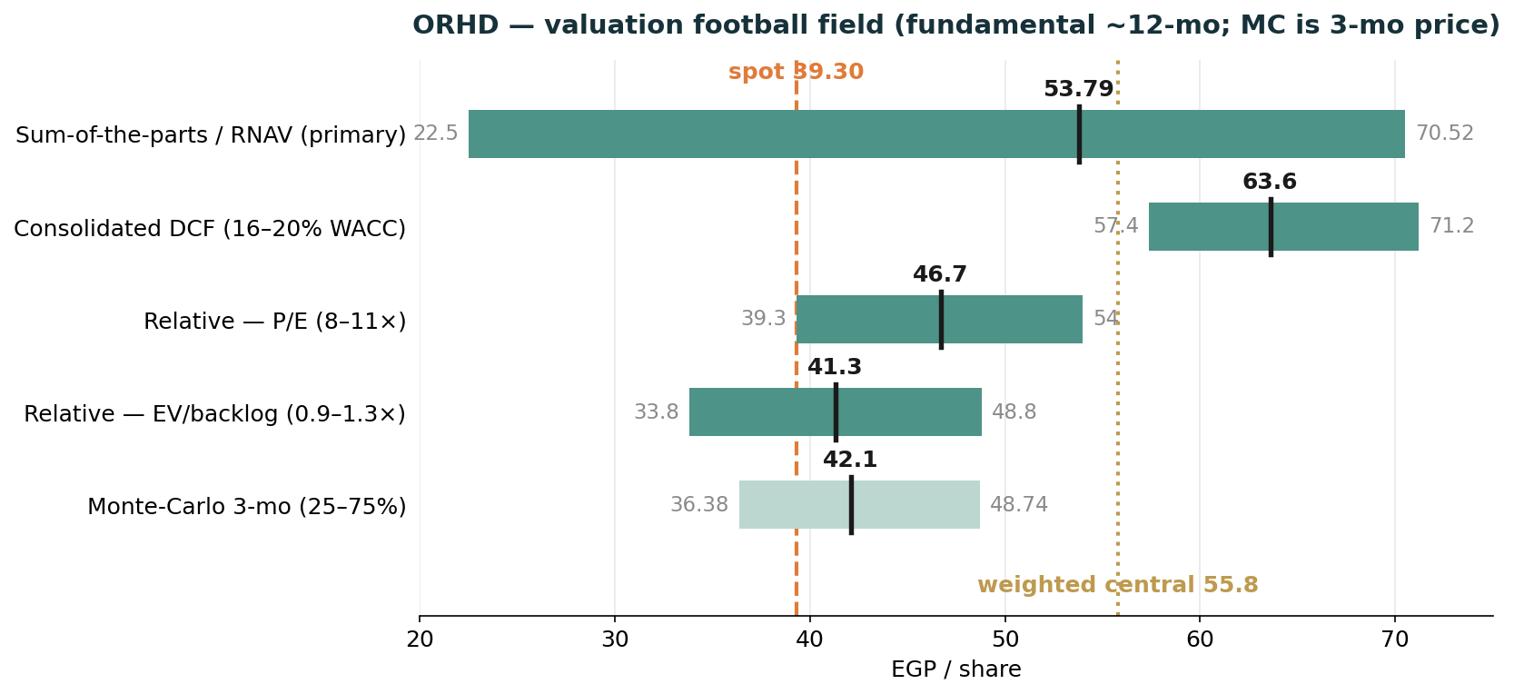
Figure 1. Valuation football field. Each bar is a method’s range; the dark mark is its central estimate. The fundamental lenses (SOTP/RNAV, consolidated DCF, relative multiples) are ~12-month intrinsic values: SOTP spans the bear floor (22.5) to full execution (70.52) with a risk-adjusted central of 53.79; the consolidated-DCF band is the 16–20% WACC range around 63.56; the relative lenses are the implied ranges from §1.3. The Monte-Carlo bar (lighter) is the 3-month price interquartile (25–75%, median 42.1) — a different horizon answering a different question, shown for context only. Dashed: spot 39.30; dotted: the weighted central fundamental value 55.8 (intrinsic-anchored). At spot the market sits below every fundamental lens and at the lower edge of the three-month price distribution — the gap is the unsold El Gouna land bank.
1.5 The three operating streams — development, hospitality, recurring
The base value is the sum of three businesses valued by the method that fits each: development + backlog by discounted cash flow (~EGP 36.0/sh risk-adjusted), and two operating segments capitalised on EBITDA multiples. Hospitality and recurring income are distinct — different revenue, different cyclicality, hence different multiples — and the model keeps them apart. The companion Excel carries a dedicated Segments sheet; the table below sets all three streams side by side.
Dimension | Development + backlog (DCF / SOTP) | Hospitality (El Gouna + Taba hotels) | Recurring income (town / retail / marina)
What it is | Integrated towns sold as units — El Gouna, O West, Makadi Heights, Taba, Byoum — plus the committed backlog | ~4,900 owned keys at El Gouna and Taba Heights, managed by Orascom Hotels Management | Town-management fees, El Gouna retail/marina, Makadi commercial inside the communities
Revenue driver | Units × price/m², collected over down-payment + instalments — mostly EGP | Room nights × ADR + F&B + events — partly USD | Rents + fees + memberships — mostly EGP
Cyclicality | Cyclical — launch timing, mortgage availability, FX on build cost | High — tourism, FX, seasonal (Red Sea) | Low — contractual, sticky
Revenue / EBITDA (FY est.) | Valued on project cash flows, not an EBITDA multiple | ~6.0 / 2.70 (~45% owned-asset margin) | ~2.0 / 1.00 (~50% blended)
Valuation | DCF per destination (SOTP), + backlog + terminal | EBITDA × 7.0× (for tourism/FX cyclicality) | EBITDA × 7.5× (an annuity premium)
Risk-adj EV (EGP bn) | ~40.7 | 16.1 | 6.4
Contribution / share | ~36.0 | 14.22 | 5.64
Key fundamentals — FY2025: revenue ~EGP 24.9bn (+14% YoY); attributable net profit ~EGP 5.55bn (EPS ~4.91). Roughly a quarter of revenue is hospitality and recurring town income — the integrated-town model that distinguishes ORHD from a pure homebuilder. The balance sheet carries modest net debt (~EGP 2.2bn, ~0.2× EBITDA); critically, ORHD capitalises most borrowing costs into work-in-progress, so the P&L finance line is suppressed and the cash-flow statement is the truer guide to debt service. Total assets are ~EGP 59bn and customer advances ~EGP 22bn, consistent with a large, partly pre-sold pipeline. The defining feature is the land: El Gouna’s ~37m m² (much undeveloped) is carried at low historical cost, so reported book value materially understates the development value the SOTP attributes to it — the engine of the discount-to-NAV. Several balance-sheet lines are estimates pending the audited FY2025 accounts.
1.6 Development portfolio — project-by-project economics (derived)
This subsection expands the SOTP into its per-destination building blocks. Each is valued as the UNSOLD remainder only — already-sold units sit in the committed backlog — from a derived unit mix (units × price/m²) and a derived cost stack (m² × construction-cost/m², plus low-sunk-cost land), discounted at the 18% WACC, then weighted by an execution probability. The gross development value (GDV) shown is the author’s estimate of the unsold gross sales value of each destination; the per-share figures are the project DCFs expressed on the ~1.13bn pre-bonus share count. Every number here is a DERIVED estimate calibrated to disclosed company totals, not a company disclosure.
Component | Location / note | GDV unsold (EGPbn, est.) | Gross EV/sh | Exec. prob. | Risk-adj EV/sh
El Gouna (Red Sea) | Red Sea flagship | ~60.5 | 12.69 | 75% | 9.52
O West (West Cairo) | West Cairo (6th October) | 53.7 | 11.53 | 85% | 9.80
Makadi Heights (Red Sea) | Red Sea (Hurghada) | 39.0 | 5.42 | 75% | 4.06
Makadi Seafront (new plot) | Red Sea, new plot | 17.2 | 2.83 | 55% | 1.56
El Gouna Waterfront (premium) | Red Sea, premium | 26.1 | 3.49 | 70% | 2.44
Taba Heights (Sinai) | Sinai | 16.6 | 1.25 | 40% | 0.50
Byoum (Fayoum) | Fayoum, JV share | 9.2 | 1.31 | 50% | 0.66
Landbank / other | strategic land | — | 2.95 | 35% | 1.03
Backlog | already sold (~EGP 42.4bn est.) | ~42.4 | 4.70 | 97% | 4.56
Terminal value (5% g) | beyond modelled pipeline | — | 2.94 | 60% | 1.77
Derived estimates only. “GDV unsold” is the estimated gross sales value of the unsold remainder; backlog GDV (~EGP 42.4bn) is the committed, already-sold deferred-revenue value. El Gouna is shown on the ~7.0m m² modelled as near-to-medium-term saleable product, not its ~37m m² gross land. The risk-adjusted column flows into the SOTP (§1.1); the gross column is the full-execution case. Reconciles to the Valuation sheet of the companion Excel.
1.7 Consolidated DCF — detailed cash-flow build and sensitivity
This subsection sets out the consolidated (whole-company) FCFF discounted cash flow underlying Method 2, in the format of a standard developer DCF. Orascom Development Egypt is treated as one unlevered free-cash-flow stream: customer collections less construction, land, SG&A, corporate overhead and cash tax. The explicit collection schedule runs to 2048 as the contracted and launched pipeline is delivered, after which a 5% perpetual-growth (Gordon) terminal value captures development beyond the modelled pipeline. The hotel and recurring segments (valued on EBITDA multiples) are added and net debt subtracted to reach equity value. WACC is 18% (nominal EGP); terminal growth 5%.
The explicit near-term build (2026e–2030e) is shown line by line below; the model runs the full collection schedule to 2048 as the contracted and launched pipeline is delivered, with the bridge to equity value following.
Consolidated FCFF DCF — unlevered free cash flow (EGP bn)
EGP bn | 2026e | 2027e | 2028e | 2029e | 2030e
Customer collections | 6.3 | 8.6 | 11.4 | 14.6 | 18.6
Construction spend | (2.9) | (3.6) | (4.3) | (5.1) | (6.0)
Land spend | 0.00 | 0.00 | 0.00 | 0.00 | 0.00
SG&A | (1.1) | (1.6) | (1.9) | (2.1) | (2.7)
Corporate overhead | (0.5) | (0.7) | (0.8) | (1.0) | (1.2)
Cash tax | (0.5) | (0.7) | (1.0) | (1.3) | (1.7)
Unlevered FCFF | 1.24 | 2.13 | 3.44 | 5.14 | 7.08
Discount factor @ 18% WACC | 0.85 | 0.72 | 0.61 | 0.52 | 0.44
PV of FCFF | 1.05 | 1.53 | 2.10 | 2.65 | 3.10
FCFF is unlevered (interest added back — ORHD capitalises most borrowing costs into WIP). Corporate overhead is charged at 5% of recognised revenue and cash tax at 22.5% of taxable profit; land cash is nil (land is sunk, not re-incurred). Collections, construction and SG&A are the bottom-up consolidated project schedules; figures may not sum exactly due to rounding.
DCF bridge to equity value
EGP bn unless stated | Value
PV of FCFF, 2026e–2030e | 10.42
PV of FCFF, 2031e–2048e (remaining explicit period) | 37.60
PV of explicit FCFF (Σ, 2026e–2048e) | 48.03
(+) Terminal value (5% g, Gordon) | 0.54
Development enterprise value (consolidated DCF) | 48.56
(+) Hospitality segment EV (EBITDA 2.7 × 7.0×) | 18.90
(+) Recurring-income segment EV (EBITDA 1.0 × 7.5×) | 7.50
Operating enterprise value | 74.96
(−) Minority interest (hospitality cross-check, ~5%) | (0.95)
(−) Net debt | (2.20)
Equity value (consolidated DCF) | 71.82
Shares outstanding, pre-bonus (bn) | 1.13
VALUE PER SHARE — consolidated DCF (EGP) | 63.56
Memo: vs spot EGP 39.30 | +62%
WACC 18% (nominal EGP); terminal growth 5%. The consolidated DCF is the whole-company cross-check on the SOTP (§1.1); it lands within ~10% of the SOTP full-execution figure (EGP 70.52). The minority line is a small (~5%) cross-check haircut on the hospitality segment; net debt (~EGP 2.2bn) is subtracted at parent share. Ties to the Valuation sheet of the companion Excel.
Sensitivity. The two dominant levers are the discount rate (WACC) and the cash-collection / pricing assumptions. The grids below recompute the value per share (gross, full-execution basis) across WACC against (i) the down-payment at contract — a proxy for collection speed — and (ii) the selling-price level. They are produced by the model engine from the base case in the Assumptions sheet.
Sensitivity 1 — value/share, gross (EGP): WACC × down-payment at contract
WACC ↓ / Down-payment → | 5% | 10% | 15% | 20% | 25%
16% | 76.26 | 79.59 | 82.92 | 86.26 | 89.59
18% | 67.27 | 70.52 | 73.76 | 77.00 | 80.25
20% | 60.18 | 63.32 | 66.46 | 69.59 | 72.73
22% | 54.50 | 57.52 | 60.54 | 63.56 | 66.58
24% | 49.88 | 52.78 | 55.68 | 58.58 | 61.48

Sensitivity 2 — value/share, gross (EGP): WACC × selling-price level
WACC ↓ / Price level → | 0.85× | 0.925× | 1.00× | 1.075× | 1.15×
16% | 70.97 | 75.28 | 79.59 | 83.90 | 88.20
18% | 63.16 | 66.84 | 70.52 | 74.19 | 77.87
20% | 56.99 | 60.16 | 63.32 | 66.48 | 69.64
22% | 52.05 | 54.78 | 57.52 | 60.25 | 62.98
24% | 48.02 | 50.40 | 52.78 | 55.16 | 57.54
Base case: WACC 18%, down-payment 10%, price level 1.00× → EGP 70.52 gross. Values are gross (full-execution) per share; the risk-adjusted SOTP applies execution probabilities on top (see §1.1).

2. Technical analysis
All technical inputs below are computed directly from the attached ORHD daily price history (3 Jan 2021 – 24 Jun 2026).
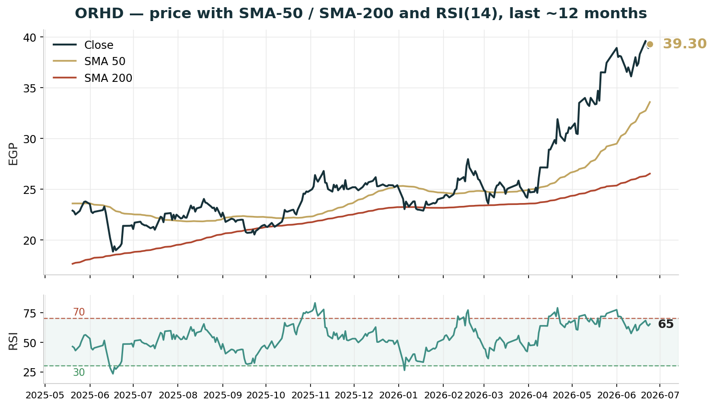
Figure 2. Close with SMA-50 (gold) and SMA-200 (red), and RSI(14) below, last ~12 months. Price rides well above both moving averages, which are themselves rising and correctly stacked (50 above 200) — the signature of a strong, intact uptrend; RSI(14) at ~65.4 (Wilder) is elevated but below the 70 overbought line. Computed from the attached ORHD price history.
Timeframe | Trend | Read
Weekly / long | Strong up | Secular bull; ~+108% off the 18.87 52-week low; price far above a rising SMA150 (27.85) and SMA200 (26.54); successive higher highs into the 39.6 all-time high — trend firmly intact
Daily | Up, extended | Price 39.3 sits above SMA5 (39.04), SMA20 (37.73) and SMA50 (33.59), all rising; RSI(14) ~65.4 (Wilder) is elevated but below the 70 overbought line; the advance is mature and stretched rather than fresh
Hourly / short | At resistance | 39.3 is a whisker below the 39.6 all-time high; a clean break opens blue-sky (no prior trades), while failure here risks a pullback toward the 37.73 (SMA20) / 33.59 (SMA50) supports given the stretched reading

Resistance | Pivot | Support
R3 blue-sky above 39.6 (no prior trades) | spot 39.3 | S1 37.73 (SMA20)
R2 round 42.0 | ATR(14) 1.41 (3.6%) | S2 33.59 (SMA50)
R1 39.6 (all-time high) | range 18.87–39.6 (52-wk) | S3 26.54 (SMA200)
Daily ATR(14) is EGP 1.41 (3.6%); realized volatility is ~45% annualized on the trailing 60 sessions (full-sample ~45%), with mild positive skew (+0.27) and near-normal tails (excess kurtosis +3) — all measured from the attached history. The moving-average configuration is unambiguously constructive: price sits above a rising 50-day and well above the 200-day, the hallmark of an intact uptrend. The tension is that the same tape is stretched (RSI ~65.4 on Wilder’s method, approaching but not at the 70 overbought line) right at the 39.6 all-time high, where every prior buyer is in profit and there is no overhead supply but also no reference for price discovery above. A daily close that holds above 39.6 confirms continuation into blue-sky; a rejection here, with RSI rolling over, would be the textbook setup for a mean-reversion pullback toward the 37.73–33.59 moving-average supports. A 2.22-for-1 bonus issue is pending, which will mechanically re-base the quoted price (to roughly one-third) without changing value — a technical discontinuity to anticipate on the charts.

3. Monte Carlo simulation — one model, ten external factors
Method. One simulation, not a model zoo: 50,000 daily paths to T+60 are driven by ten external factors. Five are continuous (compounding daily with drift and volatility): the CBE policy-rate path, the EGP/USD rate, inflation, EGX30/foreign-flow beta, and Brent/Gulf liquidity. Five are discrete events (each occurring with a stated probability on a random session, with a stated impact): a geopolitical/regional-security shock, the El Gouna / strategic-land monetization story, project-launch execution, the Red Sea / coastal-demand season, and mortgage-credit conditions. Idiosyncratic company noise (calibrated to the attached history) tops the paths up to ORHD’s realized volatility. The factors are adapted to Orascom Development Egypt’s nature — its Red Sea land bank and owned hotels make the coastal season and the El Gouna land story material levers, while modest net debt softens the rate channel. Every drift, probability and impact below is an explicit, editable judgment — the table IS the model.
3.1 The ten external factors — calibration
Factor (10 external drivers) | Type | 3M drift / prob. | 3M vol / impact | Channel
1 CBE policy rate path | continuous | +2.0% | 4% | discounting; modest net debt limits the channel
2 EGP/USD exchange rate | continuous | −1.5% | 6% | FX translation; USD hotel revenue + imported inputs
3 Inflation (CPI) | continuous | +1.5% | 4% | real-asset hedge bid; construction costs
4 EGX30 & foreign flows | continuous | +1.5% | 7% | market beta, liquidity
5 Brent oil / Gulf liquidity | continuous | +0.5% | 5% | GCC buyer purchasing power; Red Sea demand
6 Geopolitical / regional security | event | p = 30% | −10% (±5%) | risk-premium shock
7 El Gouna / land monetization | event | p = 30% | +5% (±4%) | land sales, Red Sea revaluation & sentiment
8 Project launch & sales execution | event | p = 55% | +7% (±4%) | O West / El Gouna / Makadi — the catalyst
9 Red Sea / coastal-demand season | event | p = 45% | +5% (±5%) | El Gouna & Taba hotels + resort sales
10 Mortgage finance & credit | event | p = 35% | +2% (±5%) | affordability, velocity
3.2 Percentile estimates (anchor 39.30, 50,000 paths)
Horizon — 10-factor model | 5% | 25% | Median | 75% | 95%
T+20 (~1 month) | 32.54 | 36.93 | 40.22 | 43.82 | 49.64
T+60 (~3 months) | 29.42 | 36.38 | 42.10 | 48.74 | 59.97
The five continuous factors compound daily; the five event factors arrive as discrete jumps on a random session within the window. Net expected 3M factor contribution is ~+9% before idiosyncratic noise; annualized path volatility is ~46% (vs ~45% realized over the window — kept deliberately wide given the stretched tape near all-time highs). The T+60 distribution is right-skewed: median ~42.10, with the launch, coastal and El Gouna land events carrying the upside shoulder and the geopolitical jump the left tail. Note these paths diffuse from spot and do not embed the fundamental NAV — they describe near-term price, not value.
3.3 Forward cone — percentile cone to T+60
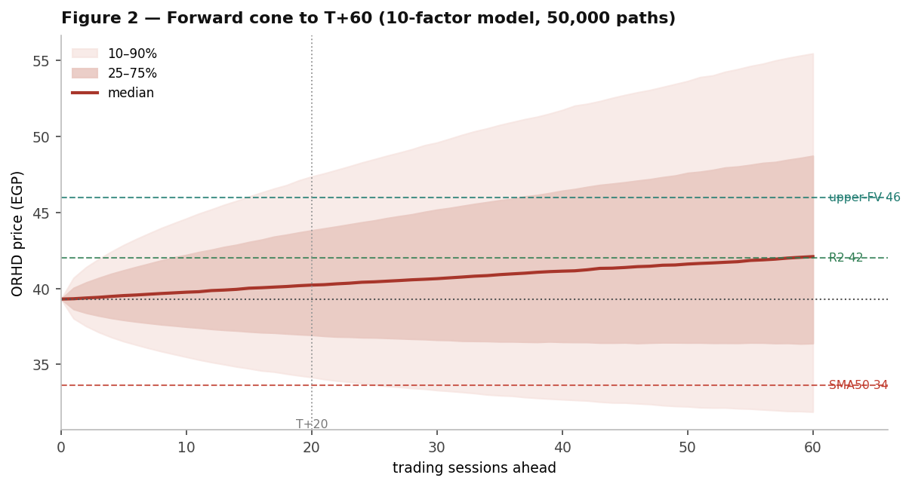
Figure 3. Forward cone (median, 25–75%, 10–90%) from the 10-factor macro model. The median drifts to ~40.22 by T+20 and ~42.10 by T+60; the 10–90% band spans ~32.54–49.64 at one month and ~29.42–59.97 at three. Dashed reference levels: 42.0 (round, green), 46.0 (upper fair-value zone, teal), 33.6 (structure-break / SMA50, red); dotted: spot 39.30; vertical mark at T+20.
3.4 Probability bell curves at T+20 and T+60
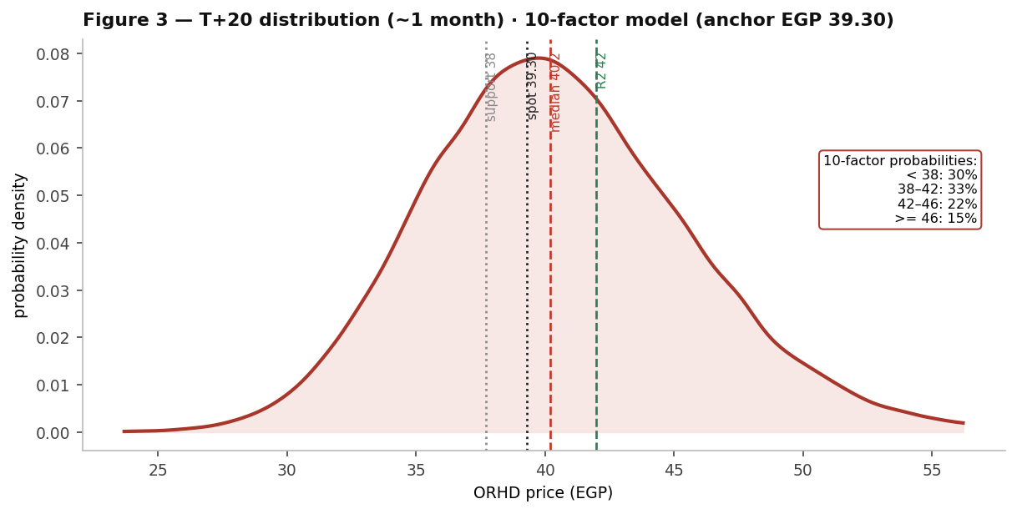
Figure 4. T+20 distribution (10-factor model): the body sits around spot 39.30, between the 37.7 support and the 42.0 round level, with the 46.0 upper-FV zone largely out of reach on a one-month horizon. The one-month view is two-sided around the current price.
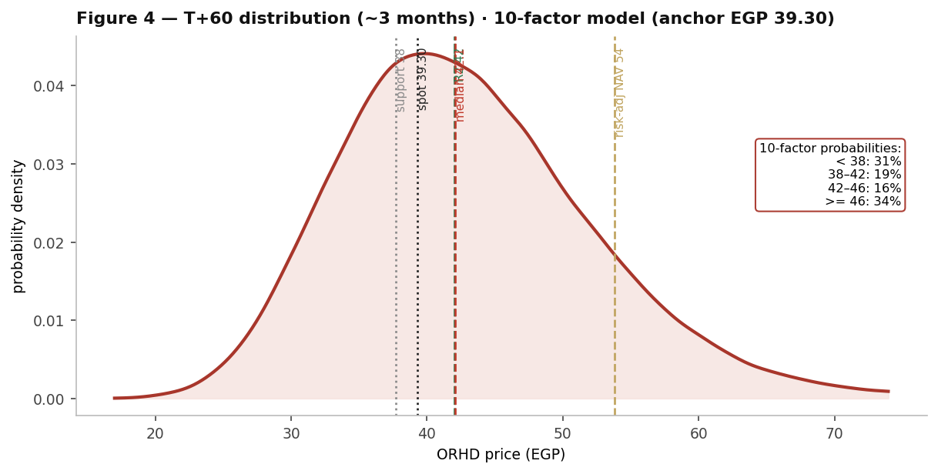
Figure 5. T+60 distribution (10-factor model). The three-month view fans out and skews right — median ~42.10, with a right tail toward 59.97 where the launch, coastal and El Gouna land events pay; the geopolitical jump keeps the left tail honest. The risk-adjusted NAV (53.79) sits beyond the three-month cone.
3.5 Level-touch probabilities
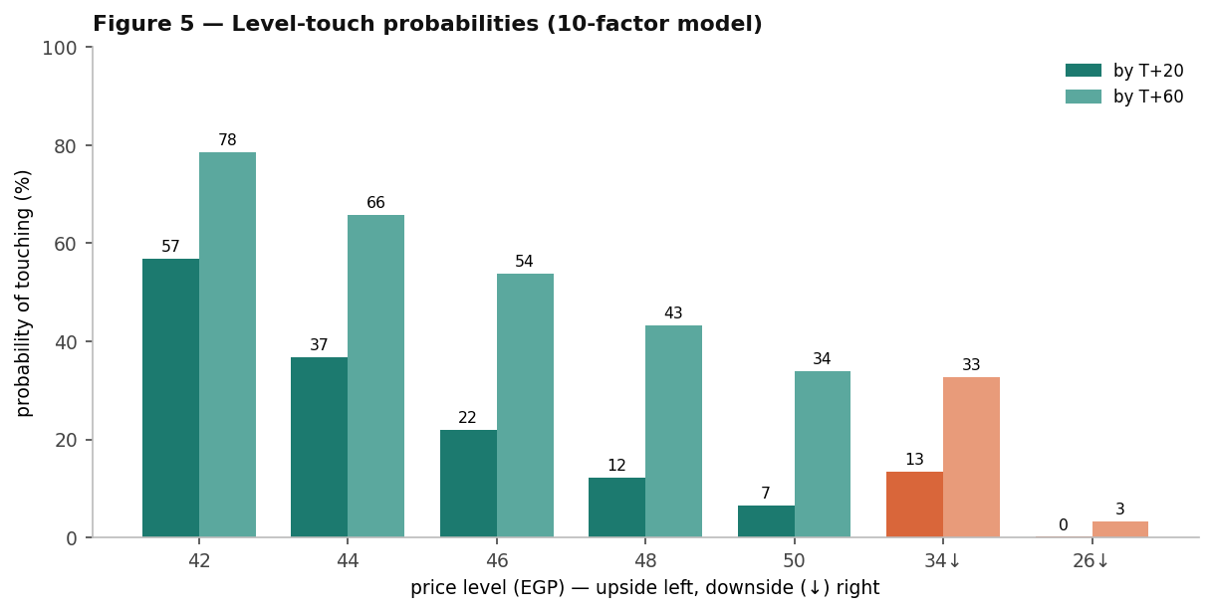
Figure 6. Level-touch probabilities (10-factor model) — probability of the price touching each level within each horizon (T+20 / T+60): upside 42 = 57%/78%, 44 = 37%/66%, 46 = 22%/54%, 48 = 12%/43%, 50 = 7%/34%; downside 33.6 = 13%/33%, 26.5 = 0%/3%. A descriptive output of the simulation: how often paths reach each level, nothing more.

4. Comparison — fundamental vs technical vs Monte Carlo
Lens | Core output | What it says | Analytical implication
Fundamental | Base EGP 53.79 risk-adjusted; 70.52 full execution; ~22.5 bear | Risk-adjusted value ~37% above market; the risk-weighted floor (~22.5) sits below price | Modelled value sits well above price; the discount is to the El Gouna land / upside case, a multi-quarter thesis
Technical | Strong uptrend, stretched; price at the 39.6 all-time high above a rising MA stack; RSI ~65.4 | A mature, intact advance that is stretched right at the all-time high | Momentum favours continuation only on a clean break of the high; from these stretched levels, rejection risks a pullback to 37.7–33.6
Monte Carlo (10-factor) | T+20 median 40.22; T+60 median 42.10 (right tail to ~59.97) | One month is two-sided around spot; three months skew right as the launch and coastal events pay | Time favours the right tail, but the NAV is beyond the three-month cone — the value gap is a multi-quarter story
Verdict: the three lenses tell one story on different clocks — the fundamental value sits ~37% above price (with a risk-weighted floor that sits below the market, the orthodox ordering), the tape is in a strong but stretched uptrend pinned at the 39.6 all-time high, and the three-month distribution skews right on launch execution and the coastal / El Gouna land catalysts while leaving the full NAV beyond the quarter. The standout — and the thing to test first — is that the market appears to ascribe little to ORHD’s unsold El Gouna land bank, carried at low historical cost but worth a great deal on a development basis; if the derived El Gouna land base, the backlog (~EGP 42.4bn) and segment EBITDA are even roughly right, that is a deep discount-to-NAV, but each is an estimate, not a disclosure. The fundamental case and the secular uptrend point the same way; the Monte Carlo simply says the next month is two-sided and stretched while the quarter can pay. What, if anything, follows for any individual depends on circumstances this study does not know and does not address.
5. Catalyst calendar
Catalyst | Date | In window | Read
Bonus issue ex-date | 2026 | likely | The approved 2.22-for-1 bonus issue mechanically re-bases the quoted price (to ~one-third); value-neutral but a visible technical event and a liquidity/index consideration
CBE MPC | Jul 2026 | within T+20 | Further EGP-rate cuts aid sentiment; modest-net-debt ORHD is less rate-sensitive than levered peers but benefits via sector flows and mortgage velocity
Red Sea / North-Coast summer season | Jun–Aug 2026 | in window | Peak El Gouna and Taba hotel occupancy and resort sales — a pivotal seasonal lever (event p = 45%)
El Gouna land / Red Sea monetization | 2026–2028 | partly | Strategic land sales and Red Sea revaluation; long-dated, heavily risk-weighted (event p = 30%) but the dominant right-tail driver
O West / Makadi launches & deliveries | 2026 | in window | New-phase execution; the largest single upside factor in the simulation (launch p = 55%)
Q2 results (backlog→rev) | ~mid-Aug | T+60 | Revenue-recognition story as backlog converts; watch the capitalised-interest and FX lines
6. Reading the probabilities — significant zones (analysis, not guidance)
This section translates the simulation into the price zones where the three lenses say something analytically distinct. It is a map of the distribution — not a plan, not guidance, and not calibrated to any reader’s circumstances.
- 39.3–39.6 — the all-time-high test. Spot sits a whisker below the 39.6 all-time high; above it is blue-sky with no prior trading and no overhead supply. 57% of simulated paths touch 42.0 within one month (78% within three), so the round-number break is within reach — but the move would occur from an elevated RSI of ~65.4 (just below the 70 overbought line) at an all-time high.
- 42.0–46.0 — the re-rating zone. The event factors (launch p = 55%, coastal p = 45%) place most of the near-term right tail here; 37%/66% of paths touch 44 and 22%/54% touch 46 (T+20/T+60). This band is where the discount to NAV begins to close if execution and the El Gouna land story land.
- 46.0–60.0 — the upper-distribution / partial-NAV zone. Only 12%/43% of paths touch 48 and 7%/34% touch 50 within the horizons — the upper reaches of the three-month cone. The risk-adjusted NAV (53.79) sits at the top of this band: the cone reaches it only beyond three months and only on strong execution.
- 37.73 / 33.59 / 26.54 — the structural-floor zone. Below the 37.73 support (SMA20) the extended advance is in question (downside touch of 33.6 ≈ 13% by T+20, 33% by T+60); below ~26.54 (SMA200) the secular uptrend itself would be challenged (touch of 26.5 ≈ 0%/3%). These are also the levels at which the market would price ORHD near the model’s risk-weighted floor.
7. Caveats
- The project-level inputs are estimates, not disclosure — this is the assumption that moves the number most. Orascom Development Egypt publishes no project-by-project economics. The unit mixes, sold-percentages, buildable ratios, prices and construction costs per m², the low-sunk-cost land assumptions, the segment EBITDA (~EGP 2.7bn hospitality, ~EGP 1.0bn recurring) and the backlog (~EGP 42.4bn) are all the author’s estimates, calibrated only to reproduce disclosed company-level totals. The single dominant swing is El Gouna: its monetizable land base (~7m m² of ~37m gross modelled as saleable) and its execution probability (0.75) drive the upside. Audited segment notes or a project disclosure would materially reshape the SOTP.
- El Gouna scale is the swing input — interrogate it first. The discount-to-NAV is overwhelmingly an El Gouna story. If the modelled monetizable area, blended pricing or execution probability are too high, the NAV falls toward the relative-multiple range (~EGP 42); if El Gouna’s land is worth more than modelled, the discount widens. Treat the headline as a prompt to set the El Gouna assumptions to one’s own view.
- Balance-sheet figures are FY2025 estimates, and interest is capitalised. Several balance-sheet lines (net debt ~EGP 2.2bn, gross debt, cash, equity ~EGP 15bn) are derived pending the audited FY2025 accounts; only the 1H25 net-debt figure is firmly sourced. ORHD capitalises most borrowing costs into work-in-progress, so the modelled P&L cost of debt (~7% effective) is deliberately low and the cash-flow statement is the truer guide to debt service.
- Bottom-up valuation is assumption-driven (WACC 18%, each destination’s sold/unsold split, the Byoum JV economic share, ~14% escalation, the normalized terminal FCFF, and the hotel/recurring EBITDA and exit multiples) — calibrated to disclosed totals, not audited project-level data. Illustrative ranges, not precision.
- The pending bonus issue re-bases the price. The approved 2.22-for-1 bonus issue is value-neutral but will multiply the share count (~1.13bn → ~3.65bn) and divide the quoted price by ~3. This study values the pre-bonus count; all per-share figures should be re-based by the same factor once the issue goes ex.
- Monte Carlo factors are independent (no cross-correlation matrix or volatility clustering — rate cuts and FX moves are in reality linked); each factor’s drift, probability and impact is judgment, not estimation; event timing within the window is uniform-random. Technical inputs are computed from the attached vendor price history and not reconciled to exchange tick data.
Momentum-reading note (educational). A standard divergence read: price rising while RSI stalls or falls under its moving average is the classic bearish-divergence configuration — momentum fading into strength. Price and RSI rising together marks a healthy trend; an elevated RSI (here ~65.4 on Wilder’s method, below the classic 70 overbought line) in an uptrend is not itself a sell signal but flags a tape vulnerable to mean-reversion if price is rejected at the all-time high. On the downside, price falling while RSI rises flags seller exhaustion. These are descriptive patterns for reading momentum, not signals to act on.

Appendix A — Summary financial statements
Reported actuals (FY2023–FY2025) are vendor-/filing-sourced and should be verified against the audited accounts; several lines are estimates. The forecast (2026e–2030e) is the study’s independent consolidated operating model — total company (development + hospitality + recurring) — shown over the near-term five-year horizon only; consistent with developer-valuation practice, a multi-decade accrual balance sheet is not projected (the valuation rests on project cash flows and asset values, §1). Two things to read through: (i) reported net profit carries FX revaluation on USD-linked balances, so the forecast deliberately excludes FX and presents a clean operating build; and (ii) ORHD capitalises most borrowing costs into WIP, so the modelled finance line is light and reported vs modelled margins are not directly comparable. All per-share figures are on the ~1.13bn pre-bonus share count.
Summary income statement
EGP bn | FY2023a | FY2024a | FY2025a | 2026e | 2027e | 2028e | 2029e | 2030e
Revenue | 16.5 | 21.8 | 24.9 | 27.5 | 31.0 | 35.0 | 39.5 | 44.5
growth (YoY) | — | +32.1% | +14.2% | +10.4% | +12.7% | +12.9% | +12.9% | +12.7%
Cost of revenue / COGS | (9.6) | (12.4) | (13.7) | (15.4) | (17.4) | (19.7) | (22.2) | (25.0)
Gross profit | 6.9 | 9.4 | 11.2 | 12.1 | 13.6 | 15.3 | 17.3 | 19.5
gross margin | 41.8% | 43.1% | 45.0% | 44.0% | 43.9% | 43.7% | 43.8% | 43.8%
SG&A | (1.8) | (2.4) | (2.9) | (3.2) | (3.6) | (4.1) | (4.6) | (5.2)
Corporate overhead | — | — | — | (1.4) | (1.6) | (1.8) | (2.0) | (2.2)
EBITDA | 5.1 | 7.0 | 8.3 | 7.5 | 8.4 | 9.4 | 10.7 | 12.1
EBITDA margin | 30.9% | 32.1% | 33.3% | 27.3% | 27.1% | 26.9% | 27.1% | 27.2%
D&A | (0.8) | (0.9) | (1.0) | (1.1) | (1.2) | (1.3) | (1.4) | (1.5)
Net interest | (0.4) | (0.5) | (0.6) | (0.7) | (0.7) | (0.6) | (0.5) | (0.4)
FX & other (actuals) | 0.3 | 0.2 | 0.5 | — | — | — | — | —
Pre-tax profit | 4.2 | 5.8 | 7.2 | 5.7 | 6.5 | 7.5 | 8.8 | 10.2
Cash tax | (1.0) | (1.4) | (1.7) | (1.3) | (1.5) | (1.7) | (2.0) | (2.3)
Net income (attributable) | 3.2 | 4.4 | 5.5 | 4.4 | 5.0 | 5.8 | 6.8 | 7.9
EPS (EGP) | 1.77 | 2.75 | 4.91 | 3.89 | 4.42 | 5.13 | 6.02 | 6.99
Actuals FX-inclusive; forecast is a clean operating build excluding FX revaluation, with a light (capitalised-adjusted) finance line. EPS on ~1.13bn pre-bonus shares; re-base by the bonus factor once ex. FY2024 and FY2025 actuals carry FX in reported profit. Reported vs modelled margins are not directly comparable.
Summary balance sheet
EGP bn | FY2023a | FY2024a | FY2025a | 2026e | 2027e | 2028e | 2029e | 2030e
Cash & investments | 6.0 | 7.5 | 8.3 | 9.5 | 11.5 | 14.0 | 17.5 | 22.0
Receivables | 3.0 | 3.4 | 3.6 | 3.6 | 3.6 | 3.6 | 3.6 | 3.6
Inventory (development properties) | 17.0 | 20.0 | 22.0 | 22.0 | 21.5 | 21.0 | 20.5 | 20.0
Other assets (hotels, PP&E, invest.) | 16.0 | 21.6 | 25.1 | 26.4 | 27.4 | 28.4 | 29.4 | 30.4
Total assets | 42.0 | 52.5 | 59.0 | 61.5 | 64.0 | 67.0 | 71.0 | 76.0
Debt (short + long term) | (9.5) | (10.5) | (10.5) | (9.5) | (8.5) | (7.5) | (6.5) | (5.5)
Customer advances / contract liab. | (14.0) | (18.0) | (22.0) | (21.0) | (20.0) | (19.0) | (18.0) | (17.0)
Payables & other liabilities | (8.5) | (12.0) | (11.5) | (13.4) | (14.9) | (16.9) | (18.3) | (20.6)
Total liabilities | (32.0) | (40.5) | (44.0) | (43.9) | (43.4) | (43.4) | (42.8) | (43.1)
Total equity | 10.0 | 12.0 | 15.0 | 17.6 | 20.6 | 23.6 | 28.2 | 32.9
Total liabilities & equity | 42.0 | 52.5 | 59.0 | 61.5 | 64.0 | 67.0 | 71.0 | 76.0
Memo: net debt | 3.5 | 3.0 | 2.2 | 0.0 | (3.0) | (6.5) | (11.0) | (16.5)
Memo: BVPS (EGP) | 8.85 | 10.62 | 13.27 | 15.58 | 18.23 | 20.88 | 24.96 | 29.12
Simplified developer balance sheet calibrated to disclosed/estimated FY2025 totals; fixed plugs hold non-core items, so it will not tie line-by-line to the reported balance sheet. Net debt declines as the pipeline delivers; the company turns net-cash mid-forecast on these (conservative) assumptions. BVPS on ~1.13bn pre-bonus shares. Debt shown negative (a liability).
Summary cash flow statement
EGP bn | FY2023a | FY2024a | FY2025a | 2026e | 2027e | 2028e | 2029e | 2030e
Operating cash flow | 3.5 | 8.0 | 9.0 | 6.0 | 7.0 | 8.0 | 9.5 | 11.0
Investing cash flow (incl. capex) | (1.5) | (2.5) | (3.0) | (1.0) | (1.0) | (1.0) | (1.0) | (1.0)
Financing cash flow | (0.5) | (2.0) | (3.5) | (3.8) | (4.0) | (4.5) | (5.0) | (5.5)
FX & other adjustments | 0.5 | 0.5 | 0.3 | — | — | — | — | —
Net change in cash | 2.0 | 4.0 | 2.8 | 1.2 | 2.0 | 2.5 | 3.5 | 4.5
Memo: capex | (1.5) | (1.2) | (1.0) | (1.0) | (1.0) | (1.0) | (1.0) | (1.0)
Memo: free cash flow (OCF + capex) | 2.0 | 6.8 | 8.0 | 5.0 | 6.0 | 7.0 | 8.5 | 9.5
Forecast operating cash flow is levered (after a light, capitalised-adjusted interest line); the consolidated DCF (§1.7) uses unlevered FCFF. Forecast financing reflects scheduled debt amortisation and assumed dividends; figures are illustrative.

Appendix B — Per-share data and key ratios
Valuation multiples are shown at the 24 Jun 2026 price of EGP 39.30 and the ~1.13bn pre-bonus share count (forward-looking), in the manner of a standard data sheet. Earnings-based multiples for FY2023–FY2024 are marked “n/m” where reported earnings were materially FX-distorted; balance-sheet measures are shown for all years.
EGP bn | FY2023a | FY2024a | FY2025a | 2026e | 2027e | 2028e | 2029e | 2030e
Net income (attributable), EGP bn | 3.2 | 4.4 | 5.5 | 4.4 | 5.0 | 5.8 | 6.8 | 7.9
EPS (EGP) | 1.77 | 2.75 | 4.91 | 3.89 | 4.42 | 5.13 | 6.02 | 6.99
BVPS (EGP) | 8.85 | 10.62 | 13.27 | 15.58 | 18.23 | 20.88 | 24.96 | 29.12
Net debt per share (EGP) | 3.10 | 2.65 | 1.95 | 0.00 | -2.65 | -5.75 | -9.73 | -14.60
P/E (×) | n/m | n/m | 8.0× | 10.1× | 8.9× | 7.7× | 6.5× | 5.6×
P/B (×) | 4.44× | 3.70× | 2.96× | 2.52× | 2.16× | 1.88× | 1.57× | 1.35×
EV / EBITDA (×) | n/m | n/m | 6.2× | 6.1× | 5.2× | 4.3× | 3.4× | 2.6×
ROE (%) | n/m | 40.0% | 40.7% | 27.0% | 26.2% | 26.2% | 26.2% | 25.9%
Net margin (%) | 19.4% | 20.2% | 22.1% | 16.0% | 16.1% | 16.6% | 17.2% | 17.8%
P/E, P/B, EV/EBITDA at EGP 39.30 and market cap ~EGP 44.4bn (constant) — forward-looking. EV = market cap + net debt; as ORHD turns net-cash mid-forecast, net debt per share goes negative. ROE = net income / average equity. Actual-year net margins carry FX; forecast margins are operating (ex-FX). Per-share figures on ~1.13bn pre-bonus shares; re-base by the bonus factor once ex. Dividends per share not separately modelled. Illustrative, not company guidance.

Appendix C — Sector multiples, peer context and key investment risks
C.1 Sector and peer context
Method 3 (§1.3) anchors the relative lenses to the EGX real-estate sector. As of early 2026 the listed Egyptian real-estate sector traded at roughly 8–9× trailing earnings and ~1.9× sales, with sector earnings forecast to grow at a mid-teens-plus rate — corroborating the 8–11× P/E and ~1.9× sales fair-range bands used in the study (indicative sector data; verify live before use).
ORHD vs EGX real-estate sector — multiples
Metric | ORHD (at EGP 39.30) | EGX real-estate sector
Price / earnings | ~8.0× (FY25 EPS 4.91; ttm higher, FX-noisy) | ~8.9× (3-yr avg ~8.1×)
Price / sales | ~1.8× | ~1.9×
Price / book | ~3.0× | —
Forward earnings growth | mid-teens (operating, ex-FX) | ~18% p.a. (sector forecast)
ORHD screens around the sector on P/E but its reported revenue understates the asset base (~EGP 59bn total assets; ~EGP 42.4bn deferred-revenue backlog; an El Gouna land bank carried at low historical cost) — hence RNAV/SOTP, not an earnings or sales multiple, is the appropriate primary method (§1.1). Indicative sector data; per-name peer multiples not independently sourced — verify against live quotes before any use.
Operational peer positioning. Among EGX-listed developers, ORHD is a high-end, asset-rich integrated-town operator distinguished by Red Sea land and a meaningful owned-hotel and recurring-income base — a different profile from the volume homebuilders. Contracted-sales league tables (Talaat Moustafa, Tatweer Misr, Palm Hills, Madinet Masr and others) rank operators by quarterly bookings; ORHD’s differentiation is asset quality and recurring town income rather than unit volume. Contracted sales are an operating metric, not a valuation input, and are distinct from the ~EGP 42.4bn deferred-revenue backlog used in the SOTP.
C.2 Key investment risks
The study’s Caveats (§7) discuss the assumptions that move the number most. The structured table below sets the principal upside and downside risks side by side, in the manner of a standard research risk section.
Direction | Risk | Description
Upside | El Gouna land monetization / Red Sea revaluation | The single largest right-tail driver: El Gouna’s ~37m m² land bank, carried at low historical cost, monetized at development value; heavily risk-weighted (event p = 30%) but the engine of the discount-to-NAV.
Upside | Project-launch execution | O West, El Gouna and Makadi launches/absorption (Monte Carlo launch p = 55%); successful execution begins to close the discount to NAV.
Upside | Red Sea / coastal-demand season | Peak El Gouna and Taba hotel occupancy and resort sales (event p = 45%) — a pivotal seasonal lever for an owner of ~4,900 keys with Red Sea exposure.
Upside | Recurring-income / hospitality re-rating | Town-management, retail, marina and hotel EBITDA as a sticky annuity base; a quality the market may under-credit in a pure-developer frame.
Upside | Backlog conversion / NAV re-rating | ~EGP 42.4bn (est.) backlog converting to revenue at low execution risk; narrowing of the 27–44% discount to NAV toward sector norms.
Downside | Derived-input risk (largest) | Project economics, the El Gouna land base, segment EBITDA and the backlog are the author’s estimates, not disclosure; audited data could reshape the SOTP and compress the discount.
Downside | Modest net debt + capitalised interest | Unlike a net-cash peer, ORHD carries net debt and capitalises borrowing costs into WIP; a rate or FX shock raises real debt service that the P&L understates.
Downside | FX revaluation distorting reported profit | USD-linked balances and USD hotel revenue swing reported earnings; EGP depreciation raises imported build costs.
Downside | Macro / rate / geopolitical shocks | Regional-security shock (event p = 30%), EGP depreciation, the CBE rate path; mortgage-credit conditions affect affordability and velocity.
Downside | Bonus-issue / liquidity mechanics | The pending 2.22-for-1 bonus issue re-bases the quoted price and changes per-share optics and index/liquidity dynamics, even though it is value-neutral.
Downside | Momentum reversal | The stock is extended at its all-time high (RSI ~65); a rejection there risks a mean-reversion pullback toward the 37.7–33.6 moving-average supports.
Risk descriptions synthesise the study’s Caveats (§7) with developer-sector factors; Monte Carlo probabilities are the study’s editable judgments (§3.1). Not exhaustive, and not calibrated to any reader’s circumstances.

Appendix — About this series: the standing format
Every instrument (equity or metal) analysed in this educational series follows the same standing format, in order:
- Headline — the analytical read, timeframe and key numbers, one paragraph.
- 1. Fundamental analysis — DCF + multiples + NAV/SOTP (per-project for developers; EBITDA-multiple segments where diversified) → football field → fair-value range.
- 2. Technical analysis — weekly/daily/hourly trend, levels table, ATR/vol, the momentum tell.
- 3. Monte Carlo simulation — ONE model: ten external macro factors, 50,000 paths; factor table + percentile table + forward cone + bell curves (T+20/T+60) + level-touch probabilities.
- 4. Comparison — fundamental vs technical vs Monte Carlo — one table reconciling the three lenses + a verdict: where they agree, where they differ, and on what clock.
- 5. Catalyst calendar · 6. Probability map · 7. Caveats + momentum note · closing Disclosure & Disclaimer.
Disclosure & Disclaimer — read in full
Nature of this document. This study is an educational valuation exercise and an expression of the preparer’s personal analytical opinion, based exclusively on publicly available information and on assumptions stated in the text and the accompanying model. It is published free of charge, on a standing periodic schedule, to demonstrate methodology and to invite scrutiny and critique of that methodology. No advice, no recommendation, no solicitation. Nothing in this document constitutes investment advice, financial consultancy, securities analysis services, a research recommendation, a rating, a price target, an offer, or a solicitation or invitation to buy, sell, hold, subscribe for or otherwise deal in any security or financial instrument. No statement herein is directed at, or calibrated to, the investment objectives, financial situation, risk tolerance or particular needs of any person. No licensed activity. The preparer is not licensed or registered with the Egyptian Financial Regulatory Authority (FRA) or any other securities regulator; does not carry on financial consultancy, securities evaluation or analysis services, portfolio management, brokerage, promotion or any other regulated activity; does not manage money; and does not accept clients, fees, subscriptions or funds of any kind. Publication independence. This study was prepared and published independently, on a pre-set schedule, and is not intended to — and must not be used to — influence the market price of any security. Estimates and uncertainty. All valuations, scenarios, probabilities and levels are model outputs resting on explicit, subjective assumptions; they are illustrative, highly uncertain, and likely to prove wrong in material respects. In particular, the project-level inputs underlying the valuation are the preparer’s estimates, not company disclosure. They are deliberately presented as ranges and distributions because no single number should be relied on. Public and vendor-sourced data are believed reliable but are not guaranteed; vendor-derived figures are flagged as such where used. No liability. To the maximum extent permitted by applicable law, the preparer accepts no liability or responsibility whatsoever for any decision made or action taken or not taken, or for any loss or damage of any kind incurred, by any person in reliance on, or in connection with, any part of this document or the accompanying model. Reader’s responsibility. Any person considering an investment decision should conduct their own independent assessment and consult a financial advisor licensed in their jurisdiction. If the publication of material of this kind is restricted where you are reading it, do not rely on it. Holdings disclosure. The preparer may hold, and may in the future take or dispose of, a position in the security discussed in this report.
25 June 2026

