Testahil · Independent Valuation Study - Educational Analysis Not investment advice
Independent Valuation Study - Educational Analysis
Oriental Weavers Carpet Company (S.A.E.) (EGX: ORWE)
Fundamental analysis · Technical analysis · Monte Carlo simulation - one integrated read
Anchor: EGP 22.34 (1 Jul 2026 close) · ~665.1 mn shares (per dividend arithmetic - confirm) · mkt cap ~EGP 14.9 bn · the world's largest machine-woven carpet and rug producer - vertically integrated from fibre extrusion to 260+ Egyptian showrooms, plants in Egypt and the US, exports ~60-64% of revenue to 130-150 countries · Khamis family 56.58% · prices and probabilities computed 1 Jul 2026 from the attached daily history · primary lens: free-cash-flow-to-equity DCF with a mid-cycle EBITDA cross-check · swing factors: the EGP, the state export-rebate program, US tariffs - and the working-capital cycle that decides how much profit becomes cash.
READ FIRST - what this document is, and is not. This study is a valuation exercise and an expression of personal analytical opinion, published free of charge for educational purposes. It is NOT investment advice, NOT a recommendation or solicitation to buy, sell or hold any security, and NOT directed at the circumstances of any reader. The preparer is not licensed by any securities regulator, manages no money, and accepts no fees, funds or clients. All values are model outputs presented as ranges and distributions because no single number should be relied on. Revenue, attributable profit and the dividend are sourced from company disclosure (4Q23 earnings release; Mubasher-reported FY24 results, 6 Jan 2025; AGM dividend disclosure, Apr 2026). The FY25 gross-profit figure and the SG&A / D&A / other-income splits are the preparer's estimates pending the FY25 consolidated statements; the share count is derived from the dividend arithmetic (EGP 997.66 mn at EGP 1.5/share); net debt is an estimate; and the Monte-Carlo factor set is borrowed from the nearest calibrated class (consumer staples) for a consumer-durables exporter - all flagged. See the Disclosure & Disclaimer at the end.
Headline
At EGP 22.34 Oriental Weavers looks cheap - 6.0x forward earnings, a 6.7% dividend yield - and is, on the weighted evidence, merely fair: the blended centre sits at ~EGP 20.9, about 6% below the price. The gap between the optics and the answer is the whole thesis. FY2025 sales rose ~10% to EGP 26.6 bn while attributable profit stayed flat at EGP 2.19 bn - margins handed back what the currency had given - and the cash-flow lens prices two things the P/E cannot see: a working-capital cycle that consumes ~28 piasters of every incremental revenue pound, and an earnings base resting on three policy crutches (devaluation pass-through, fading export rebates, and a fat non-operating income line). The three-month probability map tilts mildly higher: a 25-75% band of EGP 21.0-25.0 around a 22.9 median.
Valuation summary - every read at a glance
One table for the four reads that follow - what the business is worth (fundamental), what the tape is doing (technical), where price could travel over three months (Monte Carlo), and how three independent expert methods land. Every row is developed in the sections and appendices below.
Lens / read | What it measures | Output | Takeaway
FUNDAMENTAL - what the business is worth (the anchor)
FCFE DCF (primary) | 5-yr free cash flow to equity at 24% | EGP 17.3 | -23% vs spot
Mid-cycle EBITDA x mult. | Enterprise view, ex one-offs | EGP 21.2 | -5%
Relative multiples | 8x FY26E EPS vs EGX peers | EGP 29.7 | +33% · the ceiling
Normalized earnings | Recurring EPS x fair cyclical P/E | EGP 21.1 | -6%
Weighted central | Blend 40 / 20 / 15 / 25 | EGP 20.9 | -6% vs 22.34
TECHNICAL - what the tape is doing (timing, not value)
Trend & momentum | Price vs 20/50/100/200-day | Below all four; RSI 33 | Soft, low end of range
MONTE CARLO - where price could travel (3 months)
T+60 distribution | 16-factor, 50k paths, seed 42 | P25-P75 EGP 21.0-25.0 | Mild upward tilt
EXPERT PANEL - three independent methods
Expert 1 / 2 / 3 | Earnings power · Cash conversion · Policy triangle | EGP 23.0 / 16.7 / 21.6 | Straddling spot

Company overview - Oriental Weavers Carpet Company at a glance
Item | Value
Exchange / ticker | EGX: ORWE
Sector | Consumer durables - machine-woven carpets & rugs (world's largest)
Fiscal year-end | 31 December
Shares outstanding | ~665.1 mn (per dividend arithmetic - confirm)
Spot / market cap | EGP 22.34 / ~EGP 14.9 bn
FY25 revenue / attributable profit | EGP 26,622 mn (+10%) / EGP 2,189 mn (flat)
Dividend | EGP 1.5/share (~6.7% yield); EGP 997.66 mn total
Export share | ~60-64% of revenue, 130-150 countries; plants in Egypt & US
Ownership | Khamis family 56.58%
52-week range | EGP 21.00 - 24.92

Source: 4Q2023 earnings release (orientalweavers.com); Mubasher FY2024 results (6 Jan 2025); AGM dividend disclosure via Billionaires.Africa (8 Apr 2026); Investing.com statements; prices from the attached daily history.
1 Fundamental valuation
1.1 Free-cash-flow-to-equity DCF - the primary lens
The primary lens discounts what shareholders can actually bank: attributable profit plus D&A, less capex, less the increase in net working capital, at a 24% nominal EGP cost of equity with 11% terminal growth. The last subtraction is the story - at ~28% of revenue (inventory across 150 markets, showroom stock, export receivables), every pound of growth consumes ~28 piasters before it reaches the till, so FY26E FCFE is ~EGP 1.43 bn against EGP 2.47 bn of profit, a 58% conversion. The stream values the equity at ~EGP 11.5 bn, or EGP 17.3/share - the sober floor under the cheap-looking multiple.
Why FCFE rather than FCFF: the balance sheet mixes real debt (~EGP 5.5 bn gross) with deposits earning the interest line, so the equity-direct build avoids guessing an enterprise bridge the FY25 statements have not yet published. The 24% cost of equity is built for an EGP holder - ~20-21% risk-free plus a cyclical-exporter premium, no size discount for a 45-year franchise.
Design note: the non-operating income is carried inside attributable profit (it is real cash) but its one-off layer is stripped in the normalized lens - the two lenses bracket the truth about that line from both sides.
1.2 Reverse-DCF cross-check
Reverse-engineering the price: EGP 22.34 is equity of ~EGP 14.9 bn, which the same machine only produces if the FCFE stream runs ~30% richer - i.e., working capital easing toward 22-24% of revenue, or a cost of equity nearer 21%, or another devaluation re-arming margins. The market is paying today for a cash-conversion normalization that has not yet printed.
Each implied row is watchable: the April dividend declaration tests the payout capacity, every quarterly gross-margin print tests the crutches, and the CBE's path tests the implied Ke - the reverse-DCF is a scoreboard with four dates a year.
What spot implies | Implied level | Base case
FCFE stream backed out of 22.34 | ~+30% richer | EGP 1.43 bn FY26E
or net working capital / revenue | ~22-24% | 28%
or cost of equity | ~21% | 24%

1.3 Relative multiples
On FY26E EPS of ~EGP 3.72 the stock trades at 6.0x, with a 6.7% cash yield - against an EGX consumer/industrial band of roughly 7-9x. EV/EBITDA on FY26E is ~4.9x. At a peer-median 8x the shares are worth ~EGP 29.7 - the ceiling lens, and the one that ignores both the cash conversion and the provenance of the margin.
The global read-across frames the discount: Mohawk and Interface trade 8-12x through-cycle earnings with USD cash flows and half the working-capital intensity; ORWE entering that band from the bottom is the correct starting point, not a mispricing.
The yield is the honest half of the multiple story: EGP 1.5 has been paid or raised through every recent regime, and at 45% of normalized earnings it is arithmetic, not promise.
One more frame the multiple hides: on enterprise value the market pays ~4.9x FY26E EBITDA for a business whose EBITDA includes the rebate-and-FX layer - strip that layer and the clean-operations EV/EBITDA is nearer 6x, mid-band, which is the multiple lens quietly agreeing with the par cluster.
1.4 Normalized earnings power
Normalization strips the non-operating layer (an estimated EGP 1.15 bn in FY25 of interest, FX gains, rebate and one-off income; FY23 included the China-facility sale gain) down to ~EGP 500 mn recurring, and holds gross margin at a mid-cycle 12.5%: recurring attributable power ~EGP 2.0-2.2 bn, worth ~EGP 21.1/share at 7x. This is the honest answer to 'what if the pound and the rebate file both go quiet'.
The 7x is derived, not borrowed: 1/(Ke - g) at a 24% cost of equity and ~10% nominal growth - the same arithmetic Expert 1 defends in Appendix D, reproduced here so the synthesis carries its own audit trail.
1.5 Synthesis - five lenses
Five lenses, one field: the FCFE DCF anchors low (17.3) because the working-capital cycle taxes every growth pound; the mid-cycle enterprise view (21.2) and normalized earnings (21.1) cluster at par; relative multiples (29.7) alone sit far above. Weighting 40/20/15/25 puts the centre at ~EGP 20.9 - the price is 6% above it, the mirror image of what the 6x P/E suggests.
The weights are declared, not fitted: the cash lens leads because conversion is the thesis; the multiple lens is lightest because it imports the market's own optimism as evidence.
Lens | Fair value (EGP) | Weight
FCFE DCF (primary) | 17.3 | 40%
Mid-cycle EBITDA x multiple | 21.2 | 20%
Relative multiples | 29.7 | 15%
Normalized earnings | 21.1 | 25%
Weighted central | 20.9 | 100%

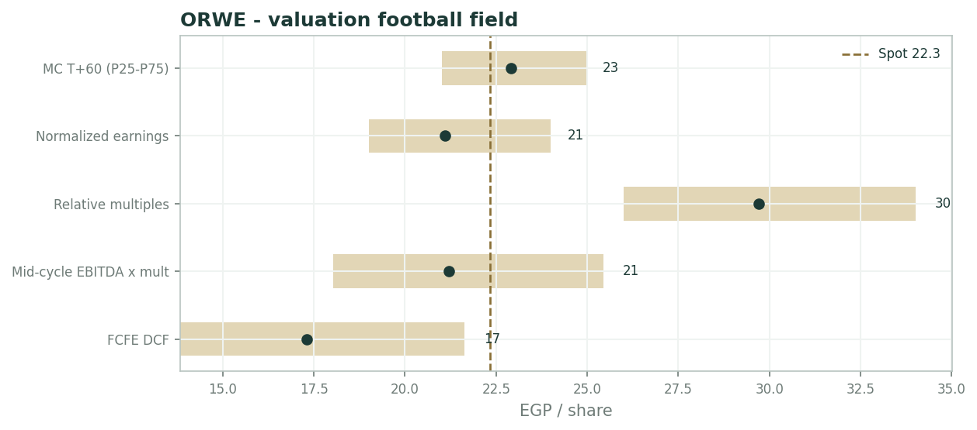
Valuation football field - lens ranges vs spot
A last synthesis note: the centre's stability was tested by re-weighting - even shifting ten points from the cash lens to the multiple lens moves it barely a pound - so the verdict is a property of the lenses, not an artifact of the blend.
1.6 The segments - where the revenue lives
Exports are ~60-64% of revenue across 130-150 countries - the Americas alone ~a third of sales, served partly from the group's US plants; Europe rides the German wholesale/online channel; GCC and Africa round the book. Egypt (~36-40%) leans on 260+ owned showrooms (over half of local sales) plus wholesale. By product, machine-woven remains the core while the tufted 'MAC' segment has been the growth surprise.
The vertical integration - fibre extrusion to finishing to retail - is the moat: it converts a weak pound directly into a cost advantage no importer can match, and it is also the reason the balance sheet carries the whole pipeline's working capital. The moat and the drag are the same asset.
Segment | Share | Driver | Read
Exports | ~60-64% | Devaluation pass-through + rebates | The margin engine; 130-150 countries
Egypt retail | ~36-40% | 260+ showrooms, 53% of local sales | Pricing power, inflation-linked
Tufted 'MAC' | growing | Mix upgrade, US listings | The growth surprise
US plants | inside tariff wall | Serve the Americas book | Partial hedge to the trade file

1.7 Three policy crutches and a working-capital cycle - the crux
The margin stands on three crutches, none controlled by the company. The pound: USD revenues against EGP costs mean each devaluation is a margin windfall (FY23's 103% gross-profit surge) and each stable stretch a squeeze (FY25's flat profit on +10% sales). The rebate file: the state export-support program is fading - the AGM itself named it - and its lapse is worth an estimated EGP 2-3/share. The tariff: the US ~10% baseline on Egyptian goods sits on roughly a third of sales.
Against all three runs the working-capital cycle, which decides how much of any margin ever becomes cash. Quantified: each 10% EGP move is worth ~1.5-2 gross-margin points (~EGP 3-4/share capitalized); each point of NWC intensity is ~EGP 0.6/share on the DCF.
The bull case is simply the FY23 playbook repeating; the bear case is a firm pound with the rebate file closed - and both are decisions taken in offices the company can only lobby.
1.8 Macro and country
Macro: Egypt's crawling-peg pound is the single largest earnings variable; polypropylene - an oil derivative - is the input side of the spread; Red Sea freight disruption still taxes the export lane; US/EU housing turnover and retail restocking set replacement demand.
The offset: carpets are a consumer durable with replacement-cycle resilience, the company has priced through every devaluation since 2016, and the US plants sit inside the tariff wall - a structural hedge the pure-export peers lack.
Timing of the crutches differs, and it matters: a devaluation reprices the export book within a quarter, the rebate file settles annually with the budget, and the tariff schedule moves on Washington's calendar - so the margin's three supports rarely fail together, which is why the base case is a squeeze, not a collapse.
1.9 Ke x working-capital sensitivity
Two dials dominate. Cost of equity 22/24/26% moves the FCFE value roughly EGP 19.5/17.3/15.5. Working capital at 24/28/32% of revenue spans ~EGP 19.5/17.3/15.0 - and each point of gross margin is worth ~EGP 2/share on the capitalized lenses. The grid crosses them; the interaction defines an honest EGP 13-24 fundamental envelope; only the relative lens escapes it.
Ke \ NWC | 24% | 28% | 32%
22% | 21.8 | 19.5 | 17.2
24% | 19.5 | 17.3 | 15.0
26% | 17.4 | 15.5 | 13.4

2 Technical and price structure
Price EGP 22.34 sits below all four moving averages - 20-day 23.1, 50-day 23.0, 100-day 22.8, 200-day 22.8 - which have flattened into a half-point band: a 12-month sideways coil (52-week range just 21.00-24.92) now grinding at its lower edge. RSI(14) at ~33 approaches oversold without confirming it.
The tape is soft but compressed - a low-energy drift awaiting a policy or earnings catalyst rather than a trending market. Coils this tight in ORWE's history have resolved with 15%+ moves inside a quarter; the direction has followed the pound, not the chart.
Indicator | Reading
Spot | EGP 22.34
SMA 20 / 50 / 100 / 200 | 23.1 / 23.0 / 22.8 / 22.8
RSI(14) | ~33 (approaching oversold)
52-week range | EGP 21.00 - 24.92
Structure | Below all four converged MAs; tight 1-year coil, lower edge

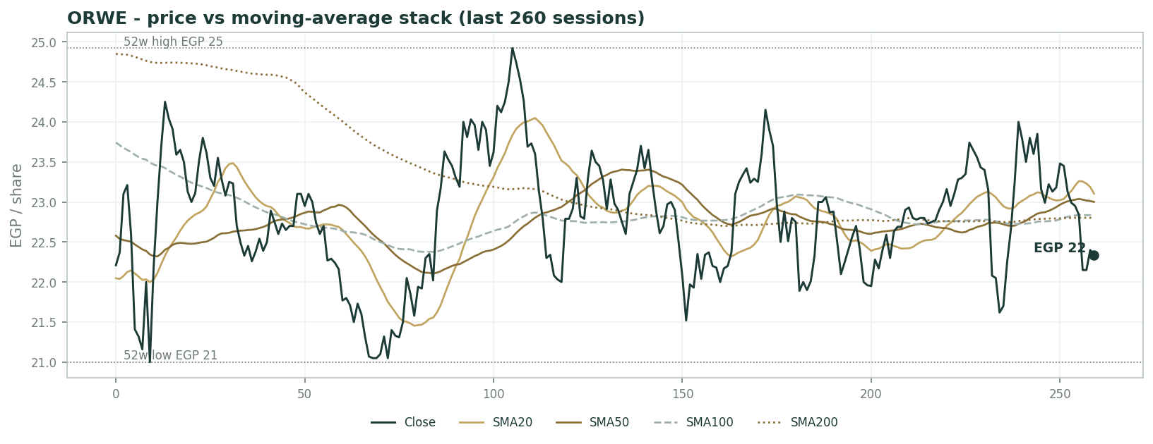
Price vs moving-average stack (last 260 sessions)
3 Monte Carlo - a probabilistic price map
Paths diffuse from spot; the §1 value gap is kept out of the drift, so the three lenses stay independent. 16-factor model - 7 continuous + 9 discrete - 50,000 paths, seed 42.
Horizon | P5 | P25 | P50 | P75 | P95
T+20 | 20 | 22 | 23 | 24 | 26
T+60 | 18 | 21 | 23 | 25 | 29

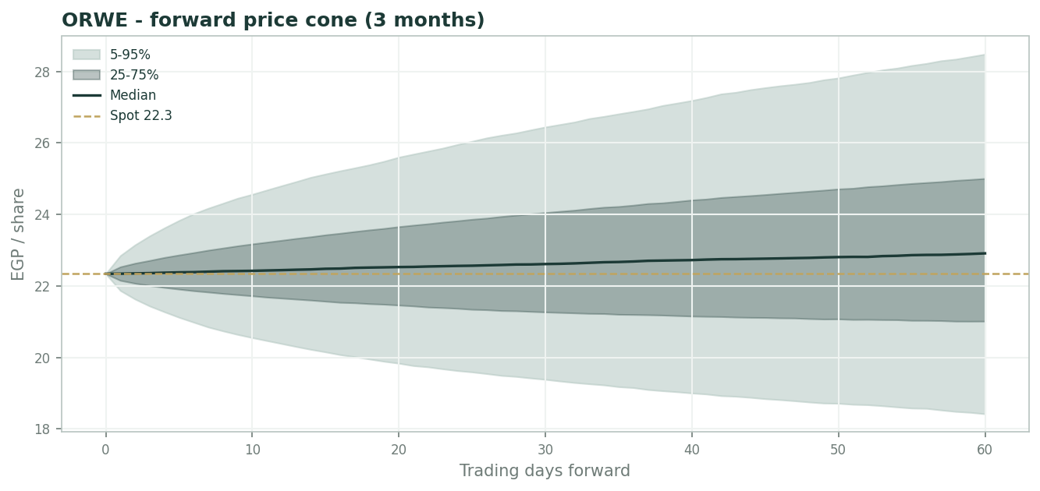
Forward price cone (3 months)
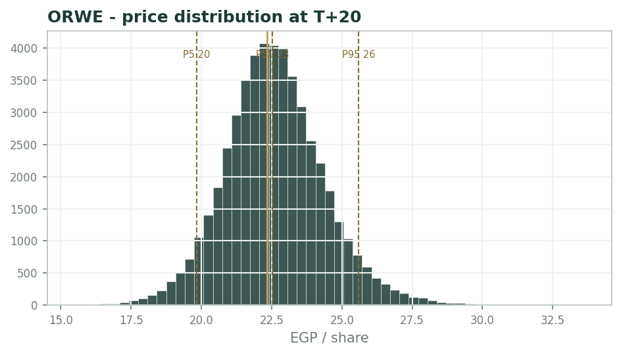
Price distribution at T+20
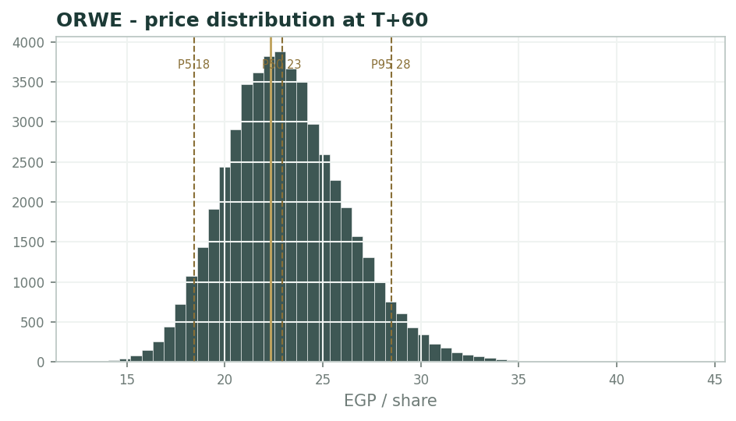
Price distribution at T+60
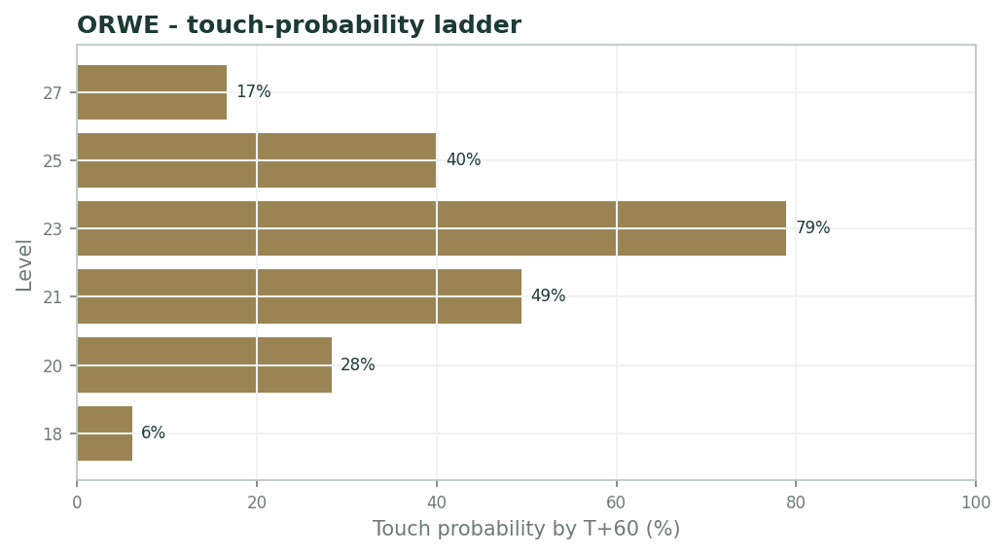
Touch-probability ladder by T+60
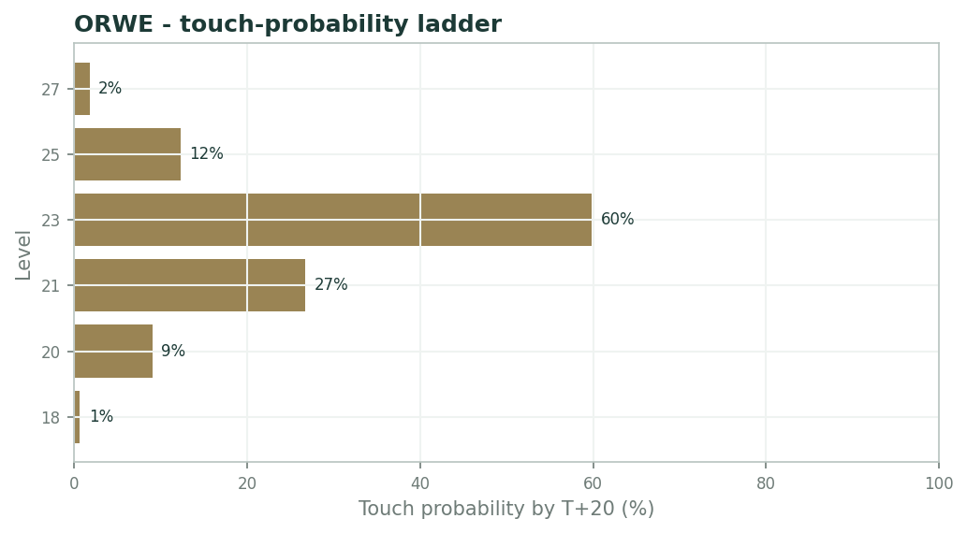
Touch-probability ladder by T+20
The distribution tilts mildly higher (median 22.9 vs spot 22.34) with a modest right tail - P95 EGP 28.5 vs P5 18.4 - carried by the FX-event and demand factors in the set. The one-year realized range (21.0-24.9) sits almost entirely inside the 25-75% band - the model sees the coil too.
Touch probabilities by T+60: EGP 23 ~79%, EGP 24 ~58%, EGP 25 ~40%, EGP 26 ~17%; downside, EGP 21 ~49% and EGP 20 ~28%. By T+20 the same ladder runs ~60/29/12% up and ~27/9% down - the near map hugs the coil, the far map lets the pound breathe.
4 Comparison of the lenses, and a verdict
The lenses split by what they trust: the cash-flow lens (17.3) refuses to pay for profit the working-capital cycle never delivers; the par cluster (21.1-21.2) pays for the recurring core; the multiple lens (29.7) pays for the print. Weighted centre EGP 20.9 vs spot 22.34.
Verdict: fairly valued with a thin premium - the 6x P/E and 6.7% yield are real, but they are the fair price of policy-dependent margins and 58% cash conversion, not a mispricing. The distribution's mild upward tilt says the market leans, gently, toward the devaluation leg - which is also the only leg that fixes all three crutches at once.
5 Catalysts to watch
- 2Q26 results (Aug 2026): gross margin and the other-income line - does the 2H25 recovery hold without rebates?
- The EGP path - any step-devaluation re-arms the FY23 margin playbook overnight.
- The export-rebate file: restoration, partial payment or lapse is worth EGP 2-3/share either way.
- US tariff decisions on Egyptian goods (~a third of sales route to the Americas).
- Polypropylene/oil input costs and Red Sea freight normalization.
- The April dividend declaration - the EGP 1.5 held, raised, or cut is the cleanest signal on cash conversion.
6 Reading the probability zones
Below ~EGP 21 (P25) the stock is cheap on every lens except the strict FCFE floor - the coil's lower edge, where the yield passes 7%. EGP 21-24 is the fair band where four of five lenses interleave; spot sits in its lower half. EGP 25-28.5 (P75-P95) prices the devaluation-plus-rebates leg. Above ~EGP 28.5 the market pays the full relative multiple - only defensible if cash conversion normalizes and the pound moves.
Zone | Range (EGP) | What it means
Cheap on most lenses | < 21 | Coil's lower edge; yield > 7%
Fair band | 21 - 24 | Four of five lenses interleave; spot in its lower half
Devaluation + rebates leg | 25 - 28.5 | P75-P95; the FY23 playbook priced
Full relative multiple | > 28.5 | Needs conversion normalized AND the pound moving

7 Caveats and what would change our mind
FY25 gross profit and the SG&A/D&A/other-income splits are estimates pending the consolidated statements (only sales, attributable profit and the dividend are sourced for FY25); the non-operating income line is a derived plug mixing interest, FX gains, rebates and one-offs (FY23 includes the China-facility sale gain); the share count (665.1 mn) is dividend arithmetic, not a read of the register; net debt is an estimate; minorities are folded into a single tax-and-minorities line; the Monte-Carlo factor set is borrowed from the consumer-staples class for a consumer-durables exporter - flag; and the working-capital ratio (28% of revenue) is inferred from the balance-sheet scale, not disclosed aging.
Appendix A Financial statements
A.1 Income statement - 3 years historical + 5-year forecast
Line | FY23 | FY24 | FY25 | FY26E | FY27E | FY28E | FY29E | FY30E
Revenue | 17,660 | 24,288 | 26,622 | 29,817 | 33,096 | 36,406 | 40,047 | 43,651
Gross profit | 2,550 | 3,103 | 3,195 | 3,727 | 4,236 | 4,733 | 5,286 | 5,849
SG&A | 705 | 1,000 | 1,065 | 1,193 | 1,324 | 1,456 | 1,602 | 1,746
EBIT (operating) | 1,845 | 2,103 | 2,130 | 2,534 | 2,912 | 3,277 | 3,684 | 4,103
D&A (memo) | 650 | 700 | 750 | 894 | 993 | 1,092 | 1,201 | 1,310
EBITDA | 2,495 | 2,803 | 2,880 | 3,429 | 3,905 | 4,369 | 4,886 | 5,413
Net interest, FX & other income | 465 | 700 | 1,146 | 900 | 850 | 800 | 800 | 800
PBT | 2,310 | 2,803 | 3,276 | 3,434 | 3,762 | 4,077 | 4,484 | 4,903
Tax & minority interest | 570 | 611 | 1,087 | 962 | 1,053 | 1,141 | 1,256 | 1,373
Net profit (attributable) | 1,740 | 2,192 | 2,189 | 2,473 | 2,709 | 2,935 | 3,229 | 3,530

A.2 Balance sheet
Line | FY23 | FY24 | FY25 | FY26E | FY27E | FY28E | FY29E | FY30E
Net working capital | 4,950 | 6,800 | 7,450 | 8,349 | 9,267 | 10,194 | 11,213 | 12,222
PP&E (net, est.) | 6,500 | 6,800 | 7,100 | 7,249 | 7,415 | 7,597 | 7,797 | 8,015
Total debt | 4,700 | 5,200 | 5,500 | 5,500 | 5,500 | 5,500 | 5,500 | 5,500
Cash & equivalents (est.) | 2,800 | 3,200 | 3,500 | 3,927 | 4,555 | 5,384 | 6,395 | 7,700
Attributable equity (est.) | 10,600 | 12,200 | 13,400 | 14,875 | 16,586 | 18,524 | 20,755 | 23,288

A.3 Cash flow
Line | FY23 | FY24 | FY25 | FY26E | FY27E | FY28E | FY29E | FY30E
Net profit (attributable) | 1,740 | 2,192 | 2,189 | 2,473 | 2,709 | 2,935 | 3,229 | 3,530
+ D&A | 650 | 700 | 750 | 894 | 993 | 1,092 | 1,201 | 1,310
- Increase in NWC | 0 | -1,850 | -650 | -899 | -918 | -927 | -1,019 | -1,009
Cash from operations | 2,390 | 1,042 | 2,289 | 2,469 | 2,784 | 3,101 | 3,411 | 3,831
- Capex | -620 | -780 | -900 | -1,044 | -1,158 | -1,274 | -1,402 | -1,528
- Dividends paid | -558 | -1,060 | -998 | -998 | -998 | -998 | -998 | -998
Net change in cash | 1,212 | -798 | 391 | 427 | 628 | 829 | 1,011 | 1,305

A.4 Discounted cash flow (5-year forecast)
Line | FY26E | FY27E | FY28E | FY29E | FY30E
Net profit (attributable) | 2,473 | 2,709 | 2,935 | 3,229 | 3,530
+ D&A | 894 | 993 | 1,092 | 1,201 | 1,310
- Capex | -1,044 | -1,158 | -1,274 | -1,402 | -1,528
- Increase in net WC | -899 | -918 | -927 | -1,019 | -1,009
FCFE | 1,425 | 1,625 | 1,826 | 2,009 | 2,303
Discount factor | 0.806 | 0.650 | 0.524 | 0.423 | 0.341
PV of FCFE | 1,149 | 1,057 | 958 | 850 | 786

DCF build | Value
Sum PV of explicit FCFE | 4,799
Terminal value (Gordon on FCFE) | 19,663
PV of terminal value | 6,707
Equity value (DCF) | 11,507
Fair value per share | 17.30

Appendix B Step 0 - calibration backtest
Step 0 initially FLAGGED: at the default volatility the 50% band over-covered (65% vs a 50 +/-12pp tolerance) - Oriental Weavers' centre is tighter than lognormal while its tails are not. Per protocol the sigma was recalibrated: a grid over drift mode and volatility multiplier found trailing drift with kvol = 0.85 the best-balanced passing configuration, covering 59 / 82 / 82% on the 50/80/90% bands with an approximately uniform PIT - calibration passes (n = 17 quarterly windows, full 5 years).
Band | Target | Realized
50% | 50% | 59%
80% | 80% | 82%
90% | 90% | 82%

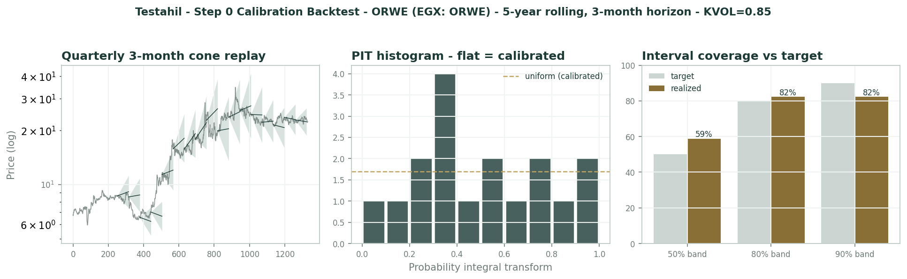
Calibration backtest - cone replay, PIT histogram, interval coverage
Appendix C Peer set, sector structure, and risks
Peers: no listed EGX pure comparable exists; the multiple band is the EGX consumer/industrial set (7-9x), with global flooring (Mohawk, Interface) a structural read-across at 8-12x through-cycle. Sector structure: the business is a currency-and-commodity spread - USD-linked selling prices against EGP labour and oil-derivative (polypropylene) inputs - wrapped in a vertically integrated manufacturer with genuine distribution.
Principal risks: a firm pound compressing the export margin, lapse of the state export-rebate program, US tariff escalation, input-cost spikes, freight disruption, the inventory/receivables cycle consuming cash, 56.58% family control and key-man concentration, and thin free float amplifying the tape.
Appendix D The expert valuation panel
D.1 Expert 1 - normalized earnings power at a fair cyclical multiple
Worldview and tradition. A manufacturer is worth its recurring earnings at a multiple that respects the cycle and the local cost of equity. Oriental Weavers prints EGP 2.2 bn and pays 6.7% - the question is only how much of that print recurs, and what a 24%-cost-of-equity market should pay per pound of it.
The tradition is Graham earning-power value for established industrials: find the profit the asset base reliably produces across a cycle, capitalize it at a rate an owner could actually demand locally, and treat every premium above that as a forecast someone else is paying for.
Applied here it collapses to one question: what does a vertically integrated loom complex with 150-country distribution reliably earn once the currency noise is averaged out - and what is a pound of that worth against a 20%+ risk-free alternative?
When it works / when it fails. Works for established industrials with a definable mid-cycle margin and a real dividend anchor - forty years of operations, a 260-showroom retail arm and an unbroken payout record qualify. Fails when the earnings base itself is a currency artifact: if the 'normal' year you capitalize was manufactured by a devaluation, the multiple compounds the error.
That is the live risk here, and I answer it in the base, not the multiple - my EPS strips the non-operating layer before anything is capitalized.
It also fails on timing, saying nothing about when the tape agrees; the coiled one-year range suggests the market is waiting for the same policy prints I am.
Standard workings. Two steps: scrub the earnings base, then derive the multiple from the cost of equity rather than a peer screen.
The scrub: FY26E attributable profit EGP 2,473 mn includes an other-income line I trim to a recurring ~EGP 500 mn of interest (removing FX gains and one-offs), leaving ~EGP 2,200 mn - EPS ~EGP 3.30. The multiple: 1/(Ke - g) with Ke ~24% and g ~10% gives ~7x for a single-digit-growth exporter.
Step | Value
FY26E attributable profit (model) | EGP 2,473 mn
- non-operating trim to recurring interest | (~273)
Normalized attributable base | ~EGP 2,200 mn
/ shares (mn) | 665.1
Normalized EPS | EGP 3.30
x fair P/E (1/(Ke-g), Ke 24%, g 10%) | 7x
Fair value per share | EGP 23.1

Worked example. Normalized EPS EGP 3.30 x 7 = EGP 23.1. At spot 22.34 the implied multiple on my normalized base is 6.8x - the market is paying almost exactly a fair cyclical multiple, no more.
The band: 6x is the answer if growth stalls at 6-7% nominal (19.8); 8x if the tufted ramp and US listings lift it toward 12% (26.4).
And the dividend closes the loop: EGP 1.5 on my 3.30 base is a 45% payout at a 6.7% yield - sustainable arithmetic, which is why the yield is an anchor for this lens rather than a warning.
Sensitivity on the swing input. The fair multiple is the swing; the normalized base is second.
Swing input | Fair value (EGP/sh)
Fair P/E 6 / 7 / 8x | 19.8 / 23.1 / 26.4
Normalized EPS +/-10% | +/- ~2.3
g 8 / 10 / 12% (via multiple) | 21 / 23 / 26

Cross-examination. To Expert 2: your working-capital penalty is real but double-counted - the dividend has been paid in cash every year through the very cycle you distrust, so the float funds itself; punish the growth capex if you must, not the whole inventory. And your terminal assumes the drag is permanent, when half of it is the same FX timing you strip elsewhere.
To Expert 3: currency is your story, but ORWE grew export volumes 15% into a devaluation year and holds 53% of its local sales in its own showrooms - there is a franchise under the FX, and franchises earn their multiple in every regime.
Verdict, falsification, and what the price implies. Fair ~EGP 23.0 (19-27). Spot sits a shade under it: the tape is paying fair value for the earnings and nothing for the optionality.
Price-implied: at 22.34 the market holds my base and my multiple almost exactly - the rare stock where the earnings-power lens and the price have already shaken hands. Falsification: two consecutive years of attributable profit below EGP 1.8 bn with the dividend cut - proving the 'normal' base was the windfall, not the floor.
D.2 Expert 2 - cash conversion - the accountant's working-capital strip-down
Worldview and tradition. Profit is an opinion; cash is a fact. A carpet exporter carries the inventory of 150 countries on its own balance sheet - every pound of growth consumes ~28 piasters of working capital before it reaches the till. Value the free cash flow to equity, not the income statement.
The tradition is the cash-conversion school: reconcile earnings to distributable cash, refuse to capitalize the difference, and let the balance sheet - not the narrative - set the base. Where conversion runs at 58%, the income statement overstates the ownable stream by nearly half.
The test case here is one ratio: net working capital at ~28% of revenue, versus ~15-18% for global flooring peers - the structural cost of being the manufacturer, wholesaler and retailer at once.
When it works / when it fails. Works whenever reported profit and distributable cash diverge structurally - inventory-heavy, receivables-heavy trades like this one, where showroom stock, export receivables and 150-market pipelines all sit on ORWE's own book. Fails when the working-capital intensity is about to normalize, where it locks in yesterday's drag as tomorrow's.
Its other blind spot is the same FX that inflates the profit: inventory bought in weakening pounds and sold in dollars flatters margins while bloating the very float I penalize - my lens punishes the symptom twice in the worst case.
I accept both risks as the price of never paying for cash I cannot see.
Standard workings. Build FCFE line by line from the model, discount at the cost of equity, Gordon terminal on the final year.
Every line links live to the companion Excel - profit from the income statement, D&A and capex from the drivers, the NWC increase from the balance sheet - so the 58% conversion is generated, not asserted.
FY26E FCFE build | EGP mn
Attributable profit | 2,473
+ D&A | 895
- Capex (3.5% of revenue) | (1,044)
- Increase in net working capital (28% of Δrev) | (895)
FCFE | 1,428
Cash conversion (FCFE / profit) | 58%
PV of 5-yr FCFE + terminal at Ke 24%, g 11% | EGP 11,507 mn
Per share / conservative centre | EGP 17.3 / 16.7

Worked example. EGP 1,428 mn of FCFE against EGP 997.66 mn of dividends leaves ~EGP 430 mn of true retained cash - the growth is nearly self-consuming, and that is the base year, not a stress case.
Discounted, the stream is worth EGP 11.5 bn or EGP 17.3/share; I centre at 16.7 on conservative conversion because the FY25 balance-sheet split is still estimated.
Grant a genuine normalization - NWC easing to 24% of revenue as the tufted mix and US plants shorten the pipeline - and the same machine is worth ~EGP 19.5: my bull case is other people's base case, which is the definition of a margin of safety.
Sensitivity on the swing input. Working-capital intensity is the swing; the gross margin is the amplifier.
Swing input | Fair value (EGP/sh)
NWC 24 / 28 / 32% of revenue | 19.5 / 17.3 / 15.0
Gross margin +/-1 pt | +/- ~2.0
Ke 22 / 24 / 26% | 19.5 / 17.3 / 15.5

Cross-examination. To Expert 1: your 7x sits on an EPS whose other-income line I cannot audit from outside - EGP 1.1 bn of 'interest, FX and other' in FY25 is a third of the profit, and your 'recurring 500' is a guess wearing a haircut. Until the consolidated statements split that line, the signed cash flow is the only base I will discount.
To Expert 3: agreed the pound made these margins - that is precisely why I refuse to capitalize them at par; but note your own scenario A worsens my ratio, because a devaluation inflates the inventory float in EGP terms faster than it inflates the profit.
Verdict, falsification, and what the price implies. Fair ~EGP 16.7 (15-19). At 22.34 the market pays ~10x my sustainable free cash flow - full, for a business whose growth eats its own lunch.
Price-implied: spot needs conversion at ~75%+ or a permanently lower Ke; neither has ever printed for two consecutive years in this company's modern history. Falsification: a full year with cash conversion (FCFE/attributable profit) above 85% while revenue still grows double digits - proving the working-capital cycle has structurally eased.
D.3 Expert 3 - the EGP, the rebates and the tariff - value as a policy triangle
Worldview and tradition. For an Egyptian exporter with USD revenues and EGP costs, the operating margin is set in three offices, none of them the company's: the central bank (the pound), the finance ministry (the export-rebate program), and Washington (the tariff schedule). Model the triangle and the carpet business prices itself.
The tradition is regime analysis for policy-geared industrials: when 60-64% of revenue is exported and the AGM itself blames fading rebates for a flat year, a point estimate is a coin call - the honest output is the weighted tree and its width.
The offices are nameable and their calendars are public: the CBE's FX regime reviews, the annual export-support budget line, and the US trade file that already carries a ~10% baseline on Egyptian goods.
When it works / when it fails. Works when policy variables dominate the spread - here the export book, the local cost base and the rebate line make the case unambiguous. Fails on the franchise layer: showroom share, the tufted 'MAC' ramp and US retail listings answer to management, not ministries, and my tree prices them only crudely inside each branch.
I anchor the probabilities on checkable things - the real-exchange-rate gap, the export-support budget's fiscal cost, the tariff docket - and publish them to be argued with.
It is the lens that names what a buyer at 22.34 is actually long: the pound's history, extrapolated.
Standard workings. Three regimes on the pound-rebate-tariff triangle, each a full re-solve of the model's margin and other-income lines - no branch borrows a convenient multiple.
Scenario A replays the FY23 playbook (devaluation pass-through plus restored rebates); C is the squeeze from all three offices at once.
Scenario | Value / prob.
A - new EGP leg + rebates restored: FY23 playbook | ~EGP 28 / 30%
B - base: crawling peg, partial rebates, 10% tariff absorbed | ~EGP 21 / 45%
C - firm pound, rebates lapse, tariffs bite the US book | ~EGP 15 / 25%
Probability-weighted | ~EGP 21.6

Worked example. 0.30x28 + 0.45x21 + 0.25x15 = EGP 21.6/share, with an honest EGP 15-28 span that measures Cairo's and Washington's choices, not Oriental Weavers' looms.
The per-unit arithmetic: each 10% EGP depreciation is worth roughly +1.5-2 gross-margin points on the export book, or ~+EGP 3-4/share capitalized; a full rebate lapse costs ~EGP 2-3/share; a tariff step-up compounds on roughly a third of sales routed to the Americas.
Width read: thirteen pounds of span on a 22 price says the position is a policy trade with an income statement attached - and the cheapest hedge against my own scenario C is the company's US plants, which sit inside the tariff wall.
Sensitivity on the swing input. The pound is the swing; the rebate file and the tariff are the modifiers.
Swing input | Fair value (EGP/sh)
EGP -10% (devaluation) | + ~3-4
Export-rebate lapse (full) | - ~2-3
US tariff step-up on Egypt | - ~1.5-2.5 (a third of sales)

Cross-examination. To Expert 1: your 'normal' year is scenario B wearing a suit - shift the pound 15% and your normalized EPS moves ~30% before the looms change speed; a base that policy can reprice overnight deserves a wider band than your 19-27.
To Expert 2: your cash-conversion drag is itself FX - inventory bought in weakening pounds and sold in dollars flatters the very profit you distrust, and in my scenario C your NWC ratio improves mechanically as the pipeline deflates; we are, embarrassingly, long and short the same currency.
Verdict, falsification, and what the price implies. Fair ~EGP 21.6 (15-28, widest). Spot 22.34 sits on the base case with a small tilt toward the devaluation leg - the market is pricing the pound's history as its future.
Price-implied: spot weights my scenarios roughly 35/45/20 - a touch fatter on A than the real-rate arithmetic justifies today. The market, in one line, is long the next devaluation. Falsification: the policy print: a step-devaluation with the rebate program refunded confirms A; six months of a firm pound with the rebate file closed and tariffs enforced confirms C.
D.5 The three in one room
Put in one room, the three converge on one line: 'Net interest, FX & other income - EGP 1,146 mn.' Expert 2 circles it: a third of the profit, and I cannot audit a pound of it from outside - show me the split or watch me discount it. Expert 1 shrugs: strip it to 500 and I still get 23 - the looms earn the multiple; you are arguing with a footnote while the dividend clears in cash every April. Expert 3 takes the pen and writes three words under the line: pound, rebate, tariff. That row is not income, he says - it is policy, booked quarterly, and both of you are capitalizing a ministry's mood. Whoever is right about that one line is right about the stock - and the FY25 consolidated statements, due within the quarter, will name the winner before the market does.
D.6 Reading the divergence
Base fair values of EGP 23.0 / 16.7 / 21.6 against spot 22.34 - the spread brackets the price from both sides. The single assumption driving each: Expert 1, the fair multiple on the recurring core (6-8x spans 19.8-26.4); Expert 2, cash conversion (NWC at 24-32% of revenue spans 19.5-15.0); Expert 3, the policy triangle (his legs span 15-28).
The divergence measures neither the looms nor the demand - it measures how much of a devaluation windfall a disciplined buyer may capitalize, and it has a calendar: the consolidated statements arbitrate Expert 2's line-split within the quarter, the April dividend tests Expert 1's payout arithmetic, and Cairo's next FX move settles Expert 3's tree before any earnings call does.
Expert | Method | Fair value (EGP) | Swing assumption
Expert 1 | Earnings power | 23.0 (19-27) | Fair multiple on the recurring core
Expert 2 | Cash conversion | 16.7 (15-19) | Working capital % of revenue
Expert 3 | Policy triangle | 21.6 (15-28) | EGP x rebates x tariffs


Expert fair values vs spot
About this series
Testahil publishes independent, educational valuation studies. The house style is distributions, not tips: we describe ranges and probabilities, not targets. Studies are framed as educational analysis, the preparer is not licensed by any securities regulator, and holdings are disclosed.
Disclosure & Disclaimer
Not investment advice. This document is educational and informational only. It is not, and must not be relied upon as, investment, financial, legal, accounting or tax advice, nor an offer, solicitation or recommendation to buy, sell or hold any security. It contains no price target and no rating.
No licence; no advisory relationship. The preparer is not registered or licensed with any securities or financial regulator in any jurisdiction, holds no brokerage or investment-advisory authorisation, and is not acting as your adviser or fiduciary. Nothing here is personalised to your circumstances.
Holdings disclosure. The preparer may hold, and may in the future take or dispose of, a position in the security discussed in this report, and may transact at any time without notice. This is a potential conflict of interest you should weigh.
Sources & accuracy. Reported financial and operating figures are drawn from the company's public disclosure and other public sources believed reliable but not independently verified; they may contain errors or be superseded. Forward-looking inputs are the preparer's own judgments and are inherently uncertain.
Forward-looking statements. Any statements about the future are estimates subject to risks and uncertainties; actual results may differ materially. The Monte Carlo models price, not value, and encodes subjective probabilities for events that have not occurred.
No reliance; your responsibility. Do your own research and consult a licensed professional before making any decision. You are solely responsible for your investment decisions and their outcomes. To the maximum extent permitted by law, the preparer accepts no liability for any loss arising from use of this document.
Currency & figures. Group figures are in EGP. Rounding may cause totals to differ slightly. Spot price and market data are as of the study date and change continuously.
TESTAHIL · Independent Valuation Study · Educational Analysis · Oriental Weavers Carpet Company (S.A.E.) (EGX: ORWE) · edition 01-07-2026 · reporting currency EGP

