Testahil · Independent Valuation Study — Educational Analysis | Pioneers Properties for Urban Development (EGX: PRDC) | Not investment advice

Independent Valuation Study — Educational Analysis
Pioneers Properties for Urban Development (PRE Group) · EGX: PRDC
Fundamental analysis · Technical analysis · Monte Carlo simulation — one integrated read
Anchor: EGP 8.28 (6 Jul 2026 close) · 1,047.2 mn shares · mkt cap ~EGP 8.67 bn · the real-estate-and-contracting entity demerged from Pioneers Holding in October 2021, housing the group's development pipeline (IVOIRE, Second Home), a large contracting arm, a rental portfolio and the majority-owned listed developer El Kahera Housing · prices and probabilities computed 6 Jul 2026 from the attached daily history · primary lens: split-leg sum-of-the-parts / RNAV (development legs carry no terminal value; recurring legs on a cap rate) · the swing factors are land monetisation, the holdco/minority discount and the contracting-margin cycle.
READ FIRST — what this document is, and is not. This study is a valuation exercise and an expression of personal analytical opinion, published free of charge for educational purposes: it shows how one analyst applies fundamental, technical and probabilistic methods to a listed company, and invites scrutiny of that methodology. It is NOT investment advice, NOT a recommendation or solicitation to buy, sell or hold any security, and NOT directed at the circumstances of any reader. The preparer is not licensed by any securities regulator in any jurisdiction, holds no Egyptian (FRA) or other authorisation, provides no financial consultancy, manages no money, and accepts no fees, funds or clients. See the Disclosure & Disclaimer at the end. All values are model outputs presented as ranges and distributions because no single number should be relied on. Reported financials are the company's own disclosure (FY2023–FY2025 results and EGX filings); forward-looking inputs — the marks on the development pipeline, the contracting and rental legs, the holdco/minority discount, the multiples, the DCF and the Monte-Carlo factor probabilities — are the preparer's judgments and are flagged throughout. A note on classification: several data vendors still tag PRDC under 'diversified financials / capital markets', a legacy label inherited from the former Pioneers Holding parent; this study treats it as what it operationally is — a real-estate developer with a large contracting arm. Consult a licensed financial advisor before any investment decision.

Headline
The model's read: broadly fairly valued after a sharp re-rating, with the upside now resting on land monetisation and a narrowing holdco/minority discount rather than on a cheap price. At EGP 8.28 the shares sit almost exactly on our weighted central estimate of EGP 8.23 (about -1%). For most of its listed life PRDC traded at a deep discount to its net asset value — a complex developer-contractor wrapped around a majority-owned listed subsidiary, paying no dividend, with earnings diluted by minority interests. In the first half of 2026 that discount collapsed: the stock roughly tripled from a 52-week low of EGP 3.08 to EGP 8.75 in mid-June before settling near EGP 8.28. The re-rating has done most of the work the value case implied. Our split-leg RNAV lands at EGP 8.85, a consolidated DCF at EGP 7.46 (a conservative, terminal-heavy cross-check), a relative-multiple read at EGP 6.01 (the floor, on the stock's still-sub-book P/B), and a property-cycle read at EGP 9.20 (the ceiling, crediting mid-cycle earnings power). Technically the stock is the mirror image of a value name: above every major moving average, RSI near 70, MACD positive — momentum is strong but stretched. Over three months the Monte Carlo places the 5th–95th band at roughly EGP 5.86–13.17, with a median modestly above spot; note that Step 0 calibration is marginal for this name (Appendix B), so §3 is presented as an illustrative price map rather than a graded forecast.
Valuation summary — every read at a glance
One table for the reads that follow — what the business is worth (fundamental), what the tape is doing (technical), where price could travel over three months (Monte Carlo, illustrative), and how three independent expert methods land. Every row is developed in the sections and appendices below.
Lens / read | What it measures | Output | Takeaway
FUNDAMENTAL — what the business is worth (the anchor)
Sum-of-the-parts / RNAV (primary) | Split-leg marked assets less net debt, minority & discount | EGP 8.85 | +7% vs spot
Consolidated DCF | Discounted 5-yr FCFF (terminal-heavy) | EGP 7.46 | -10% · conservative
Relative multiples | P/B-anchored; P/E & EV/EBITDA floor | EGP 6.01 | -27% · the floor
Property-cycle earnings | Mid-cycle attributable earnings power | EGP 9.20 | +11% · the ceiling
Weighted central | Blend 40 / 20 / 15 / 25 | EGP 8.23 | -1% vs EGP 8.28
TECHNICAL — what the tape is doing (timing, not value)
Trend & momentum | Price vs the 20/50/100/200-day averages | Above all four | Strong uptrend
Momentum / range | RSI · MACD · 52-week range | RSI 70 · MACD +0.50 · 3.08–8.75 | Stretched up
MONTE CARLO — where price could go in 3 months (illustrative; Step 0 marginal)
T+20 sessions | 50,000 paths · 16 factors | p5 6.63 · p50 8.45 · p95 10.68 | Median ≈ spot+
T+60 sessions | same engine, longer horizon | p5 5.86 · p50 8.81 · p95 13.17 | Wide, right-skewed
EXPERT PANEL — three independent methods (Appendix D)
Expert 1 — RNAV & realizable value | Conservative marks + cash-conversion | EGP 7.8 | The anchor
Expert 2 — absorption / sales velocity | Order-book converted to cash | EGP 9.4 | Most bullish
Expert 3 — macro-policy scenarios | Rates, EGP, mortgage, Gulf flows | EGP 8.2 | Middle
Panel range | Spread = land + discount question | EGP 7.8–9.4 | Centres ~EGP 8.5

Bottom line. Every read points the same way on value and disagrees only on magnitude. The fundamental central sits at EGP 8.23 — essentially on the EGP 8.28 spot — the three experts span EGP 7.8–9.4, and each one turns on the same pair of questions: what the development land bank is really worth, and how wide a discount the holdco-and-minority structure deserves. The technical tape is the lone dissenter in the other direction — strong and overbought after the surge — which is why the three-month distribution centres a little above spot with a wide band rather than snapping back.
Company overview — Pioneers Properties at a glance
Item | Value
Listed entity | Pioneers Properties for Urban Development — PRE Group (EGX: PRDC; ISIN EGS21FW1C015)
What it owns | Real-estate development (IVOIRE, Second Home) · a large contracting arm · rental/leasing portfolio · El Kahera Housing (majority-owned, listed)
Spot / date | EGP 8.28 · 6 Jul 2026 close
Shares · market cap | 1,047.2 mn · ~EGP 8.67 bn
FY25 revenue / consol. NPAT | EGP ~6.40 bn · EGP ~0.67 bn (attributable lower after minority)
Revenue mix (H1-24) | Contracting ~57% · real-estate sales ~37% · rental ~5% · retail ~1%
Contracted sales / backlog | ~EGP 27–30 bn p.a. contracted sales; contracting backlog ~EGP 7 bn
Total assets · equity (attr.) | ~EGP 54 bn · ~EGP 13.5 bn (H1-24 disclosure)
Land bank | ~545 acres (de jure) / ~833 acres (control basis), largely Greater Cairo
Key shareholders | Zaki family ~28% (CEO Waleed Zaki) · Al-Muhaidib (KSA) ~14% · Kuwait & Norway SWFs ~4% / ~2.5%
Corporate event | Demerged from Pioneers Holding; listed on EGX 11 Oct 2021
Dividend | None declared to date
Source: EGX filings, company press releases (H1-2024, FY2024, 9M-2025), and exchange data. Values rounded; several splits are house estimates flagged in the model.

1 Fundamental valuation
We value PRDC as a holding company that consolidates several quite different real-estate businesses, and triangulate four lenses. The primary lens is a split-leg sum-of-the-parts (SOTP / RNAV) because the parts run on different economics — a finite development pipeline that books profit as units are sold and handed over, a lower-margin going-concern contracting arm, a small recurring rental portfolio, and a majority-owned listed subsidiary whose minority is other people's money — and a single group multiple would blur them. Crucially, under the house split-NAV rule the development legs carry no terminal value (they are finite, sold over roughly a decade), while only the recurring leg receives a perpetual cap-rate treatment. A consolidated DCF, a relative-multiple cross-check and a property-cycle read (which replaces 'normalized earnings power' for a developer, since each project is finite) complete the set. The weights and the football field are in §1.5; the swing factors — land value and the discount — are dissected in §1.7 and the sensitivity grid in §1.9.
1.1 Split-leg sum-of-the-parts / RNAV — the primary lens
Each leg is marked on the basis that fits it. The development leg is an RNAV: the present value of the net development profit the current contracted-sales backlog and the launched/unlaunched pipeline will generate, with no terminal value. The contracting arm is a going concern, marked on normalised earnings and a contractor multiple. The rental/leasing portfolio is marked on its net operating income and a cap rate. From the summed asset value we deduct consolidated net debt and — because a large slice of the group sits in majority-owned subsidiaries — an explicit minority-interest line, then apply a holdco/complexity discount anchored to the stock's own history of trading below NAV.
Part (base case, EGP mn) | Basis | Value
Real-estate development (IVOIRE East/West, Second Home, land bank) | RNAV — PV of net development profit; no terminal value | 15,000
Contracting arm | Normalised earnings x 8x (going concern) | 1,500
Rental / leasing portfolio | NOI / cap-rate (recurring) | 1,500
Retail & other | Book / residual | 300
Σ Asset (enterprise) value |  | 18,300
less: consolidated net debt (est.) |  | (5,000)
less: minority interest (est.) |  | (3,000)
Attributable NAV (pre-discount) | = EGP 9.84 / share | 10,300
less: holdco / complexity discount | 10% (market-implied ~16%) | (1,030)
RNAV equity value | = EGP 8.85 / share | 9,270

RNAV base ≈ EGP 8.85/share, with a bear–bull span of EGP 6.30–12.00 driven mainly by the development-leg NAV, the minority deduction and the discount (see §1.9). The pre-discount attributable NAV of EGP 9.84 says the market is paying EGP 8.28 for EGP 9.84 of marked net assets — an implied discount of about 16%, a little wider than our assumed 10%. For years that implied discount was far deeper (the stock traded well below book); the crux of any remaining upside is whether it keeps narrowing.
1.2 Consolidated DCF — the cash-flow cross-check
A consolidated free-cash-flow-to-firm model is the natural check on the asset sum, though for a developer it is the least reliable lens — the value sits in a multi-year pipeline that a five-year explicit window truncates, so the answer leans heavily on the terminal. We forecast group revenue growing from a ~EGP 6.4 bn base, hold a blended EBITDA margin near 24% (development ~30% gross, diluted by lower-margin contracting), treat working capital as a modest source of cash (customer advances fund the build under instalment sales), and discount at an 18.5% debt-blended WACC. The cost of equity is shown explicitly as Ke = rf 15.0% + β 1.0 × ERP 6.5% = 21.5%; terminal growth is 10% (an EGP-nominal figure below prospective inflation).
DCF line (EGP mn) | FY26E | FY27E | FY28E | FY29E | FY30E
Revenue | 7,040 | 8,096 | 9,310 | 10,707 | 12,313
EBITDA | 1,690 | 1,943 | 2,234 | 2,570 | 2,955
D&A | (141) | (162) | (186) | (214) | (246)
EBIT | 1,549 | 1,781 | 2,048 | 2,356 | 2,709
NOPAT = EBIT×(1−t) | 1,200 | 1,380 | 1,587 | 1,826 | 2,099
+ D&A | 141 | 162 | 186 | 214 | 246
− Capex | (211) | (243) | (279) | (321) | (369)
− Δ working capital | 19 | 32 | 36 | 42 | 48
FCFF | 1,149 | 1,331 | 1,531 | 1,760 | 2,024
Discount factor | 0.844 | 0.712 | 0.601 | 0.507 | 0.428
PV of FCFF | 970 | 948 | 920 | 893 | 866

DCF bridge | Value (EGP mn)
Σ PV of explicit FCFF (FY26–30) | 4,597
Terminal value (Gordon) | 26,198
PV of terminal value | 11,212
Enterprise value | 15,809
TV as % of enterprise value | 71%
less: net debt + minority | (8,000)
Equity value | 7,809
DCF fair value / share (EGP) | 7.46

The DCF base of EGP 7.46 sits below the SOTP — as expected, since a five-year FCFF window under-captures a decade-long development pipeline, and the 71% terminal-value share (disclosed per house rule) shows the answer is largely a terminal-g-versus-WACC bet dressed as a cash-flow model. We therefore treat it as the conservative floor on cash, not a co-anchor, and never blend it with the multiple into a single point — the football field does that job.
1.3 Relative multiples
On its own numbers PRDC screens cheap on assets and unremarkable on earnings. The reliable anchor for an asset-heavy developer trading below book is price-to-book: at EGP 8.28 against a book value of about EGP 13.85/share the stock is on ~0.60× P/B, a discount that a ~5% return on equity partly justifies. Earnings-based multiples are less usable — attributable EPS is depressed by the minority split and the FY25 profit decline, so a clean P/E marks only a floor, and an EV/EBITDA net of debt and minority is dragged low by the same deductions.
Relative basis | Multiple | Implied EGP/share
P/B on book value | 0.55× | 7.62
P/E on attributable EPS (depressed) | 8.0× | 2.80
EV/EBITDA (net of debt & minority) | 7.0× | 1.72
Blended relative (P/B-weighted) |  | 6.01

Relative base ≈ EGP 6.01 — the most conservative lens and the floor of the range. It treats PRDC as a below-book asset play whose earnings quality (minority leakage, no dividend) caps the multiple, and credits no separate optionality to the land bank.
1.4 Property-cycle framing (replaces 'normalized earnings power')
Because each PRDC project is finite — land is bought, built and sold over roughly a decade — a 'normalized EPS' is near-meaningless, so we state cycle position instead. Egypt's residential market is deep in an inflation-driven presales boom: with real deposit rates negative for much of the period, property has been the household inflation hedge, and off-plan penetration is high. Contracted sales of ~EGP 27–30 bn a year put PRDC's launch machine near a cyclical high; IVOIRE East (438,000 sqm, ~EGP 22 bn of gross development value) is the flagship still being absorbed. Capitalising mid-cycle attributable earnings power — the profit the group can sustainably book and, eventually, distribute once the current build-out matures — points to a value around EGP 9.20, the ceiling of the central case. The bet embedded here is that the presales boom does not roll over into affordability strain before the pipeline is delivered.
1.5 Synthesis — five lenses
We weight the SOTP/RNAV most heavily because it respects the differing economics of the legs and the split-NAV discipline; the DCF and property-cycle lenses carry the recovery/monetisation thesis; the relative lens anchors the floor.
Lens | Weight | Bear | Base | Bull
Sum-of-the-parts / RNAV | 40% | 6.30 | 8.85 | 12.00
Consolidated DCF | 20% | 5.37 | 7.46 | 11.56
Relative multiples | 15% | 4.50 | 6.01 | 8.80
Property-cycle earnings | 25% | 6.60 | 9.20 | 12.30
Weighted central |  | 5.92 | 8.23 | 11.51

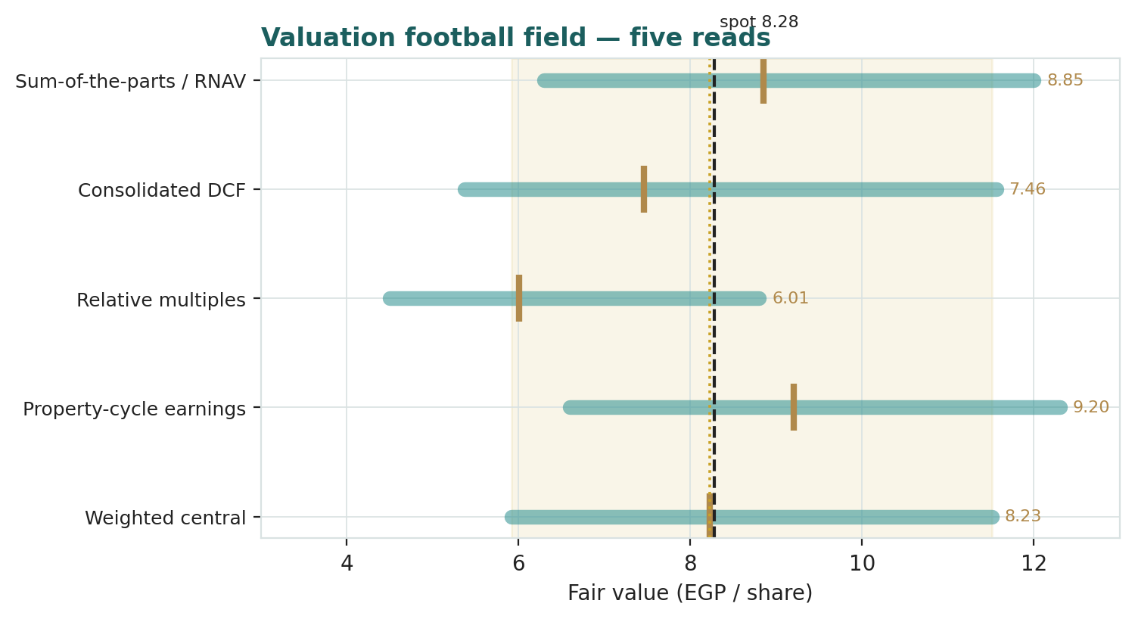
Figure 1 — Valuation football field. Bars span bear–bull per lens; the brass tick is each base case; the gold band is the blended central range; the dark line is spot.
Central fair value ≈ EGP 8.23/share, essentially on spot. The spread of the lenses (EGP 6.01 to EGP 9.20 at base) is itself the message: this is no longer a deep-value name, but a fairly-valued holding whose further re-rating depends on land being monetised at the marks and the structural discount continuing to narrow.
1.6 The holding-company assets — a deeper look
The value engine is the development pipeline; the contracting arm is the cash-converting workhorse; the rental portfolio is a small recurring anchor; and El Kahera Housing is the reason a minority line matters. The table scores each leg on the axes that drive the SOTP.
Leg | Cyclicality | Margin trend | Capital / cash intensity | Swing role
Real-estate development | High (presales cycle) | ~30% gross; mix-dependent | Very high (land + WIP) | Dominant
Contracting arm | Moderate | Thin (~5–8%), input-cost sensitive | High working capital | Cash converter
Rental / leasing | Low | Steady, inflation-linked | Low (owned assets) | Recurring anchor
El Kahera Housing (majority) | Moderate | Developer economics | High | Minority leakage

The development leg's economics are the classic Egyptian off-plan model: units are contracted years before hand-over, cash is collected on an instalment schedule that funds construction, and profit is booked on completion. That is why reported profit and cash diverge, why working capital can be a source rather than a use, and why the RNAV — not the income statement — is the right anchor. The contracting arm, roughly 57% of revenue, is a lower-margin going concern with a ~EGP 7 bn backlog; it smooths cash but adds little multiple. The rental portfolio is small but genuinely recurring. El Kahera Housing and the other majority-owned subsidiaries are consolidated line-by-line, which is why net profit before minority overstates what accrues to PRDC holders — the explicit minority deduction in §1.1 corrects for it.
1.7 The crux — land marks, the discount, and the contracting cycle
Three judgments drive the valuation more than any other, and — per house discipline — we sensitise each on its own observable driver, not on an abstract margin. First, what the development land bank is worth: the RNAV credits ~EGP 15 bn to the development leg, an implicit value per developable metre that is a house estimate; every EGP 2 bn on that mark is worth roughly EGP 1.4/share at the group level after minority and discount. Second, the holdco/complexity discount: an Egyptian developer-contractor wrapped around a majority-owned listed subsidiary, paying no dividend, will not trade at the clean sum of its parts. We apply 10%; the market is implying nearer 16%. If governance and disclosure improve and land is monetised, that discount can narrow — the principal non-operating source of upside. Third, the contracting-margin cycle: at ~57% of revenue, a one-point move in the contracting net margin swings group earnings and, through the property-cycle lens, a few tens of piastres per share. The binary catastrophic case worth naming is an EGP funding/affordability shock that stalls presales absorption: were contracted-sales velocity to fall by a third, the development leg's RNAV — and with it the whole central value — would move toward the bear case in §1.9.
1.8 Macro and country — rates, the pound, mortgages and Gulf flows
PRDC is a domestic Egyptian cyclical whose value is set by four macro levers. The CBE policy-rate path cuts both ways: high rates lift the discount rate on the pipeline but real assets are the inflation hedge that drives presales; a rate-cutting cycle (the CBE corridor easing from its 2024 highs) is, on balance, supportive of demand and of the discount narrowing. The pound matters for build-cost (imported materials) and for dollar-linked pricing on premium units; a further step devaluation is a cost-and-risk-premium negative even as it can lift nominal land values. Mortgage finance is thin in Egypt, so most sales are developer instalments — an expansion of subsidised mortgage schemes would widen the buyer pool and quicken absorption. Gulf liquidity is unusually relevant here: the Saudi Al-Muhaidib family and the Kuwaiti and Norwegian sovereign funds are on the register, and GCC buyer purchasing power supports the coast and premium Cairo product. These levers are the swing factors behind the bear and bull cases in §1.5 and the catalysts in §5.
1.9 RNAV sensitivity — how much the swing inputs move the value
Holding the contracting, rental and other legs at base, the grid re-prices the RNAV across the development-leg NAV and the holdco/complexity discount — the two inputs that matter most. The value runs from about EGP 6 to EGP 12 a share across the plausible box.
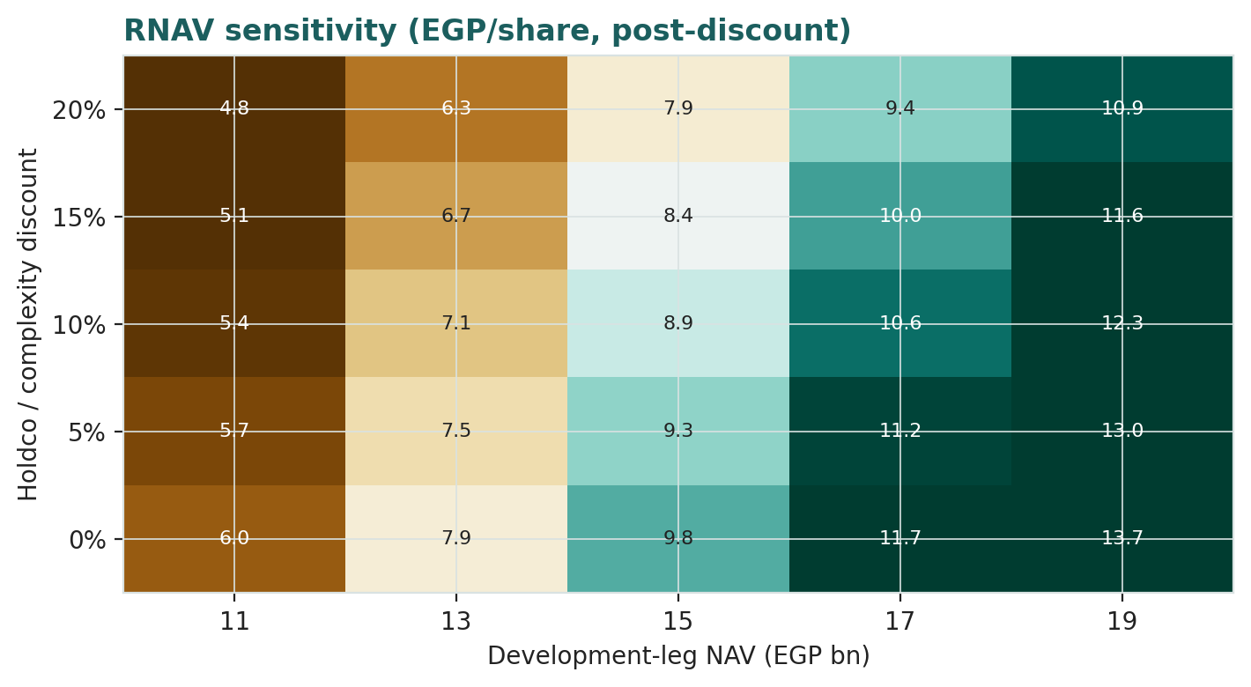
Figure 2 — RNAV sensitivity to the development-leg NAV and the holdco/complexity discount (EGP/share, post-discount).
Read it as the bet you are taking: the EGP 8.28 market price is consistent with roughly a EGP 15 bn development mark at a mid-teens discount — i.e. a partial, not a full, monetisation-and-re-rating already in the price.
2 Technical and price structure
The tape is strong and stretched to the upside — the opposite of a value name. PRDC trades above all four major moving averages, the MACD line is above its signal, and RSI sits near 70, in the upper zone though not yet at an extreme. The structure is a powerful post-discount re-rating that has carried price from a 52-week low of EGP 3.08 to a high of EGP 8.75 in mid-June, with a sharp intra-quarter surge and equally sharp reversals along the way (single sessions of +17% and −13% appear in the record).
Indicator | Reading | Signal
Spot | EGP 8.28 | —
SMA 20 / 50 | EGP 7.08 / 6.09 | Above both — short-term up
SMA 100 / 200 | EGP 5.13 / 4.49 | Above both — trend up
RSI (14) | 70 | Upper zone, near overbought
MACD (12,26,9) | +0.50 line / +0.47 signal / +0.04 hist | Bullish, momentum positive
52-week range | EGP 3.08 – 8.75 | Upper third of range
Realized vol (252d) | 45% | Very elevated

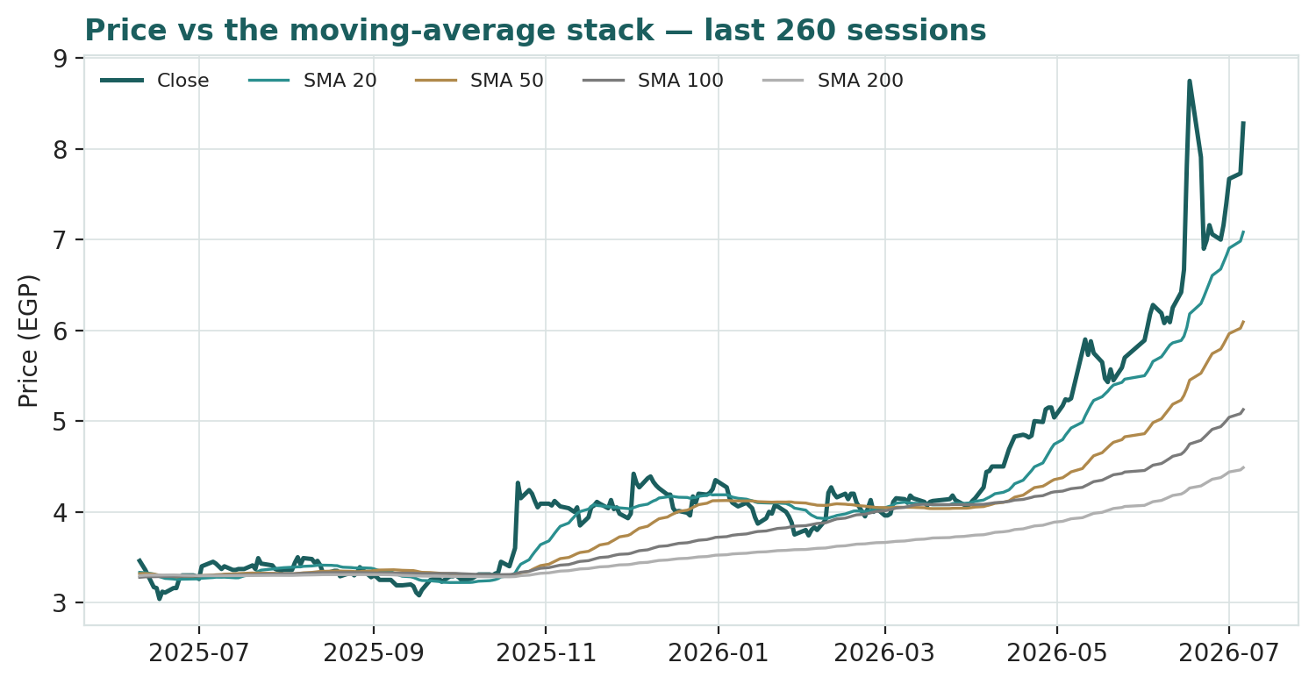
Figure 3 — Price versus the moving-average stack, last 260 sessions.
For the probabilistic work this matters in one way: a strong, above-trend but overbought tape widens the near-term two-sided tail — momentum can extend, but mean-reversion after a near-tripling is a live risk. The technical and fundamental pictures agree that value and price have converged; where they part is direction from here, and §6 reads the resulting probability zones without forcing a call.
3 Monte Carlo — a probabilistic price map (illustrative)
We simulate 50,000 three-month price paths (seed 42) using a sixteen-factor stack: seven continuous macro/operating drivers contributing a small net forward drift, and nine discrete events that each fire with a probability and an impact. By design the paths diffuse from spot, and the §1 value gap is kept out of the drift — the fundamental NAV question lives in §1, not here; §3 maps where price could go from today, not where value sits. Width is sized by the YZ-HAR engine (a log-HAR variance cascade on a gap-aware Yang-Zhang proxy, annualised ≈ {A['ann_vol_fwd_har']*100:.0f}%); innovations are unit-variance Student-t(5); the drift is the EGX-developer secular drift, floored at zero (+{A['drift_60d']*100:.1f}% over the quarter). Important calibration caveat: Step 0 (Appendix B) is only marginal for this name — the engine roughly matches, and does not decisively beat, the random-walk benchmark, with a PIT tilted high because PRDC's 2026 breakout was not forecastable from its own price history. We therefore present this section as an illustrative price map, not a graded forecast, and read it alongside the overbought technical tape.
The probability read (T+60, from the same 50,000 paths):
Probability read | Value
P(price above spot) | 61%
P(+10%) vs P(−10%) | 44% vs 23% (odds 1.89×)
Median level / move | EGP 8.81 (+6.4%)
50% band (25th–75th) | EGP 7.55 – 10.25 (-9% / +24% of spot)
Touch(+10%) / Touch(−10%) | 70% / 50%

The read is a modest positive tilt — a little more than even odds of finishing above spot, driven by the secular drift, with a wide, right-skewed band. It is presentation-only, computed after simulation, and leaves the engine and Step 0 unchanged.
The factor stack, seven continuous drivers and nine discrete events:
Continuous factor (7) | Discrete event (9) | Prob. | Mean impact
CBE policy-rate path | Geopolitical / regional security | 30% | -10.0%
EGP/USD rate | Cross-border / Gulf inflows | 30% | +3.0%
Inflation (CPI) | Project launch & sales execution (IVOIRE / Second Home) | 50% | +4.0%
EGX30 & foreign flows | Mortgage finance & credit expansion | 35% | +1.5%
Residential demand / absorption | Contracting backlog / award | 40% | +2.0%
Brent / Gulf liquidity | Land acquisition / new-launch land deal | 30% | +3.0%
Contracting input cost (steel/cement) | CBE rate-cut surprise | 30% | +2.0%
 | Earnings / minority-mix surprise | 45% | +1.0%
 | EGP devaluation step / FX shock | 25% | -6.0%

Percentile map (EGP/share):
Horizon | p5 | p25 | p50 | p75 | p95
T+20 sessions | 6.63 | 7.74 | 8.45 | 9.24 | 10.68
T+60 sessions | 5.86 | 7.55 | 8.81 | 10.25 | 13.17

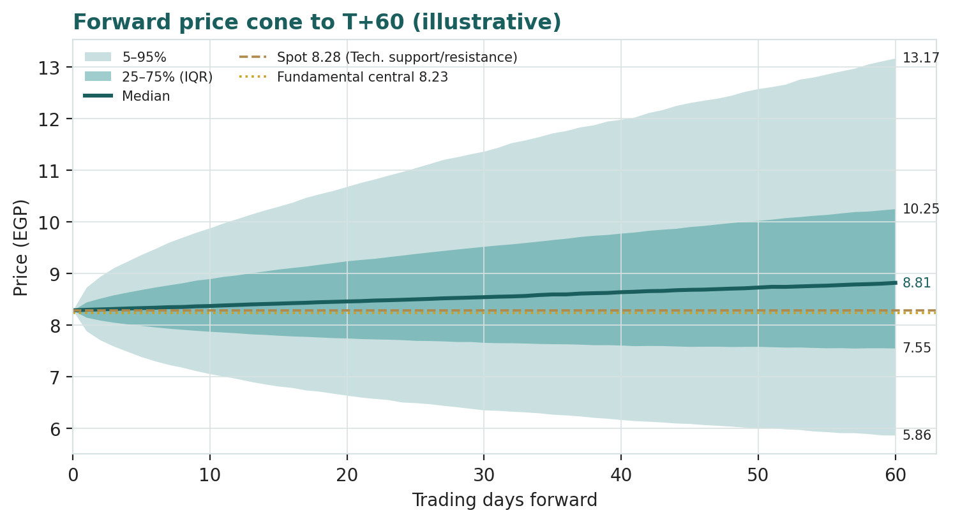
Figure 4 — Forward price cone to T+60 (illustrative). Lead with the 25–75% interquartile band; the gold dotted line marks the EGP 8.23 fundamental central value.
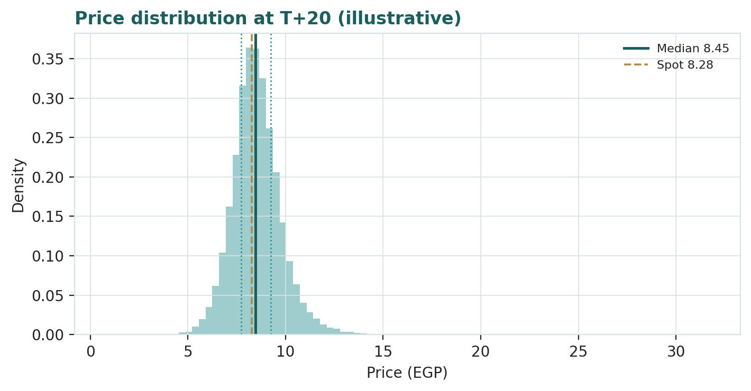
Figure 5 — Price distribution at T+20 (illustrative).
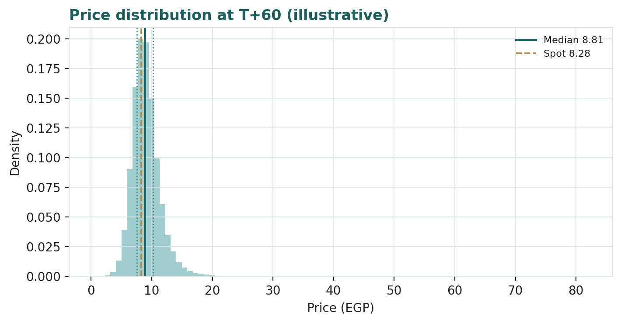
Figure 6 — Price distribution at T+60 (illustrative).
Level-touch ladder — the probability that price touches a level at any point by the horizon (running max for upside, running min for downside):
Level (EGP) | T+20 touch | T+60 touch | Note
10.76 | 7% | 30% | Above the 52-wk high
9.94 | 18% | 47% | Above the 52-wk high
9.11 | 44% | 70% | Above the 52-wk high
8.69 | 66% | 83% | Around spot
7.87 | 54% | 69% | Around spot
7.45 | 30% | 50% | Downside / mean-reversion
6.62 | 8% | 23% | Downside / mean-reversion
5.80 | 2% | 9% | Downside / mean-reversion

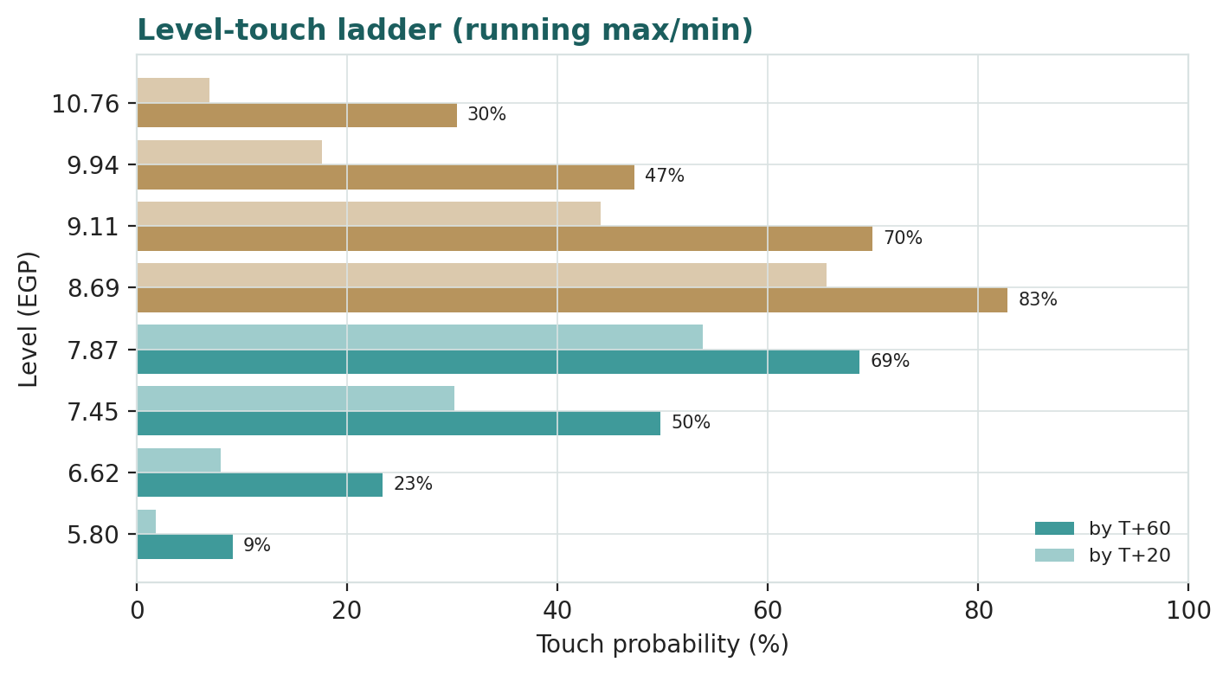
Figure 7 — Level-touch ladder (running max for upside, running min for downside).
4 Comparison of the lenses, and a verdict
Three readings sit side by side. The fundamental lenses cluster at EGP 6.01–9.20 with a central EGP 8.23 — essentially on spot, contingent on land marks and the discount. The technical picture is strong but stretched: above every average, RSI near 70, momentum positive after a near-tripling. The probabilistic map says that over three months price is modestly skewed up around spot with a wide ±band — the median is a little above EGP 8.28, not far above, because the simulation does not assume the value gap re-opens or closes further inside the quarter.
Lens | Reads | Central / implication
Fundamental (4-lens) | Fairly valued | EGP 8.23 (-1%)
Technical | Strong / overbought | Support at the MA stack ~EGP 7.08; stretched above
Monte Carlo (3-month, illustrative) | Modest up-skew, wide | Median ~EGP 8.81; p5–p95 EGP 5.86–13.17

Verdict (a fair-value read, not a recommendation). PRDC looks fairly valued on fundamentals after a powerful re-rating that closed the deep NAV discount it carried for years. The remaining upside is specific and non-operating — land monetised at the marks and a discount that narrows further — while the near-term risk is a mean-reversion pullback from overbought levels. The honest summary is a value on top of price, a three-month distribution centred a little above price, and an outcome that hinges on the land bank and the structural discount rather than on any single quarter — which is why the bear–bull span (EGP 5.92–11.51) is wide. Readers should weigh the lenses themselves; we publish the distribution, not a target.
5 Catalysts to watch
- Contracted-sales prints. Quarterly contracted-sales and collections figures are the clearest read on whether the ~EGP 27–30 bn/year absorption is holding as new supply comes to market.
- IVOIRE East delivery & new launches. Progress on the 438,000 sqm flagship and any new land deal or launch that refills the development pipeline (and the GDV behind the RNAV).
- CBE rate path. The pace of monetary easing from the 2024 highs — supportive of demand and of a narrowing discount, but a driver of the pound.
- EGP & build-cost. Any further step move in the pound re-prices build-cost, dollar-linked unit pricing, and the risk premium.
- Mortgage / subsidy policy. Expansion of subsidised mortgage schemes would widen the buyer pool and quicken absorption.
- Gulf flows. GCC buyer demand and any capital action from the Saudi/Kuwaiti/Norwegian holders on the register.
- Governance & disclosure. Clearer segment reporting, a dividend initiation, or simplification of the subsidiary structure would each argue for a narrower holdco/minority discount.
- Contracting margin & backlog. The margin cycle and backlog conversion in the ~57%-of-revenue contracting arm.
6 Reading the probability zones
Translating the three-month distribution into plain zones, anchored on spot EGP 8.28 and the fair-value cluster:
Zone (T+60) | Range | Approx. probability | What it would mean
Deep downside | < EGP 6.50 | ~10% | Re-rating unwinds / risk-off; toward mean-reversion
Lower band | EGP 6.50–7.50 | ~14% | Discount widens again; relative-multiple lens dominates
Around spot | EGP 7.50–9.00 | ~30% | Status quo; value and price converged
Upper band | EGP 9.00–11.00 | ~30% | Land credited / discount narrows; toward RNAV & cycle lens
Strong upside | > EGP 11.00 | ~16% | Monetisation + discount narrowing together

The distribution is close to symmetric with a slightly heavier upper tail from the discrete upside events (a land deal, Gulf flows, a discount re-rating). It is not a forecast; it is the spread of outcomes consistent with the stock's own volatility and the factor stack, and it should be read against the overbought technical tape.
7 Caveats and what would change our mind
- The land mark is the model. A large slice of the value rests on a house estimate of the development-leg NAV; a lower realizable land value would pull the central value toward — or below — spot.
- Minority leakage. Consolidated profit overstates what accrues to PRDC holders; the minority deduction is an estimate, and a different subsidiary economics would move it.
- The discount can widen, not just narrow. Complexity, governance perception, the no-dividend policy or a weak presales quarter could push the holdco/minority discount past the ~16% the market already implies.
- Calibration is marginal. Step 0 does not decisively beat the benchmark for this name and the PIT tilts high; the Monte Carlo is illustrative, not a graded forecast, and the recent surge makes near-term continuation odds especially uncertain.
- Overbought tape. RSI near 70 after a near-tripling; mean-reversion pullbacks are common and say nothing about value. Equally, strong tapes can extend. The technical read is context, not a trigger.
- EGP & rate leverage. The RNAV and the DCF both move with the pound and the CBE path; a step devaluation or a stalled easing cycle is a direct, mechanical downgrade.
- Data quality. Segment and balance-sheet splits are partly estimated to disclosed totals; the vendor mis-classification of PRDC as a financial name is a reminder to read the primary filings.
Appendix A Financial statements
Selected consolidated figures. FY2023–FY2025 are the company's disclosure (EGX filings and press releases); several line items and all forecast years are house estimates flagged in the companion model. FY2025 profit fell from the FY2024 peak as one-off gains normalised and minority took a larger share.
A.1 Income statement (consolidated, EGP mn)
Line | FY23 | FY24 | FY25 | FY26E | FY27E
Revenue | 5,780 | 5,000 | 6,400 | 7,040 | 8,096
EBITDA | ~1,300 | ~1,150 | ~1,470 | 1,690 | 1,943
EBIT | ~1,150 | ~1,010 | ~1,340 | 1,549 | 1,781
Net finance cost | (900) | (1,050) | (1,200) | (915) | (1,052)
Pre-tax profit | ~720 | ~1,630 | ~870 | 934 | 1,029
Net profit after tax (consolidated) | 557 | 1,260 | 674 | 724 | 797
less: minority interest | (257) | 10 | (312) | (217) | (239)
Attributable to parent | ~300 | ~1,270 | ~362 | 506 | 558
FY23–FY25 are disclosed/derived; the exceptional-item swing (a large FY24 gain, partly reversing in FY25) makes year-to-year comparison noisy — shown for scale as much as trend.

A.2 Balance sheet (consolidated, EGP mn)
Line | FY23 | FY24 | FY25
Cash & equivalents | 4,200 | 5,000 | 5,600
Trade & installment receivables | 8,000 | 9,500 | 11,000
Development inventory / WIP & land | 26,000 | 30,000 | 33,000
Investment property & PP&E | 4,500 | 5,000 | 5,300
Total assets | ~47,000 | ~54,000 | ~59,500
Borrowings (financial debt) | 9,000 | 10,000 | 10,600
Customer advances / deferred revenue | 16,000 | 19,000 | 21,000
Minority interest | 6,000 | 6,800 | 7,000
Equity attributable to parent | ~12,000 | ~13,500 | ~14,600
Total assets ~EGP 54 bn and attributable equity ~EGP 13.5 bn are H1-2024 disclosure anchors; intervening splits are estimated to balance to disclosed totals.

A.3 Cash flow & operating markers (EGP mn / units)
Marker | FY23 | FY24 | FY25
Contracted (presales) sales | ~18,000 | ~30,000 | ~27,000
Contracting backlog | ~6,000 | ~7,000 | ~7,500
Gross margin | ~30% | ~30% | ~29%
Operating cash (indirect, est.) | ~1,100 | ~1,600 | ~1,300
Dividend | 0 | 0 | 0
Source: company quarterly and full-year results FY2023–FY2025; figures rounded, several approximate.

Appendix B Step 0 — calibration backtest
Before any forecast we test the Monte Carlo lens on PRDC's own ~five years of history: at each origin, using only data to that date, we generate a three-month-ahead distribution with the YZ-HAR engine (unit-variance t(5), EGX-developer secular drift floored at zero) and score it against a naïve benchmark — a zero-drift random-walk lognormal cone at spot and trailing realized vol — by CRPS skill (1 − CRPS/CRPS_benchmark; must be > 0). A PIT histogram and interval-coverage table are produced as diagnostics only.
Window scheme | n | CRPS skill | 50% | 80% | 90% | PIT mean
Non-overlapping (step 63d) | 14 | -0.016 | 57% | 64% | 71% | 0.65
Monthly origins (step 21d) | 40 | +0.013 | 60% | 82% | 88% | 0.63
Fortnightly (step 10d) | 83 | +0.020 | 61% | 81% | 90% | 0.60
Target | — | > 0 | 50% | 80% | 90% | 0.50

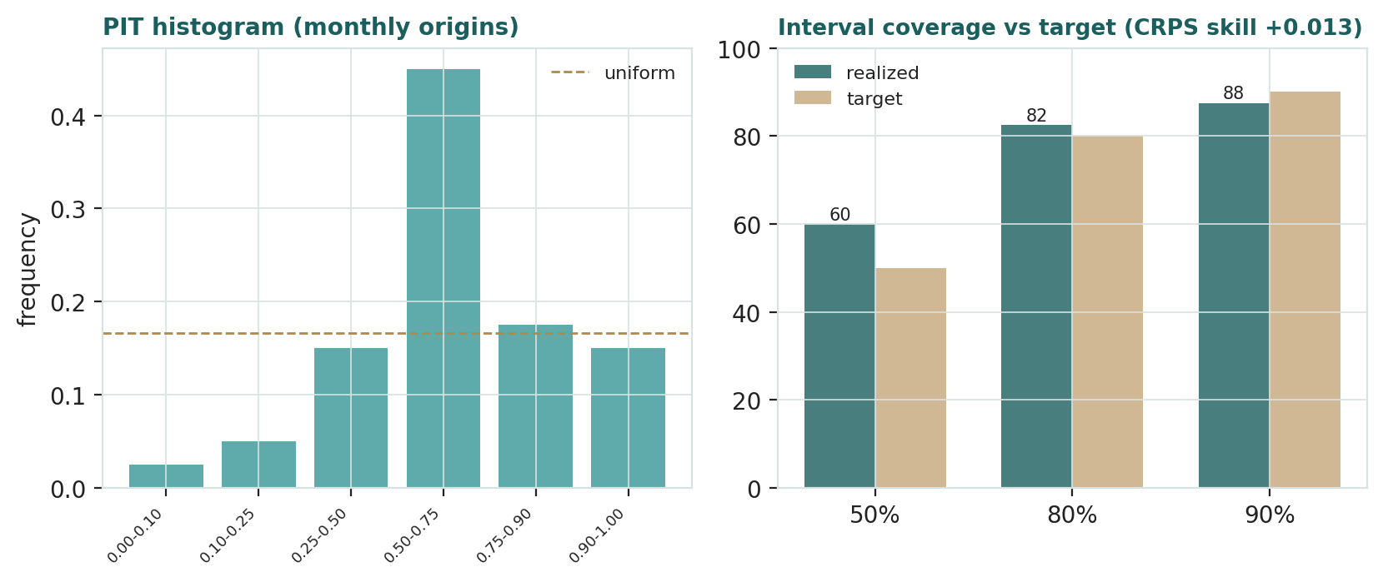
Figure B-1 — Calibration backtest: PIT histogram (monthly origins) and interval coverage versus target.
The honest result is marginal. The engine earns a small positive CRPS skill on the overlapping monthly (+1.3%) and fortnightly (+2.0%) schemes but is fractionally negative on the cleanest, autocorrelation-free non-overlapping windows (−1.6%, n = 14), and the PIT is tilted high (~0.60–0.65) — realized prices landed systematically above the forecast median. The cause is specific and instructive: PRDC spent most of the sample rangebound below its 2021 listing level before a sharp 2026 breakout that no past-only price model could have anticipated, so any principled drift under-predicts the realized upside. Per the house protocol we flag this rather than force a pass: the lens is roughly at parity with the benchmark, not decisively ahead, so the §3 Monte Carlo is presented as an illustrative price map, and the recent surge should temper any near-term directional reading of it.
Appendix C Peer set, sector structure, and risks
PRDC's cleanest comparables are the listed EGX developers, though its large contracting arm and majority-owned listed subsidiary make it a hybrid.
Peer | Closest basis | Typical valuation
TMG Holding (TMGH) | Presales-driven P/NAV | P/NAV; sector bellwether
Palm Hills (PHDC) | RNAV / P/B | Mid-cap developer
Emaar Misr (EMFD) | RNAV + cap-rate mix | Development + recurring
Heliopolis Housing (HELI) | Land-monetisation NAV | Land-rich, deep-value
SODIC (OCDI) | RNAV | New-Cairo / coast developer

Sector structure. Egypt's residential market is in an inflation-driven presales boom: negative real rates for much of the period have made property the household inflation hedge, off-plan penetration is high, and developers with land and a launch machine have compounded contracted sales. The swing macro variables are the CBE rate path, the pound, and mortgage/subsidy policy. Principal risks: a lower realizable land value; a wider holdco/minority discount; an EGP step devaluation; a stall in presales absorption if affordability breaks; thin free cash while the pipeline builds; and the data-quality/governance overhang implied by the vendor mis-classification and the no-dividend policy.
About this series
Testahil publishes independent, educational valuation studies. Each is an attempt to reason transparently about what a security is worth, with every assumption shown and a companion model so readers can disagree productively. The house style is distributions, not tips: we describe ranges and probabilities, not targets, and we do not tell anyone what to do. Studies are framed as educational analysis, the preparer is not licensed by any securities regulator, and holdings are disclosed.
Disclosure & Disclaimer
Not investment advice. This document is educational and informational only. It is not, and must not be relied upon as, investment, financial, legal, accounting or tax advice, nor an offer, solicitation or recommendation to buy, sell or hold any security. It contains no price target and no rating.
No licence; no advisory relationship. The preparer is not registered or licensed with any securities or financial regulator in any jurisdiction, holds no brokerage or investment-advisory authorisation, and is not acting as your adviser or fiduciary. Nothing here is personalised to your circumstances.
Holdings disclosure. The preparer may hold, and may in the future take or dispose of, a position in the security discussed in this report, and may transact at any time without notice. This is a potential conflict of interest you should weigh.
Sources & accuracy. Reported financial and operating figures are drawn from the company's public disclosure and other public sources believed reliable but not independently verified; they may contain errors or be superseded. Forward-looking inputs — the SOTP/RNAV marks, the land value, the holdco/minority discount, projections, multiples, the DCF and Monte-Carlo factor probabilities — are the preparer's own judgments and are inherently uncertain.
Forward-looking statements. Any statements about the future are estimates subject to risks and uncertainties; actual results may differ materially. The Monte Carlo models price, not value, encodes subjective probabilities for events that have not occurred, and for this name did not decisively beat its benchmark in backtest (Appendix B).
No reliance; your responsibility. Do your own research and consult a licensed professional before making any decision. You are solely responsible for your investment decisions and their outcomes. To the maximum extent permitted by law, the preparer accepts no liability for any loss arising from use of this document.
Currency & figures. Figures are in Egyptian pounds (EGP); mn denotes million and bn billion. Rounding may cause totals to differ slightly. Spot price and market data are as of 6 July 2026 and change continuously.
TESTAHIL · Independent Valuation Study · Educational Analysis · Pioneers Properties for Urban Development (EGX: PRDC) · edition 06-07-2026 · reporting currency EGP

Appendix D Three experts value Pioneers Properties
A single model is one mind. To pressure-test the read we convene three analysts who genuinely disagree — not on the arithmetic but on which arithmetic matters. Each is given the same disclosure and the same spot price of EGP 8.28 and asked, independently, what a share is worth and why. They are labelled Expert 1, 2 and 3; their methods, not their names, are what matter. Where they converge, confidence rises; where they diverge, the divergence itself locates the real question.
Expert 1 — the balance-sheet realist (RNAV & cash-conversion)
Worldview. The balance sheet is the truth and everything else is a story. A company is worth what its assets would fetch, marked conservatively, net of every claim that ranks ahead of the ordinary shareholder — debt, minorities, and the friction of actually turning bricks and land into distributable cash. For a developer that last point is decisive: booked profit is an accounting event; free cash is a fact, and the two diverge whenever collections lag, launches stall, or working capital swells. So this expert starts from the sum-of-the-parts, then haircuts the development mark for realizability and applies a cash-conversion overlay — what fraction of reported development profit has historically become free cash.
When it works, and when it fails. This lens is at its best on asset-heavy names trading below book, where the market has mispriced the discount and a patient re-mark is the whole thesis — precisely PRDC's situation for years. It fails in the other direction: it is static, it under-credits the franchise value of a developer that keeps selling out launches, and in a genuine boom it will look too cautious because it refuses to extrapolate cyclical earnings power into perpetuity.
Workings. Take the SOTP asset value, haircut the development leg for execution and collection risk, keep the other legs, then run the standard bridge (less net debt, less minority, less a modest residual discount) and cross-check that the implied free cash supports the mark.
Expert 1 workings (EGP mn) | Value
Development leg — reported RNAV mark | 15,000
less realizability haircut (−15%) | (2,250)
Development leg — realizable | 12,750
+ contracting + rental + retail | 3,300
Σ realizable asset value | 16,050
less net debt + minority | (8,000)
less residual discount (~7%) | (560)
Equity value | 7,490
Fair value / share (EGP) ≈ EGP 7.8 | 7.8

Worked example — the cash-conversion test. If the group books ~EGP 1.3 bn of attributable development profit but converts only ~70% into free cash while the pipeline builds, the 'quality' of the NAV is 0.7×, which is exactly why this expert haircuts the land mark rather than taking it at face value. The result, ~EGP 7.8, sits just below spot.
Sensitivity (swing input = the land-mark haircut). At a 0% haircut the value is ~EGP 9.4; at −15% (base) ~EGP 7.8; at −30% ~EGP 6.2. The entire expert-panel range can be spanned by this one assumption — a sign that the land mark, not the macro, is the master variable.
Why the cash-conversion overlay matters here specifically. Egyptian off-plan developers report profit on hand-over but collect over instalment plans that can run five to eight years, and a slice of contracted units cancel. So a developer can show rising booked profit while free cash stays thin — the money is tied up in work-in-progress and land. This expert therefore refuses to treat the EGP 15 bn development mark as cash-equivalent: he asks what it would fetch in an actual transaction today, net of the cost and time to complete, and discounts accordingly. The FY25 profit decline from the FY24 peak — driven partly by one-off gains reversing — is, to him, exactly the kind of accounting noise that vindicates anchoring on realizable assets rather than on a single year's earnings.
Cross-examination. To Expert 2: 'Contracted sales are not cash. Show me the collection curve and the cancellation rate before you capitalise a boom.' To Expert 3: 'Your scenarios are unfalsifiable; I can audit a receivable, I cannot audit your 35% probability of an easing cycle.'
Verdict, falsification, and the market. Fair value ~EGP 7.8. I am wrong if collections run above ~90% of contracted sales and comparable land changes hands near my mark — then my haircut is too harsh. At spot EGP 8.28, the market is agreeing with me almost precisely: it is paying for realizable assets, not for the boom.
Expert 2 — the absorption engine (demand & sales velocity)
Worldview. A developer is not a pile of land; it is a machine that converts launches into contracted sales and contracted sales into cash. Value is the discounted stream of developer cash flows that the current order-book and the launch cadence will produce, driven by three things: sales velocity (how fast units clear), price-per-metre escalation (which in Egypt has outrun inflation), and the collection schedule. Marking assets to a conservative book, this expert argues, misses the franchise — the brand, the land bank and the sales force that keep selling out phases.
When it works, and when it fails. In a live presales boom with visible, repeatable demand — Egypt today — this is the sharpest lens, because it prices the thing actually happening. It fails at cycle turns: it assumes velocity persists, so it will over-value right up until the moment absorption rolls over, and it tends to underweight balance-sheet leverage and minority leakage.
Workings. Start from the contracted-sales run-rate (~EGP 27–30 bn), apply development net-margin economics, layer the recognition/collection curve, add the contracting backlog at its thinner margin, and discount the resulting attributable developer cash flows.
Expert 2 workings (EGP mn) | Value
Annual contracted sales (run-rate) | 28,000
× development net margin (~18%) | 5,040
PV of ~3–4 yrs recognised profit + pipeline | 13,600
+ contracting backlog value | 1,600
+ rental / retail | 1,800
less net debt + minority | (8,000)
Equity value | ≈ 9,850
Fair value / share (EGP) ≈ EGP 9.4 | 9.4

Worked example — velocity is the engine. At EGP 28 bn of contracted sales the pipeline throws off enough recognised profit over the next three to four years to support ~EGP 9.4; hold price escalation but cut velocity 20% and the figure falls toward EGP 8; raise both and it approaches EGP 12. The lever is absorption, not the discount rate.
Sensitivity (swing input = contracted-sales velocity). ±20% on velocity moves the value roughly EGP 8.0 ↔ EGP 11.0 — the widest single-variable swing of any expert, and the reason this lens is the most bullish and the most cyclical.
Price escalation is the hidden compounding. The absorption case is not only about units cleared; it is about price-per-metre, which for Cairo developers has repeatedly outrun headline inflation as buyers treat property as the hardest available store of value. Each new launch reprices the land bank implicitly: the same plot supports a higher gross development value than the RNAV's static mark assumes. This expert credits some of that escalation, which is why his number sits above the realist's — he is valuing a moving franchise, not a frozen balance sheet. The offset he watches is the collection curve: escalation is worth little if instalment defaults rise, so he stress-tests the cash schedule, not just the headline contracted-sales figure.
Cross-examination. To Expert 1: 'Your conservative book ignores that this franchise sells out launches; you are valuing the land as if no one will develop it.' To Expert 3: 'In a negative-real-rate world, demand is driven by the inflation hedge, not the policy rate — your macro scenarios are second-order to absorption.'
Verdict, falsification, and the market. Fair value ~EGP 9.4. I am wrong if contracted sales fall for two consecutive quarters — that breaks the velocity assumption the whole case rests on. At spot EGP 8.28, the market is pricing less than my absorption case: either it doubts the velocity persists, or it is demanding the holdco/minority discount I under-weight.
Expert 3 — the macro-policy strategist (scenario-weighted)
Worldview. A domestic Egyptian cyclical is, first and last, a bet on the macro regime. The same company is worth very different amounts depending on the path of the CBE policy rate, the pound, mortgage availability and Gulf capital flows — so a point estimate is a category error. Value is a probability-weighted blend across a small set of macro states, each of which implies its own discount rate, demand multiplier and assumption about whether the structural discount narrows or widens.
When it works, and when it fails. This lens earns its keep at regime inflection points — an easing cycle beginning, a currency finding a level — which is arguably where Egypt sits now. In a stable regime it mostly adds noise, and it is helpless at valuing idiosyncratic execution: it can tell you the weather, not whether this particular developer builds well.
Workings. Define three macro states, attach probabilities, map each to a fair value (via its discount rate and demand/discount assumptions), and take the expectation.
Macro state | Prob. | Implied FV (EGP) | Contribution
Easing cycle / EGP stable / Gulf inflows | 35% | 10.5 | 3.68
Base — gradual easing, sticky discount | 45% | 8.2 | 3.69
Shock — EGP step-devaluation / risk-off | 20% | 5.5 | 1.10
Probability-weighted ≈ EGP 8.2 | 100% |  | 8.2

Worked example — the discount is a macro variable. The key insight is that the holdco/minority discount is not a fixed 16%; it narrows in the easing state (cheaper money chases yield and re-rates complex names) and widens in the shock state (risk-off punishes complexity). Folding that into each state gives the ~EGP 8.2 expectation — squarely at spot.
Sensitivity (swing input = the shock probability). Raise the shock weight from 20% to 35% and the value falls to ~EGP 7.3; cut it to 10% and it rises to ~EGP 8.9. The tail, not the base, moves the number.
How the four levers map to the states. The easing state assumes the CBE continues cutting from its 2024 highs, the pound holds a level, mortgage access widens, and Gulf inflows persist — each of which lifts demand and compresses the complexity discount as yield-seeking capital re-rates the name. The base state assumes gradual easing but a sticky discount: demand holds, but the market keeps punishing the holdco/minority structure. The shock state is a fresh EGP step-devaluation or a risk-off reversal that spikes the discount rate, raises build-cost, and freezes the re-rating. Because PRDC has foreign strategic holders (Saudi, Kuwaiti, Norwegian), this expert weights the Gulf-flow channel more heavily than he would for a purely domestic developer — capital action from those holders is itself a swing factor.
Cross-examination. To Expert 1: 'Your static NAV treats the discount as fixed; it is the single most macro-sensitive number in the whole valuation.' To Expert 2: 'Absorption is downstream of rates and the pound — your velocity is my base state in disguise, and it will not survive a devaluation.'
Verdict, falsification, and the market. Fair value ~EGP 8.2. I am wrong if the CBE reverses course and hikes, or the pound takes another step down — either would collapse my base state into the shock. At spot EGP 8.28, the market is sitting exactly at my base state: it is pricing neither the easing upside nor the shock downside.
The three in one room
Put them at one table and the argument narrows fast. The realist anchors low at EGP 7.8, insisting the land mark be haircut until collections prove it. The absorption expert counters high at EGP 9.4: the machine is selling out launches, and conservative book value denies the franchise. The macro strategist lands in the middle at EGP 8.2 and reframes the whole dispute — both of you, he says, are really arguing about one macro-sensitive number, the discount, and one execution-sensitive number, the realizable land value. They agree, grudgingly, on the shape of the disagreement: the bull case needs velocity to persist and the discount to narrow together; the bear case needs a land-mark haircut or a macro shock. Nobody at the table thinks the stock is dramatically mispriced — the fight is over EGP 7.8 to EGP 9.4, a band of about 21%, centred within a few piastres of spot.
Reading the divergence
The spread between the three is not noise to be averaged away; it is a map of the two open questions. Almost the entire EGP 7.8–9.4 range can be reproduced by moving just two inputs — the realizable land value (Expert 1's haircut) and the structural discount (Expert 3's macro state) — while Expert 2's velocity sets how fast either resolves. That is the useful output: not a single number, but the knowledge that if you want to hold PRDC you are underwriting land that monetises near its mark and a discount that does not widen, and if you want to avoid it you are betting on a haircut or a macro shock.
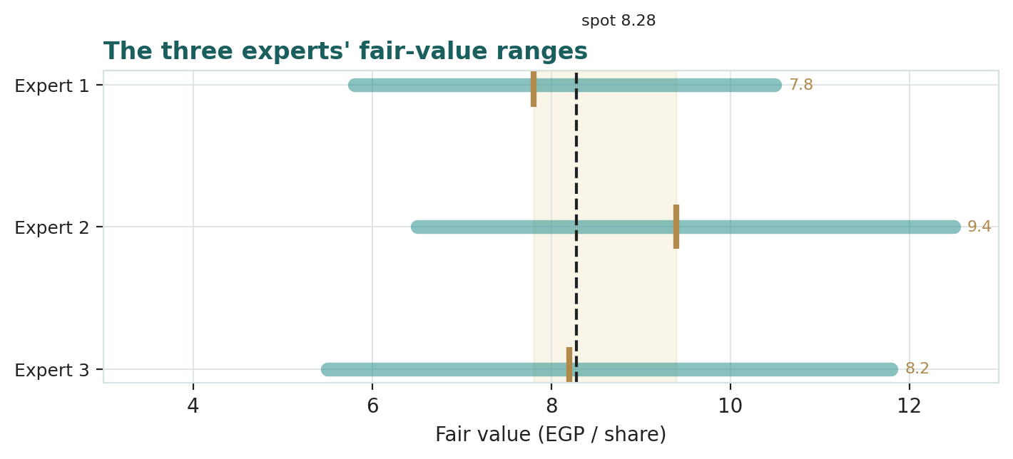
Figure D-1 — The three experts' fair-value ranges. The brass tick is each base case; the gold band spans the panel; the dark line is spot.
Expert | Method | Swing input | Fair value (EGP)
Expert 1 | RNAV + cash-conversion | Land-mark haircut & cash-conversion overlay | 7.8
Expert 2 | Absorption / sales velocity | Contracted-sales velocity / recognition pace | 9.4
Expert 3 | Macro-policy scenarios | CBE rate path, EGP, mortgage & Gulf flows | 8.2
Panel centre | Blend of the three | land value + discount | 8.5

The panel centres at ~EGP 8.5, within a hair of both the model's weighted central (EGP 8.23) and spot (EGP 8.28). Three independent methods, one conclusion: PRDC is fairly valued, and what happens next is a question about land and the discount — not about the price being wrong today.
What an investor should take from the panel. The value of convening three minds is not the average they produce but the checklist they leave behind. To be long PRDC from here, a reader must believe at least two of the following: that the development land bank monetises near its EGP 15 bn mark (Expert 1's crux), that contracted-sales velocity holds so the franchise keeps compounding (Expert 2's crux), and that the macro regime eases rather than shocks so the structural discount narrows (Expert 3's crux). To be bearish, a reader needs only one of those to fail — a land-mark haircut, two weak presales quarters, or a currency step. That asymmetry — three things must go right for the bull, one wrong for the bear — is why all three experts, despite their different methods, decline to call the stock cheap at spot, and why the honest posture is a wide distribution rather than a confident target. The panel does not tell you what to do; it tells you exactly which questions your own answer depends on.

