Testahil · Independent Valuation Study — Educational Analysis | Not investment advice
Independent Valuation Study — Educational Analysis
QNB Group (QSE: QNBK)
Fundamental analysis · Technical analysis · Monte Carlo simulation — one integrated read
Anchor: QAR 17.54 (05 Jul 2026 close) · 9.113 bn shares · market cap ≈ QAR 160 bn (≈ USD 44 bn) · the largest bank in the Middle East and Africa by assets (QAR 1,391 bn), 50%-owned by the Qatar Investment Authority · prices and probabilities computed 05 Jul 2026 from the attached daily history · primary lens: a two-stage dividend discount model · the swing factors are the post-Pillar-Two tax step, the 2026 rate-cut path through net interest margin, and how much of QNB's excess capital is returned.
READ FIRST — what this document is, and is not. This study is a valuation exercise and an expression of personal analytical opinion, published free of charge for educational purposes: it shows how one analyst applies fundamental, technical and probabilistic methods to a listed company, and invites scrutiny of that methodology. It is NOT investment advice, NOT a recommendation or solicitation to buy, sell or hold any security, and NOT directed at the circumstances of any reader. The preparer is not licensed by any securities regulator in any jurisdiction — including the Qatar Financial Markets Authority — holds no brokerage or advisory authorisation, manages no money, and accepts no fees, funds or clients. See the Disclosure & Disclaimer at the end. All values are model outputs presented as ranges and distributions because no single number should be relied on. Reported financials are the company's own disclosure (FY2025 results, 13 January 2026); forward-looking inputs — the earnings path, the payout and capital-return assumptions, the cost of equity, the multiples, the dividend-discount and FCFE models, and the Monte-Carlo factor probabilities — are the preparer's judgments and are flagged throughout. Consult a licensed financial advisor before any investment decision.
Headline
The model's read: fairly valued, with a modest premium to price that rests on QNB returning more of its excess capital as the rate cycle turns. At QAR 17.54 the shares sit about 7% below our weighted central estimate of QAR 18.8. The four lenses cluster tightly: a two-stage dividend discount model on the actual payout lands at QAR 18.7 (+6%), a distributable-capital (FCFE) model at QAR 20.2, a P/B–RoTE relative read at QAR 18.2, and a through-cycle normalized-earnings read at QAR 17.6 — the floor. The whole answer turns on three things. First, the global-minimum-tax step: 2025 net profit rose only 1.7% even as pre-tax profit rose ~10%, because Pillar Two lifted QNB's effective tax rate from near-zero to ~15% — a permanent haircut to post-tax returns. Second, the 2026 rate-cut path: as the QCB follows the Fed lower (the riyal is pegged), net interest margin compresses before volume growth offsets it. Third, and the source of the upside, the excess-capital question: QNB runs a 19.3% capital ratio and pays out only ~42% of earnings; the QAR 2.1bn buyback and rising interim dividends suggest a gradual return of that surplus, which is the gap between the actual-policy DDM (+6%) and the full-capacity FCFE read (+26%). Technically the tape is the mirror image of the fundamentals — below every major moving average, RSI in the high-30s, MACD below signal — so price and value are pulling gently apart. Over three months the Monte Carlo places the 5th–95th band at roughly QAR 14.0–20.9, with the median at spot.
Valuation summary — every read at a glance
One table for the four reads that follow — what the business is worth (fundamental), what the tape is doing (technical), where price could travel over three months (Monte Carlo), and how three independent expert methods land. Every row is developed in the sections and appendices below.
Lens / read | What it measures | Output | Takeaway
FUNDAMENTAL — what the business is worth (the anchor)
Dividend discount model (primary) | PV of dividends on actual policy | QAR 18.7 | +6% vs spot
FCFE / distributable capital | Discounted distributable earnings | QAR 20.2 | +15%
Relative multiples | Justified P/B–RoTE + peer | QAR 18.2 | +4%
Normalized earnings | Through-cycle RoTE power | QAR 17.6 | +0% · the floor
Weighted central | Blend 40 / 25 / 15 / 20 | QAR 18.8 | +7% vs QAR 17.54
TECHNICAL — what the tape is doing (timing, not value)
Trend & momentum | Price vs 20/50/100/200-day | Below all four | Weak, corrective
Momentum / range | RSI · MACD · 52-week range | RSI 38 · MACD -0.04h · QAR 16.7–20.4 | Soft
MONTE CARLO — where price could go in 3 months (paths from spot)
T+20 sessions | 50,000 paths · 16 factors | p5 15.3 · p50 17.5 · p95 19.6 | Median ≈ spot
T+60 sessions | same engine, longer horizon | p5 14.0 · p50 17.2 · p95 20.9 | Wide, mild left tail
EXPERT PANEL — three independent methods (Appendix D)
Expert 1 — capital & returns | DDM / P-B on RoTE vs Ke | QAR 18.7 | The anchor
Expert 2 — credit cycle | Through-cycle cost of risk | QAR 16.9 | Most conservative
Expert 3 — macro-policy | LNG / rates / capital return | QAR 20.4 | Most bullish
Panel range | Spread = tax & credit vs LNG | QAR 16.9–20.4 | Centres ≈ QAR 18.7
Bottom line. Every read points the same way on value and disagrees only on magnitude. The fundamental central sits near QAR 18.8 — about 7% above the QAR 17.54 spot — the three experts span QAR 16.9–20.4, and each turns on a single question: whether QNB's post-tax through-cycle return justifies a premium to its book, and whether the surplus capital is returned. The market prices QNB at ~1.48× book, which — solved back through the same model — implies a cost of equity of ~11.3%, a meaningful risk premium over our 10.5% base for the emerging-market (Türkiye, Egypt) and concentration risks. The three-month distribution centres on price, not fair value, because the simulation does not assume the gap closes inside the quarter.
Company overview — QNB Group at a glance
Item | Value
Listed entity | QNB Group Q.P.S.C. (QSE: QNBK; Doha)
What it is | Largest bank in the Middle East & Africa by assets; ~50% owned by the Qatar Investment Authority (sovereign wealth fund)
Footprint | ~28 countries, ~900 locations, ~31,000 staff; core Qatar plus QNB Finansbank (Türkiye) and QNB Alahli (Egypt)
Spot / date | QAR 17.54 · 05 Jul 2026 close
Shares · market cap | 9.113 bn · QAR 160 bn (≈ USD 44 bn)
FY25 net profit / EPS | QAR 17.0 bn (+1.7%) · EPS QAR 1.74
FY25 operating income | QAR 44.8 bn (+8%)
Total assets / loans / deposits | QAR 1,391 / 1,018 / 955 bn
Capital / asset quality | CAR 19.3% · NPL 2.6% · coverage 100%
Efficiency / margin | Cost/income 23.3% · NIM ~2.6% · cost of risk ~85–90 bps
Dividend | DPS QAR 0.725 (FY25) · yield 4.1% · 22-year track record
Valuation now | P/E 10.1× · P/B 1.48× · RoTE ~16%
Chairman · Group CEO | Sheikh Bandar bin Mohammed bin Saoud Al Thani · Abdulla Mubarak Al Khalifa
Source: QNB Group FY2023–FY2025 results (qnb.com), Qatar Stock Exchange disclosures, exchange data. Values rounded; equity split (AT1/NCI) and per-share book are the preparer's reconstruction.
1 Fundamental valuation
We value QNB as a bank, and for a bank the natural anchor is the stream of cash it can return to owners, discounted at the cost of equity. Our primary lens is therefore a two-stage dividend discount model; three cross-checks complete the set — a distributable-capital (FCFE) model that asks what QNB could pay if it distributed its full surplus, a relative P/B–RoTE read against Gulf peers, and a through-cycle normalized-earnings-power read. The weights and the football field are in §1.5; the swing factors — the Pillar-Two tax step, the rate-cut margin path and the excess-capital question — are dissected in §1.7, the macro backdrop in §1.8, and the sensitivity grid in §1.9. Two clocks are kept apart throughout: the ~12-month risk-adjusted fair value on QNB's actual dividend policy, and the higher ceiling implied by returning its full distributable capacity — the second is a multi-year outcome, never a near-term target.
1.1 Two-stage dividend discount model — the primary lens
We grow FY25 EPS of QAR 1.74 at 4% in FY26 — deliberately muted for the rate-cut margin drag and the first full year of Pillar-Two tax — then re-accelerating to 5–7% as loan growth (2025: +12%) compounds and the buyback shrinks the share count. The payout rises gently from 43% toward 47%, and we apply a conservative 60% terminal payout. Every dividend is discounted at a cost of equity Ke = rf + β·ERP = 4.5% + 1.10·5.5% = 10.5%, and the terminal value capitalizes year-5 earnings at (Ke − g) with g = 4.8%.
Line | FY25 | FY26E | FY27E | FY28E | FY29E | FY30E
EPS (QAR) | 1.74 | 1.81 | 1.91 | 2.03 | 2.18 | 2.33
Payout ratio | 41.7% | 43% | 44% | 45% | 46% | 47%
DPS (QAR) | 0.725 | 0.778 | 0.840 | 0.915 | 1.001 | 1.094
Discount factor | — | 0.905 | 0.818 | 0.740 | 0.670 | 0.606
PV of dividend (QAR) | — | 0.704 | 0.687 | 0.677 | 0.670 | 0.663
Dividend discount model | Value
Σ PV of explicit dividends (FY26–30) | QAR 3.40
Terminal value = EPS30·(1+g)·payout/(Ke−g) | QAR 25.22
PV of terminal value | QAR 15.28
DDM fair value | QAR 18.68
TV as % of value (disclosed — high terminal) | 81.8%
Implied vs spot | +6%
DDM base ≈ QAR 18.7/share (+6%). The terminal value is 81.8% of the total — high, and we flag it: this is fundamentally a Ke-minus-g bet, which is exactly why §1.9 sensitizes the answer across both. Note this figure reflects QNB's actual conservative payout; the value of the capital it retains but could distribute is taken up in §1.2 and §1.7.
1.2 FCFE / distributable-capital model — the cash-flow cross-check
A bank cannot spend booked profit twice: some must be retained to support the risk-weighted assets (RWA) behind loan growth. Free cash flow to equity is therefore net income less the increase in required capital, where required capital = RWA × a 12.5% CET1 target. This is the natural cash-flow check on the dividend model, and it answers a different question: what QNB could distribute at full capacity. We discount at the same Ke = 10.5%.
Line (per year) | FY26E | FY27E | FY28E | FY29E | FY30E
Net income (QAR mn) | 16 | 17 | 19 | 20 | 21
RWA (QAR mn) | 752 | 805 | 858 | 909 | 959
Δ required capital (QAR mn) | 7 | 6 | 7 | 6 | 6
FCFE = NI − Δ capital (QAR mn) | 10 | 11 | 12 | 13 | 15
FCFE per share (QAR) | 1.089 | 1.187 | 1.315 | 1.470 | 1.642
Discount factor | 0.905 | 0.818 | 0.740 | 0.670 | 0.606
PV of FCFE/sh (QAR) | 0.986 | 0.971 | 0.974 | 0.984 | 0.995
FCFE / distributable capital | Value
Σ PV explicit FCFE/sh | QAR 4.91
Terminal FCFE/sh = EPS30·(1+g)·term-payout | QAR 1.463
PV of terminal value/sh | QAR 15.28
FCFE fair value (actual-posture terminal) | QAR 20.19
TV as % of value (disclosed) | 75.7%
Full-capacity ceiling (RoTE-consistent payout) | QAR 22.03
FCFE base ≈ QAR 20.2 on the same conservative terminal posture as the DDM — above the dividend model because it distributes more of the near-term surplus. Push the terminal payout to the RoTE-consistent 67.2% (full distribution of non-growth earnings) and the ceiling rises to QAR 22.0 (+26%). The gap between QAR 18.7 and QAR 22.0 is the value locked in QNB's over-capitalisation — the crux of §1.7.
1.3 Relative multiples
On its own numbers QNB screens cheap and mid-pack at once: it trades at 10.1× earnings and 1.48× book on a ~16% return on tangible equity. For a bank the P/B–RoTE frame beats a raw P/E, because a low payout depresses the justified P/E even as retained earnings compound. The Gordon-justified multiple is (RoTE − g)/(Ke − g) = 1.68× on a through-cycle 14.5% RoTE; we blend that against a peer/market anchor of 1.48×.
Relative basis | Value
Through-cycle RoTE | 14.5%
Justified P/B = (RoTE − g)/(Ke − g) | 1.68×
Gordon fair value = justified P/B · tangible BVPS | QAR 18.82
Peer / market P/B (indicative) | 1.48×
Peer-based value = peer P/B · ordinary BVPS | QAR 17.54
Relative fair value (50/50 blend) | QAR 18.18
Peer P/E cross-read = 10.5× · EPS FY25 | QAR 18.27
Relative base ≈ QAR 18.2 (+4%). It is the read a sceptic anchors on: it credits QNB's scale, sovereign linkage and best-in-class asset quality with a modest premium to the non-Al-Rajhi Gulf median, but nothing heroic.
1.4 Normalized earnings power (through-cycle RoTE)
QNB is close to mid-cycle already, so normalization mostly strips cyclical provisions rather than recovering a trough. We take normalized EPS as through-cycle RoTE (14.5%) on tangible book (QAR 11.19), and apply a justified P/E of 10.8× built on the same conservative terminal payout for coherence with the DDM.
Normalized-earnings basis | Value
Normalized EPS = RoTE · tangible BVPS | QAR 1.623
RoE-consistent payout = 1 − g/RoTE (informational) | 67.2%
Justified P/E (on terminal payout) | 10.8×
Normalized fair value | QAR 17.59
Normalized base ≈ QAR 17.6 (+0%) — the floor of the central case, and in effect the bet that the post-Pillar-Two ~14.5% return is the durable one, neither eroding further nor recovering to the pre-tax ~16–17%.
1.5 Synthesis — four lenses
We weight the dividend model most heavily because it values what owners actually receive; the FCFE model carries the excess-capital case, the relative lens anchors the peer floor, and the normalized read the through-cycle earnings power.
Lens | Weight | Bear | Base | Bull
Dividend discount model | 40% | 13.2 | 18.7 | 29.2
FCFE / distributable capital | 25% | 14.9 | 20.2 | 28.8
Relative multiples | 15% | 14.4 | 18.2 | 24.5
Normalized earnings | 20% | 14.0 | 17.6 | 29.8
Weighted central |  | 14.0 | 18.8 | 28.5
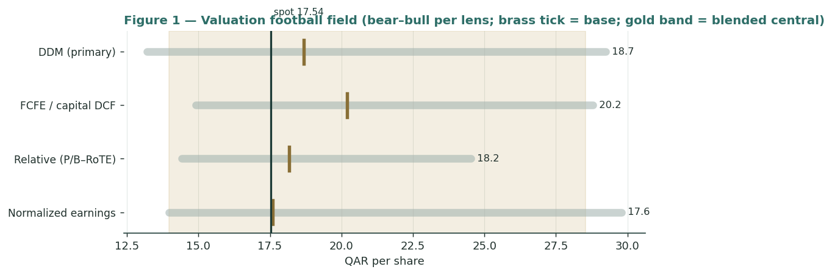
Figure 1 — Valuation football field. Bars span bear–bull per lens; the brass tick is each base case; the gold band is the blended central range; the dark line is spot.
Central fair value ≈ QAR 18.8/share, about 7% above spot. The spread of the base lenses (QAR 17.6 to QAR 20.2) is itself the message: this is not a deep-value or a clearly expensive name, but a fairly-valued sovereign-linked compounder whose re-rating depends on the tax and rate cycle turning its way and on capital being returned.
1.6 The franchise — a deeper look
QNB's balance sheet is the source of both its quality and its ceiling. Domestic Qatar is roughly three-fifths of profit at a ~18% return; QNB Finansbank (Türkiye) adds scale but is reported under hyperinflation accounting (IAS 29), so its nominal returns overstate the real, lira-translated contribution; QNB Alahli (Egypt) earns a very high nominal RoE but is small and exposed to the pound. Asset quality is best-in-class — NPLs 2.6% with 100% coverage — and efficiency is exceptional at a 23.3% cost/income ratio, among the lowest of any large bank globally. The scorecard below scores each engine on the axes that matter.
Segment | Cyclicality | Return trend | Key sensitivity | Role
Qatar (domestic) | Low | Stable ~18% | Sovereign & corporate lending | Cash anchor
Türkiye (Finansbank) | High | Hyperinflation-distorted | Lira translation, rate volatility | Scale, EM drag
Egypt (QNB Alahli) | High | High nominal RoE | EGP translation | Small, high-beta
Intl network / treasury | Moderate | Spread-driven | Rates, funding | Diversifier
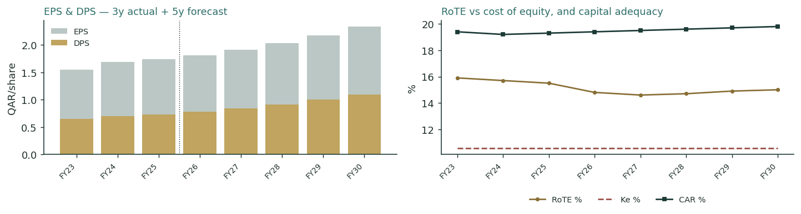
Figure — EPS/DPS across the 3-year actual and 5-year forecast (left); RoTE versus the cost of equity, and the capital-adequacy path (right). RoTE stays above Ke throughout, which is why the justified P/B exceeds 1×.
The forward capital schedule is the quiet story: on our assumptions QNB keeps generating capital faster than RWA growth consumes it, holding the CAR near 19–20% while paying less than half of earnings. For a bank, that surplus is the dividend-growth (and buyback) thesis — the capital trajectory, not the reported payout, is what to watch.
1.7 The crux — Pillar Two, the rate-cut margin path, and excess capital
Three judgments drive the valuation more than any other, and we sensitize each on its observable driver rather than an abstract margin. First, the tax step. Pillar Two (the OECD 15% global minimum tax) took QNB's effective rate from near-zero toward ~15% in 2025, which is why net profit grew 1.7% on ~10% pre-tax growth. This is permanent: at a 15% effective rate, every QAR 1.00 of pre-tax profit yields ~QAR 0.85 post-tax versus ~QAR 1.00 before — a ~15% haircut to the earnings the whole model capitalizes. Second, the rate-cut margin path. With the riyal pegged, the QCB tracks Fed cuts; QNB guides net interest margin to ~260–265 bps. Third, the excess-capital question — the swing to the upside. The table prices the crux in real units.
Swing driver | Bear / base / bull | Approx. value impact | What it is
Effective tax rate (Pillar Two) | ~0% → 15% → 18% | ≈ −0.7 / share per +5 pts | Permanent post-tax haircut
Net interest margin | 245 / 260 / 275 bps | ≈ ±1.1 / share per ±15 bps | 2026 rate-cut drag vs volume
Cost of risk | 70 / 90 / 120 bps | ≈ ∓0.5 / share per ±30 bps | Türkiye/Egypt credit sensitivity
Terminal payout / capital return | 50% / 60% / 67% | QAR 18.7 → 22.0 | The excess-capital swing
Read together: the tax step and a deeper rate cut are the downside; the return of surplus capital is the upside; and the through-cycle cost of risk — driven by the Türkiye and Egypt books — is the wobble in between. The QAR 18.7-to-QAR 22.0 range on the capital-return line is the single widest swing, which is why the buyback and interim-dividend cadence are the catalysts that matter most (§5).
1.8 Macro and country — Qatar, the peg, the LNG expansion, and the EM exposures
QNB is a leveraged play on Qatar's sovereign strength and a diversified play on emerging-market banking. Qatar carries an AA sovereign rating and one of the world's strongest fiscal positions; the North Field LNG expansion lifts export capacity materially into 2026–2027, feeding deposits, project lending and fee income — the structural tailwind. The riyal's USD peg removes the currency-devaluation risk that weighs on Egyptian or Turkish banks domestically, but it also means QNB imports Fed policy: the 2026 easing cycle compresses margins before volume offsets it. The Türkiye book (Finansbank) is the largest external swing — lira weakness and hyperinflation accounting distort reported contribution — while Egypt (QNB Alahli) adds high-nominal-return exposure to the pound. These levers sit behind the bear and bull cases in §1.5 and the catalysts in §5.
1.9 DDM sensitivity — the Ke-minus-g bet, made visible
Because the terminal value is 81.8% of the dividend-model value, the honest disclosure is a grid across the two inputs that set it. The base cell (Ke 10.5% / g 4.8%) is shaded; the value runs from the low-QAR-teens in the punitive corner to the high-QAR-20s in the benign one.
Ke \ g | 4.00% | 4.50% | 4.75% | 5.00% | 5.25%
9.5% | 20.3 | 22.0 | 23.1 | 24.2 | 25.5
10.0% | 18.5 | 19.9 | 20.8 | 21.7 | 22.7
10.5% | 17.0 | 18.2 | 18.9 | 19.6 | 20.4
11.0% | 15.7 | 16.7 | 17.2 | 17.9 | 18.5
11.5% | 14.6 | 15.4 | 15.9 | 16.4 | 17.0
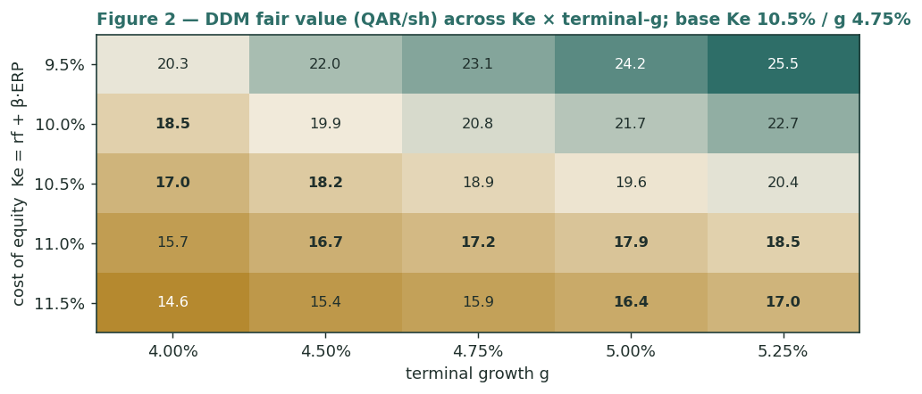
Figure 2 — DDM fair value (QAR/share) across cost of equity and terminal growth. Base Ke 10.5% / g 4.75%.
Read it as the bet you are taking: the QAR 17.54 market price is consistent with a cost of equity around 11–11.5% on our terminal growth — i.e. the market charges QNB a ~1-point risk premium over our base for its EM exposure and Qatar concentration. Whether that premium is deserved is the reader's call.
2 Technical and price structure
The tape is soft and range-bound. QNBK trades below all four major moving averages, the MACD line sits below its signal with a negative histogram, and RSI is in the high-30s — weak, but not yet oversold. The structure is a slow drift within a well-defined band: the 52-week range on the attached history runs QAR 16.7–20.4, and price is in its lower half.
Indicator | Reading | Signal
Spot | QAR 17.54 | —
SMA 20 / 50 | QAR 17.67 / 17.62 | Below both — short-term soft
SMA 100 / 200 | QAR 18.05 / 18.43 | Below both — trend down
RSI (14) | 37.9 | Weak, approaching oversold
MACD (12,26,9) | -0.011 line / 0.026 signal / -0.037 hist | Bearish, momentum negative
52-week range | QAR 16.7 – 20.4 | Lower half of range
Realized vol (252d) | 20.4% | Moderate
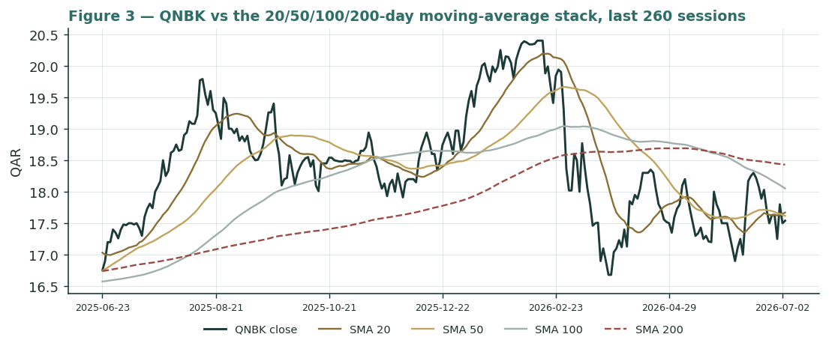
Figure 3 — QNBK versus the 20/50/100/200-day moving-average stack, last 260 sessions.
For the probabilistic work this matters in one way: a below-trend tape modestly widens the near-term downside tail even as the fundamentals argue for a small premium. The technical and fundamental pictures gently disagree, and §6 reads the resulting probability zones without forcing a reconciliation.
3 Monte Carlo — a probabilistic price map
We simulate 50,000 three-month price paths (seed 42) with a sixteen-factor stack: seven continuous macro/operating drivers contributing a small net forward tilt, and nine discrete events that each fire with a probability and an impact. By design the paths diffuse from spot, and the §1 value gap is kept out of the drift — the fundamental premium lives in §1, not here; §3 maps where price could go from today, not where value sits. Width is set by the YZ-HAR engine (a pooled log-HAR variance cascade on a gap-aware Yang-Zhang proxy), which projects an annualized forward volatility of ≈18.1% — a touch below the trailing 252-day 20.4% because the recent tape has been calm. Innovations are unit-variance Student-t(5) for honest tails, and — as a non-EGX name — the secular drift is set to zero; the net external tilt is a modest -1.2% over the quarter, a mild left-skew from the geopolitical and asset-quality tails.
Continuous factor (7) | Discrete event (9) | Prob. | Mean
QCB policy-rate path (Fed-linked) (-) | Regional geopolitical / Gulf-security shock | 25% | -8%
Hydrocarbon / Qatar sovereign liquidity (+) | Oil-price regime shift (Brent) | 30% | +2%
QAR peg stability (USD peg) (0) | Sovereign rating / QAR-peg action | 20% | +1%
QE Index & foreign / MSCI flows (+) | Global rate-path surprise (Fed pivot) | 30% | +1%
Regional private-sector credit growth (+) | Quarterly earnings surprise (NIM/fees/tax) | 50% | +1%
Turkey / Egypt EM translation (-) | Asset-quality / ECL shift (EM exposure) | 25% | -5%
Global-minimum-tax (Pillar Two) drift (-) | Capital action / dividend-policy change | 30% | +2%
 | MSCI / index reweighting or large flow | 25% | +1%
 | Pillar-Two / tax-regime step | 25% | -3%
Percentile map (QAR/share):
Horizon | p5 | p25 | p50 | p75 | p95
T+20 sessions | 15.3 | 16.7 | 17.5 | 18.2 | 19.6
T+60 sessions | 14.0 | 15.9 | 17.2 | 18.6 | 20.9
Leading with the 50% interquartile band, as the house does: over three months the middle half of outcomes sits between QAR 15.9 and QAR 18.6, a spread of ±8% around spot; at T+20 that band tightens to QAR 16.7–18.2. This residual width is QNB's genuine quarter-ahead uncertainty, not padding.
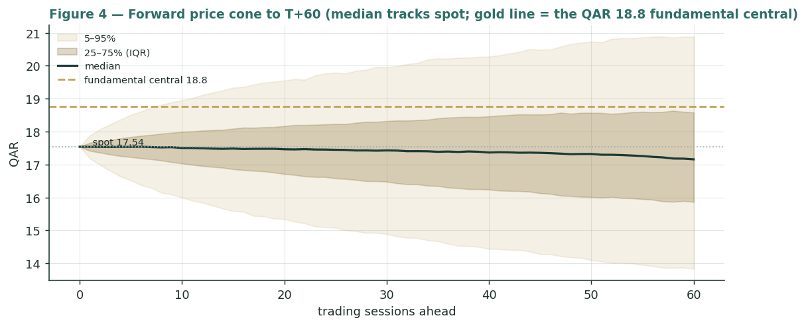
Figure 4 — Forward price cone to T+60. Median tracks spot; the gold dashed line marks the QAR 18.8 fundamental central value, deliberately above the cone.
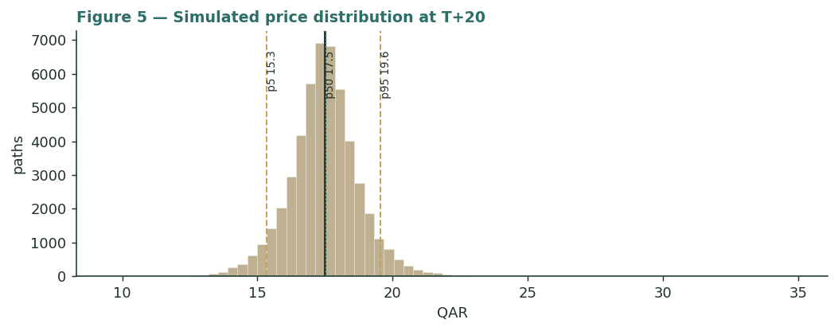
Figure 5 — Simulated price distribution at T+20.
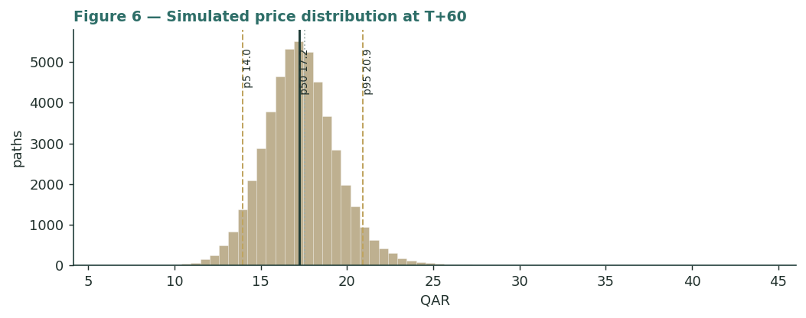
Figure 6 — Simulated price distribution at T+60.
Level-touch ladder — the probability that price touches a level at any point by the horizon (running max for upside, running min for downside):
Level | T+20 touch | T+60 touch | Note
QAR 20.5 | 2% | 12% | Toward 52-wk high
QAR 19.5 | 8% | 26% | Above fair value
QAR 19.0 | 15% | 36% | Near full-capacity read
QAR 18.5 | 28% | 50% | Near central fair value
QAR 18.0 | 51% | 69% | Just above fair-value floor
QAR 17.5 | 85% | 92% | At spot
QAR 17.0 | 49% | 72% | Just below spot
QAR 16.5 | 28% | 56% | Lower band
QAR 16.0 | 16% | 41% | Mid downside
QAR 15.5 | 8% | 30% | Toward stress
4 Comparison of the lenses, and a verdict
Three readings sit side by side. The fundamental lenses cluster at QAR 17.6–20.2 with a central QAR 18.8 — modestly above spot, contingent on the tax/rate cycle and capital return. The technical picture is the opposite: soft, below-trend, with the visible floor near the QAR 16.7 52-week low. The probabilistic map says that over three months price is roughly symmetric around spot with a mild left tail — the median is QAR 17.2, not QAR 18.8, because the simulation does not assume the value gap closes inside the quarter.
Lens | Reads | Central / implication
Fundamental (4-lens) | Modestly cheap | QAR 18.8 (+7%)
Technical | Weak / range-bound | Floor ≈ QAR 16.7; resistance at the MA stack QAR 18.1–18.4
Monte Carlo (3-month) | Symmetric, mild left tail | Median QAR 17.2; p5–p95 QAR 14.0–20.9
Verdict (a fair-value read, not a recommendation). QNB looks fairly-to-modestly-cheap on fundamentals, with unusually concentrated swing factors: the permanence of the Pillar-Two tax step, the depth of the 2026 rate-cut margin drag, and how much of a 19.3%-capitalised balance sheet is returned rather than retained. The technical softness and the near-symmetric three-month distribution argue that any re-rating is a question of proof over quarters — a buyback extension, a step-up in the interim dividend, a stabilising Türkiye — not of an imminent move. The honest summary is a value modestly above price, a near-term distribution centred on price, and an outcome that hinges on capital and tax — which is why the bear–bull span (QAR 14.0–28.5) is wide. Readers should weigh the lenses themselves; we publish the distribution, not a target.
5 Catalysts to watch
- Q1 2026 results (mid-April 2026). The first clean read on the 2026 margin path under Fed/QCB cuts and the full-year Pillar-Two effective tax rate.
- Buyback & interim-dividend cadence. Any extension of the QAR 2.1bn buyback or a step-up in interim dividends is the most direct evidence on the excess-capital return thesis — the single widest valuation swing.
- North Field LNG milestones. Export-capacity ramp feeds deposits, project lending and fee income into 2026–2027.
- Türkiye (Finansbank). The lira path, Turkish rate policy and hyperinflation-accounting effects are the largest external earnings swing.
- Egypt (QNB Alahli). The pound and Egyptian rates set the size of a small but high-nominal-return contributor.
- Asset quality / cost of risk. Any drift in the ~85–90 bps cost of risk, especially from the EM books, moves the credit-cycle lens.
- Qatar sovereign & rating. Fiscal strength and any rating action anchor QNB's own cost of funding and equity.
- Global rates. The pace of Fed easing directly sets QNB's imported policy rate and the margin trajectory.
6 Reading the probability zones
Translating the three-month distribution into plain zones, anchored on spot QAR 17.54 and the fair-value cluster:
Zone (T+60) | Range | Approx. probability | What it would mean
Deep downside | < QAR 15.5 | ~19% | EM/credit stress or risk-off; tests toward the lows
Lower band | QAR 15.5–16.5 | ~16% | Rate-cut drag persists; relative lens dominates
Around spot | QAR 16.5–18.0 | ~30% | Status quo; value gap unclosed
Upper band | QAR 18.0–19.5 | ~21% | Capital return credited; toward central fair value
Strong upside | > QAR 19.5 | ~14% | LNG tailwind + capital return together
The distribution is close to symmetric with a slightly heavier lower tail from the discrete downside events (geopolitics, an asset-quality shift). It is not a forecast; it is the spread of outcomes consistent with the stock's own volatility and the factor stack.
7 Caveats and what would change our mind
- Capital return is the swing. Much of the upside rests on QNB distributing more of its surplus; if it keeps the current ~42% payout, the actual-policy DDM (~+6%) is the truer anchor, not the full-capacity read.
- The tax step could deepen. Pillar-Two mechanics are still bedding in; a higher effective rate would pull post-tax returns — and every lens — lower.
- Rate cuts could bite harder. A faster Fed/QCB easing cycle compresses margin more than modelled before volume growth catches up.
- EM exposure cuts both ways. Türkiye and Egypt add growth and translation risk; a lira or pound shock, or a Turkish credit deterioration, would hit the credit-cycle lens directly.
- Terminal-value dependency. The dividend model is ~82% terminal value; a half-point of Ke or g moves it materially, which is why §1.9 sensitizes both.
- Concentration. A ~50% sovereign owner and heavy Qatar weighting mean QNB's fortunes track one economy and one policy regime more than a diversified global bank.
- Technical reminder. A below-trend tape can persist; RSI in the high-30s is context, not a trigger. Mean-reversion bounces say nothing about value.

Appendix A Financial statements
Selected consolidated figures. Actuals are QNB Group's own disclosure (FY2023–FY2025 results, qnb.com); the five-year forecast is the preparer's, driven by the Assumptions layer of the companion model. All figures QAR million unless noted. FY2025 net profit growth (+1.7%) reflects the first full year of Pillar-Two global-minimum-tax.
A.1 Income statement (consolidated, QAR mn) · 3-year actual + 5-year forecast
QAR mn | FY23 | FY24 | FY25 | FY26E | FY27E | FY28E | FY29E | FY30E
Operating income | 38,960 | 41,300 | 44,800 | 47,040 | 50,098 | 53,855 | 58,163 | 62,816
Operating expenses | -8,805 | -9,210 | -10,438 | -11,290 | -12,023 | -12,925 | -13,959 | -15,076
Pre-provision operating profit | 30,155 | 32,090 | 34,362 | 35,750 | 38,074 | 40,930 | 44,204 | 47,740
Net loan-loss / ECL charge | -8,600 | -8,100 | -8,500 | -8,938 | -9,519 | -10,232 | -11,051 | -11,935
Profit before tax | 21,555 | 23,990 | 25,862 | 26,813 | 28,556 | 30,697 | 33,153 | 35,805
Tax (incl. Pillar Two FY25+) | (465) | (501) | (1,400) | -4,022 | -4,283 | -4,605 | -4,973 | -5,371
Net profit | 15,500 | 16,720 | 17,000 | 18,126 | 19,117 | 20,359 | 21,791 | 23,313
Attributable EPS (QAR) | 1.55 | 1.69 | 1.74 | 1.81 | 1.91 | 2.03 | 2.18 | 2.33
FY25 pre-tax profit rose ~10% but net profit +1.7% as the effective tax rate stepped up under Pillar Two. Forecast opex at ~24% cost/income and ECL at ~19% of operating income; forecast EPS links to the dividend model.
A.2 Balance sheet (consolidated, QAR mn) · 3-year actual + 5-year forecast
QAR mn | FY23 | FY24 | FY25 | FY26E | FY27E | FY28E | FY29E | FY30E
Loans & advances | 851,000 | 911,000 | 1,018,000 | 1,114,710 | 1,215,034 | 1,318,312 | 1,423,777 | 1,530,560
Investments & other assets | 385,000 | 387,000 | 373,000 | 400,975 | 429,043 | 456,931 | 484,347 | 510,986
Total assets | 1,236,000 | 1,298,000 | 1,391,000 | 1,515,685 | 1,644,077 | 1,775,243 | 1,908,124 | 2,041,546
Customer deposits | 861,000 | 887,000 | 955,000 | 1,026,625 | 1,098,489 | 1,169,891 | 1,240,084 | 1,308,289
Other liabilities & debt (plug) | 264,000 | 297,000 | 311,000 | 353,728 | 399,551 | 448,117 | 499,038 | 551,899
Total equity | 111,000 | 114,000 | 125,000 | 135,332 | 146,037 | 157,235 | 169,002 | 181,358
CAR (%) | 19.4% | 19.2% | 19.3% | 19.4% | 19.5% | 19.6% | 19.7% | 19.8%
Total assets = loans + investments; equity rolls forward as prior equity plus retained earnings; deposits and assets grow with the RWA-growth driver. Other liabilities are the funding plug so assets = liabilities + equity.
A.3 Capital generation & distribution (QAR mn) · 3-year actual + 5-year forecast
QAR mn | FY23 | FY24 | FY25 | FY26E | FY27E | FY28E | FY29E | FY30E
Net profit | 15,500 | 16,720 | 17,000 | 18,126 | 19,117 | 20,359 | 21,791 | 23,313
Less: capital retained for RWA growth | (8,525) | (8,910) | (9,350) | -7 | -6 | -7 | -6 | -6
Distributable capital (FCFE) | 6,975 | 7,810 | 7,650 | 18,119 | 19,111 | 20,352 | 21,785 | 23,307
Cash dividends paid | -5,923 | -6,379 | -6,607 | -7,090 | -7,655 | -8,338 | -9,122 | -9,970
Share buyback | — | — | (2,100) | — | — | — | — | —
Retained / excess-capital build | 1,528 | 2,140 | 135 | 11,029 | 11,456 | 12,014 | 12,663 | 13,337
The bank cash-flow analogue: distributable capital = net profit less the capital retained to fund RWA growth at the CET1 target. The gap between FCFE and dividends is the excess-capital build — the crux for the DDM-versus-FCFE spread. FY25 buyback QAR 2.1bn (123.1mn shares).
Appendix B Step 0 — calibration backtest
Before any forecast we test the Monte-Carlo lens on QNB's own five years of history: at each origin, using only prior data, the YZ-HAR engine (zero drift for a non-EGX name, Student-t(5) shape) generates a three-month-ahead distribution, and we score the realized close against it. The grade is skill versus a naïve benchmark — a zero-drift random-walk lognormal cone at the trailing realized vol — measured by CRPS skill (must be > 0) and the interval (Winkler) score. The PIT histogram and interval coverage are shown as diagnostics only; band-containment rewards width and is never the pass criterion.
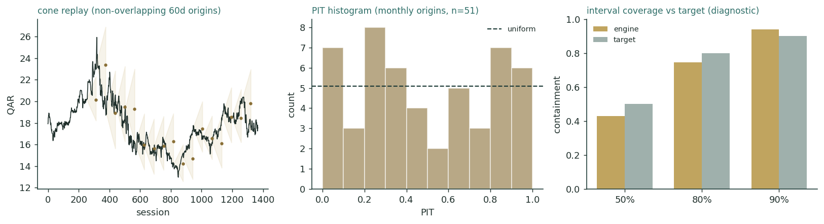
Figure B-1 — Calibration backtest: non-overlapping quarterly cone replay (left), PIT histogram on monthly origins (centre), and interval coverage versus target (right).
Window scheme | n | CRPS skill | Winkler-80 skill | PIT mean
Non-overlapping (step 63d) | 17 | +0.011 | +0.017 | 0.50
Monthly origins (step 21d) | 51 | +0.028 | +0.071 | 0.49
Fortnightly (step 10d) | 106 | +0.010 | +0.043 | 0.48
Pass criterion | — | > 0 | > 0 | ≈ 0.50
The engine beats the random-walk benchmark on CRPS skill in every scheme (+0.011 to +0.028) and on the interval score at the 50/80/90 bands, with a PIT mean of ~0.49 — well-centred, no directional bias. The margin is honest rather than heroic: for a mature mega-cap the naïve cone is already hard to beat, and the skill comes from the regime-conditional width and the tighter t5 body, not from a drift assumption. Interval coverage sits a little inside the 50% band (a tight t5 body) but the PIT is roughly uniform. The lens is accepted; this engine carries into the §3 forward run.
Appendix C Peer set, sector structure, and risks
QNB's cleanest comparables are the other GCC banking champions, though none is a perfect match: QNB is larger, more sovereign-linked and more geographically spread (Türkiye, Egypt) than most. Multiples below are indicative and dated (mid-2025 to mid-2026); they move continuously.
Bank | P/B | P/E | RoE | Div yld | Note
QNB Group (QNBK) | 1.48× | 10.1× | ~15% | 4.1% | This study
Al Rajhi (1120) | 4.0× | 19× | ~20% | 2.1% | Islamic premium
First Abu Dhabi (FAB) | 1.5× | 10.5× | ~16% | 4.5% | Largest UAE
Emirates NBD | 1.3× | 7.0× | ~19% | 4.0% | Türkiye/EM drag
Saudi National Bank | 1.4× | 11.5× | ~13% | 3.5% | Biggest by equity
Commercial Bank of Qatar | 0.7× | 7.5× | ~11% | 4.5% | Cheapest Qatari
Qatar Islamic Bank | 1.8× | 11× | ~17% | 3.7% | Qatar Islamic
Peer median (ex-Al Rajhi) | 1.4× | 10.5× | ~16% | 4.1% | —
Sector structure. GCC banking is well-capitalised, sovereign-anchored and consolidating; the near-term swing variables are the Fed-linked rate cycle (pressuring margins), the new global-minimum-tax regime (Qatar, UAE) and, for the internationally-spread banks, emerging-market translation. QNB at ~1.48× book on ~15% RoE sits a clear premium to the cheap Qatari/Saudi cluster (0.7–0.9×) and far below Al Rajhi (~4×), which the market justifies by QNB's scale, sovereign linkage, best-in-class asset quality and efficiency — but caps by its modest post-tax return and EM exposure. Principal risks: a deeper or faster rate-cut cycle; a higher effective tax rate; a Türkiye or Egypt shock; Qatar/sovereign concentration; and the possibility that surplus capital is retained rather than returned.
Source: AGBI, Bloomberg Intelligence, company disclosures, exchange data. Multiples indicative and dated.

Appendix D The expert valuation panel
Every Testahil study closes with a panel of standing expert personas — drawn from the house Expert Persona Library, not invented for the occasion, so that each accumulates a track record across studies and a quarterly update is a re-run, not a re-training. For a bank we cast the three whose methods both fit a deposit-taking, capital-constrained institution and genuinely disagree: Expert 1 (capital and returns — what the bank can distribute against its cost of equity), Expert 2 (the credit cycle — what through-cycle provisioning does to normalized earnings), and Expert 3 (macro-policy — rates, the peg, the LNG cycle and the emerging-market books). Each runs a different method, derives its fair value from shown workings, and states a falsification condition.
D.1 Expert 1 — capital and returns
Worldview and tradition. A bank is worth the present value of the capital it can hand back to owners after funding its own growth, discounted at the cost of equity. In this tradition the two numbers that matter are the return on tangible equity and the cost of that equity: when RoTE exceeds Ke, retained capital compounds value and the bank deserves a premium to book; when it does not, book value is the ceiling. Expert 1 works in dividends, distributable capital and residual income, and treats reported payout as a policy choice to be seen through.
When it works / fails. It is the right lens for a stable, well-capitalised deposit franchise with a visible return profile — which QNB is. It fails when returns are volatile or opaque (a bank mid-restructuring), when the capital position is a moving target, or when hyperinflation accounting distorts the reported return — a real caveat for QNB's Türkiye book, which Expert 1 handles by leaning on the group tangible return rather than segment nominal RoEs.
Standard workings and worked example. Grow EPS, set a payout, discount dividends at Ke, and capitalize a terminal on (Ke − g); cross-check with residual income (RoTE − Ke) × book. The workings below are Expert 1's base.
Expert 1 — capital & returns | Value
Through-cycle RoTE | 14.5%
Cost of equity Ke = rf + β·ERP | 10.5%
Terminal growth g | 4.8%
Justified P/B = (RoTE − g)/(Ke − g) | 1.68×
Two-stage DDM on actual policy | QAR 18.68
Residual-income cross-check | QAR 18.5–19.0
Expert 1 fair value | QAR 18.7
Sensitivity (swing = Ke − g). At Ke 11.5% / g 4.0% the value falls to ~QAR 15; at Ke 9.5% / g 5.25% it rises to ~QAR 23 (§1.9 grid). Cross-examination. Expert 1 tells Expert 2 that normalizing cost of risk to a punitive mid-cycle level ignores QNB's actual through-the-cycle record — 100% coverage and a ~2.6% NPL ratio earned through real stress — so his provisions are too heavy; he tells Expert 3 that a macro scenario is a story about the path, not the value, and that the discipline of RoTE-versus-Ke is what turns the story into a number. Verdict, falsification, market-implied. Fair QAR 18.7 (range QAR 15–23). Falsified if RoTE settles durably below Ke — a permanently higher tax rate or a structural margin loss that pushes the ~14.5% return toward ~10%. The market's ~1.48× book implies a Ke of ~11.3%, above his 10.5%: the market charges QNB more for risk than he does.
Expert 1's discipline is worth making explicit, because it is what separates his number from a story. He starts from the observation that QNB earns roughly QAR 15.9 bn attributable on average tangible equity of about QAR 100 bn — a return near 16% on tangible book, closer to 14.5% once the through-cycle tax and a normalized provision are allowed for. Against a 10.5% cost of equity that is a positive spread of about four points, and the residual-income identity says the shares should trade at book plus the capitalized value of that spread: BVPS of about QAR 11.85 plus roughly QAR 7 of capitalized excess return, i.e. the high-QAR-18s. That the two-stage dividend model lands in the same place is not a coincidence — both are the same present-value arithmetic seen from different angles, which is why he trusts the QAR 18.7 anchor more than any single multiple.
On the actual-versus-full-capacity gap he is deliberately conservative. He values the dividends QNB actually pays, not the dividends it could pay, because a payout is a decision the board has not yet made — and a bank that hoards capital at a low payout is, in his framework, quietly destroying a little value each year unless that capital is either deployed at RoTE or returned. He credits QNB with deploying it (loan growth at ~14.5% is above Ke), which is why he holds the premium to book; but he refuses to capitalize a 67% payout the bank has never delivered. The buyback, to him, is the first hard evidence that the surplus is finally moving — and the reason his range runs as high as QAR 23.
D.2 Expert 2 — the credit cycle
Worldview and tradition. A bank's earnings are a loan book waiting for a downturn. Expert 2 distrusts a benign provisioning line and normalizes the cost of risk across a full cycle, because the cheap years lend the expensive ones their profits. He values the bank on mid-cycle earnings after a normalized loan-loss charge, not on the current, favourable print.
When it works / fails. It is the essential corrective for a bank at a benign point in the cycle — precisely QNB now, with a ~85–90 bps cost of risk that he views as below mid-cycle. It fails if it over-normalizes a genuinely de-risked book: QNB's Qatar exposure is heavily sovereign and blue-chip corporate, so a blanket haircut can be too harsh. He resolves this by normalizing hardest where the risk actually sits — the Türkiye and Egypt books.
Standard workings and worked example. Take pre-provision profit, subtract a through-cycle cost of risk (he uses ~110–120 bps on group loans versus the ~85–90 bps reported), tax at the new 15% floor, and capitalize the resulting normalized earnings at a justified multiple.
Expert 2 — credit cycle | Value
Pre-provision operating profit (norm.) | ≈ QAR 34.5 bn
Through-cycle cost of risk | ~115 bps (vs ~88 reported)
Normalized loan-loss charge | ≈ QAR (11.7) bn
Tax at 15% (Pillar Two) | ≈ QAR (3.4) bn
Normalized net profit | ≈ QAR 15.4 bn
Justified P/E on normalized EPS | ~10×
Expert 2 fair value | QAR 16.9
Sensitivity (swing = normalized cost of risk). At ~90 bps (trust the current print) the value rises to ~QAR 19; at ~140 bps (a hard EM downturn) it falls to ~QAR 13.5. Cross-examination. Expert 2 tells Expert 1 that a dividend model built on today's low provisions capitalizes good luck — the payout looks safe only until the cycle turns; he tells Expert 3 that the LNG tailwind is a revenue story that says nothing about loan losses in Türkiye or Egypt, where the credit risk actually lives. Verdict, falsification, market-implied. Fair QAR 16.9 (range QAR 13.5–19) — the most conservative of the three. Falsified if QNB delivers a full cycle at a low cost of risk (its record so far supports the sceptic being wrong), or if the EM books are de-risked or sold. The market price sits just above his number: on a through-cycle-provisioning basis, QNB is close to fair.
Expert 2's method turns on a single number he refuses to take on trust: the cost of risk. QNB reports roughly 85–90 basis points of loan losses against a book that is heavily Qatari sovereign and blue-chip — but about a quarter of the group's assets sit in Türkiye and Egypt, where the through-cycle loss content is structurally higher and the reported figure is flattered by hyperinflation accounting and a benign recent window. He therefore blends a ~60 bps Qatar charge with a ~250–300 bps charge on the emerging-market books to reach a group through-cycle ~115 bps — roughly QAR 11.7 bn of normalized provisions against the QAR 34.5 bn of pre-provision profit, versus the ~QAR 9 bn the market extrapolates. That single adjustment is most of the gap between his QAR 16.9 and Expert 1's QAR 18.7.
He is careful not to overreach. He concedes that QNB's coverage ratio of 100% and its record through the 2017 blockade and the pandemic are real evidence that the franchise underwrites well, and that a blanket haircut to Qatar's sovereign-heavy book would be lazy. His conservatism is targeted: he normalizes hardest exactly where the risk is, and he treats the surplus capital not as distributable value but as the provision-in-waiting the other two experts are too quick to give away. If QNB delivers a full cycle at a low cost of risk — as its history suggests it might — he will have been wrong, and he says so.
D.3 Expert 3 — macro-policy
Worldview and tradition. A bank is a geared claim on its sovereign and its rate regime. Expert 3 values QNB top-down: the Qatari fiscal position and the North Field LNG expansion set the growth of deposits and lending; the Fed-linked policy rate sets the margin; and the Türkiye and Egypt currencies set the translated contribution of the foreign books. He builds macro scenarios and reads the value off them, and he is the one who credits the excess-capital return as the policy choice of a sovereign-owned champion.
When it works / fails. It is powerful for a bank whose fortunes are dominated by one economy and one policy regime — QNB, half-owned by the state, is the textbook case. It fails when it substitutes a macro view for security-level discipline: a constructive Qatar call is not automatically a cheap stock. He guards against this by tying each scenario back to EPS, payout and the same Ke the others use.
Standard workings and worked example. Build a base, a downside and an upside macro path (rates, LNG-driven balance-sheet growth, FX), map each to net profit and payout, and discount. His base credits a gradual return of surplus capital and a stabilising lira; his upside adds a faster LNG ramp and a bigger buyback.
Expert 3 — macro-policy | Value
North Field LNG → balance-sheet growth | supportive, 2026–27
Rate path (Fed/QCB) | cuts drag NIM, then volume offsets
Türkiye/Egypt translation | base: stabilising; bull: recovery
Capital return (payout → ~67%) | credited over time
Scenario-weighted net profit path | above the DDM base
Discount at Ke | 10.5%
Expert 3 fair value | QAR 20.4
Sensitivity (swing = capital return + FX). With the current payout and a weak lira, his value falls to ~QAR 16.5; with a full return of surplus and a Türkiye recovery it rises to ~QAR 26.5. Cross-examination. Expert 3 tells Expert 1 that a mechanical Ke-minus-g understates a bank riding a genuine sovereign upcycle with capital to give back; he tells Expert 2 that normalizing cost of risk to a mid-cycle average ignores that Qatar's fiscal strength and the sovereign ownership backstop the book. Verdict, falsification, market-implied. Fair QAR 20.4 (range QAR 16.5–26.5) — the most bullish. Falsified by a sustained oil/LNG downturn that weakens the sovereign, or a Türkiye/Egypt crisis that swamps the group. The market implies a macro path more cautious than his base — it does not yet price the capital return.
Expert 3 weights three scenarios explicitly. In his base (≈55% weight) the Fed and QCB cut through 2026, margin dips ~10 bps then recovers as loan growth compounds, the lira stabilizes, and QNB lifts the payout gradually toward 55–60% — worth about QAR 20. In his downside (≈25%) a weak lira and a stubborn rate-cut drag with the current payout hold the stock near QAR 16.5. In his upside (≈20%) a faster North Field ramp, a Türkiye recovery and a larger buyback carry it toward QAR 26.5. The probability-weighted blend is his QAR 20.4. The peg is central to his read: because the riyal is fixed to the dollar, QNB cannot ease its own policy to defend its margin, so the Fed path is imported wholesale — but the same peg removes the domestic devaluation risk that makes Egyptian and Turkish banks so volatile in their home currencies.
Where he parts company with the others is on what the sovereign ownership means. To Expert 3, a bank half-owned by the Qatar Investment Authority, sitting on the largest gas reserves per capita in the world, is not an ordinary credit: its funding is cheaper, its deposit base stickier, and its capital ultimately backstopped by one of the strongest sovereign balance sheets on earth. That, he argues, justifies both a lower effective cost of equity than a screen would assign and a faster return of surplus capital than a standalone bank would risk — which is precisely why his number is the highest of the three.
D.5 The three in one room
The single question they most disagree on is what to do with QNB's surplus capital — and how much to trust the earnings that surplus rests on.
Expert 3: “QNB runs a 19% capital ratio, half-owned by the state, riding the North Field cycle, and it pays out barely forty percent. Credit even a gradual return of that surplus and the stock is worth north of twenty.”
Expert 2: “Return what, exactly? The capital is the buffer against a Türkiye or Egypt credit event you are not provisioning for. Normalize the cost of risk to a real mid-cycle number and the earnings that fund your payout shrink — the surplus is doing its job sitting where it is.”
Expert 1: “You are both arguing about the path. Discipline it: the bank earns about fourteen-and-a-half on tangible equity, costs about ten-and-a-half. That spread says a premium to book is deserved — a fair value near nineteen on the actual policy, more if the capital comes back. The argument is the payout, not the franchise.”
D.6 Reading the divergence
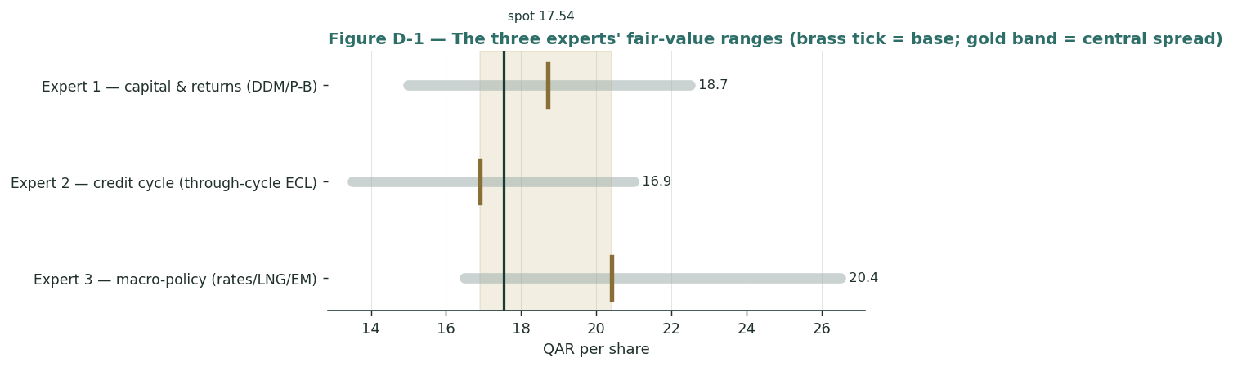
Figure D-1 — The three experts' fair-value ranges. Brass ticks are base cases; the gold band is the central spread; the dark line is spot. The spread is a tax-and-credit-versus-capital-return disagreement.
Expert | Method | Single swing assumption | Base fair value
Expert 1 | Capital & returns (DDM / P-B) | RoTE (14.5%) vs Ke (10.5%) | QAR 18.7
Expert 2 | Credit cycle | Through-cycle cost of risk (~115 bps) | QAR 16.9
Expert 3 | Macro-policy | LNG + rates + capital return | QAR 20.4
The spread — QAR 16.9 to 20.4 at base — is narrow for a bank with emerging-market exposure, and it is almost entirely a disagreement about two linked things: how much to trust QNB's benign credit and tax-adjusted earnings, and whether its surplus capital is returned or held as a buffer. None of the three contests the franchise: the scale, the sovereign linkage, the best-in-class efficiency and asset quality are common ground. Expert 2 says the earnings are flattered by a low point in the credit cycle; Expert 3 says the sovereign strength and the capital give-back are underpriced; Expert 1 says the RoTE-versus-Ke discipline settles it near book-plus-a-premium. Resolve the cost-of-risk and capital-return questions and the three converge. That is the useful conclusion of the panel: the uncertainty in QNB is not about whether it is a good bank — all three agree it is among the best-run in its region — but about two specific, observable things that resolve over the next few years. Watch the cost of risk as the emerging-market cycle turns, and watch the payout ratio and buyback cadence as the sovereign owner decides what to do with a capital surplus it does not need. Each quarterly print nudges the panel; the QAR 16.9-to-20.4 spread will narrow as those two questions are answered, and the direction in which it narrows is the real forecast this study offers.
Each expert's point fair value (and bull/base/bear) is logged with the study date (05 Jul 2026) and spot (QAR 17.54) as an internal per-expert track record, kept separate from the core Calibration Ledger.

About this series
Testahil publishes independent, educational valuation studies. Each is an attempt to reason transparently about what a security is worth, with every assumption shown and a companion model so readers can disagree productively. The house style is distributions, not tips: we describe ranges and probabilities, not targets, and we do not tell anyone what to do. Studies are framed as educational analysis, the preparer is not licensed by any securities regulator, and holdings are disclosed.
Disclosure & Disclaimer
Not investment advice. This document is educational and informational only. It is not, and must not be relied upon as, investment, financial, legal, accounting or tax advice, nor an offer, solicitation or recommendation to buy, sell or hold any security. It contains no price target and no rating.
No licence; no advisory relationship. The preparer is not registered or licensed with any securities or financial regulator in any jurisdiction — including the Qatar Financial Markets Authority — holds no brokerage or investment-advisory authorisation, and is not acting as your adviser or fiduciary. Nothing here is personalised to your circumstances.
Holdings disclosure. The preparer may hold, and may in the future take or dispose of, a position in the security discussed in this report, and may transact at any time without notice. This is a potential conflict of interest you should weigh.
Sources & accuracy. Reported financial and operating figures are drawn from the company's public disclosure and other public sources believed reliable but not independently verified; they may contain errors or be superseded. Forward-looking inputs — the earnings path, payout and capital-return assumptions, the cost of equity, projections, multiples, the dividend-discount and FCFE models and the Monte-Carlo factor probabilities — are the preparer's own judgments and are inherently uncertain.
Forward-looking statements. Any statements about the future are estimates subject to risks and uncertainties; actual results may differ materially. The Monte Carlo models price, not value, and encodes subjective probabilities for events that have not occurred.
No reliance; your responsibility. Do your own research and consult a licensed professional before making any decision. You are solely responsible for your investment decisions and their outcomes. To the maximum extent permitted by law, the preparer accepts no liability for any loss arising from use of this document.
Currency & figures. Figures are in Qatari riyals (QAR) unless noted; bn denotes billion and mn million. FX at study date: USD/QAR 3.64 (pegged). Rounding may cause totals to differ slightly. Spot price and market data are as of 05 July 2026 and change continuously.
TESTAHIL · Independent Valuation Study · Educational Analysis · QNB Group (QSE: QNBK) · edition 05-07-2026 · reporting currency QAR

