Testahil · Independent Valuation Study — Educational Analysis · Not investment advice

Independent Valuation Study — Educational Analysis
Qalaa Holdings (EGX: CCAP)
Fundamental analysis · Technical analysis · Monte Carlo simulation — one integrated read
Anchor: EGP 4.77 (30 Jun 2026 close) · ~4.2bn shares · mkt cap ~EGP 20bn · Egypt's diversified investment holding company — energy-led (Egyptian Refining Company, TAQA Arabia) with cement, mining, agrifoods and logistics platforms · prices & probabilities computed 30 Jun 2026 from the attached daily price history · holding-company sum-of-the-parts on an economic-interest basis · the holding-company discount is the swing factor.
READ FIRST — what this document is, and is not. This study is a valuation exercise and an expression of personal analytical opinion, published free of charge for educational purposes: it shows how one analyst applies fundamental, technical and probabilistic methods to a listed company, and invites scrutiny of that methodology. It is NOT investment advice, NOT a recommendation or solicitation to buy, sell or hold any security, and NOT directed at the circumstances of any reader. The preparer is not licensed by any securities regulator in any jurisdiction, holds no Egyptian (FRA) or other authorisation, provides no financial consultancy, manages no money, and accepts no fees, funds or clients. See the Disclosure & Disclaimer at the end. All values are model outputs presented as ranges and distributions because no single number should be relied on. Reported financials are Qalaa's own disclosure (its FY2024 audit carries a qualified opinion and a going-concern emphasis of matter); forward-looking inputs — the holding-company discount, the marks on the unlisted assets, the value of ERC's economic stake, the multiples, the DCF and the Monte-Carlo factor probabilities — are the preparer's judgments and are flagged throughout. Consult a licensed financial advisor before any investment decision.

Headline
The model's read: materially undervalued on a wide discount to net asset value — with the discount, not the assets, as the whole debate.
At EGP 4.77 the shares trade about 23% below our weighted central estimate of EGP 5.89; the gap is unusually wide because Qalaa is a holding company whose value sits in operating stakes — above all the Egyptian Refining Company (ERC) and TAQA Arabia — rather than in its own reported, heavily-minoritised earnings. Unlike most names we cover, the question here is not whether Qalaa owns valuable assets — a $4.3bn refinery now nearly de-levered, the country's largest private energy distributor, and a spread of cement, mining, agrifoods and logistics businesses plainly have value — but whether the market's ~44% discount to the sum of those parts is the right price.
Five independent lenses cluster between EGP 3.30 and EGP 8.60; the weighted central estimate is EGP 5.89, about 23% above spot. The holding-company sum-of-the-parts — ERC and TAQA at Qalaa's economic stake net of their own debt, the smaller platforms at attributable marks, less holdco recourse debt and a 30% discount — lands at EGP 5.94 (+24%). A consolidated DCF that values only the attributable operating cash flow of the energy platform, deliberately excluding the asset-mark uplift, lands lower at EGP 4.06 (-15%) — confirming that Qalaa's owned operating cash alone does not carry the price; the value is in the stakes and the discount. Relative multiples (EGP 5.00) and through-cycle earnings power (EGP 6.19) sit between. Only the discount-compression case at EGP 8.60 (+80%) reaches the high upside; the wide-discount case at EGP 3.30 (-31%) is the downside. We adopt neither tail as the base.
This is a statement about valuation, not direction. Qalaa's tape is the opposite of a value trap — the shares are up roughly 84% over the past year and sit only ~16% below their 52-week high — but the stock has pulled back hard from EGP 5.70 and is oversold, with an RSI near 27 and price slipping below a still-rising 20-day. A single 16-factor Monte Carlo (ERC refining margin and de-levering, TAQA earnings, EGX flows, EGP translation, plus nine discrete events including ERC dividend resumption and a going-concern flare; 50,000 paths, seed 42) puts both the T+20 and T+60 medians near spot (~EGP 4.81 and ~EGP 4.89) inside a very wide cone — Qalaa's realized volatility is ~47%. What a buyer at this level underwrites is that the holding-company discount narrows as ERC finishes retiring its senior debt and resumes distributions, that the going-concern overhang lifts as the negative parent equity continues to close toward positive, and that the unlisted marks hold — not a margin of safety on reported earnings, which capture almost none of the asset base. The downside tail belongs to a persistently wide discount, weak refining margins and the qualified-audit/going-concern overhang; the upside to ERC dividends, discount compression and crystallisation of the energy stakes.

Company overview — Qalaa Holdings at a glance
Qalaa Holdings (EGX: CCAP), formerly Citadel Capital, is a diversified African investment holding company headquartered in Cairo. Its defining asset is the Egyptian Refining Company (ERC) — a $4.3bn, 4.7-million-tonne-per-annum refinery at Mostorod, one of the largest project-financed industrial assets in Africa — which Qalaa controls and fully consolidates under IFRS 10 while owning only ~13.14% of its economics. Around ERC sit TAQA Arabia (Egypt's largest private energy distributor, now an equity-method associate after a 2023 deconsolidation), and consolidated platforms in cement (ASEC), mining (ASCOM/GlassRock), agrifoods (Dina Farms) and transport & logistics (CCTO). The structural fact for valuation is that most of Qalaa's value sits in these stakes, and that the consolidated accounts carry the full weight of ERC's revenue and project debt with a very large minority-interest line stripping out the part Qalaa does not own — so the stock is best read as a holding company trading at a discount to the sum of its parts, not as a multiple on its income statement.
Two 2025-26 developments matter. ERC has nearly retired its senior project debt — reducing the senior balance from $2.35bn to about $63m by December 2025, with full repayment due in 1Q26 — which unlocks the prospect of ERC dividends to Qalaa from 2026. And an October 2025 capital increase (converting ~$240m of holdco debt to equity via QHRI) lifted the share count to 4.2bn and roughly halved the negative parent equity (from −EGP 13.7bn to about −EGP 4.5bn). Parent equity remains negative on a consolidated basis — management cites a positive ~EGP 3.4bn figure, but that is the standalone parent, not the consolidated balance sheet. Both the de-levering and the equity inflection bear directly on the discount the shares deserve.
Item | Value (as disclosed / derived)
Listing / sector | EGX: CCAP · diversified investment holding company (energy-led)
Ultimate parent | Citadel Capital Partners Ltd (Malta) ~23.5%; QHRI vehicle post-2025 increase
Share price (30 Jun 2026 close) | EGP 4.77
Shares outstanding | ~4.2bn (post Oct-2025 capital increase)
Market capitalisation | ~EGP 20bn (~USD 0.4bn)
FY2024 revenue / EBITDA / net (attrib.) | EGP 148.9bn / 21.4bn / 6.4bn (audited, qualified)
FY2024 audit opinion | Qualified (EGP 22.3bn unconfirmed bank balances) + going-concern emphasis
Gross NAV per share (SOTP, economic) | ~EGP 8.48
Discount to gross NAV at spot | ~44%
ERC consolidation | Fully consolidated (IFRS 10); Qalaa economic interest ~13.14%
Non-controlling interest (FY2024) | ~EGP 80.7bn (largely the ~87% of ERC Qalaa does not own)
Parent equity (FY2024 → FY2025E) | −EGP 13.7bn → −EGP 4.5bn (still negative; mgmt cites +3.4bn standalone)
ERC senior debt | $2.35bn → ~$63m (Dec-2025); full repayment due 1Q26
52-week range | EGP 2.39 – 5.70 (spot ~16% off the high, +84% YoY)
Company-level figures are from Qalaa's public disclosure (Qalaa IR / EGX filings) and other public sources; forward-looking inputs — the holdco discount, the unlisted marks, ERC's economic-stake value, the projections, the multiples, the DCF and the Monte-Carlo factor probabilities — are the preparer's derived estimates, not company disclosure, and are flagged throughout.

1 Fundamental valuation
A diversified investment holding company is not valued like the operating businesses it owns: there is a portfolio of stakes — one of them (ERC) a controlled-but-minority-owned refinery, one (TAQA) an associate, the rest consolidated subsidiaries — sitting above a layer of holdco recourse debt. The primary lens is therefore a holding-company sum-of-the-parts (SOTP) on an economic-interest basis: value each asset at Qalaa's economic share (ERC and TAQA net of their own debt; the smaller platforms at attributable marks), sum to gross NAV, subtract holdco recourse debt, and then apply a holding-company discount because the market never pays full asset value for a holdco — least of all one with a qualified audit and a recent going-concern flag. We then cross-check three ways — a consolidated DCF on the owned operating cash flow, relative multiples, and a through-cycle earnings-power calculation. Reported financials are Qalaa's disclosure; the marks, the economic-stake build and the discount are our judgments, shown explicitly so you can disagree.

1.1 Holding-company sum-of-the-parts — the primary lens
Why economic interest, not consolidation. This is the single most important modelling choice in the study, and Qalaa's own accounts force it. Under IFRS 10 Qalaa controls ERC (through a chain: Qalaa → 31.5% of Orient → ARC → 66.6% of ERC) and so consolidates 100% of ERC's revenue, EBITDA and ~$4bn of project debt, booking the ~87% it does not own as a EGP 80.7bn non-controlling interest. A SOTP that added consolidated ERC value without removing that minority would overstate Qalaa's NAV by roughly eight times. We therefore value ERC at Qalaa's 13.14% economic stake net of ERC's own debt, and carry TAQA likewise at its ~55% associate economics. The crux that remains is the discount, not the assets.
Summed at our marks, Qalaa's gross asset value is about EGP 41.63bn, or EGP 8.48 per share after holdco recourse debt. The market, however, prices the shares at a ~44% discount to that gross NAV — wide, and in our view only partly justified by the qualified audit and the going-concern history. Our base case applies a 30% discount, giving a base SOTP of EGP 5.94, about 24% above spot.
SOTP component (base case) | Basis | Value (EGP bn) | Note
ERC — 13.14% economic | econ stake net of ERC debt | 8.8 | refinery; senior debt nearly retired
TAQA Arabia — ~55% (associate) | equity-method | 9.3 | energy distribution; steadier
ASCOM / GlassRock (mining) | attributable mark | 6.0 | mining, quarrying, glass
ASEC / cement (Al-Takamol, Zahana) | attributable mark | 5.0 | cement
Dina Farms / agrifoods | attributable mark | 7.0 | dairy, farms, ICDP
Transport & Logistics (CCTO/NRPMC) | attributable mark | 3.5 | ports, river barges
Other / smaller platforms | attributable mark | 2.0 | residual
Gross asset value |  | 41.6
(−) Holdco recourse net debt | parent-level | (6.0)
Gross NAV / share (EGP) |  | 8.48
(−) Holdco discount (base) | 30%
VALUE / SHARE (base) | EGP 5.94 | +24%
The three SOTP cases bracket the discount debate. The discount-compression (bull) case narrows the holding-company discount to 18% and lifts the marks modestly — it reaches EGP 8.60 (+80%). The wide-discount (bear) case widens the discount to 45% and cuts the marks — the "the discount is structural, the marks are stale, and the audit is qualified" view — and falls to EGP 3.30 (-31%). The width of that range is the honest measure of how much the answer depends on one's view of the holding-company discount, which the market does not observe directly. We flag the bull as a genuine tail: reaching EGP 8.60 needs both discount compression and mark uplift to land together.

1.2 Consolidated DCF — the cash-flow cross-check
The SOTP values Qalaa on its assets; a DCF asks a narrower, more demanding question — what is the attributable operating cash flow worth, before crediting any of the asset-mark uplift? We build unlevered free cash flow bottom-up from the projected income statement — consolidated operating profit, scaled to Qalaa's blended economic share, taxed to NOPAT, then plus D&A, less capex and the change in working capital — discount at an EGP WACC of 20% (the country-risk-laden rate the Egyptian market demands), add a normalised terminal value and parent net cash, and add none of the SOTP mark uplift. The result, EGP 4.06 (-15%), sits below spot and below the SOTP, and that gap is the point: Qalaa's owned operating cash alone does not justify the price; the value lives in the stakes and in the discount narrowing.
FCFF build (EGP bn) — bottom-up | 2026e | 2027e | 2028e | 2029e | 2030e
Consolidated EBIT | 11.0 | 14.0 | 17.0 | 19.5 | 22.0
× attributable economic share (15%) | 1.65 | 2.10 | 2.55 | 2.93 | 3.30
NOPAT (after 22.5% tax) | 1.28 | 1.63 | 1.98 | 2.27 | 2.56
(+) D&A (attributable) | 1.95 | 2.03 | 2.10 | 2.18 | 2.25
(−) Capex (attributable) | (1.35) | (1.43) | (1.50) | (1.58) | (1.65)
(−) Δ Working capital | (0.30) | (0.30) | (0.30) | (0.30) | (0.30)
Unlevered FCFF (attributable) | 1.58 | 1.93 | 2.28 | 2.57 | 2.86
DCF bridge to value | EGP bn / per share
PV of explicit FCFF (2026e-2030e) | 6.4
(+) PV of terminal value (g 6.0%) | 8.7
Enterprise value (operating) | 15.1
(+) Parent net cash | 2.0
Equity value | 17.1
DCF value / share | EGP 4.06
vs spot | -15%
Why the DCF lands below the SOTP. By construction, because it credits Qalaa with only its ~15% blended economic share of consolidated operating cash and values it at a punishing 20% Egyptian discount rate, while adding none of the asset-mark uplift. A bull will object that this ignores most of the value — correct, and exactly why we treat the DCF as a narrow cross-check rather than the primary lens. But it makes the central point unambiguous: Qalaa is an asset-and-discount story, not an operating-cash-flow story. Sensitivity grids are in 1.9.

1.3 Relative multiples
On consolidated earnings Qalaa is almost impossible to read — FY2024 net income was flattered by a ~EGP 9.9bn one-off gain on discontinued operations while continuing operations were loss-making, and ~87% of consolidated EBITDA belongs to the ERC minority. The honest relative lens works on attributable net profit. A modest 6x P/E on normalized attributable net of ~EGP 3.5bn gives EGP 5.00 (+5%). The relative lens is the least informative for a holdco with a qualified audit and is included mainly as a discipline.
Relative lens | Metric | Implied / sh
P/E on normalized attributable net | EGP 3.5bn × 6.0x | EGP 5.00

1.4 Normalized earnings power
Strip the one-off discontinued-ops gain and the worst of the refining-margin trough, and ask what Qalaa earns attributable in a normal year as ERC de-levers and distributes. A defensible through-cycle attributable net of ~EGP 4.0bn at a 6.5x multiple is EGP 6.19 (+30%). Like the relative lens it measures only operating earnings and so understates a company whose value is mostly in its asset marks; it is a discipline, not the primary anchor.

1.5 Synthesis — five lenses
The five methods and weights are below. We lean on the holding-company SOTP (the right structure for a holdco) and the normalized lens, split weight onto the relative lens, carry the DCF as a corroborating cross-check that isolates the operating cash, and put a modest weight on the discount-compression case.
Method | EGP / sh | vs spot | Weight
SOTP — base (30% discount) | EGP 5.94 | +24% | 30%
SOTP — bull (18% discount) | EGP 8.60 | +80% | 12%
Consolidated DCF (FCFF) | EGP 4.06 | -15% | 13%
Relative multiples (blended) | EGP 5.00 | +5% | 20%
Normalized earnings power | EGP 6.19 | +30% | 25%
WEIGHTED CENTRAL | EGP 5.89 | +23% | 100%
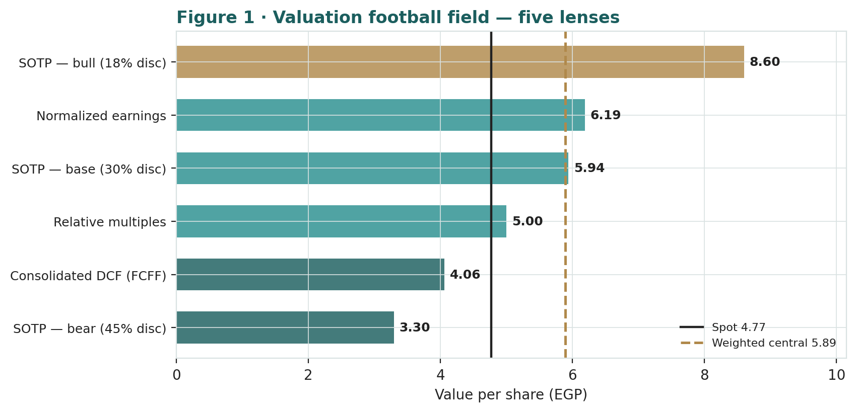
Figure 1 · Valuation football field — five lenses. Spot sits at the low end of the cluster; the DCF sits lowest (it excludes the asset marks), the discount-compression case highest as a tail.
How to read this. The cluster sits above spot — the signature of a stock the market is discounting heavily to its asset base. The dispersion is driven almost entirely by one input, the holding-company discount: at the market's ~44% the stock looks cheap; at a normalised 30% it is materially undervalued; at a widened 45% it is roughly fair. None of this forecasts direction — the next section describes a strong but recently-pulling-back price process — it states that, on the fundamentals, the debate is about the discount, not the assets.

1.6 The holding-company assets — a deeper look
The valuation rests on asset-level judgments. One fact recurs: ERC is both the largest asset and the largest source of error, because its value swings with refining margins and with how much of its de-levered cash it distributes.
Asset | Stake | Mark basis | Key tension
ERC (refining) | 13.14% econ | EV − ERC debt | margin cyclicality; dividend timing
TAQA Arabia | ~55% | EV/EBITDA | steadier; potential stake-up to ~55%+
ASCOM / GlassRock | majority | EBITDA mark | mining/quarrying cycle
ASEC / cement | ~99% | EBITDA mark | Sudan (Al-Takamol) risk
Dina Farms | majority | EBITDA mark | agri input costs
Transport & Logistics | ~92-93% | EBITDA mark | volume/throughput
ERC — the largest mark and the biggest judgment call. The Mostorod refinery is a $4.3bn asset producing 4.7mtpa of refined product. Its value to Qalaa is its 13.14% economic share of ERC equity (ERC enterprise value less ERC's own project debt). With senior debt cut from $2.35bn to ~$63m by end-2025 and full repayment due in 1Q26, ERC is rapidly de-levering, and the prospect of ERC resuming dividends to Qalaa from 2026 is the single most powerful lever on both the mark and the discount. We mark ERC's enterprise value on mid-cycle refining EBITDA (~$0.40bn base) at 5.5x; the bull lifts margin and multiple, the bear cuts both. The subordinated tranche (~$773m to 2030, repaid from 35% of ERC's available cash) is the remaining gearing.
TAQA Arabia — the steadier energy stake. Egypt's largest private energy distributor (gas, fuel marketing, power), deconsolidated end-2023 and now carried as a ~55% associate. Its earnings are far less cyclical than ERC's, and Qalaa has signalled interest in raising its stake — a step-up would lift the look-through value. We mark it on ~EGP 5bn EBITDA at 5x, net of its own debt.
The smaller platforms — diversification, not the swing. Cement (ASEC, including Al-Takamol in Sudan and Zahana), mining (ASCOM/GlassRock), agrifoods (Dina Farms) and transport (CCTO, river barges) together are a meaningful slice of NAV but none individually moves the answer the way ERC and the discount do. We mark each conservatively on attributable EBITDA.

1.7 The holding-company discount — the crux of the valuation
Because most of Qalaa's value sits in stakes, the entire valuation reduces to one question: what discount to gross NAV is appropriate?
Why holdcos trade at a discount. Markets pay less than the sum of the parts for double taxation on disposals, holdco overhead, capital-allocation risk, and the opacity of unlisted marks. For Egyptian holdcos the discount has historically been wide. Qalaa carries two additional, specific overhangs: a qualified FY2024 audit opinion (EGP 22.3bn of unconfirmed bank balances) and a going-concern emphasis of matter (current liabilities exceeded current assets by EGP 27.8bn at end-2024). Those are real reasons for a wide discount.
Why it might narrow. Three forces argue for compression. ERC's near-complete senior-debt retirement removes the refinery's existential financing risk and opens the door to dividends. The October 2025 capital increase turned parent equity positive and began clearing the going-concern flag. And crystallisation — a TAQA stake-up, an asset sale, or simply ERC distributions converting an opaque mark into observable cash — would narrow the discount mechanically.
What the price implies. At EGP 4.77 the market prices a ~44% discount to our gross NAV. Our base case applies 30% — a normalisation, not a heroic one — and lands 24% above spot. To reach the bull at EGP 8.60 the discount must compress to ~18% and the marks must firm together. To justify the bear you must believe the discount stays ~45% — that the marks are stale and the going-concern discount permanent. That is the debate, stated plainly: not what Qalaa owns, but how much of it the market will credit.

1.8 Egypt — the pound, refining margins, and the energy-subsidy regime
A valuation of Qalaa that ignores Egypt is incomplete, because three country-specific forces bear directly on the value.
The pound is a two-edged factor. ERC's functional currency is the US dollar, so EGP devaluation lifts ERC's EGP-reported revenue and the EGP value of Qalaa's economic stake — part of why FY2024 nominal figures look strong. But devaluation also raises input costs across the consolidated platforms and pressures the consumer businesses, and a disorderly move strains FX access. We carry the pound as a net-positive but volatile factor in the Monte Carlo.
Refining margins set ERC's cash. ERC's profitability swings with the gasoil/fuel-oil crack and utilisation; it posted losses through parts of 2024-25 (including a 32-day maintenance shutdown in 2Q25) before recovering to profit in 3Q25. The margin cycle is the dominant driver of the ERC mark and of the dividend timing on which the discount turns.
The energy-subsidy and policy regime. Egypt's fuel-pricing and subsidy reforms, and any change to ERC's offtake or pricing arrangements with EGPC, are a policy risk that a generalist refinery model would miss. We treat it as a discrete downside factor in the simulation.

1.9 Primary-lens sensitivity — discount × ERC value
The base SOTP lands at EGP 5.94. The grid shows how value/share moves with the two biggest swing factors — the holding-company discount and ERC's enterprise value (EGP bn). The DCF grid (WACC × g) is in the Excel companion; across its plausible space the cash-flow lens stays well below the SOTP, by construction.
disc \ ERC EV | 88 | 98 | 108 | 118 | 128
45% | 3.06 | 3.23 | 3.40 | 3.57 | 3.74
38% | 3.45 | 3.64 | 3.83 | 4.02 | 4.21
30% | 5.61 | 5.94 | 6.27 | 6.59 | 6.92
24% | 6.34 | 6.71 | 7.07 | 7.44 | 7.81
18% | 7.06 | 7.47 | 7.88 | 8.29 | 8.69
Reading the grid. The base cell (30% discount, ERC EV ~EGP 108bn ≈ $2.2bn) sits at ~EGP 5.94. Moving the discount does far more than moving the ERC mark — confirming the discount is the swing factor.

2 Technical and price structure
Technicals describe the price, not the value. They matter here because Qalaa's tape is the mirror image of the names we usually flag as cheap: this is a strong uptrend taking a sharp breather, not a falling knife. A stock up ~84% on the year, only ~16% below its high, but oversold after a pullback, is as capable of resuming higher as of correcting further.
Indicator | Reading | Interpretation
Spot vs 52-week range | 4.77 / 2.39 – 5.70 | upper third; +84% YoY
Off the 52-week high | 4.77 vs 5.70 | −16% from the high
SMA 20 / 50 / 200 | 5.17 / 4.87 / 3.65 | rising stack; price just below 20- & 50-day
RSI (14) | ~27 | oversold after the pullback
ATR (14) | 0.21 (4.3%) | elevated daily range
Realized vol 60d / 252d | ~52% / ~47% | high and persistent
Skew / excess kurtosis (252d) | +0.99 / +2.8 | right skew, fat tails
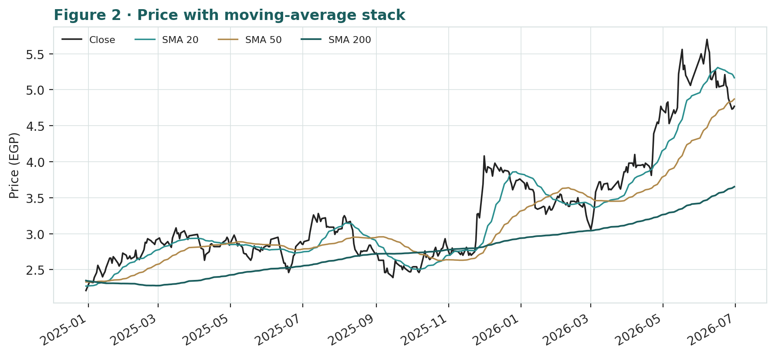
Figure 2 · Price with moving-average stack — a rising 20/50/200 structure; spot has pulled back to just below the 20- and 50-day after a run to EGP 5.70.
The honest technical read. The trend is up and the moving averages are stacked bullishly, with the 200-day far below; the recent dip has pushed price just under the rising 20- and 50-day and RSI to ~27, which is oversold and often precedes a bounce — but is not, on its own, a reversal signal in either direction. Realized volatility near 47% and fat right-skewed tails mean moves can be violent. Nearest support is the rising 50-day around EGP 4.87, then the round EGP 4.50; resistance is the recent high near EGP 5.70. The technical and fundamental pictures are consistent: a strongly-performing asset that the market still discounts heavily to its NAV, where the fundamental question is whether that discount is too wide.

3 Monte Carlo — a probabilistic price map
This models the price over the next three months, not value. We simulate 50,000 paths (seed 42) from a 16-factor structure — seven continuous drivers and nine discrete event risks — calibrated to Qalaa's own realized volatility. It answers “where could the price plausibly be, and with what probability”, not “what is Qalaa worth”. The paths diffuse from spot and deliberately do not embed the fundamental NAV — the value gap of Section 1 is kept out of the drift, so the fundamental and probabilistic lenses stay independent.
The 16 factors. Continuous (7): ERC refining margin & utilization, ERC senior-debt retirement / de-levering, TAQA & energy-distribution earnings, EGX flows / EGP carry, EGP devaluation translation, holdco-debt write-off progress, and realized price momentum (carried, not extrapolated). Discrete events (9): ERC dividend resumption (p~0.35, +8%), holdco-discount compression / re-rating (p~0.30, +6%), platform crystallization — a TAQA stake-up or asset sale (p~0.25, +6%), an EGP step devaluation lifting USD-functional assets (p~0.25, +5%), a two-sided quarterly surprise (p~0.40, ±), a refining-margin / oil-price disappointment (p~0.30, −6%), a going-concern / qualified-audit overhang flare (p~0.20, −7%), an EGX/EM risk-off (p~0.25, −6%), and a regulatory / energy-subsidy / FX-access shock (p~0.20, −5%).
Net three-month drift is mildly positive (~4.1%), total three-month volatility prints around 27% (~53% annualised), and the distribution is right-skewed — the positive catalyst set (ERC dividends, discount compression, FX translation) outweighs the negative in expectation, while the downside events are sharper per event. The drift is built from these forward factors rather than from the +84% trailing run: we do not assume the past year's momentum simply continues, and carry realized momentum only as one editable factor among sixteen.
Horizon | 5% | 25% | Median | 75% | 95%
T + 20 sessions (~1m) | 3.77 | 4.36 | 4.81 | 5.31 | 6.13
T + 60 sessions (~3m) | 3.22 | 4.13 | 4.89 | 5.79 | 7.39
Percentiles in EGP/share. Engine values are the simulated 50,000-path outputs (seed 42).
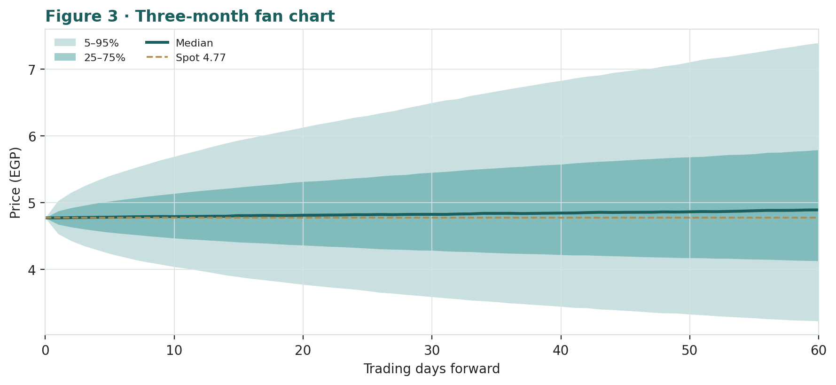
Figure 3 · Three-month fan chart — percentile cone of simulated paths from spot; median ~flat, a very wide band.
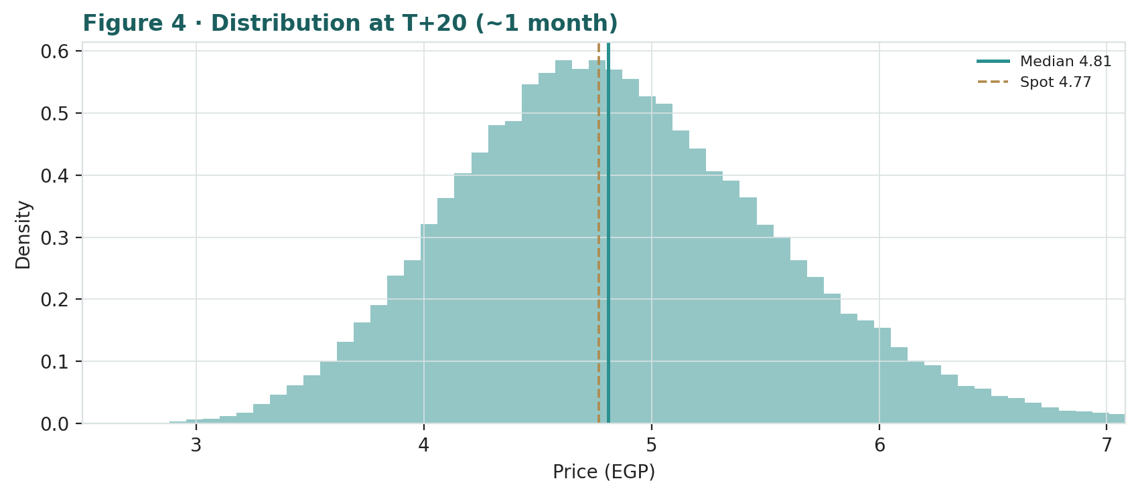
Figure 4 · Distribution of the price at T+20 (~1 month) — roughly two-sided around spot.
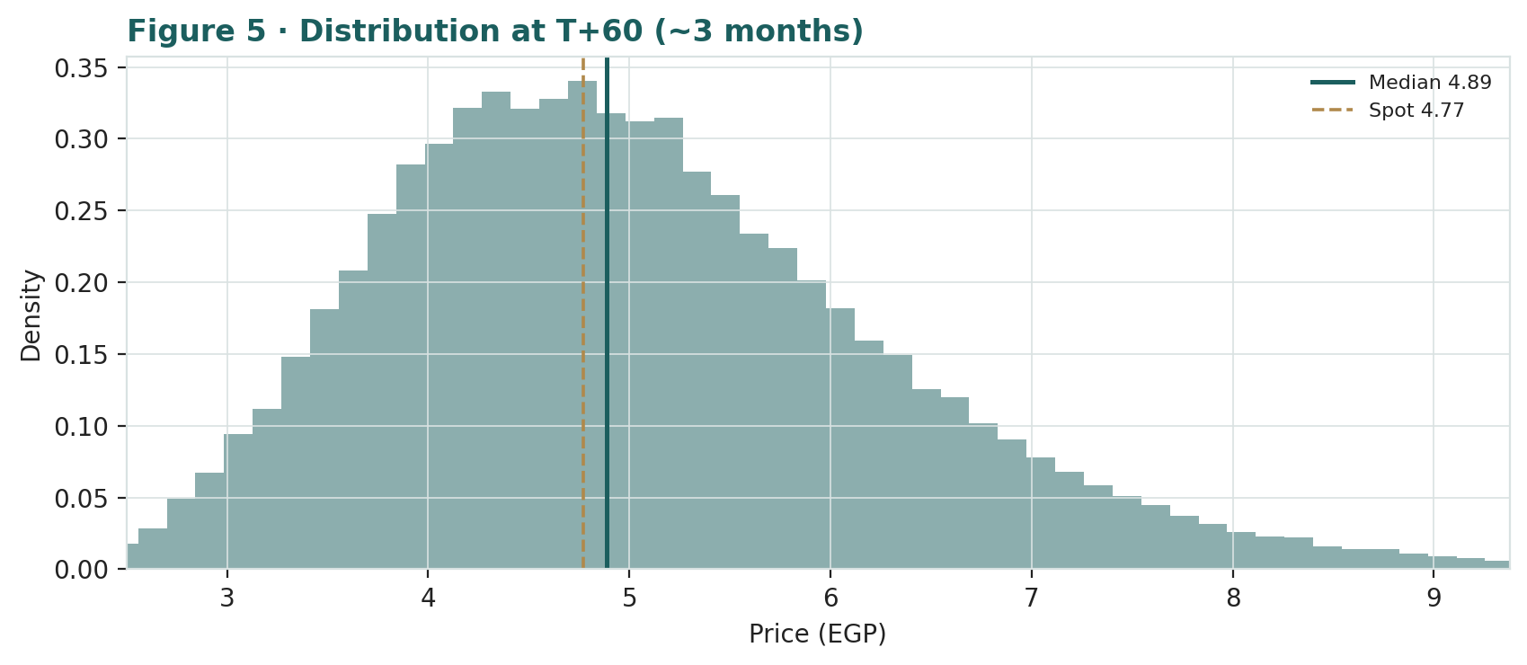
Figure 5 · Distribution of the price at T+60 (~3 months); note the mild right skew and fat tails.
Level | by T+20 | by T+60 | Note
EGP 5.20 | 49% | 70% | back above the 20-day
EGP 5.70 | 20% | 47% | retest the 52-week high
EGP 6.30 | 5% | 27% | new-high breakout
EGP 4.50 | 57% | 74% | first support test
EGP 4.00 | 17% | 41% | deeper pullback
EGP 3.50 | 2% | 17% | toward the bear/DCF zone
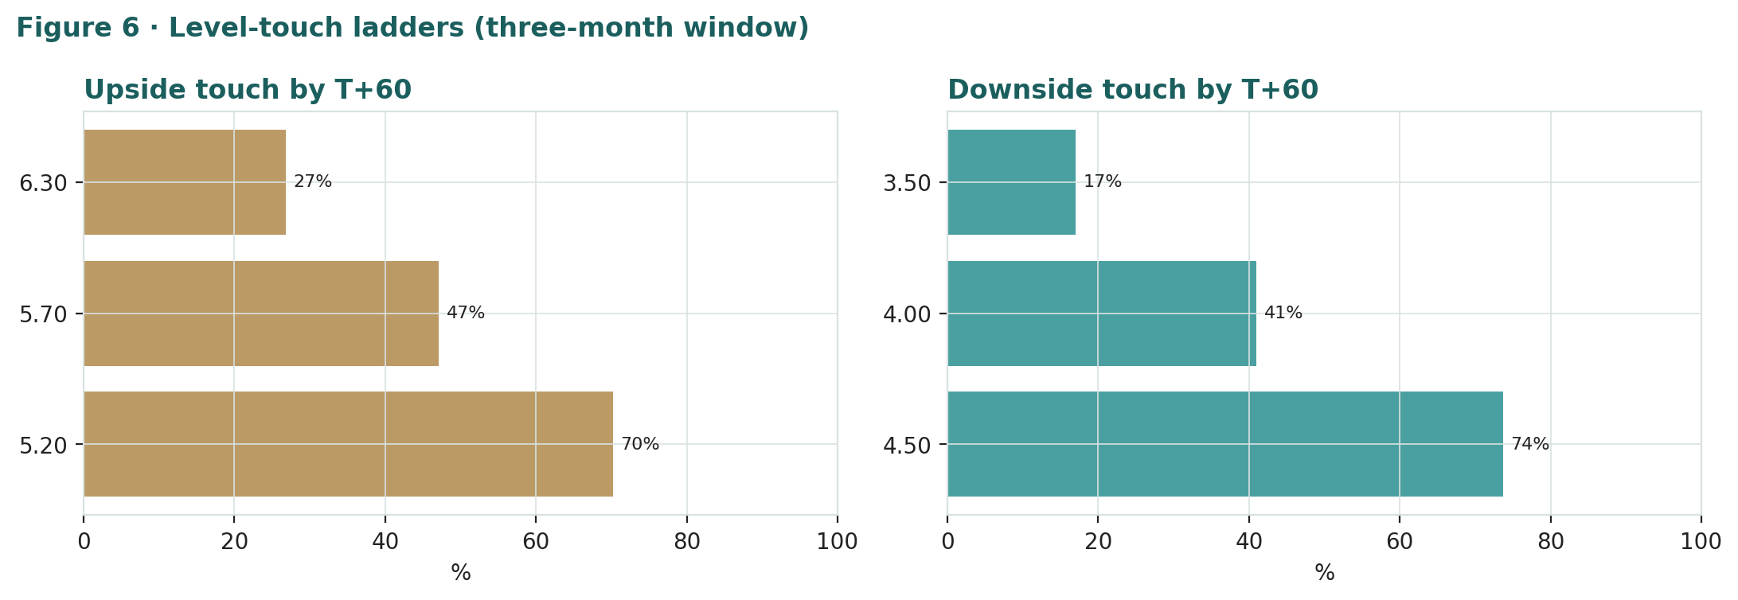
Figure 6 · Upside and downside touch ladders over the three-month window.
What the map says. Over three months a move back above the 20-day around EGP 5.20 is more likely than not (~70%), while a retest of the EGP 5.70 high is ~47% and a fresh-high breakout to EGP 6.30 a lower-probability ~27%. On the downside, a test of support near EGP 4.50 is likely (~74%) and a deeper slide toward EGP 4.00 a non-trivial ~41%. Crucially, this near-term map and the fundamental finding are not in conflict: the price can wander within a wide band over three months while value sits ~24% above price. The Monte Carlo describes the former; Section 1 describes the latter.

4 Comparison of the lenses, and a verdict
Lens | What it measures | Output | vs spot
SOTP base (primary) | gross NAV less 30% discount | EGP 5.94 | +24%
SOTP bull | discount compresses to 18% | EGP 8.60 | +80%
Consolidated DCF | attributable operating cash only | EGP 4.06 | -15%
Relative multiples | attributable net × multiple | EGP 5.00 | +5%
Normalized earnings | through-cycle attributable profit | EGP 6.19 | +30%
Weighted central | triangulated estimate | EGP 5.89 | +23%
Monte Carlo T+60 median | likely 3-month price | EGP 4.89 | +2%
Verdict — undervalued on a wide discount to NAV; the whole case is a holding-company-discount bet. The fundamental lenses agree that EGP 4.77 sits below fair: the central estimate is EGP 5.89 (+23%), and the cluster sits above spot. The cash-flow cross-check, which ignores the asset marks, is the most conservative and shows how much of the value is asset-and-discount rather than operating cash. The technical trend is strong but stretched — up ~84% on the year, oversold after a pullback — and the three-month price map is wide and roughly centred on spot. A buyer at this level is underwriting one proposition: that the ~44% holding-company discount narrows as ERC finishes retiring its senior debt and resumes distributions, the going-concern overhang lifts as the negative parent equity keeps closing, and the marks hold. If the discount compresses, the bull at EGP 8.60 is reachable; if it stays wide or the marks prove stale, the downside to the bear at EGP 3.30 is real. This study expresses a valuation, not a trade, and certainly not advice.

5 Catalysts to watch
ERC dividend resumption (↑, high impact). With ERC's senior debt all but retired (full repayment due 1Q26), the resumption of dividends to Qalaa's 13.14% stake is the single most powerful lever on both the ERC mark and the holding-company discount.
Holdco-discount / re-rating (↑). Sustained positive parent equity, a clean (unqualified) audit, and clearer capital-return discipline would attack the discount directly.
Platform crystallization (↑). A TAQA Arabia stake-up toward 55%+, or an asset sale, would convert an opaque private mark into observable value.
Refining margins & ERC results (↑/↓). The gasoil/fuel-oil crack and ERC utilisation are the clearest read on the dominant asset; the 3Q25 return to profit is the template.
The Egyptian pound (↑/↓). Devaluation lifts the EGP value of USD-functional ERC but pressures the consumer platforms and FX access — a two-edged factor.
Going-concern / audit & policy (↓). A reversion of the going-concern flag, a continued qualified opinion, or an energy-subsidy / EGPC-pricing change are the principal near-term downside catalysts.

6 Reading the probability zones
Combining the fundamental anchors with the three-month price map gives a set of zones — descriptive, not directive.
Zone | Range (EGP) | What it would mean
Discount compression | 5.70 – 6.30+ | discount narrows toward ~18%; ERC dividends / crystallisation
Re-rating underway | 5.20 – 5.70 | discount drifts toward base; momentum resumes
Central / fair | 4.50 – 5.20 | where spot and the near-term map sit
Discount persists | 3.80 – 4.50 | wide discount holds; refining soft
Wide-discount / bear | < 3.80 | discount widens; going-concern / stale-marks zone

7 Caveats and what would change our mind
The ERC mark is a judgment, and margin-sensitive. ERC's value to Qalaa swings with refining margins and with the timing and size of its dividends. This is the single biggest source of error in the SOTP.
The discount is the swing factor, and we may have it wrong. A base discount of 30% is a normalisation from the market's ~44%. If the going-concern/governance discount proves permanent, fair value migrates toward the bear; if ERC dividends and a clean audit land, toward the bull. The Excel companion lets you change the discount and every mark.
The accounts carry a qualified opinion and a going-concern history. FY2024 was audited with a qualified opinion (EGP 22.3bn unconfirmed balances) and a going-concern emphasis; the marks and debt figures inherit that uncertainty. FY2024 net income was also flattered by a ~EGP 9.9bn one-off gain.
The economic-interest choice is deliberate. We value ERC at Qalaa's ~13.14% economic stake, not consolidated. If one believed Qalaa could extract value from ERC beyond its economic share, the NAV would be higher — we do not assume that.
The Monte Carlo is a price model, not a forecast. It encodes our probability estimates for events that have not happened. The factor probabilities are inputs, not facts, and the model says nothing about value.
RSI / momentum reminder. RSI ~27 is oversold, which often precedes a bounce — but a stock that has run ~84% can correct further. Do not mistake “oversold” for a margin of safety; the margin of safety, if any, is in the discount to NAV, not the indicator.

Appendix A Financial statements (EGP bn)
Actuals: FY2023-FY2024 are Qalaa's consolidated disclosure (the FY2024 audit carries a qualified opinion and a going-concern emphasis of matter). FY2025 is shown as an estimate (FY2025E): the first nine months are Qalaa's 9M2025 limited-review consolidated actuals (revenue EGP 100.6bn, a net loss to parent of EGP 1.2bn, total assets EGP 208bn at 30 Sep 2025), with the fourth quarter estimated on management's flagged refining-margin recovery. It is NOT an audited full-year figure — Qalaa's audited FY2025 book was not published as of this study's date. FY2024 net income was flattered by a ~EGP 9.9bn one-off gain on discontinued operations while continuing operations were loss-making. Forecast columns (2026e-2030e) are the preparer's illustrative build as ERC de-levers and refining margins normalise.
A.1 Consolidated income statement (EGP bn)
Income statement | 2023a | 2024a | 2025E | 2026e | 2027e | 2028e | 2029e | 2030e
Revenue (incl. ERC) | 97.1 | 148.9 | 140.6 | 150.0 | 162.0 | 174.0 | 186.0 | 198.0
of which ERC | 87.0 | 134.9 | 127.0 | 134.0 | 143.0 | 152.0 | 161.0 | 170.0
Recurring EBITDA | 22.7 | 21.4 | 19.4 | 24.0 | 27.5 | 31.0 | 34.0 | 37.0
(−) D&A | (9.0) | (10.5) | (13.8) | (13.0) | (13.5) | (14.0) | (14.5) | (15.0)
Operating profit (EBIT) | 13.7 | 10.9 | 5.6 | 11.0 | 14.0 | 17.0 | 19.5 | 22.0
(−) Net finance cost | (12.0) | (14.0) | (8.4) | (11.0) | (9.5) | (8.5) | (8.0) | (7.5)
(+) One-offs / associates | 0.3 | 10.3 | 0.2 | 0.5 | 0.7 | 0.9 | 1.1 | 1.3
Net profit (incl. minority) | 2.0 | 6.8 | (2.6) | 0.3 | 5.2 | 9.4 | 12.6 | 15.8
attributable to NCI | 5.3 | 1.8 | (3.1) | 2.5 | 4.0 | 5.5 | 7.0 | 8.5
Net profit attributable | (3.8) | 3.9 | (1.1) | (3.2) | (0.8) | 1.2 | 2.2 | 3.3
EPS attributable (EGP) | (0.90) | 0.93 | (0.26) | (0.76) | (0.19) | 0.29 | 0.52 | 0.79
Note. ERC dominates consolidated revenue (~90%). FY2025E shows a net loss to parent — the 9M2025 actuals were loss-making (a 2Q25 refinery maintenance shutdown), with only a partial Q4 recovery. The large NCI line reflects the ~87% of ERC Qalaa does not economically own. Reported earnings capture little of the asset base, which is why the holding-company SOTP is the primary lens.
A.2 Consolidated balance sheet (EGP bn)
Balance sheet | 2023a | 2024a | 2025E | 2026e | 2027e | 2028e | 2029e | 2030e
Total current assets | 52.0 | 70.0 | 41.5 | 61.0 | 65.0 | 69.0 | 73.0 | 77.0
PP&E & refinery assets | 95.0 | 163.1 | 142.0 | 140.0 | 138.0 | 136.0 | 134.0 | 132.0
Investments in associates | 8.0 | 6.8 | 7.0 | 8.0 | 9.0 | 10.0 | 11.0 | 12.0
Total assets | 160.6 | 228.5 | 206.0 | 217.0 | 222.5 | 228.0 | 233.0 | 238.0
Total borrowings | 100.0 | 111.4 | 72.4 | 62.0 | 56.0 | 51.0 | 47.0 | 43.0
Total liabilities | 160.7 | 161.5 | 123.5 | 138.0 | 135.0 | 132.0 | 128.0 | 124.0
Non-controlling interest | 47.1 | 80.7 | 72.0 | 74.0 | 77.0 | 80.0 | 83.0 | 86.0
Equity attributable to parent | (7.1) | (13.7) | (4.5) | (2.0) | 3.5 | 9.0 | 15.0 | 22.0
Total equity | 40.0 | 67.0 | 67.5 | 72.0 | 80.5 | 89.0 | 98.0 | 108.0
Note. Parent equity REMAINS NEGATIVE through end-2025 (−EGP 4.5bn FY2025E, improved from −EGP 13.7bn at FY2024 after the October 2025 QHRI debt-to-equity conversion). Management has cited a positive ~EGP 3.4bn figure, but that refers to the standalone/pro-forma parent, not the consolidated balance sheet, which showed −EGP 5.1bn at 30 Sep 2025. Total equity is positive only because of the very large minority interest. Discount-to-NAV, not P/B, is the informative gauge.
A.3 Consolidated cash flow (simplified, EGP bn)
Cash flow | 2023a | 2024a | 2025E | 2026e | 2027e | 2028e | 2029e | 2030e
Operating cash flow | 18.0 | 20.0 | 20.1 | 22.0 | 24.0 | 26.0 | 28.0 | 30.0
(−) Capex | (8.0) | (9.0) | (9.0) | (9.0) | (9.5) | (10.0) | (10.5) | (11.0)
Free cash flow | 10.0 | 11.0 | 11.1 | 13.0 | 14.5 | 16.0 | 17.5 | 19.0
(−) Debt repayment (incl. ERC senior) | (6.0) | (28.0) | (39.0) | (10.0) | (7.0) | (6.0) | (5.0) | (5.0)
The point of A.3 for the valuation. ERC's USD 574m of senior-debt repayment drove a ~EGP 39bn cut in total consolidated debt in 2025 — the engine of the de-levering thesis. Once senior debt is retired in 1Q26, ERC's cash can flow to dividends, the catalyst the discount turns on.

Appendix B Step 0 — calibration backtest
Before publishing any probabilistic price map we test the engine against Qalaa's own five-year history: does a lognormal three-month price model, fed with realized volatility, produce calibrated intervals?
Result — passes; no σ change warranted. Over 70 independent non-overlapping windows (53 at the 20-day horizon, 17 at the 60-day) across the five-year history, pooled interval coverage is 57% / 80% / 84% against the 50/80/90% targets, and the probability-integral-transform (PIT) is close to uniform. The three-month-only width ratio of 0.86 (cone looking slightly too wide) collapses to 1.03 at the 20-day horizon — so that signal is small-sample noise from only 17 quarterly windows, not a real miss. The engine shows no material dispersion bias for CCAP at its realized volatility of ~47%, so we carry the trailing-252-day realized σ with no regime multiplier.
One standing flag. The PIT mean runs slightly high (~0.58) — realized prices land above the model median more often than not. This is the EGP-float drift artefact the house calibration methodology explicitly declines to correct: the 2022 and 2024 currency steps pumped nominal returns, and the backtest disciplines dispersion and tail shape only, never the centre. The Monte-Carlo drift therefore stays a forward, factor-based judgment, with realized momentum carried as just one editable factor.
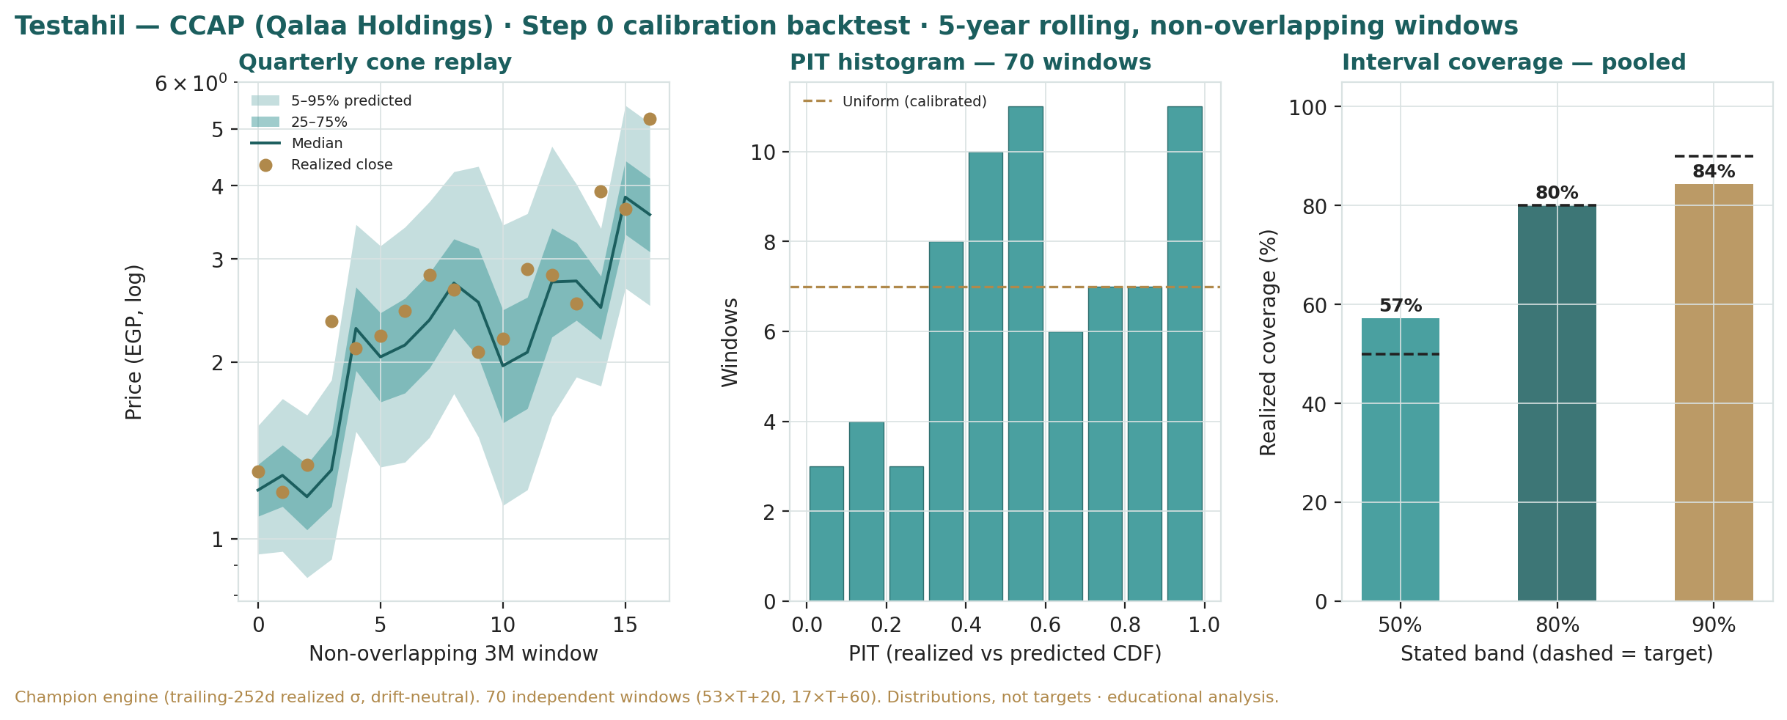
Figure B1 · Step 0 calibration — quarterly cone replay (log scale), PIT histogram over 70 windows (close to uniform), and pooled interval coverage (57/80/84% vs 50/80/90% targets). Champion engine, drift-neutral, non-overlapping windows.

Appendix C Peer set, sector structure, and risks
C.1 The structure that matters
Arena | Driver | Note
EGX holdco discount | Egyptian holdcos trade wide to NAV | sets the base discount
ERC (refining) | single-asset refinery; margin & utilization | dominant value driver
TAQA Arabia | energy distribution; steadier earnings | associate cross-check; stake-up optionality
Going-concern / audit | qualified FY2024 opinion | widens the discount
EGP / macro | devaluation lifts USD-functional ERC | two-edged translation
Crystallisation / value-up | ERC dividends, TAQA stake-up, asset sale | narrows the discount
C.2 Principal risks
Holding-company discount — the dominant factor; a persistently wide discount keeps the shares below NAV regardless of asset value.
Refining-margin cyclicality — ERC's cash and mark swing with the crack and utilisation; a weak margin cycle delays dividends and the re-rating.
Going-concern / qualified audit — a continued qualified opinion or a reversion of the going-concern flag would re-widen the discount.
EGP and FX access — devaluation is two-edged, and disorderly FX access strains the consumer platforms and the holdco.
Energy-subsidy / EGPC policy — changes to fuel pricing or ERC's offtake/pricing arrangements are a policy risk a generic model would miss.
Stale or impaired marks — the unlisted platform marks rest on judgment and could be reset down.

Appendix D Four experts, four methods — the valuation in the round
Premise. Four independent experts, drawn from the standing Expert Persona Library, each run a genuinely different method on Qalaa, none seeing the others' work. For a holding company the library casts the holdco trio — Expert 1 (NAV & discount), Expert 2 (the Accountant), and Expert 3 (Macro-Policy) — and here we add a fourth, Expert 4 (Earnings-power), because Qalaa has become operating-heavy: ERC and TAQA are real businesses, not passive marks, and an earnings-power lens that ignores the asset NAV entirely is a distinct, non-overlapping view that the other three do not supply. The divergence between them is the signal, and is not averaged away.
Where they land. Their fair values run from EGP 4.55 (Expert 2, -5%) to EGP 5.94 (Expert 1, +25%) — a spread of about EGP 1.39, or 29% of spot. That spread is the honest measure of how much of Qalaa's value rests on one thing: whether the ERC asset mark and the holding-company discount are realized in cash, or remain a booking. Expert 2 refuses to credit them until the cash arrives; Expert 1 credits them at a normalised discount; Expert 3 and Expert 4 sit between.

D.1 Expert 1 — the NAV & discount analyst
Worldview and tradition. A holding company is worth its parts minus a discount for the holdco structure. The discount — its level and what moves it — is the crux, not the NAV. Expert 1’s whole craft is reading whether anything narrows the discount.
“The NAV is the easy part. The discount — and whether anything narrows it — is the whole game.”
When it works / when it fails. Best for holdcos and conglomerates with identifiable catalysts. Fails where the discount is structurally permanent (no catalyst) or the parts are genuinely unmarkable.
Standard workings. (1) value each stake — ERC and TAQA at economic stake net of their debt, the platforms at attributable marks; (2) sum to gross NAV less holdco recourse debt; (3) assess the appropriate discount (governance, liquidity, the qualified audit, capital allocation); (4) probability-weight the catalysts that narrow it — ERC dividends, a TAQA stake-up, a clean audit.
Expert 1’s build | EGP bn | / share
Gross asset value (economic) | 41.6
(−) Holdco recourse debt | (6.0)
Gross NAV | 35.6 | 8.48
(−) Holdco discount (30%)
Fair value |  | EGP 5.94
Worked example — the discount does the work. At gross NAV of EGP 8.48, every 5 points of discount is worth about EGP 0.42 per share. The market's ~44% prices the shares at EGP 4.77; Expert 1’s 30% lifts that to EGP 5.94. He does not need the marks to rise — only the discount to normalise as ERC's de-levering removes the refinery's existential risk.
Sensitivity on the swing input (the discount). At 18% he is at EGP 7.47; at 30%, EGP 5.94; at 45%, EGP 3.06. The discount alone spans a EGP 4.4 range — wider than any other expert's entire spread, which is his whole point.
Holdco discount | 45% | 38% | 30% | 24% | 18%
Fair value / share (EGP) | 3.06 | 3.64 | 5.94 | 6.71 | 7.47
How he cross-examines the others. To Expert 2: “You haircut ERC to its debt and call it prudence — but the senior debt is almost gone and TAQA is an associate throwing off cash; you are pricing a 2019 balance sheet.” To Expert 4: “Earnings power ignores that most of the value never passes through the P&L — you are valuing the wrapper, not the contents.” To Expert 3: “Your stagflation world double-counts a risk the discount already prices.”
Verdict, falsification, and what the price implies. Fair value EGP 5.94 (+25%). Falsified if the discount stays ~44%+ for two years with ERC distributing — i.e. the discount is structural, not a catalyst-gap. The market price implies a ~44% discount, which Expert 1 reads as too wide for a de-levering holdco with a positive-equity inflection.

D.2 Expert 2 — the Accountant
Worldview and tradition. The Graham-Dodd realization school: a business is worth what its assets realize net of every claim, and reported profit is trusted only as it converts to cash. Especially apt where profit is booked years before the cash arrives — and where the auditor has qualified the accounts.
“Show me the cash, not the booking. The balance sheet is a fact; the future is a guess — and this one is a qualified guess.”
When it works / when it fails. Best where leverage is rising, working capital is heavy, and value rests on unrealized assets — Qalaa is the archetype. Fails by systematically undervaluing a genuine compounding franchise once the cash does start to convert.
Standard workings. (1) mark each asset to a conservative realizable value with explicit haircuts; (2) test earnings quality via the operating-cash-to-net-income bridge — here, distorted by the EGP 9.9bn one-off gain; (3) bridge to equity less all claims and the going-concern working-capital gap, with a cash-conversion overlay; (4) sensitivity on the swing haircut.
Expert 2’s realizable build | Mark | Haircut | EGP bn
ERC (econ stake) | credit ≈ debt only | −55% | 4.0
TAQA Arabia | associate, steadier | −20% | 7.5
Platforms (cement/mining/agri/transport) | attributable | −20% | 18.8
Gross realizable |  |  | 30.2
(−) Claims + going-concern buffer |  |  | (9.0)
Realizable NAV |  |  | 21.2
× cash-conversion overlay (0.90) | qualified audit |  | EGP 4.55
Worked example — why he won't credit ERC. ERC's enterprise value is real, but Qalaa's 13.14% economic claim is junior to ~$0.84bn of remaining ERC debt and has paid Qalaa no dividend. Expert 2 credits it at roughly its de-levered equity floor — about EGP 4bn, less than half the EV-based mark — until a dividend actually reaches the holdco. “An EV is an opinion; a dividend is a fact.”
Sensitivity on the swing input (the ERC haircut). At a −35% haircut (vs −55%) ERC contributes ~EGP 5.7bn and his fair value rises to ~EGP 5.0; at −70% it falls to ~EGP 4.2. His number is most sensitive to the one mark he most distrusts.
How he cross-examines the others. To Expert 1: “You apply a discount to a NAV built on marks I can't realize today — discounting a guess does not make it a fact.” To Expert 4: “We agree the P&L is the discipline, but yours trusts a normalized number the audit won't even sign.” To Expert 3: “Finally, someone who prices the downside — your stagflation world is my base case.”
Verdict, falsification, and what the price implies. Fair value EGP 4.55 (-5%) — essentially at spot. Falsified by a durable lift in cash conversion: an ERC dividend reaching the holdco and a clean audit. The market price, he notes, is almost exactly his realizable number — the market is pricing Qalaa the way he does, on what it can realize, not on its gross NAV.

D.3 Expert 3 — the Macro-Policy strategist
Worldview and tradition. In frontier and emerging markets, policy outranks fundamentals — the FX regime, the rate path, energy-subsidy policy and sovereign action move value more than management does. He prices Qalaa as a set of options on which policy world arrives.
“I don’t pick a side; I weight the odds. For an Egyptian energy holdco, the pound and the subsidy regime are the valuation.”
When it works / when it fails. Best in policy-driven markets with FX/rate regimes in flux — Egypt today. Fails through false precision: the probabilities are judgements, and a tree can miss the branch that grows.
Standard workings. (1) identify the policy levers that set Qalaa's value — the EGP path, FX access, energy-subsidy/EGPC pricing, the rate path; (2) define worlds as configurations of those levers; (3) re-price the base under each so the scenario values are derived; (4) probability-weight; (5) stress the weights.
Expert 3’s policy worlds | Value / sh | Probability
Reform / orderly EGP / ERC dividends | EGP 9.50 | 25%
Muddle-through | EGP 5.50 | 40%
Stagflation / FX squeeze / pricing shock | EGP 2.60 | 35%
Probability-weighted fair value |  | EGP 5.49
Worked example — the pound cuts both ways. In the orderly world, a stable pound lets ERC's USD cash convert cleanly and dividends flow — the asset mark and the discount both improve. In the squeeze world, a disorderly devaluation lifts ERC's EGP-nominal revenue but chokes FX access, pressures the consumer platforms, and keeps the holdco starved — the nominal gain is a mirage. Same currency move, opposite value, depending on the policy frame around it.
Sensitivity on the swing input (the scenario weights). Shift 15 points from the squeeze world to muddle-through and his fair value rises to ~EGP 6.0; shift them the other way and it falls to ~EGP 4.9. His answer is only as good as the policy odds.
Squeeze-world weight | 20% | 27% | 35% | 42% | 50%
Fair value / share (EGP) | 6.71 | 6.10 | 5.49 | 4.97 | 4.36
How he cross-examines the others. To Expert 1: “Your single 30% discount is my muddle-through world only — you ignore the 35% chance the pound makes the marks irrelevant.” To Expert 2: “Your caution is right for one world, too bearish for another.” To Expert 4: “Normalized earnings assume a normal policy regime Egypt may not deliver.”
Verdict, falsification, and what the price implies. Fair value EGP 5.49 (+15%). Falsified if a fourth, unmodelled policy shock dominates (a disorderly default, a subsidy cliff) or if the scenario set is mis-specified. The market price sits closest to a blend of his muddle-through and squeeze worlds — the market is pricing meaningful policy risk.

D.4 Expert 4 — the Earnings-power analyst
Worldview and tradition. An operating company is worth a fair multiple of its sustainable, mid-cycle earnings power. He strips one-off peaks and troughs and asks what the business earns through the cycle — and, crucially for Qalaa, he ignores the asset NAV entirely, because a holdco's owners are paid out of earnings, not out of gross asset value.
“What does it earn through the cycle, and what is that worth? Peaks, troughs, and asset marks are noise — the owner banks the attributable profit.”
When it works / when it fails. Best for operating businesses with a track record and in relative-value contexts. Fails at structural breaks, and — its key limitation here — it systematically understates a holdco whose value is genuinely in its asset base, which is why it is the cross-check, not the anchor.
Standard workings. (1) normalize attributable earnings to mid-cycle, stripping the EGP 9.9bn one-off and the refining trough; (2) derive sustainable attributable EPS; (3) apply a justified multiple (vs EGX peers, adjusted for the holdco/governance risk); (4) cross-check against EV/EBITDA and free-cash-flow yield.
Expert 4’s build | Value
Normalized attributable net (EGP bn) | 4.0
Justified P/E (x) | 6.0
Implied equity (EGP bn) | 24.0
Fair value / share | EGP 5.71 | +20%
Worked example — what a normal year earns. Through the cycle, as ERC de-levers and refining margins normalise and TAQA contributes steady associate income, Qalaa's attributable net settles around EGP 4bn — well above the noisy reported figures once the one-off gain and the finance-cost drag are stripped. At 6x, a modest multiple reflecting EGX and holdco risk, that is EGP 5.71. A re-rating to 7.5x (if the discount narrows) would lift him to ~EGP 7.1.
Sensitivity on the swing input (the multiple). At 5x he is at EGP 4.76 (essentially spot); at 6x, EGP 5.71; at 7.5x, EGP 7.14. The multiple is the holdco-risk dial, and it is where he and Expert 1 actually converge — Expert 1’s discount and Expert 4’s multiple are two names for the same governance question.
Justified P/E | 5.0x | 6.0x | 6.5x | 7.0x | 7.5x
Fair value / share (EGP) | 4.76 | 5.71 | 6.19 | 6.67 | 7.14
How he cross-examines the others. To Expert 1: “Your gross NAV is real but unbankable — show me it in the dividend, and then it's in my earnings.” To Expert 2: “We both distrust the marks; I just trust the normalized earnings you won't.” To Expert 3: “Your worlds are my multiple — a 6x is the muddle-through, an 8x the reform world.”
Verdict, falsification, and what the price implies. Fair value EGP 5.71 (+20%). Falsified by a structural margin re-rating (ERC's cracks permanently higher or lower) or a multiple-regime change. The market price implies roughly a 5x on his normalized earnings — pricing Qalaa as a perpetual muddle-through.

D.5 The four in one room
Put them in front of the single fact they most disagree on — ERC's value to Qalaa — and the same number reads four ways.
Expert 1: “ERC's economic equity is worth ~EGP 9bn at a mid-cycle margin, and the senior debt is almost gone. Mark it, discount the holdco, move on.”
Expert 2: “It has paid Qalaa nothing. I credit it at its debt floor — EGP 4bn — until a dividend lands in the parent's account. An EV is an opinion.”
Expert 3: “Both of you are right, in different worlds. Orderly pound and the dividend flows — Expert 1 wins. FX squeeze and it's stranded — Expert 2 wins. I weight them.”
Expert 4: “I don't care about ERC's EV at all. Tell me the attributable profit it contributes through the cycle, put a fair multiple on it, and that's the only number the owner can spend.”
Same asset, four readings: a markable equity stake (Expert 1), a debt-floored claim awaiting cash (Expert 2), a policy-contingent option (Expert 3), and an earnings contributor (Expert 4). The gap between them is not noise — it is the precise measure of how much of Qalaa's price rests on the ERC mark and the discount converting from booking to cash.

D.6 Reading the divergence
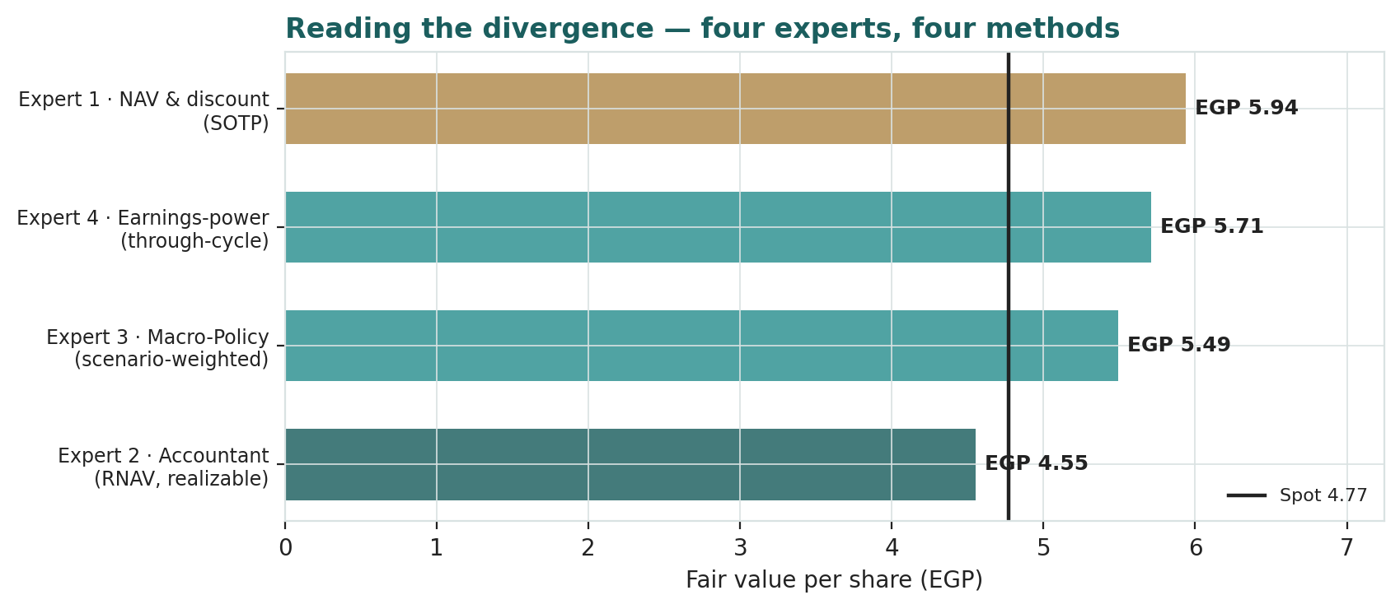
Four experts, four methods. Expert 2 (realizable value) sits near spot; Expert 1 (NAV less discount) highest; Expert 3 and Expert 4 between. The spread is the value at stake in the discount-and-mark question.
Expert | Fair value | The one assumption driving it
Expert 1 · NAV & discount | EGP 5.94 | the holdco discount normalises to 30%
Expert 4 · Earnings-power | EGP 5.71 | a 6x multiple on ~EGP 4bn attributable earnings
Expert 3 · Macro-Policy | EGP 5.49 | the policy-world probabilities (35% squeeze)
Expert 2 · Accountant | EGP 4.55 | ERC credited at its debt floor until dividends are paid
What the spread measures. The EGP 1.39 gap between Expert 2 and Expert 1 — 29% of spot — is almost entirely one question: does ERC's de-levered equity value, and the holding-company discount, convert from a balance-sheet mark into cash the owner receives? Expert 1 says yes and prices it; Expert 2 says prove it and won't; Expert 3 makes it contingent on the pound; Expert 4 routes it through the earnings multiple. The market, sitting near Expert 2’s realizable number, has sided with the skeptic — it is pricing Qalaa on what it has realized, not on what it owns. The bull case for the shares is, precisely, that the market re-rates from Expert 2’s view toward Expert 1’s as ERC starts to distribute. That is the single proposition a buyer at EGP 4.77 underwrites.

About this series
Testahil publishes independent, educational valuation studies. Each is an attempt to reason transparently about what a security is worth, with every assumption shown and a companion model so readers can disagree productively. The house style is distributions, not tips: we describe ranges and probabilities, not targets, and we do not tell anyone what to do. Studies are framed as educational analysis, the preparer is not licensed by any securities regulator, and holdings are disclosed.

Disclosure & Disclaimer
Not investment advice. This document is educational and informational only. It is not, and must not be relied upon as, investment, financial, legal, accounting or tax advice, nor an offer, solicitation or recommendation to buy, sell or hold any security. It contains no price target and no rating.
No licence; no advisory relationship. The preparer is not registered or licensed with any securities or financial regulator in any jurisdiction (including the Egyptian Financial Regulatory Authority), holds no brokerage or investment-advisory authorisation, and is not acting as your adviser or fiduciary. Nothing here is personalised to your circumstances.
Holdings disclosure. The preparer may hold, and may in the future take or dispose of, a position in the security discussed in this report, and may transact at any time without notice. This is a potential conflict of interest you should weigh.
Sources & accuracy. Reported financial and operating figures are drawn from Qalaa's public disclosure and other public sources believed reliable but not independently verified; Qalaa's FY2024 consolidated accounts carry a qualified audit opinion and a going-concern emphasis of matter, and figures may contain errors or be superseded. Forward-looking inputs — the holding-company discount, the unlisted marks, ERC's economic-stake value, projections, multiples, the DCF and Monte-Carlo factor probabilities — are the preparer's own judgments and are inherently uncertain.
Forward-looking statements. Any statements about the future are estimates subject to risks and uncertainties; actual results may differ materially. The Monte Carlo models price, not value, and encodes subjective probabilities for events that have not occurred.
No reliance; your responsibility. Do your own research and consult a licensed professional before making any decision. You are solely responsible for your investment decisions and their outcomes. To the maximum extent permitted by law, the preparer accepts no liability for any loss arising from use of this document.
Currency & figures. All figures are in Egyptian pounds (EGP) unless stated; bn denotes billion. USD/EGP taken at ~49. Rounding may cause totals to differ slightly. Spot price and market data are as of 30 June 2026 and change continuously.
TESTAHIL · Independent Valuation Study · Educational Analysis · Qalaa Holdings (EGX: CCAP) · edition 30-06-2026 · reporting currency EGP

