Testahil · Independent Valuation Study | Raya Holding (EGX: RAYA)
Independent Valuation Study — Educational Analysis | Not investment advice

Independent Valuation Study — Educational Analysis
Raya Holding for Financial Investments (EGX: RAYA)
Fundamental analysis · Technical analysis · Monte Carlo simulation — one integrated read
Anchor: EGP 7.70 (01 Jul 2026 close) · 4,281 mn shares · mkt cap ~EGP 33.0 bn · a diversified investment holding company running 11 portfolio businesses across consumer-electronics distribution (Raya Trade), IT & data-centre integration (RIT), fintech and non-bank financial services (Aman Holding), a listed BPO (RACC) and seven smaller lines · prices and probabilities computed 01 Jul 2026 from the attached daily history · primary lens: holding-company sum-of-the-parts · the Aman fintech multiple, RIT's growth and the conglomerate discount are the swing factors.
READ FIRST — what this document is, and is not. This study is a valuation exercise and an expression of personal analytical opinion, published free of charge for educational purposes: it shows how one analyst applies fundamental, technical and probabilistic methods to a listed company, and invites scrutiny of that methodology. It is NOT investment advice, NOT a recommendation or solicitation to buy, sell or hold any security, and NOT directed at the circumstances of any reader. The preparer is not licensed by any securities regulator, holds no brokerage authorisation, provides no financial consultancy, manages no money, and accepts no fees, funds or clients. All values are model outputs presented as ranges and distributions because no single number should be relied on. Reported financials are the company's own disclosure (FY2025 results, 8 March 2026); forward-looking inputs — the segment marks, the multiples, the holding-company discount, the DCF and the Monte-Carlo factor probabilities — are the preparer's judgments and are flagged throughout. Consult a licensed financial advisor before any investment decision. See the Disclosure & Disclaimer at the end.

Headline
The model's read: the re-rating has run ahead of a conservative sum-of-the-parts. At EGP 7.70 the shares sit about 38% above our weighted central estimate of EGP 5.56. The two anchor lenses agree closely and mark the downside — a holding-company sum-of-the-parts (EGP 5.01) and a consolidated FCFF DCF (EGP 4.77) both land near EGP 5 — while a relative-multiple read (EGP 6.13) and the expert panel (EGP 6.20) sit a little higher and a recovery-to-mid-cycle normalized-earnings read (EGP 8.22) marks the ceiling. The whole answer turns on three things: Aman, the fintech arm, which we value on a P/E and which alone is roughly a third of the portfolio; Raya Information Technology, which grew revenue 70% in FY2025 and whose multiple is the single largest swing in the sum-of-the-parts; and the conglomerate discount, which the market is presently applying at close to zero. FY2025 was an exceptional year — group revenue rose 41% to EGP 63.8 bn, EBITDA 60% to EGP 7.8 bn and attributable profit 53% to EGP 2.6 bn — and the tape has repriced accordingly. Technically the stock is the mirror image of the fundamentals: it trades above every major moving average, a hair below its all-time high of EGP 8.00, with RSI in the high-60s — price and a conservative value read are pulling in opposite directions. Over three months the Monte Carlo, run with the secular drift switched off, places the 5th–95th percentile band at roughly EGP 4.6–13.1 with the median at spot; these paths diffuse from spot as near-term price and deliberately do not embed the §1 value gap, so the fundamental and probabilistic lenses stay independent.
Valuation summary — every read at a glance
Read | What it measures | Central | Range / band | vs spot
FUNDAMENTAL — holdco SOTP (primary) | Marked value of each stake, less debt & discount | EGP 5.01 | EGP 3.0 – 7.8 | -35%
DCF (FCFF cross-check) | Consolidated free cash flow, 5-yr + terminal | EGP 4.77 | EGP 3.9 – 6.2 | -38%
Relative multiples | Peer P/E and EV/EBITDA | EGP 6.13 | EGP 5.4 – 7.0 | -20%
Normalized earnings | Mid-cycle earnings × fair P/E | EGP 8.22 | EGP 6.5 – 9.5 | +7%
Weighted central fair value | Blended fundamental anchor | EGP 5.56 | — | -28%
TECHNICAL | Trend, momentum, structure | Above all MAs | RSI 66.8; near ATH | —
MONTE CARLO (3-month) | Probabilistic price distribution | EGP 7.79 | 50%: 6.40–9.45 | median≈spot
EXPERT PANEL | Three independent methods (appendix) | EGP 6.20 | EGP 4.6 – 8.1 | -19%

Raya Holding at a glance
Item | Value
Exchange / ticker | EGX: RAYA (ISIN EGS690C1C010)
Business | Diversified investment holding company; 11 portfolio companies, ~40 subsidiaries, 6 countries
Founded / listed | 1998 / listed on EGX 2005 (formerly Raya Holding for Technology & Communication)
Spot (01 Jul 2026) | EGP 7.70
Shares outstanding | 4,281 mn (post 2:1 split, Jul-2024)
Market capitalisation | ~EGP 33.0 bn
FY2025 revenue | EGP 63.83 bn (+41% YoY)
FY2025 EBITDA | EGP 7.8 bn (+60%); margin 12.2%
FY2025 attributable profit | EGP 2.588 bn (+53%); EPS EGP 0.60
Total assets (Dec-2025) | EGP 50.68 bn
Spot P/E / EV-EBITDA | 12.7x / 5.8x
ROE (FY2025) | 35%
Largest segments (FY2025) | Raya Trade EGP 23.8 bn · RIT EGP 18.4 bn (+70%) · Aman EGP 9.6 bn (+49%)
Ownership | Khalil Family ~56.5%; free float ~14%
Dividend | EGP 0.04/share (FY2024)

1. Fundamental valuation
Raya is a holding company, so the natural anchor is a sum-of-the-parts: value each business on the basis that fits it, add them, subtract the debt that sits above the operating companies, and apply a discount for the holding-company structure. We treat that as the primary lens and corroborate it three ways — a consolidated discounted-cash-flow, a relative-multiple read, and a normalized-earnings read — before synthesising the four into a single weighted figure. Because one of the parts (Aman) is a financial and another (RACC) is separately listed, the sum-of-the-parts is both the most faithful and the most transparent way to see where value sits; the DCF is shown as a cross-check with an explicit caveat that consolidating a lender distorts group free cash flow.
1.1 Holding-company sum-of-the-parts (primary lens)
Each operating company is valued on an instrument-appropriate basis. Aman is a non-bank lender, so we value it on a P/E applied to an estimated net income rather than on EBITDA. RACC is listed on the EGX and was the subject of an August-2025 tender at EGP 7.5/share, so we mark Raya's economic interest at that tender-implied equity value. The remaining operating companies are valued on EV/EBITDA multiples set by business type — a low multiple for thin-margin distribution, a higher one for IT integration and data centres — with each company's own net debt deducted to reach an equity value, and Raya's ownership percentage applied. Every mark below is a preparer judgment and lives as an editable input in the model's Assumptions sheet.
Segment (EGP mn) | Revenue | EBITDA/NI | Mult | EV / Eq | Net debt | Equity | Own | Attrib.
Raya IT | 18,400 | 1,380 | 9.0x | 12,420 | 1,500 | 10,920 | 100% | 10,920
Aman Holding (P/E on NI) | 9,600 | 864 | 14.0x | 12,096 | 0 | 12,096 | 76% | 9,193
Raya Trade | 23,800 | 952 | 5.5x | 5,236 | 2,500 | 2,736 | 100% | 2,736
Raya Customer Experience (RACC, listed) | 2,440 | – | – | 1,880 | 0 | 1,880 | 87% | 1,632
Raya FMCG | 2,900 | 145 | 6.0x | 870 | 300 | 570 | 100% | 570
Ostool (logistics) | 2,200 | 198 | 5.5x | 1,089 | 500 | 589 | 100% | 589
Raya Foods | 2,050 | 226 | 6.5x | 1,466 | 400 | 1,066 | 100% | 1,066
Raya Auto | 1,300 | 52 | 5.0x | 260 | 200 | 60 | 100% | 60
Raya Electric | 700 | 42 | 5.0x | 210 | 200 | 10 | 100% | 10
Raya Smart Buildings (asset NAV) | 250 | – | – | 500 | 100 | 400 | 100% | 400
Raya Restaurants (EV/Sales) | 200 | – | 1.0x | 200 | 50 | 150 | 100% | 150
Sum of attributable equity |  |  |  |  |  |  |  | 27,326

From the attributable portfolio value we subtract holding-company net debt (parent-level bonds and net corporate borrowings, kept separate from the operating-company debt already netted above) and a capitalised charge for unallocated central costs, then apply a conglomerate discount. We set that discount at 10% in the base case — deliberately modest, because Raya is an active operator that builds and scales its businesses rather than a passive portfolio, so the classic 20–40% holding-company discount overstates the friction here.
Bridge to NAV per share (EGP mn) | Value
Sum of attributable equity | 27,326
less: parent / holdco net debt | -2,000
less: capitalised central cost | -1,500
Gross NAV | 23,826
Holdco (conglomerate) discount | 10.0%
Post-discount NAV | 21,443
Shares (mn) | 4,281
NAV per share (EGP) | 5.01
vs spot | -35%

The primary lens returns EGP 5.01 per share — about 35% below the EGP 7.70 spot. On this read the market is paying roughly one-and-a-half times a conservative NAV: the re-rating has moved past what the parts are worth on cautious marks and a modest discount.
1.2 Cash-flow cross-check (FCFF DCF)
A consolidated free-cash-flow-to-firm DCF is shown as a cross-check, not the primary lens, for one important reason: Aman is a lender whose loan book is funded by securitisations and borrowings, so its operating profit inflates group EBIT while its funding sits in group debt. Consolidating it therefore distorts free cash flow. We handle this by charging a realistic working-capital drag (net working capital runs at roughly 22% of revenue on the consolidated balance sheet, reflecting both the distribution receivables and the Aman book), which pulls free cash flow down to a level that fairly reflects how cash-hungry this group is as it grows. Discounted at a 23.5% WACC — appropriate for Egyptian equity risk and cost of capital — with an 8% terminal growth, the DCF returns a value close to the sum-of-the-parts.
FCFF DCF - 5-year forecast (EGP mn) | FY26E | FY27E | FY28E | FY29E | FY30E
Revenue | 82,978 | 102,892 | 123,471 | 144,461 | 164,685
EBIT | 8,796 | 11,318 | 13,829 | 16,469 | 18,939
NOPAT = EBIT x (1 - tax) | 6,597 | 8,489 | 10,372 | 12,351 | 14,204
add: D&A | 1,660 | 2,058 | 2,469 | 2,889 | 3,294
less: Capex | -1,991 | -2,469 | -2,963 | -3,467 | -3,952
less: change in NWC | -4,213 | -4,381 | -4,527 | -4,618 | -4,449
Free cash flow to firm (FCFF) | 2,052 | 3,696 | 5,350 | 7,156 | 9,096
Discount factor | 0.810 | 0.656 | 0.531 | 0.430 | 0.348
PV of FCFF | 1,662 | 2,423 | 2,840 | 3,076 | 3,166

DCF bridge to value per share | Value
Sum of PV of FCFF (FY26E-FY30E) | 13,167
Terminal value (Gordon, g=8%) | 63,378
PV of terminal value | 22,060
Enterprise value | 35,227
less: net debt (FY2025) | -12,000
Equity value | 23,227
Attributable (x (1 - minority)) | 20,440
Shares (mn) | 4,281
DCF value per share (EGP) | 4.77

Discounted at a 23.5% WACC with an 8% terminal growth, the five-year free-cash-flow build gives an enterprise value of about EGP 35.2 bn; after net debt and the minority share the DCF lands at EGP 4.77 per share - within touching distance of the EGP 5.01 sum-of-the-parts. Two independent methods converging near EGP 5 is the strongest single statement in this study: on cash flows and on marked assets alike, a conservative read of the business sits well below spot.
1.3 Relative multiples
On its own reported numbers Raya trades at 12.7x FY2025 earnings and 5.8x EV/EBITDA. Those are not demanding multiples for a group compounding revenue at 40%-plus — a growth investor would call the stock cheap on a PEG basis. Against Egyptian diversified-holding and distribution peers, which cluster around 8–9x earnings and 6x EV/EBITDA, applying the peer median to Raya's attributable earnings and EBITDA brackets a value of roughly EGP 5.4–7.0, central EGP 6.13. The relative lens is therefore the most generous of the fundamental reads short of the normalized ceiling — it captures the growth the SOTP marks deliberately hold back.
1.4 Normalized earnings power
If RIT and Aman sustain even a portion of their current growth for two more years and margins hold, mid-cycle attributable earnings settle materially above the FY2025 figure. Discounting a normalized ~EGP 3.2 bn of attributable earnings back and applying a through-cycle fair multiple of 11x returns EGP 8.22 per share. This is the ceiling of the fundamental range and the number the bull case leans on: it is what the shares are worth if the compounding continues and the market keeps paying a full multiple with no holding-company discount.
1.5 Synthesis — five lenses, one number
We weight the four fundamental reads plus the expert panel to a single central figure. The sum-of-the-parts carries the most weight as the primary lens; the DCF is weighted next; the relative and normalized reads and the expert panel fill in the range.
Lens | Value/sh (EGP) | Weight | Contribution (EGP)
Holdco SOTP (primary) | 5.01 | 40% | 2.00
DCF (FCFF cross-check) | 4.77 | 25% | 1.19
Relative multiples | 6.13 | 15% | 0.92
Normalized earnings | 8.22 | 10% | 0.82
Expert panel | 6.20 | 10% | 0.62
Weighted central fair value | 5.56 | 100% | 5.56

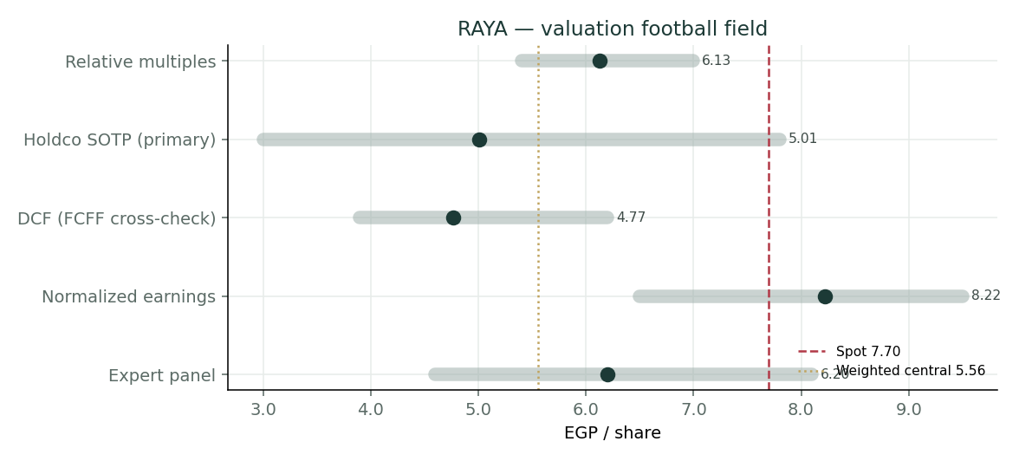
Valuation football field — the four fundamental lenses plus the expert panel, against spot (red) and the weighted central estimate (gold).
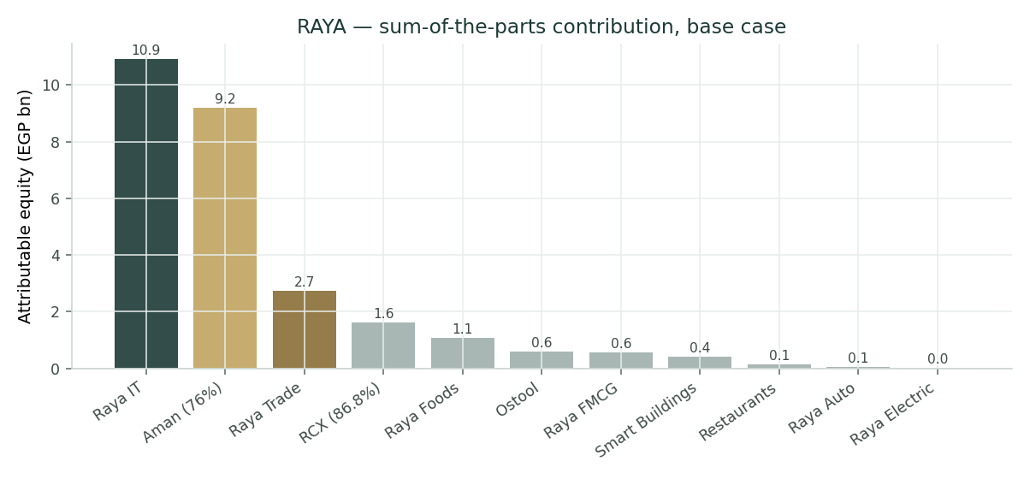
Sum-of-the-parts: attributable equity value by segment (base case). RIT and Aman dominate; the two are the swing factors.
The weighted central estimate is EGP 5.56. Spot at EGP 7.70 is about 38% above it. The honest way to read the football field is that spot sits at the bull end of the fundamental range — justified only if the normalized ceiling is the right lens.
1.6 Segment scorecard
Segment | FY25 rev (EGP bn) | Role in the thesis
Raya IT (RIT) | 18.4 | +70% growth; digital-transformation & KSA Vision-2030; largest SOTP swing
Aman Holding | 9.6 | Fintech/NBFC; +49%; valued on P/E; the crown jewel and second swing
Raya Trade | 23.8 | Consumer-electronics distribution; largest revenue, thinnest margin
RACC (listed) | 2.4 | BPO; marked at the Aug-2025 tender; Raya moving to full ownership
Raya FMCG | 2.9 | FMCG distribution; steady
Ostool | 2.2 | Land transport & logistics
Raya Foods | 2.1 | Frozen-produce exports; hard-currency earner
Raya Auto | 1.3 | XPeng/EV distribution; KSA JV with Alturki/SAMARA
Raya Electric | 0.7 | Haier/LG appliance JV
Smart Buildings | 0.3 | Smart offices; Riyadh Edge Innovation Center
Raya Restaurants | 0.2 | Ovio, Loris, Lebanese Bakery — early-stage F&B

1.7 The crux — what actually swings the value
Three inputs move the answer more than all the others combined. First, the Aman multiple: valued on a P/E, Aman is roughly a third of the portfolio, and moving it between a conservative 9x and a full fintech 18x swings NAV by well over EGP 2 a share. Aman is genuinely differentiated — 253 consumer-finance branches, a 212-branch SME network, EGP 58 bn of annual digital-payment throughput, a Saudi expansion with Jarir and Almanea and a SAMA licence — so the bull case for a high multiple is real, but Egyptian NBFC funding costs (25%-plus) cap what a disciplined buyer pays. Second, the RIT multiple: 70% revenue growth on an EGP 18.4 bn base makes the EV/EBITDA applied to RIT the single largest line in the sum-of-the-parts. Third, the holding-company discount: at 10% we are already generous; the market is applying close to zero, which is the crux of the overvaluation finding. If all three break bullish — Aman at 18x, RIT at a premium multiple, and no discount — the sum-of-the-parts reaches spot; on central marks it does not.
1.8 Macro and country
Raya is an Egyptian-pound business with a growing hard-currency overlay. The pound has been under structural pressure, and a further devaluation step raises the cost of imported hardware for Raya Trade and RIT while lifting the translated value of the five portfolio companies now operating in Saudi Arabia — a genuine two-sided exposure. High domestic policy rates cut both ways: they raise the cost of the group's sizeable working-capital and funding debt, but they also lift the yield Aman earns on its book. The structural tailwinds are real — Egypt's digital-transformation push and Saudi Vision-2030 spending are both behind RIT's growth, and the formalisation of Egypt's consumer-credit market is behind Aman's — but so are the risks: FX, a consumer-credit cycle, and competition in distribution and payments.
1.9 Sensitivity — NAV per share vs the two biggest levers
Aman P/E ↓ / Discount → | 0% | 5% | 10% | 15% | 20% | 25%
8.0x | 4.64 | 4.41 | 4.18 | 3.95 | 3.72 | 3.48
10.0x | 4.95 | 4.70 | 4.46 | 4.21 | 3.96 | 3.71
12.0x | 5.26 | 5.00 | 4.73 | 4.47 | 4.21 | 3.94
14.0x | 5.57 | 5.29 | 5.01 | 4.73 | 4.45 | 4.17
16.0x | 5.87 | 5.58 | 5.28 | 4.99 | 4.70 | 4.40
18.0x | 6.18 | 5.87 | 5.56 | 5.25 | 4.94 | 4.63

The grid recomputes the sum-of-the-parts NAV for combinations of the Aman P/E and the holding-company discount. Even at a full 18x Aman multiple and a zero discount the NAV only reaches the high-EGP-7s — i.e. it takes the most bullish corner of the grid to justify spot. At the base case (14x, 10%) the NAV is EGP 5.01.
A final word on why the sum-of-the-parts, and not the DCF or the multiples, is the primary lens here. Raya is not one business with a single cash-flow stream; it is eleven, with very different economics — a thin-margin distributor turning over EGP 24 bn, a fast-growing IT integrator, a lender whose accounts look nothing like the others, and a listed BPO with its own market price. A single consolidated multiple or a single consolidated DCF necessarily blends these into an average that fits none of them, and the average is exactly where the market can fool itself — paying a growth multiple on the whole because two parts are growing fast, while a third of revenue sits in low-return distribution. The sum-of-the-parts forces the discipline of pricing each piece on its own terms, which is why it lands below the blended reads: it refuses to pay the fintech multiple on the distribution business or the distribution multiple on Aman. That is also why the gap between the sum-of-the-parts and spot is the number worth watching — it is the market’s implied answer to how much the centre is worth, and at EGP 7.70 versus a cautious EGP 5.01 sum-of-the-parts, that answer is presently very generous.
The asymmetry matters for how an educational reader should hold this. On the downside, the fundamental anchor near EGP 5 is a floor with real support — two independent methods and a low reported multiple all point there. On the upside, the path to and beyond spot exists but requires several things to go right at once: Aman re-rated on a transaction, RIT’s growth proving durable, and the market continuing to apply no holding-company discount. A distribution centred below spot with a fat right tail is the fair one-line summary of the whole study.

2. Technical and price structure
The tape is the mirror image of the conservative fundamentals. At EGP 7.70 the stock trades above all four major moving averages, which are themselves stacked in bullish order (20 > 50 > 100 > 200), a hair below its all-time high of EGP 8.00 set on 17 May 2026, after a run from EGP 2.55 over the past year. RSI at 66.8 is elevated but not yet at the classic 70 overbought line; MACD is marginally positive with the histogram flattening — momentum is intact but decelerating as the stock presses the highs. In short, everything the fundamentals flag as expensive, the technicals confirm as strong: this is a momentum leader, and momentum leaders can stay extended well past fair value.
Indicator | Reading | Signal
Spot | EGP 7.70 | —
52-week range | EGP 2.55 – 8.00 | near the top
All-time high | EGP 8.00 (17 May 2026) | ~4% below
SMA-20 / 50 | EGP 7.33 / 6.95 | price above both — bullish
SMA-100 / 200 | EGP 6.06 / 4.59 | price well above — strong uptrend
RSI (14) | 66.8 | elevated, not overbought
MACD / signal | 0.139 / 0.131 | positive, histogram flattening
Realized vol (60d ann.) | 55% | high

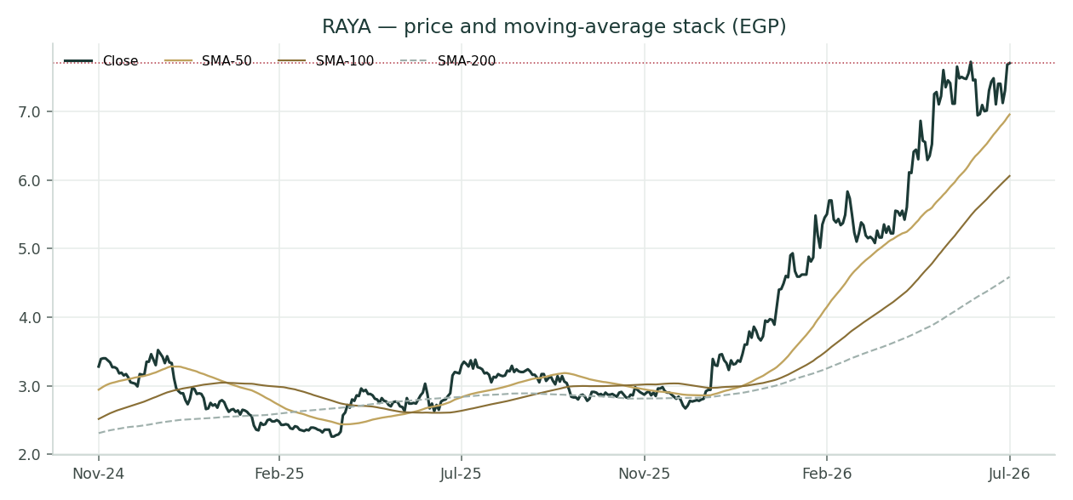
Price and moving-average stack — a clean bullish alignment with price pressing the all-time high.

3. Monte Carlo — the three-month distribution
We simulate 50,000 three-month price paths (60 trading days, seed 42) with the YZ-HAR engine. Width is sized by a pooled log-HAR cascade (variance lags 1/5/22) built on a gap-aware Yang-Zhang variance proxy from the OHLC — regime-conditional, so the cone is tight in calm tape and wide in storm — which puts the annualised volatility at 63%. The innovation shape is a unit-variance Student-t(5), giving a tighter interquartile body with honest tails. Critically, the secular drift is switched OFF: Raya is treated as a holding company rather than an EGX developer, and the Step-0 backtest (Appendix B) confirms that a zero-drift diffusion beats the benchmark while a confident trend drift fails at the 2022 and 2024 regime turns. On top of the diffusion we layer 16 forward factors — 7 continuous, 9 discrete — that together add a small net drift of +2% and shape the tails. These paths diffuse from spot as near-term price and deliberately do NOT embed the fundamental value gap of §1: the value gap lives in the fundamental lens, so the two stay independent.
Continuous factor | Sign | Channel | 3-mo drift | 3-mo vol
EGP/USD rate | mixed | import cost (Trade/RIT hardware) vs KSA hard-currency revenue | -1.0% | 6%
CBE policy-rate path | mixed | cost of debt on levered book vs Aman float/yield income | -1.2% | 5%
EGX30 & foreign flows | + | holdco re-rating, high-beta momentum name | +1.2% | 8%
Consumer spending & digital adoption | + | Trade volumes + Aman throughput + digitisation | +1.0% | 6%
Inflation (CPI) | mixed | nominal portfolio revenue vs real consumption / margin | +0.4% | 5%
KSA/Gulf expansion & FX revenue | + | five portfolio cos in KSA; SAR/USD revenue mix | +0.6% | 6%
Gov & enterprise digital-transformation capex | + | RIT 70% growth driver; Vision-2030 spend | +0.8% | 6%

Discrete event | Tier | Sign | P | Mean | Spread
Geopolitical / regional security | M | - | 30% | -10% | 5%
Holdco-discount regime shift / re-rating | M | mixed | 30% | +4% | 6%
Aman capital raise / stake monetisation / IPO | E | + | 30% | +7% | 5%
RCX full-takeover completion | E | + | 35% | +3% | 4%
EGP devaluation step / FX shock | M | - | 25% | -9% | 6%
RIT major contract award / financing | E | + | 45% | +5% | 5%
Earnings surprise (quarterly print) | E | mixed | 50% | +3% | 6%
Consumer-credit cycle / Aman asset quality | M | mixed | 30% | -3% | 5%
Competitive disruption / margin pressure | E | - | 30% | -6% | 5%

Percentile | T+20 (EGP) | move | T+60 (EGP) | move
P5 | 5.68 | -26% | 4.60 | -40%
P25 | 6.90 | -10% | 6.40 | -17%
P50 | 7.74 | +1% | 7.79 | +1%
P75 | 8.66 | +12% | 9.45 | +23%
P95 | 10.48 | +36% | 13.06 | +70%

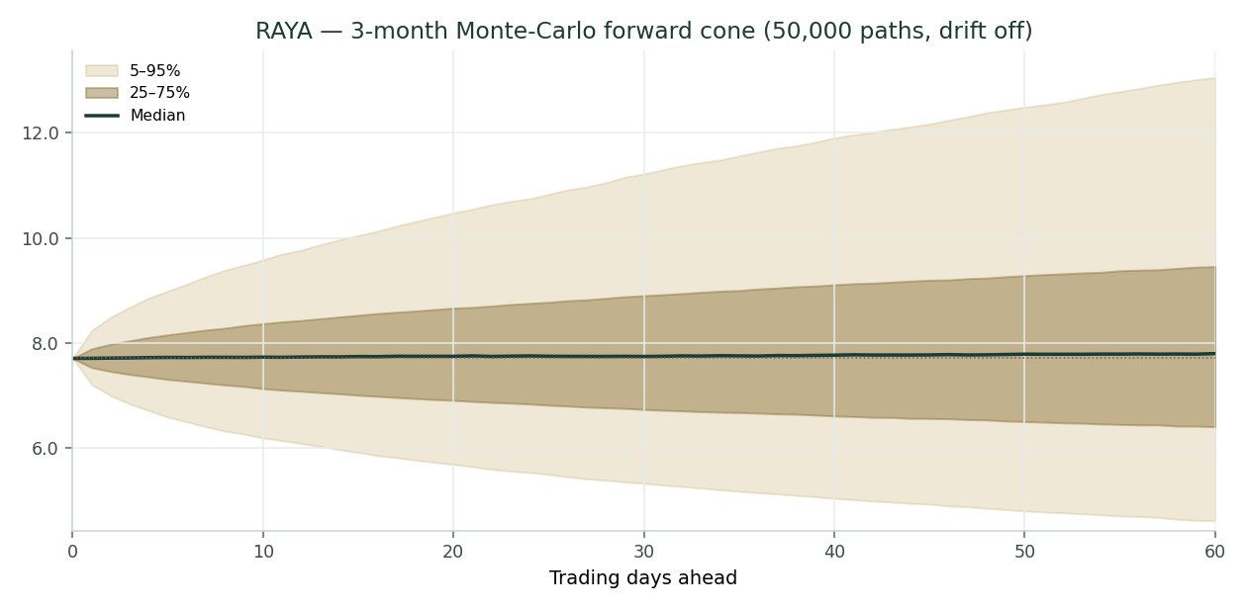
Three-month forward cone (drift off). Median near spot; the width is genuine quarter-ahead uncertainty, not padding.
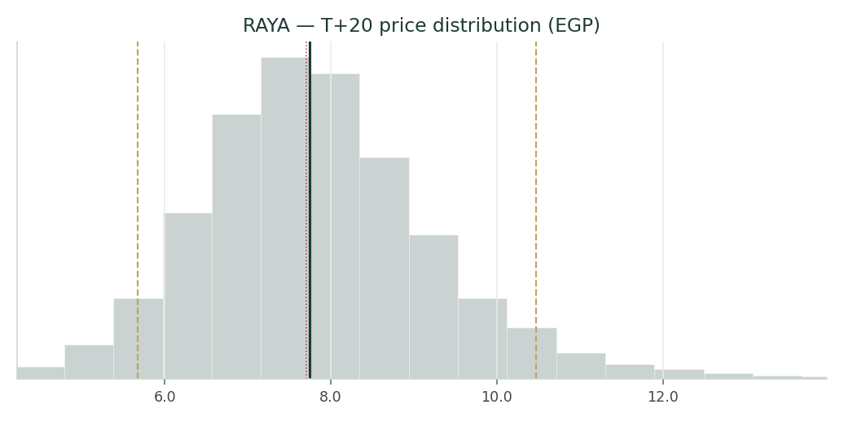
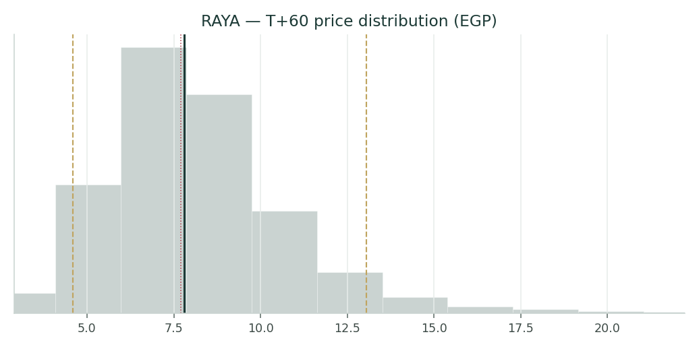
T+20 (left context) and T+60 price distributions in EGP.
Lead with the middle of the distribution, not the tail. Over one month the 50% interquartile band is roughly EGP 6.90–8.66; over three months it widens to about EGP 6.40–9.45, with the median at EGP 7.79 — essentially spot. The full 5th–95th span over three months is EGP 4.60–13.06. This is a high-volatility name, and the width reflects that honestly.
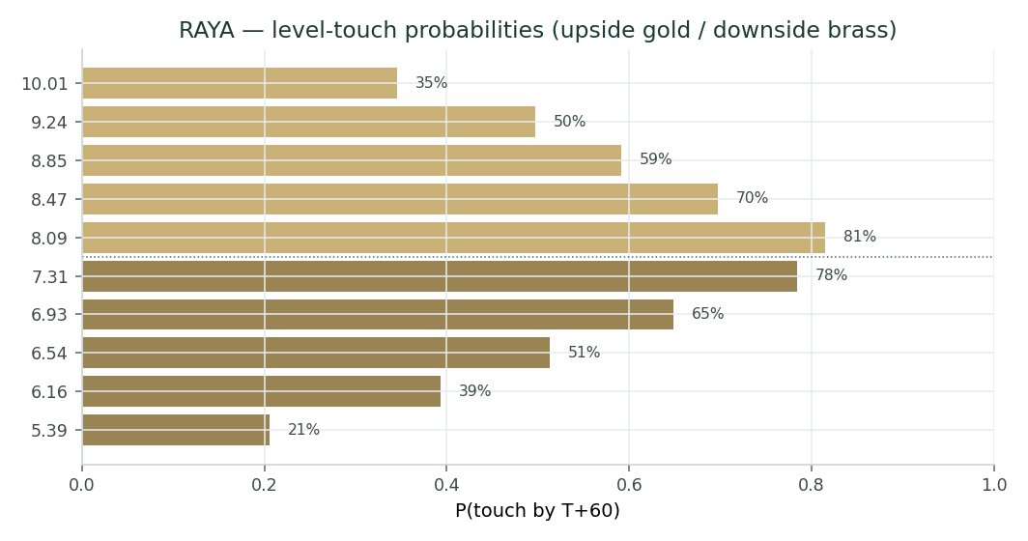
Level-touch probabilities by T+60 (upside gold, downside brass).

4. Comparison of the lenses, and a verdict
The three lenses tell a coherent story once you accept they are measuring different things. The fundamental lens, on conservative marks, says the shares are expensive: a sum-of-the-parts (EGP 5.01) and a DCF (EGP 4.77) agree near EGP 5, a weighted central of EGP 5.56 sits about 38% below spot, and only the normalized ceiling (EGP 8.22) reaches the current price. The technical lens says the opposite: the stock is a momentum leader in a clean uptrend, above every moving average and near its high. The Monte Carlo, refusing to take sides, centres the three-month distribution on spot with a wide band. The verdict for an educational reader: the re-rating has outrun a cautious fundamental read, the margin of safety on the base case is negative, and holding the current premium is a bet that Aman and RIT keep compounding and that the market keeps applying no holding-company discount. That is a coherent bull case — it is simply not the central case. This is a valuation exercise, not advice; there is no buy, sell or hold here.

5. Catalysts to watch
Catalyst | Why it matters | Direction
Aman capital raise / stake sale / IPO | Would crystallise a fintech multiple on the crown jewel | +
RACC full takeover completion | Consolidates the listed BPO to ~100% | +
RIT contract awards / financing | Sustains the 70% growth that drives the SOTP | +
Quarterly prints | Throughput and margin vs the 40%+ growth bar | ±
EGP devaluation step | Import-cost hit vs KSA translation gain | ±
CBE rate path | Funding cost vs Aman yield | ±
Consumer-credit cycle | Aman asset quality and provisioning | −

6. Reading the probability zones
Translating the distribution into plain zones over the next three months:
Zone | Range (EGP) | Rough probability | Reading
Deep pullback | < 4.60 | ~5% tail | a regime break / macro shock
Pullback to fundamentals | 4.60 – 6.40 | ~20% | drift back toward the SOTP/DCF anchor
Around spot | 6.40 – 9.45 | ~50% | momentum holds; range around EGP 7.7
Fresh highs | 9.45 – 13.06 | ~20% | the bull case gets paid
Blow-off | > 13.06 | ~5% tail | a bullish event (Aman monetisation)

7. Caveats and what would change our mind
This study rests on judgments that could be wrong, and it is worth being explicit about them. The segment marks and multiples are ours, not the market's; several smaller-segment revenues are estimated from the 1Q2025 mix rather than disclosed; Aman's net income is estimated from a margin assumption, not reported; and the historical interest and tax split is reconstructed to tie to reported profit. What would change the conservative conclusion: a disclosed Aman valuation (a raise or IPO) materially above our P/E mark; evidence that RIT's growth is durable enough to warrant a premium multiple; or a sustained demonstration that the holding-company discount should be zero because the operator consistently creates value at the centre. On the other side, an EGP devaluation, a consumer-credit downturn at Aman, or margin compression in distribution would validate the caution. Because we lead with a distribution rather than a point estimate, the honest position is that fair value is a range centred well below spot, with a real — but not central — path to the current price.

Appendix A. Financial statements
A.1 Income statement
3 years historical (FY2023-FY2025, company disclosure) + 5-year forecast (FY2026E-FY2030E, formula-driven from Assumptions).
EGP mn | FY23 | FY24 | FY25 | FY26E | FY27E | FY28E | FY29E | FY30E
Revenue | 31,300 | 45,119 | 63,829 | 82,978 | 102,892 | 123,471 | 144,461 | 164,685
Gross profit | 6,260 | 9,430 | 13,700 | 18,255 | 22,636 | 27,164 | 31,781 | 36,231
Gross margin | 20.0% | 20.9% | 21.5% | 22.0% | 22.0% | 22.0% | 22.0% | 22.0%
EBITDA | 2,974 | 4,875 | 7,800 | 10,455 | 13,376 | 16,298 | 19,358 | 22,233
EBITDA margin | 9.5% | 10.8% | 12.2% | 12.6% | 13.0% | 13.2% | 13.4% | 13.5%
Depreciation & amortisation | -400 | -620 | -1,250 | -1,660 | -2,058 | -2,469 | -2,889 | -3,294
EBIT | 2,574 | 4,255 | 6,550 | 8,796 | 11,318 | 13,829 | 16,469 | 18,939
Net finance cost | -1,822 | -1,735 | -2,643 | -2,738 | -3,395 | -4,075 | -4,767 | -5,435
Profit before tax | 752 | 2,520 | 3,907 | 6,057 | 7,923 | 9,754 | 11,701 | 13,504
Income tax | -188 | -630 | -977 | -1,514 | -1,981 | -2,439 | -2,925 | -3,376
NPAT (incl. minority) | 564 | 1,890 | 2,930 | 4,543 | 5,942 | 7,316 | 8,776 | 10,128
Minority interest | -74 | -202 | -342 | -545 | -713 | -878 | -1,053 | -1,215
NPAT attributable | 490 | 1,688 | 2,588 | 3,998 | 5,229 | 6,438 | 7,723 | 8,913
EPS (EGP) | 0.11 | 0.39 | 0.60 | 0.93 | 1.22 | 1.50 | 1.80 | 2.08

A.2 Balance sheet
3 years historical + 5-year forecast; forecast built on the accounting identity, cash as the residual.
EGP mn | FY23 | FY24 | FY25 | FY26E | FY27E | FY28E | FY29E | FY30E
Total equity (incl. minority) | 3,500 | 4,752 | 7,500 | 11,763 | 17,339 | 24,204 | 32,440 | 41,944
Total debt | 10,000 | 13,362 | 15,000 | 17,700 | 20,249 | 22,679 | 24,992 | 27,091
Trade & other payables | 14,500 | 20,998 | 28,180 | 36,510 | 45,273 | 54,327 | 63,563 | 72,462
Total liabilities | 24,500 | 34,360 | 43,180 | 54,210 | 65,521 | 77,006 | 88,555 | 99,553
Total assets | 28,000 | 39,112 | 50,680 | 65,973 | 82,861 | 101,210 | 120,994 | 141,497
Non-current assets | 4,000 | 5,185 | 5,300 | 5,632 | 6,043 | 6,537 | 7,115 | 7,774
Current assets | 24,000 | 33,927 | 45,380 | 60,341 | 76,817 | 94,673 | 113,879 | 133,723
Receivables & inventory | 21,500 | 29,915 | 42,380 | 54,765 | 67,909 | 81,491 | 95,344 | 108,692
Cash & equivalents | 2,500 | 4,012 | 3,000 | 5,576 | 8,908 | 13,182 | 18,535 | 25,030

A.3 Cash flow
Indirect method; FY2023 deltas n/a (no prior year).
EGP mn | FY23 | FY24 | FY25 | FY26E | FY27E | FY28E | FY29E | FY30E
Cash flow from operations | - | 1,201 | 1,093 | 1,641 | 2,426 | 3,016 | 3,596 | 4,157
Capex | - | -1,083 | -1,532 | -1,991 | -2,469 | -2,963 | -3,467 | -3,952
Change in debt | - | 620 | 630 | 410 | 398 | 412 | 420 | 404
Dividends | - | -118 | -181 | -280 | -366 | -451 | -541 | -624
Cash flow from financing | - | 502 | 449 | 130 | 32 | -39 | -121 | -219
Net change in cash | - | 620 | 10 | -220 | -11 | 13 | 8 | -15

Appendix B. Step-0 calibration backtest
Before running the study we backtested the engine on Raya over five years (window 2022-01-13 .. 2025-12-30), h = 60 trading days, scoring each 3-month-ahead forecast against a zero-drift random-walk lognormal benchmark. The grade is CRPS skill (must be > 0) and the interval (Winkler) score; the PIT histogram and coverage table are diagnostics only. The drift-OFF configuration passes — positive CRPS skill on both non-overlapping and overlap-corrected windows, positive Winkler skill at the 80% and 90% intervals, and a roughly uniform PIT (mean 0.58). The drift-ON configuration failed the grade (CRPS skill −0.038), confirming that a confident trend drift breaks at Raya's 2022 and 2024 regime turns — hence drift off in §3.
Metric | Non-overlap (n=17) | Overlap (n=204)
CRPS skill vs RW | +0.0106 | +0.0246
Winkler skill 80% | — | +0.0476
Winkler skill 90% | — | +0.1626
PIT mean (→0.5) | — | 0.577
Coverage 50 / 80 / 90 | — | 41 / 76 / 94%

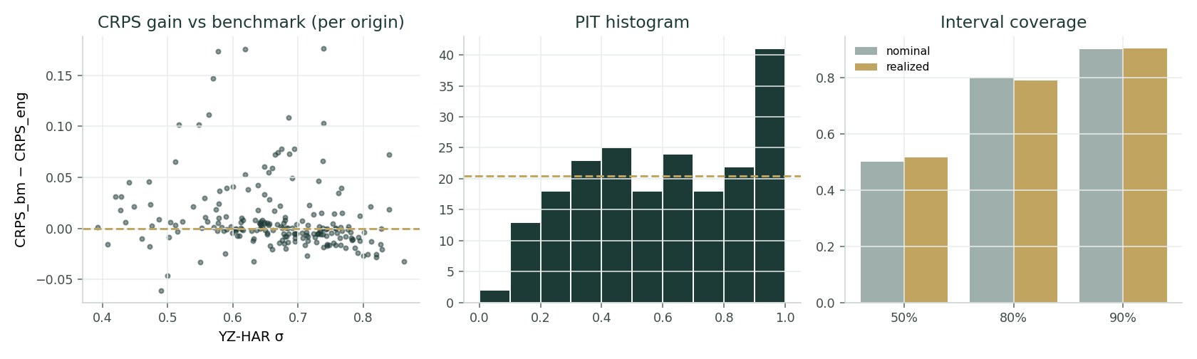
Step-0 diagnostics (drift off): per-origin CRPS gain vs benchmark, PIT histogram, and interval coverage.
Appendix C. Peer set, sector structure, and risks
Raya has no clean listed comparable — it is a genuine conglomerate spanning distribution, IT, fintech and BPO. The nearest Egyptian references are other diversified holdings and financial-services groups; the peer multiples below are indicative market data used only to frame the relative lens.
Company | P/E | EV/EBITDA | Note
Qalaa Holdings (CCAP) | 6.5x | 5.5x | Diversified holdco (energy-tilted)
EFG Holding (HRHO) | 7.5x | 6.0x | Financial-services holdco
B Investments (BINV) | 6.0x | – | Investment holdco
Distributor / industrial peers | 8.0x | 6.5x | Trade distribution
RAYA (this model, spot) | 12.7x | 5.8x | Growth premium to peers

Principal risks: EGP devaluation (import cost and translation); high policy rates on a levered balance sheet; a consumer-credit cycle at Aman; competition in distribution and payments; execution risk in the Saudi expansion; and the governance/liquidity features of a family-controlled holding company (Khalil Family ~56.5%, free float ~14%).

Appendix D. Three experts value Raya
We close, as every study does, by handing the same company to three analysts who use genuinely different methods and who disagree. Each is drawn from a standing persona library and cast by method, not invented for this report; here they are labelled Expert 1, Expert 2 and Expert 3. The point is not consensus — it is to see which single assumption each one's answer hangs on, and what the spread between them measures. For a holding company the casting is a sum-of-the-parts specialist, an earnings-quality accountant, and a top-down macro-policy strategist.
Expert 1 — the sum-of-the-parts and holding-company-discount specialist
Worldview and tradition. Expert 1 believes a conglomerate is worth its parts minus the frictions of holding them together. The discipline is to value each business as a standalone buyer would, add the equity values, subtract the debt and central costs that live above the operating companies, and then apply a discount that captures the tax, governance and liquidity drag of the holding structure. This tradition runs from break-up analysis of industrial conglomerates to today's holding-company research; its cardinal virtue is transparency — you can see exactly where value sits and argue mark by mark.
When it works and when it fails. It works when the parts are separable and markable, which is exactly Raya's situation: a listed BPO, a fintech that has been the subject of a stake sale, and operating companies with identifiable peer multiples. It fails when the parts are deeply integrated (so a break-up is fictional), or when the discount becomes a fudge factor hiding weak marks. Expert 1 guards against the latter by making the discount an explicit, defensible number rather than a plug.
Standard workings.
Step | What Expert 1 does
1 | Value each operating company on an instrument-appropriate basis (P/E for the lender, listed/tender for the BPO, EV/EBITDA for the rest)
2 | Deduct each company's own net debt to reach equity; apply Raya's ownership %
3 | Sum attributable equity across the portfolio
4 | Subtract holding-company net debt and capitalised central cost
5 | Apply a conglomerate discount calibrated to the operator's quality
6 | Divide by shares for NAV per share

Worked example.
Raya SOTP (Expert 1) | EGP mn
Attributable portfolio equity | 27,326
less holdco net debt + central cost | -3,500
Gross NAV | 23,826
Conglomerate discount (12%) | applied
Post-discount NAV (12%) | 20,966
NAV per share (EGP) | 4.90

Expert 1 uses a slightly firmer 12% discount than our base 10%, landing at about EGP 4.90 per share — call it EGP 5.10. Sensitivity on the swing input, the discount: at 0% the NAV is ~EGP 5.8; at 25% it is ~EGP 4.4. The discount alone moves the answer by about EGP 1.4.
Cross-examination. To Expert 2 (the accountant): “you are right that consolidated cash conversion is poor, but that is a working-capital timing feature of a fast-growing distributor and a lender — it does not change what a buyer pays for Aman or RIT.” To Expert 3 (the strategist): “a zero holding-company discount is a bet on the operator that history rarely rewards; I will meet you partway, not at spot.”
Verdict, falsification, price-implied read. Fair value ~EGP 5.10 — the shares are expensive. Falsification: a disclosed Aman transaction above ~16x earnings, or a genuine zero-discount regime, would move the NAV toward spot. What the EGP 7.70 price implies in this framework: either the parts are worth ~50% more than cautious marks, or the market has abolished the holding-company discount and then some.
How Expert 1 actually calibrates the discount is worth spelling out, because it is the swing input. The starting point is the classic 20–40% range observed on passive Egyptian and emerging-market holdings, reflecting the double layer of tax on dividends up-streamed from subsidiaries, the governance friction of a family that controls 56.5% of the votes, and the reduced liquidity of owning businesses only through the listed parent. Against that, Expert 1 credits Raya for being a genuine operator that has repeatedly built and scaled businesses — Aman from a standing start, RIT into an EGP 18 bn platform — and has crystallised value through disposals (BariQ, the NBE stake in Aman) rather than sitting on assets. That operating record justifies compressing the discount toward the bottom of the range, which is why 12% rather than 30% is the working number. But Expert 1 will not take it to zero: a controlled holding company with related-party complexity and a cash-hungry balance sheet carries structural friction that a single going-concern business does not, and pretending otherwise is how sum-of-the-parts analysis quietly loses its discipline. The discount, in this seat, is the price of the wrapper — and the wrapper is not free.
Expert 2 — the earnings-quality accountant
Worldview and tradition. Expert 2 trusts cash, not headline profit. The tradition — forensic, Graham-and-Dodd by temperament — asks how much of reported earnings converts to free cash, how much of growth is funded by working capital and debt, and whether the balance sheet can carry the business through a downturn. For a group that consolidates a lender and a large distribution book, this is the most sceptical seat at the table.
When it works and when it fails. It works precisely where headline growth outruns cash generation, which is Raya's profile: stockanalysis-style free cash flow has been negative even as profit compounds, because the receivables-and-inventory book grows with revenue. It fails when applied too literally to a genuine growth compounder — punishing investment that will earn its return — so Expert 2 normalises rather than simply penalising.
Standard workings.
Step | What Expert 2 does
1 | Strip reported profit back to cash: subtract the working-capital build and the funding that supports it
2 | Assess earnings quality — how much profit is Aman's book growth vs cash margin
3 | Normalise earnings to a mid-cycle, self-funding level
4 | Apply a conservative multiple reflecting the balance-sheet risk (net debt / EBITDA, current ratio)
5 | Cross-check against tangible book and the dividend

Worked example.
Earnings-quality read (Expert 2) | Value
FY2025 attributable profit (EGP mn) | 2,588
Net debt / EBITDA | 1.5x
Normalised self-funding earnings (EGP mn) | ~2,300
Conservative fair P/E | 10x
Implied equity (EGP mn) | ~23,000
Fair value per share (EGP) | ~5.40

Expert 2 lands at about EGP 5.40 — close to the sum-of-the-parts but for a different reason: not marks, but the observation that this group consumes cash as it grows and should be valued on self-funding earnings and a sober multiple. Sensitivity on the swing input, cash conversion: if the working-capital intensity eases to distribution-only levels (~10% of revenue), free cash improves and fair value rises toward EGP 6.5; if the Aman book keeps absorbing cash at the current rate, EGP 5 is generous.
Cross-examination. To Expert 1: “your marks are fine, but a buyer of the whole would discount for the cash the group swallows to grow — your discount should be wider, not narrower.” To Expert 3: “a weak currency makes the imported-hardware working-capital cycle more expensive, not less; the macro tailwind you like has a cash-flow cost.”
Verdict, falsification, price-implied read. Fair value ~EGP 5.40 — expensive on cash. Falsification: two or three quarters of positive group free cash flow while growth stays high would break the thesis and justify a re-rating. What spot implies: the market is capitalising reported profit at ~13x and ignoring the cash-conversion gap.
The arithmetic Expert 2 keeps returning to is simple and uncomfortable. Net working capital runs at roughly 22% of revenue on the consolidated balance sheet; on incremental revenue of nearly EGP 19 bn in the coming year, that is close to an EGP 4 bn cash outflow before a pound of it reaches owners, funded by the debt that keeps climbing on the other side of the balance sheet. Reported EBITDA of EGP 7.8 bn is real, but a large slice of it is reinvested into receivables and the Aman loan book rather than converted into distributable cash — which is exactly why free cash flow has been negative even as profit compounds. Expert 2 does not treat that as fraud or even as a standalone red flag; a distributor and a lender growing at 40% are supposed to absorb working capital. The discipline is to refuse to capitalise the portion of earnings that is really just balance-sheet growth, and to value the self-funding core — the earnings the group would show at a cash-sustainable pace — on a multiple that respects the leverage. Do that, and EGP 5-and-change is the answer; the gap to spot is the market paying full price for growth that has not yet turned into cash.
Expert 3 — the macro-policy strategist
Worldview and tradition. Expert 3 works top-down: the value of an Egyptian equity is set as much by the currency, the policy-rate path and cross-border flows as by the company's own numbers. The tradition is the emerging-markets strategist's — read the regime first, the stock second. For Raya the regime questions are the pound, the domestic rate cycle, the Saudi hard-currency overlay, and whether the market is in a phase that rewards conglomerates with a low or zero discount.
When it works and when it fails. It works at regime turns — devaluations, rate pivots, flow surges — which dominate Egyptian equity returns and which a bottom-up model misses. It fails when the top-down call is right but the company-specific execution is wrong, so Expert 3 must still respect the parts. Here the strategist is the most bullish of the three, because the hard-currency overlay and the digital-transformation tailwind are genuinely regime-level positives.
Standard workings.
Step | What Expert 3 does
1 | Set the EGP path and rate-cycle view; size the hard-currency (SAR/USD) share of revenue
2 | Judge the re-rating regime — is the market paying up for growth and abolishing the holdco discount?
3 | Apply a regime-appropriate multiple to normalized earnings, with little or no discount
4 | Overlay event optionality (Aman monetisation, KSA scale-up)
5 | Sanity-check against the bottom-up range

Worked example.
Top-down read (Expert 3) | Value
Normalized attributable earnings (EGP mn) | ~3,200
Regime multiple (growth, ~zero discount) | ~11x
Hard-currency / KSA optionality | +
Implied equity (EGP mn) | ~34,700
Fair value per share (EGP) | ~8.10

Expert 3 lands at about EGP 8.10 — above spot — by taking the normalized-earnings ceiling seriously and applying essentially no holding-company discount, on the view that the market is in a regime that rewards this operator. Sensitivity on the swing input, the discount/regime: reinstate even a 15% discount and the value falls toward EGP 6.9; add an EGP devaluation shock and it falls further. The whole bull case is a regime bet.
Cross-examination. To Expert 1: “your 12% discount is a peacetime number; in a re-rating regime the market pays through it, and it has.” To Expert 2: “negative free cash flow in a growth compounder funded at a positive spread is a feature, not a bug — the KSA revenue is hard currency and de-risks the model.”
Verdict, falsification, price-implied read. Fair value ~EGP 8.10 — spot is roughly fair in a bullish regime. Falsification: an EGP devaluation step or a foreign-flow reversal would collapse the regime premium and the number with it. What spot implies in this framework: the market agrees with the strategist, not the accountant.
The regime signals Expert 3 actually watches are concrete, not atmospheric. The first is the currency: five Raya businesses now earn in Saudi riyals or dollars, so each leg of pound weakness lifts the translated value of a growing share of group revenue even as it raises import costs on the distribution side — a genuine hedge a pure-domestic Egyptian name does not have, and one the strategist prices as a structural positive. The second is flows: RAYA has run from EGP 2.55 to near EGP 8.00 in a year on visible institutional accumulation, the signature of a re-rating regime in which the market pays up for scarce, hard-currency-linked growth and stops docking conglomerates for their structure. The third is the policy path: as the central bank eventually eases, the group’s heavy funding cost falls and the levered equity re-rates further. Stack those and Expert 3 is comfortable applying the normalized-earnings multiple with essentially no discount — which is how a top-down seat reaches a number above spot while the bottom-up seats sit near EGP 5. The strategist’s discipline, and its warning, is that the same three signals run in reverse: a disorderly devaluation, a flow reversal, or a rate shock would take the regime premium back out as fast as it went in.
Where each method is strongest for Raya
It is worth saying plainly where each of the three seats earns its keep on this particular company, because the answer is not the same for every stock. Expert 1’s sum-of-the-parts is unusually well-suited to Raya: the parts really are separable and markable — one is listed, one has a transaction reference, and the rest have identifiable peer economics — so the method’s worst failure mode, a fictional break-up, does not apply. Its answer should be given real weight precisely because the marks are observable rather than assumed. Expert 2’s cash-quality lens is the one most investors skip and most need here: a group that reports 53% profit growth while generating negative free cash flow is the textbook case where headline earnings and owner earnings diverge, and the accountant’s insistence on self-funding earnings is the discipline that keeps the valuation honest through the growth. Expert 3’s regime lens is the one that explains the price: nothing in the bottom-up work gets you to EGP 7.70, but a re-rating regime that pays up for scarce growth and stops applying a conglomerate discount does — and Egyptian equity history is full of exactly such regimes, in both directions.
The experts also agree on more than the spread suggests, and the agreement is instructive. All three accept the numbers: FY2025 revenue of EGP 63.8 bn, EBITDA of EGP 7.8 bn, attributable profit of EGP 2.6 bn, and the segment mix are common ground. All three accept that Aman and RIT are the value drivers and that distribution is the ballast. And all three accept that the balance sheet is levered and cash-hungry. What they cannot agree on is the meaning of those facts for price — whether a fast-growing, family-controlled, cash-absorbing Egyptian conglomerate deserves to trade at, above, or below the sum of its cautiously marked parts. That single disagreement is the whole investment question, and it is why a distribution, not a point estimate, is the honest output.
The three in one room
Put them together and the argument is entirely about one thing: the holding-company discount and the Aman multiple, which are really the same question — how much credit does Raya's centre deserve for compounding the parts? Expert 1 says a modest discount and a disciplined 14–16x on Aman (EGP ~5.1). Expert 2, watching the cash, says value the self-funding earnings on a sober multiple (EGP ~5.4). Expert 3 says the market is in a regime that pays through the discount and up for growth, so take the normalized ceiling (EGP ~8.1). They do not disagree about what Raya does, or even about its numbers — they disagree about whether a fast-growing, cash-hungry Egyptian conglomerate should trade at, above, or below the sum of cautious marks.
Reading the divergence
Expert | Method | Fair value (EGP) | The one assumption that drives it
Expert 1 | Sum-of-the-parts + discount | ~5.10 | Size of the conglomerate discount
Expert 2 | Earnings quality / cash conversion | ~5.40 | How much profit converts to free cash
Expert 3 | Top-down macro / regime | ~8.10 | EGP path & the re-rating regime (discount → 0)
Panel central | — | ~6.20 | the spread is the discount debate

The spread — roughly EGP 5.1 to 8.1 — is not noise; it is a clean measure of the single unresolved question in this name. Two of the three methods, the ones anchored in marks and cash, land near EGP 5; the third, anchored in the regime, reaches spot. The panel central of EGP 6.20 sits where it should: above the cautious anchor, below the momentum, and squarely on the discount debate that will decide whether the current price is a peak or a base. The practical use of the panel is not to average it into a single number but to hold all three in view: treat the accountant’s floor as the level with real support, respect the strategist’s regime as the reason the price is where it is, and let the sum-of-the-parts referee the two by showing that the market has, for now, sided with the optimist. When the next Aman transaction or the next devaluation print lands, one of these three seats will be proven closer to right — and this study will be scored accordingly in the calibration ledger.

About this series
Testahil publishes independent valuation studies as an educational exercise in method: how one analyst combines a fundamental lens, a technical read and a Monte-Carlo distribution into a single integrated view of a listed security, and invites scrutiny of that method. Each study is framed as a distribution of outcomes, not a single target, and each is scored after the fact against a naïve benchmark in an append-only calibration ledger. Nothing here is a recommendation.
Disclosure & Disclaimer
1. Not investment advice. This document is an educational valuation exercise and an expression of personal analytical opinion. It is not investment advice, not a recommendation or solicitation to buy, sell or hold any security, and not directed at the financial circumstances of any particular person.
2. No regulatory licence. The preparer is not licensed or registered with the Financial Regulatory Authority (FRA) of Egypt or any other securities regulator, holds no brokerage or advisory authorisation, manages no client money, and receives no fees, funds or clients in connection with this work.
3. Model outputs, not facts. All valuations, ranges and probabilities are outputs of models built on assumptions that are stated and flagged, and that may prove wrong. No single figure should be relied upon. Reported financial figures are the company's own disclosures; forward-looking inputs are the preparer's judgments.
4. Position disclosure. The preparer may hold, and may in the future take or dispose of, a position in the security discussed in this report.
5. No liability. The preparer accepts no liability for any loss arising from the use of this document. Markets are risky; past performance and modelled scenarios do not predict future results.
6. Independence and method. This study is independent and unsponsored. Consult a licensed financial advisor before making any investment decision.

Testahil · Independent Valuation Study — Educational Analysis · Raya Holding (EGX: RAYA) · computed 01 Jul 2026 · edition 1.0

