TESTAHIL · Independent Valuation Study — Educational Analysis Not investment advice
Independent Valuation Study — Educational Analysis
Reliance Industries Limited (NSE: RELIANCE)
Fundamental analysis · Technical analysis · Monte Carlo simulation — one integrated read
Anchor: ₹1,321.30 (06 Jul 2026 close) · ~1,353 cr shares (post the Oct-2024 1:1 bonus) · mkt cap ~₹17.88 lakh cr (₹17,87,719 cr) · India's largest listed company — an energy-to-consumer holding structure spanning O2C (oil-to-chemicals), Jio Platforms (digital & telecom), Reliance Retail, oil & gas exploration, JioStar media and a New Energy build-out · prices and probabilities computed 06 Jul 2026 from the attached daily history · primary lens: holding-company sum-of-the-parts. The Jio IPO value-crystallisation, the O2C refining/petrochemical margin cycle, and the holding-company discount are the swing factors.
READ FIRST — what this document is, and is not. This study is a valuation exercise and an expression of personal analytical opinion, published free of charge for educational purposes: it shows how one analyst applies fundamental, technical and probabilistic methods to a listed company, and invites scrutiny of that methodology. It is NOT investment advice, NOT a recommendation or solicitation to buy, sell or hold any security, and NOT directed at the circumstances of any reader. The preparer is not licensed by any securities regulator in any jurisdiction, holds no Indian or other brokerage authorisation, provides no financial consultancy, manages no money, and accepts no fees, funds or clients. See the Disclosure & Disclaimer at the end. All values are model outputs presented as ranges and distributions because no single number should be relied on. Reported financials are the company's own disclosure (FY26 results, 24 April 2026; Jio Platforms DRHP, 19 June 2026); forward-looking inputs — the sum-of-the-parts marks, the private-business marks on Jio and Retail, the holding-company discount, the multiples, the DCF and the Monte-Carlo factor probabilities — are the preparer's judgments and are flagged throughout. Consult a licensed financial advisor before any investment decision.

Headline
The model's read: modestly undervalued, with the upside resting on the Jio IPO crystallising private-market value and on O2C margins holding through the cycle. At ₹1,321 the shares sit about 6% below our weighted central estimate of ₹1,395. The two anchor lenses agree closely — a holding-company sum-of-the-parts lands at ₹1,342 and a consolidated DCF at ₹1,359 — while a conservative relative-multiple read (₹1,322) marks the floor and a mid-cycle normalized-earnings read (₹1,552) marks the ceiling. The whole answer turns on two things. First, the crystallisation of private value: Jio Platforms filed its DRHP on 19 June 2026 and Reliance Retail carries a large private mark, so a listing that prints these businesses at or above the marks would narrow the ~6% holding-company discount the market currently applies to the summed parts. Second, O2C through-cycle margins: roughly a third of enterprise value sits in oil-to-chemicals, whose refining GRMs and polymer-to-feedstock deltas set the near-term earnings tone. Technically the tape is the mirror image of the deep-value names we usually cover — the stock has corrected from a January-2026 high near ₹1,600 to the low-₹1,300s, sits below its 50-, 100- and 200-day averages but has just reclaimed the 20-day, with RSI neutral at ~52 and the MACD histogram turning positive — so momentum is stabilising rather than trending. Over three months the Monte Carlo places the 5th–95th percentile band at roughly ₹1,067–1,707, with the median a touch above spot at ₹1,351.

Valuation summary — every read at a glance
One table for the four reads that follow — what the business is worth (fundamental), what the tape is doing (technical), where price could travel over three months (Monte Carlo), and how three independent expert methods land. Every row is developed in the sections and appendices below.
Lens / read | What it measures | Output | Takeaway
FUNDAMENTAL — what the business is worth (the anchor)
Sum-of-the-parts (primary) | Marked parts less holdco discount | ₹1,342 | +1.5% vs spot
Consolidated DCF | Discounted 5-yr cash flows | ₹1,359 | +2.9%
Relative multiples | Normalized EV/EBITDA | ₹1,322 | ≈0% · the floor
Normalized earnings | Mid-cycle PAT × P/E | ₹1,552 | +17% · the ceiling
Weighted central | Blend 40 / 20 / 15 / 25 | ₹1,395 | +5.6% vs ₹1,321
TECHNICAL — what the tape is doing (timing, not value)
Trend & momentum | Price vs the 20/50/100/200-day averages | Below 50/100/200, above 20 | Corrective, stabilising
Momentum / range | RSI · MACD · 52-week range | RSI 52 · MACD hist +2.8 · ₹1,259–1,592 | Neutral, turning up
MONTE CARLO — where price could go in 3 months (paths from spot)
T+20 sessions | 50,000 paths · 16 factors | p5 1,160 · p50 1,331 · p95 1,526 | Median ≈ spot
T+60 sessions | same engine, longer horizon | p5 1,067 · p50 1,351 · p95 1,707 | Wide, right-skewed
EXPERT PANEL — three independent methods (Appendix C)
Expert 1 — sum-of-the-parts NAV | Holdco discount on marked parts | ₹1,360 | The anchor
Expert 2 — normalized earnings power | Mid-cycle PAT × multiple | ₹1,520 | Most bullish
Expert 3 — cash returns (DCF + ROIC) | Return on capital vs ~11.5% WACC | ₹1,300 | Most conservative
Panel range | Spread = the value-crystallisation question | ₹1,300–1,520 | Centres ~₹1,393
Bottom line. Every read points the same way on value and disagrees only on magnitude. The fundamental central sits near ₹1,395 — about 6% above the ₹1,321 spot — the three experts span ₹1,300–1,520, and each turns on a single question: whether the sum of Reliance's parts is worth more listed and separated than bundled inside one holding company, and whether O2C margins hold. The technical tape is no longer a dissenter so much as a fence-sitter: oversold pressure from the January correction has eased, momentum is turning, and the three-month distribution centres just above spot rather than already at fair value.

Company overview — Reliance Industries at a glance
Item | Value
Listed entity | Reliance Industries Limited (NSE: RELIANCE; BSE: 500325)
What it owns | O2C (refining & petrochemicals) · Jio Platforms (66.4%, digital/telecom) · Reliance Retail (~85%) · Oil & Gas E&P (KG-D6) · JioStar media (~63%) · New Energy build-out
Spot / date | ₹1,321.30 · 06 Jul 2026 close
Shares · market cap | ~1,353 crore · ~₹17.88 lakh cr (₹17,87,719 cr)
Consolidated net debt | ₹1,24,717 cr (31 Mar 2026); gross debt ₹3,74,421 cr
FY26 revenue / EBITDA margin | ₹10,75,675 cr (+11.5% YoY) · 19.3%
FY26 PAT (attributable) · EPS | ₹80,775 cr · ₹59.7 (P/E ~22×)
Largest value blocks | Jio + Retail ≈ half of gross EV; O2C ≈ a third
52-week range | ₹1,258.80 – ₹1,592.30
Chairman & MD | Mukesh D. Ambani
Corporate event in scope | Jio Platforms DRHP filed 19 Jun 2026 (IPO path); 1:1 bonus issue Oct 2024
Source: company FY26 results (24 Apr 2026), Jio Platforms DRHP (19 Jun 2026), NSE/BSE disclosures, exchange data. Values rounded.

1 Fundamental valuation
We value Reliance as a holding company that consolidates several quite different businesses, and triangulate four lenses. The primary lens is a sum-of-the-parts (SOTP) because the parts trade on entirely different economics — a capital-intensive commodity refiner-petrochemical complex, a high-margin subscriber-scale digital platform, a fast-growing but thin-margin retailer, an upstream gas producer, a media business and an early-stage New Energy option — and a single group multiple would blur them. A consolidated DCF, a relative-multiple cross-check and a normalized-earnings-power read complete the set. The weights and the football field are in §1.5; the swing factors — the Jio IPO value-crystallisation, O2C margins and the holdco discount — are dissected in §1.7 and the sensitivity grid in §1.9. Cost of equity is published explicitly (Ke = risk-free + equity-risk premium) in §1.2 and sensitised on a WACC × terminal-growth grid.

1.1 Holding-company sum-of-the-parts — the primary lens
Each business is marked on the basis that best fits it and taken at 100% enterprise value; from the summed EV we deduct consolidated net debt to reach a 100%-basis equity value, then deduct the minority interest in the part-owned subsidiaries (Jio, Retail, Media) to reach RIL-attributable equity, and finally apply a holding-company / complexity discount. Jio is marked on a digital-infrastructure EV/EBITDA (13.5×, a discount to global tower-plus-platform peers and inside the IPO band implied by the DRHP); Retail on a premium consumer multiple (28×, reflecting growth and the private-round history); O2C on a mid-cycle refining-petrochemical multiple (7×); E&P on an upstream multiple (5×); Media on 14×; and New Energy on invested capital plus option value.
Part (base case) | Basis | EV / value (₹ cr)
Jio Platforms | EBITDA ₹76,255 cr × 13.5× | 10,29,443
Reliance Retail | EBITDA ₹27,033 cr × 28× | 7,56,924
O2C | EBITDA ₹60,546 cr × 7× | 4,23,822
Oil & Gas (E&P) | EBITDA ₹19,050 cr × 5× | 95,250
Media (JioStar) | EBITDA ₹4,885 cr × 14× | 68,390
New Energy + other | Invested capital + option value | 1,20,000
Σ Gross enterprise value (100%) |  | 24,93,828
less: consolidated net debt |  | (1,24,717)
Equity value (100% basis) |  | 23,69,112
less: minority interest (Jio/Retail/Media) |  | (4,58,416)
RIL-attributable equity (pre-discount) | = ₹1,412 / share | 19,10,696
less: holdco / complexity discount | 5% | (95,535)
SOTP equity value | = ₹1,342 / share | 18,15,161
SOTP base ≈ ₹1,342/share, with a bear–bull span of ₹1,008–₹1,712 driven mainly by the Jio and O2C multiples and the holdco discount (see §1.9). The pre-discount NAV of ₹1,412 says the market is paying ₹1,321 for ₹1,412 of marked assets — a ~6% implied holding-company discount, which is the crux of the bull case: a successful Jio IPO is the most direct mechanism for narrowing it.

1.2 Consolidated DCF — the cash-flow cross-check
A consolidated free-cash-flow-to-firm model is the natural check on the asset sum. We build a five-year explicit forecast off segment revenue and margin drivers, deduct a heavy but declining capex line (Reliance is past the peak of the Jio 5G and New Energy build-out, so capex fades from ~₹1.45 lakh cr toward ~₹1.20 lakh cr), and discount at a WACC of 11.5%. The cost of equity is stated explicitly: Ke = risk-free 6.5% + beta 1.0 × equity-risk premium 5.5% = 12.0%; blended with an after-tax cost of debt this gives the 11.5% WACC. Terminal growth is 5.0% and the tax rate 25%.
DCF input | Bear | Base | Bull
WACC | 12.5% | 11.5% | 10.5%
Terminal growth | 4.5% | 5.0% | 5.5%
Normalized capex trajectory (₹ lakh cr) | 1.55→1.35 | 1.45→1.20 | 1.35→1.05
Fair value (₹/share) | 1,120 | 1,359 | 1,660
The base DCF of ₹1,359 lands just above the SOTP — reassuring, since the two methods share almost no inputs. The full five-year free-cash-flow build is shown below; every input links to the model's Assumptions sheet.
₹ crore | FY27E | FY28E | FY29E | FY30E | FY31E
Revenue | 11,63,377 | 12,68,125 | 13,82,911 | 14,97,194 | 16,16,003
EBITDA | 2,31,178 | 2,61,925 | 2,91,011 | 3,23,892 | 3,55,108
Depreciation & amortisation | 60,496 | 67,211 | 73,294 | 77,854 | 82,416
EBIT | 1,70,682 | 1,94,715 | 2,17,717 | 2,46,037 | 2,72,692
NOPAT = EBIT×(1−t) | 1,28,012 | 1,46,036 | 1,63,288 | 1,84,528 | 2,04,519
+ D&A | 60,496 | 67,211 | 73,294 | 77,854 | 82,416
− Capex | (1,45,000) | (1,40,000) | (1,30,000) | (1,25,000) | (1,20,000)
− Δ working capital (release) | 2,193 | 2,619 | 2,870 | 2,857 | 2,970
Free cash flow to firm | 45,700 | 75,865 | 1,09,451 | 1,40,239 | 1,69,905
Discount factor | 0.897 | 0.804 | 0.721 | 0.647 | 0.580
PV of FCFF | 40,986 | 61,023 | 78,958 | 90,734 | 98,590
Free cash flow to the firm, five-year explicit forecast. Every input links to the model's Assumptions sheet.
DCF bridge to value | ₹ crore / ₹ per share
Σ PV of explicit FCFF (FY27–31) | 3,70,292
Terminal value (Gordon, g = 5.0%) | 27,44,627
PV of terminal value | 15,92,608
Enterprise value | 19,62,900
less: consolidated net debt | (1,24,717)
Equity value | 18,38,183
Fair value per share (₹) | 1,359
Terminal value as % of EV | 81.1%
The DCF base of ₹1,359 is dependable as a cross-check but carries a fair warning device: terminal value is 81.1% of enterprise value (disclosed per device A-7), which is high — a consequence of Reliance's long reinvestment runway suppressing near-term free cash while the terminal captures the mature cash machine. That dependency is made visible here and sensitised on the WACC × terminal-growth grid in §1.9 rather than blended silently into a single point; we do not average the DCF and a divergent multiple into false precision (device A-8).

1.3 Relative multiples
On a group basis Reliance screens fairly, not cheaply: FY26 consolidated EBITDA of ₹2,07,911 cr against an enterprise value of ~₹19,12,000 cr is ~9.2× EV/EBITDA, and the reported P/E is ~22× on attributable EPS of ₹59.7. Because the group blends a commodity refiner with a high-multiple digital platform, a single group multiple is inherently a blend; we mark the relative lens on a normalized through-cycle EBITDA and a blended EV/EBITDA that weights the segments' own peer multiples.
Relative basis | Bear | Base | Bull
Normalized EBITDA (₹ cr) | 2,05,000 | 2,20,000 | 2,35,000
Blended EV/EBITDA multiple | 8.2× | 8.7× | 9.4×
Fair value (₹/share) | 1,179 | 1,322 | 1,509
Relative base ≈ ₹1,322 — essentially at spot, and the floor of the four lenses. It treats the group as a blended conglomerate rather than crediting the segment-level re-rating that a Jio listing could unlock, which is precisely what the SOTP does capture.

1.4 Normalized earnings power
If the group sustains its digital and retail growth while O2C runs at mid-cycle margins, mid-cycle attributable earnings sit above the FY26 print. We normalize consolidated attributable PAT to ~₹1,05,000 cr (Jio and Retail compounding, O2C at through-cycle GRMs, E&P steady) and apply a justified through-cycle P/E of 20× — a discount to the growth segments' standalone multiples and a premium to a pure refiner, reflecting the mix.
Normalized-earnings basis | Bear | Base | Bull
Mid-cycle attributable PAT (₹ cr) | 95,000 | 1,05,000 | 1,15,000
Justified P/E | 17.5× | 20.0× | 22.4×
Fair value (₹/share) | 1,231 | 1,552 | 1,904
Normalized-earnings base ≈ ₹1,552 — the recovery/growth lens and the ceiling of the central case. It is, in effect, the bet that the digital and retail franchises keep compounding and that O2C does not sit at a trough — the mirror of the relative lens's caution.

1.5 Synthesis — four lenses
We weight the SOTP most heavily because it respects the differing economics of the parts and captures the value-crystallisation optionality; the DCF and normalized-earnings lenses carry the growth thesis; the relative lens anchors the floor.
Lens | Weight | Bear | Base | Bull
Sum-of-the-parts | 40% | 1,008 | 1,342 | 1,712
Consolidated DCF | 20% | 1,120 | 1,359 | 1,660
Relative multiples | 15% | 1,179 | 1,322 | 1,509
Normalized earnings | 25% | 1,231 | 1,552 | 1,904
Weighted central |  | 1,112 | 1,395 | 1,719
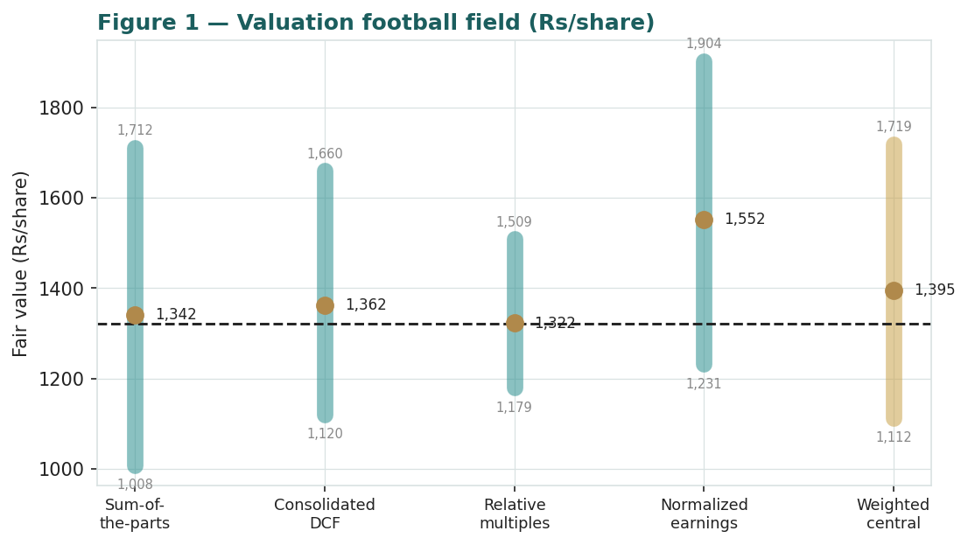
Figure 1 — Valuation football field. Bars span bear–bull per lens; the brass tick is each base case; the gold band is the blended central range; the dark line is spot.
Central fair value ≈ ₹1,395/share, about 6% above spot. The spread of the lenses (₹1,322 to ₹1,552 at base) is itself the message: this is not a deep-value or a clearly-expensive name, but a fairly-to-modestly-cheap holding whose re-rating depends on the crystallisation of segment value and on the O2C margin cycle.

1.6 The holding-company assets — a deeper look
Reliance's value is unusually well-diversified across four engines with different jobs. Jio is the high-margin scale asset (FY26 EBITDA ₹76,255 cr at a ~52% margin, RIL stake 66.4%, its own net debt ₹70,781 cr) and, with its DRHP filed, the clearest catalyst. Retail is the growth compounder (gross revenue ₹3,70,026 cr, EBITDA ₹27,033 cr at ~7.3%, RIL stake ~85%). O2C is the cash anchor and the cyclical swing (revenue ₹6,62,401 cr, EBITDA ₹60,546 cr at ~9.1%). E&P (KG-D6 gas) is a steady contributor (EBITDA ₹19,050 cr), and New Energy is early-stage optionality. The table scores each part on the axes that matter.
Part | Cyclicality | Margin trend | Capital intensity | Swing role
Jio Platforms | Low | High, ~stable | High (past 5G peak) | Catalyst (IPO)
Reliance Retail | Moderate | Improving | Moderate | Growth compounder
O2C | High | Cyclical | High | Cash anchor / swing
Oil & Gas (E&P) | High | Steady | High | Steady cash
New Energy | — | Pre-revenue | Very high | Optionality
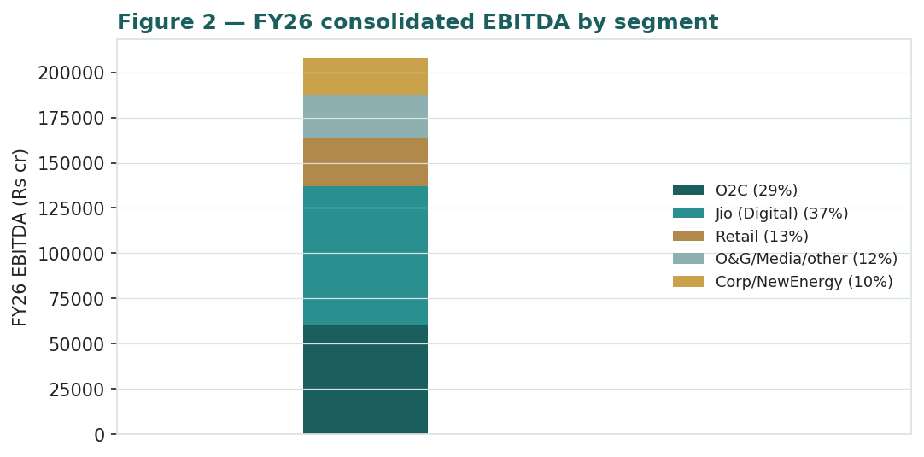
Figure 2 — FY26 EBITDA by segment (₹ cr). Jio is the largest EBITDA pool; O2C the largest revenue pool.
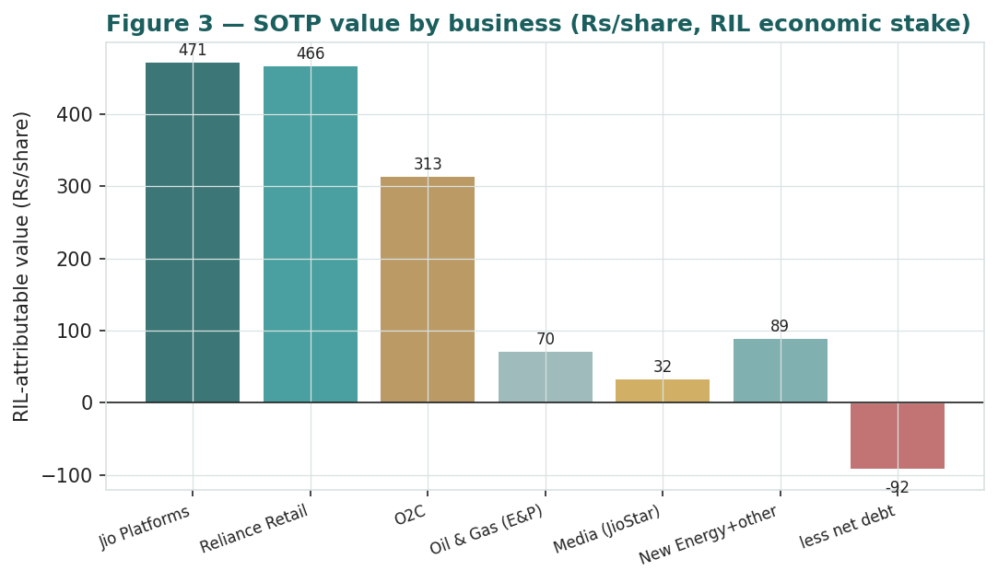
Figure 3 — Sum-of-the-parts: RIL-attributable value by business (₹/share, after applying each stake).

1.7 The crux — value-crystallisation, O2C margins, and the holdco discount
Three judgments drive the valuation more than any other. First, the Jio IPO and value-crystallisation: Jio and Retail together are roughly half of gross EV, both marked off private/peer multiples. A Jio listing (DRHP filed 19 Jun 2026) that prints at or above the 13.5× we assume both validates the mark and gives the market a mechanism to narrow the holding-company discount. Second, O2C through-cycle margins: O2C is ~17% of gross EV and the most cyclical block, so refining GRMs and polymer deltas set the near-term tone. Third, the holdco discount itself: at ~6% today it is modest by conglomerate standards, but it can widen on complexity or capital-allocation concerns as easily as it can narrow on crystallisation. We sensitise the first and third together on the grid in §1.9, and the second in real observable units below.
Swing in real units — the O2C margin. Rather than an abstract EBITDA-margin percentage, we sensitise O2C on its observable drivers: the refining gross margin in $/bbl and the polymer-to-feedstock delta in $/t. The table shows the approximate ₹/share impact at the group level of moving each from our mid-cycle base.
O2C driver (observable unit) | Bear / Base / Bull | ≈ ₹/share swing (group)
Refining GRM ($/bbl) | 7.5 / 9.5 / 11.5 | −48 / base / +48
Polymer–naphtha delta ($/t) | 380 / 460 / 540 | −30 / base / +30
O2C EV/EBITDA (×) | 6.0 / 7.0 / 8.0 | −62 / base / +62
Swing in real units — the Jio mark. Because Jio is the single largest value block and the IPO is the catalyst, the crux table below re-prices the group across the Jio EV/EBITDA multiple, holding the other parts at base. This is the same axis carried into the §1.9 grid.
Jio EV/EBITDA | Implied Jio EV (₹ cr) | Group SOTP (₹/share, post-discount)
11.0× | 8,38,805 | 1,229
12.5× | 9,53,188 | 1,300
13.5× | 10,29,443 | 1,342
15.0× | 11,43,825 | 1,414
16.0× | 12,20,080 | 1,461

1.8 Macro and country — India, crude, the rupee and rates
Reliance is a domestic-demand compounder wrapped around a globally-priced commodity core. Crude and refining spreads set O2C's earnings: Reliance is a complex refiner that generally benefits from wide light-heavy and product cracks, but a sharp crude spike compresses marketing margins and lifts feedstock cost. The rupee cuts both ways — O2C revenue is USD-linked while crude is imported, a partial natural hedge. India consumption and rates drive Jio and Retail: RBI policy easing supports discretionary demand and the discount rate, while telecom tariff moves and quick-commerce competition set the digital/retail trajectory. Foreign flows matter mechanically for a stock this size — a Jio listing and any associated index rebalancing would be a passive-demand event. These macro levers sit behind the bear and bull cases in §1.5 and the catalysts in §5.

1.9 SOTP sensitivity — the value-crystallisation grid
Holding the other parts at base, the table re-prices the SOTP across the two crux inputs: the Jio EV/EBITDA multiple (the crystallisation axis) and the holding-company discount (the wrapper axis). Cells near spot (₹1,321) are the market's implied combination.
Jio × ↓ / Holdco disc → | 0% | 5% | 10% | 12.5%
11.0× | 1,293 | 1,229 | 1,164 | 1,132
12.5× | 1,368 | 1,300 | 1,232 | 1,198
13.5× | 1,412 | 1,342 | 1,271 | 1,236
15.0× | 1,488 | 1,414 | 1,340 | 1,303
16.0× | 1,539 | 1,461 | 1,384 | 1,346
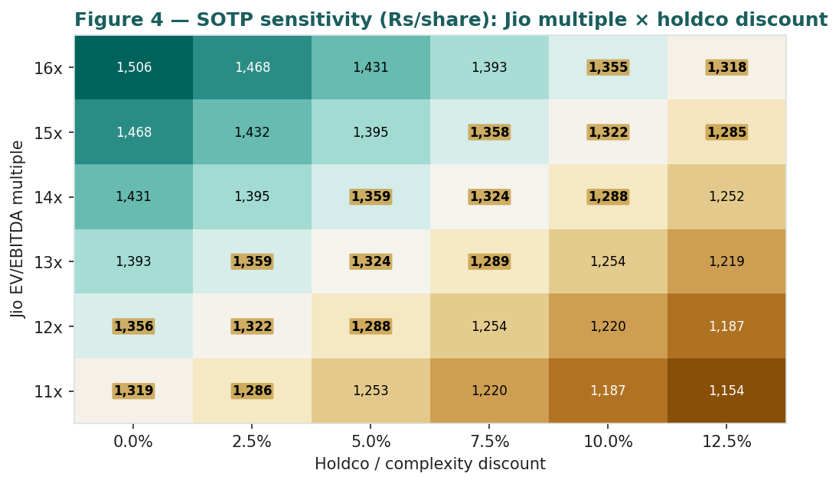
Figure 4 — SOTP sensitivity to the Jio EV/EBITDA multiple and the holding-company discount (₹/share, post-discount). Cells near spot shaded toward the centre.
Read it as the bet you are taking: the market price is consistent with roughly a 12.5–13.5× Jio multiple at a 5–10% holdco discount — i.e. a partial, not a full, crystallisation is already priced. A successful IPO at the upper multiple with the discount narrowing is the clean bull path; a widening discount is the clean bear.

2 Technical and price structure
The tape is corrective but stabilising rather than trending down. Reliance has retraced from a January-2026 high near ₹1,600 to the low-₹1,300s; it sits below its 50-, 100- and 200-day moving averages but has reclaimed the 20-day, RSI is neutral in the low-50s, and the MACD histogram has turned positive as the MACD line crosses back above its signal — an early momentum turn off the correction low.
Indicator | Reading | Signal
Spot | ₹1,321.3 | —
SMA 20 / 50 | ₹1,303 / ₹1,341 | Above 20, below 50
SMA 100 / 200 | ₹1,366 / ₹1,418 | Below both — medium-term down
RSI (14) | 51.8 | Neutral
MACD (12,26,9) | −5.90 line / −8.69 signal / +2.79 hist | Turning up (bullish cross)
52-week range | ₹1,258.8 – ₹1,592.3 | Lower third of range
Realized vol (252d) | 21.0% | Moderate
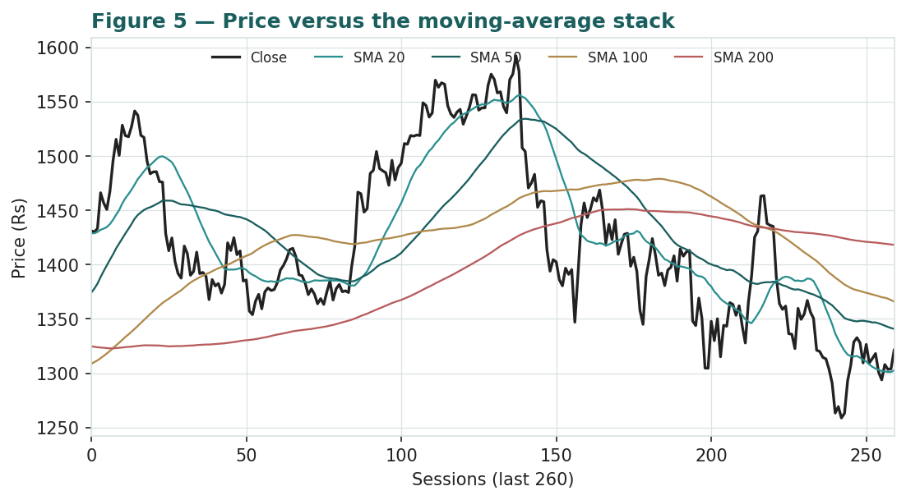
Figure 5 — Price versus the moving-average stack, last 260 sessions.
For the probabilistic work this matters in one way: a tape that has stopped falling and is turning up off a correction low reduces the near-term downside skew that a still-falling chart would imply, without adding any upward trend drift to the simulation (see §3). The technical and fundamental pictures are, for once, broadly aligned — both modestly constructive — and §6 reads the resulting probability zones.

3 Monte Carlo — a probabilistic price map
Reading the distribution first. Before the mechanics, the five-row probability read below summarises the same 50,000 three-month paths the fan chart uses — the direction and skew already in the distribution, computed after simulation. It is presentation-only: it never feeds the drift or the width and leaves the calibration mathematically unchanged.
Probability read (T+60) | Value
P(price above spot) | 57%
P(+10%) vs P(−10%) · odds | 29% vs 17% · 1.70×
Median level · % move | ₹1,351 · +2.3%
50% band (25th–75th) · as % of spot | ₹1,235 – ₹1,478 · 18.4%
Touch(+10%) / Touch(−10%) | 48% / 33%
The read is mildly constructive and honestly so: a small majority of paths finish above spot, the upside/downside odds tilt ~1.7:1, and the median sits ~2% above spot. That tilt is not a manufactured trend — as an international (non-EGX) name the path drift is set to zero — it is the net of the factor stack below (a filed Jio IPO and Q1 results as the main positive discrete events, geopolitical/crude and regulatory drags as the negatives) plus the right-skew that a lognormal diffusion naturally carries.
Mechanics. We simulate 50,000 three-month price paths (seed 42) using a sixteen-factor stack: seven continuous macro/operating drivers contributing a small net forward drift, and nine discrete events that each fire with a probability and an impact. By design the paths diffuse from spot, and the §1 value gap is kept out of the drift — the fundamental NAV gap lives in §1, not here; §3 maps where price could go from today, not where value sits. Diffusion volatility is sized by a pooled log-HAR variance cascade (variance lags 1/5/22) built on a gap-aware Yang-Zhang proxy from the OHLC, projecting the average daily variance over the next 60 sessions — regime-conditional by construction, tight in calm tape and wide in storm (annualized ≈25.0%). Innovations are unit-variance Student-t(5), implemented as a per-path chi-square variance mixture so the 60-day aggregate is exactly unit-variance t5 — a tighter interquartile body with honest tails. As an international name the secular drift is zero; the sixteen factors layer on top of that diffusion.
Continuous factor (7) | Dir. | Discrete event (9) | Prob. | Mean impact
Jio ARPU / 5G-broadband monetisation | + | Jio IPO listing / value crystallisation | 55% | +3.0%
O2C GRM & petrochemical spreads | ± | Q1 FY27 results (late-Jul) | 85% | +0.4%
Reliance Retail growth / q-commerce | + | O2C margin swing (GRM/petchem cycle) | 40% | −1.0%
India consumption & Nifty / flows | + | New Energy giga-factory milestone | 35% | +1.5%
Crude / Brent | ± | Reliance Retail listing / unlock signal | 25% | +2.0%
USD/INR | ± | Geopolitical / crude-spike shock | 25% | −3.0%
India rate path (RBI) | ± | Regulatory drag (telecom/fuel levies) | 30% | −1.5%
 |  | Index / flow rebalancing | 30% | +1.2%
 |  | Capital return / dividend / debt action | 25% | +1.0%
Percentile map (₹/share):
Horizon | p5 | p25 | p50 | p75 | p95
T+20 sessions | 1,160 | 1,266 | 1,331 | 1,400 | 1,526
T+60 sessions | 1,067 | 1,235 | 1,351 | 1,478 | 1,707
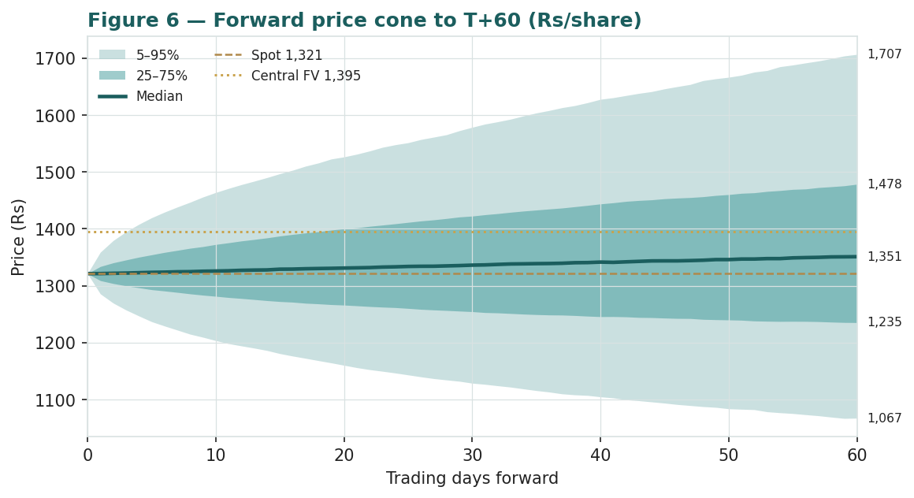
Figure 6 — Forward price cone to T+60. The 50% interquartile band and the median are led; the gold dotted line marks the ₹1,395 fundamental central value, above the median.
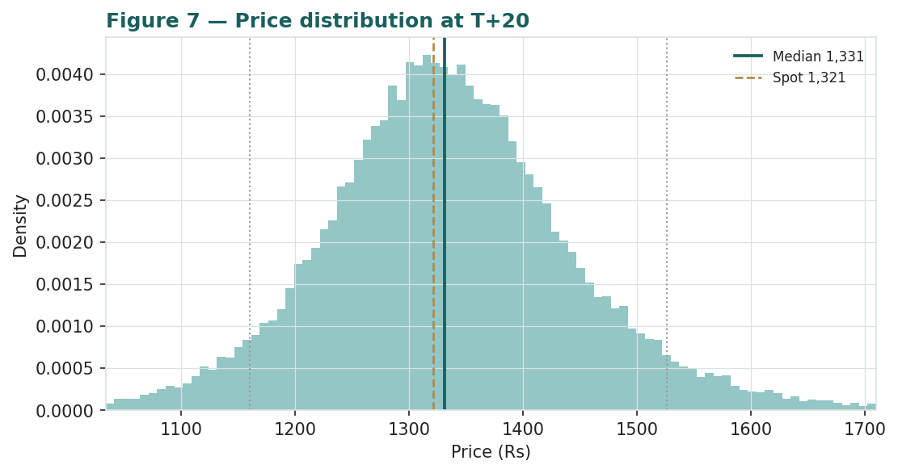
Figure 7 — Price distribution at T+20.
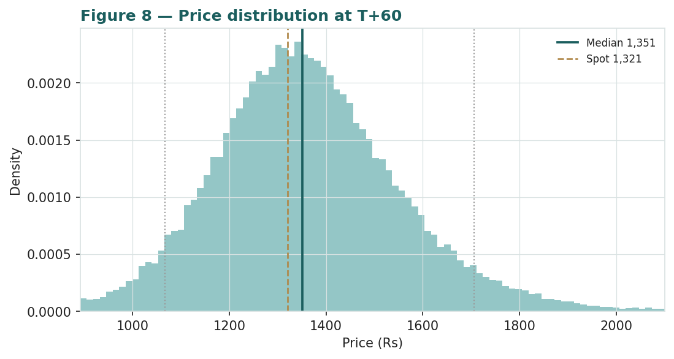
Figure 8 — Price distribution at T+60.
Level-touch ladder — the probability that price touches a level at any point by the horizon (running max for upside, running min for downside):
Level | T+20 touch | T+60 touch | Note
₹1,550 | 6% | 25% | Toward the 52-wk high zone
₹1,500 | 11% | 36% | Upper band
₹1,450 | 21% | 49% | Above central fair value
₹1,400 | 39% | 65% | Near central fair value
₹1,350 | 68% | 83% | Just above spot / median
₹1,300 | 68% | 80% | Just below spot
₹1,250 | 34% | 55% | Toward the 52-wk low
₹1,200 | 15% | 36% | Lower band
₹1,150 | 7% | 23% | Deep downside
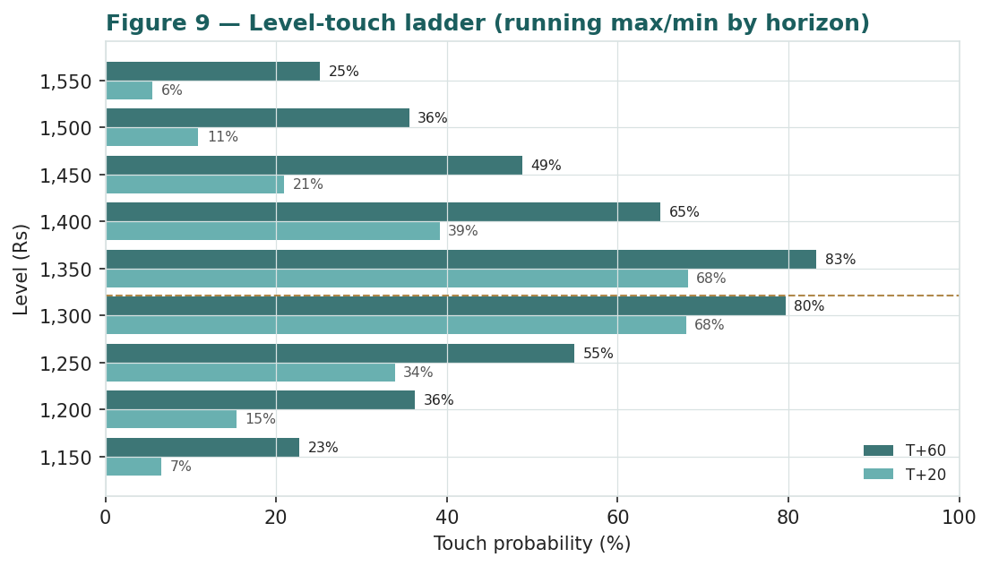
Figure 9 — Level-touch probabilities by T+20 and T+60.

4 Comparison of the lenses, and a verdict
Three readings sit side by side. The fundamental lenses cluster at ₹1,322–₹1,552 with a central ₹1,395 — modestly above spot, contingent on value-crystallisation and O2C margins. The technical picture is broadly aligned for once — corrective but turning up off the January low. The probabilistic map says that over three months price is mildly right-skewed around spot with a moderate ~25% vol band — the median is ₹1,351, a touch above spot but below the ₹1,395 central, because the simulation does not assume the value gap closes inside the quarter.
Lens | Reads | Central / implication
Fundamental (4-lens) | Modestly cheap | ₹1,395 (~+6%)
Technical | Corrective, turning up | Support ~₹1,259; resistance at the MA stack ₹1,341–1,418
Monte Carlo (3-month) | Mildly right-skewed | Median ₹1,351; p5–p95 ₹1,067–1,707
Verdict (a fair-value read, not a recommendation). Reliance looks fairly-to-modestly-cheap on fundamentals, with a clear and unusually concentrated set of swing factors: the Jio IPO as a value-crystallisation event, the O2C margin cycle, and the holding-company discount. The technical stabilisation and the mildly right-skewed three-month distribution argue that any re-rating is a question of the IPO landing and margins holding over quarters, not of an imminent move. The honest summary is a value modestly above price, a near-term distribution centred just above price, and an outcome that hinges on crystallising segment value — which is why the bear–bull span (₹1,112–₹1,719) is wide. Readers should weigh the lenses themselves; we publish the distribution, not a target.

5 Catalysts to watch
- Jio Platforms IPO. The DRHP was filed 19 June 2026; pricing, the final band and the listing itself are the single largest value-crystallisation catalyst and the most direct route to narrowing the holdco discount.
- Q1 FY27 results (late-Jul 2026). First clean post-year-end read on O2C margins, Jio ARPU and Retail momentum.
- O2C margin trajectory. Refining GRMs and polymer-to-feedstock deltas — the observable drivers behind the cyclical block.
- Reliance Retail value-unlock. Any signal on a Retail listing path or fresh private mark would re-rate the second-largest block.
- New Energy milestones. Solar giga-factory and green-hydrogen commissioning convert the option value into cash-flow visibility.
- Crude & the rupee. A crude spike or a sharp INR move re-prices the O2C block and the import bill.
- Index / flow rebalancing. A Jio listing and associated passive flows are a mechanical demand event for a stock this size.
- Capital & balance-sheet actions. Dividend policy, debt reduction and any capital-return surprise.

6 Reading the probability zones
Translating the three-month distribution into plain zones, anchored on spot ₹1,321 and the fair-value cluster:
Zone (T+60) | Range | Approx. prob. | What it would mean
Deep downside | < ₹1,150 | ~13% | Crude/geopolitical shock or O2C trough; tests the correction low
Lower band | ₹1,150–₹1,250 | ~22% | Cycle softens; relative-multiple lens dominates
Around spot | ₹1,250–₹1,400 | ~33% | Status quo; value gap unclosed, IPO pending
Upper band | ₹1,400–₹1,550 | ~21% | Crystallisation credited; toward central/normalized lens
Strong upside | > ₹1,550 | ~11% | IPO at the upper mark + discount narrowing together
The distribution is mildly right-skewed, with the heavier upper tail coming from the discrete upside events (the Jio IPO above all, plus New Energy milestones, capital return and index flows). It is not a forecast; it is the spread of outcomes consistent with the stock's own volatility and the factor stack.

7 Caveats and what would change our mind
- The IPO is the swing. A large slice of the bull case rests on Jio (and later Retail) listing at or above the marks; a delayed, downsized or below-mark IPO would validate the market's discount rather than narrow it, pulling the central toward — or below — spot.
- O2C is cyclical. A third of the swing sits in refining and petrochemical spreads; a sustained margin trough would cut both the SOTP mark and the normalized-earnings lens.
- Terminal-value dependence. The DCF is 81% terminal value — a long-runway, capex-heavy business — so it is sensitive to the WACC and terminal-growth assumptions and should be read alongside the SOTP, not on its own.
- The discount can widen. Complexity, capital-allocation perception or a weak IPO could push the holding-company discount past the ~6% the market applies today.
- Private marks are judgemental. Retail and (pre-listing) Jio are valued off peer/private multiples, not a live market; the bull–bear range on those two lines is the widest single source of dispersion.
- Technical reminder. A MACD turn off a correction low is an early, not a confirmed, momentum signal; below-trend tapes can resume. The technical read is context, not a trigger.

Appendix A Financial statements
Consolidated figures. FY24–FY26 are as reported / tied to the company's disclosed totals (FY26 results, 24 Apr 2026); FY27E–FY31E are the preparer's forecast, built as formulas linking to the model's Assumptions sheet. Both the income statement and the balance sheet carry three actual years plus a five-year forecast; the balance sheet balances to zero in every year.

A.1 Income statement (consolidated, ₹ cr)
Line | FY24 | FY25 | FY26 | FY27E | FY28E | FY29E | FY30E | FY31E
Total revenue | 8,99,062 | 9,64,693 | 10,75,675 | 11,63,377 | 12,68,125 | 13,82,911 | 14,97,194 | 16,16,003
O2C revenue | 5,64,794 | 6,26,921 | 6,62,401 | 6,88,897 | 7,23,342 | 7,59,509 | 7,89,889 | 8,21,485
Digital Services (Jio) | 1,10,175 | 1,29,333 | 1,46,885 | 1,68,918 | 1,92,566 | 2,17,600 | 2,43,712 | 2,70,520
Reliance Retail | 3,06,645 | 3,30,870 | 3,70,026 | 4,18,129 | 4,76,667 | 5,43,401 | 6,14,043 | 6,87,728
Oil & Gas / Media / other | 42,000 | 48,000 | 54,909 | 58,204 | 61,696 | 65,397 | 69,321 | 73,481
less: inter-segment elim. | (1,24,552) | (1,70,431) | (1,58,546) | (1,70,771) | (1,86,147) | (2,02,996) | (2,19,772) | (2,37,211)
Consolidated EBITDA | 1,78,677 | 1,83,344 | 2,07,911 | 2,31,178 | 2,61,925 | 2,91,011 | 3,23,892 | 3,55,108
EBITDA margin | 19.9% | 19.0% | 19.3% | 19.9% | 20.7% | 21.0% | 21.6% | 22.0%
Depreciation & amortisation | 40,012 | 52,000 | 55,000 | 60,496 | 67,211 | 73,294 | 77,854 | 82,416
EBIT | 1,38,665 | 1,31,344 | 1,52,911 | 1,70,682 | 1,94,715 | 2,17,717 | 2,46,037 | 2,72,692
Finance cost | 23,118 | 23,000 | 27,157 | 24,000 | 22,000 | 20,000 | 19,000 | 18,000
PBT | 1,15,547 | 1,08,344 | 1,25,754 | 1,46,682 | 1,72,715 | 1,97,717 | 2,27,037 | 2,54,692
Tax | 35,926 | 27,000 | 30,000 | 36,671 | 43,179 | 49,429 | 56,759 | 63,673
PAT (total, incl. minority) | 79,621 | 81,344 | 95,754 | 1,10,012 | 1,29,536 | 1,48,288 | 1,70,278 | 1,91,019
less: minority & associates | 10,000 | 11,696 | 14,979 | 17,602 | 22,021 | 25,209 | 30,650 | 34,383
PAT attributable to owners | 69,621 | 69,648 | 80,775 | 92,410 | 1,07,515 | 1,23,079 | 1,39,628 | 1,56,636
Source: RIL FY26 results (24 Apr 2026); segment splits per company disclosure. Some finance/tax/minority lines estimated to tie to reported PAT. Forecast = formulas linking to Assumptions.

A.2 Balance sheet (consolidated, ₹ cr)
Line | FY24 | FY25 | FY26 | FY27E | FY28E | FY29E | FY30E | FY31E
PP&E + intangibles (incl. CWIP) | 7,48,477 | 8,19,200 | 9,16,609 | 10,01,113 | 10,73,903 | 11,30,608 | 11,77,754 | 12,15,338
Inventory | 80,916 | 86,822 | 96,811 | 1,04,704 | 1,14,131 | 1,24,462 | 1,34,747 | 1,45,440
Receivables | 40,458 | 43,411 | 48,405 | 52,352 | 57,066 | 62,231 | 67,374 | 72,720
Cash & equivalents | 80,000 | 85,000 | 90,000 | 81,200 | 1,20,065 | 1,87,517 | 2,84,506 | 4,09,912
Current investments | 1,34,000 | 1,45,447 | 1,59,704 | 1,59,704 | 1,59,704 | 1,59,704 | 1,59,704 | 1,59,704
Other assets | 6,20,000 | 7,00,000 | 7,60,000 | 7,60,000 | 7,60,000 | 7,60,000 | 7,60,000 | 7,60,000
Total assets | 17,03,850 | 18,79,881 | 20,71,529 | 21,59,073 | 22,84,869 | 24,24,522 | 25,84,086 | 27,63,114
Equity (incl. minority) | 9,00,000 | 10,10,000 | 11,20,000 | 12,21,012 | 13,40,048 | 14,76,335 | 16,32,614 | 18,07,633
Borrowings (gross debt) | 3,30,000 | 3,47,530 | 3,74,421 | 3,46,921 | 3,36,921 | 3,21,921 | 3,06,921 | 2,91,921
Provisions | 70,000 | 78,000 | 85,000 | 85,000 | 85,000 | 85,000 | 85,000 | 85,000
Payables | 1,43,850 | 1,54,351 | 1,72,108 | 1,86,140 | 2,02,900 | 2,21,266 | 2,39,551 | 2,58,560
Other liabilities | 2,60,000 | 2,90,000 | 3,20,000 | 3,20,000 | 3,20,000 | 3,20,000 | 3,20,000 | 3,20,000
Total liabilities & equity | 17,03,850 | 18,79,881 | 20,71,529 | 21,59,073 | 22,84,869 | 24,24,522 | 25,84,086 | 27,63,114
Balance check (A − L&E) | 0 | 0 | 0 | 0 | 0 | 0 | 0 | 0
Net debt | 1,16,000 | 1,17,083 | 1,24,717 | 1,06,017 | 57,152 | (25,300) | (1,37,289) | (2,77,695)
Historical anchored to disclosed equity / borrowings / cash / net-debt; PP&E plugs to balance. Forecast rolls forward. Net debt turns negative by FY29E as cumulative free cash exceeds gross debt paydown.

A.3 Cash flow & segment summary (₹ cr)
Line | FY24 | FY25 | FY26
Cash from operations (approx.) | 1,60,000 | 1,78,000 | 2,05,000
Capex | (1,41,759) | (1,31,746) | (1,44,271)
Free cash flow (pre-financing) | 18,241 | 46,254 | 60,729
Dividend paid | ₹5.5/sh | ₹5.5/sh | ₹6.0/sh
Net debt (year-end) | 1,16,000 | 1,17,083 | 1,24,717
Source: company quarterly and full-year results FY24–FY26. Operating cash flow approximate; capex and dividend per disclosure. Figures rounded.

Appendix B Peer set, sector structure, and risks
Reliance has no clean single comparable — it is a refiner-petrochemical complex, a telecom/digital platform, a retailer, an upstream producer and a media business in one wrapper. The peer set is therefore split by part.
Part | Closest peers | Typical valuation
O2C (refining/petchem) | Formosa, LG Chem, SABIC, global refiners | EV/EBITDA ~6–8×; cyclical
Jio (digital/telecom) | Bharti Airtel, global tower+platform peers | EV/EBITDA ~11–16×; scale
Reliance Retail | Avenue Supermarts (DMart), Trent, global grocers | EV/EBITDA ~25–35×; growth
Oil & Gas (E&P) | ONGC, Oil India, upstream majors | EV/EBITDA ~4–6×; commodity
Media (JioStar) | Zee, Sun TV, streaming peers | EV/EBITDA ~12–16×
Sector structure. O2C is a globally-priced cyclical navigating the energy transition and Chinese petrochemical oversupply; refining spreads and polymer deltas are the swing macro variables. Indian telecom is a consolidated three-player market with improving ARPU and a 5G monetisation runway; Indian organized retail is structurally growing, competitive and now contested in quick-commerce. Principal risks: a sustained O2C margin trough; a delayed or below-mark Jio IPO; a widening holding-company discount; heavy capex keeping free cash thin; a crude spike or sharp rupee move; telecom/fuel regulatory levies; and execution risk on the New Energy build-out.

Appendix C The expert valuation panel
Every Testahil study closes with a panel of standing expert personas — drawn from the house Expert Persona Library, not invented for the occasion, so that each accumulates a track record across studies and a quarterly update is a re-run, not a re-training. For Reliance we cast the three whose methods both fit a holding-company-of-diverse-businesses and genuinely disagree: Expert 1 (sum-of-the-parts NAV and the holding-company discount), Expert 2 (normalized earnings power and relative multiples), and Expert 3 (cash returns — DCF and return on capital versus its cost). Each runs a different method, derives its fair value from shown workings, and states a falsification condition. The macro-policy lens — crude, the rupee, rates and regulation — runs through the body (§1.8, §5) rather than as a separate persona.

C.1 Expert 1 — sum-of-the-parts NAV and the holding-company discount
Worldview. A holding company is worth the sum of its parts at realizable value, less a discount for the wrapper. He marks each asset to what it would fetch on its own — and, crucially here, asks what a listing would print — then compares that to what the market pays for the bundle.
When it works / fails. Best where the parts are separable and markable and a listing path exists to crystallise them; it fails when a private mark is stale or when the parts are genuinely worth less apart than together.
Standard workings & worked example. Mark Jio on a digital-infrastructure multiple validated by the DRHP band, Retail on a premium consumer multiple anchored to its private rounds, O2C and E&P on commodity multiples, Media on a media multiple; deduct consolidated net debt and minority interest; apply a fair holdco discount.
Expert 1's marks (₹ cr) | Value
Jio Platforms (13.5× EBITDA) | 10,29,443
Reliance Retail (28× EBITDA) | 7,56,924
O2C (7× EBITDA) | 4,23,822
Oil & Gas (E&P) + Media + New Energy | 2,83,640
Σ Gross EV − net debt − minority = ₹1,412/sh pre-discount | 19,10,696
Fair holdco discount 4% (IPO path clarifies structure) → ₹1,360/sh | → ₹1,360
Sensitivity (swing = the discount). At a 0% discount ₹1,412; at 8%, ₹1,300; at 12.5%, ₹1,236. Cross-examination. He tells Expert 2 that mid-cycle earnings double-count assets already marked; he tells Expert 3 that a single group DCF blurs parts that deserve different discount rates and misses the listing optionality entirely.
Verdict, falsification, market-implied. Fair ₹1,360 (range ₹1,080–1,700). Falsified if a part's realizable mark proves illusory — above all if Jio or Retail list below the assumed multiples — or if the discount structurally widens. The market price implies a ~6% discount to his NAV, a touch wider than he judges fair.

C.2 Expert 2 — normalized earnings power and relative multiples
Worldview. An operating group is worth a fair multiple of its sustainable mid-cycle earnings; peaks and troughs are noise to be stripped out, and a growing digital-plus-retail mix earns a premium multiple over a pure refiner.
When it works / fails. Best for franchises with a compounding track record; it fails at structural breaks — if O2C margins are permanently lower or telecom tariffs stall, the normalization is simply wrong.
Standard workings & worked example. Normalize the segments to mid-cycle, derive group attributable PAT, apply a justified blended P/E against history and the segment peers.
Expert 2's normalization | Value
Mid-cycle attributable PAT (₹ cr) | 1,05,000
Shares (cr) → normalized EPS | 1,353 → ₹77.6
Justified blended P/E (growth mix) | 19.6×
Fair value → ₹1,520/sh | → ₹1,520
Sensitivity (swing = normalized margin / multiple). At 17.5× ₹1,358; at 22.5×, ₹1,746. Cross-examination. He tells Expert 1 that NAV struck on today's numbers understates a business whose digital and retail engines will earn far more mid-cycle; he tells Expert 3 that ROIC pessimism ignores the operating leverage of Jio at scale and Retail's maturing store base.
Verdict, falsification, market-implied. Fair ₹1,520 (range ₹1,230–1,900) — the most bullish of the three. Falsified by a structural margin re-rating down — O2C stuck in a trough or telecom ARPU stalling. The market implies normalized earnings ~15% below his: it does not yet fully credit the growth.

C.3 Expert 3 — cash returns: DCF and ROIC versus the cost of capital
Worldview. A business creates value only when each unit of capital earns above its cost. Cash, not booked profit, is the test; he looks past the income statement to the economic-profit spread — and Reliance has spent a decade of very heavy capital.
When it works / fails. Best for capital-intensive businesses where returns on capital are the crux — which describes Reliance well; it fails where reinvestment economics are about to change sharply, e.g. if New Energy earns an unexpectedly high return.
Standard workings & worked example. Build FCFF, compute ROIC against WACC, value as invested capital plus the present value of economic profit, fading excess returns to the cost of capital.
Expert 3's economic-profit test | Value
Normalized NOPAT (₹ cr) | ~1,15,000
Invested capital (₹ cr) | ~13,00,000
ROIC vs WACC | ~8.8% vs ~11.5% → negative spread near-term
Heavy-capex phase suppresses FCF for years | mark near book
Fair value → ₹1,300/sh | → ₹1,300
Sensitivity (swing = WACC / ROIC fade). At a 10.5% WACC ₹1,470; at 12.5%, ₹1,150. Cross-examination. He tells Expert 2 that mid-cycle earnings without the capital cost to produce them is a half-truth — the New Energy and 5G build consume the very cash that a P/E capitalizes; he tells Expert 1 that summing marked parts ignores whether those parts earn their cost of capital today.
Verdict, falsification, market-implied. Fair ₹1,300 (range ₹1,090–1,650) — the most cautious of the three: fairly valued, little margin of safety. Falsified by a durable ROIC lift above WACC — Jio and New Energy sustaining high incremental returns as capex normalises. The market price is almost exactly his number — on a cash-returns basis, the price is about right.

C.5 The three in one room
The single question they most disagree on is whether Reliance's parts are worth more listed and separated than bundled — and whether the capital already spent will earn its keep.
Expert 2: “Forget the wrapper. Jio at scale and Retail maturing earn about ₹1.05 lakh crore mid-cycle. Put a fair multiple on that mix and you are near ₹1,520 — the market is under-crediting the compounding.”
Expert 3: “And to earn it, Reliance has poured capital into 5G and now New Energy. Capitalize the earnings, but subtract the cash to make them. The return on capital barely clears — or misses — the hurdle. I credit no premium to book: ₹1,300.”
Expert 1: “You are both arguing about the engine. Mark the parts — Jio, Retail, O2C, the gas, the balance sheet — and the bundle is worth about ₹1,412 a share pre-discount. The market discounts it ~6%. The argument is the discount and whether the IPO narrows it, not the multiple: ₹1,360.”

C.6 Reading the divergence
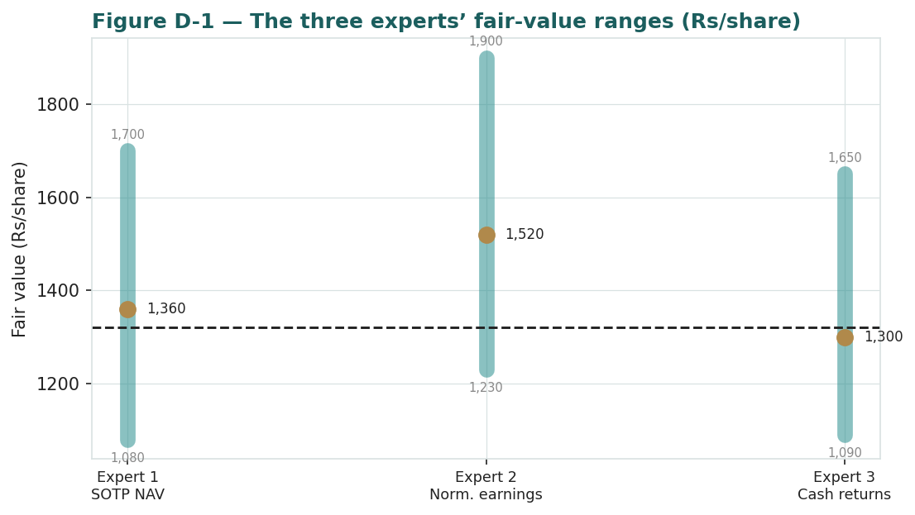
Figure C-1 — The three experts' fair-value ranges. Brass ticks are base cases; the gold band is the central; the dark line is spot. The spread is almost entirely a value-crystallisation and cost-of-capital disagreement.
Expert | Method | Single swing assumption | Base
Expert 1 | Sum-of-the-parts NAV | Fair holdco discount (4%) | ₹1,360
Expert 2 | Normalized earnings power | Mid-cycle PAT / ~19.6× | ₹1,520
Expert 3 | Cash returns / ROIC | ROIC versus a ~11.5% WACC | ₹1,300
The spread — ₹1,300 to ₹1,520 at base — is moderate, and it is almost entirely a disagreement about crystallisation and the cost of capital: none of the three contests the existence or scale of Jio, Retail or O2C. What separates them is whether the parts earn a premium to their asset base (Expert 2, operating leverage), barely clear their capital cost (Expert 3, the cash to earn it), or are a discount question that a listing resolves (Expert 1). The ₹220 spread is therefore a clean measure of one uncertainty — whether Reliance's next phase converts heavy invested capital and private marks into realised, listed value. Resolve that, and the three converge.
Each expert's point fair value (and bull/base/bear) is logged with the study date (06 Jul 2026) and spot (₹1,321.30) as an internal per-expert track record, kept separate from the core Calibration Ledger.

About this series
Testahil publishes independent, educational valuation studies. Each is an attempt to reason transparently about what a security is worth, with every assumption shown and a companion model so readers can disagree productively. The house style is distributions, not tips: we describe ranges and probabilities, not targets, and we do not tell anyone what to do. Studies are framed as educational analysis, the preparer is not licensed by any securities regulator, and holdings are disclosed.

Disclosure & Disclaimer
Not investment advice. This document is educational and informational only. It is not, and must not be relied upon as, investment, financial, legal, accounting or tax advice, nor an offer, solicitation or recommendation to buy, sell or hold any security. It contains no price target and no rating.
No licence; no advisory relationship. The preparer is not registered or licensed with any securities or financial regulator in any jurisdiction, holds no brokerage or investment-advisory authorisation, and is not acting as your adviser or fiduciary. Nothing here is personalised to your circumstances.
Holdings disclosure. The preparer may hold, and may in the future take or dispose of, a position in the security discussed in this report, and may transact at any time without notice. This is a potential conflict of interest you should weigh.
Sources & accuracy. Reported financial and operating figures are drawn from the company's public disclosure and other public sources believed reliable but not independently verified; they may contain errors or be superseded. Forward-looking inputs — the SOTP marks, the private-business marks on Jio and Retail, the holding-company discount, projections, multiples, the DCF and Monte-Carlo factor probabilities — are the preparer's own judgments and are inherently uncertain.
Forward-looking statements. Any statements about the future are estimates subject to risks and uncertainties; actual results may differ materially. The Monte Carlo models price, not value, and encodes subjective probabilities for events that have not occurred.
No reliance; your responsibility. Do your own research and consult a licensed professional before making any decision. You are solely responsible for your investment decisions and their outcomes. To the maximum extent permitted by law, the preparer accepts no liability for any loss arising from use of this document.
Currency & figures. Figures are in Indian rupees (₹); cr denotes crore and lakh cr denotes 100,000 crore. Rounding may cause totals to differ slightly. Spot price and market data are as of 06 July 2026 and change continuously.
TESTAHIL · Independent Valuation Study · Educational Analysis · Reliance Industries Limited (NSE: RELIANCE) · edition 06-07-2026 · reporting currency INR
testahil.com

