Testahil · Independent Valuation Study | Not investment advice
Independent Valuation Study — Educational Analysis
Riyad Bank (Tadawul: 1010)
Fundamental analysis · Technical analysis · Monte Carlo simulation — one integrated read
Anchor: SAR 20.23 (07 Jul 2026 close) · ~3,988mn shares (capital SAR 40bn after the 1-for-3 bonus completed Q2-2026) · market cap ~SAR 81bn (~US$22bn) · the third-largest Saudi bank by assets. This is Testahil's first coverage name on the Saudi market (Tadawul).
READ FIRST — what this is, and what it is not
• The read: moderately undervalued on the intrinsic lenses, conditional on Riyad Bank defending a mid-teens ROE. Weighted central ≈ SAR 26.6 vs spot SAR 20.23 (~+32%). Sell-side consensus PT is ~SAR 27 (Jefferies Buy at SAR 36.50), so a mid-20s central is conservative relative to the street, not aggressive.
• The tension worth understanding: RIBL earns ~16% on equity but trades at only ~1.22× book. Discount lenses (DDM SAR 24, normalized floor SAR 21) sit near spot; excess-return lenses (residual income SAR 33, FCFE SAR 32) sit well above. The spread is the question of whether retained capital compounding at 16% is worth crediting, or whether the market's skepticism is right.
• Cost of equity is built bottom-up: SAR risk-free 5.3% + beta 1.00 × Saudi ERP 5.0% = Ke 10.3%. Do NOT read this as a USD hurdle rate — the riyal's USD peg does not make the SAR and USD curves interchangeable, so the local SAR curve is used throughout.
• All per-share figures are on the current post-bonus share count (~3,988mn). Some balance-sheet sub-lines are estimated to disclosed totals (Tier-1 sukuk, common-equity split) and flagged where used.

Headline
The model's read: moderately undervalued, on the condition that Riyad Bank sustains a mid-teens return on equity through the SAMA/Fed easing cycle. At SAR 20.23 the bank trades at ~1.22× book and ~8.0× trailing earnings, with a 5.2% dividend yield — a valuation that already prices in meaningful ROE fade. The fundamental lenses span SAR 21 to SAR 33; the weighted central of SAR 26.6 sits ~32% above spot, and spot sits at the low end of the fundamental range — at or just below the cautious floor. The Monte Carlo, which prices near-term travel independent of value, has its median at spot with a 50% three-month band of SAR 19.0–21.6.
The bear case, stated fairly. The market is not obviously wrong. A ~1.22× book multiple on a 16% ROE bank is the price of skepticism about persistence: RIBL's FY25 return leaned on a peak net-interest margin and a cost of risk (37bps) near the bottom of its range, both of which normalise as SAMA follows the Fed lower and the benign credit cycle matures. Strip the margin back toward ~2.65% and the cost of risk up toward ~55bps, and the through-cycle ROE settles closer to 13–14% — at which point a ~1.2× book is roughly fair, not cheap. The undervaluation thesis is therefore not a free lunch; it is a bet that RIBL's low-cost deposit franchise (a large share of the book is non-interest-bearing) defends the margin better than the market fears, and that its corporate-and-mortgage book holds asset quality through the cycle. Everything in §1 that follows is, at bottom, a way of pricing that single bet.
Valuation summary — every read at a glance
One table for the reads that follow — what the bank is worth (fundamental), what the tape is doing (technical), where price could travel over three months (Monte Carlo), and how three independent experts value it.
Lens / read | What it measures | Output | Takeaway
Fundamental — DDM | PV of dividends actually paid | SAR 24 | Cautious anchor; still above spot on a 5.2% yield
Fundamental — FCFE | PV of distributable capital | SAR 32 | High: bank over-retains at 16% ROE
Fundamental — residual income | Book value + PV of excess returns | SAR 33 | High: full excess-return credit, ~2x book
Fundamental — relative | Peer P/B & forward P/E | SAR 25 | Modestly above spot vs sector ~1.4× book
Fundamental — normalized | Through-cycle ROE floor | SAR 21 | The floor; near spot
Fundamental — weighted central | Blend of the five | SAR 26.6 | ~+32% vs spot
Technical | Trend / momentum of the tape | Soft, oversold | Below all four MAs; RSI ~27 (oversold)
Monte Carlo — 50% band, T+60 | 3-month price travel | SAR 19.0–21.6 | Median at spot; zero drift by house rule
Monte Carlo — 90% band, T+60 | Tail range | SAR 16.9–24.2 | Mild right skew, fat left tail
Expert panel (3, blended) | Independent methods | ~SAR 22–29 | Converge on undervalued-if-ROE-holds
Bottom line. The reads point the same way on direction — spot below fair — and disagree only on how much credit to give Riyad Bank's retained-earnings machine. The fundamental central near SAR 26.6 is ~32% above spot; the Monte Carlo says the next three months are a coin-flip around spot, weighted very slightly by an oversold tape. The single swing factor is whether a ~16% ROE persists as rates fall.
Company overview — Riyad Bank at a glance
Item | Value
Exchange / ticker | Tadawul (Saudi Exchange) · 1010 · RIBL
Business | Universal bank — Retail, Corporate, Treasury & Investments, Investment Banking & Brokerage
Position | 3rd-largest Saudi bank by assets; 334 domestic branches + London/Houston/Singapore
Shares outstanding (post 1-for-3 bonus, Q2-2026) | ~3,988 million (capital SAR 40bn)
Market cap (spot SAR 20.23) | ~SAR 81bn (~US$22bn)
FY2025 net income | SAR 10,411mn (+11.7% YoY)
FY2025 EPS / DPS (post-bonus) | SAR 2.52 / SAR 1.05 (payout ~42%)
FY2025 ROE / cost-to-income | 16.9% (disclosed) / 29.6%
FY2025 NIM | 2.88%
Total assets / loans / deposits (FY2025) | SAR 519,481mn / 373,305mn / 331,721mn
Ownership | PIF 21.8%, Government of Saudi Arabia 10.4%
Sovereign rating | Saudi Arabia A+ (S&P/Fitch, 2026)
Valuation (spot) | P/B ~1.22× · P/E ~8.0× · dividend yield 5.2%
Source: Riyad Bank FY2025 results (2 Feb 2026), FY2023 annual report, Q1-2026 results (Apr 2026), Tadawul disclosures, Yahoo Finance balance sheet history. Values rounded; some balance-sheet detail estimated to disclosed totals.
1 Fundamental valuation
We value Riyad Bank as a bank, and triangulate five lenses. The primary lens is a dividend discount model (DDM), because a mature, profitable, dividend-paying bank is ultimately worth the present value of what it distributes. We cross-check with an equity DCF (FCFE), a residual-income / justified-P/B model, relative multiples, and a normalized-earnings floor. For a bank we do not build a blended WACC — customer deposits and interbank funding are operating inputs, not an optional capital-structure choice — so every lens discounts at the cost of equity, Ke.
1.1 Dividend discount model — the primary lens
We forecast the dividend per share five years out — net income from the driver model (§1.6), a payout ratio rising gently from ~42% toward ~47% as capital builds post-bonus — discount at Ke = 10.3%, and add a Gordon terminal value at 4.5% growth.
DDM build | FY26E | FY27E | FY28E | FY29E | FY30E
DPS (SAR) | 1.18 | 1.30 | 1.42 | 1.54 | 1.66
Discount factor | 0.907 | 0.822 | 0.745 | 0.676 | 0.613
PV of dividend (SAR) | 1.070 | 1.069 | 1.058 | 1.041 | 1.019
 | SAR / share
Σ PV of explicit dividends (FY26–30) | 5.26
Terminal DPS (FY31, +4.5%) | 1.74
Terminal value at Ke−g (5.8%) | 30.0
PV of terminal value | 18.4
DDM fair value | 23.6
Terminal value as % of DDM | 78%
DDM base ≈ SAR 24/share. This is the cautious anchor — and unlike a low-yielding compounder, it still lands above spot, because Riyad Bank pays a real 5.2% dividend that is itself close to fair value on distributions alone. The model is terminal-heavy (TV 78% of value), so it is sensitive to the Ke–g spread we sensitise in §1.9.
1.2 Discounted cash flow (equity DCF / FCFE)
For a bank the relevant cash flow is free cash flow to equity — net income less the common-equity capital that must be retained to fund risk-weighted-asset (RWA) growth at the target ratio. What is left is genuinely distributable, whether or not it is paid.
Ke build | Value
Risk-free rate (SAR 10Y sukuk) | 5.3%
Equity risk premium (Damodaran Jan-2026, Saudi) | 5.0%
Beta (assumed — no reliable TASI regression) | 1.00
Cost of equity Ke = rf + β·ERP | 10.3%
FCFE build (SAR mn) | FY26E | FY27E | FY28E | FY29E | FY30E
Net income | 11,296 | 12,143 | 12,932 | 13,708 | 14,462
− capital retained for RWA growth | 5,117 | 5,245 | 5,336 | 5,382 | 5,381
= FCFE | 6,179 | 6,898 | 7,596 | 8,326 | 9,081
PV of FCFE | 5,602 | 5,670 | 5,661 | 5,625 | 5,562
 | SAR mn / share
Σ PV of explicit FCFE | 28,120
PV of terminal FCFE | 100,222
Equity value | 128,342
÷ shares (3,988mn) = FCFE value / share | SAR 32.2
The FCFE base of SAR 32 sits well above the DDM because Riyad Bank retains more than it distributes: it earns more than it needs to fund RWA growth and pays out only ~42%, so its potential dividend (FCFE) is larger than the actual dividend the DDM discounts. This lens is the most aggressive and the most retention-dependent — its value is only realised if that retained capital keeps earning ~16%.
1.3 Residual income valuation
The residual-income model is how a bank specialist most naturally values a bank — it is the sole primary model our regional reference house (EFG Hermes) uses across its bank coverage. A bank creates value only in the years it earns more than its cost of equity on its book: residual income = net income − (Ke × opening book value). Fair value = today's book value + the present value of five years of residual income + a terminal value.
Residual income build (SAR mn) | FY26E | FY27E | FY28E | FY29E | FY30E
Opening book value (common equity) | 66,000 | 72,239 | 78,843 | 85,764 | 92,977
Net income to common | 10,946 | 11,793 | 12,582 | 13,358 | 14,112
− equity charge (Ke × opening BV) | 6,798 | 7,441 | 8,121 | 8,834 | 9,577
= residual income | 4,148 | 4,352 | 4,462 | 4,525 | 4,536
PV of residual income | 3,761 | 3,578 | 3,325 | 3,057 | 2,778
 | SAR mn / share
Book value FY25 (starting equity) | 66,000
Σ PV of explicit residual income | 16,498
Terminal value (RI perpetuity at g 4.5%) | 81,721
PV of terminal value | 50,056
Equity value | 132,554
÷ shares = residual-income value / share | SAR 33.2
Implied exit multiple on FY25 book | 2.01×
Residual-income value ≈ SAR 33/share (2.0× book). This is the excess-return lens in full: it fully credits RIBL earning ~16% on equity against a 10.3% cost of equity, so the model says a bank compounding book at that spread is worth ~2× book — well above the 1.22× the market pays. A more conservative reading takes a through-cycle ROE of 14.5% and solves the single-period justified P/B, (ROE−g)/(Ke−g) = 1.72× × BVPS SAR 16.55 = SAR 28; that through-cycle version is the reading Expert 1 carries in Appendix C. Like the FCFE, this lens is only realised if the mid-teens ROE persists — it is the mathematical statement of the bull case.
1.4 Relative multiples
RIBL trades at ~1.22× book and ~8.0× trailing earnings — a discount to the Saudi banking sector's ~1.4–1.6× book, despite a 16% ROE and a sub-30% cost-to-income ratio. On a Gordon-justified multiple, a 16% ROE bank at Ke 10.3% and 4.5% growth supports ~1.8–2.0× book — well above the ~1.22× the market pays.
Relative read | Workings | SAR/share
Sector P/B | 1.40× × BVPS SAR 16.55 | 23.2
Forward P/E | 9.5× × FY26E EPS SAR 2.75 | 26.1
Relative blend | average of the two | 24.6
1.5 Normalized earnings power — the floor
The conservative floor. We take a through-cycle ROE of 14% — below the FY25 16% peak, acknowledging that a record NIM and a benign cost of risk normalise as rates fall — apply it to current book value per share (SAR 16.55) for normalized EPS of SAR 2.32, and capitalise at a sober through-cycle 9× P/E → SAR 21. This lens deliberately ignores growth and retention, and lands essentially at spot — the market is pricing RIBL as if the through-cycle ROE is the whole story.
1.6 Synthesis — five lenses
We anchor on the two intrinsic lenses that best fit a mid-teens-ROE bank — the dividend model and the residual-income model. We weight the DDM most (it discounts cash actually paid), give the residual-income and relative lenses meaningful weight, and treat the FCFE as a high cross-check and the normalized read as a floor.
Lens | Fair value | Weight | What it captures
DDM | SAR 23.6 | 30% | Cash actually distributed
Residual income | SAR 33.2 | 20% | Book + PV of excess returns (~2x book)
FCFE (equity DCF) | SAR 32.2 | 15% | Distributable capital
Relative multiples | SAR 24.6 | 20% | Peer P/B & fwd P/E
Normalized earnings power | SAR 20.9 | 15% | Through-cycle floor
Weighted central | SAR 26.6 | 100% | ~+32% vs spot SAR 20.23
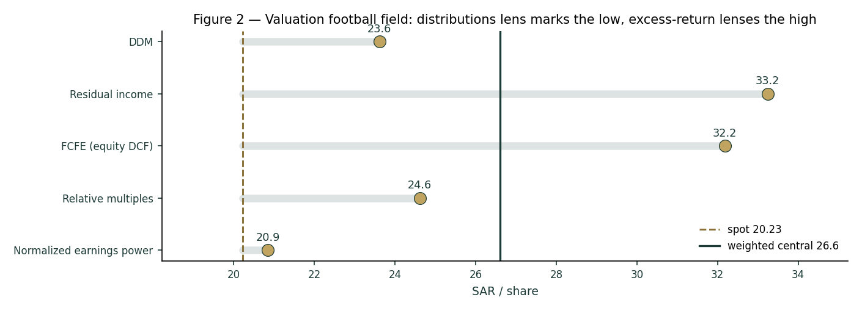
Figure 2 — Valuation football field: the dividend lens marks the low end, the excess-return lenses the high end; the spread is the retention question. Spot sits at the low end of the range.
The football field makes the disagreement plain. Every lens lands between SAR 21 and SAR 32; spot sits at the very low end, and the weighted central of SAR 26.6 is ~32% above it. The distance from the low lens (distributions) to the high lens (FCFE) is a clean measure of one thing: what Riyad Bank's retained capital is worth.
1.7 The bank driver build — a deeper look
Behind the lenses is one engine: net income built from a net-interest-margin path, a fee line, a cost-to-income ratio and a cost-of-risk charge, feeding a DuPont return decomposition and a capital schedule. FY23–25 are disclosed; the forward path is the house view.
Driver | FY23 | FY24 | FY25 | FY26E | FY27E | FY28E | FY29E | FY30E
Net income (SAR mn) | 8,036 | 9,322 | 10,411 | 11,296 | 12,143 | 12,932 | 13,708 | 14,462
NIM (%) | 2.90 | 2.85 | 2.88 | 2.80 | 2.75 | 2.70 | 2.68 | 2.65
Cost-to-income (%) | 33 | 31 | 30 | 30 | 30 | 30 | 30 | 30
Cost of risk (bps) | 55 | 51 | 37 | 42 | 44 | 45 | 45 | 45
Loans (SAR bn) | 282 | 320 | 373 | 407 | 441 | 477 | 513 | 548
ROAE (%) | n/a | 16.0 | 16.0 | 15.8 | 15.6 | 15.3 | 14.9 | 14.6
Blue-cell drivers on the model's Assumptions sheet; historical NIM/CIR/CoR are disclosed or estimated to totals, forward path is the house view.
The standard earnings-driver view — the same summary a regional bank desk publishes — makes the growth and profitability path explicit, two years back and two forward.
Key earnings driver | FY23 a | FY24 a | FY25 a | FY26 e | FY27 e
Loan growth | n/a | 13.5% | 16.6% | 9.0% | 8.5%
Deposit growth | n/a | 11.4% | 8.3% | 8.0% | 7.5%
NIM | 2.9% | 2.9% | 2.9% | 2.8% | 2.8%
Net interest income growth | n/a | 7.2% | 9.0% | 7.2% | 5.8%
Fee income growth | n/a | 12.5% | 18.5% | 14.1% | 11.0%
Revenue growth | n/a | 8.9% | 6.9% | 8.8% | 6.5%
Opex growth | n/a | 2.3% | 2.0% | 10.3% | 6.5%
Cost-to-income | 33.0% | 31.0% | 29.6% | 30.0% | 30.0%
Cost of risk (bps) | 55 | 51 | 37 | 42 | 44
Earnings growth | n/a | 16.0% | 11.7% | 8.5% | 7.5%
ROAE | n/a | 16.0% | 16.0% | 15.8% | 15.6%
ROAA | n/a | 2.2% | 2.1% | 2.1% | 2.1%
Net profit — reported (SAR mn) | 8,036 | 9,322 | 10,411 | 11,296 | 12,143
Net profit — attributable (SAR mn) | 7,686 | 8,972 | 10,061 | 10,946 | 11,793
FY23–25 net income disclosed; NIM/cost-to-income/cost-of-risk disclosed for FY25 and estimated for FY23–24; growth rates on operating sub-lines are estimated to disclosed totals. Contrast with a high-rate EM bank (an EGX name runs ~6–7% NIM, ~30–43% ROAE): RIBL is a mature, low-rate GCC bank — ~2.9% NIM, ~16% ROAE, ~2.1% ROAA, ~40bps cost of risk.
The NIM path is the heart of it. FY25 NIM printed 2.88%; as SAMA follows the Fed lower, RIBL's asset yields reprice faster than its sticky, low-cost demand deposits, so the margin glides down toward ~2.65% by FY30. That glide, not credit, is what fades ROAE from ~16% toward ~14.6% even as the book grows. The direction is not in doubt — asset-sensitive Saudi banks give back margin in a cutting cycle — but the magnitude is the whole valuation. A bank whose funding base is heavily non-interest-bearing keeps more of its asset-yield decline than a deposit-competitive peer, because a large slice of its funding cost does not fall with rates (it is already near zero). That is the mechanical reason RIBL's margin has been resilient, and the reason the base-case glide is gentle rather than a cliff.
Three levers sit underneath the net-income line, and each is disclosed or estimated in the driver table. The fee line has grown double-digits as the bank monetises its transaction, FX and brokerage franchise, and we grow it ahead of assets — a genuine offset to margin compression. The cost-to-income ratio has fallen below management's <30% target as the AI/digital investment converts to operating leverage; we hold it at ~30%, giving no further efficiency credit. The cost of risk is the swing the credit-cycle expert (Appendix C.2) presses hardest on: at 37bps in FY25 it sits near a cyclical trough, and we normalise it toward ~45bps in the base case and ~55bps in the bear. Net income growth of ~8.5% fading to ~5.5% is the arithmetic of a gently-falling margin, a growing fee line, held costs, and a normalising credit charge on a book compounding high-single-digits.
DuPont / driver | FY25 | FY26E | FY30E | Comment
NIM (%) | 2.88 | 2.80 | 2.65 | Glides with the rate cycle
Cost-to-income (%) | 29.6 | 30.0 | 30.0 | Held near management's <30% target
Cost of risk (bps) | 37 | 42 | 45 | Normalises toward through-cycle
ROAE (%) | 16.0 | 15.8 | 14.6 | Fades as equity compounds & NIM falls
Common equity/RWA (%) | 17.6 | 17.8 | 18.6 | Builds even as payout rises
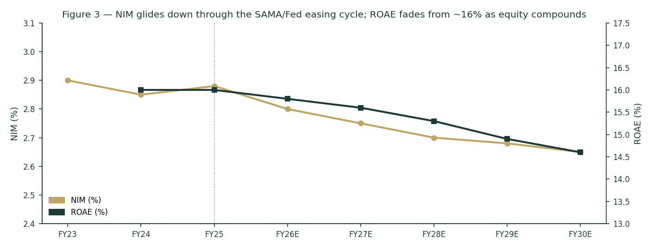
Figure 3 — NIM glides down through the SAMA/Fed easing cycle; ROAE fades from ~16% as equity compounds and rates fall.
The capital schedule is the other half of the thesis, and it is what the residual-income and FCFE lenses monetise. Even as the payout rises from ~42% toward ~47%, RIBL keeps building common equity relative to RWA — the surplus the excess-return lenses value.
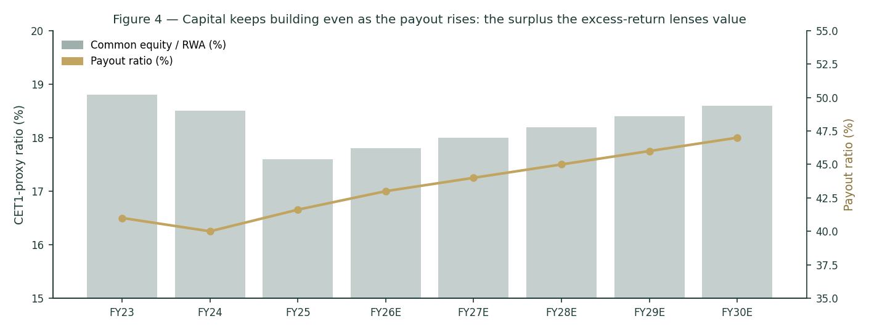
Figure 4 — Capital keeps building even as the payout rises: the surplus the excess-return lenses value.
1.8 The crux — the NIM path and the dividend-versus-retention gap
Two things swing this valuation, and we sensitise both in their own observable units.
- The NIM path through the easing cycle (basis points against the SAMA/Fed rate path). RIBL's asset yields reprice faster than its low-cost deposits, so the direction and speed of policy rates set the margin. A margin that holds ~10bp above the base case lifts through-cycle net income and fair value; a faster cutting cycle compresses both.
- The dividend-versus-retention gap (the SAR 24 to SAR 32 spread). The DDM values distributions; the residual-income and FCFE lenses value retained capital reinvested at ~16%. Which is right depends on whether RIBL keeps earning that return on the capital it retains, or whether — as the market's 1.22× book implies — that return fades toward Ke.
Swing (observable units) | Shift | Central FV | vs spot
NIM through-cycle | +10bp / −10bp | ~SAR 27 / ~SAR 24 | +33% / +19%
Through-cycle ROE credited | 16% / 13% | ~SAR 29 / ~SAR 21 | +43% / +4%
Cost of equity Ke | 9.5% / 11.0% | ~SAR 29 / ~SAR 22 | +43% / +9%
Payout ramp | to 50% / flat 42% | ~SAR 26 / ~SAR 25 | both modestly above spot
1.9 Macro and country — SAMA, oil, and Vision 2030
Riyad Bank is a leveraged play on the Saudi macro, in three channels. Rates: SAMA shadows the Fed to defend the riyal's USD peg, so the domestic rate path — and thus the NIM — is set in Washington as much as Riyadh; the peg also removes the currency channel that dominates an EGP- or lira-funded bank. Credit: the loan book is tied to Vision 2030 project finance, mortgages and SME lending, so non-oil GDP growth drives volume and asset quality. Oil: indirectly, through government spending, deposit liquidity and the sovereign's own A+ credit standing, which anchors the risk-free rate this study discounts at.
1.10 DDM sensitivity — Ke × terminal growth
Because the primary lens is terminal-heavy (TV 78% of value), the honest disclosure is a grid of the DDM fair value across the cost of equity and terminal growth.
Ke \ terminal g | 4.0% | 4.5% | 5.0% | 5.5%
9.5% | 25.3 | 27.5 | 30.0 | 33.2
10.3% | 22.1 | 23.6 | 25.4 | 27.6
11.0% | 19.8 | 21.0 | 22.4 | 24.1
The centre (Ke 10.3%, g 4.5%) is the DDM base of ~SAR 24; the full valuation blends this with the four other lenses to SAR 26.6.
2 Technical and price structure
The tape mirrors the fundamentals' conditional optimism from the other side: soft and oversold, not trending. RIBL trades below all four major moving averages, RSI sits at ~27 (oversold, sub-30), and MACD is mildly negative — a corrective, range-bound tape between roughly SAR 19 and SAR 22 over the last year. An oversold reading in a fundamentally-cheap name is the kind of setup that can precede a mean-reversion bounce, but it is not, on its own, a trend signal.
Indicator | Reading | Signal
Price vs MA20 / MA50 | SAR 20.23 vs 20.49 / 20.59 | Below both — soft
Price vs MA100 / MA200 | vs 20.99 / 20.54 | Below both — corrective
RSI (14) | 27 | Oversold (sub-30)
MACD (12/26/9) | line -0.15, signal -0.11, hist -0.04 | Mildly bearish (below signal)
52-week range | SAR 19.14 – 22.35 | Spot in lower third
Realised vol (60d, ann.) | ~16% (close-to-close) | Moderate; YZ-HAR anchor ~23%
Structure | Range-bound 19–22 | No clear trend either way
Read | Oversold within a range | Weak tape, mean-reversion candidate
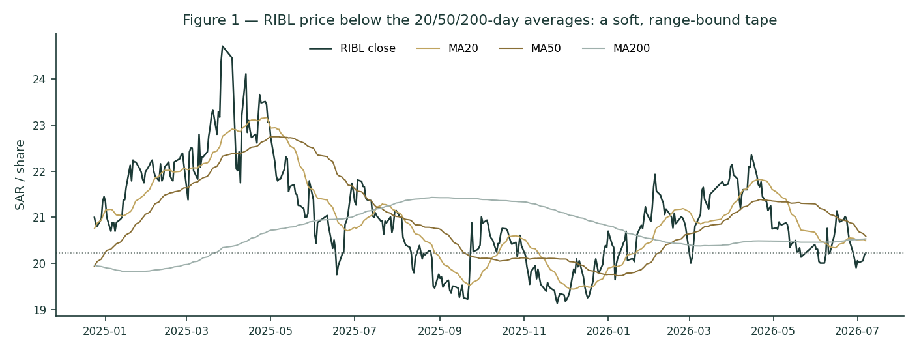
Figure 1 — Price below the 20/50/200-day averages: a soft, corrective, range-bound tape over the last year.
3 Monte Carlo — a probabilistic price map
We simulate 50,000 three-month price paths from spot. The width is set by the YZ-HAR engine — a log-HAR variance cascade on a gap-aware Yang-Zhang proxy that reads the current volatility regime — with a unit-variance Student-t(5) shape for honest tails. Drift is zero: secular drift is switched on only for EGX developers, and RIBL is neither. These paths price where the stock could travel, and deliberately do not embed the §1 fair value — the value gap is kept out of the drift.
The factor set is Saudi-bank-specific. Note the absence of any FX factor — the riyal's USD peg removes the currency channel that dominates an EGP- or lira-funded bank — and a rate channel that reflects SAMA/Fed transmission. All factor numbers are editable judgments (the table is the model); they are flagged uncalibrated pending red-pen sign-off, and net to a near-zero combined drift consistent with the zero-drift base case.
Continuous factor (7) | Tier | Sign | 3m drift | Channel
SAMA/Fed rate path | 1 | +/− | ±0.4% | NIM sensitivity to policy
Non-oil GDP / Vision 2030 | 1 | + | +0.3% | Loan volume & asset quality
Oil price / fiscal impulse | 2 | + | +0.1% | Deposit liquidity, sovereign standing
Sector credit growth | 2 | + | +0.2% | System loan demand
Dividend/payout signal | 2 | + | +0.1% | Post-bonus capital return
Foreign flows (TASI inclusion) | 3 | + | +0.1% | Passive/QFI demand
Momentum / mean-reversion | 3 | + | +0.2% | Oversold RSI bounce tilt
Discrete factor (9) | Tier | Prob | Impact (mean) | Spread
Quarterly earnings surprise | 1 | 40% | ±1.5% | wide
SAMA policy surprise | 1 | 25% | ±1.2% | wide
Dividend declaration surprise | 2 | 30% | +0.8% | moderate
Sovereign rating action | 3 | 10% | +0.6% | moderate
Regulatory fee/levy change | 2 | 20% | −0.7% | moderate
Large corporate credit event | 3 | 8% | −1.0% | wide
Index rebalance | 3 | 15% | ±0.5% | narrow
Oil shock | 2 | 15% | ±0.9% | wide
Geopolitical / regional | 3 | 12% | −0.8% | wide
Net continuous drift ~+1.4%, expected event drift ~−1.2%, combined ~+0.2% — near-zero, consistent with the zero-drift base case the fan chart shows.
Horizon | p5 | p25 | p50 | p75 | p95
T+20 | 18.3 | 19.5 | 20.2 | 21.0 | 22.4
T+60 | 16.9 | 19.0 | 20.2 | 21.6 | 24.2
We lead with the 50% interquartile band, not the 90% tail. At T+20 the middle half of paths lies between SAR 19.5 and SAR 21.0 (~±4%); at T+60, between SAR 19.0 and SAR 21.6 (~±7%). The median sits at spot — the MC prices travel, not direction. The band is relatively tight because the engine is reading a low-volatility regime: RIBL's close-to-close realised vol over the last quarter is ~16%, and even the gap-aware YZ-HAR anchor (~23%, which loads intraday range and overnight jumps) is modest for an emerging-market bank. A pegged currency, a large-cap float and a range-bound tape all compress the width. The practical reading: over a single quarter, the fundamental re-rate toward fair value that §1 argues for is a low-probability event in the tails, not the central path — the MC and the fundamental read operate on different clocks, and the three-month distribution should not be mistaken for a verdict on value.
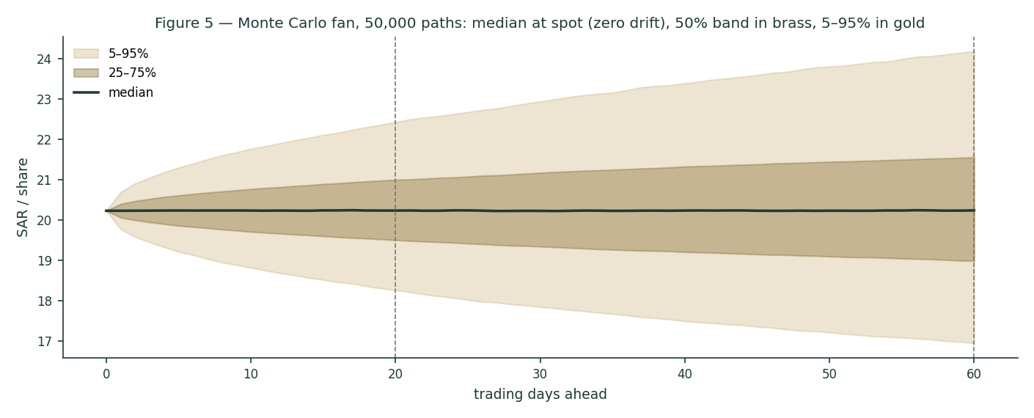
Figure 5 — Monte Carlo fan, 50,000 paths: median at spot, 50% band in brass, 5–95% in gold.
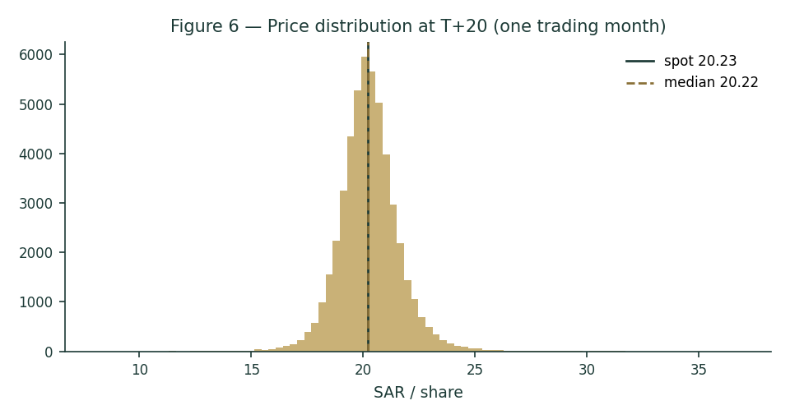
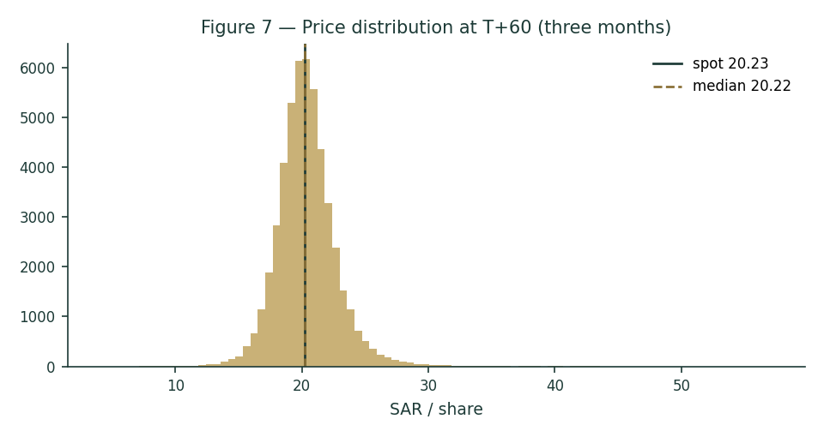
Figures 6–7 — Price distribution at T+20 (tight, near-symmetric core) and T+60 (wider, mild right skew, fat left tail).
The touch-probability ladder reads the paths a different way — the chance price touches a level at any point in the window (not where it ends). Over three months there is roughly an even chance of tagging SAR 19.2 on the downside or SAR 21.2 on the upside, with the tails fatter than the terminal percentiles suggest.
Level | Touch by T+20 | Touch by T+60
SAR 17.20 | 2% | 11%
SAR 18.21 | 8% | 25%
SAR 19.22 | 30% | 54%
SAR 20.23 | 100% | 100%
SAR 21.24 | 32% | 55%
SAR 22.25 | 10% | 29%
SAR 23.26 | 3% | 15%
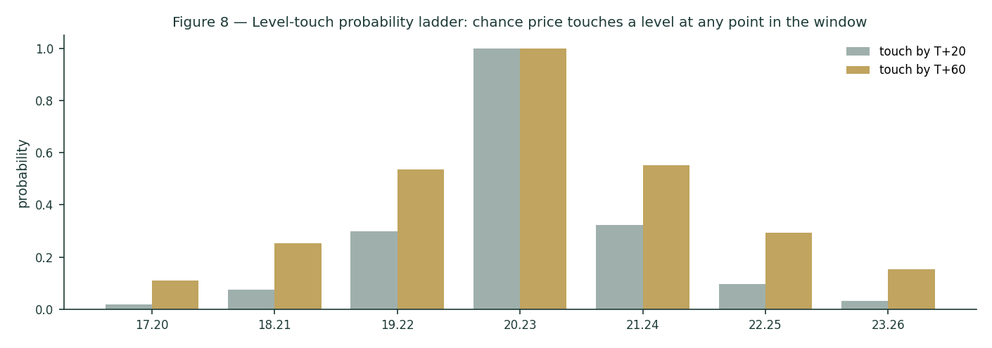
Figure 8 — Level-touch probability ladder: near-symmetric around spot, fat in the tails.
4 Comparison of the lenses, and a verdict
Three lenses, three time horizons, one question. The fundamental read says undervalued-if-ROE-holds: SAR 26.6 central, ~+32% above spot, with the answer hinging on whether Riyad Bank's ~16% return on retained capital persists as rates fall — or whether the market's 1.22× book is right that it fades. The technical read says soft and oversold — a weak tape that is nonetheless stretched to the downside. The Monte Carlo says the next three months are a coin-flip around spot. Put together: a fundamentally cheap, oversold large-cap where the upside is real but conditional, and the near-term path is symmetric. Spot at SAR 20.23 sits below every fundamental lens and in the lower third of the technical range — the balance of evidence tilts modestly favourable, with the ROE-persistence question as the swing.
5 Catalysts to watch
Catalyst | Weight | Why it matters
SAMA/Fed rate decisions | High | Sets the NIM glide — the single biggest earnings driver
Quarterly earnings (next: 27 Jul 2026) | High | Beat/miss on NIM, cost-to-income, cost of risk
Strategy 2030 execution | Medium | Retail expansion, AI cost efficiency, ROE >16% defence
Dividend / payout progression | Medium | Post-bonus capital return; DDM & FCFE both key off this
Loan growth vs guidance | Medium | High single-digit 2026 guidance, stronger H2 expected
Sovereign rating / oil | Low-Med | Anchors the risk-free rate and deposit liquidity
TASI foreign-flow / index moves | Low | Passive/QFI demand on a large-cap
Regulatory fee/levy changes | Low-Med | Flagged by management as a 2026 watch item
6 Reading the probability zones
Translating the T+60 distribution into plain zones. These are price probabilities over three months, independent of the fundamental fair value.
Zone | ~Probability (T+60) | Interpretation
< SAR 16.9 | ~5% | Downside tail — a sharp de-rate
SAR 16.9 – 19.0 | ~20% | Below-median drift
SAR 19.0 – 21.6 | ~50% | Core band around spot
SAR 21.6 – 24.2 | ~20% | Above-median drift
> SAR 24.2 | ~5% | Upside tail — a re-rate toward fair value
Probabilities are approximate, read from the 50,000-path distribution; they sum to ~100% subject to rounding.
7 Caveats and what would change our mind
- What would move us more bearish:
a faster, deeper SAMA cutting cycle that compresses NIM below ~2.6% and breaks the earnings glide; evidence that the ~16% ROE is fading toward Ke (the market's current read); a cost-to-income ratio drifting back above 30%; or a credit-quality turn as the benign cost-of-risk cycle ends.
- What would move us more bullish:
durable NIM resilience (a higher-for-longer rate path or faster low-cost deposit growth) holding the margin near 2.9%; confirmation of a rising payout without eroding the capital build; and sustained mid-teens ROE that validates crediting the retention lenses.
- Model caveats:
this is an educational model, not a forecast. The DDM and FCFE are terminal-heavy (TV ~78% of value), so they are sensitive to the Ke–g spread we have made explicit and sensitised. The risk-free rate (5.3%) is anchored to a same-week Saudi study and cross-checks, not a live NDMC 10Y auction print; beta is an assumed 1.00, not a genuine TASI regression; and several balance-sheet sub-lines are estimated to disclosed totals. Refreshing the rf, running a real beta regression, and pulling the FY2023–24 statements in full are the highest-value follow-ups.

Appendix A Financial statements
A.1 Income statement — 3-year historical + 5-year forecast (consolidated, SAR mn)
Line | FY23 | FY24 | FY25 | FY26E | FY27E | FY28E | FY29E | FY30E
Net special commission income | ~8,300 | ~8,900 | ~9,700 | ~10,400 | ~11,000 | ~11,600 | ~12,200 | ~12,800
Fee & commission income, net | ~2,400 | ~2,700 | ~3,200 | ~3,650 | ~4,050 | ~4,400 | ~4,750 | ~5,050
Trading & other income | ~1,500 | ~1,700 | ~2,000 | ~2,100 | ~2,200 | ~2,300 | ~2,400 | ~2,500
Total operating income | ~14,600 | ~15,900 | ~17,000 | ~18,500 | ~19,700 | ~20,900 | ~22,100 | ~23,300
Operating expenses | (4,820) | (4,930) | (5,030) | (5,550) | (5,910) | (6,270) | (6,630) | (6,990)
Pre-provision profit | ~9,780 | ~11,000 | ~12,000 | ~13,000 | ~13,800 | ~14,600 | ~15,500 | ~16,300
Provision for credit losses | (1,550) | (1,632) | (1,374) | (1,700) | (1,950) | (2,150) | (2,350) | (2,550)
Net income | 8,036 | 9,322 | 10,411 | 11,296 | 12,143 | 12,932 | 13,708 | 14,462
EPS (post-bonus, SAR) | 1.93 | 2.25 | 2.52 | 2.75 | 2.96 | 3.15 | 3.35 | 3.54
FY23–FY25 net income disclosed (SAR 8,036 / 9,322 / 10,411mn); FY25 provisions SAR 1,374mn and cost-to-income 29.6% disclosed. Sub-lines marked ~ are estimated to disclosed totals and growth rates. FY26E–FY30E from the driver model. Source: Riyad Bank results, IR, argaam.
A.2 Balance sheet — 3-year historical + 5-year forecast (consolidated, SAR mn)
Line | FY23 | FY24 | FY25 | FY26E | FY27E | FY28E | FY29E | FY30E
Loans & advances, net | 282,000 | 320,090 | 373,305 | 406,902 | 441,489 | 476,808 | 512,569 | 548,449
Total assets | 386,849 | 450,379 | 519,481 | 563,897 | 609,431 | 655,748 | 702,470 | 749,184
Client deposits | 275,000 | 306,412 | 331,721 | 358,259 | 385,128 | 412,087 | 440,933 | 469,594
Total equity (incl. Tier-1 sukuk) | 60,258 | 67,942 | 74,000 | 80,240 | 86,845 | 93,764 | 100,976 | 108,456
Common equity | 52,258 | 59,942 | 66,000 | 72,240 | 78,845 | 85,764 | 92,976 | 100,456
RWA (proxy, 72% of assets) | 278,531 | 324,273 | 374,026 | 406,006 | 438,790 | 472,139 | 505,778 | 539,412
Common equity / RWA (%) | 18.8 | 18.5 | 17.6 | 17.8 | 18.0 | 18.2 | 18.4 | 18.6
BVPS (post-bonus, SAR) | 13.10 | 15.03 | 16.55 | 18.11 | 19.77 | 21.51 | 23.31 | 25.19
Total assets / equity FY23–24 from disclosed statements (Yahoo Finance normalization); FY25 total assets SAR 519,481mn, loans 373,305mn, deposits 331,721mn disclosed. Tier-1 sukuk (SAR ~8bn) and the common-equity split are estimated to disclosed totals; RWA is a 72%-of-assets proxy. Common equity/RWA is a CET1-proxy, not the reported regulatory ratio.
A.3 Cash flow — sources & uses of equity capital (SAR mn)
Line | FY26E | FY27E | FY28E | FY29E | FY30E
Net income | 11,296 | 12,143 | 12,932 | 13,708 | 14,462
− dividends paid | (4,706) | (5,188) | (5,663) | (6,146) | (6,632)
− capital retained for RWA growth | (5,117) | (5,245) | (5,336) | (5,382) | (5,381)
= retained surplus (buffer) | 1,473 | 1,710 | 1,933 | 2,180 | 2,449
Memo: FCFE | 6,179 | 6,898 | 7,596 | 8,326 | 9,081
For a bank the relevant flow is distributable capital: net income less the capital retained to fund RWA growth. The retained surplus above the dividend is the buffer the excess-return lenses value.
Appendix B Peer set, sector structure, and risks
Riyad Bank is a mid-to-large name in a concentrated, well-capitalised Saudi banking sector, and screens cheaply against both Saudi and wider GCC peers — the discount its 16% ROE does not obviously earn, which is the core of the undervaluation thesis.
Bank | P/B | P/E | ROE | Note
Al Rajhi | ~3.5× | ~16× | ~23% | Premium Islamic compounder
SNB (Saudi National) | ~1.4× | ~10× | ~13% | Largest by assets, PIF-majority
Riyad Bank | ~1.2× | ~8× | ~16% | This study — cheap for the ROE
Alinma | ~1.6× | ~11× | ~15% | Faster-growing mid-tier
Banque Saudi Fransi | ~1.1× | ~9× | ~12% | Corporate-tilted
Arab National Bank | ~1.0× | ~8× | ~12% | Value end of the sector
Al Bilad | ~2.0× | ~14× | ~16% | Retail/Islamic growth
Saudi Investment Bank | ~0.9× | ~8× | ~11% | Smallest, deepest discount
GCC context — Emirates NBD | ~1.0× | ~6× | ~18% | UAE large-cap for reference
GCC context — QNB | ~1.4× | ~9× | ~18% | Qatar large-cap for reference
Multiples approximate, for context; not independently verified. The ROE–multiple relationship is the point: RIBL's ~1.2× book is low for a 16% ROE, sitting closer to the 12%-ROE value names than to same-ROE peers — the gap the intrinsic lenses flag.
Sector structure. Saudi banking is an oligopoly of ~10 banks under a conservative SAMA regime (high capital ratios, the riyal peg, Basel III-plus). Structural tailwinds — Vision 2030 credit demand, mortgage penetration, SME lending — are partly offset by the rate cycle now turning. RIBL sits mid-pack on size and ROE but at the cheap end on valuation.
Key risks
- Rate-cycle reversal compressing NIM below the base-case glide.
- ROE fade toward Ke — validating the market's current discount rather than the intrinsic lenses.
- Credit-quality deterioration if non-oil growth slows below Vision 2030 targets.
- Regulatory fee/levy changes (flagged by management as a 2026 watch item).
- Execution risk on Strategy 2030's AI/digital transformation.

Appendix C The expert valuation panel
Three independent experts value Riyad Bank by genuinely different methods, cast from the Testahil persona library's bank coverage map — a capital-and-returns specialist, a credit-cycle specialist, and a macro/policy strategist. Labeled Expert 1/2/3 only.
C.1 Expert 1 — capital, returns and the price of book value
Worldview and tradition. Expert 1 comes from the bank-analyst tradition that says a bank is a machine for turning equity capital into a return, and is worth whatever that return justifies relative to its cost — a justified price-to-book of (ROE − g)/(Ke − g), not a generic DCF.
Standard workings. (1) Estimate a sustainable through-cycle ROE. (2) Publish the cost of equity as rf + β×ERP. (3) Pick a terminal growth consistent with nominal GDP and the retention/ROE identity. (4) Solve the justified P/B and multiply by book value per share.
Input | Value | Basis
Through-cycle ROE | 14.5% | Below FY25 16% — NIM & cost-of-risk normalise
Cost of equity Ke | 10.3% | rf 5.3% + 1.00 × ERP 5.0%
Terminal growth g | 4.5% | Saudi nominal GDP proxy
Justified P/B | 1.72× | (ROE − g)/(Ke − g)
Book value per share | SAR 16.55 | Common equity ÷ shares
Fair value | SAR 28 | Justified P/B × BVPS
vs spot | +41% | spot SAR 20.23, 1.22× book
Worked example and sensitivity. At a 14.5% ROE the machine is worth ~1.7× book; the stock trades at ~1.22×, so on Expert 1's numbers RIBL is materially undervalued with the return doing the work. Every point of through-cycle ROE is worth ~SAR 3–4 of fair value; if the ROE settles at 13% (near Ke), the justified multiple collapses toward ~1.4× and the fair value falls to ~SAR 23.
When the method works, and when it fails. Expert 1 leans on history: RIBL has earned mid-teens on equity through the recent rate cycle. The method fails if the through-cycle ROE assumption is wrong — capitalising a 16% ROE into perpetuity when it is fading toward the cost of equity is exactly the error the market may be pricing out.
Cross-examination. Expert 1 tells Expert 3 (macro/DDM) that a dividend model throws away the most valuable thing RIBL does — reinvest retained capital at 16% — and so structurally understates a bank that over-retains. Expert 1 concedes to Expert 2 that the ROE and the credit cycle are not independent: the same benign cost of risk that lifts today's ROE will reverse.
C.2 Expert 2 — the credit cycle and normalized provisioning
Worldview and tradition. Expert 2 is a credit-cycle sceptic who has seen banks report record profits at the top of a benign cycle, only to give it back in provisions when it turns. The right earnings number is a through-cycle one.
Standard workings. (1) Take current pre-provision profit. (2) Replace the reported cost of risk with a through-cycle charge. (3) Tax to a normalized net income and EPS. (4) Apply a through-cycle P/E, not the peak multiple.
Input | Value | Basis
Pre-provision profit (FY25) | ~SAR 12,000mn | Disclosed / estimated
Reported cost of risk | 37 bps | FY25 provisions ÷ loans
Through-cycle cost of risk | 55 bps | Normalises off a benign trough
Extra provision vs reported | ~SAR 670mn | (55−37)bps × loans
Normalized net income | ~SAR 9,850mn | After the higher charge
Normalized EPS | ~SAR 2.38 | Post-bonus
Through-cycle P/E | 9.0× | Sober, not the peak
Fair value | ~SAR 21 | Normalized EPS × P/E
Worked example and sensitivity. Normalising the cost of risk from 37 to 55bps costs ~SAR 670mn of net income and, at 9×, ~SAR 1.5 of fair value; the sober multiple (vs the market's peak) is the bigger lever. Expert 2 lands near spot — the point being that on normalized, not peak, earnings RIBL is roughly fairly valued, and the undervaluation the other lenses see is partly a benign-cycle artefact.
When the method works, and when it fails. Expert 2 is at its most valuable near a cycle peak in a project-finance- and SME-heavy loan book. It fails when it is too pessimistic on a structurally-improved book — Saudi banks' asset quality has been resilient — and when it applies a through-cycle multiple to a bank whose cycle has genuinely lengthened under Vision 2030 spending.
Cross-examination. Expert 2 warns Expert 1 that its 14.5% through-cycle ROE quietly assumes a benign cost of risk forever, and warns Expert 3 that a dividend that looks safe today can be cut when provisions spike. Expert 2 concedes the Saudi sovereign backstop and high capital ratios make a severe credit event less likely than in an unpegged EM.
C.3 Expert 3 — macro, policy and the dividend
Worldview and tradition. Expert 3 is a top-down macro strategist who values a bank as a claim on a cash stream whose size is set by forces outside the bank's control — the policy rate, the oil price, the sovereign's standing — and discounts the dividend the bank actually pays.
Standard workings. (1) Forecast the dividend from the macro-driven earnings path and a payout schedule. (2) Publish Ke = rf + β×ERP with the macro risk in the ERP. (3) Discount the explicit dividends and a Gordon terminal.
Input | Value | Basis
FY25 DPS (post-bonus) | SAR 1.05 | Disclosed
Payout path | ~42% → ~47% | Rising post-bonus
Cost of equity Ke | 10.3% | rf 5.3% + ERP 5.0%
Terminal growth g | 4.5% | Nominal GDP proxy
Dividend yield (spot) | 5.2% | A real, sizeable payout
Fair value (DDM) | SAR 24 | PV of dividends + TV
vs spot | +17% | Cautious lens, still above spot
Worked example and sensitivity. On the cash RIBL actually pays, the shares are worth ~SAR 24 at a 10.3% Ke — above spot, which is Expert 3's point: even ignoring retention, a 5.2% yielder growing dividends mid-single-digits is worth more than SAR 20.23. Push Ke to 11% (a fuller other-risk premium for the region) and the DDM falls toward ~SAR 21 — near spot.
When the method works, and when it fails. Expert 3's DDM is the right tool for a mature bank whose payout is real and rising, and it forces the analyst to state a cost of equity. It fails on a bank that over-retains — it ignores the value of the ~58% of earnings RIBL keeps and reinvests at a high return, which is exactly what Expert 1 monetises.
Cross-examination. Expert 3 tells Expert 1 that a justified-P/B model is only as good as its ROE-persistence assumption, and that capitalising a 16% ROE into perpetuity is a heroic macro call dressed as a spreadsheet. Expert 3 agrees with Expert 2 that the dividend, not the "potential" dividend, is what shareholders actually receive.
C.5 The three in one room
Put the three in a room and the argument narrows to one question: what is Riyad Bank's retained capital worth? Expert 1 says it is worth ~1.7× book because it compounds at ~14.5%; Expert 3 says value only the cash paid, which is worth ~SAR 24; Expert 2 says normalise the cycle first, which pulls the answer to ~SAR 21, near spot. All three agree spot is not expensive; they disagree on how much of the upside to credit.
C.6 Reading the divergence
The spread — SAR 21 to SAR 28, about a third — is not noise; it is a clean measurement of a single disagreement. Each expert's answer is driven by one assumption, and the table isolates it.
Expert | Fair value | The one assumption that drives it | Where it sits and why
1 — capital & returns | SAR 28 | Through-cycle ROE persists near 14.5% | High — credits retained-capital compounding
2 — credit cycle | ~SAR 21 | Cost of risk normalises to 55bps | Low — strips the benign-cycle earnings
3 — macro / dividend | SAR 24 | Only the paid dividend counts | Middle — cautious but still above spot
What the spread measures. The distance between Expert 1 and Expert 2 is the value of RIBL's retention policy at a mid-teens ROE net of a normalized credit charge — the difference between crediting reinvestment (Expert 1) and normalising the cycle (Expert 2). Expert 3 sits between, valuing only what is paid. That every expert lands at or above spot is the study's central finding: RIBL is cheap on any of the three methods, and the only question is how cheap.

About this series
Testahil publishes independent, educational valuation studies. Each is an attempt to reason transparently about what a security is worth, with every assumption shown and a companion model so readers can change them. "Distributions, not tips." Studies are published under the Testahil brand only.
Disclosure & Disclaimer
- Not investment advice. This document is educational and informational only. It is not, and must not be relied upon as, investment, financial, legal, accounting or tax advice, nor an offer, solicitation or recommendation to buy or sell any security.
- No licence; no advisory relationship. The preparer is not registered or licensed with any securities or financial regulator in any jurisdiction, holds no brokerage or investment-advisory authorisation, and no advisory relationship is created by this document.
- Holdings disclosure. The preparer may hold, and may in the future take or dispose of, a position in the security discussed in this report, and may transact at any time without notice.
- Sources & accuracy. Reported financial and operating figures are drawn from the bank's public disclosure and other public sources believed reliable but not independently verified; they may contain errors, and several balance-sheet sub-lines are estimated to disclosed totals.
- Forward-looking statements. Any statements about the future are estimates subject to risks and uncertainties; actual results may differ materially. The Monte Carlo models price, not value, and encodes assumptions that may not hold.
- No reliance; your responsibility. Do your own research and consult a licensed professional before making any decision. You are solely responsible for your investment decisions and their outcomes.
- Currency & figures. Figures are in Saudi riyals (SAR), pegged to the US dollar at 3.75; mn denotes million and bn billion. Rounding may cause totals to differ slightly.
TESTAHIL · Independent Valuation Study · Educational Analysis · Riyad Bank (Tadawul: 1010) · edition 09-07-2026 · reporting currency SAR

