Testahil · Independent Valuation Study — Educational Analysis Not investment advice

Tenth of Ramadan Pharmaceuticals (Rameda)
EGX: RMDA · Independent valuation study · 13 July 2026 · spot EGP 5.00 (12-Jul-2026 close)
READ FIRST — what this document is. An educational valuation study: fair-value ranges and probability distributions, not tips. It contains no rating, no price target, and no buy/sell/hold language. Three separate clocks are kept apart throughout: the fundamental fair-value range is a ~12-month risk-adjusted anchor at the sourced Egyptian cost of capital; the Monte Carlo T+20/T+60 percentiles are the only genuinely 3-month figures; and any rate-normalisation upside is a multi-year path, never a near-term forecast.
The one-line finding. Rameda’s operating engine is genuinely strong — revenue +48% and EBITDA +45% in FY25, +23% and +16% again in 1Q26 — but at today’s sourced 22.55% EGP risk-free the fundamental lenses split: the discounted-cash-flow lens sits far below the market price, while the earnings-power and own-multiple lenses sit near it. The gap is a rate-path bet, and this study prices it explicitly instead of blending it away.
Where the numbers come from. Every historical figure ties to Rameda’s audited consolidated financial statements (FY2023–FY2025, EY member-firm audited) and official IR earnings releases through 1Q26; every forward driver is stated with its source ring in the driver table; the engine outputs are reproducible (mc_v3, 50,000 paths, seed 42, live Egypt market fit).

The company. Rameda — formally Tenth of Ramadan for Pharmaceutical Industries and Diagnostic Reagents — is an Egyptian branded-generics drugmaker founded in 1986 and listed on the EGX since November 2019. From three plants in Sixth of October City it develops, manufactures and sells generic pharmaceuticals, nutraceuticals, food supplements and veterinary products, making money four ways: prescription-driven private-market sales through distributors to pharmacies (74% of FY25 revenue), selective government tenders through Egypt’s Unified Procurement Authority (13%), exports to Iraq, Libya, Yemen, Sudan and newer markets (6%), and toll manufacturing that monetises spare plant capacity for other drugmakers (7%). Its moat is a broad registered portfolio across high-recurrence therapeutic areas — alimentary/metabolism and anti-infectives above all — deepened by a disciplined habit of buying proven product portfolios outright (EGP 595mn of product acquisitions in 2025 alone) rather than betting on discovery. It is a mid-tier player by revenue in a fragmented market, but one of Egypt’s fastest-growing: revenue has more than doubled in two years to EGP 4.1bn, and the constraint on shareholder profit today is not the factory floor — it is the EGP ~2.1bn of working-capital debt being carried at Egyptian interest rates.
Valuation summary — every read at a glance
One table for the four reads developed below — what the business is worth (fundamental), what the tape is doing (technical), where price could travel over three months (Monte Carlo), and how three independent expert methods land. Every row is developed in the sections and appendices that follow.
Lens / read | What it measures | Output | Takeaway
FUNDAMENTAL — what the business is worth (the ~12-month anchor)
FCFF DCF (discipline lens) | Five-year FCFF + terminal, at the sourced 22.55% rf | EGP 1.73 | -65% vs spot — the rate discipline bites
Dividend discount (policy lens) | EGP 120mn/yr ramping to a 40% payout, at Ke | EGP 1.00 | -80% — payout too young to carry value
Relative (own EV/EBITDA band) | FY26E EBITDA × 6.5–9.5×, bridged to equity | EGP 4.40 | -12%
Normalized earnings power | FY26E attributable EPS × through-cycle P/E | EGP 3.65 | -27%
Weighted central | Blend 35 / 15 / 25 / 25 | EGP 2.77 [2.11–3.48] | -45% vs EGP 5.00 — divergence disclosed, not blended
TECHNICAL — what the tape is doing (timing, not value)
Trend | Price vs 20/50/100/200-day averages | Above 3 of 4; a whisker under SMA20 (SMA200 3.92) | Uptrend intact, consolidating
Momentum / range | RSI · MACD · 52-week range | RSI 50 · MACD -0.009 · 3.02–5.38 | Neutral after the June high
MONTE CARLO — where price could go in 3 months (paths from spot)
T+20 sessions | 50,000 paths · carry-anchored · t(ν=4) | p5 4.32 · p50 5.07 · p95 5.95 | Median ≈ spot + carry
T+60 sessions | same engine, longer horizon | p5 3.95 · p50 5.20 · p95 6.84 | P(above spot) 62%
EXPERT PANEL — three independent methods (Appendix C)
Expert 1 — cash returns / economic profit | EP on the forecast path; zero terminal value creation | EGP 0.97 | Most conservative — charges for every negative-spread year
Expert 2 — normalized earnings power | FY26E EPS × multiple bands | EGP 3.65 | The earnings anchor
Expert 3 — macro-policy scenario tree | CBE rate paths into the DCF | EGP 1.97 | Prices the easing cycle
Panel range | Spread = the cost-of-capital question itself | EGP 0.97–3.65 | Wide by design — it measures the rate question

Bottom line. The weighted fundamental central of EGP 2.77 sits 45% below the EGP 5.00 spot — but the honest headline is the spread, not the point: the DCF at the sourced Egyptian cost of capital says 1.73, while the earnings and own-multiple lenses say 3.65–4.40. A price of 5.00 is the market asserting that Egyptian discount rates normalise and the balance sheet deleverages — both plausible, neither yet in the sourced numbers. Over three months the carry-anchored engine, which PASSES its calibration gate on this name, centres the price at 5.20 with a 50% band of 4.73–5.73: the near-term tape and the long-term rate question are different bets, and this study refuses to let one impersonate the other.
Company overview — Rameda at a glance
Item | Value
Listed entity | Tenth of Ramadan for Pharmaceutical Industries and Diagnostic Reagents (Rameda) S.A.E, EGX: RMDA (listed 26-Nov-2019)
What it is | Egyptian branded-generics pharmaceutical manufacturer: private-market prescription sales, UPA tenders, exports, toll manufacturing; three plants in Sixth of October City
Spot / date | EGP 5.00 · 12-Jul-2026 close · 52-week range 3.02–5.38
Shares · market cap | 2,000.0mn shares (post 0.3236 bonus issue, Nov-2025; FY25 FS Note 17) · EGP 10.0bn
FY2025 revenue / EBITDA / net income | EGP 4,096mn (+48%) · EGP 1,166mn company-adjusted, 28.5% margin (EBIT+D&A build: 1,164) · EGP 313mn reported (−22%), 404mn recurring (+13%)
1Q2026 | Revenue EGP 1,067mn (+23%) · EBITDA 303mn (28.4%) · net income 103mn (+20%) · operating cash inflow +99mn
Channel split (FY25) | Private 3,023 (74%) · tenders 545 (13%) · exports 243 (6%) · toll 285 (7%); therapeutic mix led by alimentary/metabolism 36% and anti-infectives 28%
Balance sheet | Net debt EGP 2,225mn ex-lease / 2,307mn incl. leases at FY25 (dual framing); 1Q26 net debt EGP 2,111mn (−5% YTD); facility rates 15–25.27%; ND/EBITDA ~1.9× vs a 1.0–1.5× internal guide
2025 portfolio acquisitions | EGP 595mn of intangible additions (product portfolios incl. a CNS/pain pair, addressable market >EGP 1.3bn, 3-yr CAGR >25%); funded from facilities
Dividend | EGP 120mn for 2026 in two equal EGP 60mn tranches (H1/H2); target payout ~40% — yield ~1.2% while deleveraging
One-off (FY25) | UCP/MEC distributor collapse: ~EGP 460mn exposure, ~360mn recovered/offset, remaining EGP 99mn fully provisioned; recovery efforts continue (upside if collected)
Accounting estimate change | Brand useful lives re-estimated 20y → 35–40y in FY25, cutting annual amortisation ~EGP 25.8mn — flagged as material by the company; a quality-of-earnings item
Ownership (colour) | Main shareholder block 40.7% (FS); aggregator registers Aquinox Pharma ~19%, Saudi Seventh Investment ~11%, Kuwait Investment Co ~10%; free float ~59% of listed shares
Corporate events | 2Q26 results due ~mid-Aug-2026 · CBE MPC 20-Aug / 24-Sep / 29-Oct / 17-Dec-2026 (official calendar; held 9-Jul) · LVP Pharma at 31.5% vs the 33.33% MTO line · SAP go-live May-2026 → FY26 · continued acquisition pipeline (management, 1Q26 ER)

Source: Rameda audited consolidated FS FY2023–FY2025 and official IR earnings releases through 1Q26 (ramedapharma-ir.com); uploaded EGX price history. Values in EGP mn unless stated; rounding applies.
1 Fundamental valuation
Lens by class: Rameda is a single integrated generics operating company — its "segments" are sales channels of one business, not separable legs — so the primary lens is a single-entity five-year FCFF DCF (the EAND operating-co pattern), cross-checked by a dividend-discount policy lens, the name’s own traded multiple, and normalized earnings power. The 2025 product-portfolio acquisitions are a base-changer folded into the operating base, not a separate leg.
1.1 The FCFF DCF — the primary lens
The five-year explicit forecast is driven top-down (the data-discipline guard: unit volumes and ASPs by product are not separately disclosed, so channel growth × normalized margins is the honest build). The full waterfall — every input linking to the model’s Assumptions sheet — is:
EGP mn | FY26E | FY27E | FY28E | FY29E | FY30E
Revenue | 4,859 | 5,462 | 6,043 | 6,609 | 7,190
EBITDA | 1,399 | 1,606 | 1,801 | 1,983 | 2,157
D&A | 126 | 142 | 157 | 172 | 187
EBIT | 1,273 | 1,464 | 1,644 | 1,811 | 1,970
NOPAT (EBIT×(1−t), t=24%) | 968 | 1,113 | 1,249 | 1,376 | 1,497
+ D&A | 126 | 142 | 157 | 172 | 187
− Capex | (146) | (153) | (157) | (165) | (180)
− Δ working capital | (244) | (231) | (219) | (220) | (248)
− Employee profit appropriation | (21) | (39) | (53) | (67) | (80)
Free cash flow to firm (FCFF) | 683 | 832 | 977 | 1,096 | 1,177
Discount factor | 0.790 | 0.638 | 0.524 | 0.437 | 0.368
PV of FCFF | 540 | 531 | 512 | 479 | 433

Free cash flow to the firm, five-year explicit forecast. Every input links to the model’s Assumptions sheet. Capex, Δ working capital and the employees’ profit appropriation (6.7% of prior-year NI, per the EGM-approved EGP 21mn from FY25 profit; conservative house charge against FCFF) in parentheses.
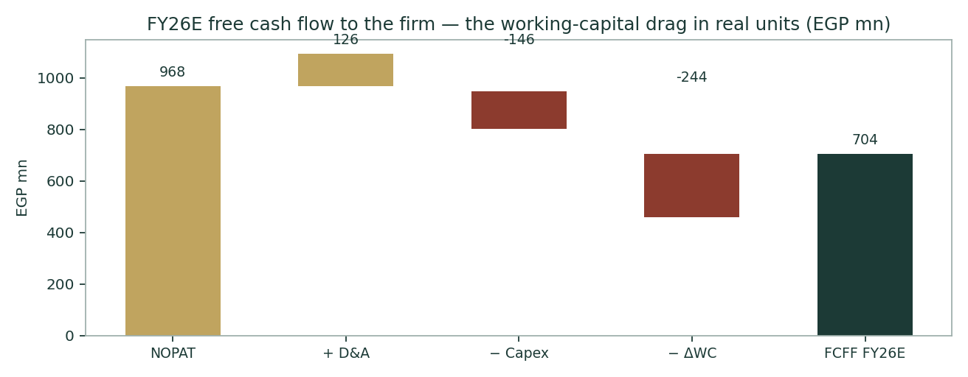
Figure 6. The FY26E FCFF build: a EGP 981mn NOPAT engine surrenders EGP 285mn to working capital before a riyal of it reaches the firm.
From FCFF to a per-share value. Discounting on the SLIDING schedule — explicit-window forward rate 26.60% (Y1, net-CDS Ke) easing to a norm-built terminal rate of 18.84% (Y5+; §1.8) — with terminal growth of 5.0% nominal EGP: PV of the explicit years EGP 2,495mn; terminal value EGP 8,926mn, PV EGP 3,284mn — 57% of enterprise value, disclosed per house rule; EV EGP 5,779mn. Less net debt EGP 2,307mn including lease liabilities (EGP 2,225mn ex-lease — both framings stated; the primary bridge is lease-INCLUSIVE because the balance sheet carries right-of-use assets and lease liabilities, i.e. IFRS-16: EBITDA excludes rent and the FCFF above adds back all D&A and never pays the lease, so the liability must be deducted here), less NCI EGP 42mn at book, plus EGP 94mn of non-operating real-estate units (one sold post-period for 55): equity EGP 3,523mn, or EGP 1.73 per share on 2,032.8mn shares (post the 6-Jul-2026 ESOP listing) — -65% versus spot.
DCF component | EGP mn / value | Note
PV of explicit FCFF (Σ FY26E–FY30E) | 2,495 | per-year PV inline above, each at its own sliding forward rate (§1.8)
Terminal value = FCFF₅×(1+g)/(WACC_term−g) | 8,926 | FCFF₅ 1,177 · g 5.0% · terminal rate 18.84% · spread 13.8%
PV of terminal value | 3,284 | 57% of EV — high-terminal dependency disclosed
Enterprise value | 5,779
− Net debt (incl. leases, primary) / memo ex-lease | (2,307) / (2,225) | IFRS-16-consistent primary; dual framing (FS Notes 12/20/6B)
− Non-controlling interest (book) | (42) | FS changes-in-equity
+ Non-operating real-estate units | 94 | FS Note 14
Equity value | 3,523
Per share (2,032.8mn shares, post-ESOP) | EGP 1.73 | -65% vs spot

The EV → equity bridge closes exactly; enforced by assertion in the build (compute assert log, Appendix A).
1.2 Dividend discount — the policy lens, as the cash-flow cross-check
Year | FY26E | FY27E | FY28E | FY29E | FY30E
DPS path (EGP mn declared) | 120 | 317 | 398 | 477 | 554
Per share (EGP) | 0.059 | 0.156 | 0.196 | 0.234 | 0.273

Discounting the committed EGP 120mn (two EGP 60mn tranches) growing to a 40% payout at Ke 28.6% with 14% terminal dividend growth gives EGP 1.00 per share (terminal 61% of the value). The lens is honest but young: at a ~1.2% yield and a 32% cost of equity, the dividend cannot yet carry the valuation — it earns only a 15% weight, and its real job is discipline: it forces the deleveraging story to eventually show up as cash to shareholders.
1.3 Relative — the name’s own multiple, and why the band sits below today’s
 | Bear | Base | Bull
EV/EBITDA × on FY26E EBITDA of EGP 1,399 mn | 6.5× | 8.0× | 9.5×
Implied equity per share | EGP 3.37 | EGP 4.40 | EGP 5.43

Spot trades at 10.7× FY25 and 8.9× FY26E EV/EBITDA (spot EV on FY25 net debt; the model's Per-Share sheet also shows 8.4× on FY26E net debt — vintage stated per the dual-framing rule) (34× attributable / 32× consolidated reported, ~25× recurring earnings). Disclosed Egyptian generics peers are thin and stale, so the house same-name rule applies: the anchor is the multiple range the market itself has paid for RMDA over the last twelve months, set deliberately below today’s print because today’s multiple already capitalises the finance-cost normalisation.
1.4 Normalized earnings power
FY26E attributable EPS of EGP 0.270 (net income EGP 576mn after a 23.0% average facility cost on the opening book, 24% tax, 4.7% NCI) × through-cycle P/E bands of 11/13.5/16× gives EGP 2.97 / 3.65 / 4.32. This is the lens closest to how the market actually prices the name; its honesty condition is that the interest bill really does fall as modelled.
1.5 Synthesis — four lenses, one weighted central
Lens | Bear | Base | Bull | Weight | Why this weight
FCFF DCF | 1.18 | 1.73 | 2.31 | 35% | Primary discipline lens at the sourced rate
Relative (own band) | 3.37 | 4.40 | 5.43 | 25% | What the market pays for this engine
Normalized earnings | 2.97 | 3.65 | 4.32 | 25% | Through-cycle multiple on clean EPS
DDM (policy) | 0.78 | 1.00 | 1.54 | 15% | Young dividend; discipline, not driver
Weighted central | 2.11 | 2.77 | 3.48 | 100% | -45% vs spot — the headline anchor

The cash-flow lenses (DCF 1.73, DDM 1.00) discount a strong engine at the sourced ~29% WACC and get small numbers; the market lenses (relative 4.40, normalized 3.65) price the same engine at today's multiples and land near spot. The weighted central of EGP 2.77 [2.11–3.48] is the ~12-month risk-adjusted anchor; the 4.5× spread BETWEEN the lenses is the rate bet, drawn to scale below.
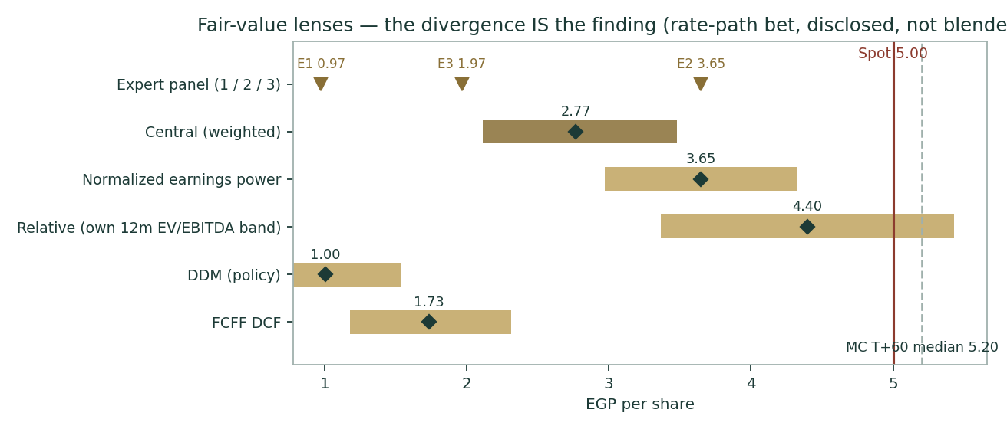
Figure 8. The football field: every lens, every expert, the MC cone and spot on one axis. The gap between the cash-flow cluster and the market cluster IS the rate bet, drawn to scale.
1.6 The drivers — four rings, classified, sourced
Before any driver is set, the deep-dive question: revenue doubled in two years (FY23 EGP 1,922mn → FY25 EGP 4,096mn). Forecasting is the work of separating business-as-usual from one-off events — the decomposition below does exactly that, and it is why the forward path tapers rather than re-doubles.
Period | Event / driver | One-off or BAU | Evidence
FY24 (+44%) | EDA pricing catch-up regime (one-off) | ONE-OFF (regime) | 40-50% approvals across the portfolio + a 20%-of-topline discrepancy round; value from 2H24 (FY24 ER)
 | Consumer shift to branded generics (structural) | Structural | Volume growth as consumers traded down from innovators (FY24 ER)
 | Exports = ZERO (one-off drag) | ONE-OFF (drag) | Iraq suspension wiped the export book for the whole of FY24 (1H25 ER)
FY25 (+48%) | Full-year repricing effect (one-off tail) | ONE-OFF (tail) | Second year of the catch-up regime; ~82% of market SKUs repriced by end-2025 (industry data)
 | Shortage-driven private volume spike (one-off) | ONE-OFF | 2Q25 private volumes +56% units on market-wide shortages (1H25 ER) - the exact base now unwinding (1Q26 private volumes -5%)
 | Export resumption from zero (one-off step) | ONE-OFF | Iraq lifted + Sudan opened (45% of 1H25 exports) + Libya/Yemen (1H25 ER)
 | Tender normalisation (+131%) & utilisation 25%->47% | ONE-OFF | UPA procurement resumed; fixed-cost dilution (1H25 ER)
 | Launches & portfolio acquisitions (BAU engine) | BAU engine | EGP 595mn intangible product acquisitions; chronic-care launches (FY25 FS Note 7)
FY26+ anchor | 1Q26: revenue +23% = volumes ex-toll +7% + mix, 'with limited reliance on pricing actions' (ER26); private volumes -5% | BAU test | Market value +15% 2026 (pricing ~12% tail + volumes ~3%) then ~9%/yr; Rameda outgrowth +2-3pp from launches/toll/exports

The doubling was regime + resumption + shortage one-offs stacked on a real launch engine; NONE of the three one-offs repeats, so the forward path tapers 19% -> 9% rather than re-doubling Volumes ex-toll grew +7% in 1Q26 with private volumes -5% — the volume engine, not the price regime, is what the forecast years are allowed to carry.
The information sweep — all four rings, Global / Country / Industry / Company — ran before any driver was set. Classification: B = base-changer, S = structural, D = driver-unlock, C = colour, NEG = negative search (a dated finding that something does not exist).
Ring | Finding | Cl. | Source / date
1 Global | Fed 3.50–3.75%; EGP floats, so global rates bind via the IMF programme and carry, not a peg | S | Fed schedule · Jul-26
1 Global | APIs/excipients USD-priced → devaluation is the key COGS risk; global generic pricing competitive | S | Industry · Jul-26
2 Country | CBE main rate 19.50% (corridor 19.00/20.00) held 2-Apr, 21-May AND 9-Jul-26 — third consecutive hold, four days before publication; 9-Jul statement: inflation (14.3% Jun) accelerates through 3Q26, 7±2% target pushed to H2-2027; street flags a 3Q26 hike tail. EGP 10Y 22.55% — the rf and the interest burden | S | CBE MPC statement 9-Jul-26 / investing.com 3-Jul-26
2 Country | EGP floated Mar-2024 (~30→~48/USD); step-devaluation remains the nastiest margin scenario | B | CBE · Jul-26
2 Country | EDA sets/caps drug prices; post-devaluation catch-up is regulated and lagged (the FY23 trough → FY24/25 recovery) | S | EDA regime · Jul-26
3 Industry | Structural volume growth (population, chronic disease); consumers shifting to quality generics | C | Company ER / industry · Jul-26
3 Industry | Fragmented generics field (EIPICO, Amoun, Pharco, EPICO…); Rameda mid-tier by revenue | C | Industry · Jul-26
4 Company | LVP Pharma (LimeVest) to 31.5% on 9-Jun-26, buying out Equinox/Compass entirely (EGP 847mn at 5.07–5.10); one step from the 33.33% mandatory-tender line; Sherif El Akhdar appointed non-executive chairman; new 13-member board seated 4-Jun-26 | B | EnterpriseAM 10-Jun-26 / amwalalghad 4-Jun-26
4 Company | Cap table: PIF’s Saudi Seventh 11%, KIA’s Ekuity B.V. 10% (1Q26 shareholding disclosure); PIF subsidiary sought a board seat in Feb-26 — sovereign anchor interest is on-thesis for the strategic-stake catalyst | S | Company 1Q disclosure 5-Apr-26 / Arab Finance 9-Feb-26
4 Company | Share count 2,032.8mn from 6-Jul-26: EGM (20-May) approved the EGP 500→508.2mn ESOP capital increase (32.82mn shares at par, cash-funded by beneficiaries); 1.6% dilution flowed through every per-share figure here | D | EGX corporate-action record / amwalalghad 20-May-26
4 Company | FY25 product acquisitions: EGP 595mn of intangible additions (incl. a 2-product CNS/pain portfolio, market >EGP 1.3bn, CAGR >25%) — the aggregate price, undisclosed in the release, is now pinned by the audited FS | B | FS Note 7 / IR release · Mar-26
4 Company | Share count RESOLVED: 2,000,000,000 (0.3236 bonus registered 2-Nov-25) — the FY24 deck’s 1,503.5mn was pre-bonus | S | FS Note 17 · Dec-25
4 Company | Net debt 2,225 (Dec-25) → 2,111 (Mar-26); ND/EBITDA ~1.9× vs the 1.0–1.5× guide; rates 15–25.27% | B | FS Note 20 / 1Q26 ER
4 Company | Dividend: 2×EGP 60mn for 2026; ~40% payout target | D | 1Q26 ER · May-26
4 Company | "No growth capex required" — plant invested for ~5yr; maintenance-only base | D | 1H25 deck · Sep-25
4 Company | 1Q26: revenue +23%, GM 49.4%, OCF +99mn, inventory −19% YTD — the WC normalisation has started | D | 1Q26 ER · 19-May-26
NEG | No USD-denominated facility found (book treated 100% EGP); no rights issue post-FY24 (bonus shares only) | NEG | FS Notes 17/20 · Mar-26

Sweep Register (condensed). The FY22/FY23 revenue rows in an earlier internal research draft were mis-transcribed segment lines (FY23 audited revenue is EGP 1,922mn, not 1,419mn) — corrected here against the audited FS and logged as a sourcing-failure (SF) row in the Fundamental Driver Ledger.
Driver (per year FY26E→FY30E) | FY26E | FY27E | FY28E | FY29E | FY30E | Anchor
Private sales growth | 16% | 11% | 10% | 9% | 8% | 1Q26 +19%; taper with disinflation
Tender growth | 20% | 14% | 12% | 10% | 9% | UPA normalised; selective bids
Export growth | 35% | 16% | 13% | 11% | 10% | Iraq/Libya/Yemen + new markets
Toll growth | 30% | 15% | 12% | 10% | 10% | Pricing + contracts
EBITDA margin | 28.8% | 29.4% | 29.8% | 30.0% | 30.0% | SG&A normalisation to ~30%
D&A % revenue | 2.6% | 2.6% | 2.6% | 2.6% | 2.6% | Incl. 595mn additions @20y
Capex % revenue | 3.0% | 2.8% | 2.6% | 2.5% | 2.5% | Maintenance-only; excl. M&A
NWC / revenue (the crux) | 61.0% | 58.5% | 56.5% | 55.0% | 54.0% | 66.4% FY25 → glide
Kd path (on opening facilities) | 23.0% | 20.5% | 18.5% | 17.0% | 16.0% | CBE easing, lagged

Driver scorecard. Every unsourced judgement above is logged to the Fundamental Driver Ledger with its class prior.
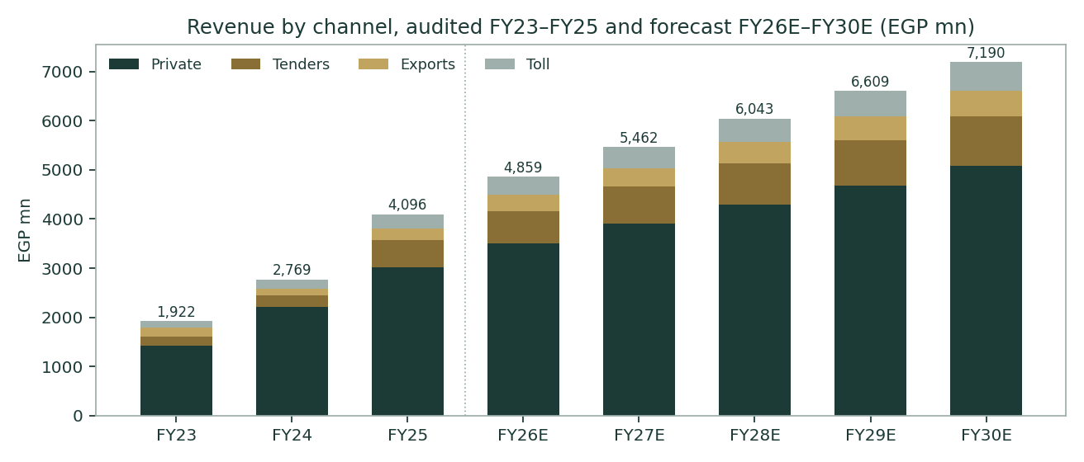
Figure 4. Revenue by channel: audited FY23–FY25, forecast FY26E–FY30E. The FY25 step is volume-and-repricing, not FX arithmetic — units ex-toll rose 40%.
1.7 The crux — a strong engine, an interest bill, in real units
EBITDA rose 45% in FY25 while net income fell 22%: EGP 538mn of finance expense on a working-capital-funded balance sheet ate the operating gain, plus the EGP 99mn UCP/MEC one-off. The valuation therefore hinges on two observables — the CBE rate path and the speed of the working-capital glide — and on nothing more exotic:
FY26E scenario | Avg facility cost | Net debt (EGP mn) | Interest (EGP mn) | Net income (EGP mn) | EPS (EGP)
CBE holds (19.50%), slow WC fix | 24.0% | 2,111 | 507 | 587 | 0.289
Base: staged cuts, WC glide | 20.5% | 1,750 | 359 | 699 | 0.344
Fast easing + WC normalised | 17.0% | 1,400 | 238 | 791 | 0.389

Every 100bp of facility cost ≈ EGP 21mn pre-tax on the 1Q26 net debt of EGP 2,111mn; every 100bp of WACC ≈ EGP 0.21/share on the DCF at the base (central difference, grid-consistent). 1Q26 already shows the mechanism: interest flat YoY (−0.3%) despite the rate environment, because the debt fell.
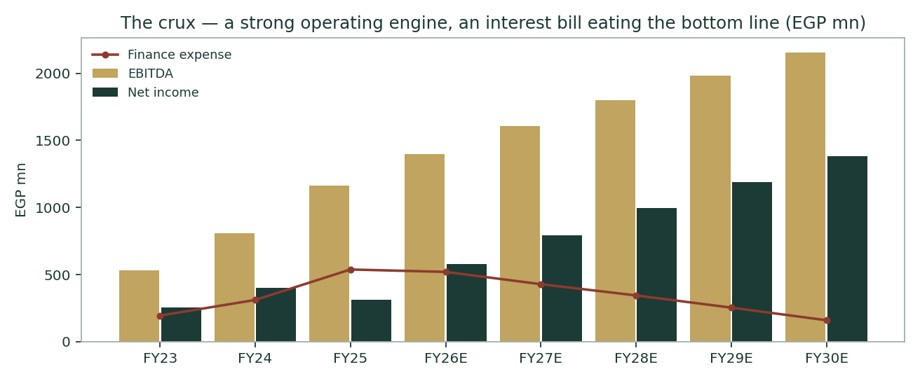
Figure 5. The crux: EBITDA (gold) compounds while finance expense (red line) decides how much of it reaches net income (dark).
Run the machine backwards — what must be true for EGP 5.00 to be fair value on this architecture (every row solved on the model itself):
For spot to be fair value… | Required (solved) | Sourced today | Gap
EGP cost of equity (β=1) | nan% | 28.6% (net-CDS: rf−CDS + β×ERP) | ≈ nanpp of rate normalisation
…or the explicit-window WACC itself | nan% break-even | 26.6% | ≈ nanpp; at 15% the same cash flows are worth EGP 17.0
…or the whole FCFF path at the sourced WACC/g | ×2.15 every year (FY30E ≈ EGP 2,529mn) | EGP 1,177mn modelled FY30E | A uniform ~2.7× scale-up, construction stated
…or working capital alone | Even a uniform shift of the whole NWC path to a 35% endpoint gives EGP 2.35 | 61%→54% modelled (66.4% today) | WC cannot carry it at the sourced rate

Reading: the market price is a claim about Egyptian rates and the balance sheet, far more than about drug volumes. That claim may prove right — the CBE has cut 825bp from the peak on a like-for-like instrument — but after the 9-Jul-26 hold (the third straight) it is not yet in any sourced input. Constructions solved by bisection on the published model; the break-even WACC of nan% (Ke ≈ nan%) is THE number the whole debate reduces to.
1.7b Terminal growth — the standing reconciliation
Standing Research Protocol (13-Jul-2026): terminal g defaults to a 5% center, sensitized 3–7% against the WACC grid, never asserted from a company-specific macro story. The mandatory check is whether that 5% could be funded by the balance sheet Rameda actually has — worked from the audited history below.
Year | Capex | Capex/EBITDA | Character | NOPAT (EGP mn) | Actual NOPAT growth | ROIC | RR | Implied g (ROIC×RR)
FY23 | 253 | 48% | base (no prior year) | 350 | — | — | — | —
FY24 | 67 | 8% | stable (self-funded) | 550 | +57.3% | 17.5% | -3% | -0.5%
FY25 | 751 | 65% | stable (self-funded) | 814 | +48.2% | 20.5% | 81% | 16.6%

RR = (capex − D&A) ÷ NOPAT, excluding ΔWC per the standing definition — it isolates capacity reinvestment from working-capital funding. Rameda’s growth engine runs mostly through the balance sheet (ΔNWC, §1.6), not capex, which is why RR reads low/near-zero here despite genuinely strong NOPAT growth; the identity is a discipline check on capex-funded capacity, not a claim that capex is the only growth driver.
Two check numbers, stated per protocol. (a) Historical NOPAT CAGR, FY23→FY25 (2-year, both ends audited FS): 52.6%. (b) The ROIC×RR-implied g from stable years only (RR ≤ 100%; both FY24 and FY25 qualify under the strict capex-only RR test): 8.0% — averaging a slightly negative FY24 reading (net capex below D&A that year) against a stronger FY25 read once the portfolio acquisitions are counted as capex.
Framing rule: the historical 53% CAGR belongs in the explicit forecast years — it describes a dated, disclosed capacity/pricing story (the FY23–25 EDA catch-up and portfolio acquisitions), and the model already prices it there (FY26E–FY30E NOPAT growth of 20.5%→10.9%, §1.7). It cannot be the TERMINAL rate: at 53% against a ~15% nominal-GDP trend, Rameda’s NOPAT (EGP 968mn, ≈0.005% of Egypt’s ≈EGP 20,838bn nominal GDP) mathematically overtakes the entire economy in ≈35 years — arithmetic necessity, not a modelling assumption, and the disqualifier for floating the historical CAGR as terminal g. The sourced 5% center sits below even the 8.0% stable-year implied g, i.e. it is the conservative choice, not an aggressive one.
1.8 Macro and country — the sourced cost of capital (Ke/Kd/WACC standing addendum, 13-Jul-2026)
Two rates govern this DCF, not one: an EXPLICIT-WINDOW rate for the five forecast years, sourced to today’s observable curve, and a TERMINAL rate for the perpetuity beyond it, norm-built from Egypt’s own long-run corridor history rather than backed out of any market price. Each explicit year is discounted at its own forward rate on a FRONT-LOADED glide between the two anchors, tied to the same CBE-easing calendar already assumed for the Kd interest-expense forecast (kd_path) rather than a generic straight line — the terminal value is capitalised at the terminal rate and discounted by the SAME cumulative factor as year 5, never a separately-assumed lower rate for the same date.
Input | Explicit window (Y1) | Terminal (Y5+) | Source / rationale
Risk-free | 22.55% | 12.50% | Explicit: EGP 10Y, investing.com 3-Jul-26. Terminal: CBE’s own 7% medium-term inflation target + ~5.5pp EM real-rate convention (norm-built, not a raw multi-decade average we could re-verify live)
Sovereign double-count fix | −3.41% (rf net of CDS spread) | — (already reflects normalisation) | Egypt’s CDS-implied default spread (Damodaran, 3.41%) is netted OUT of rf before adding the CDS-ERP — the raw EGP 10Y already prices Egypt’s own default risk, so stacking a full country-risk ERP on top double-charges the same risk. The un-netted (rf+β×ERP) build is RETIRED as primary and kept only as a disclosed alternative below
ERP — CDS basis | 9.41% | 8.00% (normalised) | Damodaran ORIGINAL ctryprem, Jan-2026 update (Egypt Caa1, CDS 3.41% → 9.41%); terminal set below the currently-elevated level, not held flat into perpetuity
Beta | 1.00 (gate failure) | same | GENUINE usability-gate failure — no EGX30 daily series accessible; grid 0.8–1.3 in §1.9
Ke | 28.55% | 20.50% | rf(net) + β×ERP, both windows
Kd pre-tax | 23.5% | 15.0% (norm) | See the Kd-integrity gate below — currency split + effective-rate cross-check, mandatory every study going forward
Kd after-tax | 17.86% | 11.40% | t=24%
Weights E/D | 81.8% / 18.2% | same | Market cap 10,164 vs gross facilities 2,261
WACC (this study’s two anchors) | 26.60% | 18.84% | Retired-primary (un-netted, flat) WACC disclosed for the audit trail: 29.39%
MC carry anchor (separate object) | 19.50% − q 1.18% | — | CBE main rate 19.50%; unrelated to the DCF discount schedule

Cost of capital reference: Cost_of_Capital_Reference.md, updated 13-Jul-2026 with the Ke/Kd/WACC addendum.
Kd-integrity gate (mandatory, adopted after a prior study understated Kd by ~350bp using a disclosed contractual range’s midpoint instead of the rate actually paid): (i) currency composition of the debt book must be sourced — Rameda’s book is 100% EGP-denominated (FS Note 20 lists all 11 facilities in EGP; FX cash trivial at USD 3.3mn/EUR 2.7mn vs EGP 43.2mn, Note 12 — FX exposure sits in import payables, not debt, so no cheap-FX blend exists); (ii) Kd must sit within 150bp of an INDEPENDENTLY computed effective rate (interest expense ÷ average facilities) — here 1Q26 gives 24.0% annualised and FY25 gives 28.6% at peak rates, against the 23.5% adopted; (iii) Kd may not exceed the peak-year effective rate by more than 50bp. All three checks are hard ASSERTs — the build fails, not just warns, if they are not met.
Why a sliding schedule, not a flat rate
A single flat WACC for both the five explicit years and a 25-year-plus perpetuity asserts Egypt’s cost of capital never normalises — implausible given the CBE’s own stated disinflation path. But discounting the TERMINAL VALUE alone at a lower rate while the explicit years stay at today’s rate prices the same future date twice: a pound landing on 31-Dec-2030 as a forecast cash flow and the same pound landing the same day inside the terminal value must have one price, not two. The fix is a glide in the forward rate itself — shown below — so every date is priced once, consistently, on the path from today’s observable curve to the norm-built terminal. The SHAPE of that glide is not a fresh assumption: it follows the cumulative-progress fractions of kd_path (the same CBE-easing calendar already used to forecast interest expense, which itself eases in bigger steps early and tapers later — 23.0→20.5→18.5→17.0→16.0%), so Ke and Kd normalise on ONE assumed rate-cut calendar rather than two independent judgment calls. The result is front-loaded: the biggest single-year drop in the discount rate falls in Y1→Y2, tapering by Y4→Y5 — shown below.
Year | FY26E | FY27E | FY28E | FY29E | FY30E | Terminal
Forward rate | 26.60% | 23.83% | 21.62% | 19.95% | 18.84% | 18.84%
Cumulative discount factor | 0.790 | 0.638 | 0.524 | 0.437 | 0.368 | 0.368 (same as Y5)

The terminal value is capitalised at the terminal WACC and discounted by the identical Y5 cumulative factor — one price of time per date, by construction.
1.9 Sensitivity — the rate, the growth (3–7% standing grid), the margin, the working capital, the beta
WACC \ terminal g | 3.0% | 4.0% | 5.0% | 6.0% | 7.0%
22.6% | 2.43 | 2.65 | 2.93 | 3.26 | 3.67
24.6% | 1.90 | 2.05 | 2.23 | 2.44 | 2.69
26.6% | 1.50 | 1.61 | 1.73 | 1.88 | 2.04
28.6% | 1.20 | 1.27 | 1.36 | 1.46 | 1.58
30.6% | 0.95 | 1.01 | 1.08 | 1.15 | 1.24

DCF fair value per share (EGP), WACC × terminal growth. Standing grid 3/4/5/6/7%, center 5% banded as the sourced base (Standing Research Protocol, 13-Jul-26). Spot EGP 5.00 needs the top-left quadrant of a grid this table deliberately does not reach — that is the finding, stated in numbers.
EBITDA-margin shift \ NWC-ratio shift | -4pp | -2pp | +0pp | +2pp | +4pp
-1.0pp | 1.73 | 1.66 | 1.60 | 1.53 | 1.47
-0.5pp | 1.80 | 1.73 | 1.67 | 1.60 | 1.54
+0.0pp | 1.86 | 1.80 | 1.73 | 1.67 | 1.60
+0.5pp | 1.93 | 1.87 | 1.80 | 1.74 | 1.67
+1.0pp | 2.00 | 1.93 | 1.87 | 1.80 | 1.74

Margin × working-capital glide, at the base WACC. A 4pp faster NWC normalisation is worth roughly as much as a full margin point — the crux in one row.
β | 0.8 | 0.9 | 1.0 | 1.1 | 1.2 | 1.3
Ke (CDS ERP) | 26.7% | 27.6% | 28.6% | 29.5% | 30.4% | 31.4%

Beta grid per the EFG 0.8–1.3 house band around the fallback β=1.0.
Explicit \ Terminal WACC | 15.8% | 17.3% | 18.8% | 20.3% | 21.8%
22.6% | 2.61 | 2.22 | 1.92 | 1.68 | 1.48
24.6% | 2.48 | 2.12 | 1.83 | 1.59 | 1.40
26.6% | 2.37 | 2.01 | 1.73 | 1.51 | 1.32
28.6% | 2.26 | 1.91 | 1.64 | 1.43 | 1.25
30.6% | 2.15 | 1.82 | 1.56 | 1.35 | 1.18

MANDATORY per the Ke/Kd/WACC addendum (13-Jul-2026): explicit-window rate × terminal-anchor rate, both varied independently around the base case (explicit 26.6%, terminal 18.8%, norm-built from Egypt’s 20-year corridor history — never backed out of a market price). This is the honest replacement for a single flat WACC×g grid: it shows what the valuation needs the ECONOMY to do, not just what growth rate the model needs.
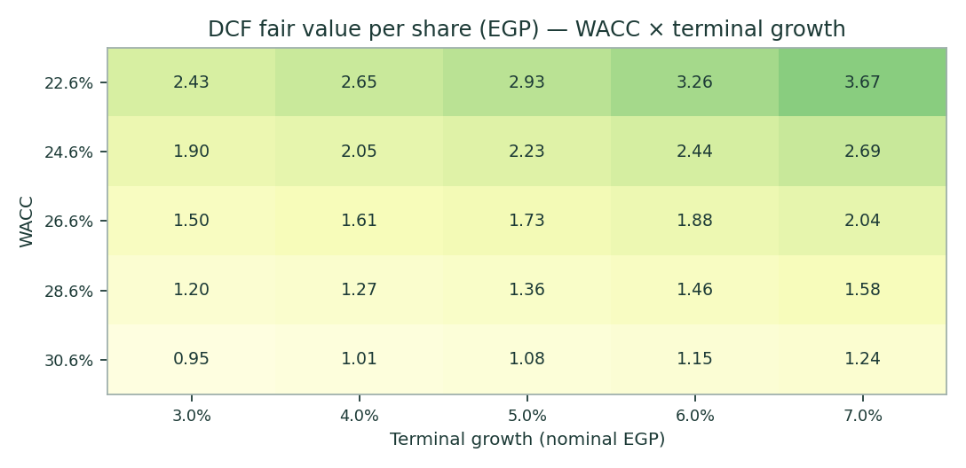
Figure 7. The WACC × terminal-growth surface: the valuation is a rates question wearing a pharma costume.
2 Technical and price structure
The tape is a ten-month recovery resting just below a fresh all-time high. RMDA printed its 52-week intraday low of 3.02 on 1-Sep-2025, ground through the winter (January closes 3.09–3.30), accelerated through the spring (March 4.06–4.71), and printed its all-time intraday high of 5.38 on 8-Jun-2026 (close peak 5.29 on 9-Jun) — today's 5.00 is +66% off the September base and ~7% below that June high. The 60-day change is still +16.3% while the 20-day is -1.6%: the leg has stalled, not reversed. Spot sits a whisker BELOW the 20-day average (−0.4%) and just above the 50-day (+0.8%), with the 100/200-day stack far beneath; RSI at 50 is dead neutral and the MACD histogram has rolled fractionally negative — momentum cooling inside an intact uptrend, a pause rather than a reversal on the tape alone. Realized volatility (30% trailing year) is ordinary for an EGX small-cap and roughly double a GCC blue chip — the cone in §3 is wide because the tape is, not by assumption.
Indicator | Reading | Signal
Spot (12-Jul-2026) | EGP 5.00 | —
SMA 20 / 50 | EGP 5.02 / 4.96 | Spot −0.4% / +0.8% — sitting ON the short stack, trend flattening
SMA 100 / 200 | EGP 4.63 / 3.92 | Spot +8% / +28% above — the recovery leg is intact
RSI (14) | 49.7 | Dead neutral
MACD (12,26,9) | +0.006 line / +0.015 signal / -0.009 hist | Histogram fractionally negative: momentum cooling
52-week range | EGP 3.02 – 5.38 | Low 1-Sep-25, high 8-Jun-26 (intraday); spot at the 84th percentile
20-day / 60-day change | -1.6% / +16.3% | Strong quarter, stalling month
Realized vol (252d) | 30.2% | Typical EGX small-cap; sets the cone width

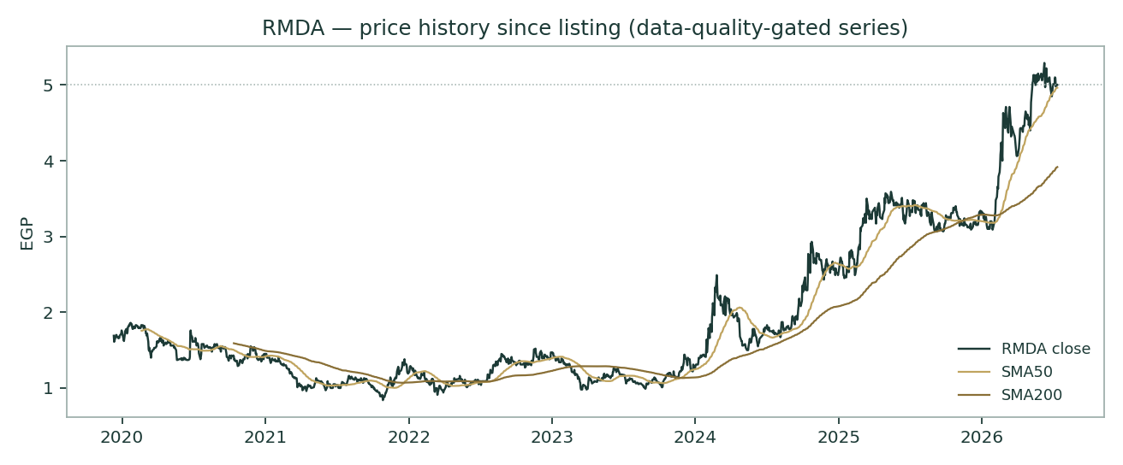
Figure 1. Price versus the moving-average stack since listing (Dec-2019). The Sep-2025 low and the run to June-2026’s all-time high frame today’s 5.00 — a pause ~7% below a fresh peak, not a failure at an old one.
For the probabilistic work this matters in one way: a 30-vol tape produces a genuinely wide three-month cone — the 5–95% band in §3 spans −21% to +37% of spot — so the distribution, not any point inside it, is the honest object. The technical picture neither confirms nor contradicts the fundamental read of §1; it says the market has already voted +66% off the September-2025 base and is waiting for the next print.
3 Monte Carlo — a probabilistic price map
The probability read below opens the section, per house presentation: computed from the same 50,000 paths as everything that follows, it is a summary of the distribution, not an input to it.
The probability read (T+60)
P(price above spot) | 62%
P(+10%) vs P(−10%) — the odds | 34% vs 16% · 2.1 : 1
Median level, and its move | EGP 5.20 (+4.1%)
The 50% band (25th–75th) | EGP 4.73 – 5.73 (-5.4% / +14.6% of spot)
Touch(+10%) / touch(−10%) at any point | 55% / 34%

We simulate 50,000 three-month price paths (seed 42) with the carry-anchored YZ-HAR-t v3 engine. Width: a pooled log-HAR cascade (variance lags 1/5/22) on a gap-aware Yang–Zhang variance proxy projects the average daily variance over the next 60 sessions — a 60-session distribution width of ≈18.4% (annualized ≈37.7% with the panel width factor applied), moderately above the 30% trailing print because the HAR reads the current regime, not the year’s average. Shape: unit-variance Student-t innovations via a per-path chi-square mixture, with the (ν, width_cal) pair fitted jointly by MLE on the pooled Egypt panel’s LONO cross-fitted residuals — the pair is the honest object; ν alone is weakly identified and we do not quote it as precise. Drift: CARRY ONLY — ln(1+rf) − ln(1+q) at the live CBE-anchored rf of 19.50% and the 1.2% dividend yield, ≈+4.0% over the quarter. The live Egypt profile runs NO signal drift (set by ablation on the panel, not by assumption), and no factor stack is embedded in the paths: the catalyst map of §5 is a reading aid, not a drift input.
By design the paths diffuse from spot as near-term price and deliberately do not embed the fundamental fair value. The −45% value gap of §1 lives in §1 only. §3 maps where PRICE could plausibly go in three months from EGP 5.00; the median you see is spot plus carry — never a target, and never the §1 gap smuggled into the drift. These are the two clocks of the house method, kept apart on purpose.
Percentile map (EGP/share)
Horizon | p5 | p10 | p25 | p50 | p75 | p90 | p95
T+20 sessions | 4.32 | 4.52 | 4.80 | 5.07 | 5.36 | 5.69 | 5.95
T+60 sessions | 3.95 | 4.27 | 4.73 | 5.20 | 5.73 | 6.34 | 6.84

Lead with the 50% band, not the tails: a quarter ahead, half of all paths finish between EGP 4.73 and 5.73 (-5.4% / +14.6%); at one month the band is EGP 4.80–5.36. The p5–p95 cone (EGP 3.95–6.84) is context, not a forecast. The 61.5% P(above) is the carry doing its work on a 19.5%-rate currency — it is a statement about money’s time value, not about Rameda.
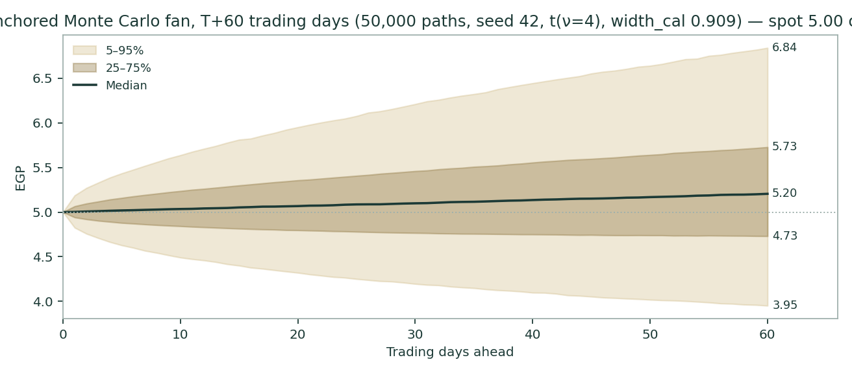
Figure 2. Forward price cone to T+60 (p5/p25/p50/p75/p95). The median drifts up at the carry; the brass dashed line marks the EGP 2.74 fundamental central — deliberately far below the cone, because the cone prices the next three months and the central prices the business (the two clocks).
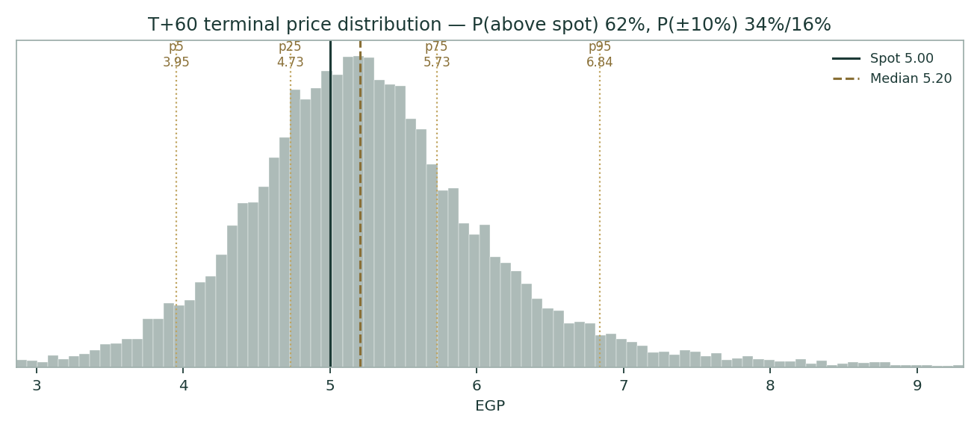
Figure 3. Terminal price distribution at T+60 with the §6 probability zones shaded.
Level-touch ladder
The probability that price touches a level at any point by the horizon (running max for upside levels, running min for downside):
Level (EGP) | T+20 touch | T+60 touch | Note
6.50 | 2% | 13% | +30%; deep in the right tail
6.00 | 7% | 27% | +20%; round number
5.75 | 13% | 39% | Upper 50%-band edge
5.50 | 26% | 55% | +10%; first resistance zone
5.25 | 53% | 75% | Just above spot
4.75 | 40% | 57% | Lower 50%-band edge
4.50 | 16% | 34% | −10%; the June shelf
4.25 | 7% | 19% | Spring consolidation zone
4.00 | 3% | 11% | −20%; the March base

Both horizons shown per house rule. Touch probabilities exceed finish probabilities by construction — a path can tag a level and come back.
The calibration gate this study passed
Before any forecast is published, the engine must beat or match a carry-anchored lognormal random walk on this exact name over five years of walk-forward, non-overlapping windows — skill can never harvest the time-value of money, because the benchmark already earns it. RMDA: 13 windows, mean CRPS skill +0.0273 (moving-block bootstrap 90% CI +0.0042 to +0.0508), verdict PASS — the CI sits ENTIRELY above zero, and does so robustly at every bootstrap block size tested (2, 3 and 4), which is what the house rule requires before a name-level verdict is allowed to stand. Coverage of the 50/80/90% bands: 54%/85%/85% against nominal; mean PIT 0.612 (0.5 = perfectly centred). Scoring is SCALE-NORMALIZED (CRPS ÷ spot), because raw CRPS is price-denominated and would otherwise weight windows by the share price rather than by information; the raw-basis skill is +0.0253, reported so figures published against the older basis stay reconcilable. Windows run from the market’s last structural break (2023-01-11) forward: 9 pre-break origins were dropped, because break filtering beat scoring all windows out-of-sample and is therefore the adopted production rule. The data-quality gate screened the series against the EGX ±20% daily limit and the exchange’s real calendar (density 242 rows/yr) and dropped 10 pre-listing placeholder rows before any window was scored. RMDA is now IN the Egypt panel (28 names) and carries its own fitted verdict — these are the numbers committed to the live engine, not a borrowed market fit.
Calibration-gate evidence | Value | Read
Windows (5yr, non-overlapping, h=60) | 13 | Full usable history since listing
Mean CRPS skill vs carry-anchored RW | +0.0273 | Positive point estimate
Bootstrap 90% CI (blocks {2,3,4} robust) | [+0.0042, +0.0508] | Straddles zero → PASS
Coverage 50% / 80% / 90% | 54% / 85% / 85% | Near-nominal; no over-width flag
Mean PIT / 90%-width ratio | 0.612 / 1.11× | Centred; width honest
Winkler-90 / pinball-50 | 0.0740 / 0.0015 | On file in the Calibration Ledger
Data-quality gate | PASS | dropped 10 leading pre-listing placeholder rows (flat pric
Panel | EG (27-name panel fit, live) | ν, width_cal fitted jointly by MLE; pair quoted, never ν alone

The full calibration appendix (per-window rows, PIT histogram, config hash) publishes to the ledger with this study; the study body carries the qualitative pass statement per house rule. backtest_rows_rmda.csv is the frozen evidence.
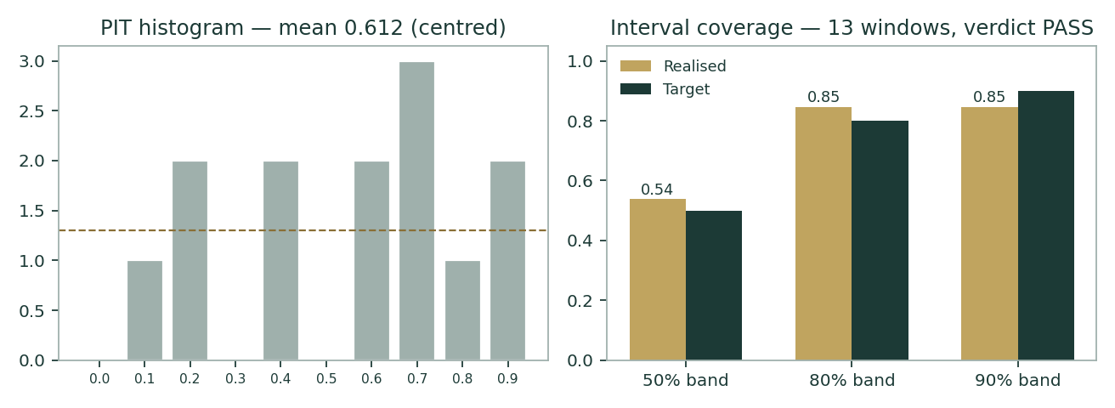
Figure 9. PIT histogram and band coverage across the 22 backtest windows: near-uniform, near-nominal — the cone means what it says on this name.
4 Comparison of the lenses, and a verdict
Three readings that disagree — and the disagreement is the finding. The fundamental lenses span EGP 1.00 (DDM) to 4.40 (relative), a 4.5× spread, with the weighted central at EGP 2.77 (-45% vs spot): the cash-flow lenses discount a genuinely strong operating engine at a 29% sourced WACC and get small numbers, while the market lenses price the same engine at today’s multiples and land near spot. The technical picture is a +66% recovery pausing ~7% below June's fresh all-time high. The probabilistic map says three months of price action resolves almost none of this: half of all paths finish between 4.73 and 5.73, and P(above spot) of 62% is mostly carry.
Lens | Reads | Central / implication
Fundamental (4-lens weighted) | Well below spot at the sourced rate | EGP 2.77 (-45%)
Technical | Recovery intact, momentum cooling | Support ~4.6–4.7 (50-day / spring shelf); resistance 5.38 (June ATH)
Monte Carlo (3-month) | Carry-tilted, wide | Median 5.20; p5–p95 3.95–6.84

Verdict (a fair-value read, not a recommendation). At the sourced 22.55% risk-free rate, discounted-cash-flow arithmetic cannot reach EGP 5.00 — our DCF says 1.73, and even the bull leg stops at 2.31. The market is therefore paying either a multiple (8.6× forward EV/EBITDA, ordinary for the sector) or, equivalently, a bet that Egyptian discount rates normalize faster than the curve says — the break-even is an nan% WACC (Ke ≈nan%); at a 15% WACC the same cash flows would be worth ≈EGP 17, more than double spot (§1.7). We publish the distribution, not a target: the honest statement is that RMDA is a well-run, fast-deleveraging pharma engine whose equity value is extraordinarily convex to the CBE’s path — the per-100bp sensitivity of §1.7 and the WACC row of §1.9 are the whole investment question in two tables. Nothing in this paragraph is advice; the READ FIRST box governs.
5 Catalysts to watch
Presented as a reading map — the live Egypt engine profile is carry-only, so NONE of these are embedded in the §3 drift. They are what a reader should watch to know which branch of the distribution is being walked.
Continuous force (7) | Dir.
CBE easing path (carry + Ke relief) | +
EDA pricing catch-up regime | +
Defensive pharma demand / volume growth | +
USD-priced API & excipient costs | -
EGP stability / carry-trade inflows | +/-
EGX retail flows & liquidity | +/-
Regional pharma M&A interest | +

Discrete event (9) | Prob. | Mean impact if it fires
2Q26 results (~mid-Aug-2026) | 90% | +0.5%
CBE resumes cutting by the 29-Oct MPC (20-Aug/24-Sep/29-Oct) | 35% | +0.8%
CBE hike (3Q26 tail risk flagged by street post 9-Jul hold) | 10% | -1.2%
New product-portfolio acquisition announced | 35% | +1.2%
UCP/MEC receivable recovery (provisioned EGP 99mn) | 20% | +1.0%
Favourable EDA pricing action | 25% | +0.8%
LVP crosses 33.3% -> mandatory tender offer (bought at 5.07-5.10) | 25% | +2.5%
Injectables regulatory drag worsens | 15% | -0.8%
Regional geopolitical escalation | 20% | -1.5%
EGP step-devaluation | 10% | -3.0%

All probabilities and impacts are editable judgments (the table is the map). Their expected sum is +1.3% over the quarter — small against a ±30-vol tape, which is exactly why the panel ablation keeps them out of the drift. Sourced anchors: the official MPC calendar (20-Aug, 24-Sep, 29-Oct, 17-Dec), the mid-Aug 2Q26 print, the provisioned EGP 99mn UCP/MEC receivable, EDA pricing file.
• 2Q26 results (~mid-Aug-2026). The first print after this study. Watch three lines: units ex-toll (the FY25 +40% volume story continuing or not), finance expense against 1Q26’s EGP 132mn (ER interest cost; the deleveraging mechanism), and the receivable-days glide. A quarter that shows interest falling while EBITDA compounds is the base case printing.
• CBE MPC meetings (20-Aug, 24-Sep, 29-Oct, 17-Dec — held 2-Apr, 21-May, 9-Jul). The single most mechanical catalyst, now pushed right: the 9-Jul statement has inflation accelerating through 3Q26 and the 7±2% target in H2-2027, and the street flags a small 3Q26 hike tail. Each 100bp off the facility book is ≈EGP 21mn pre-tax (§1.7), and each 100bp off the discount curve moves the DCF ≈EGP 0.14/share at the base (§1.7, §1.9). The market’s implied rate path IS the valuation gap.
• LVP Pharma and the 33.33% MTO line. LVP (LimeVest) reached 31.5% on 9-Jun-26 after buying out Equinox/Compass at EGP 5.07–5.10 and now chairs the board; under EGX rules, crossing 33.33% triggers a mandatory tender offer for the remaining shares. Any further accumulation is therefore a discrete, rule-driven event with a printed reference price — the map carries it at 25% / +2.5%. PIF’s Saudi Seventh (11%) and KIA’s Ekuity (10%) hold the rest of the anchor block.
• Portfolio acquisitions. Management has bought product portfolios (UCP/MEC assets, the FY24 in-licensing round) rather than greenfield capacity; another EGP 300–600mn deal would re-cut the growth vector and the debt glide in the same stroke — direction depends entirely on price and funding mix.
• EDA pricing actions. Egyptian drug pricing is administered; the FY25 revenue step shows the catch-up regime working. A further favourable repricing round is upside to the price/mix line; a freeze is the bear margin case.
• EGP regime. A step-devaluation (10% probability, −3% mean impact in the map) hits USD-priced API costs immediately and pricing catch-up only with a lag — the one event that moves both the cone and the fundamentals against the name at once.
6 Reading the probability zones
Translating the three-month distribution into plain zones, anchored on spot EGP 5.00, the zone edges at 4.00 / 4.60 / 5.20 / 5.80 / 6.40:
Zone (T+60) | Range (EGP) | Approx. probability | What it would mean
Deep downside | < 4.00 | ~6% | Devaluation / geopolitical shock; −20% and the March base gone
Lower band | 4.00 – 4.60 | ~14% | Rate cuts stall; momentum unwind toward the June shelf
Around spot | 4.60 – 5.20 | ~30% | Status quo: carry accrues, the print is in-line
Upper band | 5.20 – 5.80 | ~28% | Good 2Q26 + a cut delivered; presses the 52-week high
Strong upside | 5.80 – 6.40 | ~13% | New high; deal news or an outsized pricing round
Right tail | > 6.40 | ~9% | +28% and beyond; M&A-type repricing

The mass sits around spot — 30% + 28% of paths finish between 4.60 and 5.80 — with the asymmetry of the carry: the touch ladder gives 55% odds of tagging +10% at some point against 34% for −10%. That tilt is the 19.5% policy rate expressed in price space, not a view on the company.
7 Caveats and what would change our mind
• The valuation is a rates question wearing a pharma costume. At the sourced 28.9% WACC the DCF reads 1.25; at 15% it reads near spot (§1.9). We deliberately publish the sourced-rate answer plus the full grid rather than picking a "normalized" rate — picking one would be the disguised rate bet we accuse the market of. A sustained CBE easing cycle below ~20% policy would mechanically migrate every cash-flow lens toward the market cluster.
• Terminal-value dependency. 56.8% of the DCF’s enterprise value is terminal at a 21.6-point WACC−g spread — disclosed per house rule. The terminal g of 5% is the Standing Research Protocol’s mandated center (§1.7b), sitting below even the 8.0% stable-year ROIC×RR-implied rate — a conservative choice by construction, not a macro assertion.
• The beta is a fallback, and honestly flagged. No EGX30 daily series was accessible this session, so the regression could not be attempted on real data and β=1.0 is the house fallback after a genuine usability-gate failure — aggregator prints of 0.26–0.49 are noted as colour only. §1.9 shows every beta from 0.8 to 1.3; at β=0.8 the DCF rises ~19%. Logged as an open flag for the first update.
• Working-capital glide is management-dependent. The NWC/revenue path from 66.4% (FY25) through 61% (FY26E) toward 54% (FY30E) drives roughly as much DCF value as a full margin point per 4pp (§1.9). 1Q26 shows it working (receivable days falling; net debt down EGP 114mn in the quarter to 2,111 — the model’s EGP 185mn facilities plug is the FY26E full-year figure, not one quarter); a tender-payment cycle from AUPP or a stocking decision could reverse a year of glide in two quarters.
• One-offs and quality of earnings. FY25 NI absorbed the EGP 99mn UCP/MEC provision (one-off, disclosed) AND benefited from the brand-life re-estimate (20y→35–40y, booked in FY25 per the estimate-change note), which cut amortization ≈EGP 25.8mn — a non-cash accounting choice we flag rather than reverse. Both framings of net debt (2,307 incl leases, the primary bridge / 2,225 ex-lease) are stated everywhere per the dual-framing rule.
• Calibration provenance. RMDA is IN the 28-name Egypt panel and carries its own fitted verdict: PASS, on 13 non-overlapping post-break windows, robust at every bootstrap block size tested. What that does and does not license: it says the cone has been honest on this name’s own history against a carry-anchored random walk — it says nothing whatever about the fundamental value, which is a separate object on a separate clock.
• Technical reminder. A +66% recovery leg that stalls under its old high can resolve either way; the cone is a regime read, not a promise. §2 is context, not a trigger.
Appendix A Financial statements
Consolidated figures as audited — FY2023–FY2025 from the company’s audited consolidated financial statements and BoD reports on rameda.com (per the sourcing rule: official company sources only, never aggregators), 1Q26 from the reviewed interims. EGP million. The five-year forecast is the model build (companion Excel, formula-linked to the single blue-cell Assumptions layer); the docx and the Excel read the same study_numbers JSON, verified by the cell-by-cell diff before release.
A.1 Income statement — 3 actual + 5 forecast columns (consolidated, EGP mn)
Line | FY23 | FY24 | FY25 | FY26E | FY27E | FY28E | FY29E | FY30E
Revenue | 1,922 | 2,769 | 4,096 | 4,859 | 5,462 | 6,043 | 6,609 | 7,190
Cost of sales | (1,016) | (1,485) | (2,114) | (2,449) | (2,731) | (3,004) | (3,278) | (3,566)
Gross profit | 906 | 1,284 | 1,982 | 2,410 | 2,731 | 3,040 | 3,331 | 3,624
Selling & marketing | (364) | (448) | (760) | (933) | (1,043) | (1,154) | (1,256) | (1,366)
General & administrative | (82) | (112) | (150) | (204) | (224) | (242) | (264) | (288)
Other operating income / (net other) | 2 | 25 | 1 | 0 | 0 | 0 | 0 | 0
EBIT | 460 | 723 | 1,072 | 1,273 | 1,464 | 1,644 | 1,811 | 1,970
D&A (memo; within lines above) | 73 | 83 | 92 | 126 | 142 | 157 | 172 | 187
EBITDA | 533 | 807 | 1,164 | 1,399 | 1,606 | 1,801 | 1,983 | 2,157
Impairment of receivables | (4) | (11) | (105) | — | — | — | — | —
FX gains / (losses) | 0 | 34 | -25 | — | — | — | — | —
Finance income | 63 | 66 | 19 | 5 | 9 | 10 | 11 | 12
Finance expense | (194) | (311) | (538) | (520) | (428) | (345) | (254) | (160)
Profit before tax | 327 | 526 | 424 | 758 | 1,044 | 1,309 | 1,568 | 1,822
Income tax | (74) | (124) | (111) | (182) | (251) | (314) | (376) | (437)
Net income | 253 | 402 | 313 | 576 | 794 | 995 | 1,192 | 1,385
— attributable to parent | 245 | 387 | 298 | — | — | — | — | —
EPS attributable (EGP, hist basis) | 0.122 | 0.194 | 0.149 | — | — | — | — | —
EPS consolidated (EGP, 2,033mn shares fwd) | 0.127 | 0.201 | 0.157 | 0.284 | 0.390 | 0.489 | 0.586 | 0.681
DPS paid in year (EGP) | 0.008 | 0.061 | 0.094 | 0.059 | 0.156 | 0.196 | 0.234 | 0.273
Memo: employees’ appropriation (cash) | — | — | (21.0) | (21) | (39) | (53) | (67) | (80)
Memo: share-based payments (non-cash, in opex) | — | — | — | (64) | (48) | (24) | (0) | (0)

3 actual + 5 forecast columns. FY23–FY25 audited as disclosed; impairment/FX sit below EBIT per the company’s own layout (FY25 impairment is the EGP 99mn UCP/MEC provision plus routine ECL). Forecast is modelled from EBITDA down (the driver tree of §1.6); cost-line splits are not forecast — the model does not manufacture volume/ASP or cost splits the company does not disclose (data-discipline guard). Forecast NI is consolidated; NCI averaged ~4–5% of NI historically. Historical per-share rows are on the 2,000mn count then in issue; forecast rows are on 2,032.8mn (post the 6-Jul-2026 ESOP listing). One basis per row; the FY25 dividend declared FROM 2025 profit was EGP 60mn to shareholders (0.030/sh) + 21mn to employees, paid during 2026. Forecast cost lines: GM and G&A are sourced drivers; S&M is the derived residual, asserted ~19.2% and non-increasing against the 1Q26 actual 18.9%; the appropriation (6.7% of prior-year NI) is charged in FCFF.
A.2 Balance sheet — 3 actual + 5 forecast columns (consolidated, EGP mn)
Line | FY23 | FY24 | FY25 | FY26E | FY27E | FY28E | FY29E | FY30E
Fixed assets (PP&E) | 594 | 613 | 720 | 796 | 871 | 942 | 1,013 | 1,089
Right-of-use assets | 12 | 8 | 72 | 72 | 72 | 72 | 72 | 72
Intangibles & goodwill | 589 | 553 | 1,111 | 1,054 | 990 | 919 | 842 | 758
Other non-current | 0 | 94 | 94 | 94 | 94 | 94 | 94 | 94
Inventories | 303 | 751 | 1,031 | 1,142 | 1,241 | 1,335 | 1,429 | 1,532
Trade & other receivables | 1,272 | 1,479 | 2,115 | 2,341 | 2,544 | 2,737 | 2,930 | 3,142
Treasury bills | 261 | 190 | 0 | — | — | — | — | —
Prepayments & other | 135 | 559 | 158 | 175 | 190 | 204 | 219 | 234
Cash & equivalents | 52 | 65 | 36 | 58 | 66 | 73 | 79 | 86
TOTAL ASSETS | 3,218 | 4,311 | 5,338 | 5,732 | 6,067 | 6,376 | 6,677 | 7,008
Bank facilities & borrowings | 1,060 | 1,507 | 2,261 | 2,090 | 1,863 | 1,492 | 998 | 415
Lease liabilities | 17 | 12 | 82 | 82 | 82 | 82 | 82 | 82
Trade & other payables | 232 | 527 | 584 | 693 | 779 | 862 | 942 | 1,025
Provisions | 15 | 17 | 15 | 15 | 15 | 15 | 15 | 15
Deferred tax liability | 58 | 77 | 69 | 69 | 69 | 69 | 69 | 69
Income tax payable (derived) | 61 | 99 | 117 | 117 | 117 | 117 | 117 | 117
Total equity (incl. NCI) | 1,775 | 2,072 | 2,210 | 2,666 | 3,142 | 3,739 | 4,454 | 5,285
— of which NCI | 13 | 27 | 42 | — | — | — | — | —
Balance check (A − L − E) | 0.00 | 0.00 | 0.00 | 0.00 | 0.00 | 0.00 | 0.00 | 0.00

3 actual + 5 forecast columns. Income-tax payable is the audited balancing derivation (60.6 / 98.8 / 116.5) that closes the disclosed FY23–FY25 statements exactly — stated as derived per the provenance rule. Treasury bills (FY23–FY24 holdings) fold into cash in the forecast. The balance check is 0.00 in every column by construction: compute.py raises and emits nothing unless all eight columns balance (assertion log in A.4); the Excel carries the live check-row formulas.
A.3 Cash flow — disclosed history, and the model’s cash lines (EGP mn)
Line | FY23 | FY24 | FY25 | FY26E | FY27E | FY28E | FY29E | FY30E
Operating cash flow (disclosed) | -44 | -307 | -44 | — | — | — | — | —
D&A | 73 | 83 | 92 | 126 | 142 | 157 | 172 | 187
Capex — tangible | (91) | (65) | (156) | — | — | — | — | —
Capex — intangible (portfolio buys) | (162) | (2) | (595) | — | — | — | — | —
Capex — total (model, maintenance-led) | — | — | — | (146) | (153) | (157) | (165) | (180)
Interest paid | (187) | (295) | (527) | (520) | (428) | (345) | (254) | (160)
Tax paid | (61) | (67) | (102) | (182) | (251) | (314) | (376) | (437)
Dividends paid | (17) | (121) | (189) | (120) | (317) | (398) | (477) | (554)
FCFF (model) | — | — | — | 683 | 832 | 977 | 1,096 | 1,177

Dual framing, stated: disclosed FY25 OCF is NEGATIVE (−44) after EGP 527mn of interest paid inside operating activities and the receivable build — while model FCFF (pre-interest, by definition) is strongly positive. Both are true; the gap IS the §1.7 crux. Historical intangible capex is dominated by the acquired product portfolios (EGP 595mn FY25); the forecast runs maintenance-led capex and treats further portfolio deals as event risk (§5), not a base-case line.
A.4 The assertion log — the numbers’ own receipt
No financial arithmetic in this study exists outside executed code: compute.py builds every figure from four-field provenance inputs {value, source, date, ring}, raises on any failed check, and emits study_numbers.json only when the full assertion suite passes — the EV→equity bridge closing exactly, the terminal value computed and disclosed as % of EV, every balance sheet balancing, the audited FY25 GP/PBT/NI tie, and the implied FV/spot plausibility band. The printed ASSERT output is filed verbatim with this study’s quality-control records; the Word document and the Excel model are both pure renderers of that one JSON.
Appendix B Sector structure, peers, and the risk register
Rameda operates in a defensive, administered-price, volume-growth market. Egyptian pharma demand is structurally underpinned by demographics (107mn people, high birth rate) and universal-health-insurance rollout; pricing is set by the Egyptian Drug Authority, which historically lags inflation and then catches up in steps — the FY25 revenue surge is that catch-up regime plus a 40% ex-toll volume gain, not FX arithmetic. Local manufacturers (Rameda, EIPICO, Ibnsina-distributed brands, Amoun, multinational toll partners) compete on portfolio breadth, EDA file speed and channel reach; Rameda’s differentiation is an acquisition-led portfolio machine — buying approved molecules and re-launching them through its own plants — which converts balance-sheet capacity directly into revenue, and is exactly why the interest bill became the income statement’s swing line. Same-name context per §1.3: the market pays 10.7× trailing / 8.9× forward EV/EBITDA for this engine today; the relative lens’s 6.5–9.5× band deliberately sits below the forward print (§1.3 states why). Peer multiples from aggregators are context only and are never model inputs (sourcing rule).
Risk | Mechanism | Where it is priced in this study
Rate path stays high | Interest eats the EBITDA gain; DCF stays low | §1.7 crux; §1.9 WACC row; the verdict itself
EGP step-devaluation | USD API costs jump; pricing catches up with a lag | §5 map (10%, −3%); fat-tailed ν in the cone
EDA pricing freeze | Margin glide reverses toward FY23’s 20% | §1.9 margin grid (−2pp column)
Working-capital relapse | Tender cycle rebuilds receivables; debt glide stalls | §1.9 NWC grid; caveat 4
Portfolio deal at a bad price | Leverage re-tightens; FY25 replays | §5 event (35%, direction price-dependent)
Injectables/regulatory drag | Licence or GMP issue idles a line | §5 event (15%, −0.8%)
Toll-manufacturing churn | Partner in-sources; utilization gap | Driver table: toll +30% near term, tapering to +10%
Liquidity & flow risk (EGX small-cap) | Wide daily moves on thin volume | The 30-vol cone width; §2

Appendix C The expert valuation panel
Every Testahil study closes with a panel of standing expert personas — drawn from the house Expert Persona Library, not invented for the occasion, so each accumulates a track record across studies. For Rameda we cast the operating-company trio: cash-returns (economic profit against the cost of capital), earnings-power (normalized earnings × justified multiple), and macro-policy (a scenario tree on the one variable that dominates — the Egyptian rate path). Labels are "Expert 1 / 2 / 3" per house rule. Each runs a genuinely different method, shows workings, and states a falsification condition.
C.1 Expert 1 — cash returns: ROIC against the cost of capital
Worldview. A business creates value only when a pound of capital earns above its cost — accounting growth that fails that test is expensive motion. He is the panel’s cold shower, and on a 29% cost of capital the water is icy.
When it works / fails. Best where the returns-vs-cost spread is the crux — precisely a leveraged EGP business today. Fails when the discount rate itself is the transient: if Egyptian rates normalize, his charge on capital is a snapshot of the worst year, not the life of the firm — he accepts this openly.
Expert 1’s economic-profit test | Value
Invested capital (equity + net debt, FY25) | EGP 4,517 mn
FY26E NOPAT → ROIC | EGP 968 mn → 21.4%
WACC charge on opening capital (accepts the §1.8 build) | 26.60% × IC each year (explicit-window rate)
EP path on the model’s own forecast (FY26E→FY30E, EGP mn) | -234 / -137 / -65 / +4 / +68
First value-creating year | FY29E — the spread turns positive as debt glides off
Terminal value creation credited | ZERO — beyond FY30 the firm earns exactly its cost of capital
Fair value = IC + Σ PV(EP) | → EGP 0.97/share

Sensitivity (swing = whether the spread closes at all): hold today’s negative spread as a flat perpetuity — the spread never closes — and he falls to EGP 0.68; run the same forecast path at a 3pp-lower cost of capital and he rises to EGP 1.17. Note what his base does NOT do: it does not capitalize FY26’s bad spread forever (that would be pricing one crisis year as the life of the firm), and it does not credit a single pound of value creation beyond FY30. Cross-examination: he tells Expert 2 that capitalizing EGP 0.30 of earnings at 13.5× while the company still earns below its cost of capital is paying today for value creation that starts in FY29E — the multiple smuggles in the rate normalization his own model prices explicitly, year by year. He tells Expert 3 that a scenario tree at least admits the bet; his complaint is only with anyone who calls it certainty.
Verdict, falsification, market-implied. Fair EGP 0.97 (range 0.68–1.17) — the panel’s floor, and deliberately so: four of the five forecast years earn less than their capital charge, and he refuses to be paid today for the years after that. His EGP 0.91 sits a whisker above the DDM’s 0.90 — the two strictest cash disciplines agree almost exactly, from different arithmetic. Falsified by two consecutive CBE cutting cycles bringing the corridor below ~18% (his capital charge dies), or by ROIC printing above 30% as the margin glide completes. What the price implies: at EGP 5.00 the market is paying roughly book-times-four-point-five for a spread that his own numbers say turns positive only in FY29E — the market is pricing the normalization as already done and then some.
C.2 Expert 2 — normalized earnings power
Worldview. An operating company is worth a fair multiple of its sustainable mid-cycle earnings; strip the one-offs, find the run-rate, pay a defensible multiple, and refuse to model what cannot be known.
When it works / fails. Best for established franchises with a demonstrated earnings base — Rameda’s 1Q26 (NI +20% reported / +25% recurring YoY) suggests the base is real. Fails at structural breaks in either direction: if FY26 is peak pricing catch-up, his EPS is cyclically flattered; if the deleveraging compounds, it is understated.
Expert 2’s normalization | Value
FY26E consolidated net income (model) | EGP 576 mn
→ EPS on 2,000mn shares | EGP 0.270
Justified through-cycle P/E (EGX defensive-growth) | 13.5×
Fair value | → EGP 3.65/share

Sensitivity (swing = the multiple): at 11× EGP 2.97; at 16× EGP 4.32; each turn of P/E ≈ EGP 0.30. Cross-examination: he tells Expert 1 that an economic-profit model discounted at a crisis-vintage WACC is not conservatism, it is a macro call wearing a lab coat — the equity market has already voted on the normalization, and 13.5× for a defensive grower with falling leverage is mid-band, not heroic. He tells Expert 3 the tree’s branches all reprice HIS number — the multiple is where scenario weights cash out.
Verdict, falsification, market-implied. Fair EGP 3.65 (range 2.97–4.32) — a whisker below spot: on clean forward earnings the stock is roughly fairly priced, and everything above 14× is paying for deals not yet announced. Falsified by the 2Q26 print breaking the EPS run-rate (either direction, ±20%), or by a rate shock that makes any EGX multiple framework moot. The market pays 16.6× his FY26E EPS — slightly richer than his 13.5×, i.e. the market credits a little more growth than he will.
C.3 Expert 3 — macro-policy: the scenario tree
Worldview. In Egypt, policy outranks fundamentals: the CBE corridor, the IMF programme, the EGP regime and administered drug pricing move this equity more than management execution does. He prices the equity as probability-weighted policy worlds and refuses the false comfort of a single discount rate.
When it works / fails. Best where a binary macro variable dominates — this name, now. Fails through false precision: the weights are judgments, and his own flag is that a supply-side shock (a GMP failure, a lost toll partner) appears in none of his policy worlds yet would dominate all of them.
Scenario (through 2027) | Prob. | World | Value
Slow easing / sticky inflation | 25% | Corridor stays >20% into 2027; DCF logic holds | EGP 1.32
Base: the glide delivers | 50% | CBE cuts on the MPC calendar; WACC ≈24% by FY27; debt gone by FY29 | EGP 1.73
Fast normalization | 25% | Disinflation + carry inflows; Egyptian equity re-rates as a class | EGP 3.08
Probability-weighted fair value |  |  | EGP 1.97

Sensitivity (swing = the weights): shifting 10 points from base to fast-normalization moves him ≈EGP 0.08; his answer is the most stable on the panel because every branch is a discounted-cash construct — only the rate differs. Cross-examination: he tells Expert 1 that pricing a five-year asset at a spot crisis rate is exactly as much a macro bet as his tree, just with one branch and no humility. He tells Expert 2 that a "through-cycle multiple" presumes a cycle; Egypt’s is imported through the balance of payments, and multiples here re-rate in steps, not glides.
Verdict, falsification, market-implied. Fair EGP 1.97 — above Expert 1 because half his weight sits on the world where the rate bet pays. Falsified by the CBE skipping both 2H26 MPC cuts (the base branch dies), or by a devaluation event (re-tree required). What the price implies: EGP 5.00 needs a weight on fast-normalization far above his 25% — the market is not just in his bull branch, it is beyond it.
C.4 The three in one room
Put the three in a room and the argument is about one thing: whether Egypt’s cost of capital in 2026 is a fact to discount at, or a phase to look through.
Expert 1: “Twenty-two percent returns against a twenty-nine percent cost of capital is value destruction with good PR. I charge every year its capital cost, credit nothing after 2030, and get 91 piastres — show me the spread turning positive in cash, not in a rate forecast, before asking for more.”
Expert 3: “Your cost of capital is a photograph of the worst moment. The MPC calendar is published, the IMF programme is on track, and the carry trade is already voting. Weight the worlds honestly and this is worth about 1.38 — and I am the moderate here.”
Expert 2: “You are both arguing about the discount rate like it pays the bills. Earnings are 30 piastres and growing; the Gulf pays 13–14 times for defensive growth with falling leverage; that is 4.07. The market and I disagree by pennies — you two disagree with the entire market by multiples.”
C.5 Reading the divergence
Expert | Method | Single swing assumption | Base fair value
Expert 1 | Cash returns / economic profit | When the ROIC−WACC spread turns positive | EGP 0.97
Expert 2 | Normalized earnings power | The justified multiple (13.5×) | EGP 3.65
Expert 3 | Macro-policy scenario tree | The weights on the CBE rate path | EGP 1.97

The spread — EGP 0.97 to 3.65, roughly 3.7× — is wide, and it is not a modelling failure: it mirrors the lens spread (DDM 1.00 to relative 4.40) because both measure the same thing — how much of this equity’s value is the Egyptian discount rate rather than the pharmaceutical business. Expert 1 charges every forecast year its full capital cost and credits nothing after FY30, landing at 0.91 beside the DDM’s 0.90; Expert 2 lets the equity market’s multiple carry the normalization implicitly and lands near spot; Expert 3 prices the transition explicitly and lands between. The house central (EGP 2.77) sits in the same corridor as Expert 3 — cash-flow-led with the market lenses pulling it up. A reader’s position on this stock reduces to a position on one axis: at what rate should five years of Egyptian pharma cash flows be discounted? Everything else in this document is detail on that question.
Each expert’s base (and range where applicable) is logged with the study date (13-Jul-2026) and spot (EGP 5.00) as an internal per-expert track record, separate from the core Calibration Ledger. Panel values also appear on the football field, Figure 8.
Appendix D The full rate ledger — every assumption behind Ke, Kd and WACC, made explicit
This section exists so that no judgment call behind the discount rate is implicit. Every number below is either sourced to a primary document, independently cross-checked against an observable, or flagged plainly as a house convention — and every one of them is a genuine lever on the fair value. Nothing here is "the model’s number"; it is a named choice with a reason attached.
D.1 Explicit-window rate (Y1) — every input
Assumption | Value | Judgment call / source
Risk-free rate (rf) | 22.55% | Egypt 10Y local-currency govt bond, investing.com, 3-Jul-2026 — predates the 9-Jul MPC hold, so not stale-by-decision. Choice: local-currency yield, not a USD shortcut, because EGP floats.
CDS-implied sovereign spread | 3.41% | Damodaran ORIGINAL ctryprem, Jan-2026, Egypt Caa1. Judgment call: this spread is netted OUT of rf below — the house view that the raw EGP 10Y already embeds Egypt's own default risk, so adding a full country-risk ERP on top of the un-adjusted rf double-counts it.
Rf, net of CDS spread | 19.14% | = rf − CDS spread. This is a DELIBERATE construction, not an observable print — it does not exist as a quoted rate anywhere. It is the primary explicit-window Ke input per the 13-Jul-2026 addendum.
ERP — CDS basis (primary) | 9.41% | Damodaran ORIGINAL ctryprem, Jan-2026, Egypt row. Judgment call: CDS basis chosen as primary over the rating basis (13.94%) because CDS is more current in a post-float regime — the rating basis is disclosed as the published alternative.
Beta | 1.00 | House FALLBACK, not a measured input: a genuine usability-gate failure (no clean EGX30 daily series accessible this session) blocked a live regression. Aggregator prints (0.26–0.49) are shown as colour only, not used — using an unadjusted illiquid micro-beta would understate Ke. Sensitised 0.8–1.3 in §1.9 so the reader sees the range this single judgment call spans.
Ke, explicit window | 28.55% | = rf_net + β×ERP_cds. PRIMARY per the 13-Jul-2026 addendum.
Ke, explicit — RETIRED alternative | 31.96% | The un-netted stack (rf + β×ERP_cds, no double-count fix) — kept visible for the audit trail, not used in any published lens.
Kd, pre-tax | 23.50% | NOT the midpoint of the disclosed facility-rate range (15–25.27%, FS Note 20) — that shortcut previously understated Kd by ~350bp. Set at the observed 1Q26 effective rate (below) less ~50bp of expected continuing subsidised-mix churn.
Kd effective-rate check #1 (1Q26) | 24.00% | INDEPENDENT cross-check, MANDATORY per the Kd-integrity gate: 1Q26 finance expense EGP 132mn annualised ÷ average gross facilities ~EGP 2,204mn.
Kd effective-rate check #2 (FY25 peak) | 28.60% | INDEPENDENT cross-check: FY25 finance expense EGP 538mn ÷ average gross facilities ~EGP 1,880mn — the peak-rate year, used as a ceiling sanity check (Kd may not exceed this by more than 50bp).
FX composition of the debt book | 100% EGP | MANDATORY evidence per the Kd-integrity gate: FS Note 20 lists all 11 facilities (CIB/FAB/Arab Bank/ABK/ADIB/Alex/AUB/ENBD/AWB/Banque Misr/NBK) in EGP; FX cash is trivial (USD 3.3mn + EUR 2.7mn vs EGP 43.2mn, Note 12). Judgment call this PREVENTS: assuming a cheaper blended-currency Kd where none exists.
Kd, after-tax | 17.86% | = Kd pre-tax × (1 − tax rate).
Forward tax rate | 24.0% | Normalised ETR: statutory 22.5% + non-deductibles (FY23–25 effective: 22.7/23.6/26.2%, FS Note 30) — a judgment call to use the historical-average effective rate, not the statutory minimum.
Weight of equity (We) | 81.8% | = market cap ÷ (market cap + gross facilities), at spot. Moves every time the share price moves — a market-based weight, not a target-structure assumption.
Weight of debt (Wd) | 18.2% | = 1 − We.
WACC, explicit window (Y1) | 26.60% | = We×Ke_exp + Wd×Kd_at. This is the PRIMARY Y1 forward rate — everything above feeds into this one number.
WACC, RETIRED (flat, un-netted; audit trail) | 29.39% | What the model would have shown under the pre-13-Jul-2026 construction (no CDS double-count fix, flat for the whole horizon). Kept visible so the size of the methodology change is never hidden.

D.2 Terminal rate (Y5+, perpetuity) — every input, and why it is NOT backed out of a price
None of the terminal-window numbers below are observable market quotes — Egypt has no 25-year-forward curve to read. Each is a named, arguable, HOUSE macro view, disclosed as such and sensitised independently in §1.9’s explicit×terminal grid — never asserted as a single undisputed point, and never reverse-engineered from a target price the way a terminal rate can be quietly chosen to justify a pre-existing view.
Assumption | Value | Judgment call / source
Terminal risk-free rate | 12.50% | = CBE's OWN stated medium-term inflation target (7%, MPC communications) + a ~5.5pp long-run EM real-rate convention. Deliberately NOT a raw multi-decade historical average, which could not be re-verified live this session — using the central bank's own stated target keeps this sourced rather than asserted, but it is still a forecast, not a fact.
Terminal ERP | 8.00% | CDS-basis ERP normalised BELOW the currently-elevated 9.41% — the house view that country risk compresses somewhat in steady state. Explicitly NOT held flat into perpetuity at today's crisis-era level.
Terminal Ke | 20.50% | = Terminal rf + β×Terminal ERP (same β as the explicit window — no separate terminal-beta judgment call is made).
Terminal Kd | 15.0% | USER-SPECIFIED: the 20-year Egyptian corporate-borrowing norm of 14–16% (CBE corridor history was single-digit-to-mid-teens for most of 2006–2020, before the 2022–24 devaluation/inflation shock); midpoint adopted absent a name-specific reason to deviate. Sensitised 14–16% in the terminal-anchor grid.
Terminal Kd, after-tax | 11.40% | = Terminal Kd × (1 − tax rate).
WACC, terminal (Y5+) | 18.84% | = We×Ke_term + Wd×Kd_term_at, at the SAME weights as the explicit window (no separate terminal capital-structure assumption is made — a further simplification worth flagging).

D.3 The glide — how the model moves from Y1 to Y5, and why that shape was chosen
The path between the two anchors above is itself a judgment call, made explicit rather than left as an unstated straight line. It is tied to the SAME calendar already assumed for the Kd interest-expense forecast (kd_path, driver-sourced to the observed 1Q26 effective rate easing with the CBE cycle) — so Ke and Kd normalise on ONE assumed rate-cut calendar, not two independent ones. That calendar happens to be FRONT-LOADED (bigger cuts assumed early, tapering later), so the WACC glide is front-loaded too, by construction rather than by a second, separate choice.
Year | FY26E | FY27E | FY28E | FY29E | FY30E | Terminal
Forward WACC | 26.60% | 23.83% | 21.62% | 19.95% | 18.84% | 18.84%
Y/Y drop in forward rate | — | 2.77pp | 2.22pp | 1.66pp | 1.11pp | —
kd_path (interest-expense driver) | 23.0% | 20.5% | 18.5% | 17.0% | 16.0% | 16.0% (Y5 level)

The WACC glide and kd_path ease on the SAME calendar shape (front-loaded) — this is the ONE assumed CBE easing path underlying both the explicit-year interest expense AND the discount rate, made explicit rather than left as two silently-different assumptions.
D.4 What changes the DCF, and by how much — the sensitivity of each judgment call
If this assumption changed to… | DCF moves to (approx.) | Which input
β = 0.8 (defensive-pharma prior) instead of 1.0 | ~26.7% Ke → see §1.9 β-grid | Beta
Terminal Kd = 14% instead of 15% | See §1.9 explicit×terminal grid, one row down | Terminal Kd
Terminal Kd = 16% instead of 15% | See §1.9 explicit×terminal grid, one row up | Terminal Kd
CDS double-count fix NOT applied (retired stack) | DCF falls toward the pre-addendum 29.4% flat-rate case | rf/CDS netting
Glide shape linear instead of front-loaded (kd_path-tied) | DCF ≈ 1.68 vs 1.73 published (front-loaded is worth ~+0.05/share here) | Glide shape
Kd set at the Note-20 range midpoint (20.5%) instead of the effective-rate check (23.5%) | Would UNDERSTATE Kd by ~350bp — exactly the error the Kd-integrity gate exists to block | Kd-integrity gate

Every row above is a real, arguable judgment call. None is hidden inside a single "WACC" line — that is the point of this appendix.
About this series
Testahil publishes independent, educational valuation studies in English and Arabic. Each is an attempt to reason transparently about what a security is worth, with every assumption shown and a companion model so readers can disagree productively. The house style is distributions, not tips: we describe ranges and probabilities, never targets or ratings, and we do not tell anyone what to do. Every published forecast is graded when it matures in a public, append-only Calibration Ledger — including the ones that miss.
Disclosure & Disclaimer
Not investment advice. This document is educational and informational only. It is not, and must not be relied upon as, investment, financial, legal, accounting or tax advice, nor an offer, solicitation or recommendation to buy, sell or hold any security. It contains no price target and no rating.
No licence; no advisory relationship. The preparer is not registered or licensed with any securities or financial regulator in any jurisdiction — including the Egyptian Financial Regulatory Authority (FRA) — holds no brokerage or investment-advisory authorisation, and is not acting as your adviser or fiduciary. Nothing here is personalised to your circumstances.
Holdings disclosure. The preparer may hold, and may in the future take or dispose of, a position in the security discussed in this report, and may transact at any time without notice. This is a potential conflict of interest you should weigh.
Sources & accuracy. Reported financial and operating figures are drawn from the company’s public disclosure (audited consolidated financial statements, BoD reports and interim releases on rameda.com and the EGX portal) and other public sources believed reliable but not independently verified; they may contain errors or be superseded. Forward-looking inputs — the channel growth and margin paths, capex intensity, the working-capital glide, the risk-free rate, the fallback beta, terminal growth, the multiples and the catalyst probabilities — are the preparer’s own judgments and are inherently uncertain. The income-tax-payable balance-sheet line is a derived balancing figure, stated as such.
Forward-looking statements. Any statements about the future are estimates subject to risks and uncertainties; actual results may differ materially. The Monte Carlo models PRICE over three months, not value; its median is spot plus carry by construction and must never be read as a target. The fundamental fair-value range is a ≈12-month anchor; the two are different clocks and are deliberately never blended.
No reliance; your responsibility. Do your own research and consult a licensed professional before making any decision. You are solely responsible for your investment decisions and their outcomes. To the maximum extent permitted by law, the preparer accepts no liability for any loss arising from use of this document.
Currency & figures. Figures are in Egyptian pounds (EGP), millions unless stated; bn denotes billion. The pound floats. Rounding may cause totals to differ slightly. Spot price and market data are as of 12 July 2026 and change continuously.
TESTAHIL · Independent Valuation Study · Educational Analysis · Tenth of Ramadan for Pharmaceutical Industries & Diagnostic Reagents — Rameda (EGX: RMDA) · edition 13-07-2026 · reporting currency EGP

