TESTAHIL · Independent Valuation Study — Educational Analysis
Not investment advice · distributions, not tips

Saudi Basic Industries Corporation (Tadawul: 2010)
Fundamental analysis · Technical analysis · Monte Carlo simulation — one integrated read
Anchor: SAR 51.80 (7 Jul 2026 close) · 3,000 mn shares · market cap ~SAR 155.4 bn · Saudi Arabia's national petrochemical champion, 70%-owned by Saudi Aramco, spanning petrochemicals & polymers, agri-nutrients (listed SABIC Agri-Nutrients) and specialties · prices and probabilities computed 7 Jul 2026 from the attached daily history · primary lens: a normalized mid-cycle discounted-cash-flow model (petrochemical). The product–feedstock spread and the timing of the margin-cycle recovery are the swing factors.
READ FIRST — what this document is, and is not. This study is a valuation exercise and an expression of personal analytical opinion, published free of charge for educational purposes: it shows how one analyst applies fundamental, technical and probabilistic methods to a listed company, and invites scrutiny of that methodology. It is NOT investment advice, NOT a recommendation or solicitation to buy, sell or hold any security, and NOT directed at the circumstances of any reader. The preparer is not licensed by any securities regulator in any jurisdiction, holds no brokerage authorisation, provides no financial consultancy, manages no money, and accepts no fees, funds or clients. See the Disclosure & Disclaimer at the end. All values are model outputs presented as ranges and distributions because no single number should be relied on. Reported financials are the company's own disclosure (FY2025 results, released Feb 2026, and the FY2025 integrated report); forward-looking inputs — the mid-cycle margin, the multiples, the DCF and the Monte-Carlo factor probabilities — are the preparer's judgments and are flagged throughout. A note on the 2025 print: SABIC reported a net loss of SAR 25.8 bn for 2025, driven by one-off, non-cash fair-value writedowns on the European petrochemical and engineering-thermoplastics assets being divested; the through-cycle analysis uses ADJUSTED EBITDA and net income. Consult a licensed financial advisor before any investment decision.

Headline
The model's read: modestly undervalued at a cyclical trough, with the upside resting on the product–feedstock spread normalising. At SAR 51.80 the shares sit about 7% below our weighted central estimate of SAR 55.5, near the bottom of a deep petrochemical margin cycle.
The primary lens — a normalized mid-cycle DCF — lands at SAR 60.3, above spot, because it credits a partial recovery in the EBITDA margin from a trough 15.3% (2025 adjusted) toward a through-cycle ~19%. A relative EV/EBITDA read on trough earnings marks the floor at ~SAR 42–48, an asset/replacement (P/B) read anchors near book at SAR 51.5, and a normalized-dividend read lands at SAR 56.4 on a covered SAR 3.0 payout (a 5.8% yield at spot). The whole answer turns on one variable: where the petrochemical spread — ethylene and polyethylene against a fixed, advantaged Saudi gas feedstock — settles through the cycle. 2025 was a genuine trough (Chinese oversupply, weak global demand, a compressed spread), and the case rests on whether the margin normalises as the company completes its European divestitures and leans on its feedstock advantage. Technically the tape mirrors the fundamentals in reverse — below every major moving average, RSI near 30, MACD marginally negative — so price and value are pulling in opposite directions. Over three months the Monte Carlo places the 5th–95th percentile band at roughly SAR 41–64, with the median at spot and a slight right-tail skew.
Valuation summary — every read at a glance
One table for the four reads that follow — what the business is worth (fundamental), what the tape is doing (technical), where price could travel over three months (Monte Carlo), and how four independent expert methods land. Every row is developed in the sections and appendices below.
Lens / read | What it measures | Output (SAR) | Takeaway
FUNDAMENTAL — what the business is worth (the anchor)
DCF (mid-cycle, primary) | Discounted 5-yr FCFF, normalized margin | 60.3 | +16% · recovery lens
EV/EBITDA relative | Trough → mid-cycle EBITDA × peer multiple | 47.8 | −8% · the floor
P/B (asset / replacement) | Book / replacement value of the asset base | 51.5 | −1% · book anchor
Dividend yield (normalized) | Covered DPS ÷ target yield | 56.4 | +9% · income anchor
Weighted central | Blend 40 / 20 / 15 / 25 | 55.5 | +7% vs 51.80
TECHNICAL — what the tape is doing (timing, not value)
Trend & momentum | Price vs the 20/50/100/200-day averages | Below all four | Weak, corrective
Momentum / range | RSI · MACD · 52-week range | RSI 31 · MACD −1.4 · 49.7–62.8 | Near oversold
MONTE CARLO — where price could go in 3 months (paths from spot)
T+20 sessions | 50,000 paths · 14 factors | p5 45.2 · p50 51.8 · p95 58.8 | Median ≈ spot
T+60 sessions | same engine, longer horizon | p5 41.3 · p50 51.7 · p95 64.2 | Wide, slight right-skew
EXPERT PANEL — four independent methods (Appendix C)
Expert 1 — earnings power | Mid-cycle EBITDA × multiple | 51 | Cycle-normalized
Expert 2 — accountant / RNAV | Replacement value & earnings quality | 52 | Book anchor
Expert 3 — cash returns (DCF+ROIC) | FCFF, ROIC vs WACC, dividend cover | 58 | Most bullish
Expert 4 — macro / policy | Oil, China, feedstock, Aramco | 49 | Most conservative
Panel range | Spread = the spread question | 49–58 | Centres ~52.5

Bottom line. Every read points the same way on value and disagrees only on magnitude.
The fundamental central sits near SAR 55.5 — about 7% above spot — the four experts span SAR 49–58, and each one turns on a single question: whether the petrochemical margin normalises from its 2025 trough. The technical tape is the lone dissenter, oversold and below trend, which is why the three-month distribution centres near spot with a modest right tail rather than already at fair value.
Company overview — SABIC at a glance
Item | Value
Listed entity | Saudi Basic Industries Corporation (Tadawul: 2010)
What it owns | Petrochemicals & polymers (~70% of revenue) · Agri-Nutrients (listed SABIC AN) · Specialties
Ownership | 70% Saudi Aramco (itself majority PIF/State); free float ~30%
Spot / date | SAR 51.80 · 7 Jul 2026 close
Shares · market cap | 3,000 mn · SAR 155.4 bn
Net debt | Approx. net-cash-to-neutral (2023 net cash SAR 8.8 bn; 2025 ≈ neutral); modelled at 0
FY2025 revenue / adj. EBITDA margin | SAR 116.5 bn (continuing) · 15.3% adjusted (a trough year)
FY2025 reported result | Net loss SAR 25.8 bn — one-off non-cash writedowns on European / ET divestitures
FY2025 adjusted net income / DPS | SAR 2.07 bn · DPS SAR 3.00 (5.8% yield at spot)
Credit rating | A+ (S&P) / A1 (Moody's) — investment grade, supported by Aramco
52-week range | SAR 49.74 – 62.80 (all-time high SAR ~139 pre-cycle)
Book value / share 2025A | SAR 42.9 (spot P/B ~1.21×)

Source: SABIC FY2025 earnings release & integrated report, Tadawul disclosures. Values rounded.
1 Fundamental valuation
We value SABIC as a through-cycle petrochemical producer and triangulate four lenses. The primary lens is a normalized mid-cycle discounted-cash-flow model, because a commodity chemical maker is worth the mid-cycle cash it generates, not its trough or peak print. An EV/EBITDA relative cross-check, an asset/replacement (P/B) read and a normalized-dividend read complete the set. The weights and the football field are in §1.5; the swing factor — the product–feedstock spread — is dissected in §1.7 and the sensitivity grids in §1.9. Petrochemical earnings are cyclical, so §1.4 replaces a single 'normalized-earnings' number with an explicit statement of where the cycle sits.
1.1 Normalized mid-cycle DCF — the primary lens
A five-year explicit free-cash-flow-to-firm model on a normalizing margin is the natural anchor for a commodity producer. We fade revenue at 2.0–3.5% (volume-led; SABIC is a price-taker on product) and lift the EBITDA margin from a trough 15.5% toward a through-cycle 19.0% over the five years as the spread partially recovers and the loss-making European assets exit. We discount at a WACC of 9.75% and fade to a 2.5% terminal growth. Crucially, we publish the cost of equity explicitly rather than as a black-box WACC:
Cost of equity (Ke = rf + β·ERP) | Value
Risk-free rate (rf) — SAR sovereign | 4.5%
Beta (β) — petrochemical cyclical, in the 0.8–1.3 band | 1.05
Equity risk premium (ERP) | 5.5%
Cost of equity Ke = 4.5% + 1.05 × 5.5% | 10.28%
WACC used (base; blended with low-cost SAR debt) | 9.75%
Terminal growth g | 2.5%

The full FCFF waterfall — every row shown, from revenue to the present value of each year's cash flow — is below (SAR bn, base case).
SAR bn | 2026E | 2027E | 2028E | 2029E | 2030E
Revenue | 118.9 | 122.4 | 126.7 | 130.5 | 133.8
EBITDA margin | 16.2% | 16.9% | 17.6% | 18.3% | 19.0%
EBITDA | 19.3 | 20.7 | 22.3 | 23.9 | 25.4
less: D&A | -12.0 | -12.3 | -12.6 | -12.9 | -13.0
EBIT | 7.3 | 8.4 | 9.7 | 11.0 | 12.4
NOPAT = EBIT × (1 − t), t = 12% | 6.4 | 7.4 | 8.5 | 9.7 | 10.9
add back: D&A | 12.0 | 12.3 | 12.6 | 12.9 | 13.0
less: Capex | -9.0 | -8.5 | -8.0 | -8.0 | -8.0
less: Δ working capital | -1.0 | -0.8 | -0.9 | -0.7 | -0.6
Free cash flow to firm (FCFF) | 8.4 | 10.4 | 12.2 | 13.9 | 15.3
Discount factor @ 9.75% | 0.911 | 0.830 | 0.756 | 0.689 | 0.628
PV of FCFF | 7.6 | 8.6 | 9.3 | 9.6 | 9.6

Valuation bridge | SAR bn
Σ PV of explicit FCFF (2026–30) | 44.7
Terminal value = FCFF₂₀₃₀ × (1+g) / (WACC − g) | 216.7
PV of terminal value | 136.1
Enterprise value (EV) | 180.8
TV as % of EV (device A-7 — disclosed & sensitized) | 75.3%
less: net debt | 0.0
Equity value | 180.8
Per share (SAR) | 60.26
vs spot | +16.3%

The DCF base of SAR 60.3 sits above spot and above the weighted central, and it is deliberately the recovery lens. Its terminal value is ~75% of EV — high, as any commodity DCF on a normalizing margin will be — so §1.7 discloses that dependency and §1.9 sensitizes it directly on both the WACC × g grid and the margin × multiple grid. The bear/base/bull DCF span is SAR 36.2 / 60.3 / 96.2, driven almost entirely by the mid-cycle margin and the discount rate.
1.2 EV/EBITDA relative multiples — the cross-check
On its own trough numbers SABIC screens neither cheap nor dear: 2025 adjusted EBITDA of ~SAR 17.9 bn against an enterprise value of ~SAR 155 bn is ~8.7× — elevated because the denominator is depressed. Normalized on a mid-cycle ~SAR 22.0 bn the same EV is ~7.0×, in line with global integrated-petrochemical peers (Dow, LyondellBasell, Westlake trade ~6–8×). We mark the relative lens on both the trough print (the floor) and the mid-cycle number.
Relative basis | Bear | Base | Bull
Normalized EBITDA (SAR bn) | 17.9 (trough) | 22.0 (mid) | 24.0
EV/EBITDA multiple | 6.5× | 7.0× | 7.5×
Implied fair value (SAR/share) | 41.7 | 51.3 | 57.5

Relative base ≈ SAR 47.8 (blend of trough-floor and mid-cycle), the most conservative central lens. It treats SABIC as a cyclical commodity producer earning a peer multiple, and assigns no separate premium for the Aramco feedstock relationship or the agri-nutrients franchise.
1.3 Asset / replacement (P/B) and normalized-dividend reads
Two balance-sheet-anchored reads bracket the operating lenses. On book, SABIC trades at ~1.21× a 2025 BVPS of SAR 42.9 — but 2025 book was itself cut by the non-cash writedowns, so replacement value of the petrochemical asset base arguably sits above reported book. A justified 1.2× (mid-cycle ROE modestly above cost of equity) gives SAR 51.5; the 1.0–1.35× range spans SAR 42.9–57.9. On dividends, the SAR 3.00 payout is covered by mid-cycle free cash (2025 FCF was SAR 7.2 bn against ~SAR 9 bn paid — thin at the trough, comfortable mid-cycle); a normalized SAR 3.10 against a 5.5% target yield gives SAR 56.4.
Balance-sheet / income read | Value | Implied SAR/share | Note
P/B — book anchor | 1.0× | 42.9 | spot P/B 1.21×; 2025 book cut by writedowns
P/B — justified mid-cycle | 1.2× | 51.5 | ROE recovers above cost of equity
P/B — replacement premium | 1.35× | 57.9 | replacement value > depressed book
Dividend yield — normalized DPS 3.10 | 5.5% | 56.4 | 5.8% yield at spot; covered mid-cycle

1.4 Petrochemical-cycle framing (replaces normalized earnings power)
Each petrochemical margin cycle is finite, so a single 'normalized EPS' number is near-meaningless; instead we state where in the cycle current earnings sit. On every observable metric 2025 was a trough, not a mid-point:
Cycle marker | Reading | Cycle position
Adjusted EBITDA margin | 15.3% (2025) vs 17.8% (2024) vs a mid-cycle ~19–20% | Trough
Product–feedstock spread | Compressed by Chinese PE/MEG oversupply & weak demand | Trough
Reported earnings | 2025 net loss (one-offs); adjusted NI SAR 2.07 bn — barely positive | Trough
Global operating rates | Below mid-cycle on ethylene/PE through 2024–25 | Trough → early recovery
New-capacity wave | Peak of the 2022–25 Chinese capacity build now passing | Turning

The relevant analogy is a commodity-chemical cycle bottoming: spreads compress hardest when new capacity floods in, then normalise as demand catches up and marginal capacity rationalises. We are, in the model's judgement, near the bottom of that curve with the capacity wave passing — which is why the DCF and dividend lenses (which credit a partial recovery) sit above the relative lens (which capitalises the trough).
1.5 Synthesis — four lenses
We weight the DCF most heavily because mid-cycle cash is the right anchor for a commodity producer; the dividend lens carries the income/quality signal; the relative lens anchors the floor; the P/B lens anchors book.
Lens | Weight | Bear | Base | Bull
DCF (mid-cycle, primary) | 40% | 36.2 | 60.3 | 96.2
EV/EBITDA relative | 20% | 41.7 | 47.8 | 51.3
P/B (asset / replacement) | 15% | 42.9 | 51.5 | 57.9
Dividend yield (normalized) | 25% | 51.7 | 56.4 | 62.0
Weighted central |  | 42.8 | 55.5 | 66.4

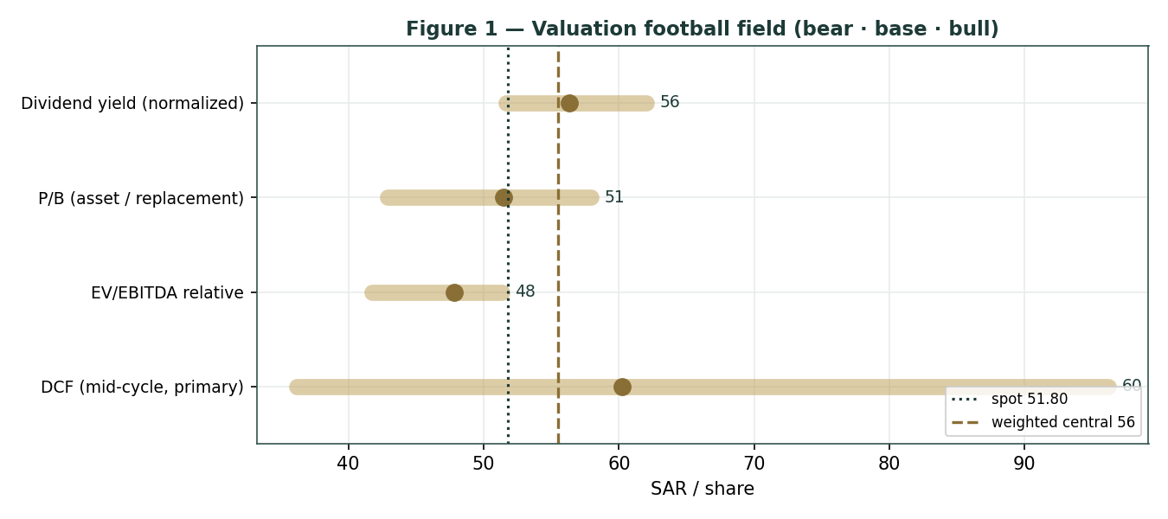
Figure 1 — Valuation football field. Bars span bear–bull per lens; the brass tick is each base case; the gold band is the blended central range; the dark line is spot.
Central fair value ≈ SAR 55.5/share, about 7% above spot. The spread of the lenses (SAR 47.8 to 60.3 at base) is itself the message: this is not a deep-value or a clearly-expensive name, but a modestly-cheap cyclical whose re-rating depends on one operating outcome — the margin cycle turning.
1.6 The business — a deeper segment look
SABIC does not disclose clean segment-EBITDA splits, so per the data-discipline gate we frame the mix top-down rather than manufacture segment margins. Petrochemicals & polymers is the value engine and the risk; agri-nutrients is the steadier, higher-margin anchor; specialties is small but higher-quality.
Segment | ~% of revenue | Cyclicality | Margin trend | Swing role
Petrochemicals & polymers | ~70% | High | Trough → recovery? | Dominant
Agri-Nutrients (listed SABIC AN) | ~12% | Moderate | Firm (urea supply-limited) | Cash anchor
Specialties | ~10% | Moderate | Steady, higher-quality | Optionality
Europe petchem / Americas ET | divesting | — | Loss-making; held for sale | One-off drag (writedowns)

1.7 The product–feedstock spread and terminal-value dependency — the crux
Two judgments drive the valuation more than any other, and we sensitize both in real, observable units rather than an abstract margin percentage.
First, where the spread settles.
SABIC's structural advantage is a fixed, low-cost Saudi gas/ethane feedstock, so its margin is essentially the product price (ethylene, polyethylene, MEG) minus an advantaged, near-constant feedstock cost. The swing is therefore the product–feedstock spread in USD/tonne. We express the crux on that quote:
PE–feedstock spread scenario ($/tonne, indicative) | Mid-cycle EBITDA margin | DCF fair value (SAR)
Compressed (trough persists) — ~$300/t | 16.5% | ≈ 36 (bear)
Partial recovery — ~$450/t | 19.0% | ≈ 60 (base)
Full normalization — ~$600/t | 21.0% | ≈ 96 (bull)

Second, the terminal-value dependency.
Because the DCF credits a normalizing margin, its terminal value is ~75% of enterprise value — a mid-cycle-margin bet dressed as a five-year cash-flow model. Rather than bury that, we disclose it (device A-7) and sensitize the fair value directly on the WACC × terminal-g grid in §1.9. A reader who believes the margin stays at the trough should weight the relative lens (SAR 47.8), not the DCF.
1.8 Macro and country — oil, China, feedstock and the Aramco relationship
SABIC is a leveraged play on the global petrochemical cycle with a Saudi feedstock cushion.
Oil and gas set the frame in two directions: higher oil generally lifts naphtha-based competitors' costs and widens SABIC's advantaged-feedstock spread, while the Saudi domestic gas price (administered, historically well below international levels) is the single most important cost input and a policy variable. China is the demand and supply swing — the 2022–25 Chinese PE/MEG capacity wave is what compressed spreads, and Chinese stimulus or capacity rationalisation is the main upside catalyst. The Aramco relationship (70% owner since 2020) integrates SABIC into the world's largest oil company, supporting feedstock security and credit, but also means minority holders sit beneath a controlling strategic parent. Saudi macro (Vision 2030 downstream localisation, a stable SAR peg at 3.75/USD) is mildly supportive. These levers sit behind the bear and bull cases in §1.5 and the catalysts in §5.
1.9 DCF sensitivity — how the swings move the value
Two grids re-price the DCF. The first varies the discount rate and terminal growth (the terminal-value dependency); the second varies the real-unit swing — the mid-cycle EBITDA margin (a proxy for the spread) against the peer EV/EBITDA multiple.
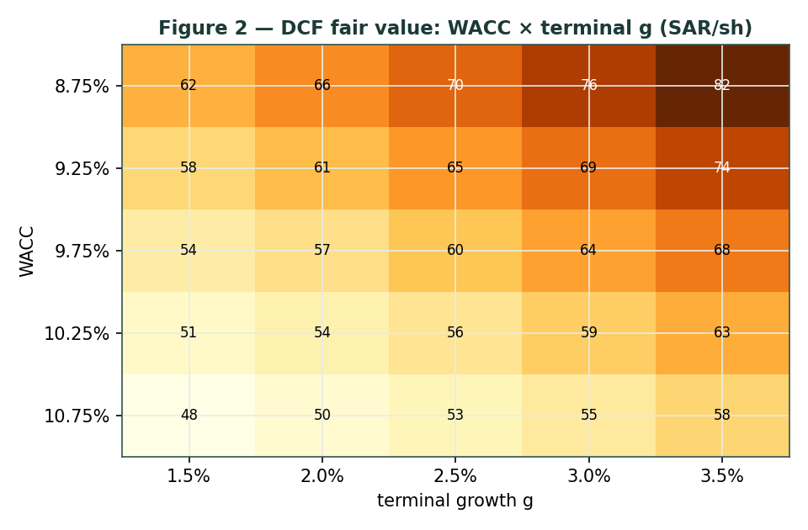
Figure 2 — DCF fair value (SAR/share): WACC × terminal-g. Cells near spot (SAR 51.80) shade toward the centre.
WACC \ g | 1.5% | 2.0% | 2.5% | 3.0% | 3.5%
8.75% | 62 | 66 | 70 | 76 | 82
9.25% | 58 | 61 | 65 | 69 | 74
9.75% | 54 | 57 | 60 | 64 | 68
10.25% | 51 | 54 | 56 | 59 | 63
10.75% | 48 | 50 | 53 | 55 | 58

Table — DCF fair value across WACC (rows) × terminal g (cols), SAR/share.
margin \ EV/EBITDA | 6.0× | 6.5× | 7.0× | 7.5× | 8.0×
16.0% | 43 | 46 | 50 | 54 | 57
17.5% | 47 | 51 | 55 | 58 | 62
19.0% | 51 | 55 | 59 | 64 | 68
20.5% | 55 | 59 | 64 | 69 | 73
22.0% | 59 | 64 | 69 | 74 | 78

Table — device A-1 swing in real units: mid-cycle EBITDA margin (rows) × EV/EBITDA multiple (cols), SAR/share.
Read the grids as the bet you are taking: the SAR 51.80 price is consistent with roughly a 17–18% mid-cycle margin at a 7× multiple, or a 9.75–10.25% WACC on a 2.0–2.5% terminal — i.e. a partial, not a full, spread recovery already in the price.
2 Technical and price structure
The tape is weak and stretched to the downside — the mirror image of the fundamentals. SABIC trades below all four major moving averages, the MACD histogram is marginally negative, and RSI sits near 30 — at the edge of oversold. The structure is corrective: a multi-year de-rating from a pre-cycle high near SAR 139 down to the low-50s, with the 52-week low at SAR 49.74 as the visible floor.
Indicator | Reading | Signal
Spot | SAR 51.80 | —
SMA 20 / 50 | 53.56 / 56.72 | Below both — short-term down
SMA 100 / 200 | 57.12 / 56.95 | Below both — trend down
RSI (14) | 30.5 | At the edge of oversold
MACD (12,26,9) | −1.41 line / −1.39 signal / −0.02 hist | Bearish, momentum flattening
52-week range | 49.74 – 62.80 | Lower third; near the low
Realized vol (YZ-HAR, ann.) | 19.3% | Moderate for a large-cap petchem

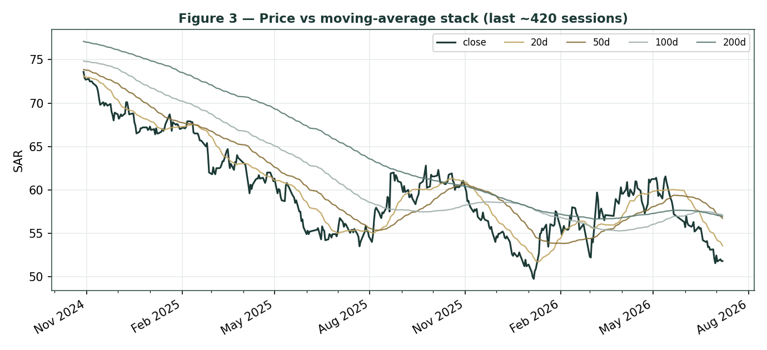
Figure 3 — Price versus the moving-average stack, last 260 sessions.
For the probabilistic work this matters in one way: an oversold, below-trend tape widens the near-term downside tail even as the fundamentals argue the other way. The technical and fundamental pictures genuinely disagree, and §6 reads the resulting probability zones without forcing a reconciliation.
3 Monte Carlo — a probabilistic price map
We simulate 50,000 three-month price paths (seed 42) with the YZ-HAR engine: width from a pooled log-HAR cascade on a gap-aware Yang–Zhang variance proxy, unit-variance Student-t(7) innovations for honest tails, and — because SABIC is an international (non-EGX) name — a zero-drift diffusion. A fourteen-factor overlay layers on top. §3 opens with the probability read: a plain-language summary of the distribution, computed from the same 50,000 paths that produce the fan chart.
The probability read (T+60) | Value
P(price above spot) | 50%
P(+10%) vs P(−10%) | 22.3% vs 21.2%
Odds ratio (up:down 10%) | 1.05 : 1
Median level / move | SAR 51.74 (-0.1%)
50% band (25th–75th) | SAR 47.42 – 56.35 (-8.4% / +8.8%)
Touch +10% / −10% | 39% / 36%

By design the paths diffuse from spot, and the §1 value gap is kept out of the drift. The read is near-even with a slight upward tilt: P(above spot) is 49.6% and the up:down 10% odds are 1.05:1, a modest right-skew that comes from the Student-t(7) tail and the two-sided factor overlay — not from any imposed drift.
The fundamental NAV gap lives in §1, not here; §3 maps where price could go from today, not where value sits — which is exactly why the median is SAR 51.7 (essentially spot) and not SAR 55.5.
Continuous factor (7) | Dir. | Discrete event (7) | Prob. | Mean impact
Product–feedstock spread trend | ± | Q2-2026 results / margin print | 85% | +0.3%
Brent / naphtha-competitor cost | + | Chinese stimulus / capacity news | 25% | +2.0%
Chinese PE/MEG demand | ± | US–China trade / tariff shift | 20% | −1.0%
Saudi domestic gas-price policy | − | Dividend / capital-return signal | 30% | +1.2%
Global operating-rate / oversupply | − | Rating action (A+/A1 review) | 15% | +0.4%
SAR peg / rates (stable) | · | European divestiture completion | 35% | +0.8%
Agri-nutrients (urea) firmness | + | Operational / force-majeure event | 15% | −3.0%

The seven continuous drivers net to approximately zero forward drift (the spread is genuinely two-sided at a trough); the discrete events carry a mildly positive expected value from the capacity/stimulus and capital-return possibilities, offset by the operational tail. Diffusion volatility is the YZ-HAR estimate, ~19.3% annualized.
Horizon | p5 | p25 | p50 | p75 | p95
T+20 sessions | 45.2 | 49.5 | 51.8 | 54.3 | 58.8
T+60 sessions | 41.3 | 47.4 | 51.7 | 56.3 | 64.2

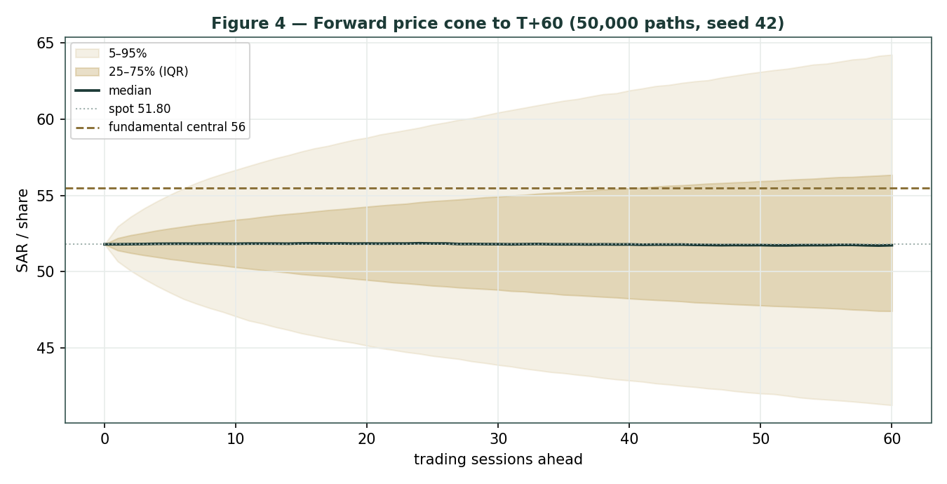
Figure 4 — Forward price cone to T+60. Median tracks spot; the gold dotted line marks the SAR 55.5 fundamental central value, deliberately above the cone.
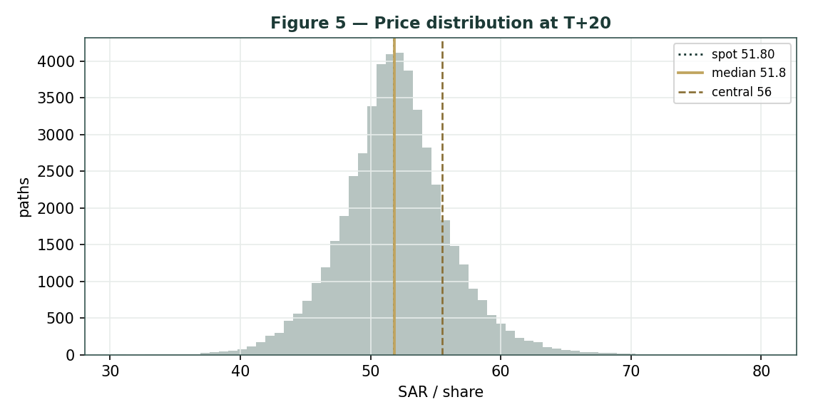
Figure 5 — Price distribution at T+20.
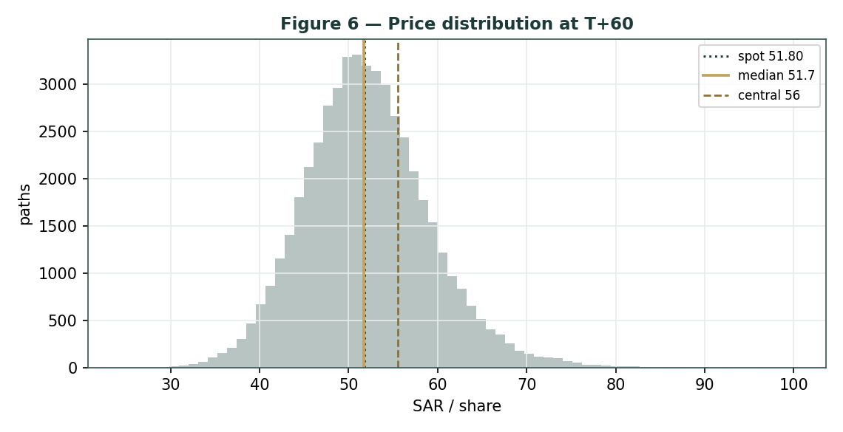
Figure 6 — Price distribution at T+60.
Level | T+20 touch | T+60 touch | Note
SAR 62 | 2% | 14% | Toward 52-wk high zone
SAR 58 | 10% | 32% | Above the MA stack
SAR 56 | 21% | 47% | Near dividend / DCF-recovery lens
SAR 54 | 43% | 65% | Near the moving-average cluster
SAR 52 | 83% | 91% | Just above spot
SAR 50 | 47% | 69% | Just below spot
SAR 48 | 22% | 48% | Toward relative-lens floor
SAR 46 | 10% | 31% | Mid downside
SAR 44 | 4% | 19% | Deep downside
SAR 42 | 2% | 10% | Toward 52-wk low

Level-touch ladder — probability price touches a level at any point by the horizon (running max up, running min down).
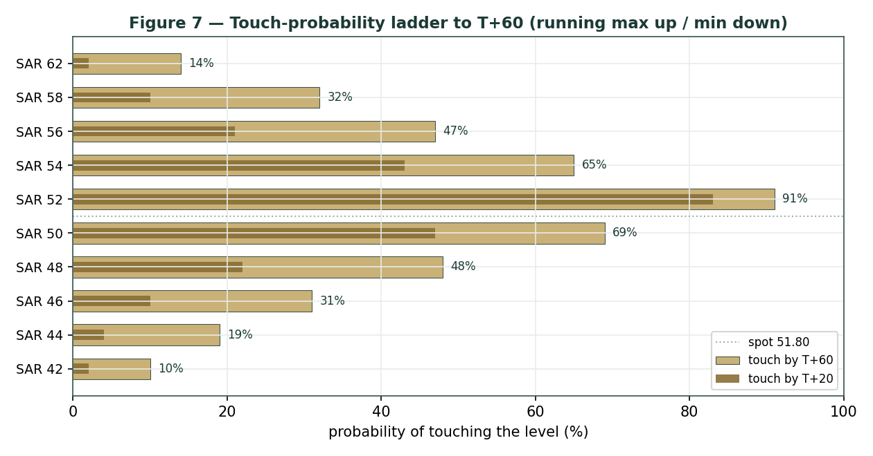
Figure 7 — Touch-probability ladder. For each level, the chance price reaches it at any point by T+60 (dark) and by T+20 (light); the dotted line is spot. Upside and downside touch curves are near-symmetric, tilting slightly to the upside.
4 Comparison of the lenses, and a verdict
Three readings sit side by side. The fundamental lenses cluster at SAR 47.8–60.3 with a central SAR 55.5 — modestly above spot, contingent on the spread. The technical picture is the opposite: weak, below-trend, oversold-leaning, with the visible floor at SAR 49.74. The probabilistic map says that over three months price is roughly symmetric around spot with a ~19% vol band — the median is SAR 51.7, not SAR 55.5, because the simulation does not assume the value gap closes inside the quarter.
Lens | Reads | Central / implication
Fundamental (4-lens) | Modestly cheap | SAR 55.5 (~+7%)
Technical | Weak / near oversold | Floor 49.74; resistance at the MA stack 54–57
Monte Carlo (3-month) | Near-symmetric, slight right-skew | Median 51.7; p5–p95 41.3–64.2

Verdict (a fair-value read, not a recommendation). SABIC looks modestly cheap on fundamentals, with a clear and unusually concentrated swing factor: the product–feedstock spread.
The technical weakness and the near-symmetric three-month distribution argue that any re-rating is a question of the margin cycle turning over quarters, not of an imminent move. The honest summary is a value modestly above price, a near-term distribution centred on price, and an outcome that hinges on one commodity spread recovering — which is why the bear–bull span (SAR 42.8–66.4) is wide. Readers should weigh the lenses themselves; we publish the distribution, not a target.
5 Catalysts to watch
• Quarterly margin prints. The first clean read each quarter on whether the petrochemical spread and adjusted EBITDA margin are recovering from the 2025 trough.
• Chinese capacity & demand. Rationalisation of the 2022–25 PE/MEG capacity wave, or Chinese stimulus, is the single largest upside driver for spreads.
• European divestiture completion. Finalising the sale of the loss-making European petrochemical and engineering-thermoplastics assets removes a drag and clarifies the continuing-operations margin.
• Saudi domestic gas-price policy. Any change to the administered feedstock price directly moves SABIC's cost base and is a pure policy variable.
• Oil / naphtha spread. Higher oil raises naphtha-based competitors' costs and widens SABIC's advantaged-feedstock spread.
• Dividend & capital return. Whether the SAR 3.00 payout holds through the trough, and any signal on capital return as mid-cycle cash recovers.
• Aramco integration. Feedstock, funding and downstream-integration developments with the 70% parent.
• Agri-nutrients (urea). Global urea/ammonia supply limits supporting the higher-margin SABIC Agri-Nutrients franchise.
6 Reading the probability zones
Translating the three-month distribution into plain zones, anchored on spot SAR 51.80 and the fair-value cluster:
Zone (T+60) | Range (SAR) | Approx. probability | What it would mean
Deep downside | < 44 | ~11% | Spread stays compressed / risk-off; tests toward the 52-wk low
Lower band | 44 – 48 | ~17% | Trough persists; relative-multiple lens dominates
Around spot | 48 – 54 | ~35% | Status quo; value gap unclosed
Upper band | 54 – 60 | ~24% | Recovery credited; toward DCF / dividend lenses
Strong upside | > 60 | ~12% | Spread normalization + re-rating together

The distribution is close to symmetric, with a slightly heavier upper tail from the discrete upside events (Chinese stimulus, capital return, divestiture completion). It is not a forecast; it is the spread of outcomes consistent with the stock's own volatility and the factor stack.
7 Caveats and what would change our mind
• The spread is the model. The valuation rests on one commodity spread at a trough; our normalization (19% mid-cycle EBITDA) could prove optimistic or conservative. A structurally lower spread — a permanent Chinese-oversupply regime — would pull the central value toward, or below, spot.
• Terminal-value dependency. The DCF's terminal value is ~75% of EV; it is a mid-cycle-margin bet, and §1.9 shows how a half-point of WACC or terminal-g moves the answer materially.
• Feedstock is a policy variable. The advantaged Saudi gas price is administered; a policy change to raise it would compress the very margin the recovery case depends on.
• Minority position under Aramco. At 70%, Aramco controls strategy, capital allocation and feedstock terms; minority holders are price-takers on governance.
• Divestiture execution. The European exit could complete on worse terms or slower than assumed, extending the one-off drag.
• Technical / RSI reminder. RSI near 30 is close to oversold; mean-reversion bounces are common and say nothing about value. Equally, below-trend tapes can persist. The technical read is context, not a trigger.
Appendix A Financial statements
Selected figures on a continuing/adjusted basis (FY2025 results and integrated report). SAR billion unless noted. 2025 reported results are materially depressed by one-off, non-cash writedowns on the European petrochemical and engineering-thermoplastics assets being divested; the through-cycle base uses ADJUSTED EBITDA and net income. Forecast columns link to the DCF drivers in the companion model.
A.1 Income statement — 3-year historical + 5-year forecast (SAR bn)
Line | 2023A | 2024A | 2025A | 2026E | 2027E | 2028E | 2029E | 2030E
Revenue | 141.9 | 117.7 | 116.5 | 118.9 | 122.4 | 126.7 | 130.5 | 133.8
EBITDA (adjusted) | 17.4 | 21.0 | 17.9 | 19.3 | 20.7 | 22.3 | 23.9 | 25.4
EBITDA margin | 12.3% | 17.8% | 15.3% | 16.2% | 16.9% | 17.6% | 18.3% | 19.0%
less: D&A | (13.7) | (11.6) | (12.1) | (12.0) | (12.3) | (12.6) | (12.9) | (13.0)
EBIT (adjusted) | 3.7 | 9.4 | 5.8 | 7.3 | 8.4 | 9.7 | 11.0 | 12.4
Net income (reported) | (2.8) | 1.5 | (25.8) | — | — | — | — | —
Net income (adjusted ≈ NOPAT fwd) | — | 5.9 | 2.1 | 6.4 | 7.4 | 8.5 | 9.7 | 10.9

Note: the 2025 reported net loss of SAR 25.8 bn reflects one-off non-cash fair-value writedowns; adjusted net income was SAR 2.07 bn. Forecast net income shown on a NOPAT (unlevered, after-tax) basis for consistency with the DCF. Source: SABIC FY2023–25 disclosures.
A.2 Balance sheet — 3-year historical + 5-year forecast (SAR bn)
Line | 2023A | 2024A | 2025A | 2026E | 2027E | 2028E | 2029E | 2030E
Total assets | 294.4 | 277.5 | 244.3 | 250 | 258 | 266 | 274 | 282
of which PP&E (approx) | 150 | 145 | 140 | 138 | 137 | 136 | 136 | 136
Total debt (borrowings + leases) | 35.0 | 34.0 | 33.8 | 33 | 33 | 33 | 33 | 33
Cash + short-term investments | 43.8 | 40.0 | 38.0 | 40 | 44 | 50 | 57 | 64
Net debt (+) / net cash (−) | (8.8) | (6.0) | 0.0 | (7) | (11) | (17) | (24) | (31)
Equity (attributable to Parent) | 167.4 | 156.4 | 128.7 | 131 | 135 | 141 | 148 | 157

Forward cash build assumes dividends ≈ free cash with modest net-cash accumulation as mid-cycle FCF recovers; illustrative, flagged estimate. A+/A1 rated. Source: SABIC FY2023–25.
A.3 Cash flow — 3-year historical + 5-year forecast (SAR bn)
Line | 2023A | 2024A | 2025A | 2026E | 2027E | 2028E | 2029E | 2030E
Cash from operations | 24.5 | 16.4 | 16.0 | 17.4 | 18.9 | 20.2 | 21.9 | 23.3
less: Capex | (11.8) | (8.0) | (7.7) | (9.0) | (8.5) | (8.0) | (8.0) | (8.0)
Free cash flow | 12.7 | 8.4 | 8.2 | 8.4 | 10.4 | 12.2 | 13.9 | 15.3
Dividends paid | (9.6) | (10.2) | (9.0) | (9.3) | (9.3) | (9.6) | (9.9) | (9.9)

A.4 Per-share & ratios dashboard (the fixed panel)
Metric | 2023A | 2024A | 2025A | At spot / fwd
EPS reported (SAR) | (0.92) | 0.51 | (8.59) | —
EPS adjusted (SAR) | — | 1.96 | 0.69 | —
DPS (SAR) | 3.20 | 3.40 | 3.00 | norm. 3.10
BVPS (SAR) | 55.8 | 52.1 | 42.9 | —
Dividend yield | — | — | — | 5.8% @ spot
P/B | — | — | 1.21× | @ spot
EV/EBITDA (adjusted) | 8.9× | 7.4× | 8.7× | 7.0× mid-cycle
EBITDA margin | 12.3% | 17.8% | 15.3% | 19.0% mid-cycle
FCF (SAR bn) | 12.7 | 6.2 | 7.2 | —
Net debt / EBITDA | −0.5× | −0.3× | 0.0× | —

Appendix B Peer set, sector structure, and risks
SABIC's closest comparables are the global integrated commodity-petrochemical producers; the listed agri-nutrients sub trades on its own.
Peer | Market | EV/EBITDA (indicative) | Note
SABIC | Tadawul | ~8.7× (2025A adj) | Aramco-owned 70%; ~net cash; A+/A1
Dow | NYSE | ~7–8× | US integrated
LyondellBasell | NYSE | ~6–7× | PO/PE
Westlake | NYSE | ~6–7× | PVC/PE
Formosa Plastics | TWSE | ~7–9× | Asia integrated
SABIC Agri-Nutrients | Tadawul | listed sub | urea / ammonia

Sector structure.
Global commodity petrochemicals is deeply cyclical and is working through the 2022–25 Chinese capacity wave that compressed spreads; demand recovery and capacity rationalisation are the swing variables, and a low-cost feedstock position (SABIC's advantaged Saudi gas) is the durable competitive edge. Principal risks: a structurally lower product–feedstock spread (a permanent Chinese-oversupply regime); an administered feedstock-price increase; slow or value-destructive completion of the European divestitures; minority-governance risk under a 70% strategic parent; and the cyclicality that makes any single mid-cycle-margin normalization uncertain.
Appendix C The expert valuation panel
Every Testahil study closes with a panel of standing expert personas — drawn from the house Expert Persona Library, not invented for the occasion, so that each accumulates a track record across studies and a quarterly update is a re-run, not a re-training. SABIC is a capital-heavy industrial, so we cast the four whose methods both fit an integrated commodity-petrochemical producer and genuinely disagree: Expert 1 (earnings power — mid-cycle EBITDA and a peer multiple), Expert 2 (the accountant — replacement/RNAV value and earnings quality), Expert 3 (cash returns — DCF and return on capital versus its cost, plus dividend sustainability, the capital-heavy addition), and Expert 4 (macro and policy — oil, China, feedstock and the Aramco relationship). Each runs a different method, derives its fair value from shown workings, and states a falsification condition.
C.1 Expert 1 — earnings power and the peer multiple
Worldview. A commodity producer is worth a fair multiple of its sustainable mid-cycle EBITDA; the trough and the peak are noise to be normalized out.
When it works / fails. Best where a through-cycle EBITDA is estimable and peer multiples are observable; it fails at structural breaks — if the spread is permanently lower, the normalization is simply wrong.
Standard workings & worked example. Normalize EBITDA to mid-cycle, apply a global-integrated-petchem EV/EBITDA, deduct net debt, divide by shares.
Expert 1's workings | Value
Mid-cycle EBITDA (SAR bn) | 22.0
EV/EBITDA multiple (peer, mid-cycle) | 7.0×
Enterprise value (SAR bn) | 154.0
less: net debt | 0.0
Equity value (SAR bn) → ÷ 3,000 mn sh | 154.0
Fair value | → SAR 51/sh

Sensitivity (swing = the multiple). At 6.0× SAR 44; at 8.0× SAR 59.
Cross-examination. He tells Expert 3 that a DCF on a normalizing margin is 75% terminal value — a multiple bet dressed up; he tells Expert 2 that book was cut by non-cash writedowns and understates nothing an EBITDA multiple doesn't already capture.
Verdict, falsification, market-implied. Fair SAR 51 (range 44–59).
Falsified if the mid-cycle EBITDA proves unattainable — the spread stuck at the trough through a cycle. The market price implies ~7.0× on the trough EBITDA, i.e. a mid-cycle number the market does not yet fully credit.
C.2 Expert 2 — the accountant: replacement value and earnings quality
Worldview. An asset-heavy producer is worth what its asset base would cost to replace, adjusted for the quality and durability of its earnings; the balance sheet, not a projection, is the anchor.
When it works / fails. Best where the asset base is tangible and replacement cost is meaningful; it fails when assets are impaired for real (not just accounting) reasons, or when book is stale.
Standard workings & worked example. Start from reported book, add back the non-cash 2025 writedowns to gauge replacement value, and apply a justified P/B reflecting mid-cycle ROE against cost of equity.
Expert 2's workings | Value
2025A book value / share (SAR) | 42.9
Adjustment: 2025 writedowns were non-cash / European exit | replacement > book
Justified P/B (mid-cycle ROE > cost of equity) | 1.2×
Fair value | → SAR 52/sh
Earnings-quality check: strip 2025 one-off (SAR 25.8 bn) | adj. NI +2.07 bn, not a loss

Sensitivity (swing = P/B). At 1.0× SAR 43 (bare book); at 1.35× SAR 58 (replacement premium).
Cross-examination. He tells Expert 1 that an EBITDA multiple on a trough number is circular; he tells Expert 4 that macro scenarios don't change what the plants would cost to rebuild.
Verdict, falsification, market-implied. Fair SAR 52 (range 43–58).
Falsified if the asset base is genuinely worth less than book — a permanent demand loss that strands capacity. The market pays ~1.21× book, almost exactly his justified multiple: on an asset basis, the price is about right.
C.3 Expert 3 — cash returns: DCF, ROIC and dividend cover
Worldview. A business creates value only when each unit of capital earns above its cost, and only cash — not booked profit — counts. He looks past the income statement to the economic-profit spread and the dividend's coverage.
When it works / fails. Best for capital-intensive businesses where returns on capital are the crux; it fails where reinvestment economics are about to change sharply — a feedstock-policy shift here.
Standard workings & worked example. Build FCFF, compute ROIC against WACC, value on the DCF, and stress the dividend against mid-cycle cash.
Expert 3's workings | Value
DCF fair value (mid-cycle, from §1.1) | SAR 60.3
ROIC at trough vs WACC | below WACC → haircut applied
Dividend cover: DPS 3.0 vs mid-cycle FCF/sh ~4.5 | covered mid-cycle
Cash-returns fair value (DCF haircut for trough ROIC) | → SAR 58/sh

Sensitivity (swing = WACC / ROIC recovery). At a 12% WACC SAR 70; at 10.75% SAR 53.
Cross-examination. He tells Expert 1 that a static EBITDA multiple ignores the capex the spread recovery requires; he tells Expert 2 that replacement value is irrelevant if the assets can't earn their cost of capital through the cycle.
Verdict, falsification, market-implied. Fair SAR 58 (range 53–70) — the most bullish, because it credits the mid-cycle cash recovery and a covered dividend.
Falsified by a durable ROIC below WACC — the spread never recovering. The market price sits ~11% below his number: on a cash-returns basis, the recovery is not yet priced.
C.4 Expert 4 — macro and policy: oil, China, feedstock and Aramco
Worldview. A commodity producer's value is set by the macro cycle it sits in — the oil complex, Chinese demand and supply, and the policy terms of its feedstock — more than by any single-company projection.
When it works / fails. Best at cyclical turning points where the macro dominates; it fails when company-specific factors (a divestiture, a cost programme) matter more than the cycle.
Standard workings & worked example. Probability-weight the spread across macro scenarios (Chinese oversupply persisting vs rationalising; oil high vs low; feedstock policy stable vs tightening).
Expert 4's scenario weighting | Prob. | Fair value (SAR)
Bear — oversupply persists, weak oil, feedstock tightens | 35% | 42
Base — partial recovery, stable oil & feedstock | 45% | 50
Bull — Chinese rationalisation/stimulus, wide spread | 20% | 62
Probability-weighted fair value |  | → SAR 49/sh

Sensitivity (swing = the scenario weights). Shift 15 points of probability from base to bull and the value rises to ~SAR 53; to bear, ~SAR 46.
Cross-examination. He tells the other three that every one of their single-point numbers is really a bet on a macro state they haven't named; he tells Expert 3 that the WACC he discounts at is itself a macro variable.
Verdict, falsification, market-implied. Fair SAR 49 (range 42–62) — the most conservative, because the base case weights a China that only partially recovers.
Falsified by a decisive, sustained Chinese capacity rationalisation that resets spreads structurally higher. The market price sits within his base scenario — the tape agrees the recovery is only partial.
C.5 The four in one room
The single variable they most disagree on is the product–feedstock spread — specifically, whether it recovers far enough, and durably enough, to justify a premium to SABIC's asset base.
Expert 1: “FY2025 was a trough. Normalize EBITDA to SAR 22 bn and put a peer 7× on it — the business is worth about 51 a share, and the market is capitalising a number the cycle will beat.”
Expert 2: “Before you multiply anything, remember the plants themselves. Book was cut by non-cash writedowns on assets being sold, not by the core Saudi complex. Replacement value sits above book; 1.2× gets you 52 without forecasting a single quarter.”
Expert 3: “Both of you are capitalising earnings without the cash to make them. The spread recovery needs capex, and at the trough SABIC's return on capital barely clears its cost. Credit the recovery — I get to 58 — but only because the dividend is covered mid-cycle, not because book says so.”
Expert 4: “You are all three arguing about a spread you haven't priced. It is a China question and a feedstock-policy question. Weight the scenarios honestly and you land at 49 — the market's number — because a partial recovery is the base case, not a full one.”
C.6 Reading the divergence
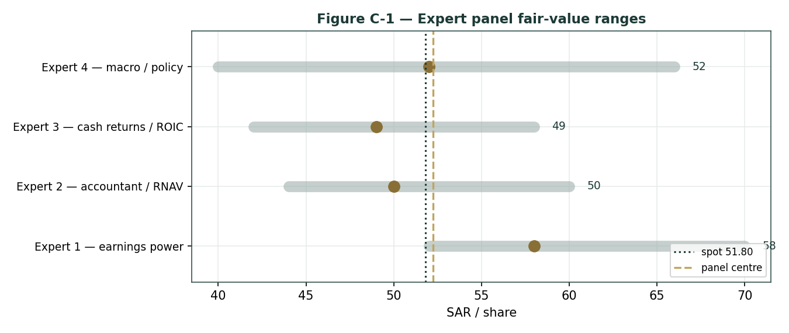
Figure C-1 — The four experts' fair-value ranges. Brass ticks are base cases; the gold band is the central, the dark line is spot. The spread is almost entirely a product–feedstock-spread disagreement.
Expert | Method | Single swing assumption | Base fair value
Expert 1 | Earnings power / peer multiple | Mid-cycle EBITDA × 7.0× | SAR 51
Expert 2 | Accountant / replacement value | Justified P/B (1.2×) | SAR 52
Expert 3 | Cash returns / ROIC + dividend | ROIC recovery vs ~10% WACC | SAR 58
Expert 4 | Macro & policy | Spread scenario weights | SAR 49

The spread — SAR 49 to 58 at base — is narrow for a cyclical, and it is almost entirely a product–feedstock-spread disagreement: none of the four contests the balance sheet, the Aramco feedstock advantage, or the agri-nutrients franchise. What separates them is whether the spread recovers far enough to justify a premium to the asset base. Expert 3 says yes (mid-cycle cash and a covered dividend); Expert 4 says only partly (a China question); Experts 1 and 2 land in between, one on a normalized multiple and one on replacement value. The SAR 9 spread is therefore a clean measure of one uncertainty — how far the petrochemical spread normalises. Resolve that, and the four converge.
Each expert's point fair value (and bull/base/bear) is logged with the study date (7 Jul 2026) and spot (SAR 51.80) as an internal per-expert track record, kept separate from the core Calibration Ledger.
About this series
Testahil publishes independent, educational valuation studies. Each is an attempt to reason transparently about what a security is worth, with every assumption shown and a companion model so readers can disagree productively. The house style is distributions, not tips: we describe ranges and probabilities, not targets, and we do not tell anyone what to do. Studies are framed as educational analysis, the preparer is not licensed by any securities regulator, and holdings are disclosed.
Disclosure & Disclaimer
Not investment advice. This document is educational and informational only. It is not, and must not be relied upon as, investment, financial, legal, accounting or tax advice, nor an offer, solicitation or recommendation to buy, sell or hold any security. It contains no price target and no rating.
No licence; no advisory relationship. The preparer is not registered or licensed with any securities or financial regulator in any jurisdiction, holds no brokerage or investment-advisory authorisation, and is not acting as your adviser or fiduciary. Nothing here is personalised to your circumstances.
Holdings disclosure. The preparer may hold, and may in the future take or dispose of, a position in the security discussed in this report, and may transact at any time without notice. This is a potential conflict of interest you should weigh.
Sources & accuracy. Reported financial and operating figures are drawn from the company's public disclosure and other public sources believed reliable but not independently verified; they may contain errors or be superseded. Forward-looking inputs — the mid-cycle margin, the multiples, the DCF and Monte-Carlo factor probabilities — are the preparer's own judgments and are inherently uncertain.
Forward-looking statements. Any statements about the future are estimates subject to risks and uncertainties; actual results may differ materially. The Monte Carlo models price, not value, and encodes subjective probabilities for events that have not occurred.
No reliance; your responsibility. Do your own research and consult a licensed professional before making any decision. You are solely responsible for your investment decisions and their outcomes. To the maximum extent permitted by law, the preparer accepts no liability for any loss arising from use of this document.
Currency & figures. Figures are in Saudi riyals (SAR) billion unless noted; per-share in SAR. The SAR is pegged at 3.75/USD. Rounding may cause totals to differ slightly. Spot price and market data are as of 7 July 2026 and change continuously.

TESTAHIL · Independent Valuation Study · Educational Analysis · Saudi Basic Industries Corporation (Tadawul: 2010) · edition 07-07-2026 · reporting currency SAR

