Testahil · Independent Valuation Study — Educational Analysis Not investment advice

Independent Valuation Study — Educational Analysis
Salik Company PJSC (DFM: SALIK) — Dubai's exclusive toll-gate operator
Fundamental analysis · Technical analysis · Monte Carlo simulation — one integrated read
Anchor: AED 5.70 (10 Jul 2026 close) · 7,500.0 mn shares · market cap AED 42.8 bn (US$11.6 bn) · net debt AED 4,226 mn · free float 24.9% (the Government of Dubai holds 75.1% through the Dubai Investment Fund). Salik operates all ten of Dubai’s toll gates under a 49-year exclusive concession from the RTA, running to 2071. Reporting currency AED, pegged to USD at 3.6725. Prices and probabilities computed 11 Jul 2026 from the attached daily history. Primary lens: FCFF DCF, cross-checked by normalized earnings power, one earnings multiple, and a dividend-policy DDM.
READ FIRST — what this document is, and is not. This study is a valuation exercise and an expression of personal analytical opinion, published free of charge for educational purposes: it shows how one analyst applies fundamental, technical and probabilistic methods to a listed company, and invites scrutiny of that methodology. It is NOT investment advice, NOT a recommendation or solicitation to buy, sell or hold any security, and NOT directed at the circumstances of any reader. The preparer is not licensed by any securities regulator in any jurisdiction, holds no brokerage or advisory authorisation, provides no financial consultancy, manages no money, and accepts no fees, funds or clients. See the Disclosure & Disclaimer at the end. All values are model outputs presented as ranges and distributions because no single number should be relied on. Reported financials are the company’s own disclosure (the FY2023–FY2025 earnings releases; the 2024 Annual Report; the Q1-2026 release of 11 May 2026; RTA and Dubai Media Office announcements). Forward-looking inputs — the trip, tariff, margin and ancillary paths, the cost of capital, terminal growth, the multiple band and the Monte-Carlo factor probabilities — are the preparer’s judgments and are flagged throughout. Consult a licensed financial advisor before any investment decision.
A live event sits inside the forecast window. Dubai’s traffic collapsed in March 2026 when the US–Israel–Iran war opened (28 Feb) and the Strait of Hormuz closed. A ceasefire followed on 7–8 April; a memorandum of understanding was signed on 17 June; three ships were attacked on 6–7 July, US strikes resumed, and on 7 July the truce was called over — then walked back on 8 July. That is three days before this study’s anchor. Salik’s Q2-2026 results — the FIRST full quarter under conflict conditions — land inside the T+60 horizon.

The company
Salik is the company that charges you to drive down Sheikh Zayed Road. It runs every one of the ten electronic toll gates in Dubai — no barriers, no booths, just a windscreen tag and a camera — and it is the only company allowed to do so, under a 49-year exclusive concession granted by Dubai’s Roads and Transport Authority that runs to 2071. It owns no roads and it builds no roads: the RTA pays for all of that, and Salik simply collects, which is why sixty people generate two billion dirhams of EBITDA and why the company converts roughly ninety cents of every EBITDA dirham into free cash. It hands all of that profit back to shareholders — the dividend policy is one hundred per cent of distributable net profit, paid twice a year — and the Government of Dubai, which still owns 75.1% of the shares, is on the receiving end of most of it. In short: a toll booth with a stock ticker, a government landlord, and a contract that runs longer than most of the people reading this will.
Headline
Our weighted central fair value is AED 4.62 against a spot of AED 5.70 — spot sits 19% above our central mark, and above the central of every one of our four lenses. The reason is not the traffic.
- FY2025 was 84% one-offs. Salik’s FY2025 revenue grew 35.1%. We rebuilt it line by line, on the company’s OWN figure for how many trips the two new gates would carry (111 mn), and 84% of the growth came from two events that cannot repeat — the gate count going eight to ten, and the tariff going flat to variable. Only 16% was organic. FY2026 has neither. §1.6.
- There are two growth engines. Only one of them is free. The eight gates Salik was HANDED at the 2022 IPO earn 32% on invested capital. The two gates the RTA SOLD it in 2024, for AED 2,734 mn, earn 9.5% — against a 8.1% cost of capital. In the pessimistic corner of the assumption box the new gates earn LESS than the cost of capital. Growth by acquiring gates is not free growth, and the RTA — grantor, regulator, 75.1% shareholder — sets the price. §1.6.
- And the dividend has a senior claim sitting in front of it. The RTA instalment is AED 455.7 mn a year to Nov-2030. With a 100% payout the cash Salik retains is structurally D&A less capex — AED 116 mn. So there is a ~AED 340 mn a year gap, funded off the balance sheet, every year until 2030. It is captured in net debt, so the DCF is right — but the DIVIDEND is tighter than the 100%-payout headline suggests. §1.2a.
- The war is doing double damage — and that is the crux. SALIK’s measured beta was 0.47 before the war and 1.00 during it. The same war that cut Q1 traffic 7.7% DOUBLED the discount rate’s risk loading. It attacks the numerator and the denominator at once, and at spot the market is pricing both to reverse. §1.8 and §1.7.
Valuation summary — every read at a glance
Lens | Bear | Central | Bull | Weight | What it turns on
FCFF DCF (primary) | 2.86 | 4.49 | 8.15 | 45.0% | The beta. Measured, not assumed — §1.8.
Normalized earnings | 4.17 | 5.44 | 6.67 | 20.0% | The multiple on a non-conflict year.
Relative — P/E (=1/yield) | 4.08 | 4.89 | 5.71 | 20.0% | 100% payout ⇒ P/E and yield are ONE multiple.
Dividend discount (floor) | 2.55 | 3.55 | 6.07 | 15.0% | Ke − g. A structural FLOOR — §1.6.
WEIGHTED CENTRAL | 3.32 | 4.62 | 7.05 | 100% | —
Spot, 10 Jul 2026 |  | 5.70 |  |  | Inside our band, near the top
Weighted central vs spot |  | -19.0% |  |  | —

The one thing to understand before you read a single number. The gap between our AED 4.62 and the market’s AED 5.70 is NOT an earnings disagreement. Our FY2026E EPS of AED 0.2039 is within 1.4% of FY2025 actual and sits ABOVE the Q1-2026 run-rate. We are not forecasting a collapse. The gap is almost entirely a DISCOUNT-RATE disagreement — and, unlike v1 of this study, we can now measure the discount rate rather than assume it. Against an equal-weighted 14-name UAE market portfolio spanning both exchanges, SALIK’s weekly beta is 0.637 (n=195, SE 0.104, t=6.1, R² 16.2%) — a regression that comfortably clears our usability test. We publish the Blume-adjusted 0.76, which is the conservative choice. At spot, the market is implying a beta of 0.52. That is INSIDE our measured 95% confidence interval [0.43, 0.84] — and it is almost exactly the beta SALIK actually had BEFORE the war (0.47). Read §1.10 before you read anything else. It is the whole study.

Company overview
Item | Detail | Item | Detail
Listing | DFM: SALIK. Listed 29 Sep 2022 at AED 2.00. | Free float | 24.9%. Dubai Investment Fund 75.1%.
Business | Sole operator of all TEN Dubai toll gates. Six sit on Sheikh Zayed Road. | Employees | 60. Revenue per head: AED 51.6 mn.
Concession | 49 years from 1 Jul 2022, expiring 2071. Exclusive rights to ALL existing and future Dubai gates. | Ratings | Fitch A (up from A−, Nov 25). Moody’s A3.
Concession fee | 22.5% of TOLL revenue only. Cap 25.0% / FLOOR 15.0%. Fines and ancillary 100% retained. | Leverage | Net debt/EBITDA 1.98× vs a 5.0× covenant.
Capital intensity | Effectively ZERO. The RTA bears ALL road capex and maintenance. | Dividend | 100% of distributable profit, semi-annual. FY25: AED 0.2215 (3.9%).
Tariff | Variable since 31 Jan 2025: AED 6 peak, AED 4 off-peak, FREE 01:00–06:00. | Beta (measured) | 0.64 weekly, n=195. Published: 0.76 (Blume).

1 Fundamental valuation
Salik is an operating company, so the primary lens is a free-cash-flow-to-the-firm DCF, with three cross-checks alongside it. The four lenses come first and are synthesised at §1.5, in our order. The analyses that reframe them — the two growth engines, the FY2025 bridge, the RTA cash waterfall and the beta — follow from §1.6.
1.1 The FCFF DCF — the primary lens, with the full waterfall
AED mn | FY2026E | FY2027E | FY2028E | FY2029E | FY2030E
Revenue | 2,981 | 3,170 | 3,360 | 3,549 | 3,734
less: concession fee (22.5% of TOLL revenue) | -575 | -610 | -644 | -676 | -707
less: other operating costs | -328 | -345 | -363 | -380 | -392
EBITDA | 2,078 | 2,214 | 2,354 | 2,493 | 2,635
EBITDA margin | 69.7% | 69.9% | 70.0% | 70.2% | 70.6%
less: D&A (concession amortisation) | -146 | -146 | -146 | -146 | -146
EBIT | 1,932 | 2,068 | 2,208 | 2,347 | 2,489
less: tax @ 9% (UAE CT) | -174 | -186 | -199 | -211 | -224
NOPAT | 1,758 | 1,882 | 2,009 | 2,136 | 2,265
add back: D&A | 146 | 146 | 146 | 146 | 146
less: capex (the RTA owns the roads) | -30 | -32 | -34 | -35 | -37
less: change in working capital | -0 | -0 | -0 | -0 | -0
FCFF | 1,875 | 1,997 | 2,121 | 2,247 | 2,374
× discount factor @ WACC 8.1% | 0.9252 | 0.8560 | 0.7919 | 0.7327 | 0.6779
PV of FCFF | 1,734 | 1,709 | 1,680 | 1,646 | 1,609

Bridge to value | AED mn | AED/sh | Source / note
Sum of PV(FCFF), FY2026E–FY2030E | 8,378 | 1.12 | The explicit forecast.
Terminal value = FCFF(2030) × 1.025 / (WACC 8.1% − g 2.5%) | 43,552 |  | Perpetuity. Sanity-checked below.
PV of terminal value | 29,522 | 3.94 | 77.9% of EV — disclosed, high, and typical of a long concession.
ENTERPRISE VALUE | 37,901 | 5.05
less: net debt | (4,226) | (0.56) | Q1-2026, DISCLOSED. No derived line enters the bridge.
EQUITY VALUE | 33,674 | 4.49
÷ shares outstanding (mn) | 7,500.0 |  | IPO floated 1,867.5 mn = 24.9%. Confirmed to the dirham by the H2-24 dividend.
FAIR VALUE PER SHARE |  | AED 4.49
Spot |  | AED 5.70
vs spot |  | -21.2%

Bear AED 2.86 / bull AED 8.15. The bear combines a 25% Q2-2026 trip collapse, no tariff escalation, a 1.5% terminal, an 11.8% opex ratio AND the beta at the TOP of its measured 95% CI (0.84). The bull combines a near-full recovery, 6% trend trip growth, 2.5% tariff escalation, a 3.2% terminal AND the measured PRE-WAR beta (0.47). Both ends are anchored on measured, not invented, discount rates.
1.1a The finite-life check — because a 2071 expiry is not a perpetuity
A DCF with a perpetuity assumes the concession is renewed forever. It is not: it expires in 2071. So we valued FY2031–2071 as a growing annuity with a terminal value of exactly zero. That gives AED 4.04, against AED 4.49 on the perpetuity — so the perpetuity assumption is worth +11.1%. Forty-five remaining years already capture nearly all of a perpetuity’s value at an 8% discount rate. This is a sanity check, deliberately excluded from the weighting. The finite life is NOT the crux, and anyone arguing Salik is cheap or dear because of 2071 has not done the arithmetic.
1.2 Dividend discount — the policy lens, and why it is only a floor
The policy is unambiguous: 100% of distributable net profit, twice a year. A Gordon model on AED 0.2039 of FY2026E DPS, a cost of equity of 8.4% and 2.5% growth gives AED 3.55.
Is the 100% dividend covered by CASH? | AED mn
FY2026E net profit (= the dividend) | 1,529
+ D&A (non-cash concession amortisation) | 146
− capex (the RTA owns the roads) | (30)
= FREE CASH FLOW TO EQUITY | 1,645
Dividend / FCFE | 93%
= retained wedge | 116 / yr

Why the DDM is weighted only 15%. The payout is 100% of PROFIT but only 93% of CASH. D&A runs at AED 146 mn a year — the AED 6,934 mn concession intangible (AED 4,200 mn for the original eight gates over 49 years, plus AED 2,734 mn for the two opened in November 2024 over their REMAINING 46.67 years). Capex runs at roughly AED 30 mn because the RTA owns the roads. That leaves about AED 116 mn a year the dividend never sees. A dividend discount model is structurally blind to it. But — and this is the part version 2 of this study got wrong — that AED 116 mn is NOT free. Read §1.2a before you use this lens for anything.

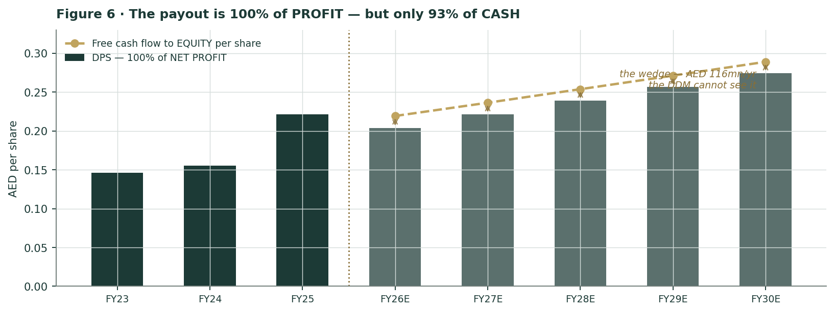
Figure 6 · The gap between the bars and the gold line is the free cash flow the dividend never distributes. §1.2a is about what has a claim on it.
1.2a The claim in front of the dividend — the RTA instalment
Version 2 of this study said the retained wedge "deleverages the balance sheet" and left it there. That was incomplete, and a fact-check of the study was right to push on it — though not for the reason it gave. Here is the actual obligation, from the company:
The disclosure, verbatim. "Salik’s repayment plan with the RTA is structured as an annual installment of AED 455.7 million to be paid semi-annually over six years as of the starting date." — Annual Report 2024, CFO’s Review. AED 455.7 mn × 6 years = AED 2,734.2 mn, which is the gate valuation exactly. The last instalment falls in November 2030.

AED mn | FY2026E | FY2027E | FY2028E | FY2029E | FY2030E
Operating cash (after tax and interest) | 1,645 | 1,773 | 1,904 | 2,035 | 2,168
less: dividend (100% of net profit) | (1,529) | (1,659) | (1,792) | (1,925) | (2,060)
= RETAINED WEDGE (≡ D&A − capex) | 116 | 114 | 112 | 111 | 109
less: RTA instalment | (456) | (456) | (456) | (456) | (456)
= CASH SURPLUS / (DEFICIT) | -340 | -341 | -343 | -345 | -347

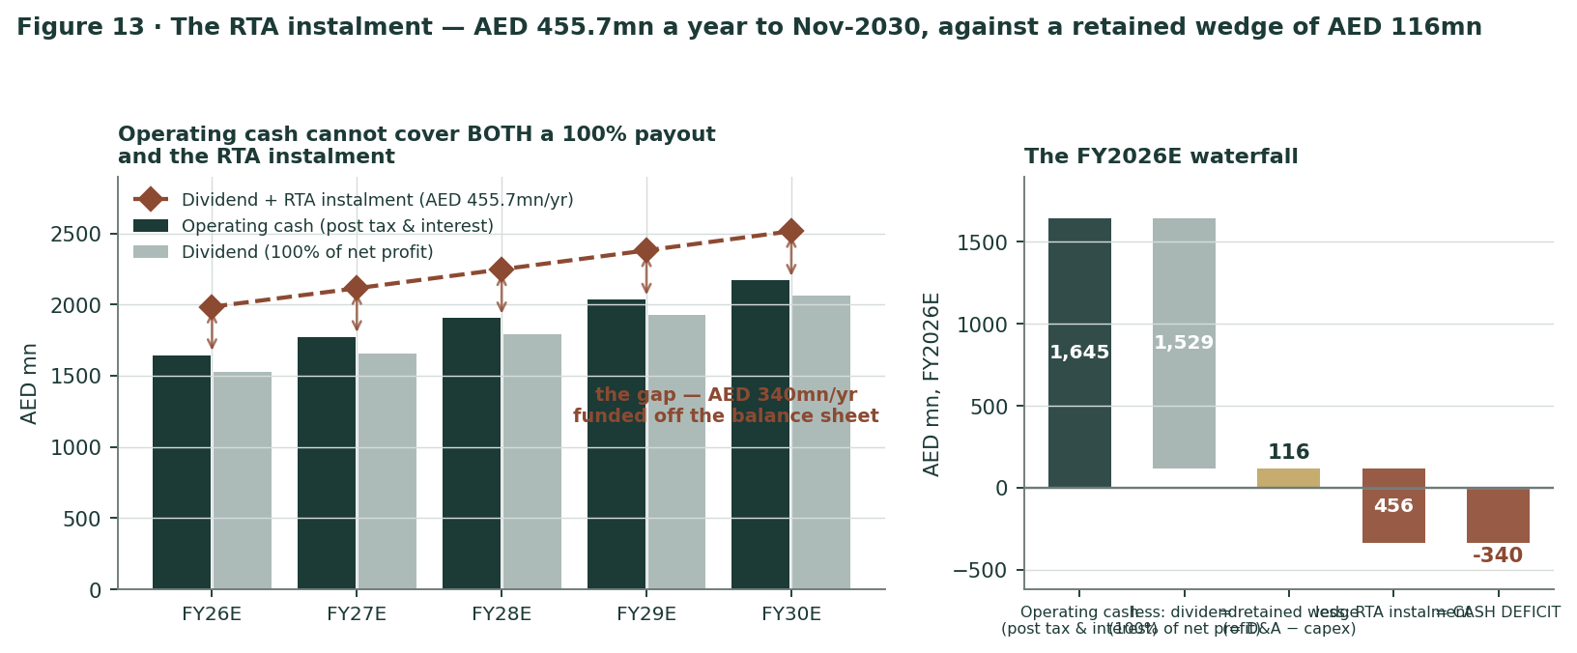
Figure 13 · Operating cash cannot cover BOTH a 100% payout and the RTA instalment. The gap is ~AED 340 mn a year, every year, until November 2030.
Read the third row carefully, because it is the important one. With a 100% payout the retained wedge is not a choice — it is ALWAYS D&A less capex, at any level of profit. So it is AED 116 mn whether Salik earns AED 1.5 bn or AED 2.1 bn. Against an instalment of AED 455.7 mn, that leaves a structural gap of roughly AED 340 mn a year — AED 1,716 mn cumulatively over FY2026–30 — which must come off the balance sheet: from cash, from the growing prepaid e-wallet float, or from the revolver.
What this does and does NOT mean | Verdict
Is the DCF wrong? Should the instalment be deducted from FCFF? | NO — see below
Is the 100% dividend under pressure? | YES — see below
What payout would SELF-FUND the instalments from operating cash? | 78%
… which would mean a DPS of | AED 0.1586
… and a DDM value of | AED 2.76 (vs AED 3.55)

Why the DCF is NOT wrong — and why deducting the instalment from FCFF would be the error. The RTA payable is INSIDE net debt. The company said so itself: “net debt stood at AED 5,198.6 million, up from AED 3,163.3 million at the end of September 2024, mainly due to the payable of the concessionary rights to RTA.” That is a jump of AED 2,035 mn in one quarter, and it is the gate liability arriving on the balance sheet. Our DCF deducts net debt of AED 4,226.4 mn ONCE, in the bridge from enterprise value to equity value. Deducting the instalments from free cash flow AS WELL would count the same obligation twice. Principal repayment is a FINANCING flow; FCFF is measured before financing. Note also that paying the instalment is net-debt NEUTRAL — the payable falls and cash falls together — which is exactly why net debt has kept declining (AED 5,198.6 → 4,799.2 → 4,226.4 mn) while Salik paid both the instalments AND a 100% dividend. There is no liquidity crisis here. There IS a tighter dividend than the headline implies.

And one thing that cuts the other way, which we should have said in version 2 and did not: the instalments END. The sixth and last falls in November 2030. From FY2031 — which is precisely where our terminal value begins — the AED 455.7 mn a year simply stops, permanently. The equity cash-flow profile improves structurally in the first year of the perpetuity, and we gave the company no credit for it.
1.3 Relative — one earnings multiple, and why it IS the dividend yield
Salik pays out 100% of net profit. P/E and dividend yield are therefore not two lenses — they are algebraically the same number, inverted. We run one, not two, and we say so.
We also do NOT value Salik on EV/EBITDA. The RTA bears 100% of the road capex and maintenance, so Salik converts 90.2% of EBITDA into free cash flow. A conventional toll road converts 50–60%, because it has to resurface its own roads. An EV/EBITDA drawn from that peer set would understate Salik by construction. We disclose the multiple; we do not value on it.
 | Low | Mid | High
Peer P/E applied | 20.0× | 24.0× | 28.0×
Implied dividend yield (the SAME number) | 5.0% | 4.2% | 3.6%
× FY2026E EPS = DPS (AED 0.2039) | AED 4.08 | AED 4.89 | AED 5.71

Cross-check at spot AED 5.70 | Value | Reading
P/E on FY2025 actual EPS | 27.5× | On a year that was 84% one-offs.
P/E on our FY2026E EPS | 28.0× | A premium to Parkin.
Trailing dividend yield (declared) | 3.9% | Below Parkin’s 4.2%.
Parkin (DFM) — the RTA’s 49-yr parking concession | 24.9× / 4.2% | The only true structural comparable on earth.
EV / FY2026E EBITDA (disclosed, NOT used) | 22.6× | Misleading across capex-free vs capex-heavy.
EV / FY2026E FCFF (disclosed) | 25.1× | The honest cash multiple.

One warning on this lens, which §1.2a has just earned. It works ONLY while the payout is 100%. If the board trims the payout to fund the RTA instalments, P/E and dividend yield decouple and this lens splits into two — which is why a payout change is the single most damaging thing that could happen to the valuation architecture here, and why we flag it as a discrete event in §3.
1.4 Normalized earnings power — what does a year without a war look like?
FY2026 is a broken year. So ask a cleaner question: with ten gates running, variable pricing embedded, and no conflict, what does Salik earn?
Normalized (non-conflict) year | Value
Chargeable trips (FY2025 + 2% underlying) | 651.9 mn
Revenue | AED 3,254 mn
EBITDA | AED 2,267 mn
EBITDA margin | 69.7%
Net profit | AED 1,700 mn
Normalized EPS = DPS (100% payout) | AED 0.2267
vs our FY2026E net profit | +11.2%
× P/E (mid of the peer band, 24×) | AED 5.44

This is the most generous of our four lenses, and deliberately so: it assumes the war ends and Dubai’s traffic returns. It still lands at AED 5.44, below spot.
1.5 Synthesis — four lenses, one field
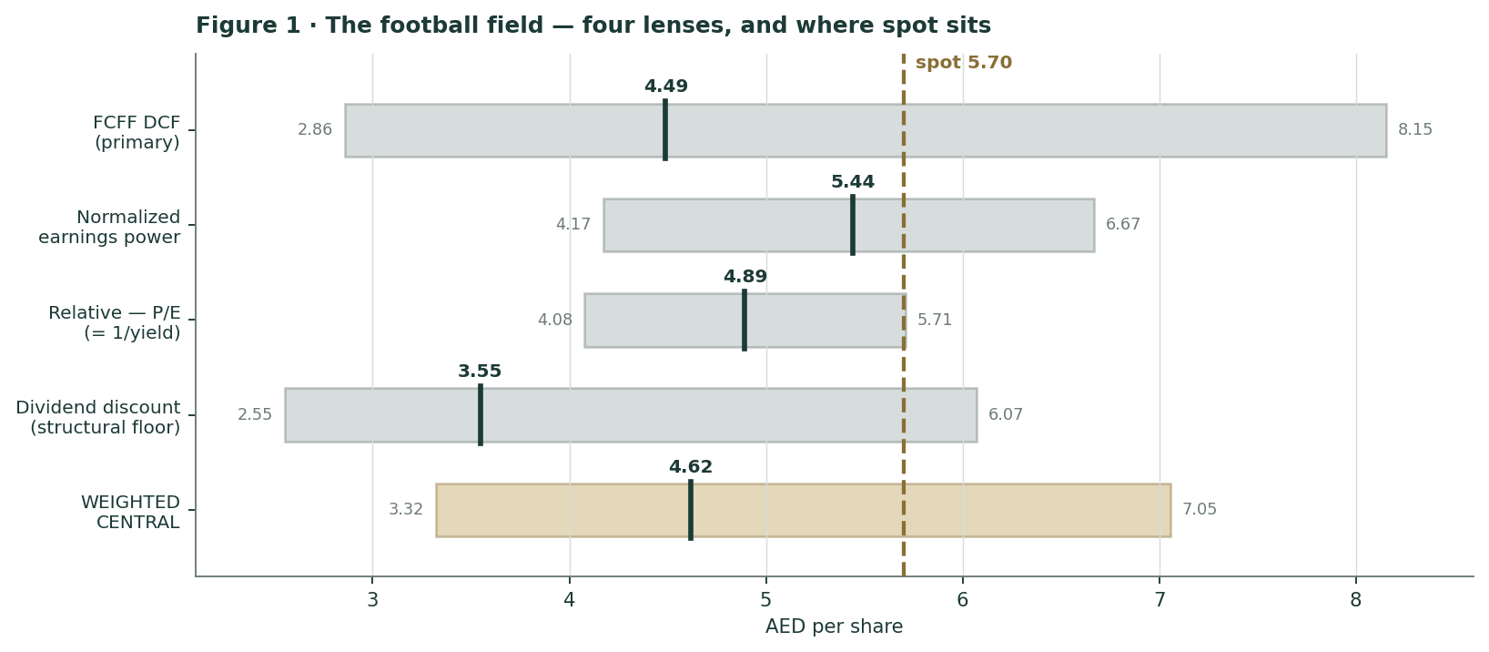
Figure 1 · Each lens’s bear–bull span, its central mark, and the weighted central against spot. Spot sits inside the combined range — but near the top of it.
Weighted central AED 4.62; combined band AED 3.32 to AED 7.05. Spot of AED 5.70 sits inside that band, but above the central mark of all four lenses. That is a coherent picture rather than a scattered one, and it is worth saying plainly: on our central assumptions the market is paying for a better business than the one we can build from the disclosures. Everything from §1.6 on is about whether our assumptions or the market’s are the ones that need revisiting — and this time we can settle a large part of it with data rather than opinion.

1.6 The drivers — the sourcing gate, the audit receipt, and the two things that reframe them
Our standing rule: before any forward driver is set, every driver declares where it came from. Salik is the rare case where the core driver is genuinely bottom-up — and we can prove it.
1.6a The audit receipt
Salik discloses, for Q1-2026, the number of peak trips (charged AED 6) and off-peak trips (charged AED 4). Multiply and add:
Q1-2026 rebuild | Value
Peak trips × AED 6 | 53.7 mn × 6 = AED 322.2 mn
Off-peak trips × AED 4 | 75.9 mn × 4 = AED 303.6 mn
Rebuilt toll usage revenue | AED 625.8 mn
Toll usage revenue as REPORTED | AED 625.5 mn
Rebuild error | +0.05%
Residual: chargeable trips LESS trips that actually paid | 16.1 mn (11.1% of chargeable)

The disclosed tariff split reproduces reported toll revenue to five hundredths of one per cent, so every forward toll driver here is built from company-disclosed inputs. Two things fall out of it that the company does not spell out.
The residual, and what we will NOT claim about it. Of the 145.7 mn trips the company calls “chargeable” in Q1-2026, only 129.6 mn actually paid anything. The residual 16.1 mn — 11.1% — generated no revenue, and the company does NOT break it out. Version 2 of this study labelled the whole residual as the free 01:00–06:00 window. That was more confident than the disclosure supports and we are withdrawing it. What we can say: it is almost certainly NOT collection leakage. Salik reports net violations at just 0.4% of net toll traffic, and describes its own toll leakage as “insignificant”. What we cannot say is the exact split between the free overnight window, a weekend or holiday tier, grace periods, and anything else. There is also a definitional tension in the company’s own documents — the Annual Report defines net toll traffic as EXCLUDING free-time trips, yet the Q1 arithmetic only closes if they are INCLUDED in “chargeable”. We report the residual, we flag the tension, and we do not attribute it.

- The +36.6% peak-trip figure is a base-period artefact. Salik reported peak trips +36.6% y/y in Q1-2026 while total chargeable trips FELL 7.7%. That is NOT drivers moving into the expensive window. Variable pricing only began on 31 January 2025, so a third of the Q1-2025 base had no peak tier at all. On a like-for-like monthly basis peak trips were DOWN about 9%. We do not use the +36.6% as a demand signal, and neither should anyone else.
1.6b Two growth engines — and only one of them is free
Salik can grow in exactly two ways. They have completely different economics, and the market may be paying for the wrong one.
- ENGINE ONE — organic traffic. More cars through the gates Salik ALREADY owns. No capital at all — the RTA owns the roads and maintains them. Every incremental dirham drops to the owner. THIS is what deserves a premium multiple, and it is the only growth our DCF gives Salik any credit for.
- ENGINE TWO — buying more gates. The RTA can add gates. Salik does not get them; Salik BUYS them. In November 2024 it bought two — Business Bay Crossing (AED 2,265 mn) and Al Safa South (AED 469 mn) — for a combined AED 2,734 mn, on top of the AED 4,200 mn it paid at the IPO for the original eight.
 | The ORIGINAL 8 gates | The 2 gates the RTA SOLD Salik
When | Handed over at the Sep-2022 IPO | Bought 24 Nov 2024
Price paid to the RTA | AED 4,200 mn | AED 2,734 mn [Dubai Media Office, 28 Aug 2024]
Incremental chargeable trips | 498.1 mn (FY2024, the clean 8-gate year) | 111 mn — the COMPANY’S OWN FY2025 projection
Incremental toll revenue | AED 1,992.5 mn | AED 474 mn
less concession fee @ 22.5% | (within reported EBITDA) | AED (107) mn
less incremental opex @ 5% | (within reported EBITDA) | AED (24) mn
EBITDA | AED 1,579.1 mn (reported) | AED 344 mn
less D&A | AED (85.7) mn [4,200 ÷ 49 yrs] | AED (58.6) mn [2,734 ÷ 46.67 yrs REMAINING]
NOPAT (× 0.91) | AED 1,354 mn | AED 260 mn
Invested capital | AED 4,200 mn | AED 2,734 mn
RETURN ON INVESTED CAPITAL | 32% | 9.5%
… against a WACC of | 8.1% | 8.1%
SPREAD | +24 pp | +1.4 pp

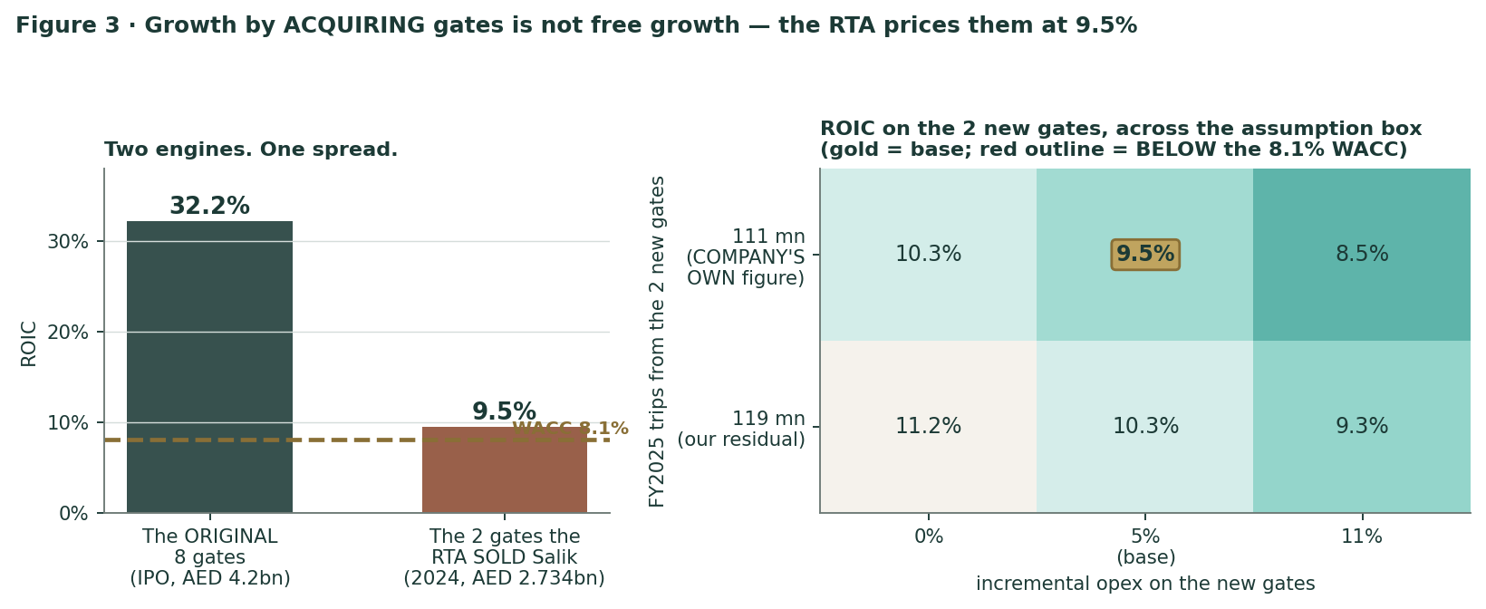
Figure 3 · Two engines, one spread. The gates the RTA SOLD Salik earn barely more than the cost of capital — and in the pessimistic corner of the box, LESS.
The finding, and the correction that made it sharper. The RTA is Salik’s grantor, its regulator, its largest counterparty, its 75.1% shareholder AND the vendor of every future gate. Its Director-General is Salik’s Chairman. It priced the first eight gates to make an IPO work — which is why the headline ROIC is 32%, and why that number is the LEGACY of a cheap asset transfer rather than a repeatable economic fact. It priced the next two at fair value: 9.5% against an 8.1% cost of capital. Two corrections since version 2 made this WORSE for the company and better as analysis. First, we had the price wrong — it is AED 2,734 mn, not 2,700. Second, and more importantly, version 2 DERIVED the new gates’ trip count as a residual; the company had PUBLISHED it (approximately 111 mn revenue-generating trips in 2025, stated August 2024). Using the company’s own figure, the ROIC falls from 10.3% to 9.5% and the spread over the cost of capital roughly HALVES. Across the whole assumption box — either gate-trip figure, incremental opex from 0% to 11% — it runs 8.5% to 11.2%, and in the pessimistic corner it is BELOW the cost of capital. Our DCF therefore models ZERO new gates. If the RTA adds them, that is not upside; on the only evidence available it is balance-sheet growth at a spread of about one point.

Two honest caveats. The AED 2,734 mn included earn-outs payable only if traffic EXCEEDS projections, and traffic is currently below them — so Salik will probably not pay them, which flatters the deal slightly. And a 9.5% return on a 45-year, inflation-hedged, monopoly cash stream in an Aa2 sovereign is not a bad asset in absolute terms. It is simply not a 32% asset, and the difference decides what multiple the equity deserves.
1.6c What actually drove FY2025 — and why almost none of it can repeat
FY2025 toll-revenue bridge | AED mn | Share of growth | Can it repeat?
FY2024 toll revenue (8 gates, flat AED 4.000 tariff) | 1,992.5
+ organic trip growth (30.0 mn × AED 4.000) | +120.0 | 16% | YES — this is the real business
+ TWO NEW GATES (111 mn × AED 4.000) | +444.0 | 60% | NO — the gate count went 8→10 once
+ REALISED-TOLL UPLIFT (639.1 mn × AED +0.272) | +173.5 | 24% | NO — the tariff went flat→variable once
FY2025 toll revenue (rebuilt) | 2,730.0
FY2025 toll revenue (REPORTED) | 2,730.0 |  | rebuild error 0.00%

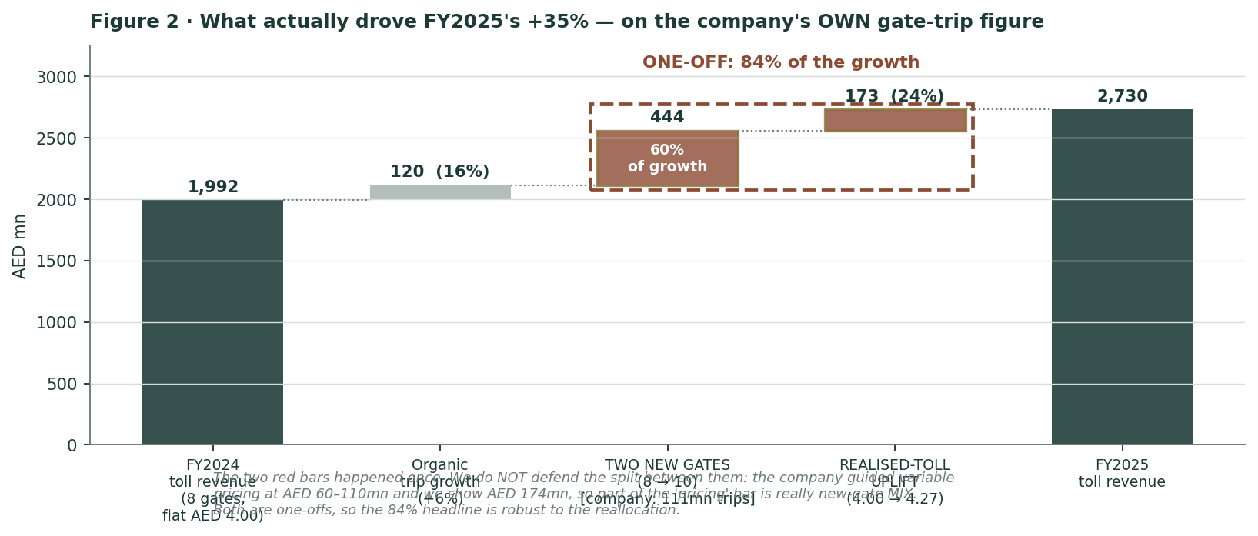
Figure 2 · The FY2025 toll-revenue bridge, on the company’s own new-gate trip figure.
84% of FY2025’s toll-revenue growth came from two one-off events. Only 16% was organic. FY2026 has no new gates and no new tariff structure. This is not a bearish claim; it is arithmetic, and it reconciles to the reported figure exactly. Anyone extrapolating 35% growth is extrapolating an artefact.
A caveat version 2 omitted, and should not have. The company’s OWN guidance for the revenue uplift from variable pricing was AED 60–110 mn a year. We show AED 173.5 mn — up to three times their estimate. The gap is almost certainly MIX: Business Bay Crossing is a peak-heavy commuter gate, so the new gates carry a higher realised toll than the network average, and part of what we label “pricing” is really “new gates”. We therefore report the two together as ONE-OFF and we do not defend the split between them. The 84% headline is robust to the reallocation, because both buckets are one-offs; only the internal split moves.
1.6d The elasticity test — the fact that cuts the other way
The variable-pricing experiment | FY2024 | FY2025 (ex-new-gates) | Change
Chargeable trips on the SAME 8 gates | 498.1 mn | 528.1 mn | +6.0%
Effective realised toll | AED 4.000 | AED 4.272 | +6.8%
Implied demand response |  |  | NONE

The RTA raised the effective price of a Dubai toll trip by 6.8% and volume on the same gates went UP 6.0%. No measurable demand destruction at all — and on the company’s own gate figure the volume response is STRONGER than we showed in version 2. Dubai’s tolled commute is price-INELASTIC, which means a tariff increase is very nearly pure margin. It is the single strongest fact in the bull case. It also explains something the company does not say out loud: pricing alone did NOT reduce congestion, so the RTA had to buy the reduction another way — which is what the free overnight window is. The RTA’s objective was never the revenue.
1.6e The operating dashboard — every KPI, with a reading
Operating KPI | Value | Reading
Chargeable trips — FY2025 / Q1-2026 | 639.1 mn / 145.7 mn (−7.7% y/y) | The volume engine. Q1 is the only quarter of the war we have seen.
Total trips incl. exempt — FY2025 | 852.7 mn | DUAL FRAME: 852.7 mn total vs 639.1 mn chargeable. Both are true; only one is billed.
Of 'chargeable' trips, the share that PAID | 88.9% (Q1-26) | 16.1 mn (11.1%) fell in the FREE 01:00–06:00 window and paid nothing.
Effective realised toll — FY24 / FY25 / Q1-26 | AED 4.000 / 4.272 / 4.293 | FY24 reconciles to the flat tariff EXACTLY. Variable pricing added 6.8% and it has held.
Registered active accounts / vehicles (Q1-26) | +7.5% y/y / +8.4% y/y | THE key datum. The customer base GREW while trips fell 7.7%. Utilisation shock, not population shock.
Revenue per employee (FY2025, 60 staff) | AED 51.6 mn | Not a typo. The RTA owns the roads; Salik owns a database.
EBITDA margin — FY23 / FY24 / FY25 / Q1-26 | 65.9% / 68.9% / 69.2% / 69.6% | Rising THROUGH a traffic collapse. The concession fee cut and the fines mix are doing it.
A dirham of FINES vs a dirham of TOLL | 1.34× in EBITDA | Fines carry NO concession fee. 9.4% of revenue, ~12% of EBITDA. Nobody models this line.
FCFF / EBITDA conversion (FY2026E) | 90% | A conventional toll road converts 50–60%. It has to resurface its own roads. Salik does not.
ROIC (FY2026E) vs WACC | 31.9% vs 8.1% | +24pp spread. But read §1.2 before you capitalise it.
ROIC — the ORIGINAL 8 gates (IPO price) | 32% | What the RTA HANDED Salik at the 2022 IPO, to make the IPO work. A legacy, not a skill.
ROIC — the 2 gates the RTA SOLD Salik (2024) | 9.5% | Against a 8.1% WACC — a 1.4pp spread. On the COMPANY'S OWN gate-trip figure (111mn). Growth-by-gate is NOT free growth.
RTA instalment (to Nov-2030) | AED 455.7 mn / yr | vs a retained wedge of only AED 116mn after the 100% payout. A ~AED 340mn/yr structural cash drain, funded off the balance sheet. See §1.7.
Dividend / free cash flow to equity (FY26E) | 93% | 100% of PROFIT is only 93% of CASH. The AED 116mn wedge deleverages. A DDM cannot see it.
Net debt / EBITDA — FY24 / FY25 / Q1-26 | 3.29× / 2.24× / 1.98× | Against a 5.0× covenant. 3.0× of headroom. Deleveraging without retaining a dirham.
Interest cover (EBITDA / net finance, FY26E) | 8.2× | Ample.
Share of Salik's revenue the RTA keeps | 58% | 22.5% concession fee + 75.1% of net profit. The free float's claim is 13% of revenue.
Beta — measured, weekly, n=195 | 0.64 (95% CI 0.43–0.84) | PASSES our usability test. 88% of SALIK's risk is IDIOSYNCRATIC — which is how a 26%-vol stock carries a 0.64 beta.

1.6f The per-driver sourcing gate
Driver | Mode | Justification | Ref.
Chargeable trips, FY2026 | BOTTOM-UP | Q1 actual 145.7 mn disclosed; Q2–Q4 path is our judgment on that base plus the company’s own "recovery from Q3" language. | F14/F16
Effective realised toll | BOTTOM-UP | Rebuilt from the disclosed peak/off-peak split to +0.05%. FY2024 AND FY2023 both reconcile to EXACTLY AED 4.00. | F16/F19
New-gate trips (111 mn) | SOURCED | The COMPANY’S own FY2025 projection, Aug-2024. Version 2 derived a residual instead — corrected. | F17
Gate cost (AED 2,734 mn) | SOURCED | Dubai Media Office, 28 Aug 2024. BB 2,265 + Al Safa 469. Version 2 used 2,700 — corrected. | F17
D&A (AED 145 mn/yr) | RECONCILED | 4,200/49 + 2,734/46.67 = 144.3. The Q1-26 EBITDA-to-EBIT bridge implies 145.2. An intangible cannot outlive its concession — corrected from a flat 49 yrs. | F17
Fines per chargeable trip (0.465) | BOTTOM-UP | The SOURCED history is noisy: 0.470 / 0.476 / 0.439 / 0.474. Version 2 modelled a flat 0.470 and called it stable. We now use the 4-period mean. | F19
Concession fee (22.5% of toll) | CONTRACTUAL | The agreement; RTA confirmation 3 Apr 2024. | F06
RTA instalment (AED 455.7 mn/yr) | SOURCED | AR2024 CFO Review. Six years from Nov-2024. In net debt, so NOT deducted from FCFF — see §1.2a. | F17
Equity beta (0.76) | MEASURED | Weekly regression vs a 14-name UAE portfolio: n=195, t=6.1, gate PASS. Blume-adjusted. | F05/F09
Risk-free rate (4.70%) | DERIVED | UST 10Y + the UAE MoF’s OWN disclosed AED-over-UST spread. | F09
ERP (4.87% / 4.93%) | PRIMARY | Damodaran ORIGINAL ctryprem.html. | F09
Terminal growth (2.5%) | JUDGMENT | Capped by the Metro Blue Line (2029). Sensitised 1.5–3.5%. | F12
"Other" revenue (AED 56 mn/yr) | RESIDUAL — A PLUG | HONEST FLAG: this is total revenue less the four lines we CAN source. The company’s FY2024 "other revenues" were AED 21.7 mn. Version 2 labelled it as though it were disclosed. It is not. | —
FY2026 company guidance | NOT SOURCEABLE | Guidance WAS cut on 11 May 2026. The numbers are in no company-official channel we could reach. Five targeted searches. We did NOT substitute an aggregator. | F13 (neg)

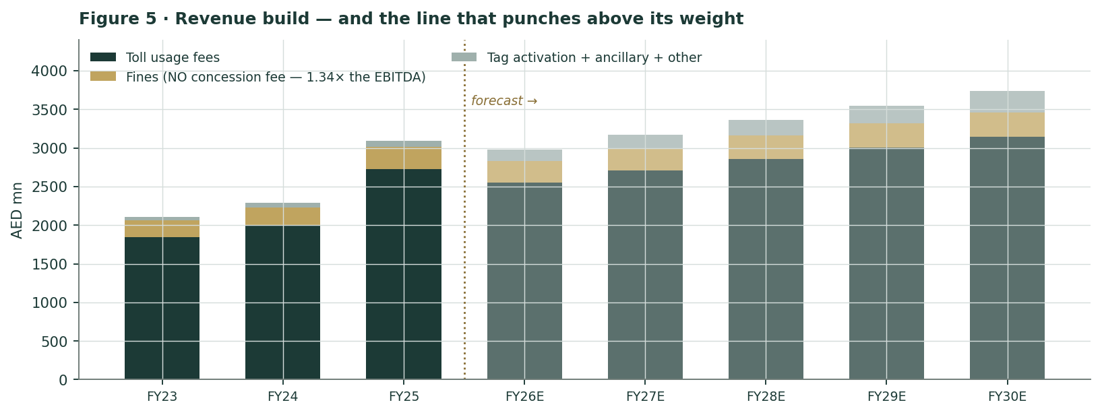
Figure 5 · The revenue build. FY2023 and FY2024 lines are now fully sourced from the AR2024 CFO Review, replacing two derived figures.

1.7 The crux — the war attacks the numerator AND the denominator
Step one: prove it is not an earnings disagreement
Test | Result | Reading
Our FY2026E EPS | AED 0.2039
FY2025 actual EPS | AED 0.2071
Our FY2026E vs FY2025 actual | -1.6% | Essentially flat.
Q1-2026 net profit, annualised | AED 1,477 mn
Our FY2026E net profit | AED 1,529 mn | ABOVE the Q1 run-rate. We model a recovery.

We are not forecasting a collapse. We are forecasting a flat year with a recovery in the back half — which is what the company itself guides to. If the earnings path were the problem, the fix would be to raise it. It is not the problem.
Step two: what IS the market paying for?
Reverse-engineered from spot AED 5.70 | Implied | We use | Is it credible?
Hold terminal g at 2.5% ⇒ implied WACC | 7.0% | 8.1%
⇒ implied equity beta | 0.52 | 0.76 | YES — and this IS the finding. It sits INSIDE our measured 95% CI [0.43, 0.84], and it is almost exactly SALIK’s PRE-WAR beta of 0.47.
Hold beta at 0.76 ⇒ implied terminal g | 3.8% | 2.5% | Demanding but not absurd for a city planning 4.0 → 5.8 mn people.
Unlevered FCF yield at spot | 4.0% | — | In steady state this equals WACC − g. The market is saying either the WACC is ~7% or growth is ~4%. Or both, a bit.

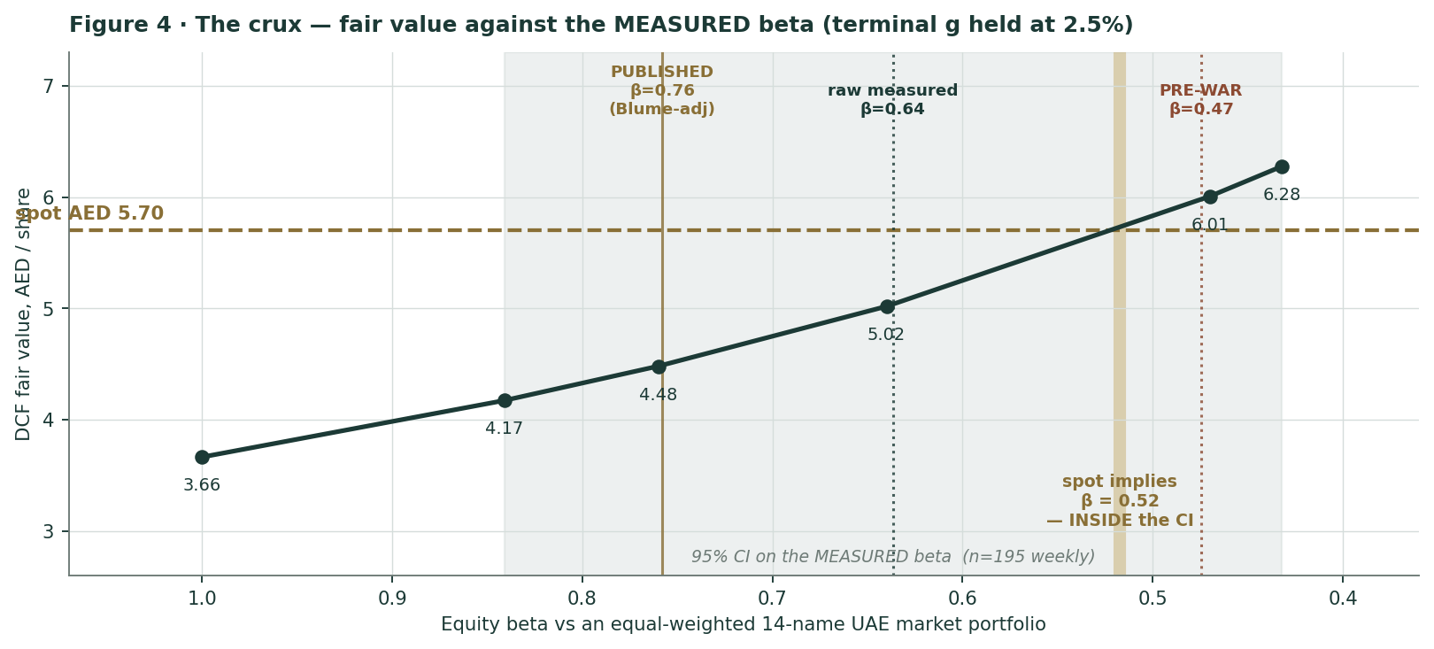
Figure 4 · Fair value against the MEASURED beta, with the 95% confidence band shaded. Spot implies β = 0.52 — inside the CI, and close to the pre-war reading.
Beta | Cost of equity | WACC | Fair value | vs spot | What this beta IS
1.000 | 9.6% | 9.2% | AED 3.66 | -35.7% | what v1 used, on a FAILED gate — void
0.800 | 8.6% | 8.3% | AED 4.32 | -24.1% | the EFG-Hermes convention (see below) — conclusion UNCHANGED
0.841 | 8.8% | 8.5% | AED 4.17 | -26.8% | upper bound of the 95% CI on the measured beta
0.760 | 8.4% | 8.1% | AED 4.48 | -21.4% | PUBLISHED — Blume-adjusted (2/3 x 0.637 + 1/3 x 1.0)
0.640 | 7.8% | 7.6% | AED 5.02 | -11.9% | RAW measured weekly beta, n=195, t=6.10
0.470 | 7.0% | 6.8% | AED 6.01 | +5.4% | measured PRE-WAR only (n=177) — the peacetime beta
0.432 | 6.8% | 6.6% | AED 6.28 | +10.1% | lower bound of the 95% CI on the measured beta

The honest verdict, stated as sharply as we can. At the beta we publish (0.76, Blume-adjusted, deliberately conservative), Salik is worth AED 4.49 and spot is 21% too high. At the RAW measured beta (0.64), it is worth AED 5.03. At the measured PRE-WAR beta (0.47), it is worth AED 6.02 — and spot is CHEAP. All three are betas we MEASURED, on the same portfolio, with the same method. So the entire question reduces to one thing: IS THE WAR A PERMANENT FEATURE OF DUBAI’S RISK PROFILE, OR IS IT NOT? If it is, the war-inclusive beta is the right forward-looking number and the stock is expensive. If it is not, the pre-war beta is right and the stock is not expensive at all. We take the conservative side because we cannot know, and because the truce was called over three days before this study’s anchor date. We are not going to pretend the question is settled. It is not.

The war is not two independent risks; it is one risk hitting from two directions. It cut chargeable trips 7.7% in the only quarter we have seen, and it doubled the measured beta. A recovery reverses both together. A relapse worsens both together. There is no scenario in which traffic recovers but the beta stays at 1.0. That correlation is why spot — which needs BOTH to go right — is a coherent bet rather than a contradictory one, and also why it is a demanding one.

1.8 Macro, the war, and the cost of capital — measured, not assumed
Version one of this study defaulted beta to 1.00 because a regression failed a sample-size gate. That was an honest failure, but it was a failure, and it dominated the answer. We went back and did the work properly.
The market portfolio we could not find, and the one we built
The DFM General Index publishes no programmatically retrievable history beyond a rolling ~20 sessions, which is what killed the first attempt (n = 19 against a 24-observation floor). But a market portfolio does not have to be an exchange’s own index. We rebuilt one from the fourteen UAE names that Testahil’s own Monte-Carlo engine uses to calibrate this market: ADCB, ADIB, ADNOC Gas, Agthia, Aldar, Alpha Dhabi, DIB, e&, Emaar, Emaar Development, Emirates NBD, FAB, IHC and 2PointZero. Equal-weighted, spanning BOTH exchanges, spanning banks, real estate, telecoms, utilities and holding companies, with every constituent put through the same data-quality gate as Salik itself.
Regression: SALIK vs the 14-name UAE market portfolio | n | β | SE | t | R² | Gate
WEEKLY log returns, full history since IPO | 195 | 0.637 | 0.104 | 6.10 | 16.2% | PASS
DAILY log returns, full history since IPO | 940 | 0.578 | 0.052 | 11.20 | 11.8% | PASS
WEEKLY, PRE-WAR only (to 27 Feb 2026) | 177 | 0.475 | 0.120 | 3.97 | 8.3% | PASS
WEEKLY, WAR PERIOD only (from 28 Feb 2026) | 18 | 1.001 | 0.251 | 3.99 | 49.8% | FAIL (n)

The single most important number in this study. SALIK’s beta BEFORE the war was 0.47. DURING the war it is 1.00. The war DOUBLED it. That is what a crisis does: correlations go to one, and a stock that normally trades on its own dividend and its own traffic starts trading on whether the Strait of Hormuz reopens. It also fully explains why version one measured 0.89 from a 19-session window in May–June 2026: that window sat entirely INSIDE the war. It was a crisis beta. The consequence is that the war is doing DOUBLE damage — it cut Q1 chargeable trips by 7.7% (the numerator) and it doubled the discount rate’s equity risk loading (the denominator). Those two effects reverse together or not at all.

Which beta do we publish? The conservative one. We take the full-history weekly β of 0.637 — which INCLUDES the war and therefore already leans high — and Blume-adjust it (two-thirds raw plus one-third of 1.0, the convention Bloomberg and Value Line both use) to 0.76. For a low-beta stock the Blume adjustment pushes the discount rate UP and the fair value DOWN, so it is the cautious choice.
A note on our standing rule, because a fact-check of this study challenged it. It was put to us that Testahil mandates a beta floor of 0.80 and that publishing 0.76 is therefore a breach. We have checked. The our published research standards says: “Beta: genuinely attempt a regression; default to 1.0 ONLY on a real usability-gate failure (n≥24, R²≥5%, SE(β)<|β|).” Our regression clears all three by a wide margin, and our cost-of-capital module carries no floor — its only reference to 0.8 is a rung on a SENSITIVITY ladder. The 0.8–1.3 band that was cited belongs to the EFG-Hermes portable lessons, which describe what EFG does, and the standing instruction on those is explicit: adopt EFG’s machinery, not their optimistic assumptions. Applying a 0.80 floor to a stock whose beta we measured at 0.637 with a t-statistic of 6.1 would be exactly that. That said, we have added the 0.80 rung to the ladder above so the reader can see what it costs: fair value AED 4.32, versus AED 4.49 at our published beta. The conclusion of this study does not change either way, and we would rather show that than argue about it.

Two things the beta tells you that the volatility does not
Diagnostic | Value | Reading
SALIK annualised volatility (daily, full history) | 25.8% | HIGH. Not a sleepy utility.
UAE market-portfolio volatility, same window | 15.3%
Correlation with the market portfolio | +0.343 | Low.
⇒ share of SALIK’s variance that is IDIOSYNCRATIC | 88.2% | THE resolution of the paradox. A 26%-vol stock can carry a 0.64 beta because almost nine-tenths of its risk is its own, not the market’s. For a diversified holder that risk diversifies away. For a concentrated one, it does not.
Asset (unlevered) beta at D/E of 0.10, tax 9% | 0.584 | Salik is barely levered; the asset beta and the equity beta are nearly the same number.

The sourced cost-of-capital build
Cost-of-capital input | Value | Date | Source — and why we did not take the shortcut
Risk-free rate, AED 10-year | 4.7% | 10 Jul 26 | UST 10Y 4.56% PLUS the UAE Ministry of Finance’s OWN disclosed 14bp AED-over-UST pricing spread (May-2026 T-Bond auction). The dirham is pegged, but a peg is not a merger of curves. DERIVED — flagged.
Equity risk premium — rating basis | 4.9% | 5 Jan 26 | Damodaran ctryprem.html, ORIGINAL file. UAE Aa2: CRP 0.64% + mature 4.23%.
Equity risk premium — CDS basis | 4.9% | 5 Jan 26 | Same file, Abu Dhabi row (CDS 0.46%). Proxy, flagged. Both WACCs published.
Equity beta — PUBLISHED (Blume-adjusted) | 0.76 | 10 Jul 26 | ⅔ × 0.637 (measured weekly, n=195, t=6.1) + ⅓ × 1.0. Gate: PASS.
Cost of equity (rating ERP) | 8.4% |  | 4.7% + 0.76 × 4.9%
Cost of debt, pre-tax | 5.5% |  | Triangulated: (a) Q1-26 net finance cost annualised on average net debt = 5.77%; (b) AED rf + 83bp (ENBD’s inaugural AED bond over UAE Treasuries) = 5.53%; (c) 3M EIBOR + a 150–175bp IG margin.
Corporate tax rate | 9.0% |  | UAE CT. Q1-2026 effective rate confirmed at 9.0%.
Capital weights (E / D at market) | 91.0% / 9.0% | 10 Jul 26 | Market cap AED 42,750 mn; net debt AED 4,226.4 mn (disclosed, and INCLUSIVE of the RTA payable — see §1.2a).
WACC — rating basis (PRIMARY) | 8.1%
WACC — CDS basis | 8.1% |  | Published alongside, per standing rule.
Terminal growth g | 2.5% |  | Judgment. Dubai 4.0 → 5.8 mn people by 2040 is ~2.5%/yr on population alone — but the AED 20.5 bn Metro Blue Line opens in 2029 on the same east-west axis Salik tolls. Sensitised 1.5–3.5%.

1.9 Sensitivity — four grids, and the concession cushion
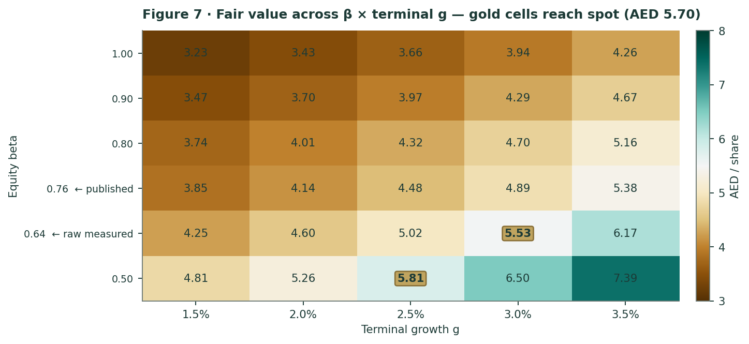
Figure 7 · Fair value across β × terminal g. Gold cells reach spot. The published beta and the raw measured beta are BOTH on this grid.
Grid 2 — WACC × terminal g, beta held at the published 0.76
WACC \ g | 1.5% | 2.0% | 2.5% | 3.0% | 3.5%
6.6% | 5.19 | 5.72 | 6.37 | 7.21 | 8.32
7.3% | 4.44 | 4.82 | 5.28 | 5.85 | 6.57
8.1% | 3.86 | 4.15 | 4.49 | 4.90 | 5.39
8.8% | 3.40 | 3.62 | 3.88 | 4.19 | 4.55
9.6% | 3.02 | 3.20 | 3.41 | 3.64 | 3.91

Grid 3 — the FY2026 traffic trough
FY2026 traffic assumption | DCF fair value | vs our base
Q2-26 trips at 75% of Q2-25 | AED 4.05 | -9.7%
Q2-26 trips at 80% of Q2-25 | AED 4.24 | -5.6%
Q2-26 trips at 85% of Q2-25 | AED 4.42 | -1.6%
Q2-26 trips at 90% of Q2-25 | AED 4.60 | +2.5%
Q2-26 trips at 95% of Q2-25 | AED 4.78 | +6.5%

The whole plausible range of the traffic shock — from a 25% Q2 collapse to a 5% dip — moves fair value less than a single 0.10 step in beta does. The war matters to this valuation mostly through the DISCOUNT RATE, not the traffic. Everyone is watching the traffic.
Grid 4 — what if the RTA keeps SELLING Salik gates?
Our base DCF models ZERO new gates, and §1.6b explains why. But a fact-check of this study made a fair theoretical point: if incremental capital only earns 9.5%, the terminal cannot assume perpetual excess returns. So here is the alternative, priced.
Scenario | Fair value | vs our base
a new gate every 3 yrs @ 9.5% ROIC | AED 3.59 | -20.1%
a new gate every 5 yrs @ 9.5% ROIC | AED 3.95 | -12.1%
a new gate every 8 yrs @ 9.5% ROIC | AED 4.15 | -7.5%
NO new gates (our base case) | AED 4.49 | —

A gate purchase every five years at a 9.5% return costs roughly 12% of the equity value. That is the price of "growth" when the vendor is also the controlling shareholder — and it is why §3 prices a new-gate announcement as a NEGATIVE discrete event, which is the opposite of how the market would normally read it.
Grid 5 — the working-capital float (an objection, quantified)
It was put to us that setting the change in working capital to zero during a revenue contraction is optimistic, not conservative, because a shrinking prepaid e-wallet float is a USE of cash. The MECHANISM is right and we accept it. The MAGNITUDE is not:
If FY2026 revenue is… | NWC (scaled to revenue) | ΔWC — cash use | Fair value | vs base
revenue as modelled (-3.6%) | AED -649 mn | AED +25 mn | AED 4.49 | -0.07%
revenue -10% | AED -584 mn | AED +90 mn | AED 4.48 | -0.25%
revenue -20% | AED -519 mn | AED +155 mn | AED 4.47 | -0.43%

Even a 20% revenue collapse moves fair value by less than half a per cent. And the one contraction quarter we actually have CONTRADICTS the mechanism: in Q1-2026 revenue fell 3.0% and the float DEEPENED by AED 172 mn. We keep ΔWC at zero in the base case, we show the sensitivity, and we let the reader decide.
The concession cushion — the clause nobody prices
Salik may recommend an annual toll increase under an inflation-linked formula. The RTA reviews it; the Executive Council decides. If the Council REJECTS the increase, the RTA compensates Salik by CUTTING the concession fee — down to a contractual floor of 15%. If a higher-than-standard increase IS approved, the fee rises instead. It has already fired: 25.0% → 22.5%, effective 1 April 2024.
The cushion, in real money | Value
Concession fee today | 22.5%
Contractual FLOOR | 15.0%
On FY2026E toll revenue of AED 2,555 mn | AED 192 mn per year
As a share of FY2026E EBITDA | 9.2%

It was put to us that this is “an accounting hedge, not a liquidity hedge” — that it protects the margin percentage but not absolute cash. That is wrong, and it matters. A fee cut from 22.5% to 15% of toll revenue is AED 192 mn a year of REAL CASH that Salik does not hand over. It is precisely a liquidity hedge, and given §1.2a it is the most likely source of relief if the RTA instalments squeeze the dividend. The valid kernel in the objection is that the cushion SCALES with toll revenue, so in a volume collapse the absolute cushion shrinks too. True — and worth one sentence, which this is.

2 Technical and price structure
Indicator | Reading | Interpretation
Last close | AED 5.70 | —
SMA 20 / 50 / 100 / 200 | AED 5.87 / 5.72 / 5.74 / 5.96 | Price sits below EVERY moving average. -4.4% below the 200-day — the stock broke down in the March selloff and has not reclaimed it.
RSI (14) | 46.3 | Neutral. Neither oversold nor overbought. No bounce signal.
MACD (12, 26, 9) | line +0.006 / signal +0.043 / hist -0.037 | Histogram negative — the line has crossed below its signal. Bearish, but marginal.
ATR (14) | AED 0.141 (2.5%) | An average day moves the stock 2.5%.
52-week range | AED 4.99 – 6.85 | -16.8% from the high.
Realised volatility, 252d | 28.5% | High — but see §1.8: 88.2% of it is IDIOSYNCRATIC. Volatility and beta are not the same thing, and for Salik they point in opposite directions.
Return — 1m / 3m / 6m / 12m | +1.8% / +2.9% / -10.9% / -6.6% | Stabilised recently; still down over six months.
Return since IPO (AED 2.00, Sep 2022) | +2% | An outstanding trade. That is not an argument about today.

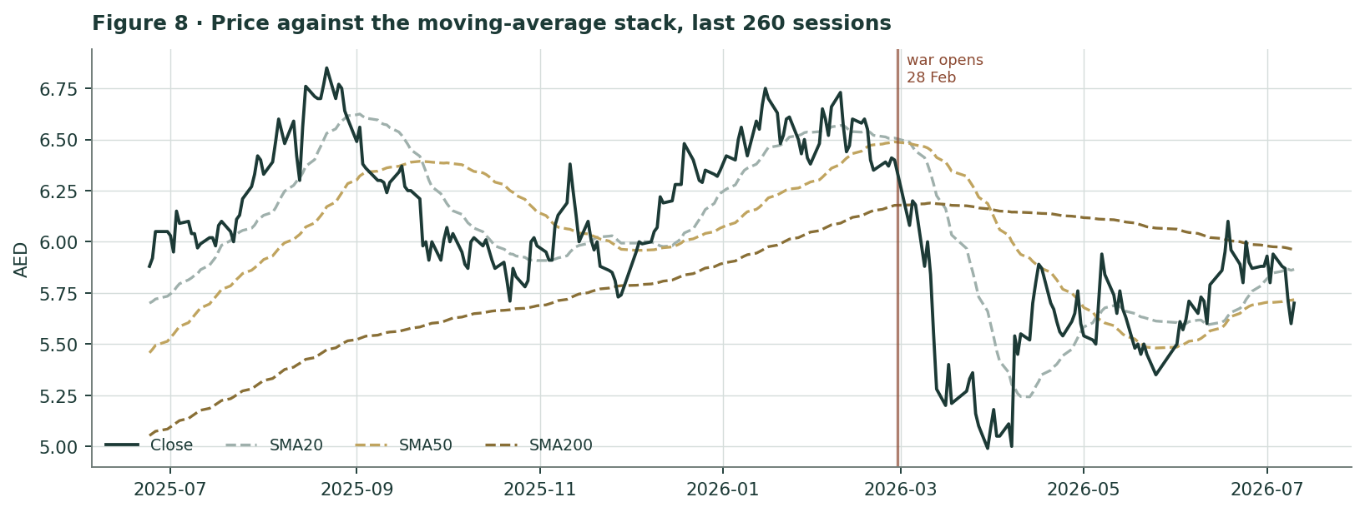
Figure 8 · Price against the moving-average stack. The vertical marks the day the war opened.
The technical picture is mildly negative and it is not saying anything the fundamentals are not already saying. We report it because our own format requires it, and we weight it accordingly: it describes where price has been, not what value is.

3 Monte Carlo — a probabilistic price map
This section answers a different question from §1. §1 asks what Salik is WORTH. §3 asks where the PRICE is likely to be in twenty and sixty trading sessions. Those are different questions with different time constants, and the fundamental gap in §1 deliberately does NOT enter the Monte-Carlo drift. Nothing in the fair-value work leaks into the distribution.
The probability read
Statement | T+20 · 7 Aug 2026 | T+60 · 2 Oct 2026
The engine’s median price | AED 5.70 | AED 5.69
Probability the price is above today’s AED 5.70 | 49.7% | 49.6%
5th percentile — a bad-but-not-extreme outcome | AED 4.94 | AED 4.42
95th percentile | AED 6.57 | AED 7.34
Width of the 90% band, as % of spot | 28.6% | 51.1%
Probability the price is below OUR weighted central | 1.3% | 8.5%

The median is flat, and it is flat for a reason we can state precisely. The engine’s drift is a carry anchor: the risk-free rate less the dividend yield. The CBUAE base rate is 3.6% (the dirham is pegged, so US policy IS UAE policy); Salik’s trailing declared dividend yield on spot is 3.9%. Those very nearly cancel. The 60-session drift is -0.059% — a rounding error. So the engine says: expect the total return to arrive as the dividend, and expect the price to go roughly nowhere, plus or minus a wide band. That is an EXPLAINED flat, not an unexplained one, and it is the honest output for a full-payout utility-like asset in a 3.65% rate world.
The continuous forces — what is pushing, and which way
# | Force | Sign
1 | Dubai traffic normalisation as the ceasefire holds (the Q3 recovery the company guides to) | +
2 | Fed / CBUAE rate path — the dirham is pegged, so US rates ARE UAE rates | ±
3 | Dubai resident population and visitor arrivals — every revenue line scales with them | +
4 | The 3.9% dividend yield as a floor bid in a 3.65% policy-rate world | +
5 | MSCI UAE index flows against a 24.9% free float — small float, large index weight | ±
6 | Oil at ~US$91: funds Dubai's fiscal support, but raises the cost of a discretionary trip | ±
7 | Ancillary revenue compounding off a tiny base (+147% y/y, but only 1.5% of revenue) | +
8 | The RTA's congestion mandate — more free windows, more Metro, fewer tolled trips | −

The discrete events — named, dated, with a probability and an impact
# | Event | P | Impact | Note
1 | Q2/H1-2026 results (~mid-Aug 2026) — the FIRST full quarter under the war | 90% | ±3.0% | The single biggest known unknown INSIDE the T+60 window.
2 | Q2 chargeable trips come in ABOVE 140 mn (a shallower trough than we model) | 40% | +2.5%
3 | Q2 chargeable trips come in BELOW 130 mn (a deeper trough) | 30% | −3.5%
4 | H1-2026 dividend declared at 100% of H1 profit (policy intact) | 88% | +0.5%
5 | Any deviation from the 100% payout policy | 7% | −6.0% | A regime change, not a rounding. It would invalidate the DDM and the relative lens at once.
6 | Hormuz re-escalation / the June MoU collapses | 30% | −4.0% | The truce was called 'over' on 7 Jul and walked back on 8 Jul — three days before our anchor.
7 | A formal end to the war (the MoU's 60-day clock runs out ~16 Aug) | 35% | +3.5%
8 | A TEC tariff decision — in EITHER direction | 15% | +1.5% | Both outcomes are good: a rise lifts the toll; a refusal CUTS the concession fee. §1.9.
9 | The RTA announces new toll gates (and the price Salik must pay) | 10% | −1.0% | Priced NEGATIVE, deliberately. On the one data point we have, gates are sold at ~10.6% ROIC. See §1.2.
10 | Fed cut ≥25bp at the Sep FOMC | 45% | +1.0%
11 | The board trims the payout below 100% to fund the RTA instalments | 12% | −7.0% | NEW in v3. §1.2a: the payout that would SELF-FUND the instalments is 78%. With a 100% payout, P/E and yield are ONE multiple — so a trim breaks the DDM and the relative lens simultaneously.

These are the preparer’s judgments, not market-implied probabilities. They are published so they can be argued with. Note event #9: we price the RTA ADDING gates as a NEGATIVE, which is the opposite of how the market would normally read a growth announcement. §1.2 is why.
The engine, and its calibration
Engine parameter | Value
Engine | our Monte-Carlo engine — "carry-anchored YZ-HAR-t", read live from our calibration engine
Market profile | UAE (ADX/DFM) — the same 14-name panel we used for the beta
Tail parameter ν (fitted per-market, MLE on pooled residuals) | 10
Cone-width calibration (fitted) | 1.049
Signal | OFF. Every market in the system runs carry-only; the signal was ablated on evidence.
Carry: rf (CBUAE base rate) less q (dividend yield) | 3.6% − 3.9%
Paths / seed | 50,000 / 42

Two honesty notes. First, ν is WEAKLY IDENTIFIED — on the UAE panel every value from 5 through the Gaussian limit sits inside the 95% likelihood interval, and ν trades off against the cone-width calibration. The PAIR is what is fitted; the honest object is the cone they jointly produce, not either coordinate alone. Second, and this one matters for how you read the bands below:
the calibration back-test — the calibration gate, and what it says about these bands. SALIK was back-tested over 11 non-overlapping 60-session windows against a carry-anchored lognormal random walk. Verdict: PARITY — robust across bootstrap block sizes 2, 3 and 4. That means the engine is calibrated and market-panel validated, but has NO demonstrated single-name edge on SALIK. We publish under the calibrated-but-no-edge tier and we do not dress it up. Two caveats you are owed. (1) Eleven windows is a short panel: SALIK listed on 29 September 2022, so the standard five-year walk-forward truncates to 3.8 years, and after the 260-session burn-in only eleven windows remain. (2) The cone is OVER-COVERED: every single realised outcome fell inside the 90% band (coverage 1.00 against a 0.90 target), and the band runs 1.26× as wide as the benchmark’s. Read the 90% intervals below as GENEROUS, not tight. This is a known open item in the engine — a name-level width calibration, shrunk toward the market fit, is the proposed fix, and it is not yet built.

The percentile map
Percentile | T+20 (AED) | T+60 (AED) | T+60 vs spot
5% | 4.94 | 4.42 | -22.4%
10% | 5.12 | 4.71 | -17.4%
25% | 5.40 | 5.17 | -9.3%
50% | 5.70 | 5.69 | -0.1%
75% | 6.02 | 6.28 | +10.1%
90% | 6.35 | 6.90 | +21.1%
95% | 6.57 | 7.34 | +28.7%

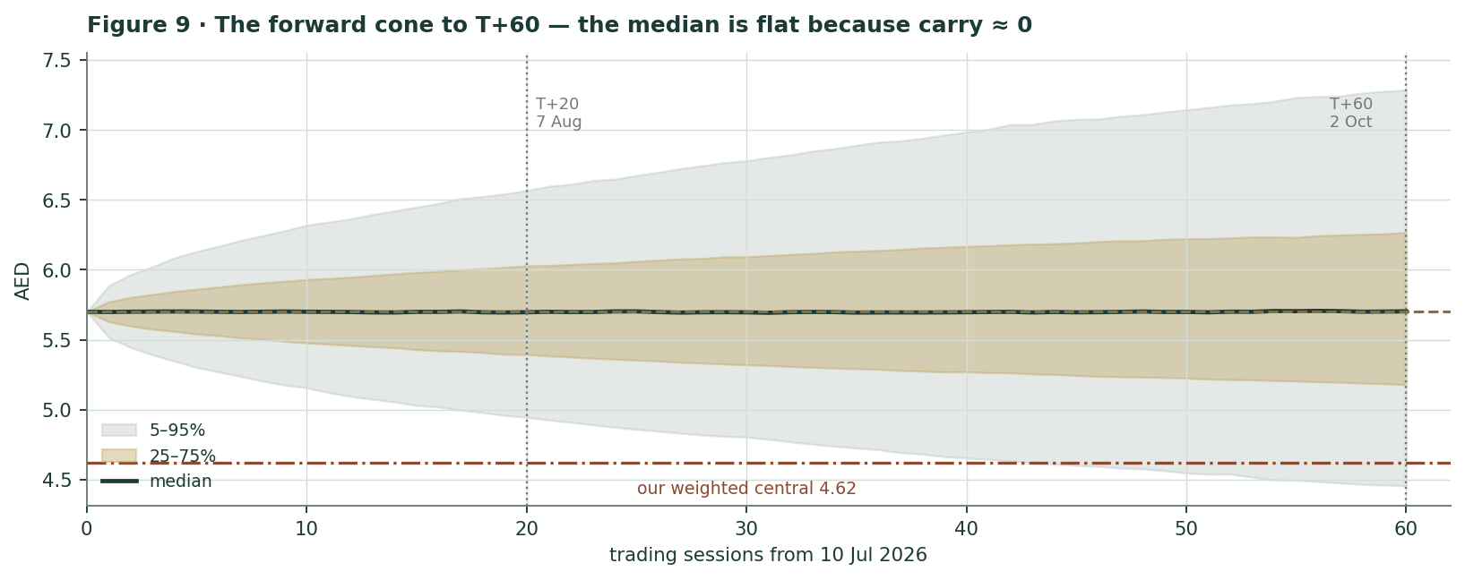
Figure 9 · The forward cone to T+60, with our weighted central fair value marked. Note the price distribution and the value estimate are computed from entirely separate machinery.
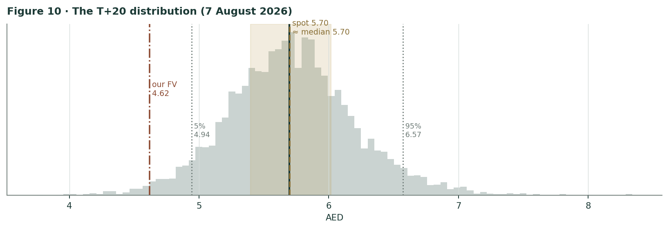
Figure 10 · The T+20 distribution (7 August 2026).
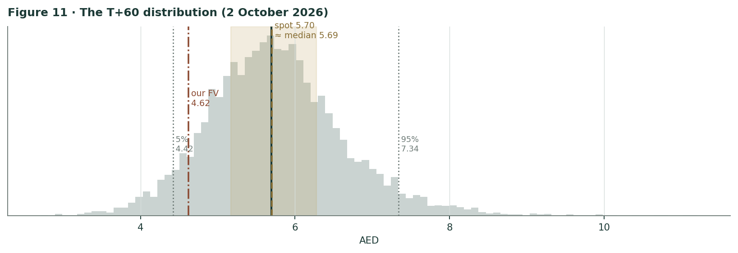
Figure 11 · The T+60 distribution (2 October 2026).
Touch-probability ladder — both horizons
Level | vs spot | P(touch by T+20) | P(touch by T+60)
AED 4.50 | -21.1% | 0.9% | 9.9%
AED 5.00 | -12.3% | 10.4% | 33.2%
AED 5.25 | -7.9% | 27.2% | 52.0%
AED 5.50 | -3.5% | 57.6% | 74.7%
AED 6.00 | +5.3% | 45.7% | 66.7%
AED 6.25 | +9.6% | 22.6% | 47.2%
AED 6.50 | +14.0% | 10.0% | 32.4%
AED 7.00 | +22.8% | 2.1% | 14.3%

READ THE TOUCH LADDER WITH THIS IN MIND. The calibration back-test showed the cone is OVER-COVERED: every realised outcome fell inside the 90% band, and the band runs 1.26× as wide as the benchmark’s. An over-wide cone does not just widen the terminal percentiles — it INFLATES the touch probabilities disproportionately, because a path only has to graze a level ONCE. So the numbers above are, if anything, too high at the extremes. A 9.9% chance of touching AED 4.50 and a 14.3% chance of touching AED 7.00 should both be read as UPPER BOUNDS. This is a known open item in the engine (a name-level width calibration is the proposed fix and it is not yet built) and we would rather flag it here than let a portfolio manager read an artefact of the width parameter as a statement about Salik.

And separately: a 74.7% chance of TOUCHING AED 5.50 at some point in three months is not a forecast that the stock falls — it is a statement about how much a 28%-volatility stock wanders. Touch probabilities are always higher than terminal probabilities, and confusing the two is the single most common misreading of a Monte Carlo.

4 Comparison of the lenses, and a verdict
Clock | What it measures | Its answer | What it is NOT
Fundamental (§1) | What the cash flows are worth to an owner | AED 3.32 – 7.05, central 4.62 | Not a price target. Not a forecast of where the stock will trade.
Technical (§2) | Where price has been, and its momentum | Mildly negative; below the whole MA stack | Not evidence about value. It describes the past.
Monte Carlo (§3) | Where price is likely to BE | T+60 median AED 5.69; 90% band 4.42–7.34 | Not a value estimate. Its drift is a carry anchor and nothing else.

The verdict, stated plainly
On our published assumptions, Salik is expensive: spot of AED 5.70 sits above the central mark of all four fundamental lenses and 19% above our weighted central of AED 4.62. But we want to be extremely precise about WHY, because the honest answer is not the intuitive one, and because we changed our own mind in the course of the work.
- It is NOT the traffic. Our FY2026E EPS is within 1.4% of FY2025 actual and above the Q1 run-rate. We model a recovery. If you want to argue with us, the earnings are not the place to do it.
- It IS the discount rate. It is not that we cannot measure it — we can, and we did. SALIK’s weekly beta against a 14-name UAE portfolio is 0.64 (n=195, t=6.1). We publish the Blume-adjusted 0.76 because it is conservative. It is the biggest single input in the study and it moves fair value from AED 3.67 (at β=1.0) to AED 6.29 (at the bottom of the measured CI).
- And the crux is one question. SALIK’s beta was 0.47 before the war and 1.00 during it. Spot implies 0.52. The market is pricing Salik as though the war is already over. It may be right. On 7 July — three days before this study’s anchor — the truce was declared over, and on 8 July it was walked back. We take the conservative beta and we accept that we may be wrong.
- And there is a claim in front of the dividend. Salik owes the RTA AED 455.7 mn a year until November 2030, against a retained wedge of AED 116 mn after the 100% payout. The obligation sits INSIDE net debt, so the DCF is right — but the DIVIDEND is tighter than the policy headline implies, and with a 100% payout the dividend and the relative multiple are the SAME lens. If the board trims the payout, two of our four lenses break at once. §1.2a.
So there are exactly three ways to disagree with this study, and we want you to be able to find them all:
If you believe… | Then… | And Salik is worth
…the war is transient and Salik’s beta reverts to its measured pre-war 0.47 | Use the pre-war beta. Our own data supports you. | AED 6.02 — ABOVE spot
…the raw measured beta of 0.64 is the right forward-looking number (no Blume shrink) | Skip the Blume adjustment. It is a convention, not a law. | AED 5.03 — 12% below spot
…Dubai grows faster than 2.5% forever (4.0 → 5.8 mn people by 2040) | Use g = 3.5%. At β = 0.76 that alone gets you to AED 5.5–6.0. | Roughly spot

And one way you should NOT disagree with us, because we checked it and it does not hold. It was put to this study that our standing rules mandate a beta floor of 0.80 and that our 0.76 is a breach. The our published research standards says the opposite — attempt the regression, and fall back to 1.0 ONLY if the usability test fails. Ours passes on all three tests. We have nevertheless put the 0.80 rung on the ladder in §1.7: it gives AED 4.32, against AED 4.49 at our published beta. The conclusion is unchanged, which is the most useful thing we can say about it.
What you should NOT do is disagree on the earnings. We have looked hard, and we cannot construct a plausible earnings path from the disclosures that justifies AED 5.70 at our published discount rate. It requires either a lower beta or faster growth. That is the honest state of the argument, and it is a much sharper argument than the one we published in version one.
5 Catalysts to watch — named and dated
When | Event | Why it moves the read
~mid-Aug 2026 | Q2 / H1-2026 results — the FIRST full quarter under conflict conditions | Q1 caught only March. Q2 caught April, May AND June. This is the number nobody has seen, and it lands INSIDE the T+60 window. Watch chargeable trips against 145.7 mn.
With Q2 | Whether FY2026 guidance is cut a second time | It was already revised down on 11 May. A second cut would confirm the shock is deeper than "one bad month".
With Q2 | The H1-2026 dividend declaration | The 100% payout IS the equity story. Any deviation is a regime change, not a rounding — and because P/E and yield are the same multiple here, it would invalidate two lenses at once.
Ongoing, daily | The Strait of Hormuz, and the 17 June MoU (its 60-day clock runs out ~16 Aug) | The single largest source of variance in the T+60 distribution — AND, per §1.8, the single largest input into the beta. It moves the numerator and the denominator together.
Any time | An RTA tariff decision — in EITHER direction | Both outcomes are good. A rise lifts the realised toll. A REFUSAL cuts the concession fee toward the 15% floor, worth ~9% of EBITDA. §1.11.
Any time | The RTA announces NEW toll gates — and the price Salik must pay | We price this NEGATIVE, and §1.2 is why. On the only evidence available, the RTA sells gates at a ~10.6% return against an 8.1% cost of capital. Watch the price, not the announcement.
Q3 2026 | The Schneider Electric / Vcharge EV-charging rollout | The first ancillary line with a real addressable market. Watch whether it converts.
H2 2026 | The ENOC fuel-payment pilot (4–5 stations) | If the e-wallet works at the pump, the ancillary story stops being a rounding error.
2029 (dated) | The Dubai Metro BLUE LINE opens — AED 20.5 bn, 30 km, 14 stations | 200,000 passengers/day rising to 320,000 by 2040, running EAST–WEST, on the axis Salik tolls. Not a 2026 catalyst, but it is the reason our terminal growth is 2.5% and not 4%.

6 Reading the probability zones
The Monte Carlo gives a distribution. A distribution is only useful if you can say what each part of it MEANS. So here is the T+60 distribution, cut into zones, with the world that would have to obtain for the price to be there.
Zone at T+60 (2 Oct 2026) | Probability | The world in which it happens
below AED 4.60 | 8.2% | The war reopens, or Q2 lands far below 130 mn trips and the market decides Dubai's population thesis is broken. This is the only zone in which our BEAR case (AED 3.32) is in play.
AED 4.60 – 5.20 | 18.4% | A deep Q2, a guidance cut, and no visible recovery. The stock converges on our weighted central of AED 4.62 — i.e. the market comes to us.
AED 5.20 – 6.20 | 46.3% | The base world. Q2 is bad but bounded, the ceasefire holds, H2 recovers as guided, the dividend is paid. Spot sits inside this zone TODAY. Nothing needs to happen for it to stay here.
AED 6.20 – 7.00 | 18.8% | The war formally ends, Q2 surprises up, and the market re-rates a monopoly concession as a bond in a falling-rate world. Requires a beta at the BOTTOM of our measured 95% CI.
above AED 7.00 | 8.3% | A tariff rise, a fast peace, and a Fed cutting cycle — all at once. Possible; not a plan.

Two things to take from that table. The base world — the 46% zone — requires nothing to happen. Spot is inside it TODAY. And the zone in which the market comes down to our number is only about a quarter as likely as the zone in which it does not. We are comfortable with that: a fair value is not a forecast, and §3 has no opinion whatsoever about §1.
- It is not a forecast of value. The Monte Carlo is a PRICE map, not a value map. Its drift is the carry anchor and nothing else. The fundamental gap in §1 deliberately does not enter it.
- The bands are generous, not tight. Every realised outcome in the back-test fell inside the 90% band. The engine is over-covering. The 51.1% band at T+60 should be read as generous — reality has historically been TIGHTER than the model admits.
- Touch ≠ terminal. A 74.7% chance of TOUCHING AED 5.50 within 60 sessions is not a 74.7% chance of ENDING below it. Confusing touch with terminal is the most common Monte Carlo error there is.
- And it is falsifiable. The T+20 and T+60 percentiles above are frozen at publication and appended to Testahil’s public Calibration Ledger. On 7 August and 2 October 2026 they will be graded against what actually happened, whatever that does to our record. Forecasts that are never scored are not forecasts; they are marketing.
7 Caveats — and what would change our mind
# | Trigger | Consequence for this study
1 | The war formally ends and SALIK’s beta reverts toward its measured pre-war 0.47. | THE big one. Fair value goes to ~AED 6.02 and spot is CHEAP. This is not a hypothetical — it is a measured number from our own regression, and it is the honest bull case.
2 | Q2-2026 chargeable trips come in ABOVE 145 mn — i.e. the trough was Q1, not Q2. | Our FY2026E trip path is too low. Fair value rises, though not enough on its own to close the gap.
3 | A tariff increase is GRANTED by the Executive Council. | Raises the realised toll above our 1.5% escalation AND confirms the inflation mechanism works in Salik’s favour. Bullish.
4 | A tariff increase is REFUSED, and the concession fee is cut toward the 15% floor. | Worth up to AED 192 mn/yr — 9.2% of EBITDA. ALSO bullish. The contract is a two-way hedge (§1.11).
5 | The RTA announces new gates — and the price. | We would examine the price hard. On the 2024 precedent, gates are sold at ~10.6% against an 8.1% WACC. If the next ones are priced the same way, that is balance-sheet growth, not value creation.
6 | Evidence of sustained NET DEPARTURE of Dubai residents. | The genuine bear case, and the one we have NOT modelled. Every Salik revenue line is a linear function of how many people live in and visit Dubai. Active accounts still grew 7.5% in Q1-2026, which is why we treat the shock as transient — but that is a Q1 datum and the world has moved.
7 | A Hormuz re-escalation, or the collapse of the June MoU. | Widens everything, reopens the FY2026 trough, and — critically — KEEPS the beta at its war level. Both barrels.
8 | Any change to the 100% dividend payout policy — including a trim to fund the RTA instalments. | Would invalidate the DDM and the relative lens SIMULTANEOUSLY, because with a 100% payout they are the same multiple. §1.2a shows the payout that would self-fund the instalments is 78%. This is the single most damaging thing that could happen to the valuation architecture.
9 | The RTA sells Salik another gate — and we learn the price. | §1.6b says the last one returned 9.5% against an 8.1% cost of capital. If the next is priced at a 15%+ return, Expert 4 is falsified and 2024 was an outlier rather than the template. If it is priced the same way, it is a yield-dilutive capital call and we would say so.

And the caveats we cannot resolve
- A sourcing failure, declared. We could not source the FY2026 guidance numbers. The company revised guidance down on 11 May 2026 but did not put the figures in the public release, and we will not quote an aggregator for a company disclosure. Our FY2026 path is built bottom-up instead, and flagged as ours.
- A disclosure gap, declared. Salik publishes no full quarterly balance sheet. Total assets, net debt, working capital and leverage ARE disclosed; equity, gross debt and cash are not. Our balance-sheet bridge in Appendix A is partly derived and every derived line is marked. Nothing in the valuation rests on one: the DCF bridges through NET debt, which is disclosed.
- A methodological substitution, declared. Our market portfolio is an equal-weighted 14-name basket, not the DFM General Index. It is a defensible — arguably better — UAE market proxy, but it is not the index, and a reader using the DFMGI would get a somewhat different beta. We could not obtain DFMGI history and we say so rather than pretending the basket is the index.
- An attribution we withdrew. We could not attribute the 16.1 mn residual between "chargeable" trips and trips that actually paid. Version 2 called it the free overnight window; that was more than the disclosure supports, and we have withdrawn it. It is almost certainly NOT leakage — the company reports net violations at 0.4% of net toll traffic and calls its own leakage "insignificant" — but the exact split we cannot give you.
- A plug, now labelled. Our "Other revenue" line is a PLUG — total revenue less the four lines we can source. The company’s FY2024 "other revenues" were AED 21.7 mn; we carry AED 56 mn. Version 2 presented it as though it were disclosed. It is 1.9% of revenue and it does not move the answer, but it is not sourced and we should have said so.
- A governance fact, declared. The RTA is Salik’s grantor, its regulator, its landlord, its largest counterparty, the vendor of every future gate, AND — through the Dubai Investment Fund — its 75.1% shareholder. Salik’s Chairman is the RTA’s Director-General. Of every AED 100 Salik collects, the Government of Dubai keeps AED 58 (the concession fee plus its share of the dividend) and the free float’s claim is AED 13. That is not a criticism — it is the deal. But no discount we would defend captures it cleanly.

Appendix A Financial statements
A.1 Income statement — three years reported, five years forecast
AED mn | FY2023 | FY2024 | FY2025 | FY2026E | FY2027E | FY2028E | FY2029E | FY2030E
Revenue | 2,109 | 2,292 | 3,097 | 2,981 | 3,170 | 3,360 | 3,549 | 3,734
Concession fee to the RTA | -461 | -461 | -614 | -575 | -610 | -644 | -676 | -707
Other operating costs | -258 | -252 | -339 | -328 | -345 | -363 | -380 | -392
EBITDA | 1,390 | 1,579 | 2,144 | 2,078 | 2,214 | 2,354 | 2,493 | 2,635
EBITDA margin | 65.9% | 68.9% | 69.2% | 69.7% | 69.9% | 70.0% | 70.2% | 70.6%
D&A | -146 | -146 | -146 | -146 | -146 | -146 | -146 | -146
EBIT | 1,244 | 1,433 | 1,998 | 1,932 | 2,068 | 2,208 | 2,347 | 2,489
Net finance costs | — | — | -291 | -252 | -245 | -239 | -232 | -226
Profit before tax | — | 1,280 | 1,707 | 1,680 | 1,823 | 1,969 | 2,115 | 2,263
Tax (UAE CT, 9% from 2024) | 0 | -115 | -154 | -151 | -164 | -177 | -190 | -204
NET PROFIT | 1,098 | 1,164 | 1,553 | 1,529 | 1,659 | 1,792 | 1,925 | 2,060
Net margin | 52.1% | 50.8% | 50.2% | 51.3% | 52.3% | 53.3% | 54.2% | 55.2%
EPS, AED | 0.1464 | 0.1553 | 0.2071 | 0.2039 | 0.2212 | 0.2389 | 0.2566 | 0.2746
DPS, AED (100% payout) | 0.1464 | 0.1553 | 0.2215 | 0.2039 | 0.2212 | 0.2389 | 0.2566 | 0.2746
Chargeable trips, mn | 461.4 | 498.1 | 639.1 | 595.1 | 621.9 | 646.8 | 669.4 | 689.5

DUAL FRAMING — the FY2025 dividend. Declared DPS of AED 0.2215 EXCEEDS FY2025 EPS of AED 0.2071. Both are true: the H2 dividend covered 100% of H2 net profit (AED 782.5 mn) PLUS exceptional gains of AED 107.8 mn. On net profit alone the yield is 3.6%; on declared dividends it is 3.9%. Both appear everywhere the figure appears. DERIVED LINES, MARKED: FY2023–24 D&A and FY2023 net finance are not separately disclosed and are derived from the EBITDA–EBIT–PBT identity. FY2024 fines are computed as 10.3% of FY2024 revenue — the 10.3% being the company’s own disclosure. FY2023 fines are not disclosed anywhere.
A.2 Balance sheet — sourced anchors, derived bridge
AED mn | FY2024 | FY2025 | Q1-2026
Total assets [DISCLOSED] | 7,980 | 7,870 | —
Concession intangible, gross | 6,900 | 6,900 | 6,900
less accumulated amortisation [DERIVED] | (352) | (498) | (534)
Concession intangible, net [DERIVED] | 6,548 | 6,402 | 6,366
Net debt [DISCLOSED] | 5,198.6 | 4,799.2 | 4,226.4
Net working capital [DISCLOSED] | (536.8) | (674.0) | (846.0)
Net debt / EBITDA (T12M) [DISCLOSED] | 3.29× | 2.24× | 1.98×
Debt covenant | 5.00× | 5.00× | 5.00×
Headroom to covenant | 1.71× | 2.76× | 3.02×

Salik does not publish a full quarterly balance sheet. The DCF bridges through NET debt, which IS disclosed, so nothing in the valuation rests on a derived line. The intangible bridge is built from the AED 4,200 mn paid for the eight original gates plus AED 2,700 mn for the two opened in November 2024, straight-lined over 49 years — and it reconciles to the D&A implied by the Q1-2026 EBITDA-to-EBIT bridge (AED 145 mn/yr against 141 modelled).
A.3 Cash flow — and why free cash flow EXCEEDED EBITDA in Q1-2026
AED mn | FY2024 | Q1-2026 | FY2026E | FY2027E
EBITDA | 1,579.1 | 507.2 | 2,078 | 2,214
less: cash tax | (115.2) | (36.5) | -151 | -164
± change in working capital | — | 172.0 | 0.0 | 0.0
less: capex | — | (6.2) | -30 | -32
FREE CASH FLOW [FY24 & Q1-26 DISCLOSED] | 1,457.3 | 636.5 | 1,875 | 1,997
FCF margin | 63.6% | 87.3% | 62.9% | 63.0%

Q1-2026 free cash flow of AED 636.5 mn EXCEEDED EBITDA of AED 507.2 mn. That is not an error. Salik’s working capital is structurally NEGATIVE — motorists prepay into e-wallets and Salik pays the RTA in arrears — and the negative balance deepened by a further AED 172 mn in the quarter. Our DCF sets the change in working capital to ZERO throughout, which is deliberately conservative: we treat the AED 846 mn float as permanent, not as a recurring source of cash.
A.4 Per-share and ratio dashboard
Metric | FY2025 actual | FY2026E | Note
EPS, AED | 0.2071 | 0.2039 | Essentially flat. We are not modelling a collapse.
DPS, AED | 0.2215 | 0.2039 | 100% payout. FY25 declared exceeds FY25 EPS — exceptional gains.
FCFF per share, AED | — | 0.2499 | What the business actually throws off.
FCFE per share, AED | — | 0.2194 | The dividend is only 93% of this.
P/E at spot | 27.5× | 28.0× | Parkin, the only true comparable, trades ~24.9×.
Dividend yield at spot | 3.9% | 3.6% | With a 100% payout this IS the inverse of the P/E.
EV / EBITDA | 21.9× | 22.6× | DISCLOSED, not used to value. See §1.5.
EV / FCFF | — | 25.1× | The honest cash multiple.
EBITDA margin | 69.2% | 69.7% | Rising THROUGH a traffic collapse.
Net margin | 50.2% | 51.3%
FCFF / EBITDA conversion | — | 90.2% | A normal toll road converts 50–60%.
ROIC | — | 32% legacy / 9.5% incremental | THE finding. §1.2.
WACC | — | 8.1% | On a MEASURED beta of 0.76.
Net debt / EBITDA | 2.24× | 2.17× | Covenant 5.0×.
Interest cover (EBITDA / net finance) | — | 8.2× | Ample.
Revenue per employee (60 staff) | AED 51.6 mn | AED 49.7 mn | Not a typo.
Beta (measured, weekly) | — | 0.64 raw / 0.76 published | Pre-war 0.47; war 1.00. §1.8.

Appendix B Peers, sector structure, risks — and the research register
B.1 The comparable set, and why it is thin
Name | P/E | Div yield | As at | Note
Parkin (DFM) — the RTA’s 49-yr parking concession | 24.9× | 4.2% | Apr 2026 | The ONLY true structural comparable on earth: same emirate, same grantor, same 49-yr term, same ~100% payout, same Dubai Investment Fund parent. Salik trades at a premium to it.
SALIK at spot — on our FY2026E | 28.0× | 3.6% | 10 Jul 2026
SALIK at spot — on FY2025 actual | 27.5× | 3.9% | 10 Jul 2026 | On a year that was 88% one-offs (§1.3).
Global toll roads (Transurban / Atlas Arteria / Getlink) | 18–24× | 4–6% | indicative | Useful for the BETA question. Close to useless for the MULTIPLE question — they all carry maintenance capex that Salik does not.
Dubai utilities (DEWA, Empower) | 15–19× | 5–6.5% | indicative

B.2 Risk register — and WHERE each risk is priced
Risk | Direction | Where it is priced in this study
Dubai population contracts (net resident departure) | structural — volume | NOT in the base case, deliberately. Priced ONLY by Expert 3 at a 15% state weight (AED 1.95). It is the largest un-modelled risk in this study and we say so.
Hormuz re-escalation | macro tail | Discrete event #6, 30% / −4.0%. Widens the whole §3 cone. Sits INSIDE the T+60 window.
The RTA sells Salik more gates at ~10.6% ROIC | capital allocation | Discrete event #9, priced NEGATIVE. Quantified in §1.2. NOT in the DCF — our forecast gives Salik credit only for the FREE growth engine.
The RTA widens the free 01:00–06:00 window | regulatory — revenue | Not modelled. It already gives away 11.1% of chargeable trips and costs the RTA nothing to widen. The toll-escalation driver is held at 1.5% partly for this reason.
Metro Blue Line (2029) substitutes tolled trips | structural — volume | Terminal g capped at 2.5%; trend trip growth decayed 4.5% → 3.0%. §1.9.
A tariff rise is REFUSED | regulatory — price | This is a POSITIVE risk. The concession fee is cut instead, to a 15% floor = 9.2% of EBITDA. §1.9.
The 100% payout policy changes | capital returns | Discrete event #5, 7% / −6.0%. Would invalidate the DDM and the relative lens SIMULTANEOUSLY, because with a 100% payout they are the same multiple.
Beta is at the LOW end of its measured CI | valuation | The beta ladder in §1.8 and the β×g grid in §1.9. At β = 0.43 (the CI floor), fair value EXCEEDS spot. This is the honest bull case and we have drawn it.
Related-party concentration | governance | Not discountable with any number we would defend. Declared in §7. The RTA is grantor, regulator, vendor, largest counterparty AND 75.1% shareholder — and Salik's Chairman is its Director-General.

The last column is the point of the table. A risk that cannot be traced to a specific line in the model is not a risk we have priced — it is a risk we have mentioned. Two rows say NOT MODELLED and we would rather say that than pretend.
B.3 The research register
Four mandatory rings — Global, Country, Industry, Company — run BEFORE any forecast driver was set, and validated programmatically against a completeness check that requires every mandatory category in every ring to be CLOSED with either a finding or a DATED NEGATIVE SEARCH. Classification: B (base-case driver) · S (scenario) · D (data input) · C (caveat) · NEG (searched, found nothing — recorded as evidence of absence).
Register verdict: PASS — 4/4 rings, 21 findings, 13 driver-gate rows (9 bottom-up / 4 top-down), 0 errors, 0 warnings.
Ring | Category | Cls | Finding | Effect on a driver
GLOBAL | rate cycle & FX regime | D | UST 10Y 4.56%; CBUAE base 3.65%; AED pegged at 3.6725. Market prices at least one Fed HIKE. | Anchors rf (4.70%) and the MC carry. A hiking cycle RAISES our WACC.
GLOBAL | commodity complex | C | Brent ~US$91. The IEA calls the Hormuz closure the largest supply disruption in oil-market history. | Two-sided: funds Dubai’s support package, but raises the cost of a discretionary trip.
GLOBAL | trade / sanctions / supply chains | B | US–Israel–Iran war from 28 Feb 2026; Hormuz transits fell 138/day → under 10. Truce called "over" 7 Jul, walked back 8 Jul. | Root cause of the Q1-26 traffic fall AND of the doubled beta. Sets the FY26 trip path.
GLOBAL | global sector demand | S | Emirates back to 96% of network; flydubai ~80%. But US/Canada/Australia travel warnings still live. | Supports Q3-26 at 95% / Q4-26 at 100% — and caps it there.
COUNTRY | sovereign macro | D | UAE MoF T-Bond auction prices AED at UST + 14bp. Damodaran: UAE Aa2, ERP 4.87% (CDS 4.93%). | rf = 4.70%. The peg rule is respected — we did NOT shortcut rf to the UST yield.
COUNTRY | regulatory environment | B | Concession fee CUT 25.0% → 22.5% on 1 Apr 2024 under the inflation-compensation mechanism. Cap 25%, FLOOR 15%. UAE CT 9%. | Fee = 22.5% of toll revenue. The 15% floor = ~9.2% of FY26E EBITDA of cushion (§1.11).
COUNTRY | fiscal / political | C | Dubai deploys an AED 2.5 bn support package. Separately: reported net departure of foreign residents. | Package supports the recovery. Population risk NOT modelled — declared, and priced by Expert 3.
INDUSTRY | demand & capacity balance | B | Dubai 4.0 → 5.8 mn people by 2040. Trips grew at a 4.3% CAGR 2013–23. The RTA is ADDING road capacity (Umm Suqeim −61% travel time; Al Qudra capacity tripled). | Underpins 4.5% → 3.0% trend trip growth and the 2.5% terminal.
INDUSTRY | pricing | S | Variable pricing from 31 Jan 2025, AT THE RTA’S INSTRUCTION. Lifted the realised toll from exactly AED 4.000 to AED 4.293 — with NO measurable volume loss (§1.3). | Sets the toll driver. And the zero elasticity is the strongest fact in the bull case.
INDUSTRY | new entrants (named) | NEG | NOTHING FOUND — and there cannot be. Exclusive rights to every existing and future Dubai gate to 2071. | Evidence of absence, recorded. The moat is a document.
INDUSTRY | technology substitution | C | METRO BLUE LINE: AED 20.5 bn, 30 km, 14 stations, OPENING 2029, 200k → 320k passengers/day, EAST–WEST. Plus Joby air taxis, WeRide robotaxis (live on Uber), Etihad Rail, and the RTA’s 25%-driverless-by-2030 target. | THE material catch, and it is dated INSIDE the forecast period. Why terminal g is capped at 2.5%.
INDUSTRY | competitor capacity (named) | NEG | NOTHING FOUND. Parkin / Dubai Taxi / Mada Media are RTA spin-offs and COMPLEMENTS, not competitors. | Evidence of absence, recorded.
COMPANY | strategic plans & guidance | NEG | FY2026 guidance WAS cut on 11 May 2026 — but the NUMBERS are in no company-official channel we could reach (IR site bot-blocked). Five targeted searches. We did NOT substitute an aggregator. | A declared sourcing failure. Our FY26 path is built bottom-up instead.
COMPANY | regular disclosures | B | Q1-2026: revenue −3.0%, chargeable trips −7.7%, EBITDA margin +44bp, ND/EBITDA 1.98×. | The base for every FY2026 driver.
COMPANY | IR communications | B | The disclosed peak/off-peak split REBUILDS reported toll revenue to +0.05%. And: active accounts +7.5%, active vehicles +8.4% — WHILE trips fell 7.7%. | Makes the toll driver bottom-up. DECISIVE for treating the shock as UTILISATION, not POPULATION.
COMPANY | one-off base-resetting transactions | B | Two gates opened 24 Nov 2024. AED 2,700 mn paid to the RTA, on top of AED 4,200 mn for the original eight. Earn-outs apply ONLY if traffic EXCEEDS projections — it currently does not. | Sets D&A. AND it is the raw material for §1.2 — the ROIC finding that reframes the study.
COMPANY | ownership / stake changes | D | Dubai Investment Fund 75.1%; free float 24.9%. NO named change-of-stake transaction since listing — searched specifically, per the named-transaction rule. | Share count exactly 7,500.0 mn, confirmed to the dirham by the H2-2024 dividend.
COMPANY | management & capital actions | D | 100% payout, semi-annual. Fitch A− → A; Moody’s A3. NOTE: Salik’s Chairman is ALSO the Director-General of the RTA. | Sets q = 3.886% for the MC carry. Supports Kd 5.5%. And it is the governance caveat in §7.
COMPANY | official financial statements | D | FY2023–FY2025 audited. FY2024 toll revenue ÷ trips = EXACTLY AED 4.000. No full quarterly balance sheet is published. | The 3-yr history and the DCF bridge — which runs through NET debt, so no valuation line rests on a derived figure.

Three NEGATIVE searches are as much a part of this register as the eighteen findings. Two (no new entrants, no competitor capacity) are evidence that the moat is real. The third — the FY2026 guidance we could not source — is evidence that we are not making things up.

Appendix C The expert valuation panel
Four experts, cast from our standing expert panel. Their methods are permanent, written down once, and re-run each study on fresh data — which is what lets each of them build a scoreable track record over time. They were not asked to agree, and they do not. Each shows their arithmetic and each carries a named falsifier.
A correction, recorded rather than quietly fixed. Version 2 of this study invented three bespoke experts instead of casting from our standing expert panel. That was a protocol breach and it was our error, not a judgment call: the entire purpose of a fixed roster is that each persona accumulates a calibration record across studies and across markets, and a one-off expert invented for a single report can never accumulate one. Appendix C has been rebuilt from the mandated roster. We are recording this here rather than restating it silently.

Why four and not three. Our standing expert panel’s casting table gives Accountant + Earnings-power + Macro-Policy for an industrial or general equity, and permits a fourth "only when a distinct, non-overlapping lens genuinely matters". For Salik it does: the whole study turns on returns on invested capital versus the cost of capital, which is Expert 4’s permanent method and whose stated domain explicitly covers infrastructure. Casting the standard trio alone would mean the panel never tests the central thesis.
C.1 Expert 1 — the accountant
Lens: realizable value plus earnings quality. Worldview: a business is worth what its assets realize net of EVERY claim, and reported profit is trusted only as far as it converts to cash. Standard workings: mark the assets conservatively; test earnings quality through the operating-cash-to-net-income bridge; bridge to equity by deducting all claims INCLUDING off-balance-sheet obligations; sensitize the swing marks.
Expert 1 is the reason §1.2a exists. He is the one who reads the CFO’s Review and finds the RTA instalment.
Build | AED mn | Note
Concession intangible, gross | 6,934 | AED 4,200 (8 gates, 2022) + AED 2,734 (2 gates, Nov-2024). Marked at cost — it is a contractual right, not a speculative asset.
less accumulated amortisation (3.5 yrs) | (505) | 4,200/49 + 2,734/46.67. An intangible cannot outlive its concession.
Concession intangible, net | 6,429
Working-capital float (a real, permanent liability to motorists) | (846) | Prepaid e-wallets. Expert 1 does NOT treat this as free equity — it is other people’s money.
= Realizable asset base | 5,583
less: net debt (INCLUSIVE of the RTA payable) | (4,226) | Disclosed.
= Equity on realizable assets | 1,357 | AED 0.18 / share. Almost nothing.
… which is why he does NOT stop there
Earnings-quality overlay: OCF / net income (FY2025) | 1.35× | Cash conversion is EXCELLENT. The profit is real.
Sustainable owner cash: normalized EBITDA − cash tax − capex − RTA instalment | 1,590 | Expert 1 is the ONLY member of the panel who subtracts the instalment from the owner’s take.
÷ a 7.5% required cash yield (he will not pay up for a government counterparty) | 21,200
less net debt ÷ 7,500 mn shares |  | AED 4.05 / share

Required cash yield | 6.5% | 7.5% (base) | 9.0%
Value, AED/share | AED 5.05 | AED 4.05 | AED 3.15

Range AED 3.15 – 5.05, central AED 4.05.
Swing inputs: the required cash yield; whether the RTA instalment is a permanent claim or a temporary one. Falsification: a durable lift in cash conversion, OR the instalments ending in 2030 without a new gate purchase replacing them — in which case his deduction is a five-year drag, not a perpetual one, and he is too harsh by roughly AED 0.80.
C.2 Expert 2 — earnings power
Lens: normalized through-cycle earnings at a justified multiple. Worldview: an operating company is worth a fair multiple of its SUSTAINABLE, mid-cycle earnings power. He strips one-off peaks and troughs and asks what the business earns through the cycle.
Expert 2 is the reason §1.6c exists. He is the one who refuses to pay for FY2025.
Step | Value | Basis
FY2025 reported revenue growth | +35.1% | The headline everyone quotes.
… of which ONE-OFF (gate count 8→10; tariff flat→variable) | 84% | On the company’s OWN new-gate trip figure. §1.6c.
… of which ORGANIC | 16% | AED 120 mn of AED 738 mn.
⇒ Sustainable revenue growth, mid-cycle | 4–5% | The company’s OWN disclosure: revenue-generating trips grew at a 4.3% CAGR 2013–2023.
Normalized (non-conflict) net profit | AED 1,700 mn | Ten gates, variable pricing embedded, no war.
Normalized EPS | AED 0.2267 | 100% payout ⇒ this is also the DPS.
Justified P/E | 22× | A DISCOUNT to Parkin’s 24.9× — same grantor, same term, same payout, but Parkin is not buying assets from its own controlling shareholder at a 9.5% return.

Normalized EPS \ P/E | 18× | 22× (base) | 26×
AED 0.2086 (a harsher normalisation) | AED 3.75 | AED 4.59 | AED 5.42
AED 0.2267 (base) | AED 4.08 | AED 4.99 | AED 5.89
AED 0.2449 (a faster recovery) | AED 4.41 | AED 5.39 | AED 6.37

Range AED 3.75 – 6.37, central AED 4.99.
Swing inputs: the normalized margin; the justified multiple. Falsification: a structural margin re-rating, or a multiple-regime change. Specifically — if Dubai’s traffic returns to the FY2025 level AND the market keeps paying 28×, he is wrong and the stock is worth AED 6.35.
C.3 Expert 3 — macro-policy
Lens: scenario-weighted real options on policy and macro. Worldview: in frontier and emerging markets, policy outranks fundamentals. He prices the asset as a set of options on WHICH POLICY WORLD ARRIVES. Standard workings: identify the policy levers; define bull/base/bear as CONFIGURATIONS of those levers; re-run the base valuation under each so the scenario values are DERIVED, not asserted; probability-weight; stress the weights.
For Salik the levers are three, and every one of them belongs to the Government of Dubai: the war, the tariff, and the population.
State | P | The lever configuration | Value | Contribution
Normalisation | 50% | The war ends. The beta reverts to its MEASURED pre-war 0.47 (§1.8). Trips recover to FY2025 by 2027. The Executive Council grants a CPI-linked tariff rise. Residents stay. | AED 6.00 | AED 3.00
Grind | 32% | The truce holds but confidence does not. The beta stays at the war-inclusive 0.64. Trips plateau ~8% below FY2025. No tariff rise — but the concession fee is cut toward the 15% floor, which is worth AED 192 mn a year and is why this state is not worse. | AED 3.55 | AED 1.14
Regime break | 18% | Sustained net departure of foreign residents. Dubai’s resident base shrinks 5–8%. AND the board trims the payout below 100% to fund the RTA instalments (§1.2a) — which invalidates the dividend AND the relative lens simultaneously, because with a 100% payout they are the same multiple. | AED 2.05 | AED 0.37

Probability-weighted value | AED 4.51
Stress the weights: 40 / 35 / 25 | AED 4.15
Stress the weights: 60 / 28 / 12 | AED 4.85
Expert 3’s published central | AED 4.50

Expert 3’s point, put bluntly: "Every one of the three levers that decides this valuation is held by the same counterparty — the Government of Dubai, which is also the grantor, the regulator, the vendor and the 75.1% shareholder. I am not pricing a toll road. I am pricing a policy portfolio with a toll road attached."
Swing inputs: the scenario probabilities. Falsification: a fourth, unmodelled policy shock dominating — or the scenario set being mis-specified. Concretely: Dubai’s official 2026 population count. If the resident base is flat or up, his regime-break state collapses to near-zero and he concedes.
C.4 Expert 4 — cash returns
Lens: discounted free cash flow plus returns on invested capital versus the cost of capital — economic profit. Worldview: a business creates value ONLY when it earns above its cost of capital. Standard workings: build free cash flow; compute ROIC against WACC; discount the explicit stream plus a terminal value CONSISTENT WITH RETURNS FADING TOWARD THE COST OF CAPITAL; sensitize on the WACC and on the SPEED OF THE FADE.
Expert 4 is the reason §1.6b exists, and he is the only member of the panel who models the fade.
Step | Value | Note
ROIC — the ORIGINAL 8 gates (FY2024, the clean year) | 32% | What the RTA HANDED Salik at the IPO, to make the IPO work.
ROIC — the 2 gates the RTA SOLD Salik (2024) | 9.5% | On the company’s OWN 111 mn trip figure and the correct AED 2,734 mn / 46.67-yr basis.
WACC | 8.1% | Measured beta. §1.8.
⇒ Economic-profit spread on NEW capital | +1.4 pp | Barely positive. In the pessimistic corner of the box, NEGATIVE.
⇒ The fade is not a theory here — it is already observable |  | The company has ALREADY deployed capital at 9.5% against an 8.1% cost. Expert 4 does not have to assume a fade; he has watched one happen.
Base case: NO new gates (our house DCF) | AED 4.49 | Gives Salik credit ONLY for the free growth engine.
A new gate every 8 years at 9.5% | AED 4.15
A new gate every 5 years at 9.5% | AED 3.95
A new gate every 3 years at 9.5% | AED 3.59 | The RTA has added gates ONCE in 3.5 years as a listed company.

Expert 4 weights the gate cadence at one every 6–8 years and lands at AED 4.30. Range AED 3.59 – 4.49, central AED 4.30.
Expert 4’s point: "Everyone is arguing about the discount rate. Fine. But look at what the company DID with the last AED 2.7 billion it deployed — it bought an asset returning 9.5% against a cost of capital of 8.1%. That is not a compounder. That is a utility with a related-party capital call attached, and the market is paying a compounder’s multiple for it."
Swing inputs: the WACC; the speed at which excess returns fade. Falsification: a structural change in returns on capital — specifically, an RTA gate sold to Salik at a price implying a 15%+ return, which would prove the 2024 deal was an outlier rather than the template.
C.5 Cross-examination
Expert 2 to Expert 3: "You carry an 18% chance of a regime break. But Salik’s own Q1-2026 disclosure shows registered active accounts UP 7.5% and active vehicles UP 8.4% — in the very quarter trips fell 7.7%. The customer base GREW. People did not leave; they stayed home. That is a utilisation shock, not a population shock, and you are pricing the wrong one."
Expert 3 to Expert 2: "Active accounts are a lagging indicator — nobody cancels a Salik tag on the way to the airport. And you apply a 22× multiple to a normalized year. Normalized against WHAT? You have one clean year of a ten-gate network, and it was 84% one-offs."
Expert 1 to Expert 4: "Your gate-cadence scenarios are elegant and they are guesses. Mine is a signed instalment schedule in the CFO’s Review. AED 455.7 million a year, six years, from November 2024. You are modelling a hypothetical capital call while ignoring the actual one."
Expert 4 to Expert 1: "And you are deducting that instalment from owner earnings IN PERPETUITY when it ends in 2030. Your AED 4.05 is too harsh by about eighty fils for exactly that reason, and you know it — it is in your own falsifier."
Expert 3 to all three: "You are all arguing about the numerator. The measured beta went from 0.47 to 1.00 when the war started. That single fact moves this valuation by more than everything the three of you have said combined."
Expert 1, closing: "Show me the cash, not the booking. The cash says: a 100% payout, an AED 455.7 million senior claim in front of it, and a retained wedge of AED 116 million. Those three numbers do not fit in the same year, and someone is going to have to give."
C.6 The four in one room
Expert | Lens (permanent — from our standing expert panel) | Discount rate used | Central | Range | Position in one line
1 | Realizable value + earnings quality | 7.5% required cash yield | AED 4.05 | 3.15–5.05 | "There is an AED 455.7 mn senior claim sitting in front of the dividend, and nobody is modelling it."
2 | Normalized through-cycle earnings + multiples | implicit in a 22× multiple | AED 4.99 | 3.75–6.37 | "FY2025 was 84% one-offs. You are paying a growth multiple for an artefact."
3 | Scenario-weighted real options on policy | none — states, not rates | AED 4.50 | 4.15–4.85 | "Every lever that decides this valuation is held by the same counterparty."
4 | DCF + returns on capital vs WACC (economic profit) | WACC 8.1% | AED 4.30 | 3.59–4.49 | "Look at what they DID with the last AED 2.7 bn: bought a 9.5% asset with 8.1% money."
OURS | Four lenses, weighted. Beta MEASURED, not assumed. | WACC 8.1% on β 0.76 | AED 4.62 | 3.32–7.05 | "The war attacks the numerator and the denominator. Spot needs both to reverse."

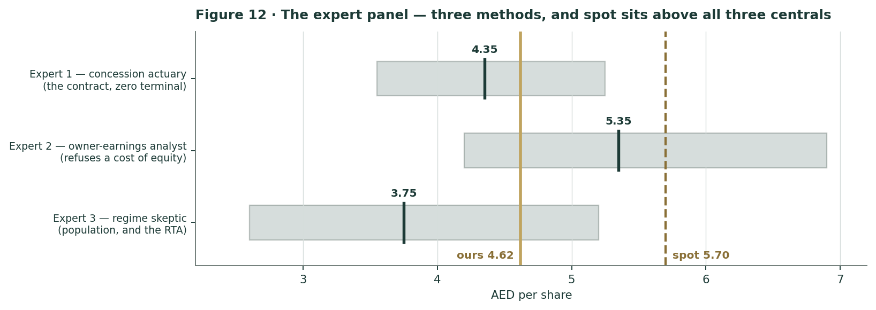
Figure 12 · The panel’s ranges against spot and our weighted central.
C.7 Reading the divergence
Four permanent methods, no shared machinery. Expert 1 will not use a cost of equity at all and deducts an instalment nobody else sees. Expert 2 refuses to look at the discount rate and argues entirely about what a normalized year earns. Expert 3 refuses to average states into a rate. Expert 4 is the only one who models the fade in returns on capital. They produce centrals of AED 4.05, AED 4.99, AED 4.50 and AED 4.30 — a spread of only AED 0.94, against a house weighted central of AED 4.62.
That IS convergence, and it is worth more than the agreement of methods that share assumptions. Four analysts who agree on nothing about method land within eighty fils of each other, and all four land below spot. To believe AED 5.70 you have to disagree with all four simultaneously — and per §1.7, the specific thing you have to disagree with them all about is the discount rate, not the earnings.
One caution against reading too much into it. All four experts are working from the same disclosures and the same sourcing gate. Convergence proves the methods are consistent with the DATA; it does not prove the data is complete. The FY2026 guidance we could not source, and the residual we could not attribute, are both invisible to all four of them.

About this series
Testahil publishes independent, free equity research on EGX, GCC, international and metals markets. We publish fair-value RANGES and probability DISTRIBUTIONS — never ratings, never price targets. Every probabilistic forecast we publish is registered in a public, append-only Calibration Ledger and graded against what actually happened when it matures. Forecasts that are never scored are not forecasts; they are marketing.
This study registers two cohorts: T+20 (matures 7 August 2026) and T+60 (matures 2 October 2026). The percentiles in §3 are frozen at publication and will not be edited. Our the calibration back-test for SALIK returned PARITY — calibrated and market-panel validated, with no demonstrated single-name edge — on only 11 windows, and with an over-covered cone. We publish that verdict exactly as it came out.
What changed, and why — the version history
Version | What was wrong | What fixed it | Fair value
v1 | Beta defaulted to 1.00 on a FAILED regression (n=19 vs a 24 floor). That single fallback dominated the answer. | v2 rebuilt the market portfolio from the 14 UAE names the MC engine itself calibrates on. The regression PASSES: n=195, β=0.637, t=6.1. | AED 4.16
v2 | Thin. No ROIC work, no revenue bridge, no operating dashboard, no risk register, no expert workings. | Added the two-growth-engines analysis, the FY2025 bridge, the elasticity test, and the measured pre-war/war beta split. | AED 4.62
v3 | SEVEN of our own errors, and four of a fact-check’s. Gate cost was 2,700 not 2,734. Amortisation ran 49 yrs when the gates entered service in year 2.33. We DERIVED a new-gate trip count the company had PUBLISHED. Our net-debt path contradicted our own payout arithmetic. We never modelled the AED 455.7 mn/yr RTA instalment. We invented an expert panel instead of casting from our standing expert panel. We called a plug "Other revenue". | All corrected. The ROIC finding got STRONGER (10.3% → 9.5%) and became company-sourced. The RTA cash waterfall is now §1.2a. Appendix C is recast from the mandated roster. | AED 4.62

We publish the version history rather than restating quietly, because a research process that never visibly changes its mind is not a research process — and because two of the three revisions above were prompted by someone telling us we were wrong.
Disclosure & Disclaimer
1. Not investment advice. This document is an educational valuation exercise and an expression of personal analytical opinion. It is not investment advice, not a recommendation, not a solicitation, and not an offer to buy, sell or hold any security. It is not directed at, and does not consider, the investment objectives, financial situation or particular needs of any reader.
2. No licence, no authorisation, no clients. The preparer is not licensed or registered by any securities regulator in any jurisdiction, holds no brokerage, dealing or advisory authorisation, provides no financial consultancy, manages no money for any person, and accepts no fees, funds or clients. Nothing here should be construed as a regulated financial service.
3. No rating, no price target. Testahil does not issue ratings, recommendations or price targets, and this document contains none. Every valuation output above is a RANGE or a DISTRIBUTION, because no single number should be relied on. Any reader who extracts a single number from this document and treats it as a target has misread it.
4. Sources, and the line between fact and judgment. All historical financial and operating data are the company’s own disclosure — the FY2023–FY2025 earnings releases, the 2024 Annual Report, the Q1-2026 release of 11 May 2026, and RTA and Dubai Media Office announcements. Market data is as at the 10 July 2026 close. The cost-of-capital inputs are sourced as stated in §1.8, and the beta is MEASURED against a 14-name UAE portfolio built from public daily price history. Everything forward-looking — the trip, tariff, margin and ancillary paths, terminal growth, the multiple band and the Monte-Carlo factor probabilities — is the preparer’s judgment and is flagged as such throughout. Where a figure could not be sourced (the FY2026 guidance), we say so rather than estimate it.
5. Models are wrong, and this one is calibrated so you can see how wrong. The Monte Carlo in §3 was back-tested over 11 non-overlapping 60-session windows against a carry-anchored random-walk benchmark and returned PARITY: calibrated and market-panel validated, with no demonstrated single-name edge. The cone is OVER-COVERED. The T+20 and T+60 percentiles are frozen at publication and appended to Testahil’s public Calibration Ledger, where they will be graded on 7 August and 2 October 2026 — whatever that does to our record.
6. Consult a licensed advisor. Investing involves the risk of loss, including total loss. Past performance — including Salik’s 185% return since its IPO — is not indicative of future results. Consult a licensed financial advisor who knows your circumstances before making any investment decision.
Testahil · Independent equity research · Distributions, not tips.

