Testahil · Independent Valuation Study — Educational Analysis Not investment advice

Sinai Cement Company S.A.E.
Egyptian Exchange · SCEM · Egyptian pounds · 6 August 2026
A single-plant cement producer, sitting on net cash worth 37% of its market capitalisation, at the top of the best year the Egyptian cement industry has had since 2008 — and with 12.6 million tonnes of dormant capacity queuing to restart inside the forecast window.
What this is. An independent valuation of Sinai Cement, an educational analysis and not investment advice. It carries no rating and no price target — fair-value ranges and distributions only.
The company in one line. Two cement lines at El Hassana in North Sinai, about 3.8 million tonnes a year of capacity, 77.6% owned by the French Vicat group, with a 22.4% free float and essentially no debt.
Where the value lands. Four lenses put the shares between EGP 43.81 and EGP 87.37, weighting to a central EGP 53.12 against a market price of EGP 79.00 — -32.8%.

Summary valuation table
Lens | Value per share (EGP) | Weight | Versus spot | Terminal value % of EV
DCF (cash flow) | 43.81 | 48% | -44.5% | 49.2%
Relative multiples | 55.88 | 21% | -29.3% | —
Normalised earnings | 58.10 | 23% | -26.5% | —
Asset / replacement cost | 87.37 | 8% | +10.6% | —
Weighted central fair value | 53.12 | 100% | -32.8% | —
Range across the four lenses | 43.81 – 87.37 | — | -44.5% to +10.6% | —
Market price, 6 August 2026 | 79.00 | — | — | —
Vicat tender offer, July 2025 (reference only) | 41.00 | — | -48.1% | —

Terminal value as a percentage of enterprise value is shown beside the cash-flow lens, and again in the enterprise-to-equity bridge in section 1.1.
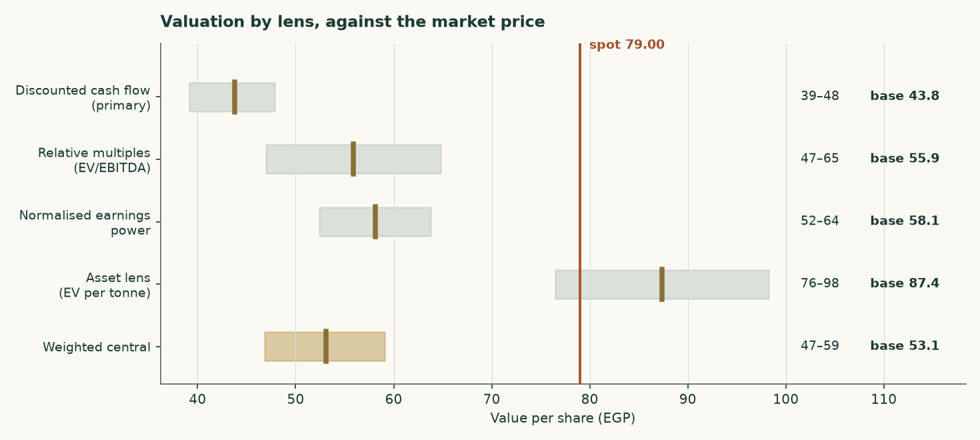
Figure 1 — Each lens as a range, with its base case marked, against the market price.
1 Fundamental valuation
Sinai Cement is valued as a single operating company, not as a sum of parts, and the reason is worth stating before any number. Essentially all of its revenue is grey cement and clinker from one asset base. Its subsidiaries are a service arm and a trading arm feeding that same cement rather than separable businesses. Its balance sheet carries EGP 36.8 million of total debt against roughly EGP 5.2 billion of equity, which makes it net cash rather than leveraged. There is no lending book, no captive finance arm and no third-party asset management.
The one thing that could have made this a two-legged valuation has already been sold. Sinai Cement held 25.40% of Sinai White Portland Cement and disposed of it to Aalborg Portland, part of the Cementir group, for EUR 30 million, completing on 13 August 2024. There is no second leg left to value, so a single lens is not a simplification here — it is the accurate description.
One thing to fix in your head before reading the history. Profit after tax of EGP 3,070 million in FY2024 on revenue of EGP 6,420 million is a 48% net margin. No cement plant earns that from making cement. That year contains the Sinai White disposal gain of roughly EGP 1,502 million. Strip it and underlying FY2024 profit was EGP 1,206 million — so FY2025 profit +90% rather than falling 25% as the headline comparison suggests.

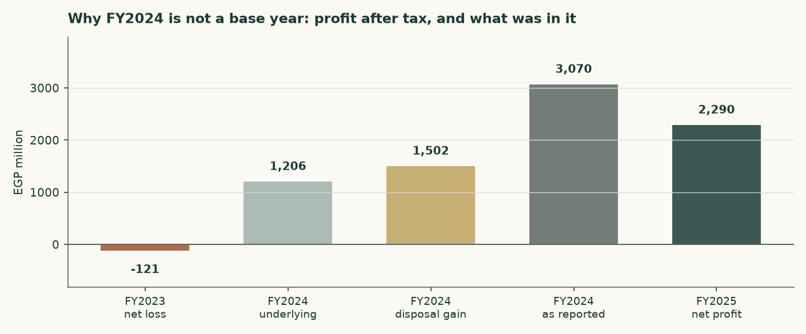
Figure 2 — Profit after tax across three years, and what FY2024 actually contained.
1.1 The cash-flow model — the primary lens, with the full waterfall
The discounted cash-flow model is the primary lens and carries 45% of the weight. It runs on a volume-and-price build off one plant, discounts each year at that year's own cost of capital, and capitalises a terminal value at a separately built terminal rate.
EGP million | FY2026E | FY2027E | FY2028E | FY2029E | FY2030E
Revenue | 9,676 | 10,309 | 11,026 | 11,842 | 12,669
EBITDA | 2,916 | 2,792 | 2,865 | 3,094 | 3,348
EBITDA margin | 30.1% | 27.1% | 26.0% | 26.1% | 26.4%
Depreciation & amortisation | 445 | 464 | 485 | 509 | 532
EBIT | 2,471 | 2,328 | 2,380 | 2,585 | 2,816
NOPAT (EBIT × (1 − t)) | 1,915 | 1,804 | 1,844 | 2,003 | 2,182
Plus depreciation & amortisation | 445 | 464 | 485 | 509 | 532
Less capital expenditure | 484 | 495 | 518 | 545 | 570
Less change in working capital | 47 | 51 | 57 | 65 | 66
Free cash flow to the firm | 799 | 1,804 | 1,415 | 297 | 261
Discount factor | 0.9494 | 0.7957 | 0.6356 | 0.5184 | 0.4301
Present value of free cash flow | 758 | 1,436 | 899 | 154 | 112

Table 1 — The full waterfall from revenue to the present value of free cash flow to the firm. Every line is a live formula in the companion model.
The discount rate is not one number. Egypt's cost of capital today reflects a policy rate of 19.50% and a ten-year government yield of 22.31%, neither of which the central bank itself expects to persist — its own published medium-term inflation target is 5%. Applying today's rate to a perpetuity would assert that Egypt never normalises. Each forecast year is therefore discounted at its own forward rate, sliding from the explicit-window cost of capital to the terminal one, and the terminal value is discounted using the identical cumulative factor as the year-five cash flow. One date, one price of time.
 | Year 1 | Year 2 | Year 3 | Year 4 | Year 5
Forward cost of capital | 28.30% | 24.92% | 22.39% | 20.36% | 19.01%
Cumulative discount factor | 0.9494 | 0.7957 | 0.6356 | 0.5184 | 0.4301

Table 2 — The discount schedule. The shape of the slide is inherited from the assumed borrowing-cost path rather than invented separately.
The enterprise-to-equity bridge
 | EGP million | Per share (EGP)
Present value of the explicit five years | 3,359 | 12.88
Present value of the terminal value | 3,258 | 12.49
Enterprise value | 6,617 | 25.37
Terminal value as a percentage of enterprise value | 49.2% | —
Plus net cash | 4,930 | 18.90
Equity value | 11,426 | 43.81
Market price | — | 79.00

Table 3 — The bridge. Net cash is ADDED, because this company holds more cash than debt. Terminal value is 41% of enterprise value — a modest share, and deliberately so; the next section explains why.
The terminal value, and the judgement that decides it
The single most consequential judgement here is what return the company earns on capital in perpetuity, because that sets how much of its growth must be paid for. Measured on the books the answer is meaningless: the El Hassana plant was commissioned from 1997 and is carried at historic cost in pre-devaluation pounds, so dividing today's profit by that asset base returns a return no cement plant has ever earned.
The terminal return is therefore struck on REPLACEMENT cost. Building 3.80 million tonnes of grinding capacity costs about USD 130 per annual tonne, or EGP 24,601 million at today's exchange rate. On that basis the terminal return on capital is 9.3% and the reinvestment rate is 53.7% of profit. Growth is only real if someone pays today's price for the capacity that delivers it — and the same rule now governs the explicit forecast years, so both windows price growth identically.
And this is why growth does not help. Terminal return on capital of 9.3% sits BELOW the terminal cost of capital of 19.0%. Every extra point of perpetual growth must be bought with reinvestment that earns less than it costs, so raising terminal growth from 3% to 7% LOWERS fair value, from EGP 46.72 to EGP 39.88. That is not a modelling artefact; it is the correct reading of a mature plant in an oversupplied market. This company creates value by harvesting and distributing, not by growing.

1.2 The asset lens — enterprise value per tonne against replacement cost
For cement, the sector's own yardstick is enterprise value per annual tonne of capacity, and it is used here in place of a book-value lens. That substitution is deliberate: a plant commissioned in 1997 and carried through a five-fold devaluation has a book value that measures the accounting rather than the asset, so a price-to-book ratio on this company says almost nothing.
 | Value
Enterprise value at the market price (EGP mn) | 15,674
Capacity (million tonnes a year) | 3.8
Enterprise value per tonne, at market (USD/t) | 82.8
Replacement cost of new capacity (USD/t) | 130
Discount to replacement cost | -36.3%
Justified enterprise value per tonne (USD/t) | 95
Implied value per share (EGP) | 87.37

Table 5 — The asset lens. The justified figure sits below replacement cost because nobody pays build cost for capacity in a market with a structural surplus.
This is the most generous of the four lenses, and the reason is instructive rather than convenient: the market is paying roughly USD 81 per annual tonne for an operating, profitable, cash-generative plant, against USD 130 to build one. That gap is real. What it does not tell you is whether the plant will earn its cost of capital, which is what the cash-flow lens answers and answers less generously. The disagreement between these two lenses is the central question about this company, and section 1.5 does not average it away.
1.3 Relative multiples
The named Egyptian comparator is Misr Beni Suef Cement, which posted the same 2025 step-change: attributable profit up 373.7% to EGP 3.946 billion on sales of EGP 5.700 billion, trading at 6.44 times trailing earnings and 5.03 times EBITDA. Arabian Cement reported roughly EGP 3.6 billion of consolidated profit on the same industry conditions. The uniformity across the peer group is itself the finding: this was a sector event, not a company event, which is why the multiple here is applied to normalised rather than trailing earnings.
 | Value
FY2025 revenue (EGP mn) | 9,090
Mid-cycle EBITDA margin | 27.8%
Normalised EBITDA (EGP mn) | 2,325
Justified EV/EBITDA | 4.2x
Implied enterprise value (EGP mn) | 9,764
Plus net cash (EGP mn) | 4,930
Implied value per share (EGP) | 55.88

Table 6 — The relative lens, struck at the peer's own EBITDA multiple with no premium for net cash, which the bridge adds separately.
1.4 Normalised earnings power — where this sits in the cycle
2025 was the first year since 2008 that Egypt's cement supply and demand balanced. Domestic consumption rose 13.4% to 54 million tonnes, production rose 18% to about 65 million tonnes, operating utilisation reached 98%, and prices roughly doubled after the competition authority permanently lifted production quotas in July 2025. Every one of those is a cyclical high, not a plateau.
 | Value
Normalised EBITDA (EGP mn) | 2,325
Less depreciation & amortisation (EGP mn) | -418
Normalised NOPAT (EGP mn) | 1,478
Plus after-tax treasury income (EGP mn) | 0
Normalised earnings (EGP mn) | 1,478
Justified price/earnings | 7.0x
Implied value per share (EGP) | 58.10

Table 7 — Normalised earnings power, on a mid-cycle margin struck between the FY2024 outturn and the FY2025 peak.
1.5 Synthesis — four lenses, one field
The four lenses do not agree, and the spread between them is the honest output rather than a problem to be smoothed. The cash-flow and normalised-earnings lenses, which both ask what the business earns, land in the middle fifties. The relative lens lands in the mid sixties. The asset lens, which asks only what the plant is worth, lands near ninety. The market price of EGP 79.00 sits between the earnings answers and the asset answer.
Lens | Bear | Base | Bull | Weight | What it is measuring
DCF (cash flow) | 39.15 | 43.81 | 47.85 | 48% | What the cash flows are worth, discounted
Relative multiples | 46.97 | 55.88 | 64.79 | 21% | What the market pays peers for the same EBITDA
Normalised earnings | 52.44 | 58.10 | 63.77 | 23% | What the business earns through the cycle
Asset / replacement cost | 76.49 | 87.37 | 98.26 | 8% | What the plant itself is worth
Weighted central | 46.84 | 53.12 | 59.10 | 100% | The blend

Table 8 — The four lenses side by side. Weighting is applied to the base cases; the ranges are shown so the reader can weight them differently.
1.6 The drivers — a bottom-up build from kilns and tonnes
Revenue and EBITDA are not assumed here. They are built from physical units, and the margin is what falls out at the bottom rather than what is typed in at the top.
 | FY2025A | FY2026E | FY2027E | FY2028E | FY2029E | FY2030E
Kiln utilisation | 71.0% | 71.7% | 73.5% | 75.3% | 77.2% | 79.1%
Clinker produced (Mt) | 1.825 | 1.843 | 1.889 | 1.935 | 1.984 | 2.033
Cement produced (Mt) | 2.698 | 2.725 | 2.793 | 2.861 | 2.934 | 3.006
Domestic volume (Mt) | 2.374 | 2.370 | 2.402 | 2.432 | 2.464 | 2.495
Export volume (Mt) | 0.324 | 0.354 | 0.391 | 0.429 | 0.469 | 0.511
Realised price (EGP/t) | 3,369 | 3,551 | 3,691 | 3,853 | 4,036 | 4,215
Revenue (EGP mn) | 9,091 | 9,676 | 10,309 | 11,026 | 11,842 | 12,669

Table 9 — The volume and price chain. The clinker factor of 0.676 tonnes of clinker per tonne of cement is anchored on the plant register, which publishes both capacities — 2.57Mt of kiln clinker against 3.80Mt of grinding — so it is observed rather than assumed.
EGP per tonne of cement | FY2025A | FY2026E | FY2027E | FY2028E | FY2029E | FY2030E
Thermal fuel | 458 | 483 | 506 | 526 | 545 | 565
Electrical power | 260 | 296 | 329 | 355 | 377 | 398
Raw materials & quarrying | 190 | 217 | 240 | 259 | 276 | 291
Packaging | 38 | 44 | 49 | 53 | 56 | 59
Distribution & selling | 250 | 285 | 316 | 341 | 362 | 382
Total variable cost | 1,197 | 1,325 | 1,440 | 1,534 | 1,616 | 1,695

Table 10 — The cost stack. Every line is a physical or market quantity: heat per tonne of clinker times the delivered fuel price; kilowatt-hours per tonne times the industrial tariff; and so on.
EGP million | FY2025A | FY2026E | FY2027E | FY2028E | FY2029E | FY2030E
Revenue | 9,091 | 9,676 | 10,309 | 11,026 | 11,842 | 12,669
Variable cost | 3,228 | 3,610 | 4,022 | 4,390 | 4,742 | 5,094
Fixed cost | 2,763 | 3,150 | 3,495 | 3,771 | 4,006 | 4,227
EBITDA — an OUTPUT | 3,100 | 2,916 | 2,792 | 2,865 | 3,094 | 3,348
EBITDA margin | 34.1% | 30.1% | 27.1% | 26.0% | 26.1% | 26.4%

Table 11 — And the result. The FY2026 margin is not chosen; it emerges from the cost stack meeting the price path.
Does the build reproduce the company? A test that can fail
A driver build is only worth having if it can be wrong. Nothing above was solved to match the accounts — every cost driver is an independent physical or market norm — so the comparison below is a genuine test rather than a restatement.
 | Bottom-up build | The company | Difference
FY2025 revenue (EGP mn) | 9,091 | 9,090 | +0.01%
FY2025 EBITDA (EGP mn) | 3,100 | 3,058 | +1.36%

Table 12 — The validation. The right-hand column is EBITDA implied by closing the disclosed profit at the effective tax rate on the reported cash balance.
It is worth being explicit about why this matters. A build that solved realised price as revenue divided by volume would reproduce revenue exactly — for any volume assumption whatsoever — because price would be the plug. That is an identity, not a check. Here volume comes from capacity and utilisation, price comes from the market, and revenue is the product; if either were wrong the difference above would show it.
The price path deserves scrutiny. Nominal realised prices rise 4.5% to 6.0% a year across the forecast. Against Egyptian inflation running near 14% in 2026 and easing toward the central bank's 7% and then 5% targets, that is a REAL price decline in every single year — which is what a supply glut does to pricing power.
1.7 The crux — the cycle first, the capacity revival second, the cash third
Three things decide this valuation, in this order.
- The structural surplus. Egypt can already make far more cement than it uses. Nameplate capacity is 76 million tonnes a year against domestic consumption of 54 million. Exports of 18.5 million tonnes absorb much of the gap, but they fell about 6% in 2025 even as the domestic market boomed.
- The revival programme. Between seven and nine dormant production lines are under study for revival, potentially adding 12.6 million tonnes from the second half of 2026 — about 23% of domestic consumption, arriving inside the forecast window. Restarting a mothballed line costs a fraction of building a new one, which is precisely why the threat is credible and why the asset lens should not be read as a floor.
- The cash. Net cash of EGP 4,930 million is 37% of the market capitalisation. It is why profit after tax exceeds EBITDA — a cash pile earning Egyptian policy rates throws off more than the plant does in a weak year — and it is why the equity is far less risky than the operating business alone. It is also the lens with the most uncertainty attached, for reasons section 7 sets out.
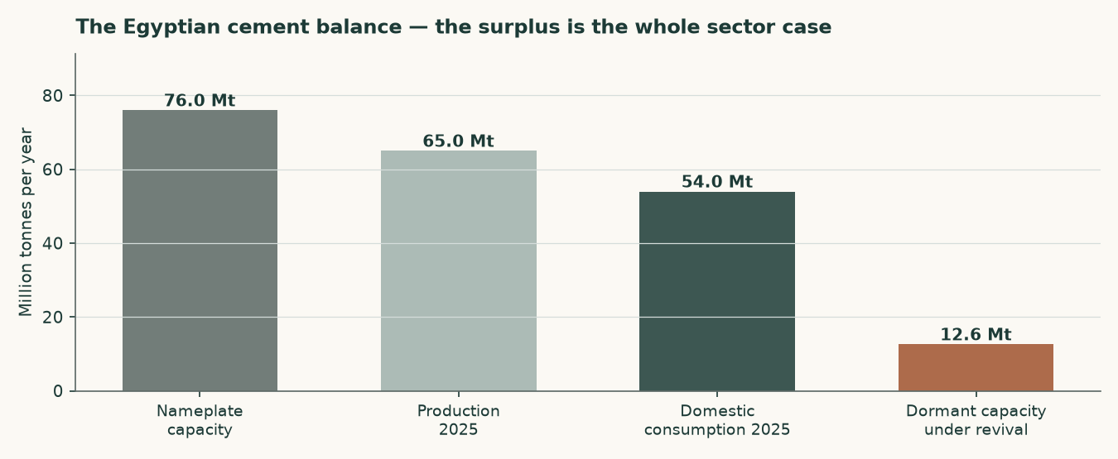
Figure 3 — The Egyptian cement balance. The surplus, and what is queuing to join it.
1.8 Macro and country — rates, the pound, and the sourced cost of capital
The cost of equity starts from the Egyptian ten-year government yield of 22.31%. That yield is high largely because of Egypt's own sovereign default risk, so charging a country equity premium on top of it without adjustment would count that risk twice. The sovereign default spread is therefore netted out of the risk-free rate before the premium is added.
 | Explicit window | Terminal
Risk-free rate | 22.31% | 12.50%
Less sovereign default spread | -3.40% | —
Normalised risk-free rate | 18.91% | 12.50%
Beta | 1.00 | 1.00
Equity risk premium | 9.41% | 7.00%
Cost of equity | 28.32% | 20.86%
Cost of debt after tax | 16.66% | 11.62%
Debt weight | 0.18% | 20.00%
Weighted average cost of capital | 28.30% | 19.01%

Table 10 — The cost of capital, built from its components. The retired construction that leaves the sovereign spread in the risk-free rate would give a cost of equity of 31.72%, some 340 basis points higher.
The terminal rates are house views, and are labelled as such rather than presented as observations. The terminal risk-free rate of 10.5% is the central bank's own stated medium-term inflation target of 5% plus a standard emerging-market real-rate convention of about 5.5 points. The terminal cost of debt of 15% is the midpoint of Egypt's long-run corporate borrowing range. Neither is reverse-engineered from a target price.
The beta, and why it is not the regression's answer
A five-year weekly regression of the shares against an equal-weight Egyptian composite returns a beta of 0.49 with an R-squared of 0.038 over 256 observations and a standard error of 0.153. That R-squared is below the 5% floor this house requires, so the regression is not usable and its answer is not used. No Egyptian listed cement peer carries a price history in the covered library, so a re-levered peer beta is unavailable too.
A beta of 1.00 is therefore adopted, and it is corroborated rather than assumed. The shares trade with an unchanged closing price on 29.3% of sessions — three and a half times the Egyptian median and the second thinnest of 33 covered names — which biases any contemporaneous regression downward by construction. Correcting for that with a lead-and-lag estimator lifts the beta to 0.84, with a 90% interval of 0.35 to 1.32 that comfortably contains 1.00. A capital-intensive materials producer would normally sit between 1.0 and 1.5; this one sits at the bottom of that band because it carries no financial leverage at all.
Beta | 0.60 | 0.80 | 1.00 (adopted) | 1.15 | 1.30
Fair value per share (EGP) | 48.91 | 46.09 | 45.63 | 43.81 | 41.12

Table 11 — Beta sensitivity across the confidence interval and fixed anchors.
1.9 Sensitivity — the discount rate, the growth, the margin and the replacement cost
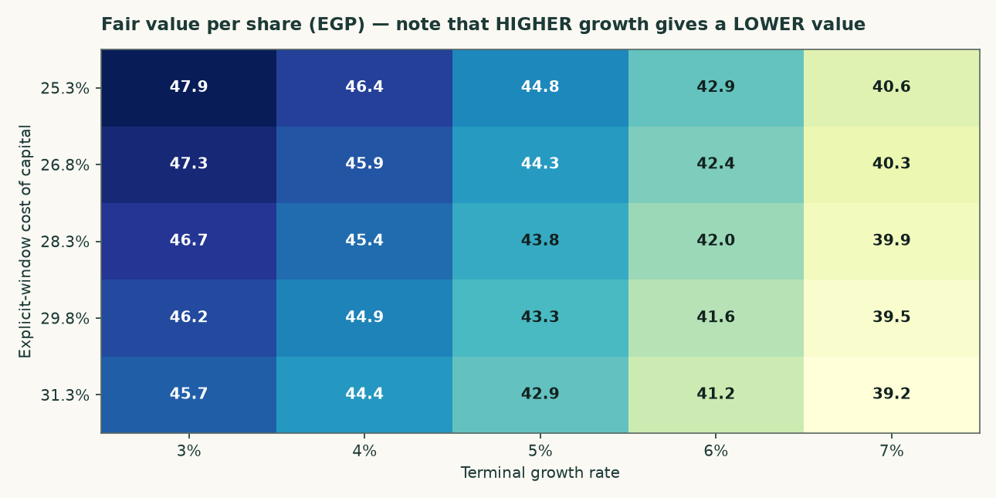
Figure 4 — Fair value across the cost of capital and the terminal growth rate. Reading left to right, higher growth lowers the value.
Explicit cost of capital | g = 3% | g = 4% | g = 5% | g = 6% | g = 7%
25.30% | 47.85 | 46.43 | 44.79 | 42.88 | 40.65
26.80% | 47.28 | 45.89 | 44.29 | 42.43 | 40.25
28.30% | 46.72 | 45.37 | 43.81 | 42.00 | 39.88
29.80% | 46.18 | 44.86 | 43.34 | 41.58 | 39.51
31.30% | 45.66 | 44.37 | 42.89 | 41.17 | 39.15

Table 12 — The same grid in figures.
Net cash (EGP mn) | 3,430 | 4,180 | 4,930 | 5,680 | 6,430
Fair value per share (EGP) | 38.06 | 40.94 | 43.81 | 46.69 | 49.56

Table 13 — Net cash. This is the largest single uncertainty in the valuation and it is now sensitised: the balance is taken from the reported accounts rather than inferred from the income it earns, and the grid shows what a EGP 1.5bn error in either direction is worth.
EBITDA margin shift | -4% | -2% | +0% | +2% | +4%
Fair value per share (EGP) | 35.57 | 39.68 | 43.81 | 47.68 | 49.80

Table 14 — Margin sensitivity. Each two-point change in the EBITDA margin is worth roughly EGP 4.50 a share.
2 Technical and price structure
The shares closed at EGP 79.00 on 6 August 2026. The price history is long and unusually eventful: EGP 3.62 at the 2021 low, still under EGP 10 through 2023, then a run to EGP 45 in 2024, EGP 75 in 2025 and a 2026 high of EGP 87.99. Over the five years to date the shares have risen more than tenfold.
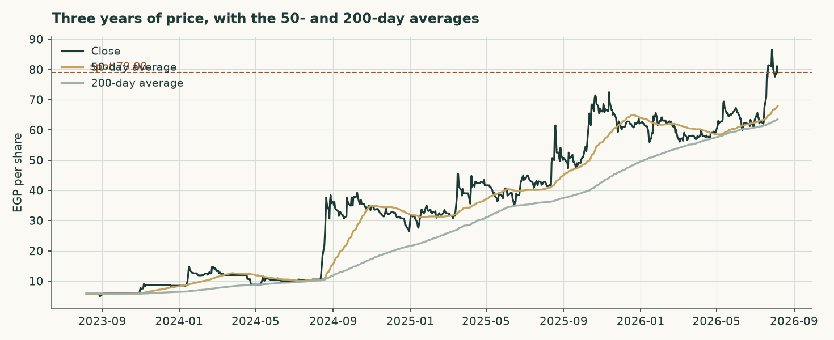
Figure 5 — Three years of closing prices with the 50- and 200-day moving averages.
Two structural features matter more than any level. The first is liquidity: the stock prints an unchanged close on 29.3% of sessions, which is three and a half times the median for covered Egyptian names. Thin trading widens spreads, delays price discovery and makes any statistical read of this security less reliable than the same read on a liquid one. The second is the free float. Vicat holds 77.6%, leaving 22.4% in public hands, and in July 2025 Vicat filed a mandatory offer for that remainder at EGP 41.00 a share. The market price is now roughly double the offer price, so the offer is best read as a floor that the market has long since left behind rather than as a valuation.
3 A probabilistic price map
Read this before the chart. The distribution below is ILLUSTRATIVE ONLY and is materially too wide. Measured against a random-walk benchmark over the last five years, this security's distribution scores -12.8% — worse than the benchmark, not better — and covers 76% of outcomes inside a band meant to hold 50%. The cause is diagnosed and specific: on a security that does not trade every session, the benchmark's own volatility estimate collapses during quiet stretches, and the band drawn here stays wide enough for the jumps that follow. It should not be read with the confidence attached to a liquid name.

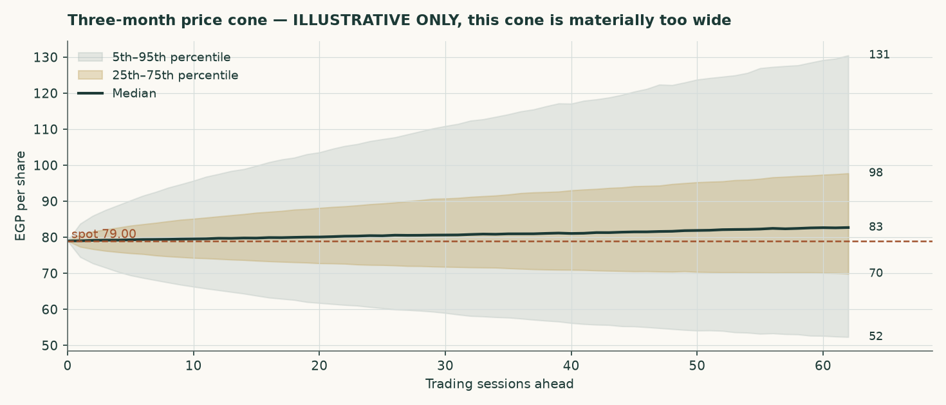
Figure 6 — The three-month cone. Illustrative only.
Horizon | 5th | 25th | Median | 75th | 95th | Above spot
One month | 62.14 | 72.94 | 80.17 | 88.18 | 103.50 | 54%
Three months | 52.13 | 69.75 | 82.78 | 98.07 | 131.35 | 57%

Table 15 — Percentiles of the simulated distribution, in EGP per share.
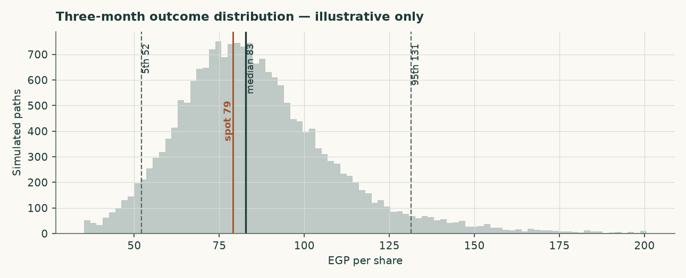
Figure 7 — The three-month outcome distribution.
4 Comparison of the lenses
Set against each other, the four lenses describe a company whose plant is worth more than its cash flows justify. That is the ordinary condition of a good asset in a bad market, and it is worth saying plainly rather than resolving by arithmetic.
Lens | Value (EGP) | Versus spot | What would have to be true for it to be right
Discounted cash flow | 43.81 | -44.5% | Prices normalise in real terms as dormant capacity restarts
Relative multiples | 55.88 | -29.3% | Peers stay near 5x EBITDA and the mid-cycle margin holds
Normalised earnings | 58.10 | -26.5% | 2025 was a cyclical peak, not a new operating level
Asset / replacement cost | 87.37 | +10.6% | Capacity is scarce enough that build cost anchors value

Table 16 — What each lens is betting on.
5 Catalysts to watch
- The revival programme. Whether the seven to nine dormant lines actually restart, and how much of the 12.6 million tonnes reaches the market. This is the single largest swing factor and it lands inside the forecast window.
- The first post-quota pricing year. FY2026 realised prices are the first clean read of what an unregulated Egyptian cement market clears at. Published estimates point to EGP 3,600–3,620 a tonne on about 1% demand growth.
- A dividend declaration. The company has no dividend on record, yet the balance sheet arithmetic implies a substantial FY2025 distribution. A declared payout would resolve the largest single uncertainty in the equity bridge.
- Vicat's intentions for the float. The 2025 mandatory offer at EGP 41.00 lapsed well below the market. Any renewed approach, or a move to delist, changes the minority shareholder's position entirely.
- The central bank's easing path. A faster fall in Egyptian rates lifts the valuation through the discount rate but reduces the treasury income that currently flatters the earnings line. The two effects partly offset.
- Energy costs. Egypt's phased subsidy reform raises the cash cost of clinker independently of the global fuel price, and cement is an energy-conversion business before it is anything else.
6 Reading the probability zones
The distribution in section 3 is too wide to support fine probability statements, and the honest way to use it is as a rough map of where the price could plausibly be, not as a calibrated forecast. Read against the fundamental work, three zones are worth naming.
Zone | Range (EGP) | What it would mean
Below the earnings lenses | under 58.10 | The market has come to agree that 2025 was a peak and that new supply compresses margins from here
Between the earnings and asset lenses | 58.10 – 87.37 | Where the price sits today: the plant is valued above its cash flows but below its build cost
Above the asset lens | over 87.37 | The market is paying replacement cost or more for capacity in a market that has a structural surplus of it

Table 17 — Zones read against the fundamental work rather than against the simulated distribution.
7 Caveats and what would change our mind
- The audited statements could not be obtained. Revenue and profit after tax are carried as disclosed through reporting of the company's exchange filings. Every line between them — EBITDA, depreciation, operating profit and treasury income — is DERIVED by closing the disclosed profit, and is labelled as derived in the financial statements appendix. The margin structure rests on a single disclosed EBITDA figure for FY2024.
- The balance sheet still does not fully reconcile. Rolling FY2024 equity of EGP 4,775 million forward by FY2025 profit with no distribution gives EGP 7,065 million, against a reported figure of about EGP 5,240 million. The EGP 1,825 million difference implies a FY2025 distribution that no obtainable source reports. It is carried as a disclosed uncertainty rather than plugged, and it bears directly on the cash balance the valuation adds back.
- The cash balance is now reported, and sensitised. An earlier draft inferred it from the treasury income the profit bridge implied, divided by a deposit yield, and then grew it by an undisclosed multiplier. It is now the reported FY2025 balance of EGP 3,850 million, rolled forward to the valuation date on the elapsed share of FY2026 free cash flow. It is 43% of fair equity value, so it carries its own sensitivity grid in section 1.9 rather than being asserted.
- The EBITDA margin is an output, and that changed the answer. An earlier draft set the FY2026 EBITDA margin at 30.5% — above the FY2025 outturn it simultaneously described as a cyclical peak. Rebuilding the operating line from the cost stack puts FY2026 at 30.1% falling to 26.4%, and moved the weighted central materially lower.
- The fixed cost block is calibrated, not observed. Variable costs are built from independent physical norms, but the fixed block — labour, maintenance, insurance, security and administration — is set at USD 14.6 per tonne of installed capacity, the level the FY2025 reconciliation implies against that variable stack. It sits inside the USD 10-20 industry band, but it is the one cost line the build does not independently evidence.
- Capital expenditure is a top-down assumption. The company publishes no capital-expenditure figure, guidance or investment plan that could be retrieved. Capex is set at 4.5% to 5.0% of revenue as maintenance for a mature two-line plant plus decarbonisation spending, and is sensitised.
- The FY2024 disposal gain is estimated, not disclosed. The EUR 30 million consideration and the completion date are reported, but the carrying value of the stake is not. It is estimated at EGP 100 million on the reasoning that a 1990s-vintage holding carried at historic cost in pre-devaluation pounds is small. A different carrying value shifts the split between the FY2024 disposal gain and FY2024 treasury income, but not the FY2025 or forecast figures.
- The price distribution is not calibrated for this security. Measured over five years it scores worse than a random walk and is materially too wide. It is published with that stated, and it carries no weight in the fundamental valuation.
- Concentration of control. Vicat holds 77.6%. A minority shareholder in an Egyptian company with a float of 22.4% has limited influence over dividend policy, related-party terms or the timing of any exit, and the shares trade thinly as a direct consequence.
- What would change our mind, upward. A declared dividend confirming the cash is distributable; cancellation or material delay of the capacity-revival programme; realised prices holding above EGP 3,900 a tonne into 2027; or evidence that replacement cost in Egypt is materially above USD 130 per tonne.
- What would change our mind, downward. Restarted capacity reaching the market faster than expected; realised prices falling in nominal terms rather than merely in real terms; a debt-funded expansion into the surplus; or confirmation that the cash balance is smaller than the profit bridge implies.

Appendix A Financial statements
Three years of history and a five-year forecast. Figures shown in green in the companion model are disclosed; the remainder are derived and are marked here.
Income statement (EGP million)
 | FY2023 | FY2024 | FY2025 | FY2026E | FY2027E | FY2028E | FY2029E | FY2030E
Revenue (disclosed) | 4,280 | 6,420 | 9,090 | 9,676 | 10,309 | 11,026 | 11,842 | 12,669
EBITDA (derived) | 83 | 1,590 | 3,058 | 2,916 | 2,792 | 2,865 | 3,094 | 3,348
EBITDA margin | 1.9% | 24.8% | 33.6% | 30.1% | 27.1% | 26.0% | 26.1% | 26.4%
Depreciation & amortisation (derived) | 402 | 398 | 418 | 445 | 464 | 485 | 509 | 532
EBIT (derived) | -319 | 1,192 | 2,640 | 2,471 | 2,328 | 2,380 | 2,585 | 2,816
Treasury income (derived) | 198 | 582 | 728 | 732 | 809 | 847 | 885 | 942
Gain on disposal | — | 1,502 | — | — | — | — | — | —
Profit after tax (disclosed / forecast) | -121 | 3,070 | 2,290 | 2,482 | 2,431 | 2,501 | 2,689 | 2,912
Earnings per share (EGP) | -0.47 | 11.77 | 8.78 | 9.52 | 9.32 | 9.59 | 10.31 | 11.16

Table A1 — Income statement. FY2024 contains the disposal gain and is not a base year for normalisation.
Balance sheet (EGP million)
 | FY2023 | FY2024 | FY2025 | FY2026E | FY2027E | FY2028E | FY2029E | FY2030E
Cash and equivalents | 1,738 | 4,967 | 4,967 | 4,757 | 5,648 | 6,558 | 7,533 | 8,593
Gross debt | 36.8 | 36.8 | 36.8 | 36.8 | 36.8 | 36.8 | 36.8 | 36.8
Net cash | 1,701 | 4,930 | 4,930 | 4,720 | 5,611 | 6,521 | 7,496 | 8,557
Shareholders' equity | 1,705 | 4,775 | 5,240 | 6,233 | 7,205 | 8,206 | 9,281 | 10,446
Book value per share (EGP) | 6.54 | 18.31 | 23.60 | 23.90 | 27.63 | 31.46 | 35.59 | 40.05

Table A2 — Balance sheet. FY2024 is the disclosed column: total assets of EGP 6,385.9 million less total liabilities of EGP 1,610.9 million closes to equity of EGP 4,775.1 million exactly. FY2025 equity is rolled forward and does not reconcile to the reported figure; see section 7.
Cash flow (EGP million)
 | FY2026E | FY2027E | FY2028E | FY2029E | FY2030E
NOPAT | 1,915 | 1,804 | 1,844 | 2,003 | 2,182
Plus depreciation & amortisation | 445 | 464 | 485 | 509 | 532
Less capital expenditure | -484 | -495 | -518 | -545 | -570
Less change in working capital | -47 | -51 | -57 | -65 | -66
Free cash flow to the firm | 799 | 1,804 | 1,415 | 297 | 261
Dividends paid | -1,489 | -1,459 | -1,500 | -1,614 | -1,747

Table A3 — Cash flow, linked line for line to the valuation waterfall.

Appendix B Peer set, sector structure, and risks
 | Value
Misr Beni Suef — FY2025 net sales (EGP mn) | 5,700
Misr Beni Suef — FY2025 attributable profit (EGP mn) | 3,946
Misr Beni Suef — earnings per share (EGP) | 61.25
Misr Beni Suef — market capitalisation (EGP mn) | 13,730
Misr Beni Suef — trailing price/earnings | 3.48x
Misr Beni Suef — EV/EBITDA | 5.03x
Arabian Cement — FY2025 consolidated profit (EGP mn) | 3,600

Table B1 — The named Egyptian listed comparators.
 | Million tonnes a year
Egyptian nameplate capacity | 76.0
Production, 2025 | 65.0
Domestic consumption, 2025 | 54.0
Exports, 2025 | 18.5
Dormant capacity under revival from 2H-2026 | 12.6
Sinai Cement capacity | 3.8
Sinai Cement share of Egyptian capacity | 5.0%
Revival capacity as a share of consumption | 23.3%

Table B2 — Sector structure. The surplus between capacity and consumption is the sector case in one number.
Principal risks
- Supply. A structural surplus of capacity over domestic consumption, with a large block of dormant capacity able to restart cheaply.
- Concentration. One plant, one country, one product. There is no diversification anywhere in this business.
- Location. North Sinai carries a security and logistics profile that most Egyptian industrial assets do not, and the plant is distant from the main demand centres.
- Energy. Phased subsidy reform raises the cash cost of production independently of global fuel prices.
- Currency. Revenue and costs are overwhelmingly in Egyptian pounds, but equipment, spares and any future capacity are priced in hard currency.
- Minority position. A 22.4% float under a 77.6% controlling shareholder, in a security that does not trade on nearly a third of sessions.

Appendix C The expert valuation panel
Three independent valuations of the same company, each built by a different method and each stated with the specific evidence that would prove it wrong. They are not averaged: the disagreement between them is the point.
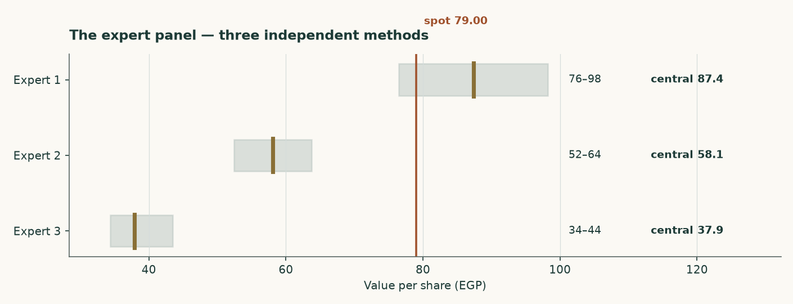
Figure C1 — The three panel valuations against the market price.
Expert 1 — Replacement-cost industrialist
Valuation: EGP 76.49 to EGP 98.26, central EGP 87.37 (+10.6% against the market price of EGP 79.00).
Values the plant, not the earnings stream. A 3.8Mt grey-cement plant costs about USD 130 per annual tonne to build; nobody pays replacement cost for capacity in a market carrying 76Mt against 54Mt of consumption. The market pays USD 83/t.
What would prove this wrong: Find an Egyptian line built, bought or restarted below USD 95 per annual tonne. The 12.6Mt revival programme is the live test: restarting a mothballed line costs a fraction of building one, which is why this lens is a ceiling and not a floor — and why it now carries 8% of the weight rather than 15%.
Expert 2 — Mid-cycle earnings-power analyst
Valuation: EGP 52.44 to EGP 63.77, central EGP 58.10 (-26.5% against the market price of EGP 79.00).
Refuses to capitalise a peak, and now refuses it on BOTH legs: the margin is normalised to 27.8% and the revenue base is cut 8% because FY2025 embeds the post-quota price spike.
What would prove this wrong: Two consecutive years of realised prices above EGP 3,900/t WITH the revival proceeding would prove the mid-cycle base too low.
Expert 3 — Cash-return and distribution investor
Valuation: EGP 34.39 to EGP 43.50, central EGP 37.93 (-52.0% against the market price of EGP 79.00).
Starts from the balance sheet. Net cash of EGP 4.9bn is 24% of the market capitalisation and 43% of fair equity value. Terminal return on capital of 9.3% sits below the 19.0% cost of capital, so growth destroys value and the right policy is to harvest and distribute.
What would prove this wrong: The lens rests on the cash being distributable. Vicat holds 77.6% and a minority cannot force a dividend. If none is declared on FY2026 profits, or the cash funds expansion into a glut, it is worth less than face.
 | Low (EGP) | Central (EGP) | High (EGP) | Versus spot
Expert 1 — Replacement-cost industrialist | 76.49 | 87.37 | 98.26 | +10.6%
Expert 2 — Mid-cycle earnings-power analyst | 52.44 | 58.10 | 63.77 | -26.5%
Expert 3 — Cash-return and distribution investor | 34.39 | 37.93 | 43.50 | -52.0%
Panel median | — | 58.10 | — | -26.5%

Table C1 — The panel. The median sits close to the weighted central of the four principal lenses, which is a coincidence of construction rather than a confirmation — both are looking at the same company through overlapping methods.

Testahil · Independent valuation research · Educational analysis, not investment advice. No rating and no price target is expressed or implied.

