Testahil · Independent Valuation Study — Educational Analysis Not investment advice
Independent Valuation Study — Educational Analysis
The Saudi National Bank (Tadawul: 1180)
Fundamental analysis · Technical analysis · Monte Carlo simulation — one integrated read
Anchor: SAR 38.96 (2 Jul 2026 close) · 6.00 bn shares · market cap ~SAR 234 bn (~USD 62 bn) · the Kingdom's largest bank, formed from the 2021 NCB–Samba merger (integration completed 2023) · prices and probabilities computed 2 Jul 2026 from the attached daily history · primary lens: two-stage dividend discount (Ke = rf + β·ERP = 10.7%) · the swing factor is net interest margin through the SAMA easing cycle and the shrinking international drag.
READ FIRST — what this document is, and is not. This study is a valuation exercise and an expression of personal analytical opinion, published free of charge for educational purposes: it shows how one analyst applies fundamental, technical and probabilistic methods to a listed company, and invites scrutiny of that methodology. It is NOT investment advice, NOT a recommendation or solicitation to buy, sell or hold any security, and NOT directed at the circumstances of any reader. The preparer is not licensed by any securities regulator in any jurisdiction, holds no Saudi (CMA) or other brokerage authorisation, provides no financial consultancy, manages no money, and accepts no fees, funds or clients. See the Disclosure & Disclaimer at the end. All values are model outputs presented as ranges and distributions because no single number should be relied on. Reported financials are the bank's own disclosure (FY2024 annual report; 9M-2025 reviewed statements; the Q4-2024 earnings call); forward-looking inputs — the cost of equity, the NIM and growth path, the terminal assumptions and the Monte-Carlo factor probabilities — are the preparer's judgments and are flagged throughout. FY2025E combines 9M-2025 reported actuals with a Q4 estimate. Consult a licensed financial advisor before any investment decision.

Headline
The model's read: modestly undervalued, with the upside resting on the net interest margin holding through the SAMA easing cycle and the international drag fading. At SAR 38.96 the shares sit about 16% below our weighted central estimate of SAR 45.3. The four lenses agree unusually closely — a two-stage dividend discount lands at SAR 44.2, a discounted-cash-flow (FCFF) build at SAR 44.9, a relative P/E-and-P/B read at SAR 46.1, and a sustainable-ROE justified P/B at SAR 46.9 — a tight SAR 44–47 cluster that says the value gap is real rather than an artefact of one lens. SNB is the Kingdom's national banking champion: ~SAR 1.26 tn of assets, the highest low-cost (CASA) deposit base among covered banks (~72%), a 74%-fixed-rate investment book that protects gross yield as rates fall, and a Tier-1 capital ratio of 20.3% that funds Vision-2030 project finance. The whole answer turns on the margin: FY2024 NIM of 3.0% is holding as SAMA cuts (repo down to 4.25% from a 6.0% peak), with the fixed-rate book and longer-duration retail loans repricing slowly while deposit-pricing competition works the other way. Technically the tape is mildly soft — below all four major moving averages, RSI in the low-40s, MACD marginally negative — a consolidation rather than a capitulation. Over three months the Monte Carlo places the 5th–95th band at roughly SAR 31–49 with the median at spot, because the simulation maps where price could travel, not where value sits.

Valuation summary — every read at a glance
One table for the four reads that follow — what the business is worth (fundamental), what the tape is doing (technical), where price could travel over three months (Monte Carlo), and how three independent expert methods land. Every row is developed in the sections and appendices below.
Lens / read | What it measures | Output | Takeaway
FUNDAMENTAL — what the business is worth (the anchor)
Dividend discount (primary) | Two-stage DDM at Ke 10.7% | SAR 44.2 | +13% vs spot
Discounted cash flow (FCFF) | 5-yr FCFF, discounted at WACC ≈ Ke | SAR 44.9 | +15%
Relative multiples | P/E and P/B vs Saudi banks | SAR 46.1 | +18%
Justified P/B | (ROE−g)/(Ke−g) × book | SAR 46.9 | +20% · sustainable-ROE
Weighted central | Blend 40 / 20 / 15 / 25 | SAR 45.3 | +16% vs SAR 38.96
TECHNICAL — what the tape is doing (timing, not value)
Trend & momentum | Price vs 20/50/100/200-day averages | Below all four | Soft, consolidating
Momentum / range | RSI · MACD · 52-week range | RSI 41 · MACD −0.25 · 33.7–45.0 | Mildly weak
MONTE CARLO — where price could go in 3 months (paths from spot)
T+20 sessions | 50,000 paths · 16 factors | p5 33.8 · p50 39.0 · p95 44.4 | Median ≈ spot
T+60 sessions | same engine, longer horizon | p5 30.8 · p50 39.0 · p95 48.7 | Wide, mild right skew
EXPERT PANEL — three independent methods (closing appendix)
Expert 1 — capital & returns | Justified P/B on sustainable RoTE | SAR 46 | The anchor
Expert 2 — credit cycle | Through-cycle earnings, normalized CoR | SAR 42 | Most conservative
Expert 3 — macro / policy | Rate-path DDM (SAMA + Vision 2030) | SAR 45 | Rate-cycle read
Panel range | Spread = the margin/credit question | SAR 42–46 | Centres ~SAR 44.3
Bottom line. Every read points the same way and disagrees only on magnitude. The fundamental central sits near SAR 45.3 — about 16% above the SAR 38.96 spot — the three experts span SAR 42–46, and each turns on a single question: whether SNB's margin and cost of risk hold through the cycle. The technical tape is the lone dissenter, soft and below trend, which is why the three-month distribution centres near spot rather than already at fair value. SNB trades at roughly 10× forward earnings and 1.3× book for a 16%+ return on tangible equity — cheap versus the quality, in line with the street (ANB Capital's residual-income work anchors ~SAR 46).

Company overview — The Saudi National Bank at a glance
Item | Value
Listed entity | The Saudi National Bank (Tadawul: 1180)
What it is | Kingdom's largest bank; retail, wholesale/corporate, treasury, capital markets (SNB Capital), international
Spot / date | SAR 38.96 · 2 Jul 2026 close
Shares · market cap | 6.00 bn · SAR 233.8 bn (~USD 62.3 bn at the 3.75 peg)
Total assets (2025E) | ~SAR 1.26 tn
Net financing · deposits (2025E) | ~SAR 728 bn · ~SAR 690 bn
FY2024 net income · ROTE | SAR 21.2 bn · 16.2% (16.8% pre-AT1)
FY2024 NIM · cost-to-income | 3.0% · 28.3% group / 25.4% domestic
Asset quality · capital | NPL 1.16% · Tier-1 CAR 20.3% · CASA ~72%
52-week range | SAR 33.68 – SAR 45.00
Chairman · CEO | Saeed Alghamdi · Tareq AlSadhan
Corporate history | NCB + Samba merger completed 2021; integration completed 2023; national banking champion
Source: SNB IR / annual report FY2024, 9M-2025 reviewed statements, Q4-2024 earnings call, Tadawul disclosures. Values rounded.

1 Fundamental valuation
We value SNB as a bank, so the primary lens is a two-stage dividend discount model (DDM): a bank's distributable cash is its dividend capacity, and the discount rate is the cost of equity, not a blended WACC. Three cross-checks complete the set — a discounted-cash-flow (FCFF) build (for a bank, discounted at a WACC that ≈ the cost of equity, since the balance sheet is equity-funded and deposits are operating rather than financing debt), a relative P/E-and-P/B read against Saudi peers, and a sustainable-ROE justified P/B in place of the usual normalized-earnings lens. The weights and the football field are in §1.5; the swing factor — the margin through the easing cycle — is dissected in §1.7 and the sensitivity grid in §1.9. Throughout, the cost of equity is published explicitly (§1 anchor line and §3.5-G): Ke = 5.0% risk-free + 0.95 beta × 6.0% equity-risk premium = 10.7%, with a 4.5% terminal growth.

1.1 Two-stage dividend discount — the primary lens
We forecast earnings per share off a rate-path-driven NIM bridge (§1.6), apply an explicit payout schedule rising from ~53% to ~60% as capital builds, discount five years of dividends at the cost of equity, and add a Gordon terminal. The dividend path is covered comfortably by earnings throughout — payout never exceeds 60% against a bank generating a 16%+ return on tangible equity.
DDM build (SAR/share) | 2026E | 2027E | 2028E | 2029E | 2030E
EPS (post-AT1) | 4.22 | 4.55 | 4.89 | 5.24 | 5.59
Payout ratio | 53% | 55% | 57% | 59% | 60%
DPS | 2.24 | 2.50 | 2.79 | 3.09 | 3.36
Discount factor @ Ke 10.7% | 0.90 | 0.82 | 0.74 | 0.66 | 0.60
PV of DPS | 2.02 | 2.04 | 2.05 | 2.05 | 2.02
Σ PV of explicit DPS (2026–30) = SAR 10.18
Terminal value (Gordon, Ke−g = 6.2%) → PV = SAR 34.0 (77% of value)
DDM fair value ≈ SAR 44.2/share (implied 10.5× 2026E P/E, 1.5× book)
DDM base ≈ SAR 44.2/share, ~13% above spot. The terminal value is 77% of the total — high, as it is for any DDM, so per device A-7 we disclose that dependency and sensitize on Ke × g directly in §1.9 rather than burying it. The two-stage structure is deliberately conservative on the terminal (g 4.5% sits below the ~6% growth that a 13.5% sustainable ROE at a 55% payout would imply).

1.2 Discounted cash flow (FCFF) — the cash-flow cross-check
A discounted free-cash-flow-to-firm model is the cash check on the dividend anchor. We build FCFF from operating income down to free cash flow, discounted at WACC. For a bank the WACC ≈ the cost of equity and enterprise value ≈ equity value, because the balance sheet is equity-funded and customer deposits are operating (not financing) liabilities; the small AT1 sukuk is the only debt-like layer, deducted at the end. The full year-by-year build, terminal value, discount rate and present values are shown below.
FCFF / DCF build (SAR mn) | 2026E | 2027E | 2028E | 2029E | 2030E
Revenue (total operating income) | 43,571 | 46,686 | 49,958 | 53,329 | 56,726
EBITDA | 32,173 | 34,672 | 37,170 | 39,711 | 42,328
D&A | 2,000 | 2,100 | 2,200 | 2,300 | 2,400
EBIT | 30,373 | 32,772 | 35,170 | 37,611 | 40,128
NOPAT (EBIT×(1−t)) | 26,425 | 28,512 | 30,598 | 32,722 | 34,912
+ D&A | 2,000 | 2,100 | 2,200 | 2,300 | 2,400
− Capex | (2,000) | (2,100) | (2,200) | (2,300) | (2,400)
− Δ working capital | (12,200) | (12,500) | (12,600) | (13,400) | (13,400)
Free cash flow to firm | 14,225 | 16,012 | 17,998 | 19,322 | 21,512
Discount factor | 0.903 | 0.816 | 0.737 | 0.666 | 0.602
PV of FCFF | 12,845 | 13,066 | 13,264 | 12,868 | 12,950
Σ PV of explicit FCFF (2026–30) = SAR 64,993 mn
Terminal FCFF (2031 = 2030 × 1.045) = 22,480 → Terminal value = TFCFF / (WACC − g), WACC − g = 6.2% = SAR 362,581 mn
PV of terminal value = SAR 218,274 mn (77.1% of enterprise value — device A-7)
WACC = cost of equity Ke = 5.0% rf + 0.95 β × 6.0% ERP = 10.7% (for a bank, WACC ≈ Ke)
Enterprise value = 64,993 + 218,274 = SAR 283,267 mn less: AT1 sukuk (debt-like) SAR 14,000 mn
Equity value = SAR 269,267 mn ÷ 6,000 mn shares = SAR 44.9 / share
Free cash flow to the firm, five-year explicit forecast. Every input links to the model's Assumptions sheet. (Δ working capital carries the bank's incremental regulatory-capital reinvestment for RWA growth; for a bank WACC ≈ the cost of equity and enterprise value ≈ equity value, since deposits are operating rather than financing debt.)
The same build under a bear / base / bull frame on the three inputs that move it — the reinvestment (capital) intensity, the terminal growth, and the WACC:
FCFF input | Bear | Base | Bull
Reinvestment (× RWA growth) | 1.08× | 1.00× | 0.92×
Terminal growth | 4.0% | 4.5% | 5.0%
WACC (≈ Ke) | 11.5% | 10.7% | 10.0%
DCF (FCFF) fair value (SAR/share) | 37 | 44.9 | 56
DCF (FCFF) base ≈ SAR 44.9, essentially on top of the DDM — reassuring, since the two share almost no mechanics (one discounts declared dividends, the other discounts firm-level free cash flow net of the capital reinvested for growth). Terminal value is ~77% of enterprise value, disclosed rather than blended (device A-7); we do not average the DCF and a multiple into a single point (device A-8) — the football field in §1.5 carries the spread.

1.3 Relative multiples
Saudi banks trade on price-to-earnings and price-to-book, calibrated to return on equity. Al Rajhi commands ~2.5–3.5× book on a ~20% ROE; the mid-caps sit ~1.1–1.6× on ~11–15%. SNB, a 16%+ RoTE national champion, trades ~1.3× book and ~10× forward earnings — cheaper than its returns warrant. We mark the relative lens on the peer average applied to SNB's own numbers.
Relative basis | Multiple | Fair value | Note
P/E on 2026E EPS 4.39 | 11.0× | SAR 48.3 | peer-average forward P/E
P/B on current book 30.5 | 1.5× | SAR 45.8 | peer-average P/B
Relative blend | avg | SAR 46.1 | the two averaged
Relative base ≈ SAR 46.1. The lens is the simplest expression of the thesis: a quality bank trading a notch cheap. It assigns no separate credit for the CASA franchise or the fixed-rate book beyond what the multiple already implies.

1.4 Sustainable-ROE justified P/B (in place of normalized earnings)
For a bank the honest form of the normalized-earnings lens is a justified price-to-book: a bank that sustainably earns a return above its cost of equity should trade above book, by exactly (ROE − g)/(Ke − g). We set a sustainable return on tangible equity of 13.5% — below the current 16%+ RoTE, haircutting for the international drag and eventual NIM normalization — against Ke 10.7% and g 4.5%.
Justified-P/B basis | Input | Value
Sustainable ROE (tangible) | 13.5% | —
Justified P/B = (ROE−g)/(Ke−g) | (13.5−4.5)/(10.7−4.5) | 1.45×
× forward book value/share | ~SAR 32.4 | —
Justified-P/B fair value |  | SAR 46.9
Justified-P/B base ≈ SAR 46.9 — the ceiling of the cluster, and the bet that SNB sustains a mid-teens return on capital. It is, in effect, the statement that the current 1.3× book is too cheap for the returns the bank generates.

1.5 Synthesis — four lenses
We weight the DDM most heavily because dividend capacity is the cleanest expression of a bank's value to a minority holder; the discounted-cash-flow (FCFF) carries the firm-level cash cross-check; the relative lens anchors to the market; the justified P/B carries the sustainable-return thesis.
Lens | Weight | Bear | Base | Bull
Dividend discount (DDM) | 40% | 36 | 44.2 | 55
Discounted cash flow (FCFF) | 20% | 37 | 44.9 | 56
Relative multiples | 15% | 37 | 46.1 | 53
Justified P/B (sustainable ROE) | 25% | 34 | 46.9 | 56
Weighted central |  | 36.25 | 45.3 | 55.15
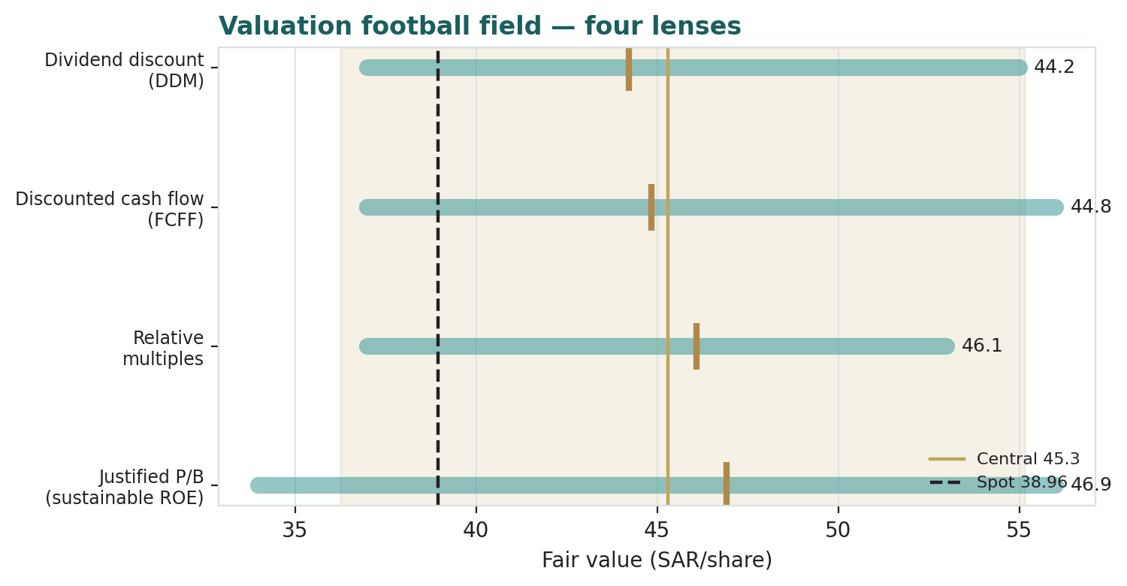
Figure 1 — Valuation football field. Bars span bear–bull per lens; the brass tick is each base case; the gold band is the blended central range; the dark dashed line is spot.
Central fair value ≈ SAR 45.3/share, about 16% above spot. The tightness of the cluster (SAR 44.2 to 46.9 at base) is itself the message: unlike a cyclical where the lenses fan out, four independent bank methods converge, so the value gap is a statement about the multiple the market assigns a quality franchise, not a fragile single-lens artefact.

1.6 The bank up close — NIM bridge, DuPont, and the capital schedule
SNB's engine is spread income on a ~SAR 1.0 tn book of earning assets, and the value driver is the net interest margin. Per the bank driver build (§3.5-B) we forecast net special commission income (NSCI) as NIM × average earning assets rather than a top-down growth rate, decompose returns DuPont-style, and carry an explicit forward capital schedule. The three tables below are the machinery.
NIM bridge (SAR bn / %) | 2024A | 2025E | 2026E | 2028E
Average earning assets | ~912 | ~1,011 | ~1,111 | ~1,270
Net interest margin | 3.00% | ~3.05% | 3.00% | 3.00%
Net special commission income | 27.4 | 30.5 | 33.3 | 39.9
Fee & other non-commission income | 8.6 | 10.0 | 10.3 | 12.0
Total operating income | 36.0 | 40.5 | 43.6 | 51.9
The margin is the crux. SAMA has cut the repo to 4.25% from a 6.0% peak, tracking the Fed through the riyal's dollar peg. A bank with a rate-sensitive asset book would see NIM compress; SNB is cushioned three ways — a 74%-fixed-rate investment book (~30% of earning assets) that keeps its gross yield as market rates fall, longer-duration retail and mortgage loans that reprice slowly, and the Kingdom's highest CASA base (~72%) that keeps funding cheap. The offset is deposit-pricing competition, which pushed total deposits down 2% in 2024 as the bank defended margin over volume. We model NIM flat at ~3.0% — neither the modest expansion some analysts pencil in nor a compression case.
DuPont (return decomposition) | 2024A | 2025E | 2026E
Operating income / avg assets | ~3.4% | ~3.4% | ~3.3%
Cost-to-income | 28.3% | 27.0% | 26.5%
Cost of risk (bps of financing) | 16 | 18 | 21
Return on tangible equity (RoTE) | 16.2% | ~17.2% | ~16.8%
Return on total equity | ~12.4% | ~13.4% | ~13.1%
Capital schedule (CET1 trajectory) | 2025E | 2027E | 2030E
Risk-weighted assets (SAR bn) | 830 | 970 | 1,190
Common equity / CET1 base (SAR bn) | 183 | 209 | 256
CET1 ratio | ~22.1% | ~21.4% | ~20.8%
Tier-1 CAR (reported basis) | ~20.0% | ~19.5% | ~19.2%
Dividend payout | 51% | 55% | 60%
The capital schedule is the dividend thesis. SNB is over-capitalised for its growth — CET1 stays above 20% even as it funds ~7–8% annual financing growth and lifts the payout toward 60%. That headroom is why the DCF (§1.2) lands essentially on the DDM: firm-level free cash flow, net of the capital reinvested for growth, is close to the declared dividend. A segment scorecard frames where each part sits:
Segment | Cyclicality | Margin trend | Capital use | Swing role
Retail (CASA-rich) | Low | Rate-cut beneficiary | Moderate | Funding anchor
Wholesale / corporate | Moderate | Steady, Vision-2030 | High | Growth engine
Treasury (investment book) | Low | Yield-locked (fixed) | Low | Margin cushion
International (Türkiye/legacy) | High | Dilutive (IAS-29) | Low | The drag

1.7 The margin through the cycle and the international drag — the crux
Two judgments drive the valuation more than any other. First, where NIM settles through the easing cycle. Rather than an abstract margin percentage, we sensitize on the observable driver in its native unit (device A-1): the through-cycle net interest margin in basis points. On SNB's ~SAR 1.05 tn average earning-asset base, every 10 bps of sustained NIM is worth roughly SAR 1.5/share at the DDM level. The table re-prices the fair value across the through-cycle margin — the market quote that actually decides the answer.
Through-cycle NIM → | 2.70% | 2.85% | 3.00% | 3.15%
DDM fair value (SAR/share) | ~40 | ~42 | 44.2 | ~47
Implied vs spot 38.96 | +3% | +8% | +13% | +20%
Second, the international drag. SNB's international book — principally a Türkiye operation subject to IAS-29 hyperinflation accounting, plus the legacy of the 2023 Credit Suisse stake write-down — runs dilutive to group NIM and return on equity. It is small (~3% of operating income) but it is the reason SNB's group metrics lag its domestic ones (domestic cost-to-income is under 26% versus 28% group; domestic RoTE is higher than the 16.2% group figure). As the Türkiye distortion normalizes and the legacy loss recedes, the group converges toward the domestic economics — a quiet, non-operating source of upside that requires no new business, only the fading of an old one. The bear case is the mirror: NIM compresses to ~2.7% as CASA migrates to term deposits, the cost of risk normalizes off its 16 bps low, and the international drag persists — which pulls the central value toward spot.

1.8 Macro and country — the peg, SAMA, oil and Vision 2030
SNB is a leveraged play on the Saudi macro. The riyal's peg at 3.75/USD means monetary policy is effectively imported from the Federal Reserve: SAMA follows Fed moves within days to preserve the peg, so the SNB margin story is really a Fed story with a Saudi funding overlay. Four levers set the trajectory.
Macro lever | Channel to SNB
SAMA / Fed rate path | Repo 4.25% (from 6.0% peak); easing trims deposit spread but the fixed-rate book and retail duration cushion NIM
The SAR peg (3.75/USD) | Imported Fed policy; a peg break is the tail risk — neither SAMA nor the government has shown any inclination to move it
Oil & fiscal liquidity | Brent sets deposit liquidity and the project-finance pipeline that drives wholesale loan growth
Vision 2030 credit demand | Giga-project and mortgage financing — the structural non-oil credit growth story behind ~8% financing growth
These are the swing factors behind the bear and bull cases in §1.5 and the catalysts in §5. The single most important is the Fed path: a re-acceleration of US inflation that forced SAMA to re-tighten would help NIM but slow credit; a faster easing cycle would pressure the margin the fixed-rate book is designed to defend.

1.9 DDM sensitivity — the cost-of-equity swing
Per the house cost-of-equity rule (§3.5-G), we publish Ke = rf + β·ERP and sensitize the fair value on a Ke × terminal-growth grid rather than presenting a single point. Holding the dividend path at base, the table re-prices the DDM across the cost of equity and terminal growth; the cells near spot are highlighted.
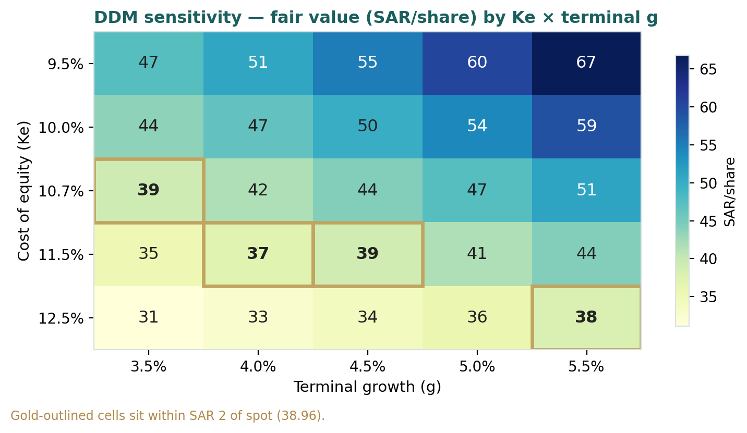
Figure 2 — DDM sensitivity to Ke × terminal growth (SAR/share). Cells nearest spot (SAR 38.96) are highlighted.
Read it as the bet you are taking: the SAR 38.96 spot is consistent with a cost of equity around 11.5–12.5% at a 4–4.5% terminal — i.e. the market is applying a materially higher discount rate to SNB's dividends than its 20%+ capital ratios and mid-teens returns warrant. Compress that discount toward our 10.7% and the value gap opens; widen it and the gap closes.

2 Technical and price structure
The tape is mildly soft rather than distressed. SNB trades just below all four major moving averages, the MACD histogram is marginally negative, and RSI sits in the low-40s — neutral-to-weak, not oversold. The structure is a consolidation in the middle-lower part of the 52-week range, with SAR 33.68 the visible floor and SAR 45.00 the ceiling that also brackets the fundamental cluster.
Indicator | Reading | Signal
Spot | SAR 38.96 | —
SMA 20 / 50 | 40.2 / 39.8 | Below both — short-term soft
SMA 100 / 200 | 41.0 / 39.8 | Below both — trend flat-down
RSI (14) | 40.9 | Neutral, mild weakness
MACD (12,26,9) | −0.22 line / +0.03 signal / −0.25 hist | Marginally bearish
52-week range | SAR 33.68 – 45.00 | Lower-middle of range
Realized vol (252d) | 24% | Moderate
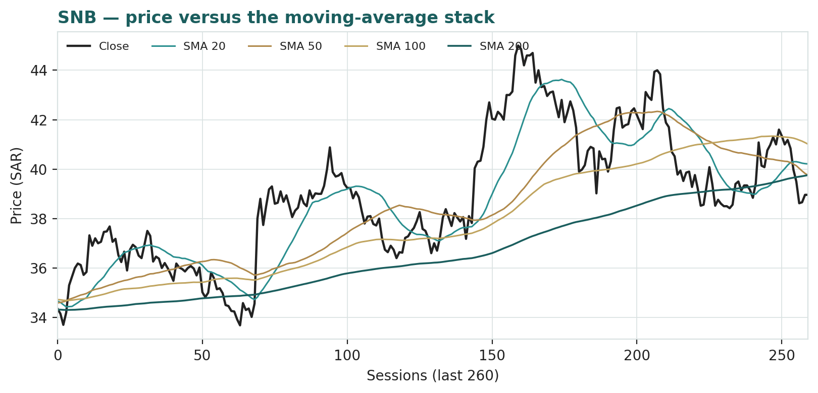
Figure 3 — SNB price versus the moving-average stack, last 260 sessions.
For the probabilistic work this matters in one way: a soft, below-trend tape widens the near-term downside tail a little even as the fundamentals argue the other way. The technical and fundamental pictures disagree mildly, and §6 reads the resulting probability zones without forcing a reconciliation.

3 Monte Carlo — a probabilistic price map
We simulate 50,000 three-month price paths (seed 42) using a sixteen-factor stack: seven continuous macro/operating drivers contributing a small net forward drift, and nine discrete events that each fire with a probability and an impact. By design the paths diffuse from spot, and the §1 value gap is kept out of the drift — the fundamental value gap lives in §1, not here; §3 maps where price could go from today, not where value sits. Width is sized by the YZ-HAR engine (Appendix B), not a trailing-vol number: a pooled log-HAR cascade on a gap-aware Yang-Zhang variance proxy projects the average daily variance over the next 60 sessions (annualized diffusion ≈ 21%), and innovations are unit-variance Student-t(5) via a per-path chi-square mixture — a tighter interquartile body with honest tails. Drift is OFF (zero secular drift) because SNB is an international name; the net external factor drift is a modest +1.9% over the quarter, so the median sits essentially at spot.
Continuous factor (7) | Dir. | Discrete event (9) | Prob. | Mean impact
SAMA / Fed rate path | − | Quarterly results print | 50% | +0.025
Non-oil GDP / credit demand | + | Vision-2030 financing mandate | 35% | +0.045
Brent / fiscal liquidity | + | International (Türkiye) drag | 35% | −0.040
TASI & foreign flows | + | Deposit-pricing / CASA migration | 35% | −0.035
Mortgage / retail cycle | + | Cost-of-risk normalization | 30% | −0.040
SAR peg stability | ± | Capital-return / payout change | 25% | +0.030
Investment-book yield lock | + | Geopolitical / regional security | 28% | −0.080
 |  | Sovereign / sukuk-yield regime | 30% | +0.020
 |  | Rights issue / AT1 / M&A action | 25% | +0.015
Percentile map (SAR/share):
Horizon | p5 | p25 | p50 | p75 | p95
T+20 sessions | 33.8 | 37.1 | 39.0 | 40.9 | 44.4
T+60 sessions | 30.8 | 35.6 | 39.0 | 42.6 | 48.7
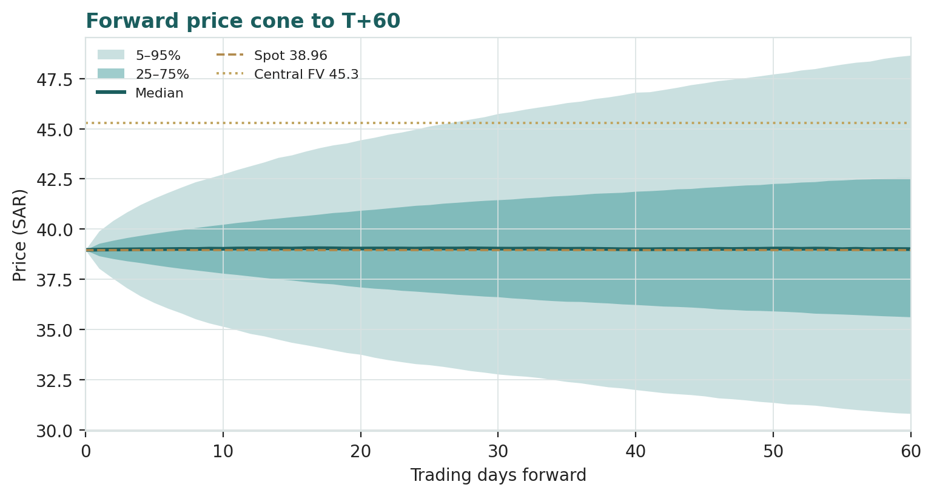
Figure 4 — Forward price cone to T+60. Median tracks spot; the gold dotted line marks the SAR 45.3 fundamental central value, deliberately above the cone.
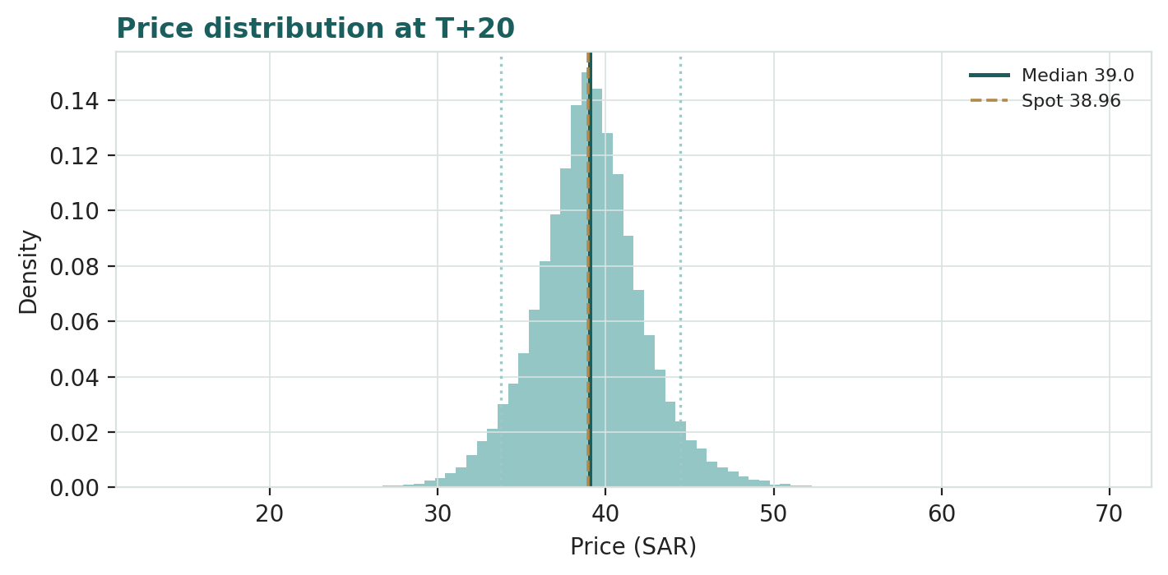
Figure 5 — Price distribution at T+20.
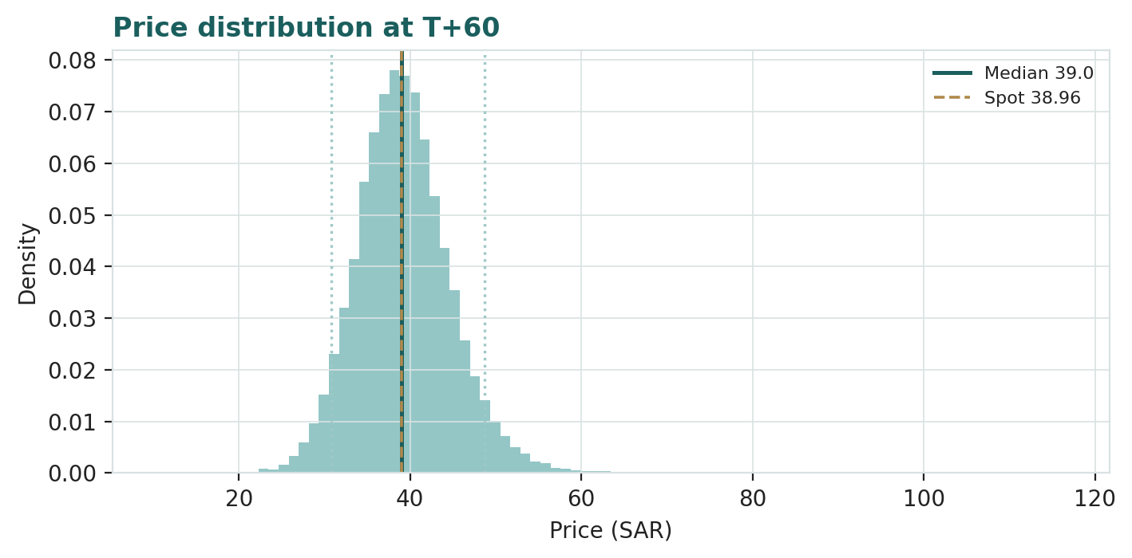
Figure 6 — Price distribution at T+60.
Level-touch ladder — the probability that price touches a level at any point by the horizon (running max for upside, running min for downside):
Level (SAR) | T+20 touch | T+60 touch | Note
46 | 3% | 18% | Toward 52-wk high
44 | 9% | 31% | Upper band
42 | 24% | 50% | Near lower fair-value cluster
40 | 59% | 76% | Just above spot
38 | 57% | 75% | Just below spot
36 | 23% | 48% | Mid downside
34 | 8% | 27% | Toward 52-wk low

4 Comparison of the lenses, and a verdict
Three readings sit side by side. The fundamental lenses cluster tightly at SAR 44–47 with a central SAR 45.3 — modestly above spot, contingent on the margin. The technical picture is mildly the opposite: soft, below-trend, neutral-to-weak, with the visible floor at SAR 33.68. The probabilistic map says that over three months price is roughly symmetric around spot with a ±~30% path-vol band — the median is SAR 39, not SAR 45.3, because the simulation does not assume the value gap closes inside the quarter.
Lens | Reads | Central / implication
Fundamental (4-lens) | Modestly cheap | SAR 45.3 (~+16%)
Technical | Soft / neutral-weak | Floor SAR 33.7; resistance at the MA stack ~40–41
Monte Carlo (3-month) | Symmetric, wide | Median SAR 39; p5–p95 SAR 31–49
Verdict (a fair-value read, not a recommendation). SNB looks modestly cheap on fundamentals, with a clear and unusually concentrated swing factor: the net interest margin through the SAMA easing cycle, and the shrinking international drag. Unlike a cyclical, the four lenses converge — SAR 44–47 — so the value gap is a statement about the multiple the market assigns a quality franchise rather than a fragile single-lens call. The technical softness and the symmetric three-month distribution argue that any re-rating is a question of margin proof over quarters, not of an imminent move. The honest summary is a value modestly above price, a near-term distribution centred on price, and an outcome that hinges on the margin holding — which is why the bear–bull span (SAR 36.5–55.4) is wide even though the base lenses agree. Readers should weigh the lenses themselves; we publish the distribution, not a target.

5 Catalysts to watch
- Quarterly results. Each print is the read on whether NIM is holding as SAMA cuts, and whether fee and investment income keep growing.
- The SAMA / Fed rate path. The single biggest lever: the pace of easing sets the deposit-spread squeeze the fixed-rate book is designed to defend.
- Deposit competition & CASA. Whether SNB can hold its ~72% CASA base without paying up — the funding-cost story behind the margin.
- Vision-2030 project finance. Giga-project and mortgage origination that drives ~8% wholesale and retail financing growth.
- International (Türkiye) normalization. Any easing of the IAS-29 hyperinflation drag lifts group metrics toward the stronger domestic ones.
- Capital return. With CET1 above 20%, room to lift the payout toward 60% or beyond — the excess-capital thesis.
- Cost of risk. Whether the 16 bps 2024 low holds or normalizes toward a mid-cycle ~40–50 bps as recoveries fade.
- Index & flow events. MSCI/EM passive flows and any sovereign-rating action on the large government-securities book.

6 Reading the probability zones
Translating the three-month distribution into plain zones, anchored on spot SAR 38.96 and the fair-value cluster:
Zone (T+60) | Range (SAR) | Approx. probability | What it would mean
Deep downside | < 34 | ~12% | Risk-off / margin scare; tests the 52-wk low
Lower band | 34–37 | ~25% | Deposit-cost squeeze; relative lens dominates
Around spot | 37–40 | ~30% | Status quo; value gap unclosed
Upper band | 40–44 | ~22% | Margin holds; toward the fair-value cluster
Strong upside | > 44 | ~11% | NIM defence + payout lift + drag fading
The distribution is close to symmetric with a slightly heavier upper tail from the discrete upside events (a Vision-2030 financing mandate, a payout lift, sukuk-yield support). It is not a forecast; it is the spread of outcomes consistent with the stock's own volatility and the factor stack.

7 Caveats and what would change our mind
- The margin is the model. The value rests on NIM holding near 3.0% through the easing cycle; a structural compression toward 2.7% as CASA migrates would pull the central value toward — or below — spot.
- Imported monetary policy. SNB's rate story is a Fed story via the peg. A faster-than-modelled easing cycle pressures the very margin the fixed-rate book defends; a peg question (remote) is a tail risk not in the base case.
- Cost of risk is at a cyclical low. 16 bps in 2024 flattered by recoveries; a normalization toward mid-cycle 40–50 bps trims earnings and the DDM.
- International drag could persist. The Türkiye IAS-29 distortion and legacy items may not fade on our timetable; the convergence-to-domestic thesis is judgemental.
- Terminal-value dependency. Both the DDM and DCF carry ~77% of value in the terminal — a Ke-versus-g bet, disclosed and sensitized (§1.9) rather than hidden.
- Technical reminder. A soft, below-trend tape can persist; RSI in the low-40s is neutral, not a trigger. The technical read is context, not a signal.

Appendix A Financial statements
Selected consolidated figures (SAR mn), as reported (FY2024 annual report; 9M-2025 reviewed statements; auditor's unmodified opinion) with a five-year forecast. FY2025E combines 9M-2025 reported actuals with a Q4 estimate; forecast years are model formulas linking to a single assumptions layer.

A.1 Income statement (consolidated, SAR mn)
Line | 2023A | 2024A | 2025E | 2026E | 2027E | 2028E | 2029E | 2030E
Net special commission income | 26,300 | 27,400 | 30,500 | 33,315 | 36,400 | 39,500 | 42,500 | 45,500
Fee & other income | 7,700 | 8,600 | 10,000 | 10,300 | 10,900 | 11,600 | 12,500 | 13,300
Total operating income | 34,000 | 36,000 | 40,500 | 43,615 | 47,300 | 51,100 | 55,000 | 58,800
Operating expenses | (9,350) | (10,190) | (10,935) | (11,558) | (12,300) | (13,180) | (14,000) | (14,880)
Pre-provision operating profit | 24,650 | 25,810 | 29,565 | 32,057 | 35,000 | 37,920 | 41,000 | 43,920
Net impairment (ECL) | (900) | (1,046) | (1,310) | (1,651) | (1,800) | (1,980) | (2,170) | (2,350)
Profit before zakat & tax | 23,750 | 24,764 | 28,255 | 30,406 | 33,200 | 35,940 | 38,830 | 41,570
Zakat & income tax | (3,750) | (3,571) | (3,205) | (3,953) | (4,300) | (4,670) | (5,050) | (5,400)
Net income (attributable) | 20,000 | 21,193 | 25,050 | 26,453 | 28,900 | 31,270 | 33,780 | 36,170
AT1 sukuk coupon | (700) | (800) | (1,000) | (1,100) | (1,200) | (1,250) | (1,300) | (1,350)
Net income to common | 19,300 | 20,393 | 24,050 | 25,353 | 27,700 | 30,020 | 32,480 | 34,820
EPS (SAR, post-AT1) | 3.22 | 3.40 | 4.01 | 4.23 | 4.62 | 5.00 | 5.41 | 5.80
Source: SNB IR / Tadawul filings — FY2024 annual, 9M-2025 reviewed statements, Q4-2024 earnings call. 2025E = 9M actual + Q4 estimate. Forecast = model formulas. Figures rounded; small differences to the companion model reflect rounding.

A.2 Balance sheet (consolidated, SAR mn)
Line | 2023A | 2024A | 2025E | 2026E | 2027E | 2028E | 2029E | 2030E
Net financing | 600,000 | 654,000 | 728,000 | 786,240 | 845,000 | 904,000 | 963,000 | 1,021,000
Investments (securities) | 270,000 | 300,000 | 340,000 | 363,800 | 389,000 | 417,000 | 446,000 | 477,000
Cash, interbank & other | 167,000 | 150,000 | 187,000 | 198,000 | 210,000 | 223,000 | 236,000 | 250,000
Total assets | 1,037,000 | 1,104,000 | 1,255,000 | 1,348,000 | 1,444,000 | 1,544,000 | 1,645,000 | 1,748,000
Customer deposits | 638,000 | 625,000 | 690,000 | 747,000 | 805,000 | 862,000 | 919,000 | 976,000
Other funding & liabilities | 233,000 | 303,000 | 368,000 | 391,000 | 415,000 | 443,000 | 471,000 | 500,000
Total equity | 166,000 | 176,000 | 197,000 | 210,000 | 224,000 | 239,000 | 255,000 | 272,000
of which AT1 sukuk | 12,000 | 14,000 | 14,000 | 15,000 | 15,000 | 16,000 | 16,000 | 16,000
Common equity (CET1 base) | 154,000 | 162,000 | 183,000 | 195,000 | 209,000 | 223,000 | 239,000 | 256,000
Risk-weighted assets | 700,000 | 750,000 | 830,000 | 900,000 | 970,000 | 1,040,000 | 1,115,000 | 1,190,000
Net financing / deposits (LDR) | 94% | 105% | 106% | 105% | 105% | 105% | 105% | 105%
Historical anchored to disclosed totals; forecast rolls forward with the balance held by a plug on other funding. The companion model balances to zero every year.

A.3 Capital & dividend flow (SAR mn)
Line | 2026E | 2027E | 2028E | 2029E
Net income to common | 25,353 | 27,700 | 30,020 | 32,480
Common dividends paid | (13,437) | (15,235) | (17,111) | (19,163)
Retained earnings | 11,916 | 12,465 | 12,909 | 13,317
Capital for RWA growth | (11,900) | (11,900) | (11,900) | (12,750)
Capital surplus / (deficit) | 16 | 565 | 1,009 | 567
CET1 ratio | ~21.6% | ~21.4% | ~21.1% | ~20.9%
Bank analogue of the cash-flow statement: capital generation, dividend capacity, and the CET1 trajectory. Payout rises to ~60% while CET1 stays above 20%.

A.4 Per-share & ratios — the standardized dashboard
Ratio | 2023A | 2024A | 2025E | 2026E | 2027E | 2028E | 2029E | 2030E
EPS (SAR) | 3.22 | 3.40 | 4.01 | 4.23 | 4.62 | 5.00 | 5.41 | 5.80
DPS (SAR) | 1.67 | 1.81 | 2.04 | 2.24 | 2.54 | 2.85 | 3.19 | 3.48
BVPS (common, SAR) | 25.7 | 27.0 | 30.5 | 32.5 | 34.8 | 37.2 | 39.8 | 42.7
Dividend yield | 4.3% | 4.6% | 5.2% | 5.7% | 6.5% | 7.3% | 8.2% | 8.9%
P/E (×) | 12.1 | 11.5 | 9.7 | 9.2 | 8.4 | 7.8 | 7.2 | 6.7
P/B (×) | 1.52 | 1.44 | 1.28 | 1.20 | 1.12 | 1.05 | 0.98 | 0.91
NIM | 3.13% | 3.00% | 3.05% | 3.00% | 3.00% | 3.00% | 3.00% | 3.00%
Cost-to-income | 27.5% | 28.3% | 27.0% | 26.5% | 26.0% | 25.8% | 25.5% | 25.3%
RoTE | 15.5% | 16.2% | 17.2% | 16.8% | 16.6% | 16.4% | 16.2% | 16.0%
Cost of risk (bps) | 15 | 16 | 18 | 21 | 21 | 21 | 22 | 22
NPL ratio | 1.20% | 1.16% | 1.15% | 1.20% | 1.22% | 1.24% | 1.25% | 1.25%
CET1 ratio | 22.0% | 21.6% | 22.1% | 21.6% | 21.4% | 21.1% | 20.9% | 20.8%
The house Data-Miner panel (device A-5), identical across studies. Device A-2 (DPS schedule + stress) is the payout line above, covered under the bear NIM/CoR case in §1.7; device A-3 (forecast-vs-actual scorecard) is N/A on a first study with no prior vintage, and begins on the next quarterly update.

Appendix B Step 0 — calibration backtest
Before any forecast we test the Monte Carlo lens on SNB's own five years of history: at each origin, using only prior data, we generate a three-month-ahead distribution with the YZ-HAR engine and score the realized close against it. The grade is skill versus a naïve zero-drift random-walk cone (spot, trailing vol) — measured by CRPS skill (must be > 0) and the interval (Winkler) score — with the PIT histogram and coverage table as diagnostics only. Over 211 overlapping origins (2022-01 → 2026-03) the engine beats the benchmark: CRPS skill +0.017 (block-bootstrap 90% CI [−0.005, +0.040]) and +0.002 on 18 independent non-overlapping windows, with a clearer interval-score edge (+0.035 / +0.071), a near-uniform PIT (mean 0.472, std 0.280 vs 0.500/0.289 uniform), and near-nominal coverage. The edge is modest because SNB is a stable large-cap where the trailing-vol benchmark is already strong — the win comes from faster vol mean-reversion and honest t5 tails, not width padding.
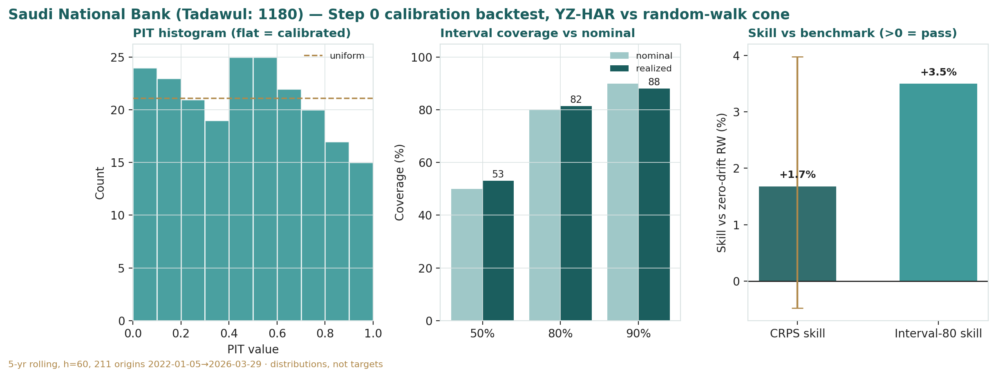
Figure B-1 — Calibration backtest: PIT histogram, interval coverage versus nominal, and CRPS/interval skill versus the random-walk benchmark.
Window scheme | n | CRPS skill | Interval-80 | 50/80/90 cov. | PIT
Dense (step 5d) | 211 | +0.017 | +0.035 | 53/82/88% | 0.47
Non-overlapping (step 60d) | 18 | +0.002 | +0.071 | 28/83/94% | 0.48
Target / pass | — | > 0 | > 0 | ≈50/80/90 | 0.50
CRPS skill is positive on both the precise (dense) central estimate and the independent windows, the interval score is more decisively positive, and the PIT is close to flat. The lens is accepted; this YZ-HAR width carries into the §3 forward run. (The 50% coverage on only 18 non-overlapping windows is small-sample noise; the 211-origin dense read of 53% is the reliable figure.)

Appendix C Peer set, sector structure, and risks
SNB's peers are the other Saudi banks, split by size and franchise. It is the largest by assets and, on a return-on-tangible-equity basis, one of the strongest — yet trades a notch cheaper than the sector's premium names.
Cohort | Closest peers | Typical valuation
Largest KSA banks | Al Rajhi (1120), Riyad (1010), SAB (1060) | P/E ~10–16×; P/B ~1.3–3.5×; ROE 13–20%
Mid-cap KSA banks | Alinma (1150), BSF (1050), ANB (1080) | P/E ~9–12×; P/B ~1.1–1.6×; ROE 11–15%
SNB positioning | Largest by assets; ~1.3× book, ~10× fwd P/E | 16%+ RoTE, 72% CASA, 20.3% T1 CAR — cheap vs quality
Sector structure. Saudi banking is a consolidated, well-capitalised, Sharia-heavy market (~75% of assets Islamic) whose fortunes track the Fed via the peg and the Kingdom's Vision-2030 credit demand. Combined sector profit reached ~SAR 80 bn in 2024 (from ~SAR 70 bn in 2023), sector ROE ~15%, with strong asset quality (impaired ratio ~1.4%, coverage >110%). Principal risks: a structural NIM compression as rates fall and CASA migrates; the international (Türkiye) drag; deposit-pricing competition; a cost-of-risk normalization off cyclical lows; and, as a remote tail, any question over the dollar peg. Analyst context: ANB Capital (Dec-2024) valued SNB by residual income at a ~SAR 46 fair value on an 11% cost of equity — close to our four-lens cluster.

Appendix D The expert valuation panel
Every Testahil study closes with a panel of standing expert personas — drawn from the house Expert Persona Library, not invented for the occasion, so each accumulates a track record and a quarterly update is a re-run, not a re-training. For a bank we cast the three whose methods both fit a deposit-funded balance sheet and genuinely disagree: Expert 1 (capital and returns — a bank as a multiple of book set by its return on equity versus its cost of equity); Expert 2 (the credit cycle — the value hinges on where the cost of risk sits through the cycle); and Expert 3 (macro and policy — a Saudi bank as a leveraged play on the SAMA/Fed rate path and Vision-2030 credit demand). Each runs a different method, derives its fair value from shown workings, and states a falsification condition.

D.1 Expert 1 — capital and returns (RoTE, DuPont, justified P/B)
Worldview and tradition. A bank is worth a multiple of its tangible book, and that multiple is set almost entirely by the spread between the return it earns on equity and the return shareholders demand. He decomposes the return DuPont-style — margin, fees, costs, credit, leverage — to judge whether a mid-teens RoTE is durable, then capitalizes it: justified P/B = (RoTE − g)/(Ke − g).
When the method works / fails. Best for a mature, well-capitalised bank whose returns are stable and legible, which is precisely SNB. It fails where the return is about to re-rate — a credit shock, a capital raise, or a margin collapse — because a single sustainable-RoTE number then misleads.
Standard workings and worked example. He starts from the 16.2% FY2024 RoTE (16.8% pre-AT1), haircuts it to a sustainable 14% for the international drag and eventual NIM normalization, and reads the DuPont: a ~3.0% margin and ~10% non-interest income against a sub-28% cost-to-income and a normalizing but still-low cost of risk.
Expert 1's justified P/B | Input | Value
Sustainable RoTE (tangible) | 14.0% | —
Cost of equity (rf 5.0% + 0.95β × 6.0% ERP) | 10.7% | —
Terminal growth | 4.5% | —
Justified P/B = (RoTE−g)/(Ke−g) | (14−4.5)/(10.7−4.5) | 1.53×
× current tangible book/share | ~SAR 30.5 | —
Fair value |  | ~SAR 46
Reading the DuPont, his durability case is that the return is not built on a single fragile line. The ~3.0% net interest margin is defended by the cheapest deposit base in the Kingdom — a ~72% CASA ratio, the highest of any covered Saudi bank — and a 74%-fixed investment book, so it does not collapse when rates fall; non-commission income is a rising ~20–25% of the top line as fees and investment activity grow, diversifying away from pure spread; the cost-to-income ratio, under 26% domestically, is among the lowest of any large bank anywhere and reflects genuine merger synergies (over SAR 1.5 bn, ahead of the original target); and the balance sheet carries a Tier-1 ratio above 20%, so the leverage multiplier in the DuPont identity is conservative rather than stretched. A 14–16% return produced from that combination — cheap funding, low costs, strong capital, diversifying revenue — is, in his reading, structurally more durable than the same headline return produced by thin capital or aggressive gearing at a peer. That is why he is comfortable capitalizing a mid-teens RoTE into a premium to book rather than treating it as a cyclical peak to be faded, and why he regards the market's ~1.3× as an under-rating of a franchise whose return is both high and defensible.
Sensitivity (swing = sustainable RoTE). At a 12% RoTE the justified P/B falls to 1.21× and the value to ~SAR 37; at 16%, it rises to 1.85× and ~SAR 56. Return on capital is the whole game. Cross-examination. He tells Expert 2 that a single bad year of provisioning does not change a franchise that structurally out-earns its cost of capital; he tells Expert 3 that the rate cycle moves the margin a little but the CASA franchise and the capital base decide the durable return.
Verdict, falsification, market-implied. Fair ~SAR 46 (range SAR 37–56). Falsified if the sustainable RoTE proves to be below the cost of equity — a structurally sub-11% return would justify a discount to book, not a premium. The market price implies a ~1.28× book, i.e. a sustainable RoTE of only ~12.5% on his formula — below what a 16%+ reporting bank should deliver, which is the value gap.

D.2 Expert 2 — the credit cycle (normalized cost of risk)
Worldview and tradition. A bank's reported earnings are only as good as its provisioning is honest, and provisioning is cyclical. He strips the cycle out: the value is a through-cycle earnings stream at a normalized cost of risk, not the flattered print of a benign year. He treats a 16 bps cost of risk as a cyclical low to be normalized, not extrapolated.
When the method works / fails. Best late in a benign credit cycle, when reported earnings are at their most flattering and the market extrapolates them — exactly the Saudi setup after two years of recoveries. It fails if the low cost of risk is structural (a genuinely de-risked book) rather than cyclical, in which case he is too cautious.
Standard workings and worked example. He rebuilds 2026E earnings at a normalized ~45 bps cost of risk (versus the modelled ~21 bps), which lifts the impairment charge on the ~SAR 786 bn book by roughly SAR 1.9 bn and trims net income to common by a similar amount after zakat — a ~7% haircut to earnings — then values the lower stream on the same DDM machinery.
Expert 2's normalized-credit test | Input | Value
2026E net income to common (as modelled) | SAR 25.4 bn | —
Normalize cost of risk 21 → 45 bps | −SAR 1.7 bn (after zakat) | —
Through-cycle net income to common | ~SAR 23.7 bn | —
Through-cycle EPS × the DDM machinery | ~SAR 3.95 | —
Fair value (normalized-credit DDM) |  | ~SAR 42
The Saudi credit history is the spine of his argument. SNB's cost of risk averaged roughly 62 bps between 2017 and 2021, fell to ~30 bps in 2022, and dropped to only ~15–16 bps in 2023–24 — the lowest in seven years — as the bank unlocked recoveries from its legacy and post-merger book against a benign macro. Recoveries alone contributed around 37 bps of gross loans in 2023; strip them out and the underlying charge was nearer ~52 bps. He treats that ~45–52 bps ex-recovery figure as the honest through-cycle number, not the ~16 bps headline flattered by one-off write-backs that cannot repeat once the legacy book is exhausted. The asset quality itself is sound — an NPL ratio of ~1.16% with a corporate book that improved sharply and a stable ~0.5% retail ratio — so his caution is not a solvency worry; it is a normalization worry, the recognition that a benign cost of risk is a point in a cycle, not a permanent feature. Applied to a growing ~SAR 800 bn financing book, the gap between 16 and 45 bps is roughly SAR 2 bn of annual pre-zakat earnings — and it is precisely those earnings the market capitalizes at today's multiple. His discipline is to value the bank on the charge it will carry in an average year, not the best year.
Sensitivity (swing = normalized cost of risk). At a 30 bps normalized cost of risk the value is ~SAR 44; at 60 bps, ~SAR 40. The provisioning assumption is his crux. Cross-examination. He tells Expert 1 that a justified P/B built on a 16% RoTE is capitalizing a benign-cycle return; normalize the credit charge and the durable RoTE is nearer 13%. He tells Expert 3 that the rate cycle is a second-order worry next to where provisioning normalizes when the Saudi non-oil economy next slows.
Verdict, falsification, market-implied. Fair ~SAR 42 (range SAR 40–52) — the most cautious of the three: modestly cheap, but less so once credit is normalized. Falsified if the cost of risk stays structurally below ~30 bps through a full cycle (a durably de-risked, mortgage-heavy, government-backed book). The market price is close to his number — on a normalized-credit basis, SNB is only mildly undervalued.

D.3 Expert 3 — macro and policy (rate-path DDM)
Worldview and tradition. A Saudi bank is a leveraged, pegged play on two forces it does not control: the Federal Reserve (imported through the riyal's dollar peg) and the Kingdom's Vision-2030 credit demand. He values the dividend stream directly, but every input — the margin, the loan growth, the discount rate — is driven from a rate-path and a fiscal-liquidity view rather than a bottom-up build.
When the method works / fails. Best when the macro regime is the dominant variable — a rate-cutting cycle with a fixed exchange rate and a state-driven investment programme, which is the Saudi setup exactly. It fails when idiosyncratic factors (a merger, a capital event, a franchise shift) dominate the macro.
Standard workings and worked example. He takes the SAMA repo path (4.25% and easing, tracking the Fed), judges that the 74%-fixed investment book and retail duration hold NIM near 3.0% through the cuts, layers ~8% Vision-2030-driven financing growth, and discounts the resulting dividend path at a cost of equity built from a 5.0% Saudi risk-free rate and a 6.0% equity-risk premium.
Expert 3's rate-path DDM | Input | Value
Through-cycle NIM (rate-path view) | ~3.0% | —
Financing growth (Vision 2030) | ~8% | —
Cost of equity (rf 5.0% + ERP 6.0% × β 0.95) | 10.7% | —
Terminal growth (Saudi nominal) | 4.5% | —
Fair value (rate-path DDM) |  | ~SAR 45
The transmission he relies on runs through the peg. Because the riyal has been fixed at 3.75 to the dollar since 1986, SAMA cannot set policy independently — it mirrors the Federal Reserve within days to preserve the peg and the capital flows it protects, so Saudi money-market rates and thus SNB's asset yields and deposit costs are effectively imported from Washington. In the 2022–23 tightening the repo travelled from 1% to about 6%; through 2024–25 it retraced to 4.25% as the Fed eased, with the reverse repo at 3.75%. For SNB the decisive feature is the asymmetry in how the two sides of the balance sheet reprice: the 74%-fixed investment book (~30% of earning assets) and the long-duration mortgage book keep their yields as market rates fall, while the CASA-heavy deposit base was never paying much to begin with — so the margin compresses far less than a naïve rate-sensitivity beta would imply. That asymmetry is the single most important input in his model, and it is why he holds NIM near 3.0% through the easing cycle rather than fading it. On the growth side, he leans on the Vision-2030 investment programme — giga-projects, mortgages, and non-oil diversification — as a structural credit-demand story that keeps the balance sheet compounding at ~8% even as rates fall, so his dividend path grows while his discount rate does not.
Sensitivity (swing = the pace of easing / peg). A faster easing cycle that compresses NIM to ~2.8% pulls the value to ~SAR 41; a shallower path that holds NIM at ~3.1% lifts it to ~SAR 47. The Fed path, not SNB, is his swing input. Cross-examination. He tells Expert 1 that a static sustainable-RoTE number ignores that the whole return re-rates with the rate cycle; he tells Expert 2 that credit normalization matters, but a Vision-2030 investment boom is a powerful offset to any provisioning drift.
Verdict, falsification, market-implied. Fair ~SAR 45 (range SAR 38–54). Falsified by a peg break or a Fed re-tightening that crushes the margin, or a Vision-2030 slowdown that stalls credit growth. The market price implies a materially higher discount rate than his 10.7% — the market is pricing more macro risk into SNB's dividends than the pegged, well-capitalised setup warrants.

D.5 The three in one room
The single question they most disagree on is the durable return on capital — specifically, whether SNB's mid-teens RoTE survives a normalizing cost of risk and a falling margin.
Expert 1: “Stop arguing about one year. SNB earns 16% on tangible equity with 20%-plus capital and the cheapest deposits in the Kingdom. A bank that out-earns its cost of capital that comfortably should trade above book — the market pays 1.3× for a franchise worth 1.5.”
Expert 2: “That 16% is a benign-credit number. Sixteen basis points of cost of risk is the lowest in seven years, propped up by recoveries. Normalize it to forty-five and the durable return is nearer 13% — still fine, but not the compounder your multiple assumes.”
Expert 3: “You are both bottom-up when the answer is top-down. This is a pegged bank riding the Fed down and a giga-project boom up. Hold the margin near three percent through the cuts, add eight percent Vision-2030 loan growth, discount at eleven — the dividends are worth forty-five, and the market is simply pricing too much macro risk.”
The room does not resolve, and that is the point: the SAR 4 spread between them is a clean, decomposed measure of a single uncertainty — the durable return on SNB's capital once a benign credit cycle and a falling margin are both accounted for. Expert 1 is right that the franchise structurally out-earns its cost of capital; Expert 2 is right that today's return is flattered by a cyclical low in provisioning; Expert 3 is right that the rate cycle sets the near-term margin. What is striking is that all three land above spot. None of them, running genuinely different methods, can construct a base case at or below SAR 39 without an assumption — a sub-cost-of-capital return, a permanently elevated cost of risk, or a margin collapse — that the bank's actual disclosure does not support. The disagreement is about how far above fair value sits, not about direction, and that unanimity of direction from three independent methods is itself the strongest statement in the study.

D.6 Reading the divergence
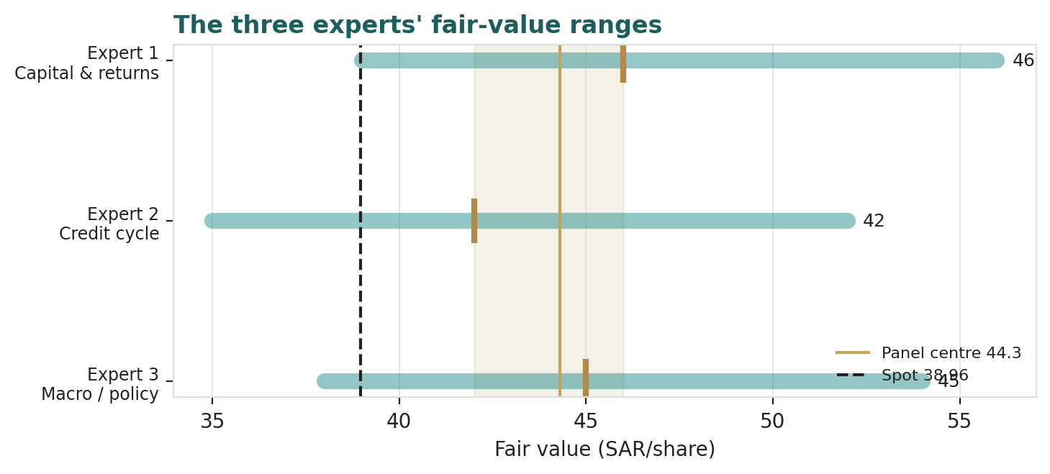
Figure D-1 — The three experts' fair-value ranges. Brass ticks are base cases; the gold band is the central; the dark dashed line is spot. The spread is a return-durability disagreement.
Expert | Method | Single swing assumption | Base fair value
Expert 1 | Capital & returns (justified P/B) | Sustainable RoTE (14%) | SAR 46
Expert 2 | Credit cycle (normalized CoR) | Normalized cost of risk (45 bps) | SAR 42
Expert 3 | Macro / policy (rate-path DDM) | NIM through the Fed path | SAR 45
The spread — SAR 42 to 46 at base — is narrow, and it is almost entirely a return-durability disagreement: none of the three contests the CASA franchise, the capital strength, or the scale. What separates them is whether the mid-teens return survives a normalizing cost of risk (Expert 2's caution) and a falling margin (Expert 3's rate-path), or whether the franchise simply out-earns its cost of capital regardless (Expert 1). The SAR 4 spread is therefore a clean measure of one uncertainty — the durable return on SNB's capital. Resolve that, and the three converge above spot.
For the reader, the practical value of the panel is that it converts a single point estimate into a map of what one would have to believe to disagree. To think SNB is worth less than its SAR 39 price, one must side with a harder version of Expert 2 — a cost of risk that stays structurally above ~50 bps through the cycle — or reject Expert 3's peg-transmission argument and assume the margin compresses toward the mid-2% range as rates fall. To think it is worth the SAR 46–47 top of the range, one sides with Expert 1: the mid-teens return is durable and deserves a full premium to book. Our weighted central of SAR 45.3 sits inside the panel, closest to Experts 1 and 3, because we judge the franchise quality and the margin defence more compelling than the credit-normalization drag — but the study deliberately shows all three so the reader can re-weight them. That is the house method: not a target, but a distribution and the reasoning behind every point in it.
Each expert's point fair value (and bull/base/bear) is logged with the study date (2 Jul 2026) and spot (SAR 38.96) as an internal per-expert track record, kept separate from the core Calibration Ledger.

About this series
Testahil publishes independent, educational valuation studies. Each is an attempt to reason transparently about what a security is worth, with every assumption shown and a companion model so readers can disagree productively. The house style is distributions, not tips: we describe ranges and probabilities, not targets, and we do not tell anyone what to do. Studies are framed as educational analysis, the preparer is not licensed by any securities regulator, and holdings are disclosed.

Disclosure & Disclaimer
Not investment advice. This document is educational and informational only. It is not, and must not be relied upon as, investment, financial, legal, accounting or tax advice, nor an offer, solicitation or recommendation to buy, sell or hold any security. It contains no price target and no rating.
No licence; no advisory relationship. The preparer is not registered or licensed with any securities or financial regulator in any jurisdiction, holds no brokerage or investment-advisory authorisation, and is not acting as your adviser or fiduciary. Nothing here is personalised to your circumstances.
Holdings disclosure. The preparer may hold, and may in the future take or dispose of, a position in the security discussed in this report, and may transact at any time without notice. This is a potential conflict of interest you should weigh.
Sources & accuracy. Reported financial and operating figures are drawn from the company's public disclosure and other public sources believed reliable but not independently verified; they may contain errors or be superseded. Forward-looking inputs — the cost of equity, the NIM and growth path, the terminal assumptions, the multiples and the Monte-Carlo factor probabilities — are the preparer's own judgments and are inherently uncertain.
Forward-looking statements. Any statements about the future are estimates subject to risks and uncertainties; actual results may differ materially. The Monte Carlo models price, not value, and encodes subjective probabilities for events that have not occurred.
No reliance; your responsibility. Do your own research and consult a licensed professional before making any decision. You are solely responsible for your investment decisions and their outcomes. To the maximum extent permitted by law, the preparer accepts no liability for any loss arising from use of this document.
Currency & figures. Figures are in Saudi riyals (SAR); the riyal is pegged at 3.75/USD. Rounding may cause totals to differ slightly, including small differences between the study and the companion model. Spot price and market data are as of 2 July 2026 and change continuously.
TESTAHIL · Independent Valuation Study · Educational Analysis · The Saudi National Bank (Tadawul: 1180) · edition 04-07-2026 · reporting currency SAR

