Testahil · Independent Valuation Study — Educational Analysis Not investment advice

Independent Valuation Study — Educational Analysis
Saudi Telecom Company (Tadawul: 7010)
Fundamental analysis · Technical analysis · Monte Carlo simulation — one integrated read
Anchor: SAR 43.58 (7 Jul 2026 close) · 4,989.8 mn shares (5,000 mn issued less treasury) · mkt cap ~SAR 217.5 bn (~US$58 bn) · the Kingdom’s incumbent operator and the largest MENA telecom by market value: stc KSA (consumer, enterprise, wholesale — ~57% mobile share, the national fibre and 5G backbone) plus subsidiaries (solutions by stc 79%, stc bank 85%, stc Kuwait 51.8%, stc Bahrain, center3 data centres, sirar, iot squared) and minority stakes — 43.06% of the PIF-controlled tower company (TAWAL/Digital Infrastructure) and 9.97% of Telefónica · reporting currency SAR (pegged to USD at 3.75) · prices and probabilities computed 7 Jul 2026 from the attached daily history · primary lens: going-concern FCFF DCF, cross-checked by the dividend-policy DDM, relative multiples and normalized earnings · the swing factors: capex intensity against the locked SAR 2.20 dividend, and the discount-rate (beta) question.
READ FIRST — what this document is, and is not.
This study is a valuation exercise and an expression of personal analytical opinion, published free of charge for educational purposes: it shows how one analyst applies fundamental, technical and probabilistic methods to a listed company, and invites scrutiny of that methodology. It is NOT investment advice, NOT a recommendation or solicitation to buy, sell or hold any security, and NOT directed at the circumstances of any reader. The preparer is not licensed by any securities regulator in any jurisdiction, holds no brokerage or advisory authorisation, provides no financial consultancy, manages no money, and accepts no fees, funds or clients. See the Disclosure & Disclaimer at the end.
All values are model outputs presented as ranges and distributions because no single number should be relied on. Reported financials are the company’s own disclosure (FY2023–FY2025 IR releases on the restated continuing-operations basis; Q1-2026 release, 28 Apr 2026; Q1-2026 interim financial statements) — all from stc.com. Forward-looking inputs — the segment growth and margin paths, capex intensity, the cost of capital, terminal growth, the multiples and the Monte-Carlo factor probabilities — are the preparer’s judgments and are flagged throughout. Some balance-sheet detail lines are grouped estimates tying to disclosed totals. Consult a licensed financial advisor before any investment decision.

Headline
The model's read: modestly undervalued, with the answer hinging on whether a zero-net-debt incumbent yielding 5% can hold its margin story while funding the AI-infrastructure build. At SAR 43.58 the shares sit about 8% below our weighted central estimate of SAR 47. The four lenses cluster unusually tightly: the FCFF DCF lands at 50 (80% of it terminal value — disclosed, not buried), the locked dividend policy discounts to 46, a justified EV/EBITDA read gives 47, and a conservative normalized-earnings read marks the floor at 43. In one sentence: on the cash it pays out today stc is roughly fairly valued; on the cash the business generates once capex normalizes from the current data-centre-and-5G investment phase, it is modestly cheap. The crux is concrete and observable (§1.7): the SAR 0.55-per-quarter dividend — locked by policy through the Q3-2027 distribution — costs SAR 11.0 bn a year, and at the guided 15–17.5% capex band our FY26E free cash flow covers between 0.86× and 1.04× of it. The balance sheet carries the gap comfortably (net debt ≈ SAR 7.1 bn, ~0.3× EBITDA, after January’s $2 bn sukuk), but the equity story quietly shifted in 2024–25: stc sold control of its towers, banked SAR 12.9 bn of gains, paid a SAR 2.00 special, and is now redeploying into AI data centres (the center3–HUMAIN 1 GW ambition) and adjacencies (stc bank, Telefónica). Technically the tape is flat — price within ±1% of every major moving average, RSI 48 — a stock waiting for its next catalyst. Over three months the Monte Carlo — zero drift, the configuration that passed the Step 0 calibration gate — places the 5th–95th percentile band at roughly SAR 39–50 with the median at 43.9, and the honest core — the 50% band — at SAR 42–46.
Valuation summary — every read at a glance
One table for the four reads that follow — what the business is worth (fundamental), what the tape is doing (technical), where price could travel over three months (Monte Carlo), and how three independent expert methods land. Every row is developed in the sections and appendices below.
Lens / read | What it measures | Output | Takeaway
FUNDAMENTAL — what the business is worth (the anchor)
FCFF DCF (primary) | Core operations + stake marks − net debt − NCI | SAR 50 | +15% vs spot
Dividend discount (policy lens) | The locked SAR 0.55/quarter, discounted at Ke | SAR 46 | +5%
Relative (EV/EBITDA) | FY26E EBITDA × justified 9.0×, bridged to equity | SAR 47 | +8%
Normalized earnings | Ex-one-off PAT × through-cycle P/E | SAR 43 | -1% · the floor
Weighted central | Blend 35 / 25 / 20 / 20 | SAR 47 | +8% vs SAR 43.58
TECHNICAL — what the tape is doing (timing, not value)
Trend & momentum | Price vs the 20/50/100/200-day averages | Flat — within ±1% of all four | Range-bound
Momentum / range | RSI · MACD · 52-week range | RSI 48 · MACD -0.09 · 40.2–45.4 | Neutral, coiled
MONTE CARLO — where price could go in 3 months (paths from spot)
T+20 sessions | 50,000 paths · 16 factors | p5 41 · p50 43.7 · p95 47 | Median ≈ spot
T+60 sessions | same engine, longer horizon | p5 39 · p50 43.9 · p95 50 | Mild upside skew
EXPERT PANEL — three independent methods (Appendix C)
Expert 1 — cash returns / economic profit | ROIC vs WACC with fading excess returns | SAR 37 | Most conservative
Expert 2 — normalized earnings power | Mid-cycle EPS × multiple | SAR 43 | The floor-setter
Expert 3 — macro-policy scenario tree | Rate path & payout scenarios into a DDM | SAR 46 | Closest to spot
Panel range | Spread = the fade-vs-franchise question | SAR 37–46 | Centres ~SAR 43

Bottom line. Every fundamental lens lands between SAR 43 and 50 — a tight cluster by house standards — and the weighted central of SAR 47 sits +8% above spot. The expert panel is more cautious than the house lenses precisely where it should be: the cash-returns expert charges the company for the capital the network swallows and lands below spot, while the earnings and policy experts sit at or just above it. This is not a deep-value situation and it is not an expensive one: it is a zero-net-debt utility-grade franchise at ~14.7× trailing earnings and a 5.0% locked yield (9.6% counting last year's special), where the return comes from the dividend plus whatever the market eventually pays for the AI-infrastructure and fintech options. The three-month distribution centres at spot with a mild upside tilt — the tape has no opinion yet.
Company overview — stc at a glance
Item | Value
Listed entity | Saudi Telecom Company (stc Group), Tadawul: 7010
What it is | The Kingdom’s incumbent telecom operator and MENA’s largest telecom by market value; consumer, enterprise and wholesale connectivity plus a digital-infrastructure and fintech portfolio
Spot / date | SAR 43.58 · 7 Jul 2026 close
Shares · market cap | 4,989.8 mn (5,000 mn issued − ~10.2 mn treasury) · ~SAR 217.5 bn (~US$58 bn)
FY2025 revenue / EBITDA / net profit | SAR 77,819 mn (+2.5%) · SAR 24,469 mn (31.4% margin) · SAR 14,828 mn (+12.5% adjusted; reported −39.9% vs FY24’s TAWAL-gain year)
Q1-2026 revenue / net profit | SAR 19,939 mn (+3.8%) · SAR 3,696 mn (+12.0% ex non-recurring; +1.3% reported)
Segment split (FY2025) | stc KSA SAR 51,119 mn (consumer 32,826 · enterprise 13,514 · wholesale 4,779) · subsidiaries net ~SAR 26,700 mn
Balance sheet | Net debt SAR 111 mn at FY25 (~0.0× EBITDA); SAR 7.1 bn at Q1-26 after the Jan-2026 $2 bn sukuk (~0.3×); cash framings: FS 21.4 bn incl. stc bank / IR core 15.4 bn
Dividend | SAR 0.55/quarter locked through Q3-2027 (SAR 2.20/yr ≈ 5.0% yield); FY24 also paid a SAR 2.00 special (cash paid 2025: SAR 4.20/sh ≈ 9.6%)
Key stakes | 43.06% Digital Infrastructure Co (TAWAL + Zain towers; PIF 54%) · 9.97% Telefónica (€2.1 bn cost; ≈€1.96 bn market) · solutions by stc 79% (mkt cap ~SAR 26 bn) · stc bank 85% (8 mn customers)
52-week range | SAR 40.20 (1 Mar 2026) – 45.38 (30 Oct 2025)
Ownership | PIF 62.0% (after the Nov-2024 SAR 3.86 bn accelerated bookbuild) · free float ~38%
Corporate events | $2 bn dual-tranche sukuk (Jan-2026, 4.489%/5.083%) · 26 mn-share ESIP buyback approved 7 May 2026 · center3–HUMAIN AI-data-centre framework (Dec-2025, toward 1 GW) · SilkLink Syria fibre corridor (SAR 3 bn, Feb-2026) · 2Q26 results due ~late Jul 2026

Source: stc FY2023–FY2025 IR releases, Q1-2026 release and interim FS, FY2025 earnings presentation (all stc.com); Saudi Exchange disclosures; PIF press releases. Values rounded.
1 Fundamental valuation
We value stc as a going-concern operator and triangulate four lenses. The primary lens is a free-cash-flow-to-firm DCF, because a mature, capital-intensive network operator is ultimately worth the cash its infrastructure produces after the capex that keeps it competitive; the tower and Telefónica stakes sit outside the operating engine and are marked separately on the bridge. A dividend-discount read is the natural cross-check for a company whose board has locked a SAR 0.55-per-quarter distribution through 2027. A relative EV/EBITDA read and a normalized-earnings read complete the set. The weights and the football field are in §1.5; the segment engine in §1.6; the crux — dividend cover against the capex cycle, in real units — in §1.7; the cost-of-capital build (every input sourced, both ERP bases published) in §1.8; and the sensitivity grids in §1.9. One lens-selection note (§3.5-F5 considered and set aside): stc does own a captive-finance-flavoured arm — stc bank — but at SAR 2.0 bn of revenue (2.5% of group) and an early-stage loan book it does not yet warrant the split-legs operating-co-plus-lender treatment; it is carried inside the subsidiaries line with a justified N/A, to be revisited once SAMA-reported bank financials give it a book worth marking separately. Throughout, the cost of equity is published explicitly as Ke = rf + β × ERP = 5.50% + 0.48 × 5.01% = 7.90% (rating basis; 8.25% on the CDS basis), with the beta a genuine — if short-window — regression against TASI rather than an assumed round number.
1.1 The FCFF DCF — the primary lens
The revenue engine is the §1.6 segment build (top-down: stc discloses unit revenue, not subscriber × ARPU detail, so per the house data-discipline gate we forecast disclosed segment lines rather than manufacture a bottom-up split). Group revenue compounds ~3.0% — consumer +2.0–3.0%, enterprise recovering to ~4% as mega-project phasing normalizes, wholesale mid-single-digit on hosting and FWA backhaul, subsidiaries ~5–6% led by solutions, stc bank and center3. The EBITDA margin glides from 31.4% (FY25) to 32.5% by FY30E — Q1-26 already printed 32.9% — as the subsidiary mix matures. Capex intensity follows management’s own band: 16.5% of revenue in FY26–27E (the “edge up slightly” guidance for the mission-critical and data-centre build), fading to 15.0% by FY30E; the long-term guided range is 15–17.5%. A working-capital/OCF-conversion drag of 0.4–0.8% of revenue reflects the receivables-heavy government business. Zakat and income tax at the normalized effective ~9.7% (statutory zakat is 2.5% of the zakat base; FY25’s net credit was a one-off).
SAR mn | FY26E | FY27E | FY28E | FY29E | FY30E
Group revenue | 80,963 | 84,287 | 87,496 | 90,548 | 93,373
EBITDA | 25,746 | 26,972 | 28,174 | 29,247 | 30,346
D&A | (10,444) | (10,789) | (11,112) | (11,409) | (11,672)
EBIT | 15,302 | 16,183 | 17,062 | 17,838 | 18,675
NOPAT = EBIT × (1 − 9.7%) | 13,818 | 14,613 | 15,407 | 16,108 | 16,863
+ D&A | 10,444 | 10,789 | 11,112 | 11,409 | 11,672
− Capex | (13,359) | (13,907) | (13,999) | (14,035) | (14,006)
− Δ working capital | (648) | (506) | (437) | (362) | (373)
FCFF | 10,255 | 10,989 | 12,082 | 13,120 | 14,155
Discount factor | 0.929 | 0.864 | 0.803 | 0.746 | 0.694
PV of FCFF | 9,532 | 9,494 | 9,702 | 9,792 | 9,820

DCF bridge | SAR mn
Σ PV of explicit FCFF (FY26–30E) | 48,340
Terminal value (Gordon, g = 2.5%) | 285,206
PV of terminal value | 197,859
Enterprise value — core operations | 246,198
Terminal value as % of EV (device A-7) | 80%
+ Associates & JVs (43.06% DIIC/TAWAL, carrying) | 4,641
+ Telefónica 9.97% (market mark) | 8,630
less: Net debt (IR basis, Q1-26) · NCI | (7,063) · (2,335)
Equity value | 250,071
DCF fair value per share | SAR 50.12

Two honesty notes. First, 80% of the enterprise value sits in the terminal — at a 5.1-point WACC−g spread this is a duration bet dressed as a five-year model, which is why §1.9 sensitizes the WACC × g grid and the beta separately rather than hiding either. Second, the model FCFF (SAR 10.3 bn FY26E) runs ~SAR 2–3 bn richer than stc's own reported FY25 free cash flow (6.5 bn), because reported OCF absorbs receivables swings, early-retirement cash and zakat timing that a NOPAT-based FCFF smooths; Q1-26's FCF of 3.9 bn (+494% YoY) suggests the gap is closing, but Appendix A shows both series so the difference is visible, not blended away (device A-8).
1.2 Dividend discount — the policy lens, as the cash-flow cross-check
stc is one of the few large emerging-market payers whose dividend is a stated, board-locked policy rather than a ratio: SAR 0.55 per quarter from the Q4-2024 distribution through the Q3-2027 distribution (announced 25 Aug 2024), with specials assessed quarterly on top — FY24 shareholders also received SAR 2.00. We discount the locked SAR 2.20 through 2027, step the DPS with earnings thereafter (payout ~75–80%), and grow the terminal dividend at 3.0%.
DDM build | FY26E | FY27E | FY28E | FY29E | FY30E
DPS (SAR) | 2.20 | 2.20 | 2.30 | 2.40 | 2.55
PV of DPS @ Ke 7.90% | 2.04 | 1.89 | 1.83 | 1.77 | 1.74

Σ PV of explicit dividends (FY26–30E) | SAR 9.27
Terminal DPS (FY31E) = FY30E × 1.03 | SAR 2.63
Terminal value = TDPS / (Ke − g) | SAR 53.55
PV of terminal value | SAR 36.61
DDM fair value per share | SAR 45.88
Terminal value as % of value (device A-7) | 80%

DDM base ≈ SAR 46/share — a touch above spot: at a 7.9% cost of equity a locked 5.0% yield growing at ~3% is worth slightly more than the market pays, and any repeat of a special distribution (the quarterly-assessment clause) is free upside to this lens. The cross-check earns its place for a subtler reason: it is the one lens that cannot be flattered by the capex assumptions, because the board has pre-committed the cash.
1.3 Relative multiples
On trailing numbers stc trades at ~14.7× earnings, ~9.5× EV/EBITDA and 2.5× book — the premium name in a GCC cohort spanning 10.7× (Ooredoo) to 17.6× (du) on earnings. The premium tracks the franchise: ~57% mobile share, the only national fixed/fibre footprint, net debt ≈ zero against regional peers at 1–2× EBITDA, and the highest absolute yield commitment. The disciplined relative read is a justified EV/EBITDA on the FY26E build, bridged to equity with the same stake marks as the DCF.
Relative basis | Bear | Base | Bull
FY26E EBITDA (SAR mn) | 25,746 | 25,746 | 25,746
Justified EV/EBITDA | 8.0× | 9.0× | 10.0×
Fair value (SAR/share) | 42.1 | 47.2 | 52.4
P/E cross-check at base (on FY26E EPS 2.82) |  | 16.7×

Relative base ≈ SAR 47 — in line with the DCF, which is itself informative: the market’s multiple for this franchise already embeds roughly the same view of its cash engine as our explicit model.
1.4 Normalized earnings power — where this sits in the cycle
Cycle position first (device A-6): unlike a developer or a smelter, stc’s P&L has no violent cycle, but FY25 profit is still not a clean base — it carries a one-off SAR 466 mn zakat credit (prior-year provision reversals), and FY24 before it carried the SAR 12.9 bn TAWAL disposal gain, a SAR 1.5 bn withholding-tax reversal and a SAR 2.6 bn early-retirement charge. Margins sit mid-cycle: EBITDA margin 31.4% is on the guided path (Q1-26: 32.9%), enterprise revenue is at the soft point of the government mega-project phasing, and the subsidiary portfolio (stc bank, center3) is still in its investment phase — 2–3 subsidiaries are guided to turn contribution-positive from 2026. Normalized attributable profit is therefore ~SAR 14.4 bn (reported FY25 14.8 bn less the zakat credit), or EPS ≈ 2.89, capitalized at a through-cycle 15× — the stock’s own multi-year median area and the peer-set mid.
Normalized-earnings basis | Bear | Base | Bull
Normalized PAT (SAR mn) | 13,600 | 14,400 | 15,200
Justified P/E | 13.5× | 15.0× | 16.5×
Fair value (SAR/share) | 36.8 | 43.3 | 50.3

Normalized base ≈ SAR 43 — the floor of the set: it pays nothing for growth beyond today’s earnings power and treats the AI-infrastructure build purely as cost.
1.5 Synthesis — four lenses
We weight the DCF most heavily because it is the only lens that prices the full capex-and-recovery arc; the DDM carries the pre-committed cash; the relative lens anchors to what the market pays for GCC telecom cash flows today; normalized earnings is the ballast.
Lens | Weight | Bear | Base | Bull
FCFF DCF (primary) | 35% | 36 | 50.1 | 69
Dividend discount (policy) | 25% | 32 | 45.9 | 58
Relative (EV/EBITDA) | 20% | 42 | 47.2 | 52
Normalized earnings | 20% | 37 | 43.3 | 50
Weighted central |  | 36.2 | 47.1 | 59.1

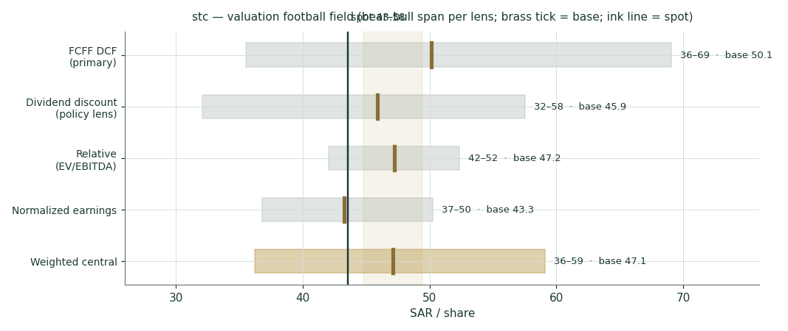
Figure 1 — Valuation football field. Bars span bear–bull per lens; the brass tick is each base case; the gold band is the blended central range; the ink line is spot.
Central fair value ≈ SAR 47/share, +8% versus spot. The bear–bull span (36–59) is driven almost entirely by the DCF’s terminal arithmetic — the bear case is WACC +100 bp with margins 50 bp lighter and capex 100 bp heavier; the bull is the mirror image. Note what the spread is NOT about: revenue. A ±1 pp change to every growth rate moves the central by only ~SAR 2 — this is a margin, capex and discount-rate story, which is exactly what §1.7 and §1.9 sensitize.
1.6 The segments — a deeper look, and the driver table
Segment / leg | FY25 revenue | Trend | Margin role | Swing role
KSA Consumer (CBU) | SAR 32.8 bn (+3.4%) | Mobility +2.8%, fixed +6.6%; 30.6 mn subs (+5.3% Q1-26) | The cash cow | Competition watch
KSA Enterprise (EBU) | SAR 13.5 bn (+0.4%) | Government phasing; private sector +6%; flat ex-mega-projects | High-margin | Recovery lever
KSA Wholesale & Carrier | SAR 4.8 bn (+10.8%) | Hosting, FWA backhaul, national roaming (+32.6% national) | Structural | Steady
Subsidiaries (net) | ~SAR 26.7 bn | solutions 12.7 bn · channels ~14.1 bn gross · stc bank 2.0 bn (+11%) · SCCC +62% · sirar +13% · center3 | Dilutive today, guided to turn | The option book
Associates & stakes | off-P&L | 43.06% towers (DIIC) · 9.97% Telefónica · iot squared 50% | Equity-method / marks | Bridge items

The top-down driver build (§3.5-C — the gate is deliberately NOT cleared for a bottom-up subscriber × ARPU model: stc discloses unit revenue and subscriber counts but not ARPU by tier, so a manufactured split would be false precision — the ETEL precedent in the house protocol). The sourced segment history comes first; the forward path is the house view:
Driver (disclosed history) | FY24 | FY25 | FY26E | FY28E | FY30E
KSA Consumer (SAR mn) | 31,741 | 32,826 | 33,811 | 35,626 | 37,138
KSA Enterprise | 13,466 | 13,514 | 13,784 | 14,837 | 15,971
KSA Wholesale & Carrier | 4,313 | 4,779 | 5,066 | 5,532 | 5,897
Subsidiaries, net | 26,249 | 26,700 | 28,302 | 31,501 | 34,366
Group revenue | 75,893 | 77,819 | 80,963 | 87,496 | 93,373
EBITDA margin | 31.5% | 31.4% | 31.8% | 32.2% | 32.5%
Capex intensity | 15.7% | 15.2% | 16.5% | 16.0% | 15.0%

History: stc FY2025 earnings presentation and IR releases (stc.com), restated basis. Forecast drivers are the house’s own flagged view (Fundamental Driver Ledger rows logged). Q1-26 actuals: CBU +5.2%, EBU −3.6%, W&C +6.2%.
1.7 The crux — dividend cover against the capex cycle, in real units
Three judgments drive this valuation, and all three are observable rather than abstract. First and largest: capex intensity against the locked dividend. The policy dividend costs SAR 10.98 bn a year (2.20 × 4,989.8 mn shares); management guides capex to 15–17.5% of revenue with 2026–27 “edging up.” The cover table below is the whole tension in one place — at the top of the guided band the dividend is only 0.86× covered by model FY26E free cash flow and the balance sheet funds the rest; at the bottom it is fully covered. Each percentage point of capex intensity is worth ≈SAR 0.8 bn of annual FCF and ≈SAR 1.6 of DCF fair value per share. Second: the discount rate. This is a 90%-equity-weighted WACC built on a 0.48 regressed beta from a nine-week window (§1.8) — at β = 1.0 the DCF falls from ~50 to ~34, below spot, so §1.9 publishes the full beta grid rather than letting one regression settle it. Third: the SAMA/Fed path — the rf is 5.5% today; each 50 bp off the Saudi curve adds ≈SAR 4–5 to the DCF and directly lowers the funding cost of the AI-infrastructure build. A fourth, slower variable: KSA mobile competition (Mobily’s subscriber growth has outpaced stc’s revenue growth for four quarters) — each 1 pp off consumer growth costs ≈SAR 2 of fair value.
FY26E scenario (real units) | Model FCF (SAR bn) | Dividend bill (SAR bn) | Cover
Capex at 15.0% | 11.5 | 11.0 | 1.04×
Capex at 16.5% (base FY26E) | 10.3 | 11.0 | 0.93×
Capex at 17.5% (top of guidance) | 9.4 | 11.0 | 0.86×

Device A-2: the DPS schedule and its stress test live in Appendix A.3. The dividend is policy-locked through the Q3-2027 distribution; the test is whether FCF or the balance sheet pays for it — at Q1-26 run-rate (FCF 3.9 bn vs a 2.74 bn quarterly dividend) it was FCF, for the first quarter in a year.
1.8 Macro and country — SAMA, oil, Vision 2030, and the sourced cost of capital
stc is a defensive claim on the Saudi macro, in three channels. Rates: SAMA shadows the Fed to defend the riyal peg (repo 4.25% / reverse repo 3.75% since 10 Dec 2025; the Fed held 3.50–3.75% on 17 Jun 2026), so the discount rate and the sukuk funding cost are set in Washington as much as Riyadh. Oil and the fiscal impulse: government ICT and giga-project spend (SAR ~32 bn of digital-government spend in 2025) drives the enterprise book — the FY25 softness was phasing, not demand. Vision 2030: the structural bid — data centres (the center3–HUMAIN 1 GW ambition inside a national AI push), 5G/fibre densification, and digital-services adjacencies — is what turns a utility growth profile into a utility-plus-options profile. Because the riyal is pegged, there is no currency-translation channel in the valuation and no FX factor in the Monte Carlo. Every input in the cost-of-capital build is sourced and named (house rule §3.5-G):
Cost-of-capital build | Value | Source
Risk-free rate (rf) | 5.50% | Derived SAR 10Y: KSA govt-guaranteed USD 10Y priced UST+95bp on 8-Jul-2026 (SRC $1.5bn sukuk; UST 4.45%) = 5.40%, plus the SAR-over-USD pickup per the Saudi Exchange sovereign-debt primer (21-May-2026); FAB’s 5.5% as cross-check. Flagged: derived — no free live SAR 10Y screen exists
Equity beta (β) | 0.48 | Genuine daily stc-vs-TASI regression, n=40 sessions (5-May→7-Jul-2026): β 0.475, R² 14.3%, SE 0.19 — passes the house usability gate; flagged short-window, beta grid in §1.9
Equity risk premium (rating-based, primary) | 5.01% | Damodaran ORIGINAL file (ctryprem.html), Saudi Arabia row, “Last updated: January 5, 2026”: Aa3, CRP 0.78% + mature 4.23%
— ERP, CDS-based (the “more current” alternative) | 5.72% | Same file, CDS column (sovereign CDS 0.98%) — for Saudi the CDS basis is the HIGHER one
Cost of equity Ke = rf + β × ERP | 7.90% | (rating basis; 8.25% on the CDS basis)
Pre-tax cost of debt | 5.00% | stc’s own instruments: Jan-26 $2bn sukuk 4.489%/5.083% (T+75/T+90); 2019 sukuk 3.89%; SAR murabaha ≈ SAIBOR 4.79% + 60–100bp
After-tax cost of debt (9.7% effective zakat/tax) | 4.51% | Debt mix: USD-linked ≈55–60% (named sukuk/ECA), SAR remainder — peg makes USD legs quasi-SAR
Weights (E / D) | 90.6% / 9.4% | Market cap (43.58 × 4,989.8 mn) vs Q1-26 disclosed total debt SAR 22,475 mn
WACC | 7.59% | (7.90% on the CDS-based ERP — both published per protocol)
Terminal growth (nominal SAR) | 2.50% | House view ≈ long-run nominal GDP-lite for a mature operator; sensitized in §1.9

Two honesty notes on this build. First, the risk-free rate is a derived figure: Saudi Arabia has no freely quoted live SAR 10-year screen, so we triangulated from a government-guaranteed USD sukuk priced the day before the study (UST + 95 bp) plus the officially documented SAR-over-USD sovereign pickup — the number is checkable end-to-end, but it is an estimate of a quote, not a quote. Second, the beta is regressed on only nine weeks of daily data, because every programmatic source of longer TASI history is access-blocked; 0.48 is consistent with a defensive, PIF-anchored mega-cap (aggregators print ~0.2 on longer windows), but the honest treatment is the grid in §1.9, where the reader can see the valuation at any beta up to 1.2. Both flags are logged in the study’s driver ledger.
1.9 Sensitivity — the margin, the capex, the rate spread, and the beta
The first grid re-prices the DCF across the two real-unit operating levers (EBITDA margin and capex intensity); the second across WACC × terminal growth; the third across the beta — the single input most likely to move the answer, given the short regression window.
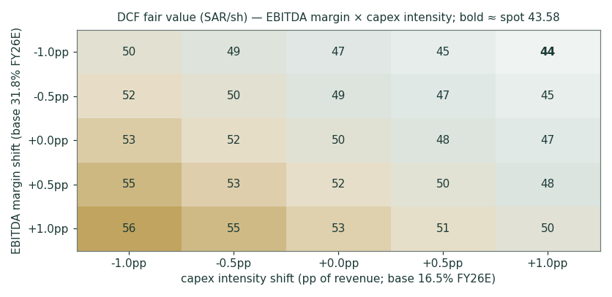
Figure 2 — DCF fair value (SAR/share) across EBITDA-margin and capex-intensity shifts. Bold cells sit nearest spot (SAR 43.58).
WACC \ terminal g | 1.5% | 2.0% | 2.5% | 3.0% | 3.5%
6.59% | 51.9 | 56.6 | 62.5 | 70.0 | 79.9
7.09% | 47.2 | 51.0 | 55.6 | 61.4 | 68.7
7.59% (base) | 43.3 | 46.4 | 50.1 | 54.7 | 60.3
8.09% | 40.0 | 42.6 | 45.6 | 49.3 | 53.7
8.59% | 37.1 | 39.3 | 41.8 | 44.8 | 48.4

DCF fair value (SAR/share) across WACC × terminal growth. Base cell 7.59% × 2.5% = 50.1. The CDS-ERP alternative WACC (7.90%) sits between the third and fourth rows.
Beta | Ke (rating ERP) | WACC | DCF value/sh | Note
0.30 | 7.00% | 7.05% | 59.8
0.48 | 7.90% | 7.59% | 50.1 | regressed base (n=40, R² 14%)
0.70 | 9.01% | 8.59% | 41.8
0.85 | 9.76% | 9.27% | 37.6
1.00 | 10.51% | 9.95% | 34.2 | house fallback had the regression failed
1.20 | 11.51% | 10.86% | 30.4

The beta grid is mandatory disclosure here (house rule): a nine-week regression passes the usability gate but is not a settled estimate. Even at β = 0.70 the DCF only converges to spot — the undervaluation read survives moderate beta doubt but not a full reversion to 1.0.
2 Technical and price structure
The tape is flat in every sense that matters. stc trades within ±1% of all four major moving averages (the stack itself is compressed into a SAR 0.7 band — 43.25 to 43.93), RSI sits at 48, and the MACD histogram is fractionally negative with both lines hugging zero. The 52-week range is narrow for an emerging-market name — 40.20 (1 Mar 2026) to 45.38 (30 Oct 2025), barely ±6% around spot — and realized volatility (13% over the trailing year) is among the lowest on Tadawul. Price action over the last quarter: +4%, in a series of small steps around the Q1 print and the May dividend. This is a coiled, catalyst-waiting chart, not a trending one.
Indicator | Reading | Signal
Spot | SAR 43.58 | —
SMA 20 / 50 | SAR 43.93 / 43.56 | Spot within ±1% of both — no trend
SMA 100 / 200 | SAR 43.25 / 43.41 | Stack compressed — long base
RSI (14) | 47.9 | Dead neutral
MACD (12,26,9) | -0.06 line / +0.03 signal / -0.09 hist | Flat, fractionally negative
52-week range | SAR 40.20 – 45.38 | Spot at the 63rd percentile
20-day / 60-day change | -1.3% / +3.8% | Quiet accumulation
Realized vol (252d) | 13.1% | Very low; HAR forward read 15.1%

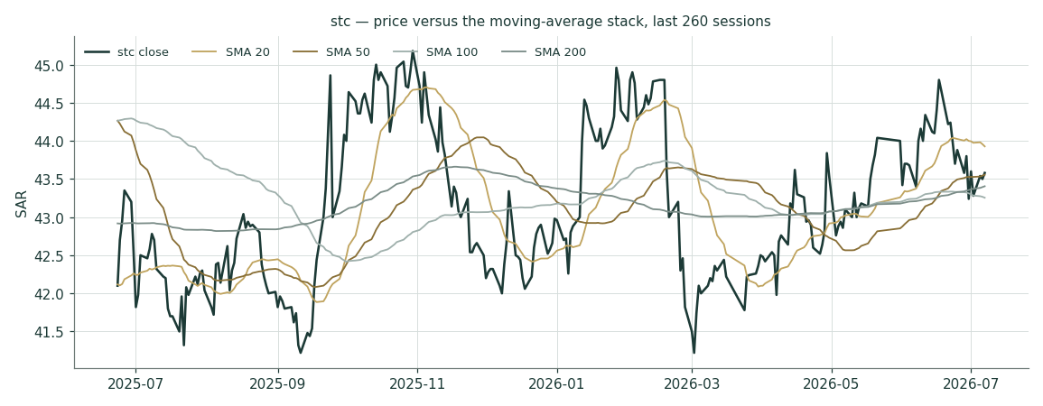
Figure 3 — Price versus the moving-average stack, last 260 sessions.
For the probabilistic work this matters in one way: a compressed, low-volatility tape produces a genuinely narrow three-month cone — the 5–95% band in §3 spans only ±12% — so even modest fundamental catalysts (a covered dividend, a capex surprise, a special) can move price to the edge of the distribution. The technical picture neither confirms nor contradicts the fundamental read; it simply has not voted yet.
3 Monte Carlo — a probabilistic price map
The probability read below opens the section, per house presentation: computed from the same 50,000 paths as everything that follows, it is a summary of the distribution, not an input to it.
The probability read (T+60)
P(price above spot) | 55%
P(+10%) vs P(−10%) — the odds | 10% vs 6% · 1.7 : 1
Median level, and its move | SAR 43.91 (+0.7%)
The 50% band (25th–75th) | SAR 42.0 – 45.8 (-3.6% / +5.2% of spot)
Touch(+10%) / touch(−10%) at any point | 17% / 11%

We simulate 50,000 three-month price paths (seed 42) with the house YZ-HAR v2 engine: width from a pooled log-HAR cascade (variance lags 1/5/22) on a gap-aware Yang-Zhang variance proxy, projecting the average daily variance over the next 60 sessions (annualized ≈ 15.1% at this origin — modestly above the very calm 13.0% trailing figure, because the HAR reads the current regime rather than averaging the past; no calibration multiplier — the retired KVOL floor is replaced by the HAR width itself); shape from unit-variance Student-t(5) innovations via a per-path chi-square mixture (tighter interquartile body, honest tails); and drift that is asset-class-conditional — here ZERO, because stc is an international/GCC name and zero drift is the configuration that passed the Step 0 gate (secular drift failed it: CRPS skill −4.8%; the full backtest stays on file in the Calibration Ledger). A sixteen-factor stack layers on top: seven continuous macro/operating drivers and nine discrete events that each fire with a probability and an impact, together adding a modest +0.7% over the quarter.
By design the paths diffuse from spot as near-term price and deliberately do not embed the fundamental fair value — the value gap of §1 is kept out of the drift. The fundamental gap lives in §1, not here; §3 maps where price could go from today, not where value sits. The near-even median you see is the honest consequence of zero drift on a calm tape — never a target, and never the §1 value gap smuggled in.
Continuous factor (7) | Dir. | Discrete event (9) | Prob. | Mean impact
SAMA/Fed policy-rate path (easing) | + | 2Q26 results (~late Jul 2026) | 90% | +0.4%
Oil price / fiscal impulse (govt ICT spend) | + | Special dividend with 2Q/3Q results | 20% | +2.0%
Vision 2030 / non-oil digital demand | + | SAMA/Fed cut ≥25 bp (Sep/Oct) | 55% | +0.6%
KSA mobile competition (Mobily/Zain) | − | center3/HUMAIN AI-DC milestone | 35% | +1.0%
Data-centre/AI buildout economics | ± | TAWAL/DIIC monetization event | 10% | +1.5%
Subsidiary drag→contribution | ± | Telefónica mark deterioration | 25% | −0.6%
TASI flows / index weight | ± | KSA mobile price-war escalation | 20% | −1.5%
 |  | Regional geopolitical escalation | 25% | −2.0%
 |  | PIF sell-down / index-flow event | 10% | −1.2%

All factor numbers are editable judgments (the table is the model); flagged uncalibrated pending red-pen sign-off. Net continuous drift +0.2%/quarter, expected event drift +0.5% — near-zero central drift with mildly asymmetric tails. No FX factor: the riyal is pegged.
Percentile map (SAR/share)
Horizon | p5 | p25 | p50 | p75 | p95
T+20 sessions | 40.8 | 42.6 | 43.7 | 44.8 | 46.8
T+60 sessions | 39.0 | 42.0 | 43.9 | 45.8 | 49.5

Lead with the 50% band, not the tails: a quarter ahead, half of all paths finish between roughly SAR 42 and 46 (−3.6% / +5.2%); at one month the band is ~SAR 43–45 (width ≈ ÷√3). The 5–95% cone is context, not a forecast — and on this name it is unusually narrow (±12%), the direct consequence of the low-volatility regime the HAR width reads.
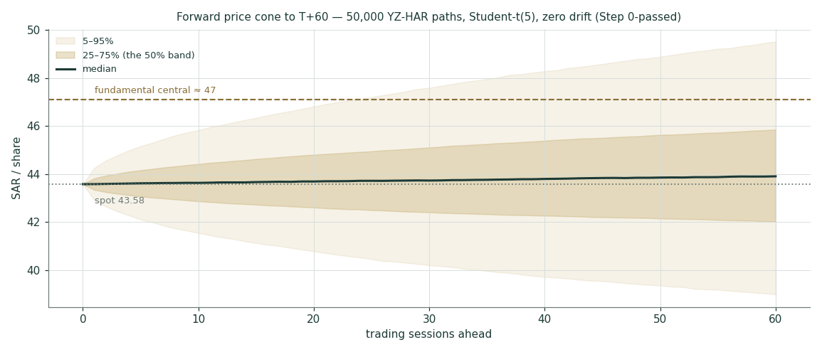
Figure 4 — Forward price cone to T+60. The median tracks spot under zero drift; the brass dashed line marks the SAR 47 fundamental central, deliberately inside the upper half of the cone rather than at its centre.
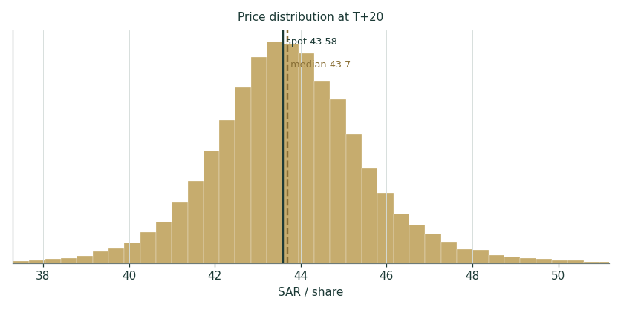
Figure 5 — Price distribution at T+20.
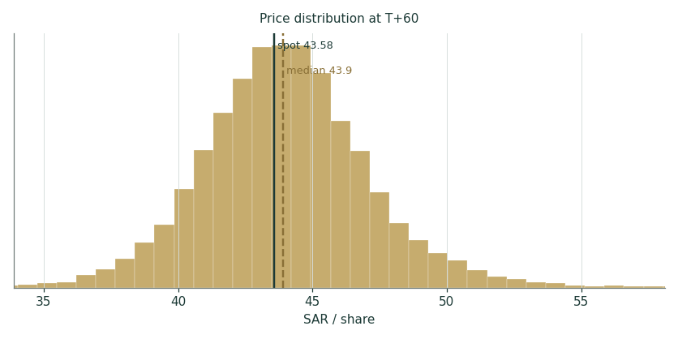
Figure 6 — Price distribution at T+60.
Level-touch ladder
The probability that price touches a level at any point by the horizon (running max for upside, running min for downside):
Level (SAR) | T+20 touch | T+60 touch | Note
50 | 1% | 7% | Round number; +14.7%
48 | 3% | 16% | Above the 52-week high
46 | 15% | 41% | Just past the Oct-25 high zone
44 | 71% | 85% | First resistance above spot
42 | 26% | 48% | The March base
40 | 4% | 16% | The 52-week-low shelf
38 | 1% | 5% | Stress zone
36 | 0% | 2% | Crisis zone

4 Comparison of the lenses, and a verdict
Three readings, one coherent picture. The fundamental lenses cluster between 43 and 50 with a central of 47 — +8% versus spot — and, unusually for this series, the disagreement between them is small: the argument is not about what stc earns but about what its capex cycle and discount rate deserve. The technical picture is a flat, compressed, low-volatility base — no trend to confirm or fight. The probabilistic map says the market is likely to keep the stock within a few riyals of spot over the quarter (50% band 42–46), with a mild upside tilt from the factor stack and near-even odds either side of today’s price. Where the tension lives is §1.7: the locked dividend against the investment phase — a question the next few quarterly prints answer in cash, not in narrative.
Lens | Reads | Central / implication
Fundamental (4-lens) | Modestly undervalued | SAR 47 (+8%)
Technical | Flat, coiled, low-vol | Support ~42 (March base); resistance 45.4 (52w high)
Monte Carlo (3-month) | Near-even, mild up-tilt | Median 43.9; p5–p95 39–50

Verdict (a fair-value read, not a recommendation). stc reads modestly undervalued (+8% to the central) with an unusually well-defined path to being proven right or wrong: hold the EBITDA margin glide, keep capex inside the guided band, and the locked 5% yield plus mid-single-digit cash-flow growth does the rest; let capex run at the top of the band through 2027 while consumer competition bites, and today’s price is fair. The lens cluster is tight enough (bear–bull 36–59 driven almost wholly by terminal arithmetic) that we would characterize the stock as a bond-like core holding with two free options — the AI-infrastructure build and the fintech/bank adjacency — rather than a re-rating story. We publish the distribution, not a target.
5 Catalysts to watch
- 2Q26 results (~late July 2026). The first full quarter to show whether Q1’s cash-flow inflection (FCF 3.9 bn, 1.4× the quarterly dividend) is a run-rate or a blip; watch enterprise revenue (mega-project phasing) and capex phasing.
- Quarterly dividend declarations. SAR 0.55 is policy through Q3-2027 — the information is in any SPECIAL distribution (the policy explicitly allows quarterly assessment; FY24 paid SAR 2.00). A special would mechanically re-rate the DDM lens; its absence through 2026 keeps the balance sheet funding the build.
- SAMA/Fed decisions (Sep/Oct 2026). Each 25–50 bp off the Saudi curve lowers this study’s discount rate and the marginal cost of the sukuk-funded infrastructure build — the single most mechanical catalyst.
- center3–HUMAIN milestones. The 1 GW AI-data-centre ambition (framework Dec-2025) converts to value only as contracted megawatts and disclosed economics; any capacity/offtake announcement is the option going in-the-money.
- TAWAL/DIIC monetization. stc still owns 43.06% of the region’s largest tower company; an IPO or stake sale would crystallize a mark this study carries at a conservative SAR 4.6 bn book. Speculation only — nothing announced.
- KSA mobile competitive prints. Mobily’s subscriber momentum vs stc’s +5.3%; a price response from any of the three would show first in consumer ARPU-proxy (CBU revenue per sub).
- Telefónica. The 9.97% stake (€2.1 bn cost) trades ≈7% below cost with a halved dividend; further deterioration is a mark-to-market drag, any Spanish-market recovery a small tailwind — the stake is ~3.5% of the DCF equity bridge.
- Index / flow events. PIF sold 2% in Nov-2024 at SAR 38.6 (float now ~38%); any further sell-down is a supply event, any float-driven index-weight uplift a demand event.
6 Reading the probability zones
Translating the three-month distribution into plain zones, anchored on spot SAR 43.58 and the fair-value cluster:
Zone (T+60) | Range | Approx. probability | What it would mean
Deep downside | < SAR 38 | ~3% | Regional shock / price war; below the 52-week low
Lower band | SAR 38–42 | ~22% | Capex runs hot, cover stays sub-1×; March base retested
Around spot | SAR 42–46 | ~52% | Status quo: yield carries the return; ~52% of all paths
Upper band | SAR 46–50 | ~19% | Cover proven / cuts delivered; presses the 52-week high
Strong upside | > SAR 50 | ~4% | Special dividend or AI-build monetization credited

The distribution is mildly right-skewed — the touch ladder shows a 17% chance of tagging +10% at some point against 11% for −10% — but the mass is concentrated: more than half of all paths finish within ±SAR 2.5 of spot. That concentration is the calm-regime HAR width, not a view; a volatility-regime shift would widen the cone mechanically at the next quarterly re-run.
7 Caveats and what would change our mind
- The dividend-vs-capex tension is the model. The FY26E cover of 0.86–1.04× is an estimate built on management’s own capex band and our margin glide; two consecutive quarters of FCF below the SAR 2.74 bn quarterly dividend bill would push the DDM lens toward its bear case and the balance sheet toward releveraging — watch the quarterly FCF line, not the payout announcements.
- Terminal-value dependency. 80% of the DCF’s enterprise value is terminal at a 5.1-point WACC−g spread; §1.9 is the honest statement that this valuation is substantially a duration bet on Saudi discount rates.
- The risk-free rate is derived, and the beta is short-window. The 5.5% rf triangulates a government-guaranteed USD print plus an officially documented SAR pickup — a screen-quoted SAR 10Y, when accessible, replaces it. The 0.48 beta passes the house gate on nine weeks of data; a 2–5-year weekly regression should replace it, and §1.9 shows the valuation at every beta to 1.2. Both are logged as open flags.
- Competition is the slow leak. stc’s consumer growth (+3%) already trails Mobily’s subscriber momentum; a price war in KSA mobile — three players, one regulator, heavy 5G capacity — is the scenario in which the margin glide reverses and every lens compresses toward the normalized floor.
- The subsidiary portfolio is an investment phase, not yet a return. stc bank (8 mn customers, SAMA-licensed Jan-2025), center3, SCCC and iot squared are guided to turn contribution-positive from 2026; if they stay dilutive through FY27, the margin glide to 32.5% is wrong by construction.
- The stake marks are point-in-time. Telefónica (9.97%) is marked at market (≈SAR 8.6 bn, ~7% below cost) and the tower stake at carrying value (SAR 4.6 bn) — the former moves daily, the latter is conservative against any transaction mark; together they are ~5% of the bridge.
- OCF conversion. Reported FY25 FCF (6.5 bn) ran well below model FCFF on receivables build and one-off cash items; we model an explicit conversion drag, but a government-receivables cycle that widens rather than narrows would make even the 0.86× bear cover optimistic.
- Technical reminder. A compressed, low-volatility tape can break either way; the narrow cone in §3 is a regime read, not a promise. The technical section is context, not a trigger.
Appendix A Financial statements
Consolidated figures as disclosed by stc — FY2023–FY2025 IR releases on the restated continuing-operations basis (TAWAL and Digital Infrastructure Co reclassified to discontinued operations), Q1-2026 release and interim FS — all from stc.com, per the study’s sourcing rule. SAR million. The five-year forecast is the model build (companion Excel, formula-linked to Assumptions).
A.1 Income statement — 3-year historical + 5-year forecast (consolidated, SAR mn)
Line | FY23 | FY24 | FY25 | FY26E | FY27E | FY28E | FY29E | FY30E
Revenue | 71,777 | 75,893 | 77,819 | 80,963 | 84,287 | 87,496 | 90,548 | 93,373
Gross profit | 34,740 | 37,326 | 37,700 | 39,267 | 40,879 | 42,436 | 43,916 | 45,286
EBITDA | 22,445 | 23,951 | 24,469 | 25,746 | 26,972 | 28,174 | 29,247 | 30,346
D&A & impairment | (9,284) | (9,525) | (10,031) | (10,444) | (10,789) | (11,112) | (11,409) | (11,672)
Operating profit (EBIT) | 13,161 | 14,426 | 14,438 | 15,302 | 16,183 | 17,062 | 17,838 | 18,675
Associates, net finance, impairments & other | 826 | (2,292) | 285 | 700 | 750 | 800 | 850 | 900
Profit before zakat & income tax | 13,987 | 12,134 | 14,723 | 16,002 | 16,933 | 17,862 | 18,688 | 19,575
Zakat & income tax | (1,327) | (1,192) | 466 | (1,552) | (1,643) | (1,733) | (1,813) | (1,899)
Profit from continuing operations | 12,660 | 10,942 | 15,189 | 14,450 | 15,291 | 16,129 | 16,875 | 17,676
Discontinued operations | 759 | 13,973 | — | — | — | — | — | —
Net profit (attributable) | 13,295 | 24,689 | 14,828 | 14,089 | 14,908 | 15,726 | 16,453 | 17,234
EPS (SAR) | 2.67 | 4.95 | 2.97 | 2.82 | 2.99 | 3.15 | 3.30 | 3.45

FY23–FY25 as disclosed (stc.com IR releases; restated). FY24 discontinued operations include the SAR 12,885 mn TAWAL/Digital-Infrastructure disposal gain. One-offs: FY23 AlKhobar land gain +1,296, WHT reversal +724; FY24 WHT reversal +1,500, ERP −2,577, BGSM impairment −764; FY25 zakat credit +466. Forecast columns are the live model build (rounded); the Excel is the source of truth.
A.2 Balance sheet — condensed house layout (consolidated, SAR mn)
Line | FY23 | FY24 | FY25 | FY26E | FY28E | FY30E
Net fixed & intangible assets | 78,408 | 74,383 | 83,529 | 86,529 | 91,801 | 95,232
Investments in associates & JVs | 3,800* | 4,200* | 4,641 | 5,141 | 6,231 | 7,441
Financial assets (incl. Telefónica) | 22,000* | 23,500* | 24,893 | 24,893 | 24,893 | 24,893
Trade receivables, net | 24,500* | 25,800* | 26,727 | 27,375 | 28,486 | 29,222
Cash, equivalents & ST murabahas | 28,138 | 30,755 | 15,080 | 21,774 | 25,177 | 31,116
Other assets | 2,800 | 2,000 | 2,952 | 2,952 | 2,952 | 2,952
TOTAL ASSETS | 159,646 | 160,638 | 157,477 | 168,664 | 179,540 | 190,856
Equity attributable | 78,985 | 89,417 | 83,414 | 86,525 | 93,364 | 101,411
Non-controlling interests | 2,530* | 3,069* | 3,482 | 3,834 | 4,606 | 5,455
Borrowings & sukuk (excl. leases) | 21,958 | 15,132 | 15,191 | 22,475 | 22,475 | 22,475
Lease liabilities | 6,985* | 4,580* | 2,253 | 2,253 | 2,253 | 2,253
Trade payables & financial liabilities | 25,000* | 26,500* | 29,610 | 29,610 | 29,610 | 29,610
Zakat, provisions & other liabilities | 24,188 | 21,940 | 23,527 | 23,967 | 27,232 | 29,652
Balance check (assets − L&E) | 0 | 0 | 0 | 0 | 0 | 0

Disclosed anchors (total assets, cash+murabaha, total debt, attributable equity) exactly as reported; * = grouped estimate tying to the disclosed totals; FY25 line detail from the Q1-2026 FS 31-Dec-25 comparatives. "Net fixed & intangible assets" and "Zakat, provisions & other" are the balancing lines, shown as formulas in the Excel so the check row is exact in every column. FY26E borrowings step up by the completed Jan-2026 $2 bn sukuk. Forecast values here are indicative reads of the live model.
A.3 Cash flow, the two FCF framings, and the DPS schedule (device A-2)
Cash flow (SAR mn) | FY23 | FY24 | FY25 | FY26E | FY28E | FY30E
Operating cash flow (disclosed / model) | 22,418 | 19,885 | 18,283 | 23,647 | 26,155 | 28,441
Capex (disclosed / model) | (9,790) | (11,927) | (11,795) | (13,359) | (14,000) | (14,006)
Free cash flow | 12,628 | 7,959 | 6,488 | 10,287 | 12,156 | 14,435
Dividends paid (attributable) | (8,000) | (18,712) | (10,978) | (10,978) | (11,477) | (12,724)

FY23–FY25 disclosed (stc IR); FY24 dividends-paid include the FY24 quarterly schedule; calendar-2025 cash dividends ≈ SAR 20.9 bn including the SAR 2.00/share special. Model OCF is a NOPAT-based construct and runs richer than the disclosed series — the conversion gap (receivables, ERP cash, zakat timing) is modelled as an explicit drag and discussed in §1.1; both framings shown per house rule.
Dividend schedule | FY25A | FY26E | FY27E | FY28E | FY29E | FY30E
DPS declared (SAR) | 2.20 | 2.20 | 2.20 | 2.30 | 2.40 | 2.55
Dividend bill (SAR bn) | 11.0 | 11.0 | 11.0 | 11.5 | 12.0 | 12.7
Payout of attributable NP | 74% | 78% | 75% | 75% | 74% | 74%
Yield at spot (declared) | 5.0% | 5.0% | 5.0% | 5.3% | 5.5% | 5.9%
Stress check | At the 17.5% top of the capex band, FY26E cover is 0.86× — the SAR 15.4 bn core cash pile funds the gap for >3 years before leverage exceeds 1× EBITDA; the policy is safe to Q3-2027 barring a margin break.

Two yield framings (house rule): declared-regular 2.20/sh = 5.0%; cash paid during calendar-2025 incl. the FY24 special = 4.20/sh = 9.6%. Forecast-vs-actual scorecard (device A-3) and new-vs-old reconciliation (A-4): not applicable on an initiation; both become standing sections from the first 3-month update.
Appendix B Peer set, sector structure, and risks
stc is the premium name in a three-player Saudi market inside a GCC cohort where telecom equity is increasingly a yield-plus-digital-infrastructure asset class.
Name | P/E (t) | Div yield | One-line profile
stc (7010) | ~14.7× | 5.0% (9.6% incl. special) | Incumbent; ~57% mobile share; net debt ~0; AI-DC and fintech options
Mobily (7020) | ~13.5× | 4.5% | No.2; e& anchor (~28%); fastest subscriber momentum
Zain KSA (7030) | ~12.8× | 4.9% | No.3; tower-light; balance-sheet repair done
e& (UAE) | ~13.2× | 5.1% | UAE incumbent + Vodafone/PPF international portfolio
Ooredoo (Qatar) | ~10.7× | 5.7% | Multi-market; MENA data-centre pivot
du (UAE) | ~17.6× | 5.5% | No.2 UAE; hyperscale data-centre momentum — the multiple stc’s DC build aspires to
Omantel / Beyon / Telecom Egypt | 11.5× / 11.1× / 8.8× | 3.9% / 7.1% / 1.5% | Regional context

Multiples approximate, mixed as-of dates (May–Jul 2026), secondary aggregators — context only, never model inputs.
Sector structure. Saudi mobile is a disciplined three-player market (~57/27/16 stc/Mobily/Zain) under CST regulation, with spectrum freshly allocated (Nov-2024 auction: stc took 600 MHz + 3.8 GHz), 5G at 63% populated coverage for stc and FWA adoption among the highest globally — FWA is both an opportunity (4.1 mn of stc’s 6.0 mn fixed lines) and the competitive vector through which mobile capacity attacks fixed pricing. Fibre stays an stc moat (3.75 mn FTTH, 258k km). The Kingdom’s AI push (HUMAIN, sovereign compute, the center3 1 GW ambition) is turning telecom capex into a national-strategy line item. Principal risks: a mobile price war; capex overshoot on the AI build; government-receivables cycles; subsidiary execution (stc bank credit costs as it scales); the Telefónica mark; regional geopolitics; and the rate path staying higher for longer.
Appendix C The expert valuation panel
Every Testahil study closes with a panel of standing expert personas — drawn from the house Expert Persona Library, not invented for the occasion, so each accumulates a track record across studies and a quarterly update is a re-run, not a re-training. For stc we cast the telecom trio from the library’s coverage map — cash-returns (DCF + returns on capital against WACC), earnings-power (normalized through-cycle earnings + multiples), and macro-policy (scenario-weighted policy options) — labelled Expert 1 / 2 / 3. Each runs a genuinely different method, derives its fair value from shown workings, and states a falsification condition.
C.1 Expert 1 — cash returns: ROIC against the cost of capital
Worldview and tradition. A business is worth the cash it returns over its life, and it creates value only when each riyal of capital earns above its cost. He looks past accounting earnings to free cash flow and to the economic-profit spread — and he is temperamentally suspicious of capex programs described with the word “vision.”
When it works / fails. Best for capital-intensive businesses where returns on capital are the crux — precisely a telecom. Fails where reinvestment economics are genuinely improving (past ROIC misleads a new-moat story) — his risk here if the AI-data-centre build earns structurally above telecom returns.
Expert 1’s economic-profit test | Value
Invested capital (equity 83.4 bn + net debt 7.1 bn) | SAR 90.5 bn
FY26E NOPAT → ROIC | SAR 13.9 bn → 15.3%
WACC (accepts the §1.8 build) | 7.59%
Economic profit = (ROIC − WACC) × IC | SAR ~7.0 bn/yr
Fade: excess returns decay 2.5%/yr toward WACC | EP multiple ≈ 13.2×
Core EV = IC + PV(fading EP) | SAR ~183 bn
+ stakes − net debt − NCI, / 4,989.8 mn shares | → SAR 37.3/share

Sensitivity (swing = the fade rate): at a 1%/yr fade (a durable moat) his value rises to ≈SAR 45; at 4%/yr (competition and technology churn eat the spread) it falls to ≈SAR 32. Cross-examination: he tells Expert 2 that a 15× multiple on normalized earnings quietly capitalizes today’s ROIC forever without charging for the capital that sustains it — his fade does explicitly what the multiple hides. He tells Expert 3 that scenario trees on the policy rate are fine, but the bigger lever is inside the company: each percentage point of capex intensity is SAR 0.8 bn of cash that either earns the spread or doesn’t.
Verdict, falsification, market-implied. Fair SAR 37.3 (range 32–45) — the panel’s conservative anchor, below spot: on his arithmetic the market already pays for the excess returns to persist a decade-plus. Falsified by disclosed data-centre economics showing contracted returns above telecom ROIC (the fade would then be too harsh), or by ROIC holding ≥15% through FY28 while capex normalizes. What the price implies: at SAR 43.58 the market discounts a fade of roughly 1.5%/yr — gentler than his 2.5%, i.e. the market believes in the moat slightly more than he does.
C.2 Expert 2 — normalized earnings power
Worldview and tradition. An operating company is worth a fair multiple of its sustainable, mid-cycle earnings power; peaks, troughs and one-off gains are noise to be stripped before anything is capitalized.
When it works / fails. Best for stable operating businesses with a track record — a fit for stc, whose underlying earnings have grown 12–13% (adjusted) for two straight years. Fails at structural breaks: if the subsidiary portfolio re-rates the growth profile, his through-cycle multiple is too low; if a price war breaks the margin, too high.
Expert 2’s normalization | Value
FY25 attributable profit, reported | SAR 14,828 mn
less: one-off zakat credit | (466)
Normalized PAT → EPS | SAR ~14,400 mn → SAR 2.89
Justified through-cycle P/E | 15.0×
Fair value | → SAR 43.3/share

Sensitivity (swing = the multiple): at 13.5× SAR 36.8; at 16.5× SAR 50.3; each 1× of P/E ≈ SAR 2.9. Cross-examination: he tells Expert 1 that a fade model is just a multiple wearing a lab coat — the honest disagreement is the number, and 15× for a zero-net-debt incumbent yielding 5% is not heroic when du trades at 17.6×. He tells Expert 3 that the dividend lens undervalues whatever the board chooses not to distribute — the same retained cash the specials keep proving exists.
Verdict, falsification, market-implied. Fair SAR 43.3 (range 37–50) — a whisker below spot: on clean current earnings the stock is fully priced, and everything above 15× is paying for growth not yet printed. Falsified by two consecutive years of double-digit adjusted EPS growth (his base would be stale), or by the margin glide reversing. The market pays 15.1× his normalized EPS — it agrees with him almost exactly.
C.3 Expert 3 — macro-policy: the scenario tree
Worldview and tradition. In a policy-driven market, policy outranks fundamentals: the Fed/SAMA rate path, the oil-funded fiscal impulse, and sovereign strategic priorities (Vision 2030, the AI build, PIF’s portfolio choices) move this stock more than management execution does. He prices the equity as a probability-weighted set of policy worlds, expressed through the dividend stream — the one cash flow a policy-anchored shareholder actually receives.
When it works / fails. Best where binary policy catalysts dominate — rate cuts, sovereign flows, national-champion capex mandates. Fails through false precision: the probabilities are judgments, and the tree can miss the branch that grows (his own flag: a KSA price war appears in nobody’s policy scenario, yet would dominate all of them).
Scenario (through 2027) | Prob. | World | DDM value
Easing + special dividends | 30% | Fed/SAMA cut 75–100 bp; cover proven; a special repeats | SAR 59
Base: policy held, dividend locked | 45% | Gradual cuts; capex mid-band; SAR 2.20 through 2027 then +3% | SAR 46
Higher-for-longer + capex overrun | 25% | No cuts to mid-2027; capex at 17.5%; no specials | SAR 31
Probability-weighted fair value |  |  | SAR 45.9

Sensitivity (swing = the scenario weights): shifting 10 points from base to bear moves him ≈SAR 1.5; his answer is more stable than either colleague’s because the dividend floor does most of the work in every branch. Cross-examination: he tells Expert 1 that a fade rate is unknowable to the decimal while the policy calendar is published — model what is scheduled. He tells Expert 2 that a through-cycle multiple assumes a cycle; Saudi rates are pegged to a foreign central bank, so the local 'cycle' is imported and can stay dislocated from local fundamentals for years.
Verdict, falsification, market-implied. Fair SAR 45.9 — essentially the DDM with eyes open, and the panel value closest to spot. Falsified by the board breaking the policy (either direction: a cut dividend or a step-change up), or by a Fed path outside his tree (no cuts through 2027, or emergency easing). What the price implies: the market is pricing roughly his base case with a small weight on the bear — i.e. the locked dividend at a ~5% yield, and near-zero credit for specials or the AI build.
C.5 The three in one room
Put the three in a room and the argument is about one thing: what happens to stc’s return on capital as the Kingdom’s AI-infrastructure build runs through its income statement.
Expert 1: “Fifteen percent returns on ninety billion of capital, fading as every telecom’s returns have always faded. The data centres are capex with a press release until someone shows me contracted economics. I pay SAR 37.”
Expert 3: “Your fade rate is a guess dressed as physics. What is not a guess: the board has signed a cheque for SAR 2.20 a year through 2027, SAMA’s next moves are the Fed’s, and the sovereign has made this company its digital-infrastructure champion. Price the policy, not the physics — SAR 46.”
Expert 2: “You are both reaching. Clean earnings are SAR 2.89 a share, growing high single digits; the market pays 15× for that across the Gulf. Everything else — fades, scenario trees, gigawatts — is a story about the sixteenth multiple point. SAR 43, and the market agrees with me to the decimal.”
C.6 Reading the divergence
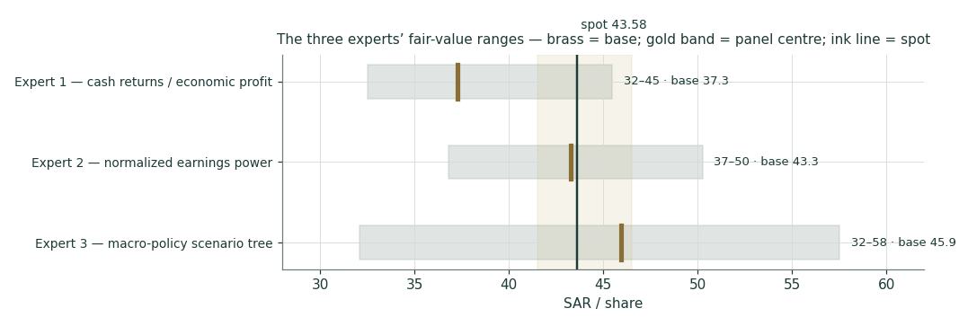
Figure C-1 — The three experts’ fair-value ranges. Brass ticks are base cases; the gold band is the panel centre; the ink line is spot. The spread is the return-fade question.
Expert | Method | Single swing assumption | Base fair value
Expert 1 | Cash returns / economic profit | The fade rate on excess returns (2.5%/yr) | SAR 37.3
Expert 2 | Normalized earnings power | The through-cycle multiple (15×) | SAR 43.3
Expert 3 | Macro-policy scenario tree | The scenario weights on the rate/payout path | SAR 45.9

The spread — SAR 37 to 46, about 23% of the low — is narrow by this series’ standards, and it measures one thing cleanly: how much of stc’s current 15% return on capital survives the next decade of competition, technology churn and nation-scale capex. Expert 1 charges for the erosion explicitly and lands below spot; Expert 2 freezes today’s clean earnings at a market multiple and lands at spot; Expert 3 prices the policy floor and lands above it. The house lenses (§1.5) sit above the panel because the DCF credits the margin glide and capex fade the experts decline to pre-pay for — that gap, ~SAR 4, is the price of believing management’s own guidance. An investor’s position on this stock reduces to a position on that one axis: if the AI-infrastructure build earns telecom-plus returns, the house DCF is right and the stock is cheap; if it earns telecom-minus, Expert 1 is right and today’s price already flatters it.
Each expert’s point fair value (and bull/base/bear where applicable) is logged with the study date (9 Jul 2026) and spot (SAR 43.58) as an internal per-expert track record, kept separate from the core Calibration Ledger.
About this series
Testahil publishes independent, educational valuation studies. Each is an attempt to reason transparently about what a security is worth, with every assumption shown and a companion model so readers can disagree productively. The house style is distributions, not tips: we describe ranges and probabilities, not targets, and we do not tell anyone what to do. Studies are framed as educational analysis, the preparer is not licensed by any securities regulator, and holdings are disclosed.
Disclosure & Disclaimer
Not investment advice. This document is educational and informational only. It is not, and must not be relied upon as, investment, financial, legal, accounting or tax advice, nor an offer, solicitation or recommendation to buy, sell or hold any security. It contains no price target and no rating.
No licence; no advisory relationship. The preparer is not registered or licensed with any securities or financial regulator in any jurisdiction — including the Saudi Capital Market Authority (CMA) — holds no brokerage or investment-advisory authorisation, and is not acting as your adviser or fiduciary. Nothing here is personalised to your circumstances.
Holdings disclosure. The preparer may hold, and may in the future take or dispose of, a position in the security discussed in this report, and may transact at any time without notice. This is a potential conflict of interest you should weigh.
Sources & accuracy. Reported financial and operating figures are drawn from the company’s public disclosure (stc.com IR releases and interim financial statements) and other public sources believed reliable but not independently verified; they may contain errors or be superseded. Forward-looking inputs — the segment growth and margin paths, capex intensity, the derived risk-free rate and regressed beta, terminal growth, the multiples, the stake marks and the Monte-Carlo factor probabilities — are the preparer’s own judgments and are inherently uncertain. Some balance-sheet detail lines are grouped estimates tying to disclosed totals.
Forward-looking statements. Any statements about the future are estimates subject to risks and uncertainties; actual results may differ materially. The Monte Carlo models price, not value, and encodes subjective probabilities for events that have not occurred.
No reliance; your responsibility. Do your own research and consult a licensed professional before making any decision. You are solely responsible for your investment decisions and their outcomes. To the maximum extent permitted by law, the preparer accepts no liability for any loss arising from use of this document.
Currency & figures. Figures are in Saudi riyals (SAR), millions unless stated; bn denotes billion. The riyal is pegged to the US dollar at 3.75. Rounding may cause totals to differ slightly. Spot price and market data are as of 7 July 2026 and change continuously.
TESTAHIL · Independent Valuation Study · Educational Analysis · Saudi Telecom Company (Tadawul: 7010) · edition 09-07-2026 · reporting currency SAR

