Testahil · Independent Valuation Study — Educational Analysis Not investment advice

Independent Valuation Study — Educational Analysis
Elsewedy Electric Company S.A.E. (EGX: SWDY)
Diversified industrial group — wires and cables, engineering and construction, electrical products, digital solutions and infrastructure investment · Egyptian Exchange · reporting currency EGP · analysis anchored on the closing price of 105.20 on 2026-08-05.
READ FIRST — what this document is. This is an educational valuation study. It contains no recommendation, no rating and no price target. What it contains is a fair-value range built from disclosed financial statements, a stated cost of capital, and explicitly listed assumptions — together with a separate, probabilistic map of where the share price could trade over the next one and three months. The two are different objects and are never blended.
What a fair value is not. A fair-value estimate is a statement about what the business appears to be worth on the assumptions set out here. It is not a forecast of the share price, and it carries no implied timeframe. A share can trade above or below an intrinsic estimate for years.
Where the numbers come from. Every figure traces to a source recorded in the accompanying source register: the company's own audited and interim financial statements and earnings releases, exchange filings, and named market data. Where a figure is derived rather than disclosed, it is labelled as derived and the derivation is shown.
The single largest uncertainty. This company earns just over half its revenue on a hard-currency-linked basis, but it reports, is listed and is financed in Egyptian pounds. The answer therefore depends heavily on which currency's cost of capital you believe applies. Both readings are computed and both are shown.

Headline
Elsewedy Electric is the largest listed industrial group on the Egyptian Exchange by revenue: EGP 281,049mn in FY2025, up +21% on FY2024 and +36% a year compounded over the last two years. It converts copper into cable, builds substations and power plants under turnkey contract, and sells meters, transformers and digital grid products across 15 countries. The company discloses exactly three reportable segments — Cables and its accessories, Constructions and infrastructure, and Electrical products and digital solutions — and just over half of group revenue is earned on a hard-currency-linked basis.
The operating story of the last two years is a margin normalisation, not a deterioration. The gross margin ran at 18.9% in FY2024 when a collapsing pound turned cheaply bought copper inventory into windfall profit; it settled to roughly 14.5% in FY2025 as that effect washed out. Revenue kept compounding through it. Net profit after minority interests was essentially flat at EGP 17,330mn against EGP 17,461mn — a flat result on a +21% revenue increase is the whole of the margin story in one line. The first quarter of 2026 reaccelerated: revenue EGP 75,298mn (+27%) and attributable profit EGP 4,845mn (+17%).
The balance sheet is not the constraint people assume. Gross borrowings are large because the working-capital cycle is large, but the group holds very substantial offsetting cash: net bank debt was EGP 20,560mn at the end of FY2025, only 0.7× EBITDA. And the debt is cheap in a way that is easy to miss: the audited notes disclose average rates of 21.3% on Egyptian-pound liabilities but only 5.3% on the blended hard-currency book. The blended rate actually paid works out near 9.8%, less than half what a purely domestic Egyptian borrower pays.
On our primary construction the four lenses centre at EGP 69.73 per share against a market price of 105.20 — the price sits about +51% above the central estimate. That gap is not mainly an argument about the business; it is an argument about the discount rate. Discounted at an Egyptian cost of capital gliding 26.6% to 15.9%, the cash flows support roughly EGP 56.08. Discount the hard-currency share of those same cash flows at a hard-currency cost of capital of about 10.1% and the same model produces EGP 85.97 — still -18% against today's price, but +53% above the primary reading. The market appears to be applying something at least as generous as the second view. Both are shown, and neither is hidden inside an average.
Valuation summary — every read at a glance
Read | Basis | Range (EGP/share) | Central | vs spot
Discounted cash flow | 5-year FCFF, cost of capital gliding 26.6% → 15.9%, terminal growth 5%; 85% of enterprise value comes from the terminal value | 19.95 – 122.33 | 56.08 | -47%
Relative multiples | 6.5× mid-cycle EV/EBITDA (trailing 8.7×; trailing P/E 13.0×) | 62.57 – 95.28 | 75.65 | -28%
Normalised earnings power | mid-cycle EBITDA margin 10.2% at a justified 9.0× P/E | 83.72 – 138.73 | 108.17 | +3%
Book value and sustainable return | justified price-to-book 1.5× on book value of 31.24/share at a sustainable return on equity of 23.5% | 35.33 – 57.29 | 51.52 | -51%
Weighted central | DCF 45% · relative 20% · normalised 20% · book 15% | 19.95 – 138.73 | 69.73 | -34%
Market price | closing price on the anchor date | — | 105.20 | —
ALTERNATIVE READINGS — not included in the weighted central above
Currency of discounting | the same cash flows with the hard-currency leg discounted at 10.1% instead of the Egyptian rate — a different view of country risk, not a fifth lens | — | 85.97 | -18%
Rating-basis cost of capital | the same model on the rating column of the published country-risk table rather than the market-spread column (see section 1.8) | — | 36.46 | -65%
Minority interests charged before net debt | an alternative sequencing of one line of the bridge (see section 1.8) | — | 55.01 | -48%

The alternative readings are shown so that each genuinely contested choice carries a number the reader can see, rather than being averaged silently into the headline. They are deliberately excluded from the weighted central because each answers a different question — which currency's cost of capital applies, which column of a risk table to use, how to sequence one line of the bridge — and blending them would hide the disagreement instead of showing it. Ranges are bear-to-bull within each lens; the central is the weighted base. Terminal value is 85% of the discounted-cash-flow enterprise value — a high share, disclosed here and again in the bridge, and the reason the terminal assumptions are stress-tested in section 1.9.
Company overview — Elsewedy Electric at a glance
Item | Detail
Founded / listed | Established 1938 by the Elsewedy family; listed on the Egyptian Exchange as SWDY
What it does | Manufactures wires, cables and accessories; executes turnkey engineering and construction projects (substations, transmission and distribution, power generation, civil works); makes transformers, busway and electrical products; supplies meters and digital grid solutions; and holds infrastructure assets including industrial development, logistics, utilities and independent power projects
Scale | More than 20,000 employees across 31 production facilities in 15 countries; FY2025 revenue EGP 281,049mn
Geographic mix | The audited FY2025 geographic note (Note 5-2) shows 40.7% of revenue booked outside Egypt — a statement about where the customer sits, not about pricing currency. Separately, this study derives the share that is hard-currency LINKED, i.e. dollar-priced, at about 51% using segment-level export-intensity weights of Cables 65% / Constructions 30% / Electrical products 45% (house judgements, stated so they can be disputed; the forecast-year share runs ~53% as Cables' weight in the mix rises); that is the figure used wherever the currency question is valued
Order book | Not disclosed in any of the audited FY2023-25 statements or the Q1-2026 interim, which are the primary sources this build is confined to. The company's quarterly earnings releases have historically disclosed order-book and volume data (the FY2024 release, for example, disclosed 167,665 tons of cable sold); those releases were not reachable from this research environment, so the forecast is built on segment revenue growth rather than a backlog figure — a cross-check against the released backlog is the first refinement to make when they become obtainable
Shares outstanding | 2,141mn
Market capitalisation | EGP 225,210mn at the anchor price
Ownership | El Sewedy family ~68.0% · Electra Investment Holding 18.9% · free float ~13.1%, per the audited FY2025 shareholder table. Electra, an Abu Dhabi holding vehicle, acquired 19.98% in a July-2024 tender offer at USD 1.05 per share (~USD 449mn) and topped up to 20.37% by FY2024-end; over 2025 it SOLD roughly 32.1mn shares into the market, taking its stake to 18.9% — a disposal, not dilution: the share count is unchanged. The 13.07% 'other shareholders' line is an upper bound on the true free float, since family-linked vehicles may sit inside it
Net bank debt | EGP 20,560mn at 31 December 2025 (0.7× EBITDA), computed from the audited balance sheet: loans and borrowings including leases 62,509 less cash 41,949. The company's own FY2025 earnings release quotes EGP 19,789mn on its own narrower basis; the audited-statement computation is used, and the ~771mn definitional gap is noted rather than resolved
Last strategic transaction | Electra Investment Holding's tender offer concluded July 2024: 428mn shares (20.0%) at USD 1.05, about USD 449mn — roughly EGP 50 per share at the rate then prevailing. Recorded because it is the last price at which a strategic buyer cleared a fifth of the company, but NOT used as a valuation anchor: it is two years stale, struck before the earnings base grew by about half, and sits at under half today's price
Dividend record | EGP 1.00 per share on the FY2024 result (12.3% of attributable profit), then EGP 1.85 on FY2025 — ratified by the general assembly on 6 May 2026, rights with the share through 1 June, paid from 4 June 2026 — 22.9% of FY2025 attributable EPS, an +85% step-up. An earlier revision of this study wrongly stated no FY2025 dividend existed, reasoning from the silence of the annual and interim filings; the interim covers a period ending before the assembly met, so its silence was never evidence. The forecast payout ratio is 25%, struck at the actual FY2025 rate

Two structural facts govern everything that follows. First, the revenue base is just over half hard-currency linked while the share, the accounts and the borrowing are Egyptian — so the company is a natural hedge against the currency its shareholders are exposed to. Second, the business consumes working capital in direct proportion to its growth: inventories, contract assets and receivables less payables and contract liabilities ran at 24.1% of revenue in FY2023, 23.1% in FY2024 and 19.9% in FY2025. In FY2025 the group earned EBITDA of EGP 28,363mn and converted only EGP 12,766mn of it into operating cash after interest and tax (45.0%). Growth here is expensive, and that is the crux of the valuation.
1 Fundamental valuation
1.1 The cash-flow model — the primary lens, with the full waterfall
The primary lens is a five-year free-cash-flow-to-the-firm model. Revenue is not forecast as a single growth rate applied to a revenue line: it is built from the three segments the company itself discloses — Cables and its accessories, Constructions and infrastructure, Electrical products and digital solutions — each grown and margined on its own driver, then summed. Margins are therefore OUTPUTS of the build rather than assumptions fed into it, and the historical version of that build reconciles to the audited income statement EXACTLY on revenue in all three years (Note 5-3) and to the audited operating profit through an explicit, exactly-reconciling corporate cost load (Note 16 less G&A, net impairment on receivables, other expenses and other income). Section 1.6 sets out the segment build. Cash flow is then taken all the way to present value, line by line, below.
EGP mn | FY26E | FY27E | FY28E | FY29E | FY30E
Revenue | 370,030 | 422,528 | 466,619 | 510,440 | 555,225
of which domestic | 175,308 | 200,259 | 221,642 | 242,445 | 263,462
of which foreign | 194,722 | 222,270 | 244,977 | 267,995 | 291,763
EBITDA | 35,158 | 41,645 | 47,603 | 53,648 | 59,209
EBITDA margin | 9.5% | 9.9% | 10.2% | 10.5% | 10.7%
Less depreciation and amortisation | (4,625) | (5,282) | (5,833) | (6,381) | (6,940)
EBIT | 30,533 | 36,363 | 41,770 | 47,268 | 52,269
NOPAT — EBIT × (1 − 24.5%) | 23,052 | 27,454 | 31,537 | 35,687 | 39,463
Add back depreciation and amortisation | 4,625 | 5,282 | 5,833 | 6,381 | 6,940
Less capital expenditure | (16,281) | (16,901) | (16,798) | (16,845) | (17,212)
Less change in working capital | (17,783) | (10,447) | (8,774) | (8,720) | (8,912)
Free cash flow to the firm | -6,387 | 5,387 | 11,797 | 16,503 | 20,279
Forward cost of capital | 26.6% | 23.1% | 20.1% | 17.7% | 15.9%
Discount factor | 0.7897 | 0.6417 | 0.5343 | 0.4539 | 0.3915
Present value of FCFF | -5,044 | 3,457 | 6,304 | 7,491 | 7,940

Every line is computed, not typed: the waterfall runs EBITDA → depreciation and amortisation → EBIT → NOPAT → add back depreciation → less capital expenditure → less the change in working capital → free cash flow to the firm → discount factor → present value. Working-capital change is the difference in net working capital held at a constant 19.9% of revenue, the level the audited balance sheets actually show.
The bridge from enterprise value to the equity — and to the anchor date
Step | EGP mn | Note
Present value of the five forecast years | 20,148 | sum of the present-value row above
Terminal-year free cash flow | 31,277 | FY2030E NOPAT grown 5% × (1 − reinvestment rate 24.5%); the reinvestment rate is forced to g ÷ terminal return on capital (20.4%) so growth is paid for — this is why the terminal cash flow sits above year-5 FCFF, disclosed here rather than left implicit
Present value of the terminal value | 111,998 | the terminal cash flow capitalised at 15.9% − 5% = 286,048, discounted at the year-5 factor 0.3915
Enterprise value | 132,146 | the two lines above
Terminal value as a share of enterprise value | 85% | disclosed here and in the summary table; stress-tested in section 1.9
Less net bank debt | (20,560) | audited, at 31 December 2025
Plus equity-accounted investees | 6,758 | audited FY2025 carrying value, no uplift; these earn outside the consolidated cash flow
Less minority interests | (11,450) | minorities take 9.7% of group profit, so they are charged the same share of the value
Equity attributable, at 31 December 2025 | 106,894 | EGP 49.93 per share — dated at the audited balance-sheet date the bridge subtracts net debt at
Rolled 217/365 of a year to the anchor | ×1.1603 | fair value accretes at the 28.4% cost of equity between the valuation date and the 5-Aug-2026 anchor — one date, one price of time, applied to the comparison itself
Less the FY2025 dividend paid in the window | (1.85/sh) | EGP 1.85, ex 1 June 2026 — value that left the share before the anchor date
Fair value per share at the anchor (EGP) | 56.08 | against a spot of 105.20 (-47%)

Every lens in this study — not only the cash-flow model — is rolled to the anchor on the same two lines, so no value dated 31 December 2025 is ever compared to an August price. An earlier revision omitted the roll; an external review correctly flagged the omission as a breach of the study's own one-date rule, worth about seven months of accretion on the primary lens.
1.2 Book value and sustainable return — the asset lens
Book value attributable to shareholders is EGP 66,871mn at the audited FY2025 close, or 31.24 per share. The trailing return on average equity is 28.4%. That number is flattered: FY2023 and FY2024 both carried devaluation gains on copper inventory bought before the pound moved, so the sustainable rate is struck lower, at 23.5%.
A justified price-to-book multiple is (return on equity − growth) ÷ (cost of equity − growth). It is priced at the PERPETUAL (terminal) cost of equity of 17.6% — a steady-state multiple takes a steady-state rate, not a five-year transitional one. (An earlier wording called this figure an 'average' of the two windows, which it never was; the actual average, 23.0%, is the construction behind this lens's published bear bound of 35.33.) That gives 1.5× book, or EGP 51.52 per share at the anchor. This is the weakest of the four lenses for this company and carries the lowest weight, for a specific reason: three years of currency translation have moved reported book value in ways that have little to do with the earning power of the assets, and a group whose value sits in an order book and a brand is poorly described by its balance sheet. It is retained because it is the lens that disagrees most, and a lens that only ever agrees is not doing any work.
1.3 Relative multiples
Measure | Value | Comment
Enterprise value / EBITDA (trailing) | 8.7× | enterprise value 245,770 over FY2025 house EBITDA 28,363 (EBIT + D&A). Two base notes: this trailing EV is market cap plus net debt WITHOUT the associates/minority adjustments the justified multiple below carries — a simpler market-observable convention, labelled as such; and on the company's own published non-GAAP EBITDA (a different, larger definition) the multiple would be lower
Price / earnings (trailing, attributable basis) | 13.0× | price 105.20 over attributable earnings per share of 8.10
Price / earnings (trailing, as-reported basis) | 14.8× | the company's own reported earnings per share is struck after the Egyptian employee and board profit-share appropriation, so screens and data vendors show this higher multiple. Both are given because a reader comparing against a screen will see the second
Price / book | 3.4× | book value 31.24 per share
Net bank debt / EBITDA | 0.7× | light net leverage against a large gross book
Justified enterprise value / EBITDA | 6.5× | applied to FY2027E EBITDA and then DISCOUNTED BACK two years, because a forward multiple produces a forward enterprise value. The multiple is set below the company's own trailing multiple as an Egyptian-market discount. NOTE: no peer multiple is computed anywhere in this study, so this is a judgement anchored on SWDY's own trading history, not a peer-derived figure — an earlier draft asserted a "peers trade at 8–11×" range that was not supported by any calculation, and it has been withdrawn
Plus interim cash flows | (1,587) | the present value of the FY2026-27 free cash flows the forward multiple does not capture — net negative, because FY2026 consumes working capital. Added after external review; omitting it had overstated this lens slightly
Implied value per share, at the anchor | 75.65 | bear 62.57 at 5.5× / bull 95.28 at 8.0×; rolled to the anchor date on the same two lines as the cash-flow bridge

Two things about this lens should be read before its number is. First, applying a multiple to a forecast year gives an enterprise value AS AT that year; it has to be discounted back before it can be compared with today's price. Not doing so would have produced EGP 123.13 per share instead of 75.65 — a EGP 47.48 overstatement, which an earlier draft of this study contained. Second, the justified multiple is a judgement, not a peer-derived figure.
The honest difficulty with this lens is that there is no clean comparable. The nearest listed regional peer in cables is a Saudi manufacturer with a fraction of the revenue, no turnkey contracting arm and a very different balance sheet; the global cable majors are European and carry neither Egyptian sovereign risk nor Egyptian growth. Applying a discounted multiple to mid-cycle EBITDA is therefore a sanity check on the cash-flow model rather than an independent valuation, and it is weighted accordingly.
1.4 Normalised earnings power — mid-cycle margin at current scale
The question this lens asks is what the group earns at its CURRENT scale in a year that is neither a currency windfall nor a margin trough. The mid-cycle EBITDA margin of 10.2% — the FY28E point of the forecast, comfortably below the FY2024 outturn of 13.6% and above the FY2025 trough of 10.1% — is applied to FY2026E revenue of EGP 370,030mn. An earlier revision applied the multiple to FY2028-SCALE earnings with no time value, injecting two years of undiscounted growth into a present-day lens; an external review flagged it correctly and the construction was restated, worth about EGP 4.9 per share on the weighted central.
Step | EGP mn
Current-scale (FY2026E) revenue | 370,030
Mid-cycle EBITDA margin (FY28E) at 10.2% | 37,749
Less depreciation and amortisation | (4,625)
Mid-cycle EBIT | 33,124
Less net interest (FY2026E) | (1,743)
Plus share of equity-accounted investees (FY2026E) | 1,694
Less tax at 24.5% and minority interests at 9.7% | (10,519)
Normalised attributable earnings | 22,555
Normalised earnings per share (EGP) | 10.54
At a justified 9.0× price/earnings, rolled to the anchor (EGP per share) | 108.17

Bear 83.72 at 7.0× and bull 138.73 at 11.5×, both rolled to the anchor date like every other lens. Every input row is the figure the computation actually uses — the associate line is the FY2026E forecast, not the FY2025 actual. One disclosed conservatism: equity-method associate income is taxed at 24.5% inside this lens although it arrives already post-tax at the investee — worth about +0.4/share on the central if removed. The justified multiple is held well below what a comparable industrial franchise would attract in a developed market, because an Egyptian cost of equity near 28% mathematically compresses what any stream of earnings is worth.
1.5 Synthesis — four lenses, one field
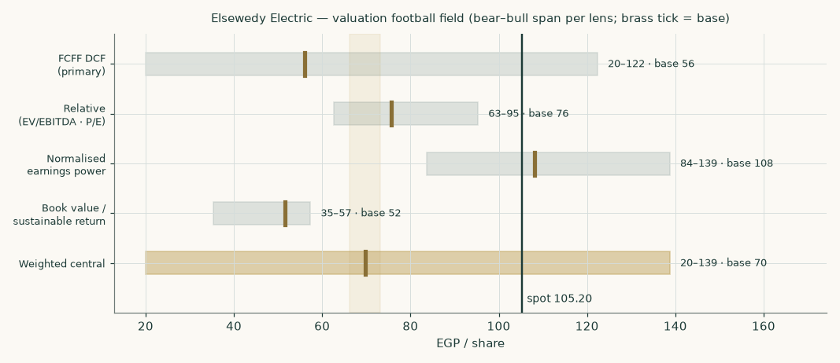
Figure 1 — the four lenses and the weighted central against the market price of 105.20. Each bar is that lens's bear-to-bull span; the brass tick is its base case.
Lens | Bear | Base | Bull | Weight | Contribution
Discounted cash flow (primary) | 19.95 | 56.08 | 122.33 | 45% | 25.24
Relative multiples | 62.57 | 75.65 | 95.28 | 20% | 15.13
Normalised earnings power | 83.72 | 108.17 | 138.73 | 20% | 21.63
Book value and sustainable return | 35.33 | 51.52 | 57.29 | 15% | 7.73
Weighted central | 19.95 | 69.73 | 138.73 | 100% | 69.73

The four lenses do not agree, and the disagreement is informative rather than embarrassing. The two lenses that look at earnings — relative multiples and normalised earnings power — land near or slightly above the market price. The two that discount cash or capital at an Egyptian cost of capital land well below it. This is the same disagreement in two forms: a multiple imported from a market with a low cost of capital implicitly assumes a low cost of capital, and a discounted model applied with an Egyptian one does not. The weighted central of EGP 69.73 sits between them.
1.6 The drivers — the three disclosed segments, each grown on its own driver
Revenue is not forecast as a single growth rate applied to a revenue line. The company discloses exactly three reportable segments — Cables and its accessories, Constructions and infrastructure, and Electrical products and digital solutions — with revenue by segment (Note 5-3) that reconciles EXACTLY to consolidated revenue in every one of the three audited years, and segment profit (Note 16) that reconciles to consolidated operating profit through an explicit corporate cost load. None of the three audited filings, including the Q1-2026 interim, discloses a tonnage, unit-volume or order-book figure for any segment, so the forecast is built as a taper on each segment's own recent revenue growth and margin path rather than a reconstructed unit model. Margins are therefore outputs of the build, not inputs to it.
The three disclosed segments, historically
Segment | FY2023 revenue | margin | FY2024 revenue | margin | FY2025 revenue | margin
Cables and its accessories | 82,421 | 19.5% | 137,190 | 18.1% | 155,793 | 13.5%
Constructions and infrastructure | 53,483 | 11.6% | 70,921 | 11.4% | 90,959 | 6.5%
Electrical products and digital solutions | 16,282 | 25.4% | 23,871 | 26.6% | 34,298 | 22.2%
Group revenue | 152,186 |  | 231,982 |  | 281,049

Segment revenue (Note 5-3) sums to consolidated revenue exactly in every year shown — there is no elimination or apportionment. Segment margin is segment profit (Note 16, inside- and outside-Egypt columns summed) divided by this same revenue base. Every segment compressed from FY2023 to FY2025; Cables and Constructions compressed the most, Electrical products the least.
How the forecast is driven
Driver | FY2025 base | FY26E | FY27E | FY28E | FY29E | FY30E
Copper (USD/tonne) | 10,000 | 13,400 | 14,000 | 14,000 | 14,000 | 14,000
USD/EGP average rate | 49.5 | 51.0 | 54.0 | 57.5 | 61.0 | 64.5
Cables — real growth (over copper × FX) | — | 3.0% | 3.0% | 3.0% | 3.0% | 3.0%
Cables — segment margin | 13.5% | 14.0% | 14.5% | 15.0% | 15.3% | 15.5%
Constructions and infrastructure — revenue growth | — | 18.0% | 14.0% | 11.0% | 9.0% | 8.0%
Constructions and infrastructure — segment margin | 6.5% | 6.8% | 7.2% | 7.6% | 7.9% | 8.2%
Electrical products and digital solutions — revenue growth | — | 20.0% | 16.0% | 13.0% | 11.0% | 10.0%
Electrical products and digital solutions — segment margin | 22.2% | 22.0% | 22.2% | 22.4% | 22.6% | 22.8%
Corporate cost load, segment profit → EBIT basis (% of revenue) | 3.2% | 4.5% | 4.7% | 4.8% | 4.8% | 4.9%
Capital expenditure (% of revenue) | 4.7% | 4.4% | 4.0% | 3.6% | 3.3% | 3.1%
Depreciation and amortisation (% of revenue) | 1.1% | 1.2% | 1.2% | 1.2% | 1.2% | 1.2%

Copper is held near the current market level rather than forecast — a directional view on the metal would dominate the valuation, and it is carried in the sensitivity instead. Cables grows on copper-price growth × FX-translation growth × a modest real-volume assumption, since no tonnage figure is disclosed in the audited statements to build a literal unit model from. Constructions and Electrical products taper on their own FY2023-25 revenue CAGR. The corporate cost load — stated on the same segment-profit-to-EBIT basis as the audited history (5.70% / 4.30% / 3.16%) — glides UP from FY2025's unusually low level toward the FY2023-24 average, the single most conservative choice in the build. The capex and D&A paths are shown because they are live free-cash-flow drivers, not footnotes: capex tapers from the FY2025 peak of 4.7% as the 2024-25 capacity programme completes (it ran 3.1% in FY2023 and 3.7% in FY2024); holding it at the FY2025 peak instead would cost roughly EGP 1.8 on the weighted central.
What the build produces — margins as outputs
EGP mn | FY26E | FY27E | FY28E | FY29E | FY30E
Revenue | 370,030 | 422,528 | 466,619 | 510,440 | 555,225
Segment profit (Note 16 basis) | 47,369 | 56,011 | 63,935 | 71,514 | 79,197
Segment profit margin | 12.8% | 13.3% | 13.7% | 14.0% | 14.3%
Less corporate cost load (to EBIT) | (16,836) | (19,648) | (22,164) | (24,246) | (26,928)
EBIT | 30,533 | 36,363 | 41,770 | 47,268 | 52,269
Add back depreciation and amortisation | 4,625 | 5,282 | 5,833 | 6,381 | 6,940
EBITDA | 35,158 | 41,645 | 47,603 | 53,648 | 59,209
EBITDA margin | 9.5% | 9.9% | 10.2% | 10.5% | 10.7%

The FY2026 build is checked, not calibrated, against the print: the disclosed Q1-2026 revenue of 75,298, grossed up on the Q1-2025 seasonal share of FY2025, implies a full FY2026 of roughly 356,323, against the build's 370,030 — a +4% difference, an independent check that the segment build is not running ahead of the company's own trading. That quarter reported revenue +27% and attributable profit +17% year on year.
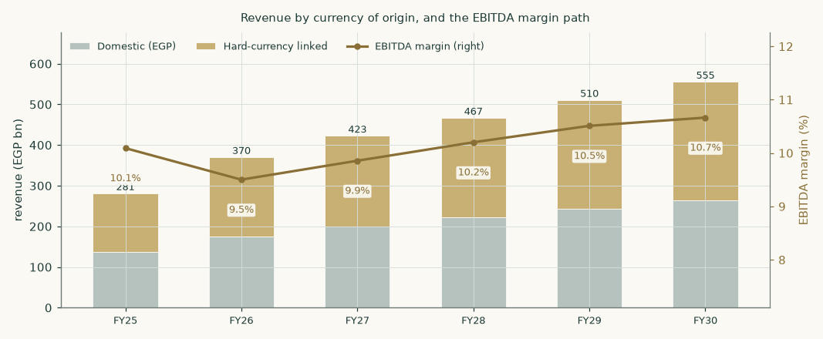
Figure 2 — revenue by currency of origin with the EBITDA margin path. The hard-currency leg does the growing; the margin recovers gently as the copper-price inflation of 2024–25 washes out of the revenue denominator.
The segment mix, FY2025 against FY2030E
Segment | FY2025 revenue (EGP mn) | Share | FY2025 margin | FY2030E revenue (EGP mn) | FY2030E share
Cables and its accessories | 155,793 | 55.4% | 13.5% | 329,470 | 59.3%
Constructions and infrastructure | 90,959 | 32.4% | 6.5% | 159,883 | 28.8%
Electrical products and digital solutions | 34,298 | 12.2% | 22.2% | 65,871 | 11.9%
Group | 281,049 | 100.0% | 12.3% | 555,225 | 100.0%

FY2025 figures are the audited Note 5-3 / Note 16 disclosures directly; nothing is apportioned or calibrated. By FY2030E Cables' share of revenue rises from 55.4% to 59.3% as it compounds on copper and FX; Constructions' share falls as its growth tapers fastest.
1.7 The crux — working capital first, the currency second, margins third
The FY2025 accounts contain the single most important number in this study. The group earned EBITDA of EGP 28,363mn and generated operating cash flow, after interest and tax, of EGP 12,766mn — about 45% of it. The difference went into working capital, though FY2025 was genuinely the best of the three audited years on this measure: net working capital fell from 23.1% of revenue in FY2024 to 19.9% in FY2025, even as revenue grew +21%.
Working capital | FY2023 | FY2024 | FY2025
Inventories | 30,882 | 56,796 | 59,860
Contract assets | 16,180 | 18,052 | 29,895
Trade and other receivables | 46,592 | 86,736 | 116,260
Less trade and other payables | (31,938) | (54,808) | (68,896)
Less contract liabilities | (25,060) | (53,281) | (81,266)
Net working capital | 36,655 | 53,495 | 55,853
As a share of revenue | 24.1% | 23.1% | 19.9%

The segment build makes a second point that a percentage-of-revenue model hides. Copper is passed through in Cables: a higher copper price raises revenue without raising the profit earned on it. But working capital scales with revenue, so a copper spike CONSUMES cash while adding almost no profit. That is visible in FY2026E, where revenue rises +32% — much of it copper and FX translation — and the resulting EGP 17,783mn working-capital build cuts free cash flow to the firm to just EGP -6,387mn, against EGP 5,387mn the following year once the step-up is absorbed. A rising copper price is not good news for this business in the year it happens.
The model holds this ratio near 19.9% of revenue, the FY2025 disclosed level. That single assumption is worth a great deal: every percentage point of revenue added to or removed from working-capital intensity is worth roughly EGP 2.22-2.38 per share (the local slope at the base and the average across the tested 17-23% span). If the group converts working capital further — collecting faster, or pushing more of the funding onto suppliers and customers — the cash-flow model reprices sharply upward. If FY2025's improvement reverses, it reprices down just as fast.
1.8 Macro and country — rates, the pound, and the sourced cost of capital
The discount rate is a schedule, not a number. Each forecast year is discounted at that year's own forward rate, moving from the explicit-window rate to the terminal rate; the terminal value is capitalised at the terminal rate and brought back using the same cumulative factor as the year-5 cash flow. One date, one price of time — the terminal value never gets a cheaper discount than a cash flow arriving on the same day.
Component | Explicit window | Terminal | Source and construction
Risk-free rate | 22.3% | 10.5% | observed 10-year local-currency government yield (readings on the anchor date span roughly 22.3-23.0% across sources and disagree; the adopted point sits at the low end and the rate is carried in the sensitivity). Terminal = the central bank's 5% Q4-2028 inflation-target midpoint — deliberately the terminal-state target, not the nearer 7% Q4-2026 waypoint — plus a 5.5pp real-rate convention
Less sovereign default spread | (3.4%) | — | the hard-currency CDS spread, netted from the local yield and then re-entering, volatility-scaled, through the country premium inside the ERP. The NET country charge through the equity channel is therefore about +1.9pp, not zero — stated plainly, since an earlier wording implied the netting removed the charge outright. The un-netted construction (cost of equity 31.8%) is retired but retained in the audit trail
Adjusted risk-free rate | 18.9% | 10.5%
Beta | 1.009 | 1.009 | own-stock weekly regression against a 31-name equal-weight local composite over five years: R-squared 0.291, n = 258, standard error 0.098, 90% interval [0.85, 1.17]
Equity risk premium | 9.4% | 7.0% | published country-premium file (January-2026 vintage, both columns confirmed against the file), credit-default-swap basis; the rating-basis column is the published alternative below. Normalised downward for the terminal rather than held at a crisis-era level
Cost of equity | 28.4% | 17.6%
Cost of debt (blended, pre-tax) | 9.5% | 8.9% | currency-blended — see the evidence immediately below. 9.5% is the FY2026 forward point of the disclosed cost-of-debt path under the central bank's easing cycle; the FY2025 trailing effective rate was 9.8%, and the integrity gate bounds the two against each other
Cost-of-debt path (drives the glide) | 9.5% / 8.9% / 8.4% / 8.0% / 7.7% | — | the forward rates whose cumulative progress sets the glide fractions between the explicit-window and terminal cost of capital — published so the three intermediate discount rates are reproducible
Debt weight | 8.4% | 15.0% | net debt against market capitalisation for the explicit window; a normalised 15% for the terminal — REVISED from 25% after review showed the old weight contradicted the model's own forecast deleveraging in the direction that flattered the valuation; worth about -2.4 on the weighted central
Cost of capital | 26.6% | 15.9%

Discounting is end-of-year discrete (each year's flow at its full-year factor) — the conservative convention; mid-year discounting would raise the explicit strip about 7%. All values are then rolled to the 5-Aug-2026 anchor as shown in the bridge.
The cost of debt — three pieces of evidence, not an assumption
A disclosed contractual range is not evidence of what a company pays. Three things are shown instead.
Test | Evidence
Currency composition of the debt book | The audited FY2025 interest-rate note discloses average rates of 21.3% on Egyptian-pound financial liabilities and 5.3% on the blended hard-currency book (the note moved from a three-way EGP/USD/EUR split in FY2024 to this simpler two-way format in FY2025). Reconciling those against the rate actually paid implies roughly 28% of the book is in Egyptian pounds and 72% in hard currency — DOWN sharply from the roughly 44% pound share implied a year earlier, as hard-currency facilities were drawn down further. Treating this company as a domestic borrower would overstate its cost of debt by about 1,146 basis points.
Independently computed effective rate | FY2025: interest expense on loans and credit facilities of 5,967 against the average of the opening and closing balance (58,797 and 62,462) = 9.8%.
Bounds | The adopted 9.5% sits within 34 basis points of the independently computed effective rate and does not exceed it by more than 50 basis points. Both bounds hold.

This is not a technicality. A cheap, majority-hard-currency debt book is one of the two genuine competitive advantages this company has over a domestic-only competitor — the other being that its revenue is hard-currency linked too. It is also why the balance sheet looks more leveraged than it is: the gross book is large because working capital is large, but it costs roughly 9.8% and is more than two-thirds offset by cash.
Where this construction is contested, and what the alternatives are worth
Six choices in the construction above are legitimately arguable, and external reviewers have argued them. Rather than defend each in prose, each alternative is computed and its value published here, so a reader who prefers a different convention can take the number directly.
Choice made | The alternative | Fair value on the alternative | Why we keep ours
Equity risk premium on the credit-default-swap basis (9.4%), with the sovereign spread netted at 3.4% | The rating basis from the same published table: spread 6.4%, premium 13.9%, cost of equity 30.0% | EGP 36.46 (against 56.08) | Both are columns of the same published source. The market-observed basis is preferred to the agency-rating basis, which lags. This is the single largest open question in the cost of capital and the alternative is worth roughly 19.63 per share
Minority interests charged against consolidated equity, after net debt | Charged against unlevered enterprise value, before net debt | EGP 55.01 (-1.08) | The audited borrowings note records facilities granted to the company AND its subsidiaries, guaranteed by promissory notes from subsidiaries — so minorities do bear a share of the debt. The alternative assumes all borrowing sits at the parent, which the note contradicts
Capital weights on net debt | On gross debt (21.7% weight, cost of capital 23.8%) | raises the value | Net debt is the quantity the bridge subtracts; using it in both places keeps the two consistent, and it is the more conservative of the two
Cost of debt on currency composition (9.5%): the disclosed coupon on each currency leg, unadjusted | EGP-equivalent (13.9%): the hard-currency legs loaded with the pound's own 5.4%/year forecast depreciation, under uncovered interest parity | EGP 55.76 (-0.33) | Net debt carries only 8.4% of the capital structure, so even this 444-basis-point swing in Kd moves the fair value by well under 1% — smaller than it looks. CAUTION: keeping the currency-composition basis as primary means the hard-currency debt is carried at its coupon rate, not compensated for devaluation risk beyond what this forecast's own exchange-rate path already assumes
Risk-free rate 22.3% | External readings of the same instrument on the same date range from about 22.3% to 23.0%, and disagree with each other; the adopted point sits at the low end | roughly ±1% of value per 100bp | Because the readings conflict, the rate is carried in the sensitivity grid rather than presented as precise; the direction of the low-end choice is generous and is said so here
Forecast effective tax rate 24.5% | Egypt's statutory 22.5%, or FY2025's actual effective 22.57% | roughly +1.8 on the weighted central (+2.5%) | Audited effective rates ran 31.3% (FY2023), 30.1% (FY2024), 22.6% (FY2025) and 25.75% (Q1-2026); no statutory-vs-effective reconciliation is disclosed, and the group pays tax in 15+ jurisdictions plus revenue-basis Free-Zone entities. 24.5% sits between the FY2025 print and the Q1-2026 print rather than extrapolating the single best year — an external review correctly noted this choice was priced in the register but not displayed here; it now is

The rating-basis column is the one most often raised against this study. It is not a correction to an error — both bases are published by the same source and both appear in this study's input register — but it is a material choice, and at EGP 36.46 the alternative sits well below the primary. A reader who prefers agency ratings to market spreads should use that number. (A July-2026 refresh of the same file reportedly lifts the rating-basis premium by roughly one point, making that alternative slightly more adverse still; the CDS-basis primary reproduces almost unchanged from the July parameters.)
1.9 Sensitivity — the discount rate, the growth, the currency, the margin and the collection
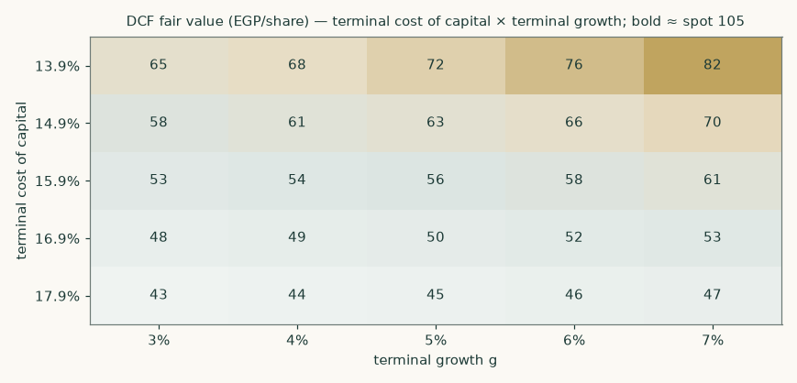
Figure 3 — discounted-cash-flow fair value per share across the terminal cost of capital and terminal growth. No cell in the tested range reaches the market price of 105.20: even the most generous corner sits well below it.
Each anchor is varied independently around its own base, so the tables show what the valuation needs the world to do rather than what growth rate the model needs.
Explicit-window cost of capital → | 23.6% | 25.1% | 26.6% | 28.1% | 29.6%
terminal 13.9% | 76.53 | 74.21 | 71.97 | 69.81 | 67.72
terminal 14.9% | 67.28 | 65.21 | 63.22 | 61.29 | 59.44
terminal 15.9% | 59.74 | 57.88 | 56.08 | 54.35 | 52.68
terminal 16.9% | 53.47 | 51.78 | 50.15 | 48.58 | 47.07
terminal 17.9% | 48.18 | 46.64 | 45.15 | 43.72 | 42.33

Explicit-window against terminal cost of capital, each moved independently — the grid that shows what the valuation needs the economy to do.
Sensitivity | Range tested | Fair value span (EGP/share) | Swing
Beta | 0.6 – 1.3 | 43.99 – 82.10 | 38.12
Exchange-rate path | base −10% to +70% (the deep tail is the interest-parity case) | 52.42 – 81.74 | 29.32
Segment margins (all three, multiplicative) | −15% to +15% | 30.10 – 82.07 | 51.98
Copper price | −15% to +15% | 50.59 – 61.58 | 11.00
Working capital / revenue | 17.0% – 23.0% | 48.70 – 62.99 | 14.28
Terminal return on invested capital | 15% – 30% | 49.68 – 61.79 | 12.11
Terminal growth | 3% – 7% | 52.63 – 60.75 | 8.12

Every row is a full re-run of the segment build, not a multiplier applied to a finished revenue line: a currency or copper move flows through Cables' revenue, the working capital and the segment profit exactly as it does in the base case. Note the copper row — the swing is small and can even run the 'wrong' way, because a higher metal price raises revenue and working capital without raising the profit Cables earns on it. Ranked by single-row swing, the segment-margin row is the LARGEST — an earlier caption claimed the terminal assumptions dominated every operating driver, which this table itself contradicts (a review caught it); what remains true is that the two cost-of-capital grids jointly span the widest surface, and a ±15% margin shock is a far larger displacement of the base case than any one row's parameter step.
The beta deserves a note. At 1.009 with an R-squared of 0.291 over 258 weekly observations and a standard error of 0.098, this is a well-identified estimate by the standards of this market — the 90% interval spans [0.85, 1.17], comfortably narrower than twice the point estimate, so it is not flagged as a weak instrument. It is also economically sensible: the largest industrial constituent of an index should have a beta near one. A defensive-staple prior of 0.6–0.9 and a cyclical prior of 1.0–1.5 bracket it, and a diversified industrial with a contracting arm belongs in the second.
2 Technical and price structure
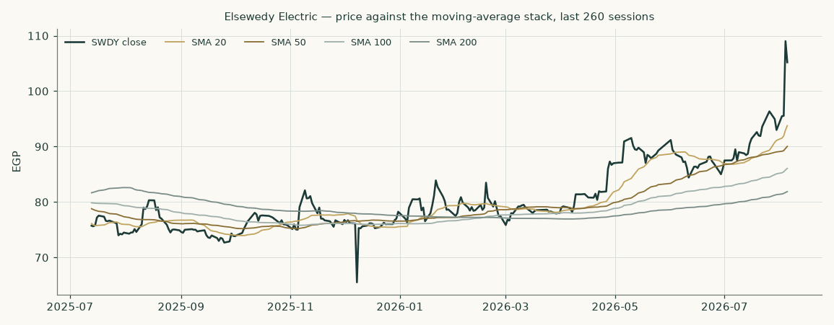
Figure 4 — price against the 20-, 50-, 100- and 200-session moving averages over the last 260 sessions.
Marker | Level (EGP) | Reading
Last close | 105.20 | the anchor for everything in this study
20-session average | 93.77 | price is +12% against it
50-session average | 90.04 | price is +17% against it
100-session average | 86.07 | price is +22% against it
200-session average | 81.88 | price is +28% against it
52-week high (closing basis) | 109.02 | -3.5% from the high — the high IS the +14.1% print of 4 August 2026, one session before the anchor
52-week high (intraday) | 114.50 | -8% from the high — the conventional basis, and the wider of the two
52-week low | 65.52 | +61% from the low
Annualised volatility | 48.4% | the fitted range-based volatility model's CURRENT state (an exponentially-weighted estimate, not a fixed window — the 50-session simple figure is given below for comparison), the input to the price cone in section 3

The share is above every moving average in the stack, and the stack itself is in ascending order — the configuration that describes an established uptrend. The price has compounded +37% over the last 252 trading sessions (the exchange's trailing year on the supplied series) and sits -3.5% from its 52-week high. Realised volatility of about 48% a year is high in absolute terms and unremarkable for this market. None of this is a valuation argument; it is the price context the valuation has to be read against, and the gap between a strongly trending price and a fundamental central below it is precisely what section 4 addresses.
One caveat on the volatility that sets the width of the price cone in section 3. The 48.4% annualised figure is dominated by a single session: the shares rose 14.1% on 4 August 2026 on roughly eleven times normal volume. Realised volatility over the last 50 sessions is 36.1%; strip out that one session and it falls to 22.0%. The cone in section 3 is therefore wide because of one day's move, and a reader who regards that session as a one-off should treat the bands as correspondingly generous.
3 A probabilistic price map
This section answers a different question from the valuation. It does not ask what the business is worth; it asks where the share price could plausibly be in one and three months, given how this share has actually moved. The engine simulates 50,000 price paths from a volatility model fitted to the daily high-low-open-close range, with a fat-tailed shock distribution and a drift anchored to the cost of carry — an EGP deposit-rate carry, ~18% annualised as implied by the median path, deliberately below the 22.3% bond yield and carrying no directional view.
The widths below are calibrated rather than assumed. Tested by walk-forward simulation over nearly five years — 19 independent non-overlapping quarterly windows with origins from 2021-10-05 to 2026-04-12 (the final window runs three months past its origin), each one forecast using only data available before it — the model scored +1.50% better than a random-walk benchmark anchored on the same cost of carry. Outcomes fell inside the stated bands at close to the advertised rate (47% inside the 50% band, 68% inside the 80%, 84% inside the 90%), and the outcomes were spread evenly across the distribution rather than bunching at one end — a uniformity test returns p = 0.28, comfortably consistent with a well-calibrated forecast. Over the very long run the picture is more mixed: across the full 14-year history the model still beats the benchmark (+1.07%) but its bands are about 22% wider than they need to be, which is a real limitation and is stated here rather than left out.
This is a map of price dispersion, not a forecast, and it is never blended with the fair-value work above.
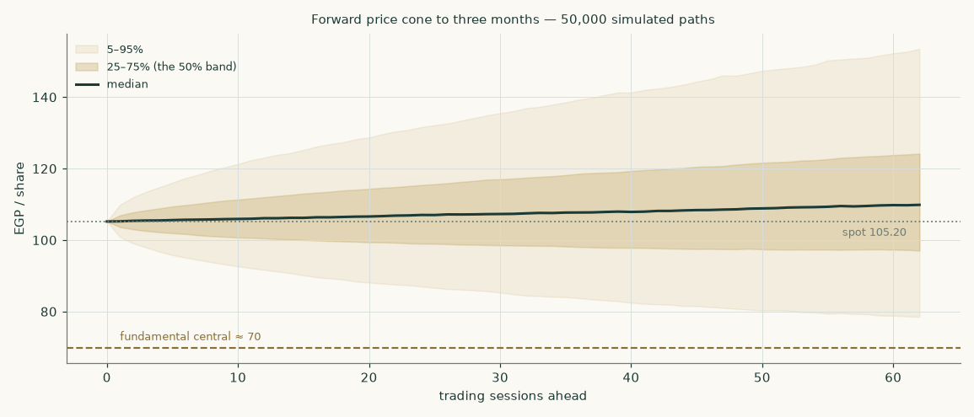
Figure 5 — the forward price cone to three months. The dashed brass line is the fundamental central estimate of 69.73; the dotted line is the spot of 105.20.
Percentile map (EGP/share)
Horizon | 5th | 25th | Median | 75th | 95th | Probability above spot
1 month (to 2026-09-06) | 87.47 | 99.11 | 106.68 | 114.90 | 130.17 | 55%
3 months (to 2026-11-05) | 78.30 | 96.94 | 109.91 | 124.46 | 154.19 | 59%

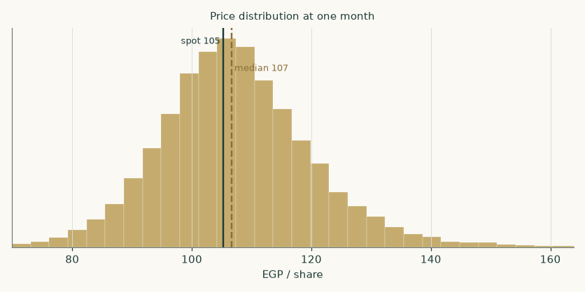
Figure 6 — the one-month price distribution.
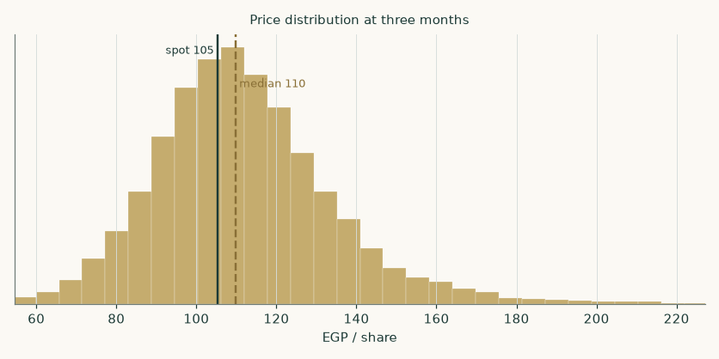
Figure 7 — the three-month price distribution.
Level-touch ladder
Event | 1 month | 3 months
Finishes 10% or more above spot | 23% | 39%
Finishes 10% or more below spot | 14% | 21%
Touches 10% above spot at any point | 37% | 63%
Touches 10% below spot at any point | 25% | 45%

Touch probabilities exceed finish probabilities because a path can visit a level and come back. This distinction matters for anyone thinking about a level rather than a date.
4 Comparison of the lenses
Read | What it says | What it assumes
Fundamental (weighted) | EGP 69.73 central, -34% against the market | an Egyptian cost of capital applied to the whole company, and no real terminal growth
Cash flow alone | EGP 56.08, -47% | a cost of capital gliding 26.6% to 15.9%
Currency-of-discounting alternative | EGP 85.97, -18% | the hard-currency cash-flow leg discounted at about 10.1%
Multiples | EGP 75.65, -28% | a judged multiple on forward earnings, discounted back, is the right way to price this (no peer multiple is computed anywhere in this study — §1.3)
The market | 105.20 | revealed preference of the marginal buyer
Three-month price map | median 109.91, 59% chance of finishing above spot | volatility persists as it has; no view on value

The reading we take from this is that the disagreement between the market and the cash-flow model is almost entirely a disagreement about the discount rate, and that this is a genuinely open question rather than a mistake by one side. A company that earns just over half its money on a hard-currency-linked basis, borrows roughly 72% of its book in hard currency at 5.3%, and holds assets in fifteen countries is only partly an Egyptian risk. Charging it the full Egyptian equity risk premium — which is what our primary construction does — is the conservative choice, not the obviously correct one. Charging it none of that premium, which is roughly what the market price implies, is the aggressive one.
Our own weighting sits closer to the conservative end because the shares are bought and sold in Egyptian pounds on an Egyptian exchange, the dividends are paid in Egyptian pounds, and the ability of a foreign shareholder to realise value depends on Egyptian capital-account conditions. That is a real risk and it belongs in the discount rate. But a reader who believes that convertibility is not the binding constraint, and that the hard-currency earnings should be valued as hard-currency earnings, will reach a materially higher number using the same cash-flow forecasts — EGP 85.97 on the alternative shown. Neither reader is being unreasonable, and this study declines to hide that behind a single figure.
No rating and no price target is expressed here or anywhere else in this document. The output is a range and a distribution.
5 Catalysts to watch
Catalyst | Why it matters | What to watch
Half-year 2026 results | the first read on whether the first quarter's reacceleration is a trend or a comparison effect, and on whether margins have stopped falling | gross margin against the 2025 exit rate; whether revenue growth holds above 20%
Working-capital conversion | the model's largest single assumption is that working capital stays near 19.9% of revenue | operating cash flow against EBITDA in the interim statements; inventory and receivable days
The exchange rate | about 51% of revenue is hard-currency linked, so both the translated result and the working capital move with the pound | the pace of depreciation against the roughly 6% a year assumed here, and whether the gap to interest-rate parity closes through rates or through the currency
Central bank policy | the discount rate glide assumes continued disinflation; a stall raises the cost of capital across the whole model | policy meetings and the inflation path against the stated targets
Copper | copper is the dominant input in the largest segment and is passed through with a lag | whether contracts continue to reprice fast enough to protect the cable gross margin during price spikes
Order intake | no order book or backlog figure is disclosed anywhere in the audited filings, so the Constructions and infrastructure forecast tapers on its own revenue growth rather than a burn rate | whether Constructions and infrastructure revenue growth (18% in FY2026E) holds up or decelerates faster than assumed
Dividend policy | the FY2025 payout ALREADY stepped up +85%, to EGP 1.85 (paid June 2026, 22.8% of attributable EPS); the forecast assumes 25% — whether the step-up is the start of a trajectory or a plateau moves the equity roll-forward and the net-debt path | the distribution proposed on the FY2026 result, against the 22.8% just paid

6 Reading the probability zones
The three-month distribution in section 3 has a median of 109.91 and a 5th-to-95th percentile span of 78.30 to 154.19. Read that span honestly: it means the model considers a -26% move and a +47% move to be equally unremarkable tail outcomes over a single quarter. Anyone who finds that range uncomfortably wide is reacting to the volatility of the share rather than to the model.
Zone | Three-month range (EGP) | How to read it
Lower tail | below 78.30 | a 1-in-20 outcome; would require a genuine shock — a currency event, a policy reversal, or a material contract failure
Lower half of the central band | 96.94 – 109.91 | ordinary drift lower; this zone overlaps the upper end of the fundamental range
Upper half of the central band | 109.91 – 124.46 | ordinary drift higher; the market continuing to price the hard-currency reading
Upper tail | above 154.19 | a 1-in-20 outcome; would need a step change in the order book, the margin, or the perceived country risk
Where the fundamental central sits | 69.73 | below even the 5th percentile (78.30) of the three-month distribution — the price map and the valuation genuinely disagree, and stating the gap at its full size is the point

7 Caveats and what would change our mind
- No order book, backlog or unit-volume figure is disclosed in the audited statements. All three audited financial statements and the Q1-2026 interim disclose segment revenue and segment profit, but no tonnage, MVA, meter count or order-book figure for any segment. The company's quarterly EARNINGS RELEASES have historically carried backlog and volume data; they were not reachable from this research environment, so the forecast is built as a taper on each segment's own recent revenue growth and margin path rather than a backlog-burn model. An earlier wording said 'disclosed anywhere', which overclaimed — the scope of the negative result is the audited statements, and cross-checking the Constructions taper against the released backlog is the first refinement to make when those releases become obtainable.
- The valuation is dated, and the dating is now explicit. The cash-flow model is constructed at 31 December 2025 (the audited balance-sheet date); every lens value is rolled 217/365 of a year to the 5-Aug-2026 anchor at the 28.4% cost of equity less the EGP 1.85 dividend paid in the window — worth about +8.00 gross on the primary lens. An earlier revision omitted this roll and compared a 31-Dec-2025 value directly to the August price; an external review flagged it, correctly.
- The terminal value is a large share of the answer. 85% of the enterprise value comes from the terminal value. This is disclosed in the summary table, in the bridge and here. It is a consequence of a high discount rate applied to a business still growing fast — the explicit years are heavily discounted, so the perpetuity carries the weight. The terminal assumptions are stressed across cost of capital, growth and return on invested capital in section 1.9.
- The FY2026 forecast is checked against one quarter, not several. The segment build for FY2026E is cross-checked, not calibrated, against the disclosed Q1-2026 print — the build's 370,030 against a 356,323 grossed-up implied full year, a gap of +4%. One quarter is a thin check, and it is the reason the half-year 2026 result matters: it will either confirm or contradict the segment growth and margin paths that all three cash-based lenses share.
- The currency of discounting is unresolved, and it is the biggest single question. Our primary construction charges the full Egyptian equity risk premium to a company earning just over half its money on a hard-currency-linked basis. The alternative construction gives EGP 85.97. We have chosen the conservative reading and shown the other in full rather than splitting the difference silently.
- Terminal growth of 5% is roughly zero in real terms. The terminal risk-free rate embeds 5% inflation, so a 5% nominal terminal growth rate assumes the company stops growing in real terms forever. For a business with a growing hard-currency export franchise that is a conservative assumption, and the 6% and 7% columns of the growth grid are not aggressive.
- Minority interests are charged at their profit share, not at book. Minorities take 9.7% of group profit but only 7.1% of book equity. Charging them the profit share removes EGP 11,450mn (5.35 per share) from the equity value — EGP 2.96 per share MORE than deducting the audited book value of 5,119mn would (an earlier wording conflated the total charge with the excess; this states both). It is also the internally consistent choice: this study values the group's equity at 1.5× book, so valuing the minorities' stake at 1.0× book while valuing everyone else's above it would apply two different standards to the same subsidiaries.
- The Egyptian-pound share of the debt book is inferred, not disclosed directly. The audited notes give average rates by currency bucket but not the size of each bucket. The 28% pound share used here is back-solved from the independently computed effective interest rate against those two disclosed rates, and is labelled as inferred throughout.
- Concentration of control. The founding family holds 68.0% and the free float is 13.1%. Minority shareholders have limited influence over capital allocation, related-party dealings and distribution policy. This is a governance fact, not an allegation, and it is one reason the justified multiples used here carry a discount.
- What would change our mind, specifically. Upward: sustained operating cash conversion above 60% of EBITDA for two consecutive years; a credible reduction in the perceived country risk premium; Constructions and infrastructure revenue growth holding above the taper assumed here. Downward: working capital rising through 23.0% of revenue; segment margins failing to stabilise; a stall in disinflation that freezes the discount rate glide.

Appendix A Financial statements
A.1 Income statement — three years historical and five years forecast (consolidated, EGP mn)
EGP mn | FY2023 | FY2024 | FY2025 | FY26E | FY27E | FY28E | FY29E | FY30E
Revenue | 152,186 | 231,982 | 281,049 | 370,030 | 422,528 | 466,619 | 510,440 | 555,225
Gross profit | 29,077 | 43,899 | 40,762 | — | — | — | — | —
EBITDA (derived: EBIT + D&A) | 20,035 | 31,601 | 28,363 | 35,158 | 41,645 | 47,603 | 53,648 | 59,209
EBITDA margin | 13.2% | 13.6% | 10.1% | 9.5% | 9.9% | 10.2% | 10.5% | 10.7%
Depreciation and amortisation | (2,296) | (2,260) | (3,009) | (4,625) | (5,282) | (5,833) | (6,381) | (6,940)
EBIT | 17,739 | 29,342 | 25,354 | 30,533 | 36,363 | 41,770 | 47,268 | 52,269
Net finance costs | (2,124) | (3,515) | (2,145) | (1,743) | (2,658) | (2,614) | (2,083) | (1,209)
Share of equity-accounted investees | 604 | 1,132 | 1,569 | 1,694 | 1,830 | 1,976 | 2,134 | 2,305
Profit before tax | 16,218 | 26,959 | 24,778 | — | — | — | — | —
Income tax | (5,080) | (8,122) | (5,591) | — | — | — | — | —
Profit for the year | 11,138 | 18,837 | 19,187 | — | — | — | — | —
Non-controlling interests | (1,022) | (1,376) | (1,856) | — | — | — | — | —
Profit attributable to shareholders | 10,116 | 17,461 | 17,330 | 20,788 | 24,233 | 28,051 | 32,270 | 36,393
Earnings per share (derived: attributable ÷ shares, EGP) | 4.73 | 8.16 | 8.10 | 9.71 | 11.32 | 13.10 | 15.07 | 17.00

Every FY2023-25 STATEMENT line is taken directly from the company's audited consolidated statements. Two rows are house DERIVATIONS and are labelled as such: EBITDA (EBIT plus D&A — the audited statements contain no EBITDA line, and the company's own separately published non-GAAP EBITDA is a different, larger definition) and earnings per share (attributable profit over shares outstanding; the company's own reported EPS of 4.26 / 7.22 / 7.13 is struck after the Egyptian employee and board profit-share appropriation and is accordingly lower — both bases appear in §1.3). Forecast profit is struck after net interest on the estimated debt and cash balances and after tax and minority interests, and therefore differs slightly from the free-cash-flow waterfall in section 1.1, which is a pre-financing measure by construction.
A.2 Balance sheet — condensed house layout (consolidated, EGP mn)
EGP mn | FY2023 | FY2024 | FY2025
Property, plant and equipment | 18,009 | 27,544 | 35,961
Equity-accounted investees | 3,802.8 | 6,474 | 6,758
Inventories | 30,882 | 56,796 | 59,860
Contract assets | 16,180 | 18,052 | 29,895
Trade and other receivables | 46,592 | 86,736 | 116,260
Cash and cash equivalents | 25,552 | 38,180 | 41,949
Total assets | 151,449 | 249,527 | 311,099
Loans and borrowings | 41,766 | 59,083 | 62,509
Trade and other payables | 31,938 | 54,808 | 68,896
Contract liabilities | 25,060 | 53,281 | 81,266
Equity attributable to shareholders | 35,724 | 55,275 | 66,871
Non-controlling interests | 2,384 | 4,252 | 5,119
Net bank debt | 16,214 | 20,903 | 20,560
Net working capital | 36,655 | 53,495 | 55,853
Net debt / EBITDA | 0.81× | 0.66× | 0.72×

FY2023, FY2024 and FY2025 are all audited — every line, including FY2025, is the closing figure from the company's own consolidated statements. No triangulation or roll-forward is used for any historical year.
A.3 Forecast balance sheet and cash-flow markers
EGP mn | FY26E | FY27E | FY28E | FY29E | FY30E
Net working capital | 73,636 | 84,083 | 92,857 | 101,578 | 110,490
Property, plant and equipment | 47,617 | 59,237 | 70,202 | 80,666 | 90,938
Intangible assets and goodwill | 1,749 | 1,749 | 1,749 | 1,749 | 1,749
Invested capital | 123,002 | 145,069 | 164,808 | 183,992 | 203,176
Return on invested capital | 18.7% | 18.9% | 19.1% | 19.4% | 19.4%
Capital expenditure | (16,281) | (16,901) | (16,798) | (16,845) | (17,212)
Change in working capital | (17,783) | (10,447) | (8,774) | (8,720) | (8,912)
Free cash flow to the firm | -6,387 | 5,387 | 11,797 | 16,503 | 20,279
Shareholders' equity | 82,462 | 100,637 | 121,675 | 145,877 | 173,172
Net debt | 33,461 | 36,139 | 33,328 | 26,465 | 16,197

The FY2025 accounts are the reason the free-cash-flow line above should be read carefully. That year the group turned EGP 28,363mn of EBITDA into EGP 12,766mn of operating cash after interest of EGP 5,740mn and tax of EGP 8,299mn, then spent EGP 13,112mn on capital expenditure. The forecast assumes working-capital intensity stays near this level rather than deteriorating, which is what allows free cash flow to turn positive and build. If it does not, the model is wrong in the direction that matters most.
Appendix B Peer frame, risk register — and the research register
B.1 Peers and the sector frame
Company | Market | Relevance | Caution
Riyadh Cables | Saudi Arabia | the nearest listed regional cable manufacturer | a fraction of the revenue, no contracting arm, a much lighter balance sheet and a pegged currency — the multiple is not transferable
Electro Cable Egypt | Egypt | the only other listed Egyptian cable manufacturer, and the closest match on country risk and input costs | far smaller, domestically concentrated, heavily levered and currently loss-making — it sets a floor for country risk, not a benchmark for quality
European cable majors | Europe | the closest match on business model — cables plus projects, with a large order book | developed-market cost of capital and no emerging-market convertibility risk; their multiples import an assumption rather than test one
Regional engineering and construction contractors | Gulf and North Africa | the right frame for the roughly 32% of revenue that is the Constructions and infrastructure segment | project accounting differs, and backlog quality is not comparable across disclosure regimes

The absence of a clean comparable is itself a finding. This is a diversified industrial group with a manufacturing business, a contracting business and an infrastructure portfolio, listed in a frontier market, earning just over half its revenue on a hard-currency-linked basis. Any single peer multiple applied to it imports assumptions about country risk that the cash-flow model tests explicitly. That is why the relative lens carries a fifth of the weight and not more.
B.2 Risk register
Risk | Mechanism | Rough valuation impact
Currency and convertibility | the ability to realise hard-currency earnings in Egyptian pounds, and the pace of depreciation | the exchange-rate sensitivity spans 29.32 per share
Cost of capital / disinflation stall | the discount-rate glide assumes continued easing | the explicit-against-terminal grid spans 34.20 per share
Working-capital discipline | growth is funded by inventory and receivables | 14.28 per share across the tested range
Margin normalisation overshooting | segment margins fail to stabilise after the currency windfall that lifted FY2023-24 unwinds further | 51.98 per share across ±2 percentage points
Terminal return on capital | the perpetuity assumes returns stay near the historical level | 12.11 per share across the tested range
Governance and control | free float of 13.1%; minority influence over capital allocation is limited | expressed through the discount applied to the justified multiples, not as a separate line
Execution and country concentration | projects across Africa and the Gulf carry counterparty, payment and political risk | sits inside the Constructions and infrastructure segment margin assumption
No order book or unit-volume disclosure | the forecast tapers on segment revenue growth rather than a reconstructed unit or backlog-burn model | stated in full in section 7

B.3 The research register — layers, dated, negative results included
Research for this study proceeded in four layers: the global and macroeconomic backdrop; the country; the industry; and the company itself. The full source-by-source register, with dates, layers and the four-field provenance of every input, is published as a separate bibliography document accompanying this study. This version was rebuilt once the company's own audited FY2023-25 consolidated statements and Q1-2026 condensed interim statements became available; two negative results remain and are recorded here because they shaped what could and could not be asserted.
- No order book, backlog or unit-volume figure is disclosed in the audited statements. Neither the three audited annual statements nor the Q1-2026 interim discloses a tonnage, MVA, meter-count or backlog figure for any segment. The company's quarterly earnings releases have historically carried such data but were not reachable from this research environment. The forecast is built as a taper on each segment's own recent revenue growth and margin path instead.
- A facility-by-facility currency split of the debt book is not disclosed. The audited notes give average rates by currency bucket (Egyptian pound and a blended hard-currency bucket in FY2025) but not the size of each bucket. The pound share used here is back-solved from the independently computed effective interest rate and is labelled as inferred.

Appendix C The expert valuation panel
Three valuation approaches are run against the same disclosed facts by three notional experts, each committed to a different method and each required to state what would prove them wrong. They are not asked to agree, and they do not. Two dating and independence notes, stated up front: every panel figure is rolled to the 5-Aug-2026 anchor exactly as the four lenses are; and Expert 1 deliberately runs the SAME kind of earnings-power question as section 1.4 with different persona choices — FY2028-scale earnings at 9.5× against the lens's current-scale earnings at 9.0× — which is why the two land 146.62 and 108.17 respectively. The divergence is the persona doing what it says (no time-value discipline), it is disclosed, and only the section-1.4 construction enters the weighted central.
C.1 Expert 1 — earnings power: mid-cycle earnings at a justified multiple
Worldview: a business is worth a multiple of what it earns in a normal year. Cycles average out; discount-rate models multiply small errors in the rate by large terminal values and produce false precision. Find the mid-cycle earnings, apply a defensible multiple, stop.
When it works: for established franchises with a long operating record and a stable competitive position — which describes this company well. When it fails: when the multiple is imported from a market with a different cost of capital, which is precisely the trap here.
Step | Value
Mid-cycle revenue (FY2028 forecast, EGP mn) | 466,619
Mid-cycle EBITDA margin | 10.2%
Mid-cycle EBIT (EGP mn) | 41,770
Less net interest (EGP mn) | (1,056)
After tax and minority interests — earnings per share (EGP) | 13.47
Justified price/earnings multiple | 9.5×
Fair value (EGP per share) | 146.62
Range (7.0× to 12.0×) | 107.55 – 185.69

Named sensitivity: each one-turn change in the multiple is worth EGP 13.47 per share, and each percentage point of mid-cycle EBITDA margin is worth roughly EGP 1.29 per share.
Falsifier, stated in advance: if the group's EBITDA margin fails to hold above 11% for two consecutive full years, the mid-cycle margin assumed here is wrong and this valuation should be discarded, not adjusted.
C.2 Expert 2 — the accountant: owner cash earnings from the statements
Worldview: earnings are an opinion, cash is a fact. The only number that matters is what an owner could take out of the business each year after everything the business needs to keep running at its current scale — including the working capital that growth consumes. Capitalise that, and nothing else.
When it works: it is the correct discipline for exactly this kind of company, where reported profit and cash generation have diverged sharply. When it fails: it undervalues a business genuinely investing ahead of demand, because it charges growth capital against the owner without crediting the growth it buys.
Step | Value
Average free cash flow to the firm, FY2028–FY2030 (EGP mn) | 16,193
Less after-tax interest (EGP mn) | (608) — the FY2029 point of the forecast's net-finance construction (cost-of-debt path × gross book less 10% on the FY2025 cash balance), after tax; shown because a review correctly noted it was not reconcilable as previously displayed
Less minority share (9.7%) | (1,508)
Owner cash earnings (EGP mn) | 14,077
Grown one year and capitalised at cost of equity less growth | × 1.05 ÷ (17.6% − 5%)
Fair value, rolled to the anchor (EGP per share) | 61.91
Range | 37.47 – 68.09

This is the harshest of the three readings, at EGP 61.91, and the reason is specific and defensible: it takes the FY2025 evidence — EGP 28,363mn of EBITDA converting to EGP 12,766mn of operating cash — as a statement about the business model rather than about one unusual year.
Named sensitivity: if working capital intensity fell by two percentage points of revenue, this valuation would rise by roughly a third, because the entire gap between this expert and the other two is the cash working capital absorbs.
Falsifier, stated in advance: two consecutive halves in which operating cash flow exceeds 60% of EBITDA would refute the premise that this business structurally cannot convert its earnings, and this number should then be abandoned.
C.3 Expert 3 — cash returns: return on capital against the cost of capital
Worldview: value is created only when the return on invested capital exceeds the cost of that capital, and the amount created is the spread multiplied by the capital employed. Growth without a positive spread destroys value; growth with one compounds it. Start from the capital already invested and add the present value of the economic profit earned on it.
When it works: it is the sharpest available test of whether growth is worth funding, and it makes the discount-rate question unavoidable rather than buried. When it fails: it is acutely sensitive to how invested capital is measured, and to the currency in which the cost of capital is struck.
Step | Value
Invested capital at the FY2025 base (EGP mn) | 93,562
Present value of economic profit, five explicit years (EGP mn) | 6,136
Present value of terminal economic profit (EGP mn) | 26,651
Enterprise value (EGP mn) | 126,349
Fair value, rolled to the anchor (EGP per share) | 53.25
Range — the upper bound is the hard-currency discounting case | 46.17 – 85.97

Year | FY26E | FY27E | FY28E | FY29E | FY30E
Return on invested capital (NOPAT ÷ closing capital) | 18.7% | 18.9% | 19.1% | 19.4% | 19.4%
Cost of capital that year | 26.6% | 23.1% | 20.1% | 17.7% | 15.9%
Spread | -7.9pp | -4.1pp | -1.0pp | +1.7pp | +3.5pp
Economic profit (NOPAT − charge on OPENING capital, EGP mn) | -1,862 | -915 | 2,388 | 6,489 | 10,145

Two conventions sit in this table and are named so they cannot be confused: the ROIC row divides by CLOSING capital (matching Appendix A.3), while economic profit charges the cost of capital on OPENING capital — the capital actually employed through the year. So spread × closing capital will not reproduce the economic-profit row; the identity holds on opening capital. Note also that this leg's enterprise value (126,349) and the DCF's (132,146) differ by 5,796: economic-profit and FCFF valuations are algebraically identical on identical assumptions, and the gap here is exactly the different terminal treatment (a fading economic-profit perpetuity versus the reinvestment-rate terminal value). Expert 3 is therefore a RESTATEMENT of the DCF under a different terminal discipline, not an independent confirmation, and is read as such.
This table is the single most revealing exhibit in the study. The spread is negative in the early years — the group earns roughly 19% on capital while its cost of capital is 27% — and turns positive only as the discount rate glides down. On this reading the company is not currently creating value at an Egyptian cost of capital; it creates value only if that cost of capital normalises, or if the correct cost of capital is the hard-currency one.
Named sensitivity: a two-percentage-point parallel reduction in the cost-of-capital schedule flips the spread positive from the first forecast year and adds materially more than any operating assumption tested elsewhere in this study.
Falsifier, stated in advance: if return on invested capital falls below 15% for two consecutive years while the cost of capital stays above 20%, this approach concludes the business is consuming value at scale and the estimate should collapse toward invested capital.
C.4 Cross-examination
Challenge | From | Response
"A multiple is just a discount rate you have not written down. Yours implies a cost of equity nowhere near the one this market charges." | Expert 3 to Expert 1 | Conceded in part. The multiple is deliberately discounted below developed-market levels for exactly this reason, but the discount is a judgement rather than a derivation, and it is the weakest joint in this method.
"You are charging the owner for working capital that funds growth which will convert to cash. That is a timing charge treated as a permanent one." | Expert 1 to Expert 2 | Partly conceded. FY2025 did improve — working capital fell from 23.1% to 19.9% of revenue even as revenue grew. Until that improvement repeats for a second year, treating the earlier absorption as the norm rather than the exception is the more cautious position.
"Your invested-capital base is understated because it excludes goodwill written off and assets held at historical cost through three devaluations." | Expert 2 to Expert 3 | Conceded. A higher capital base would lower the measured return on capital and shrink the spread, making this reading more pessimistic, not less. The direction of the error is unfavourable to the conclusion already reached.
"All three of you are answering an Egyptian question about a company that earns just over half its money on a hard-currency-linked basis." | The panel to itself | Accepted as the central unresolved issue. It is why Expert 3's range extends up to the hard-currency case, and why the main study presents both readings rather than an average.

C.5 The three in one room
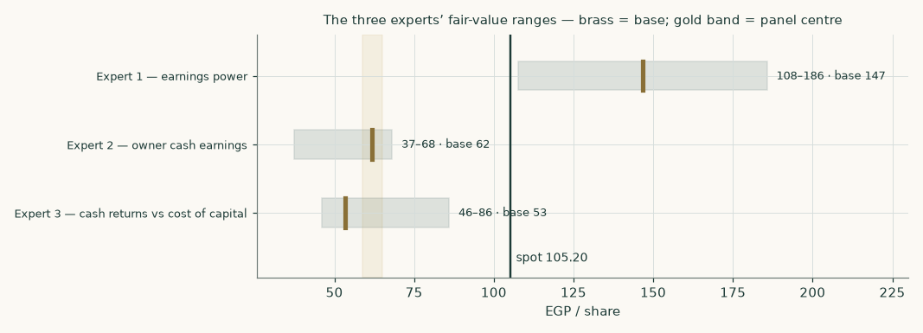
Figure 8 — the three experts' ranges. The gold band is the panel centre of 61.91; the vertical line is the market price of 105.20.
The panel spans EGP 53.25 to 146.62 — a factor of 2.8 between the most and least generous reading. That is a wide disagreement and it is not noise. Expert 1 values earnings and lands near the market price. Expert 2 values cash and lands well below it. Expert 3 values the spread between returns and the cost of capital and finds that the answer depends entirely on which cost of capital applies. The panel median of 61.91 sits -41% against the market price and -11% against the study's own weighted central of 69.73 — a real gap, stated at its size rather than smoothed, and driven by the panel's harsher cash and returns legs outvoting its generous earnings leg.
C.6 Reading the divergence
Assumption | Expert 1 | Expert 2 | Expert 3 | Why it swings the answer
Working capital | ignored — earnings basis | charged in full, permanently | charged through invested capital | the largest single source of the gap between Experts 1 and 2
Discount rate | implicit in the multiple | 17.6% explicit | the full glide, year by year | Expert 3 is the only one who lets it change over time, which is why his spread turns
Currency of discounting | not addressed | Egyptian throughout | both readings shown in the range | worth more than every operating assumption combined
Growth | embedded in the multiple | 5% perpetual | funded explicitly through reinvestment | only Expert 3 makes growth pay for the capital it needs
Terminal value | none — no perpetuity | a perpetuity of owner cash | 85% of the value in the study's main model | the reason Expert 1 is insensitive to the terminal debate and the others are not

The instruction to the reader is not to average these three. It is to decide which of the three premises is true — whether working capital converts, and which currency's cost of capital applies — and then to use the corresponding number. The disagreement is a map of what you need to have a view on.
About this series
This series publishes independent, educational valuation studies of listed companies. Each study is built from disclosed financial statements and named market data, states its assumptions explicitly, computes every figure in an auditable model rather than in prose, and publishes the ranges its assumptions produce. Studies never carry a rating or a price target. Where a figure is estimated rather than disclosed, it is labelled. Where a source could not be reached, the gap is recorded rather than filled.
The probabilistic price map in section 3 is produced by a volatility model that is tested by walk-forward simulation against a random-walk benchmark before it is allowed to publish a range. It describes price dispersion and carries no view on value. It is never combined with the fair-value work.
Disclosure & Disclaimer
This document is educational analysis and is not investment advice, an offer, or a solicitation to buy or sell any security. It contains no recommendation, no rating and no price target. The author holds no position in the security discussed and has no business relationship with the company. Figures are drawn from public sources believed reliable but not independently verified; where figures are derived or estimated this is stated in the text. Valuation is inherently uncertain and depends on assumptions that reasonable analysts will dispute — several such disputes are set out explicitly in this document rather than resolved silently. Past performance and simulated distributions are not guides to future returns. Readers must reach their own conclusions and should consider taking independent advice. No liability is accepted for any loss arising from use of this material.

