Independent Valuation Study — Educational Analysis
Samsung Electronics Co., Ltd. (KRX: 005930)
Fundamental analysis · Technical analysis · Monte Carlo simulation — one integrated read
Anchor: KRW 339,500 (26 Jun 2026 close) · ~6.63bn shares · mkt cap ~KRW 2,251tn · net cash ~KRW 119tn · #2 global semiconductor vendor · listed-affiliate stakes (Samsung SDS, Biologics, SDI, Electro-Mechanics) · prices & probabilities computed 26 Jun 2026 from the attached daily price history (4 Jan 2021 — 26 Jun 2026) · independent bottom-up valuation, derived segment/forecast inputs · memory is ~94% of peak operating profit and the swing factor.
READ FIRST — what this document is, and is not. This study is a valuation exercise and an expression of personal analytical opinion, published free of charge for educational purposes: it shows how one analyst applies fundamental, technical and probabilistic methods to a listed company, and invites scrutiny of that methodology. It is NOT investment advice, NOT a recommendation or solicitation to buy, sell or hold any security, and NOT directed at the circumstances of any reader. The preparer is not licensed by any securities regulator in any jurisdiction, holds no Korean or other brokerage authorisation, provides no financial consultancy, manages no money, and accepts no fees, funds or clients. See the Disclosure & Disclaimer at the end. All values are model outputs presented as ranges and distributions because no single number should be relied on. Reported financials are Samsung's own disclosure; forward-looking inputs — projections, normalisation, multiples, the DCF and Monte-Carlo factor probabilities — are the preparer's judgments and are flagged throughout. Consult a licensed financial advisor before any investment decision.

Headline
The model's read: the price is full, but the tape is strong. At KRW 339,500 the shares trade about 13% above our weighted central estimate of KRW 296,502; spot sits above every fundamental lens except the outright supercycle case. Samsung is the largest memory-chip maker on earth and in mid-2026 is earning more than at any point in its history — first-quarter 2026 operating profit of KRW 57tn alone exceeded the whole of FY2025 (KRW 44tn), driven almost entirely by the Device Solutions chip division (KRW 53.7tn, ~94% of group profit), and the shares have risen ~485% off their 52-week low. The question is not whether Samsung is a great company — it plainly is — but whether KRW 339,500 a share is a fair price for it.
Five independent lenses cluster between KRW 214,800 and KRW 410,754; the weighted central estimate is KRW 296,502, about 13% below spot. The sum-of-the-parts — even after crediting memory with a structurally higher, AI-era earnings plateau — lands at KRW 283,499 (-16%). A consolidated whole-company DCF (KRW 214,800), which charges Samsung for the ~KRW 100tn/yr of capital expenditure the boom demands, corroborates the asset-based build and lands lower still — on owned, after-capex cash flow the stock looks even fuller. Relative multiples (KRW 316,742) and through-cycle earnings power (KRW 253,394) complete a four-plus-one-lens synthesis. Only by capitalising near-peak earnings at full multiples — the supercycle case at KRW 410,754 (+21%) — does the arithmetic reach today's price; sell-side consensus, which clusters above spot, effectively adopts that bull case as the base case. We do not.
This is a statement about valuation, not direction. Momentum is powerful, the memory shortage is real and Samsung says it persists into 2027, and a single 16-factor Monte Carlo (DRAM/NAND ASPs, HBM share, USD/KRW, AI capex, KOSPI flows, smartphones, foundry ramp, plus nine discrete event risks; 50,000 paths, seed 42) puts the T+20 median at ~346,091 and the T+60 median at ~359,482, with a right tail to ~520,627. A richly-valued stock in a genuine boom can stay rich for a long time. What a buyer at this level underwrites is the durability of the AI-memory supercycle and Samsung closing its high-bandwidth-memory (HBM) gap with SK Hynix — not a margin of safety on normalised earnings, because there isn't one. The downside tail belongs to memory-cycle reversion and the ~94% profit concentration that offers no cushion; the upside tail to a durable supercycle, an HBM4 share recovery, and Korea's value-up re-rating.
Company overview — Samsung Electronics at a glance
Samsung Electronics (KRX: 005930) is the world's largest memory-chip maker and a vertically-integrated electronics and semiconductor conglomerate. Its profit engine is memory — DRAM, NAND flash and high-bandwidth memory (HBM). Around it sit logic-chip design (System LSI), a contract chip-manufacturing arm (Foundry), a controlled display affiliate (Samsung Display), the Galaxy smartphone and networks business (MX), televisions and home appliances (VD/DA) and Harman (connected-car audio). It also holds large stakes in listed affiliates — Samsung SDS, Samsung Biologics, Samsung SDI, Samsung Electro-Mechanics — and a fortress, net-cash balance sheet of roughly KRW 119 trillion. The defining feature for valuation is that one segment, memory, now produces almost all of the profit and is at a cyclical extreme: Q1-2026 group operating profit of KRW 57.2tn (DS KRW 53.7tn) exceeded all of FY2025.
Item | Value (as disclosed / derived)
Listing / sector | KRX: 005930 · semiconductors, electronics & devices
Ultimate context | Samsung Group affiliate; controlled-shareholder (Lee family) structure
Share price (26 Jun 2026 close) | KRW 339,500
Shares outstanding (ex-treasury) | ~6.63bn
Market capitalisation | ~KRW 2,251tn (~USD 0.42tn)
Net cash (Q1-2026) | ~KRW 119tn (fortress balance sheet)
FY2025 revenue / OP / net | KRW 333.6tn / 43.6tn / 45.2tn (records)
Q1-2026 revenue / OP | KRW 133.9tn / 57.2tn (OP > all of FY2025)
Book value per share (FY2025) | ~KRW 64,000 (P/B ~5.3x)
2026E P/E (peak EPS) | ~11.3x (vs TSMC ~24x)
R&D (FY2025) | KRW 37.7tn (record)
Profit concentration | ~94% memory / Device Solutions

Company-level figures are sourced from Samsung's public disclosure (Samsung IR) and other public sources; forward-looking inputs — the 2026e‑2030e projections, segment normalisation, multiples, the DCF and the Monte-Carlo factor probabilities — are the preparer's derived estimates, not company disclosure, and are flagged throughout.
1 Fundamental valuation
A semiconductor conglomerate is not valued like a property developer or a bank: there is no land bank to revalue and no loan book to provision, but a portfolio of operating businesses at very different points in their own cycles, sitting on a large pile of net cash and listed stakes. The primary lens is a sum-of-the-parts (SOTP): value each segment on a normalised, mid-cycle level of earnings times a multiple appropriate to that business, add net cash and stakes, and divide by shares. We then cross-check that asset-based figure three ways — a consolidated DCF, relative multiples against the global chip peer set, and a through-cycle earnings-power calculation. Reported segment numbers are Samsung's disclosure; the normalisation and multiples are our judgments, shown explicitly so you can disagree.
1.1 Sum-of-the-parts — the primary lens
The crux of the whole exercise is the memory line. In 2026 memory is earning at an extraordinary rate — annualising the Q1 chip-division run-rate would put memory operating profit near KRW 200tn. That is a peak, not a sustainable mid-cycle number. Our base case credits memory with a structurally higher, AI-era plateau of ~KRW 175tn of operating profit — well above the old-cycle average, deliberately generous to the "the boom is durable" view — and capitalises it at 9x, a multiple between a pure-commodity memory maker and a structural-growth franchise. Even on that generous basis the base SOTP is KRW 283,499, about 16% below spot.
SOTP component (base case) | Norm. OP / value | Multiple | EV (KRW tn)
Memory (DRAM / NAND / HBM) | 175 tn | 9.0x | 1,575
System LSI (logic/SoC) | 4 tn | 8.0x | 32
Samsung Display (stake) | 5 tn | 6.5x | 33
MX + Networks (mobile) | 13 tn | 6.0x | 78
VD + DA (TV/appliances) | 1.5 tn | 5.0x | 8
Harman (auto/audio) | 1.3 tn | 8.0x | 10
Foundry (option value) | — | — | 0
(+) Net cash |  |  | 119.2
(+) Listed stakes / other |  |  | 25
Equity value |  |  | ~1,880
Value / share (base) |  |  | KRW 283,499

The three SOTP cases bracket the memory debate. The supercycle (bull) case lifts memory to ~KRW 230tn at 10x and ascribes ~KRW 60tn of foundry option value — it reaches KRW 410,754 (+21%), roughly where today's price and consensus sit. The cycle-reversion (bear) case normalises memory to a genuine through-cycle ~KRW 60tn at 7x — the "still a commodity" view — and collapses to KRW 95,053 (-72%). The width of that range, KRW 95,053 to KRW 410,754, is the honest measure of how much the answer depends on one's view of the memory cycle.
1.2 Consolidated DCF — the cash-flow cross-check
The SOTP values Samsung on segment earnings; a DCF asks the more demanding question — after Samsung pays for the capital expenditure the boom requires, how much cash is left for owners? We project unlevered free cash flow to the firm (FCFF) for 2026e‑2030e (capturing the supercycle peak and a normalisation), discount at a KRW WACC of 8.5%, and add a normalised terminal value.
FCFF build (KRW tn) | 2026e | 2027e | 2028e | 2029e | 2030e
Operating profit | 215 | 190 | 120 | 132 | 145
NOPAT (after 18% tax) | 176.3 | 155.8 | 98.4 | 108.2 | 118.9
(+) D&A | 52 | 54 | 56 | 58 | 60
(−) Capex | (100) | (98) | (88) | (85) | (85)
(−) Δ Working capital | (12) | (3) | 5 | (4) | (4)
Unlevered FCFF | 116.3 | 108.8 | 71.4 | 77.2 | 89.9
Discount factor @ 8.5% | 0.922 | 0.849 | 0.783 | 0.722 | 0.665
PV of FCFF | 107.2 | 92.4 | 55.9 | 55.7 | 59.8

DCF bridge to value | KRW tn | per share
PV of explicit FCFF (2026e‑2030e) | 371
(+) PV of terminal value (norm. FCFF 80tn, g 2.5%) | 909
Enterprise value | 1,280
(+) Net cash | 119.2
(+) Listed stakes / other | 25
Equity value | 1,424
DCF value / share |  | KRW 214,800
vs spot |  | -37%

Why the DCF lands below the SOTP. At KRW 214,800 the cash-flow lens sits well below the asset-based KRW 283,499 and far below spot. The reason is structural: Samsung must spend on the order of KRW 100tn a year — roughly half of operating cash flow — to build the HBM, advanced-DRAM and foundry capacity the AI boom demands. On owned, after-capex cash flow the stock looks even fuller than on segment earnings. A bull will object that this capex is growth investment whose returns the terminal value understates; that is a fair argument, and exactly why we treat the DCF as a cross-check rather than the primary lens. But the direction is unambiguous — it corroborates, rather than relieves, the richly-valued reading. Sensitivity grids are in 1.9.
1.3 Relative multiples
On peak earnings Samsung looks cheap; on normalised earnings it does not. At KRW 339,500 the shares trade at ~11.3x our 2026e earnings of KRW 30,166 per share — optically inexpensive next to TSMC (~24x) and below SK Hynix on forward earnings. But 2026e is peak-cycle earnings; the "cheap" multiple is a function of a denominator we do not believe is sustainable. As the cycle normalises, the 2027e multiple rises to ~12.5x and the through-cycle multiple is far higher. Applying 9‑12x to 2026e EPS gives a blended KRW 316,742 (-7%). The honest reading: cheap if you annualise the peak, not cheap if you normalise.
Relative lens | Metric | Multiple | Implied / sh
2026e P/E (peak EPS KRW 30,166) | 11.3x now | 9‑12x | KRW 271,493‑361,991
2027e P/E (fading EPS KRW 27,149) | 12.5x | — | cycle rolling over
Price / book | 5.3x | 1‑1.5x hist. | well above history
Blended relative value |  |  | KRW 316,742

1.4 Normalized earnings power
Strip out the cycle and ask what Samsung earns in an average year. Blending a trough (the 2023 memory loss), the 2024‑25 recovery and the 2026‑27 peak, a defensible through-cycle net profit is ~KRW 120tn — far below the 2026e peak of KRW 200tn but far above the 2023 trough. At a 14x through-cycle multiple (a premium to a pure commodity, a discount to a secular grower) that is KRW 253,394 (-25%). This is the most conservative operating lens and the one most exposed to the objection that AI has permanently raised the floor — the supercycle question the price is asking.
1.5 Synthesis — five lenses
The five methods and weights are below. We lean on the SOTP (the right structure for a multi-segment conglomerate) and the through-cycle and relative lenses, give the DCF a modest weight as a corroborating cross-check, and keep a meaningful weight on the supercycle case because the boom is real and could prove durable.
Method | KRW / sh | vs spot | Weight
SOTP — normalized (base) | 283,499 | -16% | 25%
SOTP — supercycle (bull) | 410,754 | +21% | 15%
Consolidated DCF (FCFF) | 214,800 | -37% | 10%
Relative multiples (blended) | 316,742 | -7% | 25%
Normalized earnings power | 253,394 | -25% | 25%
WEIGHTED CENTRAL | 296,502 | -13% | 100%

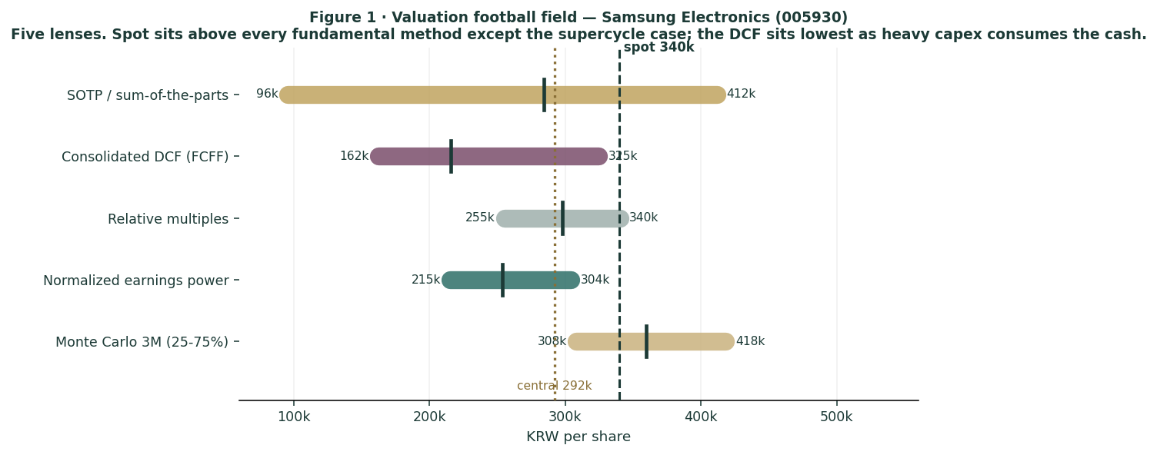
Figure 1 · Valuation football field — five lenses. Spot sits above every fundamental method except the supercycle case; the DCF sits lowest.
How to read this. The clustering is tight on the downside-to-middle and only the supercycle case overlaps spot — the signature of a stock priced for the bull outcome: little margin of safety on normalised earnings, and the buyer is paid to be right about memory-cycle durability and Samsung's HBM catch-up. None of this forecasts a fall — the next sections describe a price process with a slight upward drift — it states that, on the fundamentals, you are buying the optimistic scenario at close to full value.
1.6 The operating segments — a deeper look
The valuation rests on segment-level judgments. For each business we set out the macro-sector backdrop (the industry structure Samsung operates inside) and the company-specific position (where Samsung actually stands within it), with the strengths and weaknesses that drive the normalisation. One fact recurs throughout: memory is ~94% of peak operating profit, so everything outside memory is, in valuation terms, a rounding error today — but several of those businesses are where the structural risks and the optionality live.
Segment scorecard
Segment | Position | Cycle now | Key tension
Memory (DRAM/NAND/HBM) | #1 DRAM/NAND; #3 HBM | peak | HBM laggard
System LSI | #2 sensors; sub-scale SoC | weak | Exynos gap
Foundry | distant #2 (~7%) | turning | yield gap vs TSMC
Samsung Display | #1 small/medium OLED | solid | Chinese panel push
MX + Networks | #1/#2 smartphones | soft | own memory inflates cost
VD + DA | #1 TV brand | loss-making | China + tariffs
Harman | auto audio/electronics | steady | small, auto-cyclical

Memory — the engine, and the whole question
Macro sector. Memory is a three-player oligopoly: Samsung, SK Hynix and Micron together control more than 95% of DRAM and HBM output. It has historically been one of the most violently cyclical businesses in technology — Samsung's own chip division recorded a roughly KRW 15tn full-year loss in 2023. The AI build-out has introduced a contested "structural reset" thesis in which HBM and AI-server DRAM convert memory from boom-bust commodity into a sustained-premium franchise: HBM capacity is reported sold out through 2026, the HBM market is heading toward a ~$100bn TAM by 2028, and industry HBM margins are said to exceed 50%. The 2026 memory market is forecast to grow ~30% to north of $440bn, and conventional DRAM prices surged from Q4-2025 as capacity was diverted to AI — squeezing PCs, phones and consumer devices.
Company position. Samsung is #1 in conventional DRAM (~38% vs SK Hynix ~29%) and #1 in NAND (~29%) — it dominates the commoditising part of memory. But in HBM, the highest-margin, fastest-growing slice, it is the laggard: ~17‑28% share against SK Hynix's 50‑62%, with Micron at ~20‑21%. SK Hynix has been Nvidia's primary HBM supplier through HBM3E; Micron overtook Samsung on some allocations. That is the central irony: Samsung leads where the economics are commoditising and trails where they are richest.
- Strengths: the largest scale and lowest unit cost in DRAM/NAND; full vertical integration (own fabs, own advanced packaging); the capital firepower (~KRW 100tn/yr capex) to out-invest rivals; record memory profit in 2025‑26; and — critically for the bull case — it has reportedly passed Nvidia's HBM4 qualification at the 10‑11.7 Gbps tiers, won AMD's MI455X as primary HBM4 supplier, and is cited as leading Vera-Rubin-specific HBM4. If HBM4 resets the leaderboard, Samsung is positioned to take share back.
- Weaknesses: it lost the HBM3E leadership to SK Hynix on yield and qualification timing, the most consequential competitive miss of the cycle; 2026 memory profit is a cyclical peak, not a run-rate; and the very fact that conventional DRAM prices have surged narrows HBM's historical margin premium. Above all the concentration risk is extreme — if memory reverts, ~94% of group profit reverts with it, and there is no second engine to lean on.
System LSI — the perennial under-performer
Macro sector. Logic-chip design (mobile SoCs, image sensors, modems) is design-led, competing with Qualcomm and MediaTek in application processors and Sony in image sensors; scale, software and modem IP decide winners.
Company position & read. Samsung's Exynos SoC has struggled for years to match Qualcomm's Snapdragon in flagship performance, repeatedly ceding even Samsung's own Galaxy flagships to Qualcomm in key markets; its ISOCELL image sensors are a credible #2 behind Sony. Strengths: captive demand from Samsung's own phones and genuine sensor scale. Weaknesses: a persistent flagship-SoC gap, dependence on Samsung Foundry's yields, and small absolute profit — immaterial to the valuation but a drag on the "integrated AI-silicon champion" narrative.
Foundry — the distant second, and the call option
Macro sector. Contract chip-manufacturing is effectively a TSMC monopoly at the leading edge: TSMC holds ~70% of foundry revenue, Samsung ~7%, with Intel Foundry, SMIC and GlobalFoundries trailing. TSMC's lead is self-reinforcing — the most advanced fabless designers (Apple, Nvidia, AMD, Qualcomm, Broadcom) overwhelmingly choose TSMC, compounding yield, volume and trust. Leading-edge 2nm wafers command upward of $30,000 each.
Company position. Samsung is the only credible alternative to TSMC, but a distant one. Its 2nm gate-all-around (GAA) yields are reported ~55‑60% against TSMC's 70‑90% — the core problem, because yield drives cost and customer confidence. The arm returned to profitability in Q4-2025 (~$3.4bn revenue, helped by 2nm products and HBM4 base-die logic) and lifted share to ~7.1%. It targets 20% share and sustained profitability by 2027; its Taylor, Texas fab — reported ~94% complete in late 2025 — is due online in 2026.
- Strengths: a "turnkey" pitch unique to Samsung (memory HBM4 + logic foundry + advanced packaging in one house) attractive to AI customers; an early GAA position; a US fab that hedges geopolitics and taps CHIPS-Act support; and deep enough pockets to fund years of losses. Reported interest from Tesla, and exploratory contact with AMD, Google and Nvidia, keeps the option alive.
- Weaknesses: the yield gap, a customer-trust deficit (the largest fabless names still default to TSMC), years of accumulated losses, and sub-scale economics mean any meaningful share gain is a 2027‑28 story at the earliest. We carry foundry at zero in the base SOTP and as pure option value in the bull case — a deliberate choice not to pay today for a turnaround promised before.
Samsung Display, mobile, TVs and Harman — the rest of the house
Samsung Display (SDC). #1 in small/medium OLED, panel supplier to its own phones and to Apple; Q4-2025 operating profit of KRW 2.0tn on KRW 9.5tn revenue makes it a solid, cash-generative affiliate. Strength: technology and customer lock-in in premium OLED, plus a QD-OLED lead in monitors. Weakness: Chinese panel makers (notably BOE) are eroding share and price, and large-panel display is already commoditised.
MX (mobile) + Networks. Samsung is the #1/#2 smartphone vendor by volume, with Galaxy S and Z (foldable) flagships and a high-volume A-series; it earned double-digit annual profit in 2025, though Q4 MX+Networks profit of KRW 1.9tn softened as launch effects faded. The Galaxy S26 and "Agentic AI" are the 2026 push. Strengths: scale, brand, foldable leadership, component self-supply. Weaknesses: a mature, slow-growth market; relentless Chinese pressure (Xiaomi, Oppo, Vivo, Transsion) in the mid-range; and — a Samsung-specific irony — the memory price surge enriching the chip division simultaneously raises the component cost of its own phones, squeezing device margins. Networks (vRAN/ORAN) is sub-scale.
VD (TVs) + DA (appliances). Samsung is the #1 global TV brand on a premium Neo QLED/OLED/Micro-RGB mix — yet this division posted a Q4-2025 operating loss of KRW 0.6tn. TVs and appliances are mature and commoditising, under intense Chinese price competition (TCL, Hisense) and directly exposed to tariffs. This is the structurally weakest link: a strong brand attached to a low-to-negative-margin business.
Harman. Connected-car audio and electronics (JBL, Harman Kardon, automotive), acquired in 2017, contributes ~KRW 1.3tn of steady operating profit — a respectable, well-run niche but small and exposed to the auto production cycle.
1.7 The memory cycle and HBM — the crux of the valuation
Because memory is ~94% of profit, the entire valuation reduces to two linked questions, and reasonable people disagree on both.
- Is the supercycle durable? The bull case (held by Samsung, SK Hynix, much of the sell-side and several research houses) is that AI has structurally reset memory: HBM and AI-server DRAM are sold out, demand is years-long, margins exceed 50%, and Samsung itself warns the shortage persists into 2027. The bear case is that memory has always looked permanently changed at the top of every cycle; the surge in conventional DRAM prices and the wave of capacity additions (Samsung restarting Pyeongtaek P5, ~$73bn of 2026 chip capex) set up a classic 2027‑28 oversupply, after which prices and margins mean-revert hard.
- Can Samsung close the HBM gap? Even if the supercycle is durable, the richest profits accrue to the HBM leader — and that is SK Hynix, not Samsung. Samsung's reported HBM4 qualification at Nvidia and its AMD MI455X win are the recovery story; if HBM4 genuinely re-levels the field, Samsung's scale could let it regain share. If SK Hynix holds its lead (it has secured the majority of Nvidia's next-generation HBM4 / Rubin allocation), Samsung remains the value player in the commoditising tier while its rival keeps the cream.
What the price implies. At KRW 339,500 the market answers "yes" to both — durable supercycle and successful HBM catch-up — and prices them as the central case. Our base SOTP answers "largely yes" to durability (memory normalised at KRW 175tn, well above old-cycle levels) and still lands 16% below spot. To justify today's price you must answer "emphatically yes" to both, which is the KRW 410,754 bull case. That is the bet, stated plainly. It may pay — but it is a bet on cycle durability and competitive recovery, not a discounted purchase of today's earnings.
1.8 Korea — governance, the value-up re-rating, and the won
A valuation of Samsung that ignores Korea is incomplete, because three Korea-specific forces — the historical "Korea discount", a sweeping governance reform now under way, and the won — bear directly on what multiple the shares deserve and how earnings translate.
The Korea discount and the chaebol structure. Korean equities have long traded below global peers, rooted in the chaebol model: large, family-controlled conglomerates with cross-shareholdings, historically low returns on equity, modest shareholder returns, and recurring conflict between controlling families and minority shareholders. Samsung sits at the centre of this structure — the discount is a governance risk premium the market has demanded for decades.
The value-up reform — the re-rating thesis. Since 2024 Korea has pursued a Japan-style "Corporate Value-Up" programme, and in 2025‑26 it gained real legal teeth. Under President Lee Jae-myung's "KOSPI 5000" agenda, three rounds of Commercial Act reform have, in combination: established directors' fiduciary duty to all shareholders; mandated cancellation of repurchased treasury shares within one year — closing the loophole by which chaebols parked treasury stock to entrench family control; required independent directors to comprise at least one-third of boards (full effect by July 2027); capped a major shareholder's audit-committee voting at 3%; and introduced cumulative voting and dividend-tax reform. The market response has been dramatic: the KOSPI has pushed past 6,600 toward 7,000, and the Korea Value-Up Index has tripled from ~900 to above 3,000.
Samsung is an active participant. It cancelled roughly KRW 14.9tn of treasury shares in 2026 (SK Hynix ~KRW 12.2tn; combined over KRW 27tn) — a concrete, EPS- and book-value-accretive capital-return action of exactly the kind the reforms intend. For a company sitting on ~KRW 120tn of net cash, the agenda raises the probability that more cash is returned rather than hoarded — a genuine, if gradual, re-rating catalyst, reflected in our capital-return Monte-Carlo factor.
- The re-rating is real but uneven. The KOSPI's surge has been narrowly concentrated — Samsung and SK Hynix together account for roughly half of the index's entire gain — and more than 60% of Korean firms still earn an ROE below 7%. Much of the governance improvement most relevant to Samsung is therefore already in the price.
- The won is a swing factor. Samsung sells chips in US dollars and bears much of its cost in won; a weaker won flatters reported earnings and won strength is a direct headwind. USD/KRW is one of the larger continuous factors in the Monte Carlo for precisely this reason.
- Labour is a Korea-specific operating risk. The National Samsung Electronics Union has demanded a 15% profit-share of chip-division operating profit, removal of the 50% bonus cap and a 7% pay rise; Samsung offered a 10% allocation and a 6.2% rise, which the union rejected, with strike action threatened — a cost and operational risk at the worst point in the memory cycle.
1.9 DCF sensitivity — how much the cross-check moves
The consolidated DCF lands at KRW 214,800. The grid shows how per-share value moves with the discount rate and terminal growth. Across almost the entire plausible space the DCF stays below the base SOTP — the capex-heavy cash profile, not a single input, is what holds it down.
WACC \ g | 1.5% | 2.0% | 2.5% | 3.0% | 3.5%
7.5% | 222,043 | 235,732 | 252,160 | 272,239 | 297,337
8.0% | 207,392 | 218,762 | 232,200 | 248,326 | 268,035
8.5% | 194,824 | 204,392 | 215,555 | 228,747 | 244,577
9.0% | 183,923 | 192,065 | 201,458 | 212,417 | 225,369
9.5% | 174,377 | 181,372 | 189,365 | 198,588 | 209,348

Reading the grid. The full sensitivity range runs roughly KRW 162,221 to KRW 324,521 — only the most generous corner (low discount rate, high growth) reaches the lower edge of the SOTP, and the base cell (WACC 8.5%, g 2.5%) sits at KRW 214,800. You have to push the assumptions to their optimistic extremes to make the cash-flow lens agree with the asset-based one, and even then it does not reach spot.
2 Technical and price structure
Technicals describe the price, not the value. They matter here for one reason: a stock this far above its own moving averages, with fat-tailed returns, is as capable of a sharp drawdown as of a continued melt-up. The structure is a powerful, extended uptrend.
Indicator | Reading | Interpretation
Spot vs all-time high | KRW 339,500 / 362,500 | off ATH -6.3%
52-week range | 58,000 ‑ 362,500 | +485% off low
SMA 20 / 50 / 200 | 334,675 / 286,320 / 169,962 | rising stack (bullish)
RSI (14) | 55 | neutral, not overbought
ATR (14) | 26,214 (7.7%) | elevated daily range
Realized vol 60d / full | 82% / 33% | recent vol >> long-run
Skew / excess kurtosis | +0.33 / +8.0 | very fat tails

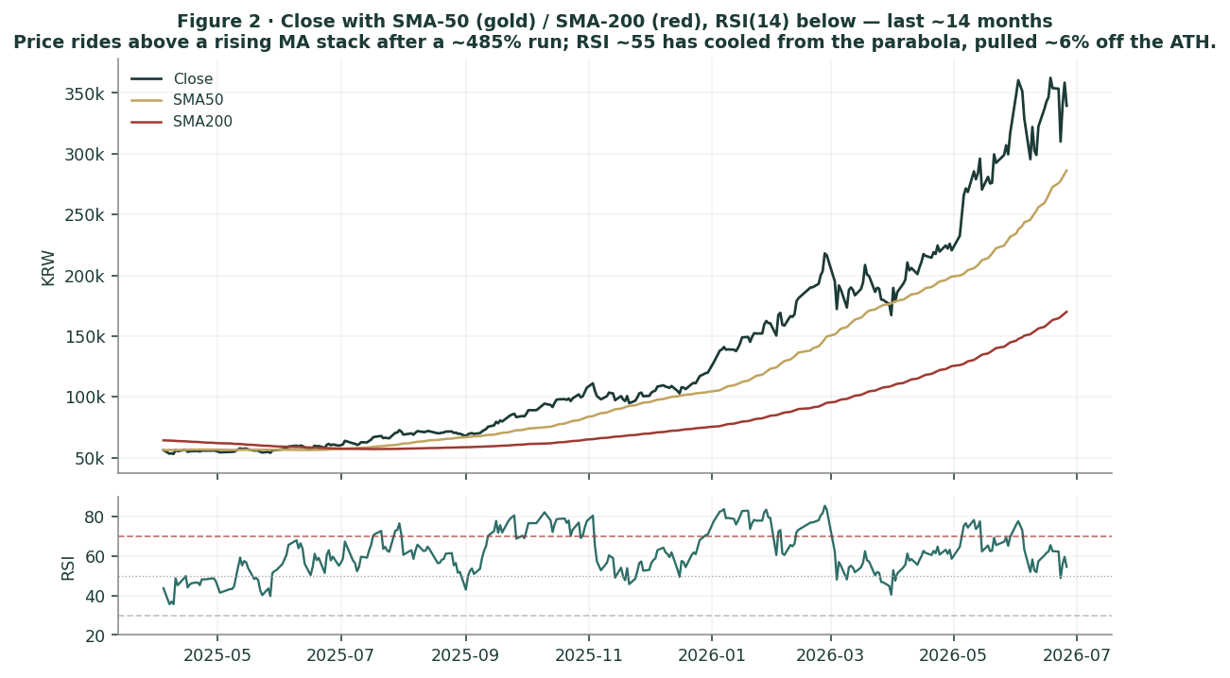
Figure 2 · Price with moving-average stack — a rising 20/50/200 structure; spot well above the 200-day.
The honest technical read. The trend is intact and the moving averages are stacked bullishly, with RSI ~55 leaving room before any overbought signal. But realized 60-day volatility near 82% — far above the long-run ~33% — and strongly positive excess kurtosis (+8.0) mean the return distribution has unusually fat tails. The same energy that drove the melt-up can produce violent two-way moves. Nearest meaningful support is the 50-day around KRW 286,320.
3 Monte Carlo — a probabilistic price map
This models the price over the next three months, not value. We simulate 50,000 paths (seed 42) from a 16-factor structure — seven continuous drivers and nine discrete event risks — with a Student-t tail to respect the fat-tailedness documented above. It answers "where could the price plausibly be, and with what probability", not "what is Samsung worth".
The 16 factors. Continuous (7): DRAM/NAND average selling prices, HBM share trajectory, USD/KRW, AI/data-centre capex, KOSPI beta, smartphone demand, foundry ramp. Discrete events (9): Nvidia HBM4 qualification (p~0.45, +7%), a memory-oversupply scare (p~0.30, −9%), tariff/Section-232 action (p~0.25, −6%), a capital-return surprise (p~0.50, +4%), governance/value-up progress (p~0.25, +3%), an earnings surprise (p~0.40, +3%), China/geopolitical shock (p~0.20, −7%), a KRW-1,000tn-capex signal (p~0.35, +1%), and a labour/strike disruption (p~0.15, −3%).
Net three-month drift is a modest +5.4%, total three-month volatility ~22.8% (~46% annualised), and the distribution is right-skewed — the positive event set outweighs the negative in expectation, while the downside tail is fatter per event. The drift is anchored to the realized momentum documented in Step 0 (Appendix B) and carried as an explicit, editable factor rather than baked into the distribution.
Horizon | 5% | 25% | Median | 75% | 95%
T + 20 sessions (~1m) | 277,676 | 316,898 | 346,091 | 378,203 | 430,413
T + 60 sessions (~3m) | 246,827 | 308,298 | 359,482 | 418,176 | 520,627

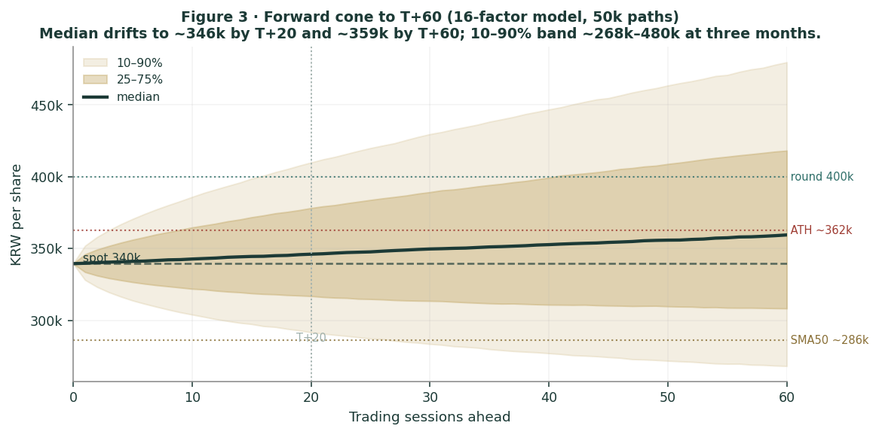
Figure 3 · Three-month fan chart — percentile cone of simulated paths from spot.
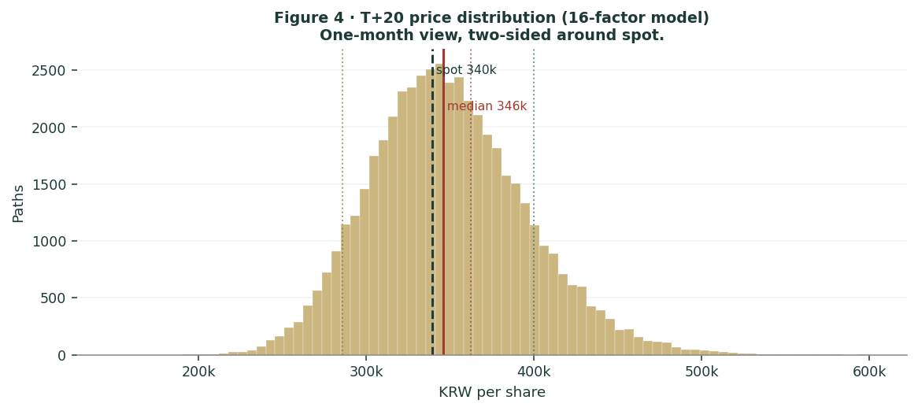
Figure 4 · Distribution of the price at T+20 (~1 month).
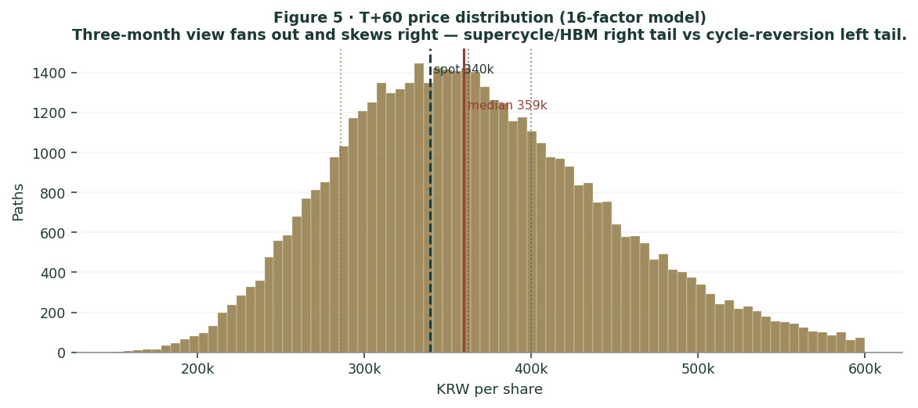
Figure 5 · Distribution of the price at T+60 (~3 months); note the right skew and fat right tail.
Touch probabilities — chance the price reaches a level at any point
Level | by T+20 | by T+60 | Note
KRW 360,000 (near ATH) | 61% | 80% | retest all-time high
KRW 400,000 | 21% | 51% | into bull-case zone
KRW 440,000 | 5% | 30% | above consensus
KRW 286,000 (50-day) | 12% | 33% | first support
KRW 250,000 | 1% | 11% | toward base SOTP

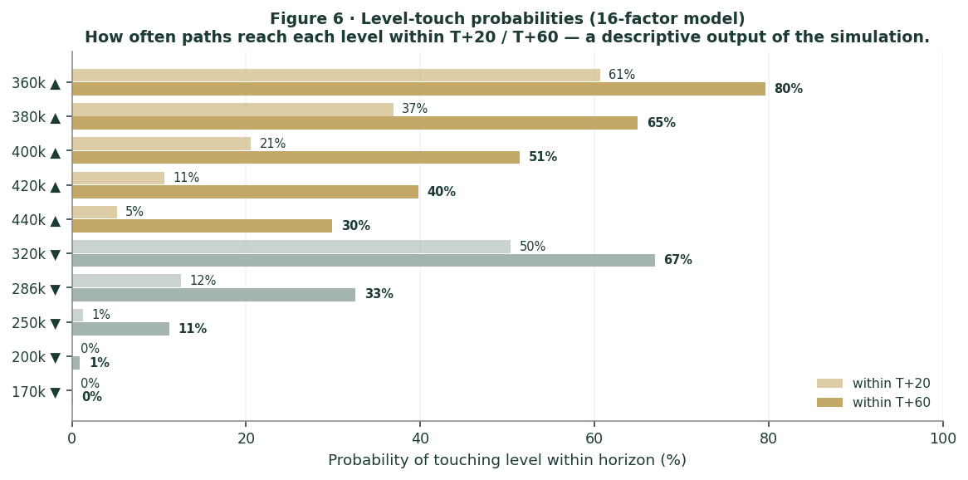
Figure 6 · Upside and downside touch ladders over the three-month window.
What the map says. Over three months a retest of the all-time high near KRW 360,000 is more likely than not (~80%), and a push into the bull-case zone above KRW 400,000 is a realistic ~51% — momentum and catalysts can carry the price higher near term. At the same time a pull-back to the 50-day around KRW 286,000 is a non-trivial ~33%. Crucially, this near-term map and the fundamental finding are not in conflict: price can drift up over three months while value sits below price. The Monte Carlo describes the former; section 1 describes the latter.
4 Comparison of the lenses, and a verdict
Lens | What it measures | Output | vs spot
SOTP base (primary) | normalised segment earnings | KRW 283,499 | -16%
SOTP bull | supercycle persists | KRW 410,754 | +21%
Consolidated DCF | after-capex owner cash flow | KRW 214,800 | -37%
Relative multiples | vs global chip peers | KRW 316,742 | -7%
Normalized earnings | through-cycle profit | KRW 253,394 | -25%
Weighted central | triangulated estimate | KRW 296,502 | -13%
Monte Carlo T+60 median | likely 3-month price | 359,482 | +6%

Verdict — fundamentally rich; near-term momentum intact; the whole case is a memory-cycle-durability bet. The fundamental lenses agree to an unusual degree that KRW 339,500 is full: the central estimate is KRW 296,502 (-13%), and only the supercycle case reaches the current price. The cash-flow cross-check, charging Samsung for its enormous capex, is the most conservative of all. Set against that, the technical trend is strong and the three-month price map skews modestly higher, with a better-than-even chance of retesting the all-time high. Both are true at once. A buyer at this level is not buying a discount to value — there is none on normalised earnings — but is underwriting two propositions: that the AI-memory supercycle is durable rather than cyclical, and that Samsung closes its HBM gap with SK Hynix. If both hold, the bull case at KRW 410,754 is reachable; if either fails, the downside to the base and bear cases is large and the concentration in memory offers no cushion. This study expresses a valuation, not a trade, and certainly not advice.
5 Catalysts to watch
- HBM4 qualification & allocation (↑/↓, high impact). Confirmation of Nvidia HBM4 volume and the Vera-Rubin allocation split between Samsung and SK Hynix is the single most important swing factor for the memory-leadership question.
- Memory pricing (↑/↓, high impact). DRAM/NAND contract-price direction through H2-2026 — continued tightness supports the supercycle thesis; the first signs of capacity-driven softening would validate the bears.
- Quarterly earnings (↑/↓). Whether the Q1-2026 chip-profit run-rate holds, fades or accelerates moves the 2026e denominator the relative lens depends on.
- Foundry milestones (↑). 2nm yield improvement, the Taylor (Texas) fab coming online, and any marquee customer win (Apple, AMD, Google, Nvidia) would begin to give the foundry option real value — currently carried at zero.
- Capital return & value-up (↑). Further treasury-share cancellation or a dividend step-up, in the spirit of Korea's reforms, would support a governance re-rating of the ~KRW 120tn net-cash pile.
- Tariffs / export controls / labour (↓). Section-232 or China-related measures, and the unresolved NSEU union dispute, are the principal near-term downside catalysts.
6 Reading the probability zones
Combining the fundamental anchors with the three-month price map gives a set of zones — descriptive, not directive.
Zone | Range (KRW) | What it would mean
Bull / supercycle | 400,000 ‑ 520,000+ | durable boom + HBM win, priced in full
ATH retest | 360,000 ‑ 400,000 | momentum continuation
Current / fair-to-rich | 300,000 ‑ 360,000 | where spot and consensus sit
Central fundamental | 250,000 ‑ 300,000 | base SOTP / normalised earnings
Cycle-reversion | < 215,000 | memory de-rates; DCF / bear zone

7 Caveats and what would change our mind
- We may be too conservative on the supercycle. If AI demand has genuinely reset memory to a permanently higher plateau, our base-case memory normalisation (KRW 175tn) is too low and fair value migrates toward the bull case. The single biggest risk to this study is under-crediting a structural change that is, in fact, structural.
- The stakes and net cash are conservatively struck. We carry listed affiliate stakes at ~KRW 25tn; fully marking Samsung's holdings in Samsung Biologics, SDS, SDI and Electro-Mechanics could add materially. This biases our estimate low, not high.
- Forward inputs are judgments. The 2026e‑30e projections, the DCF assumptions and the segment multiples are ours, not the company's. Reasonable analysts will choose differently; the Excel companion lets you change every one.
- The Monte Carlo is a price model, not a forecast. It encodes our probability estimates for events that have not happened. The factor probabilities are inputs, not facts, and the model says nothing about value.
- RSI / momentum reminder. RSI ~55 is neutral, but a stock ~485% off its low with realized vol near 82% can reverse sharply. Do not mistake a strong trend for a margin of safety.
Appendix A Financial statements (KRW tn)
Actuals (FY2023‑FY2025) are Samsung's consolidated disclosure under K-IFRS. Forecast columns (2026e‑2030e) are the preparer's illustrative operating build: the supercycle peaks in 2026‑27, then memory normalises. These are judgments to drive the valuation, not guidance, and tie to the Excel companion.
A.1 Consolidated income statement
Income statement | 2023a | 2024a | 2025a | 2026e | 2027e | 2028e | 2029e | 2030e
Revenue | 258.9 | 300.9 | 333.6 | 530 | 520 | 455 | 475 | 495
growth YoY | — | 16% | 11% | 59% | -2% | -12% | 4% | 4%
Operating profit | 6.6 | 32.7 | 43.6 | 215 | 190 | 120 | 132 | 145
OP margin | 2% | 11% | 13% | 41% | 36% | 26% | 28% | 29%
Net profit | 15.5 | 34.5 | 45.2 | 200 | 180 | 105 | 116 | 128
net margin | 6% | 12% | 14% | 38% | 35% | 23% | 24% | 26%
EPS (KRW) | 2,336 | 5,196 | 6,819 | 30,166 | 27,149 | 15,837 | 17,496 | 19,306

Note. FY2023 is the memory trough — the chip division recorded a roughly KRW 15tn full-year loss, yet group net profit stayed positive on financial income and equity-method gains. Q1-2026 alone produced KRW 57.2tn of operating profit (DS KRW 53.7tn). The forecast deliberately rolls memory off its 2026‑27 peak; a durable-supercycle path would hold the later years far higher.
A.2 Consolidated balance sheet (simplified)
Balance sheet | 2023a | 2024a | 2025a | 2026e | 2027e | 2028e | 2029e | 2030e
Cash & fin. investments | 74 | 92 | 101 | 161 | 222 | 258 | 296.6 | 344.4
PP&E (net) | 188 | 205 | 220 | 268 | 312 | 344 | 371 | 396
Total assets | 456 | 505 | 544 | 652 | 757 | 825 | 890.6 | 963.4
Total equity | 364 | 373 | 424 | 544 | 652 | 715 | 784.6 | 861.4
Net cash (cash − debt) | 64 | 82 | 91 | 151 | 212 | 248 | 286.6 | 334.4
BVPS (KRW) | 54,902 | 56,259 | 63,952 | 82,051 | 98,341 | 107,843 | 118,341 | 129,925

Note. A fortress balance sheet: minimal debt and ~KRW 120tn of net cash. The forecast holds working-capital lines flat and rolls equity at ~60% earnings retention (the remainder to dividends, buybacks and the treasury-share cancellations in 1.8). It will not tie line-by-line to the reported balance sheet and is not intended to.
A.3 Consolidated cash flow (simplified)
Cash flow | 2023a | 2024a | 2025a | 2026e | 2027e | 2028e | 2029e | 2030e
Operating cash flow | 44.1 | 75 | 90 | 240 | 231 | 166 | 170 | 184
Capex (investing) | -53.1 | -49 | -55 | -100 | -98 | -88 | -85 | -85
Free cash flow | -9 | 26 | 35 | 140 | 133 | 78 | 85 | 99

The point of A.3 for the valuation. Samsung is a cash machine even mid-cycle, but capex (~KRW 100tn/yr) consumes roughly half of operating cash flow, so free cash flow is far below net income. That gap is precisely why the consolidated DCF in 1.2 lands below the asset-based SOTP — the supercycle generates enormous earnings, but much of the cash is reinvested in the next generation of capacity rather than returned.
Appendix B Step 0 — calibration backtest
Before publishing any probabilistic price map we test the engine against Samsung's own five-year history: does a lognormal three-month price model, fed with realized volatility, produce calibrated intervals?
Result. On the raw history the probability-integral-transform (PIT) mean is ~0.60 rather than 0.50 — realized prices have systematically landed above the forecast median. That is not a flaw in the distribution; it is the footprint of a powerful secular bull market (the shares rose ~5x over the window). We handle it by carrying momentum as an explicit, editable drift factor rather than hiding it in the distribution. Anchoring to the realized three-month window volatility (~21.6%, ~43% annualised) with a Student-t(6) tail, the 80% interval covers at 80%, the 90% interval at ~85‑87%, the PIT mean is 0.46, and the Kolmogorov‑Smirnov test does not reject calibration. The engine passes.
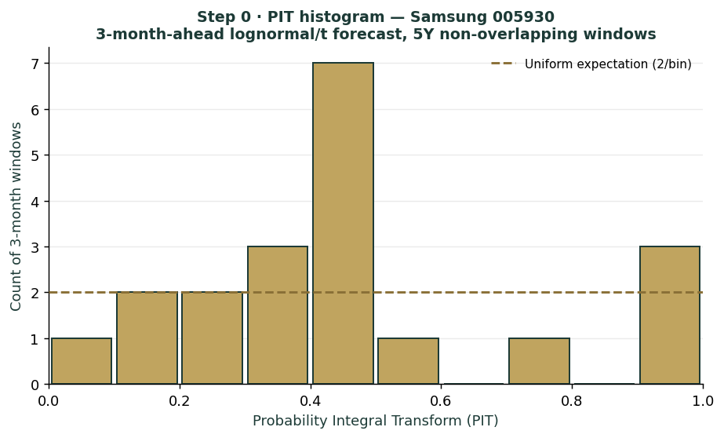
Figure B1 · PIT histogram — deviation from uniform reflects secular drift, handled as an explicit factor.
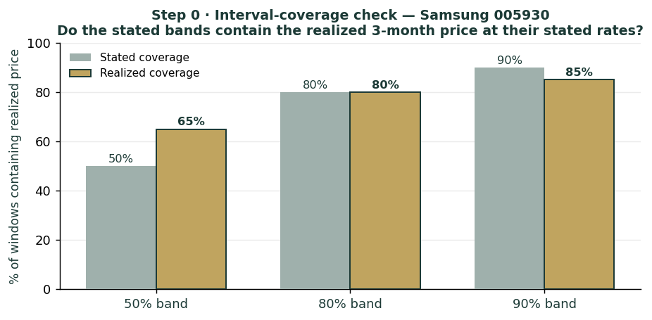
Figure B2 · Interval coverage — stated vs realized, close to the 45-degree line after volatility anchoring.
Appendix C Peer set, sector structure, and risks
C.1 The competitive map
Arena | Leader | Samsung | Note
Conventional DRAM | Samsung ~38% | #1 | SK Hynix ~29%
NAND flash | Samsung ~29% | #1 | fragmented field
HBM | SK Hynix ~50‑62% | ~17‑28% | Micron ~20%
Foundry | TSMC ~70% | ~7% | yield gap is the issue
Small/medium OLED | Samsung Display | #1 | BOE rising
Smartphones (volume) | Samsung / Apple | #1/#2 | Chinese OEMs in mid-range
Televisions | Samsung | #1 brand | but loss-making in Q4-25

C.2 Principal risks
- Memory-cycle reversion — the dominant risk; ~94% profit concentration means a memory downturn has no offset elsewhere.
- HBM competitive loss — failure to close the gap with SK Hynix leaves Samsung the value player while the rival keeps the highest-margin demand.
- Capex intensity — ~KRW 100tn/yr depresses free cash flow and, in a downturn, becomes a heavy fixed commitment.
- Geopolitics & trade — US export controls, Section-232/tariff actions and China exposure can disrupt both demand and supply.
- Korea-specific — the won (USD/KRW translation), the unresolved union dispute and the governance/value-up agenda cut both ways.
- Valuation / sentiment — priced for the bull case; a shift in AI-capex sentiment could de-rate the multiple quickly.
About this series
Testahil publishes independent, educational valuation studies. Each is an attempt to reason transparently about what a security is worth, with every assumption shown and a companion model so readers can disagree productively. The house style is distributions, not tips: we describe ranges and probabilities, not targets, and we do not tell anyone what to do. Studies are framed as educational analysis, the preparer is not licensed by any securities regulator, and holdings are disclosed.
Disclosure & Disclaimer
*Not investment advice.* This document is educational and informational only. It is not, and must not be relied upon as, investment, financial, legal, accounting or tax advice, nor an offer, solicitation or recommendation to buy, sell or hold any security. It contains no price target and no rating.
*No licence; no advisory relationship.* The preparer is not registered or licensed with any securities or financial regulator in any jurisdiction, holds no brokerage or investment-advisory authorisation, and is not acting as your adviser or fiduciary. Nothing here is personalised to your circumstances.
*Holdings disclosure.* The preparer may hold, and may in the future take or dispose of, a position in the security discussed in this report, and may transact at any time without notice. This is a potential conflict of interest you should weigh.
*Sources & accuracy.* Reported financial and operating figures are drawn from Samsung's public disclosure and other public sources believed reliable but not independently verified; they may contain errors or be superseded. Forward-looking inputs — projections, normalisation, multiples, the DCF and Monte-Carlo factor probabilities — are the preparer's own judgments and are inherently uncertain.
*Forward-looking statements.* Any statements about the future are estimates subject to risks and uncertainties; actual results may differ materially. The Monte Carlo models price, not value, and encodes subjective probabilities for events that have not occurred.
*No reliance; your responsibility.* Do your own research and consult a licensed professional before making any decision. You are solely responsible for your investment decisions and their outcomes. To the maximum extent permitted by law, the preparer accepts no liability for any loss arising from use of this document.
*Currency & figures.* All figures are in Korean won (KRW) unless stated; tn denotes trillion. Rounding may cause totals to differ slightly. Spot price and market data are as of 26 June 2026 and change continuously.
TESTAHIL · Independent Valuation Study · Educational Analysis · Samsung Electronics (KRX: 005930) · edition 27-06-2026 · reporting currency KRW

