TMGH Valuation Study — Educational Analysis
Independent Valuation Study — Educational Analysis
Talaat Moustafa Group Holding (EGX: TMGH)
Fundamental analysis · Technical analysis · Monte Carlo simulation — one integrated read
Anchor: EGP 96.80 (17 Jun 2026 close) · 2.061bn shares · mkt cap ~EGP 199.5bn · net cash ~EGP 72bn · prices & probabilities refreshed 17 Jun 2026 from the attached TMGH price history · independent bottom-up valuation of 9 Jun 2026
READ FIRST — what this document is, and is not. This study is a valuation exercise and an expression of personal analytical opinion, published free of charge for educational purposes: it shows how one analyst applies fundamental, technical and probabilistic methods to a listed company, and invites scrutiny of that methodology. It is NOT investment advice, NOT a recommendation or solicitation to buy, sell or hold any security, and NOT directed at the circumstances of any reader. The preparer is not licensed by the Egyptian Financial Regulatory Authority (FRA) or any other regulator, provides no financial consultancy, manages no money, and accepts no fees, funds or clients. see the Disclosure & Disclaimer at the end. All values are model outputs presented as ranges and distributions because no single number should be relied on. Consult a licensed financial advisor before any investment decision.

Headline
The model’s read: the three-month distribution skews constructive; the near-term recovery has extended on volume. An independent, clean-sheet bottom-up build — every project valued from units × price/m² and m² × construction-cost/m², hotels and recurring income valued as separate EBITDA-multiple segments, minority stripped segment-by-segment (hotels 40.5% for the ADQ/ADNEC stake, a contribution-weighted ~10% on the backlog — each JV at its actual share, ~nil on the wholly-owned Egyptian development and recurring) and the parent-attributable ~90% of net cash (~EGP 72bn group) added, with no external price target embedded — puts risk-adjusted fair value at EGP 147.1, ~52% above the EGP 96.80 market; full execution of the disclosed pipeline is worth EGP 189.6 (+96%). The defensible floor — net cash (90% parent) plus contracted backlog plus hotels plus recurring income, all risk-weighted — is ~EGP 83.6 (−14%). Technically the pullback from the 101.40 high found support near the rising 50-day mean (92.78) and the recovery has extended to 96.80, reclaiming the 20-day mean (96.00) and printing a 97.99 intraday high on 17 Jun on the heaviest volume in the sample (12.3m, ~2.4× the 20-day average), with RSI(14) recovering above its moving average to 55 and the daily MACD histogram narrowing — a correction resolving back up inside an intact uptrend. A single 10-factor Monte Carlo (CBE rate, FX, inflation, EGX flows, Brent/Gulf liquidity, geopolitics, cross-border JV inflows, launch execution, tourism, credit; 50,000 paths, seed 42) puts the T+20 median at ~99 and the T+60 median at ~105 with a right tail to ~144 driven by the launch and cross-border events. Net: the stock trades ~34% below the model’s risk-adjusted value, with the near-term tape turning up on volume; the right tail of the distribution belongs to launch execution and tourism, the left tail to FX/geopolitical macro and launch failure. This study estimates values and probabilities — it does not recommend actions.

1. Fundamental analysis
Method in plain terms. A DCF (discounted cash flow) values a stream of cash by the future cash it generates, discounted to today at a rate (the WACC) reflecting risk and the time value of money. TMGH is not one cash stream but a diversified portfolio: a development business (many projects), an owned-hotel portfolio operated by international flags, and a growing recurring-income base (malls, schools, sports clubs). Each development is valued as its own DCF and summed — a sum-of-the-parts (SOTP) — while hotels and recurring income are valued on EBITDA multiples appropriate to those asset types. The backlog and mature sites are the existing business; the un-launched land and the cross-border JVs are pipeline option value — worth a great deal if they execute, little if they don’t, so each is weighted by an execution probability. Minority is then deducted segment-by-segment using actual ownership — 40.5% on the hotels (the ADQ/ADNEC stake in ICON), a contribution-weighted ~10% on the consolidated backlog (each JV at its actual partner share — Banan 49%, Oman 40%, Iraq 50% — weighted by its share of the book), and nil on the ~99.99%-owned Egyptian development and recurring and on the cross-border JV projects, which are already carried at TMG's economic share — and the parent-attributable ~90% of net cash is then added to reach equity value.
This build is bottom-up: each project starts from its unit mix priced per square metre, with construction and land costed per square metre, and only the unsold remainder is valued — already-sold units sit in the contracted backlog, so nothing is double-counted. Each cohort carries an EGP price escalator (~14%/yr) and is collected over a down-payment-plus-instalment schedule. Crucially, each development is valued as a self-liquidating run-off — the cash flows run only to completion of the disclosed pipeline, with no perpetual-growth (Gordon) terminal value bolted onto a finite land bank, because a developer is a depleting pool of projects, not a going concern with a stable perpetuity. Construction is paced to TMGH’s actual run-rate, so consolidated free cash flow is positive throughout and the consolidated land-and-WIP inventory self-liquidates from book rather than running negative. Full mechanics and every input are in the companion Excel model.
The standing method, and the global standard. For a listed property developer, the primary valuation method used across global and regional investment banks is a revalued net-asset value (RNAV) built as a sum-of-the-parts: each development is valued by a discounted cash flow of its own project economics; recurring and hospitality income are capitalised on multiples; and a discount to gross NAV is then applied to reach a target price. A whole-company DCF is a cross-check, not the primary lens — and for a developer it must be a self-liquidating run-off, because bolting a perpetual-growth terminal value onto a finite, depleting land bank double-counts. This study reports all three lenses side by side and then selects a representative figure.
The three lenses. The primary lens (A) is the execution-weighted SOTP/RNAV. The consolidated run-off DCF (B) is the cross-check: with the perpetuity removed it ties to the SOTP gross, confirming the asset value rather than adding to it. The NAV-less-discount lens (C) is the street-style basis used to set a target price, and relative multiples are a memo sanity check.
Lens | EGP / share | Basis — and how it is computed
A. SOTP / RNAV — PRIMARY | 147.1 | Per-project DCF (unsold remainder) + hospitality and recurring segments on EBITDA multiples + net cash (90% parent) − segment minority. Risk-adjusted (execution-weighted) central; 189.6 gross at full execution; 83.6 bear. The primary method for a diversified developer.
B. Consolidated run-off DCF — cross-check | 196.5 | Whole-company unlevered FCFF discounted at WACC, self-liquidating, with NO perpetual-growth terminal value. Ties to the SOTP gross (189.6), validating the primary method rather than adding to it.
C. NAV less holding-company discount — street-style | 113.7 / 104.3 | Gross NAV (189.6) × (1 − discount): 40% (current street) and 45% (7-yr average). The basis on which a published target price is set; brackets the conservative side.
Relative multiples — memo | — | P/E ~13.9× trailing on attributable profit (developer peers ~6.4×); EV/backlog ~0.28× on the EGP 458bn book. Sanity checks, not a primary value.
REPRESENTATIVE FUNDAMENTAL VALUE | 147.1 | Execution-weighted SOTP/RNAV (the primary lens). Full fundamental range across lenses ~104–197; bear floor ~83.6; gross ceiling 189.6.
Selecting the representative fundamental value. Following the global standard for a diversified developer, this study anchors on the execution-weighted SOTP/RNAV — EGP 147.1 — as its representative fundamental value. The consolidated run-off DCF (EGP 196.5) confirms the gross NAV; the NAV-less-discount lens (EGP 104–114) and relative multiples bracket the conservative side; and the bear construction (EGP ~83.6) marks the floor. The full fundamental range is therefore ~EGP 104–197, with a gross (full-execution) ceiling of 189.6. No further blanket holding-company discount is layered on top of the execution-weighting, which already performs the risk adjustment; applying both would double-count.
Component (bottom-up build) | Risk-adj EGP/sh | What it is
Contracted backlog | 25.47 | already sold (EGP 458bn); collected over ~7 yrs
Madinaty — core (unsold remainder) | 10.02 | flagship 33.6m m²; mostly pre-sold, remainder here
SouthMED — North Coast | 10.34 | 23m m² mega-coastal; risk-weighted launch
The Spine — knowledge city | 9.38 | EGP 1.4tn vision; ~EGP 30bn sold in 15 days; early
Noor City — East Cairo | 8.29 | 21m m²; first deliveries H2-2026
Banan — Riyadh, KSA (51% JV) | 6.27 | first cross-border (NHC JV); risk-weighted
Sharm Bay + Privado + Celia | 9.98 | resort + Madinaty lux infill + New Capital
Oman (Yamal+Joud) + Baghdad + Al Rehab | 5.04 | intl JVs (heavily weighted) + mature remainder
Landbank + terminal value (5% g) | 4.24 | undeveloped land + a modest residual for the platform beyond the disclosed pipeline
Development + backlog subtotal | 89.05 | the property engine
Hotels (9 owned, intl-operated) | 23.59 | Four Seasons, Kempinski, Sofitel, Marriott — EBITDA × mult
Recurring income (malls/schools/clubs) | 15.16 | fast-growing annuity base — EBITDA × mult
Operating EV / share | 127.78 | all three businesses, risk-weighted
Add: net cash (90% parent, ~EGP 65bn) | +31.40 | group net cash 71.9 × 90% parent-attributable
Less: minority — hotels 40.5% + backlog | −12.06 | ADQ/ADNEC 40.5% of ICON + contribution-wtd JV shares on backlog
Base-case equity value | 147.12 | +52% vs 96.80; full execution EGP 189.6 (+96%)
Scenarios (by execution probability): Bear / defensible floor EGP ~83.6 (−14%; net cash at 90% parent + contracted backlog + hotels + recurring, all unsold pipeline ≈ 0) · Base, risk-adjusted EGP 147.1 (+52%) · Full execution of disclosed pipeline EGP 189.6 (+96%).
External cross-check. This study's risk-adjusted base, EGP 147.1, sits ~13% above the Analyst Target Price of EGP 130 (Buy, 31 Aug 2025), and the difference is about the discount, not the assets. The analyst reaches 130 from 0.6× forward NAV — a flat 40% discount to gross NAV (7-yr average ~45%). This study risk-weights each project by its own execution probability — a ~22% haircut to its own full-execution value (189.6 → 147.1) — and adds no further blanket holding-company discount, so its base is a clean, execution-weighted NAV. The ~EGP 17 gap to the Analyst Target Price is essentially the size of the holding-company/sentiment discount one chooses to apply; the market, at 96.80, is pricing more still (~34% below this study's base, ~26% below the analyst target). Apply a 15–40% discount to this study's base and the range is ~EGP 88–125, which brackets both the Analyst Target Price and the market.
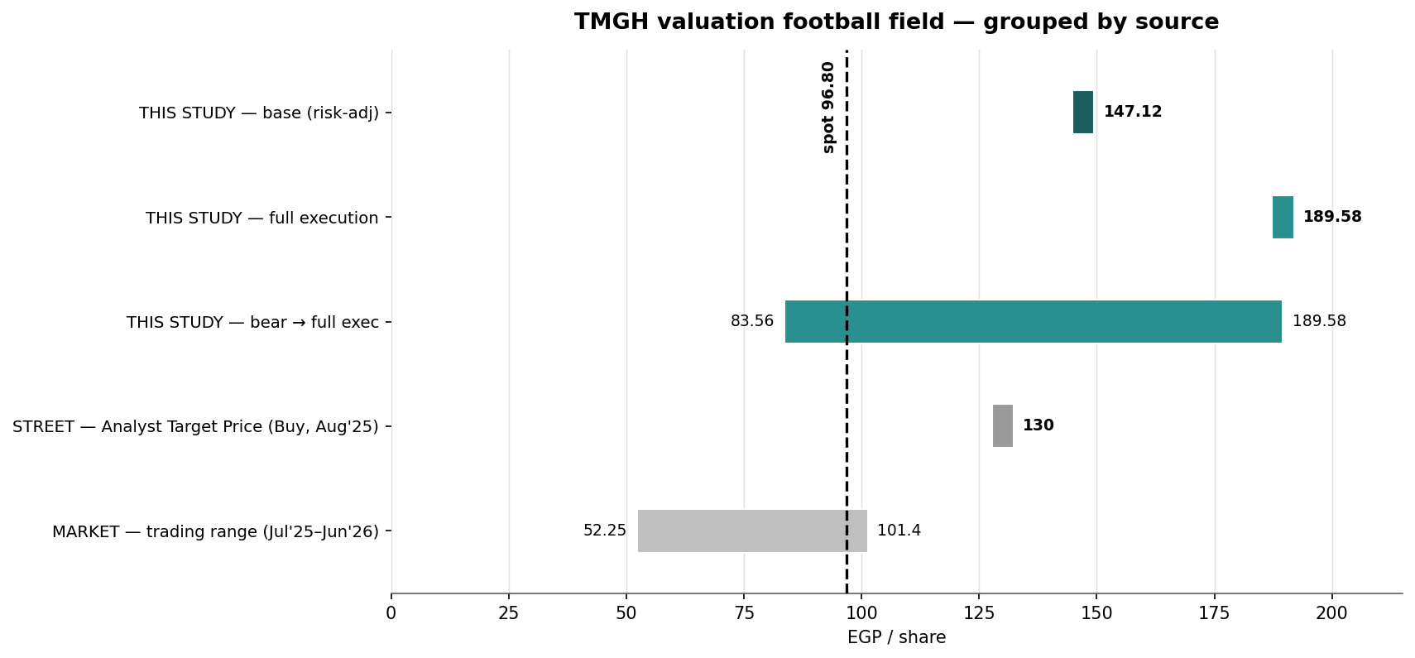
Figure 1. Valuation football field, grouped by source. THIS STUDY: base 147.1 (risk-adjusted, dark) inside its bear-to-full-execution range of 83.6–189.6; full execution 189.6. STREET: Analyst Target Price 130 (Buy, 31 Aug 2025 — the most recent street note, dated). MARKET: the trading range (Jul'25–Jun'26, 52.25–101.4) and spot 96.80 (dashed), both taken from the attached price history. At spot the market pays for the contracted business, segments and net cash plus little pipeline execution. Every bar is defined, with its source, in the table below.

1.1 The three operating streams — development, hospitality, recurring
The base value is the sum of three businesses valued by the method that fits each: development + backlog by discounted cash flow (89.05/sh risk-adjusted), and two operating segments capitalised on EBITDA multiples. Hospitality and recurring income are often conflated but are distinct — different revenue, different cyclicality, hence different multiples — and the model keeps them apart. The companion Excel carries a dedicated Segments sheet for the two capitalised segments; the table below sets all three streams side by side.
Dimension | Development + backlog (DCF / SOTP) | Hospitality (9 owned hotels) | Recurring income (malls/schools/clubs)
What it is | Egyptian + cross-border land sold as units — Madinaty, SouthMED, Noor, Sharm Bay, Banan, Oman, Iraq — plus the contracted backlog | Owned hotels (Four Seasons, Kempinski, Sofitel, Marriott…) under intl mgmt contracts | Retail/malls, schools, sports clubs, utilities & services inside the cities
Revenue driver | Units × price/m², collected over down-payment + instalments — mostly EGP | Room nights × ADR + F&B + events — partly USD | Rents + tuition + memberships + fees — mostly EGP
Cyclicality | Cyclical — launch timing, mortgage availability, FX on build cost | High — tourism, FX, seasonal | Low — contractual, sticky
Revenue / EBITDA (FY est.) | Valued on project cash flows, not an EBITDA multiple | ~17.2 / 8.8 (≈51% owned-asset margin) | ~10.8 / 4.9 (≈45% blended)
Valuation | Discounted cash flow per project (SOTP), + backlog + terminal value | EBITDA × 6.5× (lower, for cyclicality) | EBITDA × 7.5× (higher — an annuity premium)
Risk-adj EV (EGP bn) | 183.5 | 48.6 | 31.2
Contribution / share | 89.05 | 23.59 | 15.16
Key fundamentals — Q1-2026: revenue EGP 13.1bn (+39% YoY); net profit after tax EGP 5.5bn (+24%); real-estate segment revenue EGP 6.1bn (+61.6%); hospitality EGP 4.3bn (+21%); recurring EGP 2.7bn (+26%). New contracted sales EGP 49.1bn (−36% YoY, against a one-off ~EGP 17bn Madinaty bulk-sale base in Q1-25 — timing, not demand). Backlog EGP 457.9bn (~7.3× FY25 revenue). FY-2025: revenue EGP 62.5bn (+46%); consolidated net profit EGP 18.2bn; attributable net profit EGP 14.38bn (EPS 6.98) — implying ~21% minority interest; dividend EGP 0.30/sh. P/E ~13.9× trailing on attributable profit vs developer peers ~6.4×; EV ~EGP 128bn (market cap less net cash) against an EGP 458bn backlog → EV/backlog ~0.28×. The defining feature is the balance sheet: cash ~EGP 86.7bn vs debt ~EGP 14.8bn → net cash ~EGP 72bn (≈36% of market cap) — the inverse of the leveraged developer, which removes the rate-shock vulnerability that constrains the sector. Vendor-sourced ratios are flagged as such; audited figures are distinguished from estimates in the model.
Reading the football field — where every number comes from. Three kinds of bars sit on one axis: what THIS STUDY computes, what the STREET publishes, and what the MARKET has actually paid. They are deliberately not blended — each answers a different question.
Bar on the chart | EGP/sh | How it is computed — and where it comes from
Base case (risk-adjusted) | 147.12 | THIS STUDY. Each project’s DCF × its execution probability, + the hotel and recurring segments, + net cash (90% parent), − minority (segment-specific: hotels 40.5%, backlog 9.85% wtd-avg), ÷ 2.061bn shares. The number this study stands on; every input is in the companion Excel.
Full execution (gross) | 189.6 | THIS STUDY. The identical per-project bridge with every execution probability set to 100% — the ceiling if all projects, the backlog, the segments and the terminal value deliver exactly as modelled.
Bear case (range floor) | ~83.6 | THIS STUDY. Net cash (90% parent) + contracted backlog + hotels + recurring income, all risk-weighted, with every unlaunched project and the terminal value at ZERO — the floor if no new launch ever executes.
Analyst Target Price | 130 | STREET. Analyst target, Buy, 31 Aug 2025, 0.6× forward NAV (40% discount). Most recent street note; dated, shown for cross-check only.
Trading range (Jul'25–Jun'26) | 52.25–101.4 | MARKET. The EGX trading range over the attached ~11½-month price history (1 Jul 2025–17 Jun 2026). Spot 96.80 (the 17 Jun close) is the level all bars are judged against.

2. Technical analysis
All technical inputs below are computed directly from the attached TMGH daily price history (1 Jul 2025 – 17 Jun 2026, 234 sessions).
Timeframe | Trend | Read
Weekly / long | Strong up | Secular bull; +76% over the sample; price far above the rising SMA150 (83.79, +15.5%); the pullback off the 101.40 high held above the 50-day mean and the recovery has resumed — trend intact
Daily | Recovering | Pullback 101.40→92.91 found support at the rising SMA50 (92.78); the recovery extended to 96.80, reclaiming the SMA20 (96.00) and tagging 97.99 intraday on 17 Jun; RSI(14) 55.2 recovered above its MA (52.9); MACD hist −0.32 and narrowing (−0.56→−0.47→−0.32) → momentum turning up
Hourly / short | Breakout test | 17 Jun closed 96.80 (+1.3%) after tagging 97.99, on 12.3m shares — about 2.4× the 20-day average and the heaviest in the sample; the SMA20 is reclaimed, the 97.4–98.0 swing-high cluster is the immediate test

Resistance | Pivot | Support
R3 101.40 (period high, 20 May) | spot 96.80 | S1 96.00–95.26 (SMA20 / SMA5)
R2 99.27–100.95 (Boll upper / round) | ATR(14) 2.36 (2.4%) | S2 92.78–92.16 (SMA50 / Boll lower / swing low)
R1 97.39–97.99 (swing high / 17 Jun high) | range 52.25–101.40 (Jul'25–Jun'26) | S3 86.56 / 83.79 (swing low / SMA150)
Daily ATR(14) is EGP 2.36 (2.4%); realized volatility is ~36% annualized on the trailing 60 sessions (35.6%; full-sample 32.1% over the longer window), with mild positive skew (+0.67) and fat tails (excess kurtosis +2.2) — all measured from the attached history. The decisive tell is the moving-average configuration: price sits above a rising 50-day (medium-term constructive) and well above the 150-day (long-term intact), and the bounce came on rising volume — the slide into 92.91 was on lighter turnover than the 12.3m-share advance on 17 Jun. A daily close back above the 97.4–98.0 swing-high cluster confirms the resumption toward 100–101.4; a close below the 92.78 SMA50 reopens the 88 and 83 supports.

3. Monte Carlo simulation — one model, ten external factors
Method. One simulation, not a model zoo: 50,000 daily paths to T+60 are driven by ten external factors. Five are continuous (compounding daily with drift and volatility): the CBE policy-rate path, the EGP/USD rate, inflation, EGX30/foreign-flow beta, and Brent/Gulf liquidity. Five are discrete events (each occurring with a stated probability on a random session, with a stated impact): a geopolitical/regional-security shock, cross-border JV inflows (KSA/Oman/Iraq), project-launch execution, tourism/hospitality demand, and mortgage-credit conditions. Idiosyncratic company noise (calibrated to the attached history) tops the paths up to TMGH’s realized volatility. The factors are adapted to TMGH’s nature — its net-cash balance sheet softens the rate channel, its nine owned hotels make tourism a material lever, and its cross-border JVs replace PHDC’s Ras El-Hekma inflow. Every drift, probability and impact below is an explicit, editable judgment — the table IS the model.

3.1 The ten external factors — calibration
Factor (10 external drivers) | Type | 3M drift / prob. | 3M vol / impact | Channel
1 CBE policy rate path | continuous | +2.0% | 4% | discounting, softened by interest income on net cash
2 EGP/USD exchange rate | continuous | −2.5% | 7% | FX translation; USD hotel revenue + KSA/Oman
3 Inflation (CPI) | continuous | +1.5% | 4% | real-asset hedge bid, construction costs
4 EGX30 & foreign flows | continuous | +1.5% | 7% | market beta, liquidity
5 Brent oil / Gulf liquidity | continuous | +0.5% | 5% | GCC buyer purchasing power; North Coast + KSA
6 Geopolitical / regional security | event | p = 30% | −12% (±5%) | risk-premium shock
7 Cross-border JV inflows (KSA/Oman/Iraq) | event | p = 30% | +6% (±4%) | Banan/Oman/Baghdad funding & sentiment
8 Project launch & sales execution | event | p = 55% | +8% (±4%) | SouthMED / The Spine / Noor — the catalyst
9 Tourism & hospitality demand | event | p = 45% | +4% (±6%) | nine owned hotels — a material lever for TMGH
10 Mortgage finance & credit | event | p = 35% | +2% (±5%) | affordability, velocity

3.2 Percentile estimates (anchor 96.80, 50,000 paths)
Horizon — 10-factor model | 5% | 25% | Median | 75% | 95%
T+20 (~1 month) | 82.37 | 92.24 | 99.46 | 107.34 | 120.63
T+60 (~3 months) | 76.47 | 92.27 | 105.14 | 119.80 | 144.42
The five continuous factors compound daily; the five event factors arrive as discrete jumps on a random session within the window. Net expected 3M factor contribution is ~+8% before idiosyncratic noise; annualized path volatility is ~39% (vs ~36% realized over the attached sample — kept deliberately wide into the launch window). The T+60 distribution is right-skewed: median 105.1, with the launch and cross-border events carrying the upside shoulder and the geopolitical jump the left tail.

3.3 Forward cone — percentile cone to T+60
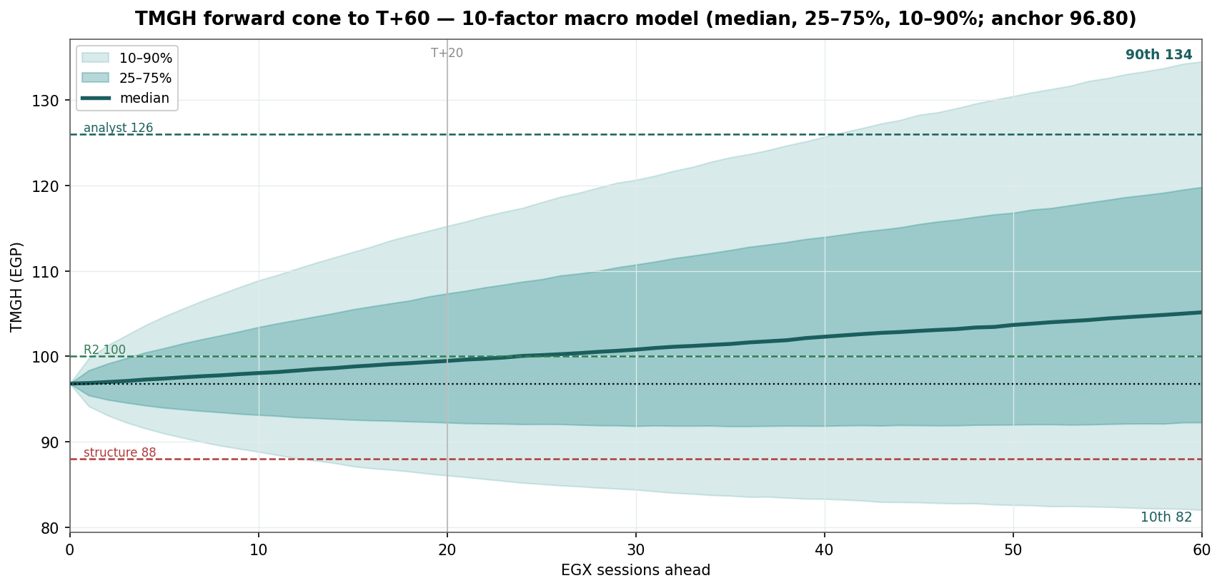
Figure 2. Forward cone (median, 25–75%, 10–90%) from the 10-factor macro model. The median drifts to ~99 by T+20 and ~105 by T+60; the 10–90% band spans ~89–113 at one month and ~82–135 at three. Dashed reference levels: 100 (R2 cluster, green), 126 (analyst-target area, teal), 88 (structure-break, red); dotted: spot 96.80; vertical mark at T+20.

3.4 Probability bell curves at T+20 and T+60
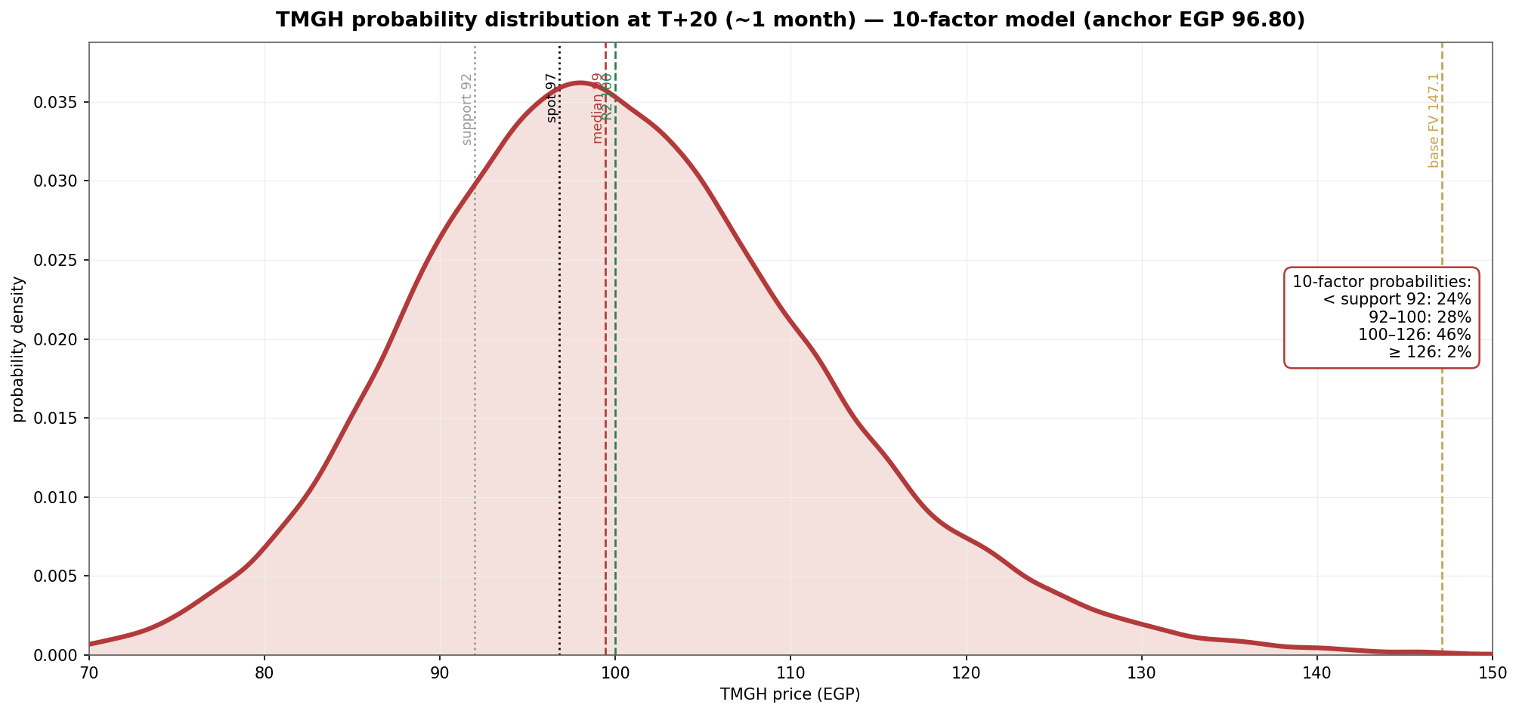
Figure 3. T+20 distribution (10-factor model): 24% below the 92 support, 28% in 92–100, 46% in 100–126, 2% ≥ 126. The body sits just above spot; the upside targets are largely out of reach on a one-month horizon.
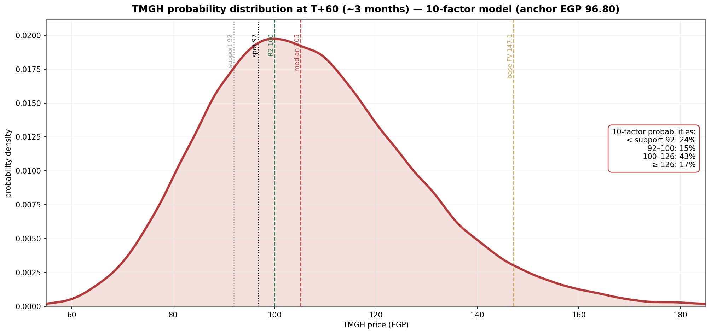
Figure 4. T+60 distribution (10-factor model). The three-month view fans out and skews right — median 105.1, with 17% of paths above the 126 analyst-target level while 24% still finish below the 92 support. This is where the catalyst factors pay; the geopolitical jump keeps the left tail honest.

3.5 Level-touch probabilities
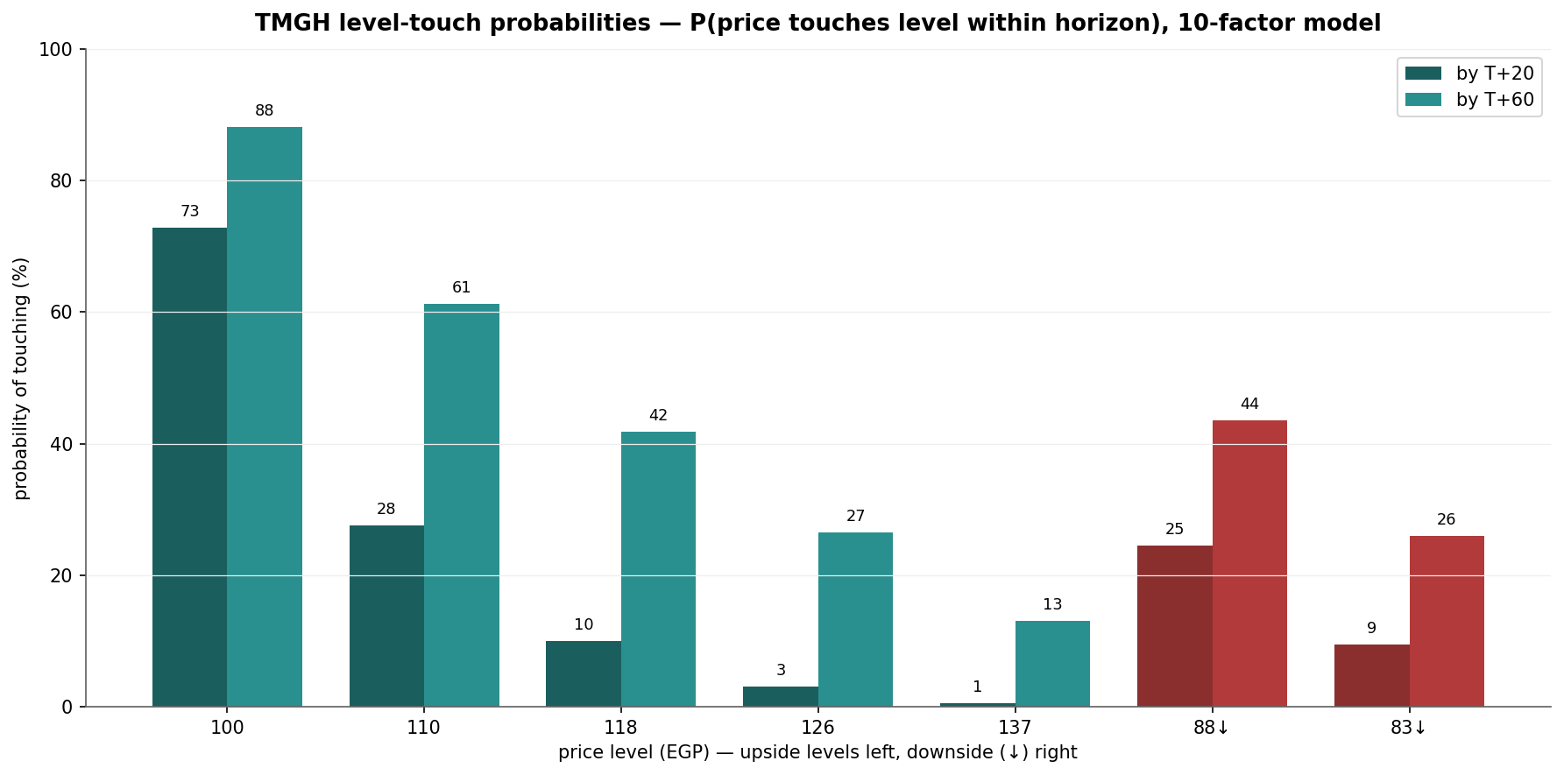
Figure 5. Level-touch probabilities (10-factor model) — probability of the price touching each level within each horizon (T+20 / T+60): upside 100 = 73%/88%, 110 = 28%/61%, 118 = 10%/42%, 126 = 3%/27%, 137 = 1%/13%; downside 88 = 25%/44%, 83 = 9%/26%. A descriptive output of the simulation: how often paths reach each level, nothing more.

4. Comparison — fundamental vs technical vs Monte Carlo
Lens | Core output | What it says | Analytical implication
Fundamental | Base EGP 147.1 risk-adjusted; 189.6 full execution; ~83.6 bear | Fair value ~52% above market before any holding-company discount. Contracted backlog + the two segments + net cash (90% parent), net of minority, are ~EGP 83.6/sh; everything above is execution of SouthMED, The Spine, Noor and the cross-border JVs | Modelled value sits well above price; below ~83.6 the market would pay less than the no-pipeline construction
Technical | Pullback held the rising SMA50; the recovery extended on heavy volume; RSI back above its MA, MACD hist narrowing | A mature uptrend that has digested its −9% correction; price back above both the 50-day and the 20-day | The advance has volume confirmation; the first dense resistance is the 97.4–100 cluster, then 101.4
Monte Carlo (10-factor) | T+20 median 99.5 (24% below 92); T+60 median 105.1 (17% ≥ 126) | One month is two-sided with a slight upward tilt; three months skew right as the launch and tourism events pay | Time favours the right tail; the launch window is where the distribution widens
Verdict: the three lenses tell one story on different clocks — the near-term tape has turned back up with volume confirmation, the three-month distribution skews right on launch execution and tourism, and the fundamental value sits ~52% above price with a floor only ~14% below it. That ~52% is the undiscounted, execution-weighted asset value: the gap to the EGP 130 Analyst Target Price and to the market is essentially the holding-company/NAV discount each chooses to apply (the analyst 40%, the market more), not a disagreement on the assets. Below ~83.6 the market would be pricing less than even the contracted-plus-cash construction. The fundamental upside and the technical recovery are aligned; the Monte Carlo simply says the next month is two-sided while the quarter pays. What, if anything, follows for any individual depends on circumstances this study does not know and does not address.

5. Catalyst calendar
Catalyst | Date | In window | Read
May CPI | ~10 Jun | done | Disinflation supports the multiple; a re-acceleration would pressure it — neutral as printed
The Spine / SouthMED launches | Summer 2026 | in window | The pivotal event — the largest single upside factor in the simulation (p = 55%)
CBE MPC | 9 Jul | within T+20 | Cuts help sentiment, but net-cash TMGH is far less rate-sensitive than levered peers
Q2 results (backlog→rev) | ~mid-Aug | T+60 | Revenue-recognition story as backlog converts; a 3-month, not near-term, driver
Noor City first deliveries | H2-2026 | out | Execution proof-point on a 21m m² project; de-risks a major pipeline block
KSA / Oman / Iraq milestones | 2026–2028 | out | Cross-border optionality (Banan, Yamal+Joud, Baghdad); long-dated, heavily risk-weighted

6. Reading the probabilities — significant zones (analysis, not guidance)
This section translates the simulation into the price zones where the three lenses say something analytically distinct. It is a map of the distribution — not a plan, not guidance, and not calibrated to any reader’s circumstances.
- 97.4–101.40 — the overhead test. The 97.4–98.0 swing-high cluster (now just above spot), the Bollinger upper / round 100, and the 101.40 period high sit overhead; 73% of simulated paths touch 100 within one month (88% within three).
- 101–126 — the re-rating zone. The discrete event factors (launch p = 55%, cross-border p = 30%) place most of the right tail here; 28%/61% of paths touch 110 and 10%/42% touch 118 (T+20/T+60), with 3%/27% reaching the 126 level — around the EGP 130 Analyst Target Price and near the top of where the three-month cone realistically reaches.
- 128–137 — Analyst-target / cone-ceiling zone. The Analyst Target Price of EGP 130 sits here, as does the 137 level that only 1%/13% of paths touch (T+20/T+60) — effectively the ceiling of the three-month distribution. This study's risk-adjusted base, EGP 147.1, sits above this band entirely: it is an undiscounted, execution-weighted NAV, and the cone reaches it only beyond three months and only on strong execution together with a narrowing of the holding-company discount the market currently applies.
- 92 / 88 / 83 — the structural-floor zone. Below the 92 support (SMA50 / bounce low) the recovery is in question (downside touch of 88 ≈ 25% by T+20, 44% by T+60); below ~83–84 (the no-pipeline construction ≈ 84; SMA150 ≈ 83) the market would price the company beneath even the bear construction — the level at which this study’s base framing would itself need rebuilding (touch of 83 ≈ 9%/26%).

7. Caveats
- Minority interest and the holding-company discount are the two assumptions that move this number most. Minority is deducted segment-by-segment from actual ownership: 40.5% on the hotels (the ADQ/ADNEC stake in ICON — the only large, hard number), a contribution-weighted ~10% on the consolidated backlog (each JV at its actual partner share — Banan 49%, Oman 40%, Iraq 50% — weighted by its share of the book), and nil on the ~99.99%-owned Egyptian development and recurring and on the cross-border JV projects, which are already carried at TMG's economic share, so re-deducting would double-count. On the backlog the partner shares are known; the only soft input is the EGP split of the EGP 457.9bn book (Banan ≈79bn, Oman ≈16bn, Iraq ~nil), and a wide ±10pp swing in it moves the base by only ~±EGP 1.5/share. The larger judgment is that this study applies no blanket holding-company/NAV discount, so the EGP 147.1 base is a clean execution-weighted NAV; the analyst layers a 40% discount to reach 130 and the market prices more. A 15–40% holding-company discount on this study's base gives ~EGP 88–125, bracketing the Analyst Target Price and the market — so the +52% is the undiscounted asset value, not an entry signal. The audited FY2025 segment notes (ownership of each development entity and the backlog split) would tighten both the minority and the discount.
- Net cash is credited at 90%, not 100%. Subsidiary research indicates ~90% of the ~EGP 72bn net cash is parent-attributable (range 85–95%): it sits overwhelmingly in the ~wholly-owned development core, with only ~EGP 2.6bn in the 59.5%-owned hotels at Sep-2025. Crediting 100% (the earlier draft) overstated value; a 5-point move in the parent share is worth ~±EGP 1.7/share.
- Bottom-up valuation is assumption-driven (WACC 18%, each project’s sold/unsold split, the JV partner-land charge, ~14% escalation, the normalized terminal FCFF, and the hotel/recurring EBITDA and exit multiples) — calibrated to disclosed totals, not audited project-level data. Illustrative ranges, not precision; NAV and multiples remain useful external cross-checks.
- Execution risk compounds over 10+ years — much of the upside (SouthMED, The Spine, Noor, and especially the KSA/Oman/Iraq JVs) is long-dated and carries FX, partner, permitting and political risk; Baghdad in particular is very early and heavily discounted here for good reason.
- Monte Carlo factors are independent (no cross-correlation matrix or volatility clustering yet — rate cuts and FX moves are in reality linked); each factor’s drift, probability and impact is judgment, not estimation; event timing within the window is uniform-random. Technical inputs and the idiosyncratic volatility are computed from the attached vendor price history and not reconciled to exchange tick data.
- No exact launch/delivery dates (“summer 2026”, “H2-2026”); an EGX sales-start or delivery disclosure would sharpen the catalyst-window timing.
Momentum-reading note (educational). A standard divergence read: price rising while RSI stalls or falls under its moving average is the classic bearish-divergence configuration — momentum fading into strength. Price and RSI rising together marks a healthy trend (the current daily condition: price recovered to 96.80 while RSI rose above its moving average to 55 — momentum confirming the turn, not diverging). On the downside, price falling while RSI rises flags seller exhaustion; both falling together marks an intact downtrend. These are descriptive patterns for reading momentum, not signals to act on.

Appendix — About this series: the standing format
Every instrument (equity or metal) analysed in this educational series follows the same standing format, in order:
- Headline — the analytical read, timeframe and key numbers, one paragraph.
- 1. Fundamental analysis — DCF (or cost-curve/real-rate model for metals) + multiples + NAV/SOTP (per-project for developers; EBITDA-multiple segments where diversified) → football field → fair-value range. For metals: real US 10Y, DXY, central-bank buying, inventories, COT.
- 2. Technical analysis — weekly/daily/hourly trend, levels table, ATR/vol, the volume tell.
- 3. Monte Carlo simulation — ONE model: ten external macro factors (policy rate, FX, inflation, market/flows, oil/Gulf liquidity, geopolitics, sovereign/JV inflows, launch execution, tourism/demand, credit), 50,000 paths; factor table + percentile table + forward cone + bell curves (T+20/T+60) + level-touch probabilities.
- 4. Comparison — fundamental vs technical vs Monte Carlo — one table reconciling the three lenses + a verdict: where they agree, where they differ, and on what clock.
- 5. Catalyst calendar · 6. Probability map · 7. Caveats + momentum note · closing Disclosure & Disclaimer.

Disclosure & Disclaimer — read in full
Nature of this document. This study is an educational valuation exercise and an expression of the preparer’s personal analytical opinion, based exclusively on publicly available information and on assumptions stated in the text and the accompanying model. It is published free of charge, on a standing periodic schedule, to demonstrate methodology and to invite scrutiny and critique of that methodology. No advice, no recommendation, no solicitation. Nothing in this document constitutes investment advice, financial consultancy, securities analysis services, a research recommendation, a rating, a price target, an offer, or a solicitation or invitation to buy, sell, hold, subscribe for or otherwise deal in any security or financial instrument. No statement herein is directed at, or calibrated to, the investment objectives, financial situation, risk tolerance or particular needs of any person. No licensed activity. The preparer is not licensed or registered with the Egyptian Financial Regulatory Authority (FRA) or any other securities regulator; does not carry on financial consultancy, securities evaluation or analysis services, portfolio management, brokerage, promotion or any other regulated activity; does not manage money; and does not accept clients, fees, subscriptions or funds of any kind. Publication independence. This study was prepared and published independently, on a pre-set schedule, and is not intended to — and must not be used to — influence the market price of any security. Estimates and uncertainty. All valuations, scenarios, probabilities and levels are model outputs resting on explicit, subjective assumptions; they are illustrative, highly uncertain, and likely to prove wrong in material respects. They are deliberately presented as ranges and distributions because no single number should be relied on. Public and vendor-sourced data are believed reliable but are not guaranteed; vendor-derived figures are flagged as such where used. No liability. To the maximum extent permitted by applicable law, the preparer accepts no liability or responsibility whatsoever for any decision made or action taken or not taken, or for any loss or damage of any kind incurred, by any person in reliance on, or in connection with, any part of this document or the accompanying model. Reader’s responsibility. Any person considering an investment decision should conduct their own independent assessment and consult a financial advisor licensed in their jurisdiction. If the publication of material of this kind is restricted where you are reading it, do not rely on it. Holdings disclosure. The preparer may hold, and may in the future take or dispose of, a position in the security discussed in this report.
17 June 2026

