Testahil · Independent Valuation Study — Educational Analysis Not investment advice
Independent Valuation Study — Educational Analysis
Tata Motors Passenger Vehicles Ltd. (NSE: TMPV)
Fundamental analysis · Technical analysis · Monte Carlo simulation — one integrated read
Anchor: ₹352.20 (30 Jun 2026 close) · ~368.23 cr shares · mkt cap ~₹1.30 tn (₹129,691 cr) · the continuing listed entity of the October-2025 Tata Motors demerger, now housing the India passenger-vehicle business, Tata Passenger Electric Mobility (TPEM) and Jaguar Land Rover (JLR) · prices and probabilities computed 30 Jun 2026 from the attached daily history · primary lens: holding-company sum-of-the-parts on a spot-FX basis (GBP/INR 125) · JLR margin-normalization and the conglomerate discount are the swing factors.
READ FIRST — what this document is, and is not.
This study is a valuation exercise and an expression of personal analytical opinion, published free of charge for educational purposes: it shows how one analyst applies fundamental, technical and probabilistic methods to a listed company, and invites scrutiny of that methodology. It is NOT investment advice, NOT a recommendation or solicitation to buy, sell or hold any security, and NOT directed at the circumstances of any reader. The preparer is not licensed by any securities regulator in any jurisdiction, holds no Indian or other brokerage authorisation, provides no financial consultancy, manages no money, and accepts no fees, funds or clients. See the Disclosure & Disclaimer at the end.
All values are model outputs presented as ranges and distributions because no single number should be relied on. Reported financials are the company's own disclosure (FY26 results, 14 May 2026); forward-looking inputs — the marks on JLR, the India EV business and the holding-company discount, the multiples, the DCF and the Monte-Carlo factor probabilities — are the preparer's judgments and are flagged throughout. A note on identity: following the demerger, the name “Tata Motors Limited” now belongs to the separately-listed commercial-vehicle company (NSE: TMCV); this study concerns the passenger-vehicle entity, NSE: TMPV, which is the price-history continuation of the former Tata Motors listing. Consult a licensed financial advisor before any investment decision.

Headline
The model's read: modestly undervalued, with the upside resting on JLR's margin normalising and the conglomerate discount narrowing. At ₹352 the shares sit about 7% below our weighted central estimate of ₹378. The two anchor lenses agree closely — a spot-FX sum-of-the-parts and a consolidated DCF both land near ₹376 — while a conservative relative-multiple read (₹324) marks the floor and a recovery-to-peak normalized-earnings read (₹416) marks the ceiling. The whole answer turns on Jaguar Land Rover, which is roughly two-thirds of the value: FY26 was a genuine trough (a cyber incident, US tariffs, China weakness and the planned wind-down of the old Jaguar range together cut JLR revenue 21% and all but erased its margin), and the case rests on whether the £1.7bn cost programme, the 300,000-unit break-even target and the new-model cycle restore mid-cycle profitability. Technically the stock is the mirror image of the fundamentals — below every major moving average, RSI in the low-30s, MACD firmly negative — so price and value are pulling in opposite directions. Over three months the Monte Carlo places the 5th–95th percentile band at roughly ₹258–481, with a median at spot.

Valuation summary — every read at a glance
One table for the four reads that follow — what the business is worth (fundamental), what the tape is doing (technical), where price could travel over three months (Monte Carlo), and how three independent expert methods land. Every row is developed in the sections and appendices below.
Lens / read | What it measures | Output | Takeaway
FUNDAMENTAL — what the business is worth (the anchor)
Sum-of-the-parts (primary) | Marked parts less holdco discount | ₹376 | +7% vs spot
Consolidated DCF | Discounted 5-yr cash flows | ₹376 | +7%
Relative multiples | Normalized EV/EBITDA | ₹324 | −8% · the floor
Normalized earnings | Mid-cycle PAT × P/E | ₹416 | +18% · the ceiling
Weighted central | Blend 40 / 20 / 15 / 25 | ₹378 | +7% vs ₹352
TECHNICAL — what the tape is doing (timing, not value)
Trend & momentum | Price vs the 20/50/100/200-day averages | Below all four | Weak, corrective
Momentum / range | RSI · MACD · 52-week range | RSI 34 · MACD −4.7 · ₹294–448 | Stretched down
MONTE CARLO — where price could go in 3 months (paths from spot)
T+20 sessions | 50,000 paths · 16 factors | p5 294 · p50 353 · p95 422 | Median ≈ spot
T+60 sessions | same engine, longer horizon | p5 258 · p50 352 · p95 481 | Wide, right-skewed
EXPERT PANEL — three independent methods (Appendix D)
Expert 1 — sum-of-the-parts NAV | Holdco discount on marked parts | ₹380 | The anchor
Expert 2 — normalized earnings power | Mid-cycle JLR margin × multiple | ₹416 | Most bullish
Expert 3 — cash returns (DCF + ROIC) | Return on capital vs ~13% WACC | ₹348 | Most conservative
Panel range | Spread = the JLR question | ₹348–416 | Centres ~₹381
Bottom line. Every read points the same way on value and disagrees only on magnitude. The fundamental central sits near ₹378 — about 7% above the ₹352 spot — the three experts span ₹348–416, and each one turns on a single question: whether JLR's margin normalises from its FY26 trough. The technical tape is the lone dissenter, oversold and below trend, which is why the three-month distribution centres near spot with a wide right tail rather than already at fair value.

Company overview — Tata Motors PV at a glance
Item | Value
Listed entity | Tata Motors Passenger Vehicles Ltd (NSE: TMPV; BSE: 500570)
What it owns | India PV (ICE) · Tata Passenger Electric Mobility (TPEM/EV) · Jaguar Land Rover (JLR, UK)
Spot / date | ₹352.20 · 30 Jun 2026 close
Shares · market cap | 368.23 crore · ₹129,691 cr (~₹1.30 tn)
Consolidated net debt | ₹30,700 cr (31 Mar 2026); ~₹32,000 cr spot-FX marked
FY26 revenue / EBITDA margin | ₹335,582 cr (−8.3% YoY) · 6.8% (a trough year)
JLR share of group | ~65–70% of revenue and of SOTP value
52-week range | ₹294 – ₹448
Chairman · PV MD | N. Chandrasekaran · Shailesh Chandra (TMPV & TPEM)
Corporate event | Demerged from CV business; record date 14 Oct 2025; renamed to TMPV 13 Oct 2025
Source: company FY26 results (14 May 2026), NSE/BSE disclosures, exchange data. Values rounded.

1 Fundamental valuation
We value TMPV as a holding company that consolidates three quite different automotive businesses, and triangulate four lenses. The primary lens is a sum-of-the-parts (SOTP) because the parts trade on different economics — a cyclical UK luxury maker, a mid-share Indian volume car business, and a loss-narrowing EV leader — and a single group multiple would blur them. A consolidated DCF, a relative-multiple cross-check and a normalized-earnings-power read complete the set. The weights and the football field are in §1.5; the swing factor — JLR — is dissected in §1.7 and the sensitivity grid in §1.9.

1.1 Holding-company sum-of-the-parts — the primary lens
Each part is marked on the basis that best fits it, on a spot-FX basis (GBP/INR 125). JLR is valued on a normalized mid-cycle EBITDA and a luxury-auto EV/EBITDA multiple; India PV-ICE on a domestic EV/EBITDA; the India EV business (TPEM) on a haircut to the private mark implied by the 2022 TPG Rise / ADIA round; and a residual “other” bucket captures joint-venture, brand and financing stubs. From the summed enterprise value we deduct consolidated net debt and apply a conglomerate/complexity discount.
Part (base case) | Basis | Value (₹ cr)
Jaguar Land Rover | £3.36bn norm. EBITDA × 3.0× = £10.1bn EV → ₹ | 126,000
India PV (ICE) | ₹3,560 cr norm. EBITDA × 7.0× | 24,920
India EV (TPEM) | Haircut private mark (~$4.3bn) | 38,000
Other (JV / brand / financing) | Residual | 6,000
Σ Enterprise value |  | 194,920
less: consolidated net debt (spot-marked) |  | (32,000)
Equity value (pre-discount) | = ₹442 / share | 162,920
less: conglomerate / complexity discount | 15% | (24,438)
SOTP equity value | = ₹376 / share | 138,482
SOTP base ≈ ₹376/share, with a bear–bull span of ₹221–₹641 driven mainly by the JLR multiple and margin and the EV mark (see §1.9). The pre-discount NAV of ₹442 says the market is paying ₹352 for ₹442 of marked assets — a ~20% implied discount, wider than our assumed 15%, which is the crux of the bull case.

1.2 Consolidated DCF — the cash-flow cross-check
A consolidated free-cash-flow-to-firm model is the natural check on the asset sum. We normalize group FCFF to roughly ₹13,000 cr — deliberately below FY24-25 peak cash generation because JLR is entering the capital-heavy phase of its £18bn five-year investment plan (≈£3.5bn annual capex), which suppresses near-term free cash. We fade a 5% ramp into a 5% terminal and discount at a 13% WACC reflecting JLR's cyclicality and an emerging-market cost of capital.
DCF input | Bear | Base | Bull
Normalized FCFF (₹ cr) | 10,500 | 13,000 | 15,500
WACC | 14.5% | 13.0% | 12.0%
Terminal growth | 4.5% | 5.0% | 5.5%
Fair value (₹/share) | 217 | 376 | 582
The DCF base of ₹376 lands on top of the SOTP — reassuring, since the two methods share almost no inputs. Its width is a fair warning: auto DCFs are unstable, and a single point of WACC or a half-turn of normalized FCFF moves the answer materially.

1.3 Relative multiples
On the group's own trough numbers TMPV screens optically cheap and richly priced at once: FY26 consolidated EBITDA of ~₹22,800 cr against an enterprise value of ~₹162,000 cr is ~7.1× EV/EBITDA, but on a normalized ~₹42,000 cr it is closer to 3.9×. Reported earnings are not usable for a clean P/E — continuing-operations PBT was negative after exceptionals. We therefore mark the relative lens on a normalized EBITDA and a blended premium-auto multiple (premium OEMs trade ~2.5–4.0× EV/EBITDA; Nomura cites 3.5× FY28 EV/EBITDA on JLR as fair).
Relative basis | Bear | Base | Bull
Normalized EBITDA (₹ cr) | 38,000 | 42,000 | 45,000
EV/EBITDA multiple | 3.0× | 3.6× | 4.2×
Fair value (₹/share) | 223 | 324 | 426
Relative base ≈ ₹324 — the most conservative lens, and probably the closest to where a sceptic anchors. It treats JLR as a cyclical premium OEM rather than a structural compounder, and assigns no separate optionality to the India EV franchise.

1.4 Normalized earnings power
If JLR re-attains something near its FY24-25 form (8.5% EBIT, ~£2.0–2.5bn PBT), the group's mid-cycle earnings power is far above FY26. We normalize consolidated PAT to ~₹18,000 cr (JLR ~£1.4bn after a haircut for the Jaguar transition and EV margin drag, plus ~₹2,000 cr India, plus other) and apply a justified through-cycle P/E of 8.5×.
Normalized-earnings basis | Bear | Base | Bull
Mid-cycle PAT (₹ cr) | 15,000 | 18,000 | 21,000
Justified P/E | 7.0× | 8.5× | 10.0×
Fair value (₹/share) | 285 | 416 | 570
Normalized-earnings base ≈ ₹416 — the recovery lens and the ceiling of the central case. It is, in effect, the bet that FY26 was the trough and not the new normal.

1.5 Synthesis — four lenses
We weight the SOTP most heavily because it respects the differing economics of the parts; the DCF and normalized-earnings lenses carry the recovery thesis; the relative lens anchors the floor.
Lens | Weight | Bear | Base | Bull
Sum-of-the-parts | 40% | 221 | 376 | 641
Consolidated DCF | 20% | 217 | 376 | 582
Relative multiples | 15% | 223 | 324 | 426
Normalized earnings | 25% | 285 | 416 | 570
Weighted central |  | 236 | 378 | 579
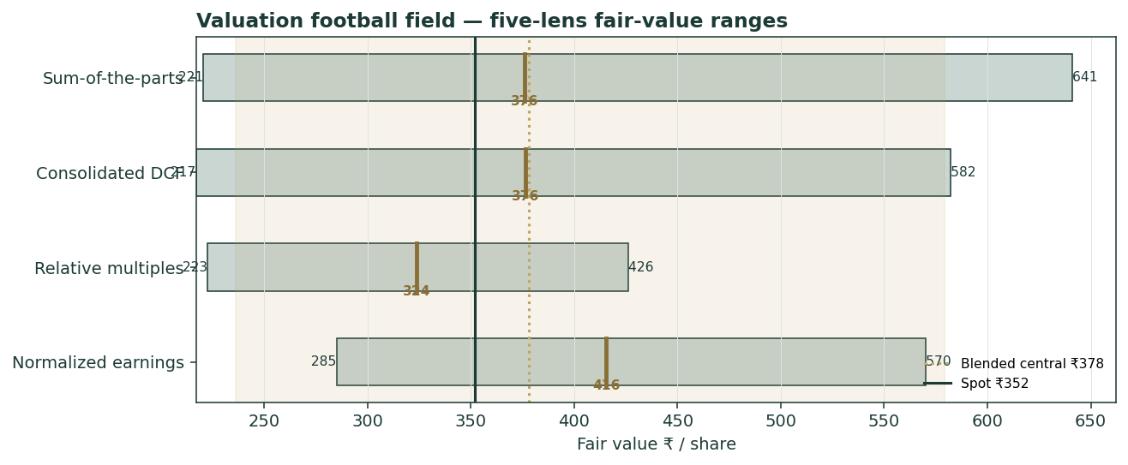
Figure 1 — Valuation football field. Bars span bear–bull per lens; the brass tick is each base case; the gold band is the blended central range; the dark line is spot.
Central fair value ≈ ₹378/share, about 7% above spot. The spread of the lenses (₹324 to ₹416 at base) is itself the message: this is not a deep-value or a clearly-expensive name, but a fairly-valued holding whose re-rating depends on one operating outcome at JLR.

1.6 The holding-company assets — a deeper look
JLR (FY26: revenue £22.9bn, EBITDA 6.7%, EBIT 0.7%, net debt £2.6bn, liquidity £6.9bn) is the value engine and the risk. Its FY24 and FY25 were records — £29.0bn revenue, 8.5% EBIT, net-cash-positive — so FY26's collapse is event-driven (cyber, tariffs, China, Jaguar run-off) rather than structural, in management's telling. The India PV+EV business (FY26: revenue ₹58,465 cr, +21%; EBITDA 6.9%; net cash ₹6.7K cr) is the steadier compounder: record 6.42 lakh PV wholesales, 40% EV market share, and an EV unit that turned EBITDA-positive in Q4. The table scores each part on the axes that matter.
Part | Cyclicality | Margin trend | Capital intensity | Swing role
JLR | High | Trough → recovery? | Very high (EV capex) | Dominant
India PV (ICE) | Moderate | Steady ~7% | Moderate | Cash anchor
India EV (TPEM) | Moderate | Improving (just +ve) | High | Optionality

1.7 JLR margin normalization and the conglomerate discount — the crux
Two judgments drive the valuation more than any other. First, where JLR's margin settles: FY26 EBITDA of 6.7% is a trough; FY24-25 ran ~15%; FY27 is guided to ~4% EBIT (≈10–11% EBITDA) as a recovery year. We assume a through-cycle ~12% EBITDA — below the old peak, acknowledging the Jaguar reinvention and EV-mix drag. Every point of JLR EBITDA margin is worth roughly ₹20/share at the group level (see §1.9). Second, the conglomerate/complexity discount: an Indian-listed wrapper around a UK luxury maker, an India volume business and a cash-burning EV unit will not trade at the clean sum of its parts. We apply 15%; the market is implying ~20%. If clarity improves (the demerger itself was a step) and JLR delivers, that discount can narrow — the principal non-operating source of upside.

1.8 Macro and country — the UK, India, China, tariffs and the rupee
TMPV is a rare cross-border cyclical: its value is set in three currencies and four demand pools. Sterling matters mechanically — at GBP/INR 125 (near a 12-month high) JLR's rupee value is ~12% richer than a year earlier; a sterling reversal would cut the SOTP directly. US tariffs on UK auto exports (partly mitigated by the May-2025 UK-US 100,000-vehicle quota) and China's luxury softness are the two external drags on JLR. In India, the PV cycle (SUV and CNG mix, festive demand) and EV competition (BYD, MG/JSW, Mahindra) set the domestic trajectory; RBI easing (policy rate ~5.25%) is mildly supportive of demand but pressures the rupee. These macro levers are the swing factors behind the bear and bull cases in §1.5 and the catalysts in §5.

1.9 SOTP sensitivity — how much the JLR swing moves the value
Holding the India and other parts at base, the table re-prices the SOTP across JLR's normalized EBITDA margin and EV/EBITDA multiple. The cells near spot (₹352) are shaded toward the centre; the value runs from ₹287 (2.5× / 10%) to ₹509 (3.75× / 14%).
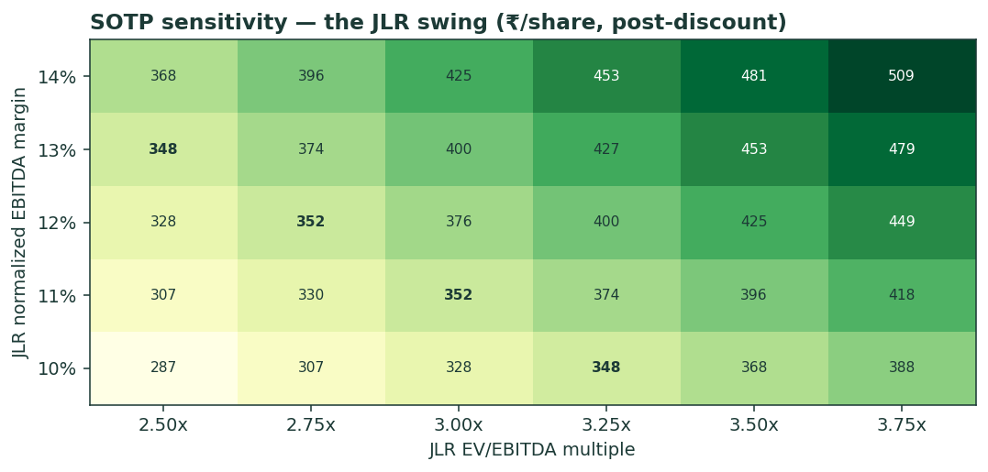
Figure 2 — SOTP sensitivity to the JLR swing inputs (₹/share, post-discount).
Read it as the bet you are taking: the market price is consistent with roughly 2.75–3.0× on an 11–12% JLR EBITDA — i.e. a partial, not a full, recovery already in the price.

2 Technical and price structure
The tape is weak and stretched to the downside. TMPV trades below all four major moving averages, the MACD histogram is firmly negative, and RSI sits in the low-30s — near, but not yet at, oversold. The structure is corrective: a post-demerger de-rating that has carried price from the high-440s to the low-350s, with the 52-week low at ₹294 as the visible floor.
Indicator | Reading | Signal
Spot | ₹352.2 | —
SMA 20 / 50 | ₹375 / ₹365 | Below both — short-term down
SMA 100 / 200 | ₹356 / ₹370 | Below both — trend down
RSI (14) | 33.7 | Approaching oversold
MACD (12,26,9) | −5.34 line / −0.62 signal / −4.73 hist | Bearish, momentum negative
52-week range | ₹294 – ₹448 | Lower third of range
Realized vol (252d) | 30.8% | Elevated
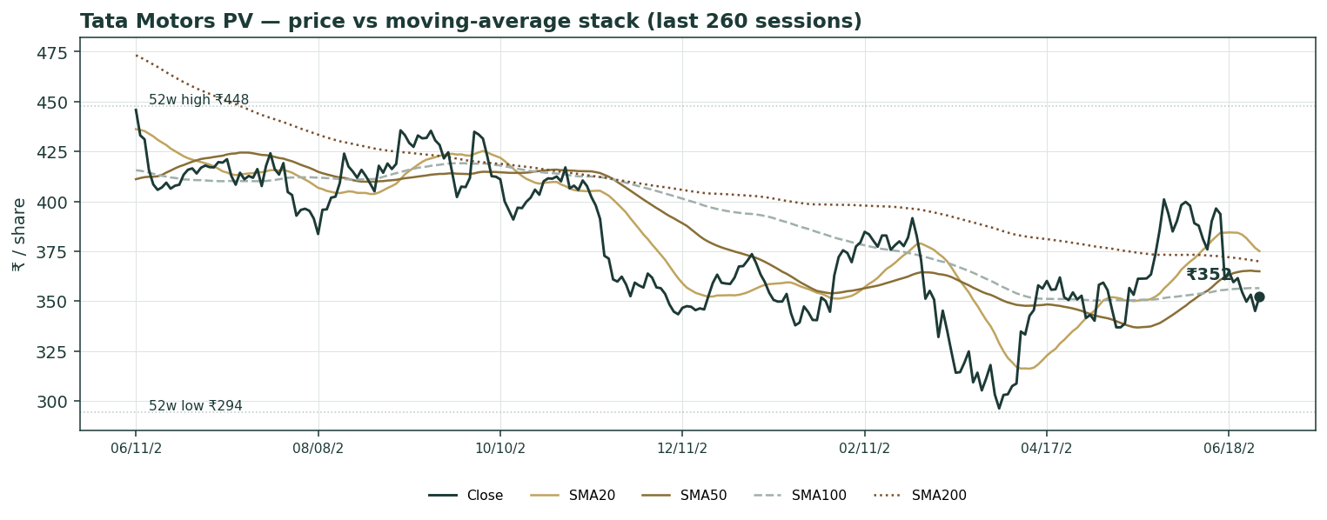
Figure 3 — Price versus the moving-average stack, last 260 sessions.
For the probabilistic work this matters in one way: an oversold, below-trend tape widens the near-term downside tail even as the fundamentals argue the other way. The technical and fundamental pictures genuinely disagree, and §6 reads the resulting probability zones without forcing a reconciliation.

3 Monte Carlo — a probabilistic price map
We simulate 50,000 three-month price paths (seed 42) using a sixteen-factor stack: seven continuous macro/operating drivers contributing a small net forward drift, and nine discrete events that each fire with a probability and an impact. By design the paths diffuse from spot, and the §1 value gap is kept out of the drift — the fundamental NAV gap lives in §1, not here; §3 maps where price could go from today, not where value sits. Diffusion volatility is the calibrated realized vol (annualized ≈35.4%, the trailing 252-day vol scaled by the calibration multiplier KVOL = 1.15 established in Appendix B). The net external drift is a modest +1.8% over the quarter.
Continuous factor (7) | Dir. | Discrete event (9) | Prob. | Mean impact
JLR demand / order-book recovery | + | Q1 FY27 results (late-Jul) | 85% | +0.5%
Sterling (GBP/INR) drift | ± | JLR guidance / Investor-Day signal | 45% | +1.0%
India PV demand (SUV/CNG mix) | + | US tariff escalation/de-escalation | 30% | −1.0%
India EV momentum vs price war | ± | China stimulus / luxury-tax change | 20% | +2.0%
China luxury softness | − | Rating action on JLR refinancing | 25% | +0.5%
US/EU tariff & trade-cost drag | − | Recall / operational disruption | 15% | −3.5%
Input cost / VME / commodity | − | EV price-war intensification | 30% | −1.5%
 |  | Capital-return / dividend surprise | 20% | +1.8%
 |  | Index / flow rebalancing | 25% | +1.2%
Percentile map (₹/share):
Horizon | p5 | p25 | p50 | p75 | p95
T+20 sessions | 294 | 327 | 353 | 379 | 422
T+60 sessions | 258 | 310 | 352 | 400 | 481
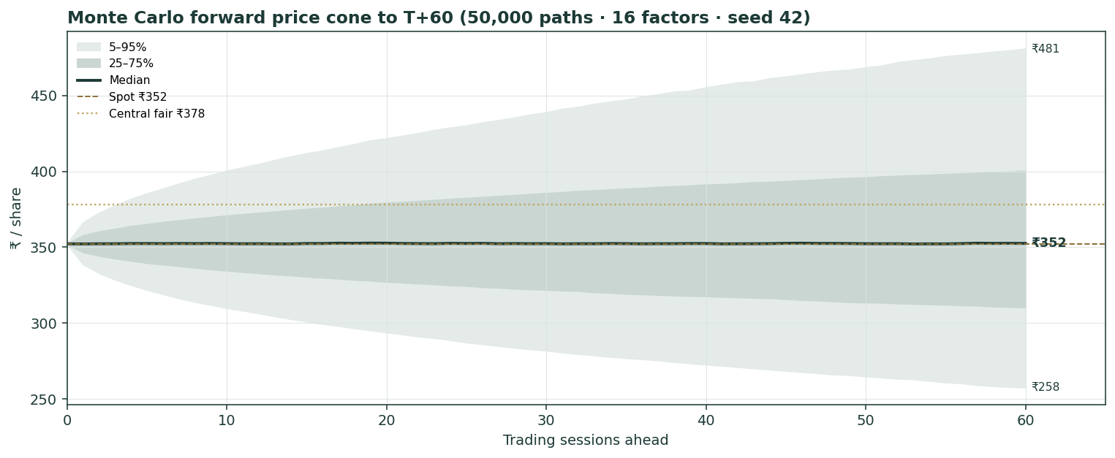
Figure 4 — Forward price cone to T+60. Median tracks spot; the gold dotted line marks the ₹378 fundamental central value, deliberately above the cone.
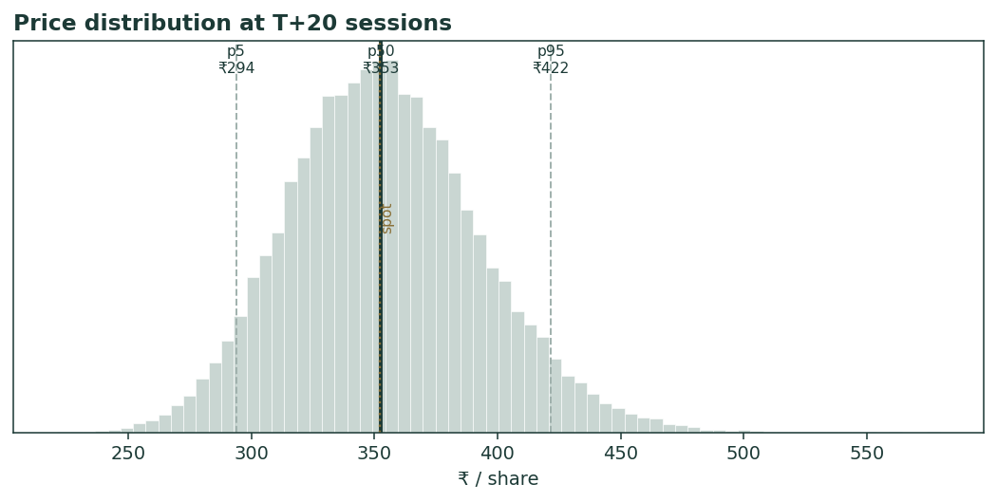
Figure 5 — Price distribution at T+20.
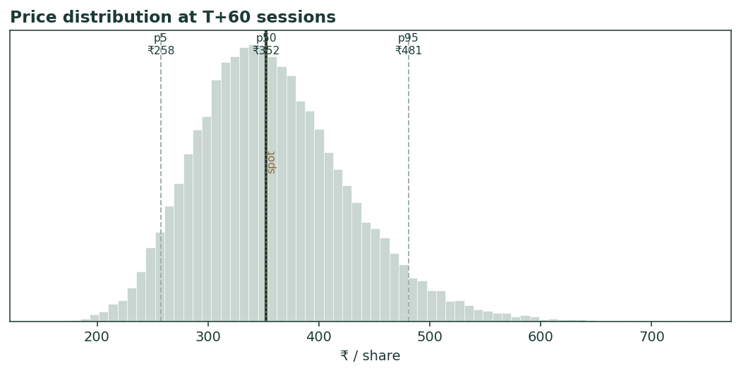
Figure 6 — Price distribution at T+60.
Level-touch ladder — the probability that price touches a level at any point by the horizon (running max for upside, running min for downside):
Level | T+20 touch | T+60 touch | Note
₹420 | 8% | 32% | Toward 52-wk high zone
₹400 | 20% | 46% | Near normalized-earnings lens
₹380 | 41% | 63% | Near central fair value
₹360 | 74% | 85% | Just above spot
₹340 | 65% | 79% | Just below spot
₹320 | 31% | 56% | Mid downside
₹300 | 11% | 36% | Toward 52-wk low

4 Comparison of the lenses, and a verdict
Three readings sit side by side. The fundamental lenses cluster at ₹324–₹416 with a central ₹378 — modestly above spot, contingent on JLR. The technical picture is the opposite: weak, below-trend, oversold-leaning, with the visible floor at ₹294. The probabilistic map says that over three months price is roughly symmetric around spot with a wide ±~35% vol band — the median is ₹352, not ₹378, because the simulation does not assume the value gap closes inside the quarter.
Lens | Reads | Central / implication
Fundamental (4-lens) | Modestly cheap | ₹378 (~+7%)
Technical | Weak / oversold | Floor ₹294; resistance at the MA stack ₹365–375
Monte Carlo (3-month) | Symmetric, wide | Median ₹352; p5–p95 ₹258–481
Verdict (a fair-value read, not a recommendation). TMPV looks fairly-to-modestly-cheap on fundamentals, with a clear and unusually concentrated swing factor: JLR's margin path. The technical weakness and the symmetric three-month distribution argue that any re-rating is a question of operating proof over quarters, not of an imminent move. The honest summary is a value modestly above price, a near-term distribution centred on price, and an outcome that hinges on one business recovering — which is why the bear–bull span (₹236–₹579) is wide. Readers should weigh the lenses themselves; we publish the distribution, not a target.

5 Catalysts to watch
- Q1 FY27 results (≈28 Jul 2026). First clean read on whether JLR's post-cyber, post-tariff margin is recovering toward guidance.
- JLR cost programme & break-even. Evidence on the £1.7bn savings plan and progress toward the 300,000-unit break-even.
- New-model cycle. New Jaguar (Type 00 → production), Range Rover Electric deliveries, and India launches (Sierra.ev, Harrier.ev).
- US tariffs & UK-US quota. Any change to the 100,000-vehicle quota or broader trade terms moves JLR margin directly.
- China luxury demand. Stabilization or further weakness in JLR's most margin-sensitive market.
- India EV trajectory. Whether TPEM holds ~40% share and sustains EBITDA breakeven against intensifying competition.
- Sterling (GBP/INR). A material move in either direction re-prices the JLR mark in rupees.
- Capital & index events. JLR refinancing/rating actions, dividend policy, and post-demerger index rebalancing flows.

6 Reading the probability zones
Translating the three-month distribution into plain zones, anchored on spot ₹352 and the fair-value cluster:
Zone (T+60) | Range | Approx. probability | What it would mean
Deep downside | < ₹300 | ~14% | JLR recovery stalls / risk-off; tests the 52-wk low
Lower band | ₹300–₹340 | ~24% | Trough persists; relative-multiple lens dominates
Around spot | ₹340–₹380 | ~28% | Status quo; value gap unclosed
Upper band | ₹380–₹430 | ~21% | Recovery credited; toward central/normalized lens
Strong upside | > ₹430 | ~13% | Margin normalization + discount narrowing together
The distribution is close to symmetric, with a slightly heavier upper tail from the discrete upside events (China stimulus, capital return, index flows). It is not a forecast; it is the spread of outcomes consistent with the stock's own volatility and the factor stack.

7 Caveats and what would change our mind
- JLR is the model. Two-thirds of the value rests on one cyclical business at a trough; our normalization (12% mid-cycle EBITDA, 3.0×) could prove optimistic or conservative. A structurally lower JLR margin would pull the central value toward — or below — spot.
- FX leverage. The SOTP is struck at GBP/INR 125, near a 12-month high. Sterling weakness is a direct, mechanical downgrade not captured in the operating story.
- EV mark is judgemental. TPEM is valued off a haircut private round, not a market; the bull–bear range on that single line is ₹22,000–₹60,000 cr.
- Capex suppresses cash. The £18bn investment plan means free cash can stay thin for years even as profit recovers, which the DCF treats but cannot precisely time.
- Discount can widen, not just narrow. Complexity, governance perception or a weak JLR could push the conglomerate discount past 20%.
- Technical / RSI reminder. RSI in the low-30s is near oversold; mean-reversion bounces are common and say nothing about value. Equally, below-trend tapes can persist. The technical read is context, not a trigger.

Appendix A Financial statements
Selected consolidated figures, as reported (FY26 results, 14 May 2026; auditor BSR & Co. LLP, unmodified opinion). JLR figures in £; group figures in ₹ crore. FY26 is materially depressed by the JLR cyber incident, US tariffs, China weakness and the Jaguar wind-down.

A.1 Income statement (consolidated, ₹ cr)
Line | FY24 | FY25 | FY26
Revenue (group, incl. CV in FY24-25) | 437,928 | 439,695 | 335,582
EBITDA | — | 57,600 | 22,820
EBIT margin | ~8.6% | ~8.5% | 1.1%
PBT (bei) | — | 34,300 | 2,519
Exceptional items | — | — | (4,142)
PAT (continuing, post-exceptional) | — | 28,100 | (1,623)
Note: FY24-25 group figures include the commercial-vehicle business demerged in Oct 2025; FY26 is the PV entity (TMPV) and is not like-for-like with prior years. Shown for scale, not for trend.

A.2 JLR segment (£mn)
JLR | FY24 | FY25 | FY26
Revenue | 28,995 | 29,000 | 22,911
EBIT margin | 8.5% | 8.5% | 0.7%
PBT (bei) | 2,200 | 2,500 | 14
Free cash flow | 2,300 | ~1,500 | (2,200)
Net debt / (cash) | 700 | (net cash) | 2,600

A.3 India PV + EV (domestic, ₹ cr) and balance-sheet markers
India PV+EV / balance sheet | FY25 | FY26
Domestic PV+EV revenue | ~48,400 | 58,465
Domestic EBITDA margin | ~6.9% | 6.9%
Domestic net cash | ~5,000 | 6,700
PV wholesales (units) | ~5.56 lakh | 6.42 lakh
EV units / EV market share | ~64k / ~38% | 92k / 40.2%
Group consolidated net debt | — | 30,700
Source: company quarterly and full-year results FY24–FY26. Figures rounded; some prior-period values approximate due to the demerger restatement.

Appendix B Step 0 — calibration backtest
Before any forecast we test the Monte Carlo lens on TMPV's own five years of history: generate three-month-ahead distributions across the sample, score the realized close against each, and ask whether the stated bands contain it at their stated rates. The diffusion volatility multiplier was tuned to KVOL = 1.15, at which the calibration passes on both overlapping and non-overlapping windows.
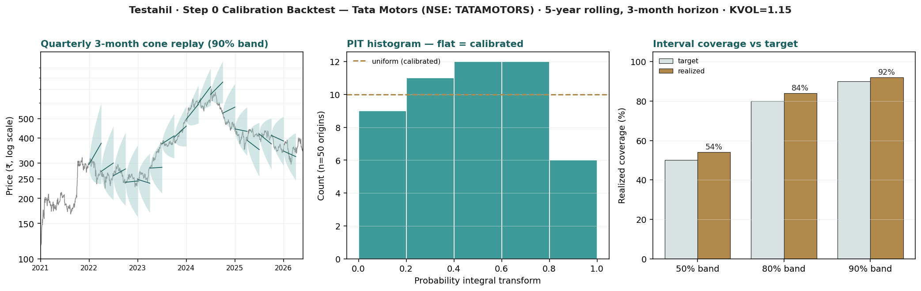
Figure B-1 — Calibration backtest: quarterly cone replay (log scale), PIT histogram, and interval coverage versus target.
Window scheme | n | 50% band | 80% band | 90% band | PIT mean
Non-overlapping (step 63d) | 17 | 53% | 82% | 94% | 0.46
Monthly origins (step 21d) | 50 | 54% | 84% | 92% | 0.47
Fortnightly (step 10d) | 105 | 50% | 79% | 92% | 0.46
Target | — | 50% | 80% | 90% | 0.50
Coverage sits within tolerance of target at all three bands and the PIT histogram is close to flat (a slight tilt to the lower bins reflects the stock's net decline over the period, not a width error). The lens is accepted; this KVOL carries into the §3 forward run.

Appendix C Peer set, sector structure, and risks
TMPV has no clean comparable — it is a UK luxury OEM, an India volume car maker and an India EV leader in one wrapper. The peer set is therefore split by part.
Part | Closest peers | Typical valuation
JLR (premium auto) | Mercedes-Benz, BMW, Aston Martin | EV/EBITDA ~2.5–4.0×; cyclical
India PV (ICE) | Maruti Suzuki, M&M, Hyundai India | P/E ~20–28×; EV/EBITDA ~12–18×
India EV (TPEM) | BYD, MG (JSW), Mahindra EV | Growth / strategic; private marks
Sector structure. Global premium auto is cyclical and now navigating an EV transition that compresses margins before it lifts them; tariffs and China are the swing macro variables. India's PV market is structurally growing, SUV- and EV-skewed, and intensely competitive. Principal risks: a structurally lower JLR margin; sterling weakness; an India EV price war; prolonged thin free cash from heavy capex; a widening conglomerate discount; and execution risk on the £1.7bn cost plan and the new-model cycle.

Appendix D The expert valuation panel
Every Testahil study closes with a panel of standing expert personas — drawn from the house Expert Persona Library, not invented for the occasion, so that each accumulates a track record across studies and a quarterly update is a re-run, not a re-training. For TMPV we cast the three whose methods both fit a holding-company-of-auto-businesses and genuinely disagree: Expert 1 (sum-of-the-parts NAV and the holdco discount), Expert 2 (normalized earnings power and relative multiples), and Expert 3 (cash returns — DCF and return on capital versus its cost). Each runs a different method, derives its fair value from shown workings, and states a falsification condition. The macro-policy lens — tariffs, China, sterling — runs through the body (§1.8, §5) rather than as a separate persona.

D.1 Expert 1 — sum-of-the-parts NAV and the holdco discount
Worldview. A holding company is worth the sum of its parts at realizable value, less a discount for the wrapper. He marks each asset to what it would fetch on its own and asks what the market pays for the bundle versus the pieces.
When it works / fails. Best where the parts are separable and markable and a conglomerate discount is observable; it fails when synergies are real (the parts are worth more together) or when a private mark is stale.
Standard workings & worked example. Mark JLR on a premium-auto EV/EBITDA, India PV-ICE on a domestic multiple, the India EV business on a haircut private round; deduct net debt; apply a fair holdco discount.
Expert 1's marks (₹ cr) | Value
JLR (£10.1bn EV → ₹) | 126,000
India PV (ICE) | 24,920
India EV (TPEM, haircut) | 38,000
Other | 6,000
Σ EV − net debt = ₹442/sh pre-discount | 162,920
Fair holdco discount 14% (demerger simplified the structure) | → ₹380/sh
Sensitivity (swing = the discount). At a 10% discount ₹398; at 20%, ₹354; at 25%, ₹332. Cross-examination. He tells Expert 2 that peak-margin earnings double-count assets already marked; he tells Expert 3 that a single group DCF blurs parts that deserve different discount rates.
Verdict, falsification, market-implied. Fair ₹380 (range ₹260–540). Falsified if a part's realizable mark proves illusory — above all if the EV business cannot be monetized near its private round — or if the discount structurally widens. The market price implies a ~20% discount to his NAV, wider than he judges fair.

D.2 Expert 2 — normalized earnings power and relative multiples
Worldview. An operating business is worth a fair multiple of its sustainable mid-cycle earnings; peaks and troughs are noise to be stripped out.
When it works / fails. Best for businesses with a through-cycle track record; it fails at structural breaks — if JLR's margins are permanently lower, his normalization is simply wrong.
Standard workings & worked example. Normalize JLR and India to mid-cycle, derive group EPS, apply a justified P/E against history and peers.
Expert 2's normalization | Value
Mid-cycle consolidated PAT (₹ cr) | 18,000
Shares (cr) → normalized EPS | 368.23 → ₹48.9
Justified P/E (cyclical auto; below India PV peers) | 8.5×
Fair value | → ₹416/sh
Sensitivity (swing = normalized margin / multiple). At 7× ₹343; at 10×, ₹489. Cross-examination. He tells Expert 1 that NAV struck on a trough year understates a business that will earn far more mid-cycle; he tells Expert 3 that ROIC pessimism ignores the operating leverage of a volume recovery.
Verdict, falsification, market-implied. Fair ₹416 (range ₹285–570). Falsified by a structural margin re-rating down — JLR stuck below ~5% EBIT through a cycle. The market implies normalized earnings ~15% below his: it does not yet believe the recovery.

D.3 Expert 3 — cash returns: DCF and ROIC versus the cost of capital
Worldview. A business creates value only when each unit of capital earns above its cost. Cash, not booked profit, is the test; he looks past the income statement to the economic-profit spread.
When it works / fails. Best for capital-intensive businesses where returns on capital are the crux; it fails where reinvestment economics are about to change sharply — which is precisely the EV-transition risk here.
Standard workings & worked example. Build FCFF, compute ROIC against WACC, value as invested capital plus the present value of economic profit, fading excess returns to the cost of capital.
Expert 3's economic-profit test | Value
Normalized NOPAT (₹ cr) | ~24,000
Invested capital (₹ cr) | ~152,000
ROIC vs WACC | ~13% vs ~13% → ≈ nil spread
EV-capex phase suppresses FCF for years | mark slightly below book
Fair value | → ~₹348/sh
Sensitivity (swing = WACC / ROIC fade). At a 12% WACC ₹392; at 14.5%, ₹300. Cross-examination. He tells Expert 2 that mid-cycle earnings without the capital cost to produce them is a half-truth — JLR's transition consumes the very cash that P/E capitalizes; he tells Expert 1 that summing marked parts ignores whether the parts earn their cost of capital.
Verdict, falsification, market-implied. Fair ₹348 (range ₹258–460) — the most cautious of the three: fairly valued, no margin of safety. Falsified by a durable ROIC lift above WACC (a genuine EV moat, or JLR sustaining FY24-25 returns). The market price is almost exactly his number — on a cash-returns basis, the price is about right.

D.5 The three in one room
The single asset they most disagree on is JLR — specifically, whether the capital it consumes through the EV transition will earn its keep at mid-cycle margins.
Expert 2: “FY26 was an event, not a trend. JLR ran 8.5% EBIT two years running; normalize it and the group earns ₹18,000 cr — the market is paying about seven times that.”
Expert 3: “And to earn it, JLR spends roughly £3.5bn a year reinventing itself. Capitalize the earnings, but subtract the cash to make them. The return on capital barely clears the hurdle; I credit no premium to book.”
Expert 1: “You are both arguing about the engine. Mark the parts — JLR, India volume, the EV franchise, the net cash. The bundle is worth ₹442 a share and the market discounts it a fifth. The argument is the discount, not the multiple.”

D.6 Reading the divergence
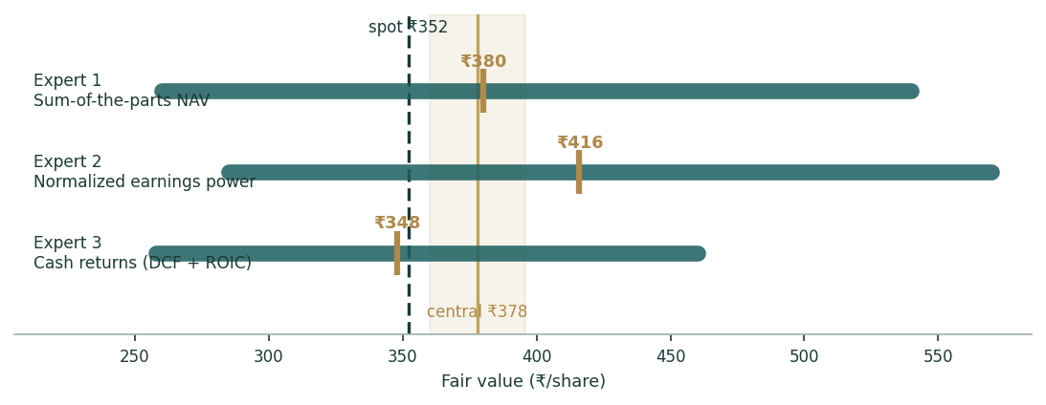
Figure D-1 — The three experts' fair-value ranges. Brass ticks are base cases; the gold band is the central, the dark line is spot. The spread is almost entirely a JLR disagreement.
Expert | Method | Single swing assumption | Base fair value
Expert 1 | Sum-of-the-parts NAV | Fair holdco discount (14%) | ₹380
Expert 2 | Normalized earnings power | Normalized JLR margin / 8.5× | ₹416
Expert 3 | Cash returns / ROIC | ROIC versus a ~13% WACC | ₹348
The spread — ₹348 to ₹416 at base — is narrow for a cyclical, and it is almost entirely a JLR disagreement: none of the three contests the India PV business, the existence of the EV franchise, or the balance sheet. What separates them is whether JLR's through-cycle economics justify a premium to its asset base. Expert 2 says yes (operating leverage); Expert 3 says barely (the capital cost to earn it); Expert 1 says it is a discount question, not a margin question. The ₹68 spread is therefore a clean measure of one uncertainty — JLR's normalized return on the capital it is now spending. Resolve that, and the three converge.
Each expert's point fair value (and bull/base/bear) is logged with the study date (30 Jun 2026) and spot (₹352.20) as an internal per-expert track record, kept separate from the core Calibration Ledger.

About this series
Testahil publishes independent, educational valuation studies. Each is an attempt to reason transparently about what a security is worth, with every assumption shown and a companion model so readers can disagree productively. The house style is distributions, not tips: we describe ranges and probabilities, not targets, and we do not tell anyone what to do. Studies are framed as educational analysis, the preparer is not licensed by any securities regulator, and holdings are disclosed.

Disclosure & Disclaimer
Not investment advice. This document is educational and informational only. It is not, and must not be relied upon as, investment, financial, legal, accounting or tax advice, nor an offer, solicitation or recommendation to buy, sell or hold any security. It contains no price target and no rating.
No licence; no advisory relationship. The preparer is not registered or licensed with any securities or financial regulator in any jurisdiction, holds no brokerage or investment-advisory authorisation, and is not acting as your adviser or fiduciary. Nothing here is personalised to your circumstances.
Holdings disclosure. The preparer may hold, and may in the future take or dispose of, a position in the security discussed in this report, and may transact at any time without notice. This is a potential conflict of interest you should weigh.
Sources & accuracy. Reported financial and operating figures are drawn from the company's public disclosure and other public sources believed reliable but not independently verified; they may contain errors or be superseded. Forward-looking inputs — the SOTP marks, the EV-business mark, the conglomerate discount, projections, multiples, the DCF and Monte-Carlo factor probabilities — are the preparer's own judgments and are inherently uncertain.
Forward-looking statements. Any statements about the future are estimates subject to risks and uncertainties; actual results may differ materially. The Monte Carlo models price, not value, and encodes subjective probabilities for events that have not occurred.
No reliance; your responsibility. Do your own research and consult a licensed professional before making any decision. You are solely responsible for your investment decisions and their outcomes. To the maximum extent permitted by law, the preparer accepts no liability for any loss arising from use of this document.
Currency & figures. Group figures are in Indian rupees (₹); cr denotes crore and tn trillion. JLR figures are in pounds sterling (£). FX at study date: GBP/INR 125, USD/INR 88. Rounding may cause totals to differ slightly. Spot price and market data are as of 30 June 2026 and change continuously.
TESTAHIL · Independent Valuation Study · Educational Analysis · Tata Motors Passenger Vehicles Ltd (NSE: TMPV) · edition 30-06-2026 · reporting currency INR

